Atoms vs Ashes

Coal-to-Nuclear Siting Assessment
  - Stage 1 and Stage 2 Siting Study for
  - Central, Eastern and Southern Europe

Prepared for:
General Director Cosmin Ghita Nuclearelectrica

Contributors:

Executive Director Bogdan Termegan ROMATOM

Expert Principal Ovidiu Coman Nuclearelectrica

Table of Contents
Acronyms and Abbreviations 3
1. Introduction 5
2. Stage 1: Site Survey 9
3. Stage 2: Site Selection 13
4. Results and Findings 21
5. Country and Site Profiles 31
6. Recommendations for Detailed Site Evaluation 614
7. Final Remarks 619
8. References 620
Annex A: IAEA and EPRI Traceability 622
Annex B: Scoring Methodology and Exclusionary Floors 625
Annex C: National Sensitivity Methodology 628
Annex D: Failure-Mode Analysis 631
Annex E: Assumption Register and Data Limitations 634
Annex F: Generated Methodology Artefacts 639

Acronyms and Abbreviations
This front-matter glossary defines the institutional, regulatory, and technical acronyms used in the report. Source-platform names, internal workflow terms, and implementation-only abbreviations are excluded from the published glossary.

Core Acronyms
Acronym | Meaning
ANANP | Romanian national protected-areas agency
BF | Basic Filters, the project criterion family for minimum grid and land-envelope tests
CNCAN | Comisia Nationala pentru Controlul Activitatilor Nucleare, the Romanian nuclear regulator
CPT | Cone Penetration Test
DOE | U.S. Department of Energy
EIA | Environmental Impact Assessment
ENTSO-E | European Network of Transmission System Operators for Electricity
EP | Emergency Planning, the project criterion family for emergency-zone feasibility
EPRI | Electric Power Research Institute
EPZ | Emergency Planning Zone
HI | Human-Induced hazards, the project criterion family for external human-origin hazards
HV | High Voltage
IAEA | International Atomic Energy Agency
IRP-MAI | Inspectoratul General pentru Situatii de Urgenta under the Romanian Ministry of Internal Affairs, the civil-protection authority
MC | Monte Carlo
MWe | Megawatt electrical
NH | Natural Hazards, the project criterion family for external natural hazards
NS | Non-Safety implementation criteria, the project criterion family for implementation and reuse factors
PGA | Peak Ground Acceleration
PFDHA | Probabilistic Fault Displacement Hazard Assessment
PSHA | Probabilistic Seismic Hazard Assessment
RI | Radiological Impact, the project criterion family for population and dispersion proxies
SMR | Small Modular Reactor
SPT | Standard Penetration Test
SSE | Safe Shutdown Earthquake
SSG-35 | IAEA Safety Guide, Site Survey and Site Selection for Nuclear Installations
SSR-1 | IAEA Safety Requirements, Site Evaluation for Nuclear Installations
TSO | Transmission System Operator
UPZ | Urgent Protective action Planning Zone
VOYGR-6 | NuScale Power six-module VOYGR deployment envelope used as the report reference case
Vs30 | Time-averaged shear-wave velocity in the upper 30 metres of soil or rock

Country Codes Used in Report Tables and Annexes
Code | Country
AL | Albania
AT | Austria
BA | Bosnia and Herzegovina
BG | Bulgaria
CZ | Czechia
HR | Croatia
HU | Hungary
LV | Latvia
MD | Moldova
ME | Montenegro
MK | North Macedonia
PL | Poland
RO | Romania
RS | Serbia
SI | Slovenia
SK | Slovakia
TR | Turkiye
UA | Ukraine
XK | Kosovo

Criterion identifiers such as NH-01, HI-06, RI-04, EP-01, NS-05, and BF-02 are defined in the scoring methodology and methodology annexes rather than expanded one by one in this glossary.

1. Introduction

1.1 Purpose of the Report
The report supports public decision-makers in identifying coal and other thermal power plant sites that merit detailed evaluation for small modular reactor deployment. It applies the IAEA site survey and site selection sequence to a broad brownfield site universe, then narrows that universe through exclusionary screening, comparative scoring, national sensitivity analysis, and country-level interpretation (IAEA, 2015; EPRI, 2022).
The report provides the data for Stage 1 and Stage 2, a basis on which progression to Stage 3 can be made. In other words, which sites deserve progression toward detailed site characterisation. The report therefore provides a disciplined screening and ranking basis for governments, energy ministries, regulators, utilities, and public agencies considering coal-to-nuclear transition options.
It does not establish site suitability, licence readiness, procurement suitability, financing viability, or construction approval.
NuScale VOYGR-6 is the reference deployment envelope used in the analysis. The reference case gives the screening method a consistent capacity, footprint, grid, cooling, transport, and emergency-planning basis. It does not imply vendor selection, procurement intent, or host-country licensing acceptance.

1.2 Scope and Boundaries: IAEA Stages 1 and 2
IAEA SSG-35 describes a staged process that begins with regional analysis and site survey, moves through site selection, and then proceeds to progressively more detailed characterisation and evaluation (IAEA, 2015). This report covers the first two stages. Stage 3 and later activities remain the responsibility of national authorities, project sponsors, regulators, operators, and technical specialists working with site-specific evidence.
Stage | Name | Treatment in this report
1 | Site Survey | Defines the study region, identifies potential sites, and screens the site universe into a candidate population.
2 | Site Selection | Evaluates, compares, ranks, and interprets candidate sites to support selection for detailed follow-up.
3 | Site Characterisation | Identified as the next work programme for selected sites; detailed field investigations and design-basis studies sit here.
4 | Pre-operational | Outside the report scope; requires confirmatory measurements and monitoring before operation.
5 | Operational | Outside the report scope; concerns long-term monitoring and periodic safety review.
The Stage 1 and Stage 2 outputs are sufficient for prioritisation. They support decisions about where to spend further public and technical effort, which issues require early regulator engagement, and which candidate sites should be moved into a site-specific work programme. They do not establish design-basis ground motion, design-basis flood levels, licensing-quality geotechnical parameters, approved emergency plans, final environmental acceptability, or public consent.

1.3 Coal-to-Nuclear Transition Context
Coal-to-nuclear transition is relevant because coal and thermal power plant sites can concentrate assets that are costly and slow to recreate on greenfield land. Existing industrial zoning, transmission corridors, cooling-water context, transport access, workforce relationships, and host-community familiarity with power generation can make some brownfield sites attractive starting points for Stage 1 and Stage 2 screening.
The U.S. Department of Energy frames coal-to-nuclear transition as a pathway for retaining energy-community economic value while replacing retiring coal generation with firm low-carbon electricity (U.S. DOE, 2024). DOE-supported analysis also identifies potential reuse value in transmission, cooling, roads, rail, land, and workforce relationships, while emphasising that each site still requires technical, environmental, regulatory, and community review (INL, 2022).
For government readers, the transition question is practical. A candidate site is stronger when existing assets reduce later project uncertainty and weaker when brownfield constraints introduce safety, environmental, emergency-planning, ownership, or stakeholder risks. The report tests that balance at screening resolution and identifies where detailed Stage 3 characterisation would add the most value.

1.4 Regulatory and Methodological Framework: IAEA, EPRI, and Project Alignment
IAEA safety standards provide the primary nuclear siting framework. SSG-35 defines the site survey and site selection process used in the report, while SSR-1 establishes the safety requirements for site-evaluation discipline that later stages must satisfy (IAEA, 2015; IAEA, 2019). Supporting IAEA safety guides inform treatment of seismic, geotechnical, hydrological, meteorological, volcanic, human-induced, radiological, and emergency-planning considerations.
EPRI’s advanced nuclear siting guide provides the practical bridge from safety standards to a structured screening workflow for advanced nuclear projects (EPRI, 2022). It distinguishes exclusionary screening, avoidance screening, suitability evaluation, and alternative-site ranking. The report uses the same logic: hard exclusionary issues and safety floors are considered before weighted scoring, and weighted scoring is used only as a comparative tool for site/technology pairs that remain inside the Stage 1 and Stage 2 candidate set.
Theme | IAEA framing | EPRI / industry framing | Project stance
Process stage | Site survey and site selection lead into progressive site evaluation. | Pre-screening, exclusionary screening, avoidance screening, suitability evaluation, and ranking. | Treat the report as a Stage 1 and Stage 2 decision-support product.
Criteria families | Safety-related, nuclear security, and non-safety-related criteria. | Practical siting categories for advanced nuclear deployment. | Organise criteria by safety family, then retain implementation criteria where they affect brownfield feasibility.
Exclusion and ranking | Exclusionary, discretionary, and ranking criteria. | Exclusionary screening, avoidance screening, suitability evaluation, and alternative-site ranking. | Apply exclusionary gates and safety floors before composite ranking.
Level of evidence | Evidence detail increases as the project moves toward characterisation. | Screening and ranking precede detailed engineering. | Use screening-grade and ranking-grade evidence for prioritisation, then route unresolved questions to Stage 3.
Robustness | Good siting practice requires explicit treatment of uncertainty and assumptions. | Rankings should be tested against sensitivity to weights and assumptions. | Use the project’s national sensitivity analysis to interpret rank robustness and sequencing.
The report also separates nuclear-safety criteria from project-implementation criteria. Grid connection, heavy-haul transport, land area, workforce, ownership context, infrastructure reuse, and coal-to-nuclear synergy matter to programme feasibility. They do not replace SSR-1 safety expectations and they do not override exclusionary or safety-floor findings.

1.5 Data, Scoring, and National Sensitivity Overview
The evidence base combines site inventory records, public geospatial and infrastructure evidence, hazard indicators, population and emergency-planning proxies, country context, documented assumptions, scoring outputs, and human review. The report describes those sources qualitatively because the public deliverable is a decision-support report rather than a catalogue of source systems.
At report scale, the method has four layers.
The first layer is the candidate inventory: coal and thermal power plant records with location, operating status, capacity, ownership, grid, and country attributes where available.
The second layer is evidence enrichment: screening-grade and ranking-grade indicators for hazards, radiological impact, emergency planning, infrastructure, land, environment, ownership, and reuse context.
The third layer is quality control: source hierarchy, evidence grading, uncertainty labels, and assumption tracking.
The fourth layer is evaluation: exclusionary checks, safety floors, weighted scoring, national rank interpretation, and sensitivity testing.
The scoring method uses a dual gate. A site/technology pair that fails an exclusionary condition or safety floor cannot be made acceptable by strong non-safety attributes. Surviving candidates are then compared through criterion scores and a composite ranking. This preserves the distinction between safety screening and programme attractiveness.
The project’s 50,000-iteration national Monte Carlo sensitivity analysis is the controlling robustness frame for country and site choices. It tests how rankings move under uncertainty in scores and weights within each country’s candidate set. Country profiles, selected-site profiles, and Stage 3 sequencing therefore use national rank stability, national score bands, and national top-tier persistence within the host-country candidate pool.
NuScale VOYGR-6 is the reference deployment envelope. The reference case is 462 MWe and is used consistently in screening, ranking, land, grid, cooling, transport, and Stage 3 sequencing language.
Criterion family | Screening role | Main Stage 1-2 limit | Treatment in this report
Natural hazards | Identify seismic, geotechnical, hydrological, meteorological, volcanic, and combined-hazard concerns. | Desk-scale evidence does not replace site-specific hazard characterisation. | Use for screening and ranking; route design-basis values to Stage 3.
Human-induced and security-relevant hazards | Screen aircraft, industrial, transport, military, electromagnetic, and external event concerns. | Public evidence may miss restricted or locally classified activity. | Treat as screening evidence; require national authority confirmation where material.
Radiological impact and emergency planning | Assess dispersion proxies, population context, evacuation feasibility, and special populations. | Screening does not constitute a dose assessment or emergency plan. | Use for comparison; require regulator-facing modelling and emergency-planning work at Stage 3.
Non-safety and implementation criteria | Capture grid, cooling, transport, land, ownership, environment, workforce, and reuse conditions. | Several factors indicate programme feasibility rather than nuclear safety. | Use for prioritisation and policy interpretation after safety gates are respected.
Data quality and assumptions | Explain evidence strength, missing values, and sensitivity to uncertainty. | Some indicators remain screening-grade or unscored. | Preserve uncertainty in score bands, confidence labels, and Stage 3 follow-up actions.

1.6 Structure of the Report
The report follows the IAEA Stage 1 and Stage 2 sequence.
Chapter 2 presents the site survey stage: study region, site universe, evidence base, eligibility checks, candidate identification, and Stage 1 outputs.
Chapter 3 presents the site selection stage: criterion families, screening and scoring logic, national sensitivity treatment, and the shortlist rationale for the NuScale VOYGR-6 reference case.
Chapter 4 presents the cross-country results and main drivers of suitability, exclusion, uncertainty, and national stability.
Chapter 5 provides the accepted country packets and selected-site profiles for the published country set.
Chapter 6 converts the screening findings into a Stage 3 work programme.
Chapter 7 closes with final remarks on how the screening evidence should be used.
Chapter 8 provides the consolidated external reference list.
The annexes carry the methodological backbone: IAEA and EPRI traceability, exclusionary floors, scoring methods, national sensitivity methods, failure-mode analysis, assumption register, and generated artefact index. A separate executive technical brief may be prepared for governance and audit audiences, but the main report remains the client-facing decision document.

2. Stage 1: Site Survey
Stage 1 establishes the survey population for the report. It converts a broad set of coal, lignite and thermal power plant locations into a screened inventory that can be compared in Stage 2 under one reference deployment envelope: NuScale VOYGR-6. The chapter follows the site survey logic in IAEA SSG-35, where regional review, site identification and initial screening precede comparative site selection (IAEA, 2015).

2.1 Objectives of the Site Survey Stage
The objective of Stage 1 is to define which sites are credible enough to enter structured comparison. The work starts from existing or former energy and industrial locations because the report is concerned with coal-to-nuclear and thermal-site reuse. At this stage, a site enters the inventory because it is identifiable, within the published study boundary, and potentially relevant to the NuScale VOYGR-6 reference case.
Stage 1 produces three outputs for the rest of the report. It fixes the published country roster and site universe, assembles a common evidence base for every site, and applies initial screening logic so that Stage 2 ranks only those sites that can be compared responsibly. This keeps site-survey work separate from site-selection work: Stage 1 identifies and screens, while Stage 2 evaluates, ranks and tests robustness.
The survey stage also protects the reader from false precision. A site with weak evidence is not treated as favourable simply because a field is missing. The evidence grade is carried forward as a limitation, a review flag, or a Stage 3 characterisation question, depending on how much the missing evidence affects the screening conclusion.

2.2 Study Region and Initial Site Universe
The published version 1.2 analysis covers 16 countries in Central, Eastern and Southern Europe: Austria, Bosnia and Herzegovina, Bulgaria, Czechia, Croatia, Hungary, Latvia, Moldova, Montenegro, North Macedonia, Poland, Romania, Serbia, Slovakia, Turkey and Ukraine. No country or site conclusion in this chapter relies on records outside the published roster.
The published site universe contains 352 site records. Each record has a representative location and enough plant identity information to enter screening. Inclusion is limited to survey relevance; availability, owner support, licensing readiness, construction feasibility and host-community acceptance belong to later technical, regulatory and stakeholder processes.
Table 2.1. Published Stage 1 site universe by country. NuScale VOYGR-6 reference case. Denominator: 352 published site records.
Country | Site records | Exclusionary pass | Clear of avoidance flags | Retained with avoidance flags | Exclusionary fail
Austria | 8 | 6 | 0 | 6 | 2
Bosnia and Herzegovina | 11 | 5 | 0 | 5 | 6
Bulgaria | 15 | 7 | 0 | 7 | 8
Czechia | 29 | 29 | 0 | 29 | 0
Croatia | 2 | 1 | 0 | 1 | 1
Hungary | 11 | 11 | 1 | 10 | 0
Latvia | 1 | 1 | 0 | 1 | 0
Moldova | 1 | 1 | 0 | 1 | 0
Montenegro | 4 | 1 | 0 | 1 | 3
North Macedonia | 4 | 3 | 0 | 3 | 1
Poland | 63 | 61 | 3 | 58 | 2
Romania | 23 | 22 | 3 | 19 | 1
Serbia | 8 | 6 | 0 | 6 | 2
Slovakia | 6 | 5 | 1 | 4 | 1
Turkey | 146 | 110 | 8 | 102 | 36
Ukraine | 20 | 20 | 12 | 8 | 0
Published total | 352 | 289 | 28 | 261 | 63
The table is a survey-stage inventory. The large number of sites retained with avoidance flags reflects the character of coal and thermal brownfields: many sit in industrial corridors, populated regions, transport corridors or constrained water and land settings. Stage 2 uses those flags to explain ranking, confidence and Stage 3 follow-up requirements.

2.3 Data Acquisition and Evidence Base
Stage 1 uses a layered public-evidence base. Plant identity and operating context are assembled from structured plant inventories, national energy information, owner and operator material where available, and reviewed public records. Spatial evidence is collected from open mapping, hazard, environmental, population, infrastructure and administrative sources that support screening-grade measurement across the full published region.
The evidence hierarchy is conservative. Authoritative public records and structured measurements are preferred where they exist. Screening proxies are used where they are appropriate for a regional survey but too coarse for licensing-grade conclusions. Automated public-evidence collection and structured review are used to close targeted gaps, with the resulting fields treated as lower-confidence evidence unless corroborated by stronger sources.
Table 2.2. Stage 1 evidence families. Published site universe. Denominator: all sites entering screening.
Evidence family | Stage 1 use | Main limitation
Plant identity and status | Confirms plant name, country, fuel or thermal history, operating status, capacity context and representative location. | Records can differ by plant name, unit boundary, retirement status or coordinate precision.
Natural hazards | Screens seismic, geological, hydrological, meteorological, terrain and combined-hazard context. | Desk-scale hazard layers cannot replace site-specific investigations or design-basis studies.
Human-induced hazards | Screens nearby aviation, industrial, military, transport and other external-event sources. | Public evidence can be incomplete for classified, operator-specific or rapidly changing activities.
Radiological and emergency-planning context | Screens population, dispersion pathways, access, geography and special-population indicators. | These indicators support comparison but do not define emergency planning zones or licensed dose outcomes.
Non-safety implementation context | Screens grid, cooling, transport, land, infrastructure reuse, workforce, policy and coal-to-nuclear transition fit. | Public evidence does not prove site control, permits, grid rights, water rights, community acceptance or commercial readiness.
Each evidence item carries a quality interpretation. High-confidence evidence can support a stronger screening conclusion; lower-confidence or incomplete evidence is disclosed as a limitation and passed into Stage 2 uncertainty treatment. Missing evidence is therefore visible to the reader and to the later Stage 3 work programme.

2.4 Initial Eligibility Checks and Screening Logic
Initial eligibility checks confirm that each record can be evaluated consistently. The checks verify country scope, site identity, representative location, relevant site type, and the minimum evidence needed for screening. Duplicate, ambiguous or out-of-scope records are resolved before the comparison stage.
The screening logic has two layers. The first layer is a basic readiness check: a site needs a usable location and enough plant and spatial context to be evaluated under the common framework. The second layer applies exclusionary conditions and safety floors for the NuScale VOYGR-6 reference case. A hard exclusionary condition captures a measured or classified concern that cannot be responsibly offset by strengths elsewhere; a safety floor prevents a critical low score from being hidden inside a favourable composite score.
Table 2.3. Exclusionary floor summary. NuScale VOYGR-6 reference case. Denominator: sites entering Stage 1 screening.
Gate | Criterion | Screening rule | Stage 1 implication
E1 | Seismic surface rupture | Mapped capable-fault separation below the score-5 boundary. | Removes sites where surface-rupture concern cannot be screened out at desk-study level.
E2 | Settlement and massive liquefaction | High or very-high susceptibility without a documented remedy, or a score below the safety floor. | Removes sites where ground-improvement feasibility cannot be assumed.
E3 | Slope stability | Terrain slope above the screening envelope, or a score below the safety floor. | Removes sites where earthworks and slope stability would dominate later evaluation.
E4 | Volcanism | Holocene volcanic proximity inside the screening standoff, or a score below the safety floor. | Removes sites with direct volcanic-hazard concern at survey resolution.
E8 | Emergency-plan feasibility | Emergency-planning composite below the hard floor. | Removes sites where access, geography and population context make emergency planning implausible at screening resolution.
Avoidance flags are treated differently from exclusions. They identify concerns that warrant caution, ranking penalty, targeted review or Stage 3 investigation while keeping the site in the candidate population. This distinction is important for brownfield energy sites, where industrial, transport or land-use constraints are common and need transparent treatment rather than silent removal.

2.5 Candidate Site Identification
A site becomes a Stage 2 candidate when it is inside the published country roster, has a usable representative location, can be evaluated against the NuScale VOYGR-6 reference case, and passes the exclusionary screen. Under the version 1.2 baseline, 289 of the 352 published site records meet that exclusionary-pass condition. Of those, 28 are clear of avoidance flags and 261 remain candidates with one or more cautions to be interpreted in Stage 2.
Candidate status are subjected to scoring and ranking process. It means that the site can enter the weighted evaluation, national sensitivity analysis and country-level shortlist logic. Sites that fail the exclusionary screen still remain useful to the report because their failure modes show where the published site universe is constrained and which concerns are likely to be difficult to resolve.
The Stage 1 handoff follows the progressive-refinement approach in SSG-35 and EPRI siting guidance (IAEA, 2015; EPRI, 2022). A broad survey becomes a candidate population, the candidate population is ranked in Stage 2, and a smaller group of sites is then identified for possible progression toward Stage 3 characterisation.

2.6 Description of Candidate Sites
Candidate sites are described through a consistent evidence pattern. Each description identifies the plant, country, local area, status, fuel or thermal history, installed-capacity context where available, and the reason the site is relevant to coal-to-nuclear or thermal-site reuse. The description then turns to the screening-relevant context: grid connection, cooling-water context, transport access, land and infrastructure reuse, surrounding population, external hazards, environmental constraints and emergency-planning conditions.
The report separates evidence from interpretation. Existing grid infrastructure, industrial land, cooling-water access or workforce context can explain why a site is worth screening, while nuclear suitability depends on the full safety, environmental, regulatory and stakeholder case. Ownership, site control, policy support and local acceptance are reported only where the evidence supports a factual statement.
Data caveats stay visible in the country and site profiles. Where a field is lower confidence, unavailable or outside the scope of the survey, the report states the limitation and connects it to the Stage 3 work programme. This preserves the value of the survey while avoiding the appearance that screening-grade evidence has resolved site-specific engineering, legal or social questions.

2.7 Stage 1 Outputs and Limitations
Stage 1 produces the published site universe, the exclusionary-pass candidate population, and a documented evidence base for Stage 2 selection. It also records why some sites fail, why many retained sites carry avoidance flags, and where evidence quality affects interpretation. These outputs allow the report to move from inventory building to transparent comparison.
The principal limitation is resolution. Stage 1 uses representative coordinates, regional evidence, public records, screening proxies and structured review. Later work must confirm final site boundaries, land rights, design-basis hazards, engineered protection, emergency-plan feasibility, grid connection rights, water permits, environmental acceptability, site control and stakeholder conditions.
The practical result is a controlled handoff to Stage 2. Sites that pass Stage 1 are ready for comparative scoring, ranking and national sensitivity analysis. Sites that fail, or remain data-limited, are still informative because their failure modes and evidence gaps identify the questions that must be resolved before any Stage 3 characterisation decision.

3. Stage 2: Site Selection
Stage 2 evaluates the candidate sites carried forward from the Stage 1 survey. It compares the sites through a common scoring framework, preserves exclusionary and safety-floor logic, and uses national sensitivity analysis to test whether a site remains credible within its own country. The result is a decision-support basis for selecting sites that justify Stage 3 characterisation.

3.1 Objectives of the Site Selection Stage
The objective of Stage 2 is to compare candidate sites and identify those with the strongest case for further characterisation. In IAEA SSG-35 terms, Stage 2 is the site selection stage: candidate sites are evaluated, compared and ranked so that preferred sites or shortlists can be identified (IAEA, 2015). The exercise remains screening-grade and supports prioritisation rather than approval.
Stage 2 converts the Stage 1 evidence base into structured decisions. It applies safety-related criteria, human-induced external-event criteria, radiological-impact and emergency-planning indicators, and non-safety implementation criteria. Exclusionary gates and safety floors control which sites can enter composite ranking; weighted scoring then compares the surviving sites on a consistent basis.
The output is an explained shortlist logic. A strong Stage 2 result means that a site clears the screening gates, performs well across relevant criterion families, and remains credible under national uncertainty testing. It supports progression toward Stage 3 characterisation, where field investigation, regulator engagement, engineering studies, environmental review and stakeholder work would test the site in detail.

3.2 Evaluation Framework and Criterion Families
The Stage 2 framework is organised into criterion families. Each family answers a different siting question, and each criterion carries a baseline weight used in the composite score. The weights are decision weights for screening comparison; safety concerns retain control through exclusionary gates, safety floors and family-level interpretation.
Three principles guide the framework. Safety-related concerns control eligibility before ranking. Non-safety implementation factors are then used to distinguish sites that can plausibly support a NuScale VOYGR-6 coal-to-nuclear transition pathway. Uncertainty is recorded through evidence quality, score ranges, avoidance flags and national sensitivity analysis rather than hidden inside one point estimate.
Table 3.1. Stage 2 criterion families and public interpretation. NuScale VOYGR-6 reference case. Weight basis: project baseline criterion weights.
Family | Main question | Stage 2 use
Basic filters | Can the site be compared against the reference deployment envelope? | Records readiness, land-footprint and grid-export context before full ranking.
Natural hazards | Are natural external hazards compatible with screening-level nuclear siting expectations? | Applies exclusionary gates, safety floors, avoidance signals and weighted safety scores.
Human-induced hazards | Do nearby human activities create external-event concerns relevant to nuclear siting? | Applies avoidance logic and ranking penalties for aviation, industrial, transport, military and other external-event sources.
Radiological impact | Would population, dispersion or environmental pathways complicate radiological protection? | Scores dose-pathway and population-context indicators at screening resolution.
Emergency planning | Is emergency planning likely to be feasible at screening resolution? | Tests access, geography, population, special-population and concurrent-hazard constraints.
Non-safety implementation | Does the site offer a credible deployment pathway for the NuScale VOYGR-6 reference case? | Differentiates sites by cooling, grid, transport, land, infrastructure reuse, workforce, policy and coal-to-nuclear fit.
This structure keeps the composite score interpretable. The score provides a consistent ordering of sites that survive screening, while family results explain the reasons for that order and the questions that would dominate Stage 3 characterisation.

3.3 Safety-Related Criteria
Safety-related criteria are treated as controlling constraints. A site that fails an exclusionary rule or safety floor leaves the composite ranking pool for the NuScale VOYGR-6 reference case. A site that remains in the pool can still carry safety-related weaknesses, but those weaknesses stay visible through lower scores, avoidance flags, family scores and Stage 3 follow-up requirements.
The natural-hazard family covers seismic, geological, hydrological, meteorological and combined-hazard questions. Seismic ground motion and capable-fault proximity test whether the site has apparent margin against earthquake demand and surface rupture. Geotechnical criteria cover settlement, liquefaction, slope stability, subsidence, karst, mining legacy, bearing conditions, bedrock and groundwater. Flooding and weather criteria cover river and coastal inundation, storm surge, tsunami, extreme winds, precipitation, drought, snow, temperature extremes, wildfire and combined hazard interactions.
Table 3.2. Safety-related criteria and baseline weights. NuScale VOYGR-6 reference case. Weight basis: project baseline criterion weights.
Criterion | Public-facing name | Baseline weight (%) | Stage 2 treatment
NH-01 | Seismic ground motion | 3.2 | Ranking and avoidance signal
NH-02 | Seismic surface rupture | 3.2 | Exclusionary gate and ranking
NH-03 | Settlement and liquefaction | 2.5 | Exclusionary gate and ranking
NH-04 | Slope stability | 1.8 | Exclusionary gate and ranking
NH-05 | Subsidence, karst, mining and oil or gas legacy | 2.5 | Ranking
NH-06 | Foundation conditions | 1.8 | Ranking
NH-07 | Volcanism | 3.5 | Exclusionary gate and ranking
NH-08 | Coastal flooding, storm surge and tsunami | 2.1 | Avoidance signal and ranking
NH-09 | River flooding | 2.8 | Avoidance signal and ranking
NH-10 | Extreme winds | 1.1 | Ranking
NH-11 | Extreme precipitation, snow and drought | 1.1 | Ranking
NH-12 | Extreme temperatures | 1.4 | Ranking
NH-13 | Forest and wildfire | 1.1 | Ranking
NH-14 | Combined hazards | 1.1 | Ranking
The safety criteria align with the IAEA expectation that site evaluation considers external natural events, site characteristics, population and emergency-planning context, and the interaction between the proposed installation and its surroundings (IAEA, 2019). At this stage, the scores are screening indicators. Stage 3 would need site-specific seismic, geotechnical, hydrological, meteorological and combined-hazard studies before any design-basis conclusion.

3.4 Nuclear Security and Human-Induced Hazard Considerations
Human-induced hazards are external-event screening criteria. They identify nearby activities that may create accident initiators, security-relevant constraints, emergency-planning complications or stakeholder concerns. Operational nuclear security, classified threat information, physical protection design, cyber security and site security plans belong to later programme and regulator-facing work.
The human-induced family includes aircraft crash hazard, industrial explosion and toxic release context, external fires, transport hazards, military installations, electromagnetic interference and nearby nuclear installations. The v1.2 treatment distinguishes major commercial or military aviation from minor airstrips, and it distinguishes higher-consequence military airfields or depots from lower-consequence training areas or administrative sites. That distinction avoids treating all nearby infrastructure as equivalent.
Table 3.3. Human-induced criteria and baseline weights. NuScale VOYGR-6 reference case. Weight basis: project baseline criterion weights.
Criterion | Public-facing name | Baseline weight (%) | Stage 2 treatment
HI-01 | Aircraft crash hazard | 2.5 | Avoidance signal and ranking
HI-02 | Industrial explosion hazard | 2.5 | Avoidance signal and ranking
HI-03 | Toxic or gas release hazard | 2.5 | Avoidance signal and ranking
HI-04 | External fires | 2.1 | Avoidance signal and ranking
HI-05 | Transport hazards | 2.1 | Ranking
HI-06 | Military installations | 2.1 | Avoidance signal and ranking
HI-07 | Electromagnetic interference | 0.7 | Ranking
HI-08 | Other nuclear installations | 1.1 | Ranking
Avoidance flags in this family are cautionary signals unless an exclusionary rule or safety floor is also triggered. This matters for coal and thermal brownfields because many sit inside established industrial or transport corridors. A high score means no obvious public-evidence concern was identified at screening resolution; it does not certify the absence of classified, operator-specific or future land-use hazards.

3.5 Radiological Impact and Emergency Planning Considerations
Radiological-impact and emergency-planning criteria address the relationship between the site, surrounding population, environmental pathways and response feasibility. They support comparative screening of conditions that could make later licensed dose assessment, emergency arrangements or regulatory emergency-planning decisions more demanding.
The radiological-impact family covers atmospheric dispersion, surface-water and groundwater pathways, population density around planning-relevant rings, separation from larger population centres and long-term population trajectory. The population-density criterion is retained as a ranking signal in the v1.2 rubric. Population-centre separation is treated separately through an avoidance rule, and any future dose-feasibility judgement would require regulator-grade analysis rather than a desk-screening proxy.
Table 3.4. Radiological-impact criteria and baseline weights. NuScale VOYGR-6 reference case. Weight basis: project baseline criterion weights.
Criterion | Public-facing name | Baseline weight (%) | Stage 2 treatment
RI-01 | Atmospheric dispersion | 2.1 | Ranking
RI-02 | Surface-water dispersion | 1.8 | Ranking
RI-03 | Groundwater dispersion | 1.8 | Ranking
RI-04 | Population density around planning-relevant rings | 2.8 | Ranking
RI-05 | Distance to large population centres | 3.5 | Avoidance signal and ranking
RI-06 | Population projections over plant life | 1.8 | Ranking
Emergency-planning criteria focus on feasibility. The composite emergency-planning indicator combines access, population context, terrain, special-population and geography indicators, with a hard floor where the composite falls below the project screening threshold. Separate criteria then examine evacuation-route quality, physical-geography constraints, hospitals, prisons and care homes, and the possibility that concurrent hazards could degrade response.
Table 3.5. Emergency-planning criteria and baseline weights. NuScale VOYGR-6 reference case. Weight basis: project baseline criterion weights.
Criterion | Public-facing name | Baseline weight (%) | Stage 2 treatment
EP-01 | Emergency-plan feasibility composite | 2.8 | Exclusionary gate and ranking
EP-02 | Evacuation routes | 2.1 | Ranking
EP-03 | Physical-geography constraints | 1.8 | Ranking
EP-04 | Special populations | 2.1 | Ranking
EP-05 | Concurrent-hazard impact on emergency planning | 1.4 | Ranking
These criteria are important for public-sector readers because they affect the credibility of any later siting process. A site near dense population, constrained terrain, weak transport networks or many special-population facilities carries a heavier burden of proof in Stage 3, even if it performs well on grid, land or reuse indicators.

3.6 Non-Safety-Related Criteria and Implementation Considerations
Non-safety criteria are included because this is a coal-to-nuclear and thermal-site reuse assessment. A site that clears safety screening can still be a weak candidate if it lacks cooling options, transmission access, transport routes, land, environmental headroom, workforce or a credible policy pathway. A site with strong reuse value still needs to clear the safety gates before it can be ranked as viable.
The non-safety family covers five practical dimensions: heat rejection, grid export, heavy-haul and construction logistics, land and environmental compatibility, and transition value. Land availability is handled carefully. The canonical site footprint is the scoring basis for the land criterion, while any wider favourable area is treated only as screening-stage context for potential laydown or future flexibility.
Table 3.6. Non-safety implementation criteria and baseline weights. NuScale VOYGR-6 reference case. Weight basis: project baseline criterion weights.
Criterion | Public-facing name | Baseline weight (%) | Stage 2 treatment
BF-02 | Land and nuclear-island footprint | 1.8 | Basic filter and ranking
NS-01 | Cooling water and ultimate heat sink | 2.8 | Avoidance signal and ranking
NS-02 | Grid connection | 2.8 | Avoidance signal and ranking
NS-03 | Heavy-haul transport access | 2.8 | Avoidance signal and ranking
NS-04 | Site topography and grading | 2.1 | Ranking
NS-05 | Land availability, ownership and zoning | 1.8 | Avoidance signal and ranking
NS-06 | Existing infrastructure reuse | 1.8 | Ranking
NS-07 | Non-radiological environmental impact | 1.8 | Avoidance signal and ranking
NS-08 | Ecological sensitivity and protected-area screening | 2.1 | Exclusionary gate and ranking
NS-09 | Socioeconomic impact | 1.8 | Ranking
NS-10 | Workforce availability | 1.4 | Ranking
NS-11 | Coal-to-nuclear synergies | 2.1 | Ranking
NS-12 | Regulatory and policy environment | 2.1 | Ranking
NS-13 | Construction logistics | 1.4 | Ranking
The non-safety interpretation is factual first. Strong grid proximity, cooling context, industrial land or workforce indicators can support a reuse case, but they do not prove owner consent, land control, public acceptance, environmental approval, grid rights, water rights or procurement feasibility. Those questions are treated as Stage 3 and programme-development issues.

3.7 Scoring, Ranking, and Comparison of Candidate Sites
Each criterion is scored on a 0-10 scale, where higher values represent more favourable screening conditions. Some criteria use a single measured value, such as distance to a hazard source. Others aggregate sub-scores, such as cooling source, distance and water-stress context, or atmospheric dispersion components. Low-confidence evidence can widen the score range and therefore widen the uncertainty envelope used in sensitivity analysis.
The method separates gates from ranking. Exclusionary criteria and safety floors are applied before composite scoring. If a site fails the exclusionary screen for NuScale VOYGR-6, it remains in the evidence record but receives no composite ranking. Avoidance flags and review flags remain visible for sites that survive the exclusionary screen, because those flags explain why a candidate may require targeted Stage 3 work.
Table 3.7. Stage 2 scoring sequence. NuScale VOYGR-6 reference case. Denominator: sites that enter the Stage 2 candidate pool.
Step | Method action | Decision value
Evidence resolution | Selects the best available field for each criterion and records evidence quality. | Prevents weak evidence from silently overriding stronger evidence.
Criterion banding | Converts raw values or categories into 0-10 scores and uncertainty ranges where needed. | Makes unlike evidence comparable while preserving uncertainty.
Exclusionary gates | Applies hard rules for critical screening concerns. | Keeps incompatible sites out of composite ranking.
Safety floors | Removes sites below the pass band on critical exclusionary criteria. | Prevents a safety weakness from being offset by unrelated strengths.
Weighted composite | Combines eligible ranking scores using baseline criterion weights. | Produces a consistent ordering of sites that survive screening.
Family explanation | Reports family scores, flags, confidence and limitations. | Shows why a site ranks as it does and what Stage 3 should test.
The composite score is therefore a disciplined comparison, not a substitute for expert judgement. It is calculated only for eligible sites and only over criteria that participate in ranking. Where a criterion is unscored, the report records coverage and uncertainty instead of treating missing evidence as favourable.

3.8 National Sensitivity and Robustness Analysis
The report uses national sensitivity analysis as the controlling frame for country and site choices. National rank means the order among candidates in the same country for the same NuScale VOYGR-6 reference case. This is the relevant decision frame for a government deciding which domestic sites should proceed toward Stage 3 characterisation.
The national Monte Carlo analysis uses 50,000 iterations with seed 42. It tests how national ranking changes when score uncertainty, weights and screening thresholds vary within the project envelope. It reports rank stability, top-rank probability, top-three and top-five probability, median rank and rank uncertainty for each country slice where the candidate pool is large enough to support interpretation.
Table 3.8. National sensitivity components. NuScale VOYGR-6 reference case. Denominator: country-level candidate pools.
Component | What it tests | How to read it
Score-uncertainty sampling | Whether lower-confidence evidence could change the composite order. | Stable sites remain competitive even when uncertain scores move within their bands.
Weight perturbation | Whether rankings depend heavily on one family weight judgement. | Robust sites stay near the top under reasonable changes in criterion importance.
Threshold perturbation | Whether a site sits close to a pass, fail or score-band boundary. | Fragile sites need more targeted Stage 3 evidence before being treated as priorities.
Criterion-importance testing | Which criteria drive rank movement within the national pool. | Helps focus Stage 3 investigation on the few evidence axes that matter most.
Small-pool flagging | Whether a country has too few candidates for strong statistical interpretation. | Results are treated as indicative where the national candidate pool is very small.
National sensitivity is the evidence basis for country and site selection in this report. Country shortlists, site stability and Stage 3 sequencing are interpreted within the national candidate pool. A site described as stable in a country profile is stable within that national pool unless the report explicitly says otherwise.

3.9 Preferred Sites and Shortlist Rationale
Preferred sites are selected through a combination of screening survival, composite rank, national sensitivity, data confidence and interpretability. A preferred site should clear exclusionary and safety-floor gates, perform well across the relevant criterion families, remain credible under national uncertainty testing, and have an understandable Stage 3 work programme.
The shortlist rationale uses four tests. First, the site must survive the NuScale VOYGR-6 exclusionary screen. Second, it should rank well in the national comparison and show no unresolved weakness that dominates the result. Third, it should remain robust under national sensitivity analysis, especially where data quality is lower or a threshold is close. Fourth, it should have a practical reason for government attention, such as strong coal-to-nuclear reuse value, grid and cooling context, manageable emergency-planning conditions or a clear national transition role.
The resulting shortlist has two layers. The first layer is the profiled full-pass characterisation set: sites that clear both the exclusionary and avoidance screens and already have a selected-site profile in Chapter 5. The second layer is the profiled unlock set: sites that clear the exclusionary screen but carry one or more avoidance flags whose resolution could make them useful national candidates.
Table 3.9. Preferred-site shortlist logic. NuScale VOYGR-6 reference case. Denominator: profiled Chapter 5 sites with exclusionary-pass status.
Site | Country | Screening class | National sensitivity reading | Stage 3 role
Turceni power station | Romania | Full pass | Band A, nationally stable leader | First Romanian characterisation candidate.
Rovinari power station | Romania | Full pass | Band B, nationally persistent | Romanian fast follower after Turceni.
Mohacs power station | Hungary | Full pass | Band A, nationally stable leader | Hungarian lead site for detailed characterisation.
Zmiivska power station | Ukraine | Full pass | Band A, high top-tier persistence | Desk-study leader, subject to Ukraine security and access caveat.
Dobrotvir power station | Ukraine | Full pass | Band B, strong top-tier persistence | Ukrainian fast follower under the same caveat.
Pólnoc power station | Poland | Full pass | Band A, nationally stable | Polish full-pass leader behind the avoidance-led point-estimate lead.
Adamow power station | Poland | Full pass | Band B, high top-tier persistence | Polish full-pass fast follower.
Vojany I power station | Slovakia | Full pass | Band A, nationally stable leader | Slovak lead site for detailed characterisation.
Konya Karapınar power station | Türkiye | Full pass | Band A, nationally stable leader | Turkish lead site for detailed characterisation.
Eren-1 power station | Türkiye | Full pass | Band A, nationally stable follower | Turkish fast-follower full-pass candidate.
Çayırhan power station | Türkiye | Full pass | Band B, nationally persistent | Turkish full-pass reserve candidate in the top national tier.
The unlock layer is equally important for country planning. Riedersbach, Stanari, Lom, Tusimice, Plomin, Kurzeme, Kuchurgan, Bar, Bitola, Polaniec, Štavalj, Tufanbeyli and Karapinar Konya Şeker are not equivalent to full-pass sites, but each is the leading or strategically relevant profiled candidate in an avoidance-led national pool. Their immediate work package is therefore issue-resolution: aircraft-crash context, grid-connection evidence, population-distance and emergency-planning checks, land envelope, cooling context, military or security features, or ecological screening, depending on the country profile and site residual-risk register.
The final shortlist is a judgement over evidence, stability and next-step clarity as well as numerical score. A high-scoring site can be less useful if its rank is fragile, its evidence base is thin, or one unresolved hazard dominates Stage 3 risk. A slightly lower-scoring site can be more decision-relevant if it is stable, transparent, nationally important and clear about the investigations needed next.

3.10 Stage 2 Outputs and Limitations
Stage 2 produces a decision-support package for government and programme planning. It identifies which candidate sites survive the gates, how they compare across criterion families, why they rank as they do, how sensitive their position is within the national pool, and which sites justify Stage 3 characterisation.
Table 3.9. Stage 2 outputs and interpretation limits. NuScale VOYGR-6 reference case. Denominator: Stage 2 candidate sites.
Output | What it supports | Interpretation limit
Pass, fail and safety-floor status | Identifies sites that should not be ranked as viable candidates under the screening rules. | New site-specific evidence may change a future screening conclusion.
Criterion and family scores | Shows the strengths and weaknesses behind each site result. | Scores do not establish design-basis hazard values or final engineering requirements.
Composite ranking | Provides a transparent ordering of eligible sites. | Ranking is not construction approval, licensing approval, procurement commitment or proof of site control.
National sensitivity profile | Shows whether a site is robust within its domestic candidate pool. | Stability does not remove the need for field data, regulator engagement and stakeholder work.
Shortlist rationale | Explains which sites should be considered for Stage 3 characterisation and why. | The rationale does not guarantee financing, grid connection rights, water permits, environmental approval or public acceptance.
Failure-mode record | Explains why screened-out sites or countries do not progress under the current reference case. | A different technology envelope, new evidence or credible mitigation could justify re-screening.
The main limitation is resolution. Stage 2 uses representative coordinates, public evidence, screening rubrics and national uncertainty analysis. Stage 3 must confirm land ownership, final site boundary, site control, subsurface conditions, design-basis seismic and flood parameters, classified hazards, emergency-plan feasibility, water rights, grid rights, environmental acceptability, stakeholder conditions and national licensing pathway.
The correct Stage 2 decision is conditional. The report identifies sites that deserve further characterisation under the NuScale VOYGR-6 reference case. Licensing suitability would require the Stage 3 evidence base and the national regulatory process. Stage 3 should focus on the highest-impact uncertainties identified by the criterion family results, national sensitivity findings and country-level residual-risk registers.

4. Results and Findings
Chapter 4 presents the results of the Stage 1-2 screening and ranking work for the NuScale VOYGR-6 reference deployment envelope. The chapter uses the current Scientific Council
country ledgers, the Chapter 5 selected-site outputs, and the project’s 50,000-iteration national Monte Carlo sensitivity analysis. The findings support prioritisation for Stage 3 characterisation; they do not establish site approval, licensing readiness, procurement suitability, construction readiness, or final site suitability.

4.1 Regional and Cross-Country Findings
The regional finding is selective but not empty. The current published country ledgers contain 16 country portfolios with 352 thermal and coal-site records. Of these, 289 records have composite scores and national sensitivity bands; 28 clear both the exclusionary and avoidance screens, 261 clear the exclusionary screen but retain at least one avoidance flag, and 63 are removed at the exclusionary screen. Chapter 5’s consolidated failure section adds Albania, Kosovo, and Slovenia as portfolios with no exclusionary-pass brownfield site in the screened thermal fleet.
The result should be read as a brownfield prioritisation map. A full-pass site is a credible candidate for detailed Stage 3 characterisation if the host government wishes to continue the process. An avoidance-flagged site remains in the candidate pool, but the controlling issue must be resolved before it can be treated as equivalent to a full-pass candidate. A hard-failed site stays in the evidence base as a comparator and as an explanation of why the existing brownfield footprint is unsuitable under the Stage 1-2 screen.
The country distribution is uneven. Türkiye has the largest screened pool and the largest number of full-pass records. Ukraine also has a sizeable full-pass pool, while Romania provides the highest individual composite score in the current v1.2 country-ledger set. Several countries have no full-pass site but retain avoidance-flagged candidates that are worth policy or technical review because the exclusionary gate is passed.
Table 4.1.1. Regional Stage 1-2 screening distribution. Cohort: published v1.2 country ledgers plus the consolidated no-pass country section. Metric: site-record status under the NuScale VOYGR-6 reference envelope. Interpretation limit: avoidance flags are not hard exclusions.
Cohort | Countries | Site records | Scored / ranked records | Full pass | Avoidance flag | Hard fail
Published country ledgers | 16 | 352 | 289 | 28 | 261 | 63
Consolidated no-pass country section | 3 | 8 | 0 | 0 | 0 | 8
Published Chapter 4 evidence base | 19 | 360 | 289 | 28 | 261 | 71
The Romania count reconciliation requested in review is now resolved through the same distinction. Romania has 23 records in the country profile: 22 scored records and one hard-fail record. Within those 23 records, three sites are full-pass candidates, 19 are exclusionary-pass sites with avoidance flags, and one is a hard fail. That country-level result is separate from any regional top-N view and is the count basis used in Chapter 5.

4.2 Per-Country Top Candidate Sites
The per-country result is more useful than a single regional league table for government decision-making. National portfolios differ in size, data coverage, energy-system context, and policy readiness. The table below therefore reports each country’s leading screened candidates inside its own national pool, using the national composite score, national stability band, and current screening class.
Countries with only avoidance-flagged leaders should not be read as failed nuclear jurisdictions. The correct interpretation is narrower: the existing thermal-site portfolio contains candidates that pass the hard exclusionary screen, but each requires a targeted avoidance-resolution task before it can be placed alongside full-pass sites. Countries with hard-failed portfolios only are handled separately because their existing brownfield thermal sites do not provide a defensible NuScale VOYGR-6 pathway under the current Stage 1-2 evidence.
Table 4.2.1. Per-country leading candidates. Cohort: published v1.2 country ledgers. Metric: top three scored records by national composite score where available. Interpretation limit: table is a candidate inventory for human selection, not a Stage 3 readiness statement.
Country | Full pass / avoidance flag / hard fail | Leading scored candidates
Austria | 0 / 6 / 2 | Riedersbach power station (7.159, band A, avoidance flag); Timelkam power station (7.016, band H, avoidance flag);  Enns Power Station (6.616, band H, avoidance flag)
Bosnia and Herzegovina | 0 / 5 / 6 | Stanari Thermal Power Plant (6.747, band A, avoidance flag); Miljevina power station (6.622, band H, avoidance flag); Kamengrad Thermal Power Plant (6.572, band H, avoidance flag)
Bulgaria | 0 / 7 / 8 | Lom Power Station (7.428, band A, avoidance flag);  Maritsa 3 power station (7.009, band D, avoidance flag);  Bobov Dol power station (6.984, band G, avoidance flag)
Czechia | 0 / 29 / 0 | Tusimice power station (7.095, band A, avoidance flag); Prunerov power station (7.016, band C, avoidance flag); Chvaletice power station (7.009, band D, avoidance flag)
Croatia | 0 / 1 / 1 | Plomin power station (6.214, band A, avoidance flag)
Hungary | 1 / 10 / 0 | Mohacs power station (7.584, band A, full pass);  Borsod power station (6.941, band D, avoidance flag);  Tiszapalkonya power station (6.778, band D, avoidance flag)
Latvia | 0 / 1 / 0 | Kurzeme power station (6.603, band A, avoidance flag)
Moldova | 0 / 1 / 0 | Kuchurgan power station (6.959, band A, avoidance flag)
Montenegro | 0 / 1 / 3 | Bar power station (6.023, band A, avoidance flag)
North Macedonia | 0 / 3 / 1 | Bitola power station (6.812, band A, avoidance flag); Negotino power station (6.707, band H, avoidance flag); Oslomej power station (5.905, band H, avoidance flag)
Poland | 3 / 58 / 2 | Polaniec power station (7.422, band A, avoidance flag);  Pólnoc power station (7.284, band A, full pass);  Adamow power station (7.227, band B, full pass)
Romania | 3 / 19 / 1 | Turceni power station (7.816, band A, full pass);  Rovinari power station (7.159, band B, full pass);  Iernut power station (7.114, band D, full pass)
Serbia | 0 / 6 / 2 | Štavalj Power Station (6.753, band A, avoidance flag);  Kostolac power station (6.634, band H, avoidance flag);  Kolubara A power station (6.559, band H, avoidance flag)
Slovakia | 1 / 4 / 1 | Vojany I power station (7.022, band A, full pass);  Trebisov power station (6.741, band H, avoidance flag);  Novaky power station (6.716, band H, avoidance flag)
Türkiye | 8 / 102 / 36 | Konya Karapınar power station (7.784, band A, full pass);  Eren-1 power station (7.459, band A, full pass);  Tufanbeyli power station (7.380, band A, avoidance flag)
Ukraine | 12 / 8 / 0 | Zmiivska power station (7.455, band A, full pass);  Dobrotvir power station (7.372, band B, full pass);  Ladyzhyn power station (7.197, band D, full pass)
The table points to three decision patterns. Romania, Türkiye, Ukraine, Poland, Hungary and Slovakia contain full-pass leadership pools that can support a staged Stage 3 work programme. Croatia, Austria, Bosnia and Herzegovina, Bulgaria, Czechia, Latvia, Moldova, Montenegro, North Macedonia and Serbia are avoidance-led portfolios: they are not eliminated, but they require resolution of a specific criterion issue before a brownfield progression case is strong.

4.3 Sites Recommended for Progression Toward Stage 3
The recommended progression set is conditional. A site enters the first-wave characterisation set when it is already profiled in Chapter 5, passes the exclusionary screen, and either clears the avoidance screen or presents a nationally stable avoidance-led case that merits targeted resolution. Hard-failed sites are not recommended for Stage 3 progression unless later evidence refutes the failing measurement or the governing threshold is explicitly changed.
Full-pass leaders should be sequenced first because they combine the cleanest screening class with the strongest basis for field confirmation. Avoidance-led leaders can still justify focused pre-Stage 3 work where the avoidance issue is measurable, bounded, and potentially resolvable. The difference is important: full-pass sites are candidates for detailed characterisation; avoidance-led sites are candidates for an unlock review followed by characterisation only if the controlling issue is resolved.
Table 4.3.1. First-wave Stage 3 characterisation candidates. Cohort: Chapter 5 profiled sites with full-pass status. Metric: national composite score, national Monte Carlo interval, national stability band, and national top-tier probability. Interpretation limit: recommendation is for detailed characterisation, not approval or construction.
Priority | Site | Country | Composite | MC interval | Band | Top-tier probability | Sequencing rationale
1 | Turceni power station | Romania | 7.816 | 6.891-8.256 | A | 100% | Highest current full-pass score and strongest Romanian stability result.
2 | Konya Karapınar power station | Türkiye | 7.784 | 6.528-8.301 | A | 100% | Turkish national leader and highest full-pass site outside Romania.
3 | Mohacs power station | Hungary | 7.584 | 6.705-8.075 | A | 100% | Clear Hungarian leader with clean screening status.
4 | Eren-1 power station | Türkiye | 7.459 | 6.604-7.900 | A | 100% | Turkish full-pass fast follower with strong national persistence.
5 | Zmiivska power station | Ukraine | 7.455 | 6.263-7.945 | A | 92% | Leading Ukrainian full-pass candidate, subject to country-specific security and implementation review.
6 | Dobrotvir power station | Ukraine | 7.372 | 6.533-8.006 | B | 100% | Stable Ukrainian full-pass candidate in the profiled cohort.
7 | Çayırhan power station | Türkiye | 7.347 | 6.513-7.806 | B | 100% | Turkish full-pass reserve candidate in the top national tier.
8 | Pólnoc power station | Poland | 7.284 | 6.462-7.869 | A | 100% | Highest full-pass Polish candidate in the current profiled set.
9 | Adamow power station | Poland | 7.227 | 6.245-7.822 | B | 92% | Full-pass Polish fast follower with strong national persistence.
10 | Ladyzhyn power station | Ukraine | 7.197 | 6.391-7.706 | D | 8% | Full-pass but less stable; use after the stronger Ukrainian leaders.
11 | Kryvorizka power station | Ukraine | 7.166 | 6.051-7.655 | D | 0% | Full-pass comparator whose rank stability needs caution.
12 | Rovinari power station | Romania | 7.159 | 6.361-7.700 | B | 100% | Fast-follower Romanian full-pass site with high national persistence.
13 | Vojany I power station | Slovakia | 7.022 | 6.250-7.481 | A | 100% | Slovak full-pass leader in the current country ledger.
14 | Burshtyn power station | Ukraine | 6.959 | 6.199-7.450 | D | 0% | Full-pass Ukrainian comparator with limited rank persistence.
This table does not exhaust every full-pass record in the regional evidence base. It records the first-wave profiled set now visible in Chapter 5. Additional full-pass records in Türkiye, Ukraine, Poland and Romania can be sequenced after their country and site profiles are brought to the same evidentiary standard.
Table 4.3.2. Conditional unlock candidates. Cohort: Chapter 5 profiled sites that pass exclusionary screening but retain an avoidance flag. Metric: national stability evidence and controlling progression condition. Interpretation limit: these sites require issue-specific resolution before they are treated as Stage 3 characterisation candidates.
Site | Country | Composite | Band | Top-tier probability | Progression condition
Polaniec power station | Poland | 7.422 | A | 100% | Resolve the HI-01 avoidance finding before treating the site as equivalent to full-pass Polish candidates.
Tufanbeyli power station | Türkiye | 7.380 | A | 100% | Resolve the controlling avoidance finding before treating the site as equivalent to full-pass Turkish candidates.
Karapinar Konya Şeker power station | Türkiye | 7.354 | A | 100% | Resolve the controlling avoidance finding and compare with the Turkish full-pass leaders.
Gubin Power Project | Poland | 7.222 | B | 92% | Resolve the controlling avoidance finding and compare with the Polish full-pass leaders.
Riedersbach power station | Austria | 7.159 | A | 100% | Resolve the NS-02 and NS-05 avoidance findings and policy context before any detailed characterisation claim.
Lom Power Station | Bulgaria | 7.428 | A | 100% | Resolve the controlling avoidance finding before promoting the Bulgarian brownfield case.
Tusimice power station | Czechia | 7.095 | A | 92% | Resolve the HI-01 avoidance finding before promoting the Czech brownfield case.
Kuchurgan power station | Moldova | 6.959 | A | 100% | Resolve HI-01 and country-specific control, security and implementation questions before any Stage 3 sequence.
Bitola power station | North Macedonia | 6.812 | A | 100% | Resolve HI-01 and NH-01 avoidance findings before characterisation sequencing.
Štavalj Power Station | Serbia | 6.753 | A | 92% | Resolve the NS-02 avoidance finding and compare with the wider Serbian avoidance-led pool.
Stanari Thermal Power Plant | Bosnia and Herzegovina | 6.747 | A | 92% | Resolve the NS-02 grid-connection avoidance finding before treating the site as a national lead.
Kurzeme power station | Latvia | 6.603 | A | 100% | Resolve HI-01, NS-02 and NS-05 avoidance findings in a single-site national pool.
Plomin power station | Croatia | 6.214 | A | 100% | Resolve the avoidance finding before treating Croatia’s only scored brownfield site as a progression candidate.

4.4 Main Drivers of Suitability and Exclusion
The leading positive driver is the combination of acceptable safety screening with non-safety implementation strength. Full-pass and high-ranked avoidance candidates tend to retain usable grid, thermal-site infrastructure, access, water context, and industrial land indicators. These advantages matter because coal and thermal sites can preserve infrastructure that a greenfield SMR programme would otherwise have to build or permit from scratch.
Natural hazards remain the strongest mean family in the scored cohort, but individual seismic and geotechnical checks still remove sites where the screening evidence indicates a hard constraint. Non-safety implementation is also strong on average, which explains why several coal and thermal sites remain attractive after the safety screen. Radiological impact and emergency planning sit near the mid-range and remain important progression controls.
Avoidance flags define the main unlock agenda. Across the published country ledgers, grid connection appears in 144 avoidance-flag records, aircraft-crash screening in 123, distance to population centres in 71, seismic ground motion in 69, and site-footprint adequacy in 40. These counts overlap because one site can carry more than one flag. The practical interpretation is that unlock work is multi-disciplinary: electrical interface, aviation-screening, population and EPZ micro-modelling, seismic, and land-envelope questions often need to be resolved together.
Table 4.4.1. Main suitability and exclusion drivers. Cohort: published v1.2 country ledgers. Metric: count of country-ledger records carrying the driver. Interpretation limit: driver counts overlap across multi-flag sites and are not additive.
Driver | Driver type | Count | Interpretation
Grid Connection (NS-02) | Avoidance | 144 | Principal unlock issue for many exclusionary-pass brownfield sites.
Aircraft Crash (HI-01) | Avoidance | 123 | Requires airport-class, flight-path and local aviation-context confirmation.
Distance to Population Centres (RI-05) | Avoidance | 71 | Requires settlement-distance and emergency-planning-zone review.
Seismic: Ground Motion (NH-01) | Avoidance | 69 | Requires national seismic evidence and site-specific hazard characterisation.
Site Footprint Adequacy (NS-05) | Avoidance | 40 | Requires parcel, contiguous-area and development-envelope confirmation.
Seismic: Surface Rupture (NH-02) | Exclusionary | 46 | Structural natural-hazard exclusion unless later evidence refutes the measurement.
Emergency Planning Feasibility (EP-01) | Exclusionary | 19 | Hard-fail driver where access, terrain or response-context proxies do not support the screen.
Ecological Sensitivity (NS-08) | Exclusionary | 3 | Localised hard constraint requiring environmental and legal review.
Geotechnical: Slope Stability (NH-04) | Exclusionary | 2 | Site-specific geotechnical issue that cannot be offset by implementation strengths.
Average family scores reinforce the same message. Natural hazards and non-safety implementation are the strongest mean families in the scored cohort, at 6.50/10 and 6.36/10 respectively. Human-induced hazards and emergency planning sit at 5.59/10 and 5.52/10. Radiological impact is the weakest average family at 5.09/10, which is consistent with the prominence of population-distance and EPZ-density questions in the avoidance agenda.

4.5 Uncertainty, Data Gaps, and Confidence Levels
The current results are credible for Stage 1-2 prioritisation, but they remain screening-grade. Across the 285 scored records in the published country ledgers, criterion coverage ranges from 35.0% to 76.47%, with an average of 61.18%. Several high-ranked country portfolios therefore combine strong point-estimate scores with incomplete evidence. That is normal for a regional brownfield screen, but it must be visible in the way the report discusses rankings.
Missing evidence must be labelled as a limitation, not converted into an implied low score. If a criterion has no measured basis, the report should state unscored / no measured basis and identify the Stage 3 or human-review action that would close the gap. If a site is hard-failed and therefore has no composite score, the correct table entry is hard fail with measured failure evidence where available, not a zero composite.
Table 4.5.1. Confidence and data-gap treatment. Cohort: Chapter 4 and Chapter 5 report surfaces. Metric: required reporting treatment for uncertainty classes. Interpretation limit: confidence labels guide Stage 3 work planning and do not replace expert judgement.
Uncertainty class | Evidence signal | Required report treatment | Stage 3 or human-review action
Partial criterion coverage | Scored records average 61.18% criterion coverage | Report coverage beside scores and avoid over-reading small rank gaps. | Complete national-source review and site-specific data collection.
Low aggregate confidence | Many ranked records retain low confidence labels in the country ledgers | Use rankings for prioritisation, not final suitability. | Replace screening proxies with field, regulator and owner evidence.
Missing measured basis | Criterion has no usable measured value | Label as unscored / no measured basis, not as a low score. | Pull the missing national dataset, owner record or field measurement.
Exclusionary failure without composite | Hard-failed site removed before ranking | Show failed criterion and threshold evidence where available; leave composite blank. | Revisit only if measurement or threshold basis changes.
Avoidance flag | Site passes hard exclusion but carries one or more caution criteria | Keep site in candidate pool but require issue-specific resolution. | Define the unlock work package before characterisation sequencing.
Country-specific security or policy context | Ukraine, Moldova and other sensitive cases require non-scoring judgement | State the caveat without turning it into a score. | Government, regulator and security review before site-specific progression.
These limitations preserve confidence in the analysis because they define the correct use of the evidence. The results are strong enough to identify leading national candidates, distinguish full-pass from avoidance-led portfolios, and explain why some brownfield fleets fall out. They are not a substitute for field investigation, regulatory engagement, land due diligence, environmental assessment, emergency-planning design, or stakeholder review.

4.6 National Sensitivity and Site-Stability Findings
National sensitivity is the controlling stability frame for Chapter 4. The relevant question is whether a site remains strong inside its own country for the same NuScale VOYGR-6 reference envelope, not whether it occupies a fixed position in a cross-country regional table. This distinction matters because ministries select projects inside national energy systems, regulatory systems, land regimes, and emergency-planning institutions.
Band A sites are robust national shortlist candidates. Band B sites remain defensible top-tier candidates but with more sensitivity to the weighting and score-band assumptions. Band D sites often remain in the broader national top tier but should not be described as stable leaders without qualification. Band H sites are rank-fragile and should normally be treated as comparators or longer-term unlock candidates.
Table 4.6.1. National sensitivity summary by country. Cohort: published v1.2 country ledgers. Metric: leading scored site, national stability band, and national top-tier probability from the project’s 50,000-iteration national Monte Carlo sensitivity analysis. Interpretation limit: small national pools require cautious interpretation.
Country | Leading scored site | Status | Composite | MC interval | Band | Top-tier probability | Stability reading
Austria | Riedersbach power station | Avoidance flag | 7.159 | 6.361-7.650 | A | 100% | Stable, but unlock-led.
Bosnia and Herzegovina | Stanari Thermal Power Plant | Avoidance flag | 6.747 | 6.028-7.237 | A | 92% | Stable, but unlock-led.
Bulgaria | Lom Power Station | Avoidance flag | 7.428 | 6.193-7.918 | A | 100% | Stable, but unlock-led.
Czechia | Tusimice power station | Avoidance flag | 7.095 | 6.144-7.691 | A | 92% | Stable, but unlock-led.
Croatia | Plomin power station | Avoidance flag | 6.214 | 5.467-6.730 | A | 100% | Stable in a very small pool, but unlock-led.
Hungary | Mohacs power station | Full pass | 7.584 | 6.705-8.075 | A | 100% | Stable national leader.
Latvia | Kurzeme power station | Avoidance flag | 6.603 | 5.912-7.200 | A | 100% | Stable but single-site and unlock-led.
Moldova | Kuchurgan power station | Avoidance flag | 6.959 | 6.199-7.500 | A | 100% | Stable but single-site and policy-sensitive.
Montenegro | Bar power station | Avoidance flag | 6.023 | 5.321-6.467 | A | 100% | Stable but small-pool and unlock-led.
North Macedonia | Bitola power station | Avoidance flag | 6.812 | 5.927-7.329 | A | 100% | Stable, but unlock-led.
Poland | Polaniec power station | Avoidance flag | 7.422 | 6.573-7.956 | A | 100% | Stable but must be compared with full-pass Pólnoc and Adamow.
Romania | Turceni power station | Full pass | 7.816 | 6.891-8.256 | A | 100% | Strongest current national leader.
Serbia | Štavalj Power Station | Avoidance flag | 6.753 | 5.928-7.175 | A | 92% | Stable, but unlock-led.
Slovakia | Vojany I power station | Full pass | 7.022 | 6.250-7.481 | A | 100% | Stable national leader.
Türkiye | Konya Karapınar power station | Full pass | 7.784 | 6.528-8.301 | A | 100% | Stable leader in the largest published pool.
Ukraine | Zmiivska power station | Full pass | 7.455 | 6.263-7.945 | A | 92% | Defensible leader with country-specific caveats.
The stability conclusion is therefore portfolio-specific. Romania, Türkiye, Hungary, Ukraine and Slovakia contain full-pass sites that can anchor Stage 3 characterisation planning, although country-specific policy and security context still matters. Poland contains high-scoring full-pass sites behind an avoidance-led national point-estimate leader, so the recommendation sequence should separate Polaniec’s unlock work from the full-pass Polish candidates. The remaining published country ledgers are nationally meaningful but avoidance-led and should be assigned issue-specific unlock tasks before characterisation funding is committed.
The report should carry this distinction into the recommendations. The first Stage 3 sequence should start with stable full-pass leaders. Avoidance-led leaders should be assigned to unlock work packages before characterisation funding is committed. Hard-failed portfolios should move either to a greenfield site-survey question or to a brownfield recovery question only if the failed measurement can be challenged with stronger evidence.

5. Country and Site Profiles
Country and site profiles translate the Stage 1-2 screening results into national decision packets. Each country profile starts with the full national distribution of assessed coal and thermal sites, then separates full-pass candidates, avoidance-flagged sites, and hard-failed sites before naming a preferred lead. That order matters: it prevents a high-scoring site from being read in isolation and keeps the evidence base visible for ministries that may need a portfolio view rather than a single-site decision.
The published Chapter 5 set now covers the accepted country packets for Austria, Bosnia and Herzegovina, Bulgaria, Czechia, Croatia, Hungary, Latvia, Moldova, Montenegro, North Macedonia, Poland, Romania, Serbia, Slovakia, Türkiye, and Ukraine. Romania and Turceni established the first accepted packet, but the chapter is no longer a Romania-only surface. The underlying claim boundary remains unchanged throughout the chapter. A site can be recommended for detailed Stage 3 characterisation, but no profile is a site-suitability determination, licensing finding, procurement recommendation, or vendor-specific approval.

5.1 Country Profile Structure and Interpretation Rules
Each country profile follows a consistent evidence sequence. It opens with the national count of ranked sites and the split between full-pass, avoidance-flagged, and hard-failed records. The leading site is introduced only after that distribution, together with its national composite score, Monte Carlo interval, stability band, and top-tier hit rate from the project’s 50,000-iteration national sensitivity analysis.
The ranked country ledger is the core evidence surface. It reports national rank, site name, screening class, composite score, Monte Carlo bracket, national stability band, top-tier hit rate, and evidence coverage. Avoidance and hard-fail Pareto sections then identify which criteria control the country’s next-step work. This makes the profile useful both for selecting near-term Stage 3 candidates and for understanding what would be required to unlock a wider brownfield pool.
Countries with no viable NuScale VOYGR-6 candidate are not forced into the same profile shape. They are routed to a consolidated failure section that records failed criteria, threshold distances where measurable, and whether the constraint appears structural, costly to mitigate, or data-limited. Countries outside the current published roster are omitted from the country-profile sequence.

5.2 Country Profiles and Top Sites
The country profiles are assembled in alphabetical order and linked through the Chapter 5 index. The published roster contains the accepted country packets only.
Country | Current profile | Leading candidate in the national ledger | Screening class
Austria | Austria country profile | Riedersbach power station | Avoidance flag
Bosnia and Herzegovina | Bosnia and Herzegovina country profile | Stanari Thermal Power Plant | Avoidance flag
Bulgaria | Bulgaria country profile | Lom Power Station | Avoidance flag
Czechia | Czechia country profile | Tusimice power station | Avoidance flag
Croatia | Croatia country profile | Plomin power station | Avoidance flag
Hungary | Hungary country profile | Mohacs power station | Full pass
Latvia | Latvia country profile | Kurzeme power station | Avoidance flag
Moldova | Moldova country profile | Kuchurgan power station | Avoidance flag
Montenegro | Montenegro country profile | Bar power station | Avoidance flag
North Macedonia | North Macedonia country profile | Bitola power station | Avoidance flag
Poland | Poland country profile | Polaniec power station | Avoidance flag
Romania | Romania country profile | Turceni power station | Full pass
Serbia | Serbia country profile | Štavalj Power Station | Avoidance flag
Slovakia | Slovakia country profile | Vojany I power station | Full pass
Türkiye | Türkiye country profile | Konya Karapınar power station | Full pass
Ukraine | Ukraine country profile | Zmiivska power station | Full pass
The per-country recommendation list gives the top exclusionary-pass candidates for each published country using the same national sensitivity basis as the profiles: Per-country top-site recommendations. The consolidated failure section records countries whose thermal-site portfolios do not contain an exclusionary-pass NuScale VOYGR-6 candidate: Countries with no exclusionary-pass site.

5.3 Site-Level Summaries and Supporting Maps
Each profile begins with a snapshot table covering location, installed thermal capacity, available surface area, available surface area for development, national score, stability band, and rank.
The body of each site profile separates evidence by criterion family:
- natural hazards,
- human-induced and security-relevant hazards,
- radiological impact and emergency planning, and
- non-safety implementation considerations.
Family sections show measured evidence first, then interpretation. The residual-risk register and Stage 3 follow-up checklist are written as work planning surfaces for field confirmation, not as conclusions that a site is suitable or licensable.
Meteorological rows in the site profiles use screening indices for precipitation and wind exposure. These values support relative ranking only. Where the index is physically implausible as a climatological measurement, the profile should read it as a data-quality flag and route it to national meteorological confirmation in Stage 3.
The accepted Turceni profile is the current completed site example: Turceni power station. Country status maps are used as the primary geographic summary, while site charts show criterion scores and family contributions where generated figures exist.

5.4 Ownership, Infrastructure, and Coal-to-Nuclear Interpretation
Ownership and infrastructure language is factual first. A profile may report parent entities, immediate operator information, generating units, retired capacity, cooling source proximity, grid connection evidence, rail access, and land-area indicators where those values exist in the local bundle. It must not imply land control, public acceptance, procurement readiness, financing availability, or regulatory acceptance.
Coal-to-nuclear interpretation is therefore framed as Stage 1-2 opportunity screening. Brownfield assets can shorten later investigation by preserving grid, cooling, transport, industrial-zoning and workforce context, but those attributes do not remove the need for site-specific Stage 3 work. The profile’s role is to identify where that work would be most productively directed.

5.5 National Sensitivity, Rank Stability, and Stage 3 Sequencing
Country and site stability statements use the national sensitivity analysis only. The relevant question is whether a site remains robust within its own country’s candidate set under weight perturbation, not whether it outperforms sites in a regional pool. The profile therefore treats national band, top-tier hit rate, and score interval as sequencing evidence for Stage 3 investigation.
High stability supports prioritisation, not approval. A stable full-pass site is a defensible first candidate for detailed characterisation; an avoidance-flagged site may remain valuable if the controlling issue is measurable and potentially resolvable; a hard-failed site remains a comparator unless the underlying measurement is refuted or the governing threshold changes. This keeps Chapter 5 aligned with IAEA SSG-35 Stage 1 and Stage 2 screening boundaries.

Austria Country Profile
Austria has 8 thermal and coal-site records tested against the NuScale VOYGR-6 reference deployment envelope. No site passes both the exclusionary and avoidance screens, 6 pass the exclusionary screen but retain avoidance flags, and 2 fail one or more exclusionary checks. Austria should therefore be read as a constrained brownfield pool rather than a clean shortlist. It also requires first-time nuclear-power operating-jurisdiction treatment in any Stage 3 programme, with legal, regulatory, workforce and public-policy readiness reviewed before a project claim is made.
The leading site is Riedersbach power station, with a composite score of 7.159 and a Monte Carlo interval of 6.361-7.650. Its national stability band is A with a national top-10% hit rate of 100%. The next five scored sites remain in band H, so the national result is a single robust leader followed by a technically relevant but sensitivity-fragile avoidance-flagged tier.
Riedersbach, Timelkam, Enns, Voitsberg and Duernrohr are the five selected Austrian profiles because they are the top five sites by national rank under the frozen baseline. None is a clean full-pass candidate at Stage 1-2. Riedersbach is the only band-A site and the only site with a 100% national top-10 hit rate; the other four selected sites have overlapping Monte Carlo bands but no top-10 persistence in the national sensitivity analysis. This makes Riedersbach the lead Stage 3 characterisation candidate, while the rest of the selected set should be treated as a contingency and issue-resolution pool.
The national unlock agenda is concentrated but demanding. Grid Connection (NS-02) affects 4 of 6 exclusionary-pass sites and is the main programme-level constraint. Toxic/Gas Releases (HI-03) and Distance to Population Centres (RI-05) each affect 2 of 6 sites, while Aircraft Crash (HI-01) and Site Footprint Adequacy (NS-05) each affect one site. Austria’s favourable natural-hazard mean does not remove the need for this work: the weak national signals sit in human-induced hazards, radiological proximity and ecological sensitivity.
A credible sequence starts with Riedersbach, because it combines the strongest national stability signal with strong cooling-water and transport evidence, then tests Timelkam as the Upper Austria alternative and Enns, Voitsberg and Duernrohr as targeted issue-resolution cases. The decision gate is not whether Austria has brownfield assets; it does. The decision gate is whether the avoidance flags can be retired without creating a larger legal, emergency-planning or public-policy burden than a new industrial-site search would carry.

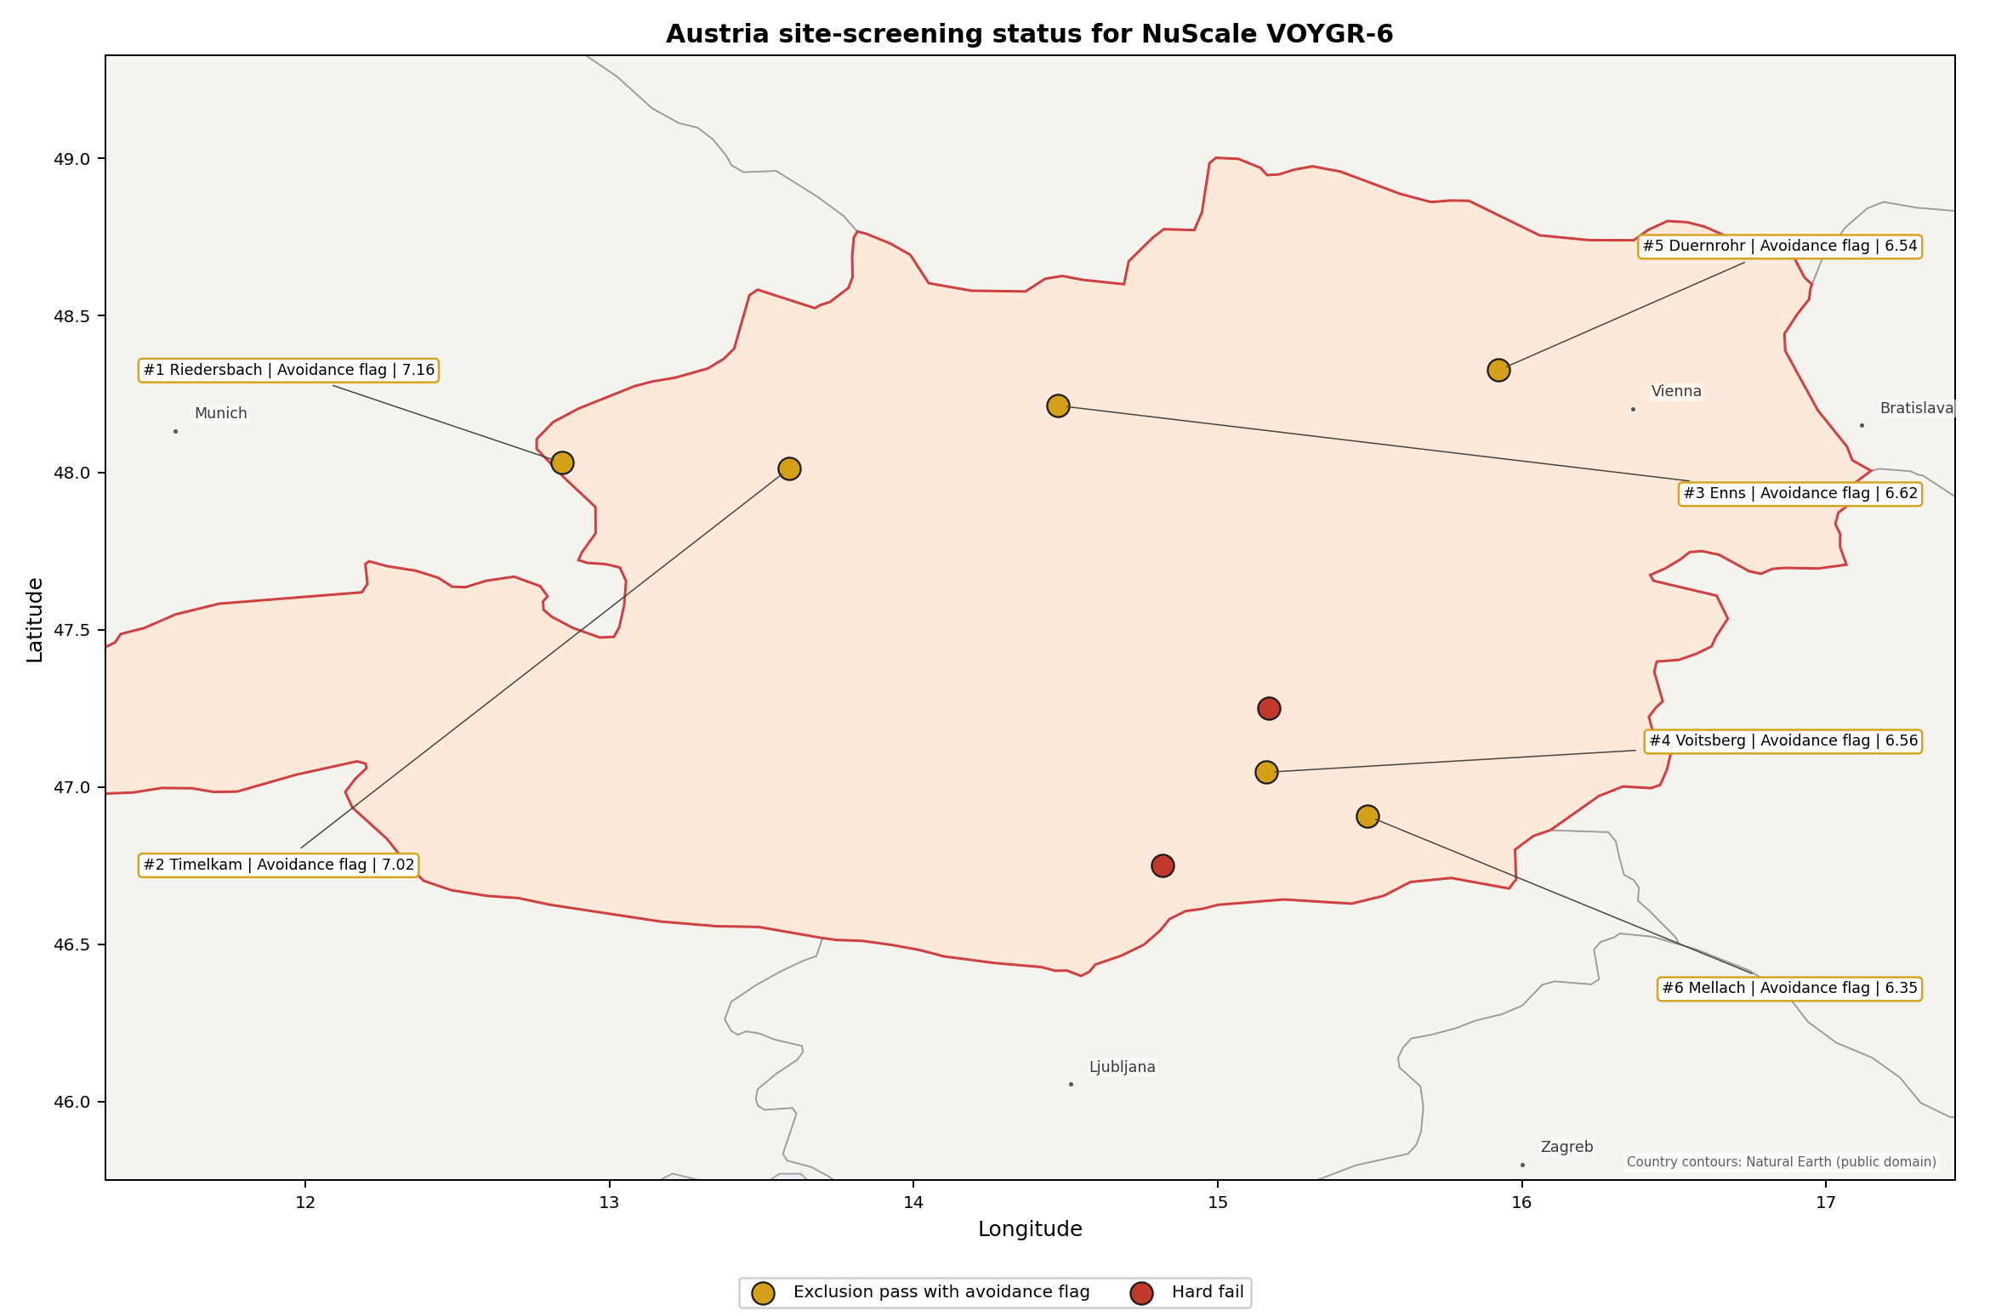
Austria status map

Austria Site Ledger
Rank | Site | Status | Composite | MC Low | MC High | Band | Top-10 Hit | Coverage
1 | Riedersbach power station | Exclusion pass with avoidance flag | 7.159 | 6.361 | 7.650 | A | 100% | 76%
2 | Timelkam power station | Exclusion pass with avoidance flag | 7.016 | 6.245 | 7.487 | H | 0% | 76%
3 | Enns Power Station | Exclusion pass with avoidance flag | 6.616 | 5.922 | 7.156 | H | 0% | 76%
4 | Voitsberg power station | Exclusion pass with avoidance flag | 6.559 | 5.876 | 7.050 | H | 0% | 76%
5 | Duernrohr power station | Exclusion pass with avoidance flag | 6.544 | 5.864 | 7.081 | H | 0% | 76%
6 | Mellach power station | Exclusion pass with avoidance flag | 6.347 | 5.705 | 6.837 | H | 0% | 76%
- | St Andrae power station | Hard fail | - | - | - | - | - | 0%
- | Zeltweg power station | Hard fail | - | - | - | - | - | 0%

Avoidance Flag Pareto
Of the 6 sites that pass the exclusionary screen, the avoidance-phase flags concentrate on a small set of criteria. Resolving them is what would move the country from a small leading group to a broader candidate pool.
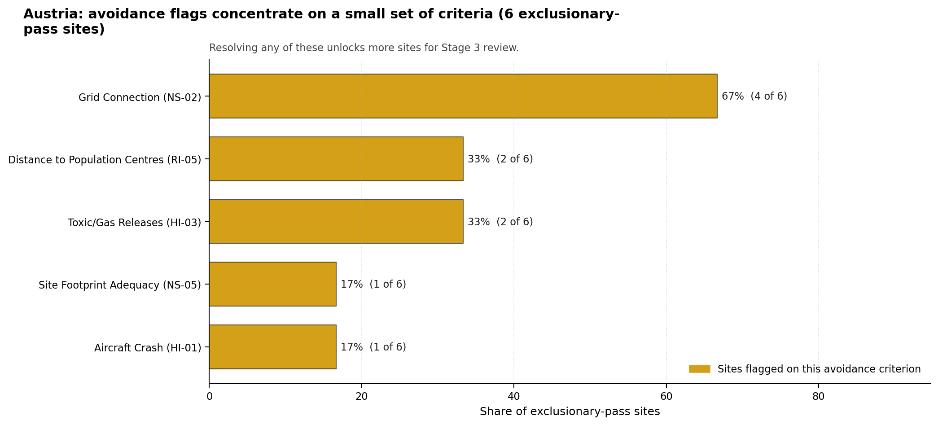
Avoidance flag Pareto
- Grid Connection (NS-02) - 4 of 6 exclusionary-pass sites (67%).
- Toxic/Gas Releases (HI-03) - 2 of 6 exclusionary-pass sites (33%).
- Distance to Population Centres (RI-05) - 2 of 6 exclusionary-pass sites (33%).
- Aircraft Crash (HI-01) - 1 of 6 exclusionary-pass sites (17%).
- Site Footprint Adequacy (NS-05) - 1 of 6 exclusionary-pass sites (17%).

Exclusionary Failure Pareto
The exclusionary failures across the country trace back to a small number of criteria. They identify which screening checks are responsible for removing sites from further consideration.
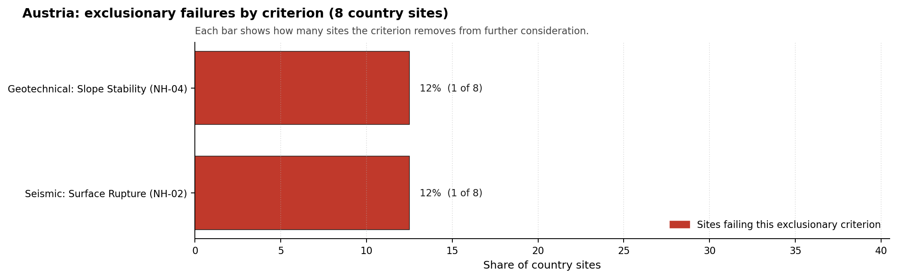
Exclusionary failure Pareto
- Seismic: Surface Rupture (NH-02) - 1 of 8 country sites (12%).
- Geotechnical: Slope Stability (NH-04) - 1 of 8 country sites (12%).

Family Strength and Weakness
Across the country the strongest criterion family is Natural Hazards at a mean normalised score of 7.65/10. The weakest family is Radiological Impact at 5.54/10. The bottom three individual criteria across the country are:
- Electromagnetic Interference (HI-07) - mean 1.50/10 across 8 scored sites (min 1.5, max 1.5).
- Military Installations (HI-06) - mean 1.62/10 across 8 scored sites (min 0.0, max 3.5).
- Ecological Sensitivity (NS-08) - mean 2.50/10 across 8 scored sites (min 1.5, max 5.5).

Interpretation for Site Selection
Austria’s site-selection result should be read by class first and rank second. The two hard-fail sites remain useful comparators for exclusionary logic, but they should not absorb Stage 3 effort unless the failed natural-hazard findings are overturned by better evidence. The six exclusionary-pass sites are not equivalent candidates: all carry avoidance flags, and only Riedersbach has a strong national sensitivity profile.

Avoidance flag Pareto - what unlocks more sites
The avoidance Pareto shows the practical unlock sequence for Austria. Transmission adequacy is the first system-level question because NS-02 affects most of the exclusionary-pass pool. Hazardous-neighbour and population-centre checks follow because they determine whether Enns and Duernrohr can remain in the selected set after detailed evidence review. Site-footprint work is narrower but important for Riedersbach because its buildable development area is small relative to the broader site surface.
The Monte Carlo intervals overlap across the selected sites, so point-rank differences below Riedersbach should not be overinterpreted. The robust finding is that Austria has one nationally stable avoidance-flagged leader and four selected follow-up sites whose Stage 3 value depends on retiring specific flags. Field work should therefore begin with Riedersbach, run a parallel transmission and land review for Timelkam and Voitsberg, and keep Enns and Duernrohr contingent on hazardous-neighbour, population-centre and ecological screens.

Status Counts
- Full pass: 0
- Exclusion pass with avoidance flag: 6
- Hard fail: 2

Duernrohr power station Site Profile
Duernrohr power station is a coal/thermal site in Austria that has been tested against the NuScale VOYGR-6 reference deployment envelope. This profile reads the screening evidence at a level that supports a decision to progress toward Stage 3 characterisation. It is not a site-suitability determination, vendor recommendation, or licensing finding.

Site Snapshot
Field | Value
Site name | Duernrohr power station
Coordinates | 48.3261, 15.9233
Subnational unit | Lower Austria
Installed thermal capacity (source data) | 802 MW
Available surface area | 120.0 ha
Available surface area for development | 10.2 ha
Composite score (baseline weights) | 6.544 (5.864-7.081 MC band)
National stability band | H (top-10% hit rate 0%)
National rank | 5
See the country status map in Austria Country Profile.

Ownership and Coal-to-Nuclear Context
Duernrohr is recorded with a split operating context: EVN AG appears as immediate operator for one unit, while Verbund Thermal Power GmbH & Co KG appears through Verbund AG for another. The bundle shows the Government of Austria holding 51.00% of Verbund AG, and EVN AG as a direct Austrian utility owner for Unit 2. Stage 3 would need to reconcile these chains into a single site-control and reuse position before treating the site as development-ready.
Generating units on record: 2 retired. Earliest unit commissioning: 1985; most recent: 1987. Retirements span 2015 to 2019, leaving a large brownfield thermal complex with strong grid, rail, water and industrial-transition relevance.

Natural Hazards (NH)
- Seismic: Ground Motion (NH-01) - score 5.5/10 (MC 5.0-6.0), pass-mark band: At or below the score-5 risk boundary., weight 0.0455, data quality high. Evidence: PGA at 475-year return period 0.087 g; PGA at 2,475-year return period 0.201 g; Vs30 reference (m/s): 760.0.
- Seismic: Surface Rupture (NH-02) - score 7.5/10 (MC 7.0-8.0), weight n/a, data quality screening grade. Evidence: nearest mapped capable fault 23.9 km; fault slip rate 0.022 mm/yr; fault name: ATCF008.
- Geotechnical: Liquefaction (NH-03) - score 5.5/10 (MC 5.0-6.0), pass-mark band: Moderate susceptibility, or high/very-high with documented (with mitigation to be confirmed) mitigation., weight n/a, data quality medium. Evidence: liquefaction susceptibility: high; dominant soil type: silty_clay_loam.
- Geotechnical: Slope Stability (NH-04) - score 7.5/10 (MC 7.0-8.0), weight n/a, data quality screening grade. Evidence: site slope 5.46 deg; max slope in 1 km box 84.2 deg; slope stability class: moderate.
- Geotechnical: Subsidence (NH-05) - score 9.5/10 (MC 9.0-10.0), favourable: No karst; mine-feature distance well above the score-5 pivot (or unknown)., weight 0.0354, data quality medium. Evidence: karst present: no; karst severity: none.
- Geotechnical: Foundation (NH-06) - score 5.5/10 (MC 5.0-6.0), pass-mark band: Typical European mixed conditions (bearing 80-150 kPa)., weight 0.0253, data quality medium. Evidence: bearing capacity 84.7 kPa; depth to bedrock 31.8 m.
- Volcanism (NH-07) - score 9.5/10 (MC 9.0-10.0), favourable: Very strong margin above the score-5 boundary (or screening found no in-radius signal)., weight n/a, data quality high. Evidence: volcanic hazard class: negligible.
- Coastal Flooding (NH-08) - score 9.5/10 (MC 9.0-10.0), favourable: Non-coastal OR elevation >= 50 m AMSL OR landlocked country, with no positive marine-hazard signal., weight 0.0303, data quality medium. Evidence: distance to coast 333.3 km.
- River Flooding (NH-09) - score 7.5/10 (MC 7.0-8.0), weight 0.0404, data quality medium. Evidence: flood zone class: negligible.
- Extreme Winds (NH-10) - score 3.5/10 (MC 3.0-4.0), weight 0.0152, data quality medium. Evidence: screening wind-speed index 11.1 m/s.
- Extreme Precipitation (NH-11) - score 8.0/10 (MC 8.0-9.0), favourable: aggregated(mean_of_sub_scores), weight 0.0152, data quality medium. Evidence: screening extreme-precipitation index 0.25 mm; screening precipitation index 25.2 mm/yr.
- Extreme Temperatures (NH-12) - score 6.5/10 (MC 6.0-7.0), pass-mark band: aggregated(mean_of_sub_scores), weight 0.0202, data quality medium. Evidence: extreme high temperature 23.4 deg C; extreme low temperature -5.12 deg C.
- Combined Hazards (NH-14) - score 5.5/10 (MC 5.0-6.0), pass-mark band: At least 5 resolved, exactly one moderate hazard (3-5) or moderate interaction only., weight 0.0152, data quality n/a. Evidence: no measured value in the current screening record.

Interpretation - Natural Hazards (NH)
Duernrohr has a moderate natural-hazard screen compared with the other selected Austrian sites. Ground motion is the highest in the selected set, with PGA of 0.087 g at 475 years and 0.201 g at 2,475 years, and the nearest mapped capable fault is 23.9 km away. Liquefaction susceptibility is high on silty clay loam, bearing capacity is 84.7 kPa, and depth to bedrock is 31.8 m. River flooding is negligible and the site is 333.3 km from the coast, but extreme winds score lower at 11.1 m/s. Stage 3 should confirm liquefaction, wind design basis and foundation conditions before relying on Duernrohr’s otherwise favourable non-safety profile.

Human-Induced and Security-Relevant Hazards (HI)
- Aircraft Crash (HI-01) - score 9.5/10 (MC 9.0-10.0), favourable: Only small / GA / heliport airport >= 10 km nearby, no flight-path proxy < 4 km, no major airport within 30 km, and no military airbase within 60 km., weight 0.0354, data quality high. Evidence: nearest airport 10.5 km; nearest flight path 7.06 km; airports within search radius 7; airport name: Tulln Heliport; airport type: heliport.
- Industrial Explosions (HI-02) - score 9.5/10 (MC 9.0-10.0), favourable: Very strong margin above the score-5 boundary (or completed search confirmed no in-radius signal)., weight 0.0354, data quality high. Evidence: nearest industrial site 0.69 km.
- Toxic/Gas Releases (HI-03) - score 0.0/10 (MC 0.0-0.0), weight 0.0354, data quality high. Evidence: nearest toxic source 0.69 km.
- External Fires (HI-04) - score 9.5/10 (MC 9.0-10.0), favourable: > 15 km, or completed flammable-storage search found nothing in radius., weight 0.0303, data quality high. Evidence: no measured value in the current screening record.
- Military Installations (HI-06) - score 1.5/10 (MC 1.0-2.0), weight 0.0303, data quality medium. Evidence: nearest military installation 7.93 km; military installations within radius 70; installation name: unnamed.
- Electromagnetic Interference (HI-07) - score 1.5/10 (MC 1.0-2.0), weight 0.0101, data quality medium. Evidence: nearest high-power transmitter 0.2 km; transmitters within radius 313; transmitter type: mast.

Interpretation - Human-Induced and Security-Relevant Hazards (HI)
Human-induced hazards are Duernrohr’s main weakness. Aircraft Crash (HI-01) is favourable at screening level, with Tulln Heliport 10.5 km away, the nearest flight path 7.06 km away and 7 airports in radius. The hazardous-neighbour screen is not favourable: Toxic/Gas Releases (HI-03) scores 0.0/10 because the nearest toxic source is 0.69 km away, creating an avoidance flag. Military Installations (HI-06) is also weak, with the nearest feature 7.93 km away and 70 records in radius, and Electromagnetic Interference (HI-07) has a transmitter 0.20 km away. Stage 3 should not proceed without a hazardous-cloud consequence study, defence-feature review and RF survey.

Radiological Impact and Emergency Planning (RI / EP)
- Emergency Planning Feasibility (EP-01) - score 7.5/10 (MC 7.0-8.0), weight n/a, data quality high. Evidence: EP feasibility composite 72.0 /100; road sub-score 78.2 /100; special-population sub-score 90.0 /100; geography sub-score 95.0 /100; population sub-score 80.0 /100; evacuation feasible: yes.
- Evacuation Routes (EP-02) - score 7.5/10 (MC 7.0-8.0), weight 0.0303, data quality medium. Evidence: road density in EPZ 1.13 km/km2; road length in EPZ 2,219 km; motorway access: yes.
- Physical Geography Constraints (EP-03) - score 9.5/10 (MC 9.0-10.0), favourable: No measured relief; open river/waterway context (interim screening)., weight 0.0253, data quality medium. Evidence: waterways crossing EPZ 0; major river barrier: no.
- Special Populations (EP-04) - score 5.5/10 (MC 5.0-6.0), pass-mark band: 9-25., weight 0.0303, data quality medium. Evidence: hospitals in EPZ 14; prisons in EPZ 3; care homes in EPZ 6.
- Atmospheric Dispersion (RI-01) - unscored (no band matched), weight 0.0303, data quality medium. Evidence: annual mean wind speed 1.35 m/s; atmospheric mixing height 548.6 m; prevailing wind direction: W.
- Surface Water Dispersion (RI-02) - score 9.5/10 (MC 9.0-10.0), favourable: > 500 m3/s., weight 0.0253, data quality n/a. Evidence: no measured value in the current screening record.
- Groundwater Dispersion (RI-03) - score 5.5/10 (MC 5.0-6.0), pass-mark band: Moderate-permeability aquifer screening proxy., weight 0.0253, data quality medium. Evidence: aquifer type: sedimentary sands.
- Population Density at EPZ Radii (RI-04) - score 3.5/10 (MC 3.0-4.0), weight 0.0404, data quality screening grade. Evidence: population density within 5 km 109.8 /km2; population density within 16 km 106.4 /km2; population density within 25 km 129.1 /km2; population density within 80 km 184.6 /km2; population within 25 km 253,384 people.
- Distance to Population Centres (RI-05) - score 1.5/10 (MC 1.0-2.0), weight 0.0505, data quality screening grade. Evidence: nearest city above 50k people 35.9 km; nearest city population 1,766,746 people; city name: Greater Wien.
- Population Projections (RI-06) - score 5.5/10 (MC 5.0-6.0), pass-mark band: 0 % to +0.3 %., weight 0.0253, data quality screening grade. Evidence: annual population growth rate 0.233 %/yr; projected population at 25 km in 60 yr 264,777 people.

Interpretation - Radiological Impact and Emergency Planning (RI / EP)
Duernrohr’s emergency-planning indicators are strong, but its position relative to Greater Wien creates an avoidance issue. EP-01 scores 72.0/100 and is feasible, supported by 1.13 km/km2 road density, 2,219 km of EPZ road length and no major river barrier. Population within 25 km is 253,384, but the 80 km density is 184.6 people/km2 and Greater Wien, with 1,766,746 people, is 35.9 km away. That is below the 48.0 km distance threshold used for a population centre of that size, so RI-05 remains an avoidance flag. The Danube setting supports strong surface-water dispersion at screening level. Stage 3 should micro-site the population-centre distance and model EPZ planning assumptions with the Vienna-region receptor context in view.

Non-Safety and Implementation Considerations (NS)
- Grid Capacity Basic Filter (BF-01) - score 7.5/10 (MC 7.0-8.0), weight n/a, data quality n/a. Evidence: no measured value in the current screening record.
- Land Area Basic Filter (BF-02) - score 1.5/10 (MC 1.0-2.0), weight 0.0253, data quality n/a. Evidence: no measured value in the current screening record.
- Cooling Water Availability (NS-01) - score 9.0/10 (MC 8.0-10.0), favourable: aggregated(weighted_mean_of_sub_scores), weight 0.0404, data quality screening grade. Evidence: distance to cooling source 1.92 km; cooling source flow 1,918 m3/s; cooling source type: major_river; cooling source name: Danube; water stress label: Low.
- Grid Connection (NS-02) - score 7.5/10 (MC 7.0-8.0), weight 0.0404, data quality high. Evidence: nearest substation 0.2 km; nearest high-voltage line 0.2 km; highest nearby line voltage 380.0 kV; grid export capacity 802.0 MW; substations within radius 2,936; HV lines within radius 896.
- Transport Access (NS-03) - score 8.0/10 (MC 8.0-9.0), favourable: aggregated(weighted_mean_of_sub_scores), weight 0.0404, data quality high. Evidence: nearest highway 3.35 km; nearest rail line 0.02 km; nearest waterway 2.18 km; heavy-haul capable: yes.
- Site Topography (NS-04) - score 9.5/10 (MC 9.0-10.0), favourable: > 80 %., weight 0.0303, data quality screening grade. Evidence: favourable land cover 92.2 %; moderate land cover 5.7 %; unfavourable land cover 2.1 %; favourable area 289.0 ha; dominant land class: 211.
- Site Footprint Adequacy (NS-05) - score 9.5/10 (MC 9.0-10.0), favourable: Very strong margin above the score-5 boundary., weight 0.0253, data quality high. Evidence: buildable area 10.2 ha; largest contiguous patch 10.2 ha; buildable patch count 6.
- Existing Infrastructure (NS-06) - unscored (no band matched), weight 0.0253, data quality n/a. Evidence: not measured at this site (criterion remains unscored).
- Ecological Sensitivity (NS-08) - score 1.5/10 (MC 1.0-2.0), weight n/a, data quality high. Evidence: natural land cover 2.1 %; distance to nearest Natura 2000 site 1.744 km; distance to nearest protected area 6.718 km; Natura 2000 overlap: no; Natura 2000 sensitivity class: moderate; protected-area overlap: no; protected-area sensitivity class: low; nearest Natura 2000 site: Tullnerfelder Donau-Auen; Natura 2000 sites within 5 km: 2; nearest protected-area designation: Landscape Protection Area.
- Workforce Availability (NS-10) - unscored (no band matched), weight 0.0202, data quality n/a. Evidence: not measured at this site (criterion remains unscored).
- Regulatory/Political Environment (NS-12) - unscored (no band matched), weight 0.0303, data quality n/a. Evidence: not measured at this site (criterion remains unscored).
- Construction Logistics (NS-13) - unscored (no band matched), weight 0.0202, data quality n/a. Evidence: not measured at this site (criterion remains unscored).

Interpretation - Non-Safety and Implementation Considerations (NS)
Duernrohr has the strongest grid and cooling infrastructure in the selected Austrian set. The Danube is 1.92 km away with recorded flow of 1,918 m3/s, the nearest substation and high-voltage line are both 0.20 km away, the highest nearby voltage is 380 kV, and recorded export capacity is 802 MW. Rail access is very close at 0.02 km and highway access is 3.35 km away. Land is more complex: the site surface is 120.0 ha, while the development-area estimate is 10.2 ha, so the wider surface should not be treated as already development-ready. Ecology is another constraint because Tullnerfelder Donau-Auen lies 1.744 km away and two Natura 2000 sites sit within 5 km. Stage 3 should confirm controlled developable land and start ecological screening alongside the hazardous-neighbour work.

Composite Score and Stability
Baseline composite score is 6.544, bracketed by Monte Carlo at 5.864-7.081. National stability band is H with a top-10% hit rate of 0% in the national sensitivity analysis.
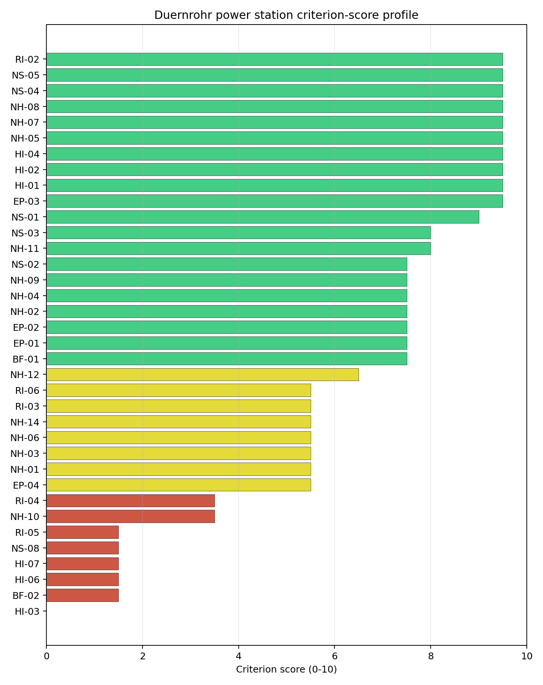
Criterion scores
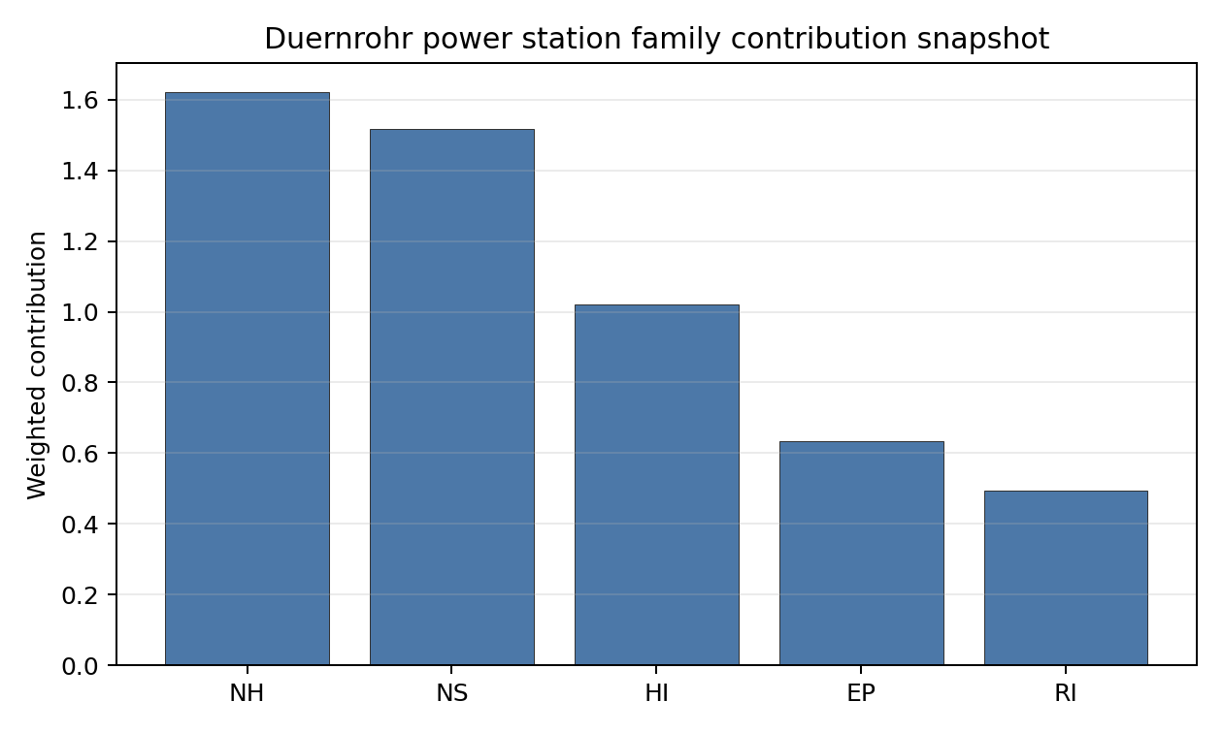
Family contributions
Duernrohr ranks fifth nationally with a composite score of 6.544 and a Monte Carlo band of 5.864-7.081. It is band H with a 0% top-10 hit rate in the national sensitivity analysis. The site stays in the selected set because its grid, cooling and logistics evidence are unusually strong for Austria. Its Stage 3 case is nevertheless conditional: HI-03 and RI-05 are active avoidance flags, and both relate to issues that can be decisive for nuclear siting rather than simple engineering refinements.

Residual Risk Register
Concern | Evidence | Consequence | Stage 3 action | Owner discipline
Toxic/Gas Releases (HI-03) | Nearest toxic source 0.69 km | Hazardous-cloud source may be incompatible without relocation or separation | Complete hazardous-neighbour consequence analysis | Industrial safety
Distance to Population Centres (RI-05) | Greater Wien 35.9 km away; required distance 48.0 km | Large-population-centre proximity may remain an avoidance constraint | Micro-site and model population-centre distance and receptor exposure | Radiological / EP
Land Development Area | 120.0 ha site surface; 10.2 ha development-area estimate | Usable controlled footprint may be smaller than the headline site area | Survey parcels, constraints and laydown envelope | Site engineering
Ecological Sensitivity (NS-08) | Tullnerfelder Donau-Auen 1.744 km away; 2 Natura 2000 sites within 5 km | Permitting schedule may be driven by protected floodplain receptors | Start Habitats Directive screening and EIA scoping | EIA
Military / EMI Context | Military feature 7.93 km away; transmitter 0.20 km away | Security or RF controls may affect layout | Confirm feature classification and complete RF survey | Security / I&C

Stage 3 Follow-Up Checklist
- Resolve Toxic/Gas Releases (HI-03) through hazardous-cloud consequence modelling and separation review.
- Resolve Distance to Population Centres (RI-05) against the Greater Wien threshold.
- Confirm Military Installations (HI-06) classification and standoff assumptions.
- Survey Electromagnetic Interference (HI-07) around the 0.20 km transmitter record.
- Complete Ecological Sensitivity (NS-08) screening for Tullnerfelder Donau-Auen.
- Improve data quality for Geotechnical: Subsidence & Collapse (NH-05b).

Evidence Limitations
- Geotechnical: Subsidence & Collapse (NH-05b) - quality low.

Enns Power Station Site Profile
Enns Power Station is a coal/thermal site in Austria that has been tested against the NuScale VOYGR-6 reference deployment envelope. This profile reads the screening evidence at a level that supports a decision to progress toward Stage 3 characterisation. It is not a site-suitability determination, vendor recommendation, or licensing finding.

Site Snapshot
Field | Value
Site name | Enns Power Station
Coordinates | 48.2131, 14.4752
Subnational unit | Enns
Installed thermal capacity (source data) | 800 MW
Available surface area | 41.5 ha
Available surface area for development | 5.7 ha
Composite score (baseline weights) | 6.616 (5.922-7.156 MC band)
National stability band | H (top-10% hit rate 0%)
National rank | 3
See the country status map in Austria Country Profile.

Ownership and Coal-to-Nuclear Context
Enns is recorded with Energie AG Oberösterreich as immediate operator. The ownership chain in the bundle is led by OÖ Landesholding GmbH at 52.71%, with additional Austrian municipal, banking and utility shareholders including Linz AG, Raiffeisenlandesbank Oberösterreich AG, TIWAG-Tiroler Wasserkraft AG and Verbund AG. Because the unit record is cancelled rather than retired operation, Stage 3 would need to confirm the current industrial land status, permitting history and reusable infrastructure before assuming coal-to-nuclear continuity.
Generating units on record: 1 cancelled. The site remains relevant because the bundle records large installed thermal capacity and strong infrastructure indicators, but it requires a stronger evidence check than a retired operating station.

Natural Hazards (NH)
- Seismic: Ground Motion (NH-01) - score 9.5/10 (MC 9.0-10.0), favourable: Well below the risk boundary., weight 0.0455, data quality high. Evidence: PGA at 475-year return period 0.036 g; PGA at 2,475-year return period 0.068 g; Vs30 reference (m/s): 760.0.
- Seismic: Surface Rupture (NH-02) - score 9.5/10 (MC 9.0-10.0), favourable: Very strong separation from mapped capable faults; surface-rupture concern effectively screened at desk-study level., weight n/a, data quality screening grade. Evidence: nearest mapped capable fault 50.0 km; fault slip rate 0 mm/yr; fault name: none_in_search_radius.
- Geotechnical: Liquefaction (NH-03) - score 5.5/10 (MC 5.0-6.0), pass-mark band: Moderate susceptibility, or high/very-high with documented (with mitigation to be confirmed) mitigation., weight n/a, data quality medium. Evidence: liquefaction susceptibility: moderate; dominant soil type: silty_clay_loam.
- Geotechnical: Slope Stability (NH-04) - score 7.5/10 (MC 7.0-8.0), weight n/a, data quality screening grade. Evidence: site slope 5.19 deg; max slope in 1 km box 85.5 deg; slope stability class: moderate.
- Geotechnical: Subsidence (NH-05) - score 9.5/10 (MC 9.0-10.0), favourable: No karst; mine-feature distance well above the score-5 pivot (or unknown)., weight 0.0354, data quality medium. Evidence: karst present: no; karst severity: none.
- Geotechnical: Foundation (NH-06) - score 5.5/10 (MC 5.0-6.0), pass-mark band: Typical European mixed conditions (bearing 80-150 kPa)., weight 0.0253, data quality medium. Evidence: bearing capacity 87.3 kPa; depth to bedrock 24.7 m.
- Volcanism (NH-07) - score 9.5/10 (MC 9.0-10.0), favourable: Very strong margin above the score-5 boundary (or screening found no in-radius signal)., weight n/a, data quality high. Evidence: volcanic hazard class: negligible.
- Coastal Flooding (NH-08) - score 9.5/10 (MC 9.0-10.0), favourable: Non-coastal OR elevation >= 50 m AMSL OR landlocked country, with no positive marine-hazard signal., weight 0.0303, data quality medium. Evidence: distance to coast 279.0 km.
- River Flooding (NH-09) - score 7.5/10 (MC 7.0-8.0), weight 0.0404, data quality medium. Evidence: flood zone class: negligible.
- Extreme Winds (NH-10) - score 5.5/10 (MC 5.0-6.0), pass-mark band: Middle relative wind exposure around the observed cohort mean (9.0-10.5 m/s)., weight 0.0152, data quality medium. Evidence: screening wind-speed index 10.4 m/s.
- Extreme Precipitation (NH-11) - score 6.0/10 (MC 6.0-7.0), pass-mark band: aggregated(mean_of_sub_scores), weight 0.0152, data quality medium. Evidence: screening extreme-precipitation index 0.36 mm; screening precipitation index 28.8 mm/yr.
- Extreme Temperatures (NH-12) - score 7.5/10 (MC 7.0-8.0), weight 0.0202, data quality medium. Evidence: extreme high temperature 23.1 deg C; extreme low temperature -3.75 deg C.
- Combined Hazards (NH-14) - score 5.5/10 (MC 5.0-6.0), pass-mark band: At least 5 resolved, exactly one moderate hazard (3-5) or moderate interaction only., weight 0.0152, data quality n/a. Evidence: no measured value in the current screening record.

Interpretation - Natural Hazards (NH)
Enns has a favourable natural-hazard screen, with low seismic loading and no current natural-hazard exclusionary signal. PGA is 0.036 g at 475 years and 0.068 g at 2,475 years, and the nearest mapped capable fault is 50.0 km away. Liquefaction susceptibility is moderate on silty clay loam, bearing capacity is 87.3 kPa, depth to bedrock is 24.7 m, and mean site slope is 5.19 degrees. The river-flood class is negligible and the site is 279.0 km from the coast. The main Stage 3 tasks are local geotechnical confirmation and a check of the precipitation values, which are too coarse for design drainage or flood claims.

Human-Induced and Security-Relevant Hazards (HI)
- Aircraft Crash (HI-01) - score 7.5/10 (MC 7.0-8.0), weight 0.0354, data quality high. Evidence: nearest airport 13.2 km; nearest flight path 6.6 km; airports within search radius 6; airport name: Hofkirchen Airfield; airport type: small airfield.
- Industrial Explosions (HI-02) - score 9.5/10 (MC 9.0-10.0), favourable: Very strong margin above the score-5 boundary (or completed search confirmed no in-radius signal)., weight 0.0354, data quality high. Evidence: nearest industrial site 5.36 km.
- Toxic/Gas Releases (HI-03) - score 3.5/10 (MC 3.0-4.0), weight 0.0354, data quality high. Evidence: nearest toxic source 5.36 km.
- External Fires (HI-04) - score 9.5/10 (MC 9.0-10.0), favourable: > 15 km, or completed flammable-storage search found nothing in radius., weight 0.0303, data quality high. Evidence: no measured value in the current screening record.
- Military Installations (HI-06) - score 0.0/10 (MC 0.0-0.0), weight 0.0303, data quality high. Evidence: nearest military installation 0.36 km; military installations within radius 32; installation name: unnamed.
- Electromagnetic Interference (HI-07) - score 1.5/10 (MC 1.0-2.0), weight 0.0101, data quality medium. Evidence: nearest high-power transmitter 0.37 km; transmitters within radius 447; transmitter type: lighting.

Interpretation - Human-Induced and Security-Relevant Hazards (HI)
Human-induced hazards are a serious constraint at Enns. Aircraft Crash (HI-01) is acceptable at screening level, with Hofkirchen Airfield 13.2 km away and the nearest flight-path proxy 6.6 km away. Industrial explosion distance is favourable at 5.36 km under the current scoring, but Toxic/Gas Releases (HI-03) remains an avoidance flag because the nearest toxic source is also 5.36 km, inside the 8 km avoidance threshold. The highest-severity concern is Military Installations (HI-06): the nearest military feature is only 0.36 km away and 32 features are recorded in the wider radius. Electromagnetic Interference (HI-07) is also weak, with a transmitter 0.37 km away and 447 transmitters in radius. Enns should not progress without a hazardous-neighbour, military and RF screen at site scale.

Radiological Impact and Emergency Planning (RI / EP)
- Emergency Planning Feasibility (EP-01) - score 7.5/10 (MC 7.0-8.0), weight n/a, data quality high. Evidence: EP feasibility composite 65.2 /100; road sub-score 78.6 /100; special-population sub-score 90.0 /100; geography sub-score 95.0 /100; population sub-score 60.0 /100; evacuation feasible: yes.
- Evacuation Routes (EP-02) - score 7.5/10 (MC 7.0-8.0), weight 0.0303, data quality medium. Evidence: road density in EPZ 1.145 km/km2; road length in EPZ 2,249 km; motorway access: yes.
- Physical Geography Constraints (EP-03) - score 9.5/10 (MC 9.0-10.0), favourable: No measured relief; open river/waterway context (interim screening)., weight 0.0253, data quality medium. Evidence: waterways crossing EPZ 0; major river barrier: no.
- Special Populations (EP-04) - score 1.5/10 (MC 1.0-2.0), weight 0.0303, data quality medium. Evidence: hospitals in EPZ 37; prisons in EPZ 4; care homes in EPZ 30.
- Atmospheric Dispersion (RI-01) - unscored (no band matched), weight 0.0303, data quality medium. Evidence: annual mean wind speed 1.03 m/s; atmospheric mixing height 496.3 m; prevailing wind direction: W.
- Surface Water Dispersion (RI-02) - score 9.5/10 (MC 9.0-10.0), favourable: > 500 m3/s., weight 0.0253, data quality n/a. Evidence: no measured value in the current screening record.
- Groundwater Dispersion (RI-03) - score 5.5/10 (MC 5.0-6.0), pass-mark band: Moderate-permeability aquifer screening proxy., weight 0.0253, data quality medium. Evidence: aquifer type: sedimentary sands.
- Population Density at EPZ Radii (RI-04) - score 3.5/10 (MC 3.0-4.0), weight 0.0404, data quality screening grade. Evidence: population density within 5 km 362.9 /km2; population density within 16 km 336.7 /km2; population density within 25 km 301.0 /km2; population density within 80 km 89.2 /km2; population within 25 km 590,914 people.
- Distance to Population Centres (RI-05) - score 3.5/10 (MC 3.0-4.0), weight 0.0505, data quality screening grade. Evidence: nearest city above 50k people 14.9 km; nearest city population 193,814 people; city name: Greater Linz.
- Population Projections (RI-06) - score 5.5/10 (MC 5.0-6.0), pass-mark band: 0 % to +0.3 %., weight 0.0253, data quality screening grade. Evidence: annual population growth rate 0.269 %/yr; projected population at 25 km in 60 yr 617,485 people.

Interpretation - Radiological Impact and Emergency Planning (RI / EP)
Radiological impact and emergency planning are the main reasons Enns is a conditional rather than robust candidate. The EP-01 composite is 65.2/100 and evacuation is marked feasible, helped by 1.145 km/km2 road density, 2,249 km of EPZ road length and motorway access. That positive access picture is offset by high receptor load: 37 hospitals, 4 prisons and 30 care homes in the EPZ, population density of 301.0 people/km2 within 25 km, and 590,914 people within 25 km. Greater Linz is 14.9 km away, which creates a Distance to Population Centres (RI-05) avoidance flag. Stage 3 would need detailed time-to-clear modelling, special-population transport planning and a population-centre micro-siting review before Enns can remain in the shortlist.

Non-Safety and Implementation Considerations (NS)
- Grid Capacity Basic Filter (BF-01) - score 5.5/10 (MC 5.0-6.0), pass-mark band: Note: substation 15-30 km OR 110-219 kV; reinforcement plausible., weight n/a, data quality n/a. Evidence: no measured value in the current screening record.
- Land Area Basic Filter (BF-02) - score 1.5/10 (MC 1.0-2.0), weight 0.0253, data quality n/a. Evidence: no measured value in the current screening record.
- Cooling Water Availability (NS-01) - score 8.0/10 (MC 8.0-9.0), favourable: aggregated(weighted_mean_of_sub_scores), weight 0.0404, data quality screening grade. Evidence: distance to cooling source 2.53 km; cooling source flow 1,563 m3/s; cooling source type: major_river; cooling source name: Bleicherbach (Stallbach); water stress label: Low.
- Grid Connection (NS-02) - score 5.5/10 (MC 5.0-6.0), pass-mark band: aggregated(min_of_sub_scores), weight 0.0404, data quality high. Evidence: nearest substation 0.73 km; nearest high-voltage line 1.65 km; highest nearby line voltage 110.0 kV; grid export capacity 800.0 MW; substations within radius 2,090; HV lines within radius 469.
- Transport Access (NS-03) - score 9.0/10 (MC 9.0-10.0), favourable: aggregated(weighted_mean_of_sub_scores), weight 0.0404, data quality high. Evidence: nearest highway 1.01 km; nearest rail line 0.91 km; nearest waterway 3.49 km; heavy-haul capable: yes.
- Site Topography (NS-04) - score 9.5/10 (MC 9.0-10.0), favourable: > 80 %., weight 0.0303, data quality screening grade. Evidence: favourable land cover 81.8 %; moderate land cover 9.9 %; unfavourable land cover 8.4 %; favourable area 41.5 ha; dominant land class: 211.
- Site Footprint Adequacy (NS-05) - score 7.5/10 (MC 7.0-8.0), weight 0.0253, data quality medium. Evidence: buildable area 5.71 ha; largest contiguous patch 5.71 ha; buildable patch count 11.
- Existing Infrastructure (NS-06) - unscored (no band matched), weight 0.0253, data quality n/a. Evidence: not measured at this site (criterion remains unscored).
- Ecological Sensitivity (NS-08) - score 1.5/10 (MC 1.0-2.0), weight n/a, data quality high. Evidence: natural land cover 8.4 %; distance to nearest Natura 2000 site 0.687 km; distance to nearest protected area 6.302 km; Natura 2000 overlap: no; Natura 2000 sensitivity class: high; protected-area overlap: no; protected-area sensitivity class: low; nearest Natura 2000 site: Unteres Steyr- und Ennstal; Natura 2000 sites within 5 km: 1; nearest protected-area designation: Nature Reserve.
- Workforce Availability (NS-10) - unscored (no band matched), weight 0.0202, data quality n/a. Evidence: not measured at this site (criterion remains unscored).
- Regulatory/Political Environment (NS-12) - unscored (no band matched), weight 0.0303, data quality n/a. Evidence: not measured at this site (criterion remains unscored).
- Construction Logistics (NS-13) - unscored (no band matched), weight 0.0202, data quality n/a. Evidence: not measured at this site (criterion remains unscored).

Interpretation - Non-Safety and Implementation Considerations (NS)
Enns has strong industrial infrastructure but a tight development envelope. Cooling is a major strength: the recorded cooling source is 2.53 km away with 1,563 m3/s flow, and road, rail and waterway access are all close enough to support heavy logistics. Grid evidence is also better than several Austrian peers, with a 0.73 km substation distance, 1.65 km high-voltage-line distance and 800 MW export-capacity record, although nearby voltage remains 110 kV. Land and ecology are the limiting issues. The site surface is 41.5 ha, but the development-area estimate is only 5.7 ha; the nearest Natura 2000 site, Unteres Steyr- und Ennstal, is 0.687 km away and has high sensitivity. Stage 3 should test whether additional controlled brownfield land exists and whether the Natura 2000 setting can be managed without narrowing the usable envelope further.

Composite Score and Stability
Baseline composite score is 6.616, bracketed by Monte Carlo at 5.922-7.156. National stability band is H with a top-10% hit rate of 0% in the national sensitivity analysis.
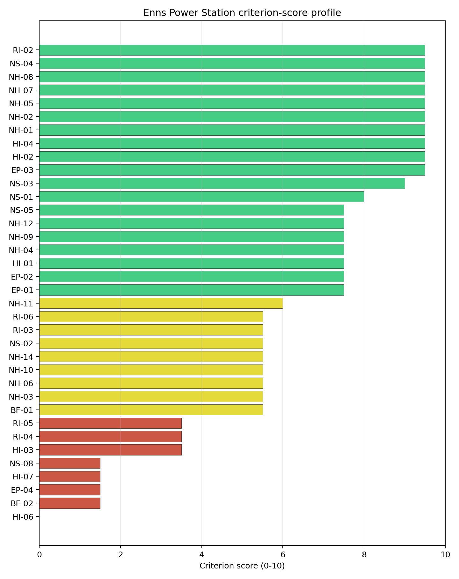
Criterion scores
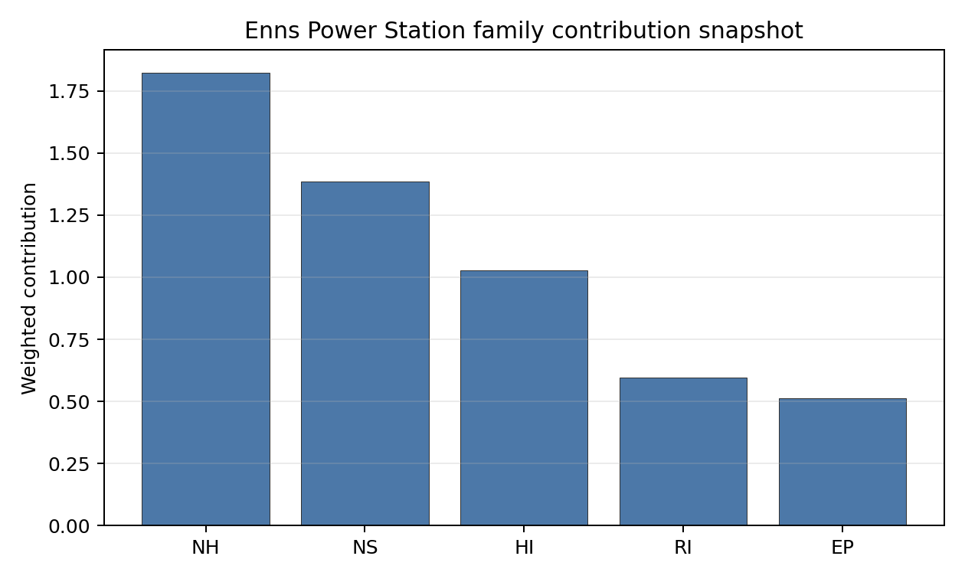
Family contributions
Enns ranks third nationally with a composite score of 6.616 and a Monte Carlo band of 5.922-7.156. Its national stability band is H with a 0% top-10 hit rate, so the point estimate does not survive the national sensitivity analysis as a robust high-ranking result. Enns is still selected because it is in the national top five and has strong cooling, access and export-capacity evidence. Its Stage 3 value depends on whether the HI-03, RI-05, military, special-population, ecology and land findings can be retired without a major redesign.

Residual Risk Register
Concern | Evidence | Consequence | Stage 3 action | Owner discipline
Toxic/Gas Releases (HI-03) | Nearest toxic source 5.36 km | Avoidance flag remains until hazardous-cloud source is resolved | Refresh hazardous-neighbour inventory and consequence distances | Industrial safety
Distance to Population Centres (RI-05) | Greater Linz 14.9 km away; required distance 16.0 km | Small distance shortfall may constrain emergency-planning confidence | Micro-site receptor distance and population-centre boundary | Radiological / EP
Military Installations (HI-06) | Nearest military feature 0.36 km; 32 features in radius | Security standoff could become a decisive constraint | Confirm feature type, status and required cordons | Security
Special Populations (EP-04) | 37 hospitals, 4 prisons and 30 care homes in EPZ | Special-mover demand may dominate evacuation planning | Model special-population clearance and support routes | Emergency planning
Ecological Sensitivity (NS-08) | Unteres Steyr- und Ennstal 0.687 km away | Permitting envelope may narrow the already small development area | Start Natura 2000 screening and receptor-pathway review | EIA

Stage 3 Follow-Up Checklist
- Resolve Toxic/Gas Releases (HI-03) through a refreshed hazardous-neighbour consequence screen.
- Resolve Distance to Population Centres (RI-05) by micro-siting against the Greater Linz distance threshold.
- Confirm Military Installations (HI-06) feature status and security-cordon implications.
- Model Special Populations (EP-04) and EPZ special-mover demand.
- Survey Electromagnetic Interference (HI-07) around the 0.37 km transmitter record.
- Complete Ecological Sensitivity (NS-08) screening for Unteres Steyr- und Ennstal.
- Improve data quality for Geotechnical: Subsidence & Collapse (NH-05b).

Evidence Limitations
- Geotechnical: Subsidence & Collapse (NH-05b) - quality low.

Riedersbach power station Site Profile
Riedersbach power station is a coal/thermal site in Austria that has been tested against the NuScale VOYGR-6 reference deployment envelope. This profile reads the screening evidence at a level that supports a decision to progress toward Stage 3 characterisation. It is not a site-suitability determination, vendor recommendation, or licensing finding.

Site Snapshot
Field | Value
Site name | Riedersbach power station
Coordinates | 48.0318, 12.8431
Subnational unit | Upper Austria
Installed thermal capacity (source data) | 220 MW
Available surface area | 18.0 ha
Available surface area for development | 12.8 ha
Composite score (baseline weights) | 7.159 (6.361-7.650 MC band)
National stability band | A (top-10% hit rate 100%)
National rank | 1
See the country status map in Austria Country Profile.

Ownership and Coal-to-Nuclear Context
Riedersbach is recorded with Energie AG Oberösterreich as immediate operator. The ownership chain in the bundle is led by OÖ Landesholding GmbH at 52.71%, with additional Austrian municipal, banking and utility shareholders including Linz AG, Raiffeisenlandesbank Oberösterreich AG, TIWAG-Tiroler Wasserkraft AG and Verbund AG. The chain is therefore anchored in Austrian public and domestic utility ownership, but detailed legal control and land rights still require owner confirmation.
Generating units on record: 2 retired. Earliest unit commissioning: 1969; most recent: 1986. Retirements span 2010 to 2016, leaving a brownfield industrial site with grid, water, transport and workforce relevance for Stage 3 review.

Natural Hazards (NH)
- Seismic: Ground Motion (NH-01) - score 9.5/10 (MC 9.0-10.0), favourable: Well below the risk boundary., weight 0.0455, data quality high. Evidence: PGA at 475-year return period 0.034 g; PGA at 2,475-year return period 0.067 g; Vs30 reference (m/s): 760.0.
- Seismic: Surface Rupture (NH-02) - score 7.5/10 (MC 7.0-8.0), weight n/a, data quality screening grade. Evidence: nearest mapped capable fault 31.2 km; fault slip rate 0.707 mm/yr; fault name: ATCF007.
- Geotechnical: Liquefaction (NH-03) - score 5.5/10 (MC 5.0-6.0), pass-mark band: Moderate susceptibility, or high/very-high with documented (with mitigation to be confirmed) mitigation., weight n/a, data quality medium. Evidence: liquefaction susceptibility: high; dominant soil type: loam.
- Geotechnical: Slope Stability (NH-04) - score 5.5/10 (MC 5.0-6.0), pass-mark band: At or below the score-5 risk boundary., weight n/a, data quality screening grade. Evidence: site slope 11.2 deg; max slope in 1 km box 87.3 deg; slope stability class: steep.
- Geotechnical: Subsidence (NH-05) - score 9.5/10 (MC 9.0-10.0), favourable: No karst; mine-feature distance well above the score-5 pivot (or unknown)., weight 0.0354, data quality medium. Evidence: karst present: no; karst severity: none.
- Geotechnical: Foundation (NH-06) - score 5.5/10 (MC 5.0-6.0), pass-mark band: Typical European mixed conditions (bearing 80-150 kPa)., weight 0.0253, data quality medium. Evidence: bearing capacity 80.7 kPa; depth to bedrock 20.5 m.
- Volcanism (NH-07) - score 9.5/10 (MC 9.0-10.0), favourable: Very strong margin above the score-5 boundary (or screening found no in-radius signal)., weight n/a, data quality high. Evidence: volcanic hazard class: negligible.
- Coastal Flooding (NH-08) - score 9.5/10 (MC 9.0-10.0), favourable: Non-coastal OR elevation >= 50 m AMSL OR landlocked country, with no positive marine-hazard signal., weight 0.0303, data quality medium. Evidence: distance to coast 252.8 km.
- River Flooding (NH-09) - score 7.5/10 (MC 7.0-8.0), weight 0.0404, data quality medium. Evidence: flood zone class: negligible.
- Extreme Winds (NH-10) - score 7.5/10 (MC 7.0-8.0), weight 0.0152, data quality medium. Evidence: screening wind-speed index 8.74 m/s.
- Extreme Precipitation (NH-11) - score 6.0/10 (MC 5.0-6.0), pass-mark band: aggregated(mean_of_sub_scores), weight 0.0152, data quality medium. Evidence: screening extreme-precipitation index 0.34 mm; screening precipitation index 44.2 mm/yr.
- Extreme Temperatures (NH-12) - score 7.5/10 (MC 7.0-8.0), weight 0.0202, data quality medium. Evidence: extreme high temperature 21.8 deg C; extreme low temperature -5.04 deg C.
- Combined Hazards (NH-14) - score 5.5/10 (MC 5.0-6.0), pass-mark band: At least 5 resolved, exactly one moderate hazard (3-5) or moderate interaction only., weight 0.0152, data quality n/a. Evidence: no measured value in the current screening record.

Interpretation - Natural Hazards (NH)
Riedersbach has a favourable natural-hazard screen, led by very low ground motion and a strong separation from mapped capable faults. The 475-year PGA is 0.034 g and the 2,475-year PGA is 0.067 g, while the nearest mapped capable fault is 31.2 km away. The main physical-site questions are geotechnical rather than country-scale: liquefaction susceptibility is high on loam soils, bearing capacity is 80.7 kPa, and depth to bedrock is 20.5 m. The site is non-coastal at 252.8 km from the coast, has negligible river-flood classification, and records moderate wind and temperature loads. Stage 3 should confirm liquefaction, bearing capacity and precipitation inputs with site investigations before the buildable patch is treated as firm.

Human-Induced and Security-Relevant Hazards (HI)
- Aircraft Crash (HI-01) - score 7.5/10 (MC 7.0-8.0), weight 0.0354, data quality high. Evidence: nearest airport 15.1 km; nearest flight path 12.5 km; airports within search radius 12; airport name: Altötting-Burghausen District Hospital Burghausen Heliport; airport type: heliport.
- Industrial Explosions (HI-02) - score 9.5/10 (MC 9.0-10.0), favourable: Very strong margin above the score-5 boundary (or completed search confirmed no in-radius signal)., weight 0.0354, data quality high. Evidence: nearest industrial site 21.9 km.
- Toxic/Gas Releases (HI-03) - score 7.5/10 (MC 7.0-8.0), weight 0.0354, data quality high. Evidence: nearest toxic source 21.9 km.
- External Fires (HI-04) - score 9.5/10 (MC 9.0-10.0), favourable: > 15 km, or completed flammable-storage search found nothing in radius., weight 0.0303, data quality high. Evidence: no measured value in the current screening record.
- Military Installations (HI-06) - score 3.5/10 (MC 3.0-4.0), weight 0.0303, data quality medium. Evidence: nearest military installation 19.0 km; military installations within radius 4; installation name: unnamed.
- Electromagnetic Interference (HI-07) - score 1.5/10 (MC 1.0-2.0), weight 0.0101, data quality medium. Evidence: nearest high-power transmitter 0.29 km; transmitters within radius 166; transmitter type: mast.

Interpretation - Human-Induced and Security-Relevant Hazards (HI)
Human-induced hazards are material but not dominated by a single exclusionary finding. Aircraft Crash (HI-01) is acceptable at screening level, with the nearest heliport 15.1 km away, the nearest flight-path proxy 12.5 km away, and 12 airports inside the search radius. Industrial and toxic-source distances are both 21.9 km, supporting a favourable hazardous-neighbour read. The principal weaknesses are Military Installations (HI-06), with 4 military features inside the radius and the nearest at 19.0 km, and Electromagnetic Interference (HI-07), with a high-power transmitter 0.29 km away and 166 transmitters in the wider radius. Stage 3 should quantify aircraft frequency, confirm military-feature classification and complete an RF/EMI survey.

Radiological Impact and Emergency Planning (RI / EP)
- Emergency Planning Feasibility (EP-01) - score 5.5/10 (MC 5.0-6.0), pass-mark band: At or above the composite score-5 boundary., weight n/a, data quality high. Evidence: EP feasibility composite 55.6 /100; road sub-score 66.4 /100; special-population sub-score 0 /100; geography sub-score 95.0 /100; population sub-score 80.0 /100; evacuation feasible: yes.
- Evacuation Routes (EP-02) - score 5.5/10 (MC 5.0-6.0), pass-mark band: Adequate primary routes (0.5-1.0)., weight 0.0303, data quality medium. Evidence: road density in EPZ 0.74 km/km2; road length in EPZ 1,452 km; motorway access: yes.
- Physical Geography Constraints (EP-03) - score 9.5/10 (MC 9.0-10.0), favourable: No measured relief; open river/waterway context (interim screening)., weight 0.0253, data quality medium. Evidence: waterways crossing EPZ 0; major river barrier: no.
- Special Populations (EP-04) - score 5.5/10 (MC 5.0-6.0), pass-mark band: 9-25., weight 0.0303, data quality medium. Evidence: hospitals in EPZ 17; prisons in EPZ 3; care homes in EPZ 2.
- Atmospheric Dispersion (RI-01) - unscored (no band matched), weight 0.0303, data quality medium. Evidence: annual mean wind speed 0.91 m/s; atmospheric mixing height 419.5 m; prevailing wind direction: WSW.
- Surface Water Dispersion (RI-02) - score 7.5/10 (MC 7.0-8.0), weight 0.0253, data quality n/a. Evidence: no measured value in the current screening record.
- Groundwater Dispersion (RI-03) - score 7.5/10 (MC 7.0-8.0), weight 0.0253, data quality medium. Evidence: aquifer type: low permeability.
- Population Density at EPZ Radii (RI-04) - score 5.5/10 (MC 5.0-6.0), pass-mark band: aggregated(min_of_sub_scores), weight 0.0404, data quality screening grade. Evidence: population density within 5 km 145.6 /km2; population density within 16 km 110.8 /km2; population density within 25 km 153.3 /km2; population density within 80 km 134.6 /km2; population within 25 km 301,073 people.
- Distance to Population Centres (RI-05) - score 9.5/10 (MC 9.0-10.0), favourable: Nearest >=50k population-centre proxy exceeds required distance by >= 50 %., weight 0.0505, data quality screening grade. Evidence: nearest city above 50k people 30.1 km; nearest city population 146,631 people; city name: Salzburg.
- Population Projections (RI-06) - score 5.5/10 (MC 5.0-6.0), pass-mark band: 0 % to +0.3 %., weight 0.0253, data quality screening grade. Evidence: annual population growth rate 0.054 %/yr; projected population at 25 km in 60 yr 314,610 people.

Interpretation - Radiological Impact and Emergency Planning (RI / EP)
Radiological and emergency-planning conditions are moderate and manageable at screening level. The EP-01 composite is 55.6/100 and marked feasible, supported by 1,452 km of road in the EPZ and no major river barrier. The weak point is the special-population burden: 17 hospitals, 3 prisons and 2 care homes sit inside the EPZ, producing a zero special-population sub-score in the composite even though EP-04 remains at 5.5/10. Population density is 145.6 people/km2 within 5 km and 153.3 people/km2 within 25 km, with Salzburg 30.1 km away. Low-permeability groundwater and the 7.5/10 surface-water dispersion score support the screen, but Stage 3 should still confirm discharge-pathway and clearance-time modelling.

Non-Safety and Implementation Considerations (NS)
- Grid Capacity Basic Filter (BF-01) - score 5.5/10 (MC 5.0-6.0), pass-mark band: Note: substation 15-30 km OR 110-219 kV; reinforcement plausible., weight n/a, data quality n/a. Evidence: no measured value in the current screening record.
- Land Area Basic Filter (BF-02) - score 1.5/10 (MC 1.0-2.0), weight 0.0253, data quality n/a. Evidence: no measured value in the current screening record.
- Cooling Water Availability (NS-01) - score 9.0/10 (MC 8.0-10.0), favourable: aggregated(weighted_mean_of_sub_scores), weight 0.0404, data quality screening grade. Evidence: distance to cooling source 0.58 km; cooling source flow 156.2 m3/s; cooling source type: major_river; cooling source name: Redlbach; water stress label: Low.
- Grid Connection (NS-02) - score 1.5/10 (MC 1.0-2.0), weight 0.0404, data quality high. Evidence: nearest substation 0.23 km; nearest high-voltage line 6.11 km; highest nearby line voltage 110.0 kV; grid export capacity 220.0 MW; substations within radius 2,656; HV lines within radius 671.
- Transport Access (NS-03) - score 8.0/10 (MC 7.0-8.0), favourable: aggregated(weighted_mean_of_sub_scores), weight 0.0404, data quality high. Evidence: nearest highway 2.55 km; nearest rail line 1.17 km; heavy-haul capable: yes.
- Site Topography (NS-04) - score 5.5/10 (MC 5.0-6.0), pass-mark band: 40-60 %., weight 0.0303, data quality screening grade. Evidence: favourable land cover 50.5 %; moderate land cover 18.3 %; unfavourable land cover 31.1 %; favourable area 90.2 ha; dominant land class: 311.
- Site Footprint Adequacy (NS-05) - score 5.5/10 (MC 5.0-6.0), pass-mark band: At or above the score-5 boundary., weight 0.0253, data quality high. Evidence: buildable area 12.8 ha; largest contiguous patch 12.8 ha; buildable patch count 17.
- Existing Infrastructure (NS-06) - unscored (no band matched), weight 0.0253, data quality n/a. Evidence: not measured at this site (criterion remains unscored).
- Ecological Sensitivity (NS-08) - score 1.5/10 (MC 1.0-2.0), weight n/a, data quality high. Evidence: natural land cover 31.1 %; distance to nearest Natura 2000 site 0.293 km; distance to nearest protected area 2.973 km; Natura 2000 overlap: no; Natura 2000 sensitivity class: high; protected-area overlap: no; protected-area sensitivity class: moderate; nearest Natura 2000 site: Salzachauen; Natura 2000 sites within 5 km: 8; nearest protected-area designation: Nature Reserve.
- Workforce Availability (NS-10) - unscored (no band matched), weight 0.0202, data quality n/a. Evidence: not measured at this site (criterion remains unscored).
- Regulatory/Political Environment (NS-12) - unscored (no band matched), weight 0.0303, data quality n/a. Evidence: not measured at this site (criterion remains unscored).
- Construction Logistics (NS-13) - unscored (no band matched), weight 0.0202, data quality n/a. Evidence: not measured at this site (criterion remains unscored).

Interpretation - Non-Safety and Implementation Considerations (NS)
Riedersbach’s implementation case is mixed: cooling water and transport are strong, while grid, ecology and land development constrain the site. The cooling source is 0.58 km away with a recorded flow of 156.2 m3/s, and heavy-haul access is supported by highway at 2.55 km and rail at 1.17 km. The grid file is the main avoidance flag: the nearest substation is 0.23 km away, but the nearest high-voltage line is 6.11 km away, the highest nearby voltage is 110 kV, and recorded export capacity is 220 MW against the 462 MWe VOYGR-6 reference output. Land is tight: the site surface is 18.0 ha and the development-area estimate is 12.8 ha. Ecological sensitivity is also high because Salzachauen lies 0.293 km away and 8 Natura 2000 sites sit within 5 km. Stage 3 should therefore combine grid-upgrade scoping, parcel/footprint confirmation and early Habitats Directive screening.

Composite Score and Stability
Baseline composite score is 7.159, bracketed by Monte Carlo at 6.361-7.650. National stability band is A with a top-10% hit rate of 100% in the national sensitivity analysis.
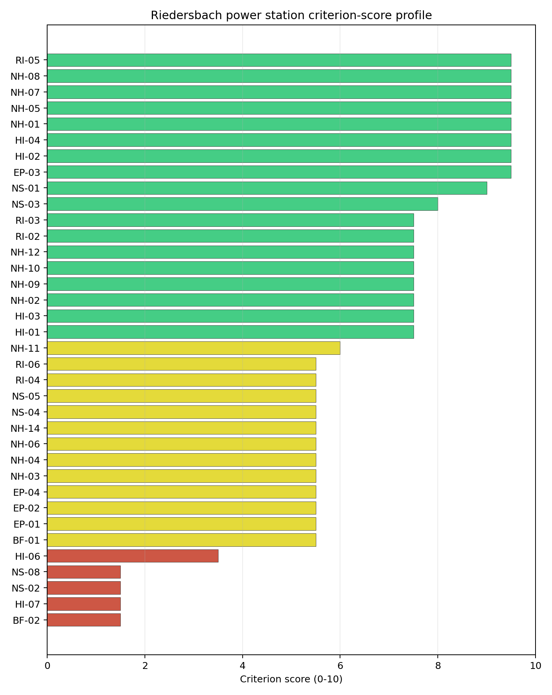
Criterion scores
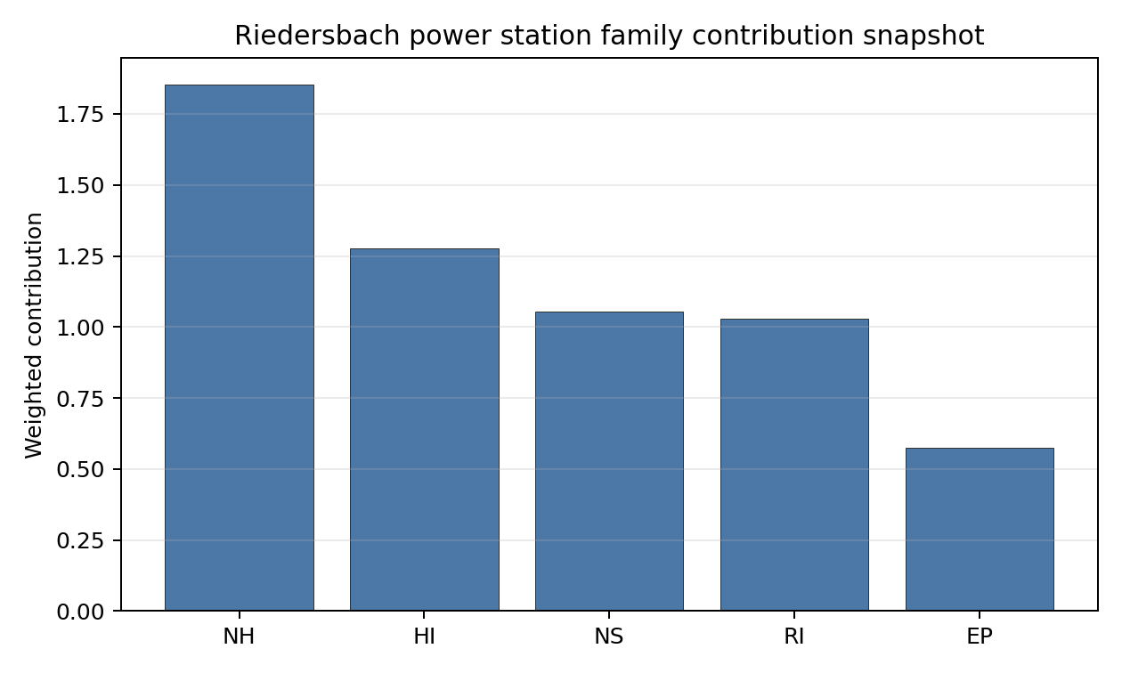
Family contributions
Riedersbach is Austria’s only stable national leader. Its baseline composite is 7.159, with a Monte Carlo band of 6.361-7.650, and it records band A with a 100% national top-10 hit rate in the project’s 50,000-iteration national sensitivity analysis. The site remains avoidance-flagged, principally through NS-02 and the small development footprint, but its lead survives the national uncertainty treatment. Stage 3 spending on Riedersbach is therefore more defensible than starting with the band-H follow-up sites.

Residual Risk Register
Concern | Evidence | Consequence | Stage 3 action | Owner discipline
Grid Connection (NS-02) | 220 MW export capacity, 110 kV nearby voltage, high-voltage line 6.11 km away | Full VOYGR-6 export would require a confirmed transmission pathway | Confirm upgrade route, voltage level and export capacity with the transmission system operator | Grid
Ecological Sensitivity (NS-08) | Salzachauen 0.293 km away; 8 Natura 2000 sites within 5 km | Permitting envelope could narrow before design optimisation | Start Habitats Directive screening and receptor-pathway review | EIA
Site Footprint / Land Area | 18.0 ha site surface; 12.8 ha development-area estimate | Layout and laydown margin may be tight for the reference envelope | Verify contiguous controlled land and adjacent-parcel options | Site engineering
Electromagnetic Interference (HI-07) | Nearest high-power transmitter 0.29 km; 166 transmitters in radius | RF restrictions may affect siting or shielding assumptions | Complete field RF survey and transmitter inventory | Security / I&C
Special Populations / EPZ | 17 hospitals, 3 prisons and 2 care homes in the EPZ | Emergency planning may depend on special-mover capacity | Model time-to-clear with special-population transport assumptions | Emergency planning

Stage 3 Follow-Up Checklist
- Resolve Grid Connection (NS-02) by confirming a transmission upgrade from the 220 MW / 110 kV screening position.
- Confirm Land Area Basic Filter (BF-02) with surveyed contiguous, controlled land.
- Survey Electromagnetic Interference (HI-07) around the 0.29 km transmitter record.
- Complete Ecological Sensitivity (NS-08) screening for Salzachauen and nearby Natura 2000 sites.
- Confirm Military Installations (HI-06) feature classification and standoff assumptions.
- Improve data quality for Geotechnical: Subsidence & Collapse (NH-05b).

Evidence Limitations
- Geotechnical: Subsidence & Collapse (NH-05b) - quality low.

Timelkam power station Site Profile
Timelkam power station is a coal/thermal site in Austria that has been tested against the NuScale VOYGR-6 reference deployment envelope. This profile reads the screening evidence at a level that supports a decision to progress toward Stage 3 characterisation. It is not a site-suitability determination, vendor recommendation, or licensing finding.

Site Snapshot
Field | Value
Site name | Timelkam power station
Coordinates | 48.0122, 13.5895
Subnational unit | Upper Austria
Installed thermal capacity (source data) | 66 MW
Available surface area | 30.6 ha
Available surface area for development | 30.6 ha
Composite score (baseline weights) | 7.016 (6.245-7.487 MC band)
National stability band | H (top-10% hit rate 0%)
National rank | 2
See the country status map in Austria Country Profile.

Ownership and Coal-to-Nuclear Context
Timelkam is recorded with Energie AG Oberösterreich as immediate operator. The ownership chain in the bundle is led by OÖ Landesholding GmbH at 52.71%, with additional Austrian municipal, banking and utility shareholders including Linz AG, Raiffeisenlandesbank Oberösterreich AG, TIWAG-Tiroler Wasserkraft AG and Verbund AG. The chain points to Austrian public and domestic utility ownership, but detailed legal control, parcel rights and reuse permissions remain Stage 3 diligence items.
Generating units on record: 1 retired. Earliest and most recent unit commissioning: 1962. Retirement is recorded in 2008, leaving a compact brownfield grid and transport setting for further characterisation.

Natural Hazards (NH)
- Seismic: Ground Motion (NH-01) - score 9.5/10 (MC 9.0-10.0), favourable: Well below the risk boundary., weight 0.0455, data quality high. Evidence: PGA at 475-year return period 0.036 g; PGA at 2,475-year return period 0.07 g; Vs30 reference (m/s): 760.0.
- Seismic: Surface Rupture (NH-02) - score 9.5/10 (MC 9.0-10.0), favourable: Very strong separation from mapped capable faults; surface-rupture concern effectively screened at desk-study level., weight n/a, data quality screening grade. Evidence: nearest mapped capable fault 50.0 km; fault slip rate 0 mm/yr; fault name: none_in_search_radius.
- Geotechnical: Liquefaction (NH-03) - score 9.5/10 (MC 9.0-10.0), favourable: Negligible susceptibility (Stage-1 favourable default)., weight n/a, data quality medium. Evidence: liquefaction susceptibility: very_low; dominant soil type: loam.
- Geotechnical: Slope Stability (NH-04) - score 5.5/10 (MC 5.0-6.0), pass-mark band: At or below the score-5 risk boundary., weight n/a, data quality screening grade. Evidence: site slope 10.2 deg; max slope in 1 km box 87.6 deg; slope stability class: steep.
- Geotechnical: Subsidence (NH-05) - score 9.5/10 (MC 9.0-10.0), favourable: No karst; mine-feature distance well above the score-5 pivot (or unknown)., weight 0.0354, data quality medium. Evidence: karst present: no; karst severity: none.
- Geotechnical: Foundation (NH-06) - score 3.5/10 (MC 3.0-4.0), weight 0.0253, data quality medium. Evidence: bearing capacity 73.3 kPa; depth to bedrock 22.9 m.
- Volcanism (NH-07) - score 9.5/10 (MC 9.0-10.0), favourable: Very strong margin above the score-5 boundary (or screening found no in-radius signal)., weight n/a, data quality high. Evidence: volcanic hazard class: negligible.
- Coastal Flooding (NH-08) - score 9.5/10 (MC 9.0-10.0), favourable: Non-coastal OR elevation >= 50 m AMSL OR landlocked country, with no positive marine-hazard signal., weight 0.0303, data quality medium. Evidence: distance to coast 249.2 km.
- River Flooding (NH-09) - score 7.5/10 (MC 7.0-8.0), weight 0.0404, data quality medium. Evidence: flood zone class: negligible.
- Extreme Winds (NH-10) - score 5.5/10 (MC 5.0-6.0), pass-mark band: Middle relative wind exposure around the observed cohort mean (9.0-10.5 m/s)., weight 0.0152, data quality medium. Evidence: screening wind-speed index 10.1 m/s.
- Extreme Precipitation (NH-11) - score 6.0/10 (MC 5.0-6.0), pass-mark band: aggregated(mean_of_sub_scores), weight 0.0152, data quality medium. Evidence: screening extreme-precipitation index 0.35 mm; screening precipitation index 44.7 mm/yr.
- Extreme Temperatures (NH-12) - score 7.5/10 (MC 7.0-8.0), weight 0.0202, data quality medium. Evidence: extreme high temperature 21.4 deg C; extreme low temperature -4.92 deg C.
- Combined Hazards (NH-14) - score 5.5/10 (MC 5.0-6.0), pass-mark band: At least 5 resolved, exactly one moderate hazard (3-5) or moderate interaction only., weight 0.0152, data quality n/a. Evidence: no measured value in the current screening record.

Interpretation - Natural Hazards (NH)
Timelkam has one of Austria’s strongest natural-hazard screens. Ground motion is low, with PGA of 0.036 g at 475 years and 0.070 g at 2,475 years, and the nearest mapped capable fault is 50.0 km away. Liquefaction susceptibility is very low, subsidence evidence is favourable, the site is 249.2 km from the coast, and river flooding is negligible. The binding physical-site issue is foundation quality: bearing capacity is 73.3 kPa over 22.9 m to bedrock. The steep-slope proxy and the very low precipitation values should be treated as screening inputs requiring confirmation, not as design values. Stage 3 should begin with geotechnical drilling and local hydrology / precipitation reconciliation.

Human-Induced and Security-Relevant Hazards (HI)
- Aircraft Crash (HI-01) - score 9.5/10 (MC 9.0-10.0), favourable: Only small / GA / heliport airport >= 10 km nearby, no flight-path proxy < 4 km, no major airport within 30 km, and no military airbase within 60 km., weight 0.0354, data quality high. Evidence: nearest airport 21.8 km; nearest flight path 10.9 km; airports within search radius 3; airport name: Gmunden-Laakirchen Airfield; airport type: small airfield.
- Industrial Explosions (HI-02) - score 9.5/10 (MC 9.0-10.0), favourable: Very strong margin above the score-5 boundary (or completed search confirmed no in-radius signal)., weight 0.0354, data quality medium. Evidence: no measured value in the current screening record.
- Toxic/Gas Releases (HI-03) - score 9.5/10 (MC 9.0-10.0), favourable: Very strong margin above the score-5 boundary (or completed search confirmed no in-radius signal)., weight 0.0354, data quality medium. Evidence: no measured value in the current screening record.
- External Fires (HI-04) - score 9.5/10 (MC 9.0-10.0), favourable: > 15 km, or completed flammable-storage search found nothing in radius., weight 0.0303, data quality medium. Evidence: no measured value in the current screening record.
- Military Installations (HI-06) - score 0.0/10 (MC 0.0-0.0), weight 0.0303, data quality medium. Evidence: nearest military installation 5.9 km; military installations within radius 81; installation name: Ehemaliger FLAK-Turm.
- Electromagnetic Interference (HI-07) - score 1.5/10 (MC 1.0-2.0), weight 0.0101, data quality medium. Evidence: nearest high-power transmitter 0.19 km; transmitters within radius 225; transmitter type: mast.

Interpretation - Human-Induced and Security-Relevant Hazards (HI)
Human-induced hazards are the main reason Timelkam remains a conditional candidate. Aircraft Crash (HI-01) is favourable, with the nearest small airport 21.8 km away, the nearest flight path 10.9 km away, and no major airport signal in the available record. Industrial, toxic and external-fire screens are also favourable at this level. The weaknesses are security and electromagnetic context: the nearest recorded military feature is the Ehemaliger FLAK-Turm at 5.9 km, with 81 military records in the wider radius, and the nearest high-power transmitter is 0.19 km away with 225 transmitters in radius. Stage 3 should prioritize defence engagement and an RF/EMI survey before design siting is fixed.

Radiological Impact and Emergency Planning (RI / EP)
- Emergency Planning Feasibility (EP-01) - score 5.5/10 (MC 5.0-6.0), pass-mark band: At or above the composite score-5 boundary., weight n/a, data quality high. Evidence: EP feasibility composite 60.9 /100; road sub-score 67.6 /100; special-population sub-score 90.0 /100; geography sub-score 10.0 /100; population sub-score 80.0 /100; evacuation feasible: yes.
- Evacuation Routes (EP-02) - score 5.5/10 (MC 5.0-6.0), pass-mark band: Adequate primary routes (0.5-1.0)., weight 0.0303, data quality medium. Evidence: road density in EPZ 0.76 km/km2; road length in EPZ 1,493 km; motorway access: yes.
- Physical Geography Constraints (EP-03) - score 1.5/10 (MC 1.0-2.0), weight 0.0253, data quality medium. Evidence: waterways crossing EPZ 163; major river barrier: yes.
- Special Populations (EP-04) - score 5.5/10 (MC 5.0-6.0), pass-mark band: 9-25., weight 0.0303, data quality medium. Evidence: hospitals in EPZ 13; prisons in EPZ 1; care homes in EPZ 9.
- Atmospheric Dispersion (RI-01) - unscored (no band matched), weight 0.0303, data quality medium. Evidence: annual mean wind speed 0.83 m/s; atmospheric mixing height 434.4 m; prevailing wind direction: WSW.
- Surface Water Dispersion (RI-02) - score 1.5/10 (MC 1.0-2.0), weight 0.0253, data quality n/a. Evidence: no measured value in the current screening record.
- Groundwater Dispersion (RI-03) - score 5.5/10 (MC 5.0-6.0), pass-mark band: Moderate-permeability aquifer screening proxy., weight 0.0253, data quality medium. Evidence: aquifer type: alluvial.
- Population Density at EPZ Radii (RI-04) - score 5.5/10 (MC 5.0-6.0), pass-mark band: aggregated(min_of_sub_scores), weight 0.0404, data quality screening grade. Evidence: population density within 5 km 246.4 /km2; population density within 16 km 149.4 /km2; population density within 25 km 125.7 /km2; population density within 80 km 127.7 /km2; population within 25 km 246,746 people.
- Distance to Population Centres (RI-05) - score 9.5/10 (MC 9.0-10.0), favourable: Nearest >=50k population-centre proxy exceeds required distance by >= 50 %., weight 0.0505, data quality screening grade. Evidence: nearest city above 50k people 47.0 km; nearest city population 146,631 people; city name: Salzburg.
- Population Projections (RI-06) - score 7.5/10 (MC 7.0-8.0), weight 0.0253, data quality screening grade. Evidence: annual population growth rate -0.174 %/yr; projected population at 25 km in 60 yr 257,843 people.

Interpretation - Radiological Impact and Emergency Planning (RI / EP)
Timelkam’s emergency-planning profile is feasible but geographically constrained. The EP-01 composite is 60.9/100 and marked feasible, with road density of 0.76 km/km2 and 1,493 km of roads inside the EPZ. The weakness is physical geography: 163 waterways cross the EPZ and a major river barrier is recorded, producing a 1.5/10 EP-03 score despite otherwise adequate road access. Population density is 246.4 people/km2 within 5 km and 125.7 people/km2 within 25 km, while Salzburg is 47.0 km away. Surface-water dispersion remains weak because the Vöckla dilution pathway is not measured. Stage 3 should model clearance times under the valley and waterway constraints and confirm the discharge-pathway basis.

Non-Safety and Implementation Considerations (NS)
- Grid Capacity Basic Filter (BF-01) - score 5.5/10 (MC 5.0-6.0), pass-mark band: Note: substation 15-30 km OR 110-219 kV; reinforcement plausible., weight n/a, data quality n/a. Evidence: no measured value in the current screening record.
- Land Area Basic Filter (BF-02) - score 3.5/10 (MC 3.0-4.0), weight 0.0253, data quality n/a. Evidence: no measured value in the current screening record.
- Cooling Water Availability (NS-01) - score 8.0/10 (MC 7.0-8.0), favourable: aggregated(weighted_mean_of_sub_scores), weight 0.0404, data quality screening grade. Evidence: distance to cooling source 0.11 km; cooling source flow 6.45 m3/s; cooling source type: small_river; cooling source name: Vöckla; water stress label: Low.
- Grid Connection (NS-02) - score 3.5/10 (MC 3.0-4.0), weight 0.0404, data quality high. Evidence: nearest substation 0.19 km; nearest high-voltage line 1.82 km; highest nearby line voltage 110.0 kV; grid export capacity 400.0 MW; substations within radius 2,987; HV lines within radius 428.
- Transport Access (NS-03) - score 9.0/10 (MC 9.0-10.0), favourable: aggregated(weighted_mean_of_sub_scores), weight 0.0404, data quality high. Evidence: nearest highway 1.51 km; nearest rail line 0.06 km; heavy-haul capable: yes.
- Site Topography (NS-04) - score 5.5/10 (MC 5.0-6.0), pass-mark band: 40-60 %., weight 0.0303, data quality screening grade. Evidence: favourable land cover 57.6 %; moderate land cover 15.1 %; unfavourable land cover 27.3 %; favourable area 150.4 ha; dominant land class: 312.
- Site Footprint Adequacy (NS-05) - score 7.5/10 (MC 7.0-8.0), weight 0.0253, data quality medium. Evidence: buildable area 30.6 ha; largest contiguous patch 30.6 ha; buildable patch count 18.
- Existing Infrastructure (NS-06) - unscored (no band matched), weight 0.0253, data quality n/a. Evidence: not measured at this site (criterion remains unscored).
- Ecological Sensitivity (NS-08) - score 3.5/10 (MC 3.0-4.0), weight n/a, data quality high. Evidence: natural land cover 27.3 %; distance to nearest Natura 2000 site 6.837 km; distance to nearest protected area 4.288 km; Natura 2000 overlap: no; Natura 2000 sensitivity class: low; protected-area overlap: no; protected-area sensitivity class: low; nearest Natura 2000 site: Mond- und Attersee; Natura 2000 sites within 5 km: 0; nearest protected-area designation: Landscape Protection Area.
- Workforce Availability (NS-10) - unscored (no band matched), weight 0.0202, data quality n/a. Evidence: not measured at this site (criterion remains unscored).
- Regulatory/Political Environment (NS-12) - unscored (no band matched), weight 0.0303, data quality n/a. Evidence: not measured at this site (criterion remains unscored).
- Construction Logistics (NS-13) - unscored (no band matched), weight 0.0202, data quality n/a. Evidence: not measured at this site (criterion remains unscored).

Interpretation - Non-Safety and Implementation Considerations (NS)
Timelkam has a strong brownfield implementation case but remains limited by grid export capacity. The Vöckla is 0.11 km from the site with 6.45 m3/s recorded flow, rail is 0.06 km away, highway access is 1.51 km away, and heavy-haul capability is recorded. The site surface and development-area estimate are both 30.6 ha, which gives a clearer land basis than several Austrian peers. Grid Connection (NS-02) is the active constraint: the nearest substation is 0.19 km away and the nearest high-voltage line is 1.82 km away, but the highest nearby voltage is 110 kV and export capacity is 400 MW, below the 462 MWe reference output. Ecological sensitivity is moderate rather than decisive, with Mond- und Attersee 6.837 km away and no Natura 2000 site within 5 km. Stage 3 should test the grid-upgrade pathway, confirm controlled land, and convert the unscored implementation criteria into project-specific evidence.

Composite Score and Stability
Baseline composite score is 7.016, bracketed by Monte Carlo at 6.245-7.487. National stability band is H with a top-10% hit rate of 0% in the national sensitivity analysis.
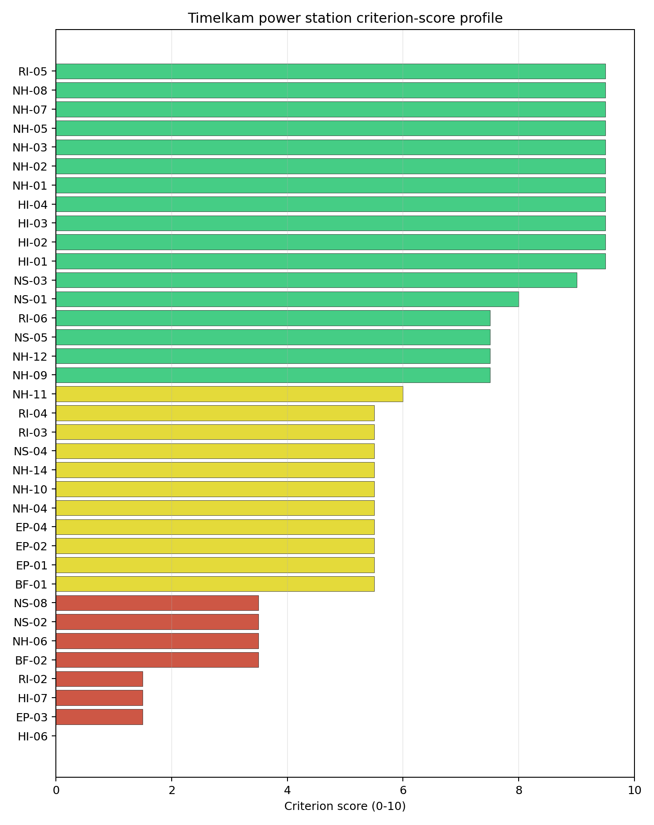
Criterion scores
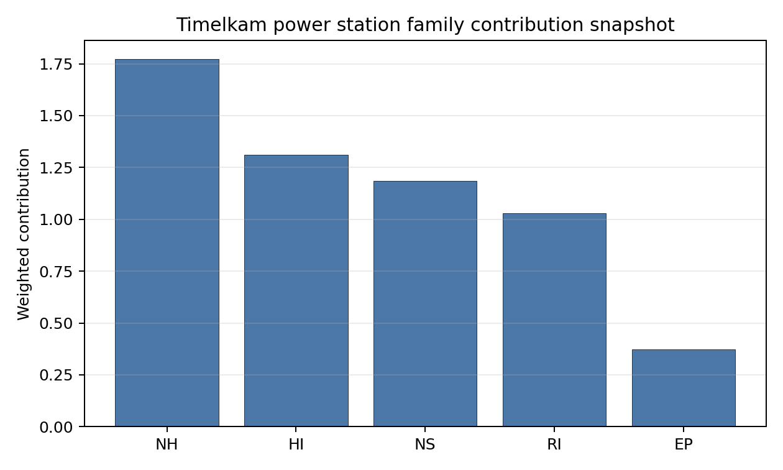
Family contributions
Timelkam ranks second nationally with a composite score of 7.016 and a Monte Carlo band of 6.245-7.487. Its national stability band is H with a 0% top-10 hit rate in the project’s 50,000-iteration national sensitivity analysis. The point estimate is strong, but the ranking is not robust once national weight uncertainty is applied. Timelkam is therefore a credible follow-up site, especially because its land and transport evidence are comparatively clear, but it should not displace Riedersbach unless the Riedersbach grid, ecology or land findings worsen in Stage 3.

Residual Risk Register
Concern | Evidence | Consequence | Stage 3 action | Owner discipline
Grid Connection (NS-02) | 400 MW export capacity; highest nearby voltage 110 kV | Existing connection is below the 462 MWe reference output | Confirm upgrade route and higher-voltage interconnection option | Grid
Military Installations (HI-06) | Ehemaliger FLAK-Turm 5.9 km away; 81 military records in radius | Security standoff and feature classification could affect site boundary | Engage defence authorities and confirm feature type | Security
Physical Geography (EP-03) | 163 waterways crossing EPZ; major river barrier recorded | Clearance-time modelling may be constrained by valley and waterway structure | Run EPZ evacuation and access modelling | Emergency planning
Surface Water Dispersion (RI-02) | Vöckla discharge pathway not measured in the criterion record | Liquid-pathway assumptions remain screening grade | Measure low-flow and discharge/dilution conditions | Hydrology
Foundation (NH-06) | Bearing capacity 73.3 kPa; depth to bedrock 22.9 m | Ground improvement or deep foundation may be needed | Complete CPT/SPT and foundation campaign | Geotechnical

Stage 3 Follow-Up Checklist
- Resolve Grid Connection (NS-02) by confirming export capacity above the VOYGR-6 reference output.
- Confirm Military Installations (HI-06) classification and standoff implications.
- Model Physical Geography Constraints (EP-03) for EPZ clearance under the waterway-barrier setting.
- Measure Surface Water Dispersion (RI-02) using Vöckla low-flow and discharge-pathway data.
- Re-measure Geotechnical: Foundation (NH-06) with site-specific bearing and settlement evidence.
- Improve data quality for Geotechnical: Subsidence & Collapse (NH-05b).

Evidence Limitations
- Geotechnical: Subsidence & Collapse (NH-05b) - quality low.

Voitsberg power station Site Profile
Voitsberg power station is a coal/thermal site in Austria that has been tested against the NuScale VOYGR-6 reference deployment envelope. This profile reads the screening evidence at a level that supports a decision to progress toward Stage 3 characterisation. It is not a site-suitability determination, vendor recommendation, or licensing finding.

Site Snapshot
Field | Value
Site name | Voitsberg power station
Coordinates | 47.0475, 15.1603
Subnational unit | Styria
Installed thermal capacity (source data) | 330 MW
Available surface area | 24.5 ha
Available surface area for development | 41.4 ha
Composite score (baseline weights) | 6.559 (5.876-7.050 MC band)
National stability band | H (top-10% hit rate 0%)
National rank | 4
See the country status map in Austria Country Profile.

Ownership and Coal-to-Nuclear Context
Voitsberg is recorded with Verbund AG as immediate operator. The bundle shows the Government of Austria holding 51.00% of Verbund AG, with additional Austrian utility and small-shareholder interests. The ownership chain is therefore state-anchored through Verbund, although site control, land disposition and reuse permissions still require direct confirmation.
Generating units on record: 1 retired. Earliest and most recent unit commissioning: 1983. Retirement is recorded in 2006, leaving a brownfield station context with grid, road, rail and workforce relevance for Stage 3 review.

Natural Hazards (NH)
- Seismic: Ground Motion (NH-01) - score 7.5/10 (MC 7.0-8.0), weight 0.0455, data quality high. Evidence: PGA at 475-year return period 0.083 g; PGA at 2,475-year return period 0.16 g; Vs30 reference (m/s): 760.0.
- Seismic: Surface Rupture (NH-02) - score 7.5/10 (MC 7.0-8.0), weight n/a, data quality screening grade. Evidence: nearest mapped capable fault 31.5 km; fault slip rate 0.382 mm/yr; fault name: ATCF00D.
- Geotechnical: Liquefaction (NH-03) - score 9.5/10 (MC 9.0-10.0), favourable: Negligible susceptibility (Stage-1 favourable default)., weight n/a, data quality medium. Evidence: liquefaction susceptibility: very_low; dominant soil type: loam.
- Geotechnical: Slope Stability (NH-04) - score 7.5/10 (MC 7.0-8.0), weight n/a, data quality screening grade. Evidence: site slope 9.03 deg; max slope in 1 km box 45.0 deg; slope stability class: moderate.
- Geotechnical: Subsidence (NH-05) - score 5.5/10 (MC 5.0-6.0), pass-mark band: At or above the mine-distance score-5 pivot; review possible., weight 0.0354, data quality medium. Evidence: karst present: no; karst severity: moderate; formation type: carbonate (Continuous carbonate rocks).
- Geotechnical: Foundation (NH-06) - score 3.5/10 (MC 3.0-4.0), weight 0.0253, data quality medium. Evidence: bearing capacity 73.3 kPa; depth to bedrock 24.3 m.
- Volcanism (NH-07) - score 9.5/10 (MC 9.0-10.0), favourable: Very strong margin above the score-5 boundary (or screening found no in-radius signal)., weight n/a, data quality high. Evidence: volcanic hazard class: negligible.
- Coastal Flooding (NH-08) - score 9.5/10 (MC 9.0-10.0), favourable: Non-coastal OR elevation >= 50 m AMSL OR landlocked country, with no positive marine-hazard signal., weight 0.0303, data quality medium. Evidence: distance to coast 184.4 km.
- River Flooding (NH-09) - score 7.5/10 (MC 7.0-8.0), weight 0.0404, data quality medium. Evidence: flood zone class: negligible.
- Extreme Winds (NH-10) - score 9.5/10 (MC 9.0-10.0), favourable: Lowest relative wind exposure in the current monthly-means gust cohort (< 7.5 m/s)., weight 0.0152, data quality medium. Evidence: screening wind-speed index 6.91 m/s.
- Extreme Precipitation (NH-11) - score 8.0/10 (MC 7.0-8.0), favourable: aggregated(mean_of_sub_scores), weight 0.0152, data quality medium. Evidence: screening extreme-precipitation index 0.24 mm; screening precipitation index 31.8 mm/yr.
- Extreme Temperatures (NH-12) - score 7.5/10 (MC 7.0-8.0), weight 0.0202, data quality medium. Evidence: extreme high temperature 21.2 deg C; extreme low temperature -5.52 deg C.
- Combined Hazards (NH-14) - score 9.5/10 (MC 9.0-10.0), favourable: At least 5 underlying NH criteria resolved, all >= 7; no interaction pair below 7., weight 0.0152, data quality n/a. Evidence: no measured value in the current screening record.

Interpretation - Natural Hazards (NH)
Voitsberg has a generally favourable natural-hazard screen with one geotechnical weakness. Ground motion is moderate for Austria, with PGA of 0.083 g at 475 years and 0.160 g at 2,475 years, and the nearest mapped capable fault is 31.5 km away. Liquefaction susceptibility is very low, slope class is moderate, river flooding is negligible, and coastal flooding is irrelevant at 184.4 km from the coast. The main weakness is foundation bearing capacity at 73.3 kPa with 24.3 m depth to bedrock, while the carbonate-formation context keeps subsidence under review. Stage 3 should measure bearing capacity, settlement and any karst-related subsurface features before relying on the current moderate natural-hazard score.

Human-Induced and Security-Relevant Hazards (HI)
- Aircraft Crash (HI-01) - score 7.5/10 (MC 7.0-8.0), weight 0.0354, data quality high. Evidence: nearest airport 22.1 km; nearest flight path 11.0 km; airports within search radius 3; airport name: Graz Airport; airport type: large airport.
- Industrial Explosions (HI-02) - score 9.5/10 (MC 9.0-10.0), favourable: Very strong margin above the score-5 boundary (or completed search confirmed no in-radius signal)., weight 0.0354, data quality high. Evidence: nearest industrial site 19.6 km.
- Toxic/Gas Releases (HI-03) - score 7.5/10 (MC 7.0-8.0), weight 0.0354, data quality high. Evidence: nearest toxic source 19.6 km.
- External Fires (HI-04) - score 9.5/10 (MC 9.0-10.0), favourable: > 15 km, or completed flammable-storage search found nothing in radius., weight 0.0303, data quality high. Evidence: no measured value in the current screening record.
- Military Installations (HI-06) - score 3.5/10 (MC 3.0-4.0), weight 0.0303, data quality medium. Evidence: nearest military installation 16.1 km; military installations within radius 58; installation name: unnamed.
- Electromagnetic Interference (HI-07) - score 1.5/10 (MC 1.0-2.0), weight 0.0101, data quality medium. Evidence: nearest high-power transmitter 0.72 km; transmitters within radius 360; transmitter type: communication.

Interpretation - Human-Induced and Security-Relevant Hazards (HI)
Voitsberg’s human-induced hazard profile is shaped by its Styrian industrial and airport context. Graz Airport is 22.1 km away, the nearest flight-path proxy is 11.0 km away, and 3 airports are recorded in the search radius, so Aircraft Crash (HI-01) remains a Stage 3 micro-siting calculation rather than a simple dismissal. Industrial and toxic sources are each 19.6 km away, which is favourable under the current avoidance logic. The weak points are Military Installations (HI-06), with the nearest feature 16.1 km away and 58 records in radius, and Electromagnetic Interference (HI-07), with a transmitter 0.72 km away and 360 transmitters in the wider radius. Stage 3 should verify military classifications and RF field strengths while preserving the airport-frequency calculation as a design input.

Radiological Impact and Emergency Planning (RI / EP)
- Emergency Planning Feasibility (EP-01) - score 5.5/10 (MC 5.0-6.0), pass-mark band: At or above the composite score-5 boundary., weight n/a, data quality high. Evidence: EP feasibility composite 55.4 /100; road sub-score 65.4 /100; special-population sub-score 0 /100; geography sub-score 95.0 /100; population sub-score 80.0 /100; evacuation feasible: yes.
- Evacuation Routes (EP-02) - score 5.5/10 (MC 5.0-6.0), pass-mark band: Adequate primary routes (0.5-1.0)., weight 0.0303, data quality medium. Evidence: road density in EPZ 0.723 km/km2; road length in EPZ 1,420 km; motorway access: yes.
- Physical Geography Constraints (EP-03) - score 9.5/10 (MC 9.0-10.0), favourable: No measured relief; open river/waterway context (interim screening)., weight 0.0253, data quality medium. Evidence: waterways crossing EPZ 0; major river barrier: no.
- Special Populations (EP-04) - score 3.5/10 (MC 3.0-4.0), weight 0.0303, data quality medium. Evidence: hospitals in EPZ 38; prisons in EPZ 4; care homes in EPZ 4.
- Atmospheric Dispersion (RI-01) - unscored (no band matched), weight 0.0303, data quality medium. Evidence: annual mean wind speed 0.64 m/s; atmospheric mixing height 395.1 m; prevailing wind direction: W.
- Surface Water Dispersion (RI-02) - score 1.5/10 (MC 1.0-2.0), weight 0.0253, data quality n/a. Evidence: no measured value in the current screening record.
- Groundwater Dispersion (RI-03) - score 5.5/10 (MC 5.0-6.0), pass-mark band: Moderate-permeability aquifer screening proxy., weight 0.0253, data quality medium. Evidence: aquifer type: alluvial.
- Population Density at EPZ Radii (RI-04) - score 5.5/10 (MC 5.0-6.0), pass-mark band: aggregated(min_of_sub_scores), weight 0.0404, data quality screening grade. Evidence: population density within 5 km 233.2 /km2; population density within 16 km 103.2 /km2; population density within 25 km 230.0 /km2; population density within 80 km 89.3 /km2; population within 25 km 451,536 people.
- Distance to Population Centres (RI-05) - score 7.5/10 (MC 7.0-8.0), weight 0.0505, data quality screening grade. Evidence: nearest city above 50k people 21.4 km; nearest city population 269,997 people; city name: Graz.
- Population Projections (RI-06) - score 3.5/10 (MC 3.0-4.0), weight 0.0253, data quality screening grade. Evidence: annual population growth rate 0.503 %/yr; projected population at 25 km in 60 yr 471,844 people.

Interpretation - Radiological Impact and Emergency Planning (RI / EP)
Voitsberg has a feasible but periurban emergency-planning profile. EP-01 scores 55.4/100 and is marked feasible, with 1,420 km of EPZ roads, road density of 0.723 km/km2 and motorway access. The special-population term is weak: 38 hospitals, 4 prisons and 4 care homes are recorded in the EPZ. Population within 25 km is 451,536 and Graz, with 269,997 people, is 21.4 km away. Population growth is positive at 0.503%/year, producing a 25 km projection of 471,844 people after 60 years. Surface-water dispersion remains a low-confidence floor. Stage 3 should model special-population evacuation, long-horizon growth and Tregistbach dilution before Voitsberg is treated as a robust fallback.

Non-Safety and Implementation Considerations (NS)
- Grid Capacity Basic Filter (BF-01) - score 5.5/10 (MC 5.0-6.0), pass-mark band: Note: substation 15-30 km OR 110-219 kV; reinforcement plausible., weight n/a, data quality n/a. Evidence: no measured value in the current screening record.
- Land Area Basic Filter (BF-02) - score 5.5/10 (MC 5.0-6.0), pass-mark band: 80-100% of required area with documented expansion / layout flexibility., weight 0.0253, data quality n/a. Evidence: no measured value in the current screening record.
- Cooling Water Availability (NS-01) - score 8.0/10 (MC 7.0-8.0), favourable: aggregated(weighted_mean_of_sub_scores), weight 0.0404, data quality screening grade. Evidence: distance to cooling source 3.73 km; cooling source flow 7.51 m3/s; cooling source type: river; cooling source name: Tregistbach; water stress label: Low.
- Grid Connection (NS-02) - score 1.5/10 (MC 1.0-2.0), weight 0.0404, data quality high. Evidence: nearest substation 2.1 km; nearest high-voltage line 1.74 km; highest nearby line voltage 110.0 kV; grid export capacity 330.0 MW; substations within radius 1,418; HV lines within radius 618.
- Transport Access (NS-03) - score 9.0/10 (MC 9.0-10.0), favourable: aggregated(weighted_mean_of_sub_scores), weight 0.0404, data quality high. Evidence: nearest highway 0.89 km; nearest rail line 0.85 km; heavy-haul capable: yes.
- Site Topography (NS-04) - score 5.5/10 (MC 5.0-6.0), pass-mark band: 40-60 %., weight 0.0303, data quality screening grade. Evidence: favourable land cover 51.2 %; moderate land cover 10.2 %; unfavourable land cover 29.0 %; favourable area 22.1 ha; dominant land class: 112.
- Site Footprint Adequacy (NS-05) - score 5.5/10 (MC 5.0-6.0), pass-mark band: At or above the score-5 boundary., weight 0.0253, data quality medium. Evidence: buildable area 41.4 ha; largest contiguous patch 41.4 ha; buildable patch count 12.
- Existing Infrastructure (NS-06) - unscored (no band matched), weight 0.0253, data quality n/a. Evidence: not measured at this site (criterion remains unscored).
- Ecological Sensitivity (NS-08) - score 3.5/10 (MC 3.0-4.0), weight n/a, data quality high. Evidence: natural land cover 29.0 %; distance to nearest Natura 2000 site 8.901 km; distance to nearest protected area 2.933 km; Natura 2000 overlap: no; Natura 2000 sensitivity class: low; protected-area overlap: no; protected-area sensitivity class: moderate; nearest Natura 2000 site: Oberlauf des Schirningbaches mit Zubringerbächen sowie Unterlauf des Enzenbaches; Natura 2000 sites within 5 km: 0; nearest protected-area designation: Landscape Protection Area.
- Workforce Availability (NS-10) - unscored (no band matched), weight 0.0202, data quality n/a. Evidence: not measured at this site (criterion remains unscored).
- Regulatory/Political Environment (NS-12) - unscored (no band matched), weight 0.0303, data quality n/a. Evidence: not measured at this site (criterion remains unscored).
- Construction Logistics (NS-13) - unscored (no band matched), weight 0.0202, data quality n/a. Evidence: not measured at this site (criterion remains unscored).

Interpretation - Non-Safety and Implementation Considerations (NS)
Voitsberg’s implementation case is strong on access and land, but weak on grid export. The site has highway access at 0.89 km, rail at 0.85 km and heavy-haul capability. Cooling is feasible but offset, with the Tregistbach 3.73 km away and recorded flow of 7.51 m3/s. The site surface is 24.5 ha and the development-area estimate is 41.4 ha, but this wider development figure should be treated as a screening envelope, not as confirmed controlled land. Grid Connection (NS-02) is the principal avoidance issue: the nearest substation is 2.10 km away, the highest nearby voltage is 110 kV, and export capacity is 330 MW, below the VOYGR-6 reference output. Ecology is moderate, with no Natura 2000 site within 5 km. Stage 3 should test a higher-voltage export route and confirm which land parcels are controlled, contiguous and developable.

Composite Score and Stability
Baseline composite score is 6.559, bracketed by Monte Carlo at 5.876-7.050. National stability band is H with a top-10% hit rate of 0% in the national sensitivity analysis.
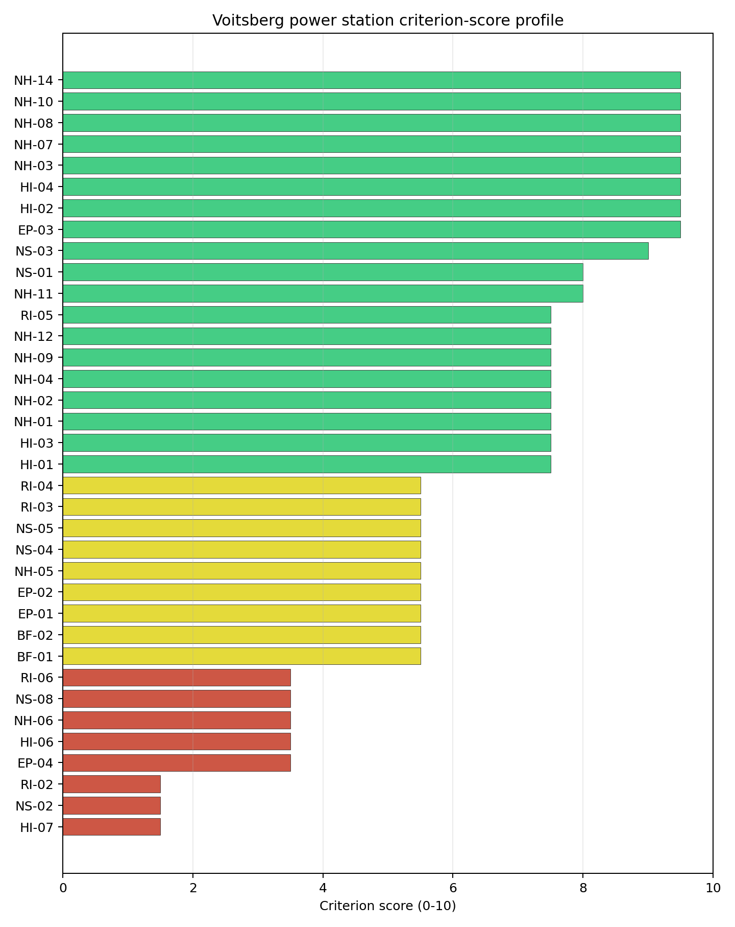
Criterion scores
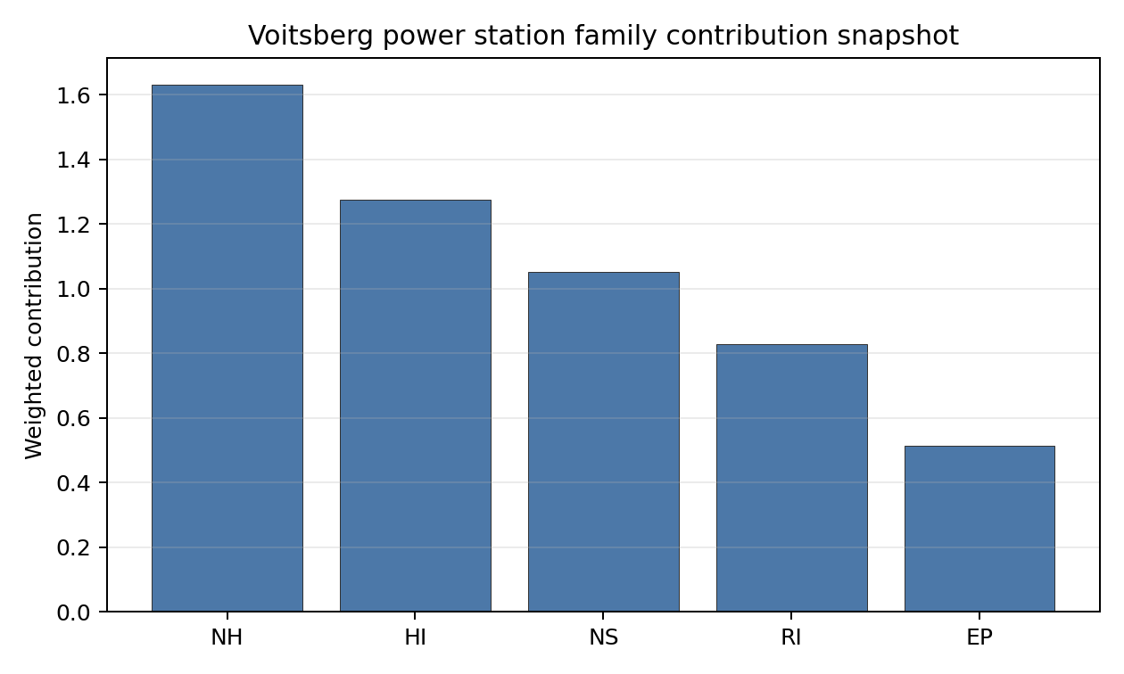
Family contributions
Voitsberg ranks fourth nationally with a composite score of 6.559 and a Monte Carlo band of 5.876-7.050. It is band H with a 0% national top-10 hit rate, so it is a point-estimate follow-up site rather than a sensitivity-robust candidate. Its value in the selected set is practical: it has good access, usable land evidence and a retired industrial context. Its weakness is that NS-02, special-population exposure and surface-water evidence all need resolution before it could move from fallback to preferred Stage 3 work.

Residual Risk Register
Concern | Evidence | Consequence | Stage 3 action | Owner discipline
Grid Connection (NS-02) | 330 MW export capacity; 110 kV nearby voltage | Existing export basis is below the 462 MWe reference output | Confirm transmission upgrade and higher-voltage route | Grid
Surface Water Dispersion (RI-02) | Criterion at 1.5/10; Tregistbach 3.73 km away with 7.51 m3/s flow | Dilution pathway remains weak and offset from site | Measure discharge and model liquid-pathway dispersion | Hydrology
Special Populations (EP-04) | 38 hospitals, 4 prisons and 4 care homes in EPZ | Emergency planning may require high special-mover capacity | Model time-to-clear and special transport resources | Emergency planning
Foundation (NH-06) | Bearing capacity 73.3 kPa; 24.3 m depth to bedrock | Ground improvement may affect cost and layout | Complete site geotechnical campaign | Geotechnical
Electromagnetic Interference (HI-07) | Transmitter 0.72 km away; 360 transmitters in radius | RF controls may affect detailed siting | Complete RF field survey and transmitter inventory | Security / I&C

Stage 3 Follow-Up Checklist
- Resolve Grid Connection (NS-02) through a higher-voltage export-capacity study.
- Survey Electromagnetic Interference (HI-07) around the 0.72 km transmitter record.
- Measure Surface Water Dispersion (RI-02) for the Tregistbach pathway.
- Model Special Populations (EP-04) and EPZ special-mover demand.
- Confirm Military Installations (HI-06) classification and standoff assumptions.
- Improve data quality for Geotechnical: Subsidence & Collapse (NH-05b).

Evidence Limitations
- Geotechnical: Subsidence & Collapse (NH-05b) - quality low.

Bosnia and Herzegovina Country Profile
Bosnia and Herzegovina has 11 thermal and coal-site records tested against the NuScale VOYGR-6 reference deployment envelope. No site passes both the exclusionary and avoidance screens, 5 sites pass the exclusionary screen with avoidance flags, and 6 fail one or more exclusionary checks. The country is therefore an avoidance-led candidate pool: it has a ranked shortlist, but every progression case depends on closing at least one screening-stage constraint before Stage 3 characterisation can be justified.
Bosnia and Herzegovina should be handled as a first-time nuclear-power jurisdiction for this Stage 1-2 screening programme unless the sponsor supplies contrary institutional evidence. That does not prevent site progression, but it makes regulatory capacity, emergency-planning institutions, workforce readiness and cross-entity coordination part of the Stage 3 work plan rather than background assumptions.
The leading site is Stanari Thermal Power Plant, with a composite score of 6.747 and a national Monte Carlo interval of 6.028-7.237. Its national stability band is A, with a national top-10% hit rate of 91.7%. The leader is therefore a stable national candidate, but it remains avoidance-flagged and should not be described as a full-pass site.
Bosnia and Herzegovina’s 11 ranked thermal records produce no full-pass site, 5 avoidance-flagged exclusionary-pass sites, and 6 hard-fail sites. Stanari, Miljevina, Kamengrad, Ugljevik and Banovici form the current leadership pool because they are the only scored exclusionary-pass sites in the frozen national run. The pool is narrow and conditional: Stanari leads with band A stability, while the other four sites sit in band H and therefore depend more heavily on the weight choice and on targeted constraint closure.
The avoidance unlock pool is concentrated. Grid Connection (NS-02) affects 5 of 5 exclusionary-pass sites, or 100%, making transmission-path confirmation the national unlock work. Aircraft Crash (HI-01) affects one site, or 20%, and should be closed through aviation and military-airspace review. The exclusionary tail is geological: Seismic: Surface Rupture (NH-02) removes 6 of 11 records, or 55%, and cannot be treated as a grid or permitting issue.
Greenfield options remain a programme lever if the brownfield shortlist cannot support the desired build-out, but they would need to screen against the same Dinaride capable-fault constraints from the outset. A credible Stage 3 sequence begins with Stanari as the national lead, tests Miljevina and Kamengrad as the first fast followers, keeps Ugljevik and Banovici as conditional reserve candidates, and treats the hard-fail sites as comparators unless new capable-fault evidence changes the exclusionary result.

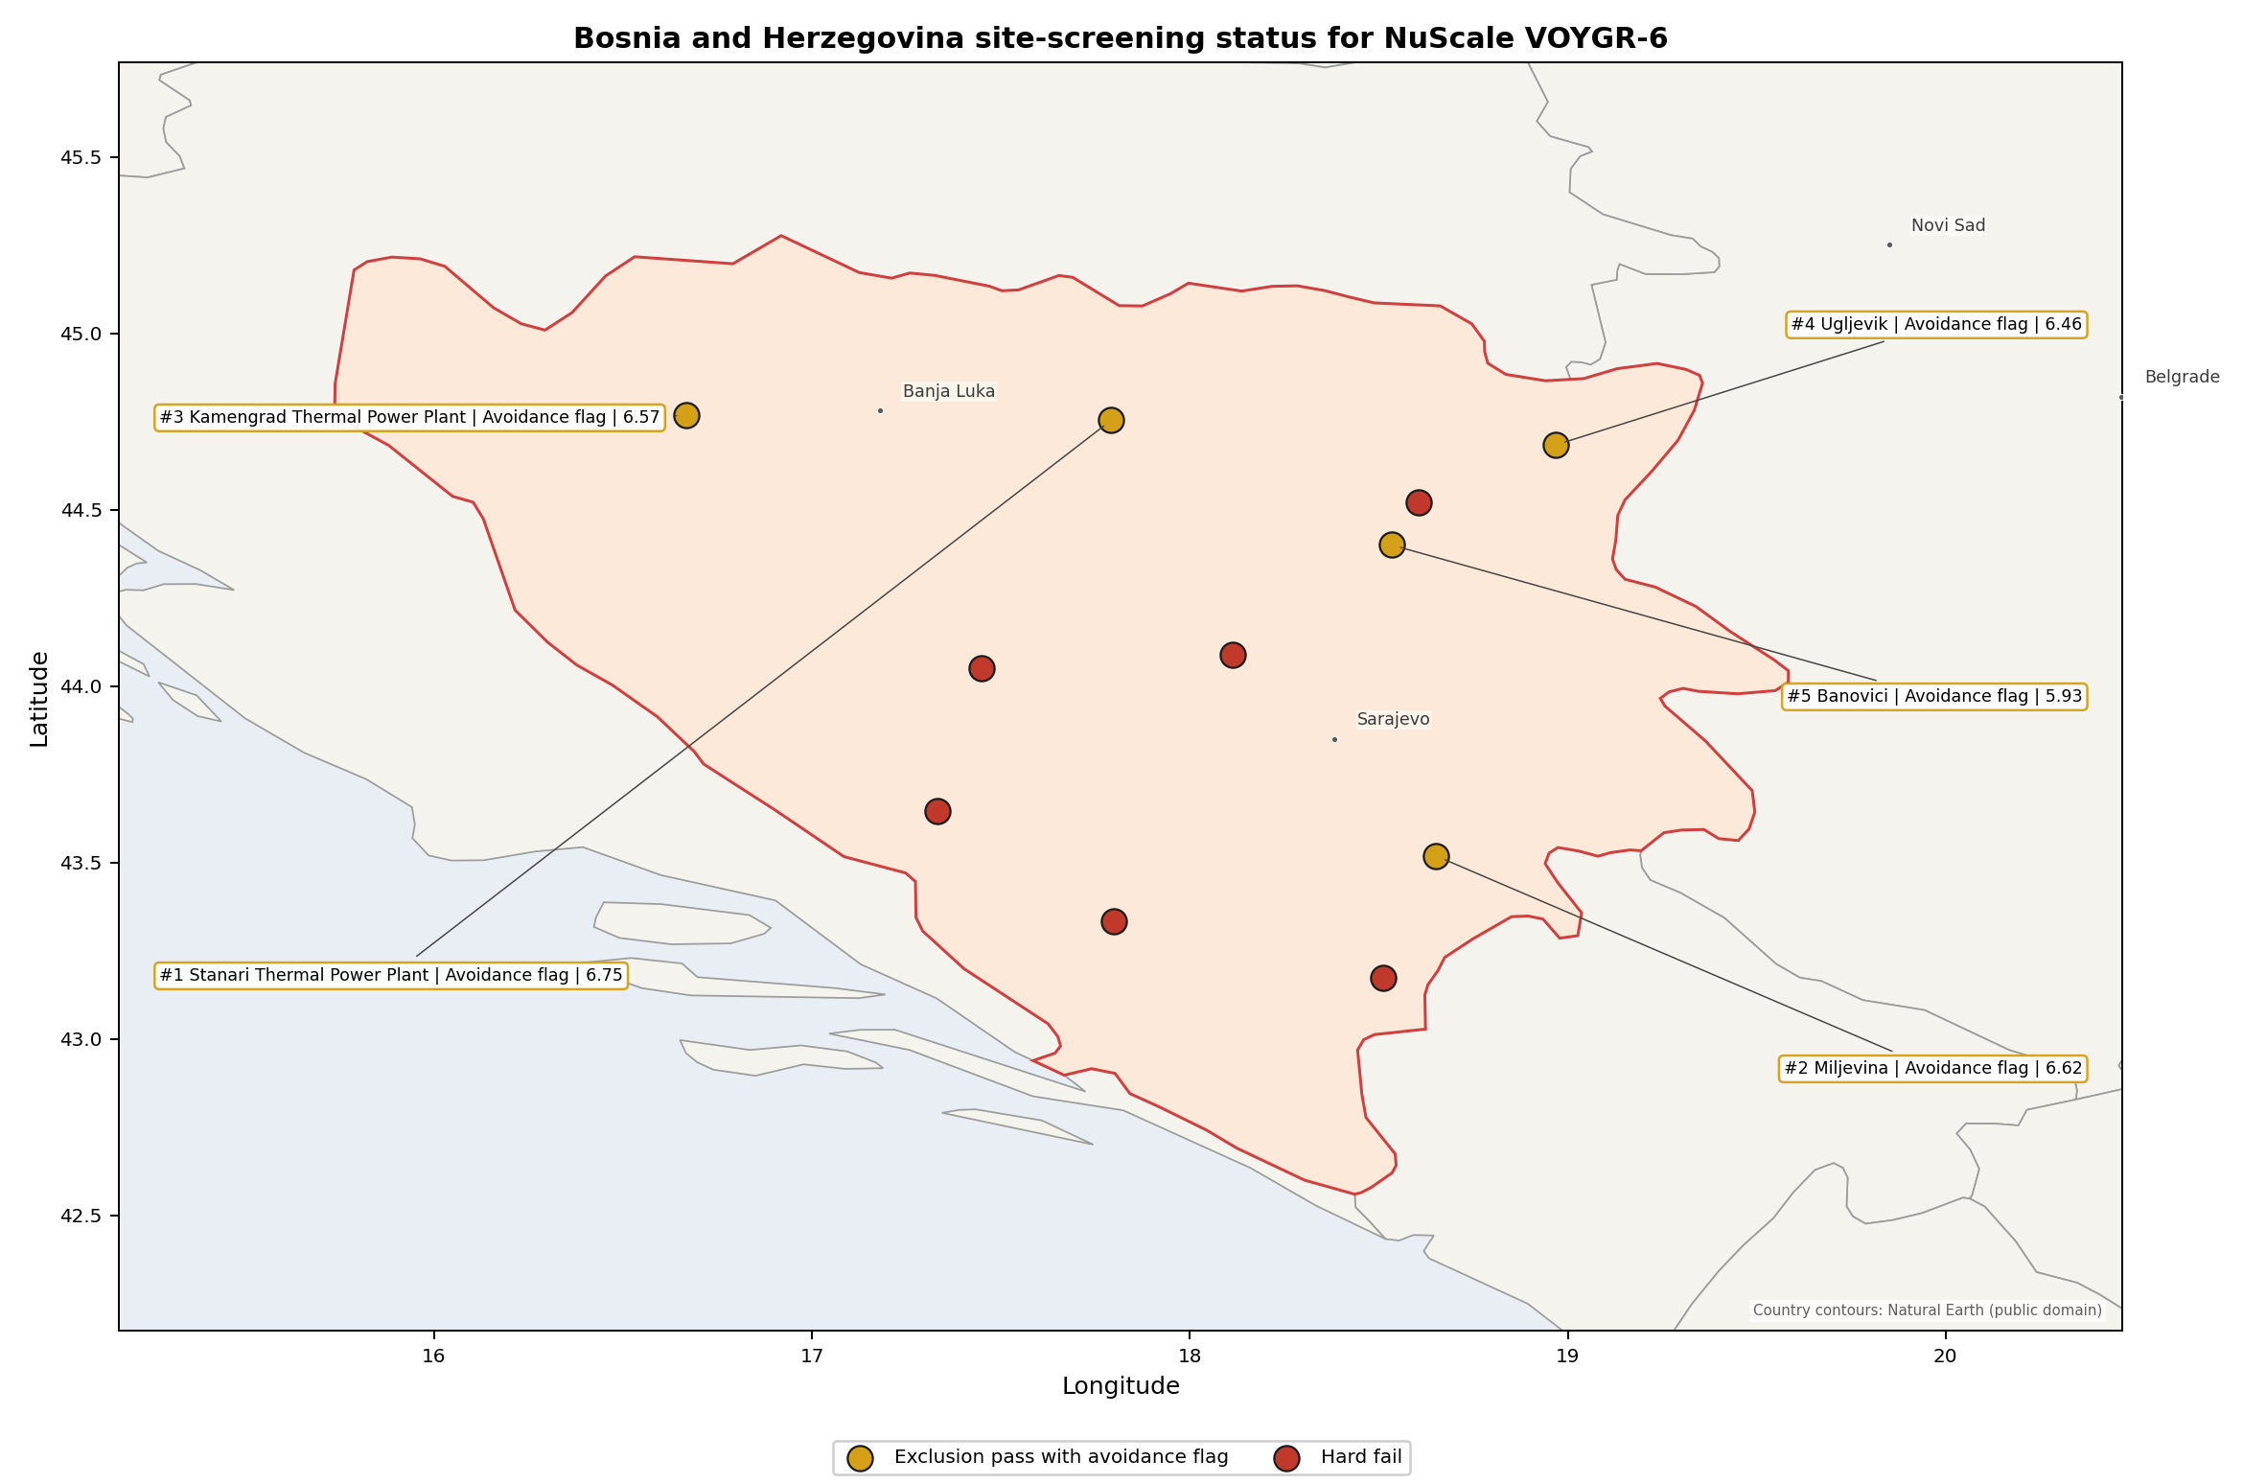
Bosnia and Herzegovina status map

Bosnia and Herzegovina Site Ledger
Rank | Site | Status | Composite | MC Low | MC High | Band | Top-10 Hit | Coverage
1 | Stanari Thermal Power Plant | Exclusion pass with avoidance flag | 6.747 | 6.028 | 7.237 | A | 92% | 76%
2 | Miljevina power station | Exclusion pass with avoidance flag | 6.622 | 5.927 | 7.131 | H | 8% | 76%
3 | Kamengrad Thermal Power Plant | Exclusion pass with avoidance flag | 6.572 | 5.886 | 7.131 | H | 0% | 76%
4 | Ugljevik power station | Exclusion pass with avoidance flag | 6.458 | 5.707 | 6.929 | H | 0% | 74%
5 | Banovici power station | Exclusion pass with avoidance flag | 5.934 | 5.325 | 6.425 | H | 0% | 76%
- | Bugojno Thermal Power Project | Hard fail | - | - | - | - | - | 0%
- | Gacko Thermal Power Plant | Hard fail | - | - | - | - | - | 0%
- | Glinica power station | Hard fail | - | - | - | - | - | 0%
- | Kakanj Thermal Power Plant | Hard fail | - | - | - | - | - | 0%
- | Kongora Thermal Power Plant | Hard fail | - | - | - | - | - | 0%
- | Tuzla Thermal Power Plant | Hard fail | - | - | - | - | - | 0%

Selected Sites for Detailed Analysis
- Stanari Thermal Power Plant - national rank 1, exclusion pass with avoidance flag, composite 6.747, national stability band A.
- Miljevina power station - national rank 2, exclusion pass with avoidance flag, composite 6.622, national stability band H.
- Kamengrad Thermal Power Plant - national rank 3, exclusion pass with avoidance flag, composite 6.572, national stability band H.
- Ugljevik power station - national rank 4, exclusion pass with avoidance flag, composite 6.458, national stability band H.
- Banovici power station - national rank 5, exclusion pass with avoidance flag, composite 5.934, national stability band H.

Avoidance Flag Pareto
Of the 5 sites that pass the exclusionary screen, the avoidance-phase flags concentrate on a small set of criteria. Resolving them is what would move Bosnia and Herzegovina from a conditional shortlist to a stronger Stage 3 candidate pool.
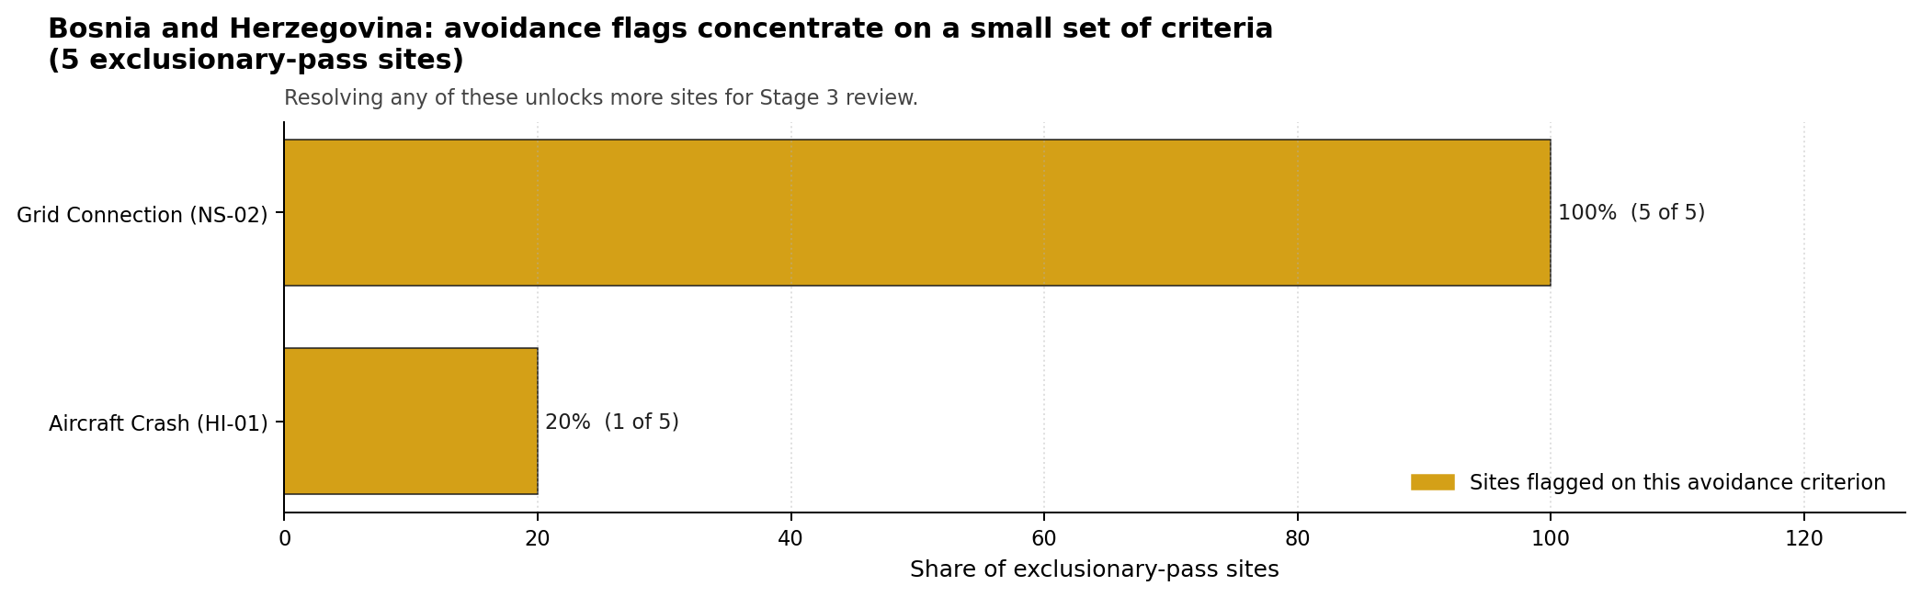
Avoidance flag Pareto
- Grid Connection (NS-02) - 5 of 5 exclusionary-pass sites (100%).
- Aircraft Crash (HI-01) - 1 of 5 exclusionary-pass sites (20%).

Exclusionary Failure Pareto
The exclusionary failures across the country trace back to a single criterion. It identifies which screening check is responsible for removing sites from further consideration.
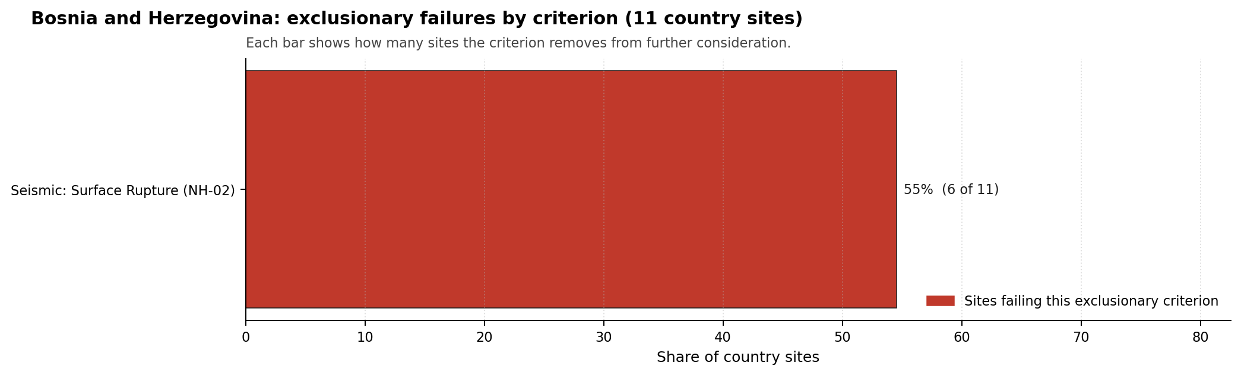
Exclusionary failure Pareto
- Seismic: Surface Rupture (NH-02) - 6 of 11 country sites (55%).

Family Strength and Weakness
Across the country the strongest criterion family is HI at a mean normalised score of 7.57/10. The weakest family is EP at 4.65/10. The bottom three individual criteria across the country are:
- Military Installations (HI-06) - mean 1.64/10 across 11 scored sites (min 0.0, max 5.0).
- Evacuation Routes (EP-02) - mean 2.41/10 across 11 scored sites (min 1.5, max 3.5).
- Surface Water Dispersion (RI-02) - mean 2.77/10 across 11 scored sites (min 1.5, max 7.5).

Interpretation for Site Selection
The Bosnia and Herzegovina result should be read as a conditional shortlist, not as a full-pass country package. The decisive distinction is that the five ranked sites survive the exclusionary screen, while all five still carry avoidance flags. That makes them candidates for targeted Stage 3 scoping only after grid and aviation constraints are tested at site level.

Avoidance flag Pareto - what unlocks more sites
Stanari is the only site with band A national stability, so it is the correct first characterisation focus. Miljevina, Kamengrad, Ugljevik and Banovici remain useful because their composite scores cluster near the leader, but their band H sensitivity result means small changes in weights or evidence can affect their order. The hard-fail sites remain in the evidence base as comparators because NH-02 surface-rupture screening is a structural exclusionary question until site-specific geological evidence proves otherwise.
The main Stage 3 questions are therefore targeted: confirm the transmission pathway and export-capacity case, resolve the aviation and airspace flag where present, verify capable-fault margins for excluded and near-threshold sites, and convert low-confidence emergency-planning, surface-water and land-envelope proxies into measured local evidence.

Status Counts
- Full pass: 0
- Exclusion pass with avoidance flag: 5
- Hard fail: 6

Banovici power station Site Profile
Banovici power station is a coal/thermal site in Bosnia and Herzegovina that has been tested against the NuScale VOYGR-6 reference deployment envelope. This profile reads the screening evidence at a level that supports a decision to progress toward Stage 3 characterisation. It is not a site-suitability determination, vendor recommendation, or licensing finding.

Site Snapshot
Field | Value
Site name | Banovici power station
Coordinates | 44.4000, 18.5333
Subnational unit | FBIH
Installed thermal capacity (source data) | 350 MW
Available surface area | 56.0 ha
Available surface area for development | 56.0 ha
Composite score (baseline weights) | 5.934 (5.325-6.425 MC band)
National stability band | H (top-10% hit rate 0%)
National rank | 5
See the country status map in Bosnia and Herzegovina Country Profile.

Ownership and Coal-to-Nuclear Context
- ZIF HERBOS FOND d.d. Tuzla (7.07% share), headquartered in Bosnia and Herzegovina; immediate operator RMU Banovici dd. Path: ZIF HERBOS FOND d.d. Tuzla -> RMU Banovici dd [7.07%] -> Banovici power station Unit 1 [100.0%]
- RMU Banovici dd (100.00% share), headquartered in Bosnia and Herzegovina; immediate operator RMU Banovici dd. Path: RMU Banovici dd -> Banovici power station Unit 1 [100.0%]
- Government of the Federation of Bosnia and Herzegovina (69.53% share), headquartered in Bosnia and Herzegovina; immediate operator RMU Banovici dd. Path: Government of the Federation of Bosnia and Herzegovina -> RMU Banovici dd [69.53%] -> Banovici power station Unit 1 [100.0%]
- small shareholder(s) (23.40% share); immediate operator RMU Banovici dd. Path: small shareholder(s) -> RMU Banovici dd [23.4%] -> Banovici power station Unit 1 [100.0%]
Generating units on record: 1 cancelled.

Natural Hazards (NH)
- Seismic: Ground Motion (NH-01) - score 5.5/10 (MC 5.0-6.0) - pass-mark band: At or below the score-5 risk boundary., weight 0.0455, data quality high. Evidence: PGA at 475-year return period 0.132 g; PGA at 2,475-year return period 0.282 g; Vs30 reference (m/s): 760.0.
- Seismic: Surface Rupture (NH-02) - score 5.5/10 (MC 5.0-6.0) - pass-mark band: Borderline acceptable separation: meets the 8.0 km score boundary; check against the 8 km conservative screen and local capability evidence., weight n/a, data quality screening grade. Evidence: nearest mapped capable fault 13.3 km; fault slip rate 0.1 mm/yr; fault name: BACF007.
- Geotechnical: Liquefaction (NH-03) - score 9.5/10 (MC 9.0-10.0) - favourable: Negligible susceptibility (Stage-1 favourable default)., weight n/a, data quality medium. Evidence: liquefaction susceptibility: very_low; dominant soil type: clay_loam.
- Geotechnical: Slope Stability (NH-04) - score 5.5/10 (MC 5.0-6.0) - pass-mark band: At or below the score-5 risk boundary., weight n/a, data quality screening grade. Evidence: site slope 18.1 deg; max slope in 1 km box 87.2 deg; slope stability class: very_steep.
- Geotechnical: Subsidence (NH-05) - score 7.5/10 (MC 7.0-8.0), weight 0.0354, data quality medium. Evidence: karst present: no; karst severity: none.
- Geotechnical: Foundation (NH-06) - score 5.5/10 (MC 5.0-6.0) - pass-mark band: Typical European mixed conditions (bearing 80-150 kPa)., weight 0.0253, data quality medium. Evidence: bearing capacity 82.0 kPa; depth to bedrock 14.8 m.
- Volcanism (NH-07) - score 9.5/10 (MC 9.0-10.0) - favourable: Very strong margin above the score-5 boundary (or connector confirmed no in-radius signal)., weight n/a, data quality high. Evidence: volcanic hazard class: negligible.
- Coastal Flooding (NH-08) - score 9.5/10 (MC 9.0-10.0) - favourable: Non-coastal OR elevation >= 50 m AMSL OR landlocked country, with no positive marine-hazard signal., weight 0.0303, data quality medium. Evidence: distance to coast 172.2 km.
- River Flooding (NH-09) - score 7.5/10 (MC 7.0-8.0), weight 0.0404, data quality medium. Evidence: flood zone class: negligible.
- Extreme Winds (NH-10) - score 9.5/10 (MC 9.0-10.0) - favourable: Lowest relative wind exposure in the current reanalysis-grade monthly-mean gust cohort (< 7.5 m/s)., weight 0.0152, data quality medium. Evidence: screening wind-speed index 6.92 m/s.
- Extreme Precipitation (NH-11) - score 6.0/10 (MC 5.0-6.0) - pass-mark band: aggregated(mean_of_sub_scores), weight 0.0152, data quality medium. Evidence: screening extreme-precipitation index 0.32 mm; screening precipitation index 34.3 mm/yr.
- Extreme Temperatures (NH-12) - score 6.5/10 (MC 6.0-7.0) - pass-mark band: aggregated(mean_of_sub_scores), weight 0.0202, data quality medium. Evidence: extreme high temperature 23.3 deg C; extreme low temperature -5.97 deg C.
- Combined Hazards (NH-14) - score 5.5/10 (MC 5.0-6.0) - pass-mark band: At least 5 resolved, exactly one moderate hazard (3-5) or moderate interaction only., weight 0.0152, data quality n/a. Evidence: values not in measurement tables.

Interpretation - Natural Hazards (NH)
Natural hazards at Banovici power station support an avoidance-flagged Stage 3 screening case rather than an unqualified site-selection conclusion. The measured record includes liquefaction susceptibility: very_low; dominant soil type: clay_loam; volcanic hazard class: negligible; PGA at 475-year return period 0.132 g. The strongest evidence is Geotechnical: Liquefaction (NH-03) at 9.5/10, Volcanism (NH-07) at 9.5/10, while the limiting criteria are Seismic: Ground Motion (NH-01) at 5.5/10, Seismic: Surface Rupture (NH-02) at 5.5/10, Geotechnical: Slope Stability (NH-04) at 5.5/10. Those limitations do not establish a licensing or suitability finding; they define the work that must be closed before the site can be treated as equivalent to a full-pass candidate. Stage 3 should therefore prioritise seismic, geotechnical, flood and meteorological confirmation, with the lowest-scoring and avoidance-flagged criteria measured first.

Human-Induced and Security-Relevant Hazards (HI)
- Aircraft Crash (HI-01) - score 7.5/10 (MC 7.0-8.0), weight 0.0354, data quality high. Evidence: nearest airport 12.8 km; nearest flight path 6.4 km; airports within search radius 3; airport name: Ciljuge Sport Airfield; airport type: small airfield.
- Industrial Explosions (HI-02) - score 9.5/10 (MC 9.0-10.0) - favourable: Very strong margin above the score-5 boundary (or completed search confirmed no in-radius signal)., weight 0.0354, data quality screening grade. Evidence: values not in measurement tables.
- Toxic/Gas Releases (HI-03) - score 9.5/10 (MC 9.0-10.0) - favourable: Very strong margin above the score-5 boundary (or completed search confirmed no in-radius signal)., weight 0.0354, data quality screening grade. Evidence: values not in measurement tables.
- External Fires (HI-04) - score 9.5/10 (MC 9.0-10.0) - favourable: > 15 km, or completed flammable-storage search found nothing in radius., weight 0.0303, data quality screening grade. Evidence: values not in measurement tables.
- Military Installations (HI-06) - score 1.5/10 (MC 1.0-2.0), weight 0.0303, data quality medium. Evidence: nearest military installation 10.9 km; military installations within radius 5; installation name: unnamed.
- Electromagnetic Interference (HI-07) - score 5.5/10 (MC 5.0-6.0) - pass-mark band: Scoreable ordinary RF environment from count/proximity evidence; power-class-specific severity deferred., weight 0.0101, data quality medium. Evidence: nearest high-power transmitter 9.65 km; transmitters within radius 11; transmitter type: mast.

Interpretation - Human-Induced and Security-Relevant Hazards (HI)
Human-induced and security-relevant hazards at Banovici power station support an avoidance-flagged Stage 3 screening case rather than an unqualified site-selection conclusion. The measured record includes nearest military installation 10.9 km; military installations within radius 5; nearest high-power transmitter 9.65 km; transmitters within radius 11. The strongest evidence is Industrial Explosions (HI-02) at 9.5/10, Toxic/Gas Releases (HI-03) at 9.5/10, while the limiting criteria are Military Installations (HI-06) at 1.5/10, Electromagnetic Interference (HI-07) at 5.5/10, Aircraft Crash (HI-01) at 7.5/10. Those limitations do not establish a licensing or suitability finding; they define the work that must be closed before the site can be treated as equivalent to a full-pass candidate. Stage 3 should therefore prioritise aviation, military, industrial-neighbour and electromagnetic-interference checks, with the lowest-scoring and avoidance-flagged criteria measured first.

Radiological Impact and Emergency Planning (RI / EP)
- Emergency Planning Feasibility (EP-01) - score 5.5/10 (MC 5.0-6.0) - pass-mark band: At or above the composite score-5 boundary., weight n/a, data quality high. Evidence: EP feasibility composite 50.2 /100; road sub-score 25.0 /100; special-population sub-score 90.0 /100; geography sub-score 10.0 /100; population sub-score 80.0 /100; evacuation feasible: yes.
- Evacuation Routes (EP-02) - score 1.5/10 (MC 1.0-2.0), weight 0.0303, data quality medium. Evidence: road density in EPZ 0.25 km/km2; road length in EPZ 491.2 km; motorway access: no.
- Physical Geography Constraints (EP-03) - score 1.5/10 (MC 1.0-2.0), weight 0.0253, data quality medium. Evidence: waterways crossing EPZ 119; major river barrier: yes.
- Special Populations (EP-04) - score 3.5/10 (MC 3.0-4.0), weight 0.0303, data quality medium. Evidence: hospitals in EPZ 26; prisons in EPZ 1; care homes in EPZ 1.
- Atmospheric Dispersion (RI-01) - score no native score (unscored - no band matched), weight 0.0303, data quality medium. Evidence: annual mean wind speed 0.52 m/s; atmospheric mixing height 408.2 m; prevailing wind direction: S.
- Surface Water Dispersion (RI-02) - score 1.5/10 (MC 1.0-2.0), weight 0.0253, data quality n/a. Evidence: values not in measurement tables.
- Groundwater Dispersion (RI-03) - score 5.5/10 (MC 5.0-6.0) - pass-mark band: Moderate-permeability aquifer screening proxy., weight 0.0253, data quality medium. Evidence: aquifer type: sedimentary sands.
- Population Density at EPZ Radii (RI-04) - score 5.5/10 (MC 5.0-6.0) - pass-mark band: aggregated(min_of_sub_scores), weight 0.0404, data quality screening grade. Evidence: population density within 5 km 208.0 /km2; population density within 16 km 145.8 /km2; population density within 25 km 132.6 /km2; population density within 80 km 102.5 /km2; population within 25 km 260,254 people.
- Distance to Population Centres (RI-05) - score 3.5/10 (MC 3.0-4.0), weight 0.0505, data quality screening grade. Evidence: values not in measurement tables.
- Population Projections (RI-06) - score 7.5/10 (MC 7.0-8.0), weight 0.0253, data quality screening grade. Evidence: annual population growth rate -0.453 %/yr; projected population at 25 km in 60 yr 142,823 people.

Interpretation - Radiological Impact and Emergency Planning (RI / EP)
Radiological impact and emergency planning at Banovici power station support an avoidance-flagged Stage 3 screening case rather than an unqualified site-selection conclusion. The measured record includes annual population growth rate -0.453 %/yr; projected population at 25 km in 60 yr 142,823 people; EP feasibility composite 50.2 /100; road sub-score 25.0 /100. The strongest evidence is Population Projections (RI-06) at 7.5/10, Emergency Planning Feasibility (EP-01) at 5.5/10, while the limiting criteria are Evacuation Routes (EP-02) at 1.5/10, Physical Geography Constraints (EP-03) at 1.5/10, Surface Water Dispersion (RI-02) at 1.5/10. Those limitations do not establish a licensing or suitability finding; they define the work that must be closed before the site can be treated as equivalent to a full-pass candidate. Stage 3 should therefore prioritise EPZ evacuation, population, atmospheric and water-pathway modelling, with the lowest-scoring and avoidance-flagged criteria measured first.

Non-Safety and Implementation Considerations (NS)
- Grid Capacity Basic Filter (BF-01) - score 5.5/10 (MC 5.0-6.0) - pass-mark band: Note: substation 15-30 km OR 110-219 kV; reinforcement plausible., weight n/a, data quality n/a. Evidence: values not in measurement tables.
- Land Area Basic Filter (BF-02) - score 7.5/10 (MC 7.0-8.0), weight 0.0253, data quality n/a. Evidence: values not in measurement tables.
- Cooling Water Availability (NS-01) - score 7.0/10 (MC 6.0-7.0), weight 0.0404, data quality screening grade. Evidence: distance to cooling source 3.24 km; cooling source flow 1.77 m3/s; cooling source type: small_river; cooling source name: Litva; water stress label: Low.
- Grid Connection (NS-02) - score 1.5/10 (MC 1.0-2.0), weight 0.0404, data quality medium. Evidence: nearest substation 6.69 km; nearest high-voltage line 12.7 km; highest nearby line voltage 220.0 kV; grid export capacity 350.0 MW; substations within radius 39; HV lines within radius 44.
- Transport Access (NS-03) - score 9.0/10 (MC 7.0-10.0) - favourable: aggregated(weighted_mean_of_sub_scores), weight 0.0404, data quality low. Evidence: nearest highway 0.42 km; nearest rail line 2.19 km; heavy-haul capable: yes.
- Site Topography (NS-04) - score 1.5/10 (MC 1.0-2.0), weight 0.0303, data quality screening grade. Evidence: favourable land cover 10.7 %; moderate land cover 20.1 %; unfavourable land cover 69.2 %; favourable area 6.16 ha; dominant land class: 311.
- Site Footprint Adequacy (NS-05) - score 7.5/10 (MC 7.0-8.0), weight 0.0253, data quality screening grade. Evidence: buildable area 56.0 ha; largest contiguous patch 155.4 ha; buildable patch count 22.
- Existing Infrastructure (NS-06) - score no native score (unscored - no band matched), weight 0.0253, data quality n/a. Evidence: not measured at this site (criterion remains unscored).
- Ecological Sensitivity (NS-08) - score 3.5/10 (MC 1.5-5.5), weight n/a, data quality insufficient. Evidence: natural land cover 69.2 %; distance to nearest protected area 2.951 km; Natura 2000 sensitivity class: unknown; protected-area overlap: no; protected-area sensitivity class: low; Natura 2000 sites within 5 km: 0; nearest protected-area designation: Protected Landscape - Terrestial landscape - marine landscape (FBIH law).
- Workforce Availability (NS-10) - score no native score (unscored - no band matched), weight 0.0202, data quality n/a. Evidence: not measured at this site (criterion remains unscored).
- Regulatory/Political Environment (NS-12) - score no native score (unscored - no band matched), weight 0.0303, data quality n/a. Evidence: not measured at this site (criterion remains unscored).
- Construction Logistics (NS-13) - score no native score (unscored - no band matched), weight 0.0202, data quality n/a. Evidence: not measured at this site (criterion remains unscored).

Interpretation - Non-Safety and Implementation Considerations (NS)
Non-safety and implementation conditions at Banovici power station support an avoidance-flagged Stage 3 screening case rather than an unqualified site-selection conclusion. The measured record includes nearest highway 0.42 km; nearest rail line 2.19 km; nearest substation 6.69 km; nearest high-voltage line 12.7 km. The strongest evidence is Transport Access (NS-03) at 9.0/10, Land Area Basic Filter (BF-02) at 7.5/10, while the limiting criteria are Grid Connection (NS-02) at 1.5/10, Site Topography (NS-04) at 1.5/10, Ecological Sensitivity (NS-08) at 3.5/10. Those limitations do not establish a licensing or suitability finding; they define the work that must be closed before the site can be treated as equivalent to a full-pass candidate. Stage 3 should therefore prioritise grid, cooling-water, transport, land and environmental-permitting checks, with the lowest-scoring and avoidance-flagged criteria measured first.

Composite Score and Stability
Baseline composite score is 5.934, bracketed by Monte Carlo at 5.325-6.425. National stability band is H with a top-10% hit rate of 0% in the project’s 50,000-iteration national sensitivity analysis.
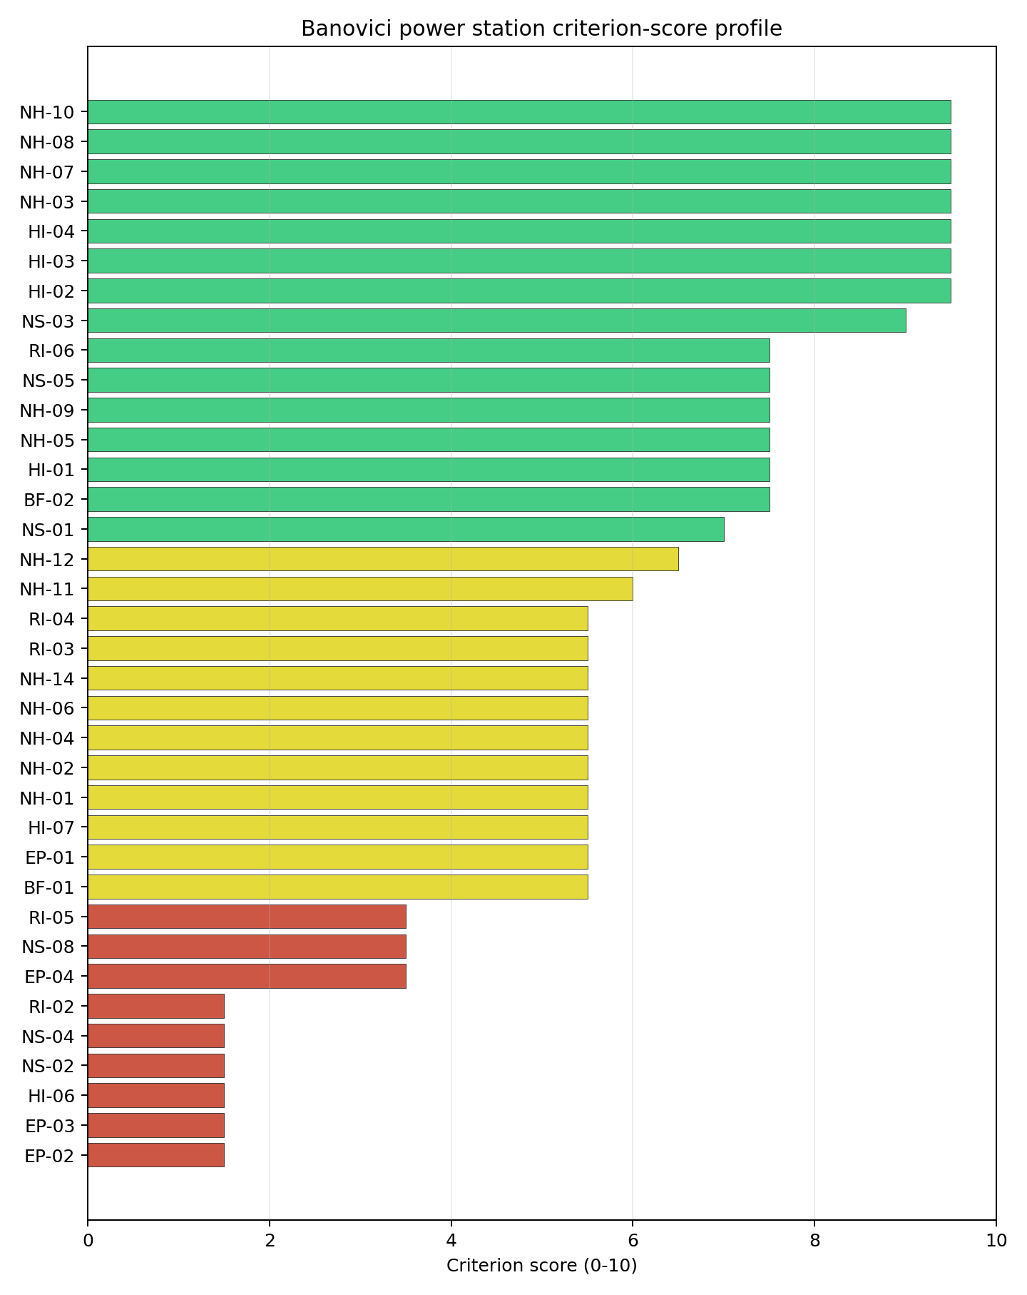
Criterion scores
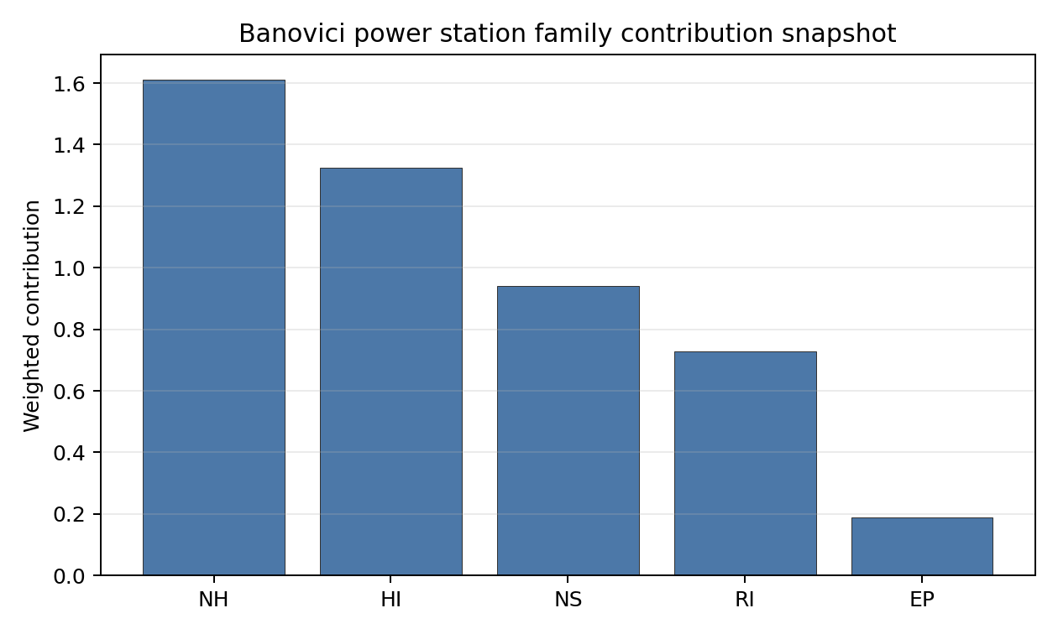
Family contributions
Banovici power station’s baseline composite score is 5.934, with a national Monte Carlo bracket of 5.325-6.425 and national rank 5. Its national stability band is H, with a 0.0% national top-10 hit rate in the project’s 50,000-iteration national sensitivity analysis; this indicates a fragile or weight-dependent shortlist position. The composite is supported most by HI 7.50, NH 7.09, while the lowest family scores are RI 5.14, EP 2.21. Stage 3 effort should narrow the uncertainty around the avoidance flags first, because those criteria determine whether the ranking can become a progression case rather than only a screened shortlist position.

Residual Risk Register
Concern | Evidence | Consequence | Stage 3 action | Owner discipline
Grid Connection (NS-02) | nearest substation 6.69 km; nearest high-voltage line 12.7 km | Grid reinforcement or voltage-path uncertainty could delay a bankable connection case. | Confirm transmission corridor, voltage pathway and export-capacity reinforcement requirements | grid
Evacuation Routes (EP-02) | road density in EPZ 0.25 km/km2; road length in EPZ 491.2 km | Emergency-planning clearance time or logistics could limit the usable siting envelope. | Model EPZ time-to-clear under seasonal and peak-load conditions | emergency planning
Physical Geography Constraints (EP-03) | waterways crossing EPZ 119; major river barrier: yes | Emergency-planning clearance time or logistics could limit the usable siting envelope. | Re-measure EP-03 with site-specific Stage 3 evidence | emergency planning
Military Installations (HI-06) | nearest military installation 10.9 km; military installations within radius 5 | Security or external-event separation could require programme-level stakeholder review. | Engage defence stakeholders on feature classification and security standoff | security
Site Topography (NS-04) | favourable land cover 10.7 %; moderate land cover 20.1 % | Implementation confidence remains limited until measured project evidence replaces screening proxies. | Re-measure NS-04 with site-specific Stage 3 evidence | socioeconomic
Surface Water Dispersion (RI-02) | No measured value beyond the screening score is available in the bundle | Dose-pathway confidence remains constrained until site-specific dispersion evidence is measured. | Quantify surface-water dilution and downstream receptor pathways | hydrology
Grid Connection (NS-02), Evacuation Routes (EP-02), Physical Geography Constraints (EP-03) dominate the residual-risk register because they either keep the site in the avoidance-flag pool or carry the weakest measured screening scores. The register is a Stage 3 work plan for an avoidance-flagged candidate, not a site-approval finding.

Stage 3 Follow-Up Checklist
Priority | Work item | Evidence driver | Owner discipline
1 | Confirm transmission corridor, voltage pathway and export-capacity reinforcement requirements | Grid Connection (NS-02): nearest substation 6.69 km | grid
2 | Model EPZ time-to-clear under seasonal and peak-load conditions | Evacuation Routes (EP-02): road density in EPZ 0.25 km/km2 | emergency planning
3 | Re-measure EP-03 with site-specific Stage 3 evidence | Physical Geography Constraints (EP-03): waterways crossing EPZ 119 | emergency planning
4 | Engage defence stakeholders on feature classification and security standoff | Military Installations (HI-06): nearest military installation 10.9 km | security
5 | Re-measure NS-04 with site-specific Stage 3 evidence | Site Topography (NS-04): favourable land cover 10.7 % | socioeconomic
6 | Quantify surface-water dilution and downstream receptor pathways | Surface Water Dispersion (RI-02): screening score 1.5/10 | hydrology

Evidence Limitations
- Transport Access (NS-03) - quality low.

Kamengrad Thermal Power Plant Site Profile
Kamengrad Thermal Power Plant is a coal/thermal site in Bosnia and Herzegovina that has been tested against the NuScale VOYGR-6 reference deployment envelope. This profile reads the screening evidence at a level that supports a decision to progress toward Stage 3 characterisation. It is not a site-suitability determination, vendor recommendation, or licensing finding.

Site Snapshot
Field | Value
Site name | Kamengrad Thermal Power Plant
Coordinates | 44.7667, 16.6667
Subnational unit | FBIH
Installed thermal capacity (source data) | 430 MW
Available surface area | 89.8 ha
Available surface area for development | 1.3 ha
Composite score (baseline weights) | 6.572 (5.886-7.131 MC band)
National stability band | H (top-10% hit rate 0%)
National rank | 3
See the country status map in Bosnia and Herzegovina Country Profile.

Ownership and Coal-to-Nuclear Context
- RMU Kamengrad dd (100.00% share), headquartered in Bosnia and Herzegovina; immediate operator RMU Kamengrad dd. Path: RMU Kamengrad dd -> Kamengrad Thermal Power Plant Unit 2 [100.0%]
- Unicredit SpA (30.61% share), headquartered in Italy; immediate operator RMU Kamengrad dd. Path: Unicredit SpA -> UniCredit Bank dd [99.35%] -> RMU Kamengrad dd [30.81%] -> Kamengrad Thermal Power Plant Unit 1 [100.0%]
- ZIF HERBOS FOND d.d. Mostar (13.22% share), headquartered in Bosnia and Herzegovina; immediate operator RMU Kamengrad dd. Path: ZIF HERBOS FOND d.d. Mostar -> RMU Kamengrad dd [13.22%] -> Kamengrad Thermal Power Plant Unit 2 [100.0%]
- unknown (44.04% share); immediate operator RMU Kamengrad dd. Path: unknown -> RMU Kamengrad dd [44.04%] -> Kamengrad Thermal Power Plant Unit 1 [100.0%]
- natural person(s) (11.93% share); immediate operator RMU Kamengrad dd. Path: natural person(s) -> RMU Kamengrad dd [11.93%] -> Kamengrad Thermal Power Plant Unit 1 [100.0%]
- UniCredit Bank dd (30.81% share), headquartered in Bosnia and Herzegovina; immediate operator RMU Kamengrad dd. Path: UniCredit Bank dd -> RMU Kamengrad dd [30.81%] -> Kamengrad Thermal Power Plant Unit 2 [100.0%]
Generating units on record: 2 cancelled.

Natural Hazards (NH)
- Seismic: Ground Motion (NH-01) - score 5.5/10 (MC 5.0-6.0) - pass-mark band: At or below the score-5 risk boundary., weight 0.0455, data quality high. Evidence: PGA at 475-year return period 0.125 g; PGA at 2,475-year return period 0.269 g; Vs30 reference (m/s): 760.0.
- Seismic: Surface Rupture (NH-02) - score 7.5/10 (MC 7.0-8.0), weight n/a, data quality screening grade. Evidence: nearest mapped capable fault 27.6 km; fault slip rate 0.173 mm/yr; fault name: BACF006.
- Geotechnical: Liquefaction (NH-03) - score 5.5/10 (MC 5.0-6.0) - pass-mark band: Moderate susceptibility, or high/very-high with documented (or pending for high) mitigation., weight n/a, data quality medium. Evidence: liquefaction susceptibility: high; dominant soil type: clay_loam.
- Geotechnical: Slope Stability (NH-04) - score 7.5/10 (MC 7.0-8.0), weight n/a, data quality screening grade. Evidence: site slope 6.84 deg; max slope in 1 km box 83.0 deg; slope stability class: moderate.
- Geotechnical: Subsidence (NH-05) - score 5.5/10 (MC 5.0-6.0) - pass-mark band: At or above the mine-distance score-5 pivot; review possible., weight 0.0354, data quality medium. Evidence: karst present: no; karst severity: moderate; formation type: carbonate (Continuous carbonate rocks).
- Geotechnical: Foundation (NH-06) - score 5.5/10 (MC 5.0-6.0) - pass-mark band: Typical European mixed conditions (bearing 80-150 kPa)., weight 0.0253, data quality medium. Evidence: bearing capacity 85.3 kPa; depth to bedrock 23.1 m.
- Volcanism (NH-07) - score 9.5/10 (MC 9.0-10.0) - favourable: Very strong margin above the score-5 boundary (or connector confirmed no in-radius signal)., weight n/a, data quality high. Evidence: volcanic hazard class: negligible.
- Coastal Flooding (NH-08) - score 9.5/10 (MC 9.0-10.0) - favourable: Non-coastal OR elevation >= 50 m AMSL OR landlocked country, with no positive marine-hazard signal., weight 0.0303, data quality medium. Evidence: distance to coast 109.8 km.
- River Flooding (NH-09) - score 7.5/10 (MC 7.0-8.0), weight 0.0404, data quality medium. Evidence: flood zone class: negligible.
- Extreme Winds (NH-10) - score 9.5/10 (MC 9.0-10.0) - favourable: Lowest relative wind exposure in the current reanalysis-grade monthly-mean gust cohort (< 7.5 m/s)., weight 0.0152, data quality medium. Evidence: screening wind-speed index 7.21 m/s.
- Extreme Precipitation (NH-11) - score 6.0/10 (MC 6.0-7.0) - pass-mark band: aggregated(mean_of_sub_scores), weight 0.0152, data quality medium. Evidence: screening extreme-precipitation index 0.29 mm; screening precipitation index 38.8 mm/yr.
- Extreme Temperatures (NH-12) - score 6.5/10 (MC 6.0-7.0) - pass-mark band: aggregated(mean_of_sub_scores), weight 0.0202, data quality medium. Evidence: extreme high temperature 23.6 deg C; extreme low temperature -5.23 deg C.
- Combined Hazards (NH-14) - score 5.5/10 (MC 5.0-6.0) - pass-mark band: At least 5 resolved, exactly one moderate hazard (3-5) or moderate interaction only., weight 0.0152, data quality n/a. Evidence: values not in measurement tables.

Interpretation - Natural Hazards (NH)
Natural hazards at Kamengrad Thermal Power Plant support an avoidance-flagged Stage 3 screening case rather than an unqualified site-selection conclusion. The measured record includes volcanic hazard class: negligible; distance to coast 109.8 km; PGA at 475-year return period 0.125 g; PGA at 2,475-year return period 0.269 g. The strongest evidence is Volcanism (NH-07) at 9.5/10, Coastal Flooding (NH-08) at 9.5/10, while the limiting criteria are Seismic: Ground Motion (NH-01) at 5.5/10, Geotechnical: Liquefaction (NH-03) at 5.5/10, Geotechnical: Subsidence (NH-05) at 5.5/10. Those limitations do not establish a licensing or suitability finding; they define the work that must be closed before the site can be treated as equivalent to a full-pass candidate. Stage 3 should therefore prioritise seismic, geotechnical, flood and meteorological confirmation, with the lowest-scoring and avoidance-flagged criteria measured first.

Human-Induced and Security-Relevant Hazards (HI)
- Aircraft Crash (HI-01) - score 3.5/10 (MC 3.0-4.0), weight 0.0354, data quality high. Evidence: nearest airport 1.58 km; nearest flight path 0.79 km; airports within search radius 2; airport name: PPG Paragliding Field; airport type: small airfield.
- Industrial Explosions (HI-02) - score 9.5/10 (MC 9.0-10.0) - favourable: Very strong margin above the score-5 boundary (or completed search confirmed no in-radius signal)., weight 0.0354, data quality screening grade. Evidence: values not in measurement tables.
- Toxic/Gas Releases (HI-03) - score 9.5/10 (MC 9.0-10.0) - favourable: Very strong margin above the score-5 boundary (or completed search confirmed no in-radius signal)., weight 0.0354, data quality screening grade. Evidence: values not in measurement tables.
- External Fires (HI-04) - score 9.5/10 (MC 9.0-10.0) - favourable: > 15 km, or completed flammable-storage search found nothing in radius., weight 0.0303, data quality screening grade. Evidence: values not in measurement tables.
- Military Installations (HI-06) - score 3.5/10 (MC 3.0-4.0), weight 0.0303, data quality medium. Evidence: nearest military installation 25.0 km; military installations within radius 1; installation name: Kasarna “Žarko Zgonjanin” Prijedor.
- Electromagnetic Interference (HI-07) - score 3.5/10 (MC 3.0-4.0), weight 0.0101, data quality medium. Evidence: nearest high-power transmitter 4.84 km; transmitters within radius 13; transmitter type: minaret.

Interpretation - Human-Induced and Security-Relevant Hazards (HI)
Human-induced and security-relevant hazards at Kamengrad Thermal Power Plant support an avoidance-flagged Stage 3 screening case rather than an unqualified site-selection conclusion. The measured record includes nearest airport 1.58 km; nearest flight path 0.79 km; nearest military installation 25.0 km; military installations within radius 1. The strongest evidence is Industrial Explosions (HI-02) at 9.5/10, Toxic/Gas Releases (HI-03) at 9.5/10, while the limiting criteria are Aircraft Crash (HI-01) at 3.5/10, Military Installations (HI-06) at 3.5/10, Electromagnetic Interference (HI-07) at 3.5/10. Those limitations do not establish a licensing or suitability finding; they define the work that must be closed before the site can be treated as equivalent to a full-pass candidate. Stage 3 should therefore prioritise aviation, military, industrial-neighbour and electromagnetic-interference checks, with the lowest-scoring and avoidance-flagged criteria measured first.

Radiological Impact and Emergency Planning (RI / EP)
- Emergency Planning Feasibility (EP-01) - score 5.5/10 (MC 5.0-6.0) - pass-mark band: At or above the composite score-5 boundary., weight n/a, data quality high. Evidence: EP feasibility composite 52.3 /100; road sub-score 27.0 /100; special-population sub-score 90.0 /100; geography sub-score 95.0 /100; population sub-score 60.0 /100; evacuation feasible: yes.
- Evacuation Routes (EP-02) - score 1.5/10 (MC 1.0-2.0), weight 0.0303, data quality medium. Evidence: road density in EPZ 0.27 km/km2; road length in EPZ 530.3 km; motorway access: no.
- Physical Geography Constraints (EP-03) - score 9.5/10 (MC 9.0-10.0) - favourable: No measured relief; open river/waterway context (interim screening)., weight 0.0253, data quality medium. Evidence: waterways crossing EPZ 0; major river barrier: no.
- Special Populations (EP-04) - score 5.5/10 (MC 5.0-6.0) - pass-mark band: 9-25., weight 0.0303, data quality medium. Evidence: hospitals in EPZ 13; prisons in EPZ 0; care homes in EPZ 0.
- Atmospheric Dispersion (RI-01) - score no native score (unscored - no band matched), weight 0.0303, data quality medium. Evidence: annual mean wind speed 0.45 m/s; atmospheric mixing height 391.6 m; prevailing wind direction: S.
- Surface Water Dispersion (RI-02) - score 3.5/10 (MC 3.0-4.0), weight 0.0253, data quality n/a. Evidence: values not in measurement tables.
- Groundwater Dispersion (RI-03) - score 5.5/10 (MC 5.0-6.0) - pass-mark band: Moderate-permeability aquifer screening proxy., weight 0.0253, data quality medium. Evidence: aquifer type: sedimentary sands.
- Population Density at EPZ Radii (RI-04) - score 3.5/10 (MC 3.0-4.0), weight 0.0404, data quality screening grade. Evidence: population density within 5 km 325.4 /km2; population density within 16 km 52.6 /km2; population density within 25 km 54.7 /km2; population density within 80 km 43.9 /km2; population within 25 km 107,431 people.
- Distance to Population Centres (RI-05) - score 9.5/10 (MC 9.0-10.0) - favourable: No >=50k population-centre proxy within screening envelope., weight 0.0505, data quality screening grade. Evidence: values not in measurement tables.
- Population Projections (RI-06) - score 9.5/10 (MC 9.0-10.0) - favourable: Declining (< -0.5 %/yr)., weight 0.0253, data quality screening grade. Evidence: annual population growth rate -1.071 %/yr; projected population at 25 km in 60 yr 58,956 people.

Interpretation - Radiological Impact and Emergency Planning (RI / EP)
Radiological impact and emergency planning at Kamengrad Thermal Power Plant support an avoidance-flagged Stage 3 screening case rather than an unqualified site-selection conclusion. The measured record includes waterways crossing EPZ 0; major river barrier: no; road density in EPZ 0.27 km/km2; road length in EPZ 530.3 km. The strongest evidence is Physical Geography Constraints (EP-03) at 9.5/10, Distance to Population Centres (RI-05) at 9.5/10, while the limiting criteria are Evacuation Routes (EP-02) at 1.5/10, Surface Water Dispersion (RI-02) at 3.5/10, Population Density at EPZ Radii (RI-04) at 3.5/10. Those limitations do not establish a licensing or suitability finding; they define the work that must be closed before the site can be treated as equivalent to a full-pass candidate. Stage 3 should therefore prioritise EPZ evacuation, population, atmospheric and water-pathway modelling, with the lowest-scoring and avoidance-flagged criteria measured first.

Non-Safety and Implementation Considerations (NS)
- Grid Capacity Basic Filter (BF-01) - score 5.5/10 (MC 5.0-6.0) - pass-mark band: Note: substation 15-30 km OR 110-219 kV; reinforcement plausible., weight n/a, data quality n/a. Evidence: values not in measurement tables.
- Land Area Basic Filter (BF-02) - score 1.5/10 (MC 1.0-2.0), weight 0.0253, data quality n/a. Evidence: values not in measurement tables.
- Cooling Water Availability (NS-01) - score 8.0/10 (MC 8.0-9.0) - favourable: aggregated(weighted_mean_of_sub_scores), weight 0.0404, data quality screening grade. Evidence: distance to cooling source 0.55 km; cooling source flow 18.2 m3/s; cooling source type: river; cooling source name: Zdena; water stress label: Low.
- Grid Connection (NS-02) - score 3.5/10 (MC 3.0-4.0), weight 0.0404, data quality high. Evidence: nearest substation 0.07 km; nearest high-voltage line 7.42 km; highest nearby line voltage 220.0 kV; grid export capacity 430.0 MW; substations within radius 31; HV lines within radius 50.
- Transport Access (NS-03) - score 7.0/10 (MC 5.0-8.0), weight 0.0404, data quality low. Evidence: nearest highway 1.18 km; nearest rail line 16.4 km; heavy-haul capable: yes.
- Site Topography (NS-04) - score 3.5/10 (MC 3.0-4.0), weight 0.0303, data quality screening grade. Evidence: favourable land cover 37.2 %; moderate land cover 35.4 %; unfavourable land cover 27.5 %; favourable area 89.8 ha; dominant land class: 321.
- Site Footprint Adequacy (NS-05) - score 9.5/10 (MC 7.5-10.0) - favourable: Very strong margin above the score-5 boundary., weight 0.0253, data quality low. Evidence: buildable area 1.32 ha; largest contiguous patch 1.32 ha; buildable patch count 4.
- Existing Infrastructure (NS-06) - score no native score (unscored - no band matched), weight 0.0253, data quality n/a. Evidence: not measured at this site (criterion remains unscored).
- Ecological Sensitivity (NS-08) - score 7.5/10 (MC 5.5-9.5), weight n/a, data quality insufficient. Evidence: natural land cover 27.5 %; Natura 2000 sensitivity class: unknown; protected-area overlap: no; protected-area sensitivity class: none; Natura 2000 sites within 5 km: 0.
- Workforce Availability (NS-10) - score no native score (unscored - no band matched), weight 0.0202, data quality n/a. Evidence: not measured at this site (criterion remains unscored).
- Regulatory/Political Environment (NS-12) - score no native score (unscored - no band matched), weight 0.0303, data quality n/a. Evidence: not measured at this site (criterion remains unscored).
- Construction Logistics (NS-13) - score no native score (unscored - no band matched), weight 0.0202, data quality n/a. Evidence: not measured at this site (criterion remains unscored).

Interpretation - Non-Safety and Implementation Considerations (NS)
Non-safety and implementation conditions at Kamengrad Thermal Power Plant support an avoidance-flagged Stage 3 screening case rather than an unqualified site-selection conclusion. The measured record includes buildable area 1.32 ha; largest contiguous patch 1.32 ha; distance to cooling source 0.55 km; cooling source flow 18.2 m3/s. The strongest evidence is Site Footprint Adequacy (NS-05) at 9.5/10, Cooling Water Availability (NS-01) at 8.0/10, while the limiting criteria are Land Area Basic Filter (BF-02) at 1.5/10, Grid Connection (NS-02) at 3.5/10, Site Topography (NS-04) at 3.5/10. Those limitations do not establish a licensing or suitability finding; they define the work that must be closed before the site can be treated as equivalent to a full-pass candidate. Stage 3 should therefore prioritise grid, cooling-water, transport, land and environmental-permitting checks, with the lowest-scoring and avoidance-flagged criteria measured first.

Composite Score and Stability
Baseline composite score is 6.572, bracketed by Monte Carlo at 5.886-7.131. National stability band is H with a top-10% hit rate of 0% in the project’s 50,000-iteration national sensitivity analysis.
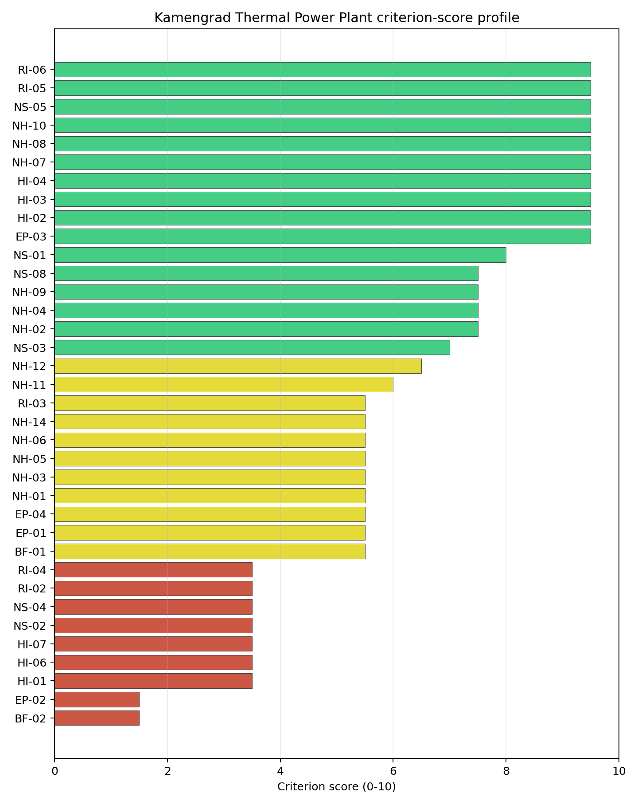
Criterion scores
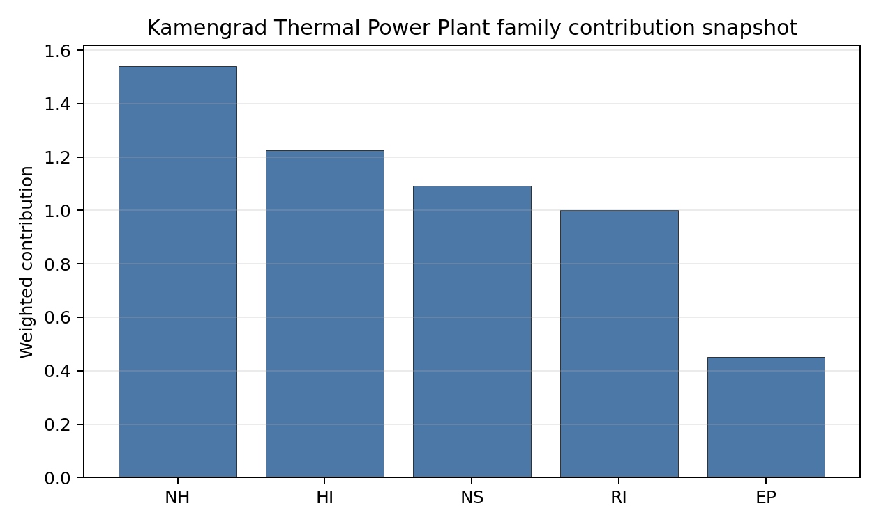
Family contributions
Kamengrad Thermal Power Plant’s baseline composite score is 6.572, with a national Monte Carlo bracket of 5.886-7.131 and national rank 3. Its national stability band is H, with a 0.0% national top-10 hit rate in the project’s 50,000-iteration national sensitivity analysis; this indicates a fragile or weight-dependent shortlist position. The composite is supported most by RI 7.07, HI 6.93, while the lowest family scores are NS 6.19, EP 5.26. Stage 3 effort should narrow the uncertainty around the avoidance flags first, because those criteria determine whether the ranking can become a progression case rather than only a screened shortlist position.

Residual Risk Register
Concern | Evidence | Consequence | Stage 3 action | Owner discipline
Aircraft Crash (HI-01) | nearest airport 1.58 km; nearest flight path 0.79 km | Aviation or airspace constraints could keep the site in the avoidance-flag pool. | Re-survey civil and military aviation constraints and flight-path separation | security
Grid Connection (NS-02) | nearest substation 0.07 km; nearest high-voltage line 7.42 km | Grid reinforcement or voltage-path uncertainty could delay a bankable connection case. | Confirm transmission corridor, voltage pathway and export-capacity reinforcement requirements | grid
Land Area Basic Filter (BF-02) | No measured value beyond the screening score is available in the bundle | Implementation confidence remains limited until measured project evidence replaces screening proxies. | Re-measure BF-02 with site-specific Stage 3 evidence | socioeconomic
Evacuation Routes (EP-02) | road density in EPZ 0.27 km/km2; road length in EPZ 530.3 km | Emergency-planning clearance time or logistics could limit the usable siting envelope. | Model EPZ time-to-clear under seasonal and peak-load conditions | emergency planning
Military Installations (HI-06) | nearest military installation 25.0 km; military installations within radius 1 | Security or external-event separation could require programme-level stakeholder review. | Engage defence stakeholders on feature classification and security standoff | security
Electromagnetic Interference (HI-07) | nearest high-power transmitter 4.84 km; transmitters within radius 13 | Security or external-event separation could require programme-level stakeholder review. | Re-measure HI-07 with site-specific Stage 3 evidence | security
Aircraft Crash (HI-01), Grid Connection (NS-02), Land Area Basic Filter (BF-02) dominate the residual-risk register because they either keep the site in the avoidance-flag pool or carry the weakest measured screening scores. The register is a Stage 3 work plan for an avoidance-flagged candidate, not a site-approval finding.

Stage 3 Follow-Up Checklist
Priority | Work item | Evidence driver | Owner discipline
1 | Re-survey civil and military aviation constraints and flight-path separation | Aircraft Crash (HI-01): nearest airport 1.58 km | security
2 | Confirm transmission corridor, voltage pathway and export-capacity reinforcement requirements | Grid Connection (NS-02): nearest substation 0.07 km | grid
3 | Re-measure BF-02 with site-specific Stage 3 evidence | Land Area Basic Filter (BF-02): screening score 1.5/10 | socioeconomic
4 | Model EPZ time-to-clear under seasonal and peak-load conditions | Evacuation Routes (EP-02): road density in EPZ 0.27 km/km2 | emergency planning
5 | Engage defence stakeholders on feature classification and security standoff | Military Installations (HI-06): nearest military installation 25.0 km | security
6 | Re-measure HI-07 with site-specific Stage 3 evidence | Electromagnetic Interference (HI-07): nearest high-power transmitter 4.84 km | security

Evidence Limitations
- Transport Access (NS-03) - quality low.
- Site Footprint Adequacy (NS-05) - quality low.

Miljevina power station Site Profile
Miljevina power station is a coal/thermal site in Bosnia and Herzegovina that has been tested against the NuScale VOYGR-6 reference deployment envelope. This profile reads the screening evidence at a level that supports a decision to progress toward Stage 3 characterisation. It is not a site-suitability determination, vendor recommendation, or licensing finding.

Site Snapshot
Field | Value
Site name | Miljevina power station
Coordinates | 43.5183, 18.6521
Subnational unit | Republika Srpska
Installed thermal capacity (source data) | 220 MW
Available surface area | 106.2 ha
Available surface area for development | 106.2 ha
Composite score (baseline weights) | 6.622 (5.927-7.131 MC band)
National stability band | H (top-10% hit rate 8%)
National rank | 2
See the country status map in Bosnia and Herzegovina Country Profile.

Ownership and Coal-to-Nuclear Context
Generating units on record: 2 cancelled.

Natural Hazards (NH)
- Seismic: Ground Motion (NH-01) - score 5.5/10 (MC 5.0-6.0) - pass-mark band: At or below the score-5 risk boundary., weight 0.0455, data quality high. Evidence: PGA at 475-year return period 0.132 g; PGA at 2,475-year return period 0.273 g; Vs30 reference (m/s): 760.0.
- Seismic: Surface Rupture (NH-02) - score 5.5/10 (MC 5.0-6.0) - pass-mark band: Borderline acceptable separation: meets the 8.0 km score boundary; check against the 8 km conservative screen and local capability evidence., weight n/a, data quality screening grade. Evidence: nearest mapped capable fault 13.6 km; fault slip rate 0.173 mm/yr; fault name: MECF007.
- Geotechnical: Liquefaction (NH-03) - score 9.5/10 (MC 9.0-10.0) - favourable: Negligible susceptibility (Stage-1 favourable default)., weight n/a, data quality medium. Evidence: liquefaction susceptibility: very_low; dominant soil type: loam.
- Geotechnical: Slope Stability (NH-04) - score 5.5/10 (MC 5.0-6.0) - pass-mark band: At or below the score-5 risk boundary., weight n/a, data quality screening grade. Evidence: site slope 18.7 deg; max slope in 1 km box 88.1 deg; slope stability class: very_steep.
- Geotechnical: Subsidence (NH-05) - score 1.5/10 (MC 1.0-2.0), weight 0.0354, data quality medium. Evidence: karst present: no; karst severity: moderate; formation type: carbonate (Continuous carbonate rocks).
- Geotechnical: Foundation (NH-06) - score 3.5/10 (MC 3.0-4.0), weight 0.0253, data quality medium. Evidence: bearing capacity 67.3 kPa; depth to bedrock 18.3 m.
- Volcanism (NH-07) - score 9.5/10 (MC 9.0-10.0) - favourable: Very strong margin above the score-5 boundary (or connector confirmed no in-radius signal)., weight n/a, data quality high. Evidence: volcanic hazard class: negligible.
- Coastal Flooding (NH-08) - score 9.5/10 (MC 9.0-10.0) - favourable: Non-coastal OR elevation >= 50 m AMSL OR landlocked country, with no positive marine-hazard signal., weight 0.0303, data quality medium. Evidence: distance to coast 104.0 km.
- River Flooding (NH-09) - score 7.5/10 (MC 7.0-8.0), weight 0.0404, data quality medium. Evidence: flood zone class: negligible.
- Extreme Winds (NH-10) - score 5.5/10 (MC 5.0-6.0) - pass-mark band: Middle relative wind exposure around the observed cohort mean (9.0-10.5 m/s)., weight 0.0152, data quality medium. Evidence: screening wind-speed index 10.1 m/s.
- Extreme Precipitation (NH-11) - score 6.0/10 (MC 6.0-7.0) - pass-mark band: aggregated(mean_of_sub_scores), weight 0.0152, data quality medium. Evidence: screening extreme-precipitation index 0.26 mm; screening precipitation index 33.8 mm/yr.
- Extreme Temperatures (NH-12) - score 7.5/10 (MC 7.0-8.0), weight 0.0202, data quality medium. Evidence: extreme high temperature 21.3 deg C; extreme low temperature -7.69 deg C.
- Combined Hazards (NH-14) - score 5.5/10 (MC 5.0-6.0) - pass-mark band: At least 5 resolved, exactly one moderate hazard (3-5) or moderate interaction only., weight 0.0152, data quality n/a. Evidence: values not in measurement tables.

Interpretation - Natural Hazards (NH)
Natural hazards at Miljevina power station support an avoidance-flagged Stage 3 screening case rather than an unqualified site-selection conclusion. The measured record includes liquefaction susceptibility: very_low; dominant soil type: loam; volcanic hazard class: negligible; karst present: no. The strongest evidence is Geotechnical: Liquefaction (NH-03) at 9.5/10, Volcanism (NH-07) at 9.5/10, while the limiting criteria are Geotechnical: Subsidence (NH-05) at 1.5/10, Geotechnical: Foundation (NH-06) at 3.5/10, Seismic: Ground Motion (NH-01) at 5.5/10. Those limitations do not establish a licensing or suitability finding; they define the work that must be closed before the site can be treated as equivalent to a full-pass candidate. Stage 3 should therefore prioritise seismic, geotechnical, flood and meteorological confirmation, with the lowest-scoring and avoidance-flagged criteria measured first.

Human-Induced and Security-Relevant Hazards (HI)
- Aircraft Crash (HI-01) - score 9.5/10 (MC 9.0-10.0) - favourable: Nearest large/medium airport > 30 km, no flight-path proxy < 4 km, and no military airbase within 60 km., weight 0.0354, data quality high. Evidence: nearest airport 42.7 km; nearest flight path 21.4 km; airports within search radius 0; airport name: Sarajevo International Airport; airport type: large airport.
- Industrial Explosions (HI-02) - score 9.5/10 (MC 9.0-10.0) - favourable: Very strong margin above the score-5 boundary (or completed search confirmed no in-radius signal)., weight 0.0354, data quality screening grade. Evidence: values not in measurement tables.
- Toxic/Gas Releases (HI-03) - score 9.5/10 (MC 9.0-10.0) - favourable: Very strong margin above the score-5 boundary (or completed search confirmed no in-radius signal)., weight 0.0354, data quality screening grade. Evidence: values not in measurement tables.
- External Fires (HI-04) - score 9.5/10 (MC 9.0-10.0) - favourable: > 15 km, or completed flammable-storage search found nothing in radius., weight 0.0303, data quality screening grade. Evidence: values not in measurement tables.
- Military Installations (HI-06) - score 1.5/10 (MC 1.0-2.0), weight 0.0303, data quality medium. Evidence: nearest military installation 7.42 km; military installations within radius 40; installation name: unnamed.
- Electromagnetic Interference (HI-07) - score 9.5/10 (MC 9.0-10.0) - favourable: Sparse and distant transmitter proxy: at most five transmitter-like features and none measured within 10 km., weight 0.0101, data quality medium. Evidence: nearest high-power transmitter 16.1 km; transmitters within radius 5; transmitter type: tower.

Interpretation - Human-Induced and Security-Relevant Hazards (HI)
Human-induced and security-relevant hazards at Miljevina power station support an avoidance-flagged Stage 3 screening case rather than an unqualified site-selection conclusion. The measured record includes nearest airport 42.7 km; nearest flight path 21.4 km; nearest military installation 7.42 km; military installations within radius 40. The strongest evidence is Aircraft Crash (HI-01) at 9.5/10, Industrial Explosions (HI-02) at 9.5/10, while the limiting criteria are Military Installations (HI-06) at 1.5/10, Aircraft Crash (HI-01) at 9.5/10, Industrial Explosions (HI-02) at 9.5/10. Those limitations do not establish a licensing or suitability finding; they define the work that must be closed before the site can be treated as equivalent to a full-pass candidate. Stage 3 should therefore prioritise aviation, military, industrial-neighbour and electromagnetic-interference checks, with the lowest-scoring and avoidance-flagged criteria measured first.

Radiological Impact and Emergency Planning (RI / EP)
- Emergency Planning Feasibility (EP-01) - score 5.5/10 (MC 5.0-6.0) - pass-mark band: At or above the composite score-5 boundary., weight n/a, data quality high. Evidence: EP feasibility composite 63.0 /100; road sub-score 21.1 /100; special-population sub-score 90.0 /100; geography sub-score 95.0 /100; population sub-score 95.0 /100; evacuation feasible: yes.
- Evacuation Routes (EP-02) - score 1.5/10 (MC 1.0-2.0), weight 0.0303, data quality medium. Evidence: road density in EPZ 0.211 km/km2; road length in EPZ 413.7 km; motorway access: no.
- Physical Geography Constraints (EP-03) - score 9.5/10 (MC 9.0-10.0) - favourable: No measured relief; open river/waterway context (interim screening)., weight 0.0253, data quality medium. Evidence: waterways crossing EPZ 0; major river barrier: no.
- Special Populations (EP-04) - score 5.5/10 (MC 5.0-6.0) - pass-mark band: 9-25., weight 0.0303, data quality medium. Evidence: hospitals in EPZ 9; prisons in EPZ 2; care homes in EPZ 0.
- Atmospheric Dispersion (RI-01) - score no native score (unscored - no band matched), weight 0.0303, data quality medium. Evidence: annual mean wind speed 0.53 m/s; atmospheric mixing height 461.8 m; prevailing wind direction: SSW.
- Surface Water Dispersion (RI-02) - score 1.5/10 (MC 1.0-2.0), weight 0.0253, data quality n/a. Evidence: values not in measurement tables.
- Groundwater Dispersion (RI-03) - score 5.5/10 (MC 5.0-6.0) - pass-mark band: Moderate-permeability aquifer screening proxy., weight 0.0253, data quality medium. Evidence: aquifer type: sedimentary sands.
- Population Density at EPZ Radii (RI-04) - score 7.5/10 (MC 7.0-8.0), weight 0.0404, data quality screening grade. Evidence: population density within 5 km 19.7 /km2; population density within 16 km 18.6 /km2; population density within 25 km 12.8 /km2; population density within 80 km 43.4 /km2; population within 25 km 25,220 people.
- Distance to Population Centres (RI-05) - score 9.5/10 (MC 9.0-10.0) - favourable: No >=50k population-centre proxy within screening envelope., weight 0.0505, data quality screening grade. Evidence: values not in measurement tables.
- Population Projections (RI-06) - score 9.5/10 (MC 9.0-10.0) - favourable: Declining (< -0.5 %/yr)., weight 0.0253, data quality screening grade. Evidence: annual population growth rate -1.328 %/yr; projected population at 25 km in 60 yr 13,845 people.

Interpretation - Radiological Impact and Emergency Planning (RI / EP)
Radiological impact and emergency planning at Miljevina power station support an avoidance-flagged Stage 3 screening case rather than an unqualified site-selection conclusion. The measured record includes waterways crossing EPZ 0; major river barrier: no; road density in EPZ 0.211 km/km2; road length in EPZ 413.7 km. The strongest evidence is Physical Geography Constraints (EP-03) at 9.5/10, Distance to Population Centres (RI-05) at 9.5/10, while the limiting criteria are Evacuation Routes (EP-02) at 1.5/10, Surface Water Dispersion (RI-02) at 1.5/10, Atmospheric Dispersion (RI-01) at 5.0/10. Those limitations do not establish a licensing or suitability finding; they define the work that must be closed before the site can be treated as equivalent to a full-pass candidate. Stage 3 should therefore prioritise EPZ evacuation, population, atmospheric and water-pathway modelling, with the lowest-scoring and avoidance-flagged criteria measured first.

Non-Safety and Implementation Considerations (NS)
- Grid Capacity Basic Filter (BF-01) - score 5.5/10 (MC 5.0-6.0) - pass-mark band: Note: substation 15-30 km OR 110-219 kV; reinforcement plausible., weight n/a, data quality n/a. Evidence: values not in measurement tables.
- Land Area Basic Filter (BF-02) - score 9.5/10 (MC 9.0-10.0) - favourable: Contiguous and buildable >= ideal area (70 ha/module)., weight 0.0253, data quality n/a. Evidence: values not in measurement tables.
- Cooling Water Availability (NS-01) - score 8.0/10 (MC 7.0-8.0) - favourable: aggregated(weighted_mean_of_sub_scores), weight 0.0404, data quality screening grade. Evidence: distance to cooling source 0.25 km; cooling source flow 8.6 m3/s; cooling source type: small_river; cooling source name: Bistrica; water stress label: Low.
- Grid Connection (NS-02) - score 1.5/10 (MC 1.0-2.0), weight 0.0404, data quality high. Evidence: nearest substation 9.07 km; nearest high-voltage line 3.94 km; highest nearby line voltage 400.0 kV; grid export capacity 220.0 MW; substations within radius 35; HV lines within radius 22.
- Transport Access (NS-03) - score 8.0/10 (MC 6.0-9.0) - favourable: aggregated(weighted_mean_of_sub_scores), weight 0.0404, data quality low. Evidence: nearest highway 0.33 km; nearest waterway 13.1 km; heavy-haul capable: yes.
- Site Topography (NS-04) - score 1.5/10 (MC 1.0-2.0), weight 0.0303, data quality screening grade. Evidence: favourable land cover 5.5 %; moderate land cover 28.8 %; unfavourable land cover 65.7 %; favourable area 6.37 ha; dominant land class: 311.
- Site Footprint Adequacy (NS-05) - score 9.5/10 (MC 9.0-10.0) - favourable: Very strong margin above the score-5 boundary., weight 0.0253, data quality screening grade. Evidence: buildable area 106.2 ha; largest contiguous patch 154.4 ha; buildable patch count 23.
- Existing Infrastructure (NS-06) - score no native score (unscored - no band matched), weight 0.0253, data quality n/a. Evidence: not measured at this site (criterion remains unscored).
- Ecological Sensitivity (NS-08) - score 1.5/10 (MC 0.0-3.5), weight n/a, data quality insufficient. Evidence: natural land cover 65.7 %; distance to nearest protected area 1.181 km; Natura 2000 sensitivity class: unknown; protected-area overlap: no; protected-area sensitivity class: high; Natura 2000 sites within 5 km: 0; nearest protected-area designation: Nature Monument (RS law).
- Workforce Availability (NS-10) - score no native score (unscored - no band matched), weight 0.0202, data quality n/a. Evidence: not measured at this site (criterion remains unscored).
- Regulatory/Political Environment (NS-12) - score no native score (unscored - no band matched), weight 0.0303, data quality n/a. Evidence: not measured at this site (criterion remains unscored).
- Construction Logistics (NS-13) - score no native score (unscored - no band matched), weight 0.0202, data quality n/a. Evidence: not measured at this site (criterion remains unscored).

Interpretation - Non-Safety and Implementation Considerations (NS)
Non-safety and implementation conditions at Miljevina power station support an avoidance-flagged Stage 3 screening case rather than an unqualified site-selection conclusion. The measured record includes buildable area 106.2 ha; largest contiguous patch 154.4 ha; nearest substation 9.07 km; nearest high-voltage line 3.94 km. The strongest evidence is Land Area Basic Filter (BF-02) at 9.5/10, Site Footprint Adequacy (NS-05) at 9.5/10, while the limiting criteria are Grid Connection (NS-02) at 1.5/10, Site Topography (NS-04) at 1.5/10, Ecological Sensitivity (NS-08) at 1.5/10. Those limitations do not establish a licensing or suitability finding; they define the work that must be closed before the site can be treated as equivalent to a full-pass candidate. Stage 3 should therefore prioritise grid, cooling-water, transport, land and environmental-permitting checks, with the lowest-scoring and avoidance-flagged criteria measured first.

Composite Score and Stability
Baseline composite score is 6.622, bracketed by Monte Carlo at 5.927-7.131. National stability band is H with a top-10% hit rate of 8% in the project’s 50,000-iteration national sensitivity analysis.
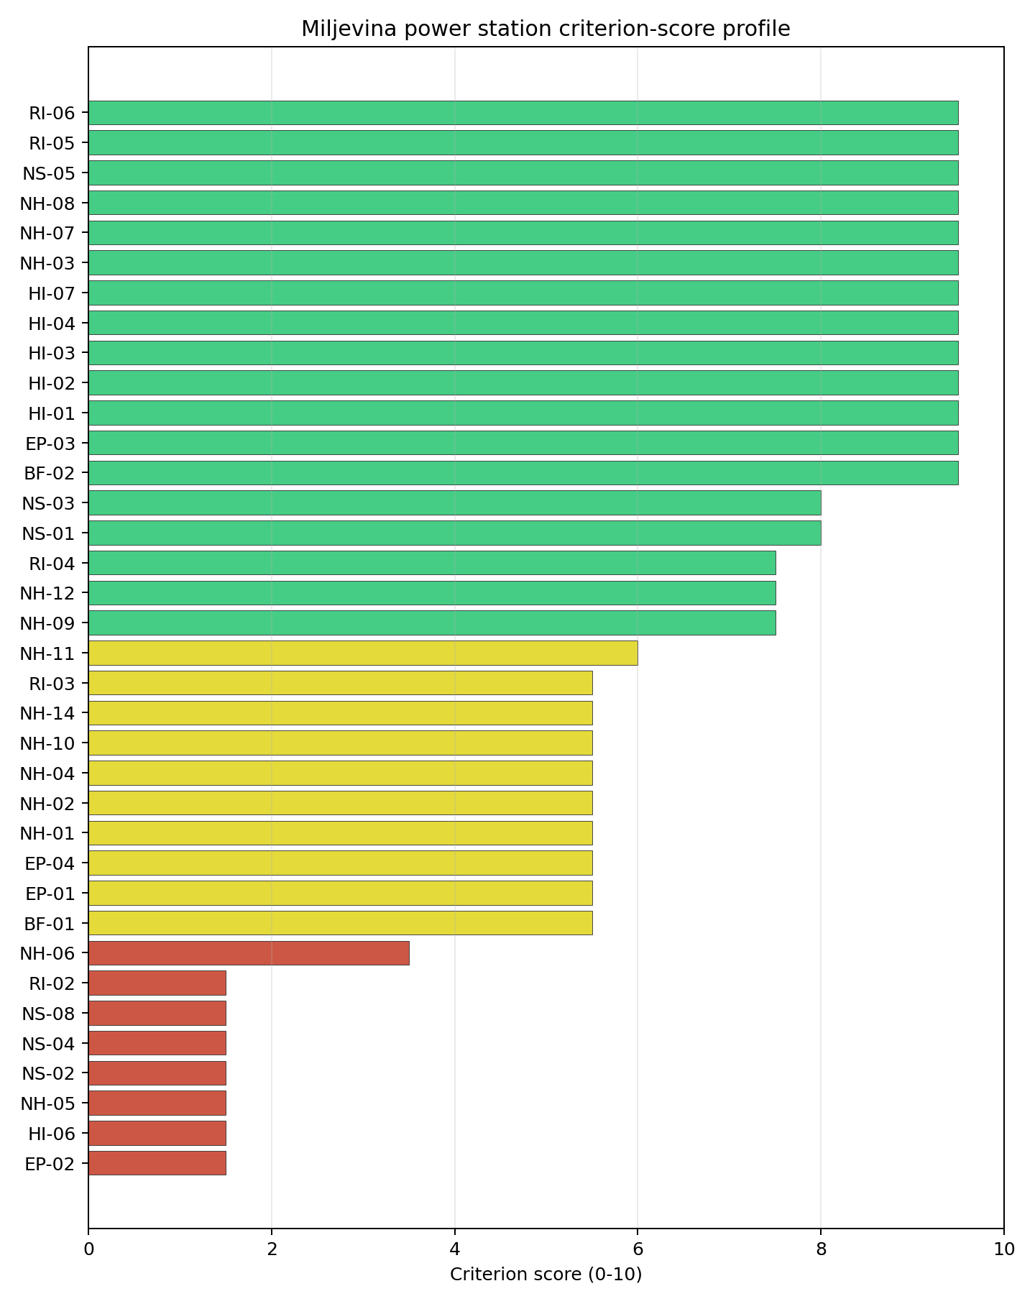
Criterion scores
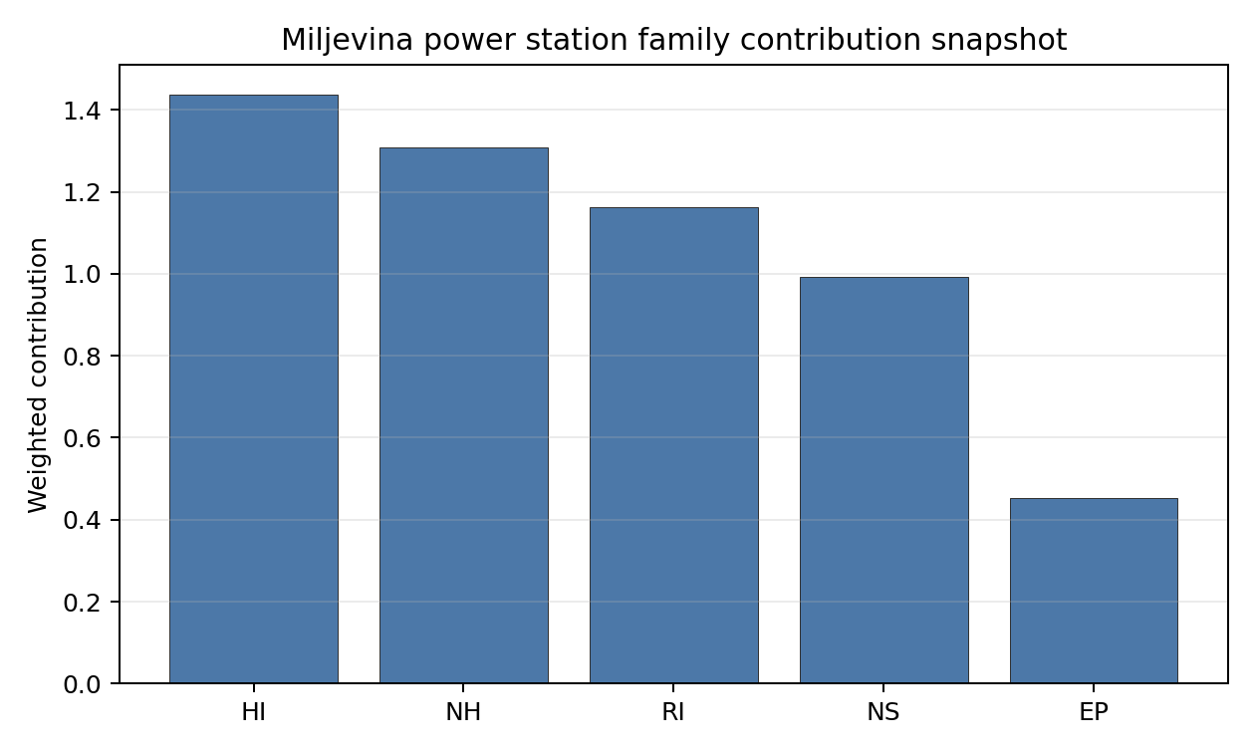
Family contributions
Miljevina power station’s baseline composite score is 6.622, with a national Monte Carlo bracket of 5.927-7.131 and national rank 2. Its national stability band is H, with a 8.3% national top-10 hit rate in the project’s 50,000-iteration national sensitivity analysis; this indicates a fragile or weight-dependent shortlist position. The composite is supported most by RI 8.21, HI 8.13, while the lowest family scores are NS 5.61, EP 5.26. Stage 3 effort should narrow the uncertainty around the avoidance flags first, because those criteria determine whether the ranking can become a progression case rather than only a screened shortlist position.

Residual Risk Register
Concern | Evidence | Consequence | Stage 3 action | Owner discipline
Grid Connection (NS-02) | nearest substation 9.07 km; nearest high-voltage line 3.94 km | Grid reinforcement or voltage-path uncertainty could delay a bankable connection case. | Confirm transmission corridor, voltage pathway and export-capacity reinforcement requirements | grid
Evacuation Routes (EP-02) | road density in EPZ 0.211 km/km2; road length in EPZ 413.7 km | Emergency-planning clearance time or logistics could limit the usable siting envelope. | Model EPZ time-to-clear under seasonal and peak-load conditions | emergency planning
Military Installations (HI-06) | nearest military installation 7.42 km; military installations within radius 40 | Security or external-event separation could require programme-level stakeholder review. | Engage defence stakeholders on feature classification and security standoff | security
Geotechnical: Subsidence (NH-05) | karst present: no; karst severity: moderate | Natural-hazard margin could narrow after field characterisation. | Confirm subsidence and karst conditions with field geophysics | geotech
Site Topography (NS-04) | favourable land cover 5.5 %; moderate land cover 28.8 % | Implementation confidence remains limited until measured project evidence replaces screening proxies. | Re-measure NS-04 with site-specific Stage 3 evidence | socioeconomic
Ecological Sensitivity (NS-08) | natural land cover 65.7 %; distance to nearest protected area 1.181 km | Implementation confidence remains limited until measured project evidence replaces screening proxies. | Screen ecological receptors and permitting triggers around the site boundary | EIA
Grid Connection (NS-02), Evacuation Routes (EP-02), Military Installations (HI-06) dominate the residual-risk register because they either keep the site in the avoidance-flag pool or carry the weakest measured screening scores. The register is a Stage 3 work plan for an avoidance-flagged candidate, not a site-approval finding.

Stage 3 Follow-Up Checklist
Priority | Work item | Evidence driver | Owner discipline
1 | Confirm transmission corridor, voltage pathway and export-capacity reinforcement requirements | Grid Connection (NS-02): nearest substation 9.07 km | grid
2 | Model EPZ time-to-clear under seasonal and peak-load conditions | Evacuation Routes (EP-02): road density in EPZ 0.211 km/km2 | emergency planning
3 | Engage defence stakeholders on feature classification and security standoff | Military Installations (HI-06): nearest military installation 7.42 km | security
4 | Confirm subsidence and karst conditions with field geophysics | Geotechnical: Subsidence (NH-05): karst present: no | geotech
5 | Re-measure NS-04 with site-specific Stage 3 evidence | Site Topography (NS-04): favourable land cover 5.5 % | socioeconomic
6 | Screen ecological receptors and permitting triggers around the site boundary | Ecological Sensitivity (NS-08): natural land cover 65.7 % | EIA

Evidence Limitations
- Transport Access (NS-03) - quality low.

Stanari Thermal Power Plant Site Profile
Stanari Thermal Power Plant is a coal/thermal site in Bosnia and Herzegovina that has been tested against the NuScale VOYGR-6 reference deployment envelope. This profile reads the screening evidence at a level that supports a decision to progress toward Stage 3 characterisation. It is not a site-suitability determination, vendor recommendation, or licensing finding.

Site Snapshot
Field | Value
Site name | Stanari Thermal Power Plant
Coordinates | 44.7539, 17.7924
Subnational unit | Republika Srpska
Installed thermal capacity (source data) | 300 MW
Available surface area | 269.0 ha
Available surface area for development | 26.6 ha
Composite score (baseline weights) | 6.747 (6.028-7.237 MC band)
National stability band | A (top-10% hit rate 92%)
National rank | 1
See the country status map in Bosnia and Herzegovina Country Profile.

Ownership and Coal-to-Nuclear Context
- Stanari Investments Ltd (100.00% share), headquartered in United Kingdom; immediate operator EFT Rudnik i Termoelektrana Stanari doo. Path: Stanari Investments Ltd -> EFT Rudnik i Termoelektrana Stanari doo [100.0%] -> Stanari Thermal Power Plant – [100.0%]
- natural person(s) (share not specified); immediate operator EFT Rudnik i Termoelektrana Stanari doo. Path: natural person(s) -> Stanari Investments Ltd [unknown %] -> EFT Rudnik i Termoelektrana Stanari doo [100.0%] -> Stanari Thermal Power Plant – [100.0%]
Generating units on record: 1 operating. Earliest unit commissioning: 2016; most recent: 2016.

Natural Hazards (NH)
- Seismic: Ground Motion (NH-01) - score 5.5/10 (MC 5.0-6.0) - pass-mark band: At or below the score-5 risk boundary., weight 0.0455, data quality high. Evidence: PGA at 475-year return period 0.136 g; PGA at 2,475-year return period 0.284 g; Vs30 reference (m/s): 760.0.
- Seismic: Surface Rupture (NH-02) - score 7.5/10 (MC 7.0-8.0), weight n/a, data quality screening grade. Evidence: nearest mapped capable fault 29.9 km; fault slip rate 0.1 mm/yr; fault name: BACF005.
- Geotechnical: Liquefaction (NH-03) - score 5.5/10 (MC 5.0-6.0) - pass-mark band: Moderate susceptibility, or high/very-high with documented (or pending for high) mitigation., weight n/a, data quality medium. Evidence: liquefaction susceptibility: moderate; dominant soil type: clay_loam.
- Geotechnical: Slope Stability (NH-04) - score no native score (unscored - no band matched), weight n/a, data quality screening grade. Evidence: not measured at this site (criterion remains unscored).
- Geotechnical: Subsidence (NH-05) - score 3.5/10 (MC 3.0-4.0), weight 0.0354, data quality medium. Evidence: karst present: no; karst severity: none.
- Geotechnical: Foundation (NH-06) - score 5.5/10 (MC 5.0-6.0) - pass-mark band: Typical European mixed conditions (bearing 80-150 kPa)., weight 0.0253, data quality medium. Evidence: bearing capacity 88.7 kPa; depth to bedrock 21.4 m.
- Volcanism (NH-07) - score 9.5/10 (MC 9.0-10.0) - favourable: Very strong margin above the score-5 boundary (or connector confirmed no in-radius signal)., weight n/a, data quality high. Evidence: volcanic hazard class: negligible.
- Coastal Flooding (NH-08) - score 9.5/10 (MC 9.0-10.0) - favourable: Non-coastal OR elevation >= 50 m AMSL OR landlocked country, with no positive marine-hazard signal., weight 0.0303, data quality medium. Evidence: distance to coast 167.2 km.
- River Flooding (NH-09) - score 7.5/10 (MC 7.0-8.0), weight 0.0404, data quality medium. Evidence: flood zone class: negligible.
- Extreme Winds (NH-10) - score 9.5/10 (MC 9.0-10.0) - favourable: Lowest relative wind exposure in the current reanalysis-grade monthly-mean gust cohort (< 7.5 m/s)., weight 0.0152, data quality medium. Evidence: screening wind-speed index 6.12 m/s.
- Extreme Precipitation (NH-11) - score 6.0/10 (MC 5.0-6.0) - pass-mark band: aggregated(mean_of_sub_scores), weight 0.0152, data quality medium. Evidence: screening extreme-precipitation index 0.31 mm; screening precipitation index 34.5 mm/yr.
- Extreme Temperatures (NH-12) - score 6.5/10 (MC 6.0-7.0) - pass-mark band: aggregated(mean_of_sub_scores), weight 0.0202, data quality medium. Evidence: extreme high temperature 24.7 deg C; extreme low temperature -4.96 deg C.
- Combined Hazards (NH-14) - score 5.5/10 (MC 5.0-6.0) - pass-mark band: At least 5 resolved, exactly one moderate hazard (3-5) or moderate interaction only., weight 0.0152, data quality n/a. Evidence: values not in measurement tables.

Interpretation - Natural Hazards (NH)
Natural hazards at Stanari Thermal Power Plant support an avoidance-flagged Stage 3 screening case rather than an unqualified site-selection conclusion. The measured record includes volcanic hazard class: negligible; distance to coast 167.2 km; karst present: no; karst severity: none. The strongest evidence is Volcanism (NH-07) at 9.5/10, Coastal Flooding (NH-08) at 9.5/10, while the limiting criteria are Geotechnical: Subsidence (NH-05) at 3.5/10, Geotechnical: Slope Stability (NH-04) at 5.0/10, Seismic: Ground Motion (NH-01) at 5.5/10. Those limitations do not establish a licensing or suitability finding; they define the work that must be closed before the site can be treated as equivalent to a full-pass candidate. Stage 3 should therefore prioritise seismic, geotechnical, flood and meteorological confirmation, with the lowest-scoring and avoidance-flagged criteria measured first.

Human-Induced and Security-Relevant Hazards (HI)
- Aircraft Crash (HI-01) - score 9.5/10 (MC 9.0-10.0) - favourable: Only small / GA / heliport airport >= 10 km nearby, no flight-path proxy < 4 km, no major airport within 30 km, and no military airbase within 60 km., weight 0.0354, data quality high. Evidence: nearest airport 33.5 km; nearest flight path 16.7 km; airports within search radius 0; airport name: Koprivna Begovac Airfield; airport type: small airfield.
- Industrial Explosions (HI-02) - score 9.5/10 (MC 9.0-10.0) - favourable: Very strong margin above the score-5 boundary (or completed search confirmed no in-radius signal)., weight 0.0354, data quality screening grade. Evidence: values not in measurement tables.
- Toxic/Gas Releases (HI-03) - score 9.5/10 (MC 9.0-10.0) - favourable: Very strong margin above the score-5 boundary (or completed search confirmed no in-radius signal)., weight 0.0354, data quality screening grade. Evidence: values not in measurement tables.
- External Fires (HI-04) - score 9.5/10 (MC 9.0-10.0) - favourable: > 15 km, or completed flammable-storage search found nothing in radius., weight 0.0303, data quality screening grade. Evidence: values not in measurement tables.
- Military Installations (HI-06) - score 1.5/10 (MC 1.0-2.0), weight 0.0303, data quality medium. Evidence: nearest military installation 10.5 km; military installations within radius 7; installation name: unnamed.
- Electromagnetic Interference (HI-07) - score 5.5/10 (MC 5.0-6.0) - pass-mark band: Scoreable ordinary RF environment from count/proximity evidence; power-class-specific severity deferred., weight 0.0101, data quality medium. Evidence: nearest high-power transmitter 16.4 km; transmitters within radius 18; transmitter type: minaret.

Interpretation - Human-Induced and Security-Relevant Hazards (HI)
Human-induced and security-relevant hazards at Stanari Thermal Power Plant support an avoidance-flagged Stage 3 screening case rather than an unqualified site-selection conclusion. The measured record includes nearest airport 33.5 km; nearest flight path 16.7 km; nearest military installation 10.5 km; military installations within radius 7. The strongest evidence is Aircraft Crash (HI-01) at 9.5/10, Industrial Explosions (HI-02) at 9.5/10, while the limiting criteria are Military Installations (HI-06) at 1.5/10, Electromagnetic Interference (HI-07) at 5.5/10, Aircraft Crash (HI-01) at 9.5/10. Those limitations do not establish a licensing or suitability finding; they define the work that must be closed before the site can be treated as equivalent to a full-pass candidate. Stage 3 should therefore prioritise aviation, military, industrial-neighbour and electromagnetic-interference checks, with the lowest-scoring and avoidance-flagged criteria measured first.

Radiological Impact and Emergency Planning (RI / EP)
- Emergency Planning Feasibility (EP-01) - score 7.5/10 (MC 7.0-8.0), weight n/a, data quality high. Evidence: EP feasibility composite 70.1 /100; road sub-score 49.4 /100; special-population sub-score 90.0 /100; geography sub-score 95.0 /100; population sub-score 95.0 /100; evacuation feasible: yes.
- Evacuation Routes (EP-02) - score 3.5/10 (MC 3.0-4.0), weight 0.0303, data quality medium. Evidence: road density in EPZ 0.457 km/km2; road length in EPZ 897.0 km; motorway access: yes.
- Physical Geography Constraints (EP-03) - score 9.5/10 (MC 9.0-10.0) - favourable: No measured relief; open river/waterway context (interim screening)., weight 0.0253, data quality medium. Evidence: waterways crossing EPZ 0; major river barrier: no.
- Special Populations (EP-04) - score 3.5/10 (MC 3.0-4.0), weight 0.0303, data quality medium. Evidence: hospitals in EPZ 26; prisons in EPZ 0; care homes in EPZ 0.
- Atmospheric Dispersion (RI-01) - score no native score (unscored - no band matched), weight 0.0303, data quality medium. Evidence: annual mean wind speed 0.5 m/s; atmospheric mixing height 394.6 m; prevailing wind direction: SSW.
- Surface Water Dispersion (RI-02) - score 1.5/10 (MC 1.0-2.0), weight 0.0253, data quality n/a. Evidence: values not in measurement tables.
- Groundwater Dispersion (RI-03) - score 5.5/10 (MC 5.0-6.0) - pass-mark band: Moderate-permeability aquifer screening proxy., weight 0.0253, data quality medium. Evidence: aquifer type: sedimentary sands.
- Population Density at EPZ Radii (RI-04) - score 5.5/10 (MC 5.0-6.0) - pass-mark band: aggregated(min_of_sub_scores), weight 0.0404, data quality screening grade. Evidence: population density within 5 km 51.5 /km2; population density within 16 km 52.5 /km2; population density within 25 km 86.6 /km2; population density within 80 km 85.1 /km2; population within 25 km 170,016 people.
- Distance to Population Centres (RI-05) - score 9.5/10 (MC 9.0-10.0) - favourable: No >=50k population-centre proxy within screening envelope., weight 0.0505, data quality screening grade. Evidence: values not in measurement tables.
- Population Projections (RI-06) - score 9.5/10 (MC 9.0-10.0) - favourable: Declining (< -0.5 %/yr)., weight 0.0253, data quality screening grade. Evidence: annual population growth rate -1.266 %/yr; projected population at 25 km in 60 yr 93,305 people.

Interpretation - Radiological Impact and Emergency Planning (RI / EP)
Radiological impact and emergency planning at Stanari Thermal Power Plant support an avoidance-flagged Stage 3 screening case rather than an unqualified site-selection conclusion. The measured record includes waterways crossing EPZ 0; major river barrier: no; road density in EPZ 0.457 km/km2; road length in EPZ 897.0 km. The strongest evidence is Physical Geography Constraints (EP-03) at 9.5/10, Distance to Population Centres (RI-05) at 9.5/10, while the limiting criteria are Surface Water Dispersion (RI-02) at 1.5/10, Evacuation Routes (EP-02) at 3.5/10, Special Populations (EP-04) at 3.5/10. Those limitations do not establish a licensing or suitability finding; they define the work that must be closed before the site can be treated as equivalent to a full-pass candidate. Stage 3 should therefore prioritise EPZ evacuation, population, atmospheric and water-pathway modelling, with the lowest-scoring and avoidance-flagged criteria measured first.

Non-Safety and Implementation Considerations (NS)
- Grid Capacity Basic Filter (BF-01) - score 5.5/10 (MC 5.0-6.0) - pass-mark band: Note: substation 15-30 km OR 110-219 kV; reinforcement plausible., weight n/a, data quality n/a. Evidence: values not in measurement tables.
- Land Area Basic Filter (BF-02) - score 3.5/10 (MC 3.0-4.0), weight 0.0253, data quality n/a. Evidence: values not in measurement tables.
- Cooling Water Availability (NS-01) - score 8.0/10 (MC 7.0-8.0) - favourable: aggregated(weighted_mean_of_sub_scores), weight 0.0404, data quality screening grade. Evidence: distance to cooling source 4.1 km; cooling source flow 6.98 m3/s; cooling source type: river; cooling source name: Ostružnja; water stress label: Low.
- Grid Connection (NS-02) - score 1.5/10 (MC 1.0-2.0), weight 0.0404, data quality medium. Evidence: nearest substation 0.29 km; nearest high-voltage line 10.9 km; highest nearby line voltage 400.0 kV; grid export capacity 300.0 MW; substations within radius 49; HV lines within radius 25.
- Transport Access (NS-03) - score 8.0/10 (MC 6.0-9.0) - favourable: aggregated(weighted_mean_of_sub_scores), weight 0.0404, data quality low. Evidence: nearest highway 7.77 km; nearest rail line 1.55 km; heavy-haul capable: yes.
- Site Topography (NS-04) - score 3.5/10 (MC 3.0-4.0), weight 0.0303, data quality screening grade. Evidence: favourable land cover 24.4 %; moderate land cover 35.9 %; unfavourable land cover 39.7 %; favourable area 53.8 ha; dominant land class: 311.
- Site Footprint Adequacy (NS-05) - score 9.5/10 (MC 9.0-10.0) - favourable: Very strong margin above the score-5 boundary., weight 0.0253, data quality high. Evidence: buildable area 26.6 ha; largest contiguous patch 26.6 ha; buildable patch count 19.
- Existing Infrastructure (NS-06) - score no native score (unscored - no band matched), weight 0.0253, data quality n/a. Evidence: not measured at this site (criterion remains unscored).
- Ecological Sensitivity (NS-08) - score 7.5/10 (MC 5.5-9.5), weight n/a, data quality insufficient. Evidence: natural land cover 39.7 %; Natura 2000 sensitivity class: unknown; protected-area overlap: no; protected-area sensitivity class: none; Natura 2000 sites within 5 km: 0.
- Workforce Availability (NS-10) - score no native score (unscored - no band matched), weight 0.0202, data quality n/a. Evidence: not measured at this site (criterion remains unscored).
- Regulatory/Political Environment (NS-12) - score no native score (unscored - no band matched), weight 0.0303, data quality n/a. Evidence: not measured at this site (criterion remains unscored).
- Construction Logistics (NS-13) - score no native score (unscored - no band matched), weight 0.0202, data quality n/a. Evidence: not measured at this site (criterion remains unscored).

Interpretation - Non-Safety and Implementation Considerations (NS)
Non-safety and implementation conditions at Stanari Thermal Power Plant support an avoidance-flagged Stage 3 screening case rather than an unqualified site-selection conclusion. The measured record includes buildable area 26.6 ha; largest contiguous patch 26.6 ha; distance to cooling source 4.1 km; cooling source flow 6.98 m3/s. The strongest evidence is Site Footprint Adequacy (NS-05) at 9.5/10, Cooling Water Availability (NS-01) at 8.0/10, while the limiting criteria are Grid Connection (NS-02) at 1.5/10, Land Area Basic Filter (BF-02) at 3.5/10, Site Topography (NS-04) at 3.5/10. Those limitations do not establish a licensing or suitability finding; they define the work that must be closed before the site can be treated as equivalent to a full-pass candidate. Stage 3 should therefore prioritise grid, cooling-water, transport, land and environmental-permitting checks, with the lowest-scoring and avoidance-flagged criteria measured first.

Composite Score and Stability
Baseline composite score is 6.747, bracketed by Monte Carlo at 6.028-7.237. National stability band is A with a top-10% hit rate of 92% in the project’s 50,000-iteration national sensitivity analysis.
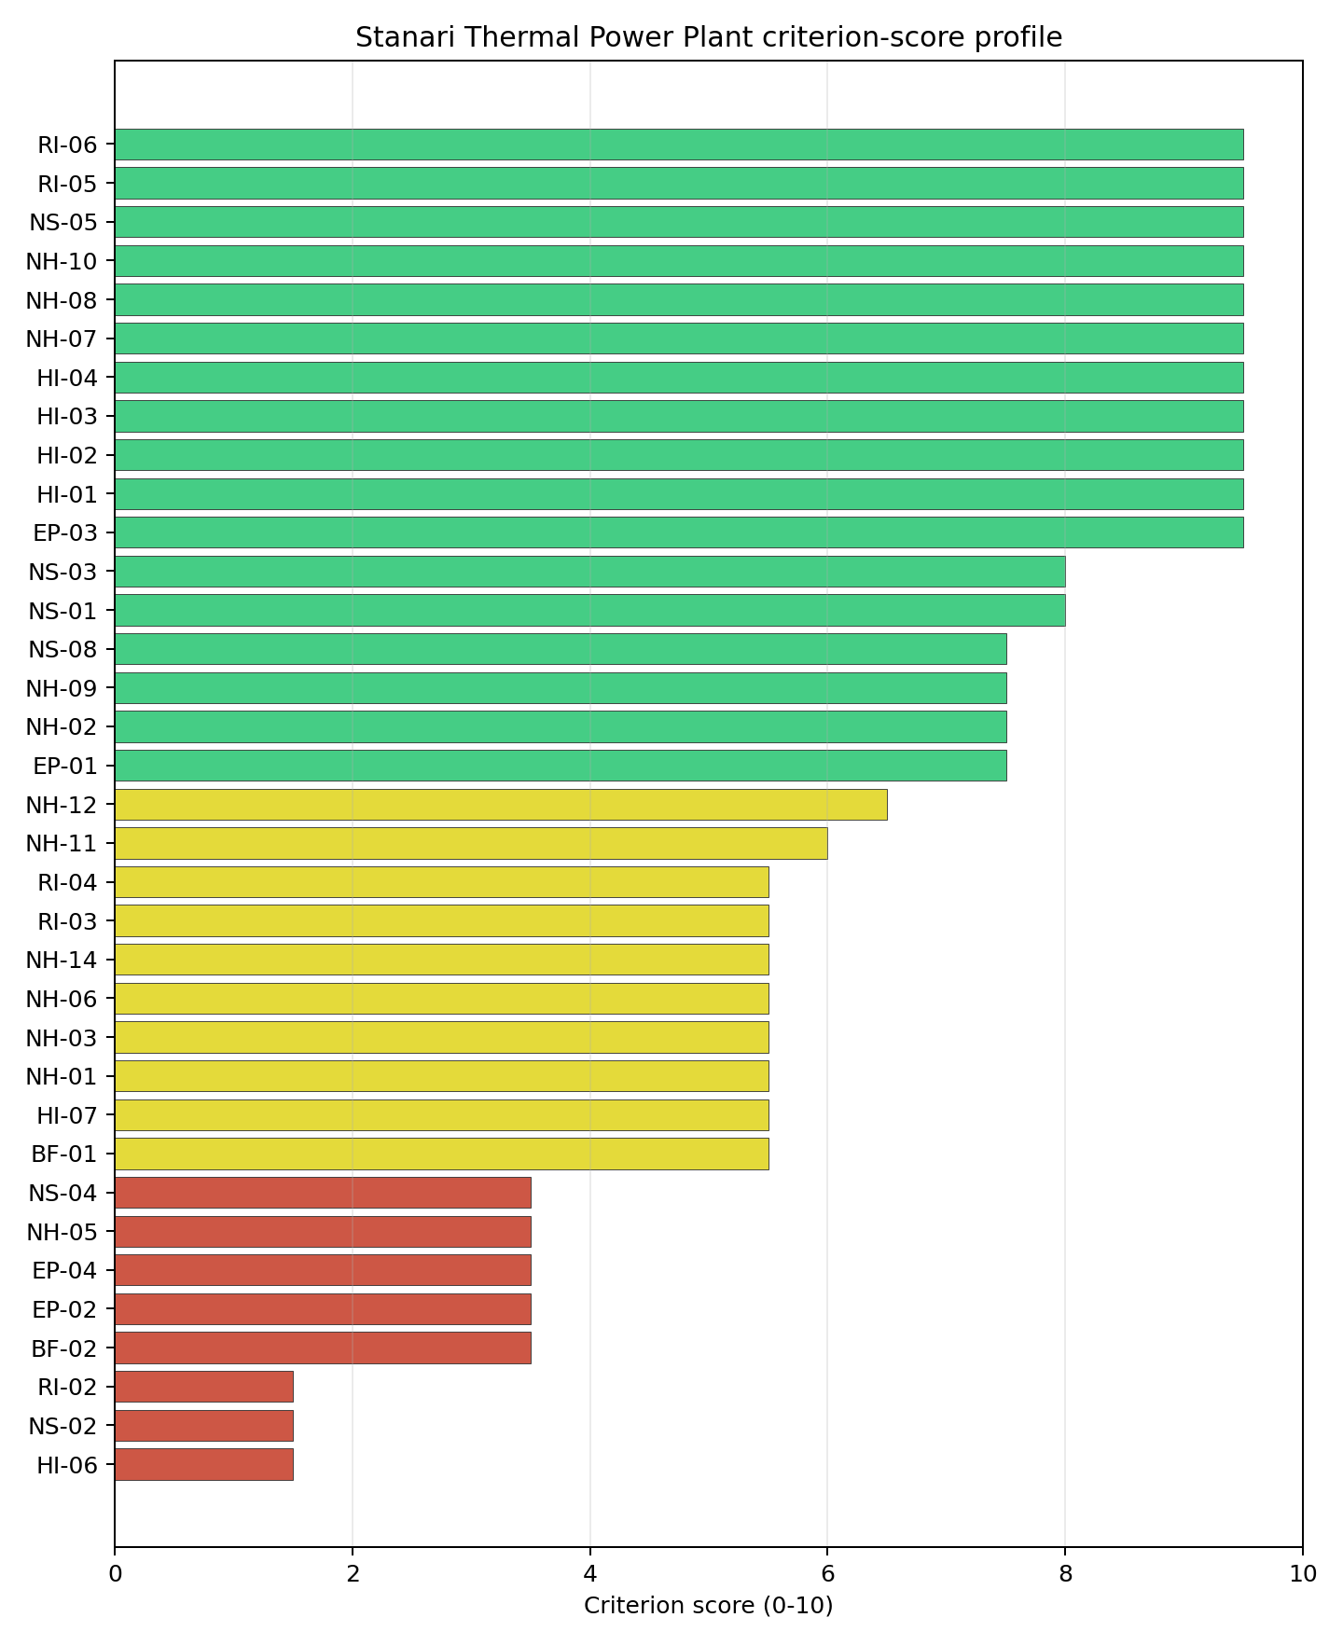
Criterion scores
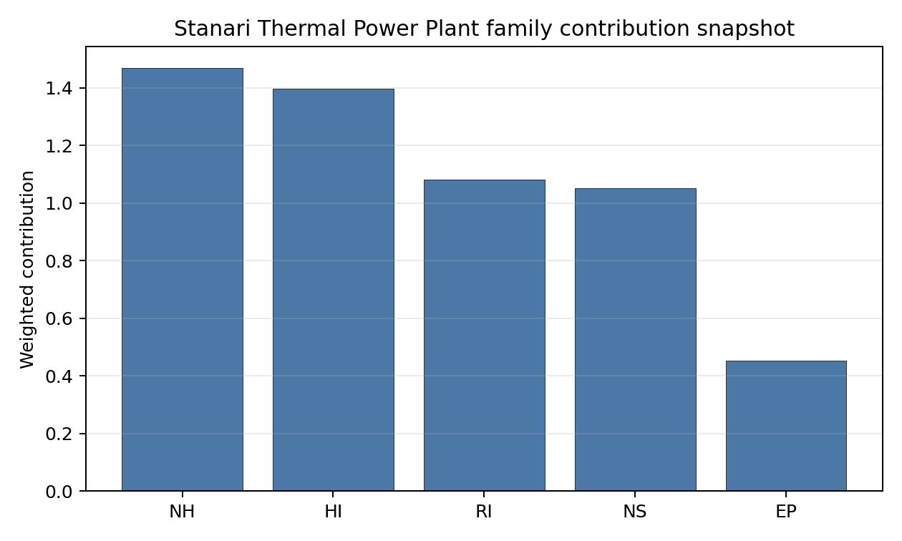
Family contributions
Stanari Thermal Power Plant’s baseline composite score is 6.747, with a national Monte Carlo bracket of 6.028-7.237 and national rank 1. Its national stability band is A, with a 91.7% national top-10 hit rate in the project’s 50,000-iteration national sensitivity analysis; this indicates a robust national lead under the weight perturbations considered. The composite is supported most by HI 7.90, RI 7.64, while the lowest family scores are NS 5.96, EP 5.26. Stage 3 effort should narrow the uncertainty around the avoidance flags first, because those criteria determine whether the ranking can become a progression case rather than only a screened shortlist position.

Residual Risk Register
Concern | Evidence | Consequence | Stage 3 action | Owner discipline
Grid Connection (NS-02) | nearest substation 0.29 km; nearest high-voltage line 10.9 km | Grid reinforcement or voltage-path uncertainty could delay a bankable connection case. | Confirm transmission corridor, voltage pathway and export-capacity reinforcement requirements | grid
Military Installations (HI-06) | nearest military installation 10.5 km; military installations within radius 7 | Security or external-event separation could require programme-level stakeholder review. | Engage defence stakeholders on feature classification and security standoff | security
Surface Water Dispersion (RI-02) | No measured value beyond the screening score is available in the bundle | Dose-pathway confidence remains constrained until site-specific dispersion evidence is measured. | Quantify surface-water dilution and downstream receptor pathways | hydrology
Land Area Basic Filter (BF-02) | No measured value beyond the screening score is available in the bundle | Implementation confidence remains limited until measured project evidence replaces screening proxies. | Re-measure BF-02 with site-specific Stage 3 evidence | socioeconomic
Evacuation Routes (EP-02) | road density in EPZ 0.457 km/km2; road length in EPZ 897.0 km | Emergency-planning clearance time or logistics could limit the usable siting envelope. | Model EPZ time-to-clear under seasonal and peak-load conditions | emergency planning
Special Populations (EP-04) | hospitals in EPZ 26; prisons in EPZ 0 | Emergency-planning clearance time or logistics could limit the usable siting envelope. | Re-measure EP-04 with site-specific Stage 3 evidence | emergency planning
Grid Connection (NS-02), Military Installations (HI-06), Surface Water Dispersion (RI-02) dominate the residual-risk register because they either keep the site in the avoidance-flag pool or carry the weakest measured screening scores. The register is a Stage 3 work plan for an avoidance-flagged candidate, not a site-approval finding.

Stage 3 Follow-Up Checklist
Priority | Work item | Evidence driver | Owner discipline
1 | Confirm transmission corridor, voltage pathway and export-capacity reinforcement requirements | Grid Connection (NS-02): nearest substation 0.29 km | grid
2 | Engage defence stakeholders on feature classification and security standoff | Military Installations (HI-06): nearest military installation 10.5 km | security
3 | Quantify surface-water dilution and downstream receptor pathways | Surface Water Dispersion (RI-02): screening score 1.5/10 | hydrology
4 | Re-measure BF-02 with site-specific Stage 3 evidence | Land Area Basic Filter (BF-02): screening score 3.5/10 | socioeconomic
5 | Model EPZ time-to-clear under seasonal and peak-load conditions | Evacuation Routes (EP-02): road density in EPZ 0.457 km/km2 | emergency planning
6 | Re-measure EP-04 with site-specific Stage 3 evidence | Special Populations (EP-04): hospitals in EPZ 26 | emergency planning

Evidence Limitations
- Transport Access (NS-03) - quality low.

Ugljevik power station Site Profile
Ugljevik power station is a coal/thermal site in Bosnia and Herzegovina that has been tested against the NuScale VOYGR-6 reference deployment envelope. This profile reads the screening evidence at a level that supports a decision to progress toward Stage 3 characterisation. It is not a site-suitability determination, vendor recommendation, or licensing finding.

Site Snapshot
Field | Value
Site name | Ugljevik power station
Coordinates | 44.6834, 18.9685
Subnational unit | Republika Srpska
Installed thermal capacity (source data) | 1,000 MW
Available surface area | 47.1 ha
Available surface area for development | 47.1 ha
Composite score (baseline weights) | 6.458 (5.707-6.929 MC band)
National stability band | H (top-10% hit rate 0%)
National rank | 4
See the country status map in Bosnia and Herzegovina Country Profile.

Ownership and Coal-to-Nuclear Context
- Elektroprivreda Republike Srpske AD (share not specified), headquartered in Bosnia and Herzegovina; immediate operator Rudnik i Termoelektrana Ugljevik AD. Path: Elektroprivreda Republike Srpske AD -> Rudnik i Termoelektrana Ugljevik AD [unknown %] -> Ugljevik power station Unit 1 [100.0%]
- Rudnik i Termoelektrana Ugljevik AD (10.00% share), headquartered in Bosnia and Herzegovina; immediate operator Comsar Energy Republika Sprska doo. Path: Rudnik i Termoelektrana Ugljevik AD -> Comsar Energy Republika Sprska doo [10.0%] -> Ugljevik power station Expansion Unit 1 [100.0%]
- Comsar Energy Group (90.00% share), headquartered in Bosnia and Herzegovina; immediate operator Comsar Energy Republika Sprska doo. Path: Comsar Energy Group -> Comsar Energy Republika Sprska doo [90.0%] -> Ugljevik power station Expansion Unit 1 [100.0%]
- Republika Srpska (Bosnia and Herzegovina) (share not specified), headquartered in Bosnia and Herzegovina; immediate operator Rudnik i Termoelektrana Ugljevik AD. Path: Republika Srpska (Bosnia and Herzegovina) -> Elektroprivreda Republike Srpske AD [100.0%] -> Rudnik i Termoelektrana Ugljevik AD [unknown %] -> Ugljevik power station Unit 1 [100.0%]
Generating units on record: 1 operating, 2 pre_permit. Earliest unit commissioning: 1985; most recent: 1985.

Natural Hazards (NH)
- Seismic: Ground Motion (NH-01) - score 5.5/10 (MC 5.0-6.0) - pass-mark band: At or below the score-5 risk boundary., weight 0.0455, data quality high. Evidence: PGA at 475-year return period 0.117 g; PGA at 2,475-year return period 0.259 g; Vs30 reference (m/s): 760.0.
- Seismic: Surface Rupture (NH-02) - score 7.5/10 (MC 7.0-8.0), weight n/a, data quality screening grade. Evidence: nearest mapped capable fault 29.9 km; fault slip rate 0.1 mm/yr; fault name: BACF007.
- Geotechnical: Liquefaction (NH-03) - score 5.5/10 (MC 5.0-6.0) - pass-mark band: Moderate susceptibility, or high/very-high with documented (or pending for high) mitigation., weight n/a, data quality medium. Evidence: liquefaction susceptibility: moderate; dominant soil type: clay_loam.
- Geotechnical: Slope Stability (NH-04) - score 5.5/10 (MC 5.0-6.0) - pass-mark band: At or below the score-5 risk boundary., weight n/a, data quality screening grade. Evidence: site slope 13.0 deg; max slope in 1 km box 86.2 deg; slope stability class: steep.
- Geotechnical: Subsidence (NH-05) - score 3.5/10 (MC 3.0-4.0), weight 0.0354, data quality medium. Evidence: karst present: no; karst severity: none.
- Geotechnical: Foundation (NH-06) - score 5.5/10 (MC 5.0-6.0) - pass-mark band: Typical European mixed conditions (bearing 80-150 kPa)., weight 0.0253, data quality medium. Evidence: bearing capacity 88.0 kPa; depth to bedrock 18.1 m.
- Volcanism (NH-07) - score 9.5/10 (MC 9.0-10.0) - favourable: Very strong margin above the score-5 boundary (or connector confirmed no in-radius signal)., weight n/a, data quality high. Evidence: volcanic hazard class: negligible.
- Coastal Flooding (NH-08) - score 9.5/10 (MC 9.0-10.0) - favourable: Non-coastal OR elevation >= 50 m AMSL OR landlocked country, with no positive marine-hazard signal., weight 0.0303, data quality medium. Evidence: distance to coast 218.4 km.
- River Flooding (NH-09) - score 7.5/10 (MC 7.0-8.0), weight 0.0404, data quality medium. Evidence: flood zone class: negligible.
- Extreme Winds (NH-10) - score 9.5/10 (MC 9.0-10.0) - favourable: Lowest relative wind exposure in the current reanalysis-grade monthly-mean gust cohort (< 7.5 m/s)., weight 0.0152, data quality medium. Evidence: screening wind-speed index 6.35 m/s.
- Extreme Precipitation (NH-11) - score 8.0/10 (MC 7.0-8.0) - favourable: aggregated(mean_of_sub_scores), weight 0.0152, data quality medium. Evidence: screening extreme-precipitation index 0.26 mm; screening precipitation index 27.5 mm/yr.
- Extreme Temperatures (NH-12) - score 6.5/10 (MC 6.0-7.0) - pass-mark band: aggregated(mean_of_sub_scores), weight 0.0202, data quality medium. Evidence: extreme high temperature 25.4 deg C; extreme low temperature -5.88 deg C.
- Combined Hazards (NH-14) - score 5.5/10 (MC 5.0-6.0) - pass-mark band: At least 5 resolved, exactly one moderate hazard (3-5) or moderate interaction only., weight 0.0152, data quality n/a. Evidence: values not in measurement tables.

Interpretation - Natural Hazards (NH)
Natural hazards at Ugljevik power station support an avoidance-flagged Stage 3 screening case rather than an unqualified site-selection conclusion. The measured record includes volcanic hazard class: negligible; distance to coast 218.4 km; karst present: no; karst severity: none. The strongest evidence is Volcanism (NH-07) at 9.5/10, Coastal Flooding (NH-08) at 9.5/10, while the limiting criteria are Geotechnical: Subsidence (NH-05) at 3.5/10, Seismic: Ground Motion (NH-01) at 5.5/10, Geotechnical: Liquefaction (NH-03) at 5.5/10. Those limitations do not establish a licensing or suitability finding; they define the work that must be closed before the site can be treated as equivalent to a full-pass candidate. Stage 3 should therefore prioritise seismic, geotechnical, flood and meteorological confirmation, with the lowest-scoring and avoidance-flagged criteria measured first.

Human-Induced and Security-Relevant Hazards (HI)
- Aircraft Crash (HI-01) - score 9.5/10 (MC 9.0-10.0) - favourable: Only small / GA / heliport airport >= 10 km nearby, no flight-path proxy < 4 km, no major airport within 30 km, and no military airbase within 60 km., weight 0.0354, data quality high. Evidence: nearest airport 12.8 km; nearest flight path 6.39 km; airports within search radius 4; airport name: Dragon Airfield; airport type: small airfield.
- Industrial Explosions (HI-02) - score 9.5/10 (MC 9.0-10.0) - favourable: Very strong margin above the score-5 boundary (or completed search confirmed no in-radius signal)., weight 0.0354, data quality screening grade. Evidence: values not in measurement tables.
- Toxic/Gas Releases (HI-03) - score 9.5/10 (MC 9.0-10.0) - favourable: Very strong margin above the score-5 boundary (or completed search confirmed no in-radius signal)., weight 0.0354, data quality screening grade. Evidence: values not in measurement tables.
- External Fires (HI-04) - score 9.5/10 (MC 9.0-10.0) - favourable: > 15 km, or completed flammable-storage search found nothing in radius., weight 0.0303, data quality screening grade. Evidence: values not in measurement tables.
- Military Installations (HI-06) - score 0.0/10 (MC 0.0-0.0), weight 0.0303, data quality high. Evidence: nearest military installation 2.48 km; military installations within radius 11; installation name: unnamed.
- Electromagnetic Interference (HI-07) - score 1.5/10 (MC 1.0-2.0), weight 0.0101, data quality medium. Evidence: nearest high-power transmitter 0.4 km; transmitters within radius 29; transmitter type: mast.

Interpretation - Human-Induced and Security-Relevant Hazards (HI)
Human-induced and security-relevant hazards at Ugljevik power station support an avoidance-flagged Stage 3 screening case rather than an unqualified site-selection conclusion. The measured record includes nearest airport 12.8 km; nearest flight path 6.39 km; nearest military installation 2.48 km; military installations within radius 11. The strongest evidence is Aircraft Crash (HI-01) at 9.5/10, Industrial Explosions (HI-02) at 9.5/10, while the limiting criteria are Military Installations (HI-06) at 0.0/10, Electromagnetic Interference (HI-07) at 1.5/10, Aircraft Crash (HI-01) at 9.5/10. Those limitations do not establish a licensing or suitability finding; they define the work that must be closed before the site can be treated as equivalent to a full-pass candidate. Stage 3 should therefore prioritise aviation, military, industrial-neighbour and electromagnetic-interference checks, with the lowest-scoring and avoidance-flagged criteria measured first.

Radiological Impact and Emergency Planning (RI / EP)
- Emergency Planning Feasibility (EP-01) - score 5.5/10 (MC 5.0-6.0) - pass-mark band: At or above the composite score-5 boundary., weight n/a, data quality high. Evidence: EP feasibility composite 64.8 /100; road sub-score 49.2 /100; special-population sub-score 90.0 /100; geography sub-score 95.0 /100; population sub-score 80.0 /100; evacuation feasible: yes.
- Evacuation Routes (EP-02) - score 3.5/10 (MC 3.0-4.0), weight 0.0303, data quality medium. Evidence: road density in EPZ 0.453 km/km2; road length in EPZ 890.2 km; motorway access: yes.
- Physical Geography Constraints (EP-03) - score 9.5/10 (MC 9.0-10.0) - favourable: No measured relief; open river/waterway context (interim screening)., weight 0.0253, data quality medium. Evidence: waterways crossing EPZ 0; major river barrier: no.
- Special Populations (EP-04) - score 3.5/10 (MC 3.0-4.0), weight 0.0303, data quality medium. Evidence: hospitals in EPZ 28; prisons in EPZ 2; care homes in EPZ 0.
- Atmospheric Dispersion (RI-01) - score no native score (unscored - no band matched), weight 0.0303, data quality medium. Evidence: annual mean wind speed 0.6 m/s; atmospheric mixing height 429.2 m; prevailing wind direction: W.
- Surface Water Dispersion (RI-02) - score 1.5/10 (MC 1.0-2.0), weight 0.0253, data quality n/a. Evidence: values not in measurement tables.
- Groundwater Dispersion (RI-03) - score no native score (unscored - no band matched), weight 0.0253, data quality low. Evidence: not measured at this site (criterion remains unscored).
- Population Density at EPZ Radii (RI-04) - score 5.5/10 (MC 5.0-6.0) - pass-mark band: aggregated(min_of_sub_scores), weight 0.0404, data quality screening grade. Evidence: population density within 5 km 116.7 /km2; population density within 16 km 68.3 /km2; population density within 25 km 128.0 /km2; population density within 80 km 87.2 /km2; population within 25 km 251,241 people.
- Distance to Population Centres (RI-05) - score 9.5/10 (MC 9.0-10.0) - favourable: Nearest >=50k population-centre proxy exceeds required distance by >= 50 %., weight 0.0505, data quality screening grade. Evidence: nearest city above 50k people 95.9 km; nearest city population 92,966 people; city name: Osijek.
- Population Projections (RI-06) - score 3.5/10 (MC 3.0-4.0), weight 0.0253, data quality screening grade. Evidence: annual population growth rate 0.482 %/yr; projected population at 25 km in 60 yr 137,878 people.

Interpretation - Radiological Impact and Emergency Planning (RI / EP)
Radiological impact and emergency planning at Ugljevik power station support an avoidance-flagged Stage 3 screening case rather than an unqualified site-selection conclusion. The measured record includes waterways crossing EPZ 0; major river barrier: no; nearest city above 50k people 95.9 km; nearest city population 92,966 people. The strongest evidence is Physical Geography Constraints (EP-03) at 9.5/10, Distance to Population Centres (RI-05) at 9.5/10, while the limiting criteria are Surface Water Dispersion (RI-02) at 1.5/10, Evacuation Routes (EP-02) at 3.5/10, Special Populations (EP-04) at 3.5/10. Those limitations do not establish a licensing or suitability finding; they define the work that must be closed before the site can be treated as equivalent to a full-pass candidate. Stage 3 should therefore prioritise EPZ evacuation, population, atmospheric and water-pathway modelling, with the lowest-scoring and avoidance-flagged criteria measured first.

Non-Safety and Implementation Considerations (NS)
- Grid Capacity Basic Filter (BF-01) - score 5.5/10 (MC 5.0-6.0) - pass-mark band: Note: substation 15-30 km OR 110-219 kV; reinforcement plausible., weight n/a, data quality n/a. Evidence: values not in measurement tables.
- Land Area Basic Filter (BF-02) - score 5.5/10 (MC 5.0-6.0) - pass-mark band: 80-100% of required area with documented expansion / layout flexibility., weight 0.0253, data quality n/a. Evidence: values not in measurement tables.
- Cooling Water Availability (NS-01) - score 6.0/10 (MC 6.0-7.0) - pass-mark band: aggregated(weighted_mean_of_sub_scores), weight 0.0404, data quality screening grade. Evidence: distance to cooling source 9.17 km; cooling source flow 2.55 m3/s; cooling source type: small_river; cooling source name: Јања; water stress label: Low.
- Grid Connection (NS-02) - score 1.5/10 (MC 1.0-2.0), weight 0.0404, data quality high. Evidence: nearest substation 0.4 km; nearest high-voltage line 0.27 km; highest nearby line voltage 400.0 kV; grid export capacity 269.0 MW; substations within radius 44; HV lines within radius 52.
- Transport Access (NS-03) - score 10.0/10 (MC 8.0-10.0) - favourable: aggregated(weighted_mean_of_sub_scores), weight 0.0404, data quality low. Evidence: nearest highway 0.64 km; heavy-haul capable: yes.
- Site Topography (NS-04) - score 3.5/10 (MC 3.0-4.0), weight 0.0303, data quality screening grade. Evidence: favourable land cover 23.5 %; moderate land cover 26.5 %; unfavourable land cover 50.0 %; favourable area 40.6 ha; dominant land class: 311.
- Site Footprint Adequacy (NS-05) - score 7.5/10 (MC 7.0-8.0), weight 0.0253, data quality high. Evidence: buildable area 47.1 ha; largest contiguous patch 47.1 ha; buildable patch count 15.
- Existing Infrastructure (NS-06) - score no native score (unscored - no band matched), weight 0.0253, data quality n/a. Evidence: not measured at this site (criterion remains unscored).
- Ecological Sensitivity (NS-08) - score 7.5/10 (MC 5.5-9.5), weight n/a, data quality insufficient. Evidence: natural land cover 50.0 %; distance to nearest protected area 22.5 km; Natura 2000 sensitivity class: unknown; protected-area overlap: no; protected-area sensitivity class: low; Natura 2000 sites within 5 km: 0; nearest protected-area designation: Emerald Network.
- Workforce Availability (NS-10) - score no native score (unscored - no band matched), weight 0.0202, data quality n/a. Evidence: not measured at this site (criterion remains unscored).
- Regulatory/Political Environment (NS-12) - score no native score (unscored - no band matched), weight 0.0303, data quality n/a. Evidence: not measured at this site (criterion remains unscored).
- Construction Logistics (NS-13) - score no native score (unscored - no band matched), weight 0.0202, data quality n/a. Evidence: not measured at this site (criterion remains unscored).

Interpretation - Non-Safety and Implementation Considerations (NS)
Non-safety and implementation conditions at Ugljevik power station support an avoidance-flagged Stage 3 screening case rather than an unqualified site-selection conclusion. The measured record includes nearest highway 0.64 km; heavy-haul capable: yes; buildable area 47.1 ha; largest contiguous patch 47.1 ha. The strongest evidence is Transport Access (NS-03) at 10.0/10, Site Footprint Adequacy (NS-05) at 7.5/10, while the limiting criteria are Grid Connection (NS-02) at 1.5/10, Site Topography (NS-04) at 3.5/10, Existing Infrastructure (NS-06) at 5.0/10. Those limitations do not establish a licensing or suitability finding; they define the work that must be closed before the site can be treated as equivalent to a full-pass candidate. Stage 3 should therefore prioritise grid, cooling-water, transport, land and environmental-permitting checks, with the lowest-scoring and avoidance-flagged criteria measured first.

Composite Score and Stability
Baseline composite score is 6.458, bracketed by Monte Carlo at 5.707-6.929. National stability band is H with a top-10% hit rate of 0% in the project’s 50,000-iteration national sensitivity analysis.
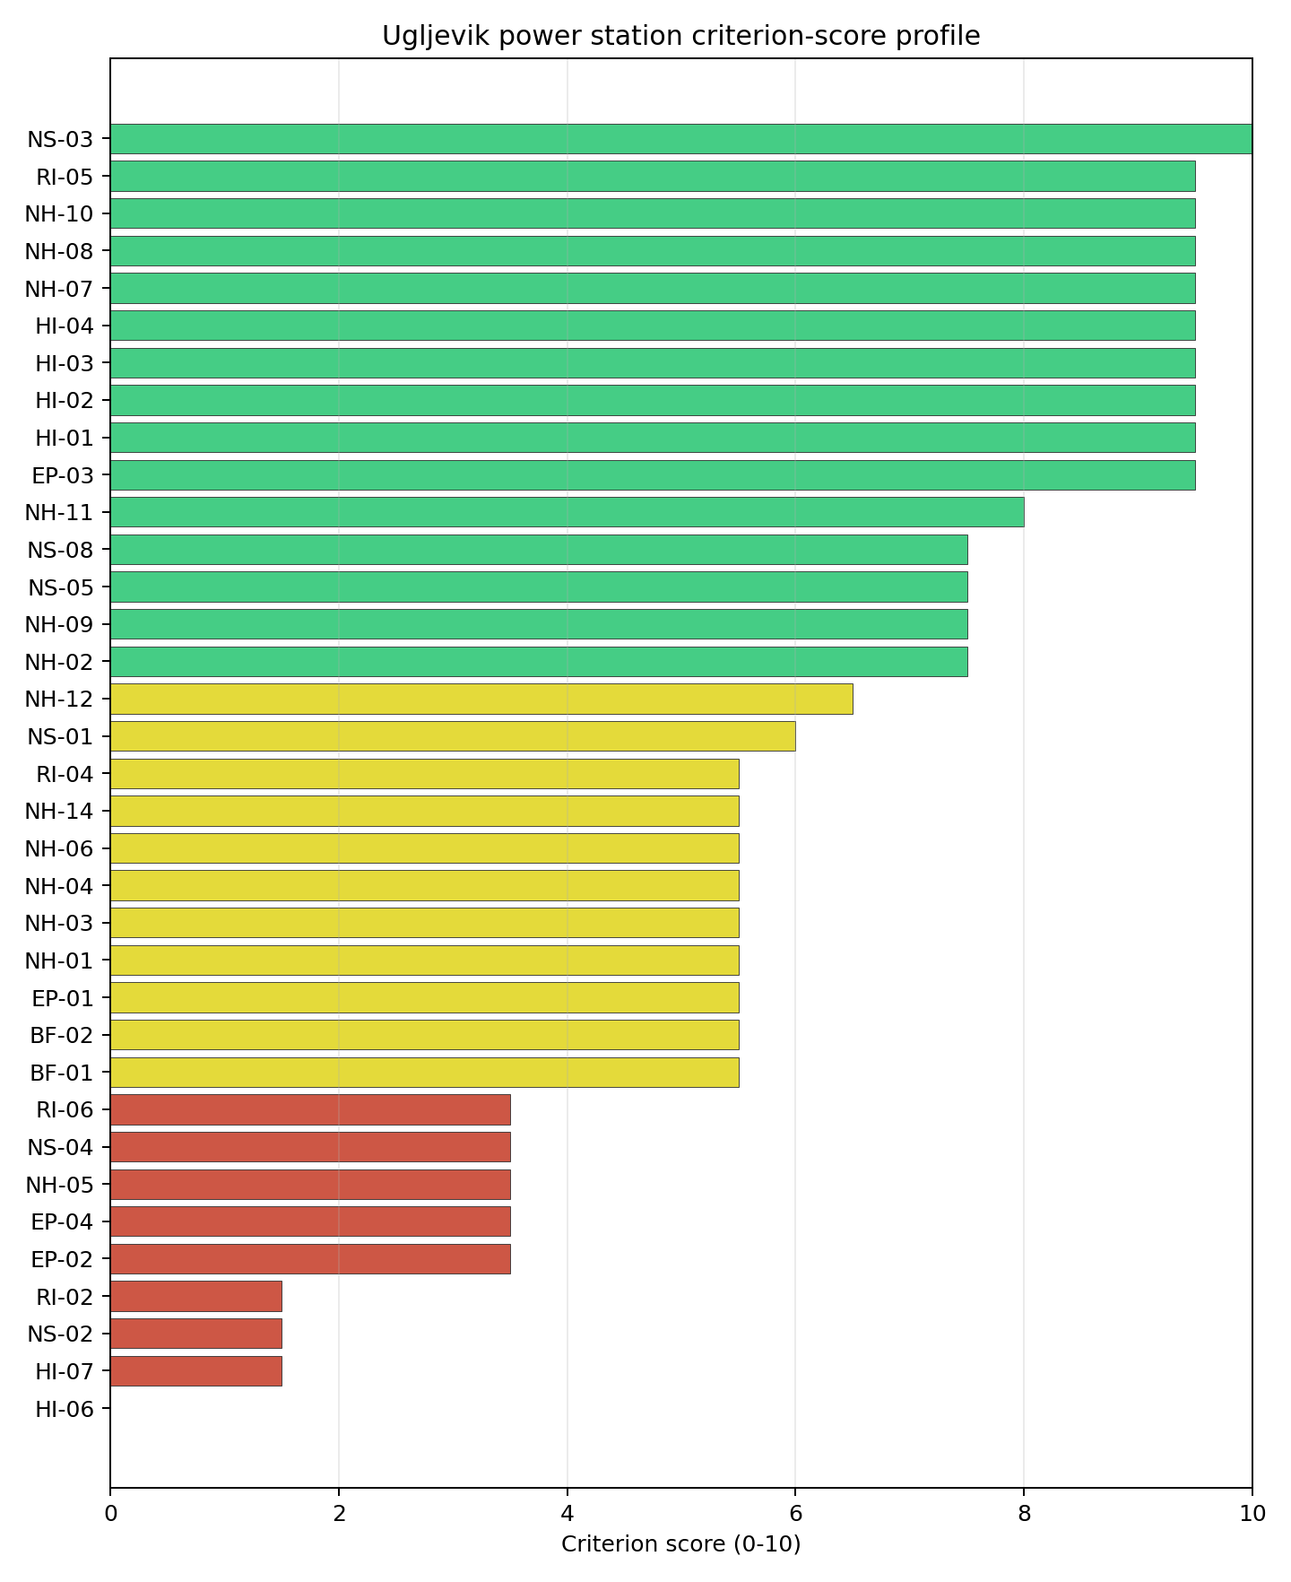
Criterion scores
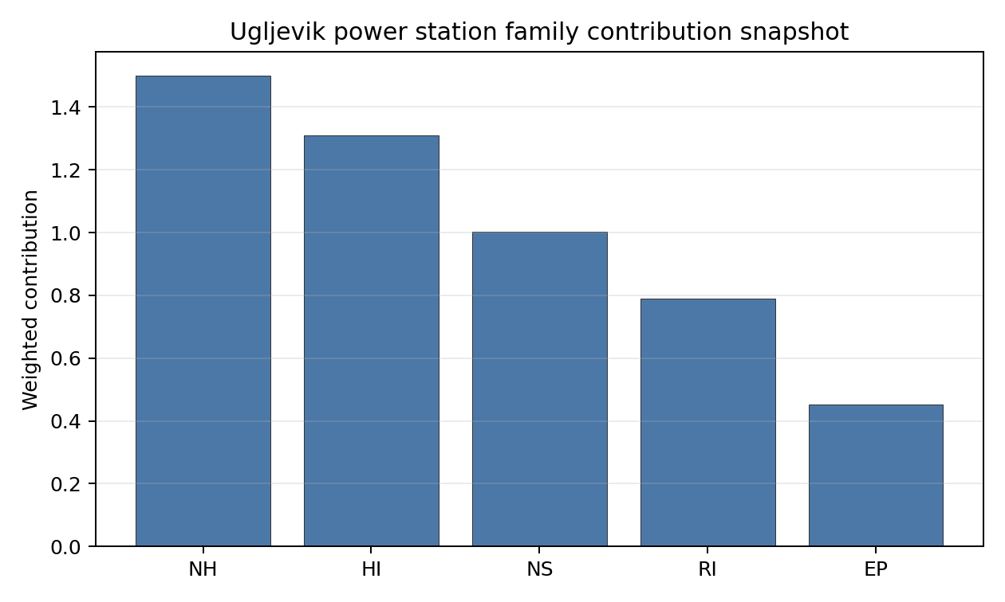
Family contributions
Ugljevik power station’s baseline composite score is 6.458, with a national Monte Carlo bracket of 5.707-6.929 and national rank 4. Its national stability band is H, with a 0.0% national top-10 hit rate in the project’s 50,000-iteration national sensitivity analysis; this indicates a fragile or weight-dependent shortlist position. The composite is supported most by HI 7.41, RI 6.80, while the lowest family scores are NS 5.67, EP 5.26. Stage 3 effort should narrow the uncertainty around the avoidance flags first, because those criteria determine whether the ranking can become a progression case rather than only a screened shortlist position.

Residual Risk Register
Concern | Evidence | Consequence | Stage 3 action | Owner discipline
Grid Connection (NS-02) | nearest substation 0.4 km; nearest high-voltage line 0.27 km | Grid reinforcement or voltage-path uncertainty could delay a bankable connection case. | Confirm transmission corridor, voltage pathway and export-capacity reinforcement requirements | grid
Military Installations (HI-06) | nearest military installation 2.48 km; military installations within radius 11 | Security or external-event separation could require programme-level stakeholder review. | Engage defence stakeholders on feature classification and security standoff | security
Electromagnetic Interference (HI-07) | nearest high-power transmitter 0.4 km; transmitters within radius 29 | Security or external-event separation could require programme-level stakeholder review. | Re-measure HI-07 with site-specific Stage 3 evidence | security
Surface Water Dispersion (RI-02) | No measured value beyond the screening score is available in the bundle | Dose-pathway confidence remains constrained until site-specific dispersion evidence is measured. | Quantify surface-water dilution and downstream receptor pathways | hydrology
Evacuation Routes (EP-02) | road density in EPZ 0.453 km/km2; road length in EPZ 890.2 km | Emergency-planning clearance time or logistics could limit the usable siting envelope. | Model EPZ time-to-clear under seasonal and peak-load conditions | emergency planning
Special Populations (EP-04) | hospitals in EPZ 28; prisons in EPZ 2 | Emergency-planning clearance time or logistics could limit the usable siting envelope. | Re-measure EP-04 with site-specific Stage 3 evidence | emergency planning
Grid Connection (NS-02), Military Installations (HI-06), Electromagnetic Interference (HI-07) dominate the residual-risk register because they either keep the site in the avoidance-flag pool or carry the weakest measured screening scores. The register is a Stage 3 work plan for an avoidance-flagged candidate, not a site-approval finding.

Stage 3 Follow-Up Checklist
Priority | Work item | Evidence driver | Owner discipline
1 | Confirm transmission corridor, voltage pathway and export-capacity reinforcement requirements | Grid Connection (NS-02): nearest substation 0.4 km | grid
2 | Engage defence stakeholders on feature classification and security standoff | Military Installations (HI-06): nearest military installation 2.48 km | security
3 | Re-measure HI-07 with site-specific Stage 3 evidence | Electromagnetic Interference (HI-07): nearest high-power transmitter 0.4 km | security
4 | Quantify surface-water dilution and downstream receptor pathways | Surface Water Dispersion (RI-02): screening score 1.5/10 | hydrology
5 | Model EPZ time-to-clear under seasonal and peak-load conditions | Evacuation Routes (EP-02): road density in EPZ 0.453 km/km2 | emergency planning
6 | Re-measure EP-04 with site-specific Stage 3 evidence | Special Populations (EP-04): hospitals in EPZ 28 | emergency planning

Evidence Limitations
- Groundwater Dispersion (RI-03) - quality low.
- Transport Access (NS-03) - quality low.

Bulgaria Country Profile
Bulgaria has 15 thermal and coal-site records tested against the NuScale VOYGR-6 reference deployment envelope. No site passes both the exclusionary and avoidance screens, seven sites pass the exclusionary screen but retain avoidance flags, and eight sites fail one or more exclusionary checks. The country is therefore a remediation-led brownfield pool: it has several sites worth Stage 3 attention, but no candidate should be presented as clear of avoidance work at Stage 1-2.
Bulgaria is a nuclear-experienced power-system jurisdiction, which gives the country a stronger institutional starting point than a first-time nuclear-power market. The country result still depends on site-specific screening evidence. The leading site is Lom Power Station, with a composite score of 7.428 and a Monte Carlo interval of 6.578-7.850. Its national stability band is A with a national top-10% hit rate of 100%, but it remains an avoidance-flag candidate because grid-capacity confirmation is still required.
Bulgaria’s 15 ranked records produce no full-pass site, seven avoidance-flagged exclusionary-pass sites, and eight hard-fail sites. Lom is the clear national leader because it combines the highest composite score with band-A national stability. Maritsa 3, Bobov Dol, Vidin Works and Svilosa form the next characterisation tier, but each carries material avoidance or implementation work. This structure supports a focused Stage 3 sequence, not a broad fleet claim.
The unlock pool is led by Grid Connection (NS-02), which affects six of the seven exclusionary-pass sites, or 86% of the pool. Aircraft Crash (HI-01) affects four of seven sites, while Distance to Population Centres (RI-05) affects two. Resolving the grid and aviation questions would therefore move most of the Bulgarian exclusionary-pass pool from screening promise toward usable characterisation candidates. The hard-fail tail is dominated by Seismic: Surface Rupture (NH-02), which removes eight of 15 records and limits how much brownfield scale can be unlocked.
Greenfield sites remain a programme lever if Bulgaria’s eventual SMR build-out target exceeds what the brownfield pool can support. Within the brownfield evidence, a credible Stage 3 cadence begins with Lom for full characterisation, treats Maritsa 3 and Bobov Dol as the next two comparators, and keeps Vidin Works and Svilosa as conditional options whose value depends on grid, aviation, military, ecological and emergency-planning confirmation.

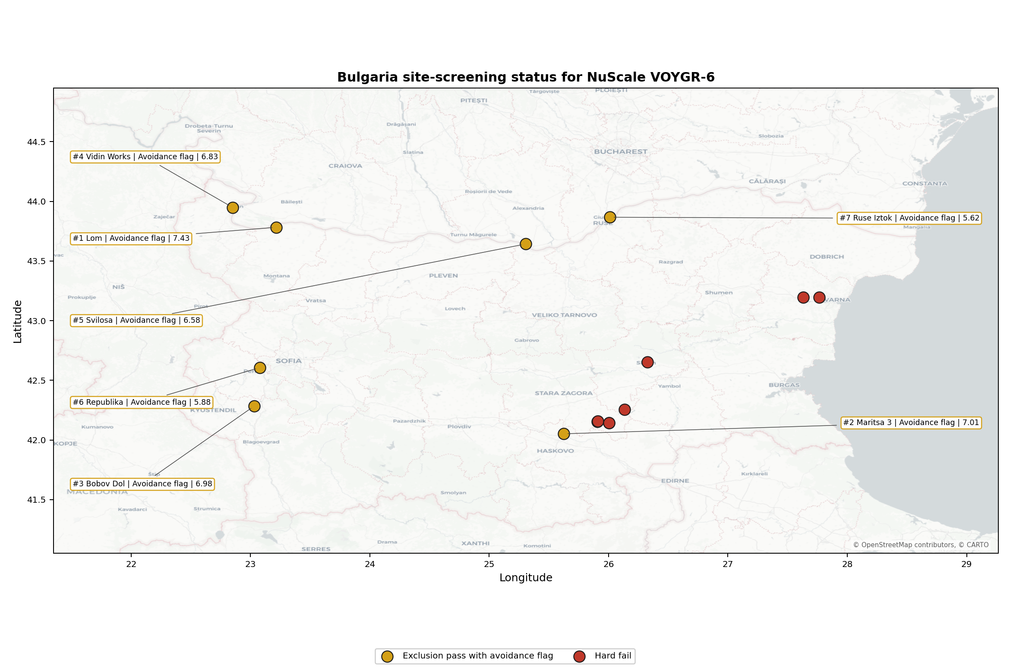
Bulgaria status map

Bulgaria Site Ledger
Rank | Site | Status | Composite | MC Low | MC High | Band | Top-10 Hit | Coverage
1 | Lom Power Station | Exclusion pass with avoidance flag | 7.428 | 6.578 | 7.850 | A | 100% | 76%
2 | Maritsa 3 power station | Exclusion pass with avoidance flag | 7.009 | 6.240 | 7.569 | D | 0% | 76%
3 | Bobov Dol power station | Exclusion pass with avoidance flag | 6.984 | 6.220 | 7.525 | G | 0% | 76%
4 | Vidin Works power station | Exclusion pass with avoidance flag | 6.828 | 6.093 | 7.369 | H | 0% | 76%
5 | Svilosa power station | Exclusion pass with avoidance flag | 6.578 | 5.891 | 7.119 | H | 0% | 76%
6 | Republika power station | Exclusion pass with avoidance flag | 5.875 | 5.323 | 6.325 | H | 0% | 76%
7 | Ruse Iztok power station | Exclusion pass with avoidance flag | 5.616 | 5.114 | 6.156 | H | 0% | 76%
- | Brikel power station | Hard fail | - | - | - | - | - | 0%
- | Deven power station | Hard fail | - | - | - | - | - | 0%
- | Maritsa Iztok-1 power station | Hard fail | - | - | - | - | - | 0%
- | Maritsa Iztok-2 power station | Hard fail | - | - | - | - | - | 0%
- | Maritsa Iztok-3 power station | Hard fail | - | - | - | - | - | 0%
- | Maritsa Iztok-4 power station | Hard fail | - | - | - | - | - | 0%
- | Sliven power station | Hard fail | - | - | - | - | - | 0%
- | Varna power station | Hard fail | - | - | - | - | - | 0%
Selected site profiles for this country batch are Lom Power Station, Maritsa 3 power station, Bobov Dol power station, Vidin Works power station, and Svilosa power station. This follows the plan rule: top five sites by national ranking under the frozen national run.

Avoidance Flag Pareto
Of the 7 sites that pass the exclusionary screen, the avoidance-phase flags concentrate on a small set of criteria. Resolving them is what would move the country from a remediation-led pool to a broader candidate set.
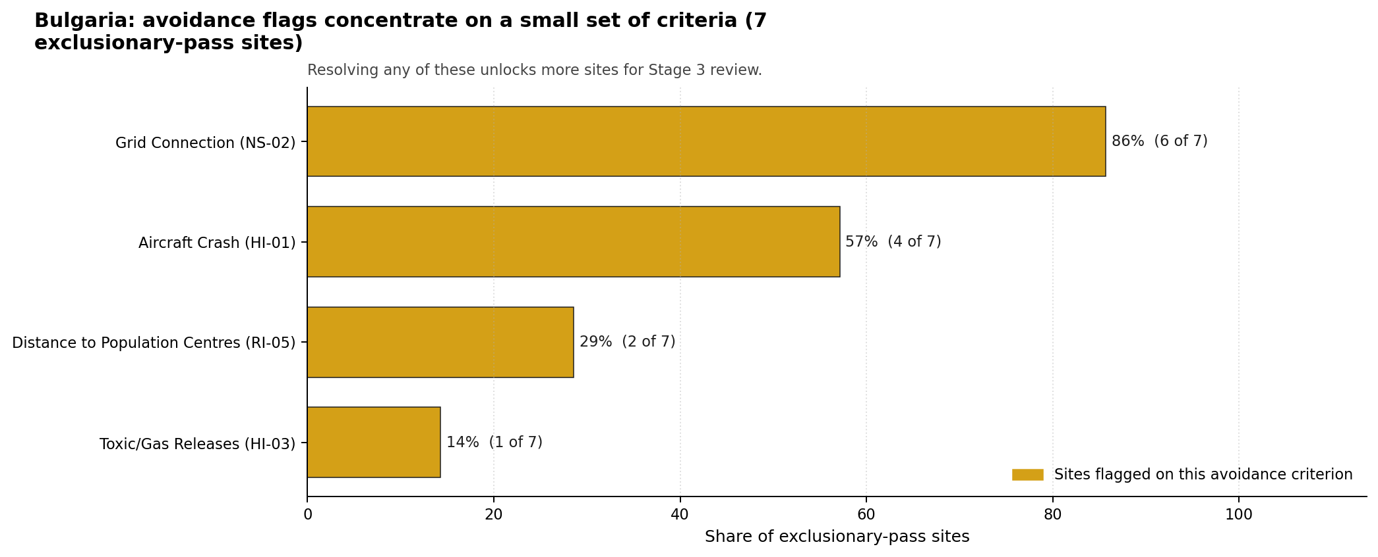
Avoidance flag Pareto
- Grid Connection (NS-02) - 6 of 7 exclusionary-pass sites (86%).
- Aircraft Crash (HI-01) - 4 of 7 exclusionary-pass sites (57%).
- Distance to Population Centres (RI-05) - 2 of 7 exclusionary-pass sites (29%).
- Toxic/Gas Releases (HI-03) - 1 of 7 exclusionary-pass sites (14%).

Exclusionary Failure Pareto
The exclusionary failures across Bulgaria are concentrated in a small number of criteria. They identify the screening checks responsible for removing sites from further consideration.
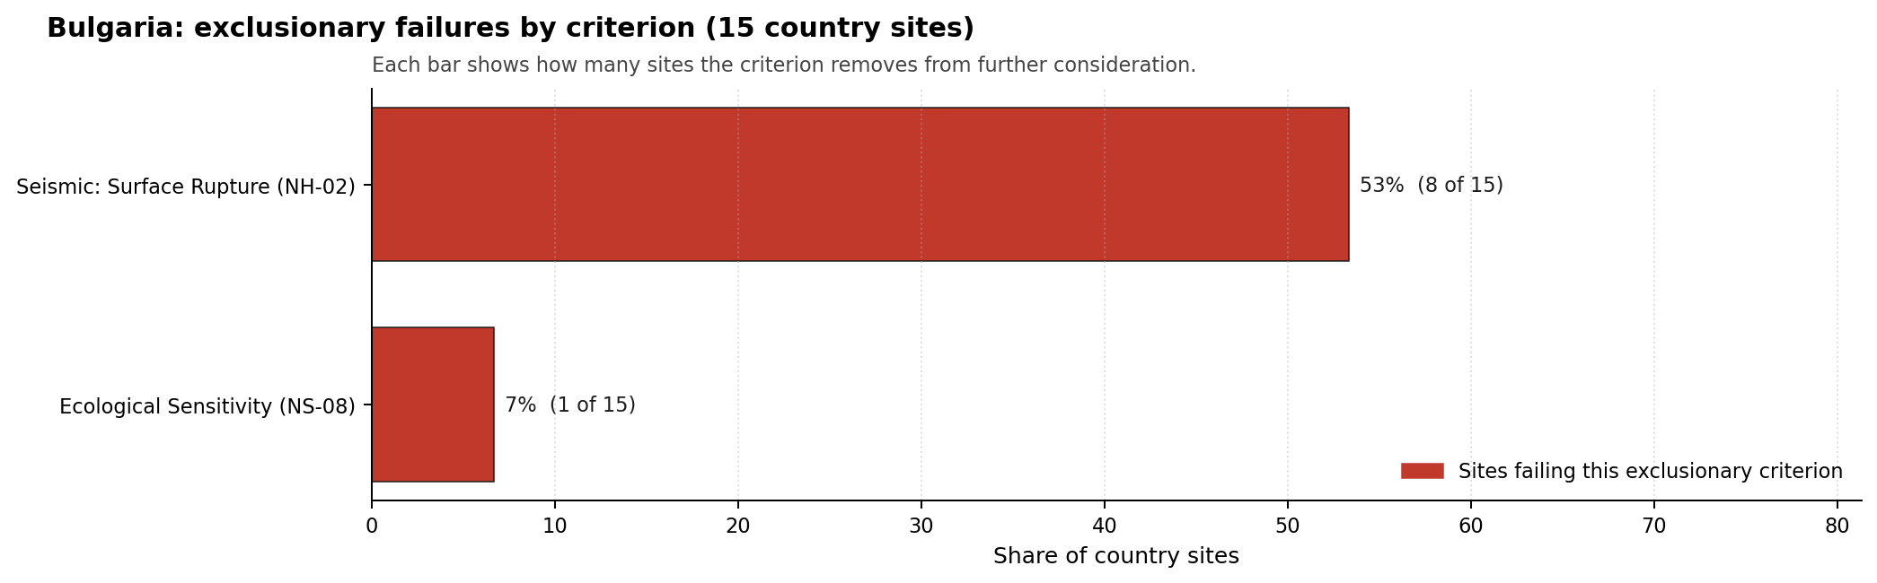
Exclusionary failure Pareto
- Seismic: Surface Rupture (NH-02) - 8 of 15 country sites (53%).
- Ecological Sensitivity (NS-08) - 1 of 15 country sites (7%).

Family Strength and Weakness
Across the country the strongest criterion family is Natural Hazards at a mean normalised score of 7.51/10. The weakest family is Emergency Planning at 5.67/10. The bottom three individual criteria across the country are:
- Military Installations (HI-06) - mean 1.77/10 across 15 scored sites (min 0.0, max 5.0).
- Ecological Sensitivity (NS-08) - mean 2.03/10 across 15 scored sites (min 1.5, max 5.5).
- Electromagnetic Interference (HI-07) - mean 2.17/10 across 15 scored sites (min 1.5, max 3.5).

National Sensitivity and Robustness
The national sensitivity result separates Lom from the rest of the Bulgarian shortlist. Lom holds band A and a 100% national top-10 hit rate, making it the only Bulgarian brownfield site that remains consistently in the leading national tail under the 50,000-iteration sensitivity analysis. Maritsa 3 remains second on the baseline score but sits in band D with no national top-10 persistence, while Bobov Dol, Vidin Works and Svilosa fall into bands G or H. The practical conclusion is that Lom should be characterised first, while the other four sites should be compared through targeted unlock work rather than through small point-score differences.

Interpretation for Site Selection
Bulgaria has no full-pass brownfield site in the frozen run. The Stage 3 question is therefore not which site is ready, but which avoidance-flagged site gives the strongest return from additional characterisation. Lom is the leading case because its score is highest and its national stability is strongest, but its grid-capacity flag means it still requires transmission-pathway confirmation before it can be treated as a mature candidate.

Avoidance flag Pareto - what unlocks more sites
The chart shows that grid connection and aviation screening are the main country-wide unlocks. Maritsa 3, Bobov Dol, Vidin Works and Svilosa all remain relevant because they pass the exclusionary screen and carry different combinations of grid, aircraft-crash, emergency-planning, ecological and military-installation questions. Hard-fail sites should remain in the evidence base as comparators unless new site-specific evidence changes the NH-02 or NS-08 exclusionary finding.
The Monte Carlo intervals reinforce the need to avoid false precision. The top five sites have overlapping score bands, and only Lom has a stable national sensitivity read. Stage 3 should therefore start with Lom, then run a structured comparison of Maritsa 3 and Bobov Dol, with Vidin Works and Svilosa retained as conditional options where grid, aviation and cross-border environmental constraints can be resolved.

Status Counts
- Full pass: 0
- Exclusion pass with avoidance flag: 7
- Hard fail: 8

Bobov Dol power station Site Profile
Bobov Dol power station is a coal/thermal site in Bulgaria that has been tested against the NuScale VOYGR-6 reference deployment envelope. This profile reads the screening evidence at a level that supports a decision to progress toward Stage 3 characterisation. It is not a site-suitability determination, vendor recommendation, or licensing finding.

Site Snapshot
Field | Value
Site name | Bobov Dol power station
Coordinates | 42.2858, 23.0328
Subnational unit | Kyustendil
Installed thermal capacity (source data) | 1,030 MW
Available surface area | 63.0 ha
Available surface area for development | 114.2 ha
Composite score (baseline weights) | 6.984 (6.220-7.525 MC band)
National stability band | G (top-10% hit rate 0%)
National rank | 3
See the country status map in Bulgaria Country Profile.

Ownership and Coal-to-Nuclear Context
- Newbury Management Ltd (22.00% share); immediate operator Konsorcium Energia MK AD. Path: Newbury Management Ltd -> Konsorcium Energia MK AD [22.0%] -> Bobov Dol power station Unit 5 [100.0%]
- Stoket Ltd (64.00% share); immediate operator Konsorcium Energia MK AD. Path: Stoket Ltd -> Konsorcium Energia MK AD [64.0%] -> Bobov Dol power station Unit 2 [100.0%]
- small shareholder(s) (4.00% share); immediate operator Konsorcium Energia MK AD. Path: small shareholder(s) -> Konsorcium Energia MK AD [4.0%] -> Bobov Dol power station Unit 5 [100.0%]
- Cowlan Corp Ltd (10.00% share); immediate operator Konsorcium Energia MK AD. Path: Cowlan Corp Ltd -> Konsorcium Energia MK AD [10.0%] -> Bobov Dol power station Unit 5 [100.0%]
Generating units on record: 2 cancelled, 3 operating. Earliest unit commissioning: 1973; most recent: 1975.

Natural Hazards (NH)
- Seismic: Ground Motion (NH-01) - score 5.5/10 (MC 5.0-6.0) - pass-mark band: At or below the score-5 risk boundary., weight 0.0455, data quality high. Evidence: PGA at 475-year return period 0.19 g; PGA at 2,475-year return period 0.393 g; Vs30 reference (m/s): 760.0.
- Seismic: Surface Rupture (NH-02) - score 5.5/10 (MC 5.0-6.0) - pass-mark band: Borderline acceptable separation: meets the 8.0 km score boundary; check against the 8 km conservative screen and local capability evidence., weight n/a, data quality screening grade. Evidence: nearest mapped capable fault 11.1 km; fault slip rate 0.158 mm/yr; fault name: BGCF017.
- Geotechnical: Liquefaction (NH-03) - score 5.5/10 (MC 5.0-6.0) - pass-mark band: Moderate susceptibility, or high/very-high with documented (or pending for high) mitigation., weight n/a, data quality medium. Evidence: liquefaction susceptibility: moderate; dominant soil type: clay_loam.
- Geotechnical: Slope Stability (NH-04) - score no native score (unscored - no band matched), weight n/a, data quality screening grade. Evidence: not measured at this site (criterion remains unscored).
- Geotechnical: Subsidence (NH-05) - score 9.5/10 (MC 9.0-10.0) - favourable: No karst; mine-feature distance well above the score-5 pivot (or unknown)., weight 0.0354, data quality medium. Evidence: karst present: no; karst severity: none.
- Geotechnical: Foundation (NH-06) - score 5.5/10 (MC 5.0-6.0) - pass-mark band: Typical European mixed conditions (bearing 80-150 kPa)., weight 0.0253, data quality medium. Evidence: bearing capacity 88.7 kPa; depth to bedrock 19.5 m.
- Volcanism (NH-07) - score 9.5/10 (MC 9.0-10.0) - favourable: Very strong margin above the score-5 boundary (or screening evidence records no in-radius signal)., weight n/a, data quality high. Evidence: volcanic hazard class: negligible.
- Coastal Flooding (NH-08) - score 9.5/10 (MC 9.0-10.0) - favourable: Non-coastal OR elevation >= 50 m AMSL OR landlocked country, with no positive marine-hazard signal., weight 0.0303, data quality medium. Evidence: distance to coast 181.4 km.
- River Flooding (NH-09) - score 7.5/10 (MC 7.0-8.0), weight 0.0404, data quality medium. Evidence: flood zone class: negligible.
- Extreme Winds (NH-10) - score 9.5/10 (MC 9.0-10.0) - favourable: Lowest relative wind exposure in the current screening wind-exposure cohort (< 7.5 m/s)., weight 0.0152, data quality medium. Evidence: screening wind-speed index 6.95 m/s.
- Extreme Precipitation (NH-11) - score 10.0/10 (MC 9.0-10.0) - favourable: aggregated(mean_of_sub_scores), weight 0.0152, data quality medium. Evidence: screening extreme-precipitation index 0.18 mm; screening precipitation index 17.2 mm/yr.
- Extreme Temperatures (NH-12) - score 6.5/10 (MC 6.0-7.0) - pass-mark band: aggregated(mean_of_sub_scores), weight 0.0202, data quality medium. Evidence: extreme high temperature 24.4 deg C; extreme low temperature -4.61 deg C.
- Combined Hazards (NH-14) - score 5.5/10 (MC 5.0-6.0) - pass-mark band: At least 5 resolved, exactly one moderate hazard (3-5) or moderate interaction only., weight 0.0152, data quality n/a. Evidence: values not in measurement tables.

Interpretation - Natural Hazards (NH)
Natural hazards at Bobov Dol are acceptable at screening level but carry the highest seismic loading among the selected Bulgarian sites. The 475-year PGA is 0.190 g and the 2,475-year PGA is 0.393 g. The nearest mapped capable fault is 11.1 km away, outside the exclusionary buffer but close enough for a site-specific seismic hazard review. Liquefaction susceptibility is moderate, bearing capacity is 88.7 kPa, depth to bedrock is 19.5 m, karst is not present, and the flood-zone class is negligible. Slope Stability (NH-04) remains unscored in the regenerated bundle, so Stage 3 should verify local slope and ground conditions alongside a probabilistic seismic hazard study.

Human-Induced and Security-Relevant Hazards (HI)
- Aircraft Crash (HI-01) - score 3.5/10 (MC 3.0-4.0), weight 0.0354, data quality high. Evidence: nearest airport 3.62 km; nearest flight path 1.81 km; airports within search radius 3; airport name: Panicharevo Airfield; airport type: small airfield.
- Industrial Explosions (HI-02) - score 9.5/10 (MC 9.0-10.0) - favourable: Very strong margin above the score-5 boundary (or no in-radius signal is recorded)., weight 0.0354, data quality high. Evidence: nearest industrial site 27.8 km.
- Toxic/Gas Releases (HI-03) - score 7.5/10 (MC 7.0-8.0), weight 0.0354, data quality high. Evidence: nearest toxic source 27.8 km.
- External Fires (HI-04) - score 9.5/10 (MC 9.0-10.0) - favourable: > 15 km, or no flammable-storage signal is recorded in radius., weight 0.0303, data quality high. Evidence: values not in measurement tables.
- Military Installations (HI-06) - score 1.5/10 (MC 1.0-2.0), weight 0.0303, data quality medium. Evidence: nearest military installation 10.8 km; military installations within radius 4; installation name: unnamed.
- Electromagnetic Interference (HI-07) - score 1.5/10 (MC 1.0-2.0), weight 0.0101, data quality medium. Evidence: nearest high-power transmitter 0.24 km; transmitters within radius 11; transmitter type: mast.

Interpretation - Human-Induced and Security-Relevant Hazards (HI)
Human-induced hazards are the main weakness at Bobov Dol. Aircraft Crash (HI-01) scores 3.5/10 because Panicharevo Airfield is 3.62 km away and the nearest flight-path proxy is 1.81 km away, both within screening distances that need project-specific confirmation. Military Installations (HI-06) scores 1.5/10, with the nearest feature 10.8 km away and four features in radius. Electromagnetic Interference (HI-07) also scores 1.5/10, with the nearest high-power transmitter 0.24 km away and 11 transmitters in radius. Industrial and toxic-source distances are more favourable, with nearest industrial and toxic records at 27.8 km. Stage 3 should open with an aircraft-crash hazard assessment, defence engagement and RF/EMI survey.

Radiological Impact and Emergency Planning (RI / EP)
- Emergency Planning Feasibility (EP-01) - score 7.5/10 (MC 7.0-8.0), weight n/a, data quality high. Evidence: EP feasibility composite 67.5 /100; road sub-score 38.9 /100; special-population sub-score 90.0 /100; geography sub-score 95.0 /100; population sub-score 95.0 /100; evacuation feasible: yes.
- Evacuation Routes (EP-02) - score 1.5/10 (MC 1.0-2.0), weight 0.0303, data quality medium. Evidence: road density in EPZ 0.289 km/km2; road length in EPZ 566.5 km; motorway access: yes.
- Physical Geography Constraints (EP-03) - score 9.5/10 (MC 9.0-10.0) - favourable: No measured relief; open river/waterway context (interim screening)., weight 0.0253, data quality medium. Evidence: waterways crossing EPZ 0; major river barrier: no.
- Special Populations (EP-04) - score 5.5/10 (MC 5.0-6.0) - pass-mark band: 9-25., weight 0.0303, data quality medium. Evidence: hospitals in EPZ 7; prisons in EPZ 2; care homes in EPZ 0.
- Atmospheric Dispersion (RI-01) - score no native score (unscored - no band matched), weight 0.0303, data quality medium. Evidence: annual mean wind speed 0.65 m/s; atmospheric mixing height 480.0 m; prevailing wind direction: N.
- Surface Water Dispersion (RI-02) - score 1.5/10 (MC 1.0-2.0), weight 0.0253, data quality n/a. Evidence: values not in measurement tables.
- Groundwater Dispersion (RI-03) - score 7.5/10 (MC 7.0-8.0), weight 0.0253, data quality medium. Evidence: aquifer type: low permeability.
- Population Density at EPZ Radii (RI-04) - score 5.5/10 (MC 5.0-6.0) - pass-mark band: aggregated(min_of_sub_scores), weight 0.0404, data quality screening grade. Evidence: population density within 5 km 39.0 /km2; population density within 16 km 65.7 /km2; population density within 25 km 41.1 /km2; population density within 80 km 104.7 /km2; population within 25 km 80,679 people.
- Distance to Population Centres (RI-05) - score 9.5/10 (MC 9.0-10.0) - favourable: Nearest >=50k population-centre proxy exceeds required distance by >= 50 %., weight 0.0505, data quality screening grade. Evidence: nearest city above 50k people 35.3 km; nearest city population 70,285 people; city name: Pernik.
- Population Projections (RI-06) - score 9.5/10 (MC 9.0-10.0) - favourable: Declining (< -0.5 %/yr)., weight 0.0253, data quality screening grade. Evidence: annual population growth rate -1.88 %/yr; projected population at 25 km in 60 yr 59,955 people.

Interpretation - Radiological Impact and Emergency Planning (RI / EP)
Radiological impact at Bobov Dol benefits from moderate population density but emergency-planning access is weak. The bundle records 39.0 people/km2 within 5 km, 41.1 people/km2 within 25 km and 80,679 people inside 25 km. Pernik, with 70,285 people, is 35.3 km away. Population projections are favourable, with the 25 km population declining to 59,955 people over 60 years. Emergency Planning Feasibility (EP-01) is strong at 67.5/100, but Evacuation Routes (EP-02) remains weak at 1.5/10 because road density is 0.289 km/km2 even though motorway access is present. Surface Water Dispersion (RI-02) is also 1.5/10 without a measured basis. Stage 3 should model EPZ clearance, special-population handling for seven hospitals and two prisons, and the Razmetanitsa liquid-pathway envelope.

Non-Safety and Implementation Considerations (NS)
- Grid Capacity Basic Filter (BF-01) - score 7.5/10 (MC 7.0-8.0), weight n/a, data quality n/a. Evidence: values not in measurement tables.
- Land Area Basic Filter (BF-02) - score 9.5/10 (MC 9.0-10.0) - favourable: Contiguous and buildable >= ideal area (70 ha/module)., weight 0.0253, data quality n/a. Evidence: values not in measurement tables.
- Cooling Water Availability (NS-01) - score 4.0/10 (MC 4.0-5.0), weight 0.0404, data quality screening grade. Evidence: distance to cooling source 6.26 km; cooling source flow 4.77 m3/s; cooling source type: small_river; cooling source name: Разметаница; water stress label: High.
- Grid Connection (NS-02) - score 7.5/10 (MC 7.0-8.0), weight 0.0404, data quality high. Evidence: nearest substation 0.12 km; nearest high-voltage line 0.32 km; highest nearby line voltage 220.0 kV; grid export capacity 570.0 MW; substations within radius 381; HV lines within radius 300.
- Transport Access (NS-03) - score 9.0/10 (MC 9.0-10.0) - favourable: aggregated(weighted_mean_of_sub_scores), weight 0.0404, data quality high. Evidence: nearest highway 1.56 km; nearest rail line 0.32 km; heavy-haul capable: yes.
- Site Topography (NS-04) - score 7.5/10 (MC 7.0-8.0), weight 0.0303, data quality screening grade. Evidence: favourable land cover 78.6 %; moderate land cover 21.4 %; unfavourable land cover 0 %; favourable area 206.4 ha; dominant land class: 211.
- Site Footprint Adequacy (NS-05) - score 7.5/10 (MC 7.0-8.0), weight 0.0253, data quality high. Evidence: buildable area 114.2 ha; largest contiguous patch 114.2 ha; buildable patch count 9.
- Existing Infrastructure (NS-06) - score no native score (unscored - no band matched), weight 0.0253, data quality n/a. Evidence: not measured at this site (criterion remains unscored).
- Ecological Sensitivity (NS-08) - score 5.5/10 (MC 5.0-6.0) - pass-mark band: Both networks NULL or >= 5 km., weight n/a, data quality high. Evidence: natural land cover 0 %; distance to nearest Natura 2000 site 5.836 km; distance to nearest protected area 9.78 km; Natura 2000 overlap: no; Natura 2000 sensitivity class: low; protected-area overlap: no; protected-area sensitivity class: low; nearest Natura 2000 site: Skrino; Natura 2000 sites within 5 km: 0; nearest protected-area designation: Protected Site.
- Workforce Availability (NS-10) - score no native score (unscored - no band matched), weight 0.0202, data quality n/a. Evidence: not measured at this site (criterion remains unscored).
- Regulatory/Political Environment (NS-12) - score no native score (unscored - no band matched), weight 0.0303, data quality n/a. Evidence: not measured at this site (criterion remains unscored).
- Construction Logistics (NS-13) - score no native score (unscored - no band matched), weight 0.0202, data quality n/a. Evidence: not measured at this site (criterion remains unscored).

Interpretation - Non-Safety and Implementation Considerations (NS)
Non-safety implementation at Bobov Dol is strong on transport, grid and land, but weaker on water stress. The nearest substation is 0.12 km away, the nearest high-voltage line is 0.32 km away, the highest nearby voltage is 220.0 kV, and grid export capacity is 570.0 MW. Transport access is favourable, with highway access at 1.56 km, rail at 0.32 km and heavy-haul capability recorded. The canonical available surface area is 63.0 ha, while the development-area value is 114.2 ha; Stage 3 should reconcile this hierarchy and confirm what land is controlled and contiguous. Cooling Water Availability (NS-01) is the main infrastructure constraint: the Razmetanitsa source is 6.26 km away, flow is 4.77 m3/s, and water stress is High. Ecological sensitivity is comparatively favourable, with Skrino 5.836 km away and no Natura 2000 site within 5 km. Stage 3 should prioritize water allocation, grid-interface confirmation and land-control due diligence.

Composite Score and Stability
Baseline composite score is 6.984, bracketed by Monte Carlo at 6.220-7.525. National stability band is G with a top-10% hit rate of 0% across 12 scored Monte Carlo scenarios.
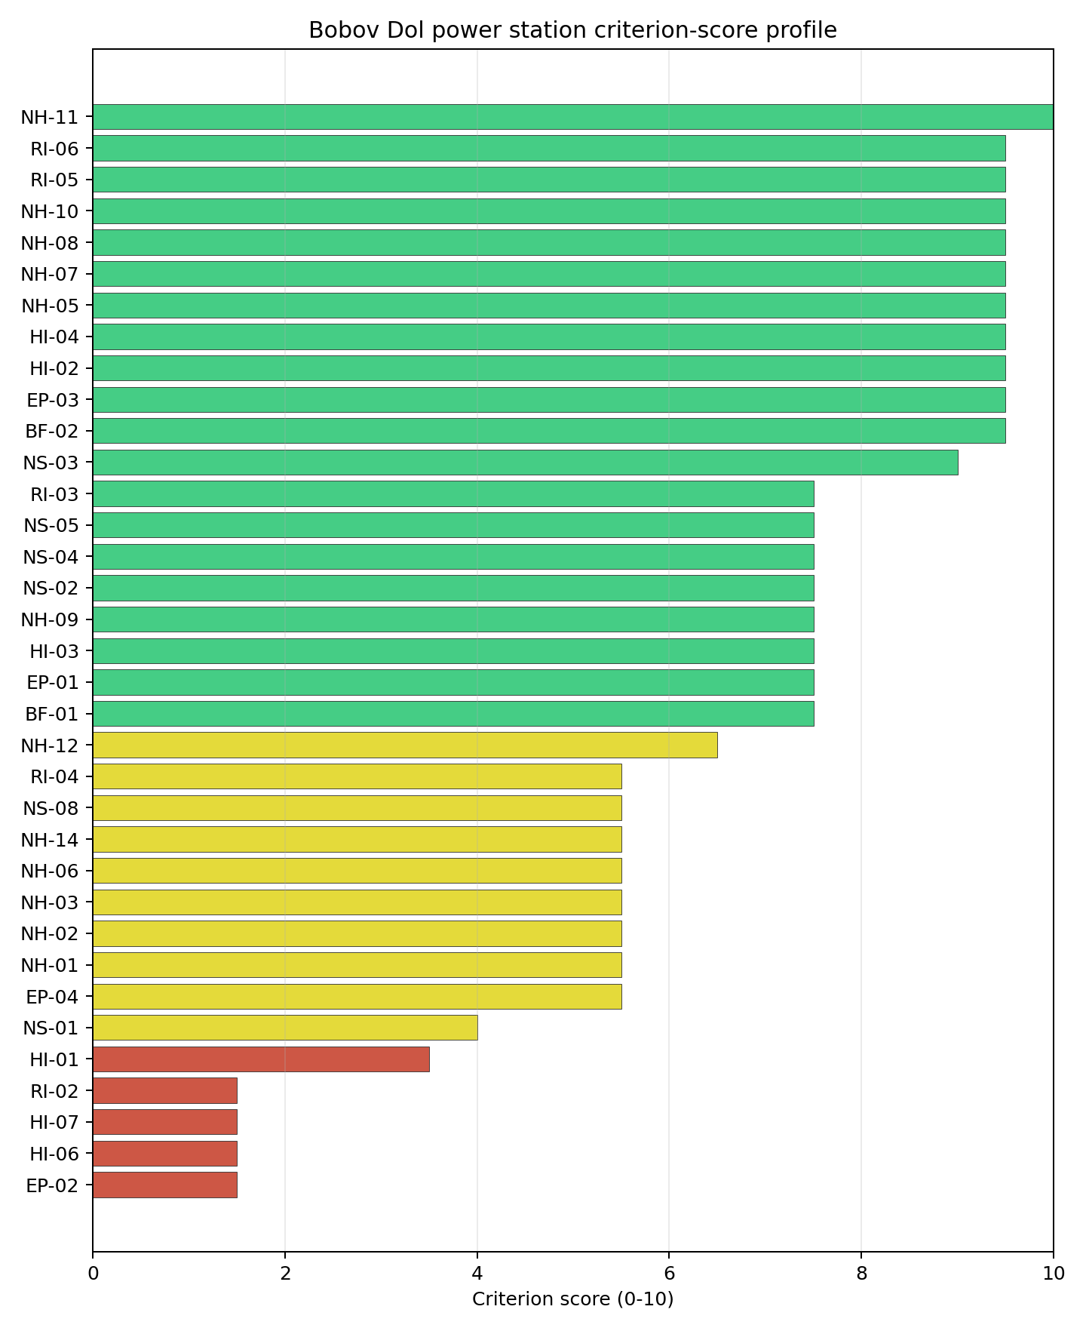
Criterion scores
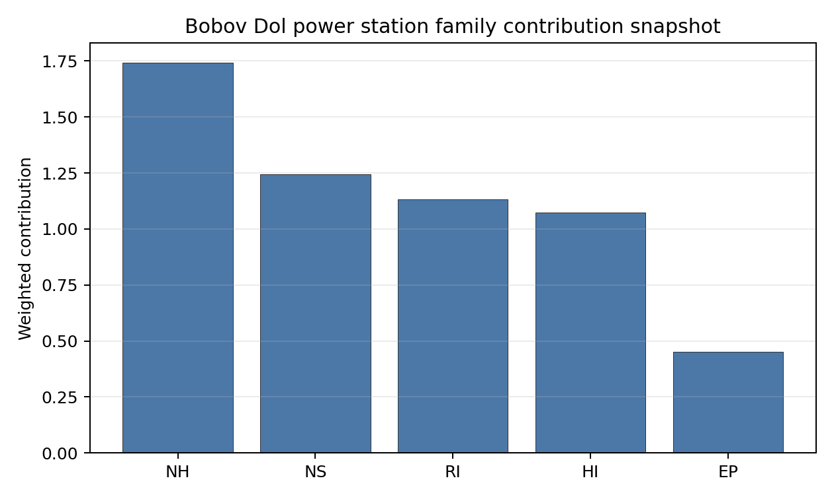
Family contributions
Bobov Dol records a baseline composite score of 6.984, with a Monte Carlo bracket of 6.220-7.525. It ranks third nationally but sits in national stability band G, with a 0% top-10 hit rate and a 25% top-30 hit rate. The site is therefore a useful comparator but a fragile national shortlist candidate. The family profile is strong for Radiological Impact at 8.00, Natural Hazards at 7.67 and Non-Safety Implementation at 7.04, while Emergency Planning falls to 5.26 and human-induced hazards are constrained by HI-01, HI-06 and HI-07. The largest uncertainty reduction would come from aircraft-crash confirmation, military-feature classification, EPZ road modelling and cooling-water evidence.

Residual Risk Register
Concern | Evidence | Consequence | Stage 3 action | Owner discipline
Aircraft Crash (HI-01) | Panicharevo Airfield 3.62 km away; flight-path proxy 1.81 km away | Aircraft-crash screening could remain binding if local traffic or approach patterns are confirmed | Model aircraft-crash frequency and flight-path exposure | security
Military Installations (HI-06) | Nearest feature 10.8 km away; four features in radius | Defence standoff or co-existence requirements could constrain the site | Engage defence authorities on feature classification | security
Evacuation Routes (EP-02) | Road density 0.289 km/km2; road length 566.5 km | Time-to-clear may remain constrained despite motorway access | Model EPZ clearance and secondary egress | emergency planning
Cooling Water Availability (NS-01) | Cooling source 6.26 km away; flow 4.77 m3/s; High water-stress label | Long-term cooling reliability may constrain the deployment envelope | Quantify low-flow availability and cooling-system options | hydrology
Surface Water Dispersion (RI-02) | Criterion score 1.5/10 with no measured dilution value in the profile | Liquid-pathway assessment remains unresolved | Measure receiving-water dilution and downstream receptors | hydrology
Bobov Dol’s residual risk is concentrated in aviation, defence, emergency planning and water. The site merits comparison, but not progression ahead of Lom without these targeted confirmations.

Stage 3 Follow-Up Checklist
- Resolve Aircraft Crash (HI-01) - Panicharevo Airfield 3.62 km away and flight-path proxy 1.81 km away.
- Engage Military Installations (HI-06) - four features in radius and nearest feature 10.8 km away.
- Model Evacuation Routes (EP-02) - 0.289 km/km2 EPZ road density.
- Quantify Surface Water Dispersion (RI-02) - criterion remains at 1.5/10 without measured dilution evidence.
- Confirm Cooling Water Availability (NS-01) - Razmetanitsa source 6.26 km away, 4.77 m3/s flow and High water stress.
- Verify Available surface area - 63.0 ha canonical site area and 114.2 ha development-area value.

Evidence Limitations
- Geotechnical: Subsidence & Collapse (NH-05b) - quality low.

Lom Power Station Site Profile
Lom Power Station is a coal/thermal site in Bulgaria that has been tested against the NuScale VOYGR-6 reference deployment envelope. This profile reads the screening evidence at a level that supports a decision to progress toward Stage 3 characterisation. It is not a site-suitability determination, vendor recommendation, or licensing finding.

Site Snapshot
Field | Value
Site name | Lom Power Station
Coordinates | 43.7825, 23.2175
Subnational unit | Montana
Installed thermal capacity (source data) | 400 MW
Available surface area | 146.3 ha
Available surface area for development | 9.7 ha
Composite score (baseline weights) | 7.428 (6.578-7.850 MC band)
National stability band | A (top-10% hit rate 100%)
National rank | 1
See the country status map in Bulgaria Country Profile.

Ownership and Coal-to-Nuclear Context
No ownership row is carried in the site bundle. Stage 3 should verify the controlling owner, land-control chain and operator status before any project-level conclusion.
Generating units on record: 1 cancelled. Earliest unit commissioning: 2011; most recent: 2011.

Natural Hazards (NH)
- Seismic: Ground Motion (NH-01) - score 7.5/10 (MC 7.0-8.0), weight 0.0455, data quality high. Evidence: PGA at 475-year return period 0.068 g; PGA at 2,475-year return period 0.135 g; Vs30 reference (m/s): 760.0.
- Seismic: Surface Rupture (NH-02) - score 7.5/10 (MC 7.0-8.0), weight n/a, data quality screening grade. Evidence: nearest mapped capable fault 22.3 km; fault slip rate 0.141 mm/yr; fault name: BGCF00M.
- Geotechnical: Liquefaction (NH-03) - score 9.5/10 (MC 9.0-10.0) - favourable: Negligible susceptibility (Stage 1 favourable default)., weight n/a, data quality medium. Evidence: liquefaction susceptibility: very_low; dominant soil type: silty_clay_loam.
- Geotechnical: Slope Stability (NH-04) - score no native score (unscored - no band matched), weight n/a, data quality screening grade. Evidence: not measured at this site (criterion remains unscored).
- Geotechnical: Subsidence (NH-05) - score 9.5/10 (MC 9.0-10.0) - favourable: No karst; mine-feature distance well above the score-5 pivot (or unknown)., weight 0.0354, data quality medium. Evidence: karst present: no; karst severity: none.
- Geotechnical: Foundation (NH-06) - score 5.5/10 (MC 5.0-6.0) - pass-mark band: Typical European mixed conditions (bearing 80-150 kPa)., weight 0.0253, data quality medium. Evidence: bearing capacity 92.0 kPa; depth to bedrock 22.9 m.
- Volcanism (NH-07) - score 9.5/10 (MC 9.0-10.0) - favourable: Very strong margin above the score-5 boundary (or screening evidence records no in-radius signal)., weight n/a, data quality high. Evidence: volcanic hazard class: negligible.
- Coastal Flooding (NH-08) - score 9.5/10 (MC 9.0-10.0) - favourable: Non-coastal OR elevation >= 50 m AMSL OR landlocked country, with no positive marine-hazard signal., weight 0.0303, data quality medium. Evidence: distance to coast 331.5 km.
- River Flooding (NH-09) - score 7.5/10 (MC 7.0-8.0), weight 0.0404, data quality medium. Evidence: flood zone class: negligible.
- Extreme Winds (NH-10) - score 7.5/10 (MC 7.0-8.0), weight 0.0152, data quality medium. Evidence: screening wind-speed index 7.61 m/s.
- Extreme Precipitation (NH-11) - score 10.0/10 (MC 9.0-10.0) - favourable: aggregated(mean_of_sub_scores), weight 0.0152, data quality medium. Evidence: screening extreme-precipitation index 0.16 mm; screening precipitation index 18.1 mm/yr.
- Extreme Temperatures (NH-12) - score 5.5/10 (MC 5.0-6.0) - pass-mark band: aggregated(mean_of_sub_scores), weight 0.0202, data quality medium. Evidence: extreme high temperature 29.0 deg C; extreme low temperature -5.45 deg C.
- Combined Hazards (NH-14) - score 9.5/10 (MC 9.0-10.0) - favourable: At least 5 underlying NH criteria resolved, all >= 7; no interaction pair below 7., weight 0.0152, data quality n/a. Evidence: values not in measurement tables.

Interpretation - Natural Hazards (NH)
Natural hazards at Lom are favourable overall, with low to moderate seismic demand and no standing exclusionary natural-hazard trigger in the screening evidence. The 475-year PGA is 0.068 g and the 2,475-year PGA is 0.135 g, while the nearest mapped capable fault is 22.3 km away. Liquefaction susceptibility is very low, karst is not present, and the foundation proxy records 92.0 kPa bearing capacity with 22.9 m depth to bedrock. Coastal exposure is remote at 331.5 km, the flood-zone class is negligible, and the 50-year screening wind-speed index is 7.61 m/s. The main limitations are that Slope Stability (NH-04) remains unscored and the precipitation values are screening-grade. Stage 3 should confirm slope, precipitation and geotechnical inputs before hardening the design-basis envelope.

Human-Induced and Security-Relevant Hazards (HI)
- Aircraft Crash (HI-01) - score 9.5/10 (MC 9.0-10.0) - favourable: Only small / GA / heliport airport >= 10 km nearby, no flight-path proxy < 4 km, no major airport within 30 km, and no military airbase within 60 km., weight 0.0354, data quality high. Evidence: nearest airport 32.3 km; nearest flight path 16.1 km; airports within search radius 0; airport name: Erden Airfield; airport type: small airfield.
- Industrial Explosions (HI-02) - score 9.5/10 (MC 9.0-10.0) - favourable: Very strong margin above the score-5 boundary (or no in-radius signal is recorded)., weight 0.0354, data quality medium. Evidence: values not in measurement tables.
- Toxic/Gas Releases (HI-03) - score 9.5/10 (MC 9.0-10.0) - favourable: Very strong margin above the score-5 boundary (or no in-radius signal is recorded)., weight 0.0354, data quality medium. Evidence: values not in measurement tables.
- External Fires (HI-04) - score 9.5/10 (MC 9.0-10.0) - favourable: > 15 km, or no flammable-storage signal is recorded in radius., weight 0.0303, data quality medium. Evidence: values not in measurement tables.
- Military Installations (HI-06) - score 0.0/10 (MC 0.0-0.0), weight 0.0303, data quality high. Evidence: nearest military installation 3.87 km; military installations within radius 2; installation name: unnamed.
- Electromagnetic Interference (HI-07) - score 3.5/10 (MC 3.0-4.0), weight 0.0101, data quality medium. Evidence: nearest high-power transmitter 4.1 km; transmitters within radius 18; transmitter type: tower.

Interpretation - Human-Induced and Security-Relevant Hazards (HI)
Human-induced hazards at Lom are strong for aviation and industrial-neighbour screening, but weak on military-installation and electromagnetic-interference evidence. Aircraft Crash (HI-01) is favourable: the nearest small airport is 32.3 km away and the nearest flight-path proxy is 16.1 km away. Industrial Explosions (HI-02), Toxic/Gas Releases (HI-03) and External Fires (HI-04) carry favourable scores because no nearby positive hazard signal is recorded in the screening evidence. The binding issue is Military Installations (HI-06), with the nearest feature 3.87 km away and two features within the search radius, producing a 0.0/10 score. Electromagnetic Interference (HI-07) also requires review, with the nearest transmitter at 4.1 km and 18 transmitters in radius. Stage 3 should begin with defence-feature classification and an RF/EMI field survey.

Radiological Impact and Emergency Planning (RI / EP)
- Emergency Planning Feasibility (EP-01) - score 5.5/10 (MC 5.0-6.0) - pass-mark band: At or above the composite score-5 boundary., weight n/a, data quality high. Evidence: EP feasibility composite 58.3 /100; road sub-score 23.2 /100; special-population sub-score 90.0 /100; geography sub-score 95.0 /100; population sub-score 80.0 /100; evacuation feasible: yes.
- Evacuation Routes (EP-02) - score 1.5/10 (MC 1.0-2.0), weight 0.0303, data quality medium. Evidence: road density in EPZ 0.232 km/km2; road length in EPZ 455.6 km; motorway access: no.
- Physical Geography Constraints (EP-03) - score 9.5/10 (MC 9.0-10.0) - favourable: No measured relief; open river/waterway context (interim screening)., weight 0.0253, data quality medium. Evidence: waterways crossing EPZ 0; major river barrier: no.
- Special Populations (EP-04) - score 7.5/10 (MC 7.0-8.0), weight 0.0303, data quality medium. Evidence: hospitals in EPZ 6; prisons in EPZ 0; care homes in EPZ 0.
- Atmospheric Dispersion (RI-01) - score no native score (unscored - no band matched), weight 0.0303, data quality medium. Evidence: annual mean wind speed 0.99 m/s; atmospheric mixing height 523.7 m; prevailing wind direction: W.
- Surface Water Dispersion (RI-02) - score 1.5/10 (MC 1.0-2.0), weight 0.0253, data quality n/a. Evidence: values not in measurement tables.
- Groundwater Dispersion (RI-03) - score 5.5/10 (MC 5.0-6.0) - pass-mark band: Moderate-permeability aquifer screening proxy., weight 0.0253, data quality medium. Evidence: aquifer type: sedimentary sands.
- Population Density at EPZ Radii (RI-04) - score 5.5/10 (MC 5.0-6.0) - pass-mark band: aggregated(min_of_sub_scores), weight 0.0404, data quality screening grade. Evidence: population density within 5 km 176.2 /km2; population density within 16 km 42.4 /km2; population density within 25 km 37.3 /km2; population density within 80 km 52.2 /km2; population within 25 km 73,177 people.
- Distance to Population Centres (RI-05) - score 9.5/10 (MC 9.0-10.0) - favourable: Nearest >=50k population-centre proxy exceeds required distance by >= 50 %., weight 0.0505, data quality screening grade. Evidence: nearest city above 50k people 75.6 km; nearest city population 301,269 people; city name: Craiova.
- Population Projections (RI-06) - score 9.5/10 (MC 9.0-10.0) - favourable: Declining (< -0.5 %/yr)., weight 0.0253, data quality screening grade. Evidence: annual population growth rate -1.578 %/yr; projected population at 25 km in 60 yr 54,381 people.

Interpretation - Radiological Impact and Emergency Planning (RI / EP)
Radiological and emergency-planning evidence at Lom is mixed. Population density is 176.2 people/km2 within 5 km, 37.3 people/km2 within 25 km, and the 25 km population is 73,177 people. The nearest city above 50,000 people is Craiova at 75.6 km, and the projected 25 km population declines to 54,381 people over the 60-year horizon. Emergency Planning Feasibility (EP-01) remains feasible at 58.3/100, but the road sub-score is only 23.2/100 and Evacuation Routes (EP-02) scores 1.5/10 because road density is 0.232 km/km2, road length is 455.6 km, and motorway access is absent. Surface Water Dispersion (RI-02) also sits at 1.5/10 without a measured basis. Stage 3 should model EPZ clearance times and quantify the Lom river dilution pathway.

Non-Safety and Implementation Considerations (NS)
- Grid Capacity Basic Filter (BF-01) - score 5.5/10 (MC 5.0-6.0) - pass-mark band: Note: substation 15-30 km OR 110-219 kV; reinforcement plausible., weight n/a, data quality n/a. Evidence: values not in measurement tables.
- Land Area Basic Filter (BF-02) - score 1.5/10 (MC 1.0-2.0), weight 0.0253, data quality n/a. Evidence: values not in measurement tables.
- Cooling Water Availability (NS-01) - score 9.0/10 (MC 8.0-9.0) - favourable: aggregated(weighted_mean_of_sub_scores), weight 0.0404, data quality screening grade. Evidence: distance to cooling source 0.46 km; cooling source flow 4.14 m3/s; cooling source type: river; cooling source name: Lom; water stress label: Low.
- Grid Connection (NS-02) - score 3.5/10 (MC 3.0-4.0), weight 0.0404, data quality high. Evidence: nearest substation 2.38 km; nearest high-voltage line 3.9 km; highest nearby line voltage 110.0 kV; grid export capacity 400.0 MW; substations within radius 42; HV lines within radius 260.
- Transport Access (NS-03) - score 8.0/10 (MC 7.0-8.0) - favourable: aggregated(weighted_mean_of_sub_scores), weight 0.0404, data quality medium. Evidence: nearest rail line 2.37 km; nearest waterway 8.36 km; heavy-haul capable: yes.
- Site Topography (NS-04) - score 7.5/10 (MC 7.0-8.0), weight 0.0303, data quality screening grade. Evidence: favourable land cover 63.3 %; moderate land cover 34.5 %; unfavourable land cover 2.1 %; favourable area 146.3 ha; dominant land class: 211.
- Site Footprint Adequacy (NS-05) - score 9.5/10 (MC 9.0-10.0) - favourable: Very strong margin above the score-5 boundary., weight 0.0253, data quality high. Evidence: buildable area 9.66 ha; largest contiguous patch 9.66 ha; buildable patch count 7.
- Existing Infrastructure (NS-06) - score no native score (unscored - no band matched), weight 0.0253, data quality n/a. Evidence: not measured at this site (criterion remains unscored).
- Ecological Sensitivity (NS-08) - score 1.5/10 (MC 1.0-2.0), weight n/a, data quality high. Evidence: natural land cover 2.1 %; distance to nearest Natura 2000 site 0.475 km; distance to nearest protected area 1.979 km; Natura 2000 overlap: no; Natura 2000 sensitivity class: high; protected-area overlap: no; protected-area sensitivity class: high; nearest Natura 2000 site: Mominbrodsko blato; Natura 2000 sites within 5 km: 2; nearest protected-area designation: Protected Site.
- Workforce Availability (NS-10) - score no native score (unscored - no band matched), weight 0.0202, data quality n/a. Evidence: not measured at this site (criterion remains unscored).
- Regulatory/Political Environment (NS-12) - score no native score (unscored - no band matched), weight 0.0303, data quality n/a. Evidence: not measured at this site (criterion remains unscored).
- Construction Logistics (NS-13) - score no native score (unscored - no band matched), weight 0.0202, data quality n/a. Evidence: not measured at this site (criterion remains unscored).

Interpretation - Non-Safety and Implementation Considerations (NS)
Non-safety implementation is the main reason Lom leads nationally, but it is not free of constraints. Cooling Water Availability (NS-01) is strong, with the Lom river 0.46 km away, a 4.14 m3/s flow value, and a Low water-stress label. Transport access is also favourable, with rail at 2.37 km, waterway access at 8.36 km, and heavy-haul capability recorded. The canonical available surface area is 146.3 ha, but the current development-area value is only 9.7 ha; Stage 3 must therefore verify what portion is controlled, contiguous and usable for a VOYGR-6 layout. Grid Connection (NS-02) is the formal avoidance flag: the site has 400 MW inherited export capacity, a 110 kV nearby line, and substations within radius, but the transmission pathway still needs confirmation. Ecological Sensitivity (NS-08) is also material because Mominbrodsko blato is 0.475 km away and two Natura 2000 sites lie within 5 km. Stage 3 should prioritize grid pathway, land-control and Habitats Directive screening work.

Composite Score and Stability
Baseline composite score is 7.428, bracketed by Monte Carlo at 6.578-7.850. National stability band is A with a top-10% hit rate of 100% across 12 scored Monte Carlo scenarios.
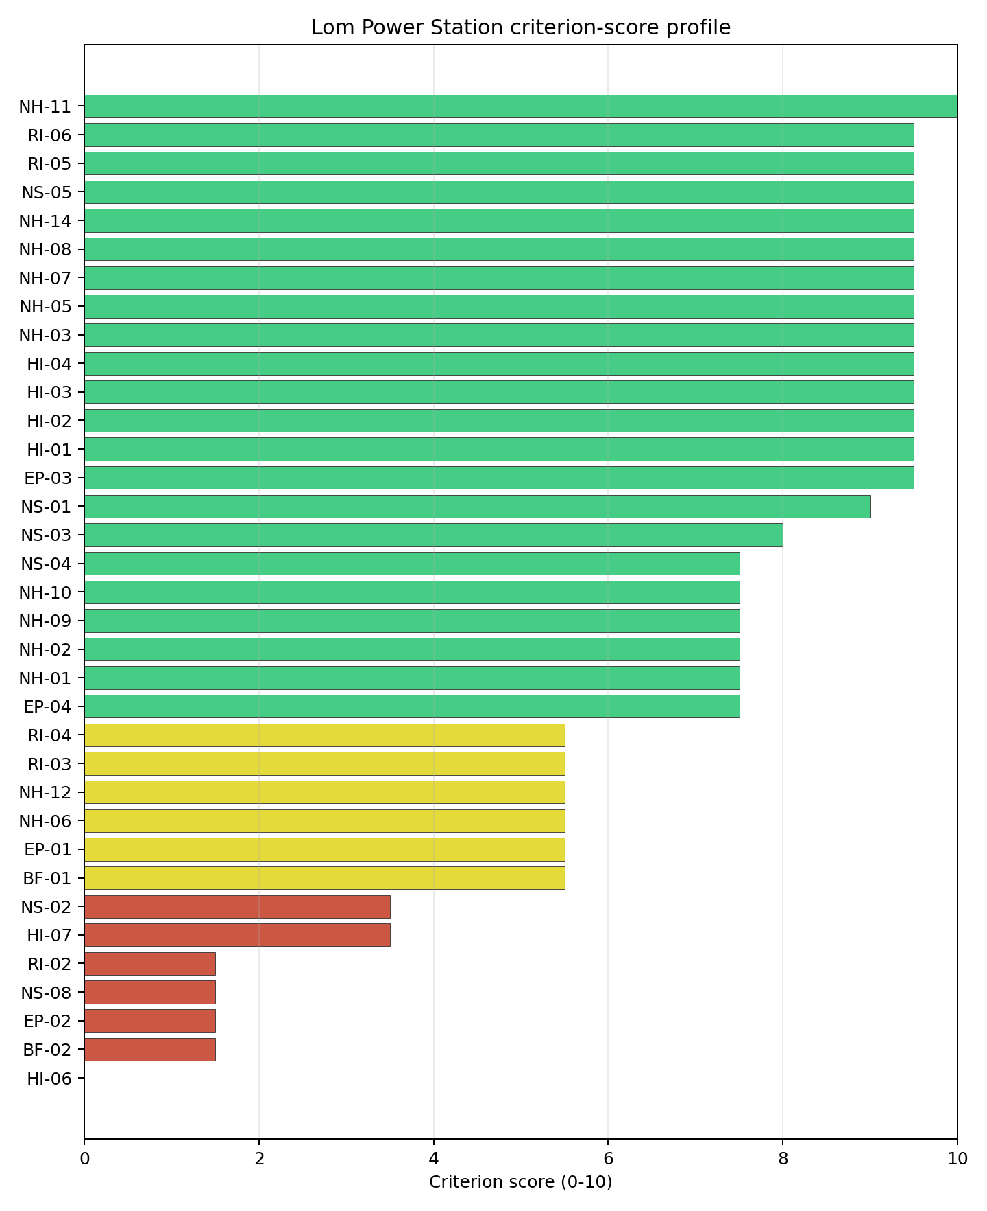
Criterion scores
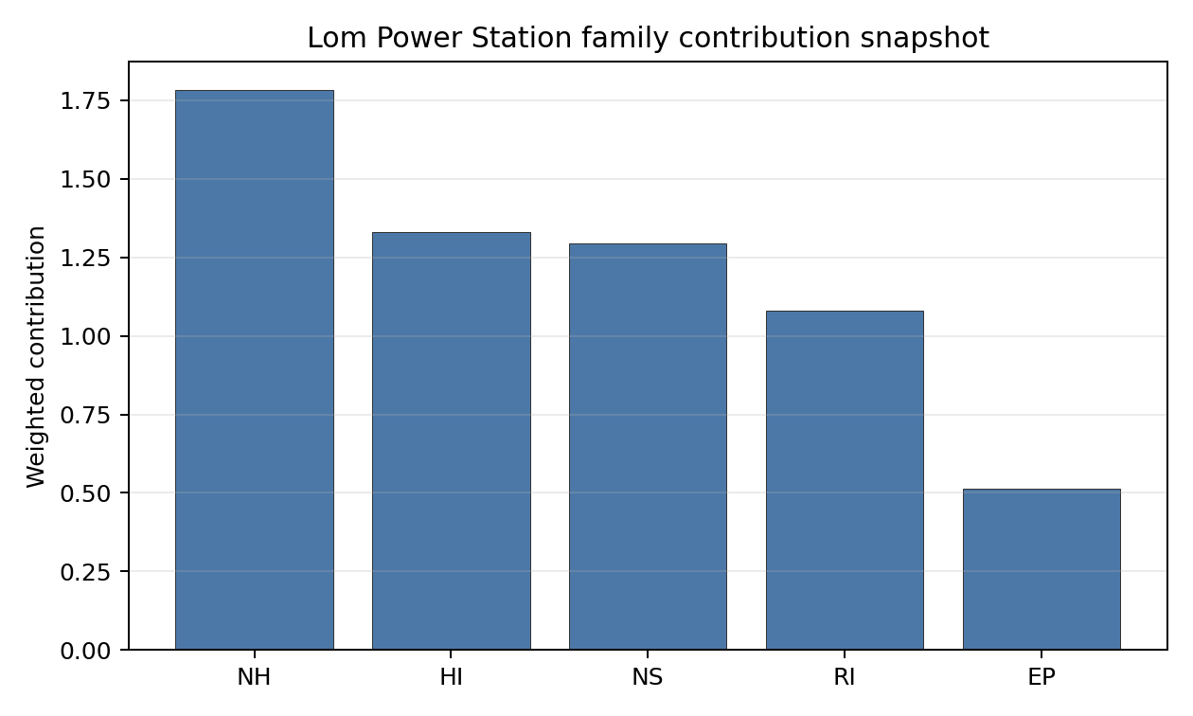
Family contributions
Lom records a baseline composite score of 7.428, with a Monte Carlo bracket of 6.578-7.850. The national stability band is A and the national top-10% hit rate is 100%, so the site remains Bulgaria’s leading brownfield candidate under the national sensitivity analysis rather than depending on a narrow baseline-weight result. The composite is balanced: Natural Hazards score 7.84, Radiological Impact 7.64, Human-Induced Hazards 7.53, Non-Safety Implementation 7.33 and Emergency Planning 5.97 after the unscored-criterion penalty. The largest uncertainty does not come from the whole-site ranking. It comes from specific Stage 3 unlocks: HI-06, NS-02, EP-02, NS-08, RI-02 and the surface-area distinction between 146.3 ha of site area and 9.7 ha of development area.

Residual Risk Register
Concern | Evidence | Consequence | Stage 3 action | Owner discipline
Military Installations (HI-06) | Nearest military feature 3.87 km away; two features in radius | Security standoff or co-existence requirements could change the usable site envelope | Engage defence authorities on feature classification and required standoff | security
Grid Connection (NS-02) | Grid export capacity 400.0 MW; highest nearby line voltage 110.0 kV | Transmission capacity may be insufficient for the VOYGR-6 envelope without reinforcement | Confirm the transmission pathway and reinforcement scope | grid
Evacuation Routes (EP-02) | Road density 0.232 km/km2; motorway access absent | EPZ clearance time may become the limiting emergency-planning issue | Model time-to-clear and identify secondary evacuation corridors | emergency planning
Ecological Sensitivity (NS-08) | Mominbrodsko blato is 0.475 km away; two Natura 2000 sites within 5 km | Permitting and layout could narrow if indirect effects are identified | Run Habitats Directive screening and receptor-pathway review | EIA
Site Footprint and Development Area (BF-02 / NS-05) | Site area 146.3 ha; development-area value 9.7 ha | Available, controlled and contiguous development land remains uncertain | Confirm land control, contiguity and usable development envelope | ownership/legal
The dominant risks are grid capacity, defence standoff and emergency planning. They are characterisation tasks for a leading screening candidate, not a finding of site approval.

Stage 3 Follow-Up Checklist
- Confirm Grid Connection (NS-02) - 400.0 MW export capacity and 110.0 kV nearby line require a VOYGR-6 transmission-pathway review.
- Engage Military Installations (HI-06) - nearest feature 3.87 km away and two features in radius.
- Verify Available surface area for development - 9.7 ha development-area value against 146.3 ha canonical site area.
- Model Evacuation Routes (EP-02) - 0.232 km/km2 EPZ road density and no motorway access.
- Screen Ecological Sensitivity (NS-08) - Mominbrodsko blato 0.475 km away and two Natura 2000 sites within 5 km.
- Quantify Surface Water Dispersion (RI-02) - criterion remains at 1.5/10 without measured dilution evidence.

Evidence Limitations
- Geotechnical: Subsidence & Collapse (NH-05b) - quality low.

Maritsa 3 power station Site Profile
Maritsa 3 power station is a coal/thermal site in Bulgaria that has been tested against the NuScale VOYGR-6 reference deployment envelope. This profile reads the screening evidence at a level that supports a decision to progress toward Stage 3 characterisation. It is not a site-suitability determination, vendor recommendation, or licensing finding.

Site Snapshot
Field | Value
Site name | Maritsa 3 power station
Coordinates | 42.0519, 25.6233
Subnational unit | Haskovo
Installed thermal capacity (source data) | 120 MW
Available surface area | 18.9 ha
Available surface area for development | 18.9 ha
Composite score (baseline weights) | 7.009 (6.240-7.569 MC band)
National stability band | D (top-10% hit rate 0%)
National rank | 2
See the country status map in Bulgaria Country Profile.

Ownership and Coal-to-Nuclear Context
- Draft EOOD (46.01% share), headquartered in Bulgaria; immediate operator TEC Maritsa 3 AD. Path: Draft EOOD -> TEC Maritsa 3 AD [46.01%] -> Maritsa 3 power station – [100.0%]
- Draft AG (46.01% share), headquartered in Liechtenstein; immediate operator TEC Maritsa 3 AD. Path: Draft AG -> Draft EOOD [100.0%] -> TEC Maritsa 3 AD [46.01%] -> Maritsa 3 power station – [100.0%]
- Heatherdell Ltd (49.00% share), headquartered in United Kingdom; immediate operator TEC Maritsa 3 AD. Path: Heatherdell Ltd -> Top Group EOOD [100.0%] -> TEC Maritsa 3 AD [49.0%] -> Maritsa 3 power station – [100.0%]
- TEC Maritsa 3 AD (100.00% share), headquartered in Bulgaria; immediate operator TEC Maritsa 3 AD. Path: TEC Maritsa 3 AD -> Maritsa 3 power station – [100.0%]
- natural person(s) (share not reported); immediate operator TEC Maritsa 3 AD. Path: natural person(s) -> Heatherdell Ltd [unknown %] -> Top Group EOOD [100.0%] -> TEC Maritsa 3 AD [49.0%] -> Maritsa 3 power station – [100.0%]
- Top Group EOOD (49.00% share), headquartered in Bulgaria; immediate operator TEC Maritsa 3 AD. Path: Top Group EOOD -> TEC Maritsa 3 AD [49.0%] -> Maritsa 3 power station – [100.0%]
Generating units on record: 1 mothballed. Earliest unit commissioning: 1971; most recent: 1971.

Natural Hazards (NH)
- Seismic: Ground Motion (NH-01) - score 5.5/10 (MC 5.0-6.0) - pass-mark band: At or below the score-5 risk boundary., weight 0.0455, data quality high. Evidence: PGA at 475-year return period 0.202 g; PGA at 2,475-year return period 0.5 g; Vs30 reference (m/s): 760.0.
- Seismic: Surface Rupture (NH-02) - score 5.5/10 (MC 5.0-6.0) - pass-mark band: Borderline acceptable separation: meets the 8.0 km score boundary; check against the 8 km conservative screen and local capability evidence., weight n/a, data quality screening grade. Evidence: nearest mapped capable fault 9.77 km; fault slip rate 0.2 mm/yr; fault name: BGCF000.
- Geotechnical: Liquefaction (NH-03) - score 5.5/10 (MC 5.0-6.0) - pass-mark band: Moderate susceptibility, or high/very-high with documented (or pending for high) mitigation., weight n/a, data quality medium. Evidence: liquefaction susceptibility: high; dominant soil type: clay_loam.
- Geotechnical: Slope Stability (NH-04) - score 7.5/10 (MC 7.0-8.0), weight n/a, data quality screening grade. Evidence: site slope 7.17 deg; max slope in 1 km box 79.3 deg; slope stability class: moderate.
- Geotechnical: Subsidence (NH-05) - score 9.5/10 (MC 9.0-10.0) - favourable: No karst; mine-feature distance well above the score-5 pivot (or unknown)., weight 0.0354, data quality medium. Evidence: karst present: no; karst severity: none.
- Geotechnical: Foundation (NH-06) - score 5.5/10 (MC 5.0-6.0) - pass-mark band: Typical European mixed conditions (bearing 80-150 kPa)., weight 0.0253, data quality medium. Evidence: bearing capacity 92.0 kPa; depth to bedrock 24.1 m.
- Volcanism (NH-07) - score 9.5/10 (MC 9.0-10.0) - favourable: Very strong margin above the score-5 boundary (or screening evidence records no in-radius signal)., weight n/a, data quality high. Evidence: volcanic hazard class: negligible.
- Coastal Flooding (NH-08) - score 9.5/10 (MC 9.0-10.0) - favourable: Non-coastal OR elevation >= 50 m AMSL OR landlocked country, with no positive marine-hazard signal., weight 0.0303, data quality medium. Evidence: distance to coast 125.2 km.
- River Flooding (NH-09) - score 7.5/10 (MC 7.0-8.0), weight 0.0404, data quality medium. Evidence: flood zone class: negligible.
- Extreme Winds (NH-10) - score 9.5/10 (MC 9.0-10.0) - favourable: Lowest relative wind exposure in the current screening wind-exposure cohort (< 7.5 m/s)., weight 0.0152, data quality medium. Evidence: screening wind-speed index 6.3 m/s.
- Extreme Precipitation (NH-11) - score 8.0/10 (MC 8.0-9.0) - favourable: aggregated(mean_of_sub_scores), weight 0.0152, data quality medium. Evidence: screening extreme-precipitation index 0.2 mm; screening precipitation index 21.2 mm/yr.
- Extreme Temperatures (NH-12) - score 6.5/10 (MC 6.0-7.0) - pass-mark band: aggregated(mean_of_sub_scores), weight 0.0202, data quality medium. Evidence: extreme high temperature 27.7 deg C; extreme low temperature -3.2 deg C.
- Combined Hazards (NH-14) - score 5.5/10 (MC 5.0-6.0) - pass-mark band: At least 5 resolved, exactly one moderate hazard (3-5) or moderate interaction only., weight 0.0152, data quality n/a. Evidence: values not in measurement tables.

Interpretation - Natural Hazards (NH)
Natural hazards at Maritsa 3 are acceptable for screening, but the seismic and geotechnical margins are closer than at Lom. The 475-year PGA is 0.202 g and the 2,475-year PGA reaches 0.5 g, which sits at the project screening boundary for this reference envelope. The nearest mapped capable fault is 9.77 km away, outside the exclusionary buffer but close enough to justify a site-specific seismic review. Liquefaction susceptibility is high, bearing capacity is 92.0 kPa, depth to bedrock is 24.1 m, and site slope is 7.17 degrees. Flood, coastal and volcanic indicators are favourable or remote, and design wind is 6.3 m/s. Stage 3 should prioritize seismic-source review, liquefaction testing and replacement of screening precipitation values with national station evidence.

Human-Induced and Security-Relevant Hazards (HI)
- Aircraft Crash (HI-01) - score 9.5/10 (MC 9.0-10.0) - favourable: Only small / GA / heliport airport >= 10 km nearby, no flight-path proxy < 4 km, no major airport within 30 km, and no military airbase within 60 km., weight 0.0354, data quality high. Evidence: nearest airport 17.9 km; nearest flight path 8.92 km; airports within search radius 2; airport name: Gorski Izvor Airstrip; airport type: small airfield.
- Industrial Explosions (HI-02) - score 9.5/10 (MC 9.0-10.0) - favourable: Very strong margin above the score-5 boundary (or no in-radius signal is recorded)., weight 0.0354, data quality medium. Evidence: values not in measurement tables.
- Toxic/Gas Releases (HI-03) - score 9.5/10 (MC 9.0-10.0) - favourable: Very strong margin above the score-5 boundary (or no in-radius signal is recorded)., weight 0.0354, data quality medium. Evidence: values not in measurement tables.
- External Fires (HI-04) - score 9.5/10 (MC 9.0-10.0) - favourable: > 15 km, or no flammable-storage signal is recorded in radius., weight 0.0303, data quality medium. Evidence: values not in measurement tables.
- Military Installations (HI-06) - score 1.5/10 (MC 1.0-2.0), weight 0.0303, data quality medium. Evidence: nearest military installation 9.99 km; military installations within radius 6; installation name: unnamed.
- Electromagnetic Interference (HI-07) - score 1.5/10 (MC 1.0-2.0), weight 0.0101, data quality medium. Evidence: nearest high-power transmitter 0.54 km; transmitters within radius 34; transmitter type: mast.

Interpretation - Human-Induced and Security-Relevant Hazards (HI)
Human-induced hazards at Maritsa 3 are limited by military and electromagnetic conditions rather than by aircraft-crash screening. The nearest small airport is 17.9 km away and the nearest flight-path proxy is 8.92 km away, so Aircraft Crash (HI-01) is favourable. Industrial Explosions (HI-02), Toxic/Gas Releases (HI-03) and External Fires (HI-04) also score favourably on the current record. The weak points are Military Installations (HI-06), with the nearest feature 9.99 km away and six features in radius, and Electromagnetic Interference (HI-07), with the nearest transmitter 0.54 km away and 34 transmitters in radius. Stage 3 should obtain defence-feature classification, run an RF/EMI survey and refresh the hazardous-neighbour inventory for the Haskovo area.

Radiological Impact and Emergency Planning (RI / EP)
- Emergency Planning Feasibility (EP-01) - score 5.5/10 (MC 5.0-6.0) - pass-mark band: At or above the composite score-5 boundary., weight n/a, data quality high. Evidence: EP feasibility composite 56.9 /100; road sub-score 45.5 /100; special-population sub-score 90.0 /100; geography sub-score 95.0 /100; population sub-score 60.0 /100; evacuation feasible: yes.
- Evacuation Routes (EP-02) - score 3.5/10 (MC 3.0-4.0), weight 0.0303, data quality medium. Evidence: road density in EPZ 0.392 km/km2; road length in EPZ 770.0 km; motorway access: yes.
- Physical Geography Constraints (EP-03) - score 9.5/10 (MC 9.0-10.0) - favourable: No measured relief; open river/waterway context (interim screening)., weight 0.0253, data quality medium. Evidence: waterways crossing EPZ 0; major river barrier: no.
- Special Populations (EP-04) - score 5.5/10 (MC 5.0-6.0) - pass-mark band: 9-25., weight 0.0303, data quality medium. Evidence: hospitals in EPZ 15; prisons in EPZ 0; care homes in EPZ 0.
- Atmospheric Dispersion (RI-01) - score no native score (unscored - no band matched), weight 0.0303, data quality medium. Evidence: annual mean wind speed 0.78 m/s; atmospheric mixing height 482.1 m; prevailing wind direction: NW.
- Surface Water Dispersion (RI-02) - score 5.5/10 (MC 5.0-6.0) - pass-mark band: 30-100 m3/s., weight 0.0253, data quality n/a. Evidence: values not in measurement tables.
- Groundwater Dispersion (RI-03) - score 7.5/10 (MC 7.0-8.0), weight 0.0253, data quality medium. Evidence: aquifer type: low permeability.
- Population Density at EPZ Radii (RI-04) - score 3.5/10 (MC 3.0-4.0), weight 0.0404, data quality screening grade. Evidence: population density within 5 km 316.0 /km2; population density within 16 km 131.2 /km2; population density within 25 km 76.4 /km2; population density within 80 km 65.7 /km2; population within 25 km 149,923 people.
- Distance to Population Centres (RI-05) - score 9.5/10 (MC 9.0-10.0) - favourable: Nearest >=50k population-centre proxy exceeds required distance by >= 50 %., weight 0.0505, data quality screening grade. Evidence: nearest city above 50k people 18.0 km; nearest city population 67,086 people; city name: Haskovo.
- Population Projections (RI-06) - score 9.5/10 (MC 9.0-10.0) - favourable: Declining (< -0.5 %/yr)., weight 0.0253, data quality screening grade. Evidence: annual population growth rate -1.486 %/yr; projected population at 25 km in 60 yr 111,418 people.

Interpretation - Radiological Impact and Emergency Planning (RI / EP)
Radiological impact and emergency planning at Maritsa 3 are driven by the population and special-population envelope around Haskovo. Population density is 316.0 people/km2 within 5 km and 76.4 people/km2 within 25 km, with 149,923 people inside 25 km. Haskovo, with 67,086 people, is 18.0 km away. The 25 km population declines to 111,418 people over the 60-year horizon, which supports the long-term demographic read but does not remove the near-field population issue. Emergency Planning Feasibility (EP-01) is feasible at 56.9/100, with road density of 0.392 km/km2 and motorway access present, but 15 hospitals in the EPZ make EP-04 a practical planning concern. Stage 3 should model evacuation timing, hospital surge arrangements and source-term placement against local wind evidence.

Non-Safety and Implementation Considerations (NS)
- Grid Capacity Basic Filter (BF-01) - score 5.5/10 (MC 5.0-6.0) - pass-mark band: Note: substation 15-30 km OR 110-219 kV; reinforcement plausible., weight n/a, data quality n/a. Evidence: values not in measurement tables.
- Land Area Basic Filter (BF-02) - score 1.5/10 (MC 1.0-2.0), weight 0.0253, data quality n/a. Evidence: values not in measurement tables.
- Cooling Water Availability (NS-01) - score 6.0/10 (MC 6.0-7.0) - pass-mark band: aggregated(weighted_mean_of_sub_scores), weight 0.0404, data quality screening grade. Evidence: distance to cooling source 0.62 km; cooling source flow 76.0 m3/s; cooling source type: river; cooling source name: Maritsa; water stress label: High.
- Grid Connection (NS-02) - score 1.5/10 (MC 1.0-2.0), weight 0.0404, data quality high. Evidence: nearest substation 0.21 km; nearest high-voltage line 1.53 km; highest nearby line voltage 110.0 kV; grid export capacity 120.0 MW; substations within radius 339; HV lines within radius 261.
- Transport Access (NS-03) - score 9.0/10 (MC 9.0-10.0) - favourable: aggregated(weighted_mean_of_sub_scores), weight 0.0404, data quality high. Evidence: nearest highway 0.76 km; nearest rail line 0.32 km; nearest waterway 3.2 km; heavy-haul capable: yes.
- Site Topography (NS-04) - score 7.5/10 (MC 7.0-8.0), weight 0.0303, data quality screening grade. Evidence: favourable land cover 70.2 %; moderate land cover 7.4 %; unfavourable land cover 13.4 %; favourable area 159.2 ha; dominant land class: 211.
- Site Footprint Adequacy (NS-05) - score 5.5/10 (MC 5.0-6.0) - pass-mark band: At or above the score-5 boundary., weight 0.0253, data quality high. Evidence: buildable area 18.9 ha; largest contiguous patch 18.9 ha; buildable patch count 10.
- Existing Infrastructure (NS-06) - score no native score (unscored - no band matched), weight 0.0253, data quality n/a. Evidence: not measured at this site (criterion remains unscored).
- Ecological Sensitivity (NS-08) - score 1.5/10 (MC 1.0-2.0), weight n/a, data quality high. Evidence: natural land cover 13.4 %; distance to nearest Natura 2000 site 0.545 km; distance to nearest protected area 0.512 km; Natura 2000 overlap: no; Natura 2000 sensitivity class: high; protected-area overlap: no; protected-area sensitivity class: moderate; nearest Natura 2000 site: Reka Maritsa; Natura 2000 sites within 5 km: 3; nearest protected-area designation: Protected Site.
- Workforce Availability (NS-10) - score no native score (unscored - no band matched), weight 0.0202, data quality n/a. Evidence: not measured at this site (criterion remains unscored).
- Regulatory/Political Environment (NS-12) - score no native score (unscored - no band matched), weight 0.0303, data quality n/a. Evidence: not measured at this site (criterion remains unscored).
- Construction Logistics (NS-13) - score no native score (unscored - no band matched), weight 0.0202, data quality n/a. Evidence: not measured at this site (criterion remains unscored).

Interpretation - Non-Safety and Implementation Considerations (NS)
Non-safety implementation at Maritsa 3 is a split profile. Transport access is strong, with highway access at 0.76 km, rail at 0.32 km, waterway access at 3.2 km and heavy-haul capability recorded. Cooling Water Availability (NS-01) is plausible on distance and flow, with the Maritsa river 0.62 km away and a 76.0 m3/s flow value, but the High water-stress label requires project-specific water review. The canonical available surface area is only 18.9 ha, even though the wider favourable-area envelope is 159.2 ha; this makes land control and usable layout a core Stage 3 question. Grid Connection (NS-02) is the formal avoidance flag, with 120 MW grid export capacity against the VOYGR-6 envelope. Ecological Sensitivity (NS-08) is also material because Reka Maritsa is 0.545 km away and three Natura 2000 sites lie within 5 km. Stage 3 should focus on grid reinforcement, controlled land area, water allocation and appropriate assessment.

Composite Score and Stability
Baseline composite score is 7.009, bracketed by Monte Carlo at 6.240-7.569. National stability band is D with a top-10% hit rate of 0% across 12 scored Monte Carlo scenarios.
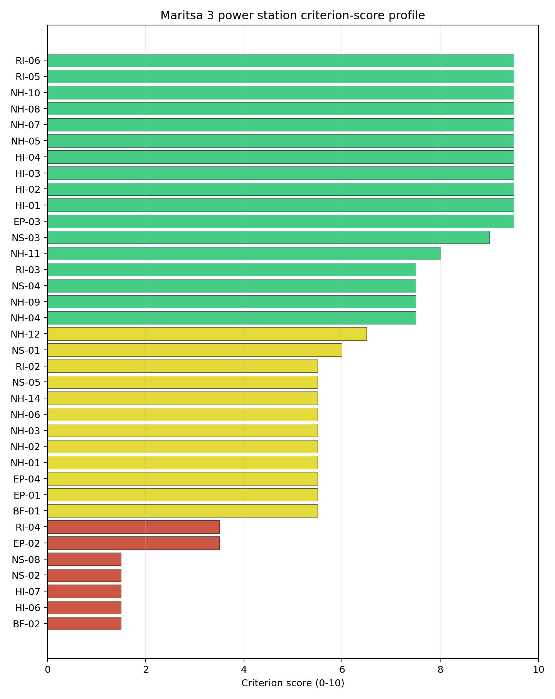
Criterion scores
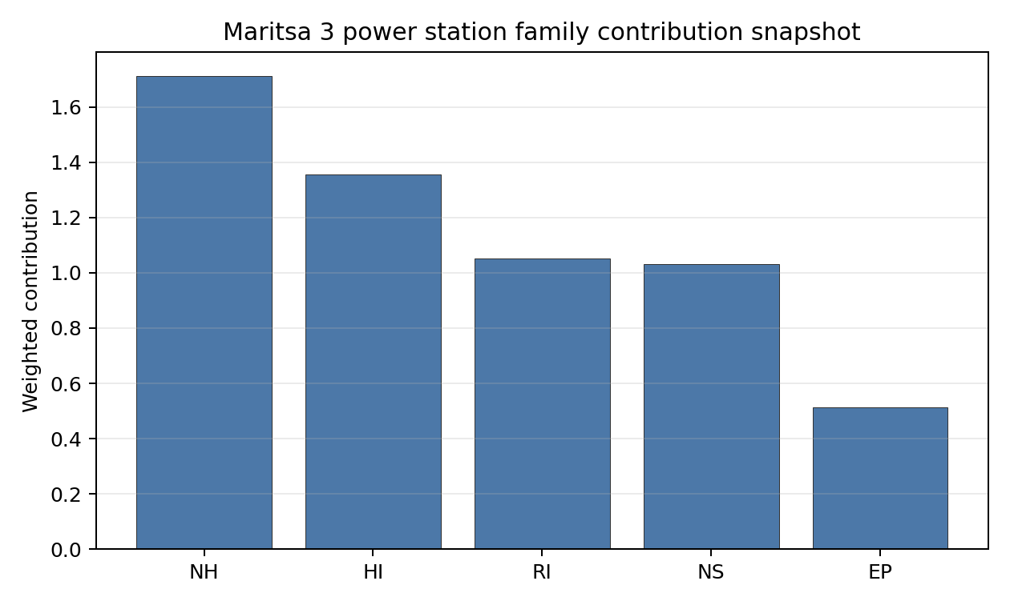
Family contributions
Maritsa 3 records a baseline composite score of 7.009, with a Monte Carlo bracket of 6.240-7.569. It ranks second nationally, but its national stability band is D and its national top-10% hit rate is 0%, which means its position is materially less robust than Lom’s. The family pattern explains the result: Human-Induced Hazards score 7.67, Natural Hazards 7.53 and Radiological Impact 7.43, while Non-Safety Implementation falls to 5.84 because grid capacity, land area and ecological proximity are binding. Maritsa 3 is therefore a useful comparator, not a first Stage 3 lead. Characterisation should test whether NS-02, BF-02 and NS-08 can be converted from constraints into resolvable project work.

Residual Risk Register
Concern | Evidence | Consequence | Stage 3 action | Owner discipline
Grid Connection (NS-02) | Grid export capacity 120.0 MW; highest nearby line voltage 110.0 kV | The site may require material transmission reinforcement before VOYGR-6 integration | Confirm 220 kV or 400 kV connection route and reinforcement scope | grid
Site Footprint (BF-02 / NS-05) | Available surface area 18.9 ha; wider favourable envelope 159.2 ha | The usable deployment footprint may be too small without adjacent controlled land | Verify ownership, contiguity and developable area | ownership/legal
Ecological Sensitivity (NS-08) | Reka Maritsa is 0.545 km away; three Natura 2000 sites within 5 km | Environmental assessment could constrain layout or cooling works | Run appropriate assessment and receptor-pathway screening | EIA
Electromagnetic Interference (HI-07) | Nearest transmitter 0.54 km away; 34 transmitters in radius | EMI controls may affect siting of safety and communications systems | Survey field strengths and exclusion distances | security
Population Density (RI-04) | 316.0 people/km2 within 5 km; 149,923 people within 25 km | EPZ planning and dose modelling may be more demanding than at rural sites | Model EPZ population, source-term placement and evacuation timing | emergency planning
Grid, land and ecological constraints dominate the register. The site remains a valid second-ranked comparator, but it needs targeted unlock evidence before it can rival Lom.

Stage 3 Follow-Up Checklist
- Confirm Grid Connection (NS-02) - 120.0 MW export capacity and 110.0 kV nearby line require reinforcement review.
- Verify Available surface area - 18.9 ha canonical site area against the VOYGR-6 layout envelope.
- Engage Military Installations (HI-06) - six military features in radius and nearest feature 9.99 km away.
- Survey Electromagnetic Interference (HI-07) - nearest transmitter 0.54 km away and 34 transmitters in radius.
- Screen Ecological Sensitivity (NS-08) - Reka Maritsa 0.545 km away and three Natura 2000 sites within 5 km.
- Model Population Density at EPZ Radii (RI-04) - 316.0 people/km2 within 5 km and 149,923 people within 25 km.

Evidence Limitations
- Geotechnical: Subsidence & Collapse (NH-05b) - quality low.

Svilosa power station Site Profile
Svilosa power station is a coal/thermal site in Bulgaria that has been tested against the NuScale VOYGR-6 reference deployment envelope. This profile reads the screening evidence at a level that supports a decision to progress toward Stage 3 characterisation. It is not a site-suitability determination, vendor recommendation, or licensing finding.

Site Snapshot
Field | Value
Site name | Svilosa power station
Coordinates | 43.6423, 25.3050
Subnational unit | Veliko Tarnovo
Installed thermal capacity (source data) | 120 MW
Available surface area | 172.0 ha
Available surface area for development | 135.7 ha
Composite score (baseline weights) | 6.578 (5.891-7.119 MC band)
National stability band | H (top-10% hit rate 0%)
National rank | 5
See the country status map in Bulgaria Country Profile.

Ownership and Coal-to-Nuclear Context
- A.R.U.S. Holding AD (96.64% share), headquartered in Bulgaria; immediate operator Svilosa AD. Path: A.R.U.S. Holding AD -> Svilosa AD [96.64%] -> Svilosa power station Unit 2 [100.0%]
- unknown (share not reported); immediate operator Svilosa AD. Path: unknown -> Svilosa AD [unknown %] -> Svilosa power station Unit 1 [100.0%]
- natural person(s) (share not reported); immediate operator Svilosa AD. Path: natural person(s) -> A.R.U.S. Holding AD [unknown %] -> Svilosa AD [96.64%] -> Svilosa power station Unit 1 [100.0%]
Generating units on record: 2 retired. Earliest unit commissioning: 1971; most recent: 1972. Retirements span 2004 to 2004, leaving brownfield grid, water, transport, and workforce assets that materially shorten Stage 3 site preparation.

Natural Hazards (NH)
- Seismic: Ground Motion (NH-01) - score 5.5/10 (MC 5.0-6.0) - pass-mark band: At or below the score-5 risk boundary., weight 0.0455, data quality high. Evidence: PGA at 475-year return period 0.142 g; PGA at 2,475-year return period 0.275 g; Vs30 reference (m/s): 760.0.
- Seismic: Surface Rupture (NH-02) - score 9.5/10 (MC 9.0-10.0) - favourable: Very strong separation from mapped capable faults; surface-rupture concern effectively screened at desk-study level., weight n/a, data quality screening grade. Evidence: nearest mapped capable fault 46.9 km; fault slip rate 0.1 mm/yr; fault name: BGCF00K.
- Geotechnical: Liquefaction (NH-03) - score 5.5/10 (MC 5.0-6.0) - pass-mark band: Moderate susceptibility, or high/very-high with documented (or pending for high) mitigation., weight n/a, data quality medium. Evidence: liquefaction susceptibility: high; dominant soil type: silty_clay_loam.
- Geotechnical: Slope Stability (NH-04) - score 9.5/10 (MC 9.0-10.0) - favourable: Well below the risk boundary., weight n/a, data quality screening grade. Evidence: site slope 3.86 deg; max slope in 1 km box 53.1 deg; slope stability class: gentle.
- Geotechnical: Subsidence (NH-05) - score 9.5/10 (MC 9.0-10.0) - favourable: No karst; mine-feature distance well above the score-5 pivot (or unknown)., weight 0.0354, data quality medium. Evidence: karst present: no; karst severity: none.
- Geotechnical: Foundation (NH-06) - score 5.5/10 (MC 5.0-6.0) - pass-mark band: Typical European mixed conditions (bearing 80-150 kPa)., weight 0.0253, data quality medium. Evidence: bearing capacity 84.0 kPa; depth to bedrock 19.2 m.
- Volcanism (NH-07) - score 9.5/10 (MC 9.0-10.0) - favourable: Very strong margin above the score-5 boundary (or screening evidence records no in-radius signal)., weight n/a, data quality high. Evidence: volcanic hazard class: negligible.
- Coastal Flooding (NH-08) - score 9.5/10 (MC 9.0-10.0) - favourable: Non-coastal OR elevation >= 50 m AMSL OR landlocked country, with no positive marine-hazard signal., weight 0.0303, data quality medium. Evidence: distance to coast 218.5 km.
- River Flooding (NH-09) - score 7.5/10 (MC 7.0-8.0), weight 0.0404, data quality medium. Evidence: flood zone class: negligible.
- Extreme Winds (NH-10) - score 9.5/10 (MC 9.0-10.0) - favourable: Lowest relative wind exposure in the current screening wind-exposure cohort (< 7.5 m/s)., weight 0.0152, data quality medium. Evidence: screening wind-speed index 7.08 m/s.
- Extreme Precipitation (NH-11) - score 8.0/10 (MC 8.0-9.0) - favourable: aggregated(mean_of_sub_scores), weight 0.0152, data quality medium. Evidence: screening extreme-precipitation index 0.21 mm; screening precipitation index 20.8 mm/yr.
- Extreme Temperatures (NH-12) - score 5.5/10 (MC 5.0-6.0) - pass-mark band: aggregated(mean_of_sub_scores), weight 0.0202, data quality medium. Evidence: extreme high temperature 28.9 deg C; extreme low temperature -5.44 deg C.
- Combined Hazards (NH-14) - score 5.5/10 (MC 5.0-6.0) - pass-mark band: At least 5 resolved, exactly one moderate hazard (3-5) or moderate interaction only., weight 0.0152, data quality n/a. Evidence: values not in measurement tables.

Interpretation - Natural Hazards (NH)
Natural hazards at Svilosa are generally favourable, with good fault separation and gentle topography, but alluvial ground conditions require confirmation. The 475-year PGA is 0.142 g and the 2,475-year PGA is 0.275 g. The nearest mapped capable fault is 46.9 km away, which is a strong surface-rupture margin. Liquefaction susceptibility is high on silty-clay-loam soils, while bearing capacity is 84.0 kPa and depth to bedrock is 19.2 m. Site slope is 3.86 degrees, karst is not present, the flood-zone class is negligible, and the distance to coast is 218.5 km. Design wind is 7.08 m/s and the temperature range remains within the screening envelope. Stage 3 should focus on CPT/SPT testing, flood-interface confirmation and local precipitation evidence.

Human-Induced and Security-Relevant Hazards (HI)
- Aircraft Crash (HI-01) - score 3.5/10 (MC 3.0-4.0), weight 0.0354, data quality high. Evidence: nearest airport 3.18 km; nearest flight path 1.59 km; airports within search radius 3; airport name: Svishtov Airfield; airport type: small airfield.
- Industrial Explosions (HI-02) - score 9.5/10 (MC 9.0-10.0) - favourable: Very strong margin above the score-5 boundary (or no in-radius signal is recorded)., weight 0.0354, data quality medium. Evidence: values not in measurement tables.
- Toxic/Gas Releases (HI-03) - score 9.5/10 (MC 9.0-10.0) - favourable: Very strong margin above the score-5 boundary (or no in-radius signal is recorded)., weight 0.0354, data quality medium. Evidence: values not in measurement tables.
- External Fires (HI-04) - score 9.5/10 (MC 9.0-10.0) - favourable: > 15 km, or no flammable-storage signal is recorded in radius., weight 0.0303, data quality medium. Evidence: values not in measurement tables.
- Military Installations (HI-06) - score 0.0/10 (MC 0.0-0.0), weight 0.0303, data quality high. Evidence: nearest military installation 4.7 km; military installations within radius 7; installation name: unnamed.
- Electromagnetic Interference (HI-07) - score 3.5/10 (MC 3.0-4.0), weight 0.0101, data quality medium. Evidence: nearest high-power transmitter 4.75 km; transmitters within radius 8; transmitter type: communication.

Interpretation - Human-Induced and Security-Relevant Hazards (HI)
Human-induced hazards at Svilosa are a major constraint. Aircraft Crash (HI-01) scores 3.5/10 because Svishtov Airfield is 3.18 km away, the nearest flight-path proxy is 1.59 km away, and three airports are in the search radius. Military Installations (HI-06) is more severe, with the nearest feature 4.7 km away and seven military features in radius, producing a 0.0/10 score. Electromagnetic Interference (HI-07) also requires review, with the nearest transmitter 4.75 km away and eight transmitters in radius. Industrial, toxic and external-fire indicators are otherwise favourable in the current screening record. Stage 3 should first test whether the aviation and military findings are recoverable before detailed engineering work proceeds.

Radiological Impact and Emergency Planning (RI / EP)
- Emergency Planning Feasibility (EP-01) - score 5.5/10 (MC 5.0-6.0) - pass-mark band: At or above the composite score-5 boundary., weight n/a, data quality high. Evidence: EP feasibility composite 44.9 /100; road sub-score 17.7 /100; special-population sub-score 10.0 /100; geography sub-score 95.0 /100; population sub-score 80.0 /100; evacuation feasible: yes.
- Evacuation Routes (EP-02) - score 1.5/10 (MC 1.0-2.0), weight 0.0303, data quality medium. Evidence: road density in EPZ 0.177 km/km2; road length in EPZ 347.5 km; motorway access: no.
- Physical Geography Constraints (EP-03) - score 9.5/10 (MC 9.0-10.0) - favourable: No measured relief; open river/waterway context (interim screening)., weight 0.0253, data quality medium. Evidence: waterways crossing EPZ 0; major river barrier: no.
- Special Populations (EP-04) - score 7.5/10 (MC 7.0-8.0), weight 0.0303, data quality medium. Evidence: hospitals in EPZ 7; prisons in EPZ 1; care homes in EPZ 0.
- Atmospheric Dispersion (RI-01) - score no native score (unscored - no band matched), weight 0.0303, data quality medium. Evidence: annual mean wind speed 0.76 m/s; atmospheric mixing height 471.8 m; prevailing wind direction: WSW.
- Surface Water Dispersion (RI-02) - score 9.5/10 (MC 9.0-10.0) - favourable: > 500 m3/s., weight 0.0253, data quality n/a. Evidence: values not in measurement tables.
- Groundwater Dispersion (RI-03) - score 1.5/10 (MC 1.0-2.0), weight 0.0253, data quality medium. Evidence: aquifer type: karsts and chalkstones.
- Population Density at EPZ Radii (RI-04) - score 3.5/10 (MC 3.0-4.0), weight 0.0404, data quality screening grade. Evidence: population density within 5 km 292.5 /km2; population density within 16 km 71.1 /km2; population density within 25 km 47.8 /km2; population density within 80 km 61.2 /km2; population within 25 km 93,874 people.
- Distance to Population Centres (RI-05) - score 9.5/10 (MC 9.0-10.0) - favourable: Nearest >=50k population-centre proxy exceeds required distance by >= 50 %., weight 0.0505, data quality screening grade. Evidence: nearest city above 50k people 58.6 km; nearest city population 89,823 people; city name: Pleven.
- Population Projections (RI-06) - score 9.5/10 (MC 9.0-10.0) - favourable: Declining (< -0.5 %/yr)., weight 0.0253, data quality screening grade. Evidence: annual population growth rate -0.95 %/yr; projected population at 25 km in 60 yr 69,760 people.

Interpretation - Radiological Impact and Emergency Planning (RI / EP)
Radiological and emergency-planning evidence at Svilosa is mixed. Population density is 292.5 people/km2 within 5 km, 47.8 people/km2 within 25 km, and 93,874 people inside 25 km. Pleven, with 89,823 people, is 58.6 km away, and the projected 25 km population declines to 69,760 people over 60 years. Emergency Planning Feasibility (EP-01) remains feasible at 44.9/100, but it is weak: the road sub-score is 17.7/100, road density is 0.177 km/km2, road length is 347.5 km, and motorway access is absent. Surface Water Dispersion (RI-02) is favourable because of the Danube-scale watercourse, but Groundwater Dispersion (RI-03) scores 1.5/10 on karsts and chalkstones. Stage 3 should model evacuation clearance, groundwater pathways and atmospheric dispersion before the site advances.

Non-Safety and Implementation Considerations (NS)
- Grid Capacity Basic Filter (BF-01) - score 5.5/10 (MC 5.0-6.0) - pass-mark band: Note: substation 15-30 km OR 110-219 kV; reinforcement plausible., weight n/a, data quality n/a. Evidence: values not in measurement tables.
- Land Area Basic Filter (BF-02) - score 9.5/10 (MC 9.0-10.0) - favourable: Contiguous and buildable >= ideal area (70 ha/module)., weight 0.0253, data quality n/a. Evidence: values not in measurement tables.
- Cooling Water Availability (NS-01) - score 9.0/10 (MC 8.0-10.0) - favourable: aggregated(weighted_mean_of_sub_scores), weight 0.0404, data quality screening grade. Evidence: distance to cooling source 0.76 km; cooling source flow 5,779 m3/s; cooling source type: major_river; cooling source name: Danube; water stress label: Low.
- Grid Connection (NS-02) - score 1.5/10 (MC 1.0-2.0), weight 0.0404, data quality high. Evidence: nearest substation 0.19 km; nearest high-voltage line 0.19 km; highest nearby line voltage 110.0 kV; grid export capacity 120.0 MW; substations within radius 36; HV lines within radius 77.
- Transport Access (NS-03) - score 8.0/10 (MC 8.0-9.0) - favourable: aggregated(weighted_mean_of_sub_scores), weight 0.0404, data quality high. Evidence: nearest highway 4.32 km; nearest rail line 0.25 km; nearest waterway 8.83 km; heavy-haul capable: yes.
- Site Topography (NS-04) - score 3.5/10 (MC 3.0-4.0), weight 0.0303, data quality screening grade. Evidence: favourable land cover 39.2 %; moderate land cover 9.9 %; unfavourable land cover 32.3 %; favourable area 77.1 ha; dominant land class: 211.
- Site Footprint Adequacy (NS-05) - score 9.5/10 (MC 9.0-10.0) - favourable: Very strong margin above the score-5 boundary., weight 0.0253, data quality medium. Evidence: buildable area 135.7 ha; largest contiguous patch 135.7 ha; buildable patch count 6.
- Existing Infrastructure (NS-06) - score no native score (unscored - no band matched), weight 0.0253, data quality n/a. Evidence: not measured at this site (criterion remains unscored).
- Ecological Sensitivity (NS-08) - score 1.5/10 (MC 1.0-2.0), weight n/a, data quality high. Evidence: natural land cover 32.3 %; distance to nearest Natura 2000 site 0.734 km; distance to nearest protected area 0.74 km; Natura 2000 overlap: no; Natura 2000 sensitivity class: high; protected-area overlap: no; protected-area sensitivity class: high; nearest Natura 2000 site: Suhaia; Natura 2000 sites within 5 km: 5; nearest protected-area designation: Wetland of International Importance (Ramsar Site).
- Workforce Availability (NS-10) - score no native score (unscored - no band matched), weight 0.0202, data quality n/a. Evidence: not measured at this site (criterion remains unscored).
- Regulatory/Political Environment (NS-12) - score no native score (unscored - no band matched), weight 0.0303, data quality n/a. Evidence: not measured at this site (criterion remains unscored).
- Construction Logistics (NS-13) - score no native score (unscored - no band matched), weight 0.0202, data quality n/a. Evidence: not measured at this site (criterion remains unscored).

Interpretation - Non-Safety and Implementation Considerations (NS)
Non-safety implementation at Svilosa is strong on cooling and land, but weak on grid, topography and ecology. Cooling Water Availability (NS-01) is favourable, with the Danube 0.76 km away, a 5,779 m3/s flow value and Low water stress. The canonical available surface area is 172.0 ha and the development-area value is 135.7 ha, which is the strongest land envelope among the selected sites. Transport access is usable, with highway access at 4.32 km, rail at 0.25 km, waterway access at 8.83 km and heavy-haul capability recorded. Grid Connection (NS-02) is binding because grid export capacity is 120.0 MW and the highest nearby voltage is 110.0 kV. Ecological Sensitivity (NS-08) is also binding: Suhaia is 0.734 km away, five Natura 2000 sites lie within 5 km, and the nearest protected-area designation is a Ramsar wetland. Stage 3 should focus on grid upgrade, ecological assessment and confirmation of usable land outside sensitive receptors.

Composite Score and Stability
Baseline composite score is 6.578, bracketed by Monte Carlo at 5.891-7.119. National stability band is H with a top-10% hit rate of 0% across 12 scored Monte Carlo scenarios.
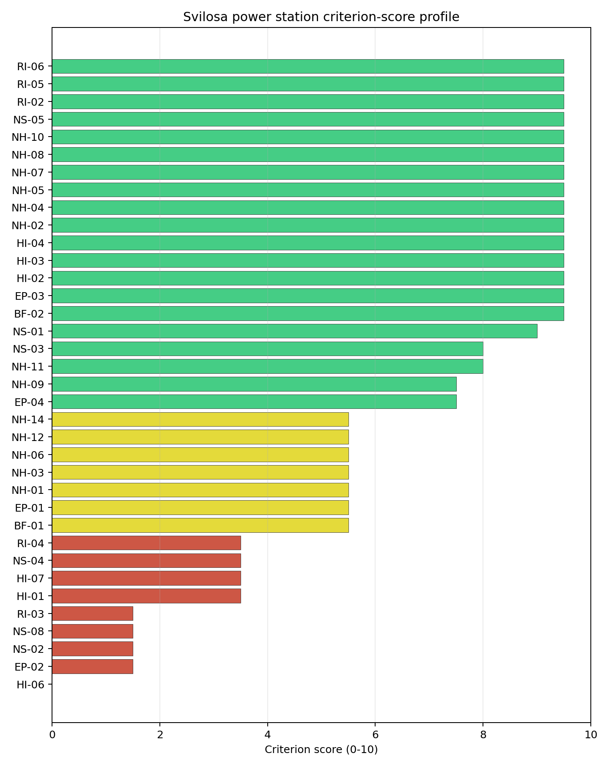
Criterion scores
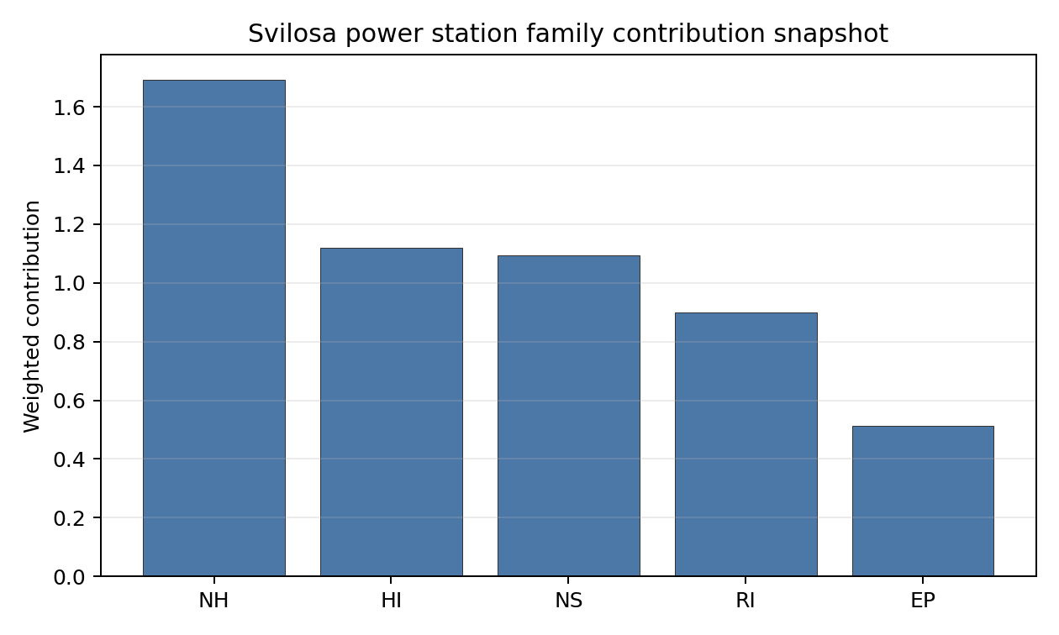
Family contributions
Svilosa records a baseline composite score of 6.578, with a Monte Carlo bracket of 5.891-7.119. It ranks fifth nationally, sits in stability band H and has a 0% national top-10 and top-30 hit rate. The site is therefore the weakest of the selected five from a robustness perspective. Natural Hazards score 7.44, while Human-Induced Hazards, Non-Safety Implementation and Radiological Impact sit between 6.19 and 6.36, with Emergency Planning at 5.97. The ranking depends on whether several binding questions can be retired together: HI-01, HI-06, NS-02, NS-08, RI-03 and EP-02. Svilosa should stay as a conditional option only if early Stage 3 work shows those constraints are recoverable.

Residual Risk Register
Concern | Evidence | Consequence | Stage 3 action | Owner discipline
Aircraft Crash (HI-01) | Svishtov Airfield 3.18 km away; flight-path proxy 1.59 km away | Aviation screening may remain binding without project-specific hazard evidence | Model aircraft-crash frequency and flight-path exposure | security
Military Installations (HI-06) | Nearest military feature 4.7 km away; seven features in radius | Defence standoff could constrain or deprecate the site | Engage defence authorities on feature classification | security
Grid Connection (NS-02) | Grid export capacity 120.0 MW; highest nearby line voltage 110.0 kV | Transmission reinforcement may be a gating implementation issue | Confirm grid upgrade and connection economics | grid
Ecological Sensitivity (NS-08) | Suhaia 0.734 km away; five Natura 2000 sites within 5 km; Ramsar-designated protected area nearby | Environmental assessment could narrow the siting envelope materially | Run appropriate assessment and wetland receptor review | EIA
Evacuation Routes (EP-02) | Road density 0.177 km/km2; motorway access absent | EPZ clearance may be difficult without new traffic arrangements | Model evacuation timing and secondary routes | emergency planning
Svilosa’s residual risk is broad. Its land and cooling strengths justify retaining it as the fifth profile, but early Stage 3 work should be designed as a recoverability test.

Stage 3 Follow-Up Checklist
- Resolve Aircraft Crash (HI-01) - Svishtov Airfield 3.18 km away and flight-path proxy 1.59 km away.
- Engage Military Installations (HI-06) - nearest feature 4.7 km away and seven features in radius.
- Confirm Grid Connection (NS-02) - 120.0 MW export capacity and 110.0 kV nearby line require upgrade review.
- Screen Ecological Sensitivity (NS-08) - Suhaia 0.734 km away, five Natura 2000 sites within 5 km and nearby Ramsar wetland designation.
- Model Evacuation Routes (EP-02) - 0.177 km/km2 EPZ road density and no motorway access.
- Quantify Groundwater Dispersion (RI-03) - karsts and chalkstones aquifer type produces the binding groundwater read.

Evidence Limitations
- Geotechnical: Subsidence & Collapse (NH-05b) - quality low.

Vidin Works power station Site Profile
Vidin Works power station is a coal/thermal site in Bulgaria that has been tested against the NuScale VOYGR-6 reference deployment envelope. This profile reads the screening evidence at a level that supports a decision to progress toward Stage 3 characterisation. It is not a site-suitability determination, vendor recommendation, or licensing finding.

Site Snapshot
Field | Value
Site name | Vidin Works power station
Coordinates | 43.9484, 22.8509
Subnational unit | Vidin
Installed thermal capacity (source data) | 120 MW
Available surface area | 130.0 ha
Available surface area for development | 156.3 ha
Composite score (baseline weights) | 6.828 (6.093-7.369 MC band)
National stability band | H (top-10% hit rate 0%)
National rank | 4
See the country status map in Bulgaria Country Profile.

Ownership and Coal-to-Nuclear Context
- Vidachim AD (100.00% share), headquartered in Bulgaria; immediate operator Vidachim AD. Path: Vidachim AD -> Vidin Works power station Unit 2 [100.0%]
- Pristisgrup-Vodno Stroitelstvo AD (70.00% share), headquartered in Bulgaria; immediate operator Vidachim AD. Path: Pristisgrup-Vodno Stroitelstvo AD -> Vidachim AD [70.0%] -> Vidin Works power station Unit 1 [100.0%]
Generating units on record: 2 mothballed. Earliest unit commissioning: 1970; most recent: 1970.

Natural Hazards (NH)
- Seismic: Ground Motion (NH-01) - score 7.5/10 (MC 7.0-8.0), weight 0.0455, data quality high. Evidence: PGA at 475-year return period 0.061 g; PGA at 2,475-year return period 0.118 g; Vs30 reference (m/s): 760.0.
- Seismic: Surface Rupture (NH-02) - score 9.5/10 (MC 9.0-10.0) - favourable: Very strong separation from mapped capable faults; surface-rupture concern effectively screened at desk-study level., weight n/a, data quality screening grade. Evidence: nearest mapped capable fault 44.4 km; fault slip rate 0.141 mm/yr; fault name: BGCF00M.
- Geotechnical: Liquefaction (NH-03) - score 5.5/10 (MC 5.0-6.0) - pass-mark band: Moderate susceptibility, or high/very-high with documented (or pending for high) mitigation., weight n/a, data quality medium. Evidence: liquefaction susceptibility: high; dominant soil type: silty_clay_loam.
- Geotechnical: Slope Stability (NH-04) - score 9.5/10 (MC 9.0-10.0) - favourable: Well below the risk boundary., weight n/a, data quality screening grade. Evidence: site slope 4.46 deg; max slope in 1 km box 59.6 deg; slope stability class: gentle.
- Geotechnical: Subsidence (NH-05) - score 9.5/10 (MC 9.0-10.0) - favourable: No karst; mine-feature distance well above the score-5 pivot (or unknown)., weight 0.0354, data quality medium. Evidence: karst present: no; karst severity: none.
- Geotechnical: Foundation (NH-06) - score 5.5/10 (MC 5.0-6.0) - pass-mark band: Typical European mixed conditions (bearing 80-150 kPa)., weight 0.0253, data quality medium. Evidence: bearing capacity 88.7 kPa; depth to bedrock 25.5 m.
- Volcanism (NH-07) - score 9.5/10 (MC 9.0-10.0) - favourable: Very strong margin above the score-5 boundary (or screening evidence records no in-radius signal)., weight n/a, data quality high. Evidence: volcanic hazard class: negligible.
- Coastal Flooding (NH-08) - score 9.5/10 (MC 9.0-10.0) - favourable: Non-coastal OR elevation >= 50 m AMSL OR landlocked country, with no positive marine-hazard signal., weight 0.0303, data quality medium. Evidence: distance to coast 359.1 km.
- River Flooding (NH-09) - score 5.5/10 (MC 5.0-6.0) - pass-mark band: Benign flood-zone class but river/waterway proxy is within 2 km; routine flood-interface review., weight 0.0404, data quality medium. Evidence: nearest river 0 km; flood zone class: negligible.
- Extreme Winds (NH-10) - score 7.5/10 (MC 7.0-8.0), weight 0.0152, data quality medium. Evidence: screening wind-speed index 7.59 m/s.
- Extreme Precipitation (NH-11) - score 8.0/10 (MC 8.0-9.0) - favourable: aggregated(mean_of_sub_scores), weight 0.0152, data quality medium. Evidence: screening extreme-precipitation index 0.21 mm; screening precipitation index 19.8 mm/yr.
- Extreme Temperatures (NH-12) - score 5.5/10 (MC 5.0-6.0) - pass-mark band: aggregated(mean_of_sub_scores), weight 0.0202, data quality medium. Evidence: extreme high temperature 27.7 deg C; extreme low temperature -5.2 deg C.
- Combined Hazards (NH-14) - score 5.5/10 (MC 5.0-6.0) - pass-mark band: At least 5 resolved, exactly one moderate hazard (3-5) or moderate interaction only., weight 0.0152, data quality n/a. Evidence: values not in measurement tables.

Interpretation - Natural Hazards (NH)
Natural hazards at Vidin Works are favourable on seismic separation and topography, with a specific river-interface question. The 475-year PGA is 0.061 g and the 2,475-year PGA is 0.118 g, the lowest seismic demand among the selected Bulgarian sites. The nearest mapped capable fault is 44.4 km away. Site slope is 4.46 degrees, the slope class is gentle, karst is not present, and volcanic and coastal indicators are favourable. The main issue is River Flooding (NH-09): the nearest river distance is 0 km while the flood-zone class is negligible, implying a levee and local flood-interface question rather than a direct exclusionary finding. Liquefaction susceptibility is high on silty-clay-loam soils, with 88.7 kPa bearing capacity and 25.5 m depth to bedrock. Stage 3 should confirm Danube flood levels, levee performance and liquefaction conditions.

Human-Induced and Security-Relevant Hazards (HI)
- Aircraft Crash (HI-01) - score 3.5/10 (MC 3.0-4.0), weight 0.0354, data quality high. Evidence: nearest airport 8.69 km; nearest flight path 4.35 km; airports within search radius 1; airport name: Vidin Smurdan Airfield; airport type: small airfield.
- Industrial Explosions (HI-02) - score 9.5/10 (MC 9.0-10.0) - favourable: Very strong margin above the score-5 boundary (or no in-radius signal is recorded)., weight 0.0354, data quality medium. Evidence: values not in measurement tables.
- Toxic/Gas Releases (HI-03) - score 9.5/10 (MC 9.0-10.0) - favourable: Very strong margin above the score-5 boundary (or no in-radius signal is recorded)., weight 0.0354, data quality medium. Evidence: values not in measurement tables.
- External Fires (HI-04) - score 9.5/10 (MC 9.0-10.0) - favourable: > 15 km, or no flammable-storage signal is recorded in radius., weight 0.0303, data quality medium. Evidence: values not in measurement tables.
- Military Installations (HI-06) - score 0.0/10 (MC 0.0-0.0), weight 0.0303, data quality medium. Evidence: nearest military installation 5.36 km; military installations within radius 9; installation name: ВО.
- Electromagnetic Interference (HI-07) - score 1.5/10 (MC 1.0-2.0), weight 0.0101, data quality medium. Evidence: nearest high-power transmitter 1.44 km; transmitters within radius 51; transmitter type: mast.

Interpretation - Human-Induced and Security-Relevant Hazards (HI)
Human-induced hazards at Vidin Works are dominated by military and electromagnetic findings, with an additional aircraft-crash avoidance flag. Vidin Smurdan Airfield is 8.69 km away and the nearest flight-path proxy is 4.35 km away, so aviation exposure requires a project-specific hazard assessment. Military Installations (HI-06) scores 0.0/10, with the nearest feature 5.36 km away, nine military features in radius, and the nearest named feature recorded as ВО. Electromagnetic Interference (HI-07) scores 1.5/10, with the nearest transmitter 1.44 km away and 51 transmitters in radius. Industrial, toxic and external-fire indicators are favourable in the screening record. Stage 3 should begin with defence-feature classification, RF/EMI measurement and aircraft-crash hazard assessment.

Radiological Impact and Emergency Planning (RI / EP)
- Emergency Planning Feasibility (EP-01) - score 5.5/10 (MC 5.0-6.0) - pass-mark band: At or above the composite score-5 boundary., weight n/a, data quality high. Evidence: EP feasibility composite 62.5 /100; road sub-score 40.0 /100; special-population sub-score 90.0 /100; geography sub-score 95.0 /100; population sub-score 80.0 /100; evacuation feasible: yes.
- Evacuation Routes (EP-02) - score 3.5/10 (MC 3.0-4.0), weight 0.0303, data quality medium. Evidence: road density in EPZ 0.3 km/km2; road length in EPZ 588.6 km; motorway access: yes.
- Physical Geography Constraints (EP-03) - score 9.5/10 (MC 9.0-10.0) - favourable: No measured relief; open river/waterway context (interim screening)., weight 0.0253, data quality medium. Evidence: waterways crossing EPZ 0; major river barrier: no.
- Special Populations (EP-04) - score 5.5/10 (MC 5.0-6.0) - pass-mark band: 9-25., weight 0.0303, data quality medium. Evidence: hospitals in EPZ 15; prisons in EPZ 0; care homes in EPZ 1.
- Atmospheric Dispersion (RI-01) - score no native score (unscored - no band matched), weight 0.0303, data quality medium. Evidence: annual mean wind speed 1.04 m/s; atmospheric mixing height 526.7 m; prevailing wind direction: W.
- Surface Water Dispersion (RI-02) - score 9.5/10 (MC 9.0-10.0) - favourable: > 500 m3/s., weight 0.0253, data quality n/a. Evidence: values not in measurement tables.
- Groundwater Dispersion (RI-03) - score 5.5/10 (MC 5.0-6.0) - pass-mark band: Moderate-permeability aquifer screening proxy., weight 0.0253, data quality medium. Evidence: aquifer type: inland water.
- Population Density at EPZ Radii (RI-04) - score 5.5/10 (MC 5.0-6.0) - pass-mark band: aggregated(min_of_sub_scores), weight 0.0404, data quality screening grade. Evidence: population density within 5 km 245.2 /km2; population density within 16 km 86.8 /km2; population density within 25 km 55.1 /km2; population density within 80 km 38.0 /km2; population within 25 km 108,261 people.
- Distance to Population Centres (RI-05) - score 9.5/10 (MC 9.0-10.0) - favourable: Nearest >=50k population-centre proxy exceeds required distance by >= 50 %., weight 0.0505, data quality screening grade. Evidence: nearest city above 50k people 81.4 km; nearest city population 106,707 people; city name: Drobeta-Turnu Severin.
- Population Projections (RI-06) - score 9.5/10 (MC 9.0-10.0) - favourable: Declining (< -0.5 %/yr)., weight 0.0253, data quality screening grade. Evidence: annual population growth rate -1.697 %/yr; projected population at 25 km in 60 yr 80,456 people.

Interpretation - Radiological Impact and Emergency Planning (RI / EP)
Radiological impact and emergency planning at Vidin Works are shaped by the urban-edge setting and Danube context. Population density is 245.2 people/km2 within 5 km, 55.1 people/km2 within 25 km, and the 25 km population is 108,261 people. The nearest city above 50,000 people is Drobeta-Turnu Severin at 81.4 km, but the 5 km density shows that Vidin itself drives near-field planning. Emergency Planning Feasibility (EP-01) is feasible at 62.5/100, road density is 0.300 km/km2, and motorway access is present. Special populations remain important, with 15 hospitals and one care home in the EPZ. Surface Water Dispersion (RI-02) is favourable because the Danube-scale flow is recorded, while atmospheric dispersion is unscored and should be modelled with local wind data. Stage 3 should focus on urban-edge EPZ modelling and cross-border emergency coordination.

Non-Safety and Implementation Considerations (NS)
- Grid Capacity Basic Filter (BF-01) - score 5.5/10 (MC 5.0-6.0) - pass-mark band: Note: substation 15-30 km OR 110-219 kV; reinforcement plausible., weight n/a, data quality n/a. Evidence: values not in measurement tables.
- Land Area Basic Filter (BF-02) - score 9.5/10 (MC 9.0-10.0) - favourable: Contiguous and buildable >= ideal area (70 ha/module)., weight 0.0253, data quality n/a. Evidence: values not in measurement tables.
- Cooling Water Availability (NS-01) - score 9.0/10 (MC 8.0-10.0) - favourable: aggregated(weighted_mean_of_sub_scores), weight 0.0404, data quality screening grade. Evidence: distance to cooling source 1.43 km; cooling source flow 5,552 m3/s; cooling source type: major_river; cooling source name: Тополовец; water stress label: Low.
- Grid Connection (NS-02) - score 1.5/10 (MC 1.0-2.0), weight 0.0404, data quality high. Evidence: nearest substation 0.23 km; nearest high-voltage line 0.25 km; highest nearby line voltage 110.0 kV; grid export capacity 120.0 MW; substations within radius 41; HV lines within radius 94.
- Transport Access (NS-03) - score 8.0/10 (MC 8.0-9.0) - favourable: aggregated(weighted_mean_of_sub_scores), weight 0.0404, data quality high. Evidence: nearest highway 0.39 km; nearest rail line 2.26 km; nearest waterway 11.0 km; heavy-haul capable: yes.
- Site Topography (NS-04) - score 5.5/10 (MC 5.0-6.0) - pass-mark band: 40-60 %., weight 0.0303, data quality screening grade. Evidence: favourable land cover 56.7 %; moderate land cover 14.5 %; unfavourable land cover 28.8 %; favourable area 169.5 ha; dominant land class: 211.
- Site Footprint Adequacy (NS-05) - score 9.5/10 (MC 9.0-10.0) - favourable: Very strong margin above the score-5 boundary., weight 0.0253, data quality medium. Evidence: buildable area 156.3 ha; largest contiguous patch 156.3 ha; buildable patch count 5.
- Existing Infrastructure (NS-06) - score no native score (unscored - no band matched), weight 0.0253, data quality n/a. Evidence: not measured at this site (criterion remains unscored).
- Ecological Sensitivity (NS-08) - score 1.5/10 (MC 1.0-2.0), weight n/a, data quality high. Evidence: natural land cover 28.8 %; distance to nearest Natura 2000 site 1.33 km; distance to nearest protected area 8.599 km; Natura 2000 overlap: no; Natura 2000 sensitivity class: moderate; protected-area overlap: no; protected-area sensitivity class: low; nearest Natura 2000 site: Ciuperceni - Desa; Natura 2000 sites within 5 km: 2; nearest protected-area designation: Protected Site.
- Workforce Availability (NS-10) - score no native score (unscored - no band matched), weight 0.0202, data quality n/a. Evidence: not measured at this site (criterion remains unscored).
- Regulatory/Political Environment (NS-12) - score no native score (unscored - no band matched), weight 0.0303, data quality n/a. Evidence: not measured at this site (criterion remains unscored).
- Construction Logistics (NS-13) - score no native score (unscored - no band matched), weight 0.0202, data quality n/a. Evidence: not measured at this site (criterion remains unscored).

Interpretation - Non-Safety and Implementation Considerations (NS)
Non-safety implementation at Vidin Works combines a strong cooling and transport setting with a binding grid and ecological profile. Cooling Water Availability (NS-01) scores strongly, with the cooling source 1.43 km away, a 5,552 m3/s flow value and Low water stress. Transport access is favourable, with highway access at 0.39 km, rail at 2.26 km, waterway access at 11.0 km and heavy-haul capability recorded. The canonical available surface area is 130.0 ha and the development-area value is 156.3 ha. Grid Connection (NS-02) is the key implementation flag: the nearest substation is 0.23 km away and the nearest high-voltage line is 0.25 km away, but the highest nearby voltage is 110.0 kV and grid export capacity is 120.0 MW. Ecological Sensitivity (NS-08) is also material because Ciuperceni - Desa is 1.33 km away and two Natura 2000 sites lie within 5 km. Stage 3 should focus on grid upgrade feasibility, cross-border ecological screening and land-control confirmation.

Composite Score and Stability
Baseline composite score is 6.828, bracketed by Monte Carlo at 6.093-7.369. National stability band is H with a top-10% hit rate of 0% across 12 scored Monte Carlo scenarios.
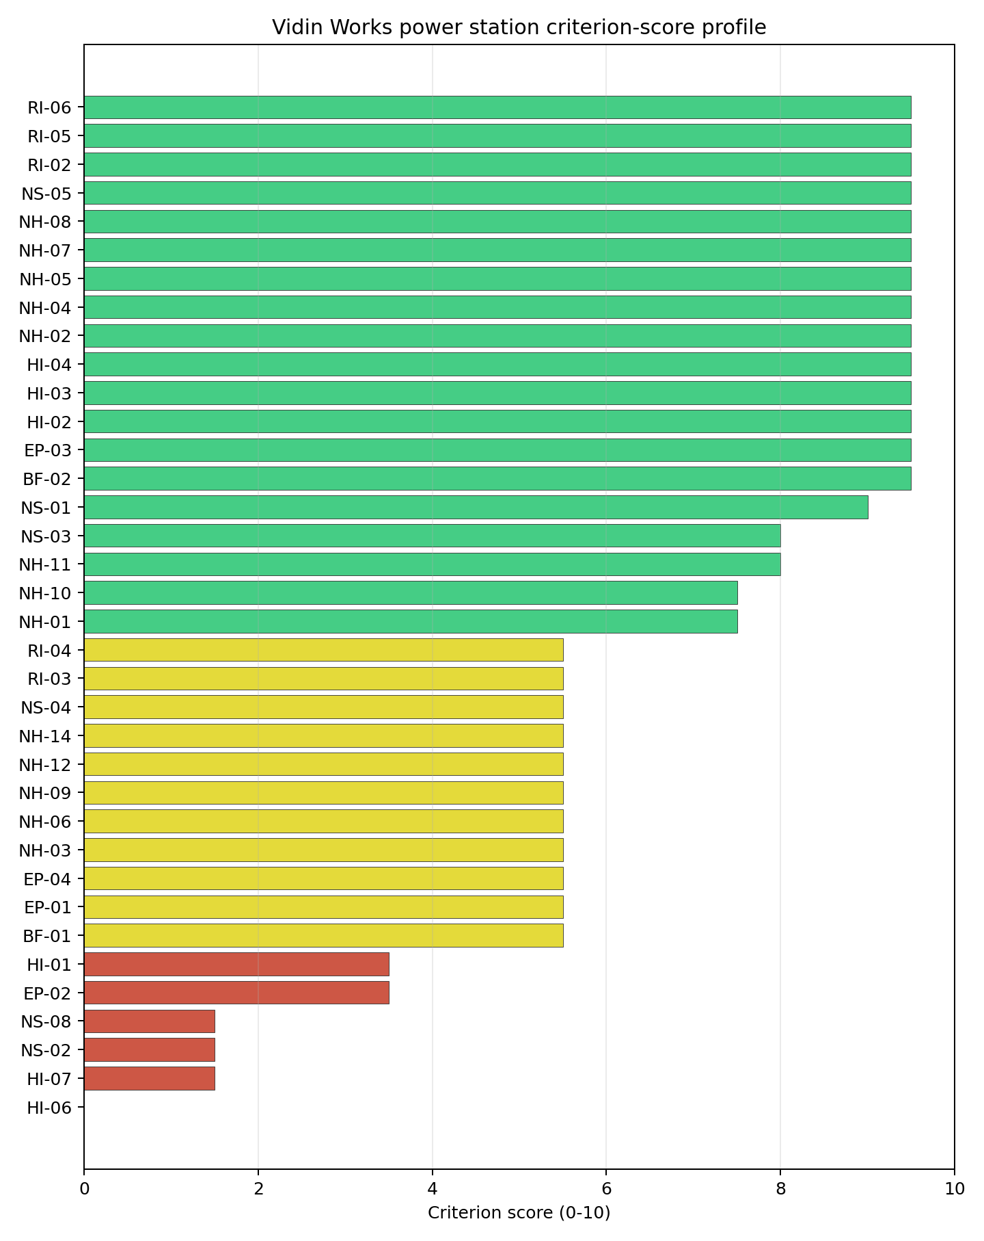
Criterion scores
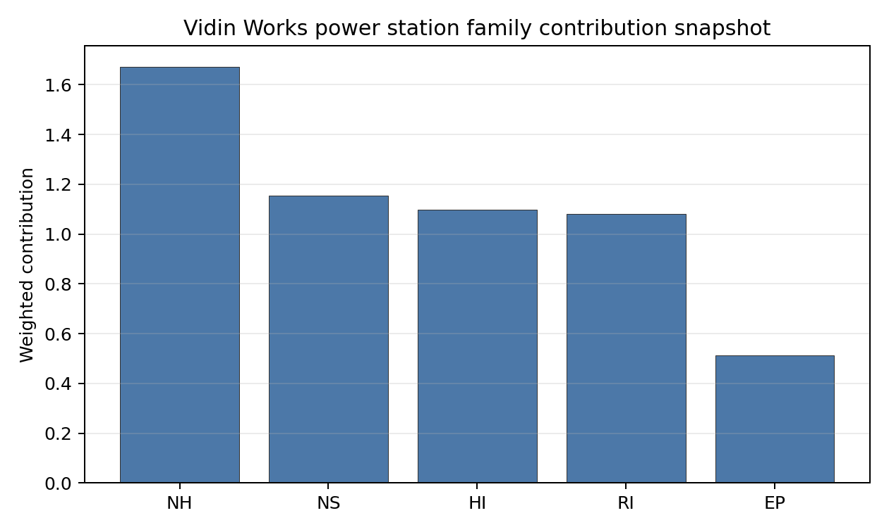
Family contributions
Vidin Works records a baseline composite score of 6.828, with a Monte Carlo bracket of 6.093-7.369. It ranks fourth nationally, sits in stability band H, and records a 0% top-10 hit rate with only an 8.33% top-30 hit rate. The site is therefore a conditional option rather than a robust national lead. The family profile is lifted by Radiological Impact at 7.64 and Natural Hazards at 7.36, but Human-Induced Hazards at 6.21 and Non-Safety Implementation at 6.53 are pulled down by HI-06, HI-07, NS-02 and NS-08. Vidin’s value lies in its low seismic demand, Danube cooling and transport access. Its Stage 3 priority is to test whether grid, defence and cross-border environmental questions can be resolved.

Residual Risk Register
Concern | Evidence | Consequence | Stage 3 action | Owner discipline
Military Installations (HI-06) | Nearest military feature 5.36 km away; nine features in radius | Defence constraints could determine whether the site remains usable | Engage defence authorities on feature classification and standoff | security
Grid Connection (NS-02) | Grid export capacity 120.0 MW; highest nearby line voltage 110.0 kV | Transmission reinforcement may dominate cost and schedule | Confirm upgrade path to a suitable transmission voltage | grid
Ecological Sensitivity (NS-08) | Ciuperceni - Desa is 1.33 km away; two Natura 2000 sites within 5 km | Cross-border environmental assessment could constrain layout or water works | Scope appropriate assessment with cross-border receptors | EIA
Population Density (RI-04) | 245.2 people/km2 within 5 km; 108,261 people within 25 km | EPZ planning may be sensitive to Vidin’s urban edge | Model source-term placement and evacuation timing | emergency planning
Electromagnetic Interference (HI-07) | Nearest transmitter 1.44 km away; 51 transmitters in radius | RF/EMI controls could affect safety and communications systems | Survey transmitter inventory and field strengths | security
Vidin’s risks are governance-heavy rather than purely physical. The site should remain in the shortlist only if grid and defence questions can be resolved early.

Stage 3 Follow-Up Checklist
- Resolve Aircraft Crash (HI-01) - Vidin Smurdan Airfield 8.69 km away.
- Confirm Grid Connection (NS-02) - 120.0 MW export capacity and 110.0 kV nearby line require upgrade review.
- Engage Military Installations (HI-06) - nearest feature 5.36 km away and nine features in radius.
- Survey Electromagnetic Interference (HI-07) - nearest transmitter 1.44 km away and 51 transmitters in radius.
- Screen Ecological Sensitivity (NS-08) - Ciuperceni - Desa 1.33 km away and two Natura 2000 sites within 5 km.
- Model River Flooding (NH-09) and EPZ response for the Danube-adjacent urban-edge setting.

Evidence Limitations
- Geotechnical: Subsidence & Collapse (NH-05b) - quality low.

Czechia Country Profile
Czechia is an established nuclear-power jurisdiction with a large coal and lignite brownfield estate. The screening result should therefore be read as a practical site-reuse and sequencing problem: the institutional setting is more mature than in a first-time nuclear country, but the candidate coal sites still need site-specific avoidance resolution before they can be treated as Stage 3 characterisation priorities.
Czechia has 29 thermal and coal-site records tested against the NuScale VOYGR-6 reference deployment envelope. No site currently clears both the exclusionary and avoidance screens; all 29 exclusionary-pass sites retain at least one avoidance flag, and no site hard-fails the exclusionary screen. The country is therefore an unlock-led brownfield pool rather than a full-pass leadership case.
The leading site is Tusimice power station, with a composite score of 7.095 and a Monte Carlo interval of 6.144-7.691. Its national stability band is A, with a national top-10% hit rate of 92%. The point-estimate lead is narrow, but Tusimice is the only band-A site in the Czechia pool, so it is the strongest starting point for targeted avoidance-resolution work.
Selected sites for full treatment are the top five by national ranking: Tusimice power station, Prunerov power station, Chvaletice power station, Pocerady power station, and Ledvice power station.

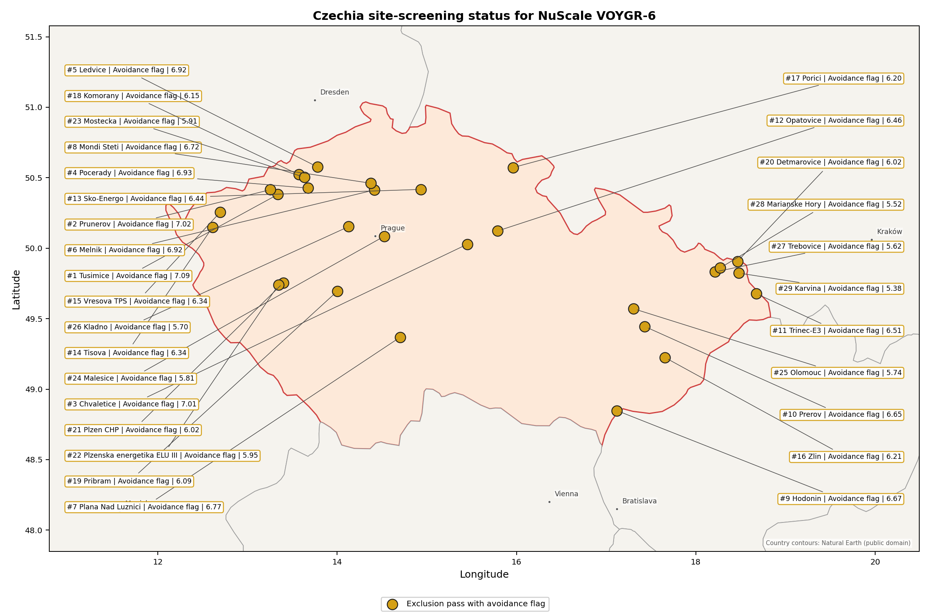
Czechia status map

Czechia Site Ledger
Rank | Site | Status | Composite | MC Low | MC High | Band | Top-10 Hit | Coverage
1 | Tusimice power station | Exclusion pass with avoidance flag | 7.095 | 6.144 | 7.691 | A | 92% | 74%
2 | Prunerov power station | Exclusion pass with avoidance flag | 7.016 | 6.083 | 7.559 | C | 67% | 74%
3 | Chvaletice power station | Exclusion pass with avoidance flag | 7.009 | 6.240 | 7.594 | D | 33% | 76%
4 | Pocerady power station | Exclusion pass with avoidance flag | 6.931 | 6.018 | 7.526 | D | 0% | 74%
5 | Ledvice power station | Exclusion pass with avoidance flag | 6.916 | 6.164 | 7.512 | D | 0% | 76%
6 | Melnik power station | Exclusion pass with avoidance flag | 6.916 | 6.164 | 7.531 | D | 8% | 76%
7 | Plana Nad Luznici power station | Exclusion pass with avoidance flag | 6.773 | 5.896 | 7.309 | D | 0% | 74%
8 | Mondi Steti power station | Exclusion pass with avoidance flag | 6.716 | 6.003 | 7.331 | D | 0% | 76%
9 | Hodonin power station | Exclusion pass with avoidance flag | 6.672 | 5.967 | 7.181 | H | 0% | 76%
10 | Prerov power station | Exclusion pass with avoidance flag | 6.648 | 5.801 | 7.145 | H | 0% | 74%
11 | Trinec-E3 power station | Exclusion pass with avoidance flag | 6.510 | 5.694 | 7.046 | H | 0% | 74%
12 | Opatovice power station | Exclusion pass with avoidance flag | 6.464 | 5.659 | 7.059 | H | 0% | 74%
13 | Sko-Energo power station | Exclusion pass with avoidance flag | 6.438 | 5.639 | 6.980 | H | 0% | 74%
14 | Tisova power station | Exclusion pass with avoidance flag | 6.345 | 5.568 | 6.888 | H | 0% | 74%
15 | Vresova TPS power station | Exclusion pass with avoidance flag | 6.339 | 5.563 | 6.954 | H | 0% | 74%
16 | Zlin power station | Exclusion pass with avoidance flag | 6.214 | 5.467 | 6.730 | H | 0% | 74%
17 | Porici power station | Exclusion pass with avoidance flag | 6.201 | 5.457 | 6.724 | H | 0% | 74%
18 | Komorany power station | Exclusion pass with avoidance flag | 6.153 | 5.548 | 6.700 | H | 0% | 76%
19 | Pribram power station | Exclusion pass with avoidance flag | 6.089 | 5.371 | 6.572 | H | 0% | 74%
20 | Detmarovice power station | Exclusion pass with avoidance flag | 6.016 | 5.437 | 6.506 | H | 0% | 76%
21 | Plzen CHP power station | Exclusion pass with avoidance flag | 6.016 | 5.316 | 6.533 | H | 0% | 74%
22 | Plzenska energetika ELU III power station | Exclusion pass with avoidance flag | 5.951 | 5.265 | 6.414 | H | 0% | 74%
23 | Mostecka Power Station | Exclusion pass with avoidance flag | 5.911 | 5.235 | 6.487 | H | 0% | 74%
24 | Malesice power station | Exclusion pass with avoidance flag | 5.809 | 5.270 | 6.344 | H | 0% | 76%
25 | Olomouc power station | Exclusion pass with avoidance flag | 5.740 | 5.104 | 6.257 | H | 0% | 74%
26 | Kladno power station | Exclusion pass with avoidance flag | 5.703 | 5.184 | 6.319 | H | 0% | 76%
27 | Trebovice power station | Exclusion pass with avoidance flag | 5.622 | 5.013 | 6.066 | H | 0% | 74%
28 | Marianske Hory power station | Exclusion pass with avoidance flag | 5.516 | 4.932 | 5.961 | H | 0% | 74%
29 | Karvina power station | Exclusion pass with avoidance flag | 5.378 | 4.922 | 5.900 | H | 0% | 76%

Avoidance Flag Pareto
Of the 29 sites that pass the exclusionary screen, the avoidance-phase flags are concentrated in four criteria. Resolving these criteria is the national unlock agenda for Czechia and applies across the site pool.
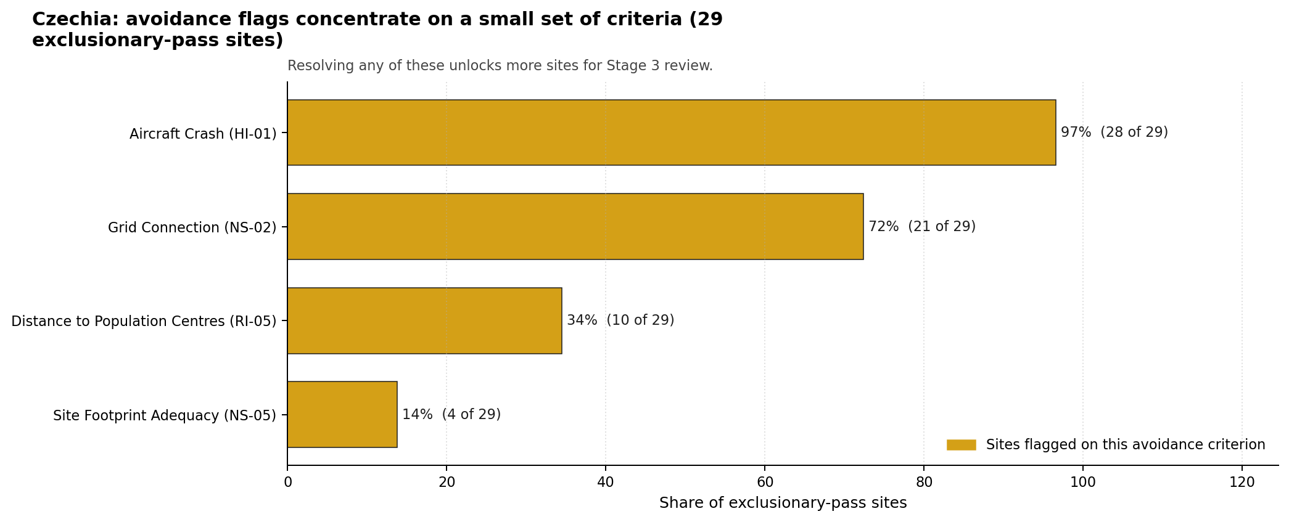
Avoidance flag Pareto
- Aircraft Crash (HI-01) - 28 of 29 exclusionary-pass sites (97%) - this criterion controls how much of the national brownfield pool can move beyond avoidance review.
- Grid Connection (NS-02) - 21 of 29 exclusionary-pass sites (72%) - this criterion controls how much of the national brownfield pool can move beyond avoidance review.
- Distance to Population Centres (RI-05) - 10 of 29 exclusionary-pass sites (34%) - this criterion controls how much of the national brownfield pool can move beyond avoidance review.
- Site Footprint Adequacy (NS-05) - 4 of 29 exclusionary-pass sites (14%) - this criterion controls how much of the national brownfield pool can move beyond avoidance review.

Family Strength and Weakness
Across the country the strongest criterion family is Natural Hazards at a mean normalised score of 6.99/10. The weakest family is Radiological Impact at 5.29/10. The bottom three individual criteria across the country are:
- Military Installations (HI-06) - mean 0.36/10 across 29 scored sites (min 0.0, max 1.5).
- Electromagnetic Interference (HI-07) - mean 1.50/10 across 29 scored sites (min 1.5, max 1.5).
- Population Density at EPZ Radii (RI-04) - mean 2.60/10 across 29 scored sites (min 1.5, max 5.5).

National Sensitivity and Robustness
The national sensitivity analysis separates Tusimice from the rest of the pool more clearly by stability than by point score. The national band distribution is 1 site in band A, 1 in band C, 6 in band D, and 21 in band H. Prunerov records a 67% top-10% hit rate in band C, while Chvaletice records 33% in band D; Pocerady and Ledvice sit in band D with no national top-10 persistence.
The Monte Carlo intervals for the top five overlap materially. That overlap argues against treating the exact rank order from second to fifth as a final preference order. The practical distinction is that Tusimice combines the lead score with band-A persistence, while the next four sites form a close technical tier whose Stage 3 order depends on resolving aircraft, grid, population-distance, land and ecological constraints.

Interpretation for Site Selection
Czechia’s Stage 3 pathway is a controlled avoidance-resolution programme. It begins with the top-ranked sites because they combine the strongest composite scores with the best national sensitivity evidence, while every selected site still carries at least one avoidance flag.

Avoidance flag Pareto - what unlocks more sites
Aircraft Crash (HI-01) is the dominant national blocker, affecting nearly the whole exclusionary-pass pool. Grid Connection (NS-02) is the second national lever, and Distance to Population Centres (RI-05) and Site Footprint Adequacy (NS-05) define the narrower siting-envelope questions. A credible sequence starts with Tusimice, then tests Prunerov and Chvaletice as the strongest follow-on cases, with Pocerady and Ledvice retained because their composite scores remain close to the leaders despite weaker national top-tier persistence.

Status Counts
- Full pass: 0
- Exclusion pass with avoidance flag: 29
- Hard fail: 0

Chvaletice power station Site Profile
Chvaletice power station is a coal/thermal site in Czechia that has been tested against the NuScale VOYGR-6 reference deployment envelope. This profile reads the screening evidence at a level that supports a decision to progress toward Stage 3 characterisation. It supports Stage 1-2 screening and defines the evidence needed before any Stage 3 judgement.

Site Snapshot
Field | Value
Site name | Chvaletice power station
Coordinates | 50.0281, 15.4505
Subnational unit | Pardubický
Installed thermal capacity (source data) | 820 MW
Available surface area | 93.9 ha
Available surface area for development | 93.9 ha
Composite score (baseline weights) | 7.009 (6.240-7.594 MC band)
National stability band | D (top-10% hit rate 33%)
National rank | 3
See the country status map in Czechia Country Profile.

Ownership and Coal-to-Nuclear Context
- natural person(s) (100.00% share); immediate operator Sev.en Energy AG. Path: natural person(s) -> Sev.en Energy AG [100.0%] -> Chvaletice power station Unit 1 [100.0%]
- Sev.en Energy AG (100.00% share), headquartered in Liechtenstein; immediate operator Sev.en Energy AG. Path: Sev.en Energy AG -> Chvaletice power station Unit 2 [100.0%]
Generating units on record: 4 operating. Earliest unit commissioning: 1977; most recent: 1978.

Natural Hazards (NH)
- Seismic: Ground Motion (NH-01) - score 9.5/10 (MC 9.0-10.0); favourable: Well below the risk boundary., weight 0.0455, data quality high. Evidence: PGA at 475-year return period 0.015 g; PGA at 2,475-year return period 0.034 g; Vs30 reference (m/s): 760.0.
- Seismic: Surface Rupture (NH-02) - score 9.5/10 (MC 9.0-10.0); favourable: Very strong separation from mapped capable faults; surface-rupture concern effectively screened at desk-study level., weight n/a, data quality screening grade. Evidence: nearest mapped capable fault 50.0 km; fault slip rate 0 mm/yr; fault name: none_in_search_radius.
- Geotechnical: Liquefaction (NH-03) - score 9.5/10 (MC 9.0-10.0); favourable: Negligible susceptibility (Stage-1 favourable default)., weight n/a, data quality medium. Evidence: liquefaction susceptibility: very_low.
- Geotechnical: Slope Stability (NH-04) - score 9.5/10 (MC 9.0-10.0); favourable: Well below the risk boundary., weight n/a, data quality screening grade. Evidence: site slope 4.76 deg; max slope in 1 km box 24.6 deg; slope stability class: gentle.
- Geotechnical: Subsidence (NH-05) - score 1.5/10 (MC 1.0-2.0), weight 0.0354, data quality medium. Evidence: karst present: no; karst severity: moderate; formation type: carbonate (Discontinuous carbonate rocks).
- Geotechnical: Foundation (NH-06) - score 3.5/10 (MC 3.0-4.0), weight 0.0253, data quality medium. Evidence: depth to bedrock 27.9 m.
- Volcanism (NH-07) - score 9.5/10 (MC 9.0-10.0); favourable: Very strong margin above the score-5 boundary, with no in-radius signal in the screening evidence., weight n/a, data quality high. Evidence: volcanic hazard class: negligible.
- Coastal Flooding (NH-08) - score 9.5/10 (MC 9.0-10.0); favourable: Non-coastal OR elevation >= 50 m AMSL OR landlocked country, with no positive marine-hazard signal., weight 0.0303, data quality medium. Evidence: distance to coast 406.2 km.
- River Flooding (NH-09) - score 7.5/10 (MC 5.5-9.5), weight 0.0404, data quality insufficient. Evidence: flood zone class: negligible.
- Extreme Winds (NH-10) - score 5.5/10 (MC 5.0-6.0); pass-mark band: Middle relative wind exposure around the observed cohort mean (9.0-10.5 m/s)., weight 0.0152, data quality medium. Evidence: screening wind-speed index 9.77 m/s.
- Extreme Precipitation (NH-11) - score 8.0/10 (MC 8.0-9.0); favourable: aggregated(mean_of_sub_scores), weight 0.0152, data quality medium. Evidence: screening extreme-precipitation index 0.21 mm; screening precipitation index 25.4 mm/yr.
- Extreme Temperatures (NH-12) - score 7.5/10 (MC 7.0-8.0), weight 0.0202, data quality medium. Evidence: extreme high temperature 22.9 deg C; extreme low temperature -4.65 deg C.
- Combined Hazards (NH-14) - score 7.5/10 (MC 7.0-8.0), weight 0.0152, data quality n/a. Evidence: values not in measurement tables.

Interpretation - Natural Hazards (NH)
Natural hazards are generally supportive at this screening stage. Ground-motion evidence is low, with PGA of 0.015 g at the 475-year return period and 0.034 g at the 2,475-year return period; the nearest mapped capable fault is 50.0 km away. Flooding and coastal exposure are not the leading constraints: the flood-zone class is negligible and the site is 406.2 km from the coast. Stage 3 should focus on Geotechnical: Subsidence (NH-05), Geotechnical: Foundation (NH-06), Extreme Winds (NH-10), with particular attention to screening wind speed, mine or foundation evidence, and local hydrology where the bundle marks data quality below final-design standard.

Human-Induced and Security-Relevant Hazards (HI)
- Aircraft Crash (HI-01) - score 3.5/10 (MC 3.0-4.0), weight 0.0354, data quality high. Evidence: nearest airport 5.05 km; nearest flight path 2.53 km; airports within search radius 18; airport name: Škudly Airstrip; airport type: small airfield.
- Industrial Explosions (HI-02) - score 9.5/10 (MC 9.0-10.0); favourable: Very strong margin above the score-5 boundary, with no in-radius signal in the screening evidence., weight 0.0354, data quality medium. Evidence: values not in measurement tables.
- Toxic/Gas Releases (HI-03) - score 9.5/10 (MC 9.0-10.0); favourable: Very strong margin above the score-5 boundary, with no in-radius signal in the screening evidence., weight 0.0354, data quality medium. Evidence: values not in measurement tables.
- External Fires (HI-04) - score 9.5/10 (MC 9.0-10.0); favourable: > 15 km, with no flammable-storage signal in the screening radius., weight 0.0303, data quality medium. Evidence: values not in measurement tables.
- Military Installations (HI-06) - score 1.5/10 (MC 1.0-2.0), weight 0.0303, data quality medium. Evidence: nearest military installation 8.8 km; military installations within radius 174; installation name: ÚŽ-6a Mokošín.
- Electromagnetic Interference (HI-07) - score 1.5/10 (MC 1.0-2.0), weight 0.0101, data quality medium. Evidence: nearest high-power transmitter 0.86 km; transmitters within radius 384; transmitter type: communication.

Interpretation - Human-Induced and Security-Relevant Hazards (HI)
Human-induced hazards are the binding avoidance issue for this site. Aircraft Crash (HI-01) is flagged because the nearest recorded airport or heliport is 5.05 km away and the nearest flight-path proxy is 2.53 km away. The security file is also material: the nearest high-consequence military feature is 8.80 km away, and the nearest high-power transmitter is 0.86 km away. Industrial explosion, toxic-release and external-fire scores are favourable in the current screening record, so Stage 3 should prioritise aviation, security and RF/EMI confirmation before broader industrial-neighbour work.

Radiological Impact and Emergency Planning (RI / EP)
- Emergency Planning Feasibility (EP-01) - score 7.5/10 (MC 7.0-8.0), weight n/a, data quality high. Evidence: EP feasibility composite 79.8 /100; road sub-score 76.0 /100; special-population sub-score 90.0 /100; geography sub-score 95.0 /100; population sub-score 95.0 /100; evacuation feasible: yes.
- Evacuation Routes (EP-02) - score 7.5/10 (MC 7.0-8.0), weight 0.0303, data quality medium. Evidence: road density in EPZ 1.038 km/km2; road length in EPZ 2,039 km; motorway access: yes.
- Physical Geography Constraints (EP-03) - score 9.5/10 (MC 9.0-10.0); favourable: No measured relief; open river/waterway context (interim screening)., weight 0.0253, data quality medium. Evidence: waterways crossing EPZ 0; major river barrier: no.
- Special Populations (EP-04) - score 3.5/10 (MC 3.0-4.0), weight 0.0303, data quality medium. Evidence: hospitals in EPZ 28; prisons in EPZ 1; care homes in EPZ 1.
- Atmospheric Dispersion (RI-01) - score no native score (unscored; no band matched), weight 0.0303, data quality medium. Evidence: annual mean wind speed 1.27 m/s; atmospheric mixing height 560.0 m; prevailing wind direction: WSW.
- Surface Water Dispersion (RI-02) - score 5.5/10 (MC 5.0-6.0); pass-mark band: 30-100 m3/s., weight 0.0253, data quality n/a. Evidence: values not in measurement tables.
- Groundwater Dispersion (RI-03) - score 5.5/10 (MC 5.0-6.0); pass-mark band: Moderate-permeability aquifer screening proxy., weight 0.0253, data quality medium. Evidence: aquifer type: hard rocks.
- Population Density at EPZ Radii (RI-04) - score 3.5/10 (MC 3.0-4.0), weight 0.0404, data quality screening grade. Evidence: population density within 5 km 89.1 /km2; population density within 16 km 113.3 /km2; population density within 25 km 146.0 /km2; population density within 80 km 175.6 /km2; population within 25 km 286,669 people.
- Distance to Population Centres (RI-05) - score 9.5/10 (MC 9.0-10.0); favourable: Nearest >=50k population-centre proxy exceeds required distance by >= 50 %., weight 0.0505, data quality screening grade. Evidence: nearest city above 50k people 22.4 km; nearest city population 88,520 people; city name: Pardubice.
- Population Projections (RI-06) - score 7.5/10 (MC 7.0-8.0), weight 0.0253, data quality screening grade. Evidence: annual population growth rate -0.065 %/yr; projected population at 25 km in 60 yr 276,242 people.

Interpretation - Radiological Impact and Emergency Planning (RI / EP)
Radiological impact and emergency-planning evidence supports continued screening, but the population and liquid-pathway questions need refinement. Emergency Planning Feasibility (EP-01) is marked feasible with a composite score of 79.8 /100; road density in the emergency-planning zone is 1.038 km/km2 and motorway access is recorded. The 25 km population is 286,669, with density of 146.0 people/km2; the nearest city above 50,000 people is Pardubice at 22.4 km. Stage 3 should model EPZ clearance, special-population handling, atmospheric dispersion and low-flow water pathways before the emergency-planning case is hardened.

Non-Safety and Implementation Considerations (NS)
- Grid Capacity Basic Filter (BF-01) - score 9.5/10 (MC 9.0-10.0); favourable: Note: substation <= 5 km, >= 400 kV, headroom >= 600 MW., weight n/a, data quality n/a. Evidence: values not in measurement tables.
- Land Area Basic Filter (BF-02) - score 9.5/10 (MC 9.0-10.0); favourable: Contiguous and buildable >= ideal area (70 ha/module)., weight 0.0253, data quality n/a. Evidence: values not in measurement tables.
- Cooling Water Availability (NS-01) - score 8.0/10 (MC 7.0-8.0); favourable: aggregated(weighted_mean_of_sub_scores), weight 0.0404, data quality screening grade. Evidence: distance to cooling source 2.21 km; cooling source flow 52.5 m3/s; cooling source type: river; cooling source name: Morašický potok; water stress label: Low.
- Grid Connection (NS-02) - score 9.5/10 (MC 9.0-10.0); favourable: aggregated(min_of_sub_scores), weight 0.0404, data quality high. Evidence: nearest substation 0.24 km; nearest high-voltage line 0.3 km; highest nearby line voltage 400.0 kV; grid export capacity 1,650 MW; substations within radius 1,039; HV lines within radius 666.
- Transport Access (NS-03) - score 9.0/10 (MC 9.0-10.0); favourable: aggregated(weighted_mean_of_sub_scores), weight 0.0404, data quality high. Evidence: nearest highway 1.68 km; nearest rail line 0.01 km; nearest waterway 3.65 km; heavy-haul capable: yes.
- Site Topography (NS-04) - score 5.5/10 (MC 5.0-6.0); pass-mark band: 40-60 %., weight 0.0303, data quality screening grade. Evidence: favourable land cover 55.3 %; moderate land cover 12.5 %; unfavourable land cover 19.2 %; favourable area 110.3 ha; dominant land class: 211.
- Site Footprint Adequacy (NS-05) - score 9.5/10 (MC 9.0-10.0); favourable: Very strong margin above the score-5 boundary., weight 0.0253, data quality medium. Evidence: buildable area 93.9 ha; largest contiguous patch 93.9 ha; buildable patch count 12.
- Existing Infrastructure (NS-06) - score no native score (unscored; no band matched), weight 0.0253, data quality n/a. Evidence: not measured at this site (criterion remains unscored).
- Ecological Sensitivity (NS-08) - score 1.5/10 (MC 1.0-2.0), weight n/a, data quality high. Evidence: natural land cover 19.2 %; distance to nearest Natura 2000 site 1.913 km; distance to nearest protected area 4.001 km; Natura 2000 overlap: no; Natura 2000 sensitivity class: moderate; protected-area overlap: no; protected-area sensitivity class: moderate; nearest Natura 2000 site: Louky u Přelouče; Natura 2000 sites within 5 km: 3; nearest protected-area designation: Nature Reserve.
- Workforce Availability (NS-10) - score no native score (unscored; no band matched), weight 0.0202, data quality n/a. Evidence: not measured at this site (criterion remains unscored).
- Regulatory/Political Environment (NS-12) - score no native score (unscored; no band matched), weight 0.0303, data quality n/a. Evidence: not measured at this site (criterion remains unscored).
- Construction Logistics (NS-13) - score no native score (unscored; no band matched), weight 0.0202, data quality n/a. Evidence: not measured at this site (criterion remains unscored).

Interpretation - Non-Safety and Implementation Considerations (NS)
Non-safety implementation conditions are the main reason the selected Czech sites remain credible despite avoidance flags. Cooling evidence identifies Morašický potok as the nearest source, 2.21 km away, with flow of 52.5 m3/s and a Low water-stress label. Grid proximity is strong where measured: the nearest substation is 0.24 km away, the nearest high-voltage line is 0.30 km away, and the inherited export-capacity estimate is 1650 MW. The canonical site surface area is 93.9 ha; the wider screening-stage favourable-area envelope is 110.3 ha and should be treated as potential laydown or expansion context, not development-ready land. Ecological screening and unscored transport or implementation criteria remain normal Stage 3 follow-up items.

Composite Score and Stability
Baseline composite score is 7.009, bracketed by Monte Carlo at 6.240-7.594. National stability band is D with a top-10% hit rate of 33% in the project’s 50,000-iteration national sensitivity analysis.
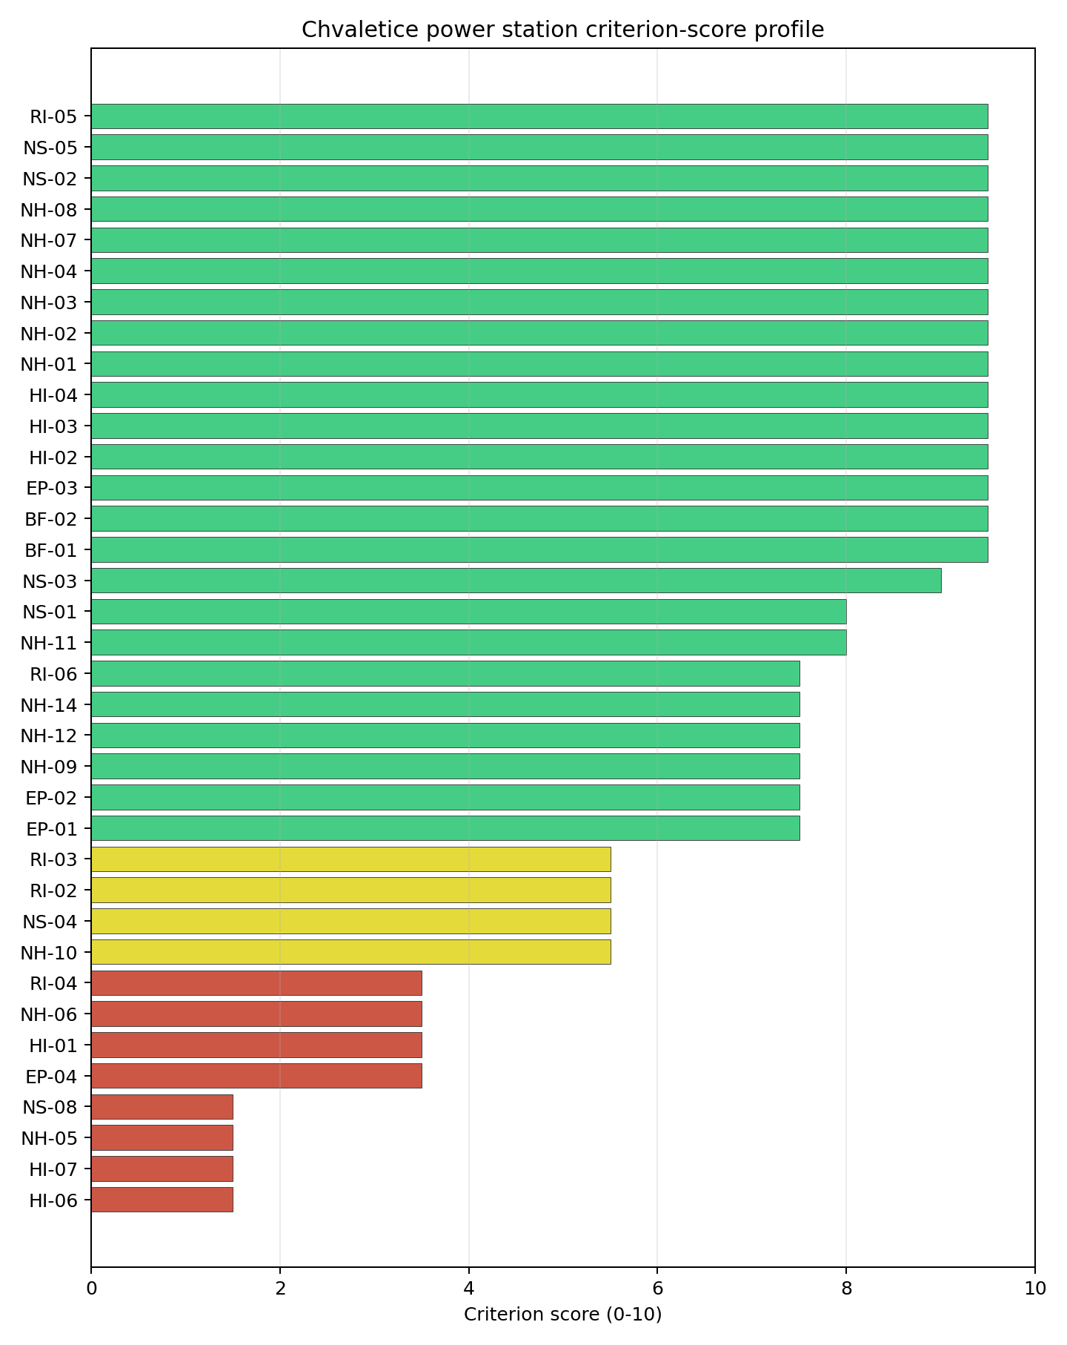
Criterion scores
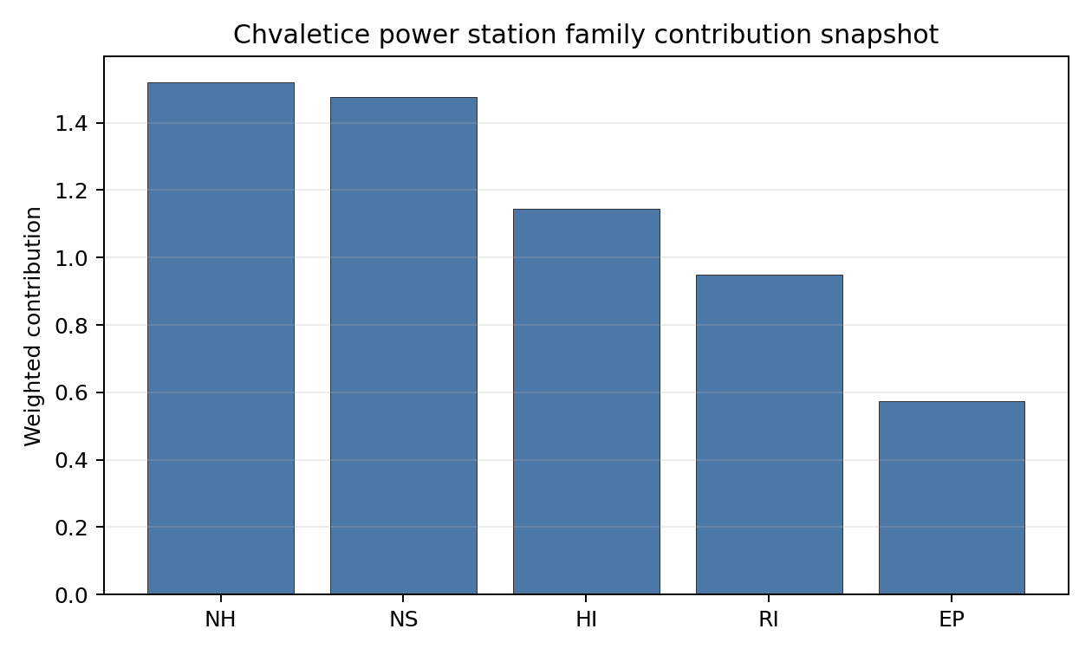
Family contributions
The site records a baseline composite score of 7.009, with a Monte Carlo bracket of 6.240-7.594. Its national stability band is D, with a national top-10% hit rate of 33%. This places the site at national rank 3 in the frozen ranking, but the overlapping top-five intervals mean the rank should guide sequencing rather than settle final preference. Family scores after the unscored-criterion treatment are EP 6.68, HI 6.47, NH 6.69, NS 8.36, RI 6.71; the Stage 3 priority is therefore to retire the avoidance flags and low-scoring criteria that could change the site boundary or emergency-planning case.

Residual Risk Register
Concern | Evidence | Consequence | Stage 3 action | Owner discipline
Aircraft crash avoidance flag | Nearest airport 5.05 km; nearest flight-path proxy 2.53 km | May constrain the usable nuclear island envelope or require detailed aviation-route demonstration. | Run airport, heliport and flight-path micro-siting review against the NuScale reference envelope. | aviation / safety
Military and security proximity | Nearest high-consequence military feature 8.80 km; military features in search radius 174 | Security standoff and emergency-zone coordination could reshape the candidate area. | Confirm feature classification, activity status, and required protective separation with national authorities. | security
Electromagnetic interference | Nearest high-power transmitter 0.86 km; transmitter count 384 | RF/EMI controls may affect instrumentation, communications and site layout. | Survey transmitter inventory, field strength and shielding or separation needs. | electrical / security
Ecological sensitivity | Nearest Natura 2000 site 1.91 km; nearest protected area 4.00 km | Permitting envelope may narrow even without a direct protected-area overlap. | Run protected-area boundary confirmation, receptor-pathway screening and EIA scoping. | environment
Subsidence and foundation setting | Bearing capacity N/A; depth to bedrock 27.9 m | Former mining and foundation uncertainty could affect nuclear-island layout. | Run geotechnical and mining-void confirmation before fixing the site boundary. | geotechnical
The register defines follow-up work for Stage 3. Approval, licensing readiness and procurement decisions require later evidence beyond this screening profile.

Stage 3 Follow-Up Checklist
Action | Evidence basis | Purpose
Run airport, heliport and flight-path micro-siting review against the NuScale reference envelope. | Aircraft crash avoidance flag: Nearest airport 5.05 km; nearest flight-path proxy 2.53 km | Reduce the main residual uncertainty before detailed site characterisation.
Confirm feature classification, activity status, and required protective separation with national authorities. | Military and security proximity: Nearest high-consequence military feature 8.80 km; military features in search radius 174 | Reduce the main residual uncertainty before detailed site characterisation.
Survey transmitter inventory, field strength and shielding or separation needs. | Electromagnetic interference: Nearest high-power transmitter 0.86 km; transmitter count 384 | Reduce the main residual uncertainty before detailed site characterisation.
Run protected-area boundary confirmation, receptor-pathway screening and EIA scoping. | Ecological sensitivity: Nearest Natura 2000 site 1.91 km; nearest protected area 4.00 km | Reduce the main residual uncertainty before detailed site characterisation.
Run geotechnical and mining-void confirmation before fixing the site boundary. | Subsidence and foundation setting: Bearing capacity N/A; depth to bedrock 27.9 m | Reduce the main residual uncertainty before detailed site characterisation.
Close unscored or low-confidence evidence gaps. | Grid Capacity Basic Filter (BF-01), Land Area Basic Filter (BF-02), Seismic: Surface Rupture (NH-02), Geotechnical: Slope Stability (NH-04). | Improve confidence in the composite score and implementation work plan.

Evidence Limitations
- Grid Capacity Basic Filter (BF-01) - evidence quality low.
- Land Area Basic Filter (BF-02) - evidence quality low.
- Seismic: Surface Rupture (NH-02) - evidence quality low.
- Geotechnical: Slope Stability (NH-04) - evidence quality low.
- Extreme Precipitation (NH-11) - evidence quality low.
- Combined Hazards (NH-14) - evidence quality low.
- Cooling Water Availability (NS-01) - evidence quality low.
- Site Topography (NS-04) - evidence quality low.
- Existing Infrastructure (NS-06) - evidence quality unscored.
- Workforce Availability (NS-10) - evidence quality unscored.

Ledvice power station Site Profile
Ledvice power station is a coal/thermal site in Czechia that has been tested against the NuScale VOYGR-6 reference deployment envelope. This profile reads the screening evidence at a level that supports a decision to progress toward Stage 3 characterisation. It supports Stage 1-2 screening and defines the evidence needed before any Stage 3 judgement.

Site Snapshot
Field | Value
Site name | Ledvice power station
Coordinates | 50.5766, 13.7798
Subnational unit | Ústí nad Labem
Installed thermal capacity (source data) | 990 MW
Available surface area | 65.0 ha
Available surface area for development | 116.8 ha
Composite score (baseline weights) | 6.916 (6.164-7.512 MC band)
National stability band | D (top-10% hit rate 0%)
National rank | 5
See the country status map in Czechia Country Profile.

Ownership and Coal-to-Nuclear Context
- Government of Czech Republic (69.80% share), headquartered in Czech Republic; immediate operator CEZ AS. Path: Government of Czech Republic -> Ministry of Finance (Czech Republic) [100.0%] -> CEZ AS [69.8%] -> Ledvice power station Unit 6 [100.0%]
- natural person(s) (13.00% share); immediate operator CEZ AS. Path: natural person(s) -> CEZ AS [13.0%] -> Ledvice power station Unit 2 [100.0%]
- small shareholder(s) (17.00% share); immediate operator CEZ AS. Path: small shareholder(s) -> CEZ AS [17.0%] -> Ledvice power station Unit 2 [100.0%]
- CEZ AS (100.00% share), headquartered in Czech Republic; immediate operator CEZ AS. Path: CEZ AS -> Ledvice power station Unit 6 [100.0%]
- Ministry of Finance (Czech Republic) (69.80% share), headquartered in Czech Republic; immediate operator CEZ AS. Path: Ministry of Finance (Czech Republic) -> CEZ AS [69.8%] -> Ledvice power station Unit 6 [100.0%]
Generating units on record: 2 operating, 2 retired. Earliest unit commissioning: 1969; most recent: 2020. Retirements span 2020 to 2020, leaving brownfield grid, water, transport, and workforce assets that materially shorten Stage 3 site preparation.

Natural Hazards (NH)
- Seismic: Ground Motion (NH-01) - score 9.5/10 (MC 9.0-10.0); favourable: Well below the risk boundary., weight 0.0455, data quality high. Evidence: PGA at 475-year return period 0.016 g; PGA at 2,475-year return period 0.033 g; Vs30 reference (m/s): 760.0.
- Seismic: Surface Rupture (NH-02) - score 9.5/10 (MC 9.0-10.0); favourable: Very strong separation from mapped capable faults; surface-rupture concern effectively screened at desk-study level., weight n/a, data quality screening grade. Evidence: nearest mapped capable fault 50.0 km; fault slip rate 0 mm/yr; fault name: none_in_search_radius.
- Geotechnical: Liquefaction (NH-03) - score 5.5/10 (MC 5.0-6.0); pass-mark band: Moderate susceptibility, or high/very-high susceptibility with mitigation requiring confirmation., weight n/a, data quality medium. Evidence: liquefaction susceptibility: high; dominant soil type: loam.
- Geotechnical: Slope Stability (NH-04) - score no native score (unscored; no band matched), weight n/a, data quality screening grade. Evidence: not measured at this site (criterion remains unscored).
- Geotechnical: Subsidence (NH-05) - score 5.5/10 (MC 5.0-6.0); pass-mark band: At or above the mine-distance score-5 pivot; review possible., weight 0.0354, data quality medium. Evidence: karst present: no; karst severity: none.
- Geotechnical: Foundation (NH-06) - score 5.5/10 (MC 5.0-6.0); pass-mark band: Typical European mixed conditions (bearing 80-150 kPa)., weight 0.0253, data quality medium. Evidence: bearing capacity 85.3 kPa; depth to bedrock 33.8 m.
- Volcanism (NH-07) - score 9.5/10 (MC 9.0-10.0); favourable: Very strong margin above the score-5 boundary, with no in-radius signal in the screening evidence., weight n/a, data quality high. Evidence: volcanic hazard class: negligible.
- Coastal Flooding (NH-08) - score 9.5/10 (MC 9.0-10.0); favourable: Non-coastal OR elevation >= 50 m AMSL OR landlocked country, with no positive marine-hazard signal., weight 0.0303, data quality medium. Evidence: distance to coast 345.2 km.
- River Flooding (NH-09) - score 7.5/10 (MC 5.5-9.5), weight 0.0404, data quality insufficient. Evidence: flood zone class: negligible.
- Extreme Winds (NH-10) - score 3.5/10 (MC 3.0-4.0), weight 0.0152, data quality medium. Evidence: screening wind-speed index 10.7 m/s.
- Extreme Precipitation (NH-11) - score 10.0/10 (MC 9.0-10.0); favourable: aggregated(mean_of_sub_scores), weight 0.0152, data quality medium. Evidence: screening extreme-precipitation index 0.15 mm; screening precipitation index 20.3 mm/yr.
- Extreme Temperatures (NH-12) - score 6.5/10 (MC 6.0-7.0); pass-mark band: aggregated(mean_of_sub_scores), weight 0.0202, data quality medium. Evidence: extreme high temperature 23.0 deg C; extreme low temperature -5.68 deg C.
- Combined Hazards (NH-14) - score 5.5/10 (MC 5.0-6.0); pass-mark band: At least 5 resolved, exactly one moderate hazard (3-5) or moderate interaction only., weight 0.0152, data quality n/a. Evidence: values not in measurement tables.

Interpretation - Natural Hazards (NH)
Natural hazards are generally supportive at this screening stage. Ground-motion evidence is low, with PGA of 0.016 g at the 475-year return period and 0.033 g at the 2,475-year return period; the nearest mapped capable fault is 50.0 km away. Flooding and coastal exposure are not the leading constraints: the flood-zone class is negligible and the site is 345.2 km from the coast. Stage 3 should focus on Geotechnical: Subsidence (NH-05), Geotechnical: Foundation (NH-06), Extreme Winds (NH-10), with particular attention to screening wind speed, mine or foundation evidence, and local hydrology where the bundle marks data quality below final-design standard.

Human-Induced and Security-Relevant Hazards (HI)
- Aircraft Crash (HI-01) - score 3.5/10 (MC 3.0-4.0), weight 0.0354, data quality high. Evidence: nearest airport 0.33 km; nearest flight path 0.33 km; airports within search radius 18; airport name: Lednice Power Station Heliport; airport type: heliport.
- Industrial Explosions (HI-02) - score 9.5/10 (MC 9.0-10.0); favourable: Very strong margin above the score-5 boundary, with no in-radius signal in the screening evidence., weight 0.0354, data quality medium. Evidence: values not in measurement tables.
- Toxic/Gas Releases (HI-03) - score 9.5/10 (MC 9.0-10.0); favourable: Very strong margin above the score-5 boundary, with no in-radius signal in the screening evidence., weight 0.0354, data quality medium. Evidence: values not in measurement tables.
- External Fires (HI-04) - score 9.5/10 (MC 9.0-10.0); favourable: > 15 km, with no flammable-storage signal in the screening radius., weight 0.0303, data quality medium. Evidence: values not in measurement tables.
- Military Installations (HI-06) - score 0.0/10 (MC 0.0-0.0), weight 0.0303, data quality high. Evidence: nearest military installation 1.35 km; military installations within radius 121; installation name: unnamed.
- Electromagnetic Interference (HI-07) - score 1.5/10 (MC 1.0-2.0), weight 0.0101, data quality medium. Evidence: nearest high-power transmitter 0.42 km; transmitters within radius 210; transmitter type: tower.

Interpretation - Human-Induced and Security-Relevant Hazards (HI)
Human-induced hazards are the binding avoidance issue for this site. Aircraft Crash (HI-01) is flagged because the nearest recorded airport or heliport is 0.33 km away and the nearest flight-path proxy is 0.33 km away. The security file is also material: the nearest high-consequence military feature is 1.35 km away, and the nearest high-power transmitter is 0.42 km away. Industrial explosion, toxic-release and external-fire scores are favourable in the current screening record, so Stage 3 should prioritise aviation, security and RF/EMI confirmation before broader industrial-neighbour work.

Radiological Impact and Emergency Planning (RI / EP)
- Emergency Planning Feasibility (EP-01) - score 5.5/10 (MC 5.0-6.0); pass-mark band: At or above the composite score-5 boundary., weight n/a, data quality high. Evidence: EP feasibility composite 64.1 /100; road sub-score 74.4 /100; special-population sub-score 90.0 /100; geography sub-score 95.0 /100; population sub-score 60.0 /100; evacuation feasible: yes.
- Evacuation Routes (EP-02) - score 5.5/10 (MC 5.0-6.0); pass-mark band: Adequate primary routes (0.5-1.0)., weight 0.0303, data quality medium. Evidence: road density in EPZ 0.975 km/km2; road length in EPZ 1,914 km; motorway access: yes.
- Physical Geography Constraints (EP-03) - score 9.5/10 (MC 9.0-10.0); favourable: No measured relief; open river/waterway context (interim screening)., weight 0.0253, data quality medium. Evidence: waterways crossing EPZ 0; major river barrier: no.
- Special Populations (EP-04) - score 3.5/10 (MC 3.0-4.0), weight 0.0303, data quality medium. Evidence: hospitals in EPZ 22; prisons in EPZ 2; care homes in EPZ 2.
- Atmospheric Dispersion (RI-01) - score no native score (unscored; no band matched), weight 0.0303, data quality medium. Evidence: annual mean wind speed 1.22 m/s; atmospheric mixing height 556.0 m; prevailing wind direction: W.
- Surface Water Dispersion (RI-02) - score 1.5/10 (MC 1.0-2.0), weight 0.0253, data quality n/a. Evidence: values not in measurement tables.
- Groundwater Dispersion (RI-03) - score 7.5/10 (MC 7.0-8.0), weight 0.0253, data quality medium. Evidence: aquifer type: low permeability.
- Population Density at EPZ Radii (RI-04) - score 3.5/10 (MC 3.0-4.0), weight 0.0404, data quality screening grade. Evidence: population density within 5 km 345.7 /km2; population density within 16 km 293.0 /km2; population density within 25 km 217.9 /km2; population density within 80 km 243.7 /km2; population within 25 km 427,866 people.
- Distance to Population Centres (RI-05) - score 9.5/10 (MC 9.0-10.0); favourable: Nearest >=50k population-centre proxy exceeds required distance by >= 50 %., weight 0.0505, data quality screening grade. Evidence: nearest city above 50k people 13.6 km; nearest city population 62,866 people; city name: Most.
- Population Projections (RI-06) - score 7.5/10 (MC 7.0-8.0), weight 0.0253, data quality screening grade. Evidence: annual population growth rate -0.155 %/yr; projected population at 25 km in 60 yr 412,310 people.

Interpretation - Radiological Impact and Emergency Planning (RI / EP)
Radiological impact and emergency-planning evidence supports continued screening, but the population and liquid-pathway questions need refinement. Emergency Planning Feasibility (EP-01) is marked feasible with a composite score of 64.1 /100; road density in the emergency-planning zone is 0.975 km/km2 and motorway access is recorded. The 25 km population is 427,866, with density of 217.9 people/km2; the nearest city above 50,000 people is Most at 13.6 km. Stage 3 should model EPZ clearance, special-population handling, atmospheric dispersion and low-flow water pathways before the emergency-planning case is hardened.

Non-Safety and Implementation Considerations (NS)
- Grid Capacity Basic Filter (BF-01) - score 5.5/10 (MC 5.0-6.0); pass-mark band: Note: substation 15-30 km OR 110-219 kV; reinforcement plausible., weight n/a, data quality n/a. Evidence: values not in measurement tables.
- Land Area Basic Filter (BF-02) - score 9.5/10 (MC 9.0-10.0); favourable: Contiguous and buildable >= ideal area (70 ha/module)., weight 0.0253, data quality n/a. Evidence: values not in measurement tables.
- Cooling Water Availability (NS-01) - score 7.0/10 (MC 7.0-8.0), weight 0.0404, data quality screening grade. Evidence: distance to cooling source 0.96 km; cooling source flow 3.93 m3/s; cooling source type: small_river; cooling source name: Bílina; water stress label: Low.
- Grid Connection (NS-02) - score 5.5/10 (MC 5.0-6.0); pass-mark band: aggregated(min_of_sub_scores), weight 0.0404, data quality high. Evidence: nearest substation 0.55 km; nearest high-voltage line 0.16 km; highest nearby line voltage 110.0 kV; grid export capacity 770.0 MW; substations within radius 1,538; HV lines within radius 1,476.
- Transport Access (NS-03) - score 9.0/10 (MC 9.0-10.0); favourable: aggregated(weighted_mean_of_sub_scores), weight 0.0404, data quality high. Evidence: nearest highway 0.52 km; nearest rail line 0.17 km; heavy-haul capable: yes.
- Site Topography (NS-04) - score 7.5/10 (MC 7.0-8.0), weight 0.0303, data quality screening grade. Evidence: favourable land cover 78.5 %; moderate land cover 10.1 %; unfavourable land cover 10.9 %; favourable area 149.9 ha; dominant land class: 231.
- Site Footprint Adequacy (NS-05) - score 7.5/10 (MC 7.0-8.0), weight 0.0253, data quality medium. Evidence: buildable area 116.8 ha; largest contiguous patch 89.5 ha; buildable patch count 15.
- Existing Infrastructure (NS-06) - score no native score (unscored; no band matched), weight 0.0253, data quality n/a. Evidence: not measured at this site (criterion remains unscored).
- Ecological Sensitivity (NS-08) - score 3.5/10 (MC 3.0-4.0), weight n/a, data quality high. Evidence: natural land cover 10.9 %; distance to nearest Natura 2000 site 4.797 km; distance to nearest protected area 2.696 km; Natura 2000 overlap: no; Natura 2000 sensitivity class: low; protected-area overlap: no; protected-area sensitivity class: moderate; nearest Natura 2000 site: Bořeň; Natura 2000 sites within 5 km: 1; nearest protected-area designation: Nature Monument.
- Workforce Availability (NS-10) - score no native score (unscored; no band matched), weight 0.0202, data quality n/a. Evidence: not measured at this site (criterion remains unscored).
- Regulatory/Political Environment (NS-12) - score no native score (unscored; no band matched), weight 0.0303, data quality n/a. Evidence: not measured at this site (criterion remains unscored).
- Construction Logistics (NS-13) - score no native score (unscored; no band matched), weight 0.0202, data quality n/a. Evidence: not measured at this site (criterion remains unscored).

Interpretation - Non-Safety and Implementation Considerations (NS)
Non-safety implementation conditions are the main reason the selected Czech sites remain credible despite avoidance flags. Cooling evidence identifies Bílina as the nearest source, 0.96 km away, with flow of 3.9 m3/s and a Low water-stress label. Grid proximity is strong where measured: the nearest substation is 0.55 km away, the nearest high-voltage line is 0.16 km away, and the inherited export-capacity estimate is 770 MW. The canonical site surface area is 65.0 ha; the wider screening-stage favourable-area envelope is 149.9 ha and should be treated as potential laydown or expansion context, not development-ready land. Ecological screening and unscored transport or implementation criteria remain normal Stage 3 follow-up items.

Composite Score and Stability
Baseline composite score is 6.916, bracketed by Monte Carlo at 6.164-7.512. National stability band is D with a top-10% hit rate of 0% in the project’s 50,000-iteration national sensitivity analysis.
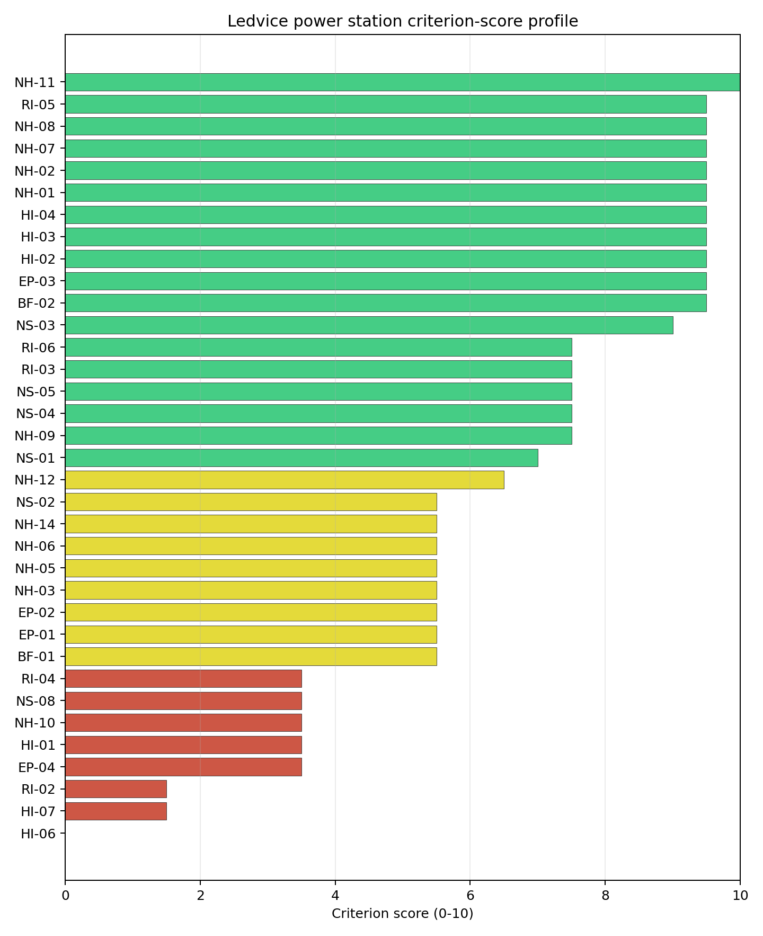
Criterion scores
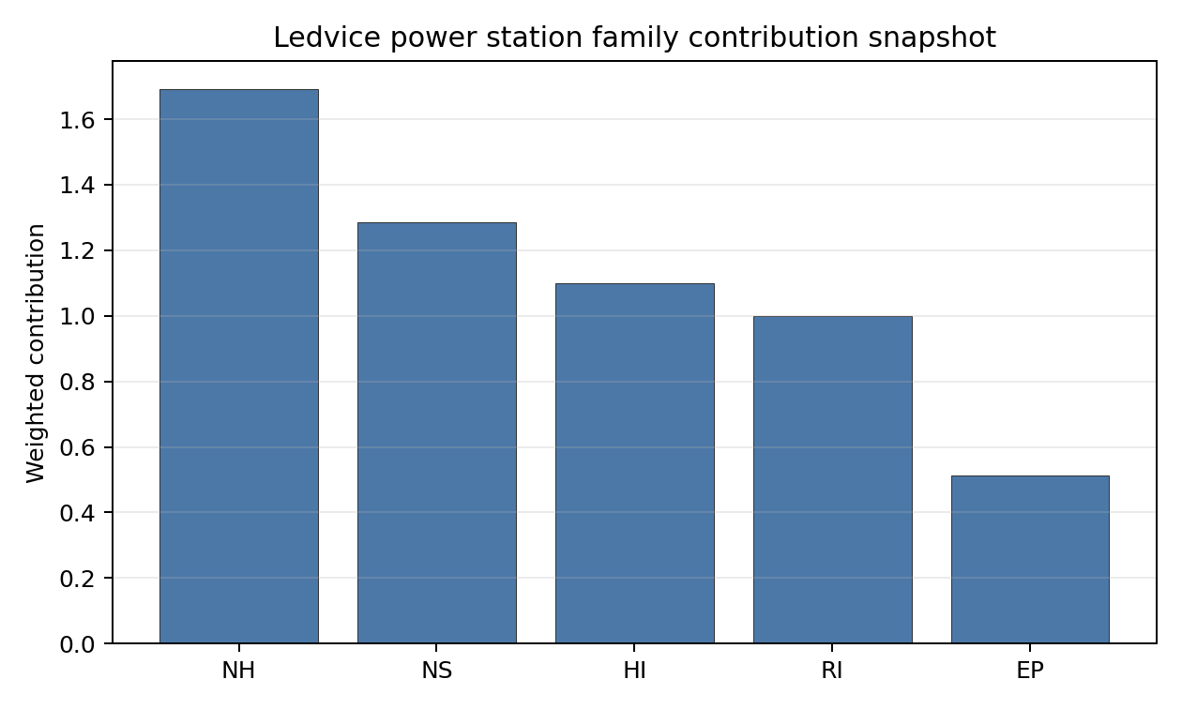
Family contributions
The site records a baseline composite score of 6.916, with a Monte Carlo bracket of 6.164-7.512. Its national stability band is D, with a national top-10% hit rate of 0%. This places the site at national rank 5 in the frozen ranking, but the overlapping top-five intervals mean the rank should guide sequencing rather than settle final preference. Family scores after the unscored-criterion treatment are EP 5.97, HI 6.21, NH 7.44, NS 7.27, RI 7.07; the Stage 3 priority is therefore to retire the avoidance flags and low-scoring criteria that could change the site boundary or emergency-planning case.

Residual Risk Register
Concern | Evidence | Consequence | Stage 3 action | Owner discipline
Aircraft crash avoidance flag | Nearest airport 0.33 km; nearest flight-path proxy 0.33 km | May constrain the usable nuclear island envelope or require detailed aviation-route demonstration. | Run airport, heliport and flight-path micro-siting review against the NuScale reference envelope. | aviation / safety
Military and security proximity | Nearest high-consequence military feature 1.35 km; military features in search radius 121 | Security standoff and emergency-zone coordination could reshape the candidate area. | Confirm feature classification, activity status, and required protective separation with national authorities. | security
Electromagnetic interference | Nearest high-power transmitter 0.42 km; transmitter count 210 | RF/EMI controls may affect instrumentation, communications and site layout. | Survey transmitter inventory, field strength and shielding or separation needs. | electrical / security
Ecological sensitivity | Nearest Natura 2000 site 4.80 km; nearest protected area 2.70 km | Permitting envelope may narrow even without a direct protected-area overlap. | Run protected-area boundary confirmation, receptor-pathway screening and EIA scoping. | environment
Surface-water dispersion | Cooling source Bílina; flow 3.9 m3/s | Liquid-pathway dilution and discharge assumptions remain screening-grade. | Model low-flow, intake, discharge and downstream-user pathways. | hydrology
The register defines follow-up work for Stage 3. Approval, licensing readiness and procurement decisions require later evidence beyond this screening profile.

Stage 3 Follow-Up Checklist
Action | Evidence basis | Purpose
Run airport, heliport and flight-path micro-siting review against the NuScale reference envelope. | Aircraft crash avoidance flag: Nearest airport 0.33 km; nearest flight-path proxy 0.33 km | Reduce the main residual uncertainty before detailed site characterisation.
Confirm feature classification, activity status, and required protective separation with national authorities. | Military and security proximity: Nearest high-consequence military feature 1.35 km; military features in search radius 121 | Reduce the main residual uncertainty before detailed site characterisation.
Survey transmitter inventory, field strength and shielding or separation needs. | Electromagnetic interference: Nearest high-power transmitter 0.42 km; transmitter count 210 | Reduce the main residual uncertainty before detailed site characterisation.
Run protected-area boundary confirmation, receptor-pathway screening and EIA scoping. | Ecological sensitivity: Nearest Natura 2000 site 4.80 km; nearest protected area 2.70 km | Reduce the main residual uncertainty before detailed site characterisation.
Model low-flow, intake, discharge and downstream-user pathways. | Surface-water dispersion: Cooling source Bílina; flow 3.9 m3/s | Reduce the main residual uncertainty before detailed site characterisation.
Close unscored or low-confidence evidence gaps. | Grid Capacity Basic Filter (BF-01), Land Area Basic Filter (BF-02), Seismic: Surface Rupture (NH-02), Geotechnical: Slope Stability (NH-04). | Improve confidence in the composite score and implementation work plan.

Evidence Limitations
- Grid Capacity Basic Filter (BF-01) - evidence quality low.
- Land Area Basic Filter (BF-02) - evidence quality low.
- Seismic: Surface Rupture (NH-02) - evidence quality low.
- Geotechnical: Slope Stability (NH-04) - evidence quality unscored.
- Extreme Precipitation (NH-11) - evidence quality low.
- Combined Hazards (NH-14) - evidence quality low.
- Cooling Water Availability (NS-01) - evidence quality low.
- Transport Access (NS-03) - evidence quality low.
- Site Topography (NS-04) - evidence quality low.
- Existing Infrastructure (NS-06) - evidence quality unscored.

Pocerady power station Site Profile
Pocerady power station is a coal/thermal site in Czechia that has been tested against the NuScale VOYGR-6 reference deployment envelope. This profile reads the screening evidence at a level that supports a decision to progress toward Stage 3 characterisation. It supports Stage 1-2 screening and defines the evidence needed before any Stage 3 judgement.

Site Snapshot
Field | Value
Site name | Pocerady power station
Coordinates | 50.4267, 13.6747
Subnational unit | Ustecky
Installed thermal capacity (source data) | 1,000 MW
Available surface area | 90.8 ha
Available surface area for development | 90.8 ha
Composite score (baseline weights) | 6.931 (6.018-7.526 MC band)
National stability band | D (top-10% hit rate 0%)
National rank | 4
See the country status map in Czechia Country Profile.

Ownership and Coal-to-Nuclear Context
- natural person(s) (100.00% share); immediate operator Sev.en Energy AG. Path: natural person(s) -> Sev.en Energy AG [100.0%] -> Pocerady power station Phase 2 Unit 2 [100.0%]
- Sev.en Energy AG (100.00% share), headquartered in Liechtenstein; immediate operator Sev.en Energy AG. Path: Sev.en Energy AG -> Pocerady power station Phase 1 Unit 4 [100.0%]
Generating units on record: 5 operating. Earliest unit commissioning: 1970; most recent: 1977.

Natural Hazards (NH)
- Seismic: Ground Motion (NH-01) - score 9.5/10 (MC 9.0-10.0); favourable: Well below the risk boundary., weight 0.0455, data quality high. Evidence: PGA at 475-year return period 0.017 g; PGA at 2,475-year return period 0.034 g; Vs30 reference (m/s): 760.0.
- Seismic: Surface Rupture (NH-02) - score 9.5/10 (MC 9.0-10.0); favourable: Very strong separation from mapped capable faults; surface-rupture concern effectively screened at desk-study level., weight n/a, data quality screening grade. Evidence: nearest mapped capable fault 50.0 km; fault slip rate 0 mm/yr; fault name: none_in_search_radius.
- Geotechnical: Liquefaction (NH-03) - score 5.5/10 (MC 5.0-6.0); pass-mark band: Moderate susceptibility, or high/very-high susceptibility with mitigation requiring confirmation., weight n/a, data quality medium. Evidence: liquefaction susceptibility: high; dominant soil type: clay_loam.
- Geotechnical: Slope Stability (NH-04) - score no native score (unscored; no band matched), weight n/a, data quality screening grade. Evidence: not measured at this site (criterion remains unscored).
- Geotechnical: Subsidence (NH-05) - score 3.5/10 (MC 3.0-4.0), weight 0.0354, data quality medium. Evidence: karst present: no; karst severity: none.
- Geotechnical: Foundation (NH-06) - score 5.5/10 (MC 5.0-6.0); pass-mark band: Typical European mixed conditions (bearing 80-150 kPa)., weight 0.0253, data quality medium. Evidence: bearing capacity 84.0 kPa; depth to bedrock 27.6 m.
- Volcanism (NH-07) - score 9.5/10 (MC 9.0-10.0); favourable: Very strong margin above the score-5 boundary, with no in-radius signal in the screening evidence., weight n/a, data quality high. Evidence: volcanic hazard class: negligible.
- Coastal Flooding (NH-08) - score 9.5/10 (MC 9.0-10.0); favourable: Non-coastal OR elevation >= 50 m AMSL OR landlocked country, with no positive marine-hazard signal., weight 0.0303, data quality medium. Evidence: distance to coast 362.9 km.
- River Flooding (NH-09) - score 7.5/10 (MC 5.5-9.5), weight 0.0404, data quality insufficient. Evidence: flood zone class: negligible.
- Extreme Winds (NH-10) - score 3.5/10 (MC 3.0-4.0), weight 0.0152, data quality medium. Evidence: screening wind-speed index 10.7 m/s.
- Extreme Precipitation (NH-11) - score 10.0/10 (MC 9.0-10.0); favourable: aggregated(mean_of_sub_scores), weight 0.0152, data quality medium. Evidence: screening extreme-precipitation index 0.15 mm; screening precipitation index 20.3 mm/yr.
- Extreme Temperatures (NH-12) - score 6.5/10 (MC 6.0-7.0); pass-mark band: aggregated(mean_of_sub_scores), weight 0.0202, data quality medium. Evidence: extreme high temperature 23.0 deg C; extreme low temperature -5.68 deg C.
- Combined Hazards (NH-14) - score 5.5/10 (MC 5.0-6.0); pass-mark band: At least 5 resolved, exactly one moderate hazard (3-5) or moderate interaction only., weight 0.0152, data quality n/a. Evidence: values not in measurement tables.

Interpretation - Natural Hazards (NH)
Natural hazards are generally supportive at this screening stage. Ground-motion evidence is low, with PGA of 0.017 g at the 475-year return period and 0.034 g at the 2,475-year return period; the nearest mapped capable fault is 50.0 km away. Flooding and coastal exposure are not the leading constraints: the flood-zone class is negligible and the site is 362.9 km from the coast. Stage 3 should focus on Geotechnical: Subsidence (NH-05), Geotechnical: Foundation (NH-06), Extreme Winds (NH-10), with particular attention to screening wind speed, mine or foundation evidence, and local hydrology where the bundle marks data quality below final-design standard.

Human-Induced and Security-Relevant Hazards (HI)
- Aircraft Crash (HI-01) - score 3.5/10 (MC 3.0-4.0), weight 0.0354, data quality high. Evidence: nearest airport 6.03 km; nearest flight path 3.01 km; airports within search radius 21; airport name: Rana Loumy Airfield; airport type: small airfield.
- Industrial Explosions (HI-02) - score 9.5/10 (MC 9.0-10.0); favourable: Very strong margin above the score-5 boundary, with no in-radius signal in the screening evidence., weight 0.0354, data quality medium. Evidence: values not in measurement tables.
- Toxic/Gas Releases (HI-03) - score 9.5/10 (MC 9.0-10.0); favourable: Very strong margin above the score-5 boundary, with no in-radius signal in the screening evidence., weight 0.0354, data quality medium. Evidence: values not in measurement tables.
- External Fires (HI-04) - score 9.5/10 (MC 9.0-10.0); favourable: > 15 km, with no flammable-storage signal in the screening radius., weight 0.0303, data quality medium. Evidence: values not in measurement tables.
- Military Installations (HI-06) - score 1.5/10 (MC 1.0-2.0), weight 0.0303, data quality medium. Evidence: nearest military installation 7.84 km; military installations within radius 321; installation name: C-13/21/A-220.
- Electromagnetic Interference (HI-07) - score 1.5/10 (MC 1.0-2.0), weight 0.0101, data quality medium. Evidence: nearest high-power transmitter 3.67 km; transmitters within radius 146; transmitter type: mast.

Interpretation - Human-Induced and Security-Relevant Hazards (HI)
Human-induced hazards are the binding avoidance issue for this site. Aircraft Crash (HI-01) is flagged because the nearest recorded airport or heliport is 6.03 km away and the nearest flight-path proxy is 3.01 km away. The security file is also material: the nearest high-consequence military feature is 7.84 km away, and the nearest high-power transmitter is 3.67 km away. Industrial explosion, toxic-release and external-fire scores are favourable in the current screening record, so Stage 3 should prioritise aviation, security and RF/EMI confirmation before broader industrial-neighbour work.

Radiological Impact and Emergency Planning (RI / EP)
- Emergency Planning Feasibility (EP-01) - score 7.5/10 (MC 7.0-8.0), weight n/a, data quality high. Evidence: EP feasibility composite 76.0 /100; road sub-score 73.2 /100; special-population sub-score 90.0 /100; geography sub-score 95.0 /100; population sub-score 95.0 /100; evacuation feasible: yes.
- Evacuation Routes (EP-02) - score 5.5/10 (MC 5.0-6.0); pass-mark band: Adequate primary routes (0.5-1.0)., weight 0.0303, data quality medium. Evidence: road density in EPZ 0.926 km/km2; road length in EPZ 1,818 km; motorway access: yes.
- Physical Geography Constraints (EP-03) - score 9.5/10 (MC 9.0-10.0); favourable: No measured relief; open river/waterway context (interim screening)., weight 0.0253, data quality medium. Evidence: waterways crossing EPZ 0; major river barrier: no.
- Special Populations (EP-04) - score 3.5/10 (MC 3.0-4.0), weight 0.0303, data quality medium. Evidence: hospitals in EPZ 22; prisons in EPZ 3; care homes in EPZ 1.
- Atmospheric Dispersion (RI-01) - score no native score (unscored; no band matched), weight 0.0303, data quality medium. Evidence: annual mean wind speed 1.22 m/s; atmospheric mixing height 556.0 m; prevailing wind direction: W.
- Surface Water Dispersion (RI-02) - score 5.5/10 (MC 5.0-6.0); pass-mark band: 30-100 m3/s., weight 0.0253, data quality n/a. Evidence: values not in measurement tables.
- Groundwater Dispersion (RI-03) - score 5.5/10 (MC 5.0-6.0); pass-mark band: Moderate-permeability aquifer screening proxy., weight 0.0253, data quality medium. Evidence: aquifer type: sedimentary sands.
- Population Density at EPZ Radii (RI-04) - score 3.5/10 (MC 3.0-4.0), weight 0.0404, data quality screening grade. Evidence: population density within 5 km 36.9 /km2; population density within 16 km 183.7 /km2; population density within 25 km 158.4 /km2; population density within 80 km 249.8 /km2; population within 25 km 310,916 people.
- Distance to Population Centres (RI-05) - score 7.5/10 (MC 7.0-8.0), weight 0.0505, data quality screening grade. Evidence: nearest city above 50k people 10.6 km; nearest city population 62,866 people; city name: Most.
- Population Projections (RI-06) - score 7.5/10 (MC 7.0-8.0), weight 0.0253, data quality screening grade. Evidence: annual population growth rate -0.271 %/yr; projected population at 25 km in 60 yr 299,608 people.

Interpretation - Radiological Impact and Emergency Planning (RI / EP)
Radiological impact and emergency-planning evidence supports continued screening, but the population and liquid-pathway questions need refinement. Emergency Planning Feasibility (EP-01) is marked feasible with a composite score of 76.0 /100; road density in the emergency-planning zone is 0.926 km/km2 and motorway access is recorded. The 25 km population is 310,916, with density of 158.4 people/km2; the nearest city above 50,000 people is Most at 10.6 km. Stage 3 should model EPZ clearance, special-population handling, atmospheric dispersion and low-flow water pathways before the emergency-planning case is hardened.

Non-Safety and Implementation Considerations (NS)
- Grid Capacity Basic Filter (BF-01) - score 9.5/10 (MC 9.0-10.0); favourable: Note: substation <= 5 km, >= 400 kV, headroom >= 600 MW., weight n/a, data quality n/a. Evidence: values not in measurement tables.
- Land Area Basic Filter (BF-02) - score 9.5/10 (MC 9.0-10.0); favourable: Contiguous and buildable >= ideal area (70 ha/module)., weight 0.0253, data quality n/a. Evidence: values not in measurement tables.
- Cooling Water Availability (NS-01) - score 7.0/10 (MC 7.0-8.0), weight 0.0404, data quality screening grade. Evidence: distance to cooling source 7.7 km; cooling source flow 31.1 m3/s; cooling source type: river; cooling source name: Počeradský potok; water stress label: Low.
- Grid Connection (NS-02) - score 9.5/10 (MC 9.0-10.0); favourable: aggregated(min_of_sub_scores), weight 0.0404, data quality high. Evidence: nearest substation 1.54 km; nearest high-voltage line 0.5 km; highest nearby line voltage 400.0 kV; grid export capacity 1,000 MW; substations within radius 1,269; HV lines within radius 1,353.
- Transport Access (NS-03) - score no native score (unscored; no band matched), weight 0.0404, data quality low. Evidence: not measured at this site (criterion remains unscored).
- Site Topography (NS-04) - score 9.5/10 (MC 9.0-10.0); favourable: > 80 %., weight 0.0303, data quality screening grade. Evidence: favourable land cover 90.9 %; moderate land cover 0 %; unfavourable land cover 0 %; favourable area 270.3 ha; dominant land class: 211.
- Site Footprint Adequacy (NS-05) - score 9.5/10 (MC 9.0-10.0); favourable: Very strong margin above the score-5 boundary., weight 0.0253, data quality medium. Evidence: buildable area 90.8 ha; largest contiguous patch 90.8 ha; buildable patch count 4.
- Existing Infrastructure (NS-06) - score no native score (unscored; no band matched), weight 0.0253, data quality n/a. Evidence: not measured at this site (criterion remains unscored).
- Ecological Sensitivity (NS-08) - score 1.5/10 (MC 1.0-2.0), weight n/a, data quality high. Evidence: natural land cover 0 %; distance to nearest Natura 2000 site 5.879 km; distance to nearest protected area 1.746 km; Natura 2000 overlap: no; Natura 2000 sensitivity class: low; protected-area overlap: no; protected-area sensitivity class: high; nearest Natura 2000 site: Vrch Milá; Natura 2000 sites within 5 km: 0; nearest protected-area designation: Nature Monument.
- Workforce Availability (NS-10) - score no native score (unscored; no band matched), weight 0.0202, data quality n/a. Evidence: not measured at this site (criterion remains unscored).
- Regulatory/Political Environment (NS-12) - score no native score (unscored; no band matched), weight 0.0303, data quality n/a. Evidence: not measured at this site (criterion remains unscored).
- Construction Logistics (NS-13) - score no native score (unscored; no band matched), weight 0.0202, data quality n/a. Evidence: not measured at this site (criterion remains unscored).

Interpretation - Non-Safety and Implementation Considerations (NS)
Non-safety implementation conditions are the main reason the selected Czech sites remain credible despite avoidance flags. Cooling evidence identifies Počeradský potok as the nearest source, 7.70 km away, with flow of 31.1 m3/s and a Low water-stress label. Grid proximity is strong where measured: the nearest substation is 1.54 km away, the nearest high-voltage line is 0.50 km away, and the inherited export-capacity estimate is 1000 MW. The canonical site surface area is 90.8 ha; the wider screening-stage favourable-area envelope is 270.3 ha and should be treated as potential laydown or expansion context, not development-ready land. Ecological screening and unscored transport or implementation criteria remain normal Stage 3 follow-up items.

Composite Score and Stability
Baseline composite score is 6.931, bracketed by Monte Carlo at 6.018-7.526. National stability band is D with a top-10% hit rate of 0% in the project’s 50,000-iteration national sensitivity analysis.
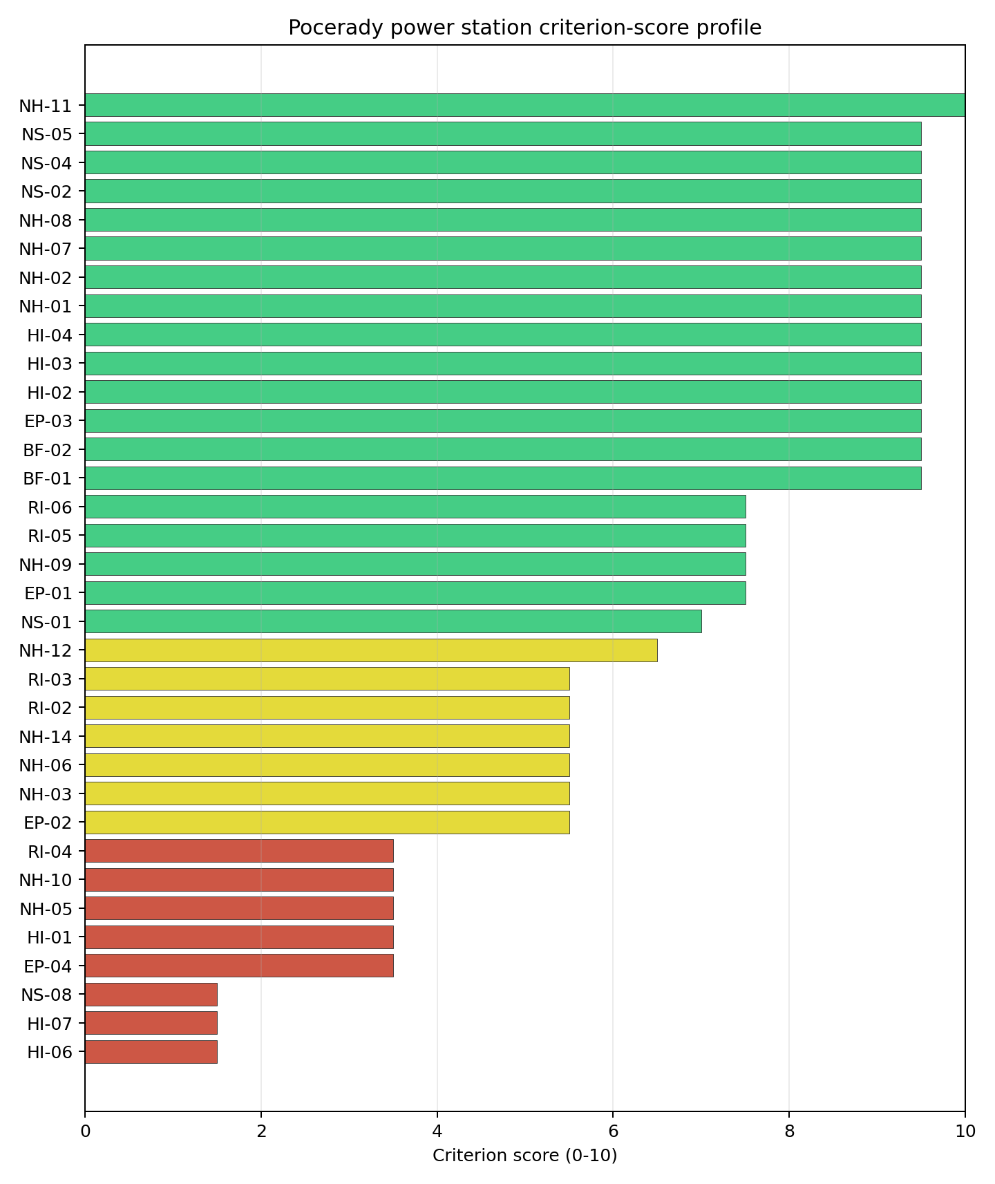
Criterion scores
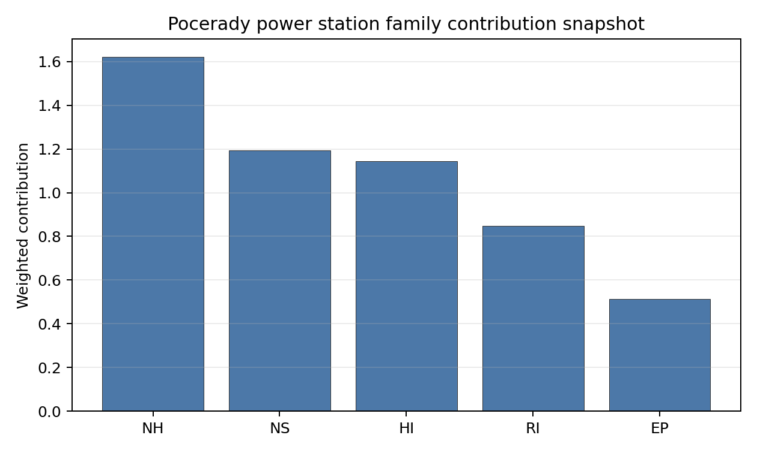
Family contributions
The site records a baseline composite score of 6.931, with a Monte Carlo bracket of 6.018-7.526. Its national stability band is D, with a national top-10% hit rate of 0%. This places the site at national rank 4 in the frozen ranking, but the overlapping top-five intervals mean the rank should guide sequencing rather than settle final preference. Family scores after the unscored-criterion treatment are EP 5.97, HI 6.47, NH 7.13, NS 8.76, RI 6.00; the Stage 3 priority is therefore to retire the avoidance flags and low-scoring criteria that could change the site boundary or emergency-planning case.

Residual Risk Register
Concern | Evidence | Consequence | Stage 3 action | Owner discipline
Aircraft crash avoidance flag | Nearest airport 6.03 km; nearest flight-path proxy 3.01 km | May constrain the usable nuclear island envelope or require detailed aviation-route demonstration. | Run airport, heliport and flight-path micro-siting review against the NuScale reference envelope. | aviation / safety
Military and security proximity | Nearest high-consequence military feature 7.84 km; military features in search radius 321 | Security standoff and emergency-zone coordination could reshape the candidate area. | Confirm feature classification, activity status, and required protective separation with national authorities. | security
Electromagnetic interference | Nearest high-power transmitter 3.67 km; transmitter count 146 | RF/EMI controls may affect instrumentation, communications and site layout. | Survey transmitter inventory, field strength and shielding or separation needs. | electrical / security
Ecological sensitivity | Nearest Natura 2000 site 5.88 km; nearest protected area 1.75 km | Permitting envelope may narrow even without a direct protected-area overlap. | Run protected-area boundary confirmation, receptor-pathway screening and EIA scoping. | environment
Extreme wind confirmation | Screening wind speed 10.7 m/s | Design-basis wind loading needs local confirmation before engineering optimisation. | Reconcile national design-wind records with site-specific meteorological data. | meteorology
The register defines follow-up work for Stage 3. Approval, licensing readiness and procurement decisions require later evidence beyond this screening profile.

Stage 3 Follow-Up Checklist
Action | Evidence basis | Purpose
Run airport, heliport and flight-path micro-siting review against the NuScale reference envelope. | Aircraft crash avoidance flag: Nearest airport 6.03 km; nearest flight-path proxy 3.01 km | Reduce the main residual uncertainty before detailed site characterisation.
Confirm feature classification, activity status, and required protective separation with national authorities. | Military and security proximity: Nearest high-consequence military feature 7.84 km; military features in search radius 321 | Reduce the main residual uncertainty before detailed site characterisation.
Survey transmitter inventory, field strength and shielding or separation needs. | Electromagnetic interference: Nearest high-power transmitter 3.67 km; transmitter count 146 | Reduce the main residual uncertainty before detailed site characterisation.
Run protected-area boundary confirmation, receptor-pathway screening and EIA scoping. | Ecological sensitivity: Nearest Natura 2000 site 5.88 km; nearest protected area 1.75 km | Reduce the main residual uncertainty before detailed site characterisation.
Reconcile national design-wind records with site-specific meteorological data. | Extreme wind confirmation: Screening wind speed 10.7 m/s | Reduce the main residual uncertainty before detailed site characterisation.
Close unscored or low-confidence evidence gaps. | Grid Capacity Basic Filter (BF-01), Land Area Basic Filter (BF-02), Seismic: Surface Rupture (NH-02), Geotechnical: Slope Stability (NH-04). | Improve confidence in the composite score and implementation work plan.

Evidence Limitations
- Grid Capacity Basic Filter (BF-01) - evidence quality low.
- Land Area Basic Filter (BF-02) - evidence quality low.
- Seismic: Surface Rupture (NH-02) - evidence quality low.
- Geotechnical: Slope Stability (NH-04) - evidence quality unscored.
- Extreme Precipitation (NH-11) - evidence quality low.
- Combined Hazards (NH-14) - evidence quality low.
- Cooling Water Availability (NS-01) - evidence quality low.
- Transport Access (NS-03) - evidence quality unscored.
- Site Topography (NS-04) - evidence quality low.
- Existing Infrastructure (NS-06) - evidence quality unscored.

Prunerov power station Site Profile
Prunerov power station is a coal/thermal site in Czechia that has been tested against the NuScale VOYGR-6 reference deployment envelope. This profile reads the screening evidence at a level that supports a decision to progress toward Stage 3 characterisation. It supports Stage 1-2 screening and defines the evidence needed before any Stage 3 judgement.

Site Snapshot
Field | Value
Site name | Prunerov power station
Coordinates | 50.4151, 13.2560
Subnational unit | Ústí nad Labem
Installed thermal capacity (source data) | 2,240 MW
Available surface area | 300.0 ha
Available surface area for development | 74.0 ha
Composite score (baseline weights) | 7.016 (6.083-7.559 MC band)
National stability band | C (top-10% hit rate 67%)
National rank | 2
See the country status map in Czechia Country Profile.

Ownership and Coal-to-Nuclear Context
- Government of Czech Republic (69.80% share), headquartered in Czech Republic; immediate operator CEZ AS. Path: Government of Czech Republic -> Ministry of Finance (Czech Republic) [100.0%] -> CEZ AS [69.8%] -> Prunerov power station Phase 2 Unit B21 [100.0%]
- natural person(s) (13.00% share); immediate operator CEZ AS. Path: natural person(s) -> CEZ AS [13.0%] -> Prunerov power station Phase 2 Unit B22 [100.0%]
- small shareholder(s) (17.00% share); immediate operator CEZ AS. Path: small shareholder(s) -> CEZ AS [17.0%] -> Prunerov power station Phase 2 Unit B22 [100.0%]
- CEZ AS (100.00% share), headquartered in Czech Republic; immediate operator CEZ AS. Path: CEZ AS -> Prunerov power station Phase 2 Unit B21 [100.0%]
- Ministry of Finance (Czech Republic) (69.80% share), headquartered in Czech Republic; immediate operator CEZ AS. Path: Ministry of Finance (Czech Republic) -> CEZ AS [69.8%] -> Prunerov power station Phase 2 Unit B21 [100.0%]
Generating units on record: 3 operating, 9 retired. Earliest unit commissioning: 1968; most recent: 2016. Retirements span 2012 to 2020, leaving brownfield grid, water, transport, and workforce assets that materially shorten Stage 3 site preparation.

Natural Hazards (NH)
- Seismic: Ground Motion (NH-01) - score 9.5/10 (MC 9.0-10.0); favourable: Well below the risk boundary., weight 0.0455, data quality high. Evidence: PGA at 475-year return period 0.025 g; PGA at 2,475-year return period 0.048 g; Vs30 reference (m/s): 760.0.
- Seismic: Surface Rupture (NH-02) - score 9.5/10 (MC 9.0-10.0); favourable: Very strong separation from mapped capable faults; surface-rupture concern effectively screened at desk-study level., weight n/a, data quality screening grade. Evidence: nearest mapped capable fault 50.0 km; fault slip rate 0 mm/yr; fault name: none_in_search_radius.
- Geotechnical: Liquefaction (NH-03) - score 9.5/10 (MC 9.0-10.0); favourable: Negligible susceptibility (Stage-1 favourable default)., weight n/a, data quality medium. Evidence: liquefaction susceptibility: very_low; dominant soil type: silty_clay_loam.
- Geotechnical: Slope Stability (NH-04) - score 7.5/10 (MC 7.0-8.0), weight n/a, data quality screening grade. Evidence: site slope 9.61 deg; max slope in 1 km box 86.0 deg; slope stability class: moderate.
- Geotechnical: Subsidence (NH-05) - score 5.5/10 (MC 5.0-6.0); pass-mark band: At or above the mine-distance score-5 pivot; review possible., weight 0.0354, data quality medium. Evidence: karst present: no; karst severity: none.
- Geotechnical: Foundation (NH-06) - score 5.5/10 (MC 5.0-6.0); pass-mark band: Typical European mixed conditions (bearing 80-150 kPa)., weight 0.0253, data quality medium. Evidence: bearing capacity 83.3 kPa; depth to bedrock 20.5 m.
- Volcanism (NH-07) - score 9.5/10 (MC 9.0-10.0); favourable: Very strong margin above the score-5 boundary, with no in-radius signal in the screening evidence., weight n/a, data quality high. Evidence: volcanic hazard class: negligible.
- Coastal Flooding (NH-08) - score 9.5/10 (MC 9.0-10.0); favourable: Non-coastal OR elevation >= 50 m AMSL OR landlocked country, with no positive marine-hazard signal., weight 0.0303, data quality medium. Evidence: distance to coast 370.1 km.
- River Flooding (NH-09) - score 7.5/10 (MC 5.5-9.5), weight 0.0404, data quality insufficient. Evidence: flood zone class: negligible.
- Extreme Winds (NH-10) - score 1.5/10 (MC 1.0-2.0), weight 0.0152, data quality medium. Evidence: screening wind-speed index 12.8 m/s.
- Extreme Precipitation (NH-11) - score 8.0/10 (MC 8.0-9.0); favourable: aggregated(mean_of_sub_scores), weight 0.0152, data quality medium. Evidence: screening extreme-precipitation index 0.18 mm; screening precipitation index 27.4 mm/yr.
- Extreme Temperatures (NH-12) - score 7.5/10 (MC 7.0-8.0), weight 0.0202, data quality medium. Evidence: extreme high temperature 20.8 deg C; extreme low temperature -6.21 deg C.
- Combined Hazards (NH-14) - score no native score (unscored; no band matched), weight 0.0152, data quality n/a. Evidence: not measured at this site (criterion remains unscored).

Interpretation - Natural Hazards (NH)
Natural hazards are generally supportive at this screening stage. Ground-motion evidence is low, with PGA of 0.025 g at the 475-year return period and 0.048 g at the 2,475-year return period; the nearest mapped capable fault is 50.0 km away. Flooding and coastal exposure are not the leading constraints: the flood-zone class is negligible and the site is 370.1 km from the coast. Stage 3 should focus on Geotechnical: Subsidence (NH-05), Geotechnical: Foundation (NH-06), Extreme Winds (NH-10), with particular attention to screening wind speed, mine or foundation evidence, and local hydrology where the bundle marks data quality below final-design standard.

Human-Induced and Security-Relevant Hazards (HI)
- Aircraft Crash (HI-01) - score 3.5/10 (MC 3.0-4.0), weight 0.0354, data quality high. Evidence: nearest airport 2.88 km; nearest flight path 2.88 km; airports within search radius 15; airport name: Kadaň Hospital Heliport; airport type: heliport.
- Industrial Explosions (HI-02) - score 9.5/10 (MC 9.0-10.0); favourable: Very strong margin above the score-5 boundary, with no in-radius signal in the screening evidence., weight 0.0354, data quality medium. Evidence: values not in measurement tables.
- Toxic/Gas Releases (HI-03) - score 9.5/10 (MC 9.0-10.0); favourable: Very strong margin above the score-5 boundary, with no in-radius signal in the screening evidence., weight 0.0354, data quality medium. Evidence: values not in measurement tables.
- External Fires (HI-04) - score 9.5/10 (MC 9.0-10.0); favourable: > 15 km, with no flammable-storage signal in the screening radius., weight 0.0303, data quality medium. Evidence: values not in measurement tables.
- Military Installations (HI-06) - score 0.0/10 (MC 0.0-0.0), weight 0.0303, data quality high. Evidence: nearest military installation 1.59 km; military installations within radius 172; installation name: K-50/6/D2.
- Electromagnetic Interference (HI-07) - score 1.5/10 (MC 1.0-2.0), weight 0.0101, data quality medium. Evidence: nearest high-power transmitter 0.43 km; transmitters within radius 151; transmitter type: communication.

Interpretation - Human-Induced and Security-Relevant Hazards (HI)
Human-induced hazards are the binding avoidance issue for this site. Aircraft Crash (HI-01) is flagged because the nearest recorded airport or heliport is 2.88 km away and the nearest flight-path proxy is 2.88 km away. The security file is also material: the nearest high-consequence military feature is 1.59 km away, and the nearest high-power transmitter is 0.43 km away. Industrial explosion, toxic-release and external-fire scores are favourable in the current screening record, so Stage 3 should prioritise aviation, security and RF/EMI confirmation before broader industrial-neighbour work.

Radiological Impact and Emergency Planning (RI / EP)
- Emergency Planning Feasibility (EP-01) - score 7.5/10 (MC 7.0-8.0), weight n/a, data quality high. Evidence: EP feasibility composite 68.2 /100; road sub-score 62.6 /100; special-population sub-score 90.0 /100; geography sub-score 95.0 /100; population sub-score 80.0 /100; evacuation feasible: yes.
- Evacuation Routes (EP-02) - score 5.5/10 (MC 5.0-6.0); pass-mark band: Adequate primary routes (0.5-1.0)., weight 0.0303, data quality medium. Evidence: road density in EPZ 0.677 km/km2; road length in EPZ 1,329 km; motorway access: yes.
- Physical Geography Constraints (EP-03) - score 9.5/10 (MC 9.0-10.0); favourable: No measured relief; open river/waterway context (interim screening)., weight 0.0253, data quality medium. Evidence: waterways crossing EPZ 0; major river barrier: no.
- Special Populations (EP-04) - score 5.5/10 (MC 5.0-6.0); pass-mark band: 9-25., weight 0.0303, data quality medium. Evidence: hospitals in EPZ 13; prisons in EPZ 4; care homes in EPZ 0.
- Atmospheric Dispersion (RI-01) - score no native score (unscored; no band matched), weight 0.0303, data quality medium. Evidence: annual mean wind speed 1.49 m/s; atmospheric mixing height 536.9 m; prevailing wind direction: WSW.
- Surface Water Dispersion (RI-02) - score 3.5/10 (MC 3.0-4.0), weight 0.0253, data quality n/a. Evidence: values not in measurement tables.
- Groundwater Dispersion (RI-03) - score 5.5/10 (MC 5.0-6.0); pass-mark band: Moderate-permeability aquifer screening proxy., weight 0.0253, data quality medium. Evidence: aquifer type: volcanic rocks.
- Population Density at EPZ Radii (RI-04) - score 3.5/10 (MC 3.0-4.0), weight 0.0404, data quality screening grade. Evidence: population density within 5 km 189.7 /km2; population density within 16 km 125.8 /km2; population density within 25 km 99.7 /km2; population density within 80 km 183.1 /km2; population within 25 km 195,748 people.
- Distance to Population Centres (RI-05) - score 9.5/10 (MC 9.0-10.0); favourable: Nearest >=50k population-centre proxy exceeds required distance by >= 50 %., weight 0.0505, data quality screening grade. Evidence: nearest city above 50k people 13.8 km; nearest city population 65,208 people; city name: Chomutov-Jirkov.
- Population Projections (RI-06) - score 7.5/10 (MC 7.0-8.0), weight 0.0253, data quality screening grade. Evidence: annual population growth rate -0.492 %/yr; projected population at 25 km in 60 yr 188,626 people.

Interpretation - Radiological Impact and Emergency Planning (RI / EP)
Radiological impact and emergency-planning evidence supports continued screening, but the population and liquid-pathway questions need refinement. Emergency Planning Feasibility (EP-01) is marked feasible with a composite score of 68.2 /100; road density in the emergency-planning zone is 0.677 km/km2 and motorway access is recorded. The 25 km population is 195,748, with density of 99.7 people/km2; the nearest city above 50,000 people is Chomutov-Jirkov at 13.8 km. Stage 3 should model EPZ clearance, special-population handling, atmospheric dispersion and low-flow water pathways before the emergency-planning case is hardened.

Non-Safety and Implementation Considerations (NS)
- Grid Capacity Basic Filter (BF-01) - score 5.5/10 (MC 5.0-6.0); pass-mark band: Note: substation 15-30 km OR 110-219 kV; reinforcement plausible., weight n/a, data quality n/a. Evidence: values not in measurement tables.
- Land Area Basic Filter (BF-02) - score 9.5/10 (MC 9.0-10.0); favourable: Contiguous and buildable >= ideal area (70 ha/module)., weight 0.0253, data quality n/a. Evidence: values not in measurement tables.
- Cooling Water Availability (NS-01) - score 8.0/10 (MC 7.0-8.0); favourable: aggregated(weighted_mean_of_sub_scores), weight 0.0404, data quality screening grade. Evidence: distance to cooling source 3.78 km; cooling source flow 24.5 m3/s; cooling source type: river; cooling source name: Prunéřovský potok; water stress label: Low.
- Grid Connection (NS-02) - score 9.5/10 (MC 9.0-10.0); favourable: aggregated(min_of_sub_scores), weight 0.0404, data quality high. Evidence: nearest substation 0.45 km; nearest high-voltage line 0.38 km; grid export capacity 2,240 MW; substations within radius 1,133; HV lines within radius 1,115.
- Transport Access (NS-03) - score no native score (unscored; no band matched), weight 0.0404, data quality low. Evidence: not measured at this site (criterion remains unscored).
- Site Topography (NS-04) - score 5.5/10 (MC 5.0-6.0); pass-mark band: 40-60 %., weight 0.0303, data quality screening grade. Evidence: favourable land cover 49.0 %; moderate land cover 7 %; unfavourable land cover 14.5 %; favourable area 91.0 ha; dominant land class: 324.
- Site Footprint Adequacy (NS-05) - score 9.5/10 (MC 9.0-10.0); favourable: Very strong margin above the score-5 boundary., weight 0.0253, data quality high. Evidence: buildable area 74.0 ha; largest contiguous patch 74.0 ha; buildable patch count 14.
- Existing Infrastructure (NS-06) - score no native score (unscored; no band matched), weight 0.0253, data quality n/a. Evidence: not measured at this site (criterion remains unscored).
- Ecological Sensitivity (NS-08) - score 3.5/10 (MC 3.0-4.0), weight n/a, data quality high. Evidence: natural land cover 14.5 %; distance to nearest Natura 2000 site 2.171 km; distance to nearest protected area 2.813 km; Natura 2000 overlap: no; Natura 2000 sensitivity class: moderate; protected-area overlap: no; protected-area sensitivity class: moderate; nearest Natura 2000 site: Kokrháč - Hasištejn; Natura 2000 sites within 5 km: 4; nearest protected-area designation: Nature Monument.
- Workforce Availability (NS-10) - score no native score (unscored; no band matched), weight 0.0202, data quality n/a. Evidence: not measured at this site (criterion remains unscored).
- Regulatory/Political Environment (NS-12) - score no native score (unscored; no band matched), weight 0.0303, data quality n/a. Evidence: not measured at this site (criterion remains unscored).
- Construction Logistics (NS-13) - score no native score (unscored; no band matched), weight 0.0202, data quality n/a. Evidence: not measured at this site (criterion remains unscored).

Interpretation - Non-Safety and Implementation Considerations (NS)
Non-safety implementation conditions are the main reason the selected Czech sites remain credible despite avoidance flags. Cooling evidence identifies Prunéřovský potok as the nearest source, 3.78 km away, with flow of 24.5 m3/s and a Low water-stress label. Grid proximity is strong where measured: the nearest substation is 0.45 km away, the nearest high-voltage line is 0.38 km away, and the inherited export-capacity estimate is 2240 MW. The canonical site surface area is 300.0 ha; the wider screening-stage favourable-area envelope is 91.0 ha and should be treated as potential laydown or expansion context, not development-ready land. Ecological screening and unscored transport or implementation criteria remain normal Stage 3 follow-up items.

Composite Score and Stability
Baseline composite score is 7.016, bracketed by Monte Carlo at 6.083-7.559. National stability band is C with a top-10% hit rate of 67% in the project’s 50,000-iteration national sensitivity analysis.
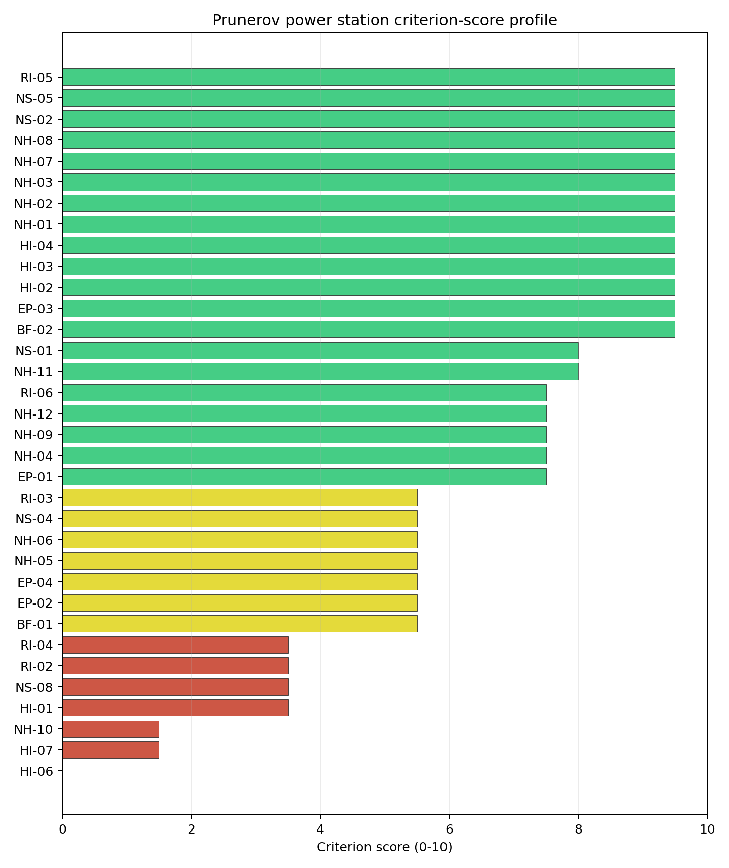
Criterion scores
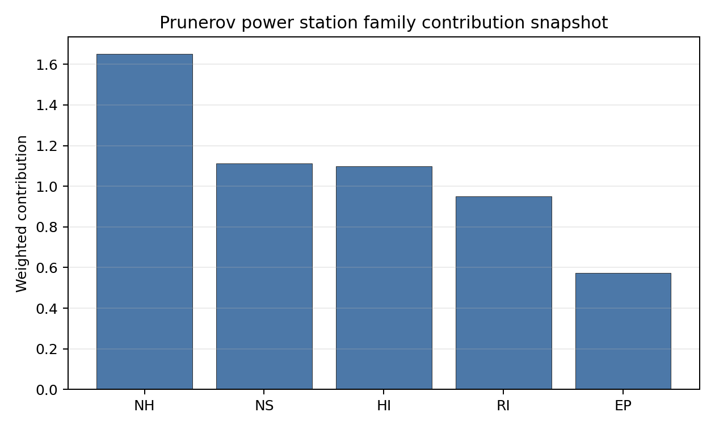
Family contributions
The site records a baseline composite score of 7.016, with a Monte Carlo bracket of 6.083-7.559. Its national stability band is C, with a national top-10% hit rate of 67%. This places the site at national rank 2 in the frozen ranking, but the overlapping top-five intervals mean the rank should guide sequencing rather than settle final preference. Family scores after the unscored-criterion treatment are EP 6.68, HI 6.21, NH 7.27, NS 8.17, RI 6.71; the Stage 3 priority is therefore to retire the avoidance flags and low-scoring criteria that could change the site boundary or emergency-planning case.

Residual Risk Register
Concern | Evidence | Consequence | Stage 3 action | Owner discipline
Aircraft crash avoidance flag | Nearest airport 2.88 km; nearest flight-path proxy 2.88 km | May constrain the usable nuclear island envelope or require detailed aviation-route demonstration. | Run airport, heliport and flight-path micro-siting review against the NuScale reference envelope. | aviation / safety
Military and security proximity | Nearest high-consequence military feature 1.59 km; military features in search radius 172 | Security standoff and emergency-zone coordination could reshape the candidate area. | Confirm feature classification, activity status, and required protective separation with national authorities. | security
Electromagnetic interference | Nearest high-power transmitter 0.43 km; transmitter count 151 | RF/EMI controls may affect instrumentation, communications and site layout. | Survey transmitter inventory, field strength and shielding or separation needs. | electrical / security
Ecological sensitivity | Nearest Natura 2000 site 2.17 km; nearest protected area 2.81 km | Permitting envelope may narrow even without a direct protected-area overlap. | Run protected-area boundary confirmation, receptor-pathway screening and EIA scoping. | environment
Surface-water dispersion | Cooling source Prunéřovský potok; flow 24.5 m3/s | Liquid-pathway dilution and discharge assumptions remain screening-grade. | Model low-flow, intake, discharge and downstream-user pathways. | hydrology
The register defines follow-up work for Stage 3. Approval, licensing readiness and procurement decisions require later evidence beyond this screening profile.

Stage 3 Follow-Up Checklist
Action | Evidence basis | Purpose
Run airport, heliport and flight-path micro-siting review against the NuScale reference envelope. | Aircraft crash avoidance flag: Nearest airport 2.88 km; nearest flight-path proxy 2.88 km | Reduce the main residual uncertainty before detailed site characterisation.
Confirm feature classification, activity status, and required protective separation with national authorities. | Military and security proximity: Nearest high-consequence military feature 1.59 km; military features in search radius 172 | Reduce the main residual uncertainty before detailed site characterisation.
Survey transmitter inventory, field strength and shielding or separation needs. | Electromagnetic interference: Nearest high-power transmitter 0.43 km; transmitter count 151 | Reduce the main residual uncertainty before detailed site characterisation.
Run protected-area boundary confirmation, receptor-pathway screening and EIA scoping. | Ecological sensitivity: Nearest Natura 2000 site 2.17 km; nearest protected area 2.81 km | Reduce the main residual uncertainty before detailed site characterisation.
Model low-flow, intake, discharge and downstream-user pathways. | Surface-water dispersion: Cooling source Prunéřovský potok; flow 24.5 m3/s | Reduce the main residual uncertainty before detailed site characterisation.
Close unscored or low-confidence evidence gaps. | Grid Capacity Basic Filter (BF-01), Land Area Basic Filter (BF-02), Seismic: Surface Rupture (NH-02), Geotechnical: Slope Stability (NH-04). | Improve confidence in the composite score and implementation work plan.

Evidence Limitations
- Grid Capacity Basic Filter (BF-01) - evidence quality low.
- Land Area Basic Filter (BF-02) - evidence quality low.
- Seismic: Surface Rupture (NH-02) - evidence quality low.
- Geotechnical: Slope Stability (NH-04) - evidence quality low.
- Extreme Precipitation (NH-11) - evidence quality low.
- Combined Hazards (NH-14) - evidence quality unscored.
- Cooling Water Availability (NS-01) - evidence quality low.
- Grid Connection (NS-02) - evidence quality low.
- Transport Access (NS-03) - evidence quality unscored.
- Site Topography (NS-04) - evidence quality low.

Tusimice power station Site Profile
Tusimice power station is a coal/thermal site in Czechia that has been tested against the NuScale VOYGR-6 reference deployment envelope. This profile reads the screening evidence at a level that supports a decision to progress toward Stage 3 characterisation. It supports Stage 1-2 screening and defines the evidence needed before any Stage 3 judgement.

Site Snapshot
Field | Value
Site name | Tusimice power station
Coordinates | 50.3819, 13.3400
Subnational unit | Ústí nad Labem
Installed thermal capacity (source data) | 800 MW
Available surface area | 104.5 ha
Available surface area for development | 104.5 ha
Composite score (baseline weights) | 7.095 (6.144-7.691 MC band)
National stability band | A (top-10% hit rate 92%)
National rank | 1
See the country status map in Czechia Country Profile.

Ownership and Coal-to-Nuclear Context
- Government of Czech Republic (69.80% share), headquartered in Czech Republic; immediate operator CEZ AS. Path: Government of Czech Republic -> Ministry of Finance (Czech Republic) [100.0%] -> CEZ AS [69.8%] -> Tusimice power station Unit 4 [100.0%]
- natural person(s) (13.00% share); immediate operator CEZ AS. Path: natural person(s) -> CEZ AS [13.0%] -> Tusimice power station Unit 4 [100.0%]
- small shareholder(s) (17.00% share); immediate operator CEZ AS. Path: small shareholder(s) -> CEZ AS [17.0%] -> Tusimice power station Unit 4 [100.0%]
- CEZ AS (100.00% share), headquartered in Czech Republic; immediate operator CEZ AS. Path: CEZ AS -> Tusimice power station Unit 4 [100.0%]
- Ministry of Finance (Czech Republic) (69.80% share), headquartered in Czech Republic; immediate operator CEZ AS. Path: Ministry of Finance (Czech Republic) -> CEZ AS [69.8%] -> Tusimice power station Unit 4 [100.0%]
Generating units on record: 4 operating. Earliest unit commissioning: 1974; most recent: 1974.

Natural Hazards (NH)
- Seismic: Ground Motion (NH-01) - score 9.5/10 (MC 9.0-10.0); favourable: Well below the risk boundary., weight 0.0455, data quality high. Evidence: PGA at 475-year return period 0.022 g; PGA at 2,475-year return period 0.043 g; Vs30 reference (m/s): 760.0.
- Seismic: Surface Rupture (NH-02) - score 9.5/10 (MC 9.0-10.0); favourable: Very strong separation from mapped capable faults; surface-rupture concern effectively screened at desk-study level., weight n/a, data quality screening grade. Evidence: nearest mapped capable fault 50.0 km; fault slip rate 0 mm/yr; fault name: none_in_search_radius.
- Geotechnical: Liquefaction (NH-03) - score 5.5/10 (MC 5.0-6.0); pass-mark band: Moderate susceptibility, or high/very-high susceptibility with mitigation requiring confirmation., weight n/a, data quality medium. Evidence: liquefaction susceptibility: moderate; dominant soil type: loam.
- Geotechnical: Slope Stability (NH-04) - score 7.5/10 (MC 7.0-8.0), weight n/a, data quality screening grade. Evidence: site slope 8.77 deg; max slope in 1 km box 85.2 deg; slope stability class: moderate.
- Geotechnical: Subsidence (NH-05) - score 5.5/10 (MC 5.0-6.0); pass-mark band: At or above the mine-distance score-5 pivot; review possible., weight 0.0354, data quality medium. Evidence: karst present: no; karst severity: none.
- Geotechnical: Foundation (NH-06) - score 5.5/10 (MC 5.0-6.0); pass-mark band: Typical European mixed conditions (bearing 80-150 kPa)., weight 0.0253, data quality medium. Evidence: bearing capacity 86.7 kPa; depth to bedrock 21.9 m.
- Volcanism (NH-07) - score 9.5/10 (MC 9.0-10.0); favourable: Very strong margin above the score-5 boundary, with no in-radius signal in the screening evidence., weight n/a, data quality high. Evidence: volcanic hazard class: negligible.
- Coastal Flooding (NH-08) - score 9.5/10 (MC 9.0-10.0); favourable: Non-coastal OR elevation >= 50 m AMSL OR landlocked country, with no positive marine-hazard signal., weight 0.0303, data quality medium. Evidence: distance to coast 372.4 km.
- River Flooding (NH-09) - score 7.5/10 (MC 5.5-9.5), weight 0.0404, data quality insufficient. Evidence: flood zone class: negligible.
- Extreme Winds (NH-10) - score 1.5/10 (MC 1.0-2.0), weight 0.0152, data quality medium. Evidence: screening wind-speed index 12.8 m/s.
- Extreme Precipitation (NH-11) - score 8.0/10 (MC 8.0-9.0); favourable: aggregated(mean_of_sub_scores), weight 0.0152, data quality medium. Evidence: screening extreme-precipitation index 0.18 mm; screening precipitation index 27.4 mm/yr.
- Extreme Temperatures (NH-12) - score 7.5/10 (MC 7.0-8.0), weight 0.0202, data quality medium. Evidence: extreme high temperature 20.8 deg C; extreme low temperature -6.21 deg C.
- Combined Hazards (NH-14) - score no native score (unscored; no band matched), weight 0.0152, data quality n/a. Evidence: not measured at this site (criterion remains unscored).

Interpretation - Natural Hazards (NH)
Natural hazards are generally supportive at this screening stage. Ground-motion evidence is low, with PGA of 0.022 g at the 475-year return period and 0.043 g at the 2,475-year return period; the nearest mapped capable fault is 50.0 km away. Flooding and coastal exposure are not the leading constraints: the flood-zone class is negligible and the site is 372.4 km from the coast. Stage 3 should focus on Geotechnical: Subsidence (NH-05), Geotechnical: Foundation (NH-06), Extreme Winds (NH-10), with particular attention to screening wind speed, mine or foundation evidence, and local hydrology where the bundle marks data quality below final-design standard.

Human-Induced and Security-Relevant Hazards (HI)
- Aircraft Crash (HI-01) - score 3.5/10 (MC 3.0-4.0), weight 0.0354, data quality high. Evidence: nearest airport 3.95 km; nearest flight path 3.95 km; airports within search radius 15; airport name: Kadaň Emergency Heliport; airport type: heliport.
- Industrial Explosions (HI-02) - score 9.5/10 (MC 9.0-10.0); favourable: Very strong margin above the score-5 boundary, with no in-radius signal in the screening evidence., weight 0.0354, data quality medium. Evidence: values not in measurement tables.
- Toxic/Gas Releases (HI-03) - score 9.5/10 (MC 9.0-10.0); favourable: Very strong margin above the score-5 boundary, with no in-radius signal in the screening evidence., weight 0.0354, data quality medium. Evidence: values not in measurement tables.
- External Fires (HI-04) - score 9.5/10 (MC 9.0-10.0); favourable: > 15 km, with no flammable-storage signal in the screening radius., weight 0.0303, data quality medium. Evidence: values not in measurement tables.
- Military Installations (HI-06) - score 0.0/10 (MC 0.0-0.0), weight 0.0303, data quality high. Evidence: nearest military installation 4.14 km; military installations within radius 391; installation name: V.a/42/B.
- Electromagnetic Interference (HI-07) - score 1.5/10 (MC 1.0-2.0), weight 0.0101, data quality medium. Evidence: nearest high-power transmitter 0.97 km; transmitters within radius 90; transmitter type: communication.

Interpretation - Human-Induced and Security-Relevant Hazards (HI)
Human-induced hazards are the binding avoidance issue for this site. Aircraft Crash (HI-01) is flagged because the nearest recorded airport or heliport is 3.95 km away and the nearest flight-path proxy is 3.95 km away. The security file is also material: the nearest high-consequence military feature is 4.14 km away, and the nearest high-power transmitter is 0.97 km away. Industrial explosion, toxic-release and external-fire scores are favourable in the current screening record, so Stage 3 should prioritise aviation, security and RF/EMI confirmation before broader industrial-neighbour work.

Radiological Impact and Emergency Planning (RI / EP)
- Emergency Planning Feasibility (EP-01) - score 5.5/10 (MC 5.0-6.0); pass-mark band: At or above the composite score-5 boundary., weight n/a, data quality high. Evidence: EP feasibility composite 55.2 /100; road sub-score 64.8 /100; special-population sub-score 0 /100; geography sub-score 95.0 /100; population sub-score 80.0 /100; evacuation feasible: yes.
- Evacuation Routes (EP-02) - score 5.5/10 (MC 5.0-6.0); pass-mark band: Adequate primary routes (0.5-1.0)., weight 0.0303, data quality medium. Evidence: road density in EPZ 0.713 km/km2; road length in EPZ 1,401 km; motorway access: yes.
- Physical Geography Constraints (EP-03) - score 9.5/10 (MC 9.0-10.0); favourable: No measured relief; open river/waterway context (interim screening)., weight 0.0253, data quality medium. Evidence: waterways crossing EPZ 0; major river barrier: no.
- Special Populations (EP-04) - score 5.5/10 (MC 5.0-6.0); pass-mark band: 9-25., weight 0.0303, data quality medium. Evidence: hospitals in EPZ 10; prisons in EPZ 2; care homes in EPZ 0.
- Atmospheric Dispersion (RI-01) - score no native score (unscored; no band matched), weight 0.0303, data quality medium. Evidence: annual mean wind speed 1.49 m/s; atmospheric mixing height 536.9 m; prevailing wind direction: WSW.
- Surface Water Dispersion (RI-02) - score 3.5/10 (MC 3.0-4.0), weight 0.0253, data quality n/a. Evidence: values not in measurement tables.
- Groundwater Dispersion (RI-03) - score 5.5/10 (MC 5.0-6.0); pass-mark band: Moderate-permeability aquifer screening proxy., weight 0.0253, data quality medium. Evidence: aquifer type: inland water.
- Population Density at EPZ Radii (RI-04) - score 3.5/10 (MC 3.0-4.0), weight 0.0404, data quality screening grade. Evidence: population density within 5 km 157.4 /km2; population density within 16 km 152.5 /km2; population density within 25 km 100.6 /km2; population density within 80 km 184.3 /km2; population within 25 km 197,501 people.
- Distance to Population Centres (RI-05) - score 9.5/10 (MC 9.0-10.0); favourable: Nearest >=50k population-centre proxy exceeds required distance by >= 50 %., weight 0.0505, data quality screening grade. Evidence: nearest city above 50k people 12.3 km; nearest city population 65,208 people; city name: Chomutov-Jirkov.
- Population Projections (RI-06) - score 7.5/10 (MC 7.0-8.0), weight 0.0253, data quality screening grade. Evidence: annual population growth rate -0.323 %/yr; projected population at 25 km in 60 yr 190,329 people.

Interpretation - Radiological Impact and Emergency Planning (RI / EP)
Radiological impact and emergency-planning evidence supports continued screening, but the population and liquid-pathway questions need refinement. Emergency Planning Feasibility (EP-01) is marked feasible with a composite score of 55.2 /100; road density in the emergency-planning zone is 0.713 km/km2 and motorway access is recorded. The 25 km population is 197,501, with density of 100.6 people/km2; the nearest city above 50,000 people is Chomutov-Jirkov at 12.3 km. Stage 3 should model EPZ clearance, special-population handling, atmospheric dispersion and low-flow water pathways before the emergency-planning case is hardened.

Non-Safety and Implementation Considerations (NS)
- Grid Capacity Basic Filter (BF-01) - score 9.5/10 (MC 9.0-10.0); favourable: Note: substation <= 5 km, >= 400 kV, headroom >= 600 MW., weight n/a, data quality n/a. Evidence: values not in measurement tables.
- Land Area Basic Filter (BF-02) - score 9.5/10 (MC 9.0-10.0); favourable: Contiguous and buildable >= ideal area (70 ha/module)., weight 0.0253, data quality n/a. Evidence: values not in measurement tables.
- Cooling Water Availability (NS-01) - score 8.0/10 (MC 8.0-9.0); favourable: aggregated(weighted_mean_of_sub_scores), weight 0.0404, data quality screening grade. Evidence: distance to cooling source 1.58 km; cooling source flow 24.6 m3/s; cooling source type: river; cooling source name: Lužický potok; water stress label: Low.
- Grid Connection (NS-02) - score 9.5/10 (MC 9.0-10.0); favourable: aggregated(min_of_sub_scores), weight 0.0404, data quality high. Evidence: nearest substation 0.18 km; nearest high-voltage line 0.16 km; highest nearby line voltage 400.0 kV; grid export capacity 800.0 MW; substations within radius 1,100; HV lines within radius 1,021.
- Transport Access (NS-03) - score no native score (unscored; no band matched), weight 0.0404, data quality low. Evidence: not measured at this site (criterion remains unscored).
- Site Topography (NS-04) - score 7.5/10 (MC 7.0-8.0), weight 0.0303, data quality screening grade. Evidence: favourable land cover 72.2 %; moderate land cover 2.9 %; unfavourable land cover 17.1 %; favourable area 190.4 ha; dominant land class: 231.
- Site Footprint Adequacy (NS-05) - score 9.5/10 (MC 9.0-10.0); favourable: Very strong margin above the score-5 boundary., weight 0.0253, data quality high. Evidence: buildable area 104.5 ha; largest contiguous patch 104.5 ha; buildable patch count 15.
- Existing Infrastructure (NS-06) - score no native score (unscored; no band matched), weight 0.0253, data quality n/a. Evidence: not measured at this site (criterion remains unscored).
- Ecological Sensitivity (NS-08) - score 1.5/10 (MC 1.0-2.0), weight n/a, data quality high. Evidence: natural land cover 17.1 %; distance to nearest Natura 2000 site 1.649 km; distance to nearest protected area 0.397 km; Natura 2000 overlap: no; Natura 2000 sensitivity class: moderate; protected-area overlap: no; protected-area sensitivity class: high; nearest Natura 2000 site: Želinský meandr; Natura 2000 sites within 5 km: 5; nearest protected-area designation: Contract Protected Area.
- Workforce Availability (NS-10) - score no native score (unscored; no band matched), weight 0.0202, data quality n/a. Evidence: not measured at this site (criterion remains unscored).
- Regulatory/Political Environment (NS-12) - score no native score (unscored; no band matched), weight 0.0303, data quality n/a. Evidence: not measured at this site (criterion remains unscored).
- Construction Logistics (NS-13) - score no native score (unscored; no band matched), weight 0.0202, data quality n/a. Evidence: not measured at this site (criterion remains unscored).

Interpretation - Non-Safety and Implementation Considerations (NS)
Non-safety implementation conditions are the main reason the selected Czech sites remain credible despite avoidance flags. Cooling evidence identifies Lužický potok as the nearest source, 1.58 km away, with flow of 24.6 m3/s and a Low water-stress label. Grid proximity is strong where measured: the nearest substation is 0.18 km away, the nearest high-voltage line is 0.16 km away, and the inherited export-capacity estimate is 800 MW. The canonical site surface area is 104.5 ha; the wider screening-stage favourable-area envelope is 190.4 ha and should be treated as potential laydown or expansion context, not development-ready land. Ecological screening and unscored transport or implementation criteria remain normal Stage 3 follow-up items.

Composite Score and Stability
Baseline composite score is 7.095, bracketed by Monte Carlo at 6.144-7.691. National stability band is A with a top-10% hit rate of 92% in the project’s 50,000-iteration national sensitivity analysis.
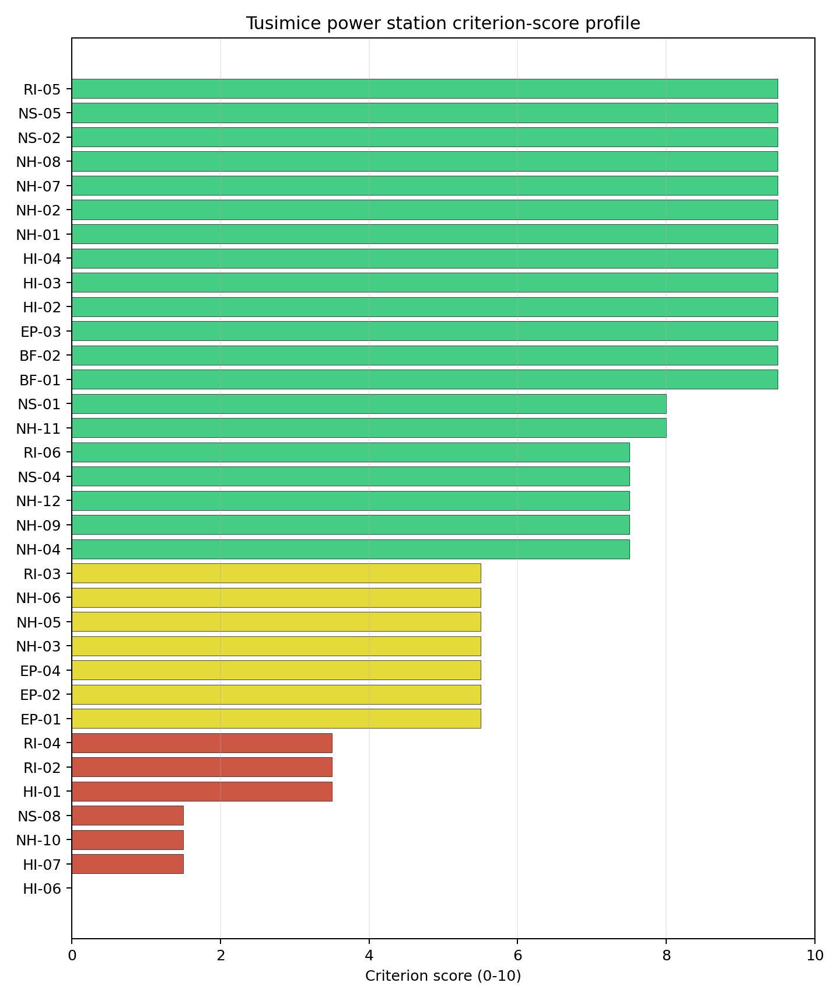
Criterion scores
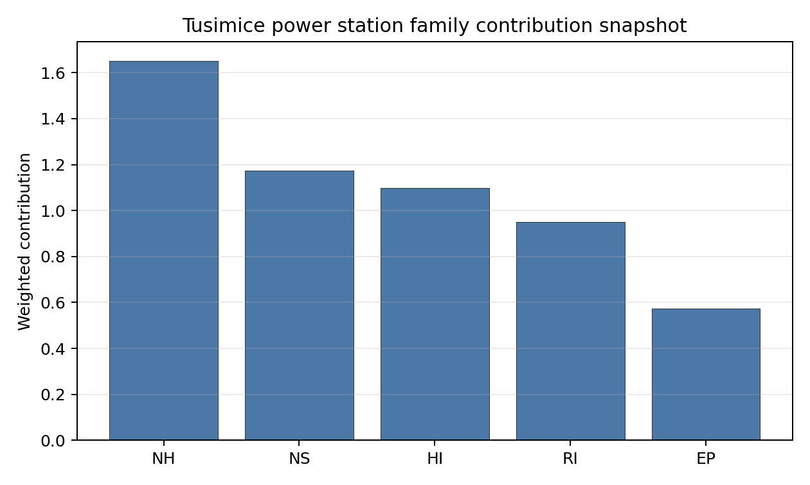
Family contributions
The site records a baseline composite score of 7.095, with a Monte Carlo bracket of 6.144-7.691. Its national stability band is A, with a national top-10% hit rate of 92%. This places the site at national rank 1 in the frozen ranking, but the overlapping top-five intervals mean the rank should guide sequencing rather than settle final preference. Family scores after the unscored-criterion treatment are EP 6.68, HI 6.21, NH 7.27, NS 8.61, RI 6.71; the Stage 3 priority is therefore to retire the avoidance flags and low-scoring criteria that could change the site boundary or emergency-planning case.

Residual Risk Register
Concern | Evidence | Consequence | Stage 3 action | Owner discipline
Aircraft crash avoidance flag | Nearest airport 3.95 km; nearest flight-path proxy 3.95 km | May constrain the usable nuclear island envelope or require detailed aviation-route demonstration. | Run airport, heliport and flight-path micro-siting review against the NuScale reference envelope. | aviation / safety
Military and security proximity | Nearest high-consequence military feature 4.14 km; military features in search radius 391 | Security standoff and emergency-zone coordination could reshape the candidate area. | Confirm feature classification, activity status, and required protective separation with national authorities. | security
Electromagnetic interference | Nearest high-power transmitter 0.97 km; transmitter count 90 | RF/EMI controls may affect instrumentation, communications and site layout. | Survey transmitter inventory, field strength and shielding or separation needs. | electrical / security
Ecological sensitivity | Nearest Natura 2000 site 1.65 km; nearest protected area 0.40 km | Permitting envelope may narrow even without a direct protected-area overlap. | Run protected-area boundary confirmation, receptor-pathway screening and EIA scoping. | environment
Surface-water dispersion | Cooling source Lužický potok; flow 24.6 m3/s | Liquid-pathway dilution and discharge assumptions remain screening-grade. | Model low-flow, intake, discharge and downstream-user pathways. | hydrology
The register defines follow-up work for Stage 3. Approval, licensing readiness and procurement decisions require later evidence beyond this screening profile.

Stage 3 Follow-Up Checklist
Action | Evidence basis | Purpose
Run airport, heliport and flight-path micro-siting review against the NuScale reference envelope. | Aircraft crash avoidance flag: Nearest airport 3.95 km; nearest flight-path proxy 3.95 km | Reduce the main residual uncertainty before detailed site characterisation.
Confirm feature classification, activity status, and required protective separation with national authorities. | Military and security proximity: Nearest high-consequence military feature 4.14 km; military features in search radius 391 | Reduce the main residual uncertainty before detailed site characterisation.
Survey transmitter inventory, field strength and shielding or separation needs. | Electromagnetic interference: Nearest high-power transmitter 0.97 km; transmitter count 90 | Reduce the main residual uncertainty before detailed site characterisation.
Run protected-area boundary confirmation, receptor-pathway screening and EIA scoping. | Ecological sensitivity: Nearest Natura 2000 site 1.65 km; nearest protected area 0.40 km | Reduce the main residual uncertainty before detailed site characterisation.
Model low-flow, intake, discharge and downstream-user pathways. | Surface-water dispersion: Cooling source Lužický potok; flow 24.6 m3/s | Reduce the main residual uncertainty before detailed site characterisation.
Close unscored or low-confidence evidence gaps. | Grid Capacity Basic Filter (BF-01), Land Area Basic Filter (BF-02), Seismic: Surface Rupture (NH-02), Geotechnical: Slope Stability (NH-04). | Improve confidence in the composite score and implementation work plan.

Evidence Limitations
- Grid Capacity Basic Filter (BF-01) - evidence quality low.
- Land Area Basic Filter (BF-02) - evidence quality low.
- Seismic: Surface Rupture (NH-02) - evidence quality low.
- Geotechnical: Slope Stability (NH-04) - evidence quality low.
- Extreme Precipitation (NH-11) - evidence quality low.
- Combined Hazards (NH-14) - evidence quality unscored.
- Cooling Water Availability (NS-01) - evidence quality low.
- Transport Access (NS-03) - evidence quality unscored.
- Site Topography (NS-04) - evidence quality low.
- Existing Infrastructure (NS-06) - evidence quality unscored.

Croatia Country Profile
Croatia has two thermal and coal-site records tested against the NuScale VOYGR-6 reference deployment envelope. No site clears both the exclusionary and avoidance screens, one site passes the exclusionary screen with an avoidance flag, and one site fails an exclusionary check. The country is therefore a constrained brownfield case: Plomin is the only ranked Croatian candidate, while Ploče remains in the evidence base as a hard-fail comparator.
The leading site is Plomin power station, with a composite score of 6.214 and a Monte Carlo interval of 5.467-6.730. Its national stability band is A with a national top-10% hit rate of 100%. The leader is stable within Croatia, but it is not avoidance-clean because Coastal Flooding (NH-08) remains unresolved at screening stage.
Croatia’s brownfield pool is narrow and should be treated as a single-candidate Stage 3 question rather than a fleet sequence. Plomin combines national rank 1, band A stability and 100% top-10 persistence with an avoidance flag on Coastal Flooding (NH-08). The relevant decision is therefore whether a focused Stage 3 package can resolve the low-elevation coastal exposure, land-envelope and ecological constraints around Plomin, not whether Croatia has several equivalent brownfield options.
The unlock pool is one site and one avoidance criterion. Plomin’s NH-08 flag is driven by a sea-coast distance of 3.51 km and a site elevation of 5.88 m, with storm-surge and tsunami exposure still unconfirmed at this screening level. Ploče does not form part of that unlock pool because it fails Seismic: Surface Rupture (NH-02), with the nearest mapped capable fault 3.24 km from the site.
Croatia has regional nuclear-sector exposure through Krško co-ownership, but this screening record does not by itself establish a domestic new-build delivery pathway. A credible programme cadence would start with Plomin only after coastal-flood, land, ecological, security and emergency-planning questions are tested in Stage 3. Expansion beyond Plomin would require a separate greenfield or wider industrial-site search outside the current coal and thermal brownfield pool.

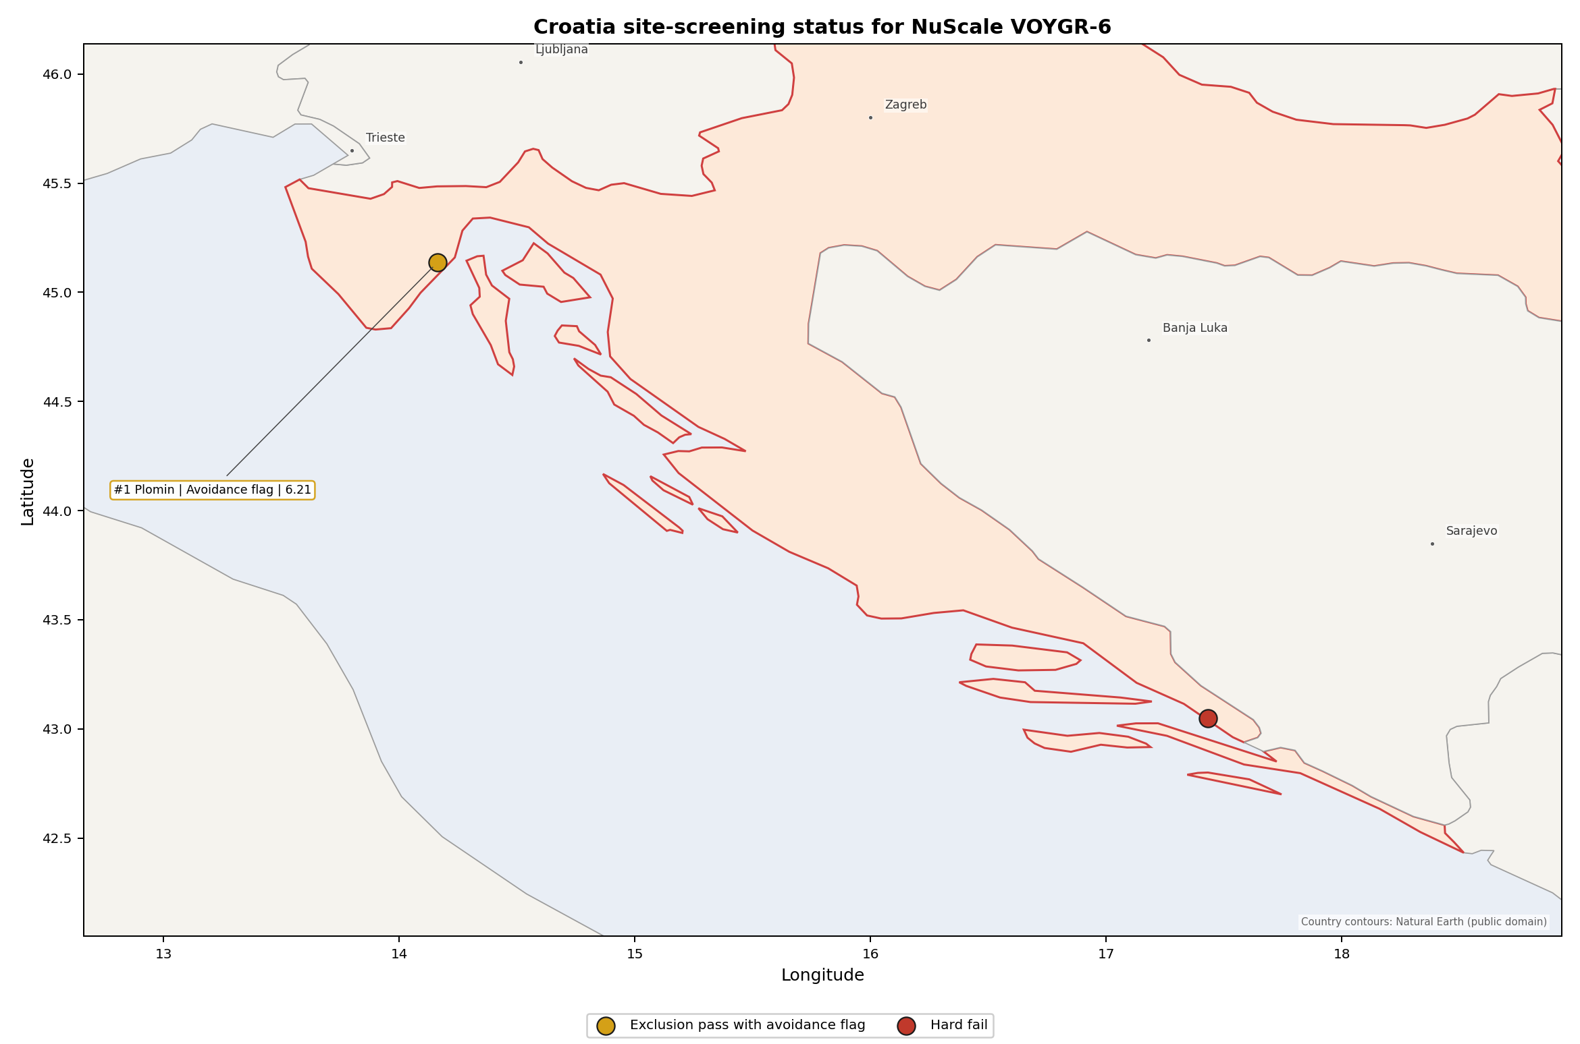
Croatia status map

Croatia Site Ledger
Rank | Site | Status | Composite | MC Low | MC High | Band | Top-10 Hit | Coverage
1 | Plomin power station | Exclusion pass with avoidance flag | 6.214 | 5.467 | 6.730 | A | 100% | 74%
- | Ploče power station | Hard fail | - | - | - | - | - | 0%

Avoidance Flag Pareto
Of the one site that passes the exclusionary screen, the avoidance-phase flag is concentrated in Coastal Flooding (NH-08). Resolving this question is the condition for treating Plomin as a cleaner Stage 3 candidate.
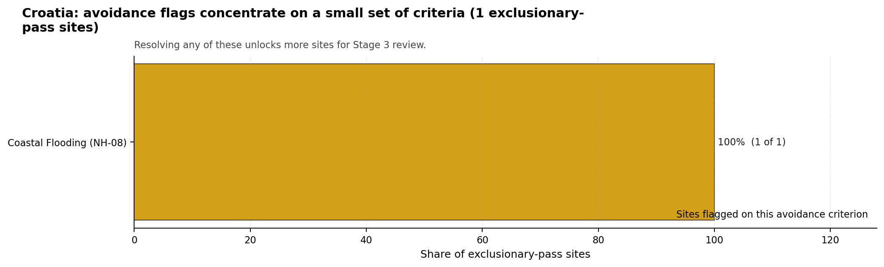
Avoidance flag Pareto
- Coastal Flooding (NH-08) - 1 of 1 exclusionary-pass sites (100%).

Exclusionary Failure Pareto
The exclusionary failures across the country trace back to a small number of criteria. They identify which screening checks are responsible for removing sites from further consideration.
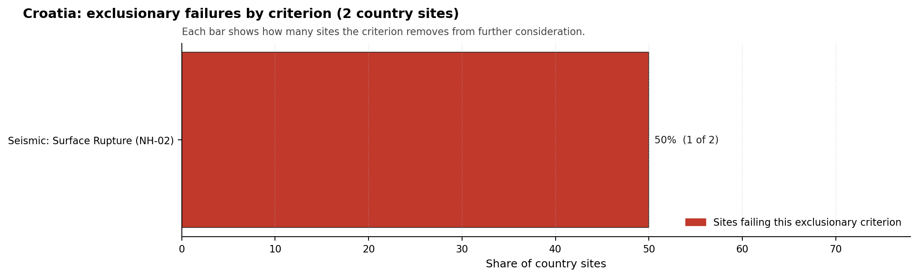
Exclusionary failure Pareto
- Seismic: Surface Rupture (NH-02) - 1 of 2 country sites (50%).

Family Strength and Weakness
Across the country the strongest criterion family is Human-Induced Hazards at a mean normalised score of 7.41/10. The weakest family is Non-Safety / Implementation at 5.13/10. The bottom three individual criteria across the country are:
- Military Installations (HI-06) - mean 0.00/10 across 2 scored sites (min 0.0, max 0.0).
- Ecological Sensitivity (NS-08) - mean 1.50/10 across 2 scored sites (min 1.5, max 1.5).
- Coastal Flooding (NH-08) - mean 1.75/10 across 2 scored sites (min 0.0, max 3.5).

Interpretation for Site Selection
The Croatia result supports a targeted, single-site Stage 3 pathway rather than a multi-site brownfield shortlist. Plomin is the only ranked site and the only site that passes the exclusionary screen. Its avoidance flag means the site should progress only with a tightly scoped coastal-flood and site-envelope work package.

Avoidance flag Pareto - what unlocks more sites
The chart shows where focused remediation effort would broaden the candidate pool. The criteria at the top of the Pareto are the policy and engineering levers that, if resolved, move avoidance-flag sites into the leading group.
An IAEA-style reading of the table focuses less on the exact rank number and more on screening class, score stability, and the nature of remaining uncertainty. Plomin power station is important because it leads nationally and sits inside the strongest stability band. The avoidance flag prevents it from being treated as a clean candidate, but the stable national ranking is a defensible reason to spend Stage 3 effort on field confirmation before reopening lower-ranked or excluded brownfield locations.
The Monte Carlo interval is a caution against false precision: Croatia has only one scored site, so national stability reflects Plomin’s dominance within a small country pool. The decisive distinction is whether Stage 3 can retire the NH-08 avoidance flag while also confirming land, ecology, security and emergency-planning assumptions.
The main Stage 3 questions are therefore targeted rather than generic: confirm coastal flooding and tsunami exposure, test the buildable land envelope, verify ecological permitting constraints, review military and electromagnetic-interference features, and model emergency-planning clearance times for the Istrian setting.

Status Counts
- Full pass: 0
- Exclusion pass with avoidance flag: 1
- Hard fail: 1

Ploče power station Site Profile
Croatia | tested against the NuScale VOYGR-6 reference deployment envelope | Hard-fail at the exclusionary screen.
Ploče power station is a coal/thermal site in Croatia that does not survive the exclusionary screen against the NuScale VOYGR-6 reference deployment envelope. This profile records the screening evidence that drives the failure and provides the siting expert’s read on whether further characterisation is justified. It is not a site-suitability determination, vendor recommendation, or licensing finding.

Site Snapshot
Field | Value
Site name | Ploče power station
Country | Croatia
Coordinates | 43.0500, 17.4333
Subnational unit | Dalmatia
Installed thermal capacity (source data) | 800 MW
Available surface area | 238.7 ha
Available surface area for development | 238.7 ha
Operating status | cancelled
Parent owner(s) | N/A
Generating units on record | 1
Screening verdict | Hard-fail (exclusionary)
Failed exclusionary criteria | NH-02
Composite score | - (not scored)
National stability band | - (not banded)
See the country status map in Croatia Country Profile.

Why It Failed
The site fails one exclusionary criterion. Exclusionary failures act as gates: a single confirmed failure removes the site from the brownfield candidate pool until the underlying measurement is refuted by site-specific Stage 3 work or until a regulatory threshold change makes the failure moot.
Criterion | Code | Measured value | Threshold | Confidence | Justification
Seismic: Surface Rupture | NH-02 | Nearest mapped capable fault: 3.24 km | Capable fault within score-5 pivot distance. | medium | Triggered: capable fault within score-5 pivot distance.

Unlock Analysis
NH-02 Seismic: Surface Rupture fails because the nearest mapped capable fault, HRCF00B, is 3.24 km from the site and has a recorded slip rate of 0.55 mm/yr. This is a structural screening failure for a brownfield envelope rather than a normal data gap: Stage 3 measurement could refine the local seismic model, but it cannot move the mapped fault away from the existing site boundary. Ploče should therefore remain outside the Croatian brownfield candidate pool unless future capable-fault evidence changes the underlying classification or the programme shifts to a different land envelope. Recommendation: Deprecate.

Evidence Limitations
- This profile is intentionally compact. Composite scoring, Monte Carlo stability, family contributions, and the residual risk register are omitted because none of those views are informative for a site that is removed at the exclusionary screen.
- The exclusionary thresholds are screening thresholds; site-specific Stage 3 measurement can either confirm the failure or lift it. The unlock analysis above states whether that investment is justified.

Plomin power station Site Profile
Plomin power station is a coal/thermal site in Croatia that has been tested against the NuScale VOYGR-6 reference deployment envelope. This profile reads the screening evidence at a level that supports a decision to progress toward Stage 3 characterisation. It is not a site-suitability determination, vendor recommendation, or licensing finding.

Site Snapshot
Field | Value
Site name | Plomin power station
Coordinates | 45.1368, 14.1627
Subnational unit | Istra
Installed thermal capacity (source data) | 842 MW
Available surface area | 30.0 ha
Available surface area for development | 21.1 ha
Composite score (baseline weights) | 6.214 (5.467-6.730 MC band)
National stability band | A (top-10% hit rate 100%)
National rank | 1
See the country status map in Croatia Country Profile.

Ownership and Coal-to-Nuclear Context
The ownership record identifies Hrvatska elektroprivreda dd as the owner/operator and records a Government of Croatia ownership path through Hrvatska elektroprivreda dd. Unit-level shares are incomplete for the operating and mothballed phases, so legal control, site rights and any reuse mandate should be confirmed before Stage 3 procurement or permitting work is framed.
Generating units on record: 1 cancelled, 1 mothballed, 1 operating. Earliest unit commissioning: 1969; most recent: 2016.

Natural Hazards (NH)
- Seismic: Ground Motion (NH-01) - score 5.5/10 (MC 5.0-6.0) - pass-mark band: At or below the score-5 risk boundary., weight 0.0455, data quality high. Evidence: PGA at 475-year return period 0.166 g; PGA at 2,475-year return period 0.381 g; Vs30 reference (m/s): 760.0.
- Seismic: Surface Rupture (NH-02) - score 5.5/10 (MC 5.0-6.0) - pass-mark band: Borderline acceptable separation: meets the 8.0 km score boundary; check against the 8 km conservative screen and local capability evidence., weight n/a, data quality screening grade. Evidence: nearest mapped capable fault 15.9 km; fault slip rate 0.102 mm/yr; fault name: HRCF00T.
- Geotechnical: Liquefaction (NH-03) - score 9.5/10 (MC 9.0-10.0) - favourable: Negligible susceptibility (Stage-1 favourable default)., weight n/a, data quality medium. Evidence: liquefaction susceptibility: very_low; dominant soil type: clay_loam.
- Geotechnical: Slope Stability (NH-04) - score 5.5/10 (MC 5.0-6.0) - pass-mark band: At or below the score-5 risk boundary., weight n/a, data quality screening grade. Evidence: site slope 11.9 deg; max slope in 1 km box 85.4 deg; slope stability class: steep.
- Geotechnical: Subsidence (NH-05) - score 5.5/10 (MC 5.0-6.0) - pass-mark band: At or above the mine-distance score-5 pivot; review possible., weight 0.0354, data quality medium. Evidence: karst present: no; karst severity: moderate; formation type: carbonate (Continuous carbonate rocks).
- Geotechnical: Foundation (NH-06) - score 3.5/10 (MC 3.0-4.0), weight 0.0253, data quality medium. Evidence: bearing capacity 77.3 kPa; depth to bedrock 18.2 m.
- Volcanism (NH-07) - score 9.5/10 (MC 9.0-10.0) - favourable: Very strong margin above the score-5 boundary, or no in-radius signal confirmed., weight n/a, data quality high. Evidence: volcanic hazard class: negligible.
- Coastal Flooding (NH-08) - score 3.5/10 (MC 3.0-4.0), weight 0.0303, data quality medium. Evidence: distance to coast 3.51 km.
- River Flooding (NH-09) - score 7.5/10 (MC 7.0-8.0), weight 0.0404, data quality medium. Evidence: flood zone class: negligible.
- Extreme Winds (NH-10) - score 3.5/10 (MC 3.0-4.0), weight 0.0152, data quality medium. Evidence: screening wind-speed index 11.1 m/s.
- Extreme Precipitation (NH-11) - score 2.0/10 (MC 2.0-3.0), weight 0.0152, data quality medium. Evidence: screening extreme-precipitation index 0.82 mm; screening precipitation index 65.5 mm/yr.
- Extreme Temperatures (NH-12) - score 7.5/10 (MC 7.0-8.0), weight 0.0202, data quality medium. Evidence: extreme high temperature 24.7 deg C; extreme low temperature 0.27 deg C.
- Combined Hazards (NH-14) - score 3.5/10 (MC 3.0-4.0), weight 0.0152, data quality n/a. Evidence: values not in measurement tables.

Interpretation - Natural Hazards (NH)
Natural hazards at Plomin support continued screening, but the site remains avoidance-flagged because coastal flooding is unresolved. Ground motion is moderate for the reference envelope, with PGA of 0.166 g at the 475-year return period and 0.381 g at the 2,475-year return period. The nearest mapped capable fault is 15.9 km away, so surface rupture does not drive the exclusionary result for this site. The controlling natural-hazard question is different: Coastal Flooding (NH-08) scores 3.5/10 because the site is 3.51 km from the coast at 5.88 m elevation, with storm-surge and tsunami proxies still unconfirmed. The local ground file also needs field confirmation. Mean site slope is 11.9 degrees, the maximum slope in the one-kilometre box is 85.4 degrees, bearing capacity is 77.3 kPa, and depth to bedrock is 18.2 m. Extreme wind and precipitation also sit in the lower score range, with 11.1 m/s design wind, 65.5 mm/year screening precipitation index and 0.82 mm screening extreme-precipitation index, values that should be checked against national hydrometeorological records before design use. Stage 3 should therefore start with coastal inundation and tsunami screening, followed by boreholes, slope-stability checks and local hydrology confirmation for the buildable patch.

Human-Induced and Security-Relevant Hazards (HI)
- Aircraft Crash (HI-01) - score 9.5/10 (MC 9.0-10.0) - favourable: Only small / GA / heliport airport >= 10 km nearby, no flight-path proxy < 4 km, no major airport within 30 km, and no military airbase within 60 km., weight 0.0354, data quality high. Evidence: nearest airport 26.6 km; nearest flight path 16.5 km; airports within search radius 1; airport name: Cres Heliport; airport type: heliport.
- Industrial Explosions (HI-02) - score 9.5/10 (MC 9.0-10.0) - favourable: Very strong margin above the score-5 boundary (or completed search confirmed no in-radius signal)., weight 0.0354, data quality medium. Evidence: values not in measurement tables.
- Toxic/Gas Releases (HI-03) - score 9.5/10 (MC 9.0-10.0) - favourable: Very strong margin above the score-5 boundary (or completed search confirmed no in-radius signal)., weight 0.0354, data quality medium. Evidence: values not in measurement tables.
- External Fires (HI-04) - score 9.5/10 (MC 9.0-10.0) - favourable: > 15 km, or completed flammable-storage search found nothing in radius., weight 0.0303, data quality medium. Evidence: values not in measurement tables.
- Military Installations (HI-06) - score 0.0/10 (MC 0.0-0.0), weight 0.0303, data quality high. Evidence: nearest military installation 4.25 km; military installations within radius 4; installation name: unnamed.
- Electromagnetic Interference (HI-07) - score 1.5/10 (MC 1.0-2.0), weight 0.0101, data quality medium. Evidence: nearest high-power transmitter 1.67 km; transmitters within radius 41; transmitter type: communication.

Interpretation - Human-Induced and Security-Relevant Hazards (HI)
Human-induced and security-relevant hazards at Plomin are mixed: aviation and industrial hazards are favourable, while military and electromagnetic-interference evidence require early Stage 3 confirmation. Aircraft Crash (HI-01) is strong, with the nearest airport feature, Cres Heliport, 26.6 km away, the nearest flight-path proxy 16.5 km away, and the nearest major airport 33.0 km away. Industrial Explosions (HI-02), Toxic/Gas Releases (HI-03), and External Fires (HI-04) also score 9.5/10 because the available screening record does not identify a nearby hazardous facility in the relevant radius. The binding issue is Military Installations (HI-06), which scores 0.0/10: the nearest depot-class military feature is 4.25 km away and four military features are recorded within 25 km. Electromagnetic Interference (HI-07) is the second weak point, with the nearest communication transmitter 1.67 km away and 41 transmitters in the search radius. Stage 3 should therefore open with Croatian defence engagement on the depot classification and required security standoff, followed by an RF/EMI survey and a refreshed hazardous-neighbour inventory for the coastal industrial and transport setting.

Radiological Impact and Emergency Planning (RI / EP)
- Emergency Planning Feasibility (EP-01) - score 7.5/10 (MC 7.0-8.0), weight n/a, data quality high. Evidence: EP feasibility composite 70.0 /100; road sub-score 49.1 /100; special-population sub-score 90.0 /100; geography sub-score 95.0 /100; population sub-score 95.0 /100; evacuation feasible: yes.
- Evacuation Routes (EP-02) - score 3.5/10 (MC 3.0-4.0), weight 0.0303, data quality medium. Evidence: road density in EPZ 0.451 km/km2; road length in EPZ 885.3 km; motorway access: yes.
- Physical Geography Constraints (EP-03) - score 9.5/10 (MC 9.0-10.0) - favourable: No measured relief; open river/waterway context (interim screening)., weight 0.0253, data quality medium. Evidence: waterways crossing EPZ 0; major river barrier: no.
- Special Populations (EP-04) - score 7.5/10 (MC 7.0-8.0), weight 0.0303, data quality medium. Evidence: hospitals in EPZ 7; prisons in EPZ 0; care homes in EPZ 0.
- Atmospheric Dispersion (RI-01) - score no native score (unscored - no band matched), weight 0.0303, data quality medium. Evidence: annual mean wind speed 1.5 m/s; atmospheric mixing height 431.6 m; prevailing wind direction: NE.
- Surface Water Dispersion (RI-02) - score 1.5/10 (MC 1.0-2.0), weight 0.0253, data quality n/a. Evidence: values not in measurement tables.
- Groundwater Dispersion (RI-03) - score 1.5/10 (MC 1.0-2.0), weight 0.0253, data quality medium. Evidence: aquifer type: karsts and chalkstones.
- Population Density at EPZ Radii (RI-04) - score 7.5/10 (MC 7.0-8.0), weight 0.0404, data quality screening grade. Evidence: population density within 5 km 47.0 /km2; population density within 16 km 31.1 /km2; population density within 25 km 27.7 /km2; population density within 80 km 45.3 /km2; population within 25 km 54,410 people.
- Distance to Population Centres (RI-05) - score 9.5/10 (MC 9.0-10.0) - favourable: Nearest >=50k population-centre proxy exceeds required distance by >= 50 %., weight 0.0505, data quality screening grade. Evidence: nearest city above 50k people 31.2 km; nearest city population 102,415 people; city name: Rijeka.
- Population Projections (RI-06) - score 7.5/10 (MC 7.0-8.0), weight 0.0253, data quality screening grade. Evidence: annual population growth rate -0.494 %/yr; projected population at 25 km in 60 yr 41,042 people.

Interpretation - Radiological Impact and Emergency Planning (RI / EP)
Radiological impact and emergency-planning conditions are one of Plomin’s stronger screening dimensions, but evacuation, surface-water and groundwater pathways need early characterisation. Population pressure is relatively low: the record shows 3,690 people within 5 km, 54,410 within 25 km and 910,646 within 80 km. Population density is 47.0 people/km2 at 5 km and 27.7 people/km2 at 25 km, while Rijeka, the nearest city above 50,000 people, is 31.2 km away. The 60-year population projection is also favourable, with the 25 km population falling to 41,042 people. Emergency Planning Feasibility (EP-01) scores 70.0/100 and is marked feasible, but the road sub-score is only 49.1/100 and Evacuation Routes (EP-02) scores 3.5/10 despite 885.3 km of road and motorway access. Atmospheric dispersion remains screening-grade, with annual mean wind speed of 1.5 m/s, a 431.6 m mixing height and a prevailing NE wind direction. The weaker radiological-pathway items are Surface Water Dispersion (RI-02), which scores 1.5/10 without measured flow evidence in the criterion row, and Groundwater Dispersion (RI-03), which scores 1.5/10 in a karsts-and-chalkstones aquifer setting. Stage 3 should model EPZ time-to-clear for seasonal traffic, quantify liquid-pathway behaviour, and confirm the site-specific meteorological basis before emergency-planning claims are hardened.

Non-Safety and Implementation Considerations (NS)
- Grid Capacity Basic Filter (BF-01) - score 5.5/10 (MC 5.0-6.0) - pass-mark band: Note: substation 15-30 km OR 110-219 kV; reinforcement plausible., weight n/a, data quality n/a. Evidence: values not in measurement tables.
- Land Area Basic Filter (BF-02) - score 1.5/10 (MC 1.0-2.0), weight 0.0253, data quality n/a. Evidence: values not in measurement tables.
- Cooling Water Availability (NS-01) - score 6.0/10 (MC 6.0-7.0) - pass-mark band: aggregated(weighted_mean_of_sub_scores), weight 0.0404, data quality screening grade. Evidence: distance to cooling source 6.59 km; cooling source flow 4.91 m3/s; cooling source type: small_river; cooling source name: Boljunčica; water stress label: Low.
- Grid Connection (NS-02) - score 5.5/10 (MC 5.0-6.0) - pass-mark band: aggregated(min_of_sub_scores), weight 0.0404, data quality high. Evidence: nearest substation 0.32 km; nearest high-voltage line 0.3 km; highest nearby line voltage 110.0 kV; grid export capacity 842.0 MW; substations within radius 291; HV lines within radius 384.
- Transport Access (NS-03) - score no native score (unscored - no band matched), weight 0.0404, data quality low. Evidence: not measured at this site (criterion remains unscored).
- Site Topography (NS-04) - score 1.5/10 (MC 1.0-2.0), weight 0.0303, data quality screening grade. Evidence: favourable land cover 6.4 %; moderate land cover 15.9 %; unfavourable land cover 71.0 %; favourable area 7.49 ha; dominant land class: 311.
- Site Footprint Adequacy (NS-05) - score 7.5/10 (MC 7.0-8.0), weight 0.0253, data quality high. Evidence: buildable area 21.1 ha; largest contiguous patch 21.1 ha; buildable patch count 8.
- Existing Infrastructure (NS-06) - score no native score (unscored - no band matched), weight 0.0253, data quality n/a. Evidence: not measured at this site (criterion remains unscored).
- Ecological Sensitivity (NS-08) - score 1.5/10 (MC 1.0-2.0), weight n/a, data quality high. Evidence: natural land cover 71.0 %; distance to nearest Natura 2000 site 2.968 km; distance to nearest protected area 1.567 km; Natura 2000 overlap: no; Natura 2000 sensitivity class: moderate; protected-area overlap: no; protected-area sensitivity class: moderate; nearest Natura 2000 site: Čepić tunel; Natura 2000 sites within 5 km: 4; nearest protected-area designation: Significant Landscape.
- Workforce Availability (NS-10) - score no native score (unscored - no band matched), weight 0.0202, data quality n/a. Evidence: not measured at this site (criterion remains unscored).
- Regulatory/Political Environment (NS-12) - score no native score (unscored - no band matched), weight 0.0303, data quality n/a. Evidence: not measured at this site (criterion remains unscored).
- Construction Logistics (NS-13) - score no native score (unscored - no band matched), weight 0.0202, data quality n/a. Evidence: not measured at this site (criterion remains unscored).

Interpretation - Non-Safety and Implementation Considerations (NS)
Non-safety implementation is Plomin’s most constrained family. The site has useful inherited infrastructure, but the land, terrain and ecological envelope is tight for a NuScale VOYGR-6 reference case. The canonical site footprint is 30.0 ha and the current buildable-area estimate is 21.1 ha; this supports continued screening but leaves the Land Area Basic Filter (BF-02) at 1.5/10. Site Topography (NS-04) also scores 1.5/10, with only 6.4% favourable land cover, 15.9% moderate land cover and 71.0% unfavourable land cover. The 7.49 ha favourable-area value is a wider screening indicator, not proof of available, permitted or contiguous development land. Cooling Water Availability (NS-01) scores 6.0/10, with the Boljunčica source 6.59 km away and a recorded flow of 4.91 m3/s under a Low water-stress label. Grid Connection (NS-02) is workable but not definitive, with the nearest substation 0.32 km away, the nearest high-voltage line 0.30 km away, a highest nearby voltage of 110 kV and an 842 MW grid export-capacity estimate. Ecological Sensitivity (NS-08) is the main non-safety constraint, scoring 1.5/10 because Čepić tunel is 2.968 km away, four Natura 2000 sites sit within 5 km, and the nearest protected area is 1.567 km away. Stage 3 should confirm the land envelope, ecological assessment pathway, grid-voltage upgrade route, cooling basis and ownership rights before any layout claim is made.

Composite Score and Stability
Baseline composite score is 6.214, bracketed by Monte Carlo at 5.467-6.730. National stability band is A with a top-10% hit rate of 100% across 12 scored Monte Carlo scenarios.
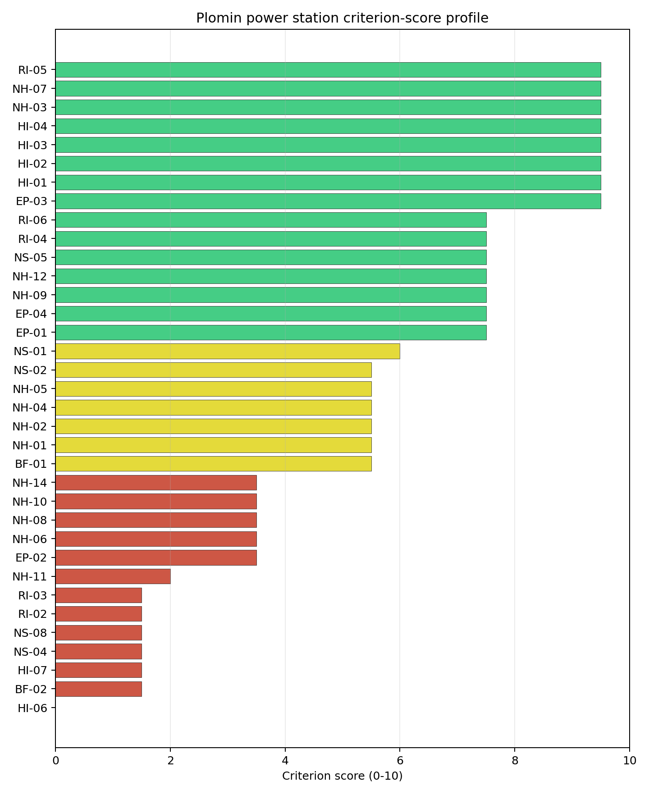
Criterion scores
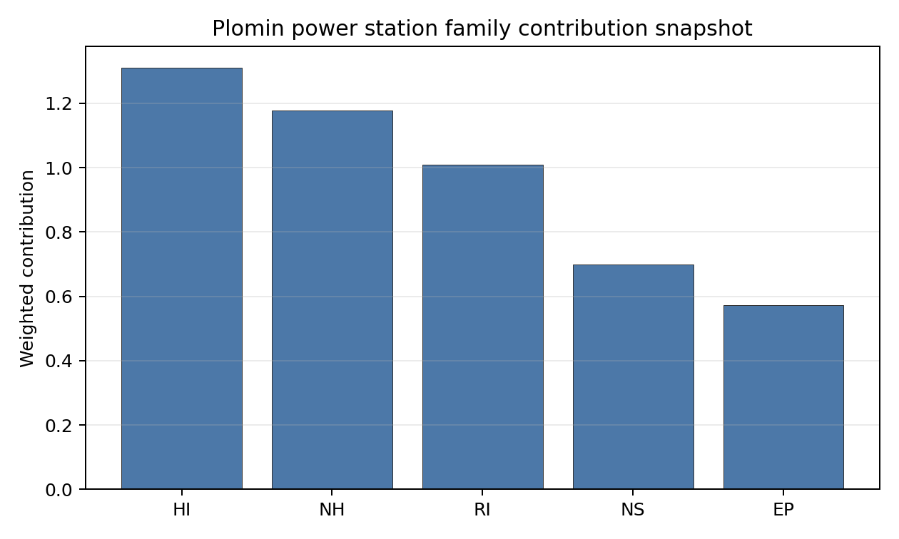
Family contributions
Plomin’s baseline composite score is 6.214, bracketed by a Monte Carlo interval of 5.467-6.730. The national stability band is A, and the site records 100% top-5, top-10 and top-30 hit rates across 12 scored national sensitivity scenarios. That is a robust national signal, but it needs careful interpretation because Croatia has only one scored site: Plomin is stable within the Croatian pool while still carrying an avoidance flag. The score is supported by Distance to Population Centres (RI-05), Aircraft Crash (HI-01), Industrial Explosions (HI-02), Toxic/Gas Releases (HI-03), River Flooding (NH-09), Population Density (RI-04), and Grid Connection (NS-02). The same composite is pulled down by Military Installations (HI-06), Land Area Basic Filter (BF-02), Electromagnetic Interference (HI-07), Site Topography (NS-04), Ecological Sensitivity (NS-08), Surface Water Dispersion (RI-02), and Groundwater Dispersion (RI-03). Stage 3 should therefore narrow the uncertainty band by resolving NH-08 coastal exposure, confirming the buildable land envelope, and testing the security, ecological and liquid-pathway assumptions before Plomin is treated as a clean progression candidate.

Residual Risk Register
Concern | Evidence | Consequence | Stage 3 action | Owner discipline
Coastal Flooding (NH-08) | Coast distance 3.51 km; site elevation 5.88 m | Storm-surge or tsunami exposure could keep the site in avoidance status | Model coastal inundation, storm surge and tsunami exposure for the Plomin Bay setting | hydrology
Land Area Basic Filter (BF-02) and Site Topography (NS-04) | Site footprint 30.0 ha; buildable area 21.1 ha; favourable land cover 6.4% | Layout, laydown or earthworks constraints could limit a VOYGR-6 envelope | Re-survey the controlled land boundary, terrain and contiguous buildable patch | geotech
Ecological Sensitivity (NS-08) | Čepić tunel is 2.968 km away; four Natura 2000 sites lie within 5 km | Permitting could narrow the usable site envelope or require early design changes | Confirm receptor pathways and appropriate-assessment triggers | EIA
Military Installations (HI-06) | Nearest depot-class feature 4.25 km away; four military features within 25 km | Security standoff or emergency-zone coordination could affect siting boundaries | Engage Croatian defence authorities on feature classification and required standoff | security
Electromagnetic Interference (HI-07) | Nearest transmitter 1.67 km away; 41 transmitters in the search radius | RF/EMI constraints may require equipment qualification or exclusion-zone controls | Survey transmitter inventory, field strengths and control measures | security
Surface Water and Groundwater Dispersion (RI-02 / RI-03) | Surface-water criterion row lacks measured flow evidence; aquifer type is karsts and chalkstones | Liquid-pathway assumptions may be too coarse for emergency-planning and dose-pathway screening | Quantify site-specific liquid pathways, groundwater behaviour and receiving-water assumptions | hydrology
The dominant residual risks are NH-08, the constrained land envelope, and ecological sensitivity because they could determine whether Plomin moves from an avoidance-flagged screened site to a clean Stage 3 candidate. HI-06, HI-07 and the liquid-pathway questions are characterisation tasks that should run in parallel. The register is a Stage 3 work plan, not a finding of final site suitability.

Stage 3 Follow-Up Checklist
- Resolve Coastal Flooding (NH-08) avoidance flag by modelling the 3.51 km coast-distance and 5.88 m elevation case for storm surge and tsunami exposure.
- Re-measure Military Installations (HI-06) - native score 0.0/10 with confidence high.
- Re-measure Land Area Basic Filter (BF-02) - native score 1.5/10 with confidence insufficient.
- Re-measure Electromagnetic Interference (HI-07) - native score 1.5/10 with confidence medium.
- Re-measure Site Topography (NS-04) - native score 1.5/10 with confidence medium.
- Re-measure Ecological Sensitivity (NS-08) - native score 1.5/10 with confidence high.
- Improve data quality for Transport Access (NS-03) - current flag low.

Evidence Limitations
- Transport Access (NS-03) - quality low.

Hungary Country Profile
Hungary has 11 thermal and coal-site records tested against the NuScale VOYGR-6 reference deployment envelope. One site passes both the exclusionary and avoidance screens, 10 sites pass the exclusionary screen but retain avoidance flags, and no site fails the exclusionary screen. The country is therefore a broad brownfield pool with one clear screening leader and a larger unlock pool whose value depends on resolving recurring grid, aircraft, toxic-release, land-footprint and population-distance constraints.
Hungary already has civil nuclear-power experience, so the Stage 3 programme can focus on site-specific characterisation while still refreshing regulatory, emergency-planning, workforce and public-stakeholder interfaces for a brownfield SMR envelope. The leading site is Mohacs power station, with a composite score of 7.584 and a Monte Carlo interval of 6.705-8.075. Its national stability band is A with a national top-10% hit rate of 100%, making it the only Hungarian site that combines a full-pass status with the strongest national stability signal.
Hungary’s 11 ranked thermal-site records produce one full-pass site and 10 exclusionary-pass sites with avoidance flags. Mohacs is the current leadership pool on its own: it records a full pass, a 7.584 composite score, an A national stability band and a 100% national top-10 hit rate. Borsod and Tiszapalkonya form the first follower tier by point estimate, but both remain avoidance-flag candidates and sit in band D; Matraterenye and Torony complete the top-five selected profile set, but both sit in band H and need stronger confirmation before they can be treated as robust fast followers.
The avoidance unlock pool is large and defines the national work programme. Grid Connection (NS-02) affects 8 of the 11 exclusionary-pass sites, Aircraft Crash (HI-01) affects 7, Toxic/Gas Releases (HI-03) affects 6, and Site Footprint Adequacy (NS-05) and Distance to Population Centres (RI-05) each affect 4. The practical unlock work is therefore not a single-site issue: it requires transmission-path confirmation, aircraft and flight-path screening, hazardous-neighbour verification, land-footprint confirmation and population-centre micro-modelling across the national pool.
A credible Stage 3 sequence begins with Mohacs as the full-characterisation lead. Borsod and Tiszapalkonya should be treated as the first avoidance-flagged candidates to revisit after the national grid and hazardous-neighbour checks are resolved, while Matraterenye and Torony are useful comparators for different constraint types: Matraterenye for land and grid limitations in a lower-population setting, and Torony for population-distance and aircraft constraints near Szombathely. Greenfield options remain a programme lever if the eventual build-out target exceeds what the brownfield pool can support.

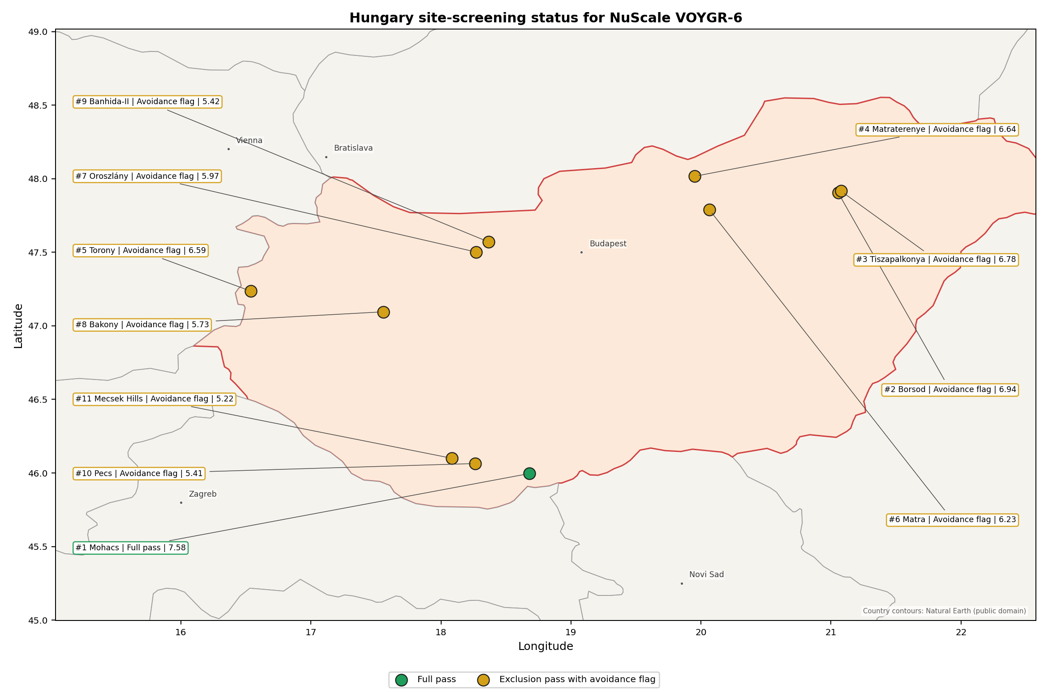
Hungary status map

Hungary Site Ledger
Rank | Site | Status | Composite | MC Low | MC High | Band | Top-10 Hit | Coverage
1 | Mohacs power station | Full pass | 7.584 | 6.705 | 8.075 | A | 100% | 76%
2 | Borsod power station | Exclusion pass with avoidance flag | 6.941 | 6.184 | 7.381 | D | 0% | 76%
3 | Tiszapalkonya power station | Exclusion pass with avoidance flag | 6.778 | 6.053 | 7.319 | D | 0% | 76%
4 | Matraterenye power station | Exclusion pass with avoidance flag | 6.641 | 5.795 | 7.158 | H | 0% | 74%
5 | Torony power station | Exclusion pass with avoidance flag | 6.595 | 5.760 | 7.059 | H | 0% | 74%
6 | Matra power station | Exclusion pass with avoidance flag | 6.230 | 5.480 | 6.691 | H | 0% | 74%
7 | Oroszlány power station | Exclusion pass with avoidance flag | 5.967 | 5.278 | 6.480 | H | 0% | 74%
8 | Bakony power station | Exclusion pass with avoidance flag | 5.730 | 5.096 | 6.191 | H | 0% | 74%
9 | Banhida-II power station | Exclusion pass with avoidance flag | 5.418 | 4.856 | 5.954 | H | 0% | 74%
10 | Pecs power station | Exclusion pass with avoidance flag | 5.411 | 4.851 | 5.977 | H | 0% | 74%
11 | Mecsek Hills power station | Exclusion pass with avoidance flag | 5.220 | 4.705 | 5.806 | H | 0% | 74%

Avoidance Flag Pareto
Of the 11 sites that pass the exclusionary screen, the avoidance-phase flags concentrate on five criteria. The denominator in each bullet is the full exclusionary-pass pool, not the top-five selected profile set.
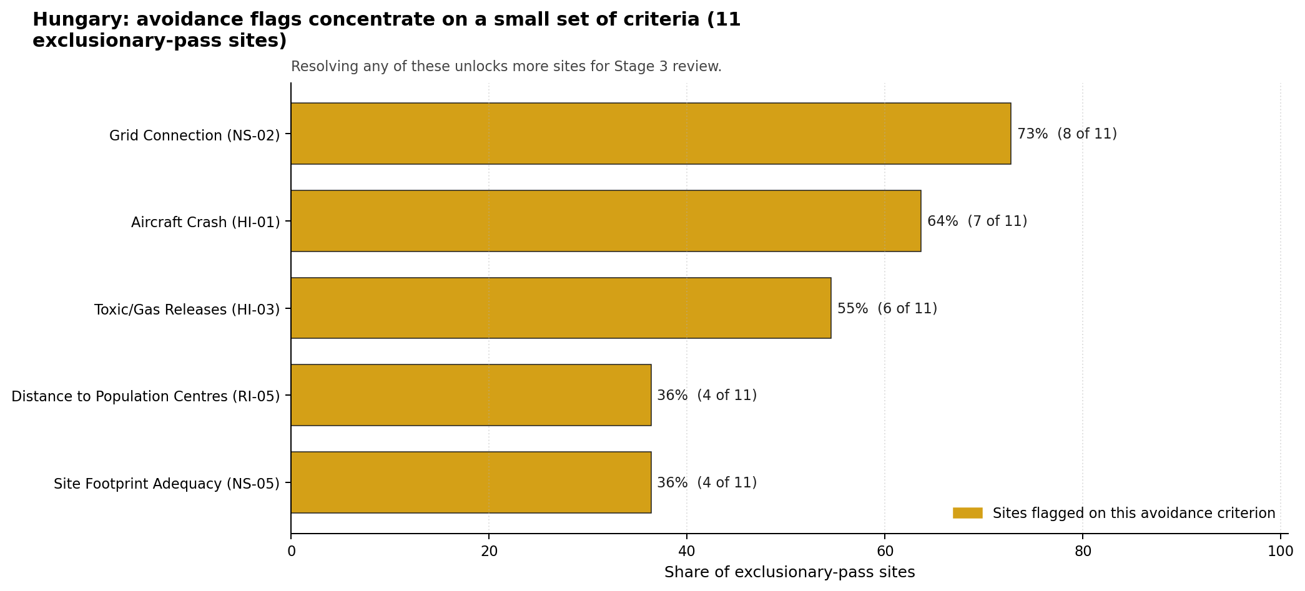
Avoidance flag Pareto
- Grid Connection (NS-02) - 8 of 11 exclusionary-pass sites (73%) - this criterion controls how quickly the avoidance-flag pool can be converted into Stage 3 characterisation candidates.
- Aircraft Crash (HI-01) - 7 of 11 exclusionary-pass sites (64%) - this criterion controls how quickly the avoidance-flag pool can be converted into Stage 3 characterisation candidates.
- Toxic/Gas Releases (HI-03) - 6 of 11 exclusionary-pass sites (55%) - this criterion controls how quickly the avoidance-flag pool can be converted into Stage 3 characterisation candidates.
- Site Footprint Adequacy (NS-05) - 4 of 11 exclusionary-pass sites (36%) - this criterion controls how quickly the avoidance-flag pool can be converted into Stage 3 characterisation candidates.
- Distance to Population Centres (RI-05) - 4 of 11 exclusionary-pass sites (36%) - this criterion controls how quickly the avoidance-flag pool can be converted into Stage 3 characterisation candidates.

Family Strength and Weakness
Across the country the strongest criterion family is Natural Hazards at a mean normalised score of 7.22/10. The weakest family is Non-Safety / Implementation at 5.55/10, closely followed by Human-Induced Hazards at 5.71/10. The bottom three individual criteria across the country are:
- Military Installations (HI-06) - mean 1.14/10 across 11 scored sites (min 0.0, max 3.5).
- Electromagnetic Interference (HI-07) - mean 1.50/10 across 11 scored sites (min 1.5, max 1.5).
- Grid Connection (NS-02) - mean 2.95/10 across 11 scored sites (min 1.5, max 5.5).

National Sensitivity and Robustness
The national sensitivity analysis separates Mohacs from the rest of the Hungarian brownfield pool. Mohacs remains in band A with a 100% national top-10 hit rate, while Borsod and Tiszapalkonya sit in band D and the remaining ranked sites sit in band H. The Monte Carlo intervals still overlap across the follower tier, so exact rank differences between Borsod, Tiszapalkonya, Matraterenye and Torony should not be overread before the avoidance flags are resolved.

Interpretation for Site Selection
The selected detailed site profiles are the top five nationally ranked sites under the frozen run: Mohacs, Borsod, Tiszapalkonya, Matraterenye and Torony. Mohacs is the only site that currently supports direct progression toward Stage 3 characterisation without an avoidance unlock. Borsod and Tiszapalkonya are the most credible fast-follower candidates because their scores are close to the leader and their limiting issues are specific: hazardous-neighbour and grid checks rather than exclusionary failures.

Avoidance flag Pareto - what unlocks more sites
The chart shows the national remediation agenda for the exclusionary-pass pool. Grid-connection work has the largest denominator, aircraft and toxic-release checks define the main human-induced hazard agenda, and land-footprint and population-distance checks determine whether the follower tier can be elevated beyond comparator status. The absence of hard-fail sites is useful, but it does not make the pool uniformly ready: avoidance-flagged sites remain contingent until the relevant Stage 3 work confirms the measured constraints.

Status Counts
- Full pass: 1 (Mohacs)
- Exclusion pass with avoidance flag: 10
- Hard fail: 0

Borsod power station Site Profile
Borsod power station is a coal/thermal site in Hungary that has been tested against the NuScale VOYGR-6 reference deployment envelope. This profile reads the screening evidence at a level that supports a decision to progress toward Stage 3 characterisation. It is not a site-suitability determination, vendor recommendation, or licensing finding.

Site Snapshot
Field | Value
Site name | Borsod power station
Coordinates | 47.9048, 21.0553
Subnational unit | Northern Hungary
Installed thermal capacity (source data) | 420 MW
Available surface area | 66.0 ha
Available surface area for development | 66.0 ha
Composite score (baseline weights) | 6.941 (6.184-7.381 MC band)
National stability band | D (top-10% hit rate 0%)
National rank | 2
See the country status map in Hungary Country Profile.

Ownership and Coal-to-Nuclear Context
- Blackrock Advisors LLC (0.36% share), headquartered in United States; immediate operator AES Corp. Path: Blackrock Advisors LLC -> BlackRock Inc [5.07%] -> AES Corp [7.09%] -> Borsod power station New Unit 2 [100.0%]
- AES Corp (100.00% share), headquartered in United States; immediate operator AES Corp. Path: AES Corp -> Borsod power station Unit 3 [100.0%]
- BlackRock Inc (7.09% share), headquartered in United States; immediate operator AES Corp. Path: BlackRock Inc -> AES Corp [7.09%] -> Borsod power station New Unit 2 [100.0%]
- small shareholder(s) (80.58% share); immediate operator AES Corp. Path: small shareholder(s) -> AES Corp [80.58%] -> Borsod power station Unit 1 [100.0%]
- The Vanguard Group Inc (12.33% share), headquartered in United States; immediate operator AES Corp. Path: The Vanguard Group Inc -> AES Corp [12.33%] -> Borsod power station New Unit 2 [100.0%]
Generating units on record: 2 cancelled, 3 retired. Earliest unit commissioning: 1951; most recent: 1951. Retirements span 2011 to 2011, leaving brownfield grid, water, transport, and workforce assets that materially shorten Stage 3 site preparation.

Natural Hazards (NH)
- Seismic: Ground Motion (NH-01) - score 7.5/10 (MC 7.0-8.0), weight 0.0455, data quality high. Evidence: PGA at 475-year return period 0.045 g; PGA at 2,475-year return period 0.105 g; Vs30 reference (m/s): 760.0.
- Seismic: Surface Rupture (NH-02) - score 9.5/10 (MC 9.0-10.0), weight n/a, data quality screening grade. Evidence: nearest mapped capable fault 50.0 km; fault slip rate 0 mm/yr; fault name: none_in_search_radius.
- Geotechnical: Liquefaction (NH-03) - score 5.5/10 (MC 5.0-6.0), weight n/a, data quality medium. Evidence: liquefaction susceptibility: high; dominant soil type: clay_loam.
- Geotechnical: Slope Stability (NH-04) - score 9.5/10 (MC 9.0-10.0), weight n/a, data quality screening grade. Evidence: site slope 3.57 deg; max slope in 1 km box 41.7 deg; slope stability class: gentle.
- Geotechnical: Subsidence (NH-05) - score 7.5/10 (MC 7.0-8.0), weight 0.0354, data quality medium. Evidence: karst present: no; karst severity: none.
- Geotechnical: Foundation (NH-06) - score 5.5/10 (MC 5.0-6.0), weight 0.0253, data quality medium. Evidence: bearing capacity 84.0 kPa; depth to bedrock 22.8 m.
- Volcanism (NH-07) - score 9.5/10 (MC 9.0-10.0), weight n/a, data quality high. Evidence: volcanic hazard class: negligible.
- Coastal Flooding (NH-08) - score 9.5/10 (MC 9.0-10.0), weight 0.0303, data quality medium. Evidence: distance to coast 569.9 km.
- River Flooding (NH-09) - score 7.5/10 (MC 7.0-8.0), weight 0.0404, data quality medium. Evidence: flood zone class: negligible.
- Extreme Winds (NH-10) - score 7.5/10 (MC 7.0-8.0), weight 0.0152, data quality medium. Evidence: screening wind-speed index 7.71 m/s.
- Extreme Precipitation (NH-11) - score 8.0/10 (MC 8.0-9.0), weight 0.0152, data quality medium. Evidence: screening extreme-precipitation index 0.23 mm; screening precipitation index 21.2 mm/yr.
- Extreme Temperatures (NH-12) - score 6.5/10 (MC 6.0-7.0), weight 0.0202, data quality medium. Evidence: extreme high temperature 25.9 deg C; extreme low temperature -6.51 deg C.
- Combined Hazards (NH-14) - score 7.5/10 (MC 7.0-8.0), weight 0.0152, data quality n/a. Evidence: values not in measurement tables.

Interpretation - Natural Hazards (NH)
Natural hazards at Borsod are favourable overall, with the main Stage 3 questions on Tisza flood behaviour and alluvial geotechnics. The 475-year PGA is 0.045 g and the 2,475-year PGA is 0.105 g, the lowest loading in the selected Hungarian group, and the nearest mapped capable fault is 50.0 km away. The site is gentle, with a mean slope of 3.57 degrees and a maximum one-kilometre slope of 41.69 degrees, but liquefaction susceptibility is high on clay loam and the foundation proxy is 84.0 kPa bearing capacity with 22.77 m depth to bedrock. The site is 569.94 km from the coast, flood-zone class is negligible at screening level, screening wind-speed index is 7.71 m/s, and temperatures range from -6.51 deg C to 25.95 deg C. Stage 3 should confirm Tisza design-basis flood levels, liquefaction susceptibility and precipitation inputs.

Human-Induced and Security-Relevant Hazards (HI)
- Aircraft Crash (HI-01) - score 9.5/10 (MC 9.0-10.0), weight 0.0354, data quality high. Evidence: nearest airport 31.8 km; nearest flight path 24.1 km; airports within search radius 0; airport name: Miskolc Heliport; airport type: heliport.
- Industrial Explosions (HI-02) - score 9.5/10 (MC 9.0-10.0), weight 0.0354, data quality high. Evidence: nearest industrial site 3 km.
- Toxic/Gas Releases (HI-03) - score 1.5/10 (MC 1.0-2.0), weight 0.0354, data quality high. Evidence: nearest toxic source 3 km.
- External Fires (HI-04) - score 9.5/10 (MC 9.0-10.0), weight 0.0303, data quality high. Evidence: values not in measurement tables.
- Military Installations (HI-06) - score 0.0/10 (MC 0.0-0.0), weight 0.0303, data quality high. Evidence: nearest military installation 0.39 km; military installations within radius 6; installation name: unnamed.
- Electromagnetic Interference (HI-07) - score 1.5/10 (MC 1.0-2.0), weight 0.0101, data quality medium. Evidence: nearest high-power transmitter 1.17 km; transmitters within radius 132; transmitter type: water_tower.

Interpretation - Human-Induced and Security-Relevant Hazards (HI)
Human-induced hazards are Borsod’s limiting family. The aircraft screen is favourable, with Miskolc Heliport 31.84 km away, the nearest flight path 24.13 km away and no airports inside the 30 km search radius. The binding issue is Toxic/Gas Releases (HI-03): the nearest toxic source is 3.0 km from the site, inside the 8 km avoidance threshold. Industrial-neighbour evidence also records an industrial site 3.0 km away. Military Installations (HI-06) is severe, with a depot-class feature 0.39 km away and six military features within 25 km. Electromagnetic Interference (HI-07) is weak, with the nearest transmitter 1.17 km away and 132 transmitters in the search radius. Stage 3 should therefore begin with hazardous-cloud assessment, military-feature confirmation and an EMI survey before Borsod is elevated from avoidance-flagged status.

Radiological Impact and Emergency Planning (RI / EP)
- Emergency Planning Feasibility (EP-01) - score 5.5/10 (MC 5.0-6.0), weight n/a, data quality high. Evidence: EP feasibility composite 64.7 /100; road sub-score 48.8 /100; special-population sub-score 90.0 /100; geography sub-score 95.0 /100; population sub-score 80.0 /100; evacuation feasible: yes.
- Evacuation Routes (EP-02) - score 3.5/10 (MC 3.0-4.0), weight 0.0303, data quality medium. Evidence: road density in EPZ 0.446 km/km2; road length in EPZ 875.2 km; motorway access: yes.
- Physical Geography Constraints (EP-03) - score 9.5/10 (MC 9.0-10.0), weight 0.0253, data quality medium. Evidence: waterways crossing EPZ 0; major river barrier: no.
- Special Populations (EP-04) - score 7.5/10 (MC 7.0-8.0), weight 0.0303, data quality medium. Evidence: hospitals in EPZ 3; prisons in EPZ 0; care homes in EPZ 0.
- Atmospheric Dispersion (RI-01) - unscored (no matched band), weight 0.0303, data quality medium. Evidence: annual mean wind speed 0.91 m/s; atmospheric mixing height 518.7 m; prevailing wind direction: N.
- Surface Water Dispersion (RI-02) - score 9.5/10 (MC 9.0-10.0), weight 0.0253, data quality n/a. Evidence: values not in measurement tables.
- Groundwater Dispersion (RI-03) - score 5.5/10 (MC 5.0-6.0), weight 0.0253, data quality medium. Evidence: aquifer type: alluvial.
- Population Density at EPZ Radii (RI-04) - score 5.5/10 (MC 5.0-6.0), weight 0.0404, data quality screening grade. Evidence: population density within 5 km 235.9 /km2; population density within 16 km 86.7 /km2; population density within 25 km 76.5 /km2; population density within 80 km 91.7 /km2; population within 25 km 150,225 people.
- Distance to Population Centres (RI-05) - score 9.5/10 (MC 9.0-10.0), weight 0.0505, data quality screening grade. Evidence: nearest city above 50k people 33.7 km; nearest city population 143,502 people; city name: Miskolc.
- Population Projections (RI-06) - score 5.5/10 (MC 5.0-6.0), weight 0.0253, data quality screening grade. Evidence: annual population growth rate 0.115 %/yr; projected population at 25 km in 60 yr 139,693 people.

Interpretation - Radiological Impact and Emergency Planning (RI / EP)
Radiological and emergency-planning evidence is usable but not clean enough to offset the human-hazard constraint. Population density is 235.94 people/km2 within 5 km, 86.66 people/km2 within 16 km and 76.52 people/km2 within 25 km, with 150,225 people inside 25 km. Miskolc, population 143,502, is 33.73 km away, so no city above 50,000 people sits inside the 25 km EPZ. The EP feasibility composite is 64.7/100 and evacuation is marked feasible, but the road sub-score is 48.8/100 and road density is 0.446 km/km2 despite motorway access and 875.19 km of roads. The Tisza provides a strong surface-water dilution context, but alluvial groundwater and the petrochemical-neighbour setting require integrated emergency modelling. Stage 3 should combine EPZ traffic modelling with hazardous-cloud and radiological release scenarios.

Non-Safety and Implementation Considerations (NS)
- Grid Capacity Basic Filter (BF-01) - score 5.5/10 (MC 5.0-6.0), weight n/a, data quality n/a. Evidence: values not in measurement tables.
- Land Area Basic Filter (BF-02) - score 5.5/10 (MC 5.0-6.0), weight 0.0253, data quality n/a. Evidence: values not in measurement tables.
- Cooling Water Availability (NS-01) - score 10.0/10 (MC 9.0-10.0), weight 0.0404, data quality screening grade. Evidence: distance to cooling source 0.49 km; cooling source flow 549.2 m3/s; cooling source type: major_river; cooling source name: Tisza; water stress label: Low.
- Grid Connection (NS-02) - score 3.5/10 (MC 3.0-4.0), weight 0.0404, data quality high. Evidence: nearest substation 1.56 km; nearest high-voltage line 0.29 km; highest nearby line voltage 132.0 kV; grid export capacity 420.0 MW; substations within radius 84; HV lines within radius 599.
- Transport Access (NS-03) - score 9.0/10 (MC 8.0-9.0), weight 0.0404, data quality high. Evidence: nearest highway 0.53 km; nearest rail line 0.71 km; nearest waterway 18.6 km; heavy-haul capable: yes.
- Site Topography (NS-04) - score 7.5/10 (MC 7.0-8.0), weight 0.0303, data quality screening grade. Evidence: favourable land cover 78.6 %; moderate land cover 0 %; unfavourable land cover 17.0 %; favourable area 168.7 ha; dominant land class: 211.
- Site Footprint Adequacy (NS-05) - score 7.5/10 (MC 7.0-8.0), weight 0.0253, data quality medium. Evidence: buildable area 66.0 ha; largest contiguous patch 39.0 ha; buildable patch count 12.
- Existing Infrastructure (NS-06) - unscored (no matched band), weight 0.0253, data quality n/a. Evidence: not measured at this site (criterion remains unscored).
- Ecological Sensitivity (NS-08) - score 1.5/10 (MC 1.0-2.0), weight n/a, data quality high. Evidence: natural land cover 17.0 %; distance to nearest Natura 2000 site 1.706 km; distance to nearest protected area 4.867 km; Natura 2000 overlap: no; Natura 2000 sensitivity class: moderate; protected-area overlap: no; protected-area sensitivity class: low; nearest Natura 2000 site: Tiszaújvárosi ártéri erdők; Natura 2000 sites within 5 km: 3; nearest protected-area designation: Landscape Protection Area.
- Workforce Availability (NS-10) - unscored (no matched band), weight 0.0202, data quality n/a. Evidence: not measured at this site (criterion remains unscored).
- Regulatory/Political Environment (NS-12) - unscored (no matched band), weight 0.0303, data quality n/a. Evidence: not measured at this site (criterion remains unscored).
- Construction Logistics (NS-13) - unscored (no matched band), weight 0.0202, data quality n/a. Evidence: not measured at this site (criterion remains unscored).

Interpretation - Non-Safety and Implementation Considerations (NS)
Borsod has strong physical implementation attributes but remains avoidance-flagged on grid capacity. The Tisza is 0.49 km away with a recorded flow of 549.23 m3/s and a Low water-stress label. Transport access is strong: highway access is 0.53 km away, rail is 0.71 km away, a waterway is 18.55 km away and heavy-haul capability is recorded. The canonical site footprint is 66.01 ha, with the same current development-area value and a wider favourable-area screen of 168.74 ha. The grid interface is the main implementation constraint: the nearest substation is 1.56 km away, the nearest high-voltage line is 0.29 km away, the highest nearby voltage is 132 kV, and the inherited export-capacity estimate is 420 MW. Stage 3 should test the 220 kV or 400 kV upgrade path and verify whether the 66.01 ha footprint remains available and contiguous under current ownership and land-use constraints.

Composite Score and Stability
Baseline composite score is 6.941, bracketed by Monte Carlo at 6.184-7.381. National stability band is D with a top-10% hit rate of 0% across 12 scored Monte Carlo scenarios.
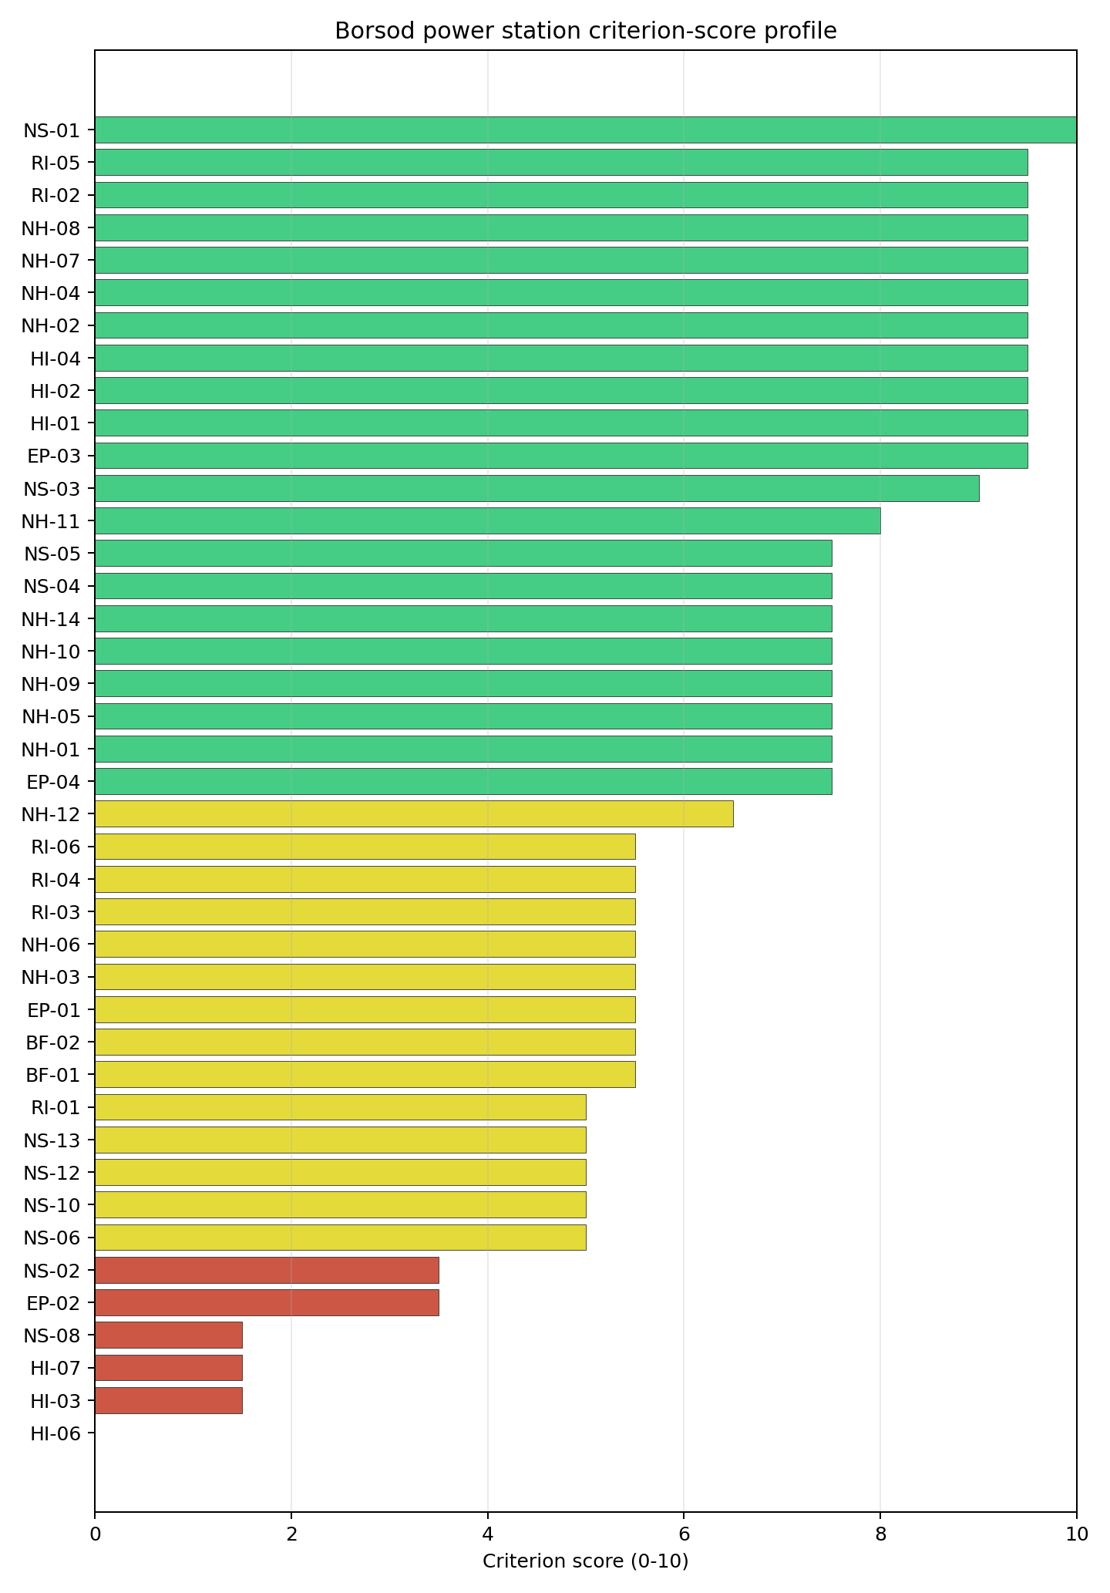
Criterion scores
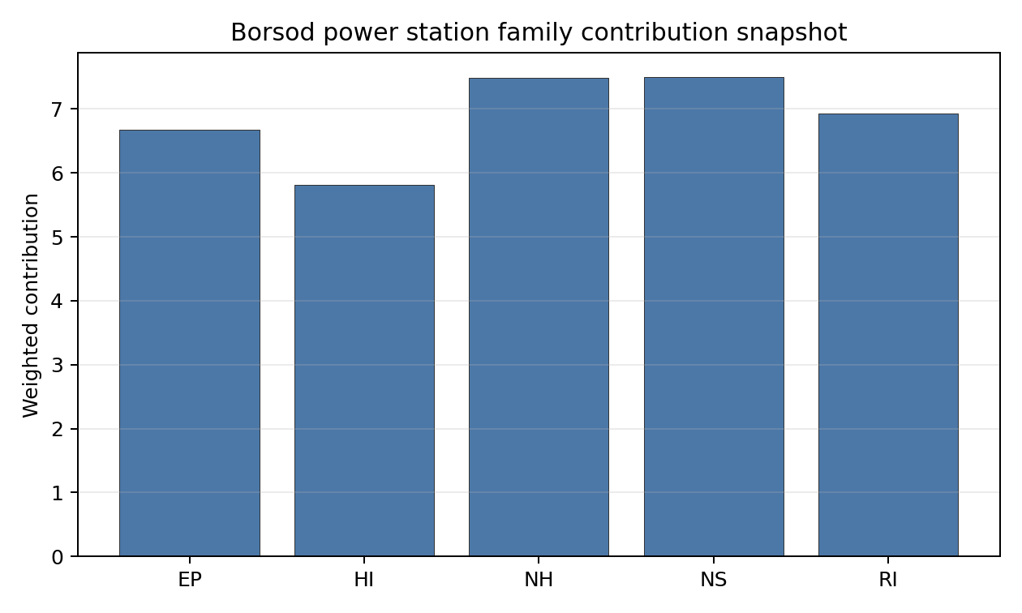
Family contributions
Borsod has a baseline composite score of 6.941 and a Monte Carlo bracket of 6.184-7.381. Its national stability band is D, with a 0% national top-10 hit rate and a 100% national top-30 hit rate across the scored national sensitivity scenarios. The site is therefore a strong follower by point estimate, but it is not a robust national leader under the weight perturbations considered. The family profile is led by NS 7.50 and NH 7.49, with RI 6.93 and EP 6.68 supporting the case, while HI 5.81 carries the hazardous-neighbour and military-feature drag. The fastest way to narrow the uncertainty band is to resolve HI-03, HI-06 and NS-02.

Residual Risk Register
Concern | Evidence | Consequence | Stage 3 action | Owner discipline
Toxic/Gas Releases (HI-03) | Nearest toxic source 3.0 km; avoidance threshold 8 km | Hazardous-cloud exposure may prevent the site from moving into the full-pass group | Model hazardous-cloud envelopes and source inventories | security
Military Installations (HI-06) | Nearest depot-class feature 0.39 km; six military features within 25 km | Security standoff or emergency-interface constraints may become controlling | Confirm feature classification and required standoff distances | security
Grid Connection (NS-02) | Grid export capacity 420 MW; highest nearby voltage 132 kV | Export capacity and voltage path may be insufficient for the reference envelope | Confirm transmission upgrade and reinforcement scope | grid
Evacuation Routes (EP-02) | Road density 0.446 km/km2; 875.19 km of road; motorway access present | EPZ clearance may be constrained by local road geometry and industrial traffic | Model time-to-clear under radiological and hazardous-cloud scenarios | emergency planning
Geotechnical: Liquefaction (NH-03) | High liquefaction susceptibility; bearing capacity 84.0 kPa | Foundation design margins may depend on alluvial-soil treatment | Re-measure liquefaction and bearing conditions | geotech
Borsod’s register is dominated by HI-03, HI-06 and NS-02. The site remains valuable as a fast-follower candidate, but only if those avoidance flags can be resolved with measured Stage 3 evidence.

Stage 3 Follow-Up Checklist
- Resolve Toxic/Gas Releases (HI-03) avoidance flag - confirm hazardous-source distance and consequence envelope against the 8 km avoidance screen.
- Resolve Grid Connection (NS-02) avoidance flag - confirm deliverable export capacity and voltage pathway for the reference deployment envelope.
- Re-measure Military Installations (HI-06) - native score 0.0/10 with confidence high.
- Re-measure Toxic/Gas Releases (HI-03) - native score 1.5/10 with confidence high.
- Re-measure Electromagnetic Interference (HI-07) - native score 1.5/10 with confidence medium.
- Re-measure Ecological Sensitivity (NS-08) - native score 1.5/10 with confidence high.
- Re-measure Evacuation Routes (EP-02) - native score 3.5/10 with confidence medium.

Evidence Limitations
- No criterion-family quality fields are flagged as low or missing in this bundle.

Matraterenye power station Site Profile
Matraterenye power station is a coal/thermal site in Hungary that has been tested against the NuScale VOYGR-6 reference deployment envelope. This profile reads the screening evidence at a level that supports a decision to progress toward Stage 3 characterisation. It is not a site-suitability determination, vendor recommendation, or licensing finding.

Site Snapshot
Field | Value
Site name | Matraterenye power station
Coordinates | 48.0167, 19.9500
Subnational unit | Northern Hungary
Installed thermal capacity (source data) | 49 MW
Available surface area | 98.5 ha
Available surface area for development | 1.2 ha
Composite score (baseline weights) | 6.641 (5.795-7.158 MC band)
National stability band | H (top-10% hit rate 0%)
National rank | 4
See the country status map in Hungary Country Profile.

Ownership and Coal-to-Nuclear Context
- Herco Holdings (nan% share), headquartered in Belgium; immediate operator Elso Nogradi Eromu. Path: Herco Holdings -> Elso Nogradi Eromu [unknown %] -> Matraterenye power station – [100.0%]
Generating units on record: 1 cancelled.

Natural Hazards (NH)
- Seismic: Ground Motion (NH-01) - score 7.5/10 (MC 7.0-8.0), weight 0.0455, data quality high. Evidence: PGA at 475-year return period 0.049 g; PGA at 2,475-year return period 0.114 g; Vs30 reference (m/s): 760.0.
- Seismic: Surface Rupture (NH-02) - score 9.5/10 (MC 9.0-10.0), weight n/a, data quality screening grade. Evidence: nearest mapped capable fault 50.0 km; fault slip rate 0 mm/yr; fault name: none_in_search_radius.
- Geotechnical: Liquefaction (NH-03) - score 5.5/10 (MC 5.0-6.0), weight n/a, data quality medium. Evidence: liquefaction susceptibility: moderate; dominant soil type: clay_loam.
- Geotechnical: Slope Stability (NH-04) - score 5.5/10 (MC 5.0-6.0), weight n/a, data quality screening grade. Evidence: site slope 10.1 deg; max slope in 1 km box 86.1 deg; slope stability class: steep.
- Geotechnical: Subsidence (NH-05) - score 3.5/10 (MC 3.0-4.0), weight 0.0354, data quality medium. Evidence: karst present: no; karst severity: none.
- Geotechnical: Foundation (NH-06) - score 5.5/10 (MC 5.0-6.0), weight 0.0253, data quality medium. Evidence: bearing capacity 88.7 kPa; depth to bedrock 25.3 m.
- Volcanism (NH-07) - score 9.5/10 (MC 9.0-10.0), weight n/a, data quality high. Evidence: volcanic hazard class: negligible.
- Coastal Flooding (NH-08) - score 9.5/10 (MC 9.0-10.0), weight 0.0303, data quality medium. Evidence: distance to coast 508.9 km.
- River Flooding (NH-09) - score 7.5/10 (MC 7.0-8.0), weight 0.0404, data quality medium. Evidence: flood zone class: negligible.
- Extreme Winds (NH-10) - score 7.5/10 (MC 7.0-8.0), weight 0.0152, data quality medium. Evidence: screening wind-speed index 8.28 m/s.
- Extreme Precipitation (NH-11) - score 8.0/10 (MC 7.0-8.0), weight 0.0152, data quality medium. Evidence: screening extreme-precipitation index 0.29 mm; screening precipitation index 26.6 mm/yr.
- Extreme Temperatures (NH-12) - score 6.5/10 (MC 6.0-7.0), weight 0.0202, data quality medium. Evidence: extreme high temperature 23.1 deg C; extreme low temperature -7.17 deg C.
- Combined Hazards (NH-14) - score 5.5/10 (MC 5.0-6.0), weight 0.0152, data quality n/a. Evidence: values not in measurement tables.

Interpretation - Natural Hazards (NH)
Natural hazards at Matraterenye are acceptable for screening but weaker than the Tisza and Danube sites. The 475-year PGA is 0.049 g and the 2,475-year PGA is 0.114 g, and the nearest mapped capable fault is 50.0 km away. Liquefaction susceptibility is moderate and bearing capacity is 88.7 kPa, but slope and subsidence require attention: mean site slope is 10.09 degrees, the one-kilometre maximum is 86.08 degrees, and the nearest mapped mining feature is 1.189 km away. The site is 508.93 km from the coast, river-flood class is negligible at screening level, screening wind-speed index is 8.28 m/s, and temperatures range from -7.17 deg C to 23.07 deg C. Stage 3 should focus on slope stability, mining-related subsidence and local geotechnical confirmation before treating the natural-hazard envelope as settled.

Human-Induced and Security-Relevant Hazards (HI)
- Aircraft Crash (HI-01) - score 9.5/10 (MC 9.0-10.0), weight 0.0354, data quality high. Evidence: nearest airport 10.8 km; nearest flight path 5.41 km; airports within search radius 3; airport name: Bátonyterenye-Világosipuszta sportreptér; airport type: small airfield.
- Industrial Explosions (HI-02) - score 9.5/10 (MC 9.0-10.0), weight 0.0354, data quality high. Evidence: nearest industrial site 26.8 km.
- Toxic/Gas Releases (HI-03) - score 7.5/10 (MC 7.0-8.0), weight 0.0354, data quality high. Evidence: nearest toxic source 26.8 km.
- External Fires (HI-04) - score 9.5/10 (MC 9.0-10.0), weight 0.0303, data quality high. Evidence: values not in measurement tables.
- Military Installations (HI-06) - score 1.5/10 (MC 1.0-2.0), weight 0.0303, data quality medium. Evidence: nearest military installation 10.6 km; military installations within radius 5; installation name: Bem József laktanya.
- Electromagnetic Interference (HI-07) - score 1.5/10 (MC 1.0-2.0), weight 0.0101, data quality medium. Evidence: nearest high-power transmitter 1.21 km; transmitters within radius 150; transmitter type: communication.

Interpretation - Human-Induced and Security-Relevant Hazards (HI)
Human-induced hazards at Matraterenye are not the main reason for its low stability band, but they still need targeted confirmation. The nearest airport is Bátonyterenye-Világosipuszta sportreptér at 10.82 km, with the nearest flight-path proxy 5.41 km away and three airports in the search radius. The nearest industrial and toxic-release source is 26.78 km away, which is favourable compared with Borsod and Tiszapalkonya. Military Installations (HI-06) remains weak because Bem József laktanya is 10.64 km away and five military features are recorded within 25 km. Electromagnetic Interference (HI-07) is also weak, with a communication transmitter 1.21 km away and 150 transmitters in the search radius. Stage 3 should verify aviation use, military-feature status and EMI exposure before the site is considered beyond comparator status.

Radiological Impact and Emergency Planning (RI / EP)
- Emergency Planning Feasibility (EP-01) - score 7.5/10 (MC 7.0-8.0), weight n/a, data quality high. Evidence: EP feasibility composite 66.4 /100; road sub-score 34.5 /100; special-population sub-score 90.0 /100; geography sub-score 95.0 /100; population sub-score 95.0 /100; evacuation feasible: yes.
- Evacuation Routes (EP-02) - score 3.5/10 (MC 3.0-4.0), weight 0.0303, data quality medium. Evidence: road density in EPZ 0.375 km/km2; road length in EPZ 735.8 km; motorway access: no.
- Physical Geography Constraints (EP-03) - score 9.5/10 (MC 9.0-10.0), weight 0.0253, data quality medium. Evidence: waterways crossing EPZ 0; major river barrier: no.
- Special Populations (EP-04) - score 5.5/10 (MC 5.0-6.0), weight 0.0303, data quality medium. Evidence: hospitals in EPZ 12; prisons in EPZ 0; care homes in EPZ 1.
- Atmospheric Dispersion (RI-01) - unscored (no matched band), weight 0.0303, data quality medium. Evidence: annual mean wind speed 0.72 m/s; atmospheric mixing height 439.1 m; prevailing wind direction: NNE.
- Surface Water Dispersion (RI-02) - score 1.5/10 (MC 1.0-2.0), weight 0.0253, data quality n/a. Evidence: values not in measurement tables.
- Groundwater Dispersion (RI-03) - score 5.5/10 (MC 5.0-6.0), weight 0.0253, data quality medium. Evidence: aquifer type: sedimentary sands.
- Population Density at EPZ Radii (RI-04) - score 5.5/10 (MC 5.0-6.0), weight 0.0404, data quality screening grade. Evidence: population density within 5 km 75.6 /km2; population density within 16 km 96.7 /km2; population density within 25 km 76.0 /km2; population density within 80 km 103.1 /km2; population within 25 km 149,129 people.
- Distance to Population Centres (RI-05) - score 9.5/10 (MC 9.0-10.0), weight 0.0505, data quality screening grade. Evidence: nearest city above 50k people 56.3 km; nearest city population 143,502 people; city name: Miskolc.
- Population Projections (RI-06) - score 7.5/10 (MC 7.0-8.0), weight 0.0253, data quality screening grade. Evidence: annual population growth rate -0.347 %/yr; projected population at 25 km in 60 yr 138,671 people.

Interpretation - Radiological Impact and Emergency Planning (RI / EP)
Radiological and emergency-planning conditions at Matraterenye are moderate, with a lower immediate population density but a weaker road envelope. Population density is 75.63 people/km2 within 5 km, 96.71 people/km2 within 16 km and 75.96 people/km2 within 25 km, with 149,129 people inside 25 km. Miskolc, population 143,502, is 56.34 km away, and the 60-year 25 km population projection is 138,671 people. The EP feasibility composite is 66.4/100 and evacuation is marked feasible, but road density is only 0.375 km/km2, the road sub-score is 34.5/100, and motorway access is not recorded. The EPZ includes 12 hospitals and one care home. Stage 3 should prioritise road-network modelling, hospital evacuation assumptions and surface-water dispersion confirmation, since RI-02 remains weak.

Non-Safety and Implementation Considerations (NS)
- Grid Capacity Basic Filter (BF-01) - score 5.5/10 (MC 5.0-6.0), weight n/a, data quality n/a. Evidence: values not in measurement tables.
- Land Area Basic Filter (BF-02) - score 1.5/10 (MC 1.0-2.0), weight 0.0253, data quality n/a. Evidence: values not in measurement tables.
- Cooling Water Availability (NS-01) - score 6.0/10 (MC 6.0-7.0), weight 0.0404, data quality screening grade. Evidence: distance to cooling source 8.98 km; cooling source flow 0.96 m3/s; cooling source type: small_river; cooling source name: Zagyva; water stress label: Low.
- Grid Connection (NS-02) - score 1.5/10 (MC 1.0-2.0), weight 0.0404, data quality high. Evidence: nearest substation 10.7 km; nearest high-voltage line 6.26 km; highest nearby line voltage 132.0 kV; grid export capacity 49.9 MW; substations within radius 75; HV lines within radius 309.
- Transport Access (NS-03) - unscored (no matched band), weight 0.0404, data quality low. Evidence: not measured at this site (criterion remains unscored).
- Site Topography (NS-04) - score 5.5/10 (MC 5.0-6.0), weight 0.0303, data quality screening grade. Evidence: favourable land cover 48.8 %; moderate land cover 11.7 %; unfavourable land cover 32.2 %; favourable area 98.5 ha; dominant land class: 231.
- Site Footprint Adequacy (NS-05) - score 9.5/10 (MC 7.5-10.0), weight 0.0253, data quality low. Evidence: buildable area 1.17 ha; largest contiguous patch 1.17 ha; buildable patch count 11.
- Existing Infrastructure (NS-06) - unscored (no matched band), weight 0.0253, data quality n/a. Evidence: not measured at this site (criterion remains unscored).
- Ecological Sensitivity (NS-08) - score 5.5/10 (MC 5.0-6.0), weight n/a, data quality high. Evidence: natural land cover 32.2 %; distance to nearest Natura 2000 site 8.414 km; distance to nearest protected area 7.636 km; Natura 2000 overlap: no; Natura 2000 sensitivity class: low; protected-area overlap: no; protected-area sensitivity class: low; nearest Natura 2000 site: Mátra; Natura 2000 sites within 5 km: 0; nearest protected-area designation: Nature Conservation Area.
- Workforce Availability (NS-10) - unscored (no matched band), weight 0.0202, data quality n/a. Evidence: not measured at this site (criterion remains unscored).
- Regulatory/Political Environment (NS-12) - unscored (no matched band), weight 0.0303, data quality n/a. Evidence: not measured at this site (criterion remains unscored).
- Construction Logistics (NS-13) - unscored (no matched band), weight 0.0202, data quality n/a. Evidence: not measured at this site (criterion remains unscored).

Interpretation - Non-Safety and Implementation Considerations (NS)
Matraterenye is materially constrained on implementation. The Zagyva is 8.98 km away with a recorded flow of 0.96 m3/s and a Low water-stress label, which is a limited cooling-water envelope for the reference deployment case. The grid position is also weak: the nearest substation is 10.71 km away, the nearest high-voltage line is 6.26 km away, the highest nearby voltage is 132 kV and the inherited export-capacity estimate is only 49.9 MW. The land hierarchy is mixed. The canonical site footprint is 98.54 ha, but the current development-area value is only 1.17 ha, and the wider favourable-area screen does not prove controlled or developable land. Stage 3 should therefore test whether the site has any realistic VOYGR-6 layout, grid and cooling pathway before major characterisation spend is committed.

Composite Score and Stability
Baseline composite score is 6.641, bracketed by Monte Carlo at 5.795-7.158. National stability band is H with a top-10% hit rate of 0% across 12 scored Monte Carlo scenarios.
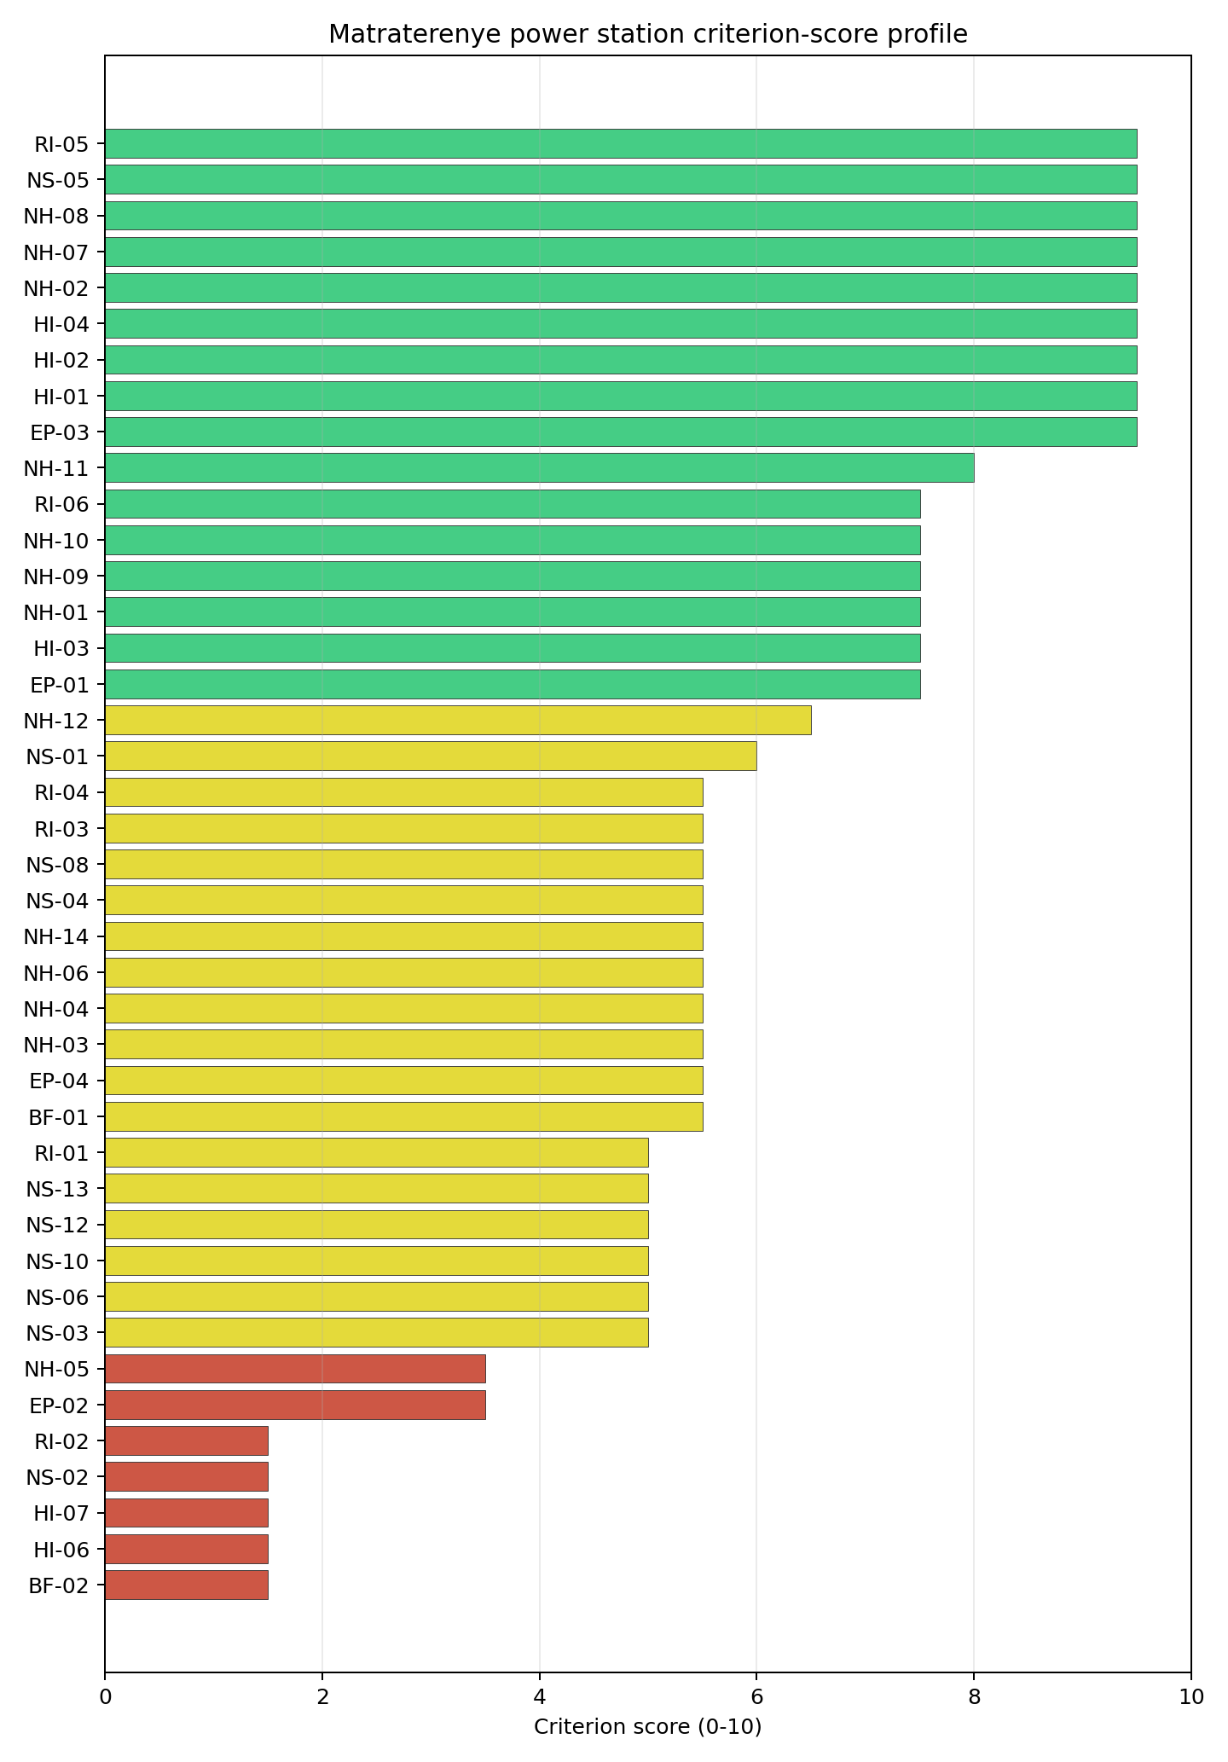
Criterion scores
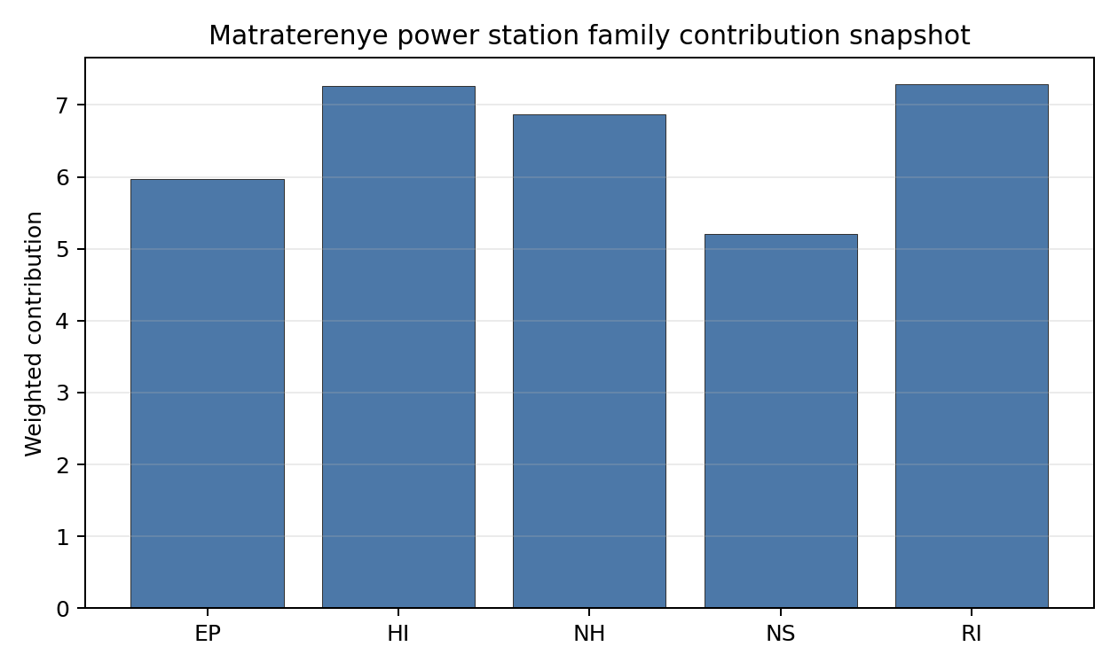
Family contributions
Matraterenye has a baseline composite score of 6.641 and a Monte Carlo bracket of 5.795-7.158. Its national stability band is H, with a 0% national top-10 hit rate across the scored national sensitivity scenarios. The point estimate is high enough to justify inclusion in the top-five selected profiles, but the national sensitivity result is fragile. RI 7.29, HI 7.27 and NH 6.87 support the score, while NS 5.20 and EP 5.97 expose the practical weakness: grid, cooling, developable land and evacuation-road capacity. Stage 3 value would come first from proving whether the site has a credible infrastructure pathway at all.

Residual Risk Register
Concern | Evidence | Consequence | Stage 3 action | Owner discipline
Grid Connection (NS-02) | Grid export capacity 49.9 MW; nearest substation 10.71 km; highest nearby voltage 132 kV | The grid pathway may be too weak for the reference deployment envelope | Confirm transmission reinforcement feasibility and cost class | grid
Site Footprint Adequacy (NS-05) | Canonical footprint 98.54 ha; current development-area value 1.17 ha | Usable land may be far smaller than the nominal site footprint | Re-survey controlled, contiguous and developable land | ownership/legal
Cooling Water Availability (NS-01) | Zagyva 8.98 km away; recorded flow 0.96 m3/s | Cooling-water strategy may require closed-cycle assumptions or an alternative source | Quantify low-flow availability and cooling configuration | hydrology
Evacuation Routes (EP-02) | Road density 0.375 km/km2; motorway access not recorded | EPZ clearance may be constrained by local road capacity | Model evacuation routes and road-upgrade needs | emergency planning
Geotechnical: Subsidence (NH-05) | Nearest mapped mining feature 1.189 km; mean site slope 10.09 degrees | Ground stability and earthworks scope may affect the site boundary | Re-measure mining, slope and foundation conditions | geotech
Matraterenye’s residual register is dominated by infrastructure feasibility. It is useful as a top-five comparator, but its Stage 3 case should be gated by grid, land and cooling confirmation.

Stage 3 Follow-Up Checklist
- Resolve Grid Connection (NS-02) avoidance flag - confirm deliverable export capacity and voltage pathway for the reference deployment envelope.
- Re-measure Land Area Basic Filter (BF-02) - native score 1.5/10 with confidence insufficient.
- Re-measure Military Installations (HI-06) - native score 1.5/10 with confidence medium.
- Re-measure Electromagnetic Interference (HI-07) - native score 1.5/10 with confidence medium.
- Re-measure Grid Connection (NS-02) - native score 1.5/10 with confidence high.
- Re-measure Surface Water Dispersion (RI-02) - native score 1.5/10 with confidence insufficient.
- Improve data quality for Transport Access (NS-03) - current flag low.
- Improve data quality for Site Footprint Adequacy (NS-05) - current flag low.

Evidence Limitations
- Transport Access (NS-03) - quality low.
- Site Footprint Adequacy (NS-05) - quality low.

Mohacs power station Site Profile
Mohacs power station is a coal/thermal site in Hungary that has been tested against the NuScale VOYGR-6 reference deployment envelope. This profile reads the screening evidence at a level that supports a decision to progress toward Stage 3 characterisation. It is not a site-suitability determination, vendor recommendation, or licensing finding.

Site Snapshot
Field | Value
Site name | Mohacs power station
Coordinates | 45.9959, 18.6798
Subnational unit | Southern Transdanubia
Installed thermal capacity (source data) | 1,200 MW
Available surface area | 30.2 ha
Available surface area for development | 30.2 ha
Composite score (baseline weights) | 7.584 (6.705-8.075 MC band)
National stability band | A (top-10% hit rate 100%)
National rank | 1
See the country status map in Hungary Country Profile.

Ownership and Coal-to-Nuclear Context
- Qatar Investment Authority (1.36% share), headquartered in Qatar; immediate operator E.ON SE. Path: Qatar Investment Authority -> Qatar Holding LLC [100.0%] -> RWE AG [9.1%] -> E.ON SE [15.0%] -> Mohacs power station – [100.0%]
- RWE AG (15.00% share), headquartered in Germany; immediate operator E.ON SE. Path: RWE AG -> E.ON SE [15.0%] -> Mohacs power station – [100.0%]
- Blackrock Advisors LLC (0.27% share), headquartered in United States; immediate operator E.ON SE. Path: Blackrock Advisors LLC -> BlackRock Inc [5.07%] -> E.ON SE [5.4%] -> Mohacs power station – [100.0%]
- Qatar Holding LLC (1.36% share), headquartered in Qatar; immediate operator E.ON SE. Path: Qatar Holding LLC -> RWE AG [9.1%] -> E.ON SE [15.0%] -> Mohacs power station – [100.0%]
- natural person(s) (1.80% share); immediate operator E.ON SE. Path: natural person(s) -> RWE AG [12.0%] -> E.ON SE [15.0%] -> Mohacs power station – [100.0%]
- Government of Qatar (1.36% share), headquartered in Qatar; immediate operator E.ON SE. Path: Government of Qatar -> Qatar Investment Authority [100.0%] -> Qatar Holding LLC [100.0%] -> RWE AG [9.1%] -> E.ON SE [15.0%] -> Mohacs power station – [100.0%]
- E.ON SE (100.00% share), headquartered in Germany; immediate operator E.ON SE. Path: E.ON SE -> Mohacs power station – [100.0%]
- BlackRock Inc (5.40% share), headquartered in United States; immediate operator E.ON SE. Path: BlackRock Inc -> E.ON SE [5.4%] -> Mohacs power station – [100.0%]
- small shareholder(s) (79.60% share); immediate operator E.ON SE. Path: small shareholder(s) -> E.ON SE [79.6%] -> Mohacs power station – [100.0%]
- The Vanguard Group Inc (0.47% share), headquartered in United States; immediate operator E.ON SE. Path: The Vanguard Group Inc -> BlackRock Inc [8.66%] -> E.ON SE [5.4%] -> Mohacs power station – [100.0%]
Generating units on record: 1 cancelled.

Natural Hazards (NH)
- Seismic: Ground Motion (NH-01) - score 7.5/10 (MC 7.0-8.0), weight 0.0455, data quality high. Evidence: PGA at 475-year return period 0.054 g; PGA at 2,475-year return period 0.121 g; Vs30 reference (m/s): 760.0.
- Seismic: Surface Rupture (NH-02) - score 9.5/10 (MC 9.0-10.0), weight n/a, data quality screening grade. Evidence: nearest mapped capable fault 50.0 km; fault slip rate 0 mm/yr; fault name: none_in_search_radius.
- Geotechnical: Liquefaction (NH-03) - score 5.5/10 (MC 5.0-6.0), weight n/a, data quality medium. Evidence: liquefaction susceptibility: high; dominant soil type: silty_clay_loam.
- Geotechnical: Slope Stability (NH-04) - score 7.5/10 (MC 7.0-8.0), weight n/a, data quality screening grade. Evidence: site slope 6.82 deg; max slope in 1 km box 77.9 deg; slope stability class: moderate.
- Geotechnical: Subsidence (NH-05) - score 7.5/10 (MC 7.0-8.0), weight 0.0354, data quality medium. Evidence: karst present: no; karst severity: none.
- Geotechnical: Foundation (NH-06) - score 5.5/10 (MC 5.0-6.0), weight 0.0253, data quality medium. Evidence: bearing capacity 91.3 kPa; depth to bedrock 21.5 m.
- Volcanism (NH-07) - score 9.5/10 (MC 9.0-10.0), weight n/a, data quality high. Evidence: volcanic hazard class: negligible.
- Coastal Flooding (NH-08) - score 9.5/10 (MC 9.0-10.0), weight 0.0303, data quality medium. Evidence: distance to coast 315.6 km.
- River Flooding (NH-09) - score 7.5/10 (MC 7.0-8.0), weight 0.0404, data quality medium. Evidence: flood zone class: negligible.
- Extreme Winds (NH-10) - score 9.5/10 (MC 9.0-10.0), weight 0.0152, data quality medium. Evidence: screening wind-speed index 7.43 m/s.
- Extreme Precipitation (NH-11) - score 10.0/10 (MC 9.0-10.0), weight 0.0152, data quality medium. Evidence: screening extreme-precipitation index 0.18 mm; screening precipitation index 21.9 mm/yr.
- Extreme Temperatures (NH-12) - score 6.5/10 (MC 6.0-7.0), weight 0.0202, data quality medium. Evidence: extreme high temperature 25.5 deg C; extreme low temperature -4.51 deg C.
- Combined Hazards (NH-14) - score 7.5/10 (MC 7.0-8.0), weight 0.0152, data quality n/a. Evidence: values not in measurement tables.

Interpretation - Natural Hazards (NH)
Natural hazards at Mohacs are favourable for Stage 1-2 screening, with the main uncertainty concentrated in local geotechnical and flood confirmation rather than in a standing exclusionary trigger. The 475-year PGA is 0.054 g and the 2,475-year PGA is 0.121 g, while the nearest mapped capable fault is 50.0 km from the site. Liquefaction remains a field question because the screening layer records high susceptibility on silty clay loam, but the foundation proxy is moderate at 91.3 kPa bearing capacity and 21.5 m depth to bedrock. The site is 315.6 km from the coast, the river-flood class is negligible at screening level, the screening wind-speed index is 7.43 m/s, and the temperature envelope runs from -4.51 deg C to 25.53 deg C. Stage 3 should start with Danube design-basis flood confirmation, CPT/SPT geotechnical testing and a local precipitation and drainage review.

Human-Induced and Security-Relevant Hazards (HI)
- Aircraft Crash (HI-01) - score 9.5/10 (MC 9.0-10.0), weight 0.0354, data quality high. Evidence: nearest airport 30.6 km; nearest flight path 15.3 km; airports within search radius 0; airport name: Mirkovac Airstrip; airport type: small airfield.
- Industrial Explosions (HI-02) - score 9.5/10 (MC 9.0-10.0), weight 0.0354, data quality high. Evidence: nearest industrial site 20.8 km.
- Toxic/Gas Releases (HI-03) - score 7.5/10 (MC 7.0-8.0), weight 0.0354, data quality high. Evidence: nearest toxic source 20.8 km.
- External Fires (HI-04) - score 9.5/10 (MC 9.0-10.0), weight 0.0303, data quality high. Evidence: values not in measurement tables.
- Military Installations (HI-06) - score 3.5/10 (MC 3.0-4.0), weight 0.0303, data quality medium. Evidence: nearest military installation 20.3 km; military installations within radius 10; installation name: unnamed.
- Electromagnetic Interference (HI-07) - score 1.5/10 (MC 1.0-2.0), weight 0.0101, data quality medium. Evidence: nearest high-power transmitter 0.06 km; transmitters within radius 170; transmitter type: communication.

Interpretation - Human-Induced and Security-Relevant Hazards (HI)
Human-induced hazards at Mohacs are manageable at screening level, although security and electromagnetic conditions need normal Stage 3 verification. The nearest airport is Mirkovac Airstrip at 30.63 km, the nearest flight-path proxy is 15.32 km, and no airports are recorded within the 30 km search radius. The nearest industrial and toxic-release source is 20.82 km away, which gives Mohacs a stronger hazardous-neighbour position than the northern Hungarian industrial sites. Military Installations (HI-06) remains a low-scoring item because 10 military features are recorded within 25 km and the nearest is 20.32 km away. Electromagnetic Interference (HI-07) is also weak, with a communication transmitter 0.06 km from the site and 170 transmitters within the search radius. Stage 3 should verify the military-feature inventory, run an EMI field survey and confirm the 20.82 km hazardous-neighbour envelope.

Radiological Impact and Emergency Planning (RI / EP)
- Emergency Planning Feasibility (EP-01) - score 5.5/10 (MC 5.0-6.0), weight n/a, data quality high. Evidence: EP feasibility composite 64.3 /100; road sub-score 47.1 /100; special-population sub-score 90.0 /100; geography sub-score 95.0 /100; population sub-score 80.0 /100; evacuation feasible: yes.
- Evacuation Routes (EP-02) - score 3.5/10 (MC 3.0-4.0), weight 0.0303, data quality medium. Evidence: road density in EPZ 0.419 km/km2; road length in EPZ 822.1 km; motorway access: yes.
- Physical Geography Constraints (EP-03) - score 9.5/10 (MC 9.0-10.0), weight 0.0253, data quality medium. Evidence: waterways crossing EPZ 0; major river barrier: no.
- Special Populations (EP-04) - score 7.5/10 (MC 7.0-8.0), weight 0.0303, data quality medium. Evidence: hospitals in EPZ 5; prisons in EPZ 0; care homes in EPZ 0.
- Atmospheric Dispersion (RI-01) - unscored (no matched band), weight 0.0303, data quality medium. Evidence: annual mean wind speed 0.93 m/s; atmospheric mixing height 484.5 m; prevailing wind direction: NW.
- Surface Water Dispersion (RI-02) - score 9.5/10 (MC 9.0-10.0), weight 0.0253, data quality n/a. Evidence: values not in measurement tables.
- Groundwater Dispersion (RI-03) - score 5.5/10 (MC 5.0-6.0), weight 0.0253, data quality medium. Evidence: aquifer type: alluvial.
- Population Density at EPZ Radii (RI-04) - score 5.5/10 (MC 5.0-6.0), weight 0.0404, data quality screening grade. Evidence: population density within 5 km 211.4 /km2; population density within 16 km 45.2 /km2; population density within 25 km 40.8 /km2; population density within 80 km 72.8 /km2; population within 25 km 80,031 people.
- Distance to Population Centres (RI-05) - score 9.5/10 (MC 9.0-10.0), weight 0.0505, data quality screening grade. Evidence: nearest city above 50k people 35.3 km; nearest city population 140,330 people; city name: Pécs.
- Population Projections (RI-06) - score 9.5/10 (MC 9.0-10.0), weight 0.0253, data quality screening grade. Evidence: annual population growth rate -1.011 %/yr; projected population at 25 km in 60 yr 74,410 people.

Interpretation - Radiological Impact and Emergency Planning (RI / EP)
Radiological impact and emergency planning at Mohacs support the leadership read because the wider 25 km population envelope is comparatively light. Population density is 211.43 people/km2 within 5 km, 45.23 people/km2 within 16 km and 40.76 people/km2 within 25 km, with 80,031 people inside 25 km. Pécs, population 140,330, is the nearest city above 50,000 people and lies 35.32 km from the site. The EP feasibility composite is 64.3/100, with evacuation marked feasible, 822.11 km of road inside the EPZ and motorway access present, although road density remains modest at 0.419 km/km2. The site records five hospitals, no prisons and no care homes in the EPZ. Stage 3 should model time-to-clear for Mohacs town, test cross-Danube emergency interfaces, and confirm low-flow dilution and dispersion behaviour for the Danube setting.

Non-Safety and Implementation Considerations (NS)
- Grid Capacity Basic Filter (BF-01) - score 5.5/10 (MC 5.0-6.0), weight n/a, data quality n/a. Evidence: values not in measurement tables.
- Land Area Basic Filter (BF-02) - score 3.5/10 (MC 3.0-4.0), weight 0.0253, data quality n/a. Evidence: values not in measurement tables.
- Cooling Water Availability (NS-01) - score 9.0/10 (MC 8.0-10.0), weight 0.0404, data quality screening grade. Evidence: distance to cooling source 1.08 km; cooling source flow 2,273 m3/s; cooling source type: major_river; cooling source name: Danube; water stress label: Low.
- Grid Connection (NS-02) - score 5.5/10 (MC 5.0-6.0), weight 0.0404, data quality high. Evidence: nearest substation 4.11 km; nearest high-voltage line 2.26 km; highest nearby line voltage 132.0 kV; grid export capacity 1,200 MW; substations within radius 203; HV lines within radius 241.
- Transport Access (NS-03) - score 9.0/10 (MC 8.0-9.0), weight 0.0404, data quality high. Evidence: nearest highway 0.84 km; nearest rail line 0.48 km; nearest waterway 17.8 km; heavy-haul capable: yes.
- Site Topography (NS-04) - score 7.5/10 (MC 7.0-8.0), weight 0.0303, data quality screening grade. Evidence: favourable land cover 77.6 %; moderate land cover 8 %; unfavourable land cover 14.4 %; favourable area 68.6 ha; dominant land class: 112.
- Site Footprint Adequacy (NS-05) - score 7.5/10 (MC 7.0-8.0), weight 0.0253, data quality medium. Evidence: buildable area 30.2 ha; largest contiguous patch 15.9 ha; buildable patch count 8.
- Existing Infrastructure (NS-06) - unscored (no matched band), weight 0.0253, data quality n/a. Evidence: not measured at this site (criterion remains unscored).
- Ecological Sensitivity (NS-08) - score 1.5/10 (MC 1.0-2.0), weight n/a, data quality high. Evidence: natural land cover 14.4 %; distance to nearest Natura 2000 site 0.738 km; distance to nearest protected area 0.738 km; Natura 2000 overlap: no; Natura 2000 sensitivity class: high; protected-area overlap: no; protected-area sensitivity class: high; nearest Natura 2000 site: Béda-Karapancsa; Natura 2000 sites within 5 km: 3; nearest protected-area designation: National Park.
- Workforce Availability (NS-10) - unscored (no matched band), weight 0.0202, data quality n/a. Evidence: not measured at this site (criterion remains unscored).
- Regulatory/Political Environment (NS-12) - unscored (no matched band), weight 0.0303, data quality n/a. Evidence: not measured at this site (criterion remains unscored).
- Construction Logistics (NS-13) - unscored (no matched band), weight 0.0202, data quality n/a. Evidence: not measured at this site (criterion remains unscored).

Interpretation - Non-Safety and Implementation Considerations (NS)
Non-safety implementation is Mohacs’s main strength, balanced by land-contiguity, grid-voltage and ecological-screening questions. The Danube is 1.08 km away with a recorded flow of 2,272.83 m3/s and a Low water-stress label. Grid evidence is close but not yet a nuclear-grade connection pathway: the nearest substation is 4.11 km away, the nearest high-voltage line is 2.26 km away, the highest nearby line voltage is 132 kV, and the inherited export-capacity estimate is 1,200 MW. Transport access is strong, with highway access 0.84 km away, rail 0.48 km away and heavy-haul capability recorded. The canonical site footprint is 30.16 ha; this is also the current development-area value, while the wider favourable-area screen is 68.64 ha. Stage 3 should verify the buildable layout, confirm the 220 kV or 400 kV grid pathway and run the protected-area and EIA screening needed around the Danube floodplain context.

Composite Score and Stability
Baseline composite score is 7.584, bracketed by Monte Carlo at 6.705-8.075. National stability band is A with a top-10% hit rate of 100% across 12 scored Monte Carlo scenarios.
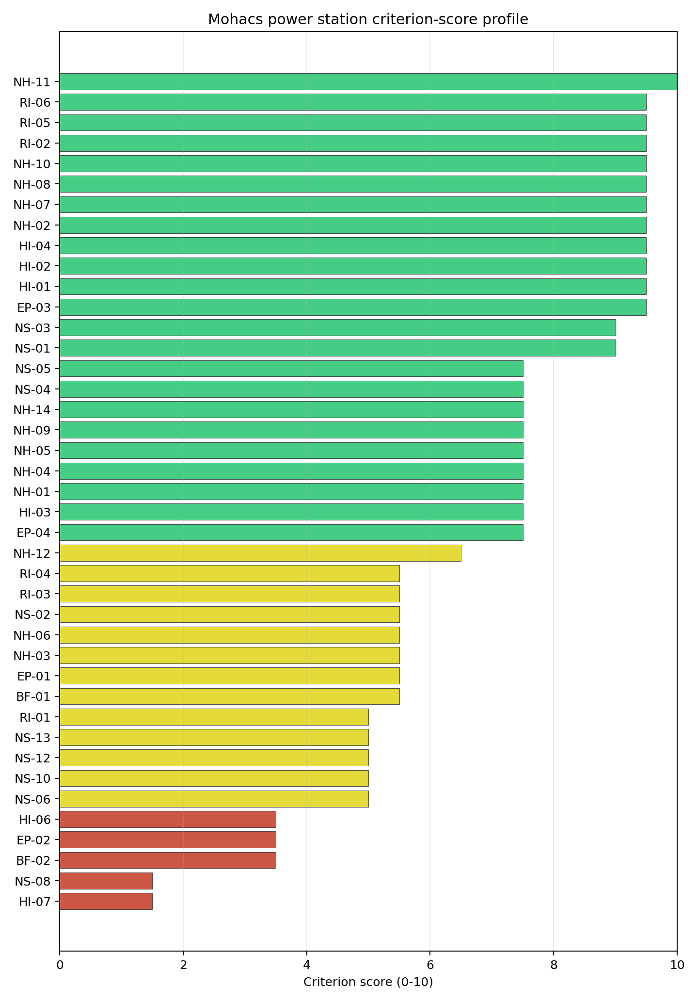
Criterion scores
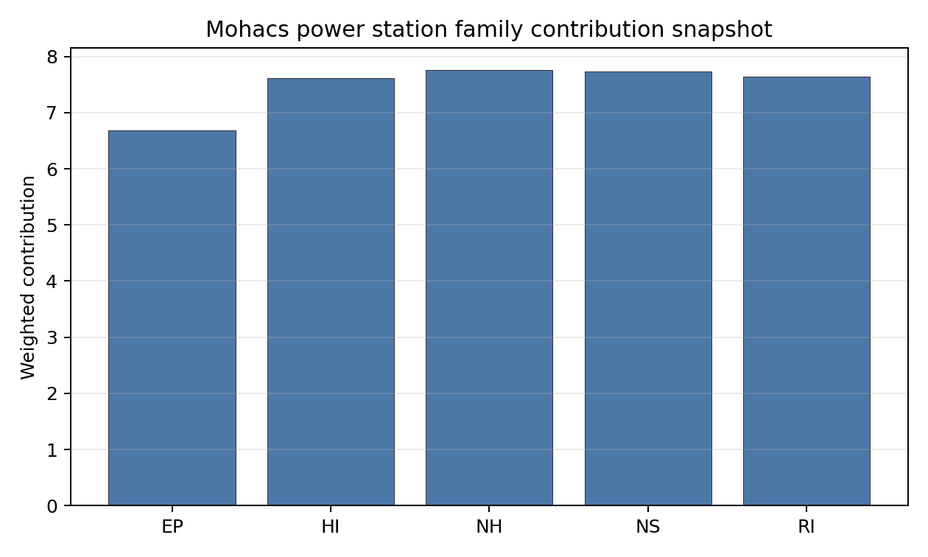
Family contributions
Mohacs has a baseline composite score of 7.584 and a Monte Carlo bracket of 6.705-8.075. Its national stability band is A, with a 100% national top-10 hit rate across the scored national sensitivity scenarios. That is the clearest Hungarian Stage 1-2 signal: Mohacs remains the national leader under the weight perturbations considered, not only under the baseline point estimate. The family profile is balanced, with NH 7.76, NS 7.73, RI 7.64, HI 7.61 and EP 6.68 after the unscored-criterion treatment. The largest uncertainty reduction would come from confirming the land footprint, grid-voltage path, EMI/military inventory and emergency-planning assumptions that sit below the strong composite result.

Residual Risk Register
Concern | Evidence | Consequence | Stage 3 action | Owner discipline
Site Footprint Adequacy (NS-05) | Canonical footprint 30.16 ha; largest contiguous patch 15.94 ha | Layout options may narrow if the contiguous patch cannot host the full VOYGR-6 envelope | Confirm the buildable layout and phasing envelope | geotech
Grid Connection (NS-02) | Nearest substation 4.11 km; nearest high-voltage line 2.26 km; highest nearby voltage 132 kV | A higher-voltage export route may be needed before the site can support the reference envelope | Confirm the 220 kV or 400 kV connection pathway and reinforcement scope | grid
Electromagnetic Interference (HI-07) | Nearest transmitter 0.06 km; 170 transmitters in the search radius | On-site or near-site communications infrastructure may require exclusion distances or shielding assumptions | Survey transmitter inventory and field strengths | security
Evacuation Routes (EP-02) | EPZ road density 0.419 km/km2; 822.11 km of road; motorway access present | Clearance-time margins may depend on seasonal and cross-border traffic conditions | Model EPZ time-to-clear and cross-Danube coordination | emergency planning
Natural-hazard confirmation (NH-03 / NH-09) | High liquefaction susceptibility; flood-zone class negligible at screening level | Foundation and flood-design margins need field confirmation | Re-measure liquefaction and Danube design-basis flood conditions | hydrology
The dominant residual risks are land contiguity, grid-voltage pathway and local emergency planning. They are Stage 3 work items for a strong screening leader, not findings of site approval.

Stage 3 Follow-Up Checklist
- Re-measure Electromagnetic Interference (HI-07) - native score 1.5/10 with confidence medium.
- Re-measure Ecological Sensitivity (NS-08) - native score 1.5/10 with confidence high.
- Re-measure Land Area Basic Filter (BF-02) - native score 3.5/10 with confidence insufficient.
- Re-measure Evacuation Routes (EP-02) - native score 3.5/10 with confidence medium.
- Re-measure Military Installations (HI-06) - native score 3.5/10 with confidence medium.

Evidence Limitations
- No criterion-family quality fields are flagged as low or missing in this bundle.

Tiszapalkonya power station Site Profile
Tiszapalkonya power station is a coal/thermal site in Hungary that has been tested against the NuScale VOYGR-6 reference deployment envelope. This profile reads the screening evidence at a level that supports a decision to progress toward Stage 3 characterisation. It is not a site-suitability determination, vendor recommendation, or licensing finding.

Site Snapshot
Field | Value
Site name | Tiszapalkonya power station
Coordinates | 47.9168, 21.0759
Subnational unit | Northern Hungary
Installed thermal capacity (source data) | 265 MW
Available surface area | 18.8 ha
Available surface area for development | 18.8 ha
Composite score (baseline weights) | 6.778 (6.053-7.319 MC band)
National stability band | D (top-10% hit rate 0%)
National rank | 3
See the country status map in Hungary Country Profile.

Ownership and Coal-to-Nuclear Context
- Blackrock Advisors LLC (0.36% share), headquartered in United States; immediate operator AES Corp. Path: Blackrock Advisors LLC -> BlackRock Inc [5.07%] -> AES Corp [7.09%] -> Tiszapalkonya power station Unit 5 [100.0%]
- AES Corp (100.00% share), headquartered in United States; immediate operator AES Corp. Path: AES Corp -> Tiszapalkonya power station Unit 3 [100.0%]
- BlackRock Inc (7.09% share), headquartered in United States; immediate operator AES Corp. Path: BlackRock Inc -> AES Corp [7.09%] -> Tiszapalkonya power station Unit 5 [100.0%]
- small shareholder(s) (80.58% share); immediate operator AES Corp. Path: small shareholder(s) -> AES Corp [80.58%] -> Tiszapalkonya power station Unit 3 [100.0%]
- The Vanguard Group Inc (12.33% share), headquartered in United States; immediate operator AES Corp. Path: The Vanguard Group Inc -> AES Corp [12.33%] -> Tiszapalkonya power station Unit 5 [100.0%]
Generating units on record: 5 retired. Earliest unit commissioning: 1952; most recent: 1952. Retirements span 2011 to 2012, leaving brownfield grid, water, transport, and workforce assets that materially shorten Stage 3 site preparation.

Natural Hazards (NH)
- Seismic: Ground Motion (NH-01) - score 7.5/10 (MC 7.0-8.0), weight 0.0455, data quality high. Evidence: PGA at 475-year return period 0.045 g; PGA at 2,475-year return period 0.105 g; Vs30 reference (m/s): 760.0.
- Seismic: Surface Rupture (NH-02) - score 9.5/10 (MC 9.0-10.0), weight n/a, data quality screening grade. Evidence: nearest mapped capable fault 50.0 km; fault slip rate 0 mm/yr; fault name: none_in_search_radius.
- Geotechnical: Liquefaction (NH-03) - score 5.5/10 (MC 5.0-6.0), weight n/a, data quality medium. Evidence: liquefaction susceptibility: high; dominant soil type: clay_loam.
- Geotechnical: Slope Stability (NH-04) - score 7.5/10 (MC 7.0-8.0), weight n/a, data quality screening grade. Evidence: site slope 5.25 deg; max slope in 1 km box 40.1 deg; slope stability class: moderate.
- Geotechnical: Subsidence (NH-05) - score 9.5/10 (MC 9.0-10.0), weight 0.0354, data quality medium. Evidence: karst present: no; karst severity: none.
- Geotechnical: Foundation (NH-06) - score 5.5/10 (MC 5.0-6.0), weight 0.0253, data quality medium. Evidence: bearing capacity 88.7 kPa; depth to bedrock 24.4 m.
- Volcanism (NH-07) - score 9.5/10 (MC 9.0-10.0), weight n/a, data quality high. Evidence: volcanic hazard class: negligible.
- Coastal Flooding (NH-08) - score 9.5/10 (MC 9.0-10.0), weight 0.0303, data quality medium. Evidence: distance to coast 572.0 km.
- River Flooding (NH-09) - score 7.5/10 (MC 7.0-8.0), weight 0.0404, data quality medium. Evidence: flood zone class: negligible.
- Extreme Winds (NH-10) - score 7.5/10 (MC 7.0-8.0), weight 0.0152, data quality medium. Evidence: screening wind-speed index 7.71 m/s.
- Extreme Precipitation (NH-11) - score 8.0/10 (MC 8.0-9.0), weight 0.0152, data quality medium. Evidence: screening extreme-precipitation index 0.23 mm; screening precipitation index 21.2 mm/yr.
- Extreme Temperatures (NH-12) - score 6.5/10 (MC 6.0-7.0), weight 0.0202, data quality medium. Evidence: extreme high temperature 25.9 deg C; extreme low temperature -6.51 deg C.
- Combined Hazards (NH-14) - score 7.5/10 (MC 7.0-8.0), weight 0.0152, data quality n/a. Evidence: values not in measurement tables.

Interpretation - Natural Hazards (NH)
Natural hazards at Tiszapalkonya are broadly favourable, with a similar Tisza alluvial setting to Borsod and the same need for field confirmation. The 475-year PGA is 0.045 g and the 2,475-year PGA is 0.105 g, and the nearest mapped capable fault is 50.0 km away. Liquefaction susceptibility is high on clay loam, while bearing capacity is 88.7 kPa and depth to bedrock is 24.4 m. The mean site slope is 5.25 degrees, with a maximum one-kilometre slope of 40.15 degrees. The site is 571.95 km from the coast, the flood-zone class is negligible at screening level, screening wind-speed index is 7.71 m/s and temperatures range from -6.51 deg C to 25.95 deg C. Stage 3 should confirm Tisza flood levels, liquefaction behaviour and the local precipitation record before the natural-hazard case is treated as mature.

Human-Induced and Security-Relevant Hazards (HI)
- Aircraft Crash (HI-01) - score 9.5/10 (MC 9.0-10.0), weight 0.0354, data quality high. Evidence: nearest airport 31.8 km; nearest flight path 23.2 km; airports within search radius 0; airport name: Miskolc Heliport; airport type: heliport.
- Industrial Explosions (HI-02) - score 9.5/10 (MC 9.0-10.0), weight 0.0354, data quality high. Evidence: nearest industrial site 4 km.
- Toxic/Gas Releases (HI-03) - score 3.5/10 (MC 3.0-4.0), weight 0.0354, data quality high. Evidence: nearest toxic source 4 km.
- External Fires (HI-04) - score 9.5/10 (MC 9.0-10.0), weight 0.0303, data quality high. Evidence: values not in measurement tables.
- Military Installations (HI-06) - score 0.0/10 (MC 0.0-0.0), weight 0.0303, data quality high. Evidence: nearest military installation 2.09 km; military installations within radius 6; installation name: unnamed.
- Electromagnetic Interference (HI-07) - score 1.5/10 (MC 1.0-2.0), weight 0.0101, data quality medium. Evidence: nearest high-power transmitter 1.52 km; transmitters within radius 131; transmitter type: communication.

Interpretation - Human-Induced and Security-Relevant Hazards (HI)
Human-induced hazards at Tiszapalkonya are mixed. Aircraft Crash (HI-01) is favourable, with Miskolc Heliport 31.8 km away, the nearest flight path 23.25 km away and no airports inside the 30 km radius. Industrial Explosions (HI-02) is also favourable at screening level, with the nearest industrial site 4.0 km away. The principal avoidance issue is Toxic/Gas Releases (HI-03), where the nearest toxic source is 4.0 km away against an 8 km avoidance threshold. Military Installations (HI-06) is more severe: the nearest military feature is 2.09 km away and six military features are recorded within 25 km. Electromagnetic Interference (HI-07) is also weak, with a communication transmitter 1.52 km away and 131 transmitters in the search radius. Stage 3 should prioritise hazardous-cloud, military and EMI confirmation.

Radiological Impact and Emergency Planning (RI / EP)
- Emergency Planning Feasibility (EP-01) - score 5.5/10 (MC 5.0-6.0), weight n/a, data quality high. Evidence: EP feasibility composite 64.7 /100; road sub-score 48.9 /100; special-population sub-score 90.0 /100; geography sub-score 95.0 /100; population sub-score 80.0 /100; evacuation feasible: yes.
- Evacuation Routes (EP-02) - score 3.5/10 (MC 3.0-4.0), weight 0.0303, data quality medium. Evidence: road density in EPZ 0.448 km/km2; road length in EPZ 880.6 km; motorway access: yes.
- Physical Geography Constraints (EP-03) - score 9.5/10 (MC 9.0-10.0), weight 0.0253, data quality medium. Evidence: waterways crossing EPZ 0; major river barrier: no.
- Special Populations (EP-04) - score 7.5/10 (MC 7.0-8.0), weight 0.0303, data quality medium. Evidence: hospitals in EPZ 3; prisons in EPZ 1; care homes in EPZ 0.
- Atmospheric Dispersion (RI-01) - unscored (no matched band), weight 0.0303, data quality medium. Evidence: annual mean wind speed 0.91 m/s; atmospheric mixing height 518.7 m; prevailing wind direction: N.
- Surface Water Dispersion (RI-02) - score 9.5/10 (MC 9.0-10.0), weight 0.0253, data quality n/a. Evidence: values not in measurement tables.
- Groundwater Dispersion (RI-03) - score 5.5/10 (MC 5.0-6.0), weight 0.0253, data quality medium. Evidence: aquifer type: alluvial.
- Population Density at EPZ Radii (RI-04) - score 5.5/10 (MC 5.0-6.0), weight 0.0404, data quality screening grade. Evidence: population density within 5 km 231.6 /km2; population density within 16 km 83.2 /km2; population density within 25 km 77.9 /km2; population density within 80 km 92.3 /km2; population within 25 km 152,917 people.
- Distance to Population Centres (RI-05) - score 9.5/10 (MC 9.0-10.0), weight 0.0505, data quality screening grade. Evidence: nearest city above 50k people 34.2 km; nearest city population 143,502 people; city name: Miskolc.
- Population Projections (RI-06) - score 5.5/10 (MC 5.0-6.0), weight 0.0253, data quality screening grade. Evidence: annual population growth rate 0.126 %/yr; projected population at 25 km in 60 yr 142,194 people.

Interpretation - Radiological Impact and Emergency Planning (RI / EP)
Radiological and emergency-planning conditions at Tiszapalkonya are moderate and closely tied to the Tiszaújváros urban-industrial setting. Population density is 231.57 people/km2 within 5 km, 83.16 people/km2 within 16 km and 77.89 people/km2 within 25 km, with 152,917 people inside 25 km. Miskolc, population 143,502, is 34.16 km away, and the 60-year 25 km population projection is 142,194 people. The EP feasibility composite is 64.7/100 and evacuation is marked feasible, but the road sub-score is 48.9/100 and EPZ road density is 0.448 km/km2. The EPZ includes three hospitals and one prison. Stage 3 should model time-to-clear for the Tiszaújváros area, test prison and hospital evacuation interfaces, and combine radiological planning with the hazardous-neighbour work required by HI-03.

Non-Safety and Implementation Considerations (NS)
- Grid Capacity Basic Filter (BF-01) - score 5.5/10 (MC 5.0-6.0), weight n/a, data quality n/a. Evidence: values not in measurement tables.
- Land Area Basic Filter (BF-02) - score 1.5/10 (MC 1.0-2.0), weight 0.0253, data quality n/a. Evidence: values not in measurement tables.
- Cooling Water Availability (NS-01) - score 9.0/10 (MC 8.0-10.0), weight 0.0404, data quality screening grade. Evidence: distance to cooling source 0.72 km; cooling source flow 549.2 m3/s; cooling source type: major_river; cooling source name: Üzemvíz-csatorna; water stress label: Low.
- Grid Connection (NS-02) - score 1.5/10 (MC 1.0-2.0), weight 0.0404, data quality high. Evidence: nearest substation 1.22 km; nearest high-voltage line 0.2 km; highest nearby line voltage 220.0 kV; grid export capacity 265.0 MW; substations within radius 83; HV lines within radius 594.
- Transport Access (NS-03) - score 8.0/10 (MC 8.0-9.0), weight 0.0404, data quality high. Evidence: nearest highway 0.36 km; nearest rail line 2.17 km; nearest waterway 20.6 km; heavy-haul capable: yes.
- Site Topography (NS-04) - score 5.5/10 (MC 5.0-6.0), weight 0.0303, data quality screening grade. Evidence: favourable land cover 53.9 %; moderate land cover 0.2 %; unfavourable land cover 33.7 %; favourable area 98.1 ha; dominant land class: 311.
- Site Footprint Adequacy (NS-05) - score 5.5/10 (MC 5.0-6.0), weight 0.0253, data quality high. Evidence: buildable area 18.8 ha; largest contiguous patch 18.8 ha; buildable patch count 10.
- Existing Infrastructure (NS-06) - unscored (no matched band), weight 0.0253, data quality n/a. Evidence: not measured at this site (criterion remains unscored).
- Ecological Sensitivity (NS-08) - score 1.5/10 (MC 1.0-2.0), weight n/a, data quality high. Evidence: natural land cover 33.7 %; distance to nearest Natura 2000 site 0.477 km; distance to nearest protected area 3 km; Natura 2000 overlap: no; Natura 2000 sensitivity class: high; protected-area overlap: no; protected-area sensitivity class: low; nearest Natura 2000 site: Tiszaújvárosi ártéri erdők; Natura 2000 sites within 5 km: 3; nearest protected-area designation: Landscape Protection Area.
- Workforce Availability (NS-10) - unscored (no matched band), weight 0.0202, data quality n/a. Evidence: not measured at this site (criterion remains unscored).
- Regulatory/Political Environment (NS-12) - unscored (no matched band), weight 0.0303, data quality n/a. Evidence: not measured at this site (criterion remains unscored).
- Construction Logistics (NS-13) - unscored (no matched band), weight 0.0202, data quality n/a. Evidence: not measured at this site (criterion remains unscored).

Interpretation - Non-Safety and Implementation Considerations (NS)
Implementation evidence at Tiszapalkonya is constrained by land and grid capacity despite strong transport and cooling proximity. The cooling source is 0.72 km away with a recorded flow of 549.23 m3/s and a Low water-stress label. The nearest substation is 1.22 km away and the nearest high-voltage line is 0.20 km away, with 220 kV recorded nearby, but the inherited export-capacity estimate is only 265 MW and NS-02 remains avoidance-flagged. Transport is favourable, with highway access 0.36 km away, rail 2.17 km away and heavy-haul capability recorded. The canonical site footprint is 18.77 ha, which is also the current development-area value; the wider favourable-area screen is 98.06 ha but does not prove controlled or contiguous land. Stage 3 should confirm whether a VOYGR-6 layout can be accommodated, and whether transmission reinforcement can lift the grid constraint.

Composite Score and Stability
Baseline composite score is 6.778, bracketed by Monte Carlo at 6.053-7.319. National stability band is D with a top-10% hit rate of 0% across 12 scored Monte Carlo scenarios.
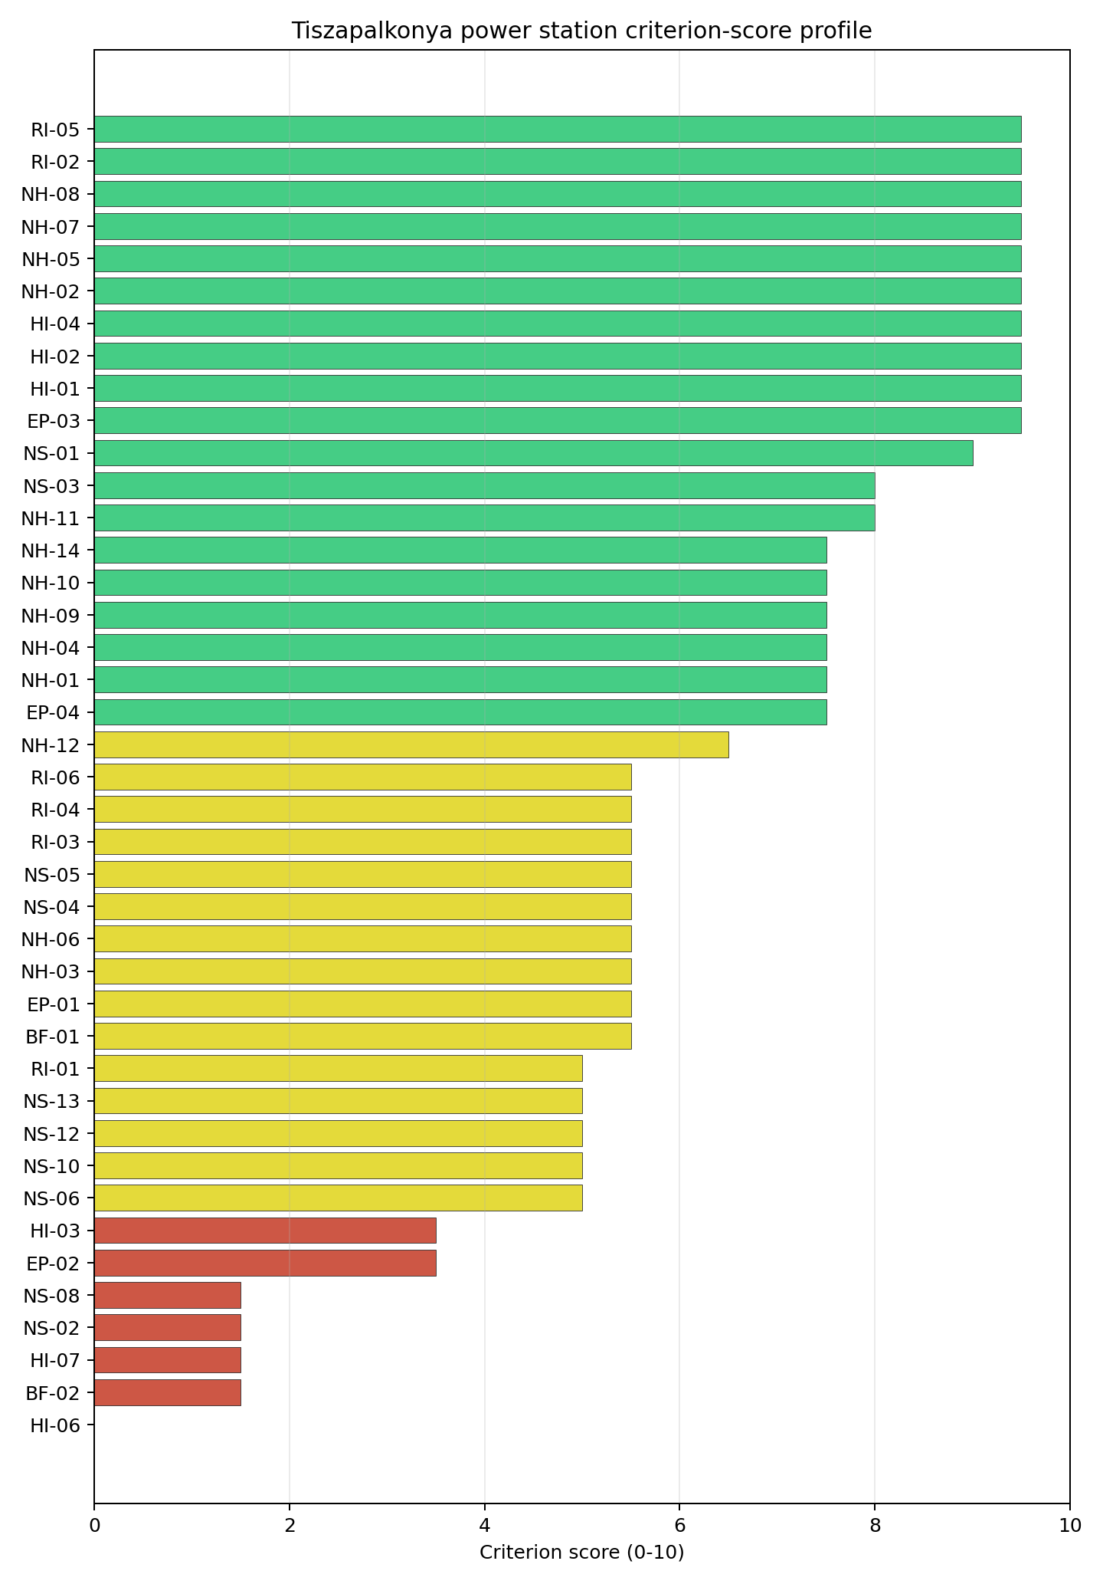
Criterion scores
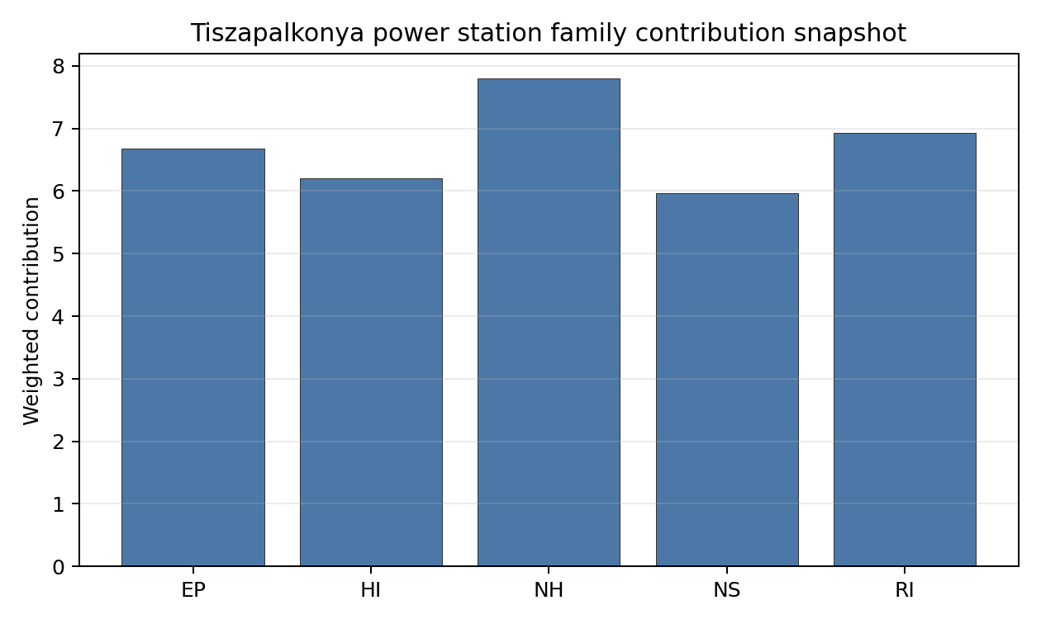
Family contributions
Tiszapalkonya has a baseline composite score of 6.778 and a Monte Carlo bracket of 6.053-7.319. Its national stability band is D, with a 0% national top-10 hit rate across the scored national sensitivity scenarios. The result makes Tiszapalkonya a credible point-estimate follower, but not a stable leader. The family profile is strongest in NH 7.80, with RI 6.93 and EP 6.68 supporting the case; NS 5.96 and HI 6.21 carry the land, grid, hazardous-neighbour, military and EMI constraints. The Stage 3 work that would narrow uncertainty fastest is the combined NS-02 grid review, NS-05 land-footprint confirmation and HI-03 hazardous-cloud assessment.

Residual Risk Register
Concern | Evidence | Consequence | Stage 3 action | Owner discipline
Grid Connection (NS-02) | Grid export capacity 265 MW; nearest high-voltage line 0.20 km; highest nearby voltage 220 kV | Export capacity may fall below the reference deployment envelope even with nearby grid assets | Confirm upgrade scope and deliverable export capacity | grid
Site Footprint Adequacy (NS-05) | Canonical footprint 18.77 ha; wider favourable-area screen 98.06 ha | The reference layout may require land assembly or a different siting envelope | Confirm controlled, contiguous and developable land | ownership/legal
Toxic/Gas Releases (HI-03) | Nearest toxic source 4.0 km; avoidance threshold 8 km | Hazardous-cloud exposure may keep the site in the avoidance-flag pool | Model hazardous-cloud envelope and inventories | security
Military Installations (HI-06) | Nearest military feature 2.09 km; six features within 25 km | Security standoff and emergency coordination could constrain the site boundary | Confirm feature classification and standoff requirements | security
Evacuation Routes (EP-02) | Road density 0.448 km/km2; EPZ includes three hospitals and one prison | Clearance-time and special-facility planning may drive emergency-plan design | Model time-to-clear and institutional evacuation interfaces | emergency planning
The register is dominated by land, grid and hazardous-neighbour constraints. Tiszapalkonya remains a high-ranking follower, but its Stage 3 case depends on converting these avoidance items into measured, resolvable conditions.

Stage 3 Follow-Up Checklist
- Resolve Toxic/Gas Releases (HI-03) avoidance flag - confirm hazardous-source distance and consequence envelope against the 8 km avoidance screen.
- Resolve Grid Connection (NS-02) avoidance flag - confirm deliverable export capacity and voltage pathway for the reference deployment envelope.
- Re-measure Military Installations (HI-06) - native score 0.0/10 with confidence high.
- Re-measure Land Area Basic Filter (BF-02) - native score 1.5/10 with confidence insufficient.
- Re-measure Electromagnetic Interference (HI-07) - native score 1.5/10 with confidence medium.
- Re-measure Grid Connection (NS-02) - native score 1.5/10 with confidence high.
- Re-measure Ecological Sensitivity (NS-08) - native score 1.5/10 with confidence high.

Evidence Limitations
- No criterion-family quality fields are flagged as low or missing in this bundle.

Torony power station Site Profile
Torony power station is a coal/thermal site in Hungary that has been tested against the NuScale VOYGR-6 reference deployment envelope. This profile reads the screening evidence at a level that supports a decision to progress toward Stage 3 characterisation. It is not a site-suitability determination, vendor recommendation, or licensing finding.

Site Snapshot
Field | Value
Site name | Torony power station
Coordinates | 47.2363, 16.5371
Subnational unit | Western Transdanubia
Installed thermal capacity (source data) | 600 MW
Available surface area | 135.3 ha
Available surface area for development | 135.3 ha
Composite score (baseline weights) | 6.595 (5.760-7.059 MC band)
National stability band | H (top-10% hit rate 0%)
National rank | 5
See the country status map in Hungary Country Profile.

Ownership and Coal-to-Nuclear Context
Generating units on record: 1 cancelled.

Natural Hazards (NH)
- Seismic: Ground Motion (NH-01) - score 7.5/10 (MC 7.0-8.0), weight 0.0455, data quality high. Evidence: PGA at 475-year return period 0.058 g; PGA at 2,475-year return period 0.13 g; Vs30 reference (m/s): 760.0.
- Seismic: Surface Rupture (NH-02) - score 9.5/10 (MC 9.0-10.0), weight n/a, data quality screening grade. Evidence: nearest mapped capable fault 50.0 km; fault slip rate 0 mm/yr; fault name: none_in_search_radius.
- Geotechnical: Liquefaction (NH-03) - score 5.5/10 (MC 5.0-6.0), weight n/a, data quality medium. Evidence: liquefaction susceptibility: moderate; dominant soil type: silty_clay_loam.
- Geotechnical: Slope Stability (NH-04) - score 7.5/10 (MC 7.0-8.0), weight n/a, data quality screening grade. Evidence: site slope 9.06 deg; max slope in 1 km box 85.5 deg; slope stability class: moderate.
- Geotechnical: Subsidence (NH-05) - score 7.5/10 (MC 7.0-8.0), weight 0.0354, data quality medium. Evidence: karst present: no; karst severity: none.
- Geotechnical: Foundation (NH-06) - score 5.5/10 (MC 5.0-6.0), weight 0.0253, data quality medium. Evidence: bearing capacity 83.3 kPa; depth to bedrock 19.7 m.
- Volcanism (NH-07) - score 9.5/10 (MC 9.0-10.0), weight n/a, data quality high. Evidence: volcanic hazard class: negligible.
- Coastal Flooding (NH-08) - score 9.5/10 (MC 9.0-10.0), weight 0.0303, data quality medium. Evidence: distance to coast 264.3 km.
- River Flooding (NH-09) - score 7.5/10 (MC 7.0-8.0), weight 0.0404, data quality medium. Evidence: flood zone class: negligible.
- Extreme Winds (NH-10) - score 7.5/10 (MC 7.0-8.0), weight 0.0152, data quality medium. Evidence: screening wind-speed index 8.51 m/s.
- Extreme Precipitation (NH-11) - score 8.0/10 (MC 8.0-9.0), weight 0.0152, data quality medium. Evidence: screening extreme-precipitation index 0.21 mm; screening precipitation index 24.6 mm/yr.
- Extreme Temperatures (NH-12) - score 6.5/10 (MC 6.0-7.0), weight 0.0202, data quality medium. Evidence: extreme high temperature 24.0 deg C; extreme low temperature -4.23 deg C.
- Combined Hazards (NH-14) - score 7.5/10 (MC 7.0-8.0), weight 0.0152, data quality n/a. Evidence: values not in measurement tables.

Interpretation - Natural Hazards (NH)
Natural hazards at Torony are generally favourable, although the western Transdanubian site still needs field geotechnical confirmation. The 475-year PGA is 0.058 g and the 2,475-year PGA is 0.130 g, while the nearest mapped capable fault is 50.0 km away. Liquefaction susceptibility is moderate on silty clay loam, bearing capacity is 83.3 kPa and depth to bedrock is 19.7 m. The mean site slope is 9.06 degrees, with a maximum one-kilometre slope of 85.54 degrees, so local slope and earthworks conditions should be checked. The site is 264.34 km from the coast, river-flood class is negligible, screening wind-speed index is 8.51 m/s, and temperatures range from -4.23 deg C to 24.03 deg C. Stage 3 should confirm geotechnical properties, local drainage and the precipitation record.

Human-Induced and Security-Relevant Hazards (HI)
- Aircraft Crash (HI-01) - score 3.5/10 (MC 3.0-4.0), weight 0.0354, data quality high. Evidence: nearest airport 6.13 km; nearest flight path 4.16 km; airports within search radius 8; airport name: Markusovszky Hospital Heliport; airport type: heliport.
- Industrial Explosions (HI-02) - score 9.5/10 (MC 9.0-10.0), weight 0.0354, data quality high. Evidence: nearest industrial site 27.9 km.
- Toxic/Gas Releases (HI-03) - score 7.5/10 (MC 7.0-8.0), weight 0.0354, data quality high. Evidence: nearest toxic source 27.9 km.
- External Fires (HI-04) - score 9.5/10 (MC 9.0-10.0), weight 0.0303, data quality high. Evidence: values not in measurement tables.
- Military Installations (HI-06) - score 0.0/10 (MC 0.0-0.0), weight 0.0303, data quality high. Evidence: nearest military installation 4.83 km; military installations within radius 20; installation name: unnamed.
- Electromagnetic Interference (HI-07) - score 1.5/10 (MC 1.0-2.0), weight 0.0101, data quality medium. Evidence: nearest high-power transmitter 1.95 km; transmitters within radius 206; transmitter type: observation.

Interpretation - Human-Induced and Security-Relevant Hazards (HI)
Human-induced hazards at Torony are driven by aviation, military and EMI questions rather than by industrial neighbours. Markusovszky Hospital Heliport is 6.13 km away, the nearest flight-path proxy is 4.16 km away and eight airports are recorded within the search radius, which triggers the Aircraft Crash (HI-01) avoidance flag. The nearest industrial and toxic-release source is 27.91 km away, giving a stronger hazardous-neighbour position than the northern industrial sites. Military Installations (HI-06) is weak, with the nearest military feature 4.83 km away and 20 features within 25 km. Electromagnetic Interference (HI-07) is also weak, with an observation-type transmitter 1.95 km away and 206 transmitters in the search radius. Stage 3 should begin with aviation, defence and EMI confirmation.

Radiological Impact and Emergency Planning (RI / EP)
- Emergency Planning Feasibility (EP-01) - score 5.5/10 (MC 5.0-6.0), weight n/a, data quality high. Evidence: EP feasibility composite 54.7 /100; road sub-score 56.7 /100; special-population sub-score 10.0 /100; geography sub-score 95.0 /100; population sub-score 80.0 /100; evacuation feasible: yes.
- Evacuation Routes (EP-02) - score 5.5/10 (MC 5.0-6.0), weight 0.0303, data quality medium. Evidence: road density in EPZ 0.579 km/km2; road length in EPZ 1,136 km; motorway access: yes.
- Physical Geography Constraints (EP-03) - score 9.5/10 (MC 9.0-10.0), weight 0.0253, data quality medium. Evidence: waterways crossing EPZ 0; major river barrier: no.
- Special Populations (EP-04) - score 7.5/10 (MC 7.0-8.0), weight 0.0303, data quality medium. Evidence: hospitals in EPZ 3; prisons in EPZ 1; care homes in EPZ 4.
- Atmospheric Dispersion (RI-01) - unscored (no matched band), weight 0.0303, data quality medium. Evidence: annual mean wind speed 0.91 m/s; atmospheric mixing height 506.7 m; prevailing wind direction: NNW.
- Surface Water Dispersion (RI-02) - score 1.5/10 (MC 1.0-2.0), weight 0.0253, data quality n/a. Evidence: values not in measurement tables.
- Groundwater Dispersion (RI-03) - score 5.5/10 (MC 5.0-6.0), weight 0.0253, data quality medium. Evidence: aquifer type: sedimentary sands.
- Population Density at EPZ Radii (RI-04) - score 5.5/10 (MC 5.0-6.0), weight 0.0404, data quality screening grade. Evidence: population density within 5 km 150.5 /km2; population density within 16 km 145.9 /km2; population density within 25 km 93.1 /km2; population density within 80 km 79.9 /km2; population within 25 km 182,718 people.
- Distance to Population Centres (RI-05) - score 3.5/10 (MC 3.0-4.0), weight 0.0505, data quality screening grade. Evidence: nearest city above 50k people 6.66 km; nearest city population 77,757 people; city name: Szombathely.
- Population Projections (RI-06) - score 7.5/10 (MC 7.0-8.0), weight 0.0253, data quality screening grade. Evidence: annual population growth rate -0.379 %/yr; projected population at 25 km in 60 yr 169,906 people.

Interpretation - Radiological Impact and Emergency Planning (RI / EP)
Radiological impact and emergency planning are Torony’s binding issue. Population density is 150.47 people/km2 within 5 km, 145.91 people/km2 within 16 km and 93.07 people/km2 within 25 km, with 182,718 people inside 25 km. Szombathely, population 77,757, is only 6.66 km from the site, inside the 8 km population-distance screen for a city above 50,000 people. The EP feasibility composite is 54.7/100, and evacuation is marked feasible, but the EPZ includes three hospitals, one prison and four care homes. Road density is better than several Hungarian sites at 0.579 km/km2 and motorway access is present. Stage 3 should model Szombathely-centred EPZ evacuation, special-population movement and atmospheric-dispersion sensitivity before Torony is treated as more than an avoidance-flagged comparator.

Non-Safety and Implementation Considerations (NS)
- Grid Capacity Basic Filter (BF-01) - score 5.5/10 (MC 5.0-6.0), weight n/a, data quality n/a. Evidence: values not in measurement tables.
- Land Area Basic Filter (BF-02) - score 9.5/10 (MC 9.0-10.0), weight 0.0253, data quality n/a. Evidence: values not in measurement tables.
- Cooling Water Availability (NS-01) - score 7.0/10 (MC 6.0-7.0), weight 0.0404, data quality screening grade. Evidence: distance to cooling source 4.67 km; cooling source flow 2.46 m3/s; cooling source type: small_river; cooling source name: Arany-patak; water stress label: Low.
- Grid Connection (NS-02) - score 5.5/10 (MC 5.0-6.0), weight 0.0404, data quality high. Evidence: nearest substation 1.29 km; nearest high-voltage line 7.71 km; highest nearby line voltage 132.0 kV; grid export capacity 600.0 MW; substations within radius 379; HV lines within radius 301.
- Transport Access (NS-03) - unscored (no matched band), weight 0.0404, data quality low. Evidence: not measured at this site (criterion remains unscored).
- Site Topography (NS-04) - score 7.5/10 (MC 7.0-8.0), weight 0.0303, data quality screening grade. Evidence: favourable land cover 66.0 %; moderate land cover 4 %; unfavourable land cover 30.0 %; favourable area 89.3 ha; dominant land class: 211.
- Site Footprint Adequacy (NS-05) - score 9.5/10 (MC 9.0-10.0), weight 0.0253, data quality screening grade. Evidence: buildable area 135.3 ha; largest contiguous patch 464.5 ha; buildable patch count 6.
- Existing Infrastructure (NS-06) - unscored (no matched band), weight 0.0253, data quality n/a. Evidence: not measured at this site (criterion remains unscored).
- Ecological Sensitivity (NS-08) - score 5.5/10 (MC 5.0-6.0), weight n/a, data quality high. Evidence: natural land cover 30.0 %; distance to nearest Natura 2000 site 6.926 km; distance to nearest protected area 5.536 km; Natura 2000 overlap: no; Natura 2000 sensitivity class: low; protected-area overlap: no; protected-area sensitivity class: low; nearest Natura 2000 site: Pinka; Natura 2000 sites within 5 km: 0; nearest protected-area designation: Nature Conservation Area.
- Workforce Availability (NS-10) - unscored (no matched band), weight 0.0202, data quality n/a. Evidence: not measured at this site (criterion remains unscored).
- Regulatory/Political Environment (NS-12) - unscored (no matched band), weight 0.0303, data quality n/a. Evidence: not measured at this site (criterion remains unscored).
- Construction Logistics (NS-13) - unscored (no matched band), weight 0.0202, data quality n/a. Evidence: not measured at this site (criterion remains unscored).

Interpretation - Non-Safety and Implementation Considerations (NS)
Torony has useful land and grid proximity, but cooling-water and population-interface questions weigh on the site. The Arany-patak is 4.67 km away with a recorded flow of 2.46 m3/s and a Low water-stress label, which is limited for the reference deployment envelope. The nearest substation is 1.29 km away, the nearest high-voltage line is 7.71 km away, the highest nearby voltage is 132 kV and the inherited export-capacity estimate is 600 MW. The canonical site footprint is 135.32 ha, with the same current development-area value; the wider favourable-area screen is 89.30 ha. Transport access remains unmeasured in the current bundle. Stage 3 should confirm cooling configuration, transmission upgrade pathway, transport access and the controlled land envelope.

Composite Score and Stability
Baseline composite score is 6.595, bracketed by Monte Carlo at 5.760-7.059. National stability band is H with a top-10% hit rate of 0% across 12 scored Monte Carlo scenarios.
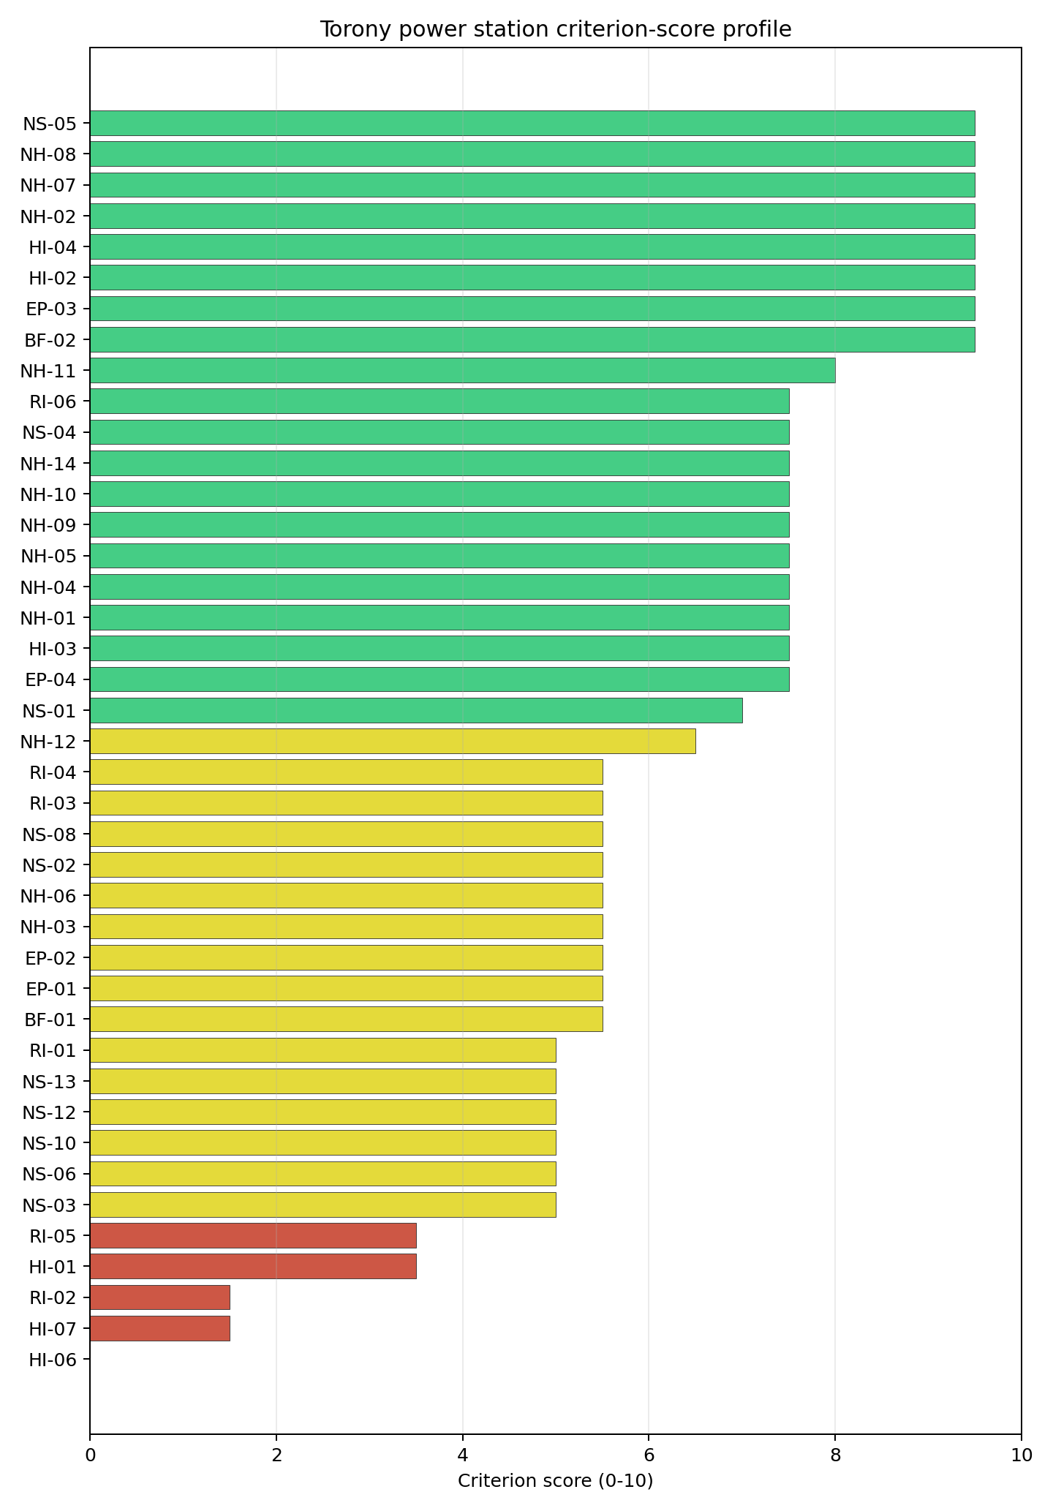
Criterion scores
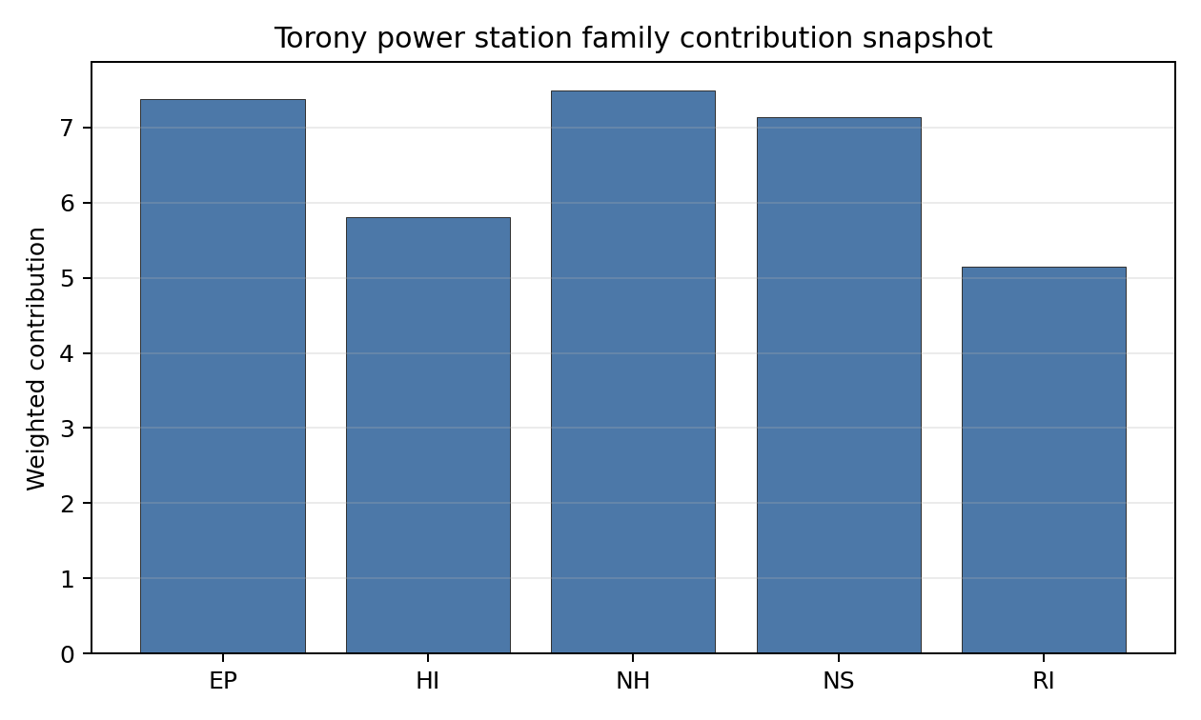
Family contributions
Torony has a baseline composite score of 6.595 and a Monte Carlo bracket of 5.760-7.059. Its national stability band is H, with a 0% national top-10 hit rate across the scored national sensitivity scenarios. The site remains in the selected top five because its point estimate is high, but the national sensitivity result is fragile and rank-dependent. EP 7.38, NH 7.49 and NS 7.13 support the case, while RI 5.14 and HI 5.81 reflect the Szombathely, aircraft, military and EMI constraints. The largest uncertainty reduction would come from RI-05 population-distance modelling, HI-01 aviation review and NS-01 cooling-water confirmation.

Residual Risk Register
Concern | Evidence | Consequence | Stage 3 action | Owner discipline
Distance to Population Centres (RI-05) | Szombathely, population 77,757, is 6.66 km away | The population-distance avoidance flag may constrain the EPZ basis | Model source-term placement and population-centre exposure | emergency planning
Aircraft Crash (HI-01) | Hospital heliport 6.13 km away; nearest flight-path proxy 4.16 km; eight airports in the search radius | Aviation hazard classification may require a site-specific aircraft-crash assessment | Confirm heliport operations and flight-path envelopes | security
Military Installations (HI-06) | Nearest military feature 4.83 km; 20 features within 25 km | Defence interfaces may affect security planning and standoff assumptions | Confirm feature classification and coordination requirements | security
Cooling Water Availability (NS-01) | Arany-patak 4.67 km away; recorded flow 2.46 m3/s | Cooling-water strategy may depend on closed-cycle assumptions or alternative sourcing | Quantify low-flow availability and cooling configuration | hydrology
Special populations (EP-04) | EPZ contains three hospitals, one prison and four care homes | Evacuation planning may require facility-specific movement assumptions | Model special-population evacuation and sheltering arrangements | emergency planning
Torony’s register is dominated by the Szombathely population interface and aviation/security questions. Those issues explain why a high point estimate still sits in a fragile national stability band.

Stage 3 Follow-Up Checklist
- Resolve Aircraft Crash (HI-01) avoidance flag - confirm the 6.13 km hospital-heliport distance and flight-path envelope against the 10 km heliport screen.
- Resolve Distance to Population Centres (RI-05) avoidance flag - confirm Szombathely at 6.66 km against the 8 km screening distance for a city above 50,000 people.
- Re-measure Military Installations (HI-06) - native score 0.0/10 with confidence high.
- Re-measure Electromagnetic Interference (HI-07) - native score 1.5/10 with confidence medium.
- Re-measure Surface Water Dispersion (RI-02) - native score 1.5/10 with confidence insufficient.
- Re-measure Aircraft Crash (HI-01) - native score 3.5/10 with confidence high.
- Re-measure Distance to Population Centres (RI-05) - native score 3.5/10 with confidence medium.
- Improve data quality for Transport Access (NS-03) - current flag low.

Evidence Limitations
- Transport Access (NS-03) - quality low.

Latvia Country Profile
Latvia has one thermal and coal-site record tested against the NuScale VOYGR-6 reference deployment envelope. No site clears both the exclusionary and avoidance screens, one site passes the exclusionary screen with avoidance flags, and no site hard-fails the exclusionary screen. The country is therefore a one-site brownfield case, not a multi-site programme pool.
Latvia should be treated as a first-time nuclear-power jurisdiction for this screening profile. That does not weaken the brownfield finding, but it makes regulatory, institutional, workforce and emergency-planning readiness part of the normal Stage 3 programme agenda alongside site characterisation.
The leading and only ranked site is Kurzeme power station, with a composite score of 6.603 and a Monte Carlo interval of 5.912-7.200. Its national stability band is A with a national top-10% hit rate of 100%. Because the national cohort contains only one ranked site, the stability signal means Kurzeme remains Latvia’s only brownfield candidate under the national weight perturbations considered; it does not remove the avoidance constraints that still govern Stage 3 entry.
Latvia’s one ranked site gives the country a clear but narrow brownfield option. Kurzeme power station is the sole exclusionary-pass candidate, but it is not a full-pass site because four avoidance flags remain active. The current evidence supports one detailed site profile and a focused unlock programme, rather than a broader brownfield shortlist.
The avoidance unlock pool is fully concentrated on the single candidate. Aircraft Crash (HI-01), Coastal Flooding (NH-08), Grid Connection (NS-02), and Site Footprint Adequacy (NS-05) each affect one of one exclusionary-pass sites. The practical unlock work is therefore not a sequencing exercise across several Latvian sites; it is a direct test of whether Kurzeme can clear aircraft-crash, coastal-flood, grid-export and land-footprint questions within the NuScale VOYGR-6 envelope.
If Latvia wants more than one nuclear siting option, the next increment would need a separate greenfield or wider industrial-site screening pass. A credible Stage 3 sequence begins with Kurzeme only, with characterisation contingent on resolving the four avoidance flags, confirming the national emergency-planning case, and testing whether the 8.7 ha canonical site footprint can support the reference deployment envelope.

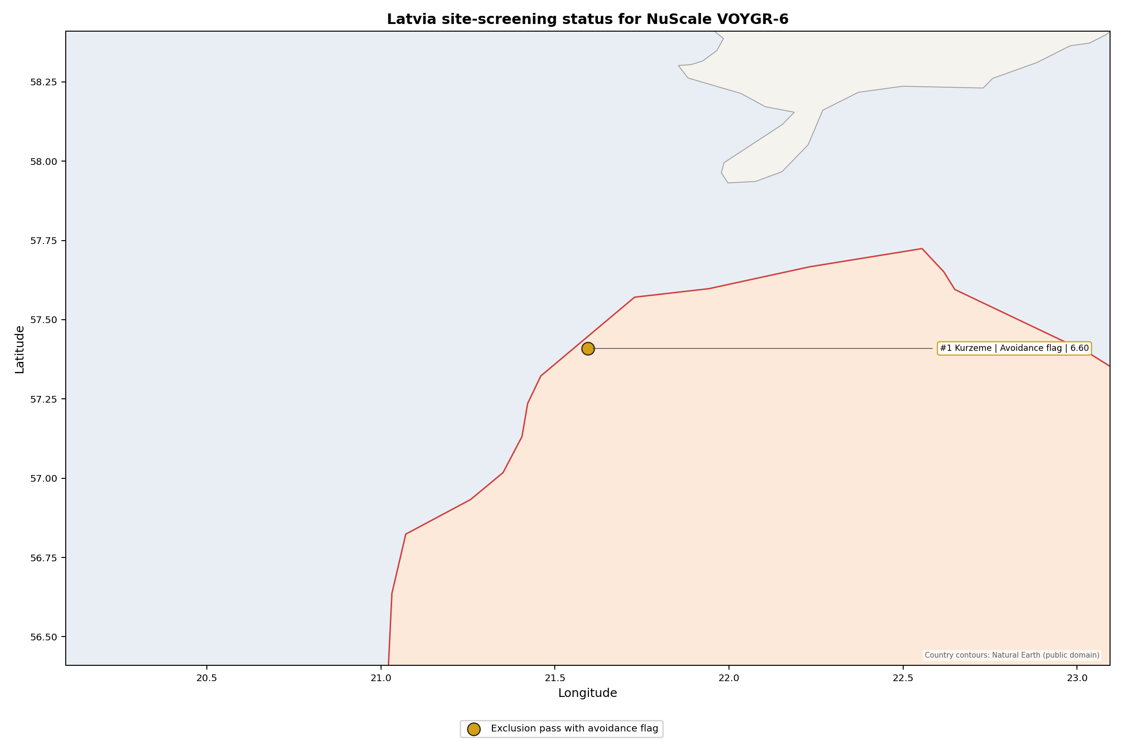
Latvia status map

Latvia Site Ledger
Rank | Site | Status | Composite | MC Low | MC High | Band | Top-10 Hit | Coverage
1 | Kurzeme power station | Exclusion pass with avoidance flag | 6.603 | 5.912 | 7.200 | A | 100% | 76%
Selected site for detailed treatment: Kurzeme power station. The top-five national selection rule yields one site because Latvia has only one ranked NuScale VOYGR-6 brownfield candidate in the frozen run.

Avoidance Flag Pareto
Of the one site that passes the exclusionary screen, all avoidance-phase flags are concentrated on the same candidate. Resolving them would not broaden a Latvian brownfield pool; it would determine whether the country’s only brownfield record can move from screening candidate to Stage 3 characterisation candidate.
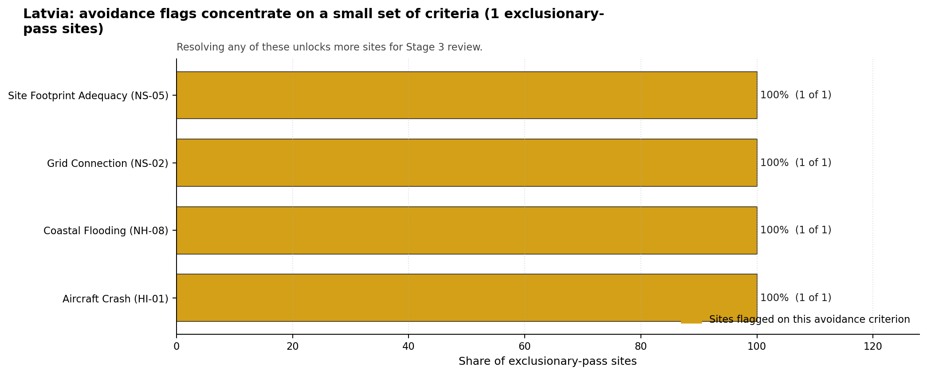
Avoidance flag Pareto
- Aircraft Crash (HI-01) - 1 of 1 exclusionary-pass sites (100%) - requires airport and flight-path hazard assessment before Kurzeme can be treated as a full-pass candidate.
- Coastal Flooding (NH-08) - 1 of 1 exclusionary-pass sites (100%) - requires coastal inundation and storm-surge modelling for a low-elevation Baltic coastal setting.
- Grid Connection (NS-02) - 1 of 1 exclusionary-pass sites (100%) - requires confirmation that the nearby 110 kV grid context can support the reference export requirement.
- Site Footprint Adequacy (NS-05) - 1 of 1 exclusionary-pass sites (100%) - requires confirmation that the 8.7 ha site footprint can be expanded, reconfigured or otherwise demonstrated for the reference envelope.

Family Strength and Weakness
Across the country, the strongest criterion family is Natural Hazards at a mean normalised score of 7.08/10, closely followed by Radiological Impact at 7.07/10. The weakest family is Human-Induced Hazards at 5.81/10. The bottom three individual criteria across the country are:
- Military Installations (HI-06) - mean 0.00/10 across one scored site (min 0.0, max 0.0).
- Evacuation Routes (EP-02) - mean 1.50/10 across one scored site (min 1.5, max 1.5).
- Extreme Winds (NH-10) - mean 1.50/10 across one scored site (min 1.5, max 1.5).
Land Area Basic Filter (BF-02) and Electromagnetic Interference (HI-07) also score 1.50/10, so the bottom-tier weakness is broader than a single criterion. The country profile should therefore be read as a narrow candidate case with several concentrated Stage 3 workstreams.

National Sensitivity and Robustness
Kurzeme records national stability band A, with 100% top-5%, top-10% and top-30% hit rates across the national sensitivity scenarios carried in the bundle. The result is robust inside Latvia because the country has only one ranked brownfield site. The same fact limits the interpretation: national rank stability confirms persistence of the only candidate, not the absence of material site constraints.
The Monte Carlo interval of 5.912-7.200 is useful because it keeps the site in a moderate-to-good screening range while still showing that unresolved criteria can move the composite materially. The appropriate Stage 3 reading is therefore focused: do not search for a lower-ranked brownfield alternative in Latvia before testing Kurzeme’s aircraft, coastal-flood, land, grid and emergency-planning constraints.

Interpretation for Site Selection
The Latvia result is structurally different from countries with several full-pass sites. There is no full-pass leadership group and no hard-fail tail; there is one exclusionary-pass site with avoidance flags. That places Kurzeme in a conditional category: it merits detailed characterisation planning only if the avoidance flags can be retired or bounded by site-specific evidence.

Avoidance flag Pareto - what unlocks more sites
An IAEA-style reading of the table focuses less on the exact national rank and more on screening class, stability, and the nature of remaining uncertainty. Kurzeme leads nationally because it is the only ranked Latvian record, and it is stable under national sensitivity because no other Latvian brownfield site competes with it. The decisive question is whether Stage 3 can close the four avoidance flags without creating a new exclusionary issue.
The main Stage 3 questions are targeted: model aircraft-crash exposure around Ventspils International Airport and the flight-path proxy, model Baltic coastal flooding for a 9.95 m site elevation, confirm the grid-export pathway from a 110 kV local context, and verify whether the 8.7 ha canonical site footprint can support the NuScale VOYGR-6 reference envelope. Emergency-planning modelling, defence-feature confirmation, EMI survey, and ecological screening should run in parallel because each can materially affect the characterisation decision.

Status Counts
- Full pass: 0
- Exclusion pass with avoidance flag: 1
- Hard fail: 0

Kurzeme power station Site Profile
Kurzeme power station is a coal/thermal site in Latvia that has been tested against the NuScale VOYGR-6 reference deployment envelope. This profile reads the screening evidence at a level that supports a decision to progress toward Stage 3 characterisation. It is not a site-suitability determination, vendor recommendation, or licensing finding.

Site Snapshot
Field | Value
Site name | Kurzeme power station
Coordinates | 57.4094, 21.5947
Subnational unit | Kurzeme
Installed thermal capacity (source data) | 435 MW
Available surface area | 8.7 ha
Available surface area for development | 8.7 ha
Composite score (baseline weights) | 6.603 (5.912-7.200 MC band)
National stability band | A (top-10% hit rate 100%)
National rank | 1
See the country status map in Latvia Country Profile.

Ownership and Coal-to-Nuclear Context
- Latvenergo AS (100.00% share), headquartered in Latvia; immediate operator Latvenergo AS. Path: Latvenergo AS -> Kurzeme power station – [100.0%]
- Ministry of Economics (Latvia) (100.00% share), headquartered in Latvia; immediate operator Latvenergo AS. Path: Ministry of Economics (Latvia) -> Latvenergo AS [100.0%] -> Kurzeme power station – [100.0%]
Generating units on record: 1 cancelled.

Natural Hazards (NH)
- Seismic: Ground Motion (NH-01) - score 9.5/10 (MC 9.0-10.0), favourable band: well below the risk boundary, weight 0.0455, data quality high. Evidence: PGA at 475-year return period 0.018 g; PGA at 2,475-year return period 0.068 g; Vs30 reference (m/s): 760.0.
- Seismic: Surface Rupture (NH-02) - score 9.5/10 (MC 9.0-10.0), favourable band: very strong separation from mapped capable faults; surface-rupture concern effectively screened at desk-study level, weight n/a, data quality screening grade. Evidence: nearest mapped capable fault 50.0 km; fault slip rate 0 mm/yr; fault name: none_in_search_radius.
- Geotechnical: Liquefaction (NH-03) - score 5.5/10 (MC 5.0-6.0), pass-mark band: moderate susceptibility, or high/very-high with documented or pending mitigation, weight n/a, data quality medium. Evidence: liquefaction susceptibility: moderate; dominant soil type: sandy_loam.
- Geotechnical: Slope Stability (NH-04) - score 9.5/10 (MC 9.0-10.0), favourable band: well below the risk boundary, weight n/a, data quality screening grade. Evidence: site slope 3.54 deg; max slope in 1 km box 44.3 deg; slope stability class: gentle.
- Geotechnical: Subsidence (NH-05) - score 9.5/10 (MC 9.0-10.0), favourable band: no karst and mine-feature distance well above the score-5 pivot, weight 0.0354, data quality medium. Evidence: karst present: no; karst severity: none.
- Geotechnical: Foundation (NH-06) - score 5.5/10 (MC 5.0-6.0), pass-mark band: typical European mixed conditions at 80-150 kPa bearing capacity, weight 0.0253, data quality medium. Evidence: bearing capacity 97.0 kPa; depth to bedrock 9.53 m.
- Volcanism (NH-07) - score 9.5/10 (MC 9.0-10.0), favourable band: very strong margin above the score-5 boundary with no in-radius signal, weight n/a, data quality high. Evidence: volcanic hazard class: negligible.
- Coastal Flooding (NH-08) - score 3.5/10 (MC 3.0-4.0), weight 0.0303, data quality medium. Evidence: distance to coast 2.17 km.
- River Flooding (NH-09) - score 7.5/10 (MC 5.5-9.5), weight 0.0404, data quality insufficient. Evidence: flood zone class: negligible.
- Extreme Winds (NH-10) - score 1.5/10 (MC 1.0-2.0), weight 0.0152, data quality medium. Evidence: screening wind-speed index 14.4 m/s.
- Extreme Precipitation (NH-11) - score 8.0/10 (MC 7.0-8.0), favourable band: aggregated mean of sub-scores, weight 0.0152, data quality medium. Evidence: screening extreme-precipitation index 0.23 mm; screening precipitation index 28.4 mm/yr.
- Extreme Temperatures (NH-12) - score 7.5/10 (MC 7.0-8.0), weight 0.0202, data quality medium. Evidence: extreme high temperature 21.0 deg C; extreme low temperature -6.03 deg C.
- Combined Hazards (NH-14) - score 3.5/10 (MC 3.0-4.0), weight 0.0152, data quality n/a. Evidence: values not in measurement tables.

Interpretation - Natural Hazards (NH)
Natural hazards are the strongest part of the Kurzeme screening profile, but they are not a clean-pass story. Seismic evidence is favourable: PGA is 0.018 g at the 475-year return period and 0.068 g at the 2,475-year return period, while the nearest mapped capable fault is recorded at 50.0 km with no slip-rate signal. The geotechnical read is moderate and suitable for Stage 3 confirmation rather than final design: liquefaction susceptibility is moderate, bearing capacity is 97.0 kPa, depth to bedrock is 9.53 m, and the mean site slope is 3.54 degrees. The main natural-hazard constraints are coastal and meteorological. Coastal Flooding (NH-08) scores 3.5/10 because the site is 2.17 km from the coast at 9.95 m elevation, and Extreme Winds (NH-10) scores 1.5/10 on a 14.4 m/s design wind-speed proxy. River Flooding (NH-09) is marked negligible but still carries insufficient data quality. Stage 3 should therefore open with Baltic coastal inundation and storm-surge modelling, project-specific wind extreme-value analysis, and a geotechnical campaign to confirm liquefaction, bearing and foundation inputs.

Human-Induced and Security-Relevant Hazards (HI)
- Aircraft Crash (HI-01) - score 3.5/10 (MC 3.0-4.0), weight 0.0354, data quality high. Evidence: nearest airport 6.49 km; nearest flight path 3.24 km; airports within search radius 1; airport name: Ventspils International Airport; airport type: small airfield.
- Industrial Explosions (HI-02) - score 9.5/10 (MC 9.0-10.0), favourable band: very strong margin above the score-5 boundary, weight 0.0354, data quality high. Evidence: nearest industrial site 16.3 km.
- Toxic/Gas Releases (HI-03) - score 7.5/10 (MC 7.0-8.0), weight 0.0354, data quality high. Evidence: nearest toxic source 16.3 km.
- External Fires (HI-04) - score 9.5/10 (MC 9.0-10.0), favourable band: > 15 km or no flammable-storage signal found in radius, weight 0.0303, data quality high. Evidence: values not in measurement tables.
- Military Installations (HI-06) - score 0.0/10 (MC 0.0-0.0), weight 0.0303, data quality high. Evidence: nearest military installation 4.21 km; military installations within radius 137; installation name: unnamed.
- Electromagnetic Interference (HI-07) - score 1.5/10 (MC 1.0-2.0), weight 0.0101, data quality medium. Evidence: nearest high-power transmitter 0.33 km; transmitters within radius 194; transmitter type: lighting.

Interpretation - Human-Induced and Security-Relevant Hazards (HI)
Human-induced and security-relevant hazards are the main reason Kurzeme remains an avoidance-flag candidate. Aircraft Crash (HI-01) scores 3.5/10 because Ventspils International Airport is 6.49 km from the site, the nearest flight-path proxy is 3.24 km away, and one airport is recorded within the search radius. Military Installations (HI-06) is more severe, scoring 0.0/10: the nearest military feature is 4.21 km away, the nearest high-consequence depot-class feature is 4.7 km away, and 137 military features are recorded within the screening radius. Electromagnetic Interference (HI-07) also needs early attention, with the nearest transmitter at 0.33 km and 194 transmitter-like features within the search radius. The wider industrial-hazard record is more favourable: the nearest industrial and toxic-source distances are both 16.3 km, and the external-fire row records no measured in-radius value. Stage 3 should therefore begin with an aircraft-crash hazard assessment, defence/security feature confirmation, and a measured RF/EMI survey before the site is advanced as a full-pass brownfield candidate.

Radiological Impact and Emergency Planning (RI / EP)
- Emergency Planning Feasibility (EP-01) - score 5.5/10 (MC 5.0-6.0), pass-mark band: at or above the composite score-5 boundary, weight n/a, data quality high. Evidence: EP feasibility composite 52.9 /100; road sub-score 29.7 /100; special-population sub-score 90.0 /100; geography sub-score 95.0 /100; population sub-score 60.0 /100; evacuation feasible: yes.
- Evacuation Routes (EP-02) - score 1.5/10 (MC 1.0-2.0), weight 0.0303, data quality medium. Evidence: road density in EPZ 0.197 km/km2; road length in EPZ 387.6 km; motorway access: yes.
- Physical Geography Constraints (EP-03) - score 9.5/10 (MC 9.0-10.0), favourable band: no measured relief and open river/waterway context at interim screening, weight 0.0253, data quality medium. Evidence: waterways crossing EPZ 0; major river barrier: no.
- Special Populations (EP-04) - score 7.5/10 (MC 7.0-8.0), weight 0.0303, data quality medium. Evidence: hospitals in EPZ 4; prisons in EPZ 0; care homes in EPZ 0.
- Atmospheric Dispersion (RI-01) - score no native score (unscored, no band matched), weight 0.0303, data quality medium. Evidence: annual mean wind speed 2.74 m/s; atmospheric mixing height 571.7 m; prevailing wind direction: SW.
- Surface Water Dispersion (RI-02) - score 7.5/10 (MC 7.0-8.0), weight 0.0253, data quality n/a. Evidence: values not in measurement tables.
- Groundwater Dispersion (RI-03) - score 5.5/10 (MC 5.0-6.0), pass-mark band: moderate-permeability aquifer screening proxy, weight 0.0253, data quality medium. Evidence: aquifer type: inland water.
- Population Density at EPZ Radii (RI-04) - score 3.5/10 (MC 3.0-4.0), weight 0.0404, data quality screening grade. Evidence: population density within 5 km 424.7 /km2; population density within 16 km 46.6 /km2; population density within 25 km 20.6 /km2; population density within 80 km 5.82 /km2; population within 25 km 40,368 people.
- Distance to Population Centres (RI-05) - score 9.5/10 (MC 9.0-10.0), favourable band: no >=50k population-centre proxy within screening envelope, weight 0.0505, data quality screening grade. Evidence: values not in measurement tables.
- Population Projections (RI-06) - score 9.5/10 (MC 9.0-10.0), favourable band: declining population projection below -0.5 %/yr, weight 0.0253, data quality screening grade. Evidence: annual population growth rate -1.787 %/yr; projected population at 25 km in 60 yr 25,531 people.

Interpretation - Radiological Impact and Emergency Planning (RI / EP)
Radiological impact and emergency planning are mixed: the wider population setting is light, but the inner EPZ and road network need careful modelling. The population density is 424.7 people/km2 within 5 km, then falls sharply to 46.6 people/km2 within 16 km, 20.6 people/km2 within 25 km, and 5.82 people/km2 within 80 km. The 25 km population is 40,368 people, and the 60-year projection falls to 25,531 people at a -1.787%/yr growth rate, which supports the long-term population read. Emergency Planning Feasibility (EP-01) is feasible but road-constrained: the composite is 52.9/100, the road sub-score is 29.7/100, and Evacuation Routes (EP-02) records only 0.197 km/km2 of road density despite 387.6 km of roads and motorway access. Atmospheric dispersion is not natively scored, but the screening values record 2.74 m/s annual mean wind speed, 571.7 m mixing height, and prevailing SW wind. Stage 3 should model EPZ time-to-clear for Ventspils and the rural coastal road network, then run site-specific meteorological and liquid-pathway modelling for the Venta and Baltic coastal setting.

Non-Safety and Implementation Considerations (NS)
- Grid Capacity Basic Filter (BF-01) - score 5.5/10 (MC 5.0-6.0), pass-mark band: substation 15-30 km or 110-219 kV with plausible reinforcement, weight n/a, data quality n/a. Evidence: values not in measurement tables.
- Land Area Basic Filter (BF-02) - score 1.5/10 (MC 1.0-2.0), weight 0.0253, data quality n/a. Evidence: values not in measurement tables.
- Cooling Water Availability (NS-01) - score 9.0/10 (MC 8.0-10.0), favourable band: aggregated weighted mean of sub-scores, weight 0.0404, data quality screening grade. Evidence: distance to cooling source 1.57 km; cooling source flow 128.8 m3/s; cooling source type: major_river; cooling source name: Venta; water stress label: Low.
- Grid Connection (NS-02) - score 3.5/10 (MC 3.0-4.0), weight 0.0404, data quality high. Evidence: nearest substation 0.26 km; nearest high-voltage line 1.03 km; highest nearby line voltage 110.0 kV; grid export capacity 435.0 MW; substations within radius 92; HV lines within radius 216.
- Transport Access (NS-03) - score 9.0/10 (MC 9.0-10.0), favourable band: aggregated weighted mean of sub-scores, weight 0.0404, data quality high. Evidence: nearest highway 0.12 km; nearest rail line 0.36 km; nearest waterway 2.84 km; heavy-haul capable: yes.
- Site Topography (NS-04) - score 7.5/10 (MC 7.0-8.0), weight 0.0303, data quality screening grade. Evidence: favourable land cover 61.3 %; moderate land cover 3.1 %; unfavourable land cover 35.6 %; favourable area 32.5 ha; dominant land class: 312.
- Site Footprint Adequacy (NS-05) - score 3.5/10 (MC 3.0-4.0), weight 0.0253, data quality medium. Evidence: buildable area 8.7 ha; largest contiguous patch 8.7 ha; buildable patch count 6.
- Existing Infrastructure (NS-06) - score no native score (unscored, no band matched), weight 0.0253, data quality n/a. Evidence: not measured at this site (criterion remains unscored).
- Ecological Sensitivity (NS-08) - score 3.5/10 (MC 3.0-4.0), weight n/a, data quality high. Evidence: natural land cover 35.6 %; distance to nearest Natura 2000 site 3.851 km; distance to nearest protected area 3.851 km; Natura 2000 overlap: no; Natura 2000 sensitivity class: low; protected-area overlap: no; protected-area sensitivity class: moderate; nearest Natura 2000 site: Būšnieku ezera krasts; Natura 2000 sites within 5 km: 1; nearest protected-area designation: Nature Reserve.
- Workforce Availability (NS-10) - score no native score (unscored, no band matched), weight 0.0202, data quality n/a. Evidence: not measured at this site (criterion remains unscored).
- Regulatory/Political Environment (NS-12) - score no native score (unscored, no band matched), weight 0.0303, data quality n/a. Evidence: not measured at this site (criterion remains unscored).
- Construction Logistics (NS-13) - score no native score (unscored, no band matched), weight 0.0202, data quality n/a. Evidence: not measured at this site (criterion remains unscored).

Interpretation - Non-Safety and Implementation Considerations (NS)
Non-safety and implementation considerations give Kurzeme its main brownfield value and its main programme constraints. Cooling Water Availability (NS-01) is strong: the Venta is 1.57 km away, the recorded flow is 128.8 m3/s, and the water-stress label is Low. Transport access is also strong, with a highway at 0.12 km, rail at 0.36 km, a waterway at 2.84 km, and heavy-haul capability recorded. Grid Connection (NS-02) is the first implementation constraint: the nearest substation is 0.26 km away and the nearest high-voltage line is 1.03 km away, but the highest nearby line voltage is 110 kV and the grid export-capacity estimate is 435 MW. Land is the second constraint. The canonical site surface area is 8.7 ha, and the current available-development figure is also 8.7 ha; the 32.5 ha favourable-area value is a wider screening-stage expansion envelope and does not prove controlled, contiguous or permitted development land. Ecological Sensitivity (NS-08) is another Stage 3 issue because Būšnieku ezera krasts is 3.851 km away, one Natura 2000 site lies within 5 km, and the nearest protected-area designation is a Nature Reserve. Stage 3 should therefore confirm the site boundary and land-control envelope, test the grid-export pathway for the NuScale VOYGR-6 reference case, and complete Natura 2000 and national EIA scoping.

Composite Score and Stability
Baseline composite score is 6.603, bracketed by Monte Carlo at 5.912-7.200. National stability band is A with a top-10% hit rate of 100% across 12 scored Monte Carlo scenarios.
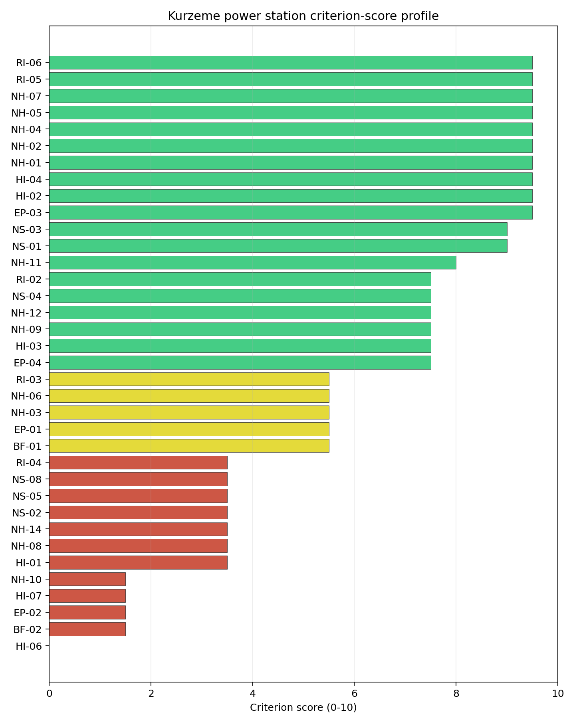
Criterion scores
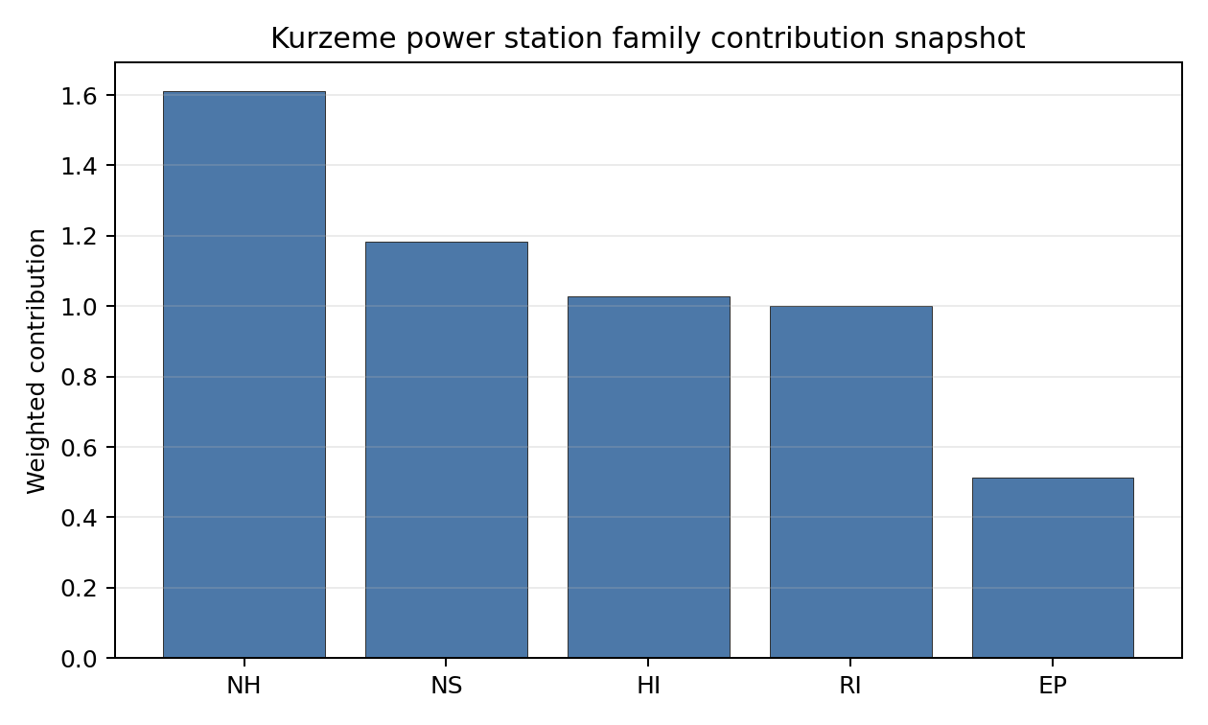
Family contributions
Kurzeme’s baseline composite score is 6.603, with a Monte Carlo bracket of 5.912-7.200. The national stability band is A, with 100% top-5%, top-10% and top-30% hit rates across the 12 scored national sensitivity scenarios. That is a robust national signal, but it must be interpreted in a one-site country cohort: Kurzeme is stable because it is Latvia’s only ranked brownfield candidate, not because the avoidance flags have disappeared. The family profile is balanced above the pass mark in aggregate, with NH 7.09, RI 7.07, NS 6.70, EP 5.97 and HI 5.81 after the unscored-criterion penalty. The composite uncertainty is driven less by a single weak family than by a cluster of specific constraints: HI-06, EP-02, NH-10, BF-02, HI-07, NS-02, NH-08, RI-04 and NS-05. The fastest way to narrow the band is to confirm site footprint, coastal flooding, evacuation-route capacity, military/EMI exposure and grid export with site-specific evidence.

Residual Risk Register
Concern | Evidence | Consequence | Stage 3 action | Owner discipline
Military Installations (HI-06) | Nearest military feature 4.21 km away; nearest high-consequence depot-class feature 4.7 km away; 137 features within the screening radius | Security standoff, airspace and emergency-planning constraints could become limiting if the feature classifications are confirmed | Engage defence authorities and confirm feature class, activity and required security separation | security
Evacuation Routes (EP-02) | Road density 0.197 km/km2; 387.6 km of road; EP road sub-score 29.7/100 | EPZ clearance time may be constrained despite motorway access | Model EPZ time-to-clear under seasonal, port, urban and rural-coastal traffic conditions | emergency planning
Coastal Flooding (NH-08) | Coast distance 2.17 km; site elevation 9.95 m | Storm surge or coastal inundation could narrow the usable footprint or affect design-basis flood assumptions | Model Baltic coastal inundation, storm surge and climate-adjusted water levels at the site boundary | hydrology
Site Footprint Adequacy (NS-05) | Canonical site area 8.7 ha; largest contiguous patch 8.7 ha; six buildable patches | The reference deployment envelope may be constrained by land control, contiguity or layout | Confirm parcel boundaries, ownership/control, buildable contiguity and site reconfiguration options | ownership/legal
Grid Connection (NS-02) | Nearest substation 0.26 km; nearest high-voltage line 1.03 km; highest nearby voltage 110 kV; export estimate 435 MW | A local-grid reinforcement requirement could dominate schedule and cost | Confirm export path, voltage upgrade needs and reinforcement scope with the transmission operator | grid
Aircraft Crash (HI-01) | Ventspils International Airport 6.49 km away; nearest flight-path proxy 3.24 km away | Aircraft-crash hazard may remain an avoidance condition if traffic and flight-path assumptions are confirmed | Model aircraft-crash frequency and flight-path exposure for the site boundary | security
HI-06, EP-02, NH-08, NS-05, NS-02 and HI-01 dominate the register because each can change the Stage 3 decision before detailed engineering begins. The register is a characterisation work plan for Latvia’s only brownfield candidate, not a finding of site approval.

Stage 3 Follow-Up Checklist
- Model Aircraft Crash (HI-01) - Ventspils International Airport is 6.49 km away and the nearest flight-path proxy is 3.24 km away.
- Model Coastal Flooding (NH-08) - the site is 2.17 km from the coast at 9.95 m elevation.
- Confirm Grid Connection (NS-02) - the current evidence records 110 kV nearby voltage and 435 MW export capacity.
- Confirm Site Footprint Adequacy (NS-05) - the canonical site area and largest contiguous patch are both 8.7 ha.
- Engage on Military Installations (HI-06) - the nearest military feature is 4.21 km away and 137 features are recorded in the screening radius.
- Model Evacuation Routes (EP-02) - EPZ road density is 0.197 km/km2 with a 29.7/100 road sub-score.
- Survey Electromagnetic Interference (HI-07) - the nearest transmitter is 0.33 km away and 194 transmitter-like features are recorded in the search radius.
- Re-measure Extreme Winds (NH-10) - the screening design wind-speed proxy is 14.4 m/s.
- Confirm Ecological Sensitivity (NS-08) - Būšnieku ezera krasts is 3.851 km away and one Natura 2000 site lies within 5 km.

Evidence Limitations
- Geotechnical: Subsidence & Collapse (NH-05b) - quality low.
- Coastal Flooding (NH-08) - storm-surge and tsunami exposure are not populated in the measurement table.
- Atmospheric Dispersion (RI-01) - remains unscored despite screening meteorological values.
- Existing Infrastructure (NS-06), Workforce Availability (NS-10), Regulatory/Political Environment (NS-12), and Construction Logistics (NS-13) - no measured basis in the site bundle.

Moldova Country Profile
Analytical basis: this profile uses the frozen NuScale VOYGR-6 scoring baseline and the project’s 50,000-iteration national Monte Carlo sensitivity analysis.
Moldova has one thermal-site record in the current national screening pool. Kuchurgan power station passes the exclusionary screen but retains an avoidance flag, so Moldova has no full-pass brownfield candidate at this stage and no hard-failed site in the country ledger. The country should therefore be treated as a single-site, first-programme case for Stage 1-2 planning: the immediate question is whether Kuchurgan can be unlocked for Stage 3 characterisation, not how to sequence a multi-site national fleet.
The leading and only ranked site is Kuchurgan power station, with a composite score of 6.959 and a Monte Carlo interval of 6.199-7.500. Its national stability band is A with a national top-10% hit rate of 100%. That stability signal is useful, but it is also a function of Moldova’s one-site pool. It should be read as national persistence for Kuchurgan, not as proof that the site is comparable to stronger multi-site country leaders.
The avoidance unlock pool is concentrated on one issue. Aircraft Crash (HI-01) affects the only exclusionary-pass site because the bundle records a small airfield at 7.03 km and a flight-path proxy at 3.52 km. Resolving this aviation constraint through national and cross-border aeronautical review is the prerequisite before Kuchurgan can be treated as a candidate for Stage 3 field characterisation.
The Stage 3 cadence is therefore narrow and conditional. Moldova should first resolve the HI-01 aviation screen, then test the site-specific governance, ownership, emergency-planning, grid, cooling-water, land and ecological assumptions that remain material at Kuchurgan. If the aviation issue cannot be resolved, the brownfield option should remain in the evidence base as a comparator and any Moldovan programme expansion would require a separate greenfield or wider industrial-site search.

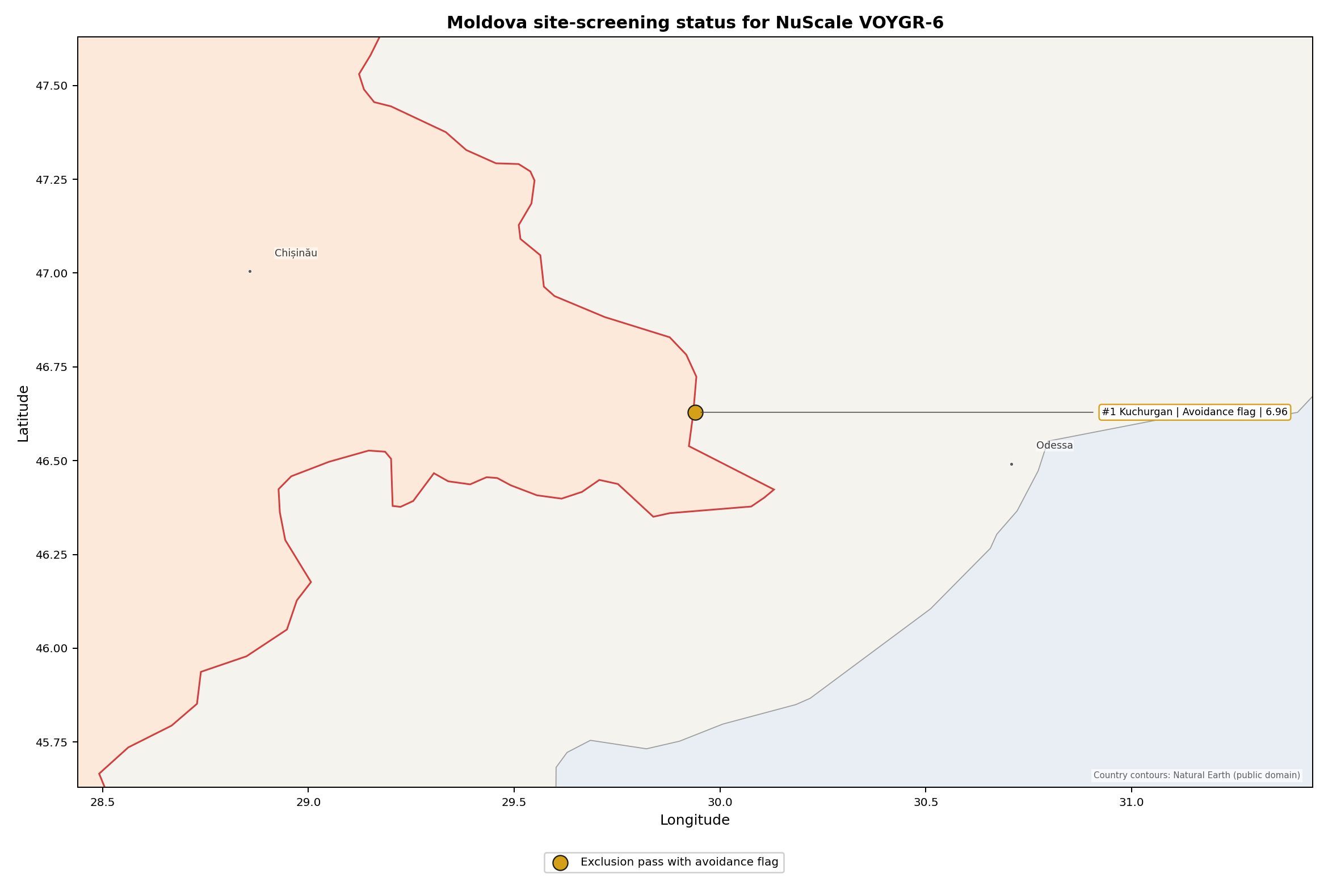
Moldova status map

Moldova Site Ledger
Rank | Site | Status | Composite | MC Low | MC High | Band | Top-10 Hit | Coverage
1 | Kuchurgan power station | Exclusion pass with avoidance flag | 6.959 | 6.199 | 7.500 | A | 100% | 76%

Selected Sites for Detailed Analysis
The selected-site rule returns one Moldovan site because only one Moldovan record exists in the frozen national ranking. The detailed profile is Kuchurgan power station.

Avoidance Flag Pareto
Of the one site that passes the exclusionary screen, the avoidance-phase flag is concentrated on a single criterion. This makes the Moldova unlock pathway clear and testable.
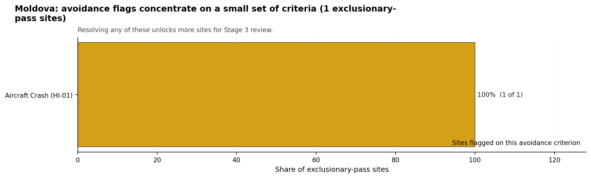
Avoidance flag Pareto
- Aircraft Crash (HI-01) - 1 of 1 exclusionary-pass sites (100%).

Exclusionary Failure Pareto
No Moldovan site fails an exclusionary criterion in the frozen national run.

Family Strength and Weakness
Across the Moldova pool, the strongest criterion family is Non-Safety / Implementation at a mean normalised score of 7.67/10. Radiological Impact follows at 7.28/10, Natural Hazards at 7.21/10, Human-Induced Hazards at 6.47/10, and Emergency Planning at 5.26/10. The bottom individual criteria are:
- Military Installations (HI-06) - mean 1.50/10 across one scored site.
- Surface Water Dispersion (RI-02) - mean 1.50/10 across one scored site.
- Evacuation Routes (EP-02) - mean 1.50/10 across one scored site.
- Electromagnetic Interference (HI-07) - mean 1.50/10 across one scored site.

Interpretation for Site Selection
Moldova’s Chapter 5 result is a single-candidate brownfield screen. Kuchurgan has a strong national rank by definition, a stable national sensitivity band, and useful reuse attributes, including an inherited 1,400 MW thermal complex, a nearby 330 kV grid context, rail access, cooling-water proximity, and a large site-area estimate. Those attributes justify a focused Stage 3 decision gate if the avoidance flag can be retired.

Avoidance flag Pareto - what unlocks more sites
The main limitation is that Moldova does not have a diversified screened brownfield pool. Small changes to Kuchurgan’s aviation, governance, ownership, emergency-planning, water-dispersion or land-control evidence can therefore change the whole country conclusion. The national sensitivity analysis supports Kuchurgan as Moldova’s only ranked candidate, but it does not remove the need for an early go/no-go review on HI-01 and the Transnistria-related governance questions.
For IAEA SSG-35 Stage 1-2 purposes, Kuchurgan should be carried forward as an avoidance-flagged candidate requiring targeted resolution, not as an unconditional preferred site. The immediate Stage 3-preparation package should confirm aviation hazard, emergency-planning feasibility, cooling-water and liquid-pathway behaviour, land availability, ownership and programme governance, and ecological screening before committing to a broader site-characterisation campaign.

Status Counts
- Full pass: 0
- Exclusion pass with avoidance flag: 1
- Hard fail: 0

Kuchurgan power station Site Profile
Kuchurgan power station is Moldova’s only ranked brownfield thermal-site candidate in the frozen NuScale VOYGR-6 Stage 1-2 screen. It passes the exclusionary screen but retains an Aircraft Crash (HI-01) avoidance flag, so the profile supports a targeted Stage 3 decision gate rather than an unconditional site-characterisation programme.

Site Snapshot
Field | Value
Site name | Kuchurgan power station
Coordinates | 46.6290, 29.9397
Subnational unit | Transnistria
Installed thermal capacity (source data) | 1,400 MW
Available surface area | 200.0 ha
Available surface area for development | 186.2 ha
Composite score (baseline weights) | 6.959 (6.199-7.500 MC band)
National stability band | A (top-10% hit rate 100%)
National rank | 1
See the country status map in Moldova Country Profile.

Ownership and Coal-to-Nuclear Context
The bundle records Kuchurgan as a mothballed 1,400 MW coal-fired complex with seven mothballed units. The earliest unit commissioning year is 1964 and the most recent is 1971. The site therefore has a long thermal-generation history, but the reuse case depends on whether grid, land, cooling, ownership and governance conditions can be verified for nuclear-grade redevelopment.
The ownership chain is concentrated around Russian-linked entities. The immediate operator is Moldavskaya GRES CJSC, with Inter RAO PJSC recorded as the 100% parent of the plant operator in the site bundle. Additional beneficial ownership rows include Inter RAO Capital JSC, Rosneftegaz JSC, the Government of Russia, the Federal Agency for State Property Management, and Federal Grid Company - Rosseti PJSC. This evidence should be treated as an ownership and programme-governance issue for Stage 3, not as a statement that any party has project rights for nuclear redevelopment.
Kuchurgan is also a first-programme governance case for Moldova. Stage 3 preparation would need to test the recognised Moldovan regulatory pathway, the de facto local governance environment, cross-border interfaces with Ukraine where relevant, workforce readiness, site access, land control and investor eligibility before technical characterisation can be relied on for a deployment decision.

Natural Hazards (NH)
Criterion | Screening score | Key evidence
NH-01 Seismic ground motion | 7.5/10 | 475-year PGA 0.085 g; 2,475-year PGA 0.156 g
NH-02 Surface rupture | 9.5/10 | No mapped capable fault inside the 50 km search radius
NH-03 Liquefaction | 9.5/10 | Very low liquefaction susceptibility; silty clay loam
NH-04 Slope stability | 9.5/10 | Mean site slope 2.73 degrees; gentle slope-stability class
NH-05 Subsidence / karst / mining | 5.5/10 | Moderate karst-severity context; mapped mining feature 9.301 km away
NH-06 Foundation conditions | 5.5/10 | Bearing-capacity proxy 84.7 kPa; depth to bedrock 26.74 m
NH-09 River flooding | 7.5/10 | Flood-zone class negligible at screening stage
NH-11 Extreme precipitation | 10.0/10 | Screening precipitation values remain low-confidence for design use
Natural hazards are one of Kuchurgan’s stronger screening families. Ground motion sits comfortably below the project screening boundary, surface-rupture evidence is favourable at desk-study level, liquefaction is very low in the current data, and the site has a gentle topographic profile. These findings support carrying the site into targeted review if the aviation avoidance issue is resolved.
The main natural-hazard follow-up is not a standing exclusionary trigger; it is evidence hardening. Stage 3 should confirm flood levels for the Kuchurhan River and reservoir setting, run geotechnical fieldwork for bearing, groundwater, liquefaction and karst uncertainty, and replace the low-confidence precipitation and design-hydrology proxies with national station records and site drainage surveys.

Human-Induced and Security-Relevant Hazards (HI)
Criterion | Screening score | Key evidence
HI-01 Aircraft Crash | 3.5/10 | Lymanske Airfield 7.03 km away; flight-path proxy 3.52 km away; 2 airports within 30 km
HI-02 Industrial explosions | 9.5/10 | Completed search records no in-radius signal in the current evidence
HI-03 Toxic / gas releases | 9.5/10 | Completed search records no in-radius signal in the current evidence
HI-04 External fires | 9.5/10 | Completed search records no in-radius signal in the current evidence
HI-06 Military installations | 1.5/10 | Nearest high-consequence military feature 11.38 km away; 13 military features within 25 km
HI-07 Electromagnetic interference | 1.5/10 | Nearest transmitter 0.47 km away; 85 transmitter-like features within 25 km
Human-induced hazards are the binding family for site selection. HI-01 is the only country-level avoidance flag and must be resolved before Kuchurgan is promoted from an avoidance-flagged candidate to a Stage 3 characterisation candidate. The airfield and flight-path distances require a current aviation hazard assessment, including runway use, approach and departure paths, airspace restrictions and cross-border operating conditions.
HI-06 and HI-07 are not recorded as exclusionary failures, but they are material residual risks. The military-feature cluster, nearest high-consequence feature at 11.38 km, and dense transmitter environment require security, standoff and electromagnetic compatibility review. Stage 3 should also refresh hazardous-neighbour evidence because the site sits in a governance environment where standard public industrial registers may be incomplete.

Radiological Impact and Emergency Planning (RI / EP)
Criterion | Screening score | Key evidence
EP-01 Emergency planning feasibility | 7.5/10 | Composite 67.0/100; road sub-score 37.0/100; evacuation feasible
EP-02 Evacuation routes | 1.5/10 | EPZ road density 0.27 km/km2; road length 529.66 km; motorway access present
EP-04 Special populations | 5.5/10 | 15 hospitals or clinics in the EPZ; no prisons or care homes recorded
RI-02 Surface water dispersion | 1.5/10 | Cooling-source flow 6.73 m3/s; liquid-pathway dilution needs low-flow confirmation
RI-04 Population density | 5.5/10 | 7,498 people within 5 km; 81,888 people within 25 km
RI-05 Distance to large population centres | 9.5/10 | No city above 50,000 people recorded within the screening envelope
RI-06 Population projections | 7.5/10 | Projected 25 km population 44,025 after 60 years
Radiological impact is moderate in the current evidence and emergency planning is the more immediate constraint. Population density is manageable for a screening-stage site, with 95.48 people/km2 within 5 km and 41.71 people/km2 within 25 km. The nearest large-population-centre criterion is favourable in the current bundle, and population projection evidence reduces long-term pressure within the 25 km planning radius.
The road network and liquid-pathway evidence require early Stage 3 attention. EP-02 scores 1.5/10 because the EPZ road density is low, even though the bundle records motorway access. RI-02 also scores 1.5/10 because the current surface-water dispersion proxy is tied to a 6.73 m3/s Kuchurhan River flow. Stage 3 should therefore model EPZ clearance times, test cross-border emergency-planning interfaces, and quantify low-flow dilution and discharge pathways before any emergency-planning conclusion is hardened.

Non-Safety and Implementation Considerations (NS)
Criterion | Screening score | Key evidence
BF-01 Grid capacity basic filter | 7.5/10 | Basic grid adequacy note is favourable
BF-02 Land area basic filter | 9.5/10 | Contiguous and buildable area exceeds the ideal screening area
NS-01 Cooling water availability | 8.0/10 | Kuchurhan River 0.98 km away; flow 6.73 m3/s; water-stress label Low
NS-02 Grid connection | 7.5/10 | Substation 0.47 km away; high-voltage line 0.06 km away; 330 kV nearby line; 1,400 MW export-capacity estimate
NS-03 Transport access | 8.0/10 | Highway 2.77 km away; rail 0.20 km away; waterway 8.29 km away; heavy-haul capable
NS-04 Site topography | 5.5/10 | 44.1% favourable land cover; 48.0% unfavourable land cover
NS-05 Site footprint adequacy | 9.5/10 | 200.0 ha canonical site area; 186.16 ha buildable area; 4 buildable patches
NS-08 Ecological sensitivity | 5.5/10 | Nistrul de Jos Emerald Network area 8.444 km away; no direct overlap recorded
Implementation evidence is the strongest part of Kuchurgan’s profile. The physical brownfield case is clear at screening level: the site has a large available surface-area estimate, a 186.16 ha buildable-area estimate, a nearby 330 kV grid context, 1,400 MW of inferred export capacity, rail access, and a low water-stress cooling-source label. These are the attributes that justify retaining Kuchurgan after the aviation flag is resolved.
The same evidence also defines the main limits. The 200.0 ha surface-area value and 186.16 ha development-area value are screening-stage land figures; they do not prove available, contiguous, permitted or controlled nuclear-development land. The ecological screen records Nistrul de Jos 8.444 km away with no overlap, but the non-EU protected-area context and the low-confidence regulatory-political criterion mean Stage 3 should include national EIA scoping, protected-area pathway review, land-title confirmation and grid-operability confirmation.

Composite Score and Stability
Baseline composite score is 6.959, bracketed by the national Monte Carlo interval at 6.199-7.500. National stability band is A, with 100% top-5, top-10 and top-30 hit rates across 12 scored national sensitivity scenarios.
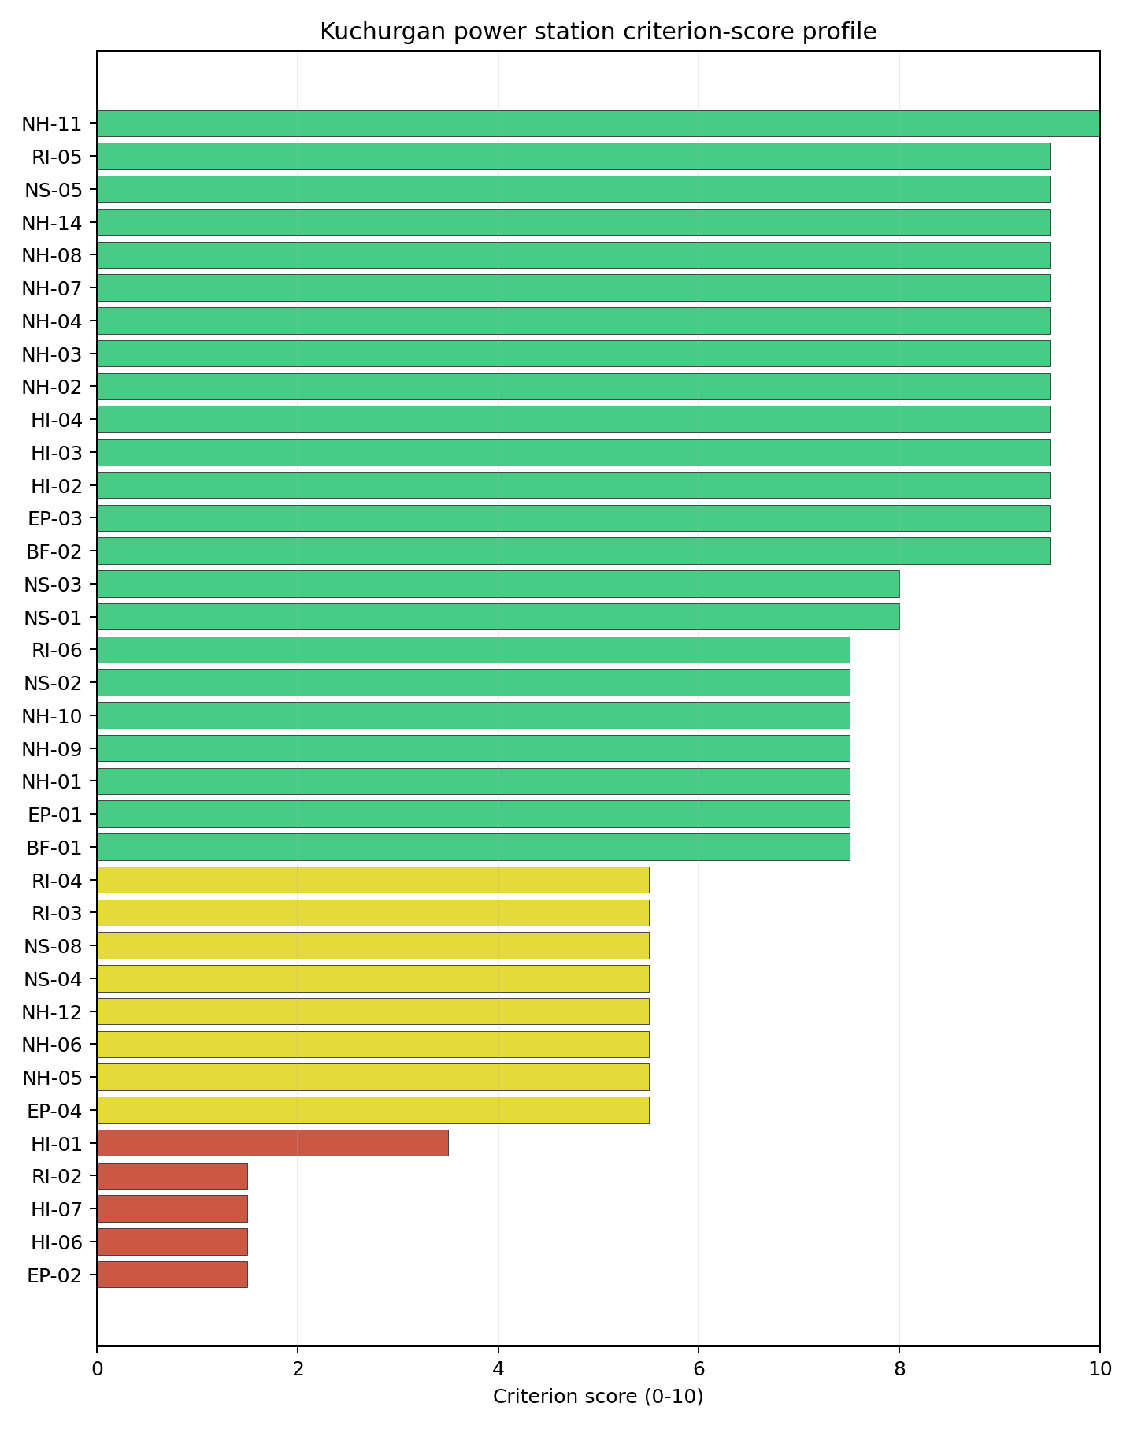
Criterion scores
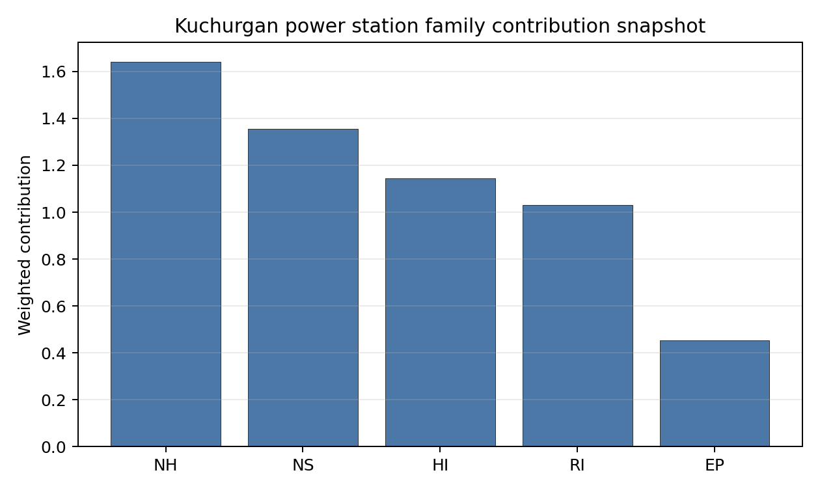
Family contributions
Kuchurgan’s national stability is high because it is the only ranked Moldovan site. The score is still useful: it shows that the site remains Moldova’s leading brownfield candidate under national weight perturbations and that its positive implementation, natural-hazard and radiological attributes are not a narrow baseline-weight artefact. The interpretation should stay disciplined, however. The site is nationally stable but avoidance-flagged, and the country has no second brownfield candidate to absorb a negative finding.
The practical Stage 3 priority is therefore to retire the issues that could change the go/no-go judgement. HI-01 aviation hazard comes first, followed by HI-06 security and governance, EP-02 evacuation capacity, RI-02 liquid-pathway dilution, HI-07 electromagnetic compatibility, land-control confirmation, ecological screening and ownership/programme governance.

Residual Risk Register
Concern | Evidence | Consequence | Stage 3 action | Owner discipline
Aircraft Crash (HI-01) | Small airfield 7.03 km away; flight-path proxy 3.52 km away | The only Moldovan site remains avoidance-flagged until aviation hazard is resolved | Commission aviation hazard assessment with current flight-path and airspace evidence | aviation safety
Military Installations (HI-06) | Nearest high-consequence military feature 11.38 km away; 13 military features within 25 km | Security standoff and governance constraints could materially narrow the feasible site envelope | Confirm feature classification, operating status, standoff requirements and security interfaces | security
Electromagnetic Interference (HI-07) | Nearest transmitter 0.47 km away; 85 transmitter-like features within 25 km | RF/EMI controls may require exclusion distances, shielding or operating constraints | Survey transmitter inventory, field strengths and compatibility requirements | electrical / I&C
Evacuation Routes (EP-02) | EPZ road density 0.27 km/km2; 529.66 km of road; motorway access present | Low route density may constrain clearance-time assumptions | Model EPZ clearance times under realistic traffic and seasonal conditions | emergency planning
Surface Water Dispersion (RI-02) | Kuchurhan River flow proxy 6.73 m3/s; RI-02 score 1.5/10 | Low-flow dilution may constrain discharge pathway design | Quantify low-flow recurrence, reservoir interaction, downstream users and discharge limits | hydrology
Land and Ownership | 200.0 ha site area and 186.16 ha buildable area are screening-stage values; ownership chain runs through Russian-linked entities | Land control, sanctions, title, access or programme eligibility may become gating issues | Verify title, site-control rights, ownership eligibility and governance approvals | legal / programme
Ecological Sensitivity (NS-08) | Nistrul de Jos Emerald Network area 8.444 km away; no overlap recorded | Indirect effects could alter the usable development envelope | Run protected-area pathway review and national EIA scoping | EIA
Governance and First-Programme Readiness | Moldova is treated as a first-programme nuclear jurisdiction in this profile | Regulatory, institutional and workforce readiness may dominate the technical site path | Define national regulator, emergency authorities, workforce plan and international support route | programme governance

Stage 3 Follow-Up Checklist
- Resolve Aircraft Crash (HI-01) using current aviation, flight-path and airspace data for the 7.03 km airfield and 3.52 km flight-path proxy.
- Confirm Military Installations (HI-06) feature class, operating status and required security standoff.
- Run Electromagnetic Interference (HI-07) field-strength and transmitter-inventory surveys.
- Model Evacuation Routes (EP-02) clearance times using the 0.27 km/km2 EPZ road-density constraint.
- Quantify Surface Water Dispersion (RI-02) low-flow dilution for the Kuchurhan River and reservoir setting.
- Verify Site Footprint Adequacy (NS-05) land control, contiguity, buildability and permitted reuse for the 200.0 ha site area and 186.16 ha development-area estimate.
- Scope Ecological Sensitivity (NS-08) against the Nistrul de Jos protected-area pathway and national EIA requirements.
- Confirm grid operability for the 330 kV context, nearby substation, nearby high-voltage line and 1,400 MW export-capacity estimate.
- Resolve ownership and programme-governance eligibility before committing to field characterisation.

Evidence Limitations
- The aviation, military, industrial-hazard and emergency-planning evidence needs current local authority confirmation because Kuchurgan sits in a complex governance setting.
- The surface-area and development-area values are screening-stage land indicators and do not prove nuclear-development rights, title, permitting status or constructability.
- RI-02, EP-02, HI-06 and HI-07 have low or weak scores that should be treated as priority characterisation issues.
- NS-06, NS-10, NS-12 and NS-13 remain unscored or low-confidence implementation fields and should be converted into site-specific evidence before any deployment-level conclusion.

Montenegro Country Profile
Montenegro has 4 thermal and coal-site records tested against the NuScale VOYGR-6 reference deployment envelope. No site passes both the exclusionary and avoidance screens, one site passes the exclusionary screen with avoidance flags, and three sites fail one or more exclusionary checks. The country is therefore a one-candidate remediation case, not a multi-site brownfield programme pool.
Montenegro should also be treated as a first-time nuclear-power jurisdiction for Stage 1-2 programme planning unless a later national review adds evidence of an established civil nuclear-power framework. That makes regulatory capacity, emergency-planning institutions, workforce development and public-stakeholder readiness part of the same Stage 3 workstream as the site-specific technical investigations. The screening result is still useful, but it supports a cautious characterisation sequence rather than an immediate deployment programme.
The leading site is Bar power station, with a composite score of 6.023 and a Monte Carlo interval of 5.321-6.467. Its national stability band is A, with a national top-10% hit rate of 100%. Bar is therefore the only Montenegrin site that currently remains in the ranked candidate set, but it remains contingent on resolving the Seismic: Ground Motion (NH-01) and Coastal Flooding (NH-08) avoidance flags.
Montenegro’s four-site pool has no full-pass leadership group. Bar is the only site that survives the exclusionary screen and the only site with a national composite score, while Berane, Maoce and Pljevlja are removed before ranking. This supports a single-site Stage 3 characterisation decision, not a national shortlist with fast followers.
The avoidance unlock pool is also narrow. Seismic: Ground Motion (NH-01) and Coastal Flooding (NH-08) each affect the one exclusionary-pass site, or 100% of the exclusionary-pass pool. Those are not administrative clean-up items: Bar needs a project-specific probabilistic seismic hazard assessment, measured site response, and coastal inundation, storm-surge and tsunami review before it can be treated as more than a contingent candidate.
Greenfield siting remains the realistic programme lever if Montenegro wishes to pursue a wider SMR siting strategy. The brownfield evidence does not yet identify a second coal or thermal site that can act as a fast follower. A credible Stage 3 sequence begins with Bar only, while any broader programme would need a greenfield or wider industrial-site survey alongside institutional and emergency-planning readiness work.

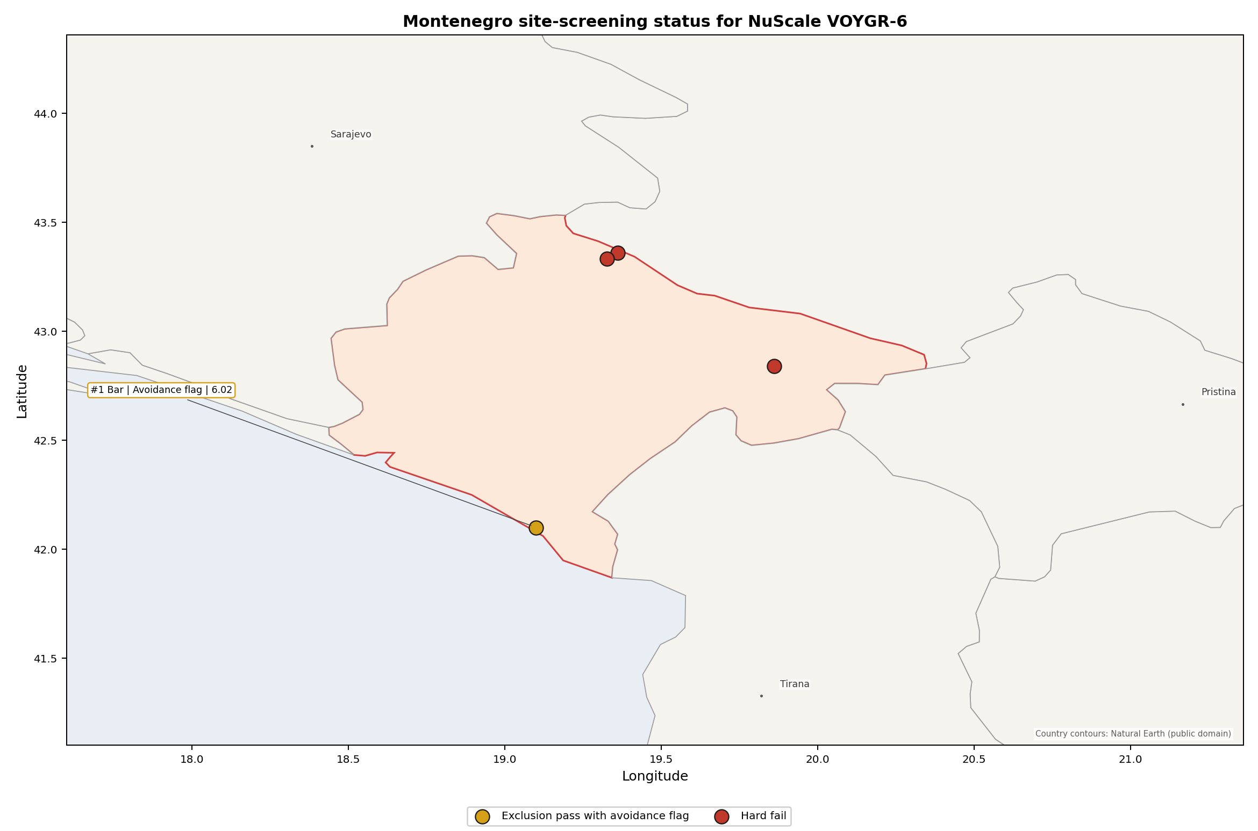
Montenegro status map

Montenegro Site Ledger
Rank | Site | Status | Composite | MC Low | MC High | Band | Top-10 Hit | Coverage
1 | Bar power station | Exclusion pass with avoidance flag | 6.023 | 5.321 | 6.467 | A | 100% | 74%
- | Berane power station | Hard fail | - | - | - | - | - | 0%
- | Maoce Power Station | Hard fail | - | - | - | - | - | 0%
- | Pljevlja power station | Hard fail | - | - | - | - | - | 0%

Avoidance Flag Pareto
Of the 1 site that passes the exclusionary screen, the avoidance-phase flags are concentrated in two natural-hazard criteria. Resolving them would clarify Bar’s status; it would not create a broader brownfield pool.
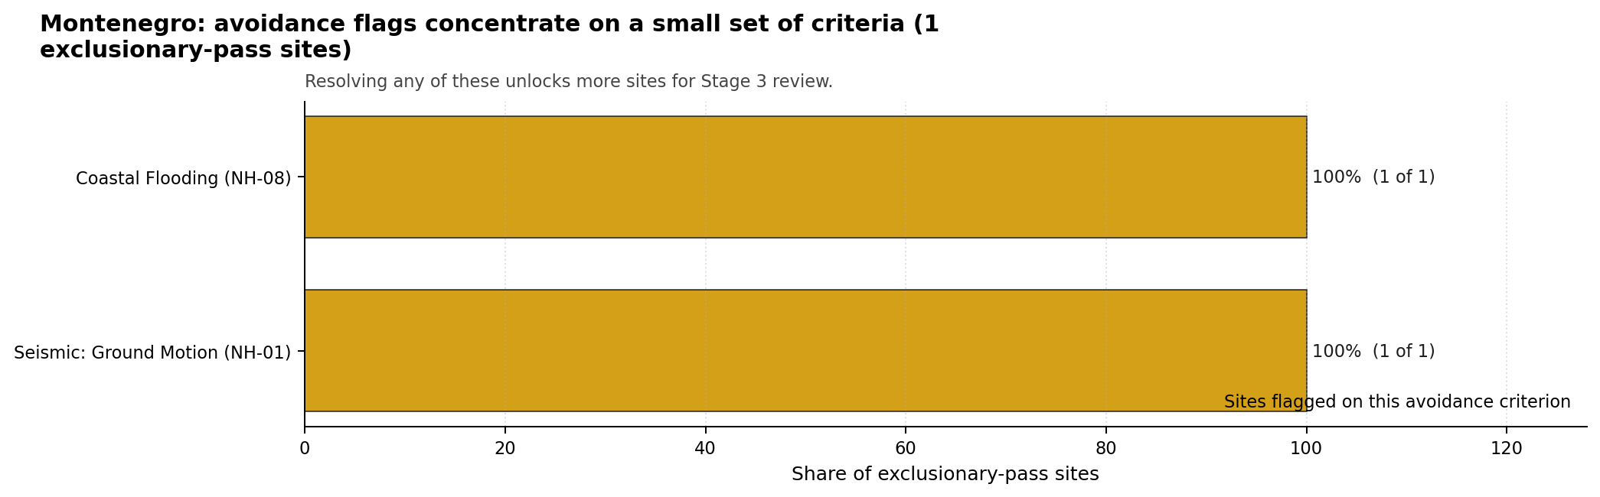
Avoidance flag Pareto
- Seismic: Ground Motion (NH-01) - 1 of 1 exclusionary-pass sites (100%) - Bar requires site-specific seismic characterisation before the avoidance flag can be retired.
- Coastal Flooding (NH-08) - 1 of 1 exclusionary-pass sites (100%) - Bar requires coastal inundation, storm-surge and tsunami confirmation because it is a low-elevation coastal site.

Exclusionary Failure Pareto
The hard-fail pattern is dominated by capable-fault proximity. This is a structural siting constraint for the current brownfield pool, not a data-quality issue that can be solved by re-ranking.
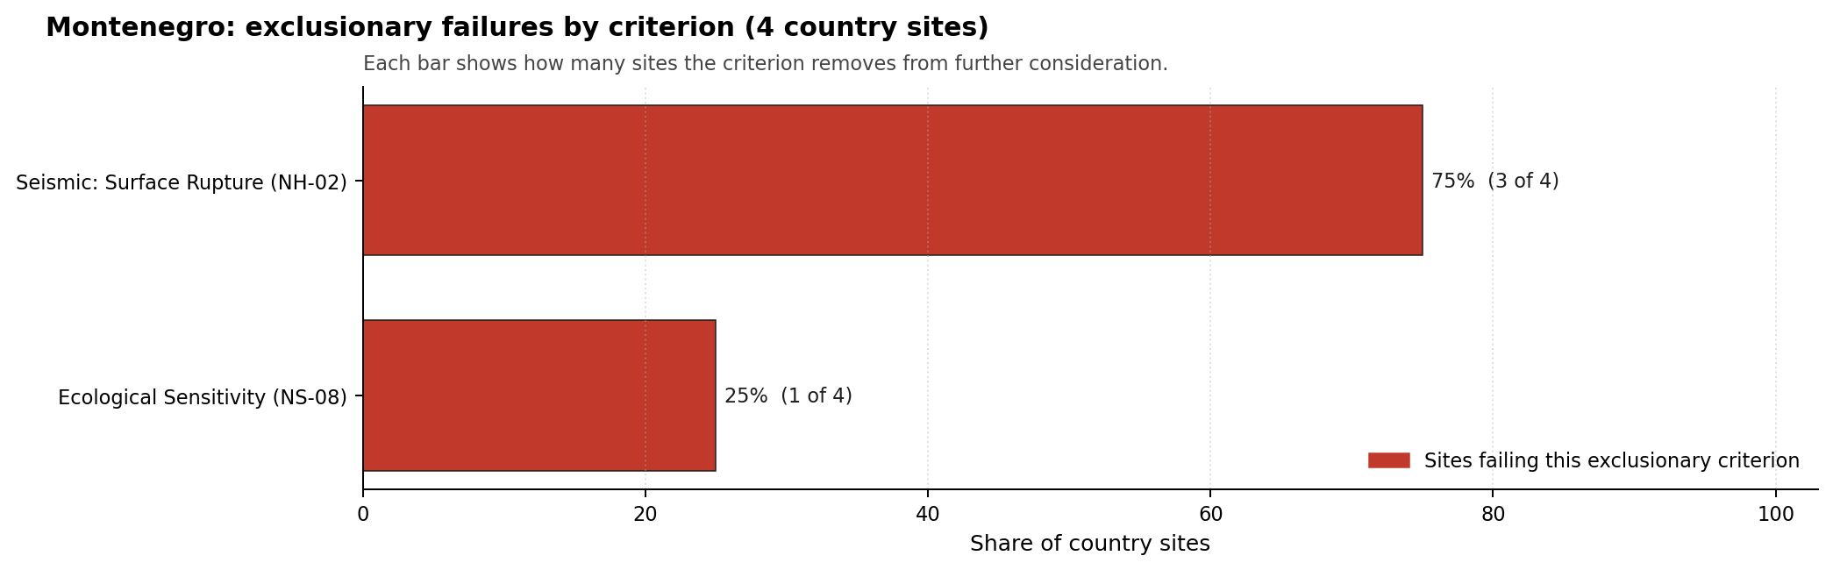
Exclusionary failure Pareto
- Seismic: Surface Rupture (NH-02) - 3 of 4 country sites (75%) - Berane, Maoce and Pljevlja require capable-fault confirmation before they could re-enter the candidate pool.
- Ecological Sensitivity (NS-08) - 1 of 4 country sites (25%) - Pljevlja carries an additional protected-area exclusionary trigger.

Family Strength and Weakness
Across the one ranked Montenegrin site, the strongest criterion family is Human-Induced and Security-Relevant Hazards at a mean normalised score of 7.41/10. The weakest family is Natural Hazards at 4.79/10, which is consistent with Bar’s seismic and coastal-plain constraints. The bottom three individual criteria across the four-site country pool are:
- Military Installations (HI-06) - mean 0.38/10 across 4 scored sites (min 0.0, max 1.5).
- Evacuation Routes (EP-02) - mean 1.50/10 across 4 scored sites (min 1.5, max 1.5).
- Ecological Sensitivity (NS-08) - mean 1.50/10 across 4 scored sites (min 1.5, max 1.5).

National Sensitivity and Robustness
The national sensitivity result is small-n by construction: only Bar has a ranked composite score. Within that limited national frame, Bar is stable. Its 6.023 baseline composite remains inside a 5.321-6.467 Monte Carlo interval and records a band-A national stability result with a 100% national top-10 hit rate across the scored sensitivity cases.
That stability should not be over-read as general site strength. It means Bar is robustly the best Montenegrin brownfield candidate because the alternatives are excluded before ranking. The Stage 3 decision is therefore binary: either Bar’s seismic and coastal evidence can support continued characterisation, or Montenegro’s coal and thermal brownfield pool does not currently provide a credible NuScale VOYGR-6 candidate.

Interpretation for Site Selection
An IAEA-style reading of the Montenegro result focuses first on screening class, then on rank. There is no full-pass group. The only site suitable for further Stage 3 consideration is Bar, and even that site remains an avoidance-flagged candidate rather than a clear shortlist leader.
The hard-fail sites should remain in the evidence base as comparators. Berane, Maoce and Pljevlja are not lower-ranked alternatives to Bar; they are removed by exclusionary checks before composite ranking. Any attempt to restore them would require new capable-fault evidence or, in Pljevlja’s case, resolution of the protected-area trigger as well.
The main Stage 3 questions for Montenegro are therefore targeted and sequential: confirm Bar’s seismic hazard and measured site response, model coastal flooding and tsunami exposure, test emergency-planning clearance on the coastal road network, verify security-relevant nearby features, and confirm whether any first-party land-control evidence supports the surface-area assumptions needed for NuScale VOYGR-6.

Status Counts
- Full pass: 0
- Exclusion pass with avoidance flag: 1 (Bar power station)
- Hard fail: 3 (Berane power station, Maoce Power Station, Pljevlja power station)

Bar power station Site Profile
Bar power station is a coal/thermal site in Montenegro that has been tested against the NuScale VOYGR-6 reference deployment envelope. This profile reads the screening evidence at a level that supports a decision to progress toward Stage 3 characterisation. It is not a site-suitability determination, vendor recommendation, or licensing finding.

Site Snapshot
Field | Value
Site name | Bar power station
Coordinates | 42.1000, 19.1000
Subnational unit | Bar
Installed thermal capacity (source data) | 800 MW
Available surface area | N/A
Available surface area for development | N/A
Composite score (baseline weights) | 6.023 (5.321-6.467 MC band)
National stability band | A (top-10% hit rate 100%)
National rank | 1
See the country status map in Montenegro Country Profile.

Ownership and Coal-to-Nuclear Context
The ownership record lists Enel SpA and Dufenergy Italia SpA as immediate owners or operators. The parent-chain record also includes Duferco Participations Holding SA, the Ministry of Economy and Finance (Italy), BlackRock Inc, Blackrock Advisors LLC, The Vanguard Group Inc and small shareholder(s), but the plant-level share entries are not quantified. Legal control, land rights and any state or private decision pathway therefore require first-party confirmation before publication or Stage 3 procurement assumptions.
Generating units on record: 1 cancelled. Earliest unit commissioning: 2014; most recent: 2014.

Natural Hazards (NH)
- Seismic: Ground Motion (NH-01) - score 3.5/10 (MC 3.0-4.0), weight 0.0455, data quality high. Evidence: PGA at 475-year return period 0.289 g; PGA at 2,475-year return period 0.689 g; Vs30 reference (m/s): 760.0.
- Seismic: Surface Rupture (NH-02) - score 5.5/10 (MC 5.0-6.0) - pass-mark band: Borderline acceptable separation: meets the 8.0 km score boundary; check against the 8 km conservative screen and local capability evidence., weight n/a, data quality screening grade. Evidence: nearest mapped capable fault 10.4 km; fault slip rate 0.324 mm/yr; fault name: MECF005.
- Geotechnical: Liquefaction (NH-03) - score 5.5/10 (MC 5.0-6.0) - pass-mark band: Moderate susceptibility, or high/very-high with documented (or pending for high) mitigation., weight n/a, data quality medium. Evidence: liquefaction susceptibility: moderate; dominant soil type: silty_clay_loam.
- Geotechnical: Slope Stability (NH-04) - score 9.5/10 (MC 9.0-10.0) - favourable: Well below the risk boundary., weight n/a, data quality screening grade. Evidence: site slope 3.81 deg; max slope in 1 km box 67.6 deg; slope stability class: gentle.
- Geotechnical: Subsidence (NH-05) - score 5.5/10 (MC 5.0-6.0) - pass-mark band: At or above the mine-distance score-5 pivot; review possible., weight 0.0354, data quality medium. Evidence: karst present: no; karst severity: moderate; formation type: carbonate (Continuous carbonate rocks).
- Geotechnical: Foundation (NH-06) - score 5.5/10 (MC 5.0-6.0) - pass-mark band: Typical European mixed conditions (bearing 80-150 kPa)., weight 0.0253, data quality medium. Evidence: bearing capacity 87.3 kPa; depth to bedrock 23.0 m.
- Volcanism (NH-07) - score 9.5/10 (MC 9.0-10.0) - favourable: Very strong margin above the score-5 boundary (or no in-radius signal is recorded)., weight n/a, data quality high. Evidence: volcanic hazard class: negligible.
- Coastal Flooding (NH-08) - score 0.0/10 (MC 0.0-0.0), weight 0.0303, data quality medium. Evidence: distance to coast 1.56 km.
- River Flooding (NH-09) - score 7.5/10 (MC 7.0-8.0), weight 0.0404, data quality medium. Evidence: flood zone class: negligible.
- Extreme Winds (NH-10) - score 7.5/10 (MC 7.0-8.0), weight 0.0152, data quality medium. Evidence: screening wind-speed index 8.79 m/s.
- Extreme Precipitation (NH-11) - score 2.0/10 (MC 2.0-3.0), weight 0.0152, data quality medium. Evidence: screening extreme-precipitation index 0.81 mm; screening precipitation index 66.4 mm/yr.
- Extreme Temperatures (NH-12) - score 7.5/10 (MC 7.0-8.0), weight 0.0202, data quality medium. Evidence: extreme high temperature 27.0 deg C; extreme low temperature 6.14 deg C.
- Combined Hazards (NH-14) - score 0.0/10 (MC 0.0-0.0), weight 0.0152, data quality n/a. Evidence: values not in measurement tables.

Interpretation - Natural Hazards (NH)
Natural hazards at Bar are the controlling technical issue for the site. Seismic: Ground Motion (NH-01) carries an avoidance flag: PGA is 0.289 g at the 475-year return period and 0.689 g at the 2,475-year return period, above the project’s 0.5 g avoidance threshold for the long-return-period case. Seismic: Surface Rupture (NH-02) is less severe but still material, with the nearest mapped capable fault 10.42 km away and a recorded slip rate of 0.324 mm/year. Coastal Flooding (NH-08) is the second avoidance flag: the site is 1.56 km from the coast and only 11.9 m above sea level, with no final storm-surge or tsunami characterisation at this stage. The geotechnical record is mixed rather than prohibitive. Liquefaction susceptibility is moderate, bearing capacity is 87.3 kPa, depth to bedrock is 23.02 m, and the mean site slope is 3.81 degrees, although local relief still requires field confirmation. Extreme precipitation remains a low-confidence input at 66.44 mm/year screening precipitation index and 0.81 mm screening extreme-precipitation index. Stage 3 should begin with a project-specific probabilistic seismic hazard assessment on measured site response, then coastal inundation and tsunami modelling, followed by geotechnical and design-hydrology confirmation.

Human-Induced and Security-Relevant Hazards (HI)
- Aircraft Crash (HI-01) - score 9.5/10 (MC 9.0-10.0) - favourable: Only small / GA / heliport airport >= 10 km nearby, no flight-path proxy < 4 km, no major airport within 30 km, and no military airbase within 60 km., weight 0.0354, data quality high. Evidence: nearest airport 28.0 km; nearest flight path 15.7 km; airports within search radius 1; airport name: Splendid Hotel Helipad; airport type: heliport.
- Industrial Explosions (HI-02) - score 9.5/10 (MC 9.0-10.0) - favourable: Very strong margin above the score-5 boundary (or completed search confirmed no in-radius signal)., weight 0.0354, data quality screening grade. Evidence: values not in measurement tables.
- Toxic/Gas Releases (HI-03) - score 9.5/10 (MC 9.0-10.0) - favourable: Very strong margin above the score-5 boundary (or completed search confirmed no in-radius signal)., weight 0.0354, data quality screening grade. Evidence: values not in measurement tables.
- External Fires (HI-04) - score 9.5/10 (MC 9.0-10.0) - favourable: > 15 km, or completed flammable-storage search found nothing in radius., weight 0.0303, data quality screening grade. Evidence: values not in measurement tables.
- Military Installations (HI-06) - score 0.0/10 (MC 0.0-0.0), weight 0.0303, data quality high. Evidence: nearest military installation 0.89 km; military installations within radius 8; installation name: unnamed.
- Electromagnetic Interference (HI-07) - score 1.5/10 (MC 1.0-2.0), weight 0.0101, data quality medium. Evidence: nearest high-power transmitter 0.46 km; transmitters within radius 56; transmitter type: tower.

Interpretation - Human-Induced and Security-Relevant Hazards (HI)
Human-induced and security-relevant hazards at Bar are uneven: the aviation and industrial screens are manageable, while security and electromagnetic-interference questions require early confirmation. Aircraft Crash (HI-01) records the nearest air feature, Splendid Hotel Helipad, at 28.0 km and the nearest flight-path proxy at 15.72 km, with one air feature in the search radius. Industrial Explosions (HI-02), Toxic/Gas Releases (HI-03), and External Fires (HI-04) score strongly in the frozen run, indicating no measured nearby hazard driver in the available screening evidence. The principal weakness is Military Installations (HI-06), which scores 0.0/10: the nearest recorded military feature is 0.89 km from the site, the nearest high-consequence feature is 23.94 km away, and eight military features are recorded within 25 km. Electromagnetic Interference (HI-07) is also material, with the nearest transmitter 0.46 km away and 56 transmitters within 25 km. Stage 3 should therefore prioritize official security-feature confirmation, airspace and standoff review, and an RF/EMI field survey before the site is treated as a stable implementation option.

Radiological Impact and Emergency Planning (RI / EP)
- Emergency Planning Feasibility (EP-01) - score 5.5/10 (MC 5.0-6.0) - pass-mark band: At or above the composite score-5 boundary., weight n/a, data quality high. Evidence: EP feasibility composite 52.7 /100; road sub-score 28.8 /100; special-population sub-score 90.0 /100; geography sub-score 95.0 /100; population sub-score 60.0 /100; evacuation feasible: yes.
- Evacuation Routes (EP-02) - score 1.5/10 (MC 1.0-2.0), weight 0.0303, data quality medium. Evidence: road density in EPZ 0.188 km/km2; road length in EPZ 369.4 km; motorway access: yes.
- Physical Geography Constraints (EP-03) - score 9.5/10 (MC 9.0-10.0) - favourable: No measured relief; open river/waterway context (interim screening)., weight 0.0253, data quality medium. Evidence: waterways crossing EPZ 0; major river barrier: no.
- Special Populations (EP-04) - score 5.5/10 (MC 5.0-6.0) - pass-mark band: 9-25., weight 0.0303, data quality medium. Evidence: hospitals in EPZ 10; prisons in EPZ 0; care homes in EPZ 0.
- Atmospheric Dispersion (RI-01) - score no native score (unscored - no band matched), weight 0.0303, data quality medium. Evidence: annual mean wind speed 1.4 m/s; atmospheric mixing height 425.8 m; prevailing wind direction: ENE.
- Surface Water Dispersion (RI-02) - score 1.5/10 (MC 1.0-2.0), weight 0.0253, data quality n/a. Evidence: values not in measurement tables.
- Groundwater Dispersion (RI-03) - score 7.5/10 (MC 7.0-8.0), weight 0.0253, data quality medium. Evidence: aquifer type: low permeability.
- Population Density at EPZ Radii (RI-04) - score 3.5/10 (MC 3.0-4.0), weight 0.0404, data quality screening grade. Evidence: population density within 5 km 396.1 /km2; population density within 16 km 59.2 /km2; population density within 25 km 34.9 /km2; population density within 80 km 40.8 /km2; population within 25 km 68,443 people.
- Distance to Population Centres (RI-05) - score 9.5/10 (MC 9.0-10.0) - favourable: No >=50k population-centre proxy within screening envelope., weight 0.0505, data quality screening grade. Evidence: values not in measurement tables.
- Population Projections (RI-06) - score 3.5/10 (MC 3.0-4.0), weight 0.0253, data quality screening grade. Evidence: annual population growth rate 0.497 %/yr; projected population at 25 km in 60 yr 50,059 people.

Interpretation - Radiological Impact and Emergency Planning (RI / EP)
Radiological impact and emergency planning at Bar are dominated by the coastal settlement pattern and the constrained evacuation network. The 5 km population is 31,106 people, with density of 396.09 people/km2; the 25 km population is 68,443 people and the 80 km population is 819,869 people. Population growth is recorded at 0.497% per year, with a 60-year 25 km projection of 50,059 people. Emergency Planning Feasibility (EP-01) remains feasible at 52.7/100, but the sub-scores show why this is not a comfortable result: the road score is 28.8/100 and the terrain score is 10.0/100, while EPZ road density is only 0.188 km/km2 across 369.39 km of roads. Surface Water Dispersion (RI-02) is a low-scoring liquid-pathway issue, while the recorded cooling-source proxy is a small river 13.52 km away with 2.27 m3/s flow. Stage 3 should model EPZ clearance under seasonal coastal demand, confirm the source-term placement against the Bar urban area, and replace the screening liquid-pathway proxy with a site-specific marine and groundwater dispersion assessment.

Non-Safety and Implementation Considerations (NS)
- Grid Capacity Basic Filter (BF-01) - score 5.5/10 (MC 5.0-6.0) - pass-mark band: Note: substation 15-30 km OR 110-219 kV; reinforcement plausible., weight n/a, data quality n/a. Evidence: values not in measurement tables.
- Land Area Basic Filter (BF-02) - score 1.5/10 (MC 1.0-2.0), weight 0.0253, data quality n/a. Evidence: values not in measurement tables.
- Cooling Water Availability (NS-01) - score 6.0/10 (MC 5.0-6.0) - pass-mark band: aggregated(weighted_mean_of_sub_scores), weight 0.0404, data quality screening grade. Evidence: distance to cooling source 13.5 km; cooling source flow 2.27 m3/s; cooling source type: small_river; cooling source name: Rena; water stress label: Low.
- Grid Connection (NS-02) - score 5.5/10 (MC 5.0-6.0) - pass-mark band: aggregated(min_of_sub_scores), weight 0.0404, data quality high. Evidence: nearest substation 0.26 km; nearest high-voltage line 1.01 km; highest nearby line voltage 110.0 kV; grid export capacity 800.0 MW; substations within radius 264; HV lines within radius 186.
- Transport Access (NS-03) - score no native score (unscored - no band matched), weight 0.0404, data quality low. Evidence: not measured at this site (criterion remains unscored).
- Site Topography (NS-04) - score 5.5/10 (MC 5.0-6.0) - pass-mark band: 40-60 %., weight 0.0303, data quality screening grade. Evidence: favourable land cover 41.7 %; moderate land cover 10.6 %; unfavourable land cover 47.7 %; favourable area 92.9 ha; dominant land class: 112.
- Site Footprint Adequacy (NS-05) - score 9.5/10 (MC 9.0-10.0) - favourable: Very strong margin above the score-5 boundary., weight 0.0253, data quality high. Evidence: buildable area 9.68 ha; largest contiguous patch 9.68 ha; buildable patch count 12.
- Existing Infrastructure (NS-06) - score no native score (unscored - no band matched), weight 0.0253, data quality n/a. Evidence: not measured at this site (criterion remains unscored).
- Ecological Sensitivity (NS-08) - score 1.5/10 (MC 0.0-3.5), weight n/a, data quality insufficient. Evidence: natural land cover 47.7 %; distance to nearest protected area 0.575 km; Natura 2000 sensitivity class: unknown; protected-area overlap: no; protected-area sensitivity class: high; Natura 2000 sites within 5 km: 0; nearest protected-area designation: Natural Monument.
- Workforce Availability (NS-10) - score no native score (unscored - no band matched), weight 0.0202, data quality n/a. Evidence: not measured at this site (criterion remains unscored).
- Regulatory/Political Environment (NS-12) - score no native score (unscored - no band matched), weight 0.0303, data quality n/a. Evidence: not measured at this site (criterion remains unscored).
- Construction Logistics (NS-13) - score no native score (unscored - no band matched), weight 0.0202, data quality n/a. Evidence: not measured at this site (criterion remains unscored).

Interpretation - Non-Safety and Implementation Considerations (NS)
Non-safety and implementation conditions at Bar contain useful brownfield attributes but also several constraints that could shape the NuScale VOYGR-6 envelope. The local screening record identifies 92.86 ha of favourable area, but first-party evidence of available, controlled and permitted development land is not yet present, so land availability remains a Stage 3 confirmation item. The older buildable-patch indicator is 9.68 ha across 12 patches and should be treated as supporting context rather than proof of the final deployment footprint. Grid proximity is favourable in distance terms: the nearest substation is 0.26 km away, the nearest high-voltage line is 1.01 km away, and the screening export-capacity estimate is 800 MW. The voltage pathway is less mature, with the highest nearby line at 110 kV. Cooling Water Availability (NS-01) needs replacement by a project-specific cooling strategy because the recorded small-river proxy is 13.52 km away with 2.27 m3/s flow. Ecological Sensitivity (NS-08) is a material permitting question: the nearest protected area is 0.575 km away and has a high sensitivity class, although no overlap is recorded for the Bar site. Stage 3 should confirm land control and contiguity, the 220 kV or 400 kV grid pathway, cooling concept, transport access, and ecological screening before any implementation claim is hardened.

Composite Score and Stability
Baseline composite score is 6.023, bracketed by Monte Carlo at 5.321-6.467. National stability band is A with a top-10% hit rate of 100% across 12 scored Monte Carlo scenarios.
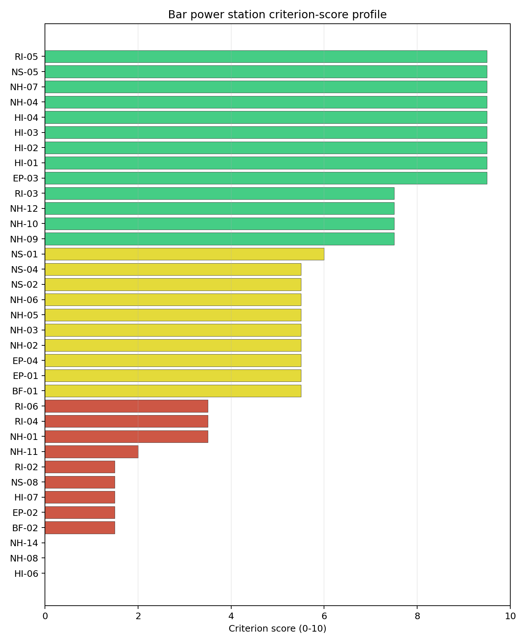
Criterion scores
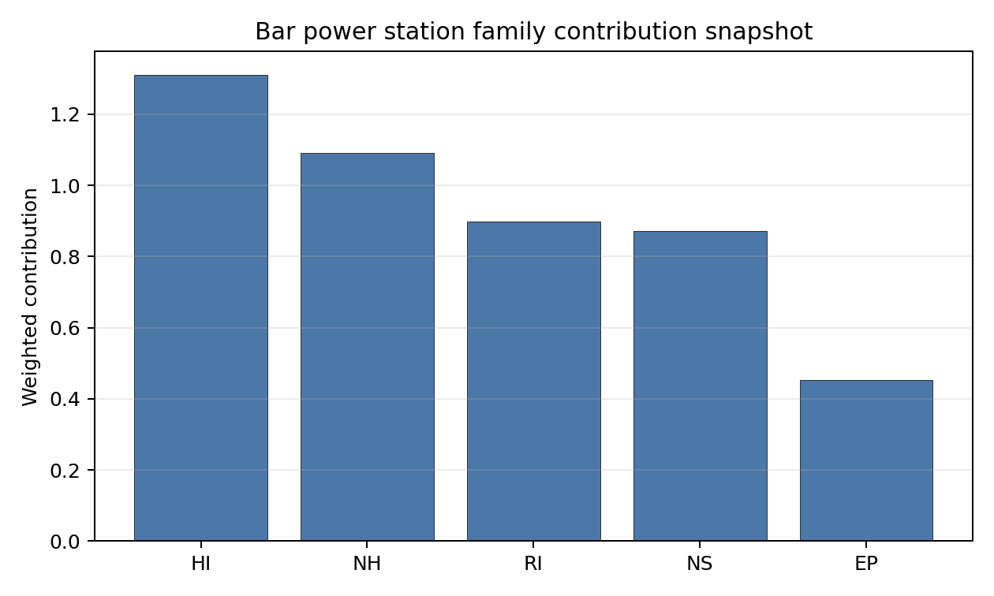
Family contributions
Bar’s baseline composite score is 6.023, with a national Monte Carlo bracket of 5.321-6.467. The national stability band is A, and the site records 100% top-5, top-10 and top-30 hit rates across the 12 scored national sensitivity cases. That is a strong national stability result, but it is strong inside a very small candidate pool: Bar remains the only ranked Montenegrin site because Berane, Maoce and Pljevlja are removed at the exclusionary screen. The family balance is mixed. Human-induced hazards are the strongest family at 7.41/10, followed by Non-Safety and Implementation at 6.39/10 and Radiological Impact at 6.35/10, while Natural Hazards are the main drag at 4.80/10 and Emergency Planning is moderate at 5.26/10. The next characterisation effort would narrow the uncertainty band most by resolving NH-01, NH-08, HI-06, EP-02 and first-party land availability, because those items determine whether Bar is a credible Stage 3 candidate or only the least-constrained member of a weak national brownfield pool.

Residual Risk Register
Concern | Evidence | Consequence | Stage 3 action | Owner discipline
Seismic: Ground Motion (NH-01) | PGA at 2,475-year return period is 0.689 g | Design-basis ground motion may remain above the project avoidance envelope | Re-measure site response and complete project-specific seismic hazard analysis | seismic
Coastal Flooding (NH-08) | Coast distance is 1.56 km and elevation is 11.9 m | Storm-surge or tsunami exposure could constrain the usable site envelope | Model coastal inundation, storm surge and tsunami return periods | hydrology
Military Installations (HI-06) | Nearest recorded military feature is 0.89 km away; eight features are within 25 km | Security standoff or coordination requirements could narrow the site boundary | Engage national defence authorities and verify the feature inventory | security
Evacuation Routes (EP-02) | EPZ road density is 0.188 km/km2 and the road sub-score is 28.8/100 | Clearance time may be constrained by the coastal corridor and terrain | Model EPZ evacuation under seasonal and peak-traffic conditions | emergency planning
Ecological Sensitivity (NS-08) | Nearest protected area is 0.575 km away with high sensitivity class | Permitting may narrow the development envelope or require avoidance buffers | Confirm protected-area boundaries and receptor pathways | EIA
Land availability and contiguity | First-party availability evidence is absent; supporting buildable-patch indicator is 9.68 ha | The VOYGR-6 footprint may not fit without boundary or layout changes | Confirm ownership, control, contiguity and permitted development area | ownership/legal
NH-01 and NH-08 dominate the register because they decide whether the site can remain in the Stage 3 characterisation sequence at all. HI-06, EP-02, NS-08 and land control are the practical implementation risks that would determine the shape, cost and stakeholder pathway of any later site evaluation. This register is a Stage 3 work plan, not a finding of site approval.

Stage 3 Follow-Up Checklist
- Complete site-specific seismic hazard and site-response work for Seismic: Ground Motion (NH-01), because PGA at the 2,475-year return period is 0.689 g.
- Model coastal inundation, storm surge and tsunami exposure for Coastal Flooding (NH-08), because the site is 1.56 km from the coast and 11.9 m above sea level.
- Confirm the official security-feature inventory for Military Installations (HI-06), because the nearest recorded feature is 0.89 km away.
- Model EPZ clearance and seasonal traffic constraints for Evacuation Routes (EP-02), because EPZ road density is 0.188 km/km2.
- Survey RF conditions for Electromagnetic Interference (HI-07), because the nearest transmitter is 0.46 km away and 56 transmitters are recorded within 25 km.
- Replace the screening liquid-pathway proxy for Surface Water Dispersion (RI-02) with a site-specific marine and groundwater dispersion assessment.
- Confirm first-party land control, contiguity and permitted development area before relying on the screening land envelope.
- Improve data quality for Geotechnical: Subsidence & Collapse (NH-05b) and Transport Access (NS-03).

Evidence Limitations
- No first-party available-area or development-area value is present in the local bundle, so both snapshot area rows are reported as N/A.
- Geotechnical: Subsidence & Collapse (NH-05b) and Transport Access (NS-03) carry low-quality evidence flags.
- Several implementation criteria remain unscored at Stage 1-2, including Existing Infrastructure (NS-06), Workforce Availability (NS-10), Regulatory/Political Environment (NS-12), and Construction Logistics (NS-13).

Berane power station Site Profile
Montenegro | tested against the NuScale VOYGR-6 reference deployment envelope | Hard-fail at the exclusionary screen.
Berane power station is a coal/thermal site in Montenegro that does not survive the exclusionary screen against the NuScale VOYGR-6 reference deployment envelope. This profile records the screening evidence that drives the failure and provides the siting expert’s read on whether further characterisation is justified. It is not a site-suitability determination, vendor recommendation, or licensing finding.

Site Snapshot
Field | Value
Site name | Berane power station
Country | Montenegro
Coordinates | 42.8400, 19.8600
Subnational unit | Berane
Installed thermal capacity (source data) | 110 MW
Available surface area | N/A
Available surface area for development | N/A
Operating status | cancelled
Parent owner(s) | Balkan Energy
Generating units on record | 1
Screening verdict | Hard-fail (exclusionary)
Failed exclusionary criteria | NH-02
Composite score | - (not scored)
National stability band | - (not banded)
See the country status map in Montenegro Country Profile.

Why It Failed
The site fails 1 exclusionary criterion below. Exclusionary failures act as gates: a single confirmed failure removes the site from the brownfield candidate pool until the underlying measurement is refuted by site-specific Stage 3 work or until a regulatory threshold change makes the failure moot.
Criterion | Code | Measured value | Threshold | Confidence | Justification
Seismic: Surface Rupture | NH-02 | Nearest mapped capable fault: 6.76 km | Capable fault within score-5 pivot distance | medium | Triggered by capable-fault proximity.

Unlock Analysis
Seismic: Surface Rupture (NH-02) fails because the nearest mapped capable fault is 6.76 km from the site, inside the exclusionary stand-off used by the screening method. This is a structural geological constraint unless a site-specific capable-fault review changes the underlying fault classification or distance. The site also carries avoidance concerns for nearby aviation features and grid export capacity, but those are secondary because the exclusionary fault trigger removes the site before ranking. No further site-level characterisation is justified for the current brownfield envelope unless a future fault-trenching or seismotectonic review downgrades the fault evidence or identifies a different controlled site boundary outside the stand-off area. Recommendation: Deprecate.

Evidence Limitations
- This profile is intentionally compact. Composite scoring, Monte Carlo stability, family contributions, and the residual risk register are omitted because none of those views are informative for a site that is removed at the exclusionary screen.
- The exclusionary thresholds are screening thresholds; site-specific Stage 3 measurement can either confirm the failure or lift it. The unlock analysis above states whether that investment is justified.

Maoce Power Station Site Profile
Montenegro | tested against the NuScale VOYGR-6 reference deployment envelope | Hard-fail at the exclusionary screen.
Maoce Power Station is a coal/thermal site in Montenegro that does not survive the exclusionary screen against the NuScale VOYGR-6 reference deployment envelope. This profile records the screening evidence that drives the failure and provides the siting expert’s read on whether further characterisation is justified. It is not a site-suitability determination, vendor recommendation, or licensing finding.

Site Snapshot
Field | Value
Site name | Maoce Power Station
Country | Montenegro
Coordinates | 43.3600, 19.3600
Subnational unit | Pljevlja
Installed thermal capacity (source data) | 500 MW
Available surface area | N/A
Available surface area for development | N/A
Operating status | cancelled
Parent owner(s) | -
Generating units on record | 1
Screening verdict | Hard-fail (exclusionary)
Failed exclusionary criteria | NH-02
Composite score | - (not scored)
National stability band | - (not banded)
See the country status map in Montenegro Country Profile.

Why It Failed
The site fails 1 exclusionary criterion below. Exclusionary failures act as gates: a single confirmed failure removes the site from the brownfield candidate pool until the underlying measurement is refuted by site-specific Stage 3 work or until a regulatory threshold change makes the failure moot.
Criterion | Code | Measured value | Threshold | Confidence | Justification
Seismic: Surface Rupture | NH-02 | Nearest mapped capable fault: 3.94 km | Capable fault within score-5 pivot distance | medium | Triggered by capable-fault proximity.

Unlock Analysis
Seismic: Surface Rupture (NH-02) fails because the nearest mapped capable fault is 3.94 km from the site, well inside the exclusionary stand-off used by the screening method. This is a structural failure for the brownfield envelope: a project-specific seismic hazard assessment can refine design motion, but it cannot move the capable-fault trace away from the site. The site has sufficient surface-area indicators for screening, but that does not override the fault-rupture gate. No further site-level characterisation is justified unless a future capable-fault catalogue review materially revises the mapped fault status or location. Recommendation: Deprecate.

Evidence Limitations
- This profile is intentionally compact. Composite scoring, Monte Carlo stability, family contributions, and the residual risk register are omitted because none of those views are informative for a site that is removed at the exclusionary screen.
- The exclusionary thresholds are screening thresholds; site-specific Stage 3 measurement can either confirm the failure or lift it. The unlock analysis above states whether that investment is justified.

Pljevlja power station Site Profile
Montenegro | tested against the NuScale VOYGR-6 reference deployment envelope | Hard-fail at the exclusionary screen.
Pljevlja power station is a coal/thermal site in Montenegro that does not survive the exclusionary screen against the NuScale VOYGR-6 reference deployment envelope. This profile records the screening evidence that drives the failure and provides the siting expert’s read on whether further characterisation is justified. It is not a site-suitability determination, vendor recommendation, or licensing finding.

Site Snapshot
Field | Value
Site name | Pljevlja power station
Country | Montenegro
Coordinates | 43.3346, 19.3271
Subnational unit | Pljevlja
Installed thermal capacity (source data) | 479 MW
Available surface area | N/A
Available surface area for development | N/A
Operating status | operating
Parent owner(s) | A2A SpA, Elektroprivreda Crne Gore AD, Government of Montenegro, Municipality of Brescia, Municipality of Milan, small shareholder(s)
Generating units on record | 2
Screening verdict | Hard-fail (exclusionary)
Failed exclusionary criteria | NH-02, NS-08
Composite score | - (not scored)
National stability band | - (not banded)
See the country status map in Montenegro Country Profile.

Why It Failed
The site fails 2 exclusionary criteria below. Exclusionary failures act as gates: a single confirmed failure removes the site from the brownfield candidate pool until the underlying measurement is refuted by site-specific Stage 3 work or until a regulatory threshold change makes the failure moot.
Criterion | Code | Measured value | Threshold | Confidence | Justification
Seismic: Surface Rupture | NH-02 | Nearest mapped capable fault: 0.09 km | Capable fault within score-5 pivot distance | medium | Triggered by capable-fault proximity.
Ecological Sensitivity | NS-08 | Strict protected-area overlap: yes | Strict protected-area or international-designation overlap | low | Triggered by protected-area overlap.

Unlock Analysis
Pljevlja fails on two exclusionary checks. Seismic: Surface Rupture (NH-02) records the nearest mapped capable fault at 0.09 km, effectively adjacent to the site boundary, and Ecological Sensitivity (NS-08) records a strict protected-area overlap. The combined finding is structural: one trigger concerns the physical fault setting, while the other concerns the protected-area envelope. Either item would remove the site from the brownfield candidate pool; together they make site-level recovery implausible without a different site boundary and a successful protected-area review. No further site-level characterisation is justified for the current power-station footprint. Recommendation: Deprecate.

Evidence Limitations
- This profile is intentionally compact. Composite scoring, Monte Carlo stability, family contributions, and the residual risk register are omitted because none of those views are informative for a site that is removed at the exclusionary screen.
- The exclusionary thresholds are screening thresholds; site-specific Stage 3 measurement can either confirm the failure or lift it. The unlock analysis above states whether that investment is justified.

North Macedonia Country Profile
North Macedonia has four thermal and coal-site records tested against the NuScale VOYGR-6 reference deployment envelope. No site currently clears both the exclusionary and avoidance screens, three sites pass the exclusionary screen with avoidance flags, and one site fails an exclusionary check. The country is therefore a conditional brownfield pool rather than a ready full-pass shortlist.
For this screening programme, North Macedonia should be treated as a first-time nuclear-power jurisdiction unless a later regulatory review identifies operating nuclear-power experience outside the project evidence base. That status does not remove sites from Stage 3 consideration, but it makes regulatory capacity, emergency-planning institutions, nuclear workforce development, and owner-readiness checks central to the next phase.
Bitola power station leads the national ranking with a composite score of 6.812 and a Monte Carlo interval of 5.927-7.329. Negotino follows closely at 6.707, but its band-H stability and 0% national top-10 hit rate separate it from Bitola’s band-A stability profile. Oslomej remains a lower third candidate at 5.905, while Mariovo is retained only as a hard-fail comparator.
The plan rule selects the top five nationally ranked sites for site profiles. North Macedonia has only three nationally ranked exclusionary-pass sites in the frozen bundle, so all three ranked sites are selected for detailed treatment: Bitola, Negotino and Oslomej.

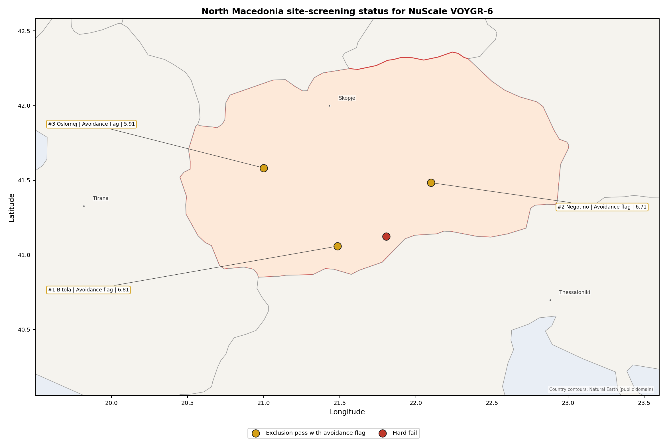
North Macedonia status map

North Macedonia Site Ledger
Rank | Site | Status | Composite | MC Low | MC High | Band | Top-10 Hit | Coverage
1 | Bitola power station | Exclusion pass with avoidance flag | 6.812 | 5.927 | 7.329 | A | 100% | 74%
2 | Negotino power station | Exclusion pass with avoidance flag | 6.707 | 5.846 | 7.171 | H | 0% | 74%
3 | Oslomej power station | Exclusion pass with avoidance flag | 5.905 | 5.230 | 6.421 | H | 0% | 74%
- | Mariovo power station | Hard fail | - | - | - | - | - | 0%

Avoidance Flag Pareto
Of the three sites that pass the exclusionary screen, all three carry at least one avoidance-phase flag. The denominator for this section is the exclusionary-pass pool, not the full four-site country set.
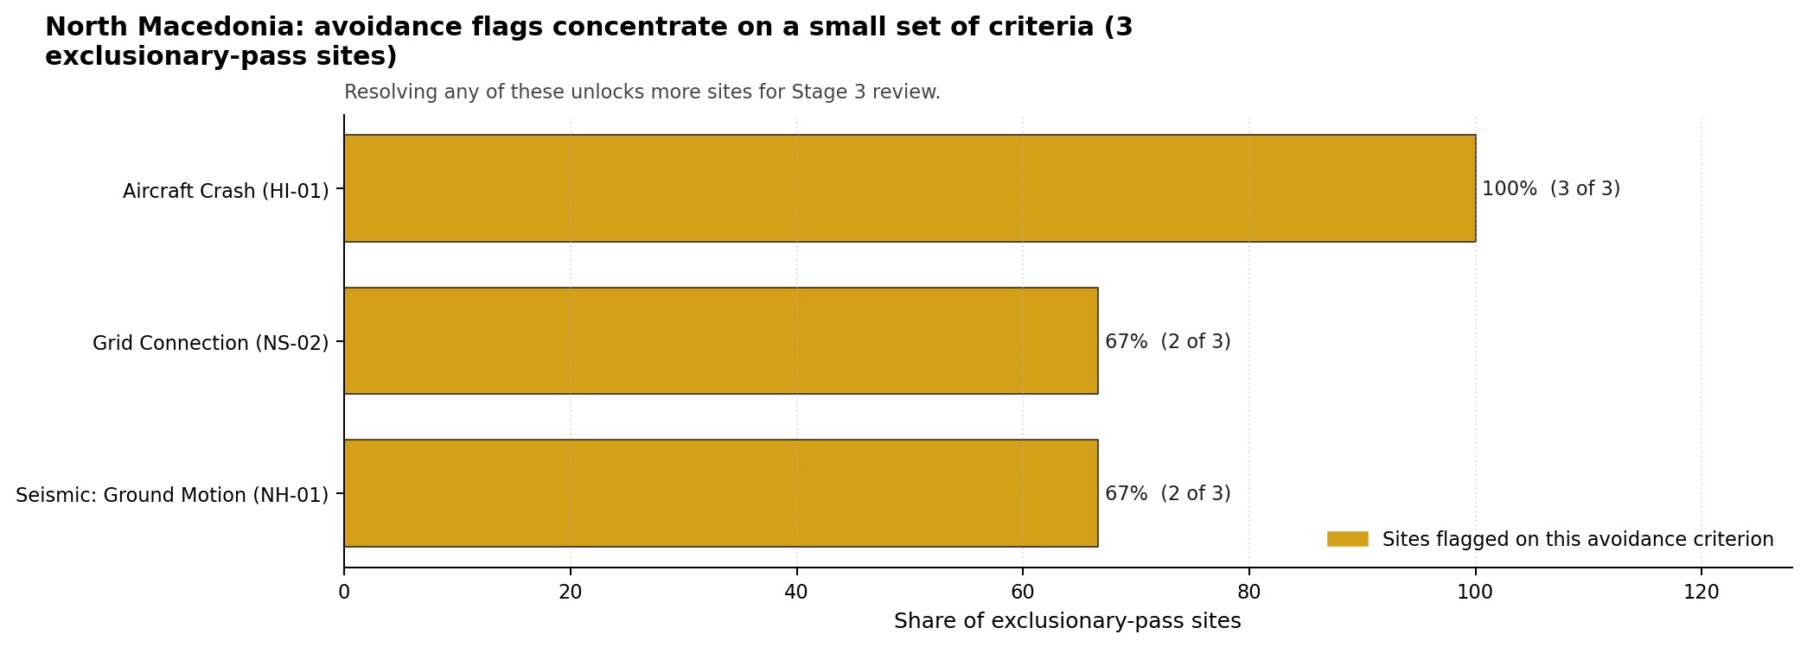
Avoidance flag Pareto
- Aircraft Crash (HI-01) - 3 of 3 exclusionary-pass sites (100%): aviation and heliport screening is a country-wide Stage 3 work item.
- Seismic: Ground Motion (NH-01) - 2 of 3 exclusionary-pass sites (67%): site-specific probabilistic seismic hazard analysis is required before Bitola or Oslomej can be treated as comparable to full-pass sites.
- Grid Connection (NS-02) - 2 of 3 exclusionary-pass sites (67%): transmission capacity and voltage-pathway work controls the lower-ranked candidate pool.

Exclusionary Failure Pareto
The exclusionary failure set is limited to one site in the country pool. The denominator for this section is the four-site country set.
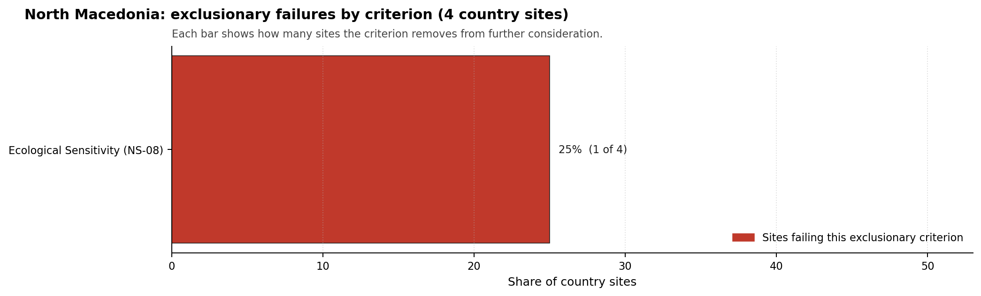
Exclusionary failure Pareto
- Ecological Sensitivity (NS-08) - 1 of 4 country sites (25%): Mariovo is removed from the ranked candidate set by the ecological screen and should remain a comparator unless that evidence is later re-measured.

Family Strength and Weakness
Across the three scored exclusionary-pass sites, the strongest criterion family is Natural Hazards at a mean normalised score of 7.17/10. The weakest family is Non-Safety / Implementation at 5.75/10, reflecting grid, land, transport and ecological-evidence constraints rather than one universal defect.
The bottom individual criteria across the country are Evacuation Routes (EP-02) at a mean 1.50/10, Electromagnetic Interference (HI-07) at 2.00/10, and Military Installations (HI-06) at 2.00/10. These values make emergency-road modelling, RF/EMI survey work, and defence-interface confirmation early Stage 3 priorities for the national shortlist.

National Sensitivity and Robustness
The national sensitivity analysis gives a clear sequencing signal despite overlapping score bands. Bitola is the only site in stability band A and records a 100% national top-10 hit rate. Negotino’s point estimate is close to Bitola, but its band-H result and 0% top-10 hit rate show that it is not a robust national leader under the weight perturbations considered.
Oslomej also sits in band H with a 0% top-10 hit rate. The site remains useful as a ranked comparator because it passes the exclusionary screen, but its combination of seismic loading, grid limitation, emergency-road weakness and small-river cooling context makes it a second-wave or de-prioritised characterisation case unless national programme objectives require a third Macedonian option.

Interpretation for Site Selection
The North Macedonia result should be read as a conditional Stage 3 programme, not as a direct progression list. There is no full-pass site. The practical question is therefore which avoidance flags are sufficiently measurable, remediable or policy-controllable to justify the first characterisation budget.

Avoidance flag Pareto - what unlocks more sites
Bitola is the defensible lead because it combines the top national score, band-A stability, a 400 kV grid interface, 699 MW of inherited export capacity and 145.7 ha of current development-area evidence. Its lead remains conditional on resolving aircraft-crash screening, elevated 2,475-year PGA, sparse EPZ road density, EMI exposure and the land-cover evidence gap.
Negotino is the fast-follower only if the programme wants a second Macedonian site after Bitola. Its score band overlaps Bitola’s, but its 110 kV / 165 MW grid envelope and 5.2 ha current development-area estimate create larger implementation questions. Oslomej is a third-wave comparator because it combines the lowest ranked score with the strongest seismic, grid, water-dispersion and military-proximity constraints in the Macedonian set.
The recommended Stage 3 cadence is therefore: characterise Bitola first; keep Negotino as a conditional second site for transmission, land and defence-interface review; and hold Oslomej as a comparator unless national policy requires a broader domestic portfolio. Mariovo should remain outside the ranked site-profile set until the ecological exclusionary trigger is re-tested.

Status Counts
- Full pass: 0
- Exclusion pass with avoidance flag: 3
- Hard fail: 1

Bitola power station Site Profile
Bitola power station is a coal/thermal site in North Macedonia that has been tested against the NuScale VOYGR-6 reference deployment envelope. This profile reads the screening evidence at a level that supports a decision to progress toward Stage 3 characterisation. It is not a site-suitability determination, vendor recommendation, or licensing finding.

Site Snapshot
Field | Value
Site name | Bitola power station
Coordinates | 41.0583, 21.4843
Subnational unit | Novaci
Installed thermal capacity (source data) | 699 MW
Available surface area | 145.7 ha
Available surface area for development | 145.7 ha
Composite score (baseline weights) | 6.812 (5.927-7.329 MC band)
National stability band | A (top-10% hit rate 100%)
National rank | 1
See the country status map in North Macedonia Country Profile.

Ownership and Coal-to-Nuclear Context
- Government of North Macedonia (100.00% share), headquartered in North Macedonia; immediate operator REK Bitola. Path: Government of North Macedonia -> Elektrani na Severna Makedonija AD [100.0%] -> REK Bitola [100.0%] -> Bitola power station Unit 1 [100.0%]
- Elektrani na Severna Makedonija AD (100.00% share), headquartered in North Macedonia; immediate operator REK Bitola. Path: Elektrani na Severna Makedonija AD -> REK Bitola [100.0%] -> Bitola power station Unit 1 [100.0%]
Generating units on record: 3 operating. Earliest unit commissioning: 1982; most recent: 1988.

Natural Hazards (NH)
- Seismic: Ground Motion (NH-01) - score 3.5/10 (MC 3.0-4.0), weight 0.0455, data quality high. Evidence: PGA at 475-year return period 0.255 g; PGA at 2,475-year return period 0.544 g; Vs30 reference (m/s): 760.0.
- Seismic: Surface Rupture (NH-02) - score 5.5/10 (MC 5.0-6.0), weight n/a, data quality screening grade. Evidence: nearest mapped capable fault 11.4 km; fault slip rate 0.173 mm/yr; fault name: MKCF003.
- Geotechnical: Liquefaction (NH-03) - score 5.5/10 (MC 5.0-6.0), weight n/a, data quality medium. Evidence: liquefaction susceptibility: moderate; dominant soil type: loam.
- Geotechnical: Slope Stability (NH-04) - score 9.5/10 (MC 9.0-10.0), weight n/a, data quality screening grade. Evidence: site slope 2.38 deg; max slope in 1 km box 31.4 deg; slope stability class: gentle.
- Geotechnical: Subsidence (NH-05) - score 9.5/10 (MC 9.0-10.0), weight 0.0354, data quality medium. Evidence: karst present: no; karst severity: none.
- Geotechnical: Foundation (NH-06) - score 5.5/10 (MC 5.0-6.0), weight 0.0253, data quality medium. Evidence: bearing capacity 86.7 kPa; depth to bedrock 26.1 m.
- Volcanism (NH-07) - score 9.5/10 (MC 9.0-10.0), weight n/a, data quality high. Evidence: volcanic hazard class: negligible.
- Coastal Flooding (NH-08) - score 9.5/10 (MC 9.0-10.0), weight 0.0303, data quality medium. Evidence: distance to coast 115.1 km.
- River Flooding (NH-09) - score 7.5/10 (MC 7.0-8.0), weight 0.0404, data quality medium. Evidence: flood zone class: negligible.
- Extreme Winds (NH-10) - score 9.5/10 (MC 9.0-10.0), weight 0.0152, data quality medium. Evidence: screening wind-speed index 7.43 m/s.
- Extreme Precipitation (NH-11) - score 10.0/10 (MC 9.0-10.0), weight 0.0152, data quality medium. Evidence: screening extreme-precipitation index 0.17 mm; screening precipitation index 20.3 mm/yr.
- Extreme Temperatures (NH-12) - score 6.5/10 (MC 6.0-7.0), weight 0.0202, data quality medium. Evidence: extreme high temperature 25.1 deg C; extreme low temperature -4.41 deg C.
- Combined Hazards (NH-14) - score 5.5/10 (MC 5.0-6.0), weight 0.0152, data quality n/a. Evidence: values not in measurement tables.

Interpretation - Natural Hazards (NH)
Natural hazards at Bitola are favourable in several desk-screening dimensions, but Seismic: Ground Motion (NH-01) is the binding natural-hazard question. The 475-year PGA is 0.255 g and the 2,475-year PGA is 0.544 g, which places the site above the project’s avoidance trigger for the long-return-period ground-motion screen. Surface rupture is less severe at this stage: the nearest mapped capable fault is 11.4 km away, and the screening file records a 0.173 mm/yr slip rate for MKCF003. The supporting geotechnical file is mixed but workable for Stage 1-2. Liquefaction susceptibility is moderate, bearing capacity is 86.7 kPa, depth to bedrock is 26.1 m, and the site slope is a gentle 2.38 degrees. Wider natural-hazard conditions are stronger: the flood-zone class is negligible, the coast is 115.1 km away, the 50-year screening wind-speed index is 7.43 m/s, and the volcanic hazard class is negligible. The precipitation values, 20.3 mm/yr screening precipitation index and 0.17 mm screening extreme-precipitation index, are useful only as screening evidence and should be re-checked before design use. Stage 3 should start with site-specific PSHA using measured Vs30, then confirm local flood, precipitation and drainage inputs and run a CPT/SPT geotechnical campaign for liquefaction and foundation design.

Human-Induced and Security-Relevant Hazards (HI)
- Aircraft Crash (HI-01) - score 3.5/10 (MC 3.0-4.0), weight 0.0354, data quality high. Evidence: nearest airport 6.64 km; nearest flight path 3.32 km; airports within search radius 2; airport name: Logovardi Sport Aerodrome; airport type: small airfield.
- Industrial Explosions (HI-02) - score 9.5/10 (MC 9.0-10.0), weight 0.0354, data quality screening grade. Evidence: values not in measurement tables.
- Toxic/Gas Releases (HI-03) - score 9.5/10 (MC 9.0-10.0), weight 0.0354, data quality screening grade. Evidence: values not in measurement tables.
- External Fires (HI-04) - score 9.5/10 (MC 9.0-10.0), weight 0.0303, data quality screening grade. Evidence: values not in measurement tables.
- Military Installations (HI-06) - score 3.5/10 (MC 3.0-4.0), weight 0.0303, data quality medium. Evidence: nearest military installation 16.2 km; military installations within radius 10; installation name: unnamed.
- Electromagnetic Interference (HI-07) - score 1.5/10 (MC 1.0-2.0), weight 0.0101, data quality medium. Evidence: nearest high-power transmitter 0.22 km; transmitters within radius 26; transmitter type: mast.

Interpretation - Human-Induced and Security-Relevant Hazards (HI)
Human-induced and security-relevant hazards at Bitola are led by aviation and RF/EMI screening issues, not by the broader industrial-hazard file. Aircraft Crash (HI-01) scores 3.5/10 because Logovardi Sport Aerodrome is 6.64 km from the site and the nearest flight-path proxy is 3.32 km away; both values require a project-specific aircraft-crash hazard assessment before the avoidance flag can be retired. Industrial Explosions (HI-02), Toxic/Gas Releases (HI-03), and External Fires (HI-04) each score 9.5/10 in the frozen scoring run, indicating no standing adverse signal in the available screening evidence. Military Installations (HI-06) is a moderate concern rather than the lead issue: the nearest military feature is 16.2 km away, with 10 features inside the wider screening radius. Electromagnetic Interference (HI-07) is more material, with a transmitter 0.22 km from the site and 26 transmitters in the search radius. Stage 3 should therefore commission the aircraft-crash assessment for Logovardi, complete an RF/EMI field survey, and refresh the hazardous-neighbour and defence-feature inventories with the responsible national authorities.

Radiological Impact and Emergency Planning (RI / EP)
- Emergency Planning Feasibility (EP-01) - score 7.5/10 (MC 7.0-8.0), weight n/a, data quality high. Evidence: EP feasibility composite 67.3 /100; road sub-score 38.1 /100; special-population sub-score 90.0 /100; geography sub-score 95.0 /100; population sub-score 95.0 /100; evacuation feasible: yes.
- Evacuation Routes (EP-02) - score 1.5/10 (MC 1.0-2.0), weight 0.0303, data quality medium. Evidence: road density in EPZ 0.281 km/km2; road length in EPZ 552.5 km; motorway access: yes.
- Physical Geography Constraints (EP-03) - score 9.5/10 (MC 9.0-10.0), weight 0.0253, data quality medium. Evidence: waterways crossing EPZ 0; major river barrier: no.
- Special Populations (EP-04) - score 7.5/10 (MC 7.0-8.0), weight 0.0303, data quality medium. Evidence: hospitals in EPZ 6; prisons in EPZ 1; care homes in EPZ 0.
- Atmospheric Dispersion (RI-01) - score no native score (unscored, no band matched), weight 0.0303, data quality medium. Evidence: annual mean wind speed 0.6 m/s; atmospheric mixing height 523.2 m; prevailing wind direction: NW.
- Surface Water Dispersion (RI-02) - score 3.5/10 (MC 3.0-4.0), weight 0.0253, data quality n/a. Evidence: values not in measurement tables.
- Groundwater Dispersion (RI-03) - score 5.5/10 (MC 5.0-6.0), weight 0.0253, data quality medium. Evidence: aquifer type: alluvial.
- Population Density at EPZ Radii (RI-04) - score 7.5/10 (MC 7.0-8.0), weight 0.0404, data quality screening grade. Evidence: population density within 5 km 22.2 /km2; population density within 16 km 111.6 /km2; population density within 25 km 54.9 /km2; population density within 80 km 50.4 /km2; population within 25 km 107,711 people.
- Distance to Population Centres (RI-05) - score 5.5/10 (MC 5.0-6.0), weight 0.0505, data quality screening grade. Evidence: values not in measurement tables.
- Population Projections (RI-06) - score 7.5/10 (MC 7.0-8.0), weight 0.0253, data quality screening grade. Evidence: annual population growth rate -0.399 %/yr; projected population at 25 km in 60 yr 72,283 people.

Interpretation - Radiological Impact and Emergency Planning (RI / EP)
Radiological impact and emergency-planning conditions at Bitola are helped by low population density but constrained by the EPZ road network and unmeasured liquid-pathway evidence. Emergency Planning Feasibility (EP-01) is marked feasible with a 67.3/100 composite, but the road sub-score is only 38.1/100. Evacuation Routes (EP-02) therefore remains a binding Stage 3 topic: the EPZ road density is 0.281 km/km2, with 552.5 km of road length and motorway access recorded. Population density is favourable for screening, at 22.2 people/km2 within 5 km and 54.9 people/km2 within 25 km; the 25 km population is 107,711 people and the 60-year projection is 72,283 people. Atmospheric dispersion is unscored on the native banding, but the measured values, 0.6 m/s annual mean wind speed, 523.2 m mixing height and NW prevailing wind direction, justify a site meteorological campaign. Surface Water Dispersion (RI-02) remains a 3.5/10 question with no measured values in the table. Stage 3 should model EPZ clearance times, install a local meteorological measurement programme, and quantify Crna Reka and canal-system dilution at low-flow conditions.

Non-Safety and Implementation Considerations (NS)
- Grid Capacity Basic Filter (BF-01) - score 9.5/10 (MC 9.0-10.0), weight n/a, data quality n/a. Evidence: values not in measurement tables.
- Land Area Basic Filter (BF-02) - score 9.5/10 (MC 9.0-10.0), weight 0.0253, data quality n/a. Evidence: values not in measurement tables.
- Cooling Water Availability (NS-01) - score 7.0/10 (MC 6.0-8.0), weight 0.0404, data quality screening grade. Evidence: distance to cooling source 3.99 km; cooling source flow 22.9 m3/s; cooling source type: river; cooling source name: X Канал; water stress label: Low-Medium.
- Grid Connection (NS-02) - score 9.5/10 (MC 9.0-10.0), weight 0.0404, data quality high. Evidence: nearest substation 0.99 km; nearest high-voltage line 0.54 km; highest nearby line voltage 400.0 kV; grid export capacity 699.0 MW; substations within radius 42; HV lines within radius 79.
- Transport Access (NS-03) - score no native score (unscored, no band matched), weight 0.0404, data quality low. Evidence: not measured at this site (criterion remains unscored).
- Site Topography (NS-04) - score 1.5/10 (MC 1.0-2.0), weight 0.0303, data quality screening grade. Evidence: favourable land cover 0 %; moderate land cover 0 %; unfavourable land cover 0 %; favourable area 0 ha.
- Site Footprint Adequacy (NS-05) - score 9.5/10 (MC 9.0-10.0), weight 0.0253, data quality high. Evidence: buildable area 145.7 ha; largest contiguous patch 145.7 ha; buildable patch count 1.
- Existing Infrastructure (NS-06) - score no native score (unscored, no band matched), weight 0.0253, data quality n/a. Evidence: not measured at this site (criterion remains unscored).
- Ecological Sensitivity (NS-08) - score 5.5/10 (MC 3.5-7.5), weight n/a, data quality insufficient. Evidence: natural land cover 0 %; distance to nearest protected area 8.618 km; Natura 2000 sensitivity class: unknown; protected-area overlap: no; protected-area sensitivity class: low; Natura 2000 sites within 5 km: 0; nearest protected-area designation: Emerald Network.
- Workforce Availability (NS-10) - score no native score (unscored, no band matched), weight 0.0202, data quality n/a. Evidence: not measured at this site (criterion remains unscored).
- Regulatory/Political Environment (NS-12) - score no native score (unscored, no band matched), weight 0.0303, data quality n/a. Evidence: not measured at this site (criterion remains unscored).
- Construction Logistics (NS-13) - score no native score (unscored, no band matched), weight 0.0202, data quality n/a. Evidence: not measured at this site (criterion remains unscored).

Interpretation - Non-Safety and Implementation Considerations (NS)
Non-safety and implementation conditions are Bitola’s main strength, with a strong grid and land signal offset by land-cover, transport and ecological-evidence gaps. The grid file is the clearest advantage: the nearest substation is 0.99 km away, the nearest high-voltage line is 0.54 km away, the highest nearby line voltage is 400 kV, and inherited export capacity is 699 MW. Cooling Water Availability (NS-01) is also usable at Stage 1-2, with the X Канал source 3.99 km from the site, 22.9 m3/s flow, and a Low-Medium water-stress label. The site snapshot records 145.7 ha of available surface area and 145.7 ha currently available for development, so the land-footprint screen is favourable. The caution is that Site Topography (NS-04) records 0% favourable, moderate and unfavourable land-cover values, which reads as a measurement gap rather than a physical absence of land. Ecological Sensitivity (NS-08) is a Stage 3 evidence item: no protected-area overlap is recorded, the nearest protected area is 8.618 km away, and data quality is insufficient. Stage 3 should reconcile land-cover mapping with the 145.7 ha development estimate, confirm cooling-water reliability under dry-year conditions, and complete transport, ecological and ownership/legal due diligence.

Composite Score and Stability
Baseline composite score is 6.812, bracketed by Monte Carlo at 5.927-7.329. National stability band is A with a top-10% hit rate of 100% across 12 scored Monte Carlo scenarios.
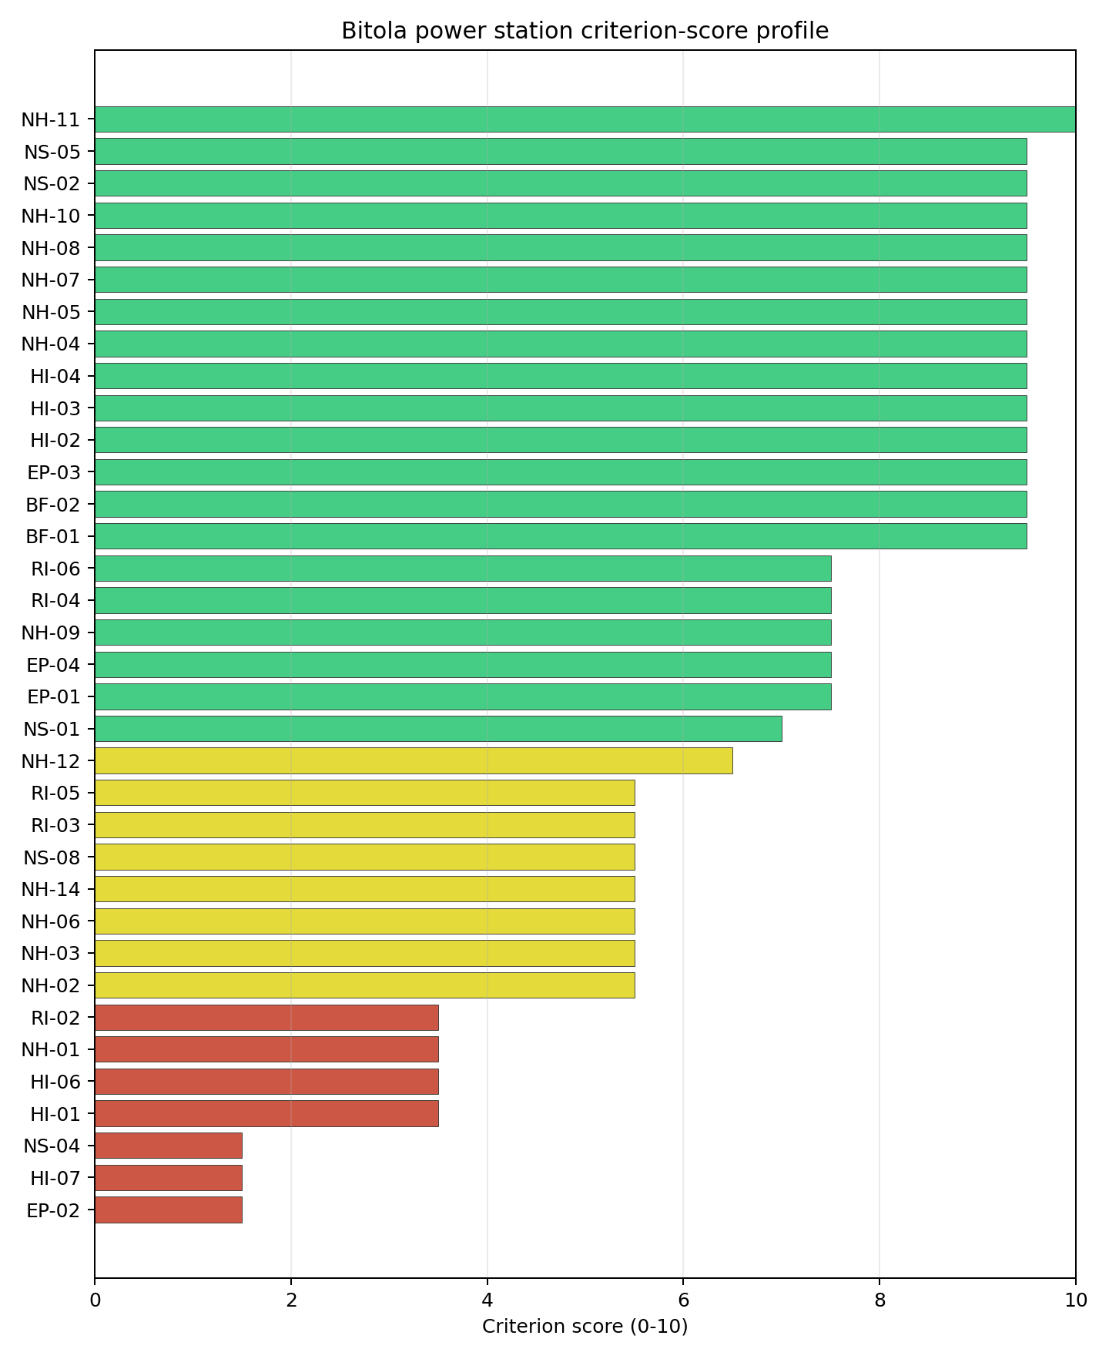
Criterion scores
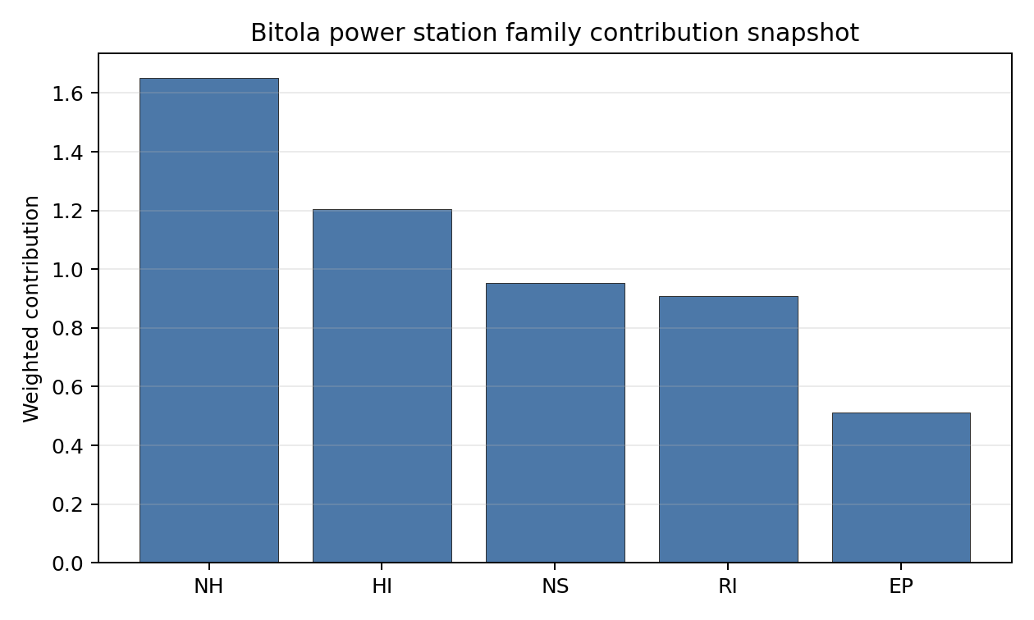
Family contributions
Bitola’s baseline composite score is 6.812, with a Monte Carlo bracket of 5.927-7.329. The bracket is moderately wide, but the national sensitivity signal is strong: Bitola is the only Macedonian site in stability band A and records a 100% national top-10 hit rate across the 12 scored national sensitivity scenarios. In programme terms, that means Bitola remains the national leader under the weight perturbations considered, rather than depending on one narrow baseline-weight choice. The composite is supported by grid connection, land area, population-density and natural-hazard strengths, while the main drag comes from EP-02, HI-01, HI-07, NH-01 and the NS-04 land-cover evidence gap. Stage 3 effort should therefore concentrate on the few measurements most likely to narrow the composite band: PSHA, aircraft-crash analysis, EPZ road modelling, EMI survey work, and land-cover verification.

Residual Risk Register
Concern | Evidence | Consequence | Stage 3 action | Owner discipline
Seismic: Ground Motion (NH-01) | PGA at 2,475-year return period is 0.544 g | The site may remain avoidance-flagged if site-specific PSHA confirms the screening value | Re-measure ground motion with site-specific PSHA and measured Vs30 | seismic
Aircraft Crash (HI-01) | Logovardi Sport Aerodrome is 6.64 km away; nearest flight-path proxy is 3.32 km | Aircraft-crash screening could constrain micro-siting or require operational assumptions | Model aircraft-crash hazard using local traffic and flight-path evidence | security
Evacuation Routes (EP-02) | EPZ road density is 0.281 km/km2; road sub-score is 38.1/100 | Clearance-time performance may be weak despite motorway access | Model EPZ clearance times and road-upgrade requirements | emergency planning
Electromagnetic Interference (HI-07) | Nearest transmitter is 0.22 km away; 26 transmitters are recorded in the search radius | RF/EMI controls may affect design separation or operating rules | Survey transmitter inventory and field strengths | security
Site Topography (NS-04) | Favourable, moderate and unfavourable land-cover values all read 0% | Land-cover evidence is not yet adequate to support layout decisions | Re-survey land cover and reconcile it with the 145.7 ha development estimate | EIA
Surface Water Dispersion (RI-02) | Criterion scores 3.5/10 with no measured values in the table | Liquid-pathway dilution remains uncertain at low-flow conditions | Quantify canal and Crna Reka dilution behaviour | hydrology
Bitola’s residual risk is concentrated rather than diffuse. Seismic loading and aircraft-crash screening decide whether the site can move out of avoidance status, while EPZ roads, EMI, land-cover and liquid-pathway evidence shape the Stage 3 work programme. The register is a characterisation plan for the national lead site, not a site-approval finding.

Stage 3 Follow-Up Checklist
- Re-measure Seismic: Ground Motion (NH-01) with site-specific PSHA because the 2,475-year PGA is 0.544 g.
- Model Aircraft Crash (HI-01) for Logovardi Sport Aerodrome and the 3.32 km flight-path proxy.
- Model Evacuation Routes (EP-02) because EPZ road density is 0.281 km/km2.
- Survey Electromagnetic Interference (HI-07) because the nearest transmitter is 0.22 km away.
- Reconcile Site Topography (NS-04) land-cover data with the 145.7 ha development-area estimate.
- Improve Transport Access (NS-03) and Geotechnical: Subsidence and Collapse (NH-05b) evidence quality.

Evidence Limitations
- Geotechnical: Subsidence & Collapse (NH-05b) - quality low.
- Transport Access (NS-03) - quality low.

Negotino power station Site Profile
Negotino power station is a coal/thermal site in North Macedonia that has been tested against the NuScale VOYGR-6 reference deployment envelope. This profile reads the screening evidence at a level that supports a decision to progress toward Stage 3 characterisation. It is not a site-suitability determination, vendor recommendation, or licensing finding.

Site Snapshot
Field | Value
Site name | Negotino power station
Coordinates | 41.4833, 22.1000
Subnational unit | Negotino
Installed thermal capacity (source data) | 300 MW
Available surface area | 192.9 ha
Available surface area for development | 5.2 ha
Composite score (baseline weights) | 6.707 (5.846-7.171 MC band)
National stability band | H (top-10% hit rate 0%)
National rank | 2
See the country status map in North Macedonia Country Profile.

Ownership and Coal-to-Nuclear Context
- Government of North Macedonia (100.00% share), headquartered in North Macedonia; immediate operator Elektrani na Severna Makedonija AD. Path: Government of North Macedonia -> Elektrani na Severna Makedonija AD [100.0%] -> Negotino power station Unit II [100.0%]
- Elektrani na Severna Makedonija AD (100.00% share), headquartered in North Macedonia; immediate operator Elektrani na Severna Makedonija AD. Path: Elektrani na Severna Makedonija AD -> Negotino power station Unit II [100.0%]
Generating units on record: 1 cancelled.

Natural Hazards (NH)
- Seismic: Ground Motion (NH-01) - score 5.5/10 (MC 5.0-6.0), weight 0.0455, data quality high. Evidence: PGA at 475-year return period 0.219 g; PGA at 2,475-year return period 0.481 g; Vs30 reference (m/s): 760.0.
- Seismic: Surface Rupture (NH-02) - score 7.5/10 (MC 7.0-8.0), weight n/a, data quality screening grade. Evidence: nearest mapped capable fault 17.7 km; fault slip rate 0.224 mm/yr; fault name: MKCF00B.
- Geotechnical: Liquefaction (NH-03) - score 5.5/10 (MC 5.0-6.0), weight n/a, data quality medium. Evidence: liquefaction susceptibility: moderate; dominant soil type: loam.
- Geotechnical: Slope Stability (NH-04) - score 7.5/10 (MC 7.0-8.0), weight n/a, data quality screening grade. Evidence: site slope 7.63 deg; max slope in 1 km box 83.2 deg; slope stability class: moderate.
- Geotechnical: Subsidence (NH-05) - score 9.5/10 (MC 9.0-10.0), weight 0.0354, data quality medium. Evidence: karst present: no; karst severity: none.
- Geotechnical: Foundation (NH-06) - score 5.5/10 (MC 5.0-6.0), weight 0.0253, data quality medium. Evidence: bearing capacity 86.0 kPa; depth to bedrock 19.7 m.
- Volcanism (NH-07) - score 9.5/10 (MC 9.0-10.0), weight n/a, data quality high. Evidence: volcanic hazard class: negligible.
- Coastal Flooding (NH-08) - score 9.5/10 (MC 9.0-10.0), weight 0.0303, data quality medium. Evidence: distance to coast 116.9 km.
- River Flooding (NH-09) - score 7.5/10 (MC 7.0-8.0), weight 0.0404, data quality medium. Evidence: flood zone class: negligible.
- Extreme Winds (NH-10) - score 9.5/10 (MC 9.0-10.0), weight 0.0152, data quality medium. Evidence: screening wind-speed index 7.38 m/s.
- Extreme Precipitation (NH-11) - score 10.0/10 (MC 9.0-10.0), weight 0.0152, data quality medium. Evidence: screening extreme-precipitation index 0.17 mm; screening precipitation index 15.7 mm/yr.
- Extreme Temperatures (NH-12) - score 6.5/10 (MC 6.0-7.0), weight 0.0202, data quality medium. Evidence: extreme high temperature 28.4 deg C; extreme low temperature -3.77 deg C.
- Combined Hazards (NH-14) - score 5.5/10 (MC 5.0-6.0), weight 0.0152, data quality n/a. Evidence: values not in measurement tables.

Interpretation - Natural Hazards (NH)
Natural hazards at Negotino are materially easier than at Oslomej and slightly easier than Bitola on ground motion, but they still need site-specific confirmation. Seismic: Ground Motion (NH-01) records 0.219 g at the 475-year return period and 0.481 g at the 2,475-year return period, just below the project’s Phase 2 avoidance trigger. Surface rupture is not the binding issue: the nearest mapped capable fault is 17.7 km away and the recorded slip rate is 0.224 mm/yr for MKCF00B. The site has moderate liquefaction susceptibility on loam, bearing capacity of 86.0 kPa, and 19.7 m depth to bedrock. Topography is more constrained than Bitola, with a 7.63 degree site slope and an 83.2 degree maximum slope within the 1 km box, but the mean slope remains within the pass-mark band. River flooding is negligible in the screening file, the coast is 116.9 km away, the screening wind-speed index is 7.38 m/s, and the volcanic hazard class is negligible. Stage 3 should confirm the sub-threshold ground-motion result with site-specific PSHA, verify the Vardar and Negotinska Reka flood envelope, and complete a topographic and geotechnical campaign across the usable development area.

Human-Induced and Security-Relevant Hazards (HI)
- Aircraft Crash (HI-01) - score 3.5/10 (MC 3.0-4.0), weight 0.0354, data quality high. Evidence: nearest airport 6.34 km; nearest flight path 3.17 km; airports within search radius 2; airport name: Krivolak Airstrip; airport type: small airfield.
- Industrial Explosions (HI-02) - score 9.5/10 (MC 9.0-10.0), weight 0.0354, data quality screening grade. Evidence: values not in measurement tables.
- Toxic/Gas Releases (HI-03) - score 9.5/10 (MC 9.0-10.0), weight 0.0354, data quality screening grade. Evidence: values not in measurement tables.
- External Fires (HI-04) - score 9.5/10 (MC 9.0-10.0), weight 0.0303, data quality screening grade. Evidence: values not in measurement tables.
- Military Installations (HI-06) - score 1.5/10 (MC 1.0-2.0), weight 0.0303, data quality medium. Evidence: nearest military installation 6.96 km; military installations within radius 2; installation name: Krivolak Trainig Area KTA.
- Electromagnetic Interference (HI-07) - score 3.5/10 (MC 3.0-4.0), weight 0.0101, data quality medium. Evidence: nearest high-power transmitter 4.5 km; transmitters within radius 7; transmitter type: mast.

Interpretation - Human-Induced and Security-Relevant Hazards (HI)
Human-induced hazards at Negotino are dominated by the Krivolak military and aviation setting. Military Installations (HI-06) scores 1.5/10: the nearest military feature is 6.96 km away and the bundle names the Krivolak Training Area. Aircraft Crash (HI-01) is also an avoidance issue because Krivolak Airstrip is 6.34 km from the site and the nearest flight-path proxy is 3.17 km away. Those two findings should be treated together because the airstrip and military feature form a single operational context for Stage 3 screening. Electromagnetic Interference (HI-07) is less severe than at Bitola or Oslomej, with the nearest transmitter 4.5 km away and seven transmitters in the search radius. Industrial Explosions (HI-02), Toxic/Gas Releases (HI-03), and External Fires (HI-04) each score 9.5/10 in the frozen run, but the report should still treat those as screening-grade findings until a national hazardous-neighbour cadastre is reviewed. Stage 3 should begin with defence-interface engagement for Krivolak, then complete an aircraft-crash assessment and an updated industrial and transport-hazard inventory.

Radiological Impact and Emergency Planning (RI / EP)
- Emergency Planning Feasibility (EP-01) - score 5.5/10 (MC 5.0-6.0), weight n/a, data quality high. Evidence: EP feasibility composite 61.8 /100; road sub-score 37.3 /100; special-population sub-score 90.0 /100; geography sub-score 95.0 /100; population sub-score 80.0 /100; evacuation feasible: yes.
- Evacuation Routes (EP-02) - score 1.5/10 (MC 1.0-2.0), weight 0.0303, data quality medium. Evidence: road density in EPZ 0.273 km/km2; road length in EPZ 536.1 km; motorway access: yes.
- Physical Geography Constraints (EP-03) - score 9.5/10 (MC 9.0-10.0), weight 0.0253, data quality medium. Evidence: waterways crossing EPZ 0; major river barrier: no.
- Special Populations (EP-04) - score 7.5/10 (MC 7.0-8.0), weight 0.0303, data quality medium. Evidence: hospitals in EPZ 5; prisons in EPZ 1; care homes in EPZ 0.
- Atmospheric Dispersion (RI-01) - score no native score (unscored, no band matched), weight 0.0303, data quality medium. Evidence: annual mean wind speed 0.6 m/s; atmospheric mixing height 580.5 m; prevailing wind direction: NW.
- Surface Water Dispersion (RI-02) - score 7.5/10 (MC 7.0-8.0), weight 0.0253, data quality n/a. Evidence: values not in measurement tables.
- Groundwater Dispersion (RI-03) - score 7.5/10 (MC 7.0-8.0), weight 0.0253, data quality medium. Evidence: aquifer type: low permeability.
- Population Density at EPZ Radii (RI-04) - score 5.5/10 (MC 5.0-6.0), weight 0.0404, data quality screening grade. Evidence: population density within 5 km 202.8 /km2; population density within 16 km 78.4 /km2; population density within 25 km 37.3 /km2; population density within 80 km 61.5 /km2; population within 25 km 73,257 people.
- Distance to Population Centres (RI-05) - score 5.5/10 (MC 5.0-6.0), weight 0.0505, data quality screening grade. Evidence: values not in measurement tables.
- Population Projections (RI-06) - score 7.5/10 (MC 7.0-8.0), weight 0.0253, data quality screening grade. Evidence: annual population growth rate -0.212 %/yr; projected population at 25 km in 60 yr 49,159 people.

Interpretation - Radiological Impact and Emergency Planning (RI / EP)
Radiological impact and emergency-planning conditions at Negotino are acceptable for continued screening, but road capacity is a clear weakness. Emergency Planning Feasibility (EP-01) records a 61.8/100 composite and is marked feasible, with strong geography and special-population sub-scores but a road sub-score of 37.3/100. Evacuation Routes (EP-02) therefore remains the family constraint: road density in the EPZ is 0.273 km/km2, with 536.1 km of road and motorway access recorded. Population density is higher close to the site than at Bitola, at 202.8 people/km2 within 5 km, but falls to 37.3 people/km2 within 25 km; the 25 km population is 73,257 people and the 60-year projection is 49,159. Groundwater dispersion is relatively favourable on a low-permeability aquifer, while Atmospheric Dispersion (RI-01) remains unscored despite 0.6 m/s annual mean wind speed, 580.5 m mixing height and NW prevailing wind direction. Stage 3 should model EPZ clearance, confirm meteorology, and translate the feasible EP composite into an operational emergency plan for the hospital and prison inventory inside the EPZ.

Non-Safety and Implementation Considerations (NS)
- Grid Capacity Basic Filter (BF-01) - score 5.5/10 (MC 5.0-6.0), weight n/a, data quality n/a. Evidence: values not in measurement tables.
- Land Area Basic Filter (BF-02) - score 1.5/10 (MC 1.0-2.0), weight 0.0253, data quality n/a. Evidence: values not in measurement tables.
- Cooling Water Availability (NS-01) - score 8.0/10 (MC 7.0-8.0), weight 0.0404, data quality screening grade. Evidence: distance to cooling source 2.26 km; cooling source flow 163.7 m3/s; cooling source type: major_river; cooling source name: Неготинска Река; water stress label: Low-Medium.
- Grid Connection (NS-02) - score 1.5/10 (MC 1.0-2.0), weight 0.0404, data quality high. Evidence: nearest substation 0.61 km; nearest high-voltage line 2.1 km; highest nearby line voltage 110.0 kV; grid export capacity 165.0 MW; substations within radius 29; HV lines within radius 72.
- Transport Access (NS-03) - score no native score (unscored, no band matched), weight 0.0404, data quality low. Evidence: not measured at this site (criterion remains unscored).
- Site Topography (NS-04) - score 7.5/10 (MC 7.0-8.0), weight 0.0303, data quality screening grade. Evidence: favourable land cover 62.6 %; moderate land cover 29.6 %; unfavourable land cover 7.8 %; favourable area 192.9 ha; dominant land class: 211.
- Site Footprint Adequacy (NS-05) - score 9.5/10 (MC 9.0-10.0), weight 0.0253, data quality medium. Evidence: buildable area 5.25 ha; largest contiguous patch 5.25 ha; buildable patch count 2.
- Existing Infrastructure (NS-06) - score no native score (unscored, no band matched), weight 0.0253, data quality n/a. Evidence: not measured at this site (criterion remains unscored).
- Ecological Sensitivity (NS-08) - score 3.5/10 (MC 1.5-5.5), weight n/a, data quality insufficient. Evidence: natural land cover 7.8 %; distance to nearest protected area 4.903 km; Natura 2000 sensitivity class: unknown; protected-area overlap: no; protected-area sensitivity class: low; Natura 2000 sites within 5 km: 0; nearest protected-area designation: Designated area not yet reviewed.
- Workforce Availability (NS-10) - score no native score (unscored, no band matched), weight 0.0202, data quality n/a. Evidence: not measured at this site (criterion remains unscored).
- Regulatory/Political Environment (NS-12) - score no native score (unscored, no band matched), weight 0.0303, data quality n/a. Evidence: not measured at this site (criterion remains unscored).
- Construction Logistics (NS-13) - score no native score (unscored, no band matched), weight 0.0202, data quality n/a. Evidence: not measured at this site (criterion remains unscored).

Interpretation - Non-Safety and Implementation Considerations (NS)
Non-safety and implementation conditions at Negotino are mixed: the water and wider land envelope are useful, but the grid and current development-area values create a major qualification. Cooling Water Availability (NS-01) is strong, with a major-river source 2.26 km from the site, 163.7 m3/s flow, and a Low-Medium water-stress label. The site snapshot records 192.9 ha of available surface area, but only 5.2 ha of current development-area evidence, so Stage 3 must reconcile the wider surface-area figure with actual contiguous, controlled and buildable land. Grid Connection (NS-02) is the binding implementation issue: the nearest substation is 0.61 km away and the nearest high-voltage line is 2.1 km away, but the highest nearby voltage is 110 kV and inherited export capacity is 165 MW. That is below the 462 MWe reference envelope and explains the grid avoidance flag. Ecological Sensitivity (NS-08) also needs field confirmation because the nearest protected area is 4.903 km away and the data quality is insufficient. Stage 3 should first scope a voltage and export-capacity pathway, then verify land control and contiguity beyond the 5.2 ha development estimate.

Composite Score and Stability
Baseline composite score is 6.707, bracketed by Monte Carlo at 5.846-7.171. National stability band is H with a top-10% hit rate of 0% across 12 scored Monte Carlo scenarios.
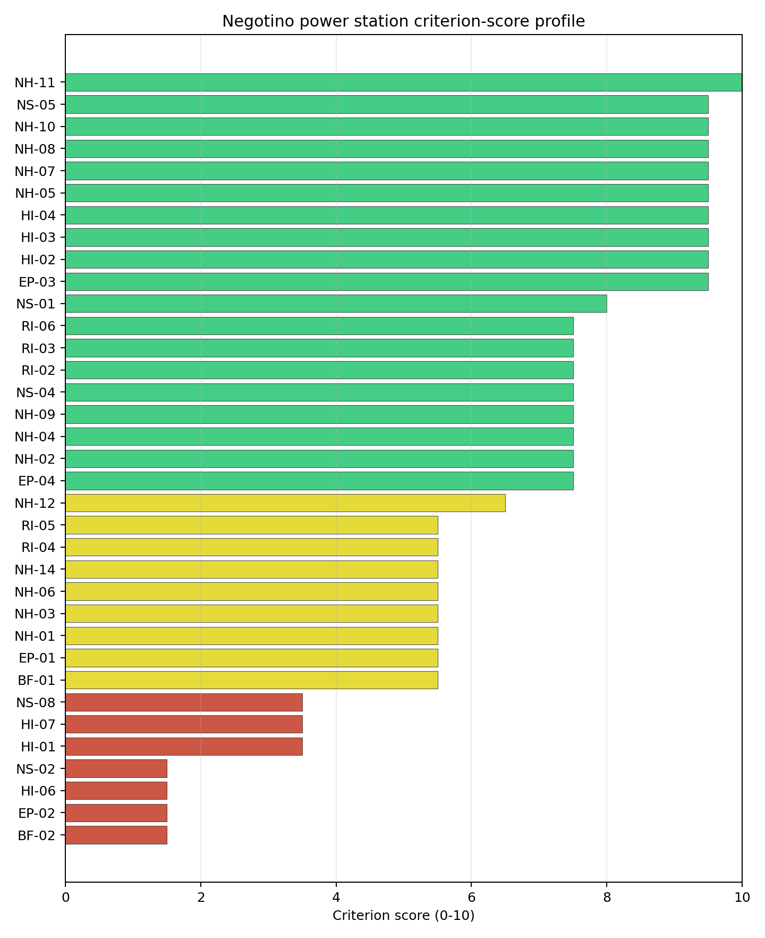
Criterion scores
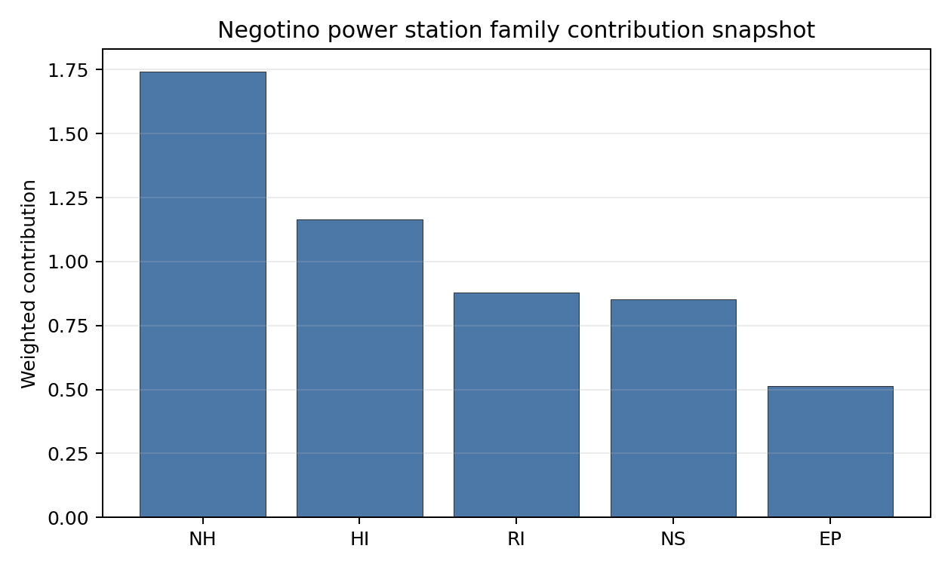
Family contributions
Negotino’s baseline composite score is 6.707, with a Monte Carlo bracket of 5.846-7.171. The point estimate is close to Bitola and the score bands overlap, so the rank difference should not be over-read. The national sensitivity result is the decisive distinction: Negotino is in stability band H and records a 0% national top-10 hit rate across the 12 scored national sensitivity scenarios. That means it is a plausible second site in the baseline ranking, but not a robust alternative leader. The composite benefits from water availability, population and several natural-hazard scores, while grid connection, military proximity, aircraft-crash screening, evacuation routes, EMI and land certainty remain the practical constraints. Stage 3 should only advance Negotino after a focused transmission, land and defence-interface review shows that the avoidance flags can be retired without losing the brownfield advantage.

Residual Risk Register
Concern | Evidence | Consequence | Stage 3 action | Owner discipline
Grid Connection (NS-02) | Highest nearby line voltage is 110 kV; export capacity is 165 MW | The inherited grid may not support the 462 MWe reference envelope without major reinforcement | Confirm the 220 kV or 400 kV pathway and export-capacity upgrade scope | grid
Military Installations (HI-06) | Krivolak Training Area is recorded 6.96 km from the site | Defence buffers or live-fire envelopes could constrain site use | Engage defence authorities on operational buffers and data confidence | security
Aircraft Crash (HI-01) | Krivolak Airstrip is 6.34 km away; flight-path proxy is 3.17 km | Aviation screening may remain coupled to the military-training context | Model aircraft-crash hazard with civil and military operating assumptions | security
Development Area | Site snapshot records 192.9 ha surface area but 5.2 ha development area | The brownfield footprint may be too fragmented or uncontrolled for layout planning | Re-survey contiguous, controlled and buildable land parcels | ownership/legal
Evacuation Routes (EP-02) | EPZ road density is 0.273 km/km2; road sub-score is 37.3/100 | Clearance-time performance may be weak under emergency-planning assumptions | Model EPZ clearance and road-upgrade needs | emergency planning
Ecological Sensitivity (NS-08) | Nearest protected area is 4.903 km away; data quality is insufficient | Permitting scope could expand after field ecological review | Confirm protected-area boundaries and receptor pathways | EIA
Negotino’s residual risk is dominated by implementation feasibility rather than by one natural-hazard exclusion. Grid reinforcement, land contiguity and defence-interface evidence decide whether the site can become a credible fast follower. The register is a Stage 3 work plan and does not establish suitability.

Stage 3 Follow-Up Checklist
- Confirm Grid Connection (NS-02) upgrade scope because export capacity is 165 MW at 110 kV.
- Re-survey the development footprint because the snapshot records 192.9 ha surface area but 5.2 ha current development area.
- Engage defence authorities on Military Installations (HI-06) because Krivolak Training Area is 6.96 km away.
- Model Aircraft Crash (HI-01) for Krivolak Airstrip and the 3.17 km flight-path proxy.
- Model Evacuation Routes (EP-02) because EPZ road density is 0.273 km/km2.
- Improve Transport Access (NS-03) and Geotechnical: Subsidence and Collapse (NH-05b) evidence quality.

Evidence Limitations
- Geotechnical: Subsidence & Collapse (NH-05b) - quality low.
- Transport Access (NS-03) - quality low.

Oslomej power station Site Profile
Oslomej power station is a coal/thermal site in North Macedonia that has been tested against the NuScale VOYGR-6 reference deployment envelope. This profile reads the screening evidence at a level that supports a decision to progress toward Stage 3 characterisation. It is not a site-suitability determination, vendor recommendation, or licensing finding.

Site Snapshot
Field | Value
Site name | Oslomej power station
Coordinates | 41.5821, 21.0003
Subnational unit | Kičevo
Installed thermal capacity (source data) | 254 MW
Available surface area | 26.0 ha
Available surface area for development | 18.8 ha
Composite score (baseline weights) | 5.905 (5.230-6.421 MC band)
National stability band | H (top-10% hit rate 0%)
National rank | 3
See the country status map in North Macedonia Country Profile.

Ownership and Coal-to-Nuclear Context
- Government of North Macedonia (100.00% share), headquartered in North Macedonia; immediate operator Elektrani na Severna Makedonija AD. Path: Government of North Macedonia -> Elektrani na Severna Makedonija AD [100.0%] -> Oslomej power station Reconstruction [100.0%]
- Elektrani na Severna Makedonija AD (100.00% share), headquartered in North Macedonia; immediate operator Elektrani na Severna Makedonija AD. Path: Elektrani na Severna Makedonija AD -> Oslomej power station Reconstruction [100.0%]
Generating units on record: 1 cancelled, 1 operating. Earliest unit commissioning: 1980; most recent: 1980.

Natural Hazards (NH)
- Seismic: Ground Motion (NH-01) - score 3.5/10 (MC 3.0-4.0), weight 0.0455, data quality high. Evidence: PGA at 475-year return period 0.346 g; PGA at 2,475-year return period 0.727 g; Vs30 reference (m/s): 760.0.
- Seismic: Surface Rupture (NH-02) - score 5.5/10 (MC 5.0-6.0), weight n/a, data quality screening grade. Evidence: nearest mapped capable fault 11.4 km; fault slip rate 0.2 mm/yr; fault name: MKCF005.
- Geotechnical: Liquefaction (NH-03) - score 9.5/10 (MC 9.0-10.0), weight n/a, data quality medium. Evidence: liquefaction susceptibility: very_low; dominant soil type: loam.
- Geotechnical: Slope Stability (NH-04) - score 7.5/10 (MC 7.0-8.0), weight n/a, data quality screening grade. Evidence: site slope 9.92 deg; max slope in 1 km box 88.0 deg; slope stability class: moderate.
- Geotechnical: Subsidence (NH-05) - score 5.5/10 (MC 5.0-6.0), weight 0.0354, data quality medium. Evidence: karst present: no; karst severity: moderate; formation type: carbonate (Discontinuous carbonate rocks).
- Geotechnical: Foundation (NH-06) - score 5.5/10 (MC 5.0-6.0), weight 0.0253, data quality medium. Evidence: bearing capacity 86.0 kPa; depth to bedrock 22.8 m.
- Volcanism (NH-07) - score 9.5/10 (MC 9.0-10.0), weight n/a, data quality high. Evidence: volcanic hazard class: negligible.
- Coastal Flooding (NH-08) - score 9.5/10 (MC 9.0-10.0), weight 0.0303, data quality medium. Evidence: distance to coast 118.9 km.
- River Flooding (NH-09) - score 7.5/10 (MC 7.0-8.0), weight 0.0404, data quality medium. Evidence: flood zone class: negligible.
- Extreme Winds (NH-10) - score 7.5/10 (MC 7.0-8.0), weight 0.0152, data quality medium. Evidence: screening wind-speed index 7.89 m/s.
- Extreme Precipitation (NH-11) - score 10.0/10 (MC 9.0-10.0), weight 0.0152, data quality medium. Evidence: screening extreme-precipitation index 0.19 mm; screening precipitation index 24.1 mm/yr.
- Extreme Temperatures (NH-12) - score 7.5/10 (MC 7.0-8.0), weight 0.0202, data quality medium. Evidence: extreme high temperature 22.2 deg C; extreme low temperature -7.9 deg C.
- Combined Hazards (NH-14) - score 5.5/10 (MC 5.0-6.0), weight 0.0152, data quality n/a. Evidence: values not in measurement tables.

Interpretation - Natural Hazards (NH)
Natural hazards at Oslomej are controlled by the strongest seismic signal in the Macedonian ranked set. Seismic: Ground Motion (NH-01) records 0.346 g at the 475-year return period and 0.727 g at the 2,475-year return period, well above the project’s avoidance trigger and materially higher than Bitola or Negotino. Surface rupture is less severe in the screening record: the nearest mapped capable fault is 11.4 km away and the recorded slip rate is 0.2 mm/yr for MKCF005. Other geotechnical evidence is mixed. Liquefaction susceptibility is very low, but the site slope is 9.92 degrees, the maximum 1 km slope is 88.0 degrees, and the subsidence file records moderate karst severity in discontinuous carbonate rocks. Bearing capacity is 86.0 kPa and depth to bedrock is 22.8 m. River flooding is negligible, the coast is 118.9 km away, and the screening wind-speed index is 7.89 m/s. Stage 3 would therefore need a site-specific PSHA first, followed by karst-focused geophysics, slope review and foundation investigation; the ground-motion result may remain a binding avoidance issue even after better measurement.

Human-Induced and Security-Relevant Hazards (HI)
- Aircraft Crash (HI-01) - score 3.5/10 (MC 3.0-4.0), weight 0.0354, data quality high. Evidence: nearest airport 7.41 km; nearest flight path 7.41 km; airports within search radius 1; airport name: Kičevo Military Barracks Heliport; airport type: heliport.
- Industrial Explosions (HI-02) - score 9.5/10 (MC 9.0-10.0), weight 0.0354, data quality screening grade. Evidence: values not in measurement tables.
- Toxic/Gas Releases (HI-03) - score 9.5/10 (MC 9.0-10.0), weight 0.0354, data quality screening grade. Evidence: values not in measurement tables.
- External Fires (HI-04) - score 9.5/10 (MC 9.0-10.0), weight 0.0303, data quality screening grade. Evidence: values not in measurement tables.
- Military Installations (HI-06) - score 1.5/10 (MC 1.0-2.0), weight 0.0303, data quality medium. Evidence: nearest military installation 7.33 km; military installations within radius 3; installation name: unnamed.
- Electromagnetic Interference (HI-07) - score 1.5/10 (MC 1.0-2.0), weight 0.0101, data quality medium. Evidence: nearest high-power transmitter 1.44 km; transmitters within radius 15; transmitter type: communication.

Interpretation - Human-Induced and Security-Relevant Hazards (HI)
Human-induced hazards at Oslomej combine military, aviation and EMI constraints. Aircraft Crash (HI-01) scores 3.5/10 because Kičevo Military Barracks Heliport is 7.41 km from the site, with the nearest flight-path proxy also at 7.41 km. Military Installations (HI-06) scores 1.5/10: the nearest military feature is 7.33 km away and three military installations are recorded in the wider search radius. Electromagnetic Interference (HI-07) is also material, with the nearest communication transmitter 1.44 km away and 15 transmitters in the search radius. The wider industrial-hazard file is less adverse in the frozen run, with Industrial Explosions (HI-02), Toxic/Gas Releases (HI-03), and External Fires (HI-04) each at 9.5/10. Stage 3 should still refresh those inventories, but the first-order decisions are defence-interface confirmation, helicopter-crash hazard modelling and RF/EMI survey work. These checks decide whether Oslomej can move beyond a comparison case into an active characterisation option.

Radiological Impact and Emergency Planning (RI / EP)
- Emergency Planning Feasibility (EP-01) - score 5.5/10 (MC 5.0-6.0), weight n/a, data quality high. Evidence: EP feasibility composite 59.7 /100; road sub-score 28.8 /100; special-population sub-score 90.0 /100; geography sub-score 95.0 /100; population sub-score 80.0 /100; evacuation feasible: yes.
- Evacuation Routes (EP-02) - score 1.5/10 (MC 1.0-2.0), weight 0.0303, data quality medium. Evidence: road density in EPZ 0.188 km/km2; road length in EPZ 368.9 km; motorway access: yes.
- Physical Geography Constraints (EP-03) - score 9.5/10 (MC 9.0-10.0), weight 0.0253, data quality medium. Evidence: waterways crossing EPZ 0; major river barrier: no.
- Special Populations (EP-04) - score 7.5/10 (MC 7.0-8.0), weight 0.0303, data quality medium. Evidence: hospitals in EPZ 7; prisons in EPZ 0; care homes in EPZ 0.
- Atmospheric Dispersion (RI-01) - score no native score (unscored, no band matched), weight 0.0303, data quality medium. Evidence: annual mean wind speed 0.59 m/s; atmospheric mixing height 445.5 m; prevailing wind direction: NNW.
- Surface Water Dispersion (RI-02) - score 1.5/10 (MC 1.0-2.0), weight 0.0253, data quality n/a. Evidence: values not in measurement tables.
- Groundwater Dispersion (RI-03) - score 5.5/10 (MC 5.0-6.0), weight 0.0253, data quality medium. Evidence: aquifer type: alluvial.
- Population Density at EPZ Radii (RI-04) - score 5.5/10 (MC 5.0-6.0), weight 0.0404, data quality screening grade. Evidence: population density within 5 km 181.2 /km2; population density within 16 km 74.3 /km2; population density within 25 km 56.9 /km2; population density within 80 km 95.8 /km2; population within 25 km 111,730 people.
- Distance to Population Centres (RI-05) - score 5.5/10 (MC 5.0-6.0), weight 0.0505, data quality screening grade. Evidence: values not in measurement tables.
- Population Projections (RI-06) - score 7.5/10 (MC 7.0-8.0), weight 0.0253, data quality screening grade. Evidence: annual population growth rate -0.047 %/yr; projected population at 25 km in 60 yr 74,984 people.

Interpretation - Radiological Impact and Emergency Planning (RI / EP)
Radiological impact and emergency-planning conditions at Oslomej are constrained by the weakest road and surface-water-dispersion signals in the Macedonian ranked set. Emergency Planning Feasibility (EP-01) is marked feasible with a 59.7/100 composite, but its road sub-score is only 28.8/100. Evacuation Routes (EP-02) therefore remains a binding concern: EPZ road density is 0.188 km/km2 and total road length is 368.9 km, despite motorway access being recorded. Special-population evidence includes seven hospitals inside the EPZ and no prisons or care homes. Population density is moderate, with 181.2 people/km2 within 5 km and 56.9 people/km2 within 25 km; the 25 km population is 111,730 and the 60-year projection is 74,984. Atmospheric evidence remains unscored, with 0.59 m/s annual mean wind speed, 445.5 m mixing height and NNW prevailing wind direction. Surface Water Dispersion (RI-02) scores 1.5/10 with no measured values in the table, which is especially important because the associated cooling source is a small river. Stage 3 should model EPZ clearance, install site meteorology, and quantify low-flow liquid-pathway behaviour before Oslomej receives any stronger screening claim.

Non-Safety and Implementation Considerations (NS)
- Grid Capacity Basic Filter (BF-01) - score 5.5/10 (MC 5.0-6.0), weight n/a, data quality n/a. Evidence: values not in measurement tables.
- Land Area Basic Filter (BF-02) - score 1.5/10 (MC 1.0-2.0), weight 0.0253, data quality n/a. Evidence: values not in measurement tables.
- Cooling Water Availability (NS-01) - score 6.0/10 (MC 6.0-7.0), weight 0.0404, data quality screening grade. Evidence: distance to cooling source 3.55 km; cooling source flow 2.97 m3/s; cooling source type: small_river; cooling source name: Темница; water stress label: Low-Medium.
- Grid Connection (NS-02) - score 1.5/10 (MC 1.0-2.0), weight 0.0404, data quality high. Evidence: nearest substation 0.46 km; nearest high-voltage line 4.09 km; highest nearby line voltage 110.0 kV; grid export capacity 125.0 MW; substations within radius 34; HV lines within radius 44.
- Transport Access (NS-03) - score no native score (unscored, no band matched), weight 0.0404, data quality low. Evidence: not measured at this site (criterion remains unscored).
- Site Topography (NS-04) - score 3.5/10 (MC 3.0-4.0), weight 0.0303, data quality screening grade. Evidence: favourable land cover 23.9 %; moderate land cover 51.1 %; unfavourable land cover 24.9 %; favourable area 51.2 ha; dominant land class: 321.
- Site Footprint Adequacy (NS-05) - score 5.5/10 (MC 5.0-6.0), weight 0.0253, data quality high. Evidence: buildable area 18.8 ha; largest contiguous patch 18.8 ha; buildable patch count 7.
- Existing Infrastructure (NS-06) - score no native score (unscored, no band matched), weight 0.0253, data quality n/a. Evidence: not measured at this site (criterion remains unscored).
- Ecological Sensitivity (NS-08) - score 7.5/10 (MC 5.5-9.5), weight n/a, data quality insufficient. Evidence: natural land cover 24.9 %; distance to nearest protected area 13.8 km; Natura 2000 sensitivity class: unknown; protected-area overlap: no; protected-area sensitivity class: low; Natura 2000 sites within 5 km: 0; nearest protected-area designation: Designated area not yet reviewed.
- Workforce Availability (NS-10) - score no native score (unscored, no band matched), weight 0.0202, data quality n/a. Evidence: not measured at this site (criterion remains unscored).
- Regulatory/Political Environment (NS-12) - score no native score (unscored, no band matched), weight 0.0303, data quality n/a. Evidence: not measured at this site (criterion remains unscored).
- Construction Logistics (NS-13) - score no native score (unscored, no band matched), weight 0.0202, data quality n/a. Evidence: not measured at this site (criterion remains unscored).

Interpretation - Non-Safety and Implementation Considerations (NS)
Non-safety and implementation conditions at Oslomej are weaker than at Bitola and Negotino. Grid Connection (NS-02) is the main constraint: the nearest substation is 0.46 km away and the nearest high-voltage line is 4.09 km away, but the highest nearby voltage is 110 kV and inherited export capacity is 125 MW. That is well below the 462 MWe reference envelope and leaves the site dependent on major grid reinforcement. Cooling Water Availability (NS-01) is also constrained by scale. The Темница source is 3.55 km away with 2.97 m3/s flow, so water stress is labelled Low-Medium but absolute flow is limited for a multi-module reference case. The site snapshot records 26.0 ha of available surface area and 18.8 ha of current development-area evidence. Site Topography (NS-04) is moderate to weak, with 23.9% favourable, 51.1% moderate and 24.9% unfavourable land cover in the wider area. Ecological Sensitivity (NS-08) is favourable on distance, with the nearest protected area 13.8 km away, but data quality remains insufficient. Stage 3 would need to resolve grid capacity, cooling-water reliability, land layout and ecological evidence before Oslomej could be advanced beyond a lower-ranked comparator.

Composite Score and Stability
Baseline composite score is 5.905, bracketed by Monte Carlo at 5.230-6.421. National stability band is H with a top-10% hit rate of 0% across 12 scored Monte Carlo scenarios.
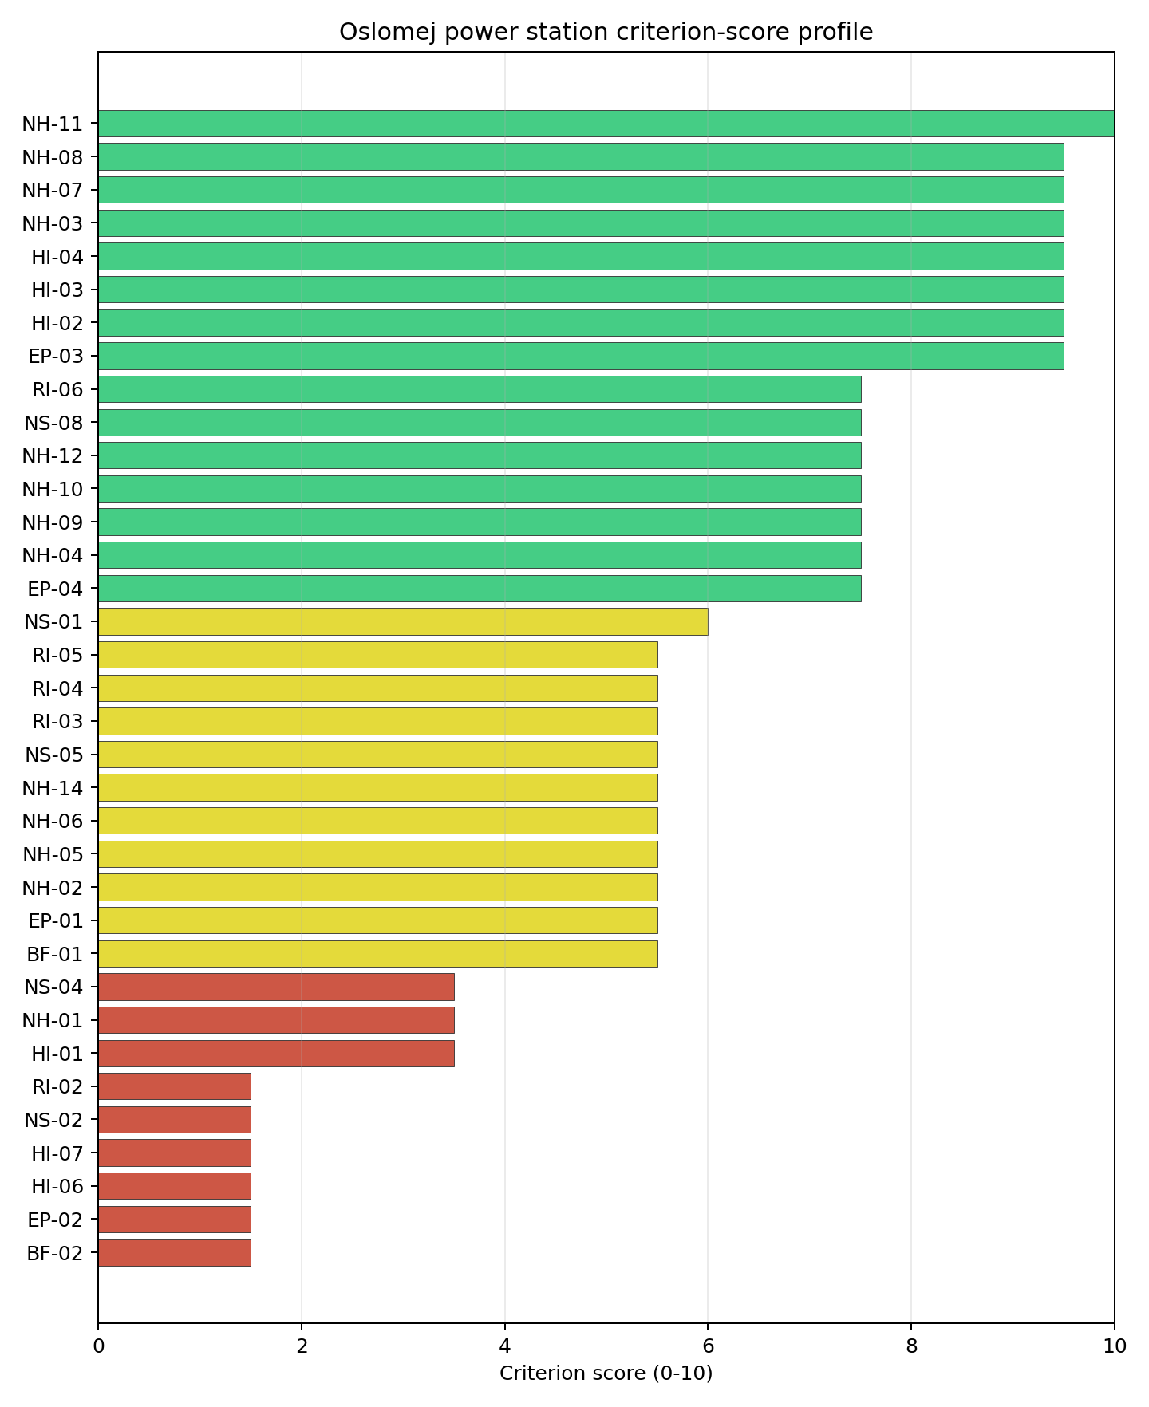
Criterion scores
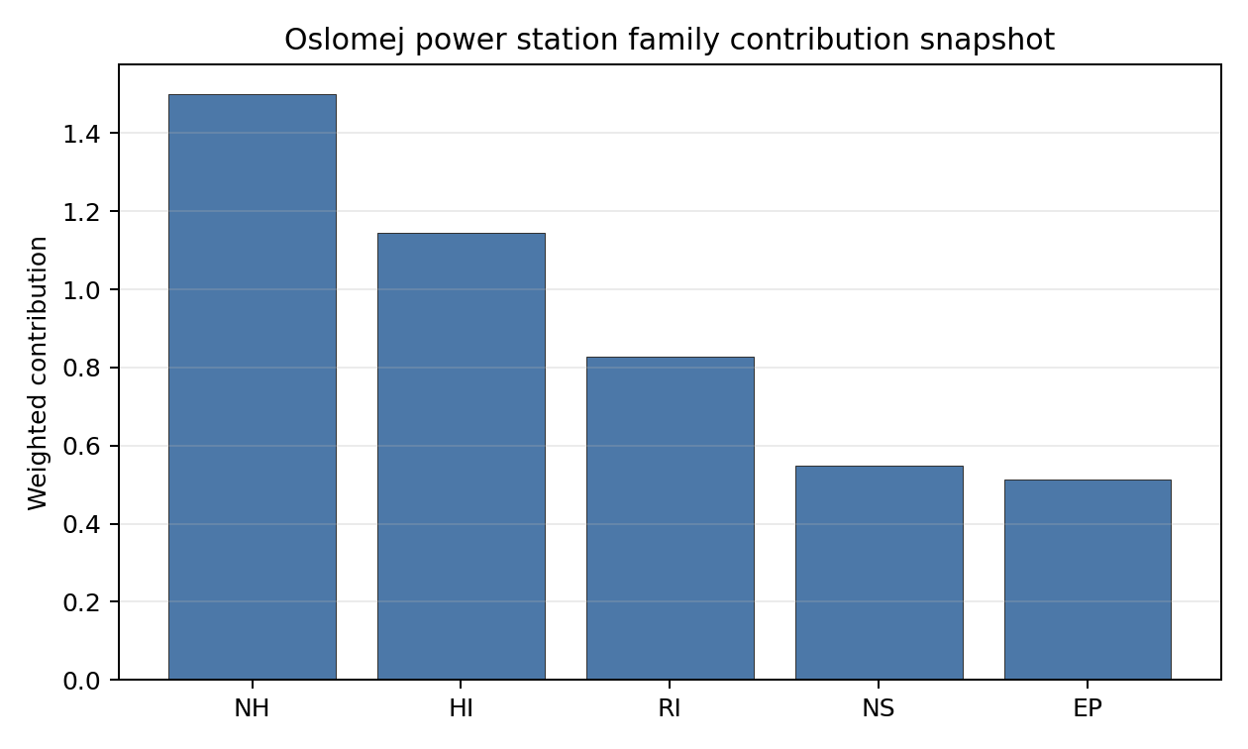
Family contributions
Oslomej’s baseline composite score is 5.905, with a Monte Carlo bracket of 5.230-6.421. It is the lowest ranked Macedonian site in the frozen national pool and sits in stability band H, with a 0% national top-10 hit rate across the 12 scored national sensitivity scenarios. The bracket is narrower than Bitola’s, but it is centred lower and does not create a credible leadership case. The composite has some support from land-footprint adequacy, population context and several natural-hazard scores, but the practical constraints are strong: 0.727 g 2,475-year PGA, 125 MW grid export capacity, 0.188 km/km2 EPZ road density, 2.97 m3/s cooling-source flow, military proximity and EMI. Stage 3 should treat Oslomej as a comparator unless the national programme needs a third domestic option and is prepared to fund simultaneous seismic, grid, water and security work.

Residual Risk Register
Concern | Evidence | Consequence | Stage 3 action | Owner discipline
Seismic: Ground Motion (NH-01) | PGA at 2,475-year return period is 0.727 g | Ground motion may remain an avoidance constraint after refined analysis | Re-measure with site-specific PSHA and measured Vs30 | seismic
Grid Connection (NS-02) | Export capacity is 125 MW and highest nearby voltage is 110 kV | The inherited grid is below the 462 MWe reference envelope | Confirm a reinforcement route to 220 kV or 400 kV service | grid
Surface Water Dispersion (RI-02) | Criterion scores 1.5/10; cooling source flow is 2.97 m3/s | Low-flow dilution may constrain liquid-pathway assumptions | Quantify seasonal flow and dilution behaviour for the Темница source | hydrology
Evacuation Routes (EP-02) | EPZ road density is 0.188 km/km2; road sub-score is 28.8/100 | Emergency clearance could be constrained by the sparse road network | Model EPZ clearance and required road upgrades | emergency planning
Military Installations (HI-06) | Nearest military feature is 7.33 km away | Defence buffers could constrain the siting envelope | Engage defence authorities on operational buffers and feature classification | security
Electromagnetic Interference (HI-07) | Nearest transmitter is 1.44 km away; 15 transmitters are recorded | RF/EMI controls may require separation or shielding assumptions | Survey transmitter inventory and field strengths | security
Oslomej’s register is heavier than Bitola’s because several constraints would need to be retired together. Seismic loading, grid capacity, water dispersion, EPZ road capacity and military/EMI evidence all require early work. The register supports comparison and contingency planning, not a progression finding.

Stage 3 Follow-Up Checklist
- Re-measure Seismic: Ground Motion (NH-01) because the 2,475-year PGA is 0.727 g.
- Confirm Grid Connection (NS-02) reinforcement because export capacity is 125 MW at 110 kV.
- Quantify Surface Water Dispersion (RI-02) and cooling-source reliability for the 2.97 m3/s Темница source.
- Model Evacuation Routes (EP-02) because EPZ road density is 0.188 km/km2.
- Engage defence authorities on Military Installations (HI-06) because the nearest feature is 7.33 km away.
- Survey Electromagnetic Interference (HI-07) because the nearest transmitter is 1.44 km away.
- Improve Transport Access (NS-03) and Geotechnical: Subsidence and Collapse (NH-05b) evidence quality.

Evidence Limitations
- Geotechnical: Subsidence & Collapse (NH-05b) - quality low.
- Transport Access (NS-03) - quality low.

Poland Country Profile
Poland has 63 thermal and coal-site records tested against the NuScale VOYGR-6 reference deployment envelope. Three sites pass both the exclusionary and avoidance screens, 58 pass the exclusionary screen but retain avoidance flags, and two fail one or more exclusionary checks. The country is therefore a broad brownfield pool with a small full-pass leadership group, a large avoidance-unlock tier, and a limited hard-fail tail.
The leading site is Polaniec power station, with a composite score of 7.422 and a Monte Carlo interval of 6.573-7.956. Its national stability band is A with a national top-10% hit rate of 100%. Polaniec is the current point-estimate leader and a stable national candidate, but it remains an avoidance-flagged site because Aircraft Crash (HI-01) requires Stage 3 resolution.
Poland’s 63 ranked thermal records produce three full-pass sites: Pólnoc, Adamow, and Dolna Odra. The top-five national ranking also selects Polaniec, Gubin Power Project, and Kedzierzyn CCS Project because their composite scores and national stability positions place them ahead of several full-pass or lower-risk comparators. That structure supports a staged programme in which the first characterisation tranche combines the highest-ranked avoidance-flagged candidate with the strongest full-pass sites, rather than treating full-pass status alone as the sequencing rule.
The avoidance unlock pool is the main national planning issue. Distance to Population Centres (RI-05) and Aircraft Crash (HI-01) each affect 39 of the 61 exclusionary-pass sites, or 64% of that pool, while Grid Connection (NS-02) affects 34 sites, or 56%. The unlock work is therefore country-wide: EPZ population micro-modelling, airfield and flight-path hazard assessment, and transmission-pathway confirmation would determine whether Poland’s large exclusionary-pass pool can become a deeper Stage 3 candidate list.
A credible Stage 3 sequence begins with the top-five national ranking: Polaniec for national-leader characterisation subject to HI-01 resolution; Pólnoc and Adamow as the first full-pass followers; and Gubin and Kedzierzyn as high-scoring avoidance-flagged candidates where land, airfield, military, ecological, and EPZ constraints must be tested early. Dolna Odra remains the next full-pass reserve candidate, but it sits below the top-five rule for this country batch.

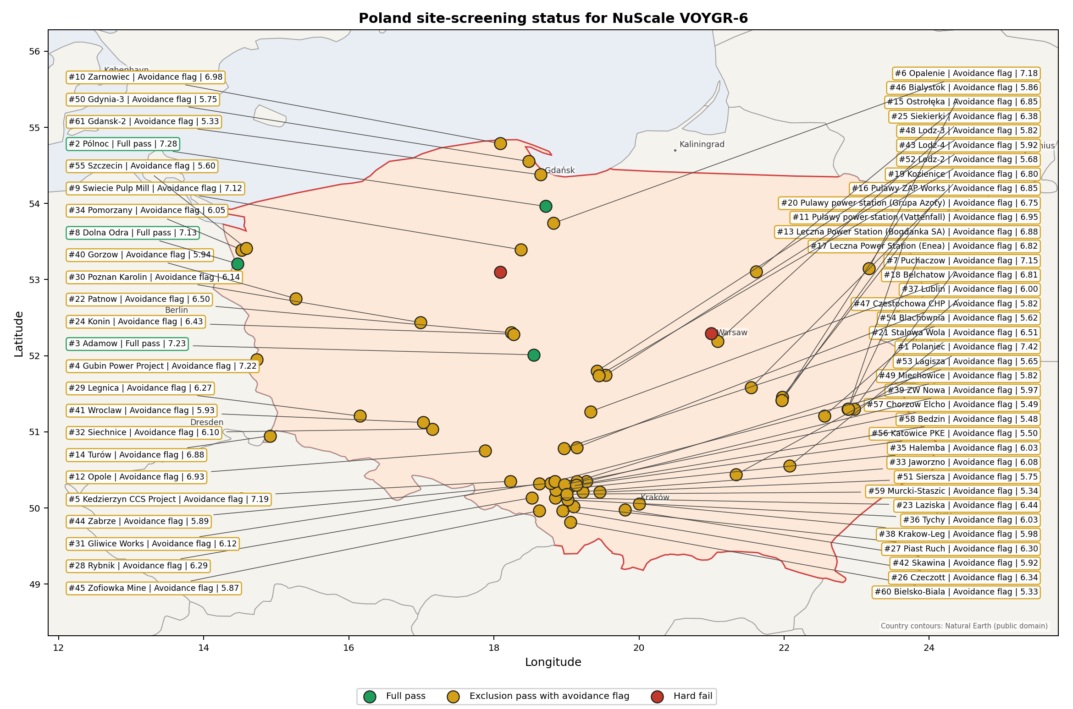
Poland status map

Poland Site Ledger
Rank | Site | Status | Composite | MC Low | MC High | Band | Top-10 Hit | Coverage
1 | Polaniec power station | Exclusion pass with avoidance flag | 7.422 | 6.573 | 7.956 | A | 100% | 76%
2 | Pólnoc power station | Full pass | 7.284 | 6.462 | 7.869 | A | 100% | 76%
3 | Adamow power station | Full pass | 7.227 | 6.245 | 7.822 | B | 92% | 74%
4 | Gubin Power Project | Exclusion pass with avoidance flag | 7.222 | 6.412 | 7.803 | B | 92% | 76%
5 | Kedzierzyn CCS Project | Exclusion pass with avoidance flag | 7.191 | 6.386 | 7.737 | C | 75% | 76%
6 | Opalenie power station | Exclusion pass with avoidance flag | 7.184 | 6.381 | 7.769 | B | 100% | 76%
7 | Puchaczow power station | Exclusion pass with avoidance flag | 7.153 | 6.356 | 7.650 | D | 25% | 76%
8 | Dolna Odra power station | Full pass | 7.134 | 6.341 | 7.769 | D | 8% | 76%
9 | Swiecie Pulp Mill power station | Exclusion pass with avoidance flag | 7.116 | 6.326 | 7.731 | D | 8% | 76%
10 | Zarnowiec power station | Exclusion pass with avoidance flag | 6.984 | 6.058 | 7.579 | D | 0% | 74%
11 | Pulawy power station (Vattenfall) | Exclusion pass with avoidance flag | 6.953 | 6.194 | 7.566 | D | 0% | 76%
12 | Opole power station | Exclusion pass with avoidance flag | 6.934 | 6.179 | 7.500 | D | 0% | 76%
13 | Leczna Power Station (Bogdanka SA) | Exclusion pass with avoidance flag | 6.884 | 6.139 | 7.450 | D | 0% | 76%
14 | Turów power station | Exclusion pass with avoidance flag | 6.884 | 6.139 | 7.469 | D | 0% | 76%
15 | Ostrołęka power station | Exclusion pass with avoidance flag | 6.853 | 6.114 | 7.469 | D | 0% | 76%
16 | Pulawy ZAP Works power station | Exclusion pass with avoidance flag | 6.853 | 6.114 | 7.469 | D | 0% | 76%
17 | Leczna Power Station (Enea) | Exclusion pass with avoidance flag | 6.822 | 6.088 | 7.434 | D | 0% | 76%
18 | Belchatow power station | Exclusion pass with avoidance flag | 6.806 | 5.922 | 7.349 | D | 0% | 74%
19 | Kozienice power station | Exclusion pass with avoidance flag | 6.797 | 6.068 | 7.331 | F | 0% | 76%
20 | Pulawy power station (Grupa Azoty) | Exclusion pass with avoidance flag | 6.753 | 6.033 | 7.366 | H | 0% | 76%
21 | Stalowa Wola power station | Exclusion pass with avoidance flag | 6.513 | 5.838 | 7.106 | H | 0% | 76%
22 | Patnow power station | Exclusion pass with avoidance flag | 6.503 | 5.831 | 7.069 | H | 0% | 76%
23 | Laziska power station | Exclusion pass with avoidance flag | 6.441 | 5.780 | 7.056 | H | 0% | 76%
24 | Konin power station | Exclusion pass with avoidance flag | 6.428 | 5.770 | 7.044 | H | 0% | 76%
25 | Siekierki power station | Exclusion pass with avoidance flag | 6.384 | 5.735 | 6.969 | H | 0% | 76%
26 | Czeczott power station | Exclusion pass with avoidance flag | 6.345 | 5.568 | 6.862 | H | 0% | 74%
27 | Piast Ruch Power Station | Exclusion pass with avoidance flag | 6.297 | 5.664 | 6.931 | H | 0% | 76%
28 | Rybnik power station | Exclusion pass with avoidance flag | 6.291 | 5.659 | 6.837 | H | 0% | 76%
29 | Legnica Power Station | Exclusion pass with avoidance flag | 6.266 | 5.639 | 6.881 | H | 0% | 76%
30 | Poznan Karolin power station | Exclusion pass with avoidance flag | 6.141 | 5.538 | 6.687 | H | 0% | 76%
31 | Gliwice Works power station | Exclusion pass with avoidance flag | 6.116 | 5.518 | 6.631 | H | 0% | 76%
32 | Siechnice power station | Exclusion pass with avoidance flag | 6.103 | 5.508 | 6.650 | H | 0% | 76%
33 | Jaworzno power station | Exclusion pass with avoidance flag | 6.082 | 5.366 | 6.658 | H | 0% | 74%
34 | Pomorzany power station | Exclusion pass with avoidance flag | 6.053 | 5.467 | 6.619 | H | 0% | 76%
35 | Halemba power station | Exclusion pass with avoidance flag | 6.030 | 5.326 | 6.572 | H | 0% | 74%
36 | Tychy power station | Exclusion pass with avoidance flag | 6.028 | 5.447 | 6.594 | H | 0% | 76%
37 | Lublin Power Station | Exclusion pass with avoidance flag | 6.003 | 5.427 | 6.619 | H | 0% | 76%
38 | Krakow-Leg power station | Exclusion pass with avoidance flag | 5.978 | 5.381 | 6.494 | H | 0% | 76%
39 | ZW Nowa power station | Exclusion pass with avoidance flag | 5.969 | 5.399 | 6.500 | H | 0% | 76%
40 | Gorzow power station | Exclusion pass with avoidance flag | 5.941 | 5.376 | 6.556 | H | 0% | 76%
41 | Wroclaw power station | Exclusion pass with avoidance flag | 5.928 | 5.362 | 6.525 | H | 0% | 76%
42 | Skawina power station | Exclusion pass with avoidance flag | 5.922 | 5.361 | 6.431 | H | 0% | 76%
43 | Lodz-4 power station | Exclusion pass with avoidance flag | 5.916 | 5.356 | 6.531 | H | 0% | 76%
44 | Zabrze power station | Exclusion pass with avoidance flag | 5.891 | 5.294 | 6.406 | H | 0% | 76%
45 | Zofiowka Mine power station | Exclusion pass with avoidance flag | 5.866 | 5.316 | 6.356 | H | 0% | 76%
46 | Bialystok power station | Exclusion pass with avoidance flag | 5.859 | 5.194 | 6.454 | H | 0% | 74%
47 | Czestochowa CHP power station | Exclusion pass with avoidance flag | 5.819 | 5.164 | 6.414 | H | 0% | 74%
48 | Lodz-3 power station | Exclusion pass with avoidance flag | 5.816 | 5.275 | 6.431 | H | 0% | 76%
49 | Miechowice power station | Exclusion pass with avoidance flag | 5.816 | 5.269 | 6.381 | H | 0% | 76%
50 | Gdynia-3 power station | Exclusion pass with avoidance flag | 5.753 | 5.114 | 6.329 | H | 0% | 74%
51 | Siersza power station | Exclusion pass with avoidance flag | 5.753 | 5.225 | 6.350 | H | 0% | 76%
52 | Lodz-2 power station | Exclusion pass with avoidance flag | 5.678 | 5.131 | 6.244 | H | 0% | 76%
53 | Lagisza power station | Exclusion pass with avoidance flag | 5.653 | 5.087 | 6.200 | H | 0% | 76%
54 | Blachownia power station | Exclusion pass with avoidance flag | 5.622 | 5.013 | 6.164 | H | 0% | 74%
55 | Szczecin power station | Exclusion pass with avoidance flag | 5.603 | 5.056 | 6.169 | H | 0% | 76%
56 | Katowice PKE power station | Exclusion pass with avoidance flag | 5.500 | 4.919 | 6.020 | H | 0% | 74%
57 | Chorzow Elcho power station | Exclusion pass with avoidance flag | 5.493 | 4.914 | 6.020 | H | 0% | 74%
58 | Bedzin power station | Exclusion pass with avoidance flag | 5.480 | 4.904 | 6.039 | H | 0% | 74%
59 | Murcki-Staszic power station | Exclusion pass with avoidance flag | 5.341 | 4.844 | 5.956 | H | 0% | 76%
60 | Bielsko-Biala power station | Exclusion pass with avoidance flag | 5.332 | 4.790 | 5.849 | H | 0% | 74%
61 | Gdansk-2 power station | Exclusion pass with avoidance flag | 5.328 | 4.712 | 5.825 | H | 0% | 76%
- | Bydgoszcz power station | Hard fail | - | - | - | - | - | 0%
- | Zeran power station | Hard fail | - | - | - | - | - | 0%

Avoidance Flag Pareto
Of the 61 sites that pass the exclusionary screen, the avoidance-phase flags concentrate on a small set of criteria. Resolving them is what would move the country from a small leading group to a broader candidate pool.
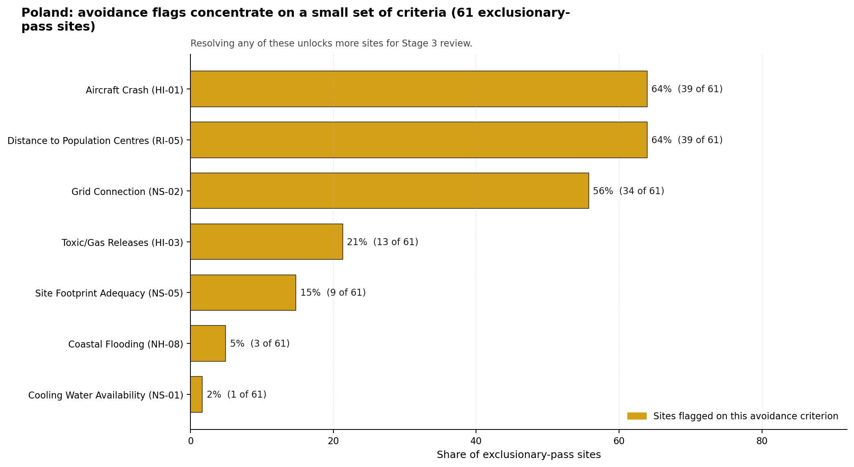
Avoidance flag Pareto
- Distance to Population Centres (RI-05) - 39 of 61 exclusionary-pass sites (64%).
- Aircraft Crash (HI-01) - 39 of 61 exclusionary-pass sites (64%).
- Grid Connection (NS-02) - 34 of 61 exclusionary-pass sites (56%).
- Toxic/Gas Releases (HI-03) - 13 of 61 exclusionary-pass sites (21%).
- Site Footprint Adequacy (NS-05) - 9 of 61 exclusionary-pass sites (15%).
- Coastal Flooding (NH-08) - 3 of 61 exclusionary-pass sites (5%).
- Cooling Water Availability (NS-01) - 1 of 61 exclusionary-pass sites (2%).

Exclusionary Failure Pareto
The exclusionary failures across the country trace back to a small number of criteria. They identify which screening checks are responsible for removing sites from further consideration.
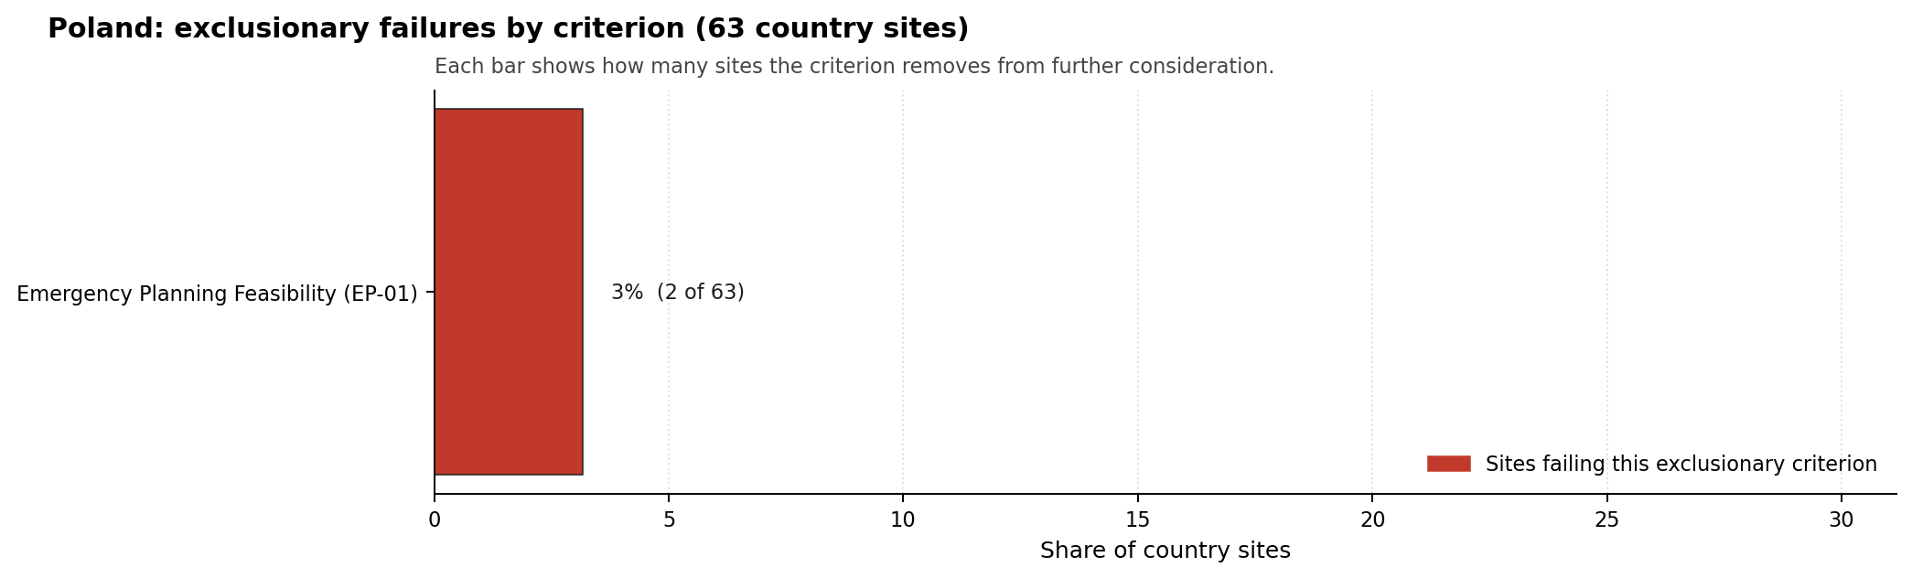
Exclusionary failure Pareto
- Emergency Planning Feasibility (EP-01) - 2 of 63 country sites (3%).

Family Strength and Weakness
Across the country the strongest criterion family is Natural Hazards at a mean normalised score of 7.55/10. The weakest family is Radiological Impact at 4.44/10. The bottom three individual criteria across the country are:
- Military Installations (HI-06) - mean 0.37/10 across 63 scored sites (min 0.0, max 3.5).
- Electromagnetic Interference (HI-07) - mean 1.56/10 across 63 scored sites (min 1.5, max 3.5).
- Population Density at EPZ Radii (RI-04) - mean 2.45/10 across 63 scored sites (min 1.5, max 5.5).

Interpretation for Site Selection
The Poland result is not a simple full-pass shortlist. The full-pass group, Pólnoc, Adamow, and Dolna Odra, provides the clearest low-friction Stage 3 entry points, but the national ranking places Polaniec first and keeps Gubin and Kedzierzyn in the selected top five. Those three avoidance-flagged sites should progress only with explicit early work on their binding avoidance criteria.

Avoidance flag Pareto - what unlocks more sites
The chart shows the national unlock agenda for the 61 exclusionary-pass sites. RI-05 and HI-01 each affect 39 sites, and NS-02 affects 34 sites, so targeted population-centre modelling, aircraft-crash assessment, and grid-pathway confirmation would have programme-wide value rather than site-only value.
For this Poland tranche, the selected detailed profiles are the top five by national rank under the national sensitivity basis: Polaniec power station, Pólnoc power station, Adamow power station, Gubin Power Project, and Kedzierzyn CCS Project.
The Monte Carlo intervals are a caution against false precision: the first five sites sit in a tight score range from 7.191 to 7.422, and several bands overlap. The decisive Stage 3 distinction is therefore the type of residual work each site carries: Polaniec is an HI-01 resolution case; Pólnoc and Adamow are full-pass candidates with land, military, EMI, and cooling-water questions; Gubin is an airfield, ecological, land-footprint, and cross-border river case; and Kedzierzyn is a compact industrial-site case with footprint, HI-06, EMI, and RI-04 constraints.

Status Counts
- Full pass: 3
- Exclusion pass with avoidance flag: 58
- Hard fail: 2

Adamow power station Site Profile
Adamow power station is a coal/thermal site in Poland that has been tested against the NuScale VOYGR-6 reference deployment envelope. This profile reads the screening evidence at a level that supports a decision to progress toward Stage 3 characterisation. It is not a site-suitability determination, vendor recommendation, or licensing finding.

Site Snapshot
Field | Value
Site name | Adamow power station
Coordinates | 52.0123, 18.5462
Subnational unit | Wielkopolskie
Installed thermal capacity (source data) | 600 MW
Available surface area | 158.9 ha
Available surface area for development | 6.0 ha
Composite score (baseline weights) | 7.227 (6.245-7.822 MC band)
National stability band | B (top-10% hit rate 92%)
National rank | 3
See the country status map in Poland Country Profile.

Ownership and Coal-to-Nuclear Context
- Zespół Elektrowni Pątnów Adamów Konin SA (100.00% share), headquartered in Poland; immediate operator Zespół Elektrowni Pątnów Adamów Konin SA. Path: Zespół Elektrowni Pątnów Adamów Konin SA -> Adamow power station Unit 1 [100.0%]
Generating units on record: 5 retired. Earliest unit commissioning: 1964; most recent: 1966. Retirements span 2017 to 2017, leaving brownfield grid, water, transport, and workforce assets that materially shorten Stage 3 site preparation.

Natural Hazards (NH)
- Seismic: Ground Motion (NH-01) - score 9.5/10 (MC 9.0-10.0) - favourable: Well below the risk boundary., weight 0.0455, data quality high. Evidence: PGA at 475-year return period 0.011 g; PGA at 2,475-year return period 0.029 g; Vs30 reference (m/s): 760.0.
- Seismic: Surface Rupture (NH-02) - score 9.5/10 (MC 9.0-10.0) - favourable: Very strong separation from mapped capable faults; surface-rupture concern effectively screened at desk-study level., weight n/a, data quality screening grade. Evidence: nearest mapped capable fault 50.0 km; fault slip rate 0 mm/yr; fault name: none_in_search_radius.
- Geotechnical: Liquefaction (NH-03) - score 5.5/10 (MC 5.0-6.0) - pass-mark band: Moderate susceptibility, or high/very-high with documented (or pending for high) mitigation., weight n/a, data quality medium. Evidence: liquefaction susceptibility: high; dominant soil type: loamy_sand.
- Geotechnical: Slope Stability (NH-04) - score 7.5/10 (MC 7.0-8.0), weight n/a, data quality screening grade. Evidence: site slope 7.58 deg; max slope in 1 km box 76.5 deg; slope stability class: moderate.
- Geotechnical: Subsidence (NH-05) - score 9.5/10 (MC 9.0-10.0) - favourable: No karst; mine-feature distance well above the score-5 pivot (or unknown)., weight 0.0354, data quality medium. Evidence: karst present: no; karst severity: none.
- Geotechnical: Foundation (NH-06) - score 5.5/10 (MC 5.0-6.0) - pass-mark band: Typical European mixed conditions (bearing 80-150 kPa)., weight 0.0253, data quality medium. Evidence: bearing capacity 120.0 kPa; depth to bedrock 24.8 m.
- Volcanism (NH-07) - score 9.5/10 (MC 9.0-10.0) - favourable: Very strong margin above the score-5 boundary (or screening evidence confirms no in-radius signal)., weight n/a, data quality high. Evidence: volcanic hazard class: negligible.
- Coastal Flooding (NH-08) - score 9.5/10 (MC 9.0-10.0) - favourable: Non-coastal OR elevation >= 50 m AMSL OR landlocked country, with no positive marine-hazard signal., weight 0.0303, data quality medium. Evidence: distance to coast 261.6 km.
- River Flooding (NH-09) - score 7.5/10 (MC 5.5-9.5), weight 0.0404, data quality insufficient. Evidence: flood zone class: negligible.
- Extreme Winds (NH-10) - score 3.5/10 (MC 3.0-4.0), weight 0.0152, data quality medium. Evidence: screening wind-speed index 11.0 m/s.
- Extreme Precipitation (NH-11) - score 8.0/10 (MC 8.0-9.0) - favourable: aggregated(mean_of_sub_scores), weight 0.0152, data quality medium. Evidence: screening extreme-precipitation index 0.22 mm; screening precipitation index 21.8 mm/yr.
- Extreme Temperatures (NH-12) - score 6.5/10 (MC 6.0-7.0) - pass-mark band: aggregated(mean_of_sub_scores), weight 0.0202, data quality medium. Evidence: extreme high temperature 23.7 deg C; extreme low temperature -7.53 deg C.
- Combined Hazards (NH-14) - score 5.5/10 (MC 5.0-6.0) - pass-mark band: At least 5 resolved, exactly one moderate hazard (3-5) or moderate interaction only., weight 0.0152, data quality n/a. Evidence: values not in measurement tables.

Interpretation - Natural Hazards (NH)
Natural hazards at Adamow are generally favourable, with liquefaction, wind, and flood confirmation the practical Stage 3 priorities. Ground motion is very low, with PGA of 0.011 g at the 475-year return period and 0.029 g at the 2,475-year return period, and no mapped capable fault is recorded within 50.0 km. Liquefaction susceptibility is high on loamy sand, while bearing capacity is 120.0 kPa and depth to bedrock is 24.8 m. Karst is absent, coastal distance is 261.6 km, and the flood-zone class is negligible, but River Flooding (NH-09) still carries insufficient data quality. Extreme Winds (NH-10) is weaker at 3.5/10 with screening wind-speed index of 11.0 m/s. Stage 3 should therefore confirm foundation behaviour, liquefaction susceptibility, local flood inputs, and wind loading before detailed layout selection.

Human-Induced and Security-Relevant Hazards (HI)
- Aircraft Crash (HI-01) - score 9.5/10 (MC 9.0-10.0) - favourable: Only small / GA / heliport airport >= 10 km nearby, no flight-path proxy < 4 km, no major airport within 30 km, and no military airbase within 60 km., weight 0.0354, data quality high. Evidence: nearest airport 36.3 km; nearest flight path 18.1 km; airports within search radius 0; airport name: Rossoszyca (Warta) Highway Strip; airport type: small airfield.
- Industrial Explosions (HI-02) - score 9.5/10 (MC 9.0-10.0) - favourable: Very strong margin above the score-5 boundary (or completed search confirmed no in-radius signal)., weight 0.0354, data quality medium. Evidence: values not in measurement tables.
- Toxic/Gas Releases (HI-03) - score 9.5/10 (MC 9.0-10.0) - favourable: Very strong margin above the score-5 boundary (or completed search confirmed no in-radius signal)., weight 0.0354, data quality medium. Evidence: values not in measurement tables.
- External Fires (HI-04) - score 9.5/10 (MC 9.0-10.0) - favourable: > 15 km, or completed flammable-storage search found nothing in radius., weight 0.0303, data quality medium. Evidence: values not in measurement tables.
- Military Installations (HI-06) - score 0.0/10 (MC 0.0-0.0), weight 0.0303, data quality high. Evidence: nearest military installation 4.34 km; military installations within radius 65; installation name: 12 Wielkopolska Brygada Obrony Terytorialnej.
- Electromagnetic Interference (HI-07) - score 1.5/10 (MC 1.0-2.0), weight 0.0101, data quality medium. Evidence: nearest high-power transmitter 0.3 km; transmitters within radius 97; transmitter type: mast.

Interpretation - Human-Induced and Security-Relevant Hazards (HI)
Human-induced hazards at Adamow are sharply divided between favourable aircraft and industrial indicators and a severe military/EMI screen. Aircraft Crash (HI-01) scores 9.5/10: the nearest airport is 36.3 km away, the nearest flight-path proxy is 18.1 km away, and no airport is recorded within the search radius. Industrial Explosions (HI-02), Toxic/Gas Releases (HI-03), and External Fires (HI-04) are also favourable in the screening record. The binding issue is Military Installations (HI-06), which scores 0.0/10 because the nearest military feature is 4.34 km away and 65 features are recorded within 25 km. Electromagnetic Interference (HI-07) is also weak, with a mast 0.3 km away and 97 transmitters in the search radius. Stage 3 should start with defence-authority engagement and an EMI field survey.

Radiological Impact and Emergency Planning (RI / EP)
- Emergency Planning Feasibility (EP-01) - score 5.5/10 (MC 5.0-6.0) - pass-mark band: At or above the composite score-5 boundary., weight n/a, data quality high. Evidence: EP feasibility composite 58.6 /100; road sub-score 52.4 /100; special-population sub-score 90.0 /100; geography sub-score 95.0 /100; population sub-score 60.0 /100; evacuation feasible: yes.
- Evacuation Routes (EP-02) - score 5.5/10 (MC 5.0-6.0) - pass-mark band: Adequate primary routes (0.5-1.0)., weight 0.0303, data quality medium. Evidence: road density in EPZ 0.507 km/km2; road length in EPZ 994.9 km; motorway access: yes.
- Physical Geography Constraints (EP-03) - score 9.5/10 (MC 9.0-10.0) - favourable: No measured relief; open river/waterway context (interim screening)., weight 0.0253, data quality medium. Evidence: waterways crossing EPZ 0; major river barrier: no.
- Special Populations (EP-04) - score 5.5/10 (MC 5.0-6.0) - pass-mark band: 9-25., weight 0.0303, data quality medium. Evidence: hospitals in EPZ 9; prisons in EPZ 0; care homes in EPZ 1.
- Atmospheric Dispersion (RI-01) - score no native score (unscored - no band matched), weight 0.0303, data quality medium. Evidence: annual mean wind speed 1.62 m/s; atmospheric mixing height 580.6 m; prevailing wind direction: WSW.
- Surface Water Dispersion (RI-02) - score 1.5/10 (MC 1.0-2.0), weight 0.0253, data quality n/a. Evidence: values not in measurement tables.
- Groundwater Dispersion (RI-03) - score 5.5/10 (MC 5.0-6.0) - pass-mark band: Moderate-permeability aquifer screening proxy., weight 0.0253, data quality medium. Evidence: aquifer type: sedimentary carbonates.
- Population Density at EPZ Radii (RI-04) - score 3.5/10 (MC 3.0-4.0), weight 0.0404, data quality screening grade. Evidence: population density within 5 km 419.7 /km2; population density within 16 km 91.0 /km2; population density within 25 km 82.0 /km2; population density within 80 km 136.3 /km2; population within 25 km 161,026 people.
- Distance to Population Centres (RI-05) - score 9.5/10 (MC 9.0-10.0) - favourable: Nearest >=50k population-centre proxy exceeds required distance by >= 50 %., weight 0.0505, data quality screening grade. Evidence: nearest city above 50k people 33.3 km; nearest city population 67,066 people; city name: Konin.
- Population Projections (RI-06) - score 7.5/10 (MC 7.0-8.0), weight 0.0253, data quality screening grade. Evidence: annual population growth rate -0.097 %/yr; projected population at 25 km in 60 yr 126,551 people.

Interpretation - Radiological Impact and Emergency Planning (RI / EP)
Radiological and emergency-planning evidence at Adamow is adequate but not light. EP-01 is 58.6/100 and marked evacuation feasible, with 52.4/100 on roads, 90.0/100 on special populations, 95.0/100 on geography, and 60.0/100 on population. The EPZ contains nine hospitals and one care home, and road density is 0.507 km/km2 with motorway access present. Population Density at EPZ Radii (RI-04) is a weakness at 3.5/10, driven by 419.7 people/km2 within 5 km, although the 25 km density is 82.0 people/km2 and the 25 km population is 161,026 people. Konin is the nearest city above 50,000 people at 33.3 km. Surface Water Dispersion (RI-02) is the major radiological data weakness at 1.5/10. Stage 3 should model liquid pathways, EPZ clearance, and local population distribution before hardening the site read.

Non-Safety and Implementation Considerations (NS)
- Grid Capacity Basic Filter (BF-01) - score 5.5/10 (MC 5.0-6.0) - pass-mark band: Note: substation 15-30 km OR 110-219 kV; reinforcement plausible., weight n/a, data quality n/a. Evidence: values not in measurement tables.
- Land Area Basic Filter (BF-02) - score 1.5/10 (MC 1.0-2.0), weight 0.0253, data quality n/a. Evidence: values not in measurement tables.
- Cooling Water Availability (NS-01) - score 4.0/10 (MC 4.0-5.0), weight 0.0404, data quality screening grade. Evidence: distance to cooling source 5.08 km; cooling source flow 0.73 m3/s; cooling source type: small_river; cooling source name: Kiełbaska; water stress label: High.
- Grid Connection (NS-02) - score 5.5/10 (MC 5.0-6.0) - pass-mark band: aggregated(min_of_sub_scores), weight 0.0404, data quality high. Evidence: nearest substation 0.3 km; nearest high-voltage line 0.15 km; highest nearby line voltage 110.0 kV; grid export capacity 600.0 MW; substations within radius 327; HV lines within radius 472.
- Transport Access (NS-03) - score no native score (unscored - no band matched), weight 0.0404, data quality low. Evidence: not measured at this site (criterion remains unscored).
- Site Topography (NS-04) - score 9.5/10 (MC 9.0-10.0) - favourable: > 80 %., weight 0.0303, data quality screening grade. Evidence: favourable land cover 88.8 %; moderate land cover 7.8 %; unfavourable land cover 3.4 %; favourable area 211.8 ha; dominant land class: 211.
- Site Footprint Adequacy (NS-05) - score 9.5/10 (MC 9.0-10.0) - favourable: Very strong margin above the score-5 boundary., weight 0.0253, data quality high. Evidence: buildable area 5.96 ha; largest contiguous patch 5.96 ha; buildable patch count 10.
- Existing Infrastructure (NS-06) - score no native score (unscored - no band matched), weight 0.0253, data quality n/a. Evidence: not measured at this site (criterion remains unscored).
- Ecological Sensitivity (NS-08) - score 3.5/10 (MC 3.0-4.0), weight n/a, data quality high. Evidence: natural land cover 3.4 %; distance to nearest Natura 2000 site 11.0 km; distance to nearest protected area 3.184 km; Natura 2000 overlap: no; Natura 2000 sensitivity class: low; protected-area overlap: no; protected-area sensitivity class: low; nearest Natura 2000 site: Dolina Środkowej Warty; Natura 2000 sites within 5 km: 0; nearest protected-area designation: Protected Landscape Area.
- Workforce Availability (NS-10) - score no native score (unscored - no band matched), weight 0.0202, data quality n/a. Evidence: not measured at this site (criterion remains unscored).
- Regulatory/Political Environment (NS-12) - score no native score (unscored - no band matched), weight 0.0303, data quality n/a. Evidence: not measured at this site (criterion remains unscored).
- Construction Logistics (NS-13) - score no native score (unscored - no band matched), weight 0.0202, data quality n/a. Evidence: not measured at this site (criterion remains unscored).

Interpretation - Non-Safety and Implementation Considerations (NS)
Adamow’s implementation case benefits from a retired brownfield setting but carries cooling-water, land-development, and transport-data questions. The canonical site surface area is 158.9 ha, while the development-area estimate is 6.0 ha; the latter should be treated only as a screening-stage development envelope. Cooling Water Availability (NS-01) scores 4.0/10 because the Kiełbaska is 5.08 km away, recorded flow is 0.73 m3/s, and water stress is High. Grid evidence is plausible, with a substation 0.3 km away, a high-voltage line 0.15 km away, 110.0 kV highest nearby voltage, and 600.0 MW export capacity. Site Topography (NS-04) is strong, with 88.8% favourable land cover and 211.8 ha favourable area. Stage 3 should test whether cooling water, grid reinforcement, developable land, and transport access can support a NuScale VOYGR-6 envelope.

Composite Score and Stability
Baseline composite score is 7.227, bracketed by Monte Carlo at 6.245-7.822. National stability band is B with a top-10% hit rate of 92% in the project’s 50,000-iteration national sensitivity analysis.
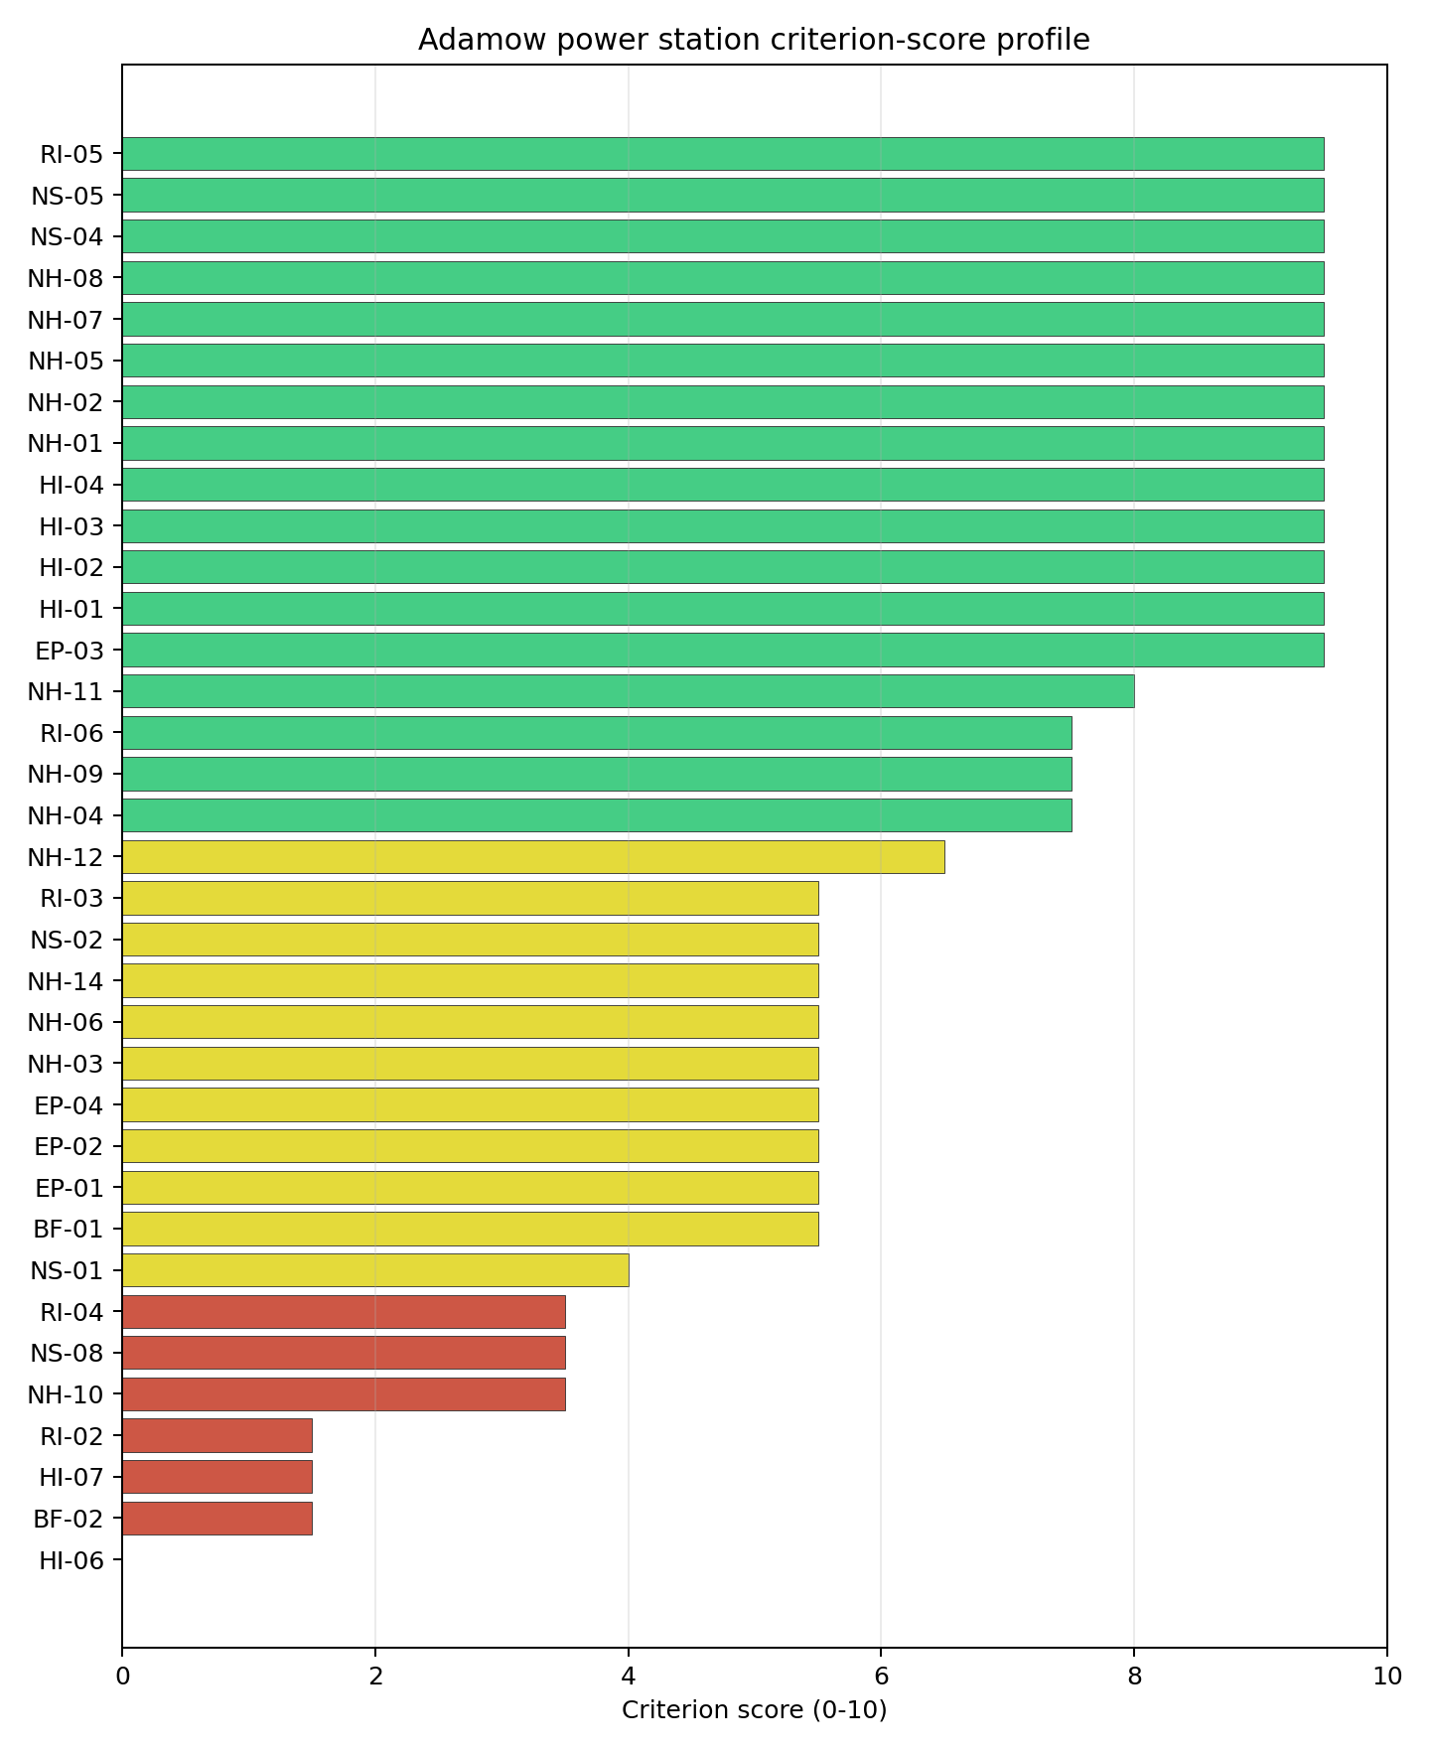
Criterion scores
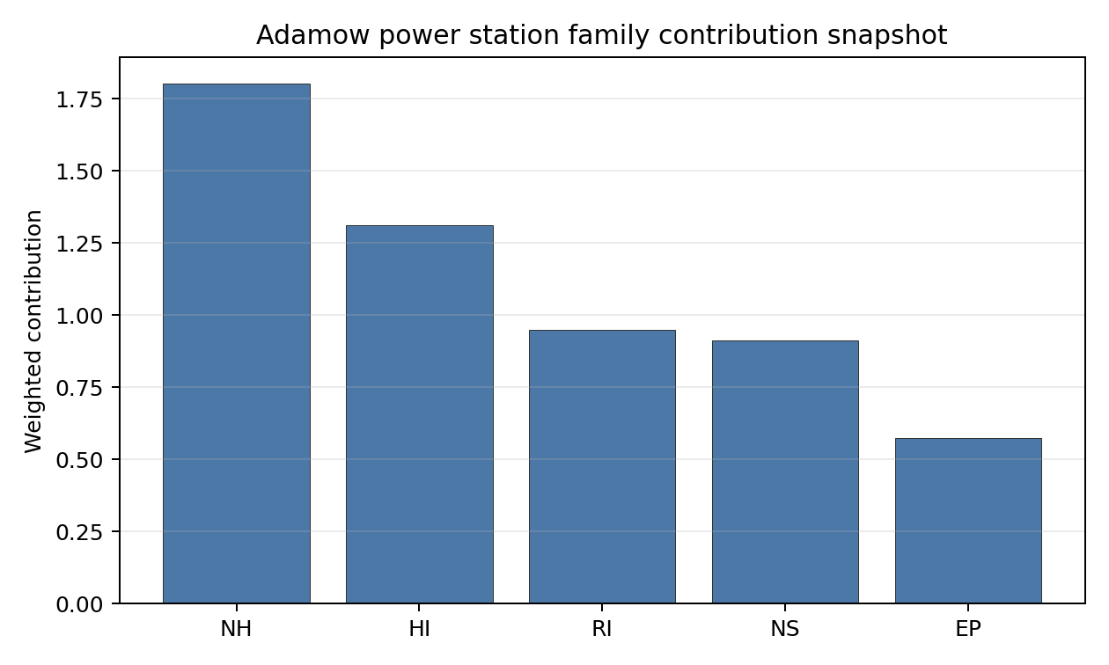
Family contributions
Adamow’s baseline composite score is 7.227, with a Monte Carlo bracket of 6.245-7.822. Its national stability band is B with a 92% top-10 hit rate in the project’s 50,000-iteration national sensitivity analysis, so it is robust under most weight perturbations but less dominant than the two band-A leaders. The score benefits from very low seismic hazard, full-pass screening status, strong topography, and proximity to existing grid infrastructure. Its ranking is most exposed to HI-06, RI-02, cooling-water adequacy, and development-area confirmation. Stage 3 should sequence Adamow as a full-pass candidate that needs early water, security, and land work before it can be treated as a straightforward brownfield conversion case.

Residual Risk Register
Concern | Evidence | Consequence | Stage 3 action | Owner discipline
Military Installations (HI-06) | Nearest feature is 4.34 km away; 65 features are within 25 km | Security buffers or classification could constrain the site envelope | Engage defence authorities and classify active features | security
Surface Water Dispersion (RI-02) | Criterion scores 1.5/10 with no measured value in the table | Liquid-pathway confidence is weak | Quantify discharge, dilution, and downstream receptor pathways | hydrology
Cooling Water Availability (NS-01) | Kiełbaska is 5.08 km away; flow is 0.73 m3/s; water stress is High | Cooling concept may require redesign or an alternative water strategy | Confirm cooling-water source, drought flow, and abstraction limits | hydrology
Land Area Basic Filter (BF-02) | Canonical site area is 158.9 ha; development-area estimate is 6.0 ha | Usable parcel may be smaller than the brownfield site record | Confirm developable parcels, ownership, and constraints | ownership/legal
Electromagnetic Interference (HI-07) | Nearest mast is 0.3 km away; 97 transmitters are within the search radius | RF environment could affect controls and instrumentation | Survey transmitter field strengths and exclusion distances | security
Adamow’s full-pass status makes it attractive, but the residual register shows why it should not be treated as a low-work site. Water, security, land, and liquid-pathway evidence are the high-value Stage 3 confirmations.

Stage 3 Follow-Up Checklist
- Classify Military Installations (HI-06) for the feature 4.34 km away and the 65-feature search-radius inventory.
- Confirm Land Area Basic Filter (BF-02) using parcel, ownership, constraint, and contiguity evidence for the 6.0 ha development-area estimate.
- Survey Electromagnetic Interference (HI-07) for the mast 0.3 km away and 97-transmitter inventory.
- Quantify Surface Water Dispersion (RI-02) because the current liquid-pathway score is 1.5/10.
- Confirm Cooling Water Availability (NS-01) for the Kiełbaska flow, drought conditions, and abstraction limits.

Evidence Limitations
- Geotechnical: Subsidence & Collapse (NH-05b) - quality low.
- Transport Access (NS-03) - quality low.

Gubin Power Project Site Profile
Gubin Power Project is a coal/thermal site in Poland that has been tested against the NuScale VOYGR-6 reference deployment envelope. This profile reads the screening evidence at a level that supports a decision to progress toward Stage 3 characterisation. It is not a site-suitability determination, vendor recommendation, or licensing finding.

Site Snapshot
Field | Value
Site name | Gubin Power Project
Coordinates | 51.9490, 14.7285
Subnational unit | Lubuskie
Installed thermal capacity (source data) | 3,000 MW
Available surface area | 38.8 ha
Available surface area for development | 0.1 ha
Composite score (baseline weights) | 7.222 (6.412-7.803 MC band)
National stability band | B (top-10% hit rate 92%)
National rank | 4
See the country status map in Poland Country Profile.

Ownership and Coal-to-Nuclear Context
- Ministry of State Treasury (Poland) (60.86% share), headquartered in Poland; immediate operator PGE Polska Grupa Energetyczna SA. Path: Ministry of State Treasury (Poland) -> PGE Polska Grupa Energetyczna SA [60.86%] -> Gubin Power Project – [100.0%]
- small shareholder(s) (39.14% share); immediate operator PGE Polska Grupa Energetyczna SA. Path: small shareholder(s) -> PGE Polska Grupa Energetyczna SA [39.14%] -> Gubin Power Project – [100.0%]
- PGE Polska Grupa Energetyczna SA (100.00% share), headquartered in Poland; immediate operator PGE Polska Grupa Energetyczna SA. Path: PGE Polska Grupa Energetyczna SA -> Gubin Power Project – [100.0%]
Generating units on record: 1 cancelled. Earliest unit commissioning: 2020; most recent: 2020.

Natural Hazards (NH)
- Seismic: Ground Motion (NH-01) - score 9.5/10 (MC 9.0-10.0) - favourable: Well below the risk boundary., weight 0.0455, data quality high. Evidence: PGA at 475-year return period 0.009 g; PGA at 2,475-year return period 0.024 g; Vs30 reference (m/s): 760.0.
- Seismic: Surface Rupture (NH-02) - score 9.5/10 (MC 9.0-10.0) - favourable: Very strong separation from mapped capable faults; surface-rupture concern effectively screened at desk-study level., weight n/a, data quality screening grade. Evidence: nearest mapped capable fault 50.0 km; fault slip rate 0 mm/yr; fault name: none_in_search_radius.
- Geotechnical: Liquefaction (NH-03) - score 9.5/10 (MC 9.0-10.0) - favourable: Negligible susceptibility (Stage-1 favourable default)., weight n/a, data quality medium. Evidence: liquefaction susceptibility: very_low; dominant soil type: sandy_loam.
- Geotechnical: Slope Stability (NH-04) - score 9.5/10 (MC 9.0-10.0) - favourable: Well below the risk boundary., weight n/a, data quality screening grade. Evidence: site slope 2.91 deg; max slope in 1 km box 21.0 deg; slope stability class: gentle.
- Geotechnical: Subsidence (NH-05) - score 9.5/10 (MC 9.0-10.0) - favourable: No karst; mine-feature distance well above the score-5 pivot (or unknown)., weight 0.0354, data quality medium. Evidence: karst present: no; karst severity: none.
- Geotechnical: Foundation (NH-06) - score 5.5/10 (MC 5.0-6.0) - pass-mark band: Typical European mixed conditions (bearing 80-150 kPa)., weight 0.0253, data quality medium. Evidence: bearing capacity 123.0 kPa; depth to bedrock 22.8 m.
- Volcanism (NH-07) - score 9.5/10 (MC 9.0-10.0) - favourable: Very strong margin above the score-5 boundary (or screening evidence confirms no in-radius signal)., weight n/a, data quality high. Evidence: volcanic hazard class: negligible.
- Coastal Flooding (NH-08) - score 9.5/10 (MC 9.0-10.0) - favourable: Non-coastal OR elevation >= 50 m AMSL OR landlocked country, with no positive marine-hazard signal., weight 0.0303, data quality medium. Evidence: distance to coast 188.4 km.
- River Flooding (NH-09) - score 5.5/10 (MC 3.5-7.5) - pass-mark band: Benign flood-zone class but river/waterway proxy is within 2 km; routine flood-interface review., weight 0.0404, data quality insufficient. Evidence: nearest river 0 km; flood zone class: negligible.
- Extreme Winds (NH-10) - score 3.5/10 (MC 3.0-4.0), weight 0.0152, data quality medium. Evidence: screening wind-speed index 11.4 m/s.
- Extreme Precipitation (NH-11) - score 8.0/10 (MC 8.0-9.0) - favourable: aggregated(mean_of_sub_scores), weight 0.0152, data quality medium. Evidence: screening extreme-precipitation index 0.23 mm; screening precipitation index 22.6 mm/yr.
- Extreme Temperatures (NH-12) - score 6.5/10 (MC 6.0-7.0) - pass-mark band: aggregated(mean_of_sub_scores), weight 0.0202, data quality medium. Evidence: extreme high temperature 24.4 deg C; extreme low temperature -5.56 deg C.
- Combined Hazards (NH-14) - score 5.5/10 (MC 5.0-6.0) - pass-mark band: At least 5 resolved, exactly one moderate hazard (3-5) or moderate interaction only., weight 0.0152, data quality n/a. Evidence: values not in measurement tables.

Interpretation - Natural Hazards (NH)
Natural hazards at Gubin are favourable on seismic, surface-rupture, liquefaction, slope, karst, and coastal indicators, but river interface and wind require Stage 3 confirmation. Ground motion is very low, with PGA of 0.009 g at the 475-year return period and 0.024 g at the 2,475-year return period, and no mapped capable fault is recorded within 50.0 km. Liquefaction susceptibility is very low, site slope is 2.91 degrees, and bearing capacity is 123.0 kPa. River Flooding (NH-09) is weaker at 5.5/10 because the nearest river is 0 km from the site, despite a negligible flood-zone class and insufficient data quality. Extreme Winds (NH-10) scores 3.5/10 with screening wind-speed index of 11.4 m/s. Stage 3 should confirm the river-edge flood envelope, drainage, and design wind loading before detailed site layout.

Human-Induced and Security-Relevant Hazards (HI)
- Aircraft Crash (HI-01) - score 3.5/10 (MC 3.0-4.0), weight 0.0354, data quality high. Evidence: nearest airport 4.77 km; nearest flight path 2.38 km; airports within search radius 3; airport name: Lotnisko Sportowe Gubin; airport type: small airfield.
- Industrial Explosions (HI-02) - score 9.5/10 (MC 9.0-10.0) - favourable: Very strong margin above the score-5 boundary (or completed search confirmed no in-radius signal)., weight 0.0354, data quality medium. Evidence: values not in measurement tables.
- Toxic/Gas Releases (HI-03) - score 9.5/10 (MC 9.0-10.0) - favourable: Very strong margin above the score-5 boundary (or completed search confirmed no in-radius signal)., weight 0.0354, data quality medium. Evidence: values not in measurement tables.
- External Fires (HI-04) - score 9.5/10 (MC 9.0-10.0) - favourable: > 15 km, or completed flammable-storage search found nothing in radius., weight 0.0303, data quality medium. Evidence: values not in measurement tables.
- Military Installations (HI-06) - score 1.5/10 (MC 1.0-2.0), weight 0.0303, data quality medium. Evidence: nearest military installation 14.0 km; military installations within radius 25; installation name: unnamed.
- Electromagnetic Interference (HI-07) - score 1.5/10 (MC 1.0-2.0), weight 0.0101, data quality medium. Evidence: nearest high-power transmitter 1.27 km; transmitters within radius 101; transmitter type: communication.

Interpretation - Human-Induced and Security-Relevant Hazards (HI)
Human-induced hazards are the main screening constraint at Gubin. Aircraft Crash (HI-01) scores 3.5/10 because Lotnisko Sportowe Gubin is 4.77 km away and the nearest flight-path proxy is 2.38 km away; both require a focused aircraft-crash hazard assessment. Military Installations (HI-06) scores 1.5/10, with the nearest military feature 14.0 km away and 25 features within 25 km. Electromagnetic Interference (HI-07) also scores 1.5/10, with a communication transmitter 1.27 km away and 101 transmitters in the search radius. Industrial, toxic, and external-fire screens are favourable on the current record. Stage 3 should start with airfield and flight-path modelling, then confirm military-feature classification and the RF environment.

Radiological Impact and Emergency Planning (RI / EP)
- Emergency Planning Feasibility (EP-01) - score 5.5/10 (MC 5.0-6.0) - pass-mark band: At or above the composite score-5 boundary., weight n/a, data quality high. Evidence: EP feasibility composite 60.3 /100; road sub-score 47.2 /100; special-population sub-score 90.0 /100; geography sub-score 95.0 /100; population sub-score 60.0 /100; evacuation feasible: yes.
- Evacuation Routes (EP-02) - score 3.5/10 (MC 3.0-4.0), weight 0.0303, data quality medium. Evidence: road density in EPZ 0.42 km/km2; road length in EPZ 825.2 km; motorway access: yes.
- Physical Geography Constraints (EP-03) - score 9.5/10 (MC 9.0-10.0) - favourable: No measured relief; open river/waterway context (interim screening)., weight 0.0253, data quality medium. Evidence: waterways crossing EPZ 0; major river barrier: no.
- Special Populations (EP-04) - score 5.5/10 (MC 5.0-6.0) - pass-mark band: 9-25., weight 0.0303, data quality medium. Evidence: hospitals in EPZ 14; prisons in EPZ 2; care homes in EPZ 4.
- Atmospheric Dispersion (RI-01) - score no native score (unscored - no band matched), weight 0.0303, data quality medium. Evidence: annual mean wind speed 1.57 m/s; atmospheric mixing height 615.4 m; prevailing wind direction: SW.
- Surface Water Dispersion (RI-02) - score 3.5/10 (MC 3.0-4.0), weight 0.0253, data quality n/a. Evidence: values not in measurement tables.
- Groundwater Dispersion (RI-03) - score 5.5/10 (MC 5.0-6.0) - pass-mark band: Moderate-permeability aquifer screening proxy., weight 0.0253, data quality medium. Evidence: aquifer type: alluvial.
- Population Density at EPZ Radii (RI-04) - score 3.5/10 (MC 3.0-4.0), weight 0.0404, data quality screening grade. Evidence: population density within 5 km 448.9 /km2; population density within 16 km 62.0 /km2; population density within 25 km 60.3 /km2; population density within 80 km 74.7 /km2; population within 25 km 118,459 people.
- Distance to Population Centres (RI-05) - score 9.5/10 (MC 9.0-10.0) - favourable: Nearest >=50k population-centre proxy exceeds required distance by >= 50 %., weight 0.0505, data quality screening grade. Evidence: nearest city above 50k people 31.7 km; nearest city population 94,778 people; city name: Cottbus.
- Population Projections (RI-06) - score 7.5/10 (MC 7.0-8.0), weight 0.0253, data quality screening grade. Evidence: annual population growth rate -0.38 %/yr; projected population at 25 km in 60 yr 93,100 people.

Interpretation - Radiological Impact and Emergency Planning (RI / EP)
Radiological and emergency-planning conditions at Gubin are acceptable but constrained by road density, local population density, and liquid-pathway uncertainty. EP-01 is 60.3/100 and marked evacuation feasible, with road score 47.2/100, special populations 90.0/100, geography 95.0/100, and population 60.0/100. Evacuation Routes (EP-02) scores 3.5/10, with road density of 0.42 km/km2, road length of 825.2 km, and motorway access present. RI-04 also scores 3.5/10, reflecting 448.9 people/km2 within 5 km, though the 25 km density is 60.3 people/km2 and the 25 km population is 118,459. Cottbus is the nearest city above 50,000 people at 31.7 km, and the 60-year projected 25 km population is 93,100 people. Stage 3 should model EPZ clearance, surface-water pathways, and cross-border population assumptions.

Non-Safety and Implementation Considerations (NS)
- Grid Capacity Basic Filter (BF-01) - score 5.5/10 (MC 5.0-6.0) - pass-mark band: Note: substation 15-30 km OR 110-219 kV; reinforcement plausible., weight n/a, data quality n/a. Evidence: values not in measurement tables.
- Land Area Basic Filter (BF-02) - score 1.5/10 (MC 1.0-2.0), weight 0.0253, data quality n/a. Evidence: values not in measurement tables.
- Cooling Water Availability (NS-01) - score 8.0/10 (MC 8.0-8.0) - favourable: aggregated(weighted_mean_of_sub_scores), weight 0.0404, data quality screening grade. Evidence: distance to cooling source 0.38 km; cooling source flow 21.6 m3/s; cooling source type: river; cooling source name: Lubsza; water stress label: Low-Medium.
- Grid Connection (NS-02) - score 9.5/10 (MC 9.0-10.0) - favourable: aggregated(min_of_sub_scores), weight 0.0404, data quality high. Evidence: nearest substation 0.98 km; nearest high-voltage line 0.99 km; grid export capacity 3,000 MW; substations within radius 526; HV lines within radius 553.
- Transport Access (NS-03) - score 8.0/10 (MC 7.0-8.0) - favourable: aggregated(weighted_mean_of_sub_scores), weight 0.0404, data quality high. Evidence: nearest highway 3.02 km; nearest rail line 1.04 km; nearest waterway 0.73 km; heavy-haul capable: yes.
- Site Topography (NS-04) - score 9.5/10 (MC 9.0-10.0) - favourable: > 80 %., weight 0.0303, data quality screening grade. Evidence: favourable land cover 85.1 %; moderate land cover 2 %; unfavourable land cover 0.5 %; favourable area 38.8 ha; dominant land class: 112.
- Site Footprint Adequacy (NS-05) - score 7.5/10 (MC 5.5-9.5), weight 0.0253, data quality low. Evidence: buildable area 0.05 ha; largest contiguous patch 0.05 ha; buildable patch count 9.
- Existing Infrastructure (NS-06) - score no native score (unscored - no band matched), weight 0.0253, data quality n/a. Evidence: not measured at this site (criterion remains unscored).
- Ecological Sensitivity (NS-08) - score 1.5/10 (MC 1.0-2.0), weight n/a, data quality high. Evidence: natural land cover 0.5 %; distance to nearest Natura 2000 site 0.554 km; distance to nearest protected area 3.134 km; Natura 2000 overlap: no; Natura 2000 sensitivity class: high; protected-area overlap: no; protected-area sensitivity class: moderate; nearest Natura 2000 site: Oder-Neiße Ergänzung; Natura 2000 sites within 5 km: 3; nearest protected-area designation: Protected Landscape Area.
- Workforce Availability (NS-10) - score no native score (unscored - no band matched), weight 0.0202, data quality n/a. Evidence: not measured at this site (criterion remains unscored).
- Regulatory/Political Environment (NS-12) - score no native score (unscored - no band matched), weight 0.0303, data quality n/a. Evidence: not measured at this site (criterion remains unscored).
- Construction Logistics (NS-13) - score no native score (unscored - no band matched), weight 0.0202, data quality n/a. Evidence: not measured at this site (criterion remains unscored).

Interpretation - Non-Safety and Implementation Considerations (NS)
Gubin has strong grid, water, transport, and topography signals, but its land and ecology evidence are limiting. Cooling water is close, with the Lubsza 0.38 km away, 21.6 m3/s flow, and a Low-Medium water-stress label. Grid Connection (NS-02) scores 9.5/10, with the nearest substation 0.98 km away, the nearest high-voltage line 0.99 km away, and 3,000 MW export capacity. Transport access is also strong, with highway 3.02 km away, rail 1.04 km away, waterway 0.73 km away, and heavy-haul capability recorded. The land hierarchy is weak: canonical site surface area is 38.8 ha, but the development-area estimate is only 0.1 ha and NS-05 has low data quality. Ecological Sensitivity (NS-08) is also weak, with Oder-Neiße Ergänzung 0.554 km away and three Natura 2000 sites within 5 km. Stage 3 should confirm developable land, ecological pathways, and whether the river-adjacent envelope can accommodate the reference design.

Composite Score and Stability
Baseline composite score is 7.222, bracketed by Monte Carlo at 6.412-7.803. National stability band is B with a top-10% hit rate of 92% in the project’s 50,000-iteration national sensitivity analysis.
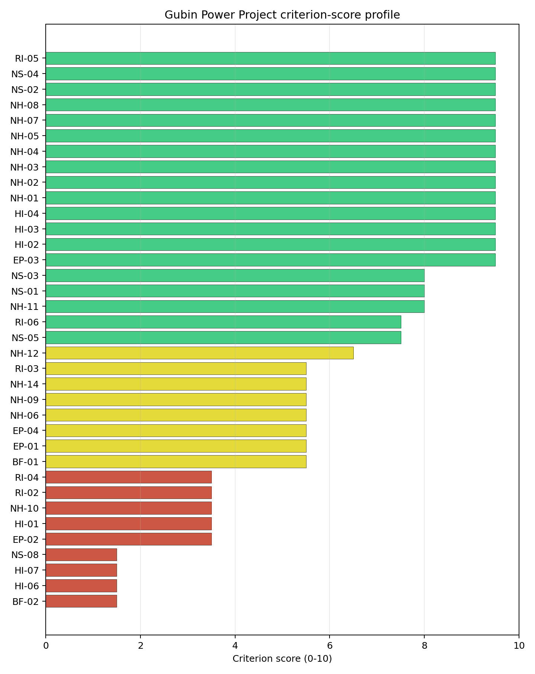
Criterion scores
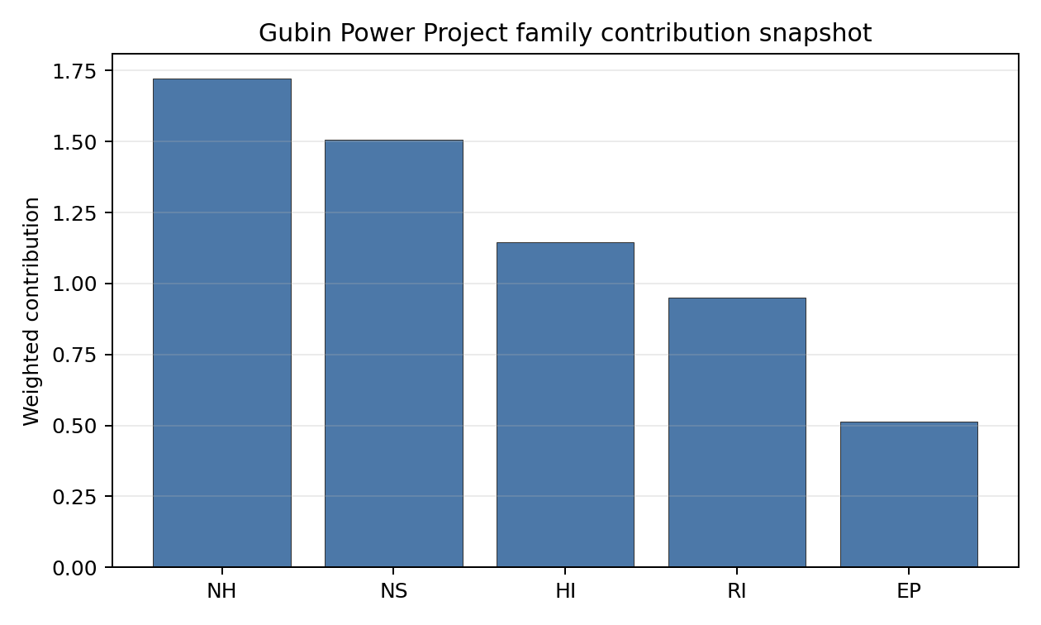
Family contributions
Gubin’s baseline composite score is 7.222, with a Monte Carlo bracket of 6.412-7.803. Its national stability band is B with a 92% top-10 hit rate in the project’s 50,000-iteration national sensitivity analysis, so the site is robust under most weight perturbations despite being avoidance-flagged. The composite is supported by very low seismic hazard, strong grid connection, cooling proximity, transport access, and distance to major population centres. The residual uncertainty is concentrated in HI-01, BF-02/NS-05 land evidence, NS-08 ecology, EP-02 evacuation routes, and HI-07 EMI. Stage 3 should treat Gubin as a high-ranking characterisation candidate only if the airfield, land, and ecological constraints are tested in the first work package.

Residual Risk Register
Concern | Evidence | Consequence | Stage 3 action | Owner discipline
Aircraft Crash (HI-01) | Lotnisko Sportowe Gubin is 4.77 km away; flight-path proxy is 2.38 km away | The avoidance flag may constrain or preclude parts of the site envelope | Model airfield operations, flight paths, and aircraft-crash frequency | security
Site Footprint Adequacy (NS-05) | Canonical site area is 38.8 ha; development-area estimate is 0.1 ha; low data quality | Usable land may be insufficient without a wider parcel strategy | Re-survey parcels, constraints, contiguity, and ownership | ownership/legal
Ecological Sensitivity (NS-08) | Oder-Neiße Ergänzung is 0.554 km away; three Natura 2000 sites lie within 5 km | Permitting and siting corridor could narrow materially | Confirm receptor pathways and Article 6(3) requirements | EIA
Evacuation Routes (EP-02) | Road density is 0.42 km/km2; road length is 825.2 km; motorway access is present | EPZ clearance may be sensitive to local routing assumptions | Model evacuation clearance and cross-border road constraints | emergency planning
Electromagnetic Interference (HI-07) | Nearest transmitter is 1.27 km away; 101 transmitters are within the search radius | RF environment may affect controls and layout | Survey transmitter inventory and field strengths | security
Gubin’s score is strong, but the risk register is front-loaded. Airfield, land, ecological, and evacuation questions must be resolved before the site can move from high-ranking screening candidate to a credible detailed-characterisation case.

Stage 3 Follow-Up Checklist
- Model Aircraft Crash (HI-01) for Lotnisko Sportowe Gubin at 4.77 km and the 2.38 km flight-path proxy.
- Confirm Site Footprint Adequacy (NS-05) using parcel, ownership, constraint, and contiguity evidence for the 0.1 ha development-area estimate.
- Screen Ecological Sensitivity (NS-08) for Oder-Neiße Ergänzung 0.554 km away and the three Natura 2000 sites within 5 km.
- Model Evacuation Routes (EP-02) for the 0.42 km/km2 road-density screen and cross-border routing assumptions.
- Survey Electromagnetic Interference (HI-07) for the transmitter 1.27 km away and 101-transmitter inventory.

Evidence Limitations
- Geotechnical: Subsidence & Collapse (NH-05b) - quality low.
- Site Footprint Adequacy (NS-05) - quality low.

Kedzierzyn CCS Project Site Profile
Kedzierzyn CCS Project is a coal/thermal site in Poland that has been tested against the NuScale VOYGR-6 reference deployment envelope. This profile reads the screening evidence at a level that supports a decision to progress toward Stage 3 characterisation. It is not a site-suitability determination, vendor recommendation, or licensing finding.

Site Snapshot
Field | Value
Site name | Kedzierzyn CCS Project
Coordinates | 50.3499, 18.2262
Subnational unit | Opolskie
Installed thermal capacity (source data) | 910 MW
Available surface area | 7.7 ha
Available surface area for development | 5.3 ha
Composite score (baseline weights) | 7.191 (6.386-7.737 MC band)
National stability band | C (top-10% hit rate 75%)
National rank | 5
See the country status map in Poland Country Profile.

Ownership and Coal-to-Nuclear Context
- KGHM Polska Miedź SA (share not reported), headquartered in Poland; immediate operator ZAK-PKE Consortium. Path: KGHM Polska Miedź SA -> TAURON Polska Energia SA [10.39%] -> TAURON Wytwarzanie SA [100.0%] -> ZAK-PKE Consortium [unknown %] -> Kedzierzyn CCS Project – [100.0%]
- Government of Poland (share not reported), headquartered in Poland; immediate operator ZAK-PKE Consortium. Path: Government of Poland -> TAURON Polska Energia SA [30.06%] -> TAURON Wytwarzanie SA [100.0%] -> ZAK-PKE Consortium [unknown %] -> Kedzierzyn CCS Project – [100.0%]
- TAURON Polska Energia SA (share not reported), headquartered in Poland; immediate operator ZAK-PKE Consortium. Path: TAURON Polska Energia SA -> TAURON Wytwarzanie SA [100.0%] -> ZAK-PKE Consortium [unknown %] -> Kedzierzyn CCS Project – [100.0%]
- unknown (share not reported); immediate operator ZAK-PKE Consortium. Path: unknown -> KGHM Polska Miedź SA [58.14%] -> TAURON Polska Energia SA [10.39%] -> TAURON Wytwarzanie SA [100.0%] -> ZAK-PKE Consortium [unknown %] -> Kedzierzyn CCS Project – [100.0%]
- Aviva Powszechne Towarzystwo Emerytalne Aviva Santander SA (share not reported), headquartered in Poland; immediate operator ZAK-PKE Consortium. Path: Aviva Powszechne Towarzystwo Emerytalne Aviva Santander SA -> KGHM Polska Miedź SA [5.02%] -> TAURON Polska Energia SA [10.39%] -> TAURON Wytwarzanie SA [100.0%] -> ZAK-PKE Consortium [unknown %] -> Kedzierzyn CCS Project – [100.0%]
- Nationale-Nederlanden Open Pension Fund (share not reported), headquartered in Poland; immediate operator ZAK-PKE Consortium. Path: Nationale-Nederlanden Open Pension Fund -> KGHM Polska Miedź SA [5.05%] -> TAURON Polska Energia SA [10.39%] -> TAURON Wytwarzanie SA [100.0%] -> ZAK-PKE Consortium [unknown %] -> Kedzierzyn CCS Project – [100.0%]
- Zakłady Azotowe Kędzierzyn (share not reported); immediate operator ZAK-PKE Consortium. Path: Zakłady Azotowe Kędzierzyn -> ZAK-PKE Consortium [unknown %] -> Kedzierzyn CCS Project – [100.0%]
Generating units on record: 1 cancelled. Earliest unit commissioning: 2011; most recent: 2011.

Natural Hazards (NH)
- Seismic: Ground Motion (NH-01) - score 9.5/10 (MC 9.0-10.0) - favourable: Well below the risk boundary., weight 0.0455, data quality high. Evidence: PGA at 475-year return period 0.03 g; PGA at 2,475-year return period 0.082 g; Vs30 reference (m/s): 760.0.
- Seismic: Surface Rupture (NH-02) - score 9.5/10 (MC 9.0-10.0) - favourable: Very strong separation from mapped capable faults; surface-rupture concern effectively screened at desk-study level., weight n/a, data quality screening grade. Evidence: nearest mapped capable fault 50.0 km; fault slip rate 0 mm/yr; fault name: none_in_search_radius.
- Geotechnical: Liquefaction (NH-03) - score 5.5/10 (MC 5.0-6.0) - pass-mark band: Moderate susceptibility, or high/very-high with documented (or pending for high) mitigation., weight n/a, data quality medium. Evidence: liquefaction susceptibility: high; dominant soil type: loam.
- Geotechnical: Slope Stability (NH-04) - score 7.5/10 (MC 7.0-8.0), weight n/a, data quality screening grade. Evidence: site slope 9.63 deg; max slope in 1 km box 81.7 deg; slope stability class: moderate.
- Geotechnical: Subsidence (NH-05) - score 9.5/10 (MC 9.0-10.0) - favourable: No karst; mine-feature distance well above the score-5 pivot (or unknown)., weight 0.0354, data quality medium. Evidence: karst present: no; karst severity: none.
- Geotechnical: Foundation (NH-06) - score 5.5/10 (MC 5.0-6.0) - pass-mark band: Typical European mixed conditions (bearing 80-150 kPa)., weight 0.0253, data quality medium. Evidence: bearing capacity 82.7 kPa; depth to bedrock 18.9 m.
- Volcanism (NH-07) - score 9.5/10 (MC 9.0-10.0) - favourable: Very strong margin above the score-5 boundary (or screening evidence confirms no in-radius signal)., weight n/a, data quality high. Evidence: volcanic hazard class: negligible.
- Coastal Flooding (NH-08) - score 9.5/10 (MC 9.0-10.0) - favourable: Non-coastal OR elevation >= 50 m AMSL OR landlocked country, with no positive marine-hazard signal., weight 0.0303, data quality medium. Evidence: distance to coast 443.2 km.
- River Flooding (NH-09) - score 7.5/10 (MC 5.5-9.5), weight 0.0404, data quality insufficient. Evidence: flood zone class: negligible.
- Extreme Winds (NH-10) - score 5.5/10 (MC 5.0-6.0) - pass-mark band: Middle relative wind exposure around the observed cohort mean (9.0-10.5 m/s)., weight 0.0152, data quality medium. Evidence: screening wind-speed index 9.55 m/s.
- Extreme Precipitation (NH-11) - score 8.0/10 (MC 7.0-8.0) - favourable: aggregated(mean_of_sub_scores), weight 0.0152, data quality medium. Evidence: screening extreme-precipitation index 0.35 mm; screening precipitation index 24.5 mm/yr.
- Extreme Temperatures (NH-12) - score 6.5/10 (MC 6.0-7.0) - pass-mark band: aggregated(mean_of_sub_scores), weight 0.0202, data quality medium. Evidence: extreme high temperature 23.3 deg C; extreme low temperature -6.96 deg C.
- Combined Hazards (NH-14) - score 5.5/10 (MC 5.0-6.0) - pass-mark band: At least 5 resolved, exactly one moderate hazard (3-5) or moderate interaction only., weight 0.0152, data quality n/a. Evidence: values not in measurement tables.

Interpretation - Natural Hazards (NH)
Natural hazards at Kedzierzyn are favourable at screening level, with local geotechnical and flood confirmation still required. Ground motion is low, with PGA of 0.03 g at the 475-year return period and 0.082 g at the 2,475-year return period, and no mapped capable fault is recorded within 50.0 km. Liquefaction susceptibility is high on loam, site slope is 9.63 degrees, and bearing capacity is 82.7 kPa over 18.9 m to bedrock. Karst is absent, coastal distance is 443.2 km, and the river-flood class is negligible, but River Flooding (NH-09) still has insufficient data quality. Extreme Precipitation (NH-11) is favourable in the current run, with 0.35 mm screening extreme-precipitation index and 24.5 mm/year screening precipitation index. Stage 3 should prioritize liquefaction, foundation, slope, flood, and drainage confirmation.

Human-Induced and Security-Relevant Hazards (HI)
- Aircraft Crash (HI-01) - score 9.5/10 (MC 9.0-10.0) - favourable: Only small / GA / heliport airport >= 10 km nearby, no flight-path proxy < 4 km, no major airport within 30 km, and no military airbase within 60 km., weight 0.0354, data quality high. Evidence: nearest airport 15.8 km; nearest flight path 7.93 km; airports within search radius 3; airport name: Kuźnia Raciborska Firefighting Airstrip; airport type: small airfield.
- Industrial Explosions (HI-02) - score 9.5/10 (MC 9.0-10.0) - favourable: Very strong margin above the score-5 boundary (or completed search confirmed no in-radius signal)., weight 0.0354, data quality medium. Evidence: values not in measurement tables.
- Toxic/Gas Releases (HI-03) - score 9.5/10 (MC 9.0-10.0) - favourable: Very strong margin above the score-5 boundary (or completed search confirmed no in-radius signal)., weight 0.0354, data quality medium. Evidence: values not in measurement tables.
- External Fires (HI-04) - score 9.5/10 (MC 9.0-10.0) - favourable: > 15 km, or completed flammable-storage search found nothing in radius., weight 0.0303, data quality medium. Evidence: values not in measurement tables.
- Military Installations (HI-06) - score 0.0/10 (MC 0.0-0.0), weight 0.0303, data quality high. Evidence: nearest military installation 3.1 km; military installations within radius 31; installation name: unnamed.
- Electromagnetic Interference (HI-07) - score 1.5/10 (MC 1.0-2.0), weight 0.0101, data quality medium. Evidence: nearest high-power transmitter 0.1 km; transmitters within radius 165; transmitter type: mast.

Interpretation - Human-Induced and Security-Relevant Hazards (HI)
Human-induced hazards at Kedzierzyn are dominated by military and EMI constraints, not by aircraft or industrial-source distance. Aircraft Crash (HI-01) scores 9.5/10: the nearest airport is 15.8 km away, the nearest flight-path proxy is 7.93 km away, and three airports are recorded within the search radius. Industrial Explosions (HI-02), Toxic/Gas Releases (HI-03), and External Fires (HI-04) are favourable on the current record. The binding issue is Military Installations (HI-06), which scores 0.0/10 because the nearest military feature is 3.1 km away and 31 features are recorded within 25 km. Electromagnetic Interference (HI-07) also scores 1.5/10, with a mast 0.1 km away and 165 transmitters in the search radius. Stage 3 should begin with defence-authority classification and an EMI field survey.

Radiological Impact and Emergency Planning (RI / EP)
- Emergency Planning Feasibility (EP-01) - score 5.5/10 (MC 5.0-6.0) - pass-mark band: At or above the composite score-5 boundary., weight n/a, data quality high. Evidence: EP feasibility composite 61.0 /100; road sub-score 62.0 /100; special-population sub-score 90.0 /100; geography sub-score 95.0 /100; population sub-score 60.0 /100; evacuation feasible: yes.
- Evacuation Routes (EP-02) - score 5.5/10 (MC 5.0-6.0) - pass-mark band: Adequate primary routes (0.5-1.0)., weight 0.0303, data quality medium. Evidence: road density in EPZ 0.667 km/km2; road length in EPZ 1,309 km; motorway access: yes.
- Physical Geography Constraints (EP-03) - score 9.5/10 (MC 9.0-10.0) - favourable: No measured relief; open river/waterway context (interim screening)., weight 0.0253, data quality medium. Evidence: waterways crossing EPZ 0; major river barrier: no.
- Special Populations (EP-04) - score 5.5/10 (MC 5.0-6.0) - pass-mark band: 9-25., weight 0.0303, data quality medium. Evidence: hospitals in EPZ 14; prisons in EPZ 3; care homes in EPZ 1.
- Atmospheric Dispersion (RI-01) - score no native score (unscored - no band matched), weight 0.0303, data quality medium. Evidence: annual mean wind speed 1.41 m/s; atmospheric mixing height 543.7 m; prevailing wind direction: SSW.
- Surface Water Dispersion (RI-02) - score 5.5/10 (MC 5.0-6.0) - pass-mark band: 30-100 m3/s., weight 0.0253, data quality n/a. Evidence: values not in measurement tables.
- Groundwater Dispersion (RI-03) - score 7.5/10 (MC 7.0-8.0), weight 0.0253, data quality medium. Evidence: aquifer type: low permeability.
- Population Density at EPZ Radii (RI-04) - score 1.5/10 (MC 1.0-2.0), weight 0.0404, data quality screening grade. Evidence: population density within 5 km 537.7 /km2; population density within 16 km 146.7 /km2; population density within 25 km 120.7 /km2; population density within 80 km 273.8 /km2; population within 25 km 236,899 people.
- Distance to Population Centres (RI-05) - score 9.5/10 (MC 9.0-10.0) - favourable: Nearest >=50k population-centre proxy exceeds required distance by >= 50 %., weight 0.0505, data quality screening grade. Evidence: nearest city above 50k people 30.9 km; nearest city population 169,915 people; city name: Gliwice.
- Population Projections (RI-06) - score 9.5/10 (MC 9.0-10.0) - favourable: Declining (< -0.5 %/yr)., weight 0.0253, data quality screening grade. Evidence: annual population growth rate -0.663 %/yr; projected population at 25 km in 60 yr 186,170 people.

Interpretation - Radiological Impact and Emergency Planning (RI / EP)
Radiological and emergency-planning evidence at Kedzierzyn is mixed: emergency planning is workable, but local population density is a material screening weakness. EP-01 is 61.0/100 and marked evacuation feasible, with the strongest road score in the selected Poland group at 62.0/100, geography 95.0/100, and special populations 90.0/100. The EPZ contains 14 hospitals, three prisons, and one care home. Road density is 0.667 km/km2, and motorway access is present. Population Density at EPZ Radii (RI-04) is the main radiological weakness at 1.5/10, with 537.7 people/km2 within 5 km and 236,899 people within 25 km. Gliwice is 30.9 km away, and the projected 25 km population declines to 186,170 after 60 years. Stage 3 should refine population micro-modelling, emergency-planning zones, and site-specific dispersion before drawing stronger conclusions.

Non-Safety and Implementation Considerations (NS)
- Grid Capacity Basic Filter (BF-01) - score 5.5/10 (MC 5.0-6.0) - pass-mark band: Note: substation 15-30 km OR 110-219 kV; reinforcement plausible., weight n/a, data quality n/a. Evidence: values not in measurement tables.
- Land Area Basic Filter (BF-02) - score 1.5/10 (MC 1.0-2.0), weight 0.0253, data quality n/a. Evidence: values not in measurement tables.
- Cooling Water Availability (NS-01) - score 7.0/10 (MC 6.0-8.0), weight 0.0404, data quality screening grade. Evidence: distance to cooling source 4.71 km; cooling source flow 66.5 m3/s; cooling source type: river; cooling source name: Kłodnica; water stress label: Low-Medium.
- Grid Connection (NS-02) - score 5.5/10 (MC 5.0-6.0) - pass-mark band: aggregated(min_of_sub_scores), weight 0.0404, data quality high. Evidence: nearest substation 0.1 km; nearest high-voltage line 0.11 km; highest nearby line voltage 110.0 kV; grid export capacity 910.0 MW; substations within radius 2,249; HV lines within radius 1,176.
- Transport Access (NS-03) - score 9.0/10 (MC 8.0-9.0) - favourable: aggregated(weighted_mean_of_sub_scores), weight 0.0404, data quality high. Evidence: nearest highway 0.58 km; nearest rail line 1.31 km; nearest waterway 0.74 km; heavy-haul capable: yes.
- Site Topography (NS-04) - score 5.5/10 (MC 5.0-6.0) - pass-mark band: 40-60 %., weight 0.0303, data quality screening grade. Evidence: favourable land cover 45.0 %; moderate land cover 8.8 %; unfavourable land cover 46.2 %; favourable area 7.65 ha; dominant land class: 312.
- Site Footprint Adequacy (NS-05) - score 3.5/10 (MC 3.0-4.0), weight 0.0253, data quality medium. Evidence: buildable area 5.34 ha; largest contiguous patch 5.34 ha; buildable patch count 4.
- Existing Infrastructure (NS-06) - score no native score (unscored - no band matched), weight 0.0253, data quality n/a. Evidence: not measured at this site (criterion remains unscored).
- Ecological Sensitivity (NS-08) - score 5.5/10 (MC 5.0-6.0) - pass-mark band: Both networks NULL or >= 5 km., weight n/a, data quality high. Evidence: natural land cover 46.2 %; distance to nearest Natura 2000 site 7.701 km; distance to nearest protected area 7.693 km; Natura 2000 overlap: no; Natura 2000 sensitivity class: low; protected-area overlap: no; protected-area sensitivity class: low; nearest Natura 2000 site: Góra Świętej Anny; Natura 2000 sites within 5 km: 0; nearest protected-area designation: Landscape Park.
- Workforce Availability (NS-10) - score no native score (unscored - no band matched), weight 0.0202, data quality n/a. Evidence: not measured at this site (criterion remains unscored).
- Regulatory/Political Environment (NS-12) - score no native score (unscored - no band matched), weight 0.0303, data quality n/a. Evidence: not measured at this site (criterion remains unscored).
- Construction Logistics (NS-13) - score no native score (unscored - no band matched), weight 0.0202, data quality n/a. Evidence: not measured at this site (criterion remains unscored).

Interpretation - Non-Safety and Implementation Considerations (NS)
Kedzierzyn’s industrial brownfield setting gives strong logistics and moderate cooling evidence, but the site footprint is tight. Cooling water is from the Kłodnica 4.71 km away, with 66.5 m3/s flow and a Low-Medium water-stress label. Grid Connection (NS-02) is close but voltage-limited in the screening data: the nearest substation is 0.1 km away, the nearest high-voltage line is 0.11 km away, the highest nearby voltage is 110.0 kV, and export capacity is 910.0 MW. Transport access is strong, with highway 0.58 km away, rail 1.31 km away, waterway 0.74 km away, and heavy-haul capability recorded. The site area is the limiting factor: canonical surface area is 7.7 ha, development area is 5.3 ha, and Site Footprint Adequacy (NS-05) scores 3.5/10. Stage 3 should test whether a viable NuScale VOYGR-6 envelope can be accommodated or whether the candidate requires a broader adjoining land strategy.

Composite Score and Stability
Baseline composite score is 7.191, bracketed by Monte Carlo at 6.386-7.737. National stability band is C with a top-10% hit rate of 75% in the project’s 50,000-iteration national sensitivity analysis.
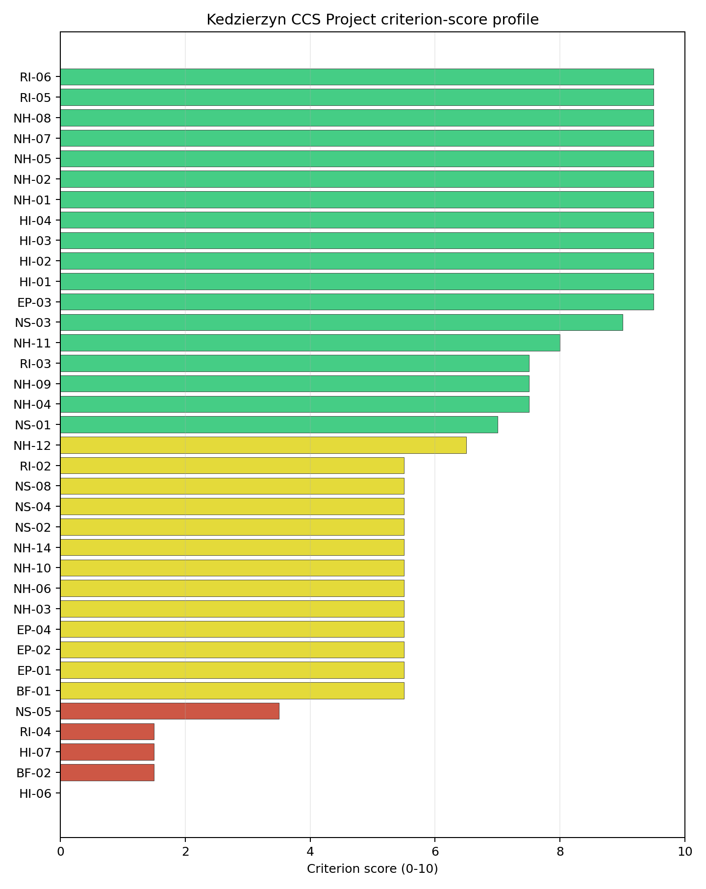
Criterion scores
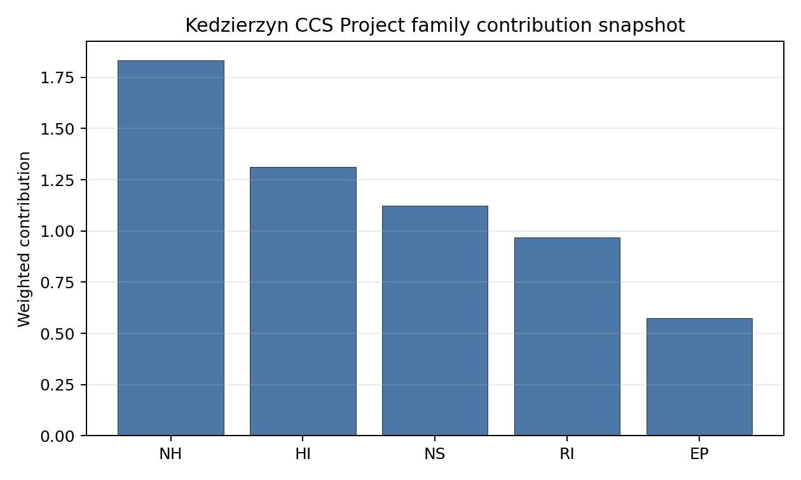
Family contributions
Kedzierzyn’s baseline composite score is 7.191, with a Monte Carlo bracket of 6.386-7.737. Its national stability band is C with a 75% top-10 hit rate in the project’s 50,000-iteration national sensitivity analysis, making it less robust than the band-A and band-B leaders but still inside the selected top-five tranche. The score benefits from low seismic hazard, strong transport access, favourable distance to larger population centres, and useful cooling-water proximity. The ranking is most exposed to the compact site footprint, HI-06, HI-07, RI-04, and voltage-pathway uncertainty. Stage 3 should treat Kedzierzyn as a high-scoring industrial-site candidate that needs an early land-envelope decision before deeper characterisation spend is committed.

Residual Risk Register
Concern | Evidence | Consequence | Stage 3 action | Owner discipline
Site Footprint Adequacy (NS-05) | Canonical surface area is 7.7 ha; development-area estimate is 5.3 ha | The reference deployment envelope may not fit without adjoining land | Confirm parcel boundaries, contiguity, and expansion options | ownership/legal
Military Installations (HI-06) | Nearest feature is 3.1 km away; 31 features are within 25 km | Security buffers could narrow the candidate envelope | Engage defence authorities and classify active features | security
Electromagnetic Interference (HI-07) | Nearest mast is 0.1 km away; 165 transmitters are within the search radius | RF environment may affect layout and instrumentation | Survey transmitter inventory and field strengths | security
Population Density at EPZ Radii (RI-04) | 537.7 people/km2 within 5 km; 236,899 people within 25 km | EPZ design and public-protection planning may become constraining | Model population distribution at project-specific EPZ radii | emergency planning
Grid Connection (NS-02) | Substation is 0.1 km away; highest nearby voltage is 110.0 kV; export capacity is 910.0 MW | Reinforcement may be needed for nuclear export requirements | Confirm 220 kV or 400 kV pathway and substation upgrade needs | grid
Kedzierzyn’s residual register is dominated by land and urban-industrial interface questions. Those issues do not negate the screening score, but they should be resolved before the site is treated as a straightforward Stage 3 candidate.

Stage 3 Follow-Up Checklist
- Confirm Site Footprint Adequacy (NS-05) for the 7.7 ha canonical surface area and 5.3 ha development-area estimate.
- Classify Military Installations (HI-06) for the feature 3.1 km away and the 31-feature search-radius inventory.
- Survey Electromagnetic Interference (HI-07) for the mast 0.1 km away and 165-transmitter inventory.
- Model Population Density at EPZ Radii (RI-04) for the 537.7 people/km2 density within 5 km.
- Confirm Grid Connection (NS-02) for the 110.0 kV voltage screen and higher-voltage export pathway.

Evidence Limitations
- Geotechnical: Subsidence & Collapse (NH-05b) - quality low.

Polaniec power station Site Profile
Polaniec power station is a coal/thermal site in Poland that has been tested against the NuScale VOYGR-6 reference deployment envelope. This profile reads the screening evidence at a level that supports a decision to progress toward Stage 3 characterisation. It is not a site-suitability determination, vendor recommendation, or licensing finding.

Site Snapshot
Field | Value
Site name | Polaniec power station
Coordinates | 50.4377, 21.3377
Subnational unit | Świętokrzyskie
Installed thermal capacity (source data) | 1,882 MW
Available surface area | 188.0 ha
Available surface area for development | 116.4 ha
Composite score (baseline weights) | 7.422 (6.573-7.956 MC band)
National stability band | A (top-10% hit rate 100%)
National rank | 1
See the country status map in Poland Country Profile.

Ownership and Coal-to-Nuclear Context
- ENEA SA (100.00% share), headquartered in Poland; immediate operator ENEA SA. Path: ENEA SA -> Polaniec power station Unit 8, timepoint 1 [100.0%]
- Ministry of State Treasury (Poland) (52.29% share), headquartered in Poland; immediate operator ENEA SA. Path: Ministry of State Treasury (Poland) -> ENEA SA [52.29%] -> Polaniec power station Unit 3 [100.0%]
Generating units on record: 7 operating, 1 retired. Earliest unit commissioning: 1979; most recent: 1983. Retirements span 2011 to 2011, leaving brownfield grid, water, transport, and workforce assets that materially shorten Stage 3 site preparation.

Natural Hazards (NH)
- Seismic: Ground Motion (NH-01) - score 9.5/10 (MC 9.0-10.0) - favourable: Well below the risk boundary., weight 0.0455, data quality high. Evidence: PGA at 475-year return period 0.023 g; PGA at 2,475-year return period 0.054 g; Vs30 reference (m/s): 760.0.
- Seismic: Surface Rupture (NH-02) - score 9.5/10 (MC 9.0-10.0) - favourable: Very strong separation from mapped capable faults; surface-rupture concern effectively screened at desk-study level., weight n/a, data quality screening grade. Evidence: nearest mapped capable fault 50.0 km; fault slip rate 0 mm/yr; fault name: none_in_search_radius.
- Geotechnical: Liquefaction (NH-03) - score 5.5/10 (MC 5.0-6.0) - pass-mark band: Moderate susceptibility, or high/very-high with documented (or pending for high) mitigation., weight n/a, data quality medium. Evidence: liquefaction susceptibility: moderate; dominant soil type: loam.
- Geotechnical: Slope Stability (NH-04) - score 9.5/10 (MC 9.0-10.0) - favourable: Well below the risk boundary., weight n/a, data quality screening grade. Evidence: site slope 2.54 deg; max slope in 1 km box 23.7 deg; slope stability class: gentle.
- Geotechnical: Subsidence (NH-05) - score 5.5/10 (MC 5.0-6.0) - pass-mark band: At or above the mine-distance score-5 pivot; review possible., weight 0.0354, data quality medium. Evidence: karst present: no; karst severity: moderate; formation type: carbonate (Discontinuous carbonate rocks).
- Geotechnical: Foundation (NH-06) - score 5.5/10 (MC 5.0-6.0) - pass-mark band: Typical European mixed conditions (bearing 80-150 kPa)., weight 0.0253, data quality medium. Evidence: bearing capacity 87.3 kPa; depth to bedrock 19.9 m.
- Volcanism (NH-07) - score 9.5/10 (MC 9.0-10.0) - favourable: Very strong margin above the score-5 boundary (or screening evidence confirms no in-radius signal)., weight n/a, data quality high. Evidence: volcanic hazard class: negligible.
- Coastal Flooding (NH-08) - score 9.5/10 (MC 9.0-10.0) - favourable: Non-coastal OR elevation >= 50 m AMSL OR landlocked country, with no positive marine-hazard signal., weight 0.0303, data quality medium. Evidence: distance to coast 458.5 km.
- River Flooding (NH-09) - score 7.5/10 (MC 5.5-9.5), weight 0.0404, data quality insufficient. Evidence: flood zone class: negligible.
- Extreme Winds (NH-10) - score 5.5/10 (MC 5.0-6.0) - pass-mark band: Middle relative wind exposure around the observed cohort mean (9.0-10.5 m/s)., weight 0.0152, data quality medium. Evidence: screening wind-speed index 9.75 m/s.
- Extreme Precipitation (NH-11) - score 8.0/10 (MC 8.0-9.0) - favourable: aggregated(mean_of_sub_scores), weight 0.0152, data quality medium. Evidence: screening extreme-precipitation index 0.25 mm; screening precipitation index 23.6 mm/yr.
- Extreme Temperatures (NH-12) - score 6.5/10 (MC 6.0-7.0) - pass-mark band: aggregated(mean_of_sub_scores), weight 0.0202, data quality medium. Evidence: extreme high temperature 23.2 deg C; extreme low temperature -7.76 deg C.
- Combined Hazards (NH-14) - score 5.5/10 (MC 5.0-6.0) - pass-mark band: At least 5 resolved, exactly one moderate hazard (3-5) or moderate interaction only., weight 0.0152, data quality n/a. Evidence: values not in measurement tables.

Interpretation - Natural Hazards (NH)
Natural hazards at Polaniec are favourable overall, with the screening burden concentrated in geotechnical and flood confirmation rather than in seismic or volcanic hazards. Ground motion is low, with PGA of 0.023 g at the 475-year return period and 0.054 g at the 2,475-year return period, and no mapped capable fault is recorded within 50.0 km. The site is gently sloped at 2.54 degrees, while liquefaction remains a moderate alluvial-soil question and foundation bearing capacity is 87.3 kPa over 19.9 m to bedrock. River Flooding (NH-09) scores 7.5/10 but still carries insufficient data quality, and Extreme Precipitation (NH-11) relies on screening values of 0.25 mm screening extreme-precipitation index and 23.6 mm/year screening precipitation index. Stage 3 should therefore confirm Vistula flood levels, run CPT/SPT geotechnical tests, and reconcile the precipitation proxy with local hydrological design data.

Human-Induced and Security-Relevant Hazards (HI)
- Aircraft Crash (HI-01) - score 3.5/10 (MC 3.0-4.0), weight 0.0354, data quality high. Evidence: nearest airport 8.02 km; nearest flight path 4.01 km; airports within search radius 3; airport name: Górki Airfield; airport type: small airfield.
- Industrial Explosions (HI-02) - score 9.5/10 (MC 9.0-10.0) - favourable: Very strong margin above the score-5 boundary (or completed search confirmed no in-radius signal)., weight 0.0354, data quality high. Evidence: nearest industrial site 23.0 km.
- Toxic/Gas Releases (HI-03) - score 7.5/10 (MC 7.0-8.0), weight 0.0354, data quality high. Evidence: nearest toxic source 23.0 km.
- External Fires (HI-04) - score 9.5/10 (MC 9.0-10.0) - favourable: > 15 km, or completed flammable-storage search found nothing in radius., weight 0.0303, data quality high. Evidence: values not in measurement tables.
- Military Installations (HI-06) - score 3.5/10 (MC 3.0-4.0), weight 0.0303, data quality medium. Evidence: nearest military installation 17.0 km; military installations within radius 4; installation name: unnamed.
- Electromagnetic Interference (HI-07) - score 1.5/10 (MC 1.0-2.0), weight 0.0101, data quality medium. Evidence: nearest high-power transmitter 0.45 km; transmitters within radius 101; transmitter type: lighting.

Interpretation - Human-Induced and Security-Relevant Hazards (HI)
Human-induced hazards are the main reason Polaniec is not a full-pass site. Aircraft Crash (HI-01) scores 3.5/10 because Górki Airfield is 8.02 km from the site and the nearest flight-path proxy is 4.01 km away; this is a concrete SSG-35 Stage 3 hazard-assessment item, not a finding of unsuitability. Military Installations (HI-06) sits at 3.5/10, with the nearest feature 17.0 km away and four installations within 25 km. Electromagnetic Interference (HI-07) is weaker, with the nearest high-power transmitter 0.45 km away and 101 transmitters in the search radius. The favourable offset is that industrial explosion and toxic-release proxies are both 23.0 km away. Stage 3 should begin with airfield and flight-path modelling, then confirm the transmitter inventory and military-feature classification.

Radiological Impact and Emergency Planning (RI / EP)
- Emergency Planning Feasibility (EP-01) - score 5.5/10 (MC 5.0-6.0) - pass-mark band: At or above the composite score-5 boundary., weight n/a, data quality high. Evidence: EP feasibility composite 54.6 /100; road sub-score 44.5 /100; special-population sub-score 10.0 /100; geography sub-score 95.0 /100; population sub-score 80.0 /100; evacuation feasible: yes.
- Evacuation Routes (EP-02) - score 5.5/10 (MC 5.0-6.0) - pass-mark band: Adequate primary routes (0.5-1.0)., weight 0.0303, data quality medium. Evidence: road density in EPZ 0.542 km/km2; road length in EPZ 1,064 km; motorway access: no.
- Physical Geography Constraints (EP-03) - score 9.5/10 (MC 9.0-10.0) - favourable: No measured relief; open river/waterway context (interim screening)., weight 0.0253, data quality medium. Evidence: waterways crossing EPZ 0; major river barrier: no.
- Special Populations (EP-04) - score 5.5/10 (MC 5.0-6.0) - pass-mark band: 9-25., weight 0.0303, data quality medium. Evidence: hospitals in EPZ 15; prisons in EPZ 1; care homes in EPZ 0.
- Atmospheric Dispersion (RI-01) - score no native score (unscored - no band matched), weight 0.0303, data quality medium. Evidence: annual mean wind speed 1.35 m/s; atmospheric mixing height 548.5 m; prevailing wind direction: WSW.
- Surface Water Dispersion (RI-02) - score 7.5/10 (MC 7.0-8.0), weight 0.0253, data quality n/a. Evidence: values not in measurement tables.
- Groundwater Dispersion (RI-03) - score 7.5/10 (MC 7.0-8.0), weight 0.0253, data quality medium. Evidence: aquifer type: low permeability.
- Population Density at EPZ Radii (RI-04) - score 5.5/10 (MC 5.0-6.0) - pass-mark band: aggregated(min_of_sub_scores), weight 0.0404, data quality screening grade. Evidence: population density within 5 km 155.2 /km2; population density within 16 km 89.2 /km2; population density within 25 km 117.3 /km2; population density within 80 km 138.7 /km2; population within 25 km 230,209 people.
- Distance to Population Centres (RI-05) - score 9.5/10 (MC 9.0-10.0) - favourable: Nearest >=50k population-centre proxy exceeds required distance by >= 50 %., weight 0.0505, data quality screening grade. Evidence: nearest city above 50k people 52.8 km; nearest city population 103,129 people; city name: Tarnów.
- Population Projections (RI-06) - score 7.5/10 (MC 7.0-8.0), weight 0.0253, data quality screening grade. Evidence: annual population growth rate -0.121 %/yr; projected population at 25 km in 60 yr 180,924 people.

Interpretation - Radiological Impact and Emergency Planning (RI / EP)
Radiological and emergency-planning indicators support further characterisation, with special-population and road-network details requiring early attention. Emergency Planning Feasibility (EP-01) is 54.6/100 and marked evacuation feasible; the road sub-score is 44.5/100, and the special-population sub-score is 10.0/100 because the EPZ contains 15 hospitals and one prison. Population density is moderate by the Polish pool: 155.2 people/km2 within 5 km, 117.3 people/km2 within 25 km, and 230,209 people within 25 km. The nearest city above 50,000 people is Tarnów at 52.8 km, and the 60-year projected 25 km population is 180,924 people. Stage 3 should model EPZ clearance times, confirm special-population evacuation arrangements, and install site meteorology for the 1.35 m/s annual mean wind-speed setting.

Non-Safety and Implementation Considerations (NS)
- Grid Capacity Basic Filter (BF-01) - score 9.5/10 (MC 9.0-10.0) - favourable: Note: substation <= 5 km, >= 400 kV, headroom >= 600 MW., weight n/a, data quality n/a. Evidence: values not in measurement tables.
- Land Area Basic Filter (BF-02) - score 9.5/10 (MC 9.0-10.0) - favourable: Contiguous and buildable >= ideal area (70 ha/module)., weight 0.0253, data quality n/a. Evidence: values not in measurement tables.
- Cooling Water Availability (NS-01) - score 9.0/10 (MC 8.0-9.0) - favourable: aggregated(weighted_mean_of_sub_scores), weight 0.0404, data quality screening grade. Evidence: distance to cooling source 0.29 km; cooling source flow 236.2 m3/s; cooling source type: major_river; cooling source name: Wisła; water stress label: Low-Medium.
- Grid Connection (NS-02) - score 9.5/10 (MC 9.0-10.0) - favourable: aggregated(min_of_sub_scores), weight 0.0404, data quality high. Evidence: nearest substation 0.69 km; nearest high-voltage line 0.17 km; highest nearby line voltage 400.0 kV; grid export capacity 1,558 MW; substations within radius 207; HV lines within radius 450.
- Transport Access (NS-03) - score 9.0/10 (MC 8.0-9.0) - favourable: aggregated(weighted_mean_of_sub_scores), weight 0.0404, data quality high. Evidence: nearest highway 1.27 km; nearest rail line 0.13 km; nearest waterway 12.8 km; heavy-haul capable: yes.
- Site Topography (NS-04) - score 5.5/10 (MC 5.0-6.0) - pass-mark band: 40-60 %., weight 0.0303, data quality screening grade. Evidence: favourable land cover 48.8 %; moderate land cover 22.3 %; unfavourable land cover 20.4 %; favourable area 114.4 ha; dominant land class: 211.
- Site Footprint Adequacy (NS-05) - score 9.5/10 (MC 9.0-10.0) - favourable: Very strong margin above the score-5 boundary., weight 0.0253, data quality high. Evidence: buildable area 116.4 ha; largest contiguous patch 116.4 ha; buildable patch count 19.
- Existing Infrastructure (NS-06) - score no native score (unscored - no band matched), weight 0.0253, data quality n/a. Evidence: not measured at this site (criterion remains unscored).
- Ecological Sensitivity (NS-08) - score 1.5/10 (MC 1.0-2.0), weight n/a, data quality high. Evidence: natural land cover 20.4 %; distance to nearest Natura 2000 site 2.353 km; distance to nearest protected area 1.782 km; Natura 2000 overlap: no; Natura 2000 sensitivity class: moderate; protected-area overlap: no; protected-area sensitivity class: low; nearest Natura 2000 site: Dolna Wisłoka z Dopływami; Natura 2000 sites within 5 km: 2; nearest protected-area designation: Nature Reserve.
- Workforce Availability (NS-10) - score no native score (unscored - no band matched), weight 0.0202, data quality n/a. Evidence: not measured at this site (criterion remains unscored).
- Regulatory/Political Environment (NS-12) - score no native score (unscored - no band matched), weight 0.0303, data quality n/a. Evidence: not measured at this site (criterion remains unscored).
- Construction Logistics (NS-13) - score no native score (unscored - no band matched), weight 0.0202, data quality n/a. Evidence: not measured at this site (criterion remains unscored).

Interpretation - Non-Safety and Implementation Considerations (NS)
Polaniec has one of Poland’s strongest brownfield infrastructure cases. Cooling Water Availability (NS-01) draws on the Wisła 0.29 km away, with 236.2 m3/s flow and a Low-Medium water-stress label. Grid Connection (NS-02) is also strong: the nearest substation is 0.69 km away, the nearest high-voltage line is 0.17 km away, the highest nearby voltage is 400.0 kV, and recorded grid export capacity is 1,558 MW. Transport access is strong, with rail 0.13 km away, highway 1.27 km away, and heavy-haul capability recorded. The land hierarchy is important: the canonical site surface area is 188.0 ha, while the development-area estimate is 116.4 ha and must not be treated as permitted or controlled nuclear land. Ecological Sensitivity (NS-08) is the main non-safety weakness, with Dolna Wisłoka z Dopływami 2.353 km away and two Natura 2000 sites within 5 km. Stage 3 should confirm land control, Article 6(3) screening, and the 400 kV export path.

Composite Score and Stability
Baseline composite score is 7.422, bracketed by Monte Carlo at 6.573-7.956. National stability band is A with a top-10% hit rate of 100% in the project’s 50,000-iteration national sensitivity analysis.
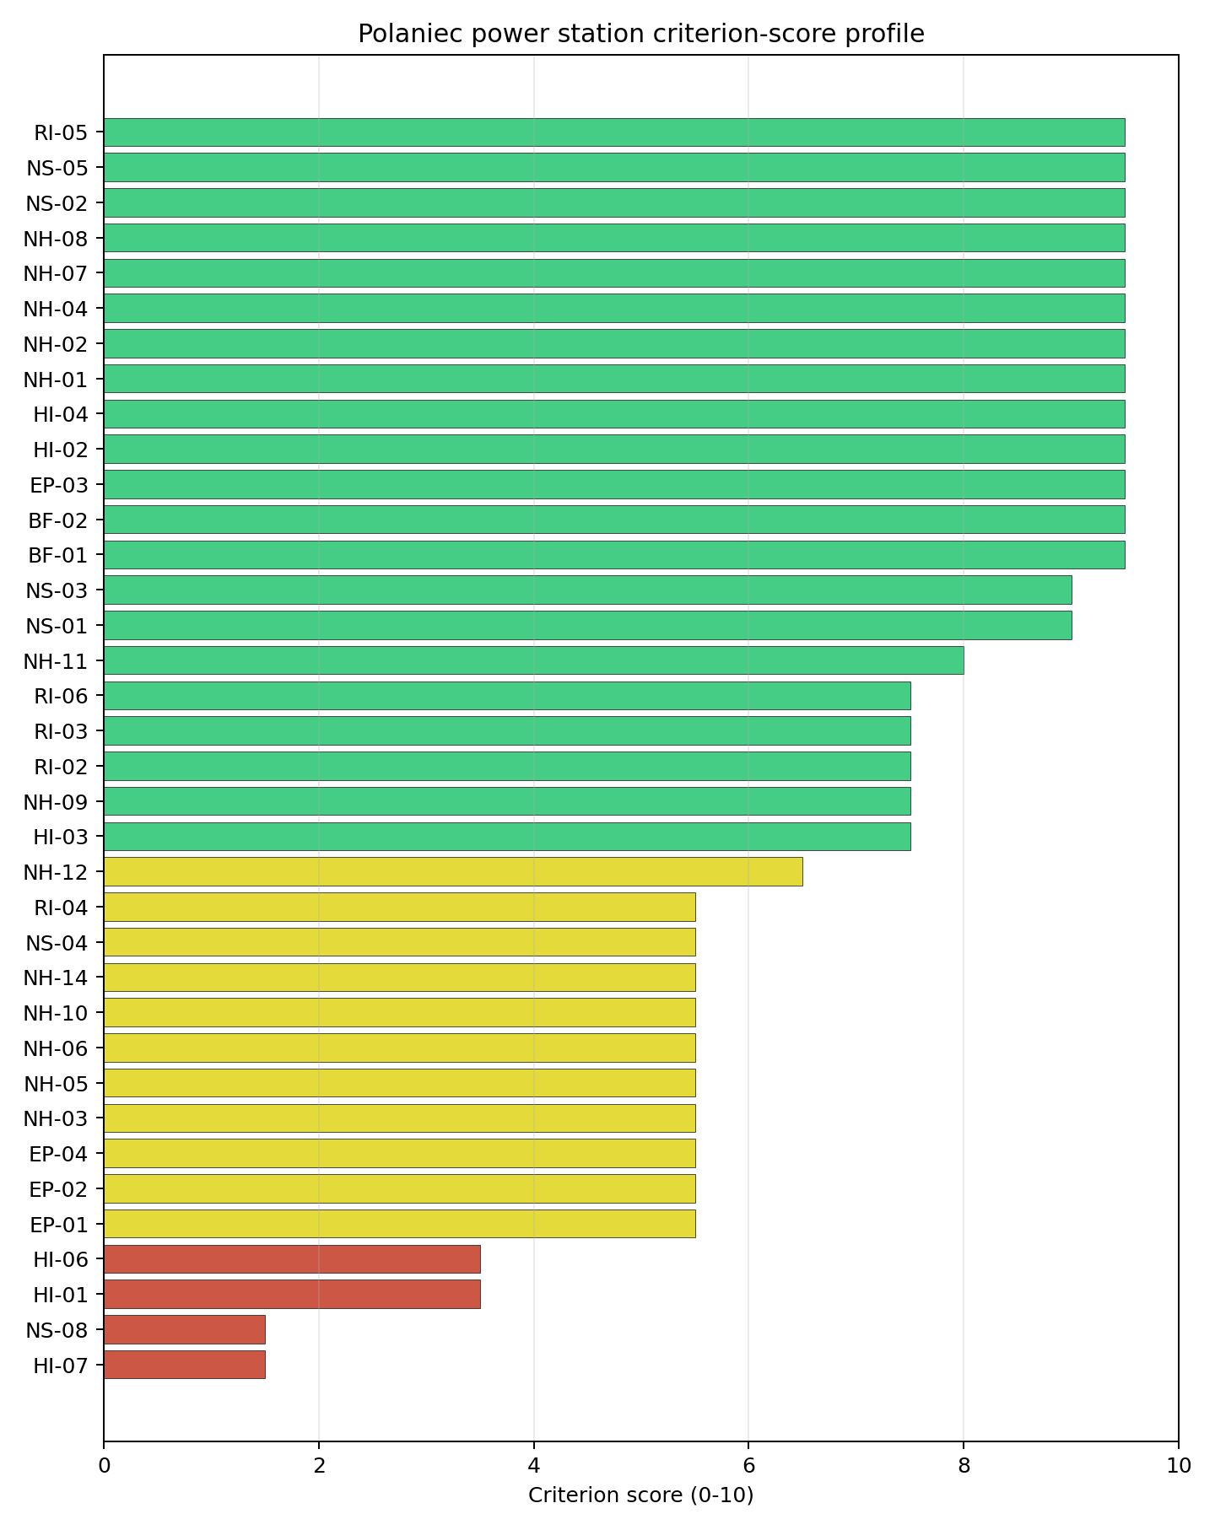
Criterion scores
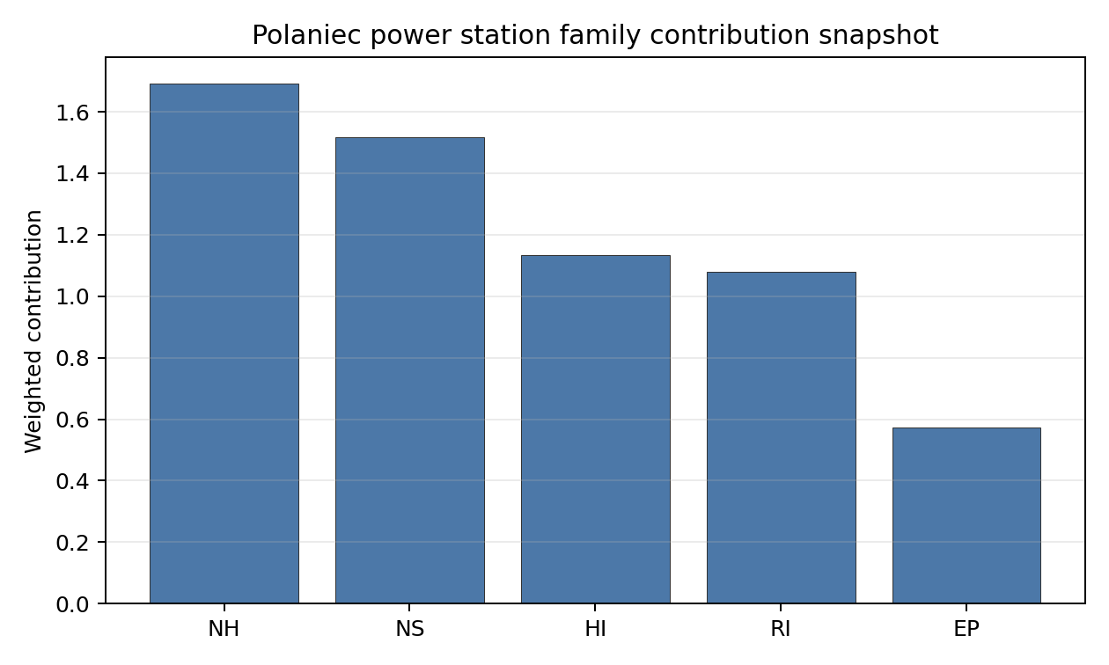
Family contributions
Polaniec’s baseline composite score is 7.422, with a Monte Carlo bracket of 6.573-7.956. Its national stability band is A with a 100% top-10 hit rate in the project’s 50,000-iteration national sensitivity analysis, so the national-leader result is robust to the weight perturbations considered. The score is driven by strong seismic, grid, cooling-water, transport, site-area, and distance-to-population-centre evidence, while the principal drag comes from HI-01, HI-07, NS-08, and HI-06. The Stage 3 sequencing implication is clear: Polaniec deserves early characterisation because it leads nationally, but the first work package must test the airfield and flight-path constraint before the site can be treated as equivalent to the full-pass group.

Residual Risk Register
Concern | Evidence | Consequence | Stage 3 action | Owner discipline
Aircraft Crash (HI-01) | Górki Airfield is 8.02 km away; nearest flight-path proxy is 4.01 km | The avoidance flag could constrain the usable siting envelope | Model airfield operations, flight paths, and aircraft-crash frequency | security
Electromagnetic Interference (HI-07) | Nearest transmitter is 0.45 km away; 101 transmitters are within the search radius | RF controls could affect layout and instrumentation assumptions | Survey transmitter inventory and field strengths | security
Ecological Sensitivity (NS-08) | Dolna Wisłoka z Dopływami is 2.353 km away; two Natura 2000 sites lie within 5 km | Permitting scope may expand if indirect pathways are identified | Confirm receptor pathways and Article 6(3) screening needs | EIA
Emergency Planning Special Populations (EP-04) | 15 hospitals and one prison are inside the EPZ | Evacuation planning could drive additional authority coordination | Engage regional emergency-planning authorities on facility-specific arrangements | emergency planning
River Flooding (NH-09) | Flood-zone class is negligible but data quality is insufficient | Design-basis flood confidence remains incomplete | Re-measure Vistula flood and drainage inputs | hydrology
The register is dominated by HI-01 because it is the standing avoidance flag on the national leader. The other entries are normal Stage 3 work items for a strong brownfield candidate and should be retired through field confirmation, agency engagement, and site-specific modelling.

Stage 3 Follow-Up Checklist
- Model Aircraft Crash (HI-01) for Górki Airfield at 8.02 km and the 4.01 km flight-path proxy.
- Survey Electromagnetic Interference (HI-07) for the transmitter 0.45 km away and the 101-transmitter search-radius inventory.
- Screen Ecological Sensitivity (NS-08) for Dolna Wisłoka z Dopływami 2.353 km away and the two Natura 2000 sites within 5 km.
- Confirm Military Installations (HI-06) feature classification for the nearest installation 17.0 km away.
- Re-measure River Flooding (NH-09) and drainage assumptions because flood evidence remains insufficient.

Evidence Limitations
- Geotechnical: Subsidence & Collapse (NH-05b) - quality low.

Pólnoc power station Site Profile
Pólnoc power station is a coal/thermal site in Poland that has been tested against the NuScale VOYGR-6 reference deployment envelope. This profile reads the screening evidence at a level that supports a decision to progress toward Stage 3 characterisation. It is not a site-suitability determination, vendor recommendation, or licensing finding.

Site Snapshot
Field | Value
Site name | Pólnoc power station
Coordinates | 53.9629, 18.7118
Subnational unit | Pomorskie
Installed thermal capacity (source data) | 1,600 MW
Available surface area | 209.8 ha
Available surface area for development | 5.5 ha
Composite score (baseline weights) | 7.284 (6.462-7.869 MC band)
National stability band | A (top-10% hit rate 100%)
National rank | 2
See the country status map in Poland Country Profile.

Ownership and Coal-to-Nuclear Context
- Allianz Polska Open Pension Fund (7.83% share), headquartered in Poland; immediate operator Polenergia SA. Path: Allianz Polska Open Pension Fund -> Polenergia SA [7.83%] -> Pólnoc power station Unit 1 [100.0%]
- Polenergia SA (100.00% share), headquartered in Poland; immediate operator Polenergia SA. Path: Polenergia SA -> Pólnoc power station Unit 1 [100.0%]
- BIF IV Europe Holdings Ltd (32.04% share), headquartered in United Kingdom; immediate operator Polenergia SA. Path: BIF IV Europe Holdings Ltd -> Polenergia SA [32.04%] -> Pólnoc power station Unit 1 [100.0%]
- Mansa Investments SP zoo (42.84% share), headquartered in Poland; immediate operator Polenergia SA. Path: Mansa Investments SP zoo -> Polenergia SA [42.84%] -> Pólnoc power station Unit 1 [100.0%]
- Nationale-Nederlanden Open Pension Fund (5.92% share), headquartered in Poland; immediate operator Polenergia SA. Path: Nationale-Nederlanden Open Pension Fund -> Polenergia SA [5.92%] -> Pólnoc power station Unit 2 [100.0%]
- Master Bif Iv Uk Holdings Ltd (share not reported), headquartered in United Kingdom; immediate operator Polenergia SA. Path: Master Bif Iv Uk Holdings Ltd -> BIF IV Europe Holdings Ltd [unknown %] -> Polenergia SA [32.04%] -> Pólnoc power station Unit 2 [100.0%]
Generating units on record: 2 cancelled.

Natural Hazards (NH)
- Seismic: Ground Motion (NH-01) - score 9.5/10 (MC 9.0-10.0) - favourable: Well below the risk boundary., weight 0.0455, data quality high. Evidence: PGA at 475-year return period 0.008 g; PGA at 2,475-year return period 0.025 g; Vs30 reference (m/s): 760.0.
- Seismic: Surface Rupture (NH-02) - score 9.5/10 (MC 9.0-10.0) - favourable: Very strong separation from mapped capable faults; surface-rupture concern effectively screened at desk-study level., weight n/a, data quality screening grade. Evidence: nearest mapped capable fault 50.0 km; fault slip rate 0 mm/yr; fault name: none_in_search_radius.
- Geotechnical: Liquefaction (NH-03) - score 9.5/10 (MC 9.0-10.0) - favourable: Negligible susceptibility (Stage-1 favourable default)., weight n/a, data quality medium. Evidence: liquefaction susceptibility: very_low; dominant soil type: sandy_loam.
- Geotechnical: Slope Stability (NH-04) - score 7.5/10 (MC 7.0-8.0), weight n/a, data quality screening grade. Evidence: site slope 6.52 deg; max slope in 1 km box 71.1 deg; slope stability class: moderate.
- Geotechnical: Subsidence (NH-05) - score 9.5/10 (MC 9.0-10.0) - favourable: No karst; mine-feature distance well above the score-5 pivot (or unknown)., weight 0.0354, data quality medium. Evidence: karst present: no; karst severity: none.
- Geotechnical: Foundation (NH-06) - score 5.5/10 (MC 5.0-6.0) - pass-mark band: Typical European mixed conditions (bearing 80-150 kPa)., weight 0.0253, data quality medium. Evidence: bearing capacity 106.0 kPa; depth to bedrock 20.2 m.
- Volcanism (NH-07) - score 9.5/10 (MC 9.0-10.0) - favourable: Very strong margin above the score-5 boundary (or screening evidence confirms no in-radius signal)., weight n/a, data quality high. Evidence: volcanic hazard class: negligible.
- Coastal Flooding (NH-08) - score 9.5/10 (MC 9.0-10.0) - favourable: Non-coastal OR elevation >= 50 m AMSL OR landlocked country, with no positive marine-hazard signal., weight 0.0303, data quality medium. Evidence: distance to coast 45.9 km.
- River Flooding (NH-09) - score 7.5/10 (MC 5.5-9.5), weight 0.0404, data quality insufficient. Evidence: flood zone class: negligible.
- Extreme Winds (NH-10) - score 3.5/10 (MC 3.0-4.0), weight 0.0152, data quality medium. Evidence: screening wind-speed index 11.4 m/s.
- Extreme Precipitation (NH-11) - score 8.0/10 (MC 8.0-9.0) - favourable: aggregated(mean_of_sub_scores), weight 0.0152, data quality medium. Evidence: screening extreme-precipitation index 0.2 mm; screening precipitation index 21.6 mm/yr.
- Extreme Temperatures (NH-12) - score 7.5/10 (MC 7.0-8.0), weight 0.0202, data quality medium. Evidence: extreme high temperature 21.4 deg C; extreme low temperature -7.65 deg C.
- Combined Hazards (NH-14) - score 5.5/10 (MC 5.0-6.0) - pass-mark band: At least 5 resolved, exactly one moderate hazard (3-5) or moderate interaction only., weight 0.0152, data quality n/a. Evidence: values not in measurement tables.

Interpretation - Natural Hazards (NH)
Natural hazards at Pólnoc are favourable for Stage 1-2 screening, with wind and river-flood confirmation the main priorities. Ground motion is very low, with PGA of 0.008 g at the 475-year return period and 0.025 g at the 2,475-year return period, and no mapped capable fault is recorded within 50.0 km. Liquefaction susceptibility is very low, karst is absent, and bearing capacity is 106.0 kPa with 20.2 m to bedrock. The site is 45.9 km from the coast, but Coastal Flooding (NH-08) is favourable in the bundle. Extreme Winds (NH-10) is the weak natural-hazard criterion at 3.5/10, with screening wind-speed index of 11.4 m/s, while River Flooding (NH-09) has insufficient data quality. Stage 3 should confirm design wind, drainage, and flood assumptions before layout work begins.

Human-Induced and Security-Relevant Hazards (HI)
- Aircraft Crash (HI-01) - score 7.5/10 (MC 7.0-8.0), weight 0.0354, data quality high. Evidence: nearest airport 14.7 km; nearest flight path 7.36 km; airports within search radius 5; airport name: Linowiec Airfield; airport type: small airfield.
- Industrial Explosions (HI-02) - score 9.5/10 (MC 9.0-10.0) - favourable: Very strong margin above the score-5 boundary (or completed search confirmed no in-radius signal)., weight 0.0354, data quality high. Evidence: nearest industrial site 18.5 km.
- Toxic/Gas Releases (HI-03) - score 7.5/10 (MC 7.0-8.0), weight 0.0354, data quality high. Evidence: nearest toxic source 18.5 km.
- External Fires (HI-04) - score 9.5/10 (MC 9.0-10.0) - favourable: > 15 km, or completed flammable-storage search found nothing in radius., weight 0.0303, data quality high. Evidence: values not in measurement tables.
- Military Installations (HI-06) - score 1.5/10 (MC 1.0-2.0), weight 0.0303, data quality medium. Evidence: nearest military installation 7.81 km; military installations within radius 22; installation name: Bateria artyleryjska Mały Garc.
- Electromagnetic Interference (HI-07) - score 1.5/10 (MC 1.0-2.0), weight 0.0101, data quality medium. Evidence: nearest high-power transmitter 0.56 km; transmitters within radius 111; transmitter type: communication.

Interpretation - Human-Induced and Security-Relevant Hazards (HI)
Human-induced hazards at Pólnoc are mixed: aircraft and industrial hazards are manageable, but military and EMI evidence require early confirmation. Aircraft Crash (HI-01) scores 7.5/10, with Linowiec Airfield 14.7 km away and the nearest flight-path proxy 7.36 km away. Industrial and toxic-source distances are both 18.5 km, supporting a favourable initial read. The main weakness is Military Installations (HI-06), which scores 1.5/10 because Bateria artyleryjska Mały Garc is 7.81 km away and 22 military features are recorded within 25 km. Electromagnetic Interference (HI-07) also scores 1.5/10, with a communication transmitter 0.56 km away and 111 transmitters within the search radius. Stage 3 should classify the military features, confirm airspace use, and complete an RF/EMI survey.

Radiological Impact and Emergency Planning (RI / EP)
- Emergency Planning Feasibility (EP-01) - score 7.5/10 (MC 7.0-8.0), weight n/a, data quality high. Evidence: EP feasibility composite 66.6 /100; road sub-score 56.3 /100; special-population sub-score 90.0 /100; geography sub-score 95.0 /100; population sub-score 80.0 /100; evacuation feasible: yes.
- Evacuation Routes (EP-02) - score 5.5/10 (MC 5.0-6.0) - pass-mark band: Adequate primary routes (0.5-1.0)., weight 0.0303, data quality medium. Evidence: road density in EPZ 0.572 km/km2; road length in EPZ 1,122 km; motorway access: yes.
- Physical Geography Constraints (EP-03) - score 9.5/10 (MC 9.0-10.0) - favourable: No measured relief; open river/waterway context (interim screening)., weight 0.0253, data quality medium. Evidence: waterways crossing EPZ 0; major river barrier: no.
- Special Populations (EP-04) - score 3.5/10 (MC 3.0-4.0), weight 0.0303, data quality medium. Evidence: hospitals in EPZ 32; prisons in EPZ 3; care homes in EPZ 2.
- Atmospheric Dispersion (RI-01) - score no native score (unscored - no band matched), weight 0.0303, data quality medium. Evidence: annual mean wind speed 1.8 m/s; atmospheric mixing height 565.1 m; prevailing wind direction: SW.
- Surface Water Dispersion (RI-02) - score 3.5/10 (MC 3.0-4.0), weight 0.0253, data quality n/a. Evidence: values not in measurement tables.
- Groundwater Dispersion (RI-03) - score 5.5/10 (MC 5.0-6.0) - pass-mark band: Moderate-permeability aquifer screening proxy., weight 0.0253, data quality medium. Evidence: aquifer type: alluvial.
- Population Density at EPZ Radii (RI-04) - score 5.5/10 (MC 5.0-6.0) - pass-mark band: aggregated(min_of_sub_scores), weight 0.0404, data quality screening grade. Evidence: population density within 5 km 149.0 /km2; population density within 16 km 204.2 /km2; population density within 25 km 155.1 /km2; population density within 80 km 122.8 /km2; population within 25 km 304,409 people.
- Distance to Population Centres (RI-05) - score 9.5/10 (MC 9.0-10.0) - favourable: Nearest >=50k population-centre proxy exceeds required distance by >= 50 %., weight 0.0505, data quality screening grade. Evidence: nearest city above 50k people 14.8 km; nearest city population 56,936 people; city name: Tczew.
- Population Projections (RI-06) - score 5.5/10 (MC 5.0-6.0) - pass-mark band: 0 % to +0.3 %., weight 0.0253, data quality screening grade. Evidence: annual population growth rate 0.217 %/yr; projected population at 25 km in 60 yr 239,231 people.

Interpretation - Radiological Impact and Emergency Planning (RI / EP)
Radiological and emergency-planning conditions support Pólnoc’s full-pass status, but the special-population count and positive population trajectory need careful treatment. EP-01 is 66.6/100 and marked evacuation feasible, with road score 56.3/100, geography 95.0/100, and population 80.0/100. The EPZ contains 32 hospitals, three prisons, and two care homes, which explains the 3.5/10 Special Populations (EP-04) score. Road density is 0.572 km/km2 and motorway access is present. Population density is 149.0 people/km2 within 5 km and 155.1 people/km2 within 25 km, with 304,409 people within 25 km. Tczew is 14.8 km away, and projected 25 km population is 239,231 people after 60 years. Stage 3 should test EPZ clearance, special-population movement, and dispersion assumptions for the 1.8 m/s wind setting.

Non-Safety and Implementation Considerations (NS)
- Grid Capacity Basic Filter (BF-01) - score 5.5/10 (MC 5.0-6.0) - pass-mark band: Note: substation 15-30 km OR 110-219 kV; reinforcement plausible., weight n/a, data quality n/a. Evidence: values not in measurement tables.
- Land Area Basic Filter (BF-02) - score 1.5/10 (MC 1.0-2.0), weight 0.0253, data quality n/a. Evidence: values not in measurement tables.
- Cooling Water Availability (NS-01) - score 8.0/10 (MC 7.0-8.0) - favourable: aggregated(weighted_mean_of_sub_scores), weight 0.0404, data quality screening grade. Evidence: distance to cooling source 2.4 km; cooling source flow 25.5 m3/s; cooling source type: river; cooling source name: Wierzyca; water stress label: Low.
- Grid Connection (NS-02) - score 5.5/10 (MC 5.0-6.0) - pass-mark band: aggregated(min_of_sub_scores), weight 0.0404, data quality high. Evidence: nearest substation 0.17 km; nearest high-voltage line 1.98 km; highest nearby line voltage 110.0 kV; grid export capacity 1,600 MW; substations within radius 691; HV lines within radius 590.
- Transport Access (NS-03) - score 7.0/10 (MC 7.0-8.0), weight 0.0404, data quality high. Evidence: nearest highway 3.49 km; nearest rail line 1.76 km; nearest waterway 18.3 km; heavy-haul capable: yes.
- Site Topography (NS-04) - score 9.5/10 (MC 9.0-10.0) - favourable: > 80 %., weight 0.0303, data quality screening grade. Evidence: favourable land cover 80.4 %; moderate land cover 7.3 %; unfavourable land cover 12.4 %; favourable area 209.8 ha; dominant land class: 211.
- Site Footprint Adequacy (NS-05) - score 9.5/10 (MC 9.0-10.0) - favourable: Very strong margin above the score-5 boundary., weight 0.0253, data quality medium. Evidence: buildable area 5.46 ha; largest contiguous patch 5.46 ha; buildable patch count 6.
- Existing Infrastructure (NS-06) - score no native score (unscored - no band matched), weight 0.0253, data quality n/a. Evidence: not measured at this site (criterion remains unscored).
- Ecological Sensitivity (NS-08) - score 3.5/10 (MC 3.0-4.0), weight n/a, data quality high. Evidence: natural land cover 12.4 %; distance to nearest Natura 2000 site 3.692 km; distance to nearest protected area 7.524 km; Natura 2000 overlap: no; Natura 2000 sensitivity class: low; protected-area overlap: no; protected-area sensitivity class: low; nearest Natura 2000 site: Waćmierz; Natura 2000 sites within 5 km: 1; nearest protected-area designation: Protected Landscape Area.
- Workforce Availability (NS-10) - score no native score (unscored - no band matched), weight 0.0202, data quality n/a. Evidence: not measured at this site (criterion remains unscored).
- Regulatory/Political Environment (NS-12) - score no native score (unscored - no band matched), weight 0.0303, data quality n/a. Evidence: not measured at this site (criterion remains unscored).
- Construction Logistics (NS-13) - score no native score (unscored - no band matched), weight 0.0202, data quality n/a. Evidence: not measured at this site (criterion remains unscored).

Interpretation - Non-Safety and Implementation Considerations (NS)
Pólnoc has strong surface-area and transport context but a narrow development-area indicator. The canonical site surface area is 209.8 ha, while the development-area estimate is only 5.5 ha; this must be treated as a screening-stage development envelope, not as proof of available nuclear land. Cooling water comes from the Wierzyca 2.4 km away, with 25.5 m3/s flow and a Low water-stress label. Grid evidence is plausible but not ideal: the nearest substation is 0.17 km away, the nearest high-voltage line is 1.98 km away, the highest nearby voltage is 110.0 kV, and export capacity is 1,600 MW. Transport access is credible, with highway 3.49 km away, rail 1.76 km away, and heavy-haul capability recorded. Stage 3 should confirm land contiguity and rights, the 110 kV-to-higher-voltage pathway, and whether the Wierzyca cooling envelope is adequate in dry-year conditions.

Composite Score and Stability
Baseline composite score is 7.284, bracketed by Monte Carlo at 6.462-7.869. National stability band is A with a top-10% hit rate of 100% in the project’s 50,000-iteration national sensitivity analysis.
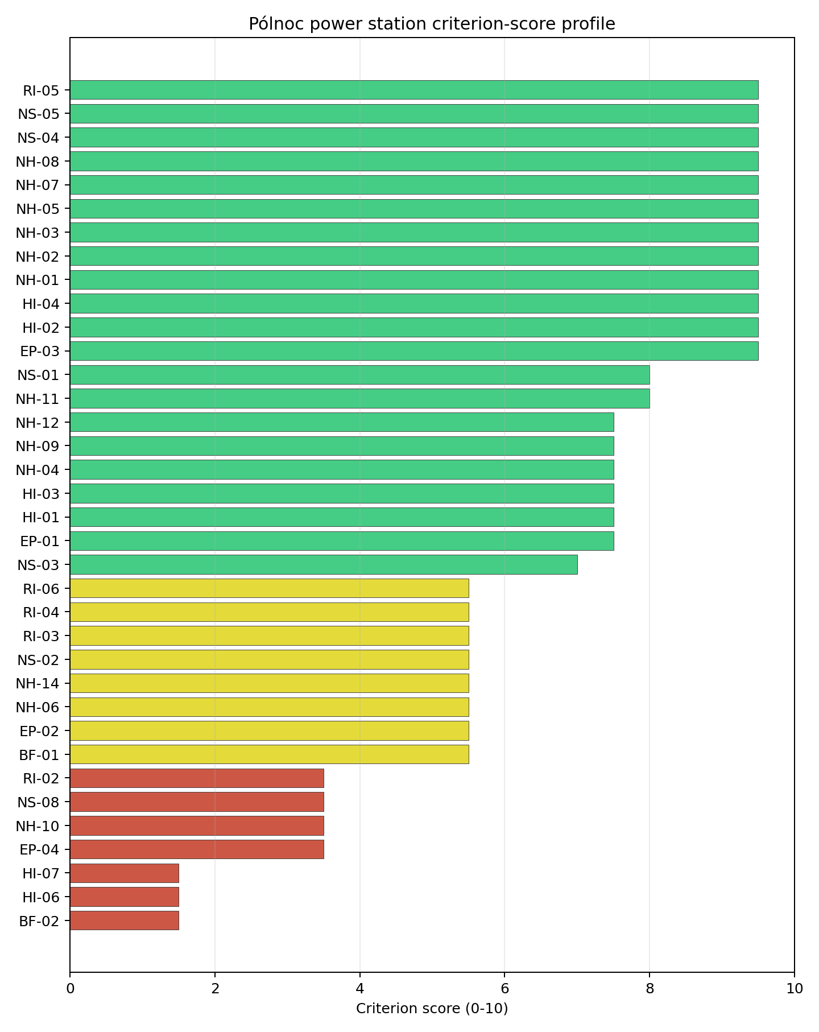
Criterion scores
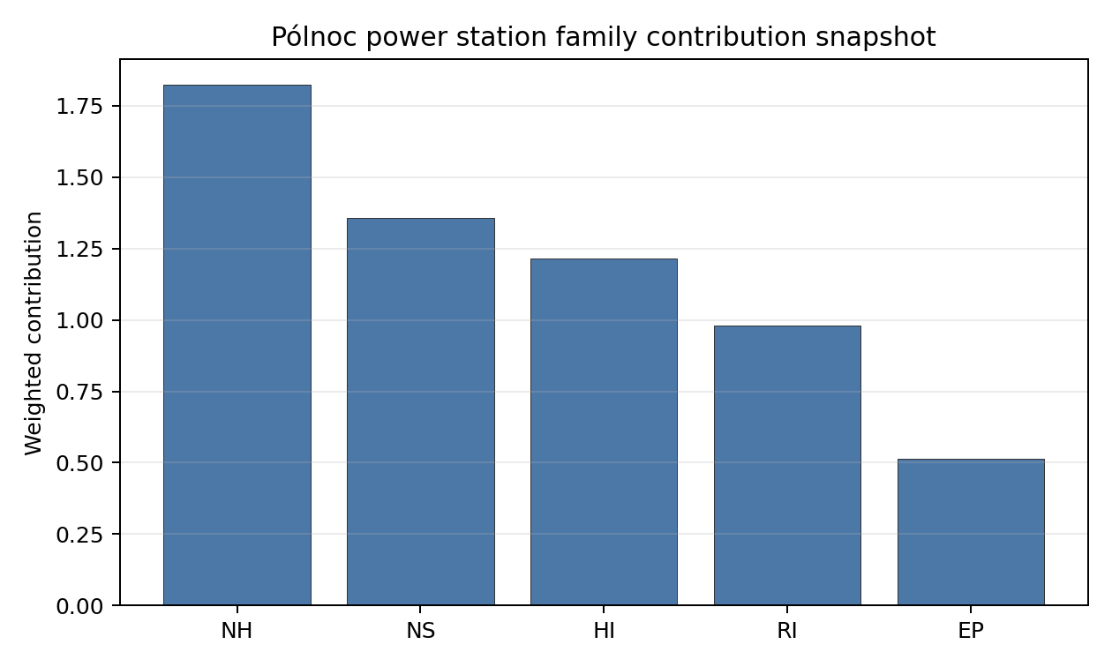
Family contributions
Pólnoc’s baseline composite score is 7.284, with a Monte Carlo bracket of 6.462-7.869. Its national stability band is A with a 100% top-10 hit rate in the project’s 50,000-iteration national sensitivity analysis, making it the strongest full-pass candidate in the Poland batch. The score is supported by very low seismic hazard, strong site topography, favourable cooling-water and transport evidence, and a full-pass screening class. The main uncertainty is not rank stability; it is whether the small development-area estimate, HI-06 military proximity, and EMI environment can be resolved into a usable project envelope. Stage 3 should therefore start with land and security confirmation while preserving Pólnoc as the first full-pass follower after Polaniec.

Residual Risk Register
Concern | Evidence | Consequence | Stage 3 action | Owner discipline
Land Area Basic Filter (BF-02) | Canonical site area is 209.8 ha; development-area estimate is 5.5 ha | The usable nuclear island and laydown envelope may be narrower than the site record implies | Confirm ownership, contiguity, constraints, and developable parcels | ownership/legal
Military Installations (HI-06) | Nearest feature is 7.81 km away; 22 features are within 25 km | Security consultation could change the screening class or required buffers | Engage defence authorities and classify each feature | security
Electromagnetic Interference (HI-07) | Nearest communication transmitter is 0.56 km away; 111 transmitters are within the search radius | RF environment may constrain instrumentation or layout | Survey transmitter inventory and field strengths | security
Special Populations (EP-04) | 32 hospitals, three prisons, and two care homes are inside the EPZ | Emergency-planning coordination burden may be material | Model assisted-evacuation arrangements | emergency planning
Extreme Winds (NH-10) | Screening wind-speed index is 11.4 m/s | Design-basis wind loading needs local confirmation | Re-measure site wind climate and extreme gust assumptions | hydrology
Pólnoc is a full-pass candidate, but its residual work is not trivial. Land, security, EMI, and special-population planning are the issues most likely to determine whether the site can move efficiently into detailed characterisation.

Stage 3 Follow-Up Checklist
- Confirm Land Area Basic Filter (BF-02) using parcel, ownership, constraint, and contiguity evidence for the 5.5 ha development-area estimate.
- Classify Military Installations (HI-06) for the feature 7.81 km away and the 22-feature search-radius inventory.
- Survey Electromagnetic Interference (HI-07) for the transmitter 0.56 km away and 111-transmitter inventory.
- Model Special Populations (EP-04) evacuation arrangements for 32 hospitals, three prisons, and two care homes inside the EPZ.
- Re-measure Extreme Winds (NH-10) for the 11.4 m/s design-wind screen.

Evidence Limitations
- Geotechnical: Subsidence & Collapse (NH-05b) - quality low.

Romania Country Profile
Romania has 23 thermal and coal-site records tested against the NuScale VOYGR-6 reference deployment envelope. Three sites pass both the exclusionary and avoidance screens, 19 pass the exclusionary screen but retain avoidance flags, and one fails one or more exclusionary checks. The country is therefore a structured brownfield pool: a compact full-pass leadership group, a large unlock pool, and a limited hard-fail tail.
The leading site is Turceni power station, with a composite score of 7.816 and a Monte Carlo interval of 6.891-8.256. Its national stability band is A with a national top-10% hit rate of 100%. The leader is therefore not only the current point-estimate front-runner; it is also a stable national candidate under the sensitivity treatment used for the report.
Romania’s 23 ranked coal and thermal records produce three full-pass sites, 19 exclusionary-pass sites with avoidance flags, and one hard-fail site. Turceni, Rovinari and Iernut form the full-pass leadership pool, but the pool is tiered: Turceni leads with band A stability and a 100% national top-10 hit rate, Rovinari follows in band B with the same top-10 hit rate, and Iernut is a qualifying third site with band D stability and no national top-10 persistence in the sensitivity run. That structure supports a staged brownfield programme led by one robust site and one fast follower, rather than an immediate large fleet claim.
The avoidance unlock pool is broad and material. Aircraft Crash (HI-01), Grid Connection (NS-02), and Distance to Population Centres (RI-05) each affect 13 of the 22 exclusionary-pass sites, or 59% of that pool; Toxic/Gas Releases (HI-03) and Site Footprint Adequacy (NS-05) each affect five sites, or 23%. The unlock work is therefore not a narrow Turceni issue. It is a national screening agenda covering flight-path and airport-class confirmation, transmission reinforcement and voltage-pathway review, population-centre and EPZ micro-modelling, hazardous-neighbour inventory checks, and site-footprint confirmation.
Greenfield options remain a programme lever if the eventual Romanian build-out target exceeds what the brownfield pool can support, but the current evidence does not require that lever for the first Stage 3 sequence. A credible sequence begins with Turceni for full characterisation, uses Rovinari as the fast follower, keeps Iernut as a qualifying third site subject to stability review, and treats Mintia-Deva, Braila and Suceava as the first avoidance-flagged candidates to revisit after the national unlock work resolves the leading HI-01, NS-02 and RI-05 constraints.

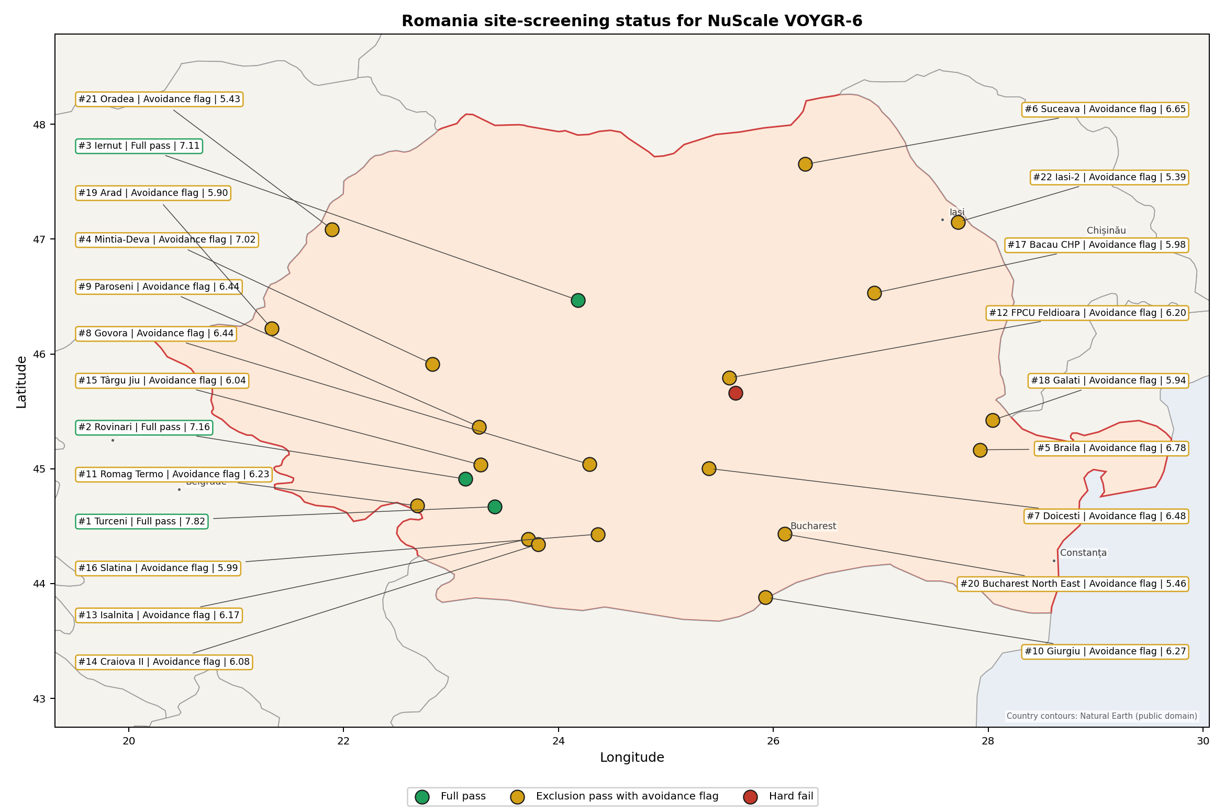
Romania status map

Romania Site Ledger
Rank | Site | Status | Composite | MC Low | MC High | Band | Top-10 Hit | Coverage
1 | Turceni power station | Full pass | 7.816 | 6.891 | 8.256 | A | 100% | 76%
2 | Rovinari power station | Full pass | 7.159 | 6.361 | 7.700 | B | 100% | 76%
3 | Iernut power station | Full pass | 7.114 | 5.285 | 7.555 | D | 0% | 53%
4 | Mintia-Deva power station | Exclusion pass with avoidance flag | 7.016 | 6.245 | 7.487 | D | 0% | 76%
5 | Braila power station | Exclusion pass with avoidance flag | 6.784 | 6.058 | 7.275 | D | 0% | 76%
6 | Suceava power station | Exclusion pass with avoidance flag | 6.653 | 5.952 | 7.144 | D | 0% | 76%
7 | Doicesti power station | Exclusion pass with avoidance flag | 6.478 | 5.811 | 6.950 | H | 0% | 76%
8 | Govora power station | Exclusion pass with avoidance flag | 6.441 | 5.780 | 6.862 | H | 0% | 76%
9 | Paroseni power station | Exclusion pass with avoidance flag | 6.441 | 5.780 | 6.912 | H | 0% | 76%
10 | Giurgiu power station | Exclusion pass with avoidance flag | 6.266 | 5.639 | 6.806 | H | 0% | 76%
11 | Romag Termo power station | Exclusion pass with avoidance flag | 6.228 | 5.609 | 6.700 | H | 0% | 76%
12 | FPCU Feldioara | Exclusion pass with avoidance flag | 6.197 | 5.583 | 6.662 | H | 0% | 76%
13 | Isalnita power station | Exclusion pass with avoidance flag | 6.174 | 5.437 | 6.638 | H | 0% | 74%
14 | Craiova II power station | Exclusion pass with avoidance flag | 6.078 | 5.487 | 6.569 | H | 0% | 76%
15 | Târgu Jiu Thermal Plant | Exclusion pass with avoidance flag | 6.041 | 5.457 | 6.512 | H | 0% | 76%
16 | Slatina power station | Exclusion pass with avoidance flag | 5.991 | 5.417 | 6.481 | H | 0% | 76%
17 | Bacau CHP power station | Exclusion pass with avoidance flag | 5.978 | 5.407 | 6.419 | H | 0% | 76%
18 | Galati Power Station | Exclusion pass with avoidance flag | 5.941 | 5.376 | 6.481 | H | 0% | 76%
19 | Arad power station | Exclusion pass with avoidance flag | 5.903 | 5.346 | 6.444 | H | 0% | 76%
20 | Bucharest North East power station | Exclusion pass with avoidance flag | 5.463 | 4.987 | 5.856 | H | 0% | 76%
21 | Oradea power station | Exclusion pass with avoidance flag | 5.428 | 4.962 | 5.969 | H | 0% | 76%
22 | Iasi-2 power station | Exclusion pass with avoidance flag | 5.391 | 4.800 | 5.912 | H | 0% | 76%
- | Brasov power station | Hard fail | - | - | - | - | - | 0%

Avoidance Flag Pareto
Of the 22 sites that pass the exclusionary screen, the avoidance-phase flags concentrate on a small set of criteria. Resolving them is what would move the country from a small leading group to a broader candidate pool.
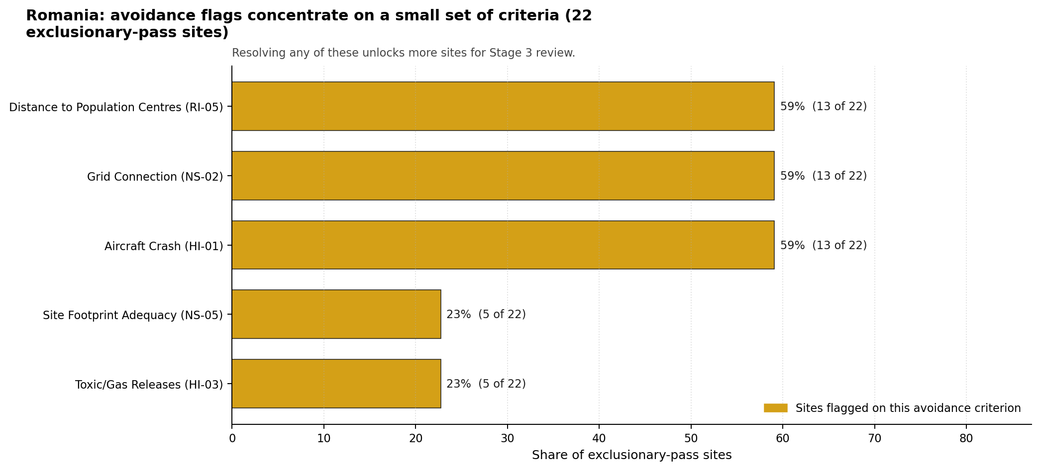
Avoidance flag Pareto
- Aircraft Crash (HI-01) - 13 of 22 exclusionary-pass sites (59%).
- Grid Connection (NS-02) - 13 of 22 exclusionary-pass sites (59%).
- Distance to Population Centres (RI-05) - 13 of 22 exclusionary-pass sites (59%).
- Toxic/Gas Releases (HI-03) - 5 of 22 exclusionary-pass sites (23%).
- Site Footprint Adequacy (NS-05) - 5 of 22 exclusionary-pass sites (23%).

Exclusionary Failure Pareto
The exclusionary failures across the country trace back to a small number of criteria. They identify which screening checks are responsible for removing sites from further consideration.
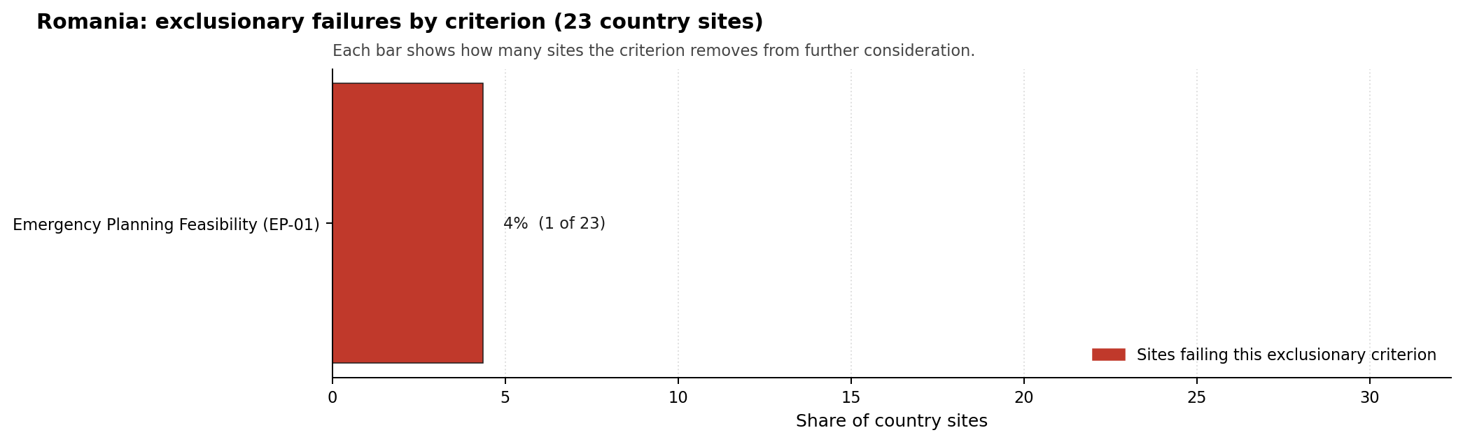
Exclusionary failure Pareto
- Emergency Planning Feasibility (EP-01) - 1 of 23 country sites (4%).

Family Strength and Weakness
Across the country the strongest criterion family is Natural Hazards at a mean normalised score of 7.31/10. The weakest family is Radiological Impact at 4.79/10. The bottom three individual criteria across the country are:
- Military Installations (HI-06) - mean 0.41/10 across 23 scored sites (min 0.0, max 5.0).
- Electromagnetic Interference (HI-07) - mean 2.70/10 across 23 scored sites (min 1.5, max 5.5).
- Grid Connection (NS-02) - mean 2.98/10 across 23 scored sites (min 0.0, max 5.5).

Interpretation for Site Selection
The Romania result shows a clear separation between sites that can support further Stage 3 consideration and sites that should remain in the evidence base only as comparators. The full-pass group is the relevant pool for progression. Avoidance-flag sites are not discarded, but they identify locations where a specific constraint must be resolved before the site can be treated as equivalent to the leading group.

Avoidance flag Pareto - what unlocks more sites
The chart shows where focused remediation effort would broaden the candidate pool. The criteria at the top of the Pareto are the policy and engineering levers that, if resolved, move avoidance-flag sites into the leading group.
An IAEA-style reading of the table focuses less on the exact rank number and more on screening class, score stability, and the nature of remaining uncertainty. Turceni power station is important because it leads nationally, sits inside the strongest stability band, and retains a full-pass status. That does not establish final site suitability. It is a defensible reason to spend Stage 3 effort on field confirmation, national data review, and stakeholder engagement before lower-ranked or avoidance-flag locations.
The Monte Carlo interval is a caution against false precision: several sites have overlapping score bands, so small score differences should not be overinterpreted. The decisive distinction is whether a site combines acceptable exclusionary performance with a stable ranking position and no unresolved avoidance flag.
The main Stage 3 questions are therefore targeted rather than generic: confirm local natural-hazard inputs, verify emergency-planning assumptions, test land and ownership constraints, assess cooling and grid interface conditions, and reconcile environmental constraints with national permitting requirements.

Status Counts
- Full pass: 3 (Turceni, Rovinari, Iernut)
- Exclusion pass with avoidance flag: 19
- Hard fail: 1

Braila power station Site Profile
Braila power station is a coal/thermal site in Romania that has been tested against the NuScale VOYGR-6 reference deployment envelope. This profile reads the screening evidence at a level that supports a decision to progress toward Stage 3 characterisation. It is not a site-suitability determination, vendor recommendation, or licensing finding.

Site Snapshot
Field | Value
Site name | Braila power station
Coordinates | 45.1650, 27.9234
Subnational unit | Braila
Installed thermal capacity (source data) | 850 MW
Composite score (baseline weights) | 6.784 (6.058-7.275 MC band)
National stability band | D (top-10% hit rate 0%)
National rank | 5
See the country status map in Romania Country Profile.

Ownership and Coal-to-Nuclear Context
Generating units on record: 1 retired. Retirements span 2013 to 2013, leaving brownfield grid, water, transport, and workforce assets that materially shorten Stage 3 site preparation.

Natural Hazards (NH)
- Seismic: Ground Motion (NH-01) - score 5.5/10 (MC 5.0-6.0), weight 0.0396, data quality high. Evidence: PGA at 475-year return period 0.212 g; PGA at 2,475-year return period 0.369 g; Vs30 reference (m/s): 760.0.
- Seismic: Surface Rupture (NH-02) - score 9.5/10 (MC 9.0-10.0), weight n/a, data quality screening grade. Evidence: nearest mapped capable fault 50.0 km; fault slip rate 0 mm/yr; fault name: none_in_search_radius.
- Geotechnical: Liquefaction (NH-03) - score 5.0/10 (MC 5.0-5.0), weight n/a, data quality medium. Evidence: liquefaction susceptibility: high; dominant soil type: silty_clay_loam.
- Geotechnical: Slope Stability (NH-04) - score 9.5/10 (MC 9.0-10.0), weight n/a, data quality screening grade. Evidence: site slope 1.56 deg; max slope in 1 km box 27.1 deg; slope stability class: flat.
- Geotechnical: Subsidence (NH-05) - score 5.5/10 (MC 5.0-6.0), weight 0.0308, data quality medium. Evidence: karst present: no; karst severity: none.
- Geotechnical: Foundation (NH-06) - score 5.5/10 (MC 5.0-6.0), weight 0.0220, data quality medium. Evidence: bearing capacity 85.3 kPa; depth to bedrock 35.4 m.
- Volcanism (NH-07) - score 5.0/10 (MC 5.0-5.0), weight n/a, data quality high. Evidence: volcanic hazard class: negligible.
- Coastal Flooding (NH-08) - score 5.0/10 (MC 5.0-5.0), weight 0.0264, data quality low. Evidence: values not in measurement tables.
- River Flooding (NH-09) - score 5.0/10 (MC 5.0-5.0), weight 0.0352, data quality medium. Evidence: flood zone class: negligible.
- Extreme Winds (NH-10) - score 9.5/10 (MC 9.0-10.0), weight n/a, data quality medium. Evidence: screening wind-speed index 7.65 m/s.
- Extreme Precipitation (NH-11) - score 4.0/10 (MC 4.0-4.0), weight 0.0132, data quality medium. Evidence: screening extreme-precipitation index 0.19 mm; screening precipitation index 17.4 mm/yr.
- Extreme Temperatures (NH-12) - score 9.5/10 (MC 9.0-10.0), weight 0.0176, data quality medium. Evidence: extreme high temperature 27.7 deg C; extreme low temperature -5.8 deg C.
- Forest/Wildfire (NH-13) - score 5.0/10 (MC 5.0-5.0), weight 0.0132, data quality n/a. Evidence: values not in measurement tables.
- Combined Hazards (NH-14) - score 5.0/10 (MC 5.0-5.0), weight 0.0132, data quality n/a. Evidence: values not in measurement tables.

Interpretation - Natural Hazards (NH)
Natural hazards at Brăila sit in the moderate-seismic, low-meteorological envelope expected for the lower Danube floodplain, with a single material concern in geotechnical liquefaction. PGA at the 475-yr return period is 0.212 g and at the 2,475-yr return period is 0.369 g at a screening-grid distance of 5.1 km from the site centre, the highest seismic loading of the three Romanian first-batch sites and reflective of the Vrancea source zone influence on the eastern plain; both values stay inside the NuScale VOYGR-6 project envelope of 0.5 g at 2,475-yr but the Stage 3 PSHA case is materially stronger here than at the southern-Carpathian sites. The nearest mapped capable fault is at 50 km, so NH-02 settles at 9.5/10 on distance alone. The binding geotechnical concern is NH-03 Liquefaction Susceptibility, which classifies the site high at screening grade (raw class 4 of 5) over silty-clay-loam soils with a screening-proxy bearing capacity of 85 kPa; depth to bedrock is 35.42 m and the slope-stability class is flat (mean slope 1.6°, max 27.1° within the 1 km box). The combination of high liquefaction susceptibility, very flat ground, deep alluvium and a 0.21 g 475-yr PGA is the single most important Stage 3 priority for this site, because it bears directly on the foundation, anti-liquefaction treatment and seismic-isolation envelope for any NuScale VOYGR-6 module placement. Extreme meteorology is calm: the screening reanalysis (1991-2020) gives a screening wind-speed index of 7.6 m/s, an extreme temperature range of -5.8 °C to 27.7 °C, and a flood susceptibility classified negligible (annual probability 0.0000 over 484 weekly snapshots). NH-11 (Extreme Precipitation) reads 4.0/10 with a screening precipitation index of 17 mm/yr and an extreme daily of 0.2 mm, both physically implausible and the same coarse-grid artefact seen at Rovinari and Turceni. NH-04 (Slope Stability) reads 9.5/10 because the 1 km box is genuinely flat (1.3 % above 15°, 0 % above 30°), a notable contrast with the steep canopy artefacts that suppress NH-04 at the Carpathian-foothills sites. The Stage 3 priority order is therefore: commission a site-specific PSHA together with a Cone-Penetration-Test campaign focused on the upper 30 m of alluvium so NH-01 and NH-03 settle on measured Vs30 and liquefaction-susceptibility values rather than coarse-grid screening proxies, and replace the screening precipitation reading with ANM station data.

Human-Induced and Security-Relevant Hazards (HI)
- Aircraft Crash (HI-01) - score 5.5/10 (MC 5.0-6.0), weight 0.0308, data quality high. Evidence: nearest airport 22.2 km; nearest flight path 11.1 km; airports within search radius 1; airport name: Aerial Club Vădeni; airport type: small airfield.
- Industrial Explosions (HI-02) - score 5.0/10 (MC 5.0-5.0), weight 0.0308, data quality high. Evidence: nearest industrial site 18.7 km.
- Toxic/Gas Releases (HI-03) - score 7.5/10 (MC 7.0-8.0), weight 0.0308, data quality high. Evidence: nearest toxic source 18.7 km.
- External Fires (HI-04) - score 5.0/10 (MC 5.0-5.0), weight 0.0264, data quality high. Evidence: values not in measurement tables.
- Transport Hazards (HI-05) - score 5.0/10 (MC 5.0-5.0), weight 0.0264, data quality n/a. Evidence: values not in measurement tables.
- Military Installations (HI-06) - score 1.5/10 (MC 1.0-2.0), weight 0.0264, data quality medium. Evidence: nearest military installation 8.86 km; military installations within radius 153.
- Electromagnetic Interference (HI-07) - score 9.5/10 (MC 9.0-10.0), weight 0.0088, data quality not_found. Evidence: nearest high-power transmitter 0.23 km; transmitters within radius 0; transmitter type: mast.
- Other Nuclear Installations (HI-08) - score 5.0/10 (MC 5.0-5.0), weight 0.0132, data quality n/a. Evidence: values not in measurement tables.

Interpretation - Human-Induced and Security-Relevant Hazards (HI)
Human-induced and security-relevant hazards at Brăila are dominated by an exceptionally dense military feature count and a single mapped toxic source within a 25 km buffer. The nearest civilian airport is the Aerial Club Vădeni (small airfield) at 22.2 km, with the nearest large airport at 99.8 km, the nearest medium at 63.1 km, and one airport inside the 30 km screening radius; the nearest commercial flight path is 11.1 km, which puts HI-01 inside the project pass band and yields a 5.5/10 ranking score. The dominant criterion in the family is Military Installations (HI-06) at 1.5/10: the nearest military feature is an unnamed bunker at 8.86 km, with 153 military features inside the 25 km search radius. As at Rovinari and Turceni the screening records carry no military-type attribute that engages either the A5 firing-range or A6 ammunition-storage avoidance trigger, so HI-06 is held near the floor on distance alone; but the count itself, by far the highest of the three first-batch Romanian sites, converts the HI-06 finding from a single-feature governance question into a regional security-cordon question that needs Romanian Ministry of National Defence engagement before any other characterisation is committed at this site. HI-03 Toxic / Gas Releases scores 7.5/10 with the nearest screening-inventory toxic-release site at 18.7 km and zero sites inside the 5 km avoidance radius, so the criterion passes the avoidance threshold of 8 km comfortably even though a positive feature is present in the broader area. The three remaining unscored rows HI-02 (Industrial Explosions, Seveso/IED), HI-04 (External Fires) and HI-05 (Transport Hazards) all read “no facility within search radius” on the screening pollutant-release inventory and sit at the pass-mark default of 5.0/10. HI-07 Electromagnetic Interference scores 9.5/10 (no high-power transmitters found within 25 km), the highest score in the family. HI-08 (Other Nuclear Installations) is null. The Stage 3 priority order is therefore: open the Ministry of National Defence engagement on the 153 HI-06 features so the regional security context is mapped before any other family work is committed, re-query HI-02, HI-04 and HI-05 against the national Seveso and hazmat-corridor cadastres so the unscored rows convert to defensible distances, and re-confirm the 18.7 km HI-03 site identity to support the Stage 3 dispersion modelling.

Radiological Impact and Emergency Planning (RI / EP)
- Emergency Planning Feasibility (EP-01) - score 7.5/10 (MC 7.0-8.0), weight n/a, data quality high. Evidence: EP feasibility composite 65.4 /100; road sub-score 39.4 /100; special-population sub-score 90.0 /100; geography sub-score 95.0 /100; population sub-score 80.0 /100; evacuation feasible: yes.
- Evacuation Routes (EP-02) - score 1.5/10 (MC 1.0-2.0), weight 0.0264, data quality medium. Evidence: road density in EPZ 0.294 km/km2; road length in EPZ 576.8 km; motorway access: yes.
- Physical Geography Constraints (EP-03) - score 5.0/10 (MC 5.0-5.0), weight 0.0220, data quality medium. Evidence: waterways crossing EPZ 0; major river barrier: no.
- Special Populations (EP-04) - score 5.5/10 (MC 5.0-6.0), weight 0.0264, data quality medium. Evidence: hospitals in EPZ 21; prisons in EPZ 1; care homes in EPZ 0.
- Concurrent Hazard Impact (EP-05) - score 5.0/10 (MC 5.0-5.0), weight 0.0176, data quality n/a. Evidence: values not in measurement tables.
- Atmospheric Dispersion (RI-01) - score 5.0/10 (MC 5.0-5.0), weight 0.0264, data quality medium. Evidence: annual mean wind speed 0.91 m/s; atmospheric mixing height 543.5 m; prevailing wind direction: N.
- Surface Water Dispersion (RI-02) - score 9.5/10 (MC 9.0-10.0), weight 0.0220, data quality n/a. Evidence: values not in measurement tables.
- Groundwater Dispersion (RI-03) - score 5.0/10 (MC 5.0-5.0), weight 0.0220, data quality medium. Evidence: aquifer type: inland water.
- Population Density at EPZ Radii (RI-04) - score 5.5/10 (MC 5.0-6.0), weight 0.0352, data quality screening grade. Evidence: population density within 5 km 118.4 /km2; population density within 16 km 237.7 /km2; population density within 25 km 121.0 /km2; population density within 80 km 67.8 /km2; population within 25 km 237,457 people.
- Distance to Population Centres (RI-05) - score 5.0/10 (MC 5.0-5.0), weight 0.0441, data quality screening grade. Evidence: nearest city above 50k people 12.7 km; nearest city population 202,740 people; city name: Brăila.
- Population Projections (RI-06) - score 7.5/10 (MC 7.0-8.0), weight 0.0220, data quality screening grade. Evidence: annual population growth rate -0.233 %/yr; projected population at 25 km in 60 yr 183,292 people.

Interpretation - Radiological Impact and Emergency Planning (RI / EP)
Radiological impact and emergency planning at Brăila read as a suburban envelope with elevated population density at the 16 km radius and a binding finding on evacuation routes. Population density at the screening epoch (2020) is 118 p/km² at 5 km, 238 p/km² at 16 km (the highest of the three first-batch Romanian sites and reflective of the proximity to Brăila city), 121 p/km² at 25 km, and 68 p/km² at 80 km, with a 25 km total of 237,457 people and an 80 km total of 1,363,554; the nearest city above 50,000 people is Brăila (202,740) at 12.7 km, hierarchy suburban, with one city above 50k inside the 25 km screening radius and three within 80 km. The trajectory is favourable for a 60-year siting horizon: a -0.233 %/yr national growth rate yields a 25 km projection of 183,292 people in 60 years (down 23 % from 2020), which lifts RI-04 to 5.5/10 and RI-06 to 7.5/10 against the population-projection scoring band. The atmospheric envelope is more diluting than at Rovinari: the screening reanalysis (1991-2020) gives a mean wind speed of 0.9 m/s, a prevailing direction of N (0°), a mean planetary boundary-layer height of 544 m, and a stable-fraction of 42.2 % (stability class C dominant at 57.5 %, class E at 42.2 %); the higher BLH and the lower stable-fraction give a more diluting plume than the southern-Carpathian sites, which is consistent with RI-01 at 5.0/10 with a high-quality dispersion record. The binding criterion in the family is Evacuation Routes (EP-02) at 1.5/10: the road density in the EPZ is only 0.294 km/km² over 576.8 km of road and a single major-river barrier is absent, but the EP-01 composite drops to a roads=39.4 sub-score against special_pop=90, geography=95, terrain=30, population=80 for an overall composite of 65.4/100 (FEASIBLE). The lower road density and the suburban population gradient combine to produce the worst EP-02 score of any first-batch Romanian site. RI-02 (Surface Water Dispersion) reads 9.5/10 because the Danube provides effectively unbounded dilution capacity (cooling source flow 6,237 m³/s, water stress label Low); the criterion is one of the strongest in the family. The Stage 3 priority order is therefore: model EPZ time-to-clear under summer and winter loadings with national IRP-MAI traffic data and the Brăila county network, because the EP-02 1.5/10 is the single largest narrative driver against this site, and confirm the Brăila urban-population profile inside the EPZ once the NuScale VOYGR-6 EPZ radius is finalised so RI-04 and RI-05 settle on a measured city-by-city receptor inventory rather than a 5 km-shell average.

Non-Safety and Implementation Considerations (NS)
- Grid Capacity Basic Filter (BF-01) - score 5.5/10 (MC 5.0-6.0), weight 0.0352, data quality n/a. Evidence: values not in measurement tables.
- Land Area Basic Filter (BF-02) - score 7.5/10 (MC 7.0-8.0), weight 0.0220, data quality n/a. Evidence: values not in measurement tables.
- Cooling Water Availability (NS-01) - score 7.0/10 (MC 6.0-7.0), weight n/a, data quality screening grade. Evidence: distance to cooling source 1.65 km; cooling source flow 6,237 m3/s; cooling source type: major_river; cooling source name: Danube; water stress label: Low.
- Grid Connection (NS-02) - score 5.5/10 (MC 5.0-6.0), weight 0.0352, data quality medium. Evidence: nearest substation 0.23 km; nearest high-voltage line 2.53 km; highest nearby line voltage 110.0 kV; grid export capacity 850.0 MW; substations within radius 70; HV lines within radius 189.
- Transport Access (NS-03) - score 8.0/10 (MC 7.0-8.0), weight 0.0352, data quality high. Evidence: nearest highway 3.44 km; nearest rail line 3.52 km; nearest waterway 5.49 km; heavy-haul capable: yes.
- Site Topography (NS-04) - score 7.5/10 (MC 7.0-8.0), weight 0.0264, data quality high. Evidence: favourable land cover 69.8 %; moderate land cover 8.2 %; unfavourable land cover 21.6 %; favourable area 179.8 ha; dominant land class: 211.
- Site Footprint Adequacy (NS-05) - score 7.5/10 (MC 7.0-8.0), weight 0.0220, data quality high. Evidence: buildable area 41.8 ha; largest contiguous patch 41.8 ha; buildable patch count 6.
- Existing Infrastructure (NS-06) - score 5.0/10 (MC 5.0-5.0), weight 0.0220, data quality n/a. Evidence: values not in measurement tables.
- Environmental Impact (non-rad) (NS-07) - score 5.0/10 (MC 5.0-5.0), weight 0.0220, data quality n/a. Evidence: values not in measurement tables.
- Ecological Sensitivity (NS-08) - score 7.5/10 (MC 7.0-8.0), weight n/a, data quality high. Evidence: natural land cover 21.6 %; distance to nearest Natura 2000 site 1.166 km; distance to nearest protected area 1.275 km; Natura 2000 overlap: no; Natura 2000 sensitivity class: moderate; protected-area overlap: no; protected-area sensitivity class: moderate; nearest Natura 2000 site: Balta Mică a Brăilei; Natura 2000 sites within 5 km: 3; nearest protected-area designation: Natural park.
- Socioeconomic Impact (NS-09) - score 5.0/10 (MC 5.0-5.0), weight 0.0220, data quality n/a. Evidence: values not in measurement tables.
- Workforce Availability (NS-10) - score 5.0/10 (MC 5.0-5.0), weight 0.0176, data quality n/a. Evidence: values not in measurement tables.
- Coal-to-Nuclear Synergies (NS-11) - score 5.0/10 (MC 5.0-5.0), weight 0.0264, data quality n/a. Evidence: values not in measurement tables.
- Regulatory/Political Environment (NS-12) - score 5.0/10 (MC 5.0-5.0), weight 0.0264, data quality n/a. Evidence: values not in measurement tables.
- Construction Logistics (NS-13) - score 5.0/10 (MC 5.0-5.0), weight 0.0176, data quality n/a. Evidence: values not in measurement tables.

Interpretation - Non-Safety and Implementation Considerations (NS)
Non-safety and implementation conditions are the strongest part of Brăila’s screening file and the primary reason the site ranks third nationally despite the geotechnical and EP-02 concerns above. Cooling water is essentially unbounded: the Danube sits 1.65 km from the site at an annual mean discharge of 6,237 m³/s on a stream order 8 reach, with a screening water-stress score of 0.013 (Low) and a depletion ratio of 0.009; the river is cooling-viable for any plausible NuScale VOYGR-6 deployment scale and the existing thermal-station intake works can be inherited rather than rebuilt, which yields NS-01 at 7.0/10 and is the headline brownfield argument for the lower Danube corridor in general. Site topography and footprint are favourable: the dominant land class is non-irrigated arable land at 50.1 %, favourable land cover is 69.8 % over a 256.8 ha screening buildable reference, and the existing industrial polygon for the Brăila plant sits 0.18 km from the centre point. Buildable area is 41.78 ha in a single contiguous patch, the smallest of the three first-batch Romanian sites and a Stage 3 footprint constraint to confirm against the NuScale VOYGR-6 (6-module) layout. NS-04 reads 7.5/10 and NS-05 reads 7.5/10 on this evidence. Ecology is the principal sensitivity: the nearest Natura 2000 site is Balta Mică a Brăilei (Special Protection Area, area 25,794 ha) at only 1.166 km, no overlap, sensitivity class moderate; six Natura 2000 sites sit within 16 km, eleven within 25 km, and the area fraction of Natura 2000 land within 5 km is 31.27 %. The nearest IUCN protected area (Parcul Natural Balta Mică a Brăilei, IUCN V) is at 1.275 km, no overlap, with the strictest IUCN category in the 25 km buffer being III (a national park is at 22 km). NS-08 settles at 7.5/10 but the Article-6(3) Habitats Directive Appropriate Assessment workload at this site is materially heavier than at Rovinari or Romag Termo and should be costed accordingly. The criterion that drives the family read is Grid Connection (NS-02) at 5.5/10: the nearest substation is at 0.23 km with 70 substations in the broader area and 189 HV lines, but the line voltage is 110 kV and the 850 MW export-capacity figure is a screening fallback against the installed-capacity register and carries comfortable headroom over the 462 MWe NuScale VOYGR-6 (6 × 77 MWe modules) reference output. NS-03 (Transport Access) reads 8.0/10 with highway 3.44 km, rail 3.52 km (1435 mm gauge) and a navigable waterway at 5.49 km (Dunărea, Brațul Cravia), heavy-haul capable with high confidence. This is the only first-batch Romanian site with measured Danube barge access. The Stage 3 priority order is therefore: trigger early Romanian ANANP / ANM scoping on the Balta Mică a Brăilei Natura 2000 site so the Article-6(3) workload is sized before construction commitments, confirm the Transelectrica corridor upgrade pathway to 220 kV / 400 kV for NS-02, and validate the 41.78 ha contiguous buildable patch against the VOYGR-6 (6-module) footprint and lay-down requirements.

Composite Score and Stability
Baseline composite score is 6.784, bracketed by Monte Carlo at 6.058-7.275. National stability band is D with a top-10% hit rate of 0% in the national sensitivity analysis.
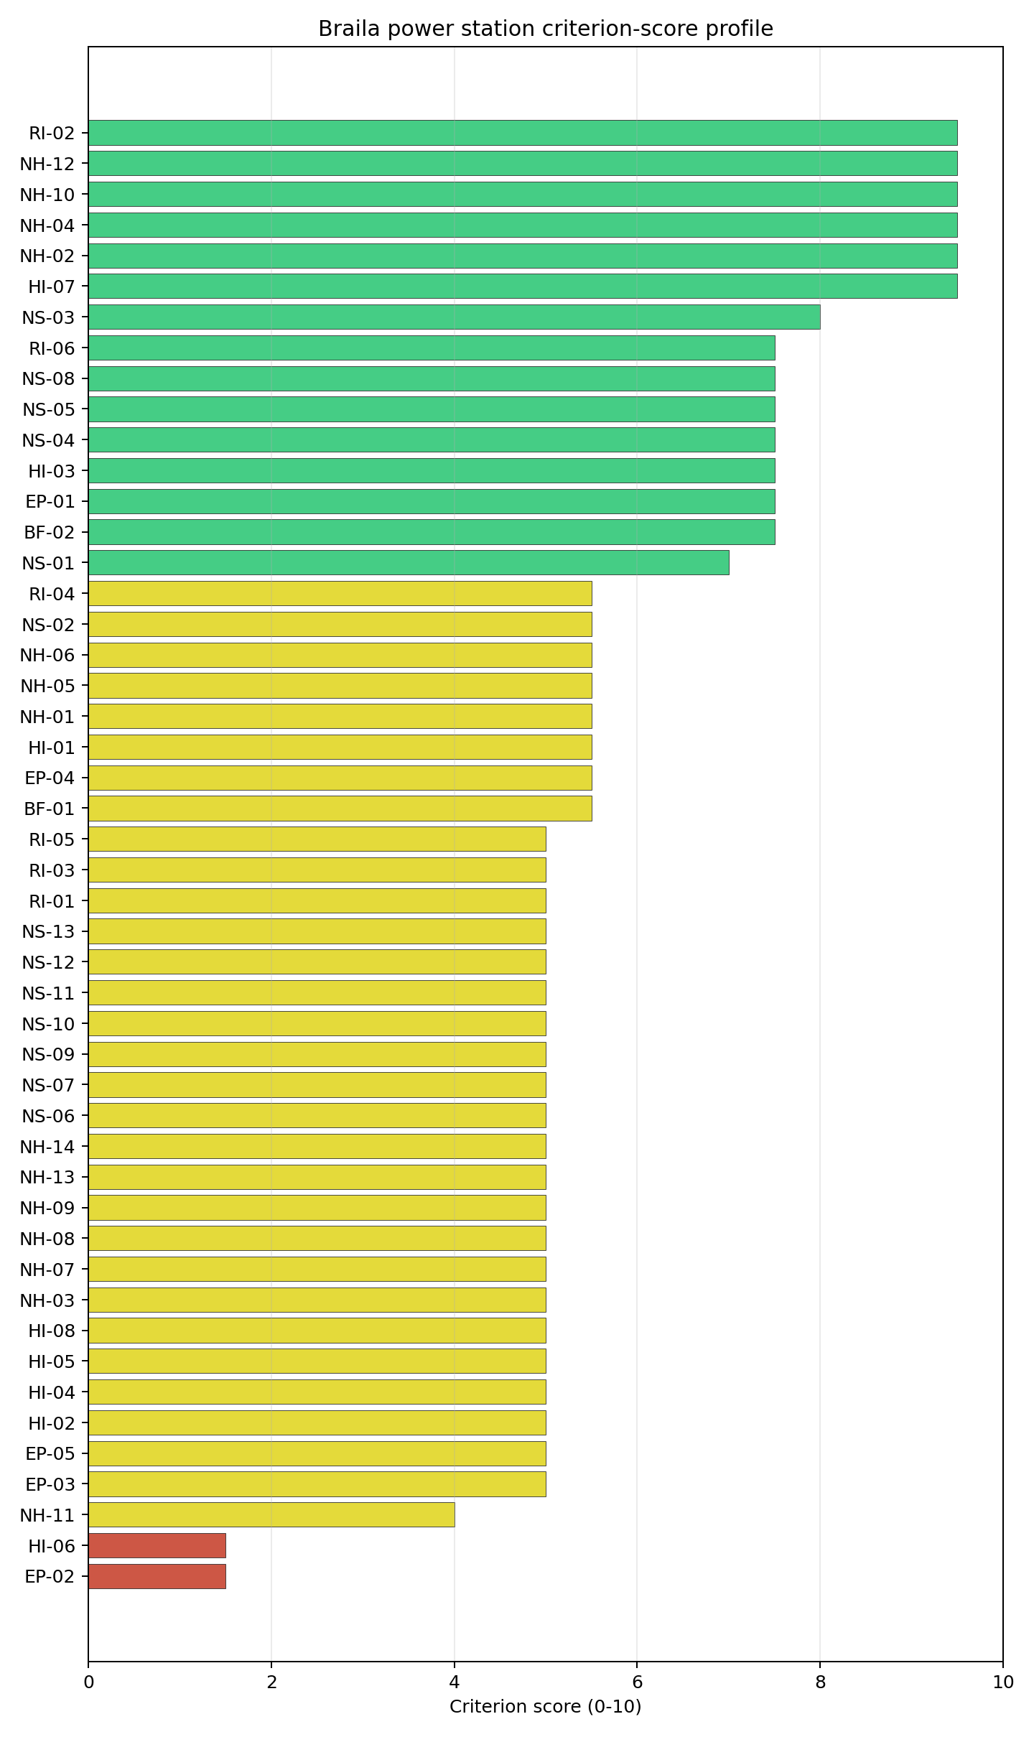
Criterion scores
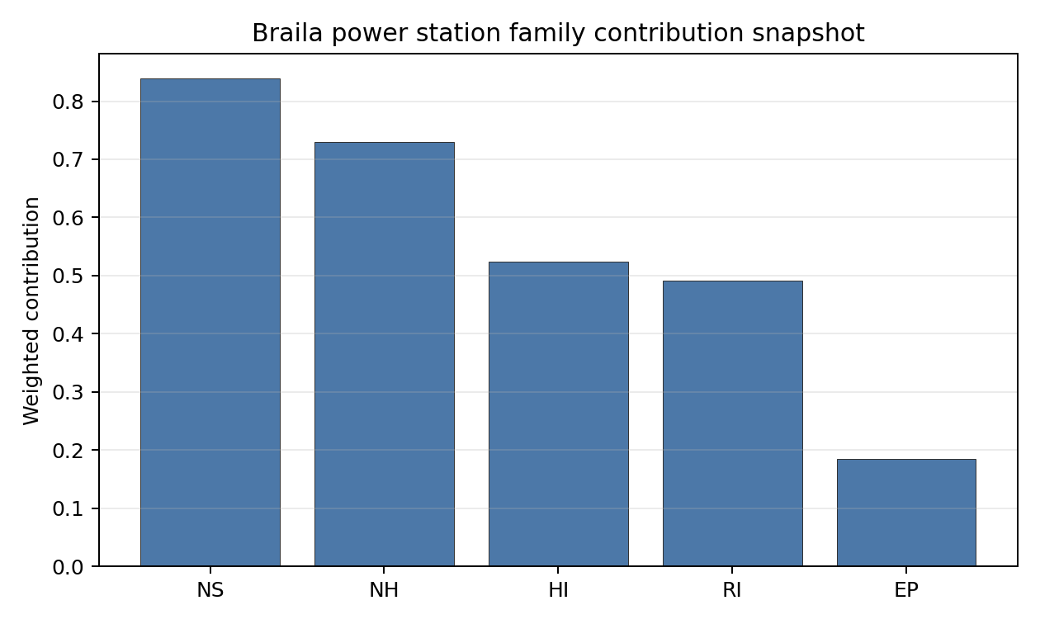
Family contributions
Brăila is Romania’s fifth-ranked exclusionary-pass site in the current country ledger. It remains avoidance-flagged and therefore should be treated as an unlock candidate rather than a first-wave full-pass site. The 6.784 composite score is strong enough to keep the site in the Romanian follow-up set, but the D stability band and 0% national top-10 hit rate mean that sequencing should follow Turceni, Rovinari, and the other full-pass Romanian candidates unless Brăila’s controlling issues are retired. Stage 3 preparation should focus on liquefaction, emergency-route modelling, military-feature classification, ecological permitting, land envelope confirmation, and grid-voltage pathway.

Residual Risk Register
Concern | Evidence | Consequence | Stage 3 action | Owner discipline
Liquefaction Susceptibility (NH-03) | Screening grade class 4 of 5 (high) on silty-clay-loam soils; bearing capacity 85 kPa; depth to bedrock 35.42 m; 0.21 g 475-yr PGA | Foundation, anti-liquefaction treatment and seismic-isolation envelope undefined for VOYGR-6 module placement on deep alluvium | Run a site-specific Cone-Penetration-Test campaign over the upper 30 m of alluvium and produce a measured Vs30 profile so NH-03 settles on site-specific evidence | geotechnical
Evacuation Routes (EP-02) | Road density in EPZ 0.294 km/km², total road length 576.8 km, motorway access present, EP-01 composite 65.4/100 (FEASIBLE) with roads=39 sub-score | Lower road density and the suburban Brăila population gradient combine to produce the worst EP-02 score of any first-batch Romanian site; potential overrun of national IRP-MAI clearance time | Model EPZ time-to-clear under summer and winter loadings using IRP-MAI traffic data and the Brăila county network | emergency planning
Military Installations (HI-06) | Nearest military feature at 8.86 km; 153 features within the 25 km search radius; military-type attribute absent on each screening record | Regional security-cordon question rather than a single-feature one; the highest military feature count in the first batch and a candidate for a structural HI-06 finding | Open Romanian Ministry of National Defence engagement to characterise the 153 features by class and confirm any airspace or cordon overlap with the EPZ | security
Ecological Sensitivity (NS-08) | Natura 2000 “Balta Mică a Brăilei” (Special Protection Area, 25,794 ha) at 1.166 km, no overlap; area fraction 31.27 % within 5 km; six Natura 2000 sites within 16 km; Parcul Natural Balta Mică a Brăilei (IUCN V) at 1.275 km | Article-6(3) Habitats Directive Appropriate Assessment workload materially heavier than at the other first-batch Romanian sites; permitting timeline risk | Trigger early Romanian ANANP / ANM scoping on Balta Mică a Brăilei so the Article-6(3) workload is sized before construction commitments | EIA
Site Footprint Adequacy (NS-05) | Buildable area 41.78 ha in a single contiguous patch (smallest of the first-batch Romanian sites); screening buildable reference 256.8 ha | The 41.78 ha contiguous patch is tight against a NuScale VOYGR-6 (6 × 77 MWe modules) layout plus lay-down requirements; may force module-count compromise | Validate the contiguous patch against the VOYGR-6 footprint and lay-down requirements; consider partial overlap with the existing industrial polygon | site engineering
Grid Connection (NS-02) | Nearest substation 0.23 km, nearest HV line 2.53 km at 110 kV; 850 MW export capacity (screening fallback against the installed-capacity register) | 110 kV interconnection is below the 220-400 kV typically preferred for new nuclear; the 850 MW export capacity exceeds the 462 MWe NuScale VOYGR-6 (6 × 77 MWe modules) reference output, leaving headroom for the certified VOYGR-6 envelope without invoking any uncertified larger configuration | Confirm Transelectrica corridor upgrade pathway to 220 kV / 400 kV and update NS-02 against the planned topology | grid
Extreme Precipitation (NH-11) | Screening reanalysis 1991-2020: screening precipitation index 17 mm/yr, extreme daily 0.2 mm; SPI12, snow-months and freezing-days not measured | Screening grid is too coarse to set the design rainfall and snow-load envelope; values physically implausible | Re-measure with ANM (Administraţia Naţională de Meteorologie) station data and complete the precipitation sub-criteria | hydrology
Two concerns dominate the register. NH-03 is an engineering question: the high liquefaction susceptibility on deep alluvium, combined with the 0.21 g 475-year PGA, is the Stage 3 measurement that most affects the cost envelope and module placement. NS-08 is the principal permitting question: the nearby Natura 2000 context makes early environmental scoping essential. The remaining entries are characterisation gaps and engineering precursors rather than findings against the site. Brăila remains in active contention as an avoidance-flagged Romanian unlock candidate, ranking fifth nationally with a D stability band and a 6.784 baseline composite.

Stage 3 Follow-Up Checklist
- Re-measure Evacuation Routes (EP-02) - native score 1.5/10 with confidence medium.
- Re-measure Military Installations (HI-06) - native score 1.5/10 with confidence medium.
- Re-measure Extreme Precipitation (NH-11) - native score 4.0/10 with confidence medium.
- Re-measure Physical Geography Constraints (EP-03) - native score 5.0/10 with confidence medium.
- Re-measure Concurrent Hazard Impact (EP-05) - native score 5.0/10 with confidence insufficient.
- Improve data quality for Geotechnical: Subsidence & Collapse (NH-05b) - current flag low.
- Improve data quality for Coastal Flooding (NH-08) - current flag low.
- Improve data quality for Electromagnetic Interference (HI-07) - current flag not_found.

Evidence Limitations
- Geotechnical: Subsidence & Collapse (NH-05b) - quality low.
- Coastal Flooding (NH-08) - quality low.
- Electromagnetic Interference (HI-07) - quality not_found.

Romag Termo power station Site Profile
Romag Termo power station is a coal/thermal site in Romania that has been tested against the NuScale VOYGR-6 reference deployment envelope. This profile reads the screening evidence at a level that supports a decision to progress toward Stage 3 characterisation. It is not a site-suitability determination, vendor recommendation, or licensing finding.

Site Snapshot
Field | Value
Site name | Romag Termo power station
Coordinates | 44.6778, 22.6860
Subnational unit | Mehedinti
Installed thermal capacity (source data) | 1,065 MW
Composite score (baseline weights) | 6.228 (5.609-6.700 MC band)
National stability band | H (top-10% hit rate 0%)
National rank | 11
See the country status map in Romania Country Profile.

Ownership and Coal-to-Nuclear Context
- Government of Romania (nan% share), headquartered in Romania; immediate operator Regia Autonomă pentru Activități Nucleare. Path: Government of Romania -> Regia Autonomă pentru Activități Nucleare [unknown %] -> Romag Termo power station Unit 3 [100.0%]
- Regia Autonomă pentru Activități Nucleare (nan% share), headquartered in Romania; immediate operator Sucursala Romag-Termo. Path: Regia Autonomă pentru Activități Nucleare -> Sucursala Romag-Termo [unknown %] -> Romag Termo power station Expansion [100.0%]
Generating units on record: 1 cancelled, 6 retired. Earliest unit commissioning: 1986; most recent: 1988. Retirements span 2008 to 2019, leaving brownfield grid, water, transport, and workforce assets that materially shorten Stage 3 site preparation.

Natural Hazards (NH)
- Seismic: Ground Motion (NH-01) - score 5.5/10 (MC 5.0-6.0), weight 0.0396, data quality high. Evidence: PGA at 475-year return period 0.089 g; PGA at 2,475-year return period 0.222 g; Vs30 reference (m/s): 760.0.
- Seismic: Surface Rupture (NH-02) - score 9.5/10 (MC 9.0-10.0), weight n/a, data quality screening grade. Evidence: nearest mapped capable fault 50.0 km; fault slip rate 0 mm/yr; fault name: none_in_search_radius.
- Geotechnical: Liquefaction (NH-03) - score 5.0/10 (MC 5.0-5.0), weight n/a, data quality medium. Evidence: liquefaction susceptibility: very_low; dominant soil type: clay_loam.
- Geotechnical: Slope Stability (NH-04) - score 7.5/10 (MC 7.0-8.0), weight n/a, data quality screening grade. Evidence: site slope 7.38 deg; max slope in 1 km box 81.0 deg; slope stability class: moderate.
- Geotechnical: Subsidence (NH-05) - score 5.5/10 (MC 5.0-6.0), weight 0.0308, data quality medium. Evidence: karst present: no; karst severity: none.
- Geotechnical: Foundation (NH-06) - score 5.5/10 (MC 5.0-6.0), weight 0.0220, data quality medium. Evidence: bearing capacity 86.0 kPa; depth to bedrock 22.5 m.
- Volcanism (NH-07) - score 5.0/10 (MC 5.0-5.0), weight n/a, data quality high. Evidence: volcanic hazard class: negligible.
- Coastal Flooding (NH-08) - score 5.0/10 (MC 5.0-5.0), weight 0.0264, data quality low. Evidence: values not in measurement tables.
- River Flooding (NH-09) - score 5.0/10 (MC 5.0-5.0), weight 0.0352, data quality medium. Evidence: flood zone class: negligible.
- Extreme Winds (NH-10) - score 9.5/10 (MC 9.0-10.0), weight n/a, data quality medium. Evidence: screening wind-speed index 6.46 m/s.
- Extreme Precipitation (NH-11) - score 4.0/10 (MC 4.0-4.0), weight 0.0132, data quality medium. Evidence: screening extreme-precipitation index 0.28 mm; screening precipitation index 26.4 mm/yr.
- Extreme Temperatures (NH-12) - score 9.5/10 (MC 9.0-10.0), weight 0.0176, data quality medium. Evidence: extreme high temperature 25.2 deg C; extreme low temperature -4.06 deg C.
- Forest/Wildfire (NH-13) - score 5.0/10 (MC 5.0-5.0), weight 0.0132, data quality n/a. Evidence: values not in measurement tables.
- Combined Hazards (NH-14) - score 5.0/10 (MC 5.0-5.0), weight 0.0132, data quality n/a. Evidence: values not in measurement tables.

Interpretation - Natural Hazards (NH)
Natural hazards at Romag Termo sit in the low-seismic, low-meteorological envelope expected for the western Drobeta-Turnu Severin foothills, and no exclusionary natural-hazard check is currently failing. PGA at the 475-yr return period is 0.089 g and at the 2,475-yr return period is 0.222 g at a screening-grid distance of 2.5 km from the site centre (the closest seismic-grid match of the three first-batch sites), which keeps the seismic loading well inside the NuScale VOYGR-6 project envelope of 0.5 g at 2,475-yr; the nearest mapped capable fault is at 50 km, so NH-02 settles at 9.5/10. Geotechnical conditions are favourable: clay-loam soils with a screening-proxy bearing capacity of 86 kPa, depth to bedrock 22.48 m, mean site slope 7.4° and a moderate slope-stability class. The 1 km-box maximum slope of 81° is a digital surface model canopy artefact and NH-04 carries the standard caveat (7.5 % above 15°, 6.9 % above 30° in the 1 km box). Liquefaction susceptibility is very low at screening grade (raw class 1 of 5), which is a notable advantage over Brăila on the same family. Karst is absent (nearest mapped zone 11.7 km) and no mining-heritage feature is mapped within the search radius. Extreme meteorology is calm: the screening reanalysis (1991-2020) gives a screening wind-speed index of 6.5 m/s with a prevailing direction of 292° (WNW), an extreme temperature range of -4.1 °C to 25.2 °C, and a flood susceptibility classified negligible (annual probability 0.0000 over 484 weekly snapshots, nearest flash-flood activation 38.2 km). NH-11 (Extreme Precipitation) reads 4.0/10 with a screening precipitation index of 26 mm/yr and an extreme daily of 0.3 mm, both physically implausible and the same coarse-grid artefact seen across the southern Romanian sites. NH-07 (Volcanism), NH-08 (Coastal Flooding) and NH-09 (River Flooding) all read negligible on the screening proxies but are flagged inconclusive on the avoidance phase because the site-specific receptors are unmeasured at this stage. The Stage 3 priority order is therefore: replace the screening precipitation reading with ANM (Administraţia Naţională de Meteorologie) station data, commission a site-specific PSHA so the screening grid value is replaced by a measured UHS for the design envelope, and validate the NH-04 slope read against a bare-earth digital elevation model to retire the canopy artefact.

Human-Induced and Security-Relevant Hazards (HI)
- Aircraft Crash (HI-01) - score 3.5/10 (MC 3.0-4.0), weight 0.0308, data quality high. Evidence: nearest airport 6.65 km; nearest flight path 6.65 km; airports within search radius 2; airport name: Drobeta-Turnu Severin Heliport; airport type: heliport.
- Industrial Explosions (HI-02) - score 5.0/10 (MC 5.0-5.0), weight 0.0308, data quality high. Evidence: nearest industrial site 3.25 km.
- Toxic/Gas Releases (HI-03) - score 1.5/10 (MC 1.0-2.0), weight 0.0308, data quality high. Evidence: nearest toxic source 3.25 km.
- External Fires (HI-04) - score 5.0/10 (MC 5.0-5.0), weight 0.0264, data quality high. Evidence: values not in measurement tables.
- Transport Hazards (HI-05) - score 5.0/10 (MC 5.0-5.0), weight 0.0264, data quality n/a. Evidence: values not in measurement tables.
- Military Installations (HI-06) - score 0.0/10 (MC 0.0-0.0), weight 0.0264, data quality high. Evidence: nearest military installation 4.64 km; military installations within radius 27.
- Electromagnetic Interference (HI-07) - score 9.5/10 (MC 9.0-10.0), weight 0.0088, data quality not_found. Evidence: nearest high-power transmitter 2.21 km; transmitters within radius 0; transmitter type: mast.
- Other Nuclear Installations (HI-08) - score 5.0/10 (MC 5.0-5.0), weight 0.0132, data quality n/a. Evidence: values not in measurement tables.

Interpretation - Human-Induced and Security-Relevant Hazards (HI)
Human-induced and security-relevant hazards at Romag Termo are the weakest part of the screening file and the reason this site sits in the avoidance-flagged tier rather than the full-pass tier. Three findings drive the family read. The headline is HI-03 Toxic / Gas Releases at 1.5/10, which is the active avoidance flag for this site: the nearest screening-inventory toxic-release site is at 3.25 km with two such sites inside the 5 km buffer, both well inside the project avoidance threshold of >= 8 km from hazardous-cloud sources. The Drobeta-Turnu Severin industrial cluster in this area is the underlying driver and the avoidance flag is treated as a Stage 3 unlock candidate rather than an exclusionary failure. HI-01 Aircraft Crash scores 3.5/10 because the nearest airport is the Drobeta-Turnu Severin Heliport (heliport) at 6.65 km, the closest airport of any kind among the three first-batch Romanian sites, with two airports inside the 30 km screening radius and a flight-path distance of 6.65 km; the heliport classification limits the design-basis aircraft mass relative to a fixed-wing site, but the proximity remains a screening-grade concern that scales the impact-frequency input. HI-06 Military Installations sits at 0.0/10 (the floor): nearest military feature at 4.64 km, 27 features within 25 km. The screening records carry no military-type attribute that engages either the A5 or A6 avoidance trigger, so HI-06 is held at the floor on distance alone rather than a confirmed exclusionary finding, but the count and proximity together convert HI-06 into the second governance question for this site. The four unscored rows HI-02 (Industrial Explosions, Seveso/IED), HI-04 (External Fires), HI-05 (Transport Hazards) and HI-08 (Other Nuclear Installations) sit at the pass-mark default of 5.0/10. HI-07 Electromagnetic Interference scores 9.5/10 (no high-power transmitters within 25 km). The Stage 3 priority order is therefore: confirm the 3.25 km toxic source identity and prevailing dispersion footprint to either close out the HI-03 avoidance flag or convert it to a binding finding (this is the first unlock work for this site), open the Romanian Ministry of National Defence engagement on the 27 HI-06 features, and confirm whether the Drobeta-Turnu Severin Heliport is in active service and what aircraft classes it supports for the HI-01 design-basis aircraft input.

Radiological Impact and Emergency Planning (RI / EP)
- Emergency Planning Feasibility (EP-01) - score 5.5/10 (MC 5.0-6.0), weight n/a, data quality high. Evidence: EP feasibility composite 57.4 /100; road sub-score 47.5 /100; special-population sub-score 90.0 /100; geography sub-score 95.0 /100; population sub-score 60.0 /100; evacuation feasible: yes.
- Evacuation Routes (EP-02) - score 3.5/10 (MC 3.0-4.0), weight 0.0264, data quality medium. Evidence: road density in EPZ 0.425 km/km2; road length in EPZ 835.1 km; motorway access: yes.
- Physical Geography Constraints (EP-03) - score 5.0/10 (MC 5.0-5.0), weight 0.0220, data quality medium. Evidence: waterways crossing EPZ 0; major river barrier: no.
- Special Populations (EP-04) - score 5.5/10 (MC 5.0-6.0), weight 0.0264, data quality medium. Evidence: hospitals in EPZ 24; prisons in EPZ 1; care homes in EPZ 0.
- Concurrent Hazard Impact (EP-05) - score 5.0/10 (MC 5.0-5.0), weight 0.0176, data quality n/a. Evidence: values not in measurement tables.
- Atmospheric Dispersion (RI-01) - score 5.0/10 (MC 5.0-5.0), weight 0.0264, data quality medium. Evidence: annual mean wind speed 0.92 m/s; atmospheric mixing height 424.7 m; prevailing wind direction: WNW.
- Surface Water Dispersion (RI-02) - score 9.5/10 (MC 9.0-10.0), weight 0.0220, data quality n/a. Evidence: values not in measurement tables.
- Groundwater Dispersion (RI-03) - score 5.0/10 (MC 5.0-5.0), weight 0.0220, data quality medium. Evidence: aquifer type: alluvial.
- Population Density at EPZ Radii (RI-04) - score 3.5/10 (MC 3.0-4.0), weight 0.0352, data quality screening grade. Evidence: population density within 5 km 448.7 /km2; population density within 16 km 155.4 /km2; population density within 25 km 81.1 /km2; population density within 80 km 41.0 /km2; population within 25 km 159,248 people.
- Distance to Population Centres (RI-05) - score 5.0/10 (MC 5.0-5.0), weight 0.0441, data quality screening grade. Evidence: nearest city above 50k people 7.81 km; nearest city population 106,707 people; city name: Drobeta-Turnu Severin.
- Population Projections (RI-06) - score 9.5/10 (MC 9.0-10.0), weight 0.0220, data quality screening grade. Evidence: annual population growth rate -0.516 %/yr; projected population at 25 km in 60 yr 122,917 people.

Interpretation - Radiological Impact and Emergency Planning (RI / EP)
Radiological impact and emergency planning at Romag Termo read as a periurban envelope with elevated 5 km population density and a moderate dispersion regime. Population density at the screening epoch (2020) is 449 p/km² at 5 km (the highest of any first-batch Romanian site at the close-in radius and reflective of the proximity to Drobeta-Turnu Severin), 155 p/km² at 16 km, 81 p/km² at 25 km, and 41 p/km² at 80 km, with a 25 km total of 159,248 people and an 80 km total of 824,643; the nearest city above 50,000 people is Drobeta-Turnu Severin (106,707) at only 7.81 km, hierarchy suburban, with one city above 50k inside the 25 km screening radius and two within 80 km. The trajectory is favourable: a -0.516 %/yr national growth rate (the steepest decline of the three first-batch sites) yields a 25 km projection of 122,917 people in 60 years (down 23 % from 2020), which lifts RI-06 to 9.5/10 even though the present-day RI-04 settles at 3.5/10 against the population-density bands. The atmospheric envelope sits between Rovinari and Brăila on diluting capacity: the screening reanalysis (1991-2020) gives a mean wind speed of 0.9 m/s, a prevailing direction of WNW (292°), material because the city of Drobeta-Turnu Severin lies almost directly downwind of the site, a mean planetary boundary-layer height of 425 m, and a stable-fraction of 66.1 % (stability class E dominant at 66.1 %, class C at 33.9 %). The near-2/3 stable-class regime concentrates accidental release within a narrower WNW plume than a less stable site, and the WNW prevailing direction is the single most important atmospheric finding for this site because it points the dispersion plume at the largest receptor population in the EPZ. EP-01 composite is 57.4/100 (FEASIBLE) with sub-scores roads=47.5, special_pop=90, geography=95, terrain=10, population=60; the population sub-score drag reflects the same Drobeta-Turnu Severin proximity. EP-02 (Evacuation Routes) scores 3.5/10 with road density 0.425 km/km², 835 km of road in the EPZ and motorway access present. The Stage 3 priority order is therefore: model EPZ time-to-clear under summer and winter loadings with national IRP-MAI traffic data and the Mehedinți county network, run a site-specific atmospheric dispersion model with a measured wind rose so the WNW prevailing-direction concern toward Drobeta-Turnu Severin is quantified rather than carried as a screening concern, and confirm the Drobeta-Turnu Severin urban-population profile inside the EPZ once the NuScale VOYGR-6 EPZ radius is finalised so RI-04 and RI-05 settle on a measured city-by-city receptor inventory.

Non-Safety and Implementation Considerations (NS)
- Grid Capacity Basic Filter (BF-01) - score 7.5/10 (MC 7.0-8.0), weight 0.0352, data quality n/a. Evidence: values not in measurement tables.
- Land Area Basic Filter (BF-02) - score 9.5/10 (MC 9.0-10.0), weight 0.0220, data quality n/a. Evidence: values not in measurement tables.
- Cooling Water Availability (NS-01) - score 6.0/10 (MC 6.0-6.0), weight n/a, data quality screening grade. Evidence: distance to cooling source 6.57 km; cooling source flow 5,511 m3/s; cooling source type: major_river; cooling source name: Topolnița; water stress label: Low.
- Grid Connection (NS-02) - score 5.5/10 (MC 5.0-6.0), weight 0.0352, data quality medium. Evidence: nearest substation 1.81 km; nearest high-voltage line 0.98 km; highest nearby line voltage 110.0 kV; grid export capacity 1,065 MW; substations within radius 70; HV lines within radius 123.
- Transport Access (NS-03) - score 9.0/10 (MC 8.0-9.0), weight 0.0352, data quality high. Evidence: nearest highway 0.65 km; nearest rail line 0.1 km; heavy-haul capable: yes.
- Site Topography (NS-04) - score 7.5/10 (MC 7.0-8.0), weight 0.0264, data quality high. Evidence: favourable land cover 67.1 %; moderate land cover 19.7 %; unfavourable land cover 7.1 %; favourable area 169.3 ha; dominant land class: 211.
- Site Footprint Adequacy (NS-05) - score 9.5/10 (MC 9.0-10.0), weight 0.0220, data quality high. Evidence: buildable area 95.3 ha; largest contiguous patch 95.3 ha; buildable patch count 12.
- Existing Infrastructure (NS-06) - score 5.0/10 (MC 5.0-5.0), weight 0.0220, data quality n/a. Evidence: values not in measurement tables.
- Environmental Impact (non-rad) (NS-07) - score 5.0/10 (MC 5.0-5.0), weight 0.0220, data quality n/a. Evidence: values not in measurement tables.
- Ecological Sensitivity (NS-08) - score 7.5/10 (MC 7.0-8.0), weight n/a, data quality high. Evidence: natural land cover 7.1 %; distance to nearest Natura 2000 site 6.715 km; distance to nearest protected area 2.609 km; Natura 2000 overlap: no; Natura 2000 sensitivity class: low; protected-area overlap: no; protected-area sensitivity class: moderate; nearest Natura 2000 site: Porțile de Fier; Natura 2000 sites within 5 km: 0; nearest protected-area designation: Natural park.
- Socioeconomic Impact (NS-09) - score 5.0/10 (MC 5.0-5.0), weight 0.0220, data quality n/a. Evidence: values not in measurement tables.
- Workforce Availability (NS-10) - score 5.0/10 (MC 5.0-5.0), weight 0.0176, data quality n/a. Evidence: values not in measurement tables.
- Coal-to-Nuclear Synergies (NS-11) - score 5.0/10 (MC 5.0-5.0), weight 0.0264, data quality n/a. Evidence: values not in measurement tables.
- Regulatory/Political Environment (NS-12) - score 5.0/10 (MC 5.0-5.0), weight 0.0264, data quality n/a. Evidence: values not in measurement tables.
- Construction Logistics (NS-13) - score 5.0/10 (MC 5.0-5.0), weight 0.0176, data quality n/a. Evidence: values not in measurement tables.

Interpretation - Non-Safety and Implementation Considerations (NS)
Non-safety and implementation conditions are the strongest part of Romag Termo’s screening file and offset much of the human-hazard weakness in the family balance. Cooling water is unbounded: the nearest cooling source is the Topolnița (a Danube-system tributary) at 6.57 km with an annual mean discharge of 5,511 m³/s on a stream order 8 reach (the high discharge reflects the Danube confluence rather than the local river segment), with a screening water-stress score of 0.006 (Low) and a depletion ratio of 0.003, the lowest water-stress reading of the three first-batch Romanian sites. NS-01 at 6.0/10 is held back by the 6.57 km source distance rather than the flow availability. Site topography and footprint are favourable: the dominant land class is non-irrigated arable land at 39.1 %, favourable land cover is 67.1 % over a 252.7 ha screening buildable reference, and the buildable area is 95.28 ha in a single contiguous patch, the largest of the three first-batch Romanian sites and a comfortable margin against the NuScale VOYGR-6 (6-module) footprint. NS-04 reads 7.5/10 and NS-05 reads 9.5/10, the strongest in the family. The existing industrial polygon for the CET Halânga plant sits 0.12 km from the centre point, so the brownfield reuse argument is effectively unconstrained at the parcel scale. Ecology is low sensitivity on the Natura 2000 layer (nearest site Porțile de Fier at 6.715 km, no overlap, area fraction 26 % within 25 km) but moderate on the IUCN protected-area layer (nearest designation Geoparcul Platoul Mehedinți, IUCN V, at 2.609 km, no overlap; 19 protected areas within 25 km of which 14 are IUCN IV-VI). NS-08 settles at 7.5/10. Grid Connection (NS-02) reads 5.5/10: nearest substation 1.81 km, nearest HV line 0.98 km at 110 kV, with 70 substations and 123 HV lines in the broader area; the 1,065 MW export-capacity figure is a screening fallback against the installed-capacity register, but the value matches the site’s nameplate exactly and provides headroom against the 462 MWe VOYGR-6 (6 × 77 MWe modules) reference output. NS-03 Transport Access reads 9.0/10 with highway 0.65 km (primary), rail 0.10 km (1435 mm gauge with rail siding < 1 km) and heavy-haul capable with high confidence. The rail siding is the single best piece of inherited brownfield infrastructure at this site. Romania’s curated nuclear policy stance is favourable (NS-12). The Stage 3 priority order is therefore: confirm the Topolnița cooling-loop intake and condenser-return arrangement at 6.57 km from the site (this is a longer distance than at Rovinari or Brăila and may force a dedicated supply pipeline), run the moderate Geoparcul Platoul Mehedinți protected-area buffer through Romanian ANANP scoping ahead of NS-08 confirmation, and confirm the Transelectrica corridor upgrade pathway to 220 kV / 400 kV for NS-02.

Composite Score and Stability
Baseline composite score is 6.228, bracketed by Monte Carlo at 5.609-6.700. National stability band is H with a top-10% hit rate of 0% in the national sensitivity analysis.
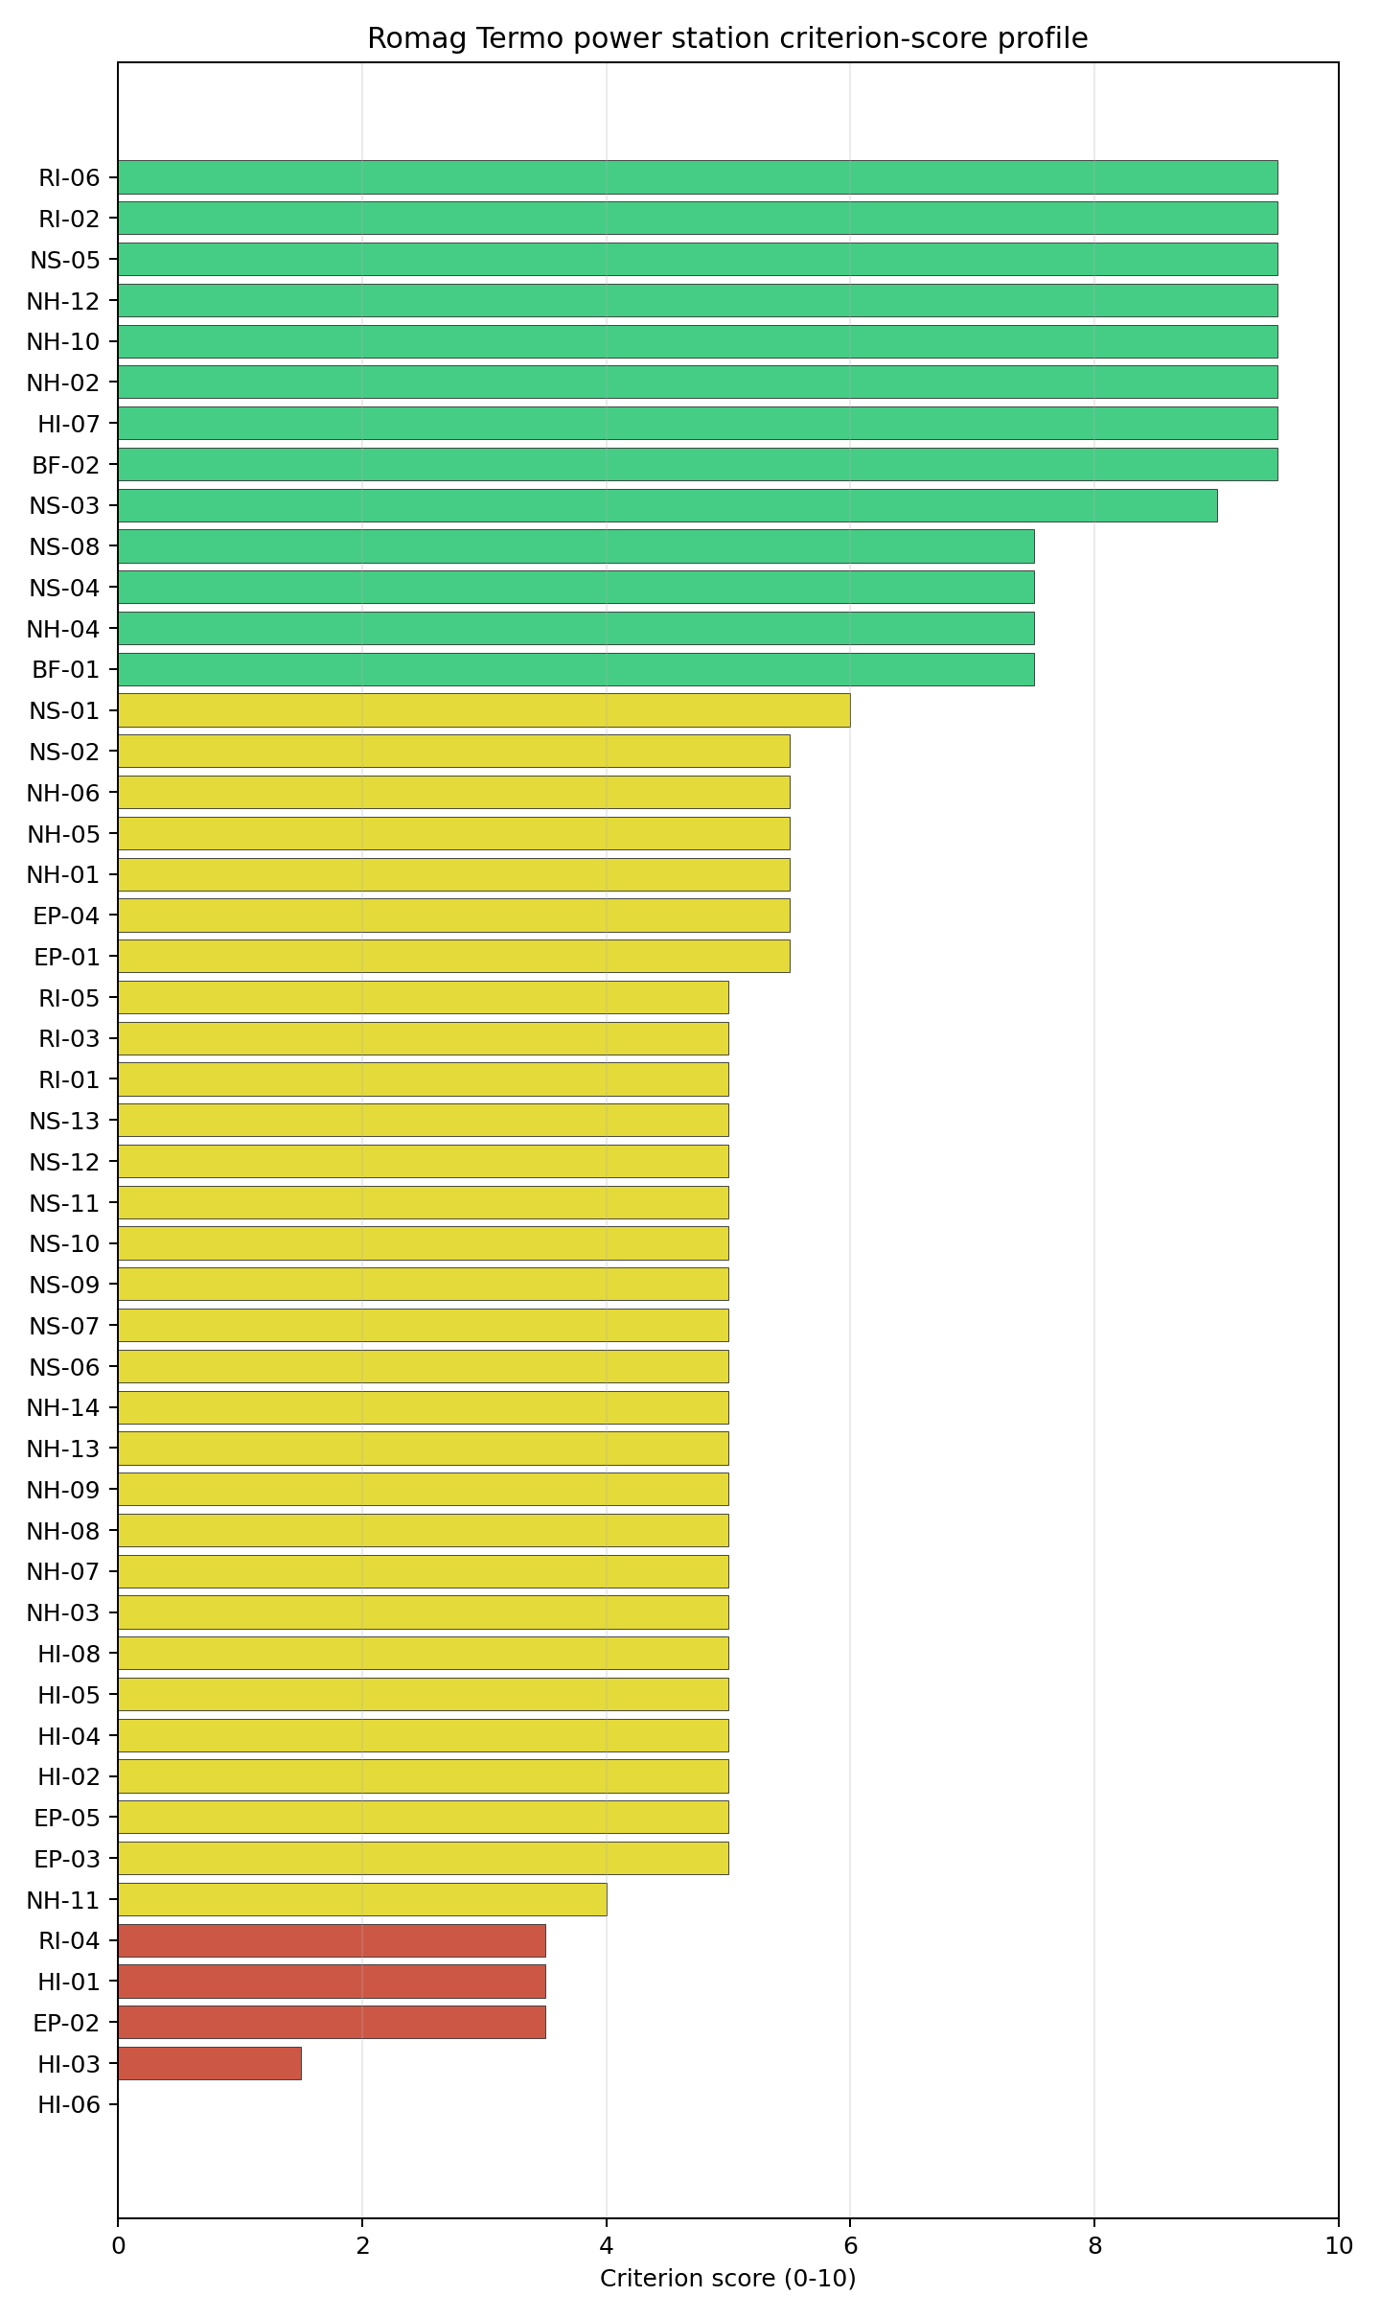
Criterion scores
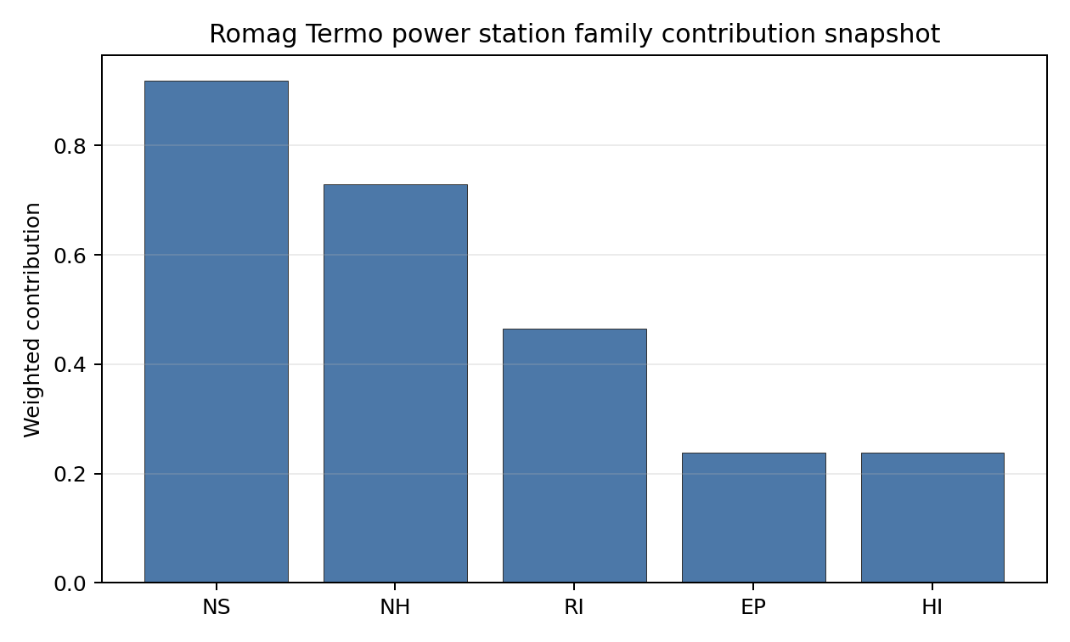
Family contributions
Romag Termo is an avoidance-flagged Romanian follow-up site, not a first-wave national leader. Its 6.228 composite score keeps it inside the Romanian evidence base, but the H stability band and 0% national top-10 hit rate make it rank-fragile compared with Turceni, Rovinari, Iernut, Mintia-Deva, and Brăila. The site remains strategically useful because of land, rail, cooling, and inherited infrastructure indicators; its Stage 3 value depends on retiring the toxic-release, military-feature, aviation, population-density, cooling-loop, and grid-voltage questions identified below.

Residual Risk Register
Concern | Evidence | Consequence | Stage 3 action | Owner discipline
Toxic / Gas Releases (HI-03) | Nearest screening-inventory toxic source at 3.25 km; two such sites within 5 km; active avoidance flag (project threshold >= 8 km) | Avoidance flag is Stage 3 unlock candidate; sustained finding would convert to a binding facility-siting concern and may force EPZ or stand-off redesign | Confirm the 3.25 km source identity, fugitive-emission inventory and prevailing dispersion footprint; close out or convert the avoidance flag accordingly | hazard analysis
Military Installations (HI-06) | Nearest military feature at 4.64 km, 27 features within 25 km; military-type attribute absent on each screening record | Feature-classification ambiguity may convert to a security-cordon overlap once Romanian Ministry of National Defence positions are obtained; HI-06 currently at the floor of 0.0/10 | Engage Romanian Ministry of National Defence on the 27 features by class and confirm any airspace or cordon overlap with the EPZ | security
Aircraft Crash (HI-01) | Drobeta-Turnu Severin Heliport (heliport) at 6.65 km; two airports within 30 km; flight-path distance 6.65 km | Heliport class limits design-basis aircraft mass relative to a fixed-wing site; closeness scales the impact-frequency input | Confirm whether the heliport is in active service and what aircraft classes it supports; size HI-01 design-basis aircraft accordingly | aviation safety
Atmospheric Dispersion (RI-01) | Screening reanalysis 1991-2020: prevailing direction WNW (292°) toward Drobeta-Turnu Severin (106,707 pop) at 7.81 km; mean wind speed 0.9 m/s; stable-fraction 66.1 % (E class dominant); current score 5.0/10 | Prevailing plume points at the largest receptor population in the EPZ; the European-default dispersion assumption may be non-conservative for this site | Run a site-specific dispersion model with a measured wind rose and confirm the WNW-toward-city plume scenario is bounded by the design basis | meteorology
Population Density at EPZ Radii (RI-04) | 449 p/km² at 5 km (highest of any first-batch site at this radius); Drobeta-Turnu Severin (106,707) at 7.81 km, hierarchy suburban; current score 3.5/10 | Close-in population density is the binding receptor input for the EPZ; the Drobeta-Turnu Severin city receptor is a structural rather than seasonal constraint | Confirm the Drobeta-Turnu Severin urban-population profile inside the EPZ once the VOYGR-6 EPZ radius is finalised; settle RI-04 on a measured city-by-city receptor inventory | radiological
Cooling-Loop Distance (NS-01) | Topolnița (stream order 8, 5,511 m³/s) at 6.57 km; screening water-stress score 0.006 (Low) | Cooling source is unbounded but distance forces a dedicated supply pipeline rather than the in-place intake reuse available at Rovinari and Brăila | Confirm the cooling-loop intake and condenser-return arrangement at 6.57 km; size the dedicated pipeline against Stage 3 capex | mechanical / hydrology
Grid Connection (NS-02) | Nearest substation 1.81 km, nearest HV line 0.98 km at 110 kV; 1,065 MW export capacity (screening fallback against the installed-capacity register) | 110 kV interconnection is below the 220-400 kV typically preferred for new nuclear; the 1,065 MW figure carries comfortable headroom against the 462 MWe VOYGR-6 (6 × 77 MWe modules) reference output, but the interconnection upgrade is still required | Confirm Transelectrica corridor upgrade pathway to 220 kV / 400 kV and update NS-02 against the planned topology | grid
Two concerns dominate the register. HI-03 is the active avoidance flag and the single Stage 3 unlock that most affects the standing of this site: confirming the 3.25 km toxic-source identity and dispersion footprint either closes out the flag or converts it into a binding facility-siting concern. HI-06 is the secondary governance question. The remaining entries are characterisation gaps and engineering precursors rather than findings against the site. Romag Termo remains in active contention as a Romanian comparator and unlock candidate, but it ranks eleventh nationally with an H stability band and a 6.228 baseline composite.

Stage 3 Follow-Up Checklist
- Resolve Toxic/Gas Releases (HI-03) avoidance flag - measured toxic-source distance 3.25 km against the 8 km hazardous-cloud separation screen.
- Re-measure Military Installations (HI-06) - native score 0.0/10 with confidence high.
- Re-measure Toxic/Gas Releases (HI-03) - native score 1.5/10 with confidence high.
- Re-measure Evacuation Routes (EP-02) - native score 3.5/10 with confidence medium.
- Re-measure Aircraft Crash (HI-01) - native score 3.5/10 with confidence high.
- Re-measure Population Density at EPZ Radii (RI-04) - native score 3.5/10 with confidence medium.
- Improve data quality for Geotechnical: Subsidence & Collapse (NH-05b) - current flag low.
- Improve data quality for Coastal Flooding (NH-08) - current flag low.
- Improve data quality for Electromagnetic Interference (HI-07) - current flag not_found.

Evidence Limitations
- Geotechnical: Subsidence & Collapse (NH-05b) - quality low.
- Coastal Flooding (NH-08) - quality low.
- Electromagnetic Interference (HI-07) - quality not_found.

Rovinari power station Site Profile
Rovinari power station is a coal/thermal site in Romania that has been tested against the NuScale VOYGR-6 reference deployment envelope. This profile reads the screening evidence at a level that supports a decision to progress toward Stage 3 characterisation. It is not a site-suitability determination, vendor recommendation, or licensing finding.

Site Snapshot
Field | Value
Site name | Rovinari power station
Coordinates | 44.9106, 23.1348
Subnational unit | Gorj
Installed thermal capacity (source data) | 1,920 MW
Composite score (baseline weights) | 7.159 (6.361-7.700 MC band)
National stability band | B (top-10% hit rate 100%)
National rank | 2
See the country status map in Romania Country Profile.

Ownership and Coal-to-Nuclear Context
- Government of Romania (77.15% share), headquartered in Romania; immediate operator Complexul Energetic Oltenia SA. Path: Government of Romania -> Ministry of Energy (Romania) [100.0%] -> Complexul Energetic Oltenia SA [77.15%] -> Rovinari power station Unit 6 [100.0%]
- Fondul Proprietatea SA (21.55% share), headquartered in Romania; immediate operator Complexul Energetic Oltenia SA. Path: Fondul Proprietatea SA -> Complexul Energetic Oltenia SA [21.55%] -> Rovinari power station Unit 6 [100.0%]
- NN Group NV (2.42% share), headquartered in Netherlands; immediate operator Complexul Energetic Oltenia SA. Path: NN Group NV -> Fondul Proprietatea SA [11.24%] -> Complexul Energetic Oltenia SA [21.55%] -> Rovinari power station Unit 6 [100.0%]
- small shareholder(s) (17.84% share); immediate operator Complexul Energetic Oltenia SA. Path: small shareholder(s) -> Fondul Proprietatea SA [82.79%] -> Complexul Energetic Oltenia SA [21.55%] -> Rovinari power station Unit 6 [100.0%]
- Ministry of Energy (Romania) (77.15% share), headquartered in Romania; immediate operator Complexul Energetic Oltenia SA. Path: Ministry of Energy (Romania) -> Complexul Energetic Oltenia SA [77.15%] -> Rovinari power station Unit 6 [100.0%]
Generating units on record: 1 cancelled, 3 operating, 1 retired. Earliest unit commissioning: 1976; most recent: 2020. Retirements span 2023 to 2023, leaving brownfield grid, water, transport, and workforce assets that materially shorten Stage 3 site preparation.

Natural Hazards (NH)
- Seismic: Ground Motion (NH-01) - score 5.5/10 (MC 5.0-6.0), weight 0.0396, data quality high. Evidence: PGA at 475-year return period 0.094 g; PGA at 2,475-year return period 0.221 g; Vs30 reference (m/s): 760.0.
- Seismic: Surface Rupture (NH-02) - score 9.5/10 (MC 9.0-10.0), weight n/a, data quality screening grade. Evidence: nearest mapped capable fault 50.0 km; fault slip rate 0 mm/yr; fault name: none_in_search_radius.
- Geotechnical: Liquefaction (NH-03) - score 5.0/10 (MC 5.0-5.0), weight n/a, data quality medium. Evidence: liquefaction susceptibility: very_low; dominant soil type: clay_loam.
- Geotechnical: Slope Stability (NH-04) - score 5.5/10 (MC 5.0-6.0), weight n/a, data quality screening grade. Evidence: site slope 10.7 deg; max slope in 1 km box 85.2 deg; slope stability class: steep.
- Geotechnical: Subsidence (NH-05) - score 5.5/10 (MC 5.0-6.0), weight 0.0308, data quality medium. Evidence: karst present: no; karst severity: none.
- Geotechnical: Foundation (NH-06) - score 5.5/10 (MC 5.0-6.0), weight 0.0220, data quality medium. Evidence: bearing capacity 88.7 kPa; depth to bedrock 23.2 m.
- Volcanism (NH-07) - score 5.0/10 (MC 5.0-5.0), weight n/a, data quality high. Evidence: volcanic hazard class: negligible.
- Coastal Flooding (NH-08) - score 5.0/10 (MC 5.0-5.0), weight 0.0264, data quality low. Evidence: values not in measurement tables.
- River Flooding (NH-09) - score 5.0/10 (MC 5.0-5.0), weight 0.0352, data quality medium. Evidence: flood zone class: negligible.
- Extreme Winds (NH-10) - score 9.5/10 (MC 9.0-10.0), weight n/a, data quality medium. Evidence: screening wind-speed index 5.36 m/s.
- Extreme Precipitation (NH-11) - score 4.0/10 (MC 4.0-4.0), weight 0.0132, data quality medium. Evidence: screening extreme-precipitation index 0.29 mm; screening precipitation index 27.3 mm/yr.
- Extreme Temperatures (NH-12) - score 9.5/10 (MC 9.0-10.0), weight 0.0176, data quality medium. Evidence: extreme high temperature 24.4 deg C; extreme low temperature -4.27 deg C.
- Forest/Wildfire (NH-13) - score 5.0/10 (MC 5.0-5.0), weight 0.0132, data quality n/a. Evidence: values not in measurement tables.
- Combined Hazards (NH-14) - score 5.0/10 (MC 5.0-5.0), weight 0.0132, data quality n/a. Evidence: values not in measurement tables.

Interpretation - Natural Hazards (NH)
Natural hazards at Rovinari sit in the low-seismic, low-meteorological envelope expected for the Jiu valley brownfield, and no exclusionary natural-hazard check is currently failing. PGA at the 475-yr return period is 0.094 g and at the 2,475-yr return period is 0.221 g at a screening-grid distance of 3.9 km from the site centre, which keeps the seismic loading well inside the NuScale VOYGR-6 project envelope of 0.5 g at 2,475-yr; the nearest mapped capable fault is at 50 km, so NH-02 settles at 9.5/10. Geotechnical conditions are middle-band: clay-loam soils with a screening-proxy bearing capacity of 89 kPa, depth to bedrock 23.25 m, mean site slope 10.7° and a “steep” slope-stability class. The 1 km-box maximum slope of 85.2° is a digital surface model canopy artefact rather than a geomorphological feature, and NH-04 carries the standard caveat. Liquefaction susceptibility is “very low” at screening grade (raw class 1 of 5), which materially reduces the Stage 3 geotechnical risk relative to the regional Jiu floodplain. Extreme meteorology is calm: the screening reanalysis gives a screening wind-speed index of 5.4 m/s, an extreme temperature range of -4.3 °C to 24.4 °C, and a flood susceptibility classified negligible (annual probability 0.0000 over 484 weekly snapshots, 2013-2025). The single criterion drawing attention is Extreme Precipitation (NH-11) at 4.0/10 with a screening precipitation index reading of 27 mm/yr and an extreme daily of 0.3 mm; both numbers are physically implausible for the southern Carpathians and almost certainly reflect a coarse-grid mismatch with the local Jiu valley climatology. NH-07 (Volcanism), NH-08 (Coastal Flooding) and NH-09 (River Flooding) all read negligible on the screening proxies but are flagged inconclusive because the nearest-volcano distance, coast distance, and the local Jiu river-segment flood model are unmeasured at this stage. The Stage 3 priority order is therefore: replace the screening-grid precipitation reading with national ANM (Administraţia Naţională de Meteorologie) station data, and commission a site-specific PSHA so the screening grid value is replaced by a defensible UHS for the 0.5 g design envelope.

Human-Induced and Security-Relevant Hazards (HI)
- Aircraft Crash (HI-01) - score 5.5/10 (MC 5.0-6.0), weight 0.0308, data quality high. Evidence: nearest airport 18.8 km; nearest flight path 9.38 km; airports within search radius 1; airport name: Barza Târgu-Jiu Airfield; airport type: small airfield.
- Industrial Explosions (HI-02) - score 5.0/10 (MC 5.0-5.0), weight 0.0308, data quality medium. Evidence: values not in measurement tables.
- Toxic/Gas Releases (HI-03) - score 5.0/10 (MC 5.0-5.0), weight 0.0308, data quality medium. Evidence: values not in measurement tables.
- External Fires (HI-04) - score 5.0/10 (MC 5.0-5.0), weight 0.0264, data quality medium. Evidence: values not in measurement tables.
- Transport Hazards (HI-05) - score 5.0/10 (MC 5.0-5.0), weight 0.0264, data quality n/a. Evidence: values not in measurement tables.
- Military Installations (HI-06) - score 1.5/10 (MC 1.0-2.0), weight 0.0264, data quality not_found. Evidence: nearest military installation 7.99 km; military installations within radius 0.
- Electromagnetic Interference (HI-07) - score 5.0/10 (MC 5.0-5.0), weight 0.0088, data quality medium. Evidence: nearest high-power transmitter 11.8 km; transmitters within radius 17; transmitter type: mast.
- Other Nuclear Installations (HI-08) - score 5.0/10 (MC 5.0-5.0), weight 0.0132, data quality n/a. Evidence: values not in measurement tables.

Interpretation - Human-Induced and Security-Relevant Hazards (HI)
Human-induced and security-relevant hazards at Rovinari are dominated by an unclassified military feature near the site and an otherwise quiet industrial neighbourhood. The nearest civilian airport is the Barza Târgu-Jiu Airfield (small airfield) at 18.8 km, with the nearest large airport at 88.9 km, the nearest medium at 89.4 km, and one airport inside the 30 km screening radius; the nearest commercial flight path is 9.4 km, which puts HI-01 inside the project pass band and yields a 5.5/10 ranking score. The dominant criterion in the family is Military Installations (HI-06) at 1.5/10: the nearest military feature is at 7.99 km with zero classified military features inside the 25 km search radius, but the screening record for the nearest feature carries no military-type attribute that would have engaged either the A5 firing-range or A6 ammunition-storage avoidance trigger, so HI-06 is held near the floor on distance alone rather than a confirmed exclusionary finding. This is a governance question rather than an engineering one: a Romanian Ministry of National Defence position on the feature classification is the only step that can lift HI-06 off the floor. The four unscored rows HI-02 (Industrial Explosions, Seveso/IED), HI-03 (Toxic / Gas Releases), HI-04 (External Fires) and HI-05 (Transport Hazards) all read “no facility within search radius” on the screening pollutant-release inventory and sit at the pass-mark default of 5.0/10 because the connector found no positive feature to score against; absence-of-evidence is not yet evidence-of-absence at screening grade. HI-07 Electromagnetic Interference scores 5.0/10 with the nearest mast at 11.75 km and 17 transmitters within 25 km; the count is informational, no transmitter is inside a stand-off radius that would prompt the EMI avoidance flag. HI-08 (Other Nuclear Installations) is null. The Stage 3 priority order is therefore: open the Ministry of National Defence engagement on the HI-06 feature so the criterion can be addressed before any other family work is committed, and re-run HI-02 to HI-05 against the Romanian national Seveso and hazmat-corridor cadastres so the four unscored rows convert to defensible distances.

Radiological Impact and Emergency Planning (RI / EP)
- Emergency Planning Feasibility (EP-01) - score 5.5/10 (MC 5.0-6.0), weight n/a, data quality high. Evidence: EP feasibility composite 44.0 /100; road sub-score 50.7 /100; special-population sub-score 90.0 /100; geography sub-score 10.0 /100; population sub-score 80.0 /100; evacuation feasible: yes.
- Evacuation Routes (EP-02) - score 3.5/10 (MC 3.0-4.0), weight 0.0264, data quality medium. Evidence: road density in EPZ 0.478 km/km2; road length in EPZ 938.2 km; motorway access: yes.
- Physical Geography Constraints (EP-03) - score 5.0/10 (MC 5.0-5.0), weight 0.0220, data quality medium. Evidence: waterways crossing EPZ 17; major river barrier: yes.
- Special Populations (EP-04) - score 7.5/10 (MC 7.0-8.0), weight 0.0264, data quality medium. Evidence: hospitals in EPZ 8; prisons in EPZ 0; care homes in EPZ 0.
- Concurrent Hazard Impact (EP-05) - score 5.0/10 (MC 5.0-5.0), weight 0.0176, data quality n/a. Evidence: values not in measurement tables.
- Atmospheric Dispersion (RI-01) - score 5.0/10 (MC 5.0-5.0), weight 0.0264, data quality medium. Evidence: annual mean wind speed 0.52 m/s; atmospheric mixing height 360.7 m; prevailing wind direction: N.
- Surface Water Dispersion (RI-02) - score 3.5/10 (MC 3.0-4.0), weight 0.0220, data quality n/a. Evidence: values not in measurement tables.
- Groundwater Dispersion (RI-03) - score 5.0/10 (MC 5.0-5.0), weight 0.0220, data quality medium. Evidence: aquifer type: alluvial.
- Population Density at EPZ Radii (RI-04) - score 5.5/10 (MC 5.0-6.0), weight 0.0352, data quality screening grade. Evidence: population density within 5 km 158.2 /km2; population density within 16 km 72.9 /km2; population density within 25 km 109.0 /km2; population density within 80 km 47.2 /km2; population within 25 km 213,934 people.
- Distance to Population Centres (RI-05) - score 5.0/10 (MC 5.0-5.0), weight 0.0441, data quality screening grade. Evidence: nearest city above 50k people 19.4 km; nearest city population 95,351 people; city name: Târgu Jiu.
- Population Projections (RI-06) - score 7.5/10 (MC 7.0-8.0), weight 0.0220, data quality screening grade. Evidence: annual population growth rate -0.173 %/yr; projected population at 25 km in 60 yr 165,137 people.

Interpretation - Radiological Impact and Emergency Planning (RI / EP)
Radiological impact and emergency planning at Rovinari read as a low-population periurban envelope with two material concerns: a poor evacuation feasibility composite and an exceptionally stable, low-wind atmospheric regime. Population density at the screening epoch (2020) is 158 p/km² at 5 km, 73 p/km² at 16 km, 109 p/km² at 25 km, and 47 p/km² at 80 km, with a 25 km total of 213,934 people and an 80 km total of 948,197; the nearest city above 50,000 people is Târgu Jiu (95,351) at 19.4 km, hierarchy periurban, with one city above 50k inside the 25 km screening radius and two within 80 km. Trajectory is favourable for a 60-year siting horizon: a -0.173 %/yr national growth rate yields a 25 km projection of 165,137 people in 60 years (down 23 % from 2020), so RI-04 settles at 5.5/10 and RI-06 at 7.5/10 against the population-projection scoring band. The atmospheric envelope is the binding concern: the screening reanalysis (1991-2020) gives a mean wind speed of 0.5 m/s (very low), a prevailing direction of N (0°), a mean planetary boundary-layer height of 361 m, and a stable-fraction of 88.1 % (stability class E dominant at 88.1 %, class C at 11.9 %); a low-wind, near-permanently-stable regime suppresses dispersion and concentrates accidental release within a narrow N plume rather than diluting it outward, which is why RI-01 holds at the pass-mark 5.0/10 even though the population field is sparse. The two sub-4 criteria are Surface Water Dispersion (RI-02) at 3.5/10 (no nearest_river_flow_m3s measurement; current band is the proxy 10-30 m³/s default) and Evacuation Routes (EP-02) at 3.5/10 (road density 0.478 km/km², 938 km of road in the EPZ, motorway access present); the EP-02 score sits in the EP-01 sub-score breakdown which gives roads=50.7, special_pop=90, geography=10, terrain=10, population=80 for an EP-01 composite of 44.0/100. The geography and terrain sub-scores are the drag, which reflects the Jiu valley topography and the major-river barrier at the EPZ boundary (17 waterways crossing, major river barrier present). The Stage 3 priority order is therefore: model EPZ time-to-clear under summer and winter loadings using the Romanian IRP-MAI traffic data and the Gorj county network, source the Jiu segment dilution flow so RI-02 settles on a measured value rather than a screening proxy, and confirm the dispersion modelling assumptions for an 88 % stable-class regime that is not the European default.

Non-Safety and Implementation Considerations (NS)
- Grid Capacity Basic Filter (BF-01) - score 5.5/10 (MC 5.0-6.0), weight 0.0352, data quality n/a. Evidence: values not in measurement tables.
- Land Area Basic Filter (BF-02) - score 7.5/10 (MC 7.0-8.0), weight 0.0220, data quality n/a. Evidence: values not in measurement tables.
- Cooling Water Availability (NS-01) - score 6.0/10 (MC 6.0-6.0), weight n/a, data quality screening grade. Evidence: distance to cooling source 2.02 km; cooling source flow 16.9 m3/s; cooling source type: river; cooling source name: Râul Jiu; water stress label: Low-Medium.
- Grid Connection (NS-02) - score 5.5/10 (MC 5.0-6.0), weight 0.0352, data quality medium. Evidence: nearest substation 0.38 km; nearest high-voltage line 0.42 km; highest nearby line voltage 110.0 kV; grid export capacity 882.0 MW; substations within radius 0; HV lines within radius 0.
- Transport Access (NS-03) - score 9.0/10 (MC 8.0-9.0), weight 0.0352, data quality high. Evidence: nearest highway 0.73 km; nearest rail line 0.17 km; heavy-haul capable: yes.
- Site Topography (NS-04) - score 5.5/10 (MC 5.0-6.0), weight 0.0264, data quality high. Evidence: favourable land cover 57.9 %; moderate land cover 10.6 %; unfavourable land cover 28.7 %; favourable area 128.2 ha; dominant land class: 311.
- Site Footprint Adequacy (NS-05) - score 7.5/10 (MC 7.0-8.0), weight 0.0220, data quality high. Evidence: buildable area 62.9 ha; largest contiguous patch 62.9 ha; buildable patch count 10.
- Existing Infrastructure (NS-06) - score 5.0/10 (MC 5.0-5.0), weight 0.0220, data quality n/a. Evidence: values not in measurement tables.
- Environmental Impact (non-rad) (NS-07) - score 5.0/10 (MC 5.0-5.0), weight 0.0220, data quality n/a. Evidence: values not in measurement tables.
- Ecological Sensitivity (NS-08) - score 7.5/10 (MC 7.0-8.0), weight n/a, data quality high. Evidence: natural land cover 28.7 %; distance to nearest Natura 2000 site 10.4 km; distance to nearest protected area 19.8 km; Natura 2000 overlap: no; Natura 2000 sensitivity class: low; protected-area overlap: no; protected-area sensitivity class: low; nearest Natura 2000 site: Coridorul Jiului; Natura 2000 sites within 5 km: 0; nearest protected-area designation: Natural park.
- Socioeconomic Impact (NS-09) - score 5.0/10 (MC 5.0-5.0), weight 0.0220, data quality n/a. Evidence: values not in measurement tables.
- Workforce Availability (NS-10) - score 5.0/10 (MC 5.0-5.0), weight 0.0176, data quality n/a. Evidence: values not in measurement tables.
- Coal-to-Nuclear Synergies (NS-11) - score 5.0/10 (MC 5.0-5.0), weight 0.0264, data quality n/a. Evidence: values not in measurement tables.
- Regulatory/Political Environment (NS-12) - score 5.0/10 (MC 5.0-5.0), weight 0.0264, data quality n/a. Evidence: values not in measurement tables.
- Construction Logistics (NS-13) - score 5.0/10 (MC 5.0-5.0), weight 0.0176, data quality n/a. Evidence: values not in measurement tables.

Interpretation - Non-Safety and Implementation Considerations (NS)
Non-safety and implementation conditions are the strongest part of Rovinari’s screening file and a principal reason a coal-to-nuclear conversion at this site is attractive. Cooling water is immediately to hand: the Râul Jiu sits 2.02 km from the site at an annual mean discharge of 16.85 m³/s, on a stream order 4 reach with a screening water-stress score of 0.250 (Low-Medium) and a depletion ratio of 0.094; the river is cooling-viable for the NuScale VOYGR-6 envelope and the existing thermal-station intake works can be inherited rather than rebuilt, which is the core brownfield argument behind NS-01 at 6.0/10. Site topography and footprint are favourable: the dominant land class is broad-leaved forest at 28.7 %, but the buildable mix shows favourable land cover at 57.9 % over a 221 ha screening footprint, with 128 ha of favourable area. NS-04 reads 5.5/10 and NS-05 reads 7.5/10, with a single contiguous buildable patch of 62.94 ha across 10 patches and the existing industrial polygon for the Rovinari plant at 0.05 km from the centre point. Ecology is low-sensitivity: the nearest Natura 2000 site is Coridorul Jiului at 10.44 km, no overlap, sensitivity class low; the area fraction of Natura 2000 land within 25 km is 12.15 %. The nearest IUCN protected area (Geoparcul Platoul Mehedinți, IUCN V) is at 19.80 km with no overlap and sensitivity low; NS-08 settles at 7.5/10. The criterion that drives the family read is Grid Connection (NS-02) at 5.5/10: the nearest substation is at 0.38 km and the nearest HV line at 0.42 km, but the line voltage is 110 kV (below the 220-400 kV typically preferred for new nuclear) and the 882 MW export-capacity figure was matched to the existing Rovinari unit on the screening transmission topology rather than from a fresh interconnection study; while the figure exceeds the 462 MWe NuScale VOYGR-6 (6 × 77 MWe modules) reference output, a Stage 3 Transelectrica engagement is still required to confirm whether the existing 110 kV interconnection plus the planned corridor upgrade can absorb a VOYGR-6 export. NS-03 (Transport Access) is excellent at 9.0/10: highway 0.73 km (trunk-link class), rail 0.17 km (1435 mm gauge with a rail siding < 1 km), heavy-haul capable with high confidence. Romania’s curated nuclear policy stance is favourable (NS-12), and the seven NS rows from NS-06 onwards carry null national supplements at this stage. The Stage 3 priority order is therefore: confirm the Transelectrica corridor upgrade to 220 kV / 400 kV so NS-02 settles on a measured higher-voltage interconnection, complete the brownfield reuse audit (NS-06) and EIA scoping (NS-07), and source the NUTS-3 socioeconomic and workforce supplements so NS-09 to NS-13 convert from pass-mark defaults to defensible measurements.

Composite Score and Stability
Baseline composite score is 7.159, bracketed by Monte Carlo at 6.361-7.700. National stability band is B with a top-10% hit rate of 100% in the national sensitivity analysis.
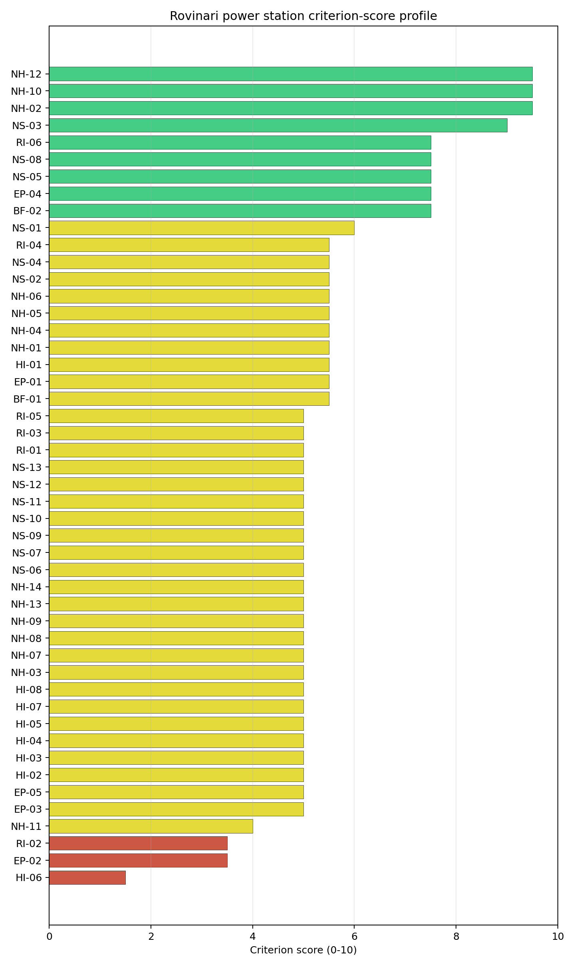
Criterion scores
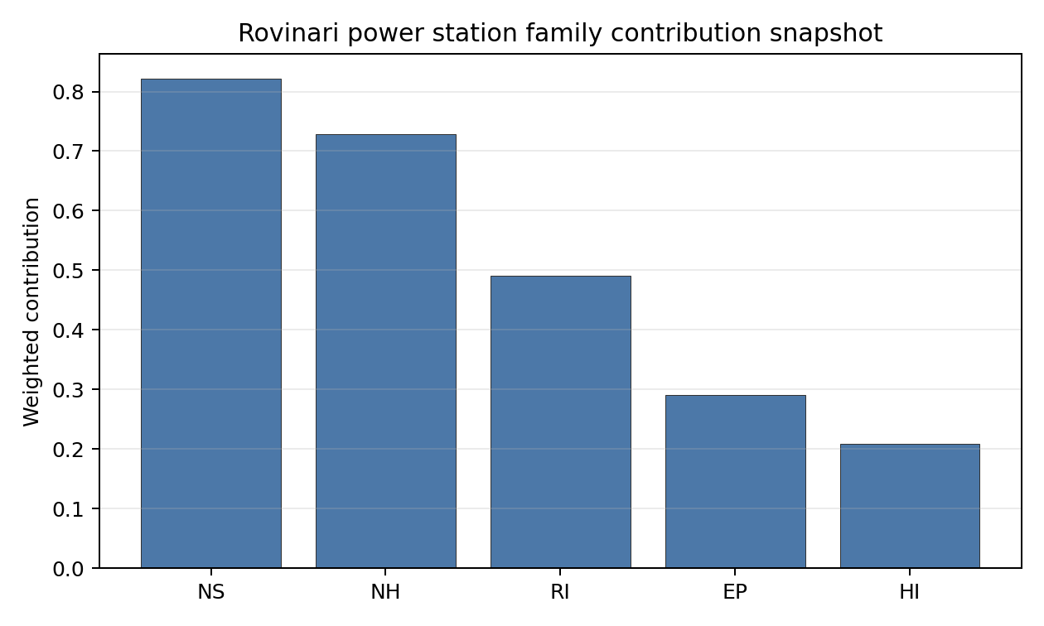
Family contributions
Rovinari is Romania’s second-ranked full-pass site in the current country ledger. Its 7.159 composite score and B stability band make it a credible fast follower after Turceni, rather than a marginal avoidance-led case. The Monte Carlo interval remains wide enough to justify targeted evidence upgrades, especially for military-feature classification, emergency planning, liquid-pathway evidence, meteorology, and grid-voltage confirmation. Those tasks narrow the Stage 3 evidence envelope; they do not change the current full-pass screening status.

Residual Risk Register
Concern | Evidence | Consequence | Stage 3 action | Owner discipline
Military Installations (HI-06) | Nearest military feature at 7.99 km; screening record carries no military-type attribute (no classified count within 25 km) | Feature classification ambiguity may convert to a security-cordon overlap once Romanian Ministry of National Defence positions are obtained | Engage Romanian Ministry of National Defence on the feature classification, airspace use, and any security-cordon depth requirements | security
Surface Water Dispersion (RI-02) | No site-specific receptor measurement (nearest_river_flow_m3s missing); current proxy band 10-30 m³/s with insufficient confidence | Liquid-effluent dilution margin unverified; affects radioactive-discharge permitting envelope on the Jiu | Measure Jiu river-segment dilution flow, low-flow recurrence, and downstream user inventory | hydrology
Evacuation Routes (EP-02) | Road density in EPZ 0.478 km/km², total road length 938.2 km, motorway access present, EP-01 composite 44.0/100 (FEASIBLE) with geography=10, terrain=10, roads=50.7 sub-scores | Evacuation bottlenecks driven by Jiu valley geography and the 17-waterway EPZ crossing may exceed national IRP-MAI target clearance time during peak conditions | Model EPZ time-to-clear under summer and winter loadings using IRP-MAI traffic data and the Gorj county network | emergency planning
Atmospheric Dispersion (RI-01) | Screening reanalysis 1991-2020: mean wind speed 0.5 m/s, prevailing N (0°), mean BLH 361 m, stable-fraction 88.1 % (E class dominant); current score 5.0/10 | Low-wind, near-permanently-stable regime concentrates accidental release within a narrow N plume rather than diluting it outward; the European-default dispersion assumption may be non-conservative | Confirm dispersion modelling assumptions for an 88 % stable-class regime with a national meteorological reference profile | meteorology
Extreme Precipitation (NH-11) | Screening reanalysis 1991-2020: screening precipitation index 27 mm/yr, extreme daily 0.3 mm; SPI12, snow-months and freezing-days not measured | Screening grid is too coarse to set the design rainfall and snow-load envelope; the values are physically implausible for the southern Carpathians | Re-measure with ANM (Administraţia Naţională de Meteorologie) station data and complete the precipitation sub-criteria | hydrology
Grid Connection (NS-02) | Nearest substation 0.38 km, nearest HV line 0.42 km at 110 kV; 882 MW export capacity matched to existing CTE_Rovinari_ROVI3_CA unit | 110 kV interconnection is below the 220-400 kV typically preferred for new nuclear; the 882 MW export capacity exceeds the 462 MWe NuScale VOYGR-6 (6 × 77 MWe modules) reference output, leaving headroom for the certified VOYGR-6 envelope without invoking any uncertified larger configuration | Confirm Transelectrica corridor upgrade pathway to 220 kV / 400 kV and update NS-02 against the planned topology | grid
Two concerns dominate the register. HI-06 is a governance question that only Ministry of National Defence engagement can resolve, and NS-02 is an engineering and programme question tied to the Transelectrica upgrade pathway. The remaining entries are characterisation gaps and permitting precursors rather than findings against the site. The register is a Stage 3 work plan, not a deal-breaker list: Rovinari is a full-pass site, ranks second nationally, and records a B stability band with a 100% national top-10 hit rate on a baseline composite of 7.159.

Stage 3 Follow-Up Checklist
- Re-measure Military Installations (HI-06) - native score 1.5/10 with confidence medium.
- Re-measure Evacuation Routes (EP-02) - native score 3.5/10 with confidence medium.
- Re-measure Surface Water Dispersion (RI-02) - native score 3.5/10 with confidence insufficient.
- Re-measure Extreme Precipitation (NH-11) - native score 4.0/10 with confidence medium.
- Re-measure Physical Geography Constraints (EP-03) - native score 5.0/10 with confidence medium.
- Improve data quality for Geotechnical: Subsidence & Collapse (NH-05b) - current flag low.
- Improve data quality for Coastal Flooding (NH-08) - current flag low.
- Improve data quality for Military Installations (HI-06) - current flag not_found.

Evidence Limitations
- Geotechnical: Subsidence & Collapse (NH-05b) - quality low.
- Coastal Flooding (NH-08) - quality low.
- Military Installations (HI-06) - quality not_found.

Turceni power station Site Profile
Turceni power station is a coal/thermal site in Romania that has been tested against the NuScale VOYGR-6 reference deployment envelope. This profile reads the screening evidence at a level that supports a decision to progress toward Stage 3 characterisation. It is not a site-suitability determination, vendor recommendation, or licensing finding.

Site Snapshot
Field | Value
Site name | Turceni power station
Coordinates | 44.6697, 23.4078
Subnational unit | Gorj
Installed thermal capacity (source data) | 2,640 MW
Available surface area | 173.0 ha
Available surface area for development | 169.8 ha
Composite score (baseline weights) | 7.816 (6.891-8.256 MC band)
National stability band | A (top-10% hit rate 100%)
National rank | 1
See the country status map in Romania Country Profile.

Ownership and Coal-to-Nuclear Context
- Government of Romania (77.15% share), headquartered in Romania; immediate operator Complexul Energetic Oltenia SA. Path: Government of Romania -> Ministry of Energy (Romania) [100.0%] -> Complexul Energetic Oltenia SA [77.15%] -> Turceni power station Unit 6 [100.0%]
- Fondul Proprietatea SA (21.55% share), headquartered in Romania; immediate operator Complexul Energetic Oltenia SA. Path: Fondul Proprietatea SA -> Complexul Energetic Oltenia SA [21.55%] -> Turceni power station Unit 1 [100.0%]
- NN Group NV (2.42% share), headquartered in Netherlands; immediate operator Complexul Energetic Oltenia SA. Path: NN Group NV -> Fondul Proprietatea SA [11.24%] -> Complexul Energetic Oltenia SA [21.55%] -> Turceni power station Unit 1 [100.0%]
- small shareholder(s) (17.84% share); immediate operator Complexul Energetic Oltenia SA. Path: small shareholder(s) -> Fondul Proprietatea SA [82.79%] -> Complexul Energetic Oltenia SA [21.55%] -> Turceni power station Unit 6 [100.0%]
- Ministry of Energy (Romania) (77.15% share), headquartered in Romania; immediate operator Complexul Energetic Oltenia SA. Path: Ministry of Energy (Romania) -> Complexul Energetic Oltenia SA [77.15%] -> Turceni power station Unit 6 [100.0%]
Generating units on record: 1 cancelled, 2 operating, 5 retired. Earliest unit commissioning: 1976; most recent: 1989. Retirements span 2006 to 2025, leaving brownfield grid, water, transport, and workforce assets that materially shorten Stage 3 site preparation.

Natural Hazards (NH)
- Seismic: Ground Motion (NH-01) - score 7.5/10 (MC 7.0-8.0), weight 0.0455, data quality high. Evidence: PGA at 475-year return period 0.081 g; PGA at 2,475-year return period 0.158 g; Vs30 reference (m/s): 760.0.
- Seismic: Surface Rupture (NH-02) - score 9.5/10 (MC 9.0-10.0), favourable band: very strong separation from mapped capable faults; surface-rupture concern effectively screened at desk-study level, weight n/a, data quality screening grade. Evidence: nearest mapped capable fault 50.0 km; fault slip rate 0 mm/yr; fault name: none_in_search_radius.
- Geotechnical: Liquefaction (NH-03) - score 5.5/10 (MC 5.0-6.0), pass-mark band: moderate susceptibility, or high/very-high with documented or pending mitigation, weight n/a, data quality medium. Evidence: liquefaction susceptibility: high; dominant soil type: clay_loam.
- Geotechnical: Slope Stability (NH-04) - score 7.5/10 (MC 7.0-8.0), weight n/a, data quality screening grade. Evidence: site slope 7.75 deg; max slope in 1 km box 79.9 deg; slope stability class: moderate.
- Geotechnical: Subsidence (NH-05) - score 9.5/10 (MC 9.0-10.0), favourable band: no karst and mine-feature distance well above the score-5 pivot, weight 0.0354, data quality medium. Evidence: karst present: no; karst severity: none.
- Geotechnical: Foundation (NH-06) - score 5.5/10 (MC 5.0-6.0), pass-mark band: typical European mixed conditions at 80-150 kPa bearing capacity, weight 0.0253, data quality medium. Evidence: bearing capacity 91.3 kPa; depth to bedrock 23.4 m.
- Volcanism (NH-07) - score 9.5/10 (MC 9.0-10.0), favourable band: very strong margin above the score-5 boundary with no in-radius signal, weight n/a, data quality high. Evidence: volcanic hazard class: negligible.
- Coastal Flooding (NH-08) - score 9.5/10 (MC 9.0-10.0), favourable band: non-coastal setting with no positive marine-hazard signal, weight 0.0303, data quality medium. Evidence: distance to coast 398.7 km.
- River Flooding (NH-09) - score 7.5/10 (MC 7.0-8.0), weight 0.0404, data quality medium. Evidence: flood zone class: negligible.
- Extreme Winds (NH-10) - score 9.5/10 (MC 9.0-10.0), favourable band: lowest relative wind exposure in the current monthly-means gust cohort, weight 0.0152, data quality medium. Evidence: screening wind-speed index 6.65 m/s.
- Extreme Precipitation (NH-11) - score 6.0/10 (MC 6.0-7.0), pass-mark band: aggregated mean of sub-scores, weight 0.0152, data quality medium. Evidence: screening extreme-precipitation index 0.37 mm; screening precipitation index 28.2 mm/yr.
- Extreme Temperatures (NH-12) - score 6.5/10 (MC 6.0-7.0), pass-mark band: aggregated mean of sub-scores, weight 0.0202, data quality medium. Evidence: extreme high temperature 25.7 deg C; extreme low temperature -4.67 deg C.
- Combined Hazards (NH-14) - score 7.5/10 (MC 7.0-8.0), weight 0.0152, data quality n/a. Evidence: values not in measurement tables.

Interpretation - Natural Hazards (NH)
Natural hazards at Turceni are favourable overall, with screening attention concentrated on liquefaction confidence, local precipitation, and geotechnical confirmation rather than on any standing exclusionary natural-hazard trigger. Ground motion is moderate: PGA is 0.081 g at the 475-year return period and 0.158 g at the 2,475-year return period, while the nearest mapped capable fault is 50.0 km from the site. The geotechnical file is adequate for Stage 1-2 but not final: liquefaction susceptibility is high, bearing capacity is 91.3 kPa, depth to bedrock is 23.4 m, site slope is 7.75 degrees, and the one-kilometre maximum slope of 79.94 degrees is a screening artefact that still warrants field confirmation. The wider hazard setting is stronger. Volcanic hazard is negligible, the coast is 398.66 km away, the flood-zone class is negligible, and the 50-year screening wind-speed index is 6.65 m/s. Extreme Precipitation (NH-11) has improved to 6.0/10 in the frozen scoring run, but the underlying values, 28.22 mm/year screening precipitation index and 0.37 mm screening extreme-precipitation index, remain implausibly low for a site near the southern Carpathian fringe. Stage 3 should therefore start with site-specific precipitation, snow-load and drainage confirmation, then run a CPT/SPT geotechnical campaign to settle liquefaction, bearing and foundation design inputs.

Human-Induced and Security-Relevant Hazards (HI)
- Aircraft Crash (HI-01) - score 9.5/10 (MC 9.0-10.0), favourable band: only small / GA / heliport airport >= 10 km nearby, no flight-path proxy < 4 km, no major airport within 30 km, and no military airbase within 60 km, weight 0.0354, data quality high. Evidence: nearest airport 36.9 km; nearest flight path 18.4 km; airports within search radius 0; airport name: Predeşti SkyFun Airfield; airport type: small airfield.
- Industrial Explosions (HI-02) - score 9.5/10 (MC 9.0-10.0), favourable band: very strong margin above the score-5 boundary, weight 0.0354, data quality medium. Evidence: values not in measurement tables.
- Toxic/Gas Releases (HI-03) - score 9.5/10 (MC 9.0-10.0), favourable band: very strong margin above the score-5 boundary, weight 0.0354, data quality medium. Evidence: values not in measurement tables.
- External Fires (HI-04) - score 9.5/10 (MC 9.0-10.0), favourable band: > 15 km or no flammable-storage signal found in radius, weight 0.0303, data quality medium. Evidence: values not in measurement tables.
- Military Installations (HI-06) - score 0.0/10 (MC 0.0-0.0), weight 0.0303, data quality high. Evidence: nearest military installation 2.91 km; military installations within radius 8; installation name: unnamed.
- Electromagnetic Interference (HI-07) - score 3.5/10 (MC 3.0-4.0), weight 0.0101, data quality medium. Evidence: nearest high-power transmitter 2.97 km; transmitters within radius 21; transmitter type: communication.

Interpretation - Human-Induced and Security-Relevant Hazards (HI)
Human-induced hazards at Turceni have one severe security issue inside an otherwise strong screening profile. Aircraft Crash (HI-01) is now favourable in the frozen run: the nearest airport is the Predeşti SkyFun Airfield at 36.85 km, the nearest major airport is 54.6 km away, the nearest flight-path proxy is 18.43 km away, and no airport is recorded inside the search radius. Industrial Explosions (HI-02), Toxic/Gas Releases (HI-03), and External Fires (HI-04) also score 9.5/10 on the current record, indicating no positive nearby hazard signal in the available screening evidence. The binding exception is Military Installations (HI-06), which scores 0.0/10: the nearest high-consequence military feature is a depot at 2.91 km, and eight depot-class military features sit within 25 km. Electromagnetic Interference (HI-07) is the second material issue, with the nearest transmitter at 2.97 km and 21 communication transmitters within 25 km, producing a 3.5/10 score. Stage 3 should therefore open with Ministry of National Defence engagement on the depot cluster and airspace/security perimeter, followed by an RF/EMI survey and a refreshed hazardous-neighbour inventory for the industrial and transport criteria.

Radiological Impact and Emergency Planning (RI / EP)
- Emergency Planning Feasibility (EP-01) - score 7.5/10 (MC 7.0-8.0), weight n/a, data quality high. Evidence: EP feasibility composite 69.7 /100; road sub-score 47.6 /100; special-population sub-score 90.0 /100; geography sub-score 95.0 /100; population sub-score 95.0 /100; evacuation feasible: yes.
- Evacuation Routes (EP-02) - score 3.5/10 (MC 3.0-4.0), weight 0.0303, data quality medium. Evidence: road density in EPZ 0.427 km/km2; road length in EPZ 838.6 km; motorway access: yes.
- Physical Geography Constraints (EP-03) - score 9.5/10 (MC 9.0-10.0), favourable band: no measured relief and open river/waterway context at interim screening, weight 0.0253, data quality medium. Evidence: waterways crossing EPZ 0; major river barrier: no.
- Special Populations (EP-04) - score 7.5/10 (MC 7.0-8.0), weight 0.0303, data quality medium. Evidence: hospitals in EPZ 6; prisons in EPZ 0; care homes in EPZ 0.
- Atmospheric Dispersion (RI-01) - score no native score (unscored, no band matched), weight 0.0303, data quality medium. Evidence: annual mean wind speed 0.75 m/s; atmospheric mixing height 417.5 m; prevailing wind direction: NE.
- Surface Water Dispersion (RI-02) - score 3.5/10 (MC 3.0-4.0), weight 0.0253, data quality n/a. Evidence: values not in measurement tables.
- Groundwater Dispersion (RI-03) - score 5.5/10 (MC 5.0-6.0), pass-mark band: moderate-permeability aquifer screening proxy, weight 0.0253, data quality medium. Evidence: aquifer type: alluvial.
- Population Density at EPZ Radii (RI-04) - score 7.5/10 (MC 7.0-8.0), weight 0.0404, data quality screening grade. Evidence: population density within 5 km 84.4 /km2; population density within 16 km 63.2 /km2; population density within 25 km 59.9 /km2; population density within 80 km 70.9 /km2; population within 25 km 117,614 people.
- Distance to Population Centres (RI-05) - score 9.5/10 (MC 9.0-10.0), favourable band: nearest >=50k population-centre proxy exceeds required distance by >= 50%, weight 0.0505, data quality screening grade. Evidence: nearest city above 50k people 42.7 km; nearest city population 95,351 people; city name: Târgu Jiu.
- Population Projections (RI-06) - score 9.5/10 (MC 9.0-10.0), favourable band: declining population projection below -0.5%/year, weight 0.0253, data quality screening grade. Evidence: annual population growth rate -0.667 %/yr; projected population at 25 km in 60 yr 90,790 people.

Interpretation - Radiological Impact and Emergency Planning (RI / EP)
Radiological impact and emergency planning at Turceni support Stage 3 consideration, but evacuation capacity and liquid-pathway evidence need early verification. Population pressure is moderate to low: the bundle records 6,628 people within 5 km, 117,614 within 25 km, and 1,424,739 within 80 km; population density is 84.4 people/km2 at 5 km and 59.91 people/km2 at 25 km. Târgu Jiu, with 95,351 people, is the nearest city above 50,000 people and lies 42.72 km away. Population Projections (RI-06) strengthen the screening read, with a -0.667%/year national growth rate and a projected 25 km population of 90,790 after 60 years. Emergency Planning Feasibility (EP-01) scores 69.7/100 and is marked feasible, with 47.6/100 on roads, 90.0/100 on special populations, 95.0/100 on geography, and 95.0/100 on population. The main weakness is Evacuation Routes (EP-02), where road density is 0.427 km/km2 despite 838.63 km of road and motorway access. Atmospheric dispersion remains a screening question because annual mean wind speed is 0.75 m/s and mixing height is 417.51 m, while Surface Water Dispersion (RI-02) sits at 3.5/10 pending a measured discharge and dilution analysis. Stage 3 should model EPZ clearance times on the Gorj road network, confirm Jiu low-flow and dilution behaviour, and run site-specific meteorological dispersion modelling before any emergency-planning claim is hardened.

Non-Safety and Implementation Considerations (NS)
- Grid Capacity Basic Filter (BF-01) - score 5.5/10 (MC 5.0-6.0), pass-mark band: substation 15-30 km or 110-219 kV, reinforcement plausible, weight n/a, data quality n/a. Evidence: values not in measurement tables.
- Land Area Basic Filter (BF-02) - score 9.5/10 (MC 9.0-10.0), favourable band: contiguous and buildable area above the ideal area, weight 0.0253, data quality n/a. Evidence: values not in measurement tables.
- Cooling Water Availability (NS-01) - score 8.0/10 (MC 7.0-8.0), favourable band: aggregated weighted mean of sub-scores, weight 0.0404, data quality screening grade. Evidence: distance to cooling source 1.28 km; cooling source flow 24.2 m3/s; cooling source type: river; cooling source name: Râul Jiu; water stress label: Low-Medium.
- Grid Connection (NS-02) - score 5.5/10 (MC 5.0-6.0), pass-mark band: aggregated minimum of sub-scores, weight 0.0404, data quality high. Evidence: nearest substation 0.22 km; nearest high-voltage line 0.59 km; highest nearby line voltage 110.0 kV; grid export capacity 1,311 MW; substations within radius 33; HV lines within radius 117.
- Transport Access (NS-03) - score 10.0/10 (MC 9.0-10.0), favourable band: aggregated weighted mean of sub-scores, weight 0.0404, data quality medium. Evidence: nearest rail line 0.26 km; heavy-haul capable: yes.
- Site Topography (NS-04) - score 9.5/10 (MC 9.0-10.0), favourable band: > 80%, weight 0.0303, data quality screening grade. Evidence: favourable land cover 83.9%; moderate land cover 7.8%; unfavourable land cover 8.2%; favourable area 235.1 ha; dominant land class: 211.
- Site Footprint Adequacy (NS-05) - score 9.5/10 (MC 9.0-10.0), favourable band: very strong margin above the score-5 boundary, weight 0.0253, data quality high. Evidence: buildable area 169.8 ha; largest contiguous patch 169.8 ha; buildable patch count 14.
- Existing Infrastructure (NS-06) - score no native score (unscored, no band matched), weight 0.0253, data quality n/a. Evidence: not measured at this site (criterion remains unscored).
- Ecological Sensitivity (NS-08) - score 1.5/10 (MC 1.0-2.0), weight n/a, data quality high. Evidence: natural land cover 8.2 %; distance to nearest Natura 2000 site 1.418 km; distance to nearest protected area 7.473 km; Natura 2000 overlap: no; Natura 2000 sensitivity class: moderate; protected-area overlap: no; protected-area sensitivity class: low; nearest Natura 2000 site: Coridorul Jiului; Natura 2000 sites within 5 km: 1; nearest protected-area designation: Not Assigned.
- Workforce Availability (NS-10) - score no native score (unscored, no band matched), weight 0.0202, data quality n/a. Evidence: not measured at this site (criterion remains unscored).
- Regulatory/Political Environment (NS-12) - score no native score (unscored, no band matched), weight 0.0303, data quality n/a. Evidence: not measured at this site (criterion remains unscored).
- Construction Logistics (NS-13) - score no native score (unscored, no band matched), weight 0.0202, data quality n/a. Evidence: not measured at this site (criterion remains unscored).

Interpretation - Non-Safety and Implementation Considerations (NS)
Non-safety and implementation conditions are the strongest part of Turceni’s profile, although ecological sensitivity and voltage pathway remain material Stage 3 questions. Cooling Water Availability (NS-01) scores 8.0/10: the Râul Jiu is 1.28 km from the site, mean discharge is 24.24 m3/s, and the water-stress score is 0.25, labelled Low-Medium. Grid Connection (NS-02) is close but not yet ideal for a nuclear project, with the nearest substation at 0.22 km, the nearest high-voltage line at 0.59 km, 117 high-voltage lines and 33 substations within the search radius, but a highest nearby voltage of 110 kV and a 1,311 MW inherited export-capacity estimate. Transport access is strong, with rail at 0.26 km and heavy-haul capability recorded. Land is also strong when the correct hierarchy is used: the canonical site footprint is 173.0 ha, the current buildable-area estimate is 169.78 ha in the largest contiguous patch, and the 235.12 ha favourable-area figure is only a wider screening-stage expansion envelope. Ecological Sensitivity (NS-08) is the main non-safety constraint, scoring 1.5/10 because Coridorul Jiului is 1.418 km away and one Natura 2000 site lies within 5 km, despite no direct overlap; the nearest protected-area record is 7.473 km away. Stage 3 should therefore confirm the 220 kV or 400 kV grid pathway, run a Habitats Directive Article 6(3) screening and national EIA scoping review, and verify ownership, contiguity and reuse conditions for the 173.0 ha site footprint.

Composite Score and Stability
Baseline composite score is 7.816, bracketed by Monte Carlo at 6.891-8.256. National stability band is A with a top-10% hit rate of 100% across 12 scored Monte Carlo scenarios.
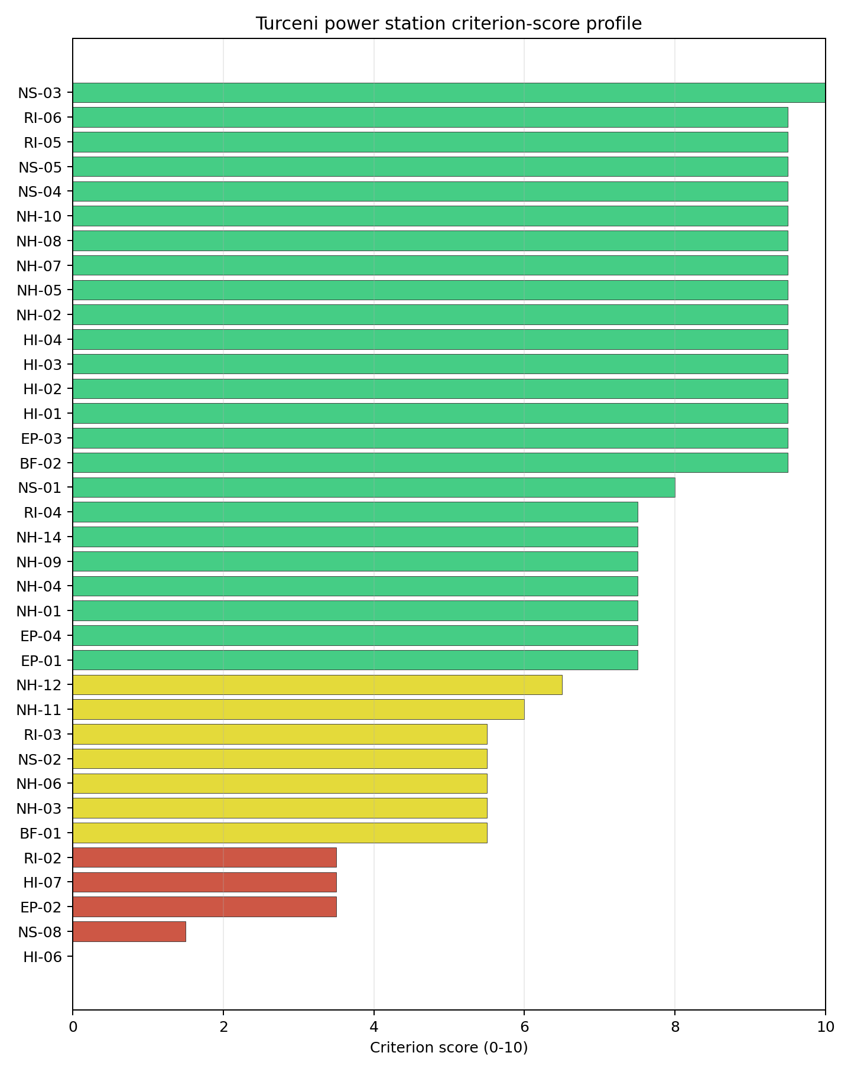
Criterion scores
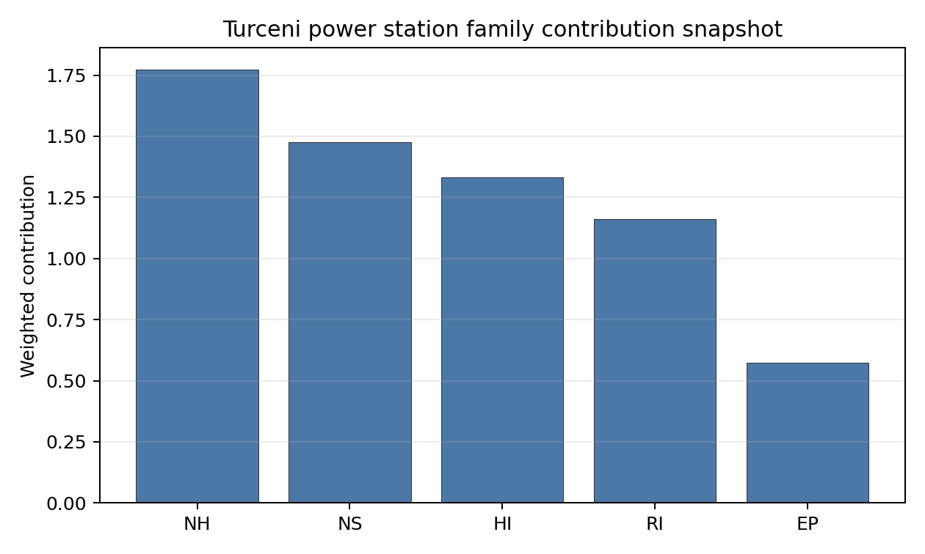
Family contributions
Turceni’s baseline composite score is 7.816, with a Monte Carlo bracket of 6.891-8.256. The national stability band is A, and the site records 100% top-5, top-10 and top-30 hit rates across all 12 scored national sensitivity scenarios. That is a tight and useful Stage 1-2 signal: Turceni remains Romania’s leading brownfield candidate under the national weight perturbations considered, rather than depending on a narrow baseline-weight result. The composite is also balanced across families, with NS 8.36, RI 8.21, NH 7.80, HI 7.53 and EP 6.68 after the unscored-criterion penalty. The remaining uncertainty is therefore not about the whole-site ranking, but about which Stage 3 work items can retire the largest residual risk. HI-06, NS-08, EP-02, HI-07 and RI-02 are the practical priorities, while NS-06, NS-10, NS-12 and NS-13 need conversion from unscored or low-confidence values into project-specific evidence.

Residual Risk Register
Concern | Evidence | Consequence | Stage 3 action | Owner discipline
Military Installations (HI-06) | Nearest depot-class military feature 2.91 km away; eight depot-class features within 25 km | Security standoff, airspace and emergency-zone coordination could become exclusionary if the feature classification is confirmed | Engage the Ministry of National Defence on feature classification, airspace, and required security-cordon depth | security
Ecological Sensitivity (NS-08) | Coridorul Jiului is 1.418 km away with no overlap; one Natura 2000 site lies within 5 km; nearest protected-area record is 7.473 km away | Permitting and siting envelope may narrow if the Article 6(3) and EIA screens identify indirect effects | Confirm protected-area boundaries, receptor pathways and appropriate-assessment trigger status | EIA
Evacuation Routes (EP-02) | EPZ road density 0.427 km/km2; 838.63 km of road; motorway access present | Time-to-clear may be constrained despite regional road access | Model EPZ evacuation clearance under seasonal and peak-load conditions | emergency planning
Electromagnetic Interference (HI-07) | Nearest transmitter 2.97 km away; 21 communication transmitters within 25 km | RF/EMI controls may require design separation or operating restrictions | Survey transmitter inventory, field strengths and exclusion distances | security
Surface Water Dispersion (RI-02) | Cooling source 1.28 km away; mean flow 24.24 m3/s; liquid-pathway score 3.5/10 | Low-flow dilution margin remains unverified for the radioactive-discharge envelope | Quantify Jiu low-flow recurrence, intake/discharge pathways and downstream users | hydrology
Extreme Precipitation (NH-11) | Screening precipitation index 28.22 mm/year; screening extreme-precipitation index 0.37 mm | Screening precipitation values appear too low for design-rainfall and drainage sizing | Re-measure precipitation and snow-load inputs against national station records and site drainage surveys | hydrology
HI-06 and NS-08 dominate the residual-risk register because either could change the site boundary or the go/no-go judgement before engineering optimisation begins. EP-02, HI-07, RI-02 and NH-11 are characterisation tasks that can narrow the Stage 3 work programme and reduce uncertainty around emergency planning, EMI, liquid pathways and design hydrology. The register is a Stage 3 work plan for a leading screening candidate, not a finding of site approval.

Stage 3 Follow-Up Checklist
- Re-measure Military Installations (HI-06) - native score 0.0/10 with confidence high.
- Re-measure Ecological Sensitivity (NS-08) - native score 1.5/10 with confidence high.
- Re-measure Evacuation Routes (EP-02) - native score 3.5/10 with confidence medium.
- Re-measure Electromagnetic Interference (HI-07) - native score 3.5/10 with confidence medium.
- Re-measure Surface Water Dispersion (RI-02) - native score 3.5/10 with confidence insufficient.
- Improve data quality for Geotechnical: Subsidence & Collapse (NH-05b) - current flag low.

Evidence Limitations
- Geotechnical: Subsidence & Collapse (NH-05b) - quality low.

Serbia Country Profile
Serbia has 8 thermal and coal-site records tested against the NuScale VOYGR-6 reference deployment envelope. No site clears both the exclusionary and avoidance screens, 6 sites pass the exclusionary screen with avoidance flags, and 2 sites are removed at the exclusionary stage. The national pool is therefore a remediation-first brownfield portfolio rather than a ready full-pass shortlist.
The current evidence base does not treat national nuclear-programme readiness as settled. Serbia’s profile should therefore couple any Stage 3 site characterisation with regulatory, emergency-planning, workforce and owner-governance readiness work. The screening result is still useful: it identifies where the existing thermal estate offers grid, water, land and transport inheritance, and where those advantages are conditional on avoidance-flag resolution.
The leading site is Štavalj Power Station, with a composite score of 6.753 and a Monte Carlo interval of 5.928-7.175. Its national stability band is A with a national top-10% hit rate of 92%. Kostolac, Kolubara A, Kovin and Kolubara B complete the selected top five, but all four sit in band H, so the national sequence should start with the stable leader and treat the remaining sites as conditional fast followers.
Serbia’s 8 ranked thermal records produce no full-pass site, 6 exclusionary-pass sites with avoidance flags, and 2 hard-fail sites. The leadership pool is therefore narrow and conditional: Štavalj leads with band A stability, while Kostolac, Kolubara A, Kovin and Kolubara B remain close on point-estimate score but much weaker on national stability. That structure supports one priority characterisation candidate and a second tier that should be tested through targeted avoidance-flag work before any multi-site programme claim is made.
The avoidance unlock pool is concentrated. Aircraft Crash (HI-01) and Grid Connection (NS-02) each affect 3 of the 6 exclusionary-pass sites, or 50% of the pool. Resolving those constraints means airport and flight-path confirmation, transmission voltage and export-capacity review, and owner-specific interface work for the plants whose brownfield value depends on grid inheritance.
Greenfield options remain a programme lever if Serbia’s eventual build-out objective exceeds what the brownfield pool can support. On the current screening evidence, a credible Stage 3 sequence begins with Štavalj as the stable national leader, uses Kostolac as the first operating-site comparator, and keeps the Kolubara and Kovin entries as a third wave dependent on resolving grid and aircraft-crash constraints. Morava and Despotovac should remain in the evidence base as hard-fail comparators unless site-specific work refutes their Seismic: Surface Rupture (NH-02) exclusionary trigger.

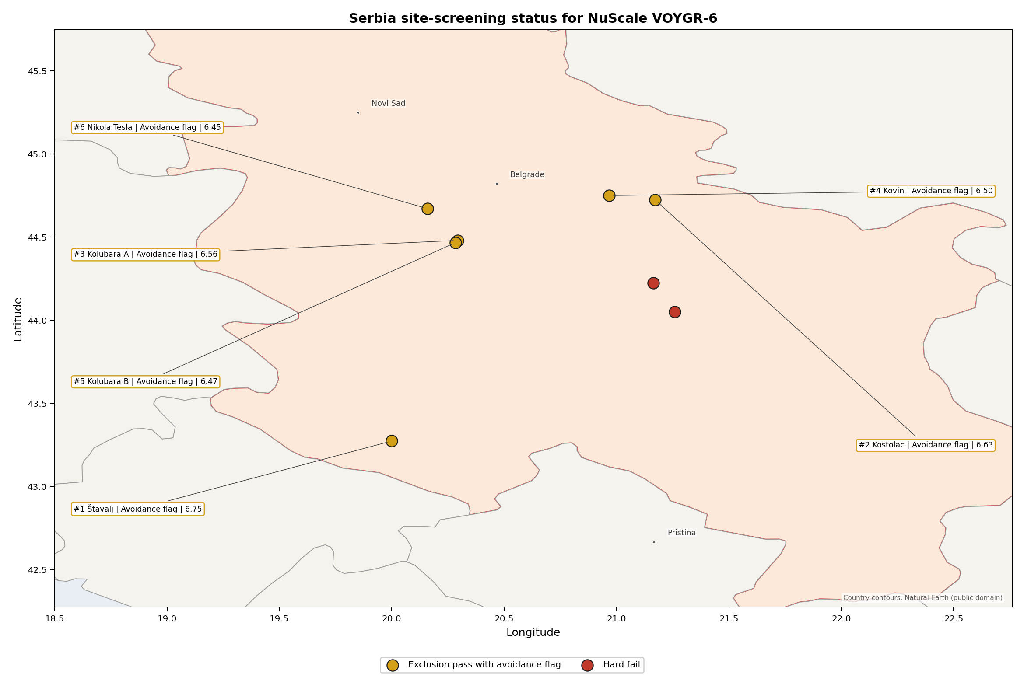
Serbia status map

Serbia Site Ledger
Rank | Site | Status | Composite | MC Low | MC High | Band | Top-10 Hit | Coverage
1 | Štavalj Power Station | Exclusion pass with avoidance flag | 6.753 | 5.928 | 7.175 | A | 92% | 76%
2 | Kostolac power station | Exclusion pass with avoidance flag | 6.634 | 5.906 | 7.244 | H | 8% | 76%
3 | Kolubara A power station | Exclusion pass with avoidance flag | 6.559 | 5.831 | 7.069 | H | 0% | 76%
4 | Kovin power station | Exclusion pass with avoidance flag | 6.503 | 5.831 | 7.094 | H | 0% | 76%
5 | Kolubara B power station | Exclusion pass with avoidance flag | 6.472 | 5.744 | 6.981 | H | 0% | 76%
6 | Nikola Tesla power station | Exclusion pass with avoidance flag | 6.453 | 5.694 | 6.994 | H | 0% | 76%
- | Despotovac power station | Hard fail | - | - | - | - | - | 0%
- | Morava power station | Hard fail | - | - | - | - | - | 0%
Selected for detailed site profiles: Štavalj Power Station, Kostolac power station, Kolubara A power station, Kovin power station, and Kolubara B power station. These are the top five sites by national ranking under the frozen national sensitivity basis.

Avoidance Flag Pareto
Of the 6 sites that pass the exclusionary screen, the avoidance-phase flags concentrate on two criteria. Each affects half of the exclusionary-pass pool, so the unlock work is narrow but material.
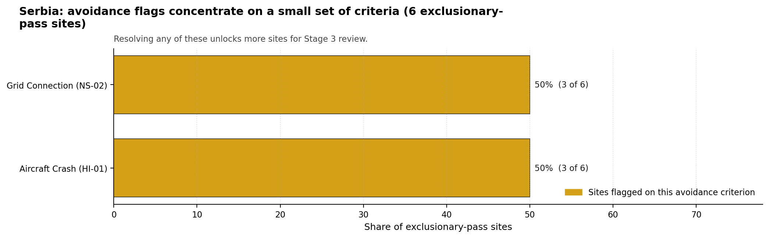
Avoidance flag Pareto
- Aircraft Crash (HI-01) - 3 of 6 exclusionary-pass sites (50%) - airport, airspace and flight-path confirmation for the selected brownfield envelope.
- Grid Connection (NS-02) - 3 of 6 exclusionary-pass sites (50%) - transmission voltage, export-capacity and reinforcement-path confirmation.

Exclusionary Failure Pareto
The hard-fail tail is driven by one criterion. This keeps the exclusionary story clear: the removed sites require site-specific capable-fault review before they can re-enter the brownfield candidate pool.
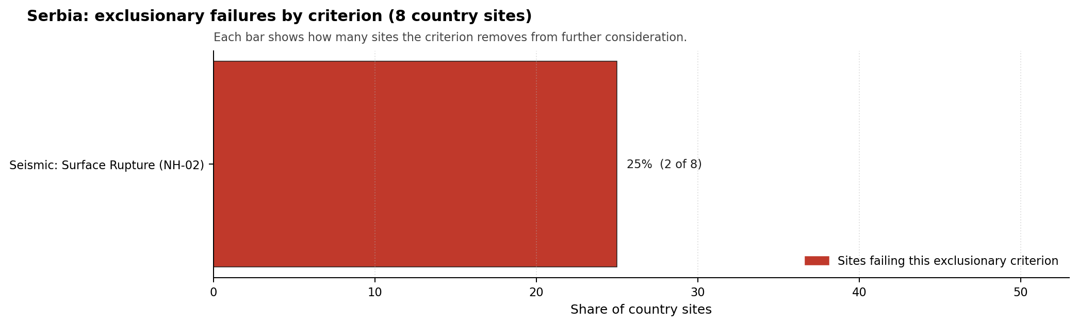
Exclusionary failure Pareto
- Seismic: Surface Rupture (NH-02) - 2 of 8 country sites (25%) - capable-fault stand-off controls whether the site remains excluded.

Family Strength and Weakness
Across the country the strongest criterion family is Natural Hazards at a mean normalised score of 7.07/10. The weakest family is Radiological Impact at 5.41/10. The bottom three individual criteria across the country are:
- Military Installations (HI-06) - mean 1.25/10 across 8 scored sites (min 0.0, max 3.5).
- Electromagnetic Interference (HI-07) - mean 1.75/10 across 8 scored sites (min 1.5, max 3.5).
- Grid Connection (NS-02) - mean 3.25/10 across 8 scored sites (min 1.5, max 7.5).

National Sensitivity and Robustness
The national sensitivity result separates Štavalj from the rest of the scored pool. Štavalj records band A and a 92% national top-10% hit rate, while the other five scored sites sit in band H with top-10% hit rates from 0% to 8%. The Monte Carlo score intervals overlap across the selected group, so exact point-estimate differences should not drive sequencing by themselves.

Interpretation for Site Selection
Serbia has no current full-pass site. The selected top five are therefore not deployment recommendations; they are the most defensible places to spend Stage 3 characterisation effort if the programme owner accepts an avoidance-resolution workstream. The first distinction is exclusionary survival: Štavalj, Kostolac, Kolubara A, Kovin and Kolubara B remain in the ranked pool, while Morava and Despotovac are hard-fail comparators until their NH-02 evidence changes.

Avoidance flag Pareto - what unlocks more sites
The chart shows that targeted work can retire a large share of Serbia’s uncertainty. Aircraft Crash (HI-01) and Grid Connection (NS-02) are the leading unlock levers, and both are better handled as national or owner-level workstreams than as isolated site notes.
A practical Stage 3 cadence starts with Štavalj because it combines the highest point estimate, the only band A stability profile, and a large enough surface-area envelope for screening purposes. Kostolac should be reviewed next because it is an operating thermal site with large installed capacity and direct brownfield relevance. Kolubara A, Kovin and Kolubara B then form the conditional third wave, with the Kolubara entries treated as related evidence on the same wider brownfield envelope rather than as independent programme slots until ownership, grid and land controls are confirmed.

Status Counts
- Full pass: 0
- Exclusion pass with avoidance flag: 6
- Hard fail: 2

Kolubara A power station Site Profile
Kolubara A power station is a coal/thermal site in Serbia that has been tested against the NuScale VOYGR-6 reference deployment envelope. This profile reads the screening evidence at a level that supports a decision to progress toward Stage 3 characterisation. It is not a site suitability determination, vendor recommendation, or licensing finding.

Site Snapshot
Field | Value
Site name | Kolubara A power station
Coordinates | 44.4803, 20.2935
Subnational unit | Beograd
Installed thermal capacity (source data) | 271 MW
Available surface area | 51.5 ha
Available surface area for development | 51.5 ha
Composite score (baseline weights) | 6.559 (5.831-7.069 MC band)
National stability band | H (top-10% hit rate 0%)
National rank | 3
See the country status map in Serbia Country Profile.

Ownership and Coal-to-Nuclear Context
- Elektroprivreda Srbije Beograd AD (100.00% share), headquartered in Serbia; immediate operator Elektroprivreda Srbije Beograd AD. Path: Elektroprivreda Srbije Beograd AD -> Kolubara A power station Unit 1 [100.0%]
- Government of the Republic of Serbia (100.00% share), headquartered in Serbia; immediate operator Elektroprivreda Srbije Beograd AD. Path: Government of the Republic of Serbia -> Elektroprivreda Srbije Beograd AD [100.0%] -> Kolubara A power station Unit 1 [100.0%]
Generating units on record: 1 mothballed, 4 operating. Earliest unit commissioning: 1956; most recent: 1979.

Natural Hazards (NH)
- Seismic: Ground Motion (NH-01) - score 5.5/10 (MC 5.0-6.0) - pass-mark band: At or below the score-5 risk boundary, weight 0.0455, data quality high. Evidence: PGA at 475-year return period 0.184 g; PGA at 2,475-year return period 0.397 g; Vs30 reference (m/s): 760.0.
- Seismic: Surface Rupture (NH-02) - score 5.5/10 (MC 5.0-6.0) - pass-mark band: Borderline acceptable separation: meets the 8.0 km score boundary; check against the 8 km conservative screen and local capability evidence, weight n/a, data quality screening grade. Evidence: nearest mapped capable fault 13.0 km; fault slip rate 0.071 mm/yr; fault name: RSCF00J.
- Geotechnical: Liquefaction (NH-03) - score 5.5/10 (MC 5.0-6.0) - pass-mark band: Moderate susceptibility, or high/very-high with documented (or pending for high) mitigation, weight n/a, data quality medium. Evidence: liquefaction susceptibility: moderate; dominant soil type: clay_loam.
- Geotechnical: Slope Stability (NH-04) - score 9.5/10 (MC 9.0-10.0) - favourable: Well below the risk boundary, weight n/a, data quality screening grade. Evidence: site slope 4.59 deg; max slope in 1 km box 80.1 deg; slope stability class: gentle.
- Geotechnical: Subsidence (NH-05) - score 7.5/10 (MC 7.0-8.0), weight 0.0354, data quality medium. Evidence: karst present: no; karst severity: none.
- Geotechnical: Foundation (NH-06) - score 5.5/10 (MC 5.0-6.0) - pass-mark band: Typical European mixed conditions (bearing 80-150 kPa), weight 0.0253, data quality medium. Evidence: bearing capacity 88.7 kPa; depth to bedrock 21.1 m.
- Volcanism (NH-07) - score 9.5/10 (MC 9.0-10.0) - favourable: Very strong margin above the score-5 boundary (or no in-radius signal is recorded), weight n/a, data quality high. Evidence: volcanic hazard class: negligible.
- Coastal Flooding (NH-08) - score 9.5/10 (MC 9.0-10.0) - favourable: Non-coastal OR elevation >= 50 m AMSL OR landlocked country, with no positive marine-hazard signal, weight 0.0303, data quality medium. Evidence: distance to coast 262.7 km.
- River Flooding (NH-09) - score 7.5/10 (MC 7.0-8.0), weight 0.0404, data quality medium. Evidence: flood zone class: negligible.
- Extreme Winds (NH-10) - score 9.5/10 (MC 9.0-10.0) - favourable: Lowest relative wind exposure in the current screening wind-exposure cohort (< 7.5 m/s), weight 0.0152, data quality medium. Evidence: screening wind-speed index 7.47 m/s.
- Extreme Precipitation (NH-11) - score 8.0/10 (MC 8.0-9.0) - favourable: aggregated(mean_of_sub_scores), weight 0.0152, data quality medium. Evidence: screening extreme-precipitation index 0.24 mm; screening precipitation index 23.0 mm/yr.
- Extreme Temperatures (NH-12) - score 5.5/10 (MC 5.0-6.0) - pass-mark band: aggregated(mean_of_sub_scores), weight 0.0202, data quality medium. Evidence: extreme high temperature 26.5 deg C; extreme low temperature -4.95 deg C.
- Combined Hazards (NH-14) - score 5.5/10 (MC 5.0-6.0) - pass-mark band: At least 5 resolved, exactly one moderate hazard (3-5) or moderate interaction only, weight 0.0152, data quality n/a. Evidence: values not in measurement tables.

Interpretation - Natural Hazards (NH)
Natural hazards at Kolubara A power station support a Stage 1-2 screening read, but they do not remove the need for site-specific characterisation. Key measured evidence is Seismic: Ground Motion (NH-01): PGA at 475-year return period 0.184 g; PGA at 2,475-year return period 0.397 g; Seismic: Surface Rupture (NH-02): nearest mapped capable fault 13.0 km; fault slip rate 0.071 mm/yr; Geotechnical: Liquefaction (NH-03): liquefaction susceptibility: moderate; dominant soil type: clay_loam. The main Stage 3 questions are Seismic: Ground Motion (NH-01), Seismic: Surface Rupture (NH-02), Geotechnical: Liquefaction (NH-03); each should be re-measured or confirmed before the site is treated as more than a screening-stage candidate.

Human-Induced and Security-Relevant Hazards (HI)
- Aircraft Crash (HI-01) - score 9.5/10 (MC 9.0-10.0) - favourable: Only small / GA / heliport airport >= 10 km nearby, no flight-path proxy < 4 km, no major airport within 30 km, and no military airbase within 60 km, weight 0.0354, data quality high. Evidence: nearest airport 24.1 km; nearest flight path 12.1 km; airports within search radius 3; airport name: Zabrežje Airfield; airport type: small airfield.
- Industrial Explosions (HI-02) - score 9.5/10 (MC 7.5-10.0) - favourable: Very strong margin above the score-5 boundary (or no in-radius signal is recorded), weight 0.0354, data quality low. Evidence: values not in measurement tables.
- Toxic/Gas Releases (HI-03) - score 9.5/10 (MC 7.5-10.0) - favourable: Very strong margin above the score-5 boundary (or no in-radius signal is recorded), weight 0.0354, data quality low. Evidence: values not in measurement tables.
- External Fires (HI-04) - score 9.5/10 (MC 7.5-10.0) - favourable: > 15 km, or completed flammable-storage search found nothing in radius, weight 0.0303, data quality low. Evidence: values not in measurement tables.
- Military Installations (HI-06) - score 3.5/10 (MC 3.0-4.0), weight 0.0303, data quality medium. Evidence: nearest military installation 21.6 km; military installations within radius 5; installation name: unnamed.
- Electromagnetic Interference (HI-07) - score 1.5/10 (MC 1.0-2.0), weight 0.0101, data quality medium. Evidence: nearest high-power transmitter 0.16 km; transmitters within radius 107; transmitter type: mast.

Interpretation - Human-Induced and Security-Relevant Hazards (HI)
Human-induced and security-relevant hazards at Kolubara A power station support a Stage 1-2 screening read, but they do not remove the need for site-specific characterisation. Key measured evidence is Electromagnetic Interference (HI-07): nearest high-power transmitter 0.16 km; transmitters within radius 107; Military Installations (HI-06): nearest military installation 21.6 km; military installations within radius 5; Aircraft Crash (HI-01): nearest airport 24.1 km; nearest flight path 12.1 km. The main Stage 3 questions are Electromagnetic Interference (HI-07), Military Installations (HI-06), Aircraft Crash (HI-01); each should be re-measured or confirmed before the site is treated as more than a screening-stage candidate.

Radiological Impact and Emergency Planning (RI / EP)
- Emergency Planning Feasibility (EP-01) - score 7.5/10 (MC 7.0-8.0), weight n/a, data quality high. Evidence: EP feasibility composite 65.7 /100; road sub-score 52.9 /100; special-population sub-score 90.0 /100; geography sub-score 95.0 /100; population sub-score 80.0 /100; evacuation feasible: yes.
- Evacuation Routes (EP-02) - score 5.5/10 (MC 5.0-6.0) - pass-mark band: Adequate primary routes (0.5-1.0), weight 0.0303, data quality medium. Evidence: road density in EPZ 0.515 km/km2; road length in EPZ 1,010 km; motorway access: yes.
- Physical Geography Constraints (EP-03) - score 9.5/10 (MC 9.0-10.0) - favourable: No measured relief; open river/waterway context (interim screening), weight 0.0253, data quality medium. Evidence: waterways crossing EPZ 0; major river barrier: no.
- Special Populations (EP-04) - score 5.5/10 (MC 5.0-6.0) - pass-mark band: 9-25, weight 0.0303, data quality medium. Evidence: hospitals in EPZ 11; prisons in EPZ 0; care homes in EPZ 0.
- Atmospheric Dispersion (RI-01) - score no native score (unscored - no band matched), weight 0.0303, data quality medium. Evidence: annual mean wind speed 0.77 m/s; atmospheric mixing height 495.1 m; prevailing wind direction: W.
- Surface Water Dispersion (RI-02) - score 3.5/10 (MC 3.0-4.0), weight 0.0253, data quality n/a. Evidence: values not in measurement tables.
- Groundwater Dispersion (RI-03) - score 5.5/10 (MC 5.0-6.0) - pass-mark band: Moderate-permeability aquifer screening proxy, weight 0.0253, data quality medium. Evidence: aquifer type: alluvial.
- Population Density at EPZ Radii (RI-04) - score 3.5/10 (MC 3.0-4.0), weight 0.0404, data quality screening grade. Evidence: population density within 5 km 144.9 /km2; population density within 16 km 131.2 /km2; population density within 25 km 144.1 /km2; population density within 80 km 179.2 /km2; population within 25 km 282,896 people.
- Distance to Population Centres (RI-05) - score 3.5/10 (MC 3.0-4.0), weight 0.0505, data quality screening grade. Evidence: values not in measurement tables.
- Population Projections (RI-06) - score 7.5/10 (MC 7.0-8.0), weight 0.0253, data quality screening grade. Evidence: annual population growth rate -0.304 %/yr; projected population at 25 km in 60 yr 157,994 people.

Interpretation - Radiological Impact and Emergency Planning (RI / EP)
Radiological impact and emergency planning at Kolubara A power station support a Stage 1-2 screening read, but they do not remove the need for site-specific characterisation. Key measured evidence is Surface Water Dispersion (RI-02): not measured in the current evidence set; Population Density at EPZ Radii (RI-04): population density within 5 km 144.9 /km2; population density within 16 km 131.2 /km2; Distance to Population Centres (RI-05): nearest city distance not recorded; required distance 16.0 km. The main Stage 3 questions are Surface Water Dispersion (RI-02), Population Density at EPZ Radii (RI-04), Distance to Population Centres (RI-05); each should be re-measured or confirmed before the site is treated as more than a screening-stage candidate.

Non-Safety and Implementation Considerations (NS)
- Grid Capacity Basic Filter (BF-01) - score 5.5/10 (MC 5.0-6.0) - pass-mark band: Note: substation 15-30 km OR 110-219 kV; reinforcement plausible, weight n/a, data quality n/a. Evidence: values not in measurement tables.
- Land Area Basic Filter (BF-02) - score 7.5/10 (MC 7.0-8.0), weight 0.0253, data quality n/a. Evidence: values not in measurement tables.
- Cooling Water Availability (NS-01) - score 8.0/10 (MC 7.0-8.0) - favourable: aggregated(weighted_mean_of_sub_scores), weight 0.0404, data quality screening grade. Evidence: distance to cooling source 4.31 km; cooling source flow 10.2 m3/s; cooling source type: river; cooling source name: Турија; water stress label: Low.
- Grid Connection (NS-02) - score 1.5/10 (MC 1.0-2.0), weight 0.0404, data quality high. Evidence: nearest substation 0.16 km; nearest high-voltage line 0.3 km; highest nearby line voltage 110.0 kV; grid export capacity 175.0 MW; substations within radius 206; HV lines within radius 241.
- Transport Access (NS-03) - score 9.0/10 (MC 8.0-10.0) - favourable: aggregated(weighted_mean_of_sub_scores), weight 0.0404, data quality low. Evidence: nearest highway 1.2 km; nearest rail line 0.16 km; heavy-haul capable: yes.
- Site Topography (NS-04) - score 3.5/10 (MC 3.0-4.0), weight 0.0303, data quality screening grade. Evidence: favourable land cover 36.7 %; moderate land cover 28.4 %; unfavourable land cover 35.0 %; favourable area 77.9 ha; dominant land class: 311.
- Site Footprint Adequacy (NS-05) - score 7.5/10 (MC 7.0-8.0), weight 0.0253, data quality high. Evidence: buildable area 51.5 ha; largest contiguous patch 51.5 ha; buildable patch count 9.
- Existing Infrastructure (NS-06) - score no native score (unscored - no band matched), weight 0.0253, data quality n/a. Evidence: not measured at this site (criterion remains unscored).
- Ecological Sensitivity (NS-08) - score 5.5/10 (MC 3.5-7.5) - pass-mark band: Both networks NULL or >= 5 km, weight n/a, data quality insufficient. Evidence: natural land cover 35.0 %; distance to nearest protected area 9.693 km; Natura 2000 sensitivity class: unknown; protected-area overlap: no; protected-area sensitivity class: low; Natura 2000 sites within 5 km: 0; nearest protected-area designation: Natural Monument.
- Workforce Availability (NS-10) - score no native score (unscored - no band matched), weight 0.0202, data quality n/a. Evidence: not measured at this site (criterion remains unscored).
- Regulatory/Political Environment (NS-12) - score no native score (unscored - no band matched), weight 0.0303, data quality n/a. Evidence: not measured at this site (criterion remains unscored).
- Construction Logistics (NS-13) - score no native score (unscored - no band matched), weight 0.0202, data quality n/a. Evidence: not measured at this site (criterion remains unscored).

Interpretation - Non-Safety and Implementation Considerations (NS)
Non-safety and implementation considerations at Kolubara A power station support a Stage 1-2 screening read, but they do not remove the need for site-specific characterisation. Key measured evidence is Grid Connection (NS-02): nearest substation 0.16 km; nearest high-voltage line 0.3 km; Site Topography (NS-04): favourable land cover 36.7 %; moderate land cover 28.4 %; Existing Infrastructure (NS-06): not measured in the current evidence set. The main Stage 3 questions are Grid Connection (NS-02), Site Topography (NS-04), Existing Infrastructure (NS-06); each should be re-measured or confirmed before the site is treated as more than a screening-stage candidate.

Composite Score and Stability
Baseline composite score is 6.559, bracketed by Monte Carlo at 5.831-7.069. National stability band is H with a top-10% hit rate of 0% across 12 scored Monte Carlo scenarios.
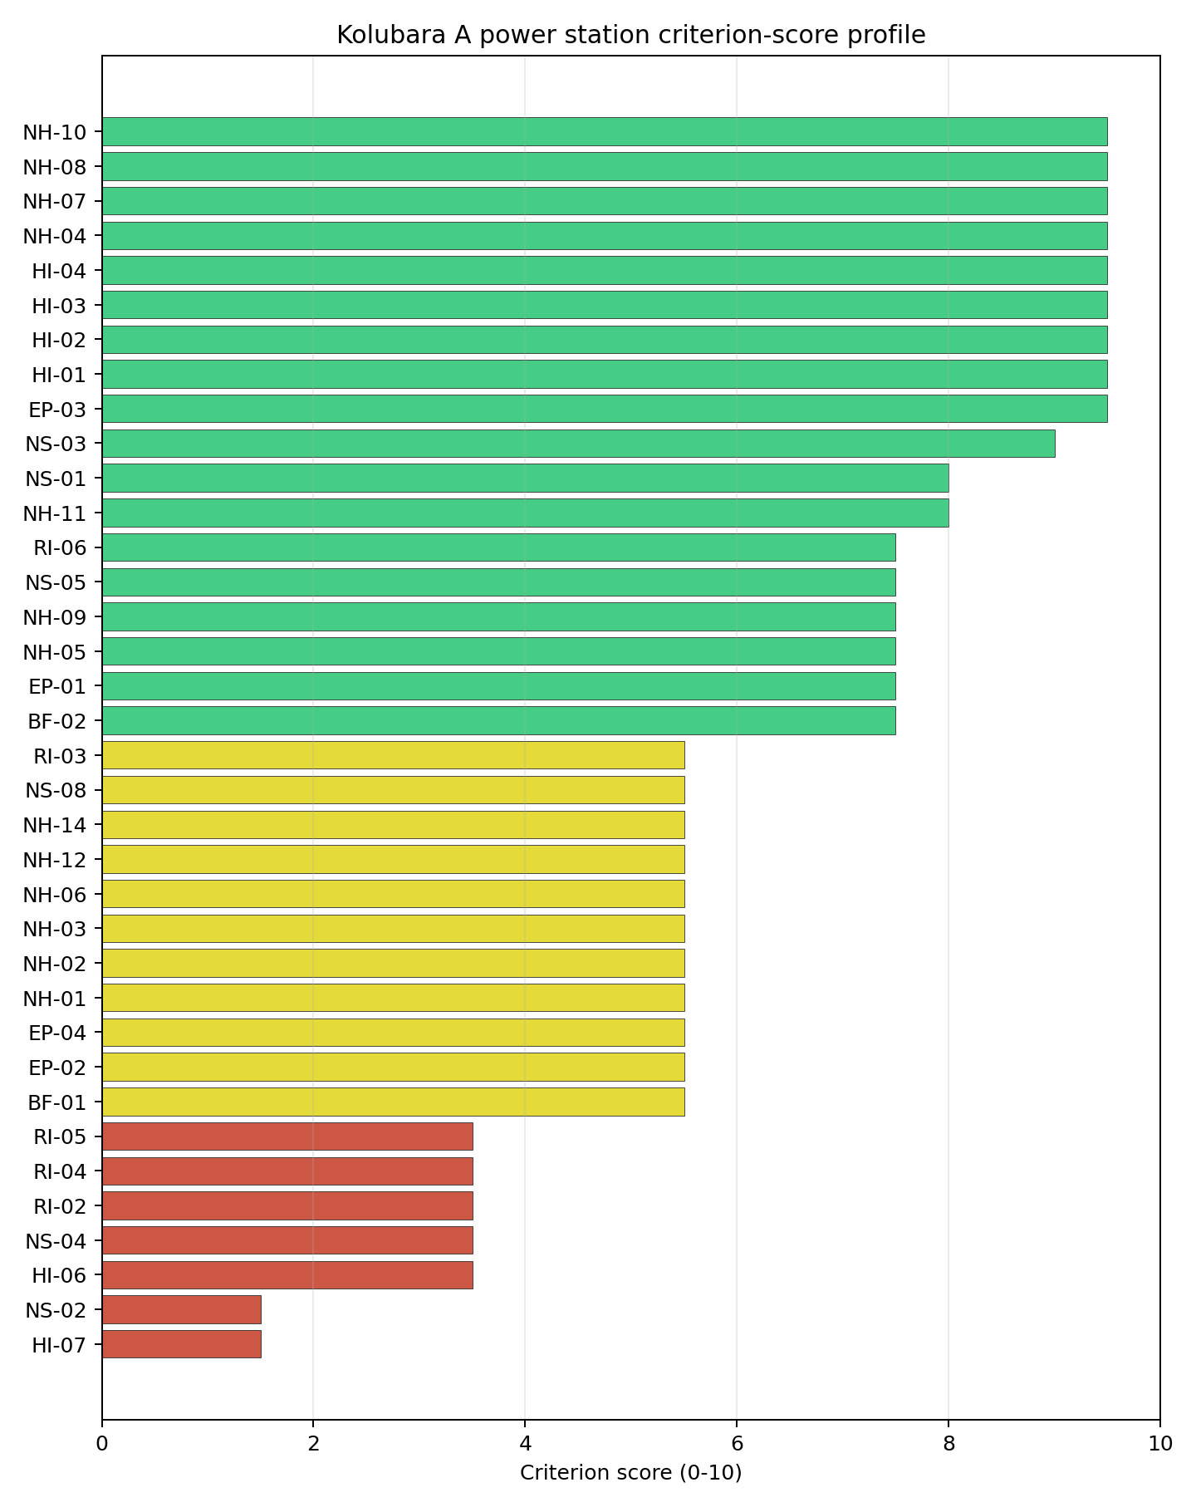
Criterion scores
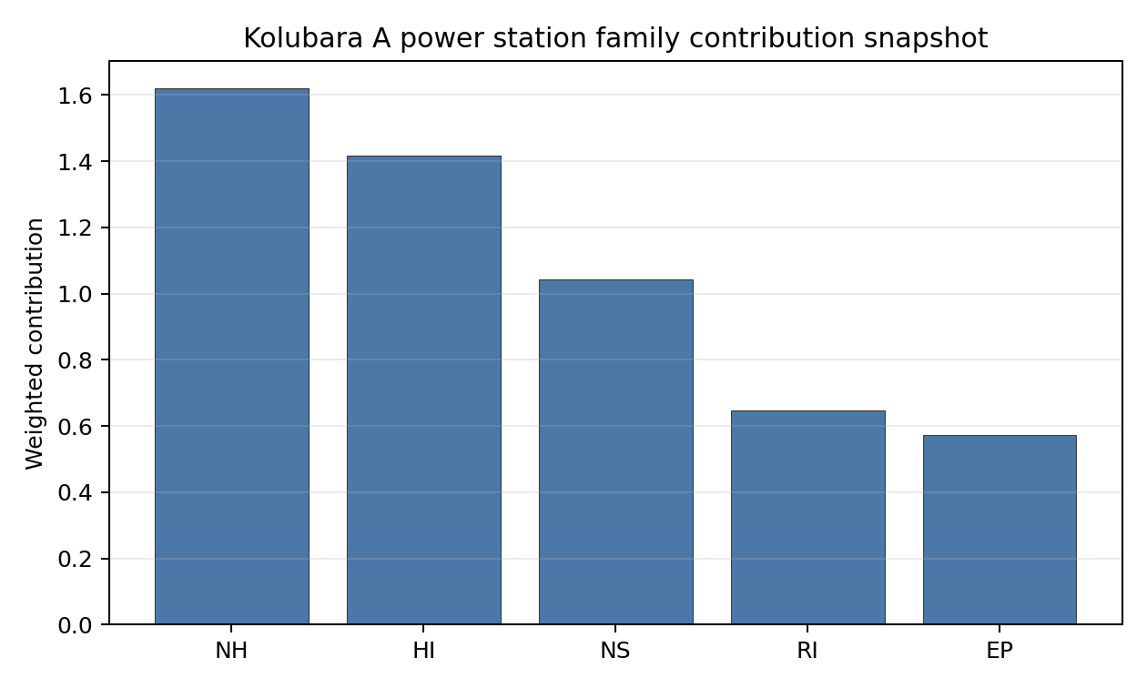
Family contributions
Kolubara A power station’s baseline composite score is 6.559, with a national Monte Carlo bracket of 5.831-7.069. The site ranks 3 nationally, sits in stability band H, and records a national top-10% hit rate of 0%. That means the site is rank-dependent on the national weight choice and should not be over-read from the point estimate alone. The composite is led by Transport Access (NS-03), Transport Access (NS-03), Transport Access (NS-03), so Stage 3 effort should first narrow the criteria that both depress the score and carry avoidance or low-confidence evidence.

Residual Risk Register
Concern | Evidence | Consequence | Stage 3 action | Owner discipline
Grid Connection (NS-02) | nearest substation 0.16 km; nearest high-voltage line 0.3 km | Could change the screening class, site boundary, or characterisation priority. | Confirm Grid Connection with site-specific measurements and responsible-agency review. | grid
Electromagnetic Interference (HI-07) | nearest high-power transmitter 0.16 km; transmitters within radius 107 | Could change the screening class, site boundary, or characterisation priority. | Confirm Electromagnetic Interference with site-specific measurements and responsible-agency review. | security
Military Installations (HI-06) | nearest military installation 21.6 km; military installations within radius 5 | Could change the screening class, site boundary, or characterisation priority. | Confirm Military Installations with site-specific measurements and responsible-agency review. | security
Site Topography (NS-04) | favourable land cover 36.7 %; moderate land cover 28.4 % | Could change the screening class, site boundary, or characterisation priority. | Confirm Site Topography with site-specific measurements and responsible-agency review. | grid
Surface Water Dispersion (RI-02) | not measured in the current evidence set | Could change the screening class, site boundary, or characterisation priority. | Confirm Surface Water Dispersion with site-specific measurements and responsible-agency review. | hydrology
Population Density at EPZ Radii (RI-04) | population density within 5 km 144.9 /km2; population density within 16 km 131.2 /km2 | Could change the screening class, site boundary, or characterisation priority. | Confirm Population Density at EPZ Radii with site-specific measurements and responsible-agency review. | hydrology
Grid Connection (NS-02), Electromagnetic Interference (HI-07), Military Installations (HI-06) dominate the residual-risk register. The register is a Stage 3 work plan for screening follow-up, not a finding of site approval or a procurement recommendation.

Stage 3 Follow-Up Checklist
- Resolve Grid Connection (NS-02) avoidance flag - measured grid export capacity 175.0 MW against the reference SMR export-capacity screen.
- Re-measure Electromagnetic Interference (HI-07) - native score 1.5/10 with confidence medium.
- Re-measure Grid Connection (NS-02) - native score 1.5/10 with confidence high.
- Re-measure Military Installations (HI-06) - native score 3.5/10 with confidence medium.
- Re-measure Site Topography (NS-04) - native score 3.5/10 with confidence medium.
- Re-measure Surface Water Dispersion (RI-02) - native score 3.5/10 with confidence insufficient.
- Improve data quality for Industrial Explosions (HI-02) - current flag low.
- Improve data quality for Toxic/Gas Releases (HI-03) - current flag low.
- Improve data quality for External Fires (HI-04) - current flag low.
- Improve data quality for Transport Access (NS-03) - current flag low.

Evidence Limitations
- Industrial Explosions (HI-02) - quality low.
- Toxic/Gas Releases (HI-03) - quality low.
- External Fires (HI-04) - quality low.
- Transport Access (NS-03) - quality low.

Kolubara B power station Site Profile
Kolubara B power station is a coal/thermal site in Serbia that has been tested against the NuScale VOYGR-6 reference deployment envelope. This profile reads the screening evidence at a level that supports a decision to progress toward Stage 3 characterisation. It is not a site suitability determination, vendor recommendation, or licensing finding.

Site Snapshot
Field | Value
Site name | Kolubara B power station
Coordinates | 44.4675, 20.2844
Subnational unit | Veliki Crljeni
Installed thermal capacity (source data) | 725 MW
Available surface area | 51.5 ha
Available surface area for development | 51.5 ha
Composite score (baseline weights) | 6.472 (5.744-6.981 MC band)
National stability band | H (top-10% hit rate 0%)
National rank | 5
See the country status map in Serbia Country Profile.

Ownership and Coal-to-Nuclear Context
- Elektroprivreda Srbije Beograd AD (100.00% share), headquartered in Serbia; immediate operator Elektroprivreda Srbije Beograd AD. Path: Elektroprivreda Srbije Beograd AD -> Kolubara B power station Unit 1 [100.0%]
- Government of the Republic of Serbia (100.00% share), headquartered in Serbia; immediate operator Elektroprivreda Srbije Beograd AD. Path: Government of the Republic of Serbia -> Elektroprivreda Srbije Beograd AD [100.0%] -> Kolubara B power station Unit 1 [100.0%]
Generating units on record: 2 cancelled. Earliest unit commissioning: 2024; most recent: 2024.

Natural Hazards (NH)
- Seismic: Ground Motion (NH-01) - score 5.5/10 (MC 5.0-6.0) - pass-mark band: At or below the score-5 risk boundary, weight 0.0455, data quality high. Evidence: PGA at 475-year return period 0.184 g; PGA at 2,475-year return period 0.397 g; Vs30 reference (m/s): 760.0.
- Seismic: Surface Rupture (NH-02) - score 5.5/10 (MC 5.0-6.0) - pass-mark band: Borderline acceptable separation: meets the 8.0 km score boundary; check against the 8 km conservative screen and local capability evidence, weight n/a, data quality screening grade. Evidence: nearest mapped capable fault 11.5 km; fault slip rate 0.071 mm/yr; fault name: RSCF00J.
- Geotechnical: Liquefaction (NH-03) - score 9.5/10 (MC 9.0-10.0) - favourable: Negligible susceptibility (Stage-1 favourable default), weight n/a, data quality medium. Evidence: liquefaction susceptibility: very_low; dominant soil type: clay_loam.
- Geotechnical: Slope Stability (NH-04) - score 7.5/10 (MC 7.0-8.0), weight n/a, data quality screening grade. Evidence: site slope 5.04 deg; max slope in 1 km box 81.8 deg; slope stability class: moderate.
- Geotechnical: Subsidence (NH-05) - score 5.5/10 (MC 5.0-6.0) - pass-mark band: At or above the mine-distance score-5 pivot; review possible, weight 0.0354, data quality medium. Evidence: karst present: no; karst severity: none.
- Geotechnical: Foundation (NH-06) - score 5.5/10 (MC 5.0-6.0) - pass-mark band: Typical European mixed conditions (bearing 80-150 kPa), weight 0.0253, data quality medium. Evidence: bearing capacity 90.0 kPa; depth to bedrock 24.1 m.
- Volcanism (NH-07) - score 9.5/10 (MC 9.0-10.0) - favourable: Very strong margin above the score-5 boundary (or no in-radius signal is recorded), weight n/a, data quality high. Evidence: volcanic hazard class: negligible.
- Coastal Flooding (NH-08) - score 9.5/10 (MC 9.0-10.0) - favourable: Non-coastal OR elevation >= 50 m AMSL OR landlocked country, with no positive marine-hazard signal, weight 0.0303, data quality medium. Evidence: distance to coast 261.1 km.
- River Flooding (NH-09) - score 7.5/10 (MC 7.0-8.0), weight 0.0404, data quality medium. Evidence: flood zone class: negligible.
- Extreme Winds (NH-10) - score 9.5/10 (MC 9.0-10.0) - favourable: Lowest relative wind exposure in the current screening wind-exposure cohort (< 7.5 m/s), weight 0.0152, data quality medium. Evidence: screening wind-speed index 7.47 m/s.
- Extreme Precipitation (NH-11) - score 8.0/10 (MC 8.0-9.0) - favourable: aggregated(mean_of_sub_scores), weight 0.0152, data quality medium. Evidence: screening extreme-precipitation index 0.24 mm; screening precipitation index 23.0 mm/yr.
- Extreme Temperatures (NH-12) - score 5.5/10 (MC 5.0-6.0) - pass-mark band: aggregated(mean_of_sub_scores), weight 0.0202, data quality medium. Evidence: extreme high temperature 26.5 deg C; extreme low temperature -4.95 deg C.
- Combined Hazards (NH-14) - score 7.5/10 (MC 7.0-8.0), weight 0.0152, data quality n/a. Evidence: values not in measurement tables.

Interpretation - Natural Hazards (NH)
Natural hazards at Kolubara B power station support a Stage 1-2 screening read, but they do not remove the need for site-specific characterisation. Key measured evidence is Seismic: Ground Motion (NH-01): PGA at 475-year return period 0.184 g; PGA at 2,475-year return period 0.397 g; Seismic: Surface Rupture (NH-02): nearest mapped capable fault 11.5 km; fault slip rate 0.071 mm/yr; Geotechnical: Subsidence (NH-05): karst present: no; karst severity: none. The main Stage 3 questions are Seismic: Ground Motion (NH-01), Seismic: Surface Rupture (NH-02), Geotechnical: Subsidence (NH-05); each should be re-measured or confirmed before the site is treated as more than a screening-stage candidate.

Human-Induced and Security-Relevant Hazards (HI)
- Aircraft Crash (HI-01) - score 9.5/10 (MC 9.0-10.0) - favourable: Only small / GA / heliport airport >= 10 km nearby, no flight-path proxy < 4 km, no major airport within 30 km, and no military airbase within 60 km, weight 0.0354, data quality high. Evidence: nearest airport 25.3 km; nearest flight path 12.7 km; airports within search radius 3; airport name: Zabrežje Airfield; airport type: small airfield.
- Industrial Explosions (HI-02) - score 9.5/10 (MC 7.5-10.0) - favourable: Very strong margin above the score-5 boundary (or no in-radius signal is recorded), weight 0.0354, data quality low. Evidence: values not in measurement tables.
- Toxic/Gas Releases (HI-03) - score 9.5/10 (MC 7.5-10.0) - favourable: Very strong margin above the score-5 boundary (or no in-radius signal is recorded), weight 0.0354, data quality low. Evidence: values not in measurement tables.
- External Fires (HI-04) - score 9.5/10 (MC 7.5-10.0) - favourable: > 15 km, or completed flammable-storage search found nothing in radius, weight 0.0303, data quality low. Evidence: values not in measurement tables.
- Military Installations (HI-06) - score 3.5/10 (MC 3.0-4.0), weight 0.0303, data quality medium. Evidence: nearest military installation 22.2 km; military installations within radius 4; installation name: unnamed.
- Electromagnetic Interference (HI-07) - score 1.5/10 (MC 1.0-2.0), weight 0.0101, data quality medium. Evidence: nearest high-power transmitter 1.02 km; transmitters within radius 105; transmitter type: communication.

Interpretation - Human-Induced and Security-Relevant Hazards (HI)
Human-induced and security-relevant hazards at Kolubara B power station support a Stage 1-2 screening read, but they do not remove the need for site-specific characterisation. Key measured evidence is Electromagnetic Interference (HI-07): nearest high-power transmitter 1.02 km; transmitters within radius 105; Military Installations (HI-06): nearest military installation 22.2 km; military installations within radius 4; Aircraft Crash (HI-01): nearest airport 25.3 km; nearest flight path 12.7 km. The main Stage 3 questions are Electromagnetic Interference (HI-07), Military Installations (HI-06), Aircraft Crash (HI-01); each should be re-measured or confirmed before the site is treated as more than a screening-stage candidate.

Radiological Impact and Emergency Planning (RI / EP)
- Emergency Planning Feasibility (EP-01) - score 7.5/10 (MC 7.0-8.0), weight n/a, data quality high. Evidence: EP feasibility composite 65.6 /100; road sub-score 52.5 /100; special-population sub-score 90.0 /100; geography sub-score 95.0 /100; population sub-score 80.0 /100; evacuation feasible: yes.
- Evacuation Routes (EP-02) - score 5.5/10 (MC 5.0-6.0) - pass-mark band: Adequate primary routes (0.5-1.0), weight 0.0303, data quality medium. Evidence: road density in EPZ 0.508 km/km2; road length in EPZ 996.9 km; motorway access: yes.
- Physical Geography Constraints (EP-03) - score 9.5/10 (MC 9.0-10.0) - favourable: No measured relief; open river/waterway context (interim screening), weight 0.0253, data quality medium. Evidence: waterways crossing EPZ 0; major river barrier: no.
- Special Populations (EP-04) - score 5.5/10 (MC 5.0-6.0) - pass-mark band: 9-25, weight 0.0303, data quality medium. Evidence: hospitals in EPZ 11; prisons in EPZ 0; care homes in EPZ 0.
- Atmospheric Dispersion (RI-01) - score no native score (unscored - no band matched), weight 0.0303, data quality medium. Evidence: annual mean wind speed 0.77 m/s; atmospheric mixing height 495.1 m; prevailing wind direction: W.
- Surface Water Dispersion (RI-02) - score 3.5/10 (MC 3.0-4.0), weight 0.0253, data quality n/a. Evidence: values not in measurement tables.
- Groundwater Dispersion (RI-03) - score 5.5/10 (MC 5.0-6.0) - pass-mark band: Moderate-permeability aquifer screening proxy, weight 0.0253, data quality medium. Evidence: aquifer type: alluvial.
- Population Density at EPZ Radii (RI-04) - score 3.5/10 (MC 3.0-4.0), weight 0.0404, data quality screening grade. Evidence: population density within 5 km 130.4 /km2; population density within 16 km 127.8 /km2; population density within 25 km 135.7 /km2; population density within 80 km 179.8 /km2; population within 25 km 266,365 people.
- Distance to Population Centres (RI-05) - score 3.5/10 (MC 3.0-4.0), weight 0.0505, data quality screening grade. Evidence: values not in measurement tables.
- Population Projections (RI-06) - score 7.5/10 (MC 7.0-8.0), weight 0.0253, data quality screening grade. Evidence: annual population growth rate -0.336 %/yr; projected population at 25 km in 60 yr 148,761 people.

Interpretation - Radiological Impact and Emergency Planning (RI / EP)
Radiological impact and emergency planning at Kolubara B power station support a Stage 1-2 screening read, but they do not remove the need for site-specific characterisation. Key measured evidence is Surface Water Dispersion (RI-02): not measured in the current evidence set; Population Density at EPZ Radii (RI-04): population density within 5 km 130.4 /km2; population density within 16 km 127.8 /km2; Distance to Population Centres (RI-05): nearest city distance not recorded; required distance 16.0 km. The main Stage 3 questions are Surface Water Dispersion (RI-02), Population Density at EPZ Radii (RI-04), Distance to Population Centres (RI-05); each should be re-measured or confirmed before the site is treated as more than a screening-stage candidate.

Non-Safety and Implementation Considerations (NS)
- Grid Capacity Basic Filter (BF-01) - score 5.5/10 (MC 5.0-6.0) - pass-mark band: Note: substation 15-30 km OR 110-219 kV; reinforcement plausible, weight n/a, data quality n/a. Evidence: values not in measurement tables.
- Land Area Basic Filter (BF-02) - score 7.5/10 (MC 7.0-8.0), weight 0.0253, data quality n/a. Evidence: values not in measurement tables.
- Cooling Water Availability (NS-01) - score 8.0/10 (MC 7.0-8.0) - favourable: aggregated(weighted_mean_of_sub_scores), weight 0.0404, data quality screening grade. Evidence: distance to cooling source 2.82 km; cooling source flow 10.2 m3/s; cooling source type: river; cooling source name: Турија; water stress label: Low.
- Grid Connection (NS-02) - score 1.5/10 (MC 1.0-2.0), weight 0.0404, data quality high. Evidence: nearest substation 1.08 km; nearest high-voltage line 0.29 km; highest nearby line voltage 110.0 kV; grid export capacity 175.0 MW; substations within radius 202; HV lines within radius 237.
- Transport Access (NS-03) - score 9.0/10 (MC 8.0-10.0) - favourable: aggregated(weighted_mean_of_sub_scores), weight 0.0404, data quality low. Evidence: nearest highway 0.74 km; nearest rail line 0.45 km; heavy-haul capable: yes.
- Site Topography (NS-04) - score 3.5/10 (MC 3.0-4.0), weight 0.0303, data quality screening grade. Evidence: favourable land cover 34.5 %; moderate land cover 37.7 %; unfavourable land cover 27.8 %; favourable area 79.2 ha; dominant land class: 321.
- Site Footprint Adequacy (NS-05) - score 7.5/10 (MC 7.0-8.0), weight 0.0253, data quality medium. Evidence: buildable area 51.5 ha; largest contiguous patch 51.5 ha; buildable patch count 10.
- Existing Infrastructure (NS-06) - score no native score (unscored - no band matched), weight 0.0253, data quality n/a. Evidence: not measured at this site (criterion remains unscored).
- Ecological Sensitivity (NS-08) - score 7.5/10 (MC 5.5-9.5), weight n/a, data quality insufficient. Evidence: natural land cover 27.8 %; distance to nearest protected area 11.3 km; Natura 2000 sensitivity class: unknown; protected-area overlap: no; protected-area sensitivity class: low; Natura 2000 sites within 5 km: 0; nearest protected-area designation: Natural Monument.
- Workforce Availability (NS-10) - score no native score (unscored - no band matched), weight 0.0202, data quality n/a. Evidence: not measured at this site (criterion remains unscored).
- Regulatory/Political Environment (NS-12) - score no native score (unscored - no band matched), weight 0.0303, data quality n/a. Evidence: not measured at this site (criterion remains unscored).
- Construction Logistics (NS-13) - score no native score (unscored - no band matched), weight 0.0202, data quality n/a. Evidence: not measured at this site (criterion remains unscored).

Interpretation - Non-Safety and Implementation Considerations (NS)
Non-safety and implementation considerations at Kolubara B power station support a Stage 1-2 screening read, but they do not remove the need for site-specific characterisation. Key measured evidence is Grid Connection (NS-02): nearest substation 1.08 km; nearest high-voltage line 0.29 km; Site Topography (NS-04): favourable land cover 34.5 %; moderate land cover 37.7 %; Existing Infrastructure (NS-06): not measured in the current evidence set. The main Stage 3 questions are Grid Connection (NS-02), Site Topography (NS-04), Existing Infrastructure (NS-06); each should be re-measured or confirmed before the site is treated as more than a screening-stage candidate.

Composite Score and Stability
Baseline composite score is 6.472, bracketed by Monte Carlo at 5.744-6.981. National stability band is H with a top-10% hit rate of 0% across 12 scored Monte Carlo scenarios.
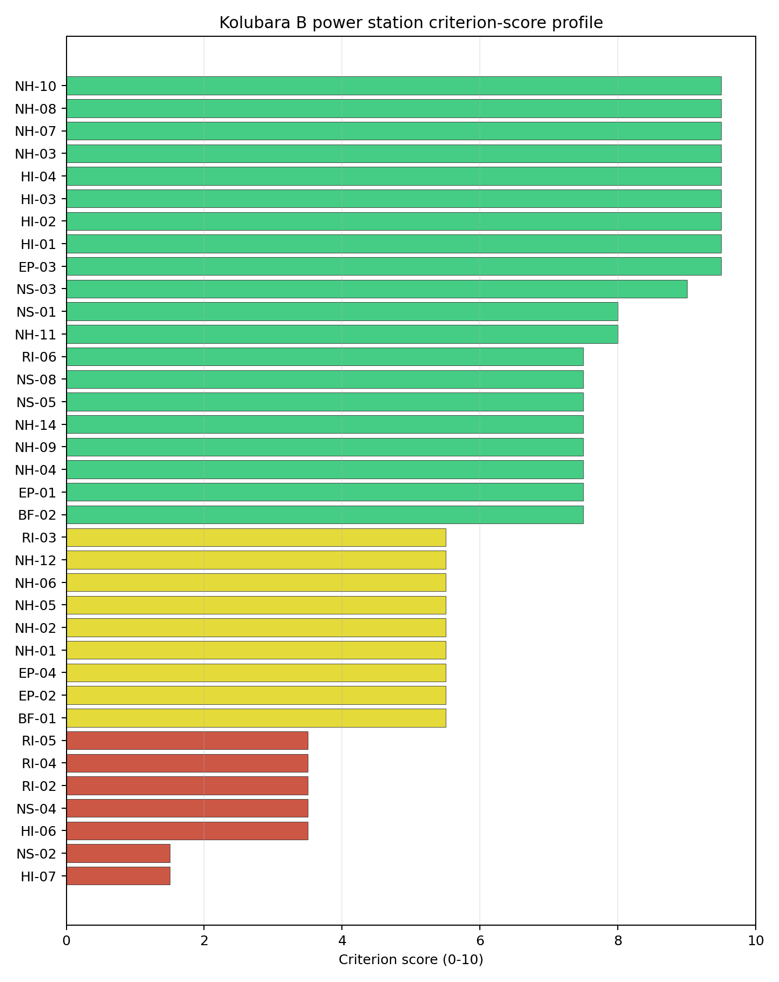
Criterion scores
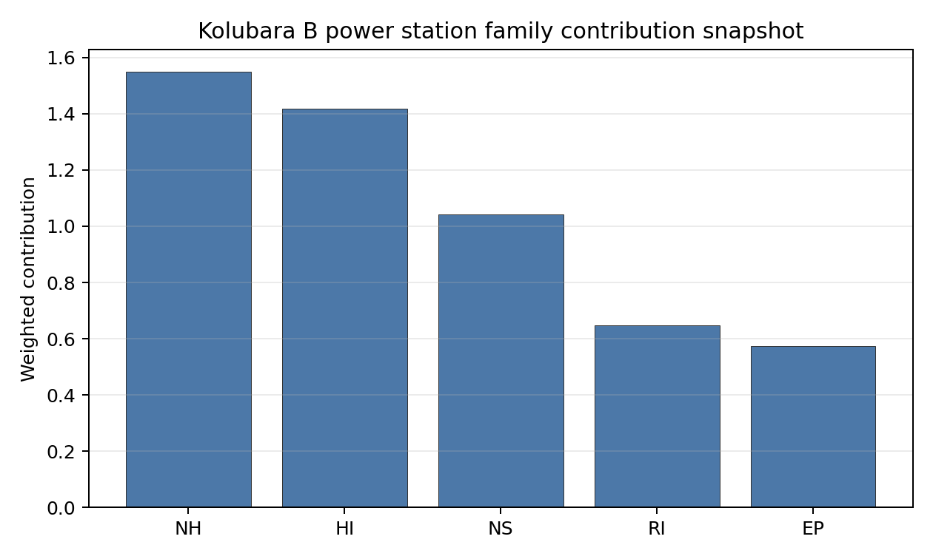
Family contributions
Kolubara B power station’s baseline composite score is 6.472, with a national Monte Carlo bracket of 5.744-6.981. The site ranks 5 nationally, sits in stability band H, and records a national top-10% hit rate of 0%. That means the site is rank-dependent on the national weight choice and should not be over-read from the point estimate alone. The composite is led by Transport Access (NS-03), Transport Access (NS-03), Transport Access (NS-03), so Stage 3 effort should first narrow the criteria that both depress the score and carry avoidance or low-confidence evidence.

Residual Risk Register
Concern | Evidence | Consequence | Stage 3 action | Owner discipline
Grid Connection (NS-02) | nearest substation 1.08 km; nearest high-voltage line 0.29 km | Could change the screening class, site boundary, or characterisation priority. | Confirm Grid Connection with site-specific measurements and responsible-agency review. | grid
Electromagnetic Interference (HI-07) | nearest high-power transmitter 1.02 km; transmitters within radius 105 | Could change the screening class, site boundary, or characterisation priority. | Confirm Electromagnetic Interference with site-specific measurements and responsible-agency review. | security
Military Installations (HI-06) | nearest military installation 22.2 km; military installations within radius 4 | Could change the screening class, site boundary, or characterisation priority. | Confirm Military Installations with site-specific measurements and responsible-agency review. | security
Site Topography (NS-04) | favourable land cover 34.5 %; moderate land cover 37.7 % | Could change the screening class, site boundary, or characterisation priority. | Confirm Site Topography with site-specific measurements and responsible-agency review. | grid
Surface Water Dispersion (RI-02) | not measured in the current evidence set | Could change the screening class, site boundary, or characterisation priority. | Confirm Surface Water Dispersion with site-specific measurements and responsible-agency review. | hydrology
Population Density at EPZ Radii (RI-04) | population density within 5 km 130.4 /km2; population density within 16 km 127.8 /km2 | Could change the screening class, site boundary, or characterisation priority. | Confirm Population Density at EPZ Radii with site-specific measurements and responsible-agency review. | hydrology
Grid Connection (NS-02), Electromagnetic Interference (HI-07), Military Installations (HI-06) dominate the residual-risk register. The register is a Stage 3 work plan for screening follow-up, not a finding of site approval or a procurement recommendation.

Stage 3 Follow-Up Checklist
- Resolve Grid Connection (NS-02) avoidance flag - measured grid export capacity 175.0 MW against the reference SMR export-capacity screen.
- Re-measure Electromagnetic Interference (HI-07) - native score 1.5/10 with confidence medium.
- Re-measure Grid Connection (NS-02) - native score 1.5/10 with confidence high.
- Re-measure Military Installations (HI-06) - native score 3.5/10 with confidence medium.
- Re-measure Site Topography (NS-04) - native score 3.5/10 with confidence medium.
- Re-measure Surface Water Dispersion (RI-02) - native score 3.5/10 with confidence insufficient.
- Improve data quality for Industrial Explosions (HI-02) - current flag low.
- Improve data quality for Toxic/Gas Releases (HI-03) - current flag low.
- Improve data quality for External Fires (HI-04) - current flag low.
- Improve data quality for Transport Access (NS-03) - current flag low.

Evidence Limitations
- Industrial Explosions (HI-02) - quality low.
- Toxic/Gas Releases (HI-03) - quality low.
- External Fires (HI-04) - quality low.
- Transport Access (NS-03) - quality low.

Kostolac power station Site Profile
Kostolac power station is a coal/thermal site in Serbia that has been tested against the NuScale VOYGR-6 reference deployment envelope. This profile reads the screening evidence at a level that supports a decision to progress toward Stage 3 characterisation. It is not a site suitability determination, vendor recommendation, or licensing finding.

Site Snapshot
Field | Value
Site name | Kostolac power station
Coordinates | 44.7237, 21.1716
Subnational unit | Braničevo
Installed thermal capacity (source data) | 1,360 MW
Available surface area | 109.0 ha
Available surface area for development | 37.0 ha
Composite score (baseline weights) | 6.634 (5.906-7.244 MC band)
National stability band | H (top-10% hit rate 8%)
National rank | 2
See the country status map in Serbia Country Profile.

Ownership and Coal-to-Nuclear Context
- Elektroprivreda Srbije Beograd AD (100.00% share), headquartered in Serbia; immediate operator Elektroprivreda Srbije Beograd AD. Path: Elektroprivreda Srbije Beograd AD -> Kostolac power station Phase B Unit 3 [100.0%]
- Government of the Republic of Serbia (100.00% share), headquartered in Serbia; immediate operator Elektroprivreda Srbije Beograd AD. Path: Government of the Republic of Serbia -> Elektroprivreda Srbije Beograd AD [100.0%] -> Kostolac power station Phase B Unit 3 [100.0%]
Generating units on record: 5 operating. Earliest unit commissioning: 1967; most recent: 2024.

Natural Hazards (NH)
- Seismic: Ground Motion (NH-01) - score 5.5/10 (MC 5.0-6.0) - pass-mark band: At or below the score-5 risk boundary, weight 0.0455, data quality high. Evidence: PGA at 475-year return period 0.114 g; PGA at 2,475-year return period 0.25 g; Vs30 reference (m/s): 760.0.
- Seismic: Surface Rupture (NH-02) - score 9.5/10 (MC 9.0-10.0) - favourable: Very strong separation from mapped capable faults; surface-rupture concern effectively screened at desk-study level, weight n/a, data quality screening grade. Evidence: nearest mapped capable fault 46.8 km; fault slip rate 0.071 mm/yr; fault name: RSCF00L.
- Geotechnical: Liquefaction (NH-03) - score 5.5/10 (MC 5.0-6.0) - pass-mark band: Moderate susceptibility, or high/very-high with documented (or pending for high) mitigation, weight n/a, data quality medium. Evidence: liquefaction susceptibility: moderate; dominant soil type: silty_clay_loam.
- Geotechnical: Slope Stability (NH-04) - score 9.5/10 (MC 9.0-10.0) - favourable: Well below the risk boundary, weight n/a, data quality screening grade. Evidence: site slope 3.65 deg; max slope in 1 km box 26.9 deg; slope stability class: gentle.
- Geotechnical: Subsidence (NH-05) - score 9.5/10 (MC 9.0-10.0) - favourable: No karst; mine-feature distance well above the score-5 pivot (or unknown), weight 0.0354, data quality medium. Evidence: karst present: no; karst severity: none.
- Geotechnical: Foundation (NH-06) - score 5.5/10 (MC 5.0-6.0) - pass-mark band: Typical European mixed conditions (bearing 80-150 kPa), weight 0.0253, data quality medium. Evidence: bearing capacity 84.7 kPa; depth to bedrock 24.0 m.
- Volcanism (NH-07) - score 9.5/10 (MC 9.0-10.0) - favourable: Very strong margin above the score-5 boundary (or no in-radius signal is recorded), weight n/a, data quality high. Evidence: volcanic hazard class: negligible.
- Coastal Flooding (NH-08) - score 9.5/10 (MC 9.0-10.0) - favourable: Non-coastal OR elevation >= 50 m AMSL OR landlocked country, with no positive marine-hazard signal, weight 0.0303, data quality medium. Evidence: distance to coast 325.3 km.
- River Flooding (NH-09) - score 7.5/10 (MC 7.0-8.0), weight 0.0404, data quality medium. Evidence: flood zone class: negligible.
- Extreme Winds (NH-10) - score 5.5/10 (MC 5.0-6.0) - pass-mark band: Middle relative wind exposure around the observed cohort mean (9.0-10.5 m/s), weight 0.0152, data quality medium. Evidence: screening wind-speed index 10.1 m/s.
- Extreme Precipitation (NH-11) - score 8.0/10 (MC 8.0-9.0) - favourable: aggregated(mean_of_sub_scores), weight 0.0152, data quality medium. Evidence: screening extreme-precipitation index 0.2 mm; screening precipitation index 23.7 mm/yr.
- Extreme Temperatures (NH-12) - score 6.5/10 (MC 6.0-7.0) - pass-mark band: aggregated(mean_of_sub_scores), weight 0.0202, data quality medium. Evidence: extreme high temperature 26.9 deg C; extreme low temperature -3.84 deg C.
- Combined Hazards (NH-14) - score 5.5/10 (MC 5.0-6.0) - pass-mark band: At least 5 resolved, exactly one moderate hazard (3-5) or moderate interaction only, weight 0.0152, data quality n/a. Evidence: values not in measurement tables.

Interpretation - Natural Hazards (NH)
Natural hazards at Kostolac power station support a Stage 1-2 screening read, but they do not remove the need for site-specific characterisation. Key measured evidence is Seismic: Ground Motion (NH-01): PGA at 475-year return period 0.114 g; PGA at 2,475-year return period 0.25 g; Geotechnical: Liquefaction (NH-03): liquefaction susceptibility: moderate; dominant soil type: silty_clay_loam; Geotechnical: Foundation (NH-06): bearing capacity 84.7 kPa; depth to bedrock 24.0 m. The main Stage 3 questions are Seismic: Ground Motion (NH-01), Geotechnical: Liquefaction (NH-03), Geotechnical: Foundation (NH-06); each should be re-measured or confirmed before the site is treated as more than a screening-stage candidate.

Human-Induced and Security-Relevant Hazards (HI)
- Aircraft Crash (HI-01) - score 3.5/10 (MC 3.0-4.0), weight 0.0354, data quality high. Evidence: nearest airport 1.47 km; nearest flight path 0.74 km; airports within search radius 5; airport name: Kostolac Airfield; airport type: small airfield.
- Industrial Explosions (HI-02) - score 9.5/10 (MC 7.5-10.0) - favourable: Very strong margin above the score-5 boundary (or no in-radius signal is recorded), weight 0.0354, data quality low. Evidence: values not in measurement tables.
- Toxic/Gas Releases (HI-03) - score 9.5/10 (MC 7.5-10.0) - favourable: Very strong margin above the score-5 boundary (or no in-radius signal is recorded), weight 0.0354, data quality low. Evidence: values not in measurement tables.
- External Fires (HI-04) - score 9.5/10 (MC 7.5-10.0) - favourable: > 15 km, or completed flammable-storage search found nothing in radius, weight 0.0303, data quality low. Evidence: values not in measurement tables.
- Military Installations (HI-06) - score 1.5/10 (MC 1.0-2.0), weight 0.0303, data quality medium. Evidence: nearest military installation 9.73 km; military installations within radius 6; installation name: Касарна „Звезда”.
- Electromagnetic Interference (HI-07) - score 1.5/10 (MC 1.0-2.0), weight 0.0101, data quality medium. Evidence: nearest high-power transmitter 1.51 km; transmitters within radius 79; transmitter type: communication.

Interpretation - Human-Induced and Security-Relevant Hazards (HI)
Human-induced and security-relevant hazards at Kostolac power station support a Stage 1-2 screening read, but they do not remove the need for site-specific characterisation. Key measured evidence is Aircraft Crash (HI-01): nearest airport 1.47 km; nearest flight path 0.74 km; Military Installations (HI-06): nearest military installation 9.73 km; military installations within radius 6; Electromagnetic Interference (HI-07): nearest high-power transmitter 1.51 km; transmitters within radius 79. The main Stage 3 questions are Aircraft Crash (HI-01), Military Installations (HI-06), Electromagnetic Interference (HI-07); each should be re-measured or confirmed before the site is treated as more than a screening-stage candidate.

Radiological Impact and Emergency Planning (RI / EP)
- Emergency Planning Feasibility (EP-01) - score 7.5/10 (MC 7.0-8.0), weight n/a, data quality high. Evidence: EP feasibility composite 65.6 /100; road sub-score 40.4 /100; special-population sub-score 90.0 /100; geography sub-score 95.0 /100; population sub-score 80.0 /100; evacuation feasible: yes.
- Evacuation Routes (EP-02) - score 3.5/10 (MC 3.0-4.0), weight 0.0303, data quality medium. Evidence: road density in EPZ 0.306 km/km2; road length in EPZ 599.9 km; motorway access: yes.
- Physical Geography Constraints (EP-03) - score 9.5/10 (MC 9.0-10.0) - favourable: No measured relief; open river/waterway context (interim screening), weight 0.0253, data quality medium. Evidence: waterways crossing EPZ 0; major river barrier: no.
- Special Populations (EP-04) - score 5.5/10 (MC 5.0-6.0) - pass-mark band: 9-25, weight 0.0303, data quality medium. Evidence: hospitals in EPZ 10; prisons in EPZ 2; care homes in EPZ 0.
- Atmospheric Dispersion (RI-01) - score no native score (unscored - no band matched), weight 0.0303, data quality medium. Evidence: annual mean wind speed 0.94 m/s; atmospheric mixing height 497.8 m; prevailing wind direction: ESE.
- Surface Water Dispersion (RI-02) - score 9.5/10 (MC 9.0-10.0) - favourable: > 500 m3/s, weight 0.0253, data quality n/a. Evidence: values not in measurement tables.
- Groundwater Dispersion (RI-03) - score 5.5/10 (MC 5.0-6.0) - pass-mark band: Moderate-permeability aquifer screening proxy, weight 0.0253, data quality medium. Evidence: aquifer type: sedimentary sands.
- Population Density at EPZ Radii (RI-04) - score 5.5/10 (MC 5.0-6.0) - pass-mark band: aggregated(min_of_sub_scores), weight 0.0404, data quality screening grade. Evidence: population density within 5 km 172.4 /km2; population density within 16 km 105.2 /km2; population density within 25 km 107.9 /km2; population density within 80 km 141.6 /km2; population within 25 km 211,921 people.
- Distance to Population Centres (RI-05) - score 5.5/10 (MC 5.0-6.0) - pass-mark band: GHSL 16 km population proxy indicates >=50k people in the wider screening ring, but no city-distance margin is available, weight 0.0505, data quality screening grade. Evidence: values not in measurement tables.
- Population Projections (RI-06) - score 9.5/10 (MC 9.0-10.0) - favourable: Declining (< -0.5 %/yr), weight 0.0253, data quality screening grade. Evidence: annual population growth rate -1.138 %/yr; projected population at 25 km in 60 yr 118,355 people.

Interpretation - Radiological Impact and Emergency Planning (RI / EP)
Radiological impact and emergency planning at Kostolac power station support a Stage 1-2 screening read, but they do not remove the need for site-specific characterisation. Key measured evidence is Evacuation Routes (EP-02): road density in EPZ 0.306 km/km2; road length in EPZ 599.9 km; Atmospheric Dispersion (RI-01): annual mean wind speed 0.94 m/s; atmospheric mixing height 497.8 m; Special Populations (EP-04): hospitals in EPZ 10; prisons in EPZ 2. The main Stage 3 questions are Evacuation Routes (EP-02), Atmospheric Dispersion (RI-01), Special Populations (EP-04); each should be re-measured or confirmed before the site is treated as more than a screening-stage candidate.

Non-Safety and Implementation Considerations (NS)
- Grid Capacity Basic Filter (BF-01) - score 5.5/10 (MC 5.0-6.0) - pass-mark band: Note: substation 15-30 km OR 110-219 kV; reinforcement plausible, weight n/a, data quality n/a. Evidence: values not in measurement tables.
- Land Area Basic Filter (BF-02) - score 3.5/10 (MC 3.0-4.0), weight 0.0253, data quality n/a. Evidence: values not in measurement tables.
- Cooling Water Availability (NS-01) - score 8.0/10 (MC 8.0-9.0) - favourable: aggregated(weighted_mean_of_sub_scores), weight 0.0404, data quality screening grade. Evidence: distance to cooling source 2.7 km; cooling source flow 5,470 m3/s; cooling source type: major_river; cooling source name: Млава; water stress label: Low.
- Grid Connection (NS-02) - score 5.5/10 (MC 5.0-6.0) - pass-mark band: aggregated(min_of_sub_scores), weight 0.0404, data quality high. Evidence: nearest substation 0.23 km; nearest high-voltage line 0.4 km; highest nearby line voltage 110.0 kV; grid export capacity 1,357 MW; substations within radius 91; HV lines within radius 137.
- Transport Access (NS-03) - score 7.0/10 (MC 5.0-9.0), weight 0.0404, data quality low. Evidence: nearest highway 8.21 km; nearest rail line 8.43 km; heavy-haul capable: yes.
- Site Topography (NS-04) - score 3.5/10 (MC 3.0-4.0), weight 0.0303, data quality screening grade. Evidence: favourable land cover 24.3 %; moderate land cover 32.6 %; unfavourable land cover 43.1 %; favourable area 38.6 ha; dominant land class: 311.
- Site Footprint Adequacy (NS-05) - score 9.5/10 (MC 9.0-10.0) - favourable: Very strong margin above the score-5 boundary, weight 0.0253, data quality high. Evidence: buildable area 37.0 ha; largest contiguous patch 37.0 ha; buildable patch count 10.
- Existing Infrastructure (NS-06) - score no native score (unscored - no band matched), weight 0.0253, data quality n/a. Evidence: not measured at this site (criterion remains unscored).
- Ecological Sensitivity (NS-08) - score 3.5/10 (MC 1.5-5.5), weight n/a, data quality insufficient. Evidence: natural land cover 43.1 %; distance to nearest protected area 4.778 km; Natura 2000 sensitivity class: unknown; protected-area overlap: no; protected-area sensitivity class: moderate; Natura 2000 sites within 5 km: 0; nearest protected-area designation: Emerald Network.
- Workforce Availability (NS-10) - score no native score (unscored - no band matched), weight 0.0202, data quality n/a. Evidence: not measured at this site (criterion remains unscored).
- Regulatory/Political Environment (NS-12) - score no native score (unscored - no band matched), weight 0.0303, data quality n/a. Evidence: not measured at this site (criterion remains unscored).
- Construction Logistics (NS-13) - score no native score (unscored - no band matched), weight 0.0202, data quality n/a. Evidence: not measured at this site (criterion remains unscored).

Interpretation - Non-Safety and Implementation Considerations (NS)
Non-safety and implementation considerations at Kostolac power station support a Stage 1-2 screening read, but they do not remove the need for site-specific characterisation. Key measured evidence is Land Area Basic Filter (BF-02): not measured in the current evidence set; Site Topography (NS-04): favourable land cover 24.3 %; moderate land cover 32.6 %; Ecological Sensitivity (NS-08): natural land cover 43.1 %; distance to nearest protected area 4.778 km. The main Stage 3 questions are Land Area Basic Filter (BF-02), Site Topography (NS-04), Ecological Sensitivity (NS-08); each should be re-measured or confirmed before the site is treated as more than a screening-stage candidate.

Composite Score and Stability
Baseline composite score is 6.634, bracketed by Monte Carlo at 5.906-7.244. National stability band is H with a top-10% hit rate of 8% across 12 scored Monte Carlo scenarios.
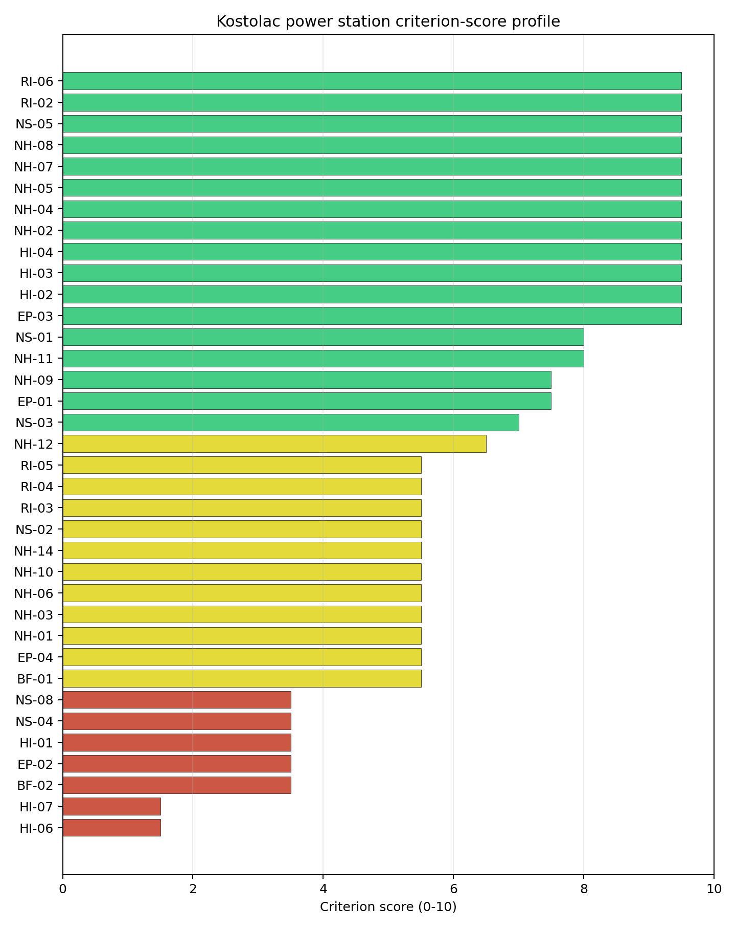
Criterion scores
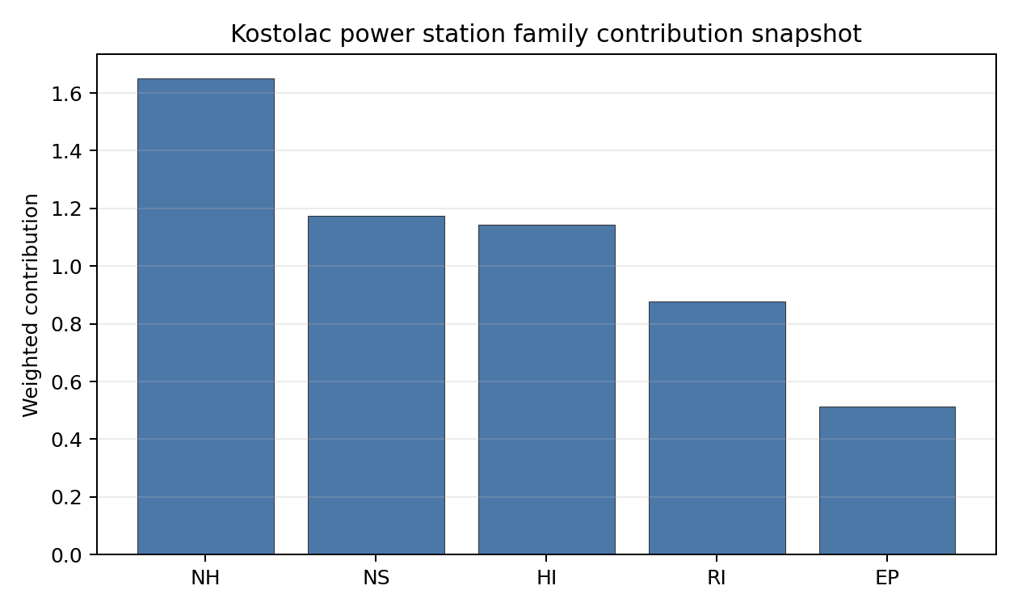
Family contributions
Kostolac power station’s baseline composite score is 6.634, with a national Monte Carlo bracket of 5.906-7.244. The site ranks 2 nationally, sits in stability band H, and records a national top-10% hit rate of 8%. That means the site is rank-dependent on the national weight choice and should not be over-read from the point estimate alone. The composite is led by Industrial Explosions (HI-02), Industrial Explosions (HI-02), Industrial Explosions (HI-02), so Stage 3 effort should first narrow the criteria that both depress the score and carry avoidance or low-confidence evidence.

Residual Risk Register
Concern | Evidence | Consequence | Stage 3 action | Owner discipline
Aircraft Crash (HI-01) | nearest airport 1.47 km; nearest flight path 0.74 km | Could change the screening class, site boundary, or characterisation priority. | Confirm Aircraft Crash with site-specific measurements and responsible-agency review. | security
Military Installations (HI-06) | nearest military installation 9.73 km; military installations within radius 6 | Could change the screening class, site boundary, or characterisation priority. | Confirm Military Installations with site-specific measurements and responsible-agency review. | security
Electromagnetic Interference (HI-07) | nearest high-power transmitter 1.51 km; transmitters within radius 79 | Could change the screening class, site boundary, or characterisation priority. | Confirm Electromagnetic Interference with site-specific measurements and responsible-agency review. | security
Land Area Basic Filter (BF-02) | not measured in the current evidence set | Could change the screening class, site boundary, or characterisation priority. | Confirm Land Area Basic Filter with site-specific measurements and responsible-agency review. | grid
Evacuation Routes (EP-02) | road density in EPZ 0.306 km/km2; road length in EPZ 599.9 km | Could change the screening class, site boundary, or characterisation priority. | Confirm Evacuation Routes with site-specific measurements and responsible-agency review. | emergency planning
Site Topography (NS-04) | favourable land cover 24.3 %; moderate land cover 32.6 % | Could change the screening class, site boundary, or characterisation priority. | Confirm Site Topography with site-specific measurements and responsible-agency review. | grid
Aircraft Crash (HI-01), Military Installations (HI-06), Electromagnetic Interference (HI-07) dominate the residual-risk register. The register is a Stage 3 work plan for screening follow-up, not a finding of site approval or a procurement recommendation.

Stage 3 Follow-Up Checklist
- Resolve Aircraft Crash (HI-01) avoidance flag - measured nearest light-airport distance 1.47 km against the 10 km small-airport screen.
- Resolve Aircraft Crash (HI-01) avoidance flag - measured nearest flight-path proxy 0.74 km against the 4 km airway screen.
- Re-measure Military Installations (HI-06) - native score 1.5/10 with confidence medium.
- Re-measure Electromagnetic Interference (HI-07) - native score 1.5/10 with confidence medium.
- Re-measure Land Area Basic Filter (BF-02) - native score 3.5/10 with confidence insufficient.
- Re-measure Evacuation Routes (EP-02) - native score 3.5/10 with confidence medium.
- Re-measure Aircraft Crash (HI-01) - native score 3.5/10 with confidence high.
- Improve data quality for Geotechnical: Subsidence & Collapse (NH-05b) - current flag low.
- Improve data quality for Industrial Explosions (HI-02) - current flag low.
- Improve data quality for Toxic/Gas Releases (HI-03) - current flag low.
- Improve data quality for External Fires (HI-04) - current flag low.
- Improve data quality for Transport Access (NS-03) - current flag low.

Evidence Limitations
- Geotechnical: Subsidence & Collapse (NH-05b) - quality low.
- Industrial Explosions (HI-02) - quality low.
- Toxic/Gas Releases (HI-03) - quality low.
- External Fires (HI-04) - quality low.
- Transport Access (NS-03) - quality low.

Kovin power station Site Profile
Kovin power station is a coal/thermal site in Serbia that has been tested against the NuScale VOYGR-6 reference deployment envelope. This profile reads the screening evidence at a level that supports a decision to progress toward Stage 3 characterisation. It is not a site suitability determination, vendor recommendation, or licensing finding.

Site Snapshot
Field | Value
Site name | Kovin power station
Coordinates | 44.7500, 20.9667
Subnational unit | Vojvodina
Installed thermal capacity (source data) | 700 MW
Available surface area | 209.3 ha
Available surface area for development | 7.9 ha
Composite score (baseline weights) | 6.503 (5.831-7.094 MC band)
National stability band | H (top-10% hit rate 0%)
National rank | 4
See the country status map in Serbia Country Profile.

Ownership and Coal-to-Nuclear Context
- Gazprom PJSC (11.30% share), headquartered in Russia; immediate operator Naftna Industrija Srbije AD. Path: Gazprom PJSC -> Naftna Industrija Srbije AD [11.3%] -> Kovin power station Unit 1 [100.0%]
- Rosneftegaz JSC (1.24% share), headquartered in Russia; immediate operator Naftna Industrija Srbije AD. Path: Rosneftegaz JSC -> Gazprom PJSC [10.97%] -> Naftna Industrija Srbije AD [11.3%] -> Kovin power station Unit 1 [100.0%]
- Government of Russia (4.34% share), headquartered in Russia; immediate operator Naftna Industrija Srbije AD. Path: Government of Russia -> Federal Agency for State Property Management (Russia) [100.0%] -> Gazprom PJSC [38.37%] -> Naftna Industrija Srbije AD [11.3%] -> Kovin power station Unit 1 [100.0%]
- Government of Serbia (share not specified), headquartered in Serbia; immediate operator Government of Serbia. Path: Government of Serbia -> Kovin power station Unit 1 [unknown %]
- Federal Agency for State Property Management (Russia) (4.34% share), headquartered in Russia; immediate operator Naftna Industrija Srbije AD. Path: Federal Agency for State Property Management (Russia) -> Gazprom PJSC [38.37%] -> Naftna Industrija Srbije AD [11.3%] -> Kovin power station Unit 1 [100.0%]
- Gazprom Neft PJSC (44.85% share), headquartered in Russia; immediate operator Naftna Industrija Srbije AD. Path: Gazprom Neft PJSC -> Naftna Industrija Srbije AD [44.85%] -> Kovin power station Unit 1 [100.0%]
- small shareholder(s) (13.98% share); immediate operator Naftna Industrija Srbije AD. Path: small shareholder(s) -> Naftna Industrija Srbije AD [13.98%] -> Kovin power station Unit 1 [100.0%]
- Naftna Industrija Srbije AD (100.00% share), headquartered in Serbia; immediate operator Naftna Industrija Srbije AD. Path: Naftna Industrija Srbije AD -> Kovin power station Unit 2 [100.0%]
Generating units on record: 2 cancelled.

Natural Hazards (NH)
- Seismic: Ground Motion (NH-01) - score 5.5/10 (MC 5.0-6.0) - pass-mark band: At or below the score-5 risk boundary, weight 0.0455, data quality high. Evidence: PGA at 475-year return period 0.104 g; PGA at 2,475-year return period 0.234 g; Vs30 reference (m/s): 760.0.
- Seismic: Surface Rupture (NH-02) - score 9.5/10 (MC 9.0-10.0) - favourable: Very strong separation from mapped capable faults; surface-rupture concern effectively screened at desk-study level, weight n/a, data quality screening grade. Evidence: nearest mapped capable fault 45.9 km; fault slip rate 0.071 mm/yr; fault name: RSCF00L.
- Geotechnical: Liquefaction (NH-03) - score 5.5/10 (MC 5.0-6.0) - pass-mark band: Moderate susceptibility, or high/very-high with documented (or pending for high) mitigation, weight n/a, data quality medium. Evidence: liquefaction susceptibility: moderate; dominant soil type: clay.
- Geotechnical: Slope Stability (NH-04) - score 9.5/10 (MC 9.0-10.0) - favourable: Well below the risk boundary, weight n/a, data quality screening grade. Evidence: site slope 1.68 deg; max slope in 1 km box 12.9 deg; slope stability class: flat.
- Geotechnical: Subsidence (NH-05) - score 9.5/10 (MC 9.0-10.0) - favourable: No karst; mine-feature distance well above the score-5 pivot (or unknown), weight 0.0354, data quality medium. Evidence: karst present: no; karst severity: none.
- Geotechnical: Foundation (NH-06) - score 3.5/10 (MC 3.0-4.0), weight 0.0253, data quality medium. Evidence: bearing capacity 68.0 kPa; depth to bedrock 22.2 m.
- Volcanism (NH-07) - score 9.5/10 (MC 9.0-10.0) - favourable: Very strong margin above the score-5 boundary (or no in-radius signal is recorded), weight n/a, data quality high. Evidence: volcanic hazard class: negligible.
- Coastal Flooding (NH-08) - score 9.5/10 (MC 9.0-10.0) - favourable: Non-coastal OR elevation >= 50 m AMSL OR landlocked country, with no positive marine-hazard signal, weight 0.0303, data quality medium. Evidence: distance to coast 317.5 km.
- River Flooding (NH-09) - score 7.5/10 (MC 7.0-8.0), weight 0.0404, data quality medium. Evidence: flood zone class: negligible.
- Extreme Winds (NH-10) - score 5.5/10 (MC 5.0-6.0) - pass-mark band: Middle relative wind exposure around the observed cohort mean (9.0-10.5 m/s), weight 0.0152, data quality medium. Evidence: screening wind-speed index 9.17 m/s.
- Extreme Precipitation (NH-11) - score 8.0/10 (MC 8.0-9.0) - favourable: aggregated(mean_of_sub_scores), weight 0.0152, data quality medium. Evidence: screening extreme-precipitation index 0.23 mm; screening precipitation index 26.1 mm/yr.
- Extreme Temperatures (NH-12) - score 6.5/10 (MC 6.0-7.0) - pass-mark band: aggregated(mean_of_sub_scores), weight 0.0202, data quality medium. Evidence: extreme high temperature 26.7 deg C; extreme low temperature -3.82 deg C.
- Combined Hazards (NH-14) - score 5.5/10 (MC 5.0-6.0) - pass-mark band: At least 5 resolved, exactly one moderate hazard (3-5) or moderate interaction only, weight 0.0152, data quality n/a. Evidence: values not in measurement tables.

Interpretation - Natural Hazards (NH)
Natural hazards at Kovin power station support a Stage 1-2 screening read, but they do not remove the need for site-specific characterisation. Key measured evidence is Geotechnical: Foundation (NH-06): bearing capacity 68.0 kPa; depth to bedrock 22.2 m; Seismic: Ground Motion (NH-01): PGA at 475-year return period 0.104 g; PGA at 2,475-year return period 0.234 g; Geotechnical: Liquefaction (NH-03): liquefaction susceptibility: moderate; dominant soil type: clay. The main Stage 3 questions are Geotechnical: Foundation (NH-06), Seismic: Ground Motion (NH-01), Geotechnical: Liquefaction (NH-03); each should be re-measured or confirmed before the site is treated as more than a screening-stage candidate.

Human-Induced and Security-Relevant Hazards (HI)
- Aircraft Crash (HI-01) - score 3.5/10 (MC 3.0-4.0), weight 0.0354, data quality high. Evidence: nearest airport 2.74 km; nearest flight path 1.37 km; airports within search radius 3; airport name: Kovin Airstrip; airport type: small airfield.
- Industrial Explosions (HI-02) - score 9.5/10 (MC 9.0-10.0) - favourable: Very strong margin above the score-5 boundary (or no in-radius signal is recorded), weight 0.0354, data quality medium. Evidence: nearest industrial hazard establishment 25.3 km; nearest industrial site 25.3 km.
- Toxic/Gas Releases (HI-03) - score 7.5/10 (MC 7.0-8.0), weight 0.0354, data quality medium. Evidence: nearest toxic source 29.4 km.
- External Fires (HI-04) - score 9.5/10 (MC 9.0-10.0) - favourable: > 15 km, or completed flammable-storage search found nothing in radius, weight 0.0303, data quality medium. Evidence: nearest flammable storage 25.3 km.
- Military Installations (HI-06) - score 0.0/10 (MC 0.0-0.0), weight 0.0303, data quality high. Evidence: nearest military installation 2.42 km; military installations within radius 6; installation name: Аеродром Ковин.
- Electromagnetic Interference (HI-07) - score 1.5/10 (MC 1.0-2.0), weight 0.0101, data quality medium. Evidence: nearest high-power transmitter 0.71 km; transmitters within radius 71; transmitter type: water_tower.

Interpretation - Human-Induced and Security-Relevant Hazards (HI)
Human-induced and security-relevant hazards at Kovin power station support a Stage 1-2 screening read, but they do not remove the need for site-specific characterisation. Key measured evidence is Aircraft Crash (HI-01): nearest airport 2.74 km; nearest flight path 1.37 km; Military Installations (HI-06): nearest military installation 2.42 km; military installations within radius 6; Electromagnetic Interference (HI-07): nearest high-power transmitter 0.71 km; transmitters within radius 71. The main Stage 3 questions are Aircraft Crash (HI-01), Military Installations (HI-06), Electromagnetic Interference (HI-07); each should be re-measured or confirmed before the site is treated as more than a screening-stage candidate.

Radiological Impact and Emergency Planning (RI / EP)
- Emergency Planning Feasibility (EP-01) - score 7.5/10 (MC 7.0-8.0), weight n/a, data quality high. Evidence: EP feasibility composite 69.2 /100; road sub-score 40.0 /100; special-population sub-score 90.0 /100; geography sub-score 95.0 /100; population sub-score 80.0 /100; evacuation feasible: yes.
- Evacuation Routes (EP-02) - score 3.5/10 (MC 3.0-4.0), weight 0.0303, data quality medium. Evidence: road density in EPZ 0.3 km/km2; road length in EPZ 590.0 km; motorway access: yes.
- Physical Geography Constraints (EP-03) - score 9.5/10 (MC 9.0-10.0) - favourable: No measured relief; open river/waterway context (interim screening), weight 0.0253, data quality medium. Evidence: waterways crossing EPZ 0; major river barrier: no.
- Special Populations (EP-04) - score 5.5/10 (MC 5.0-6.0) - pass-mark band: 9-25, weight 0.0303, data quality medium. Evidence: hospitals in EPZ 15; prisons in EPZ 3; care homes in EPZ 0.
- Atmospheric Dispersion (RI-01) - score no native score (unscored - no band matched), weight 0.0303, data quality medium. Evidence: annual mean wind speed 0.94 m/s; atmospheric mixing height 499.4 m; prevailing wind direction: ESE.
- Surface Water Dispersion (RI-02) - score 9.5/10 (MC 9.0-10.0) - favourable: > 500 m3/s, weight 0.0253, data quality n/a. Evidence: values not in measurement tables.
- Groundwater Dispersion (RI-03) - score 5.5/10 (MC 5.0-6.0) - pass-mark band: Moderate-permeability aquifer screening proxy, weight 0.0253, data quality medium. Evidence: aquifer type: sedimentary sands.
- Population Density at EPZ Radii (RI-04) - score 5.5/10 (MC 5.0-6.0) - pass-mark band: aggregated(min_of_sub_scores), weight 0.0404, data quality screening grade. Evidence: population density within 5 km 168.3 /km2; population density within 16 km 149.3 /km2; population density within 25 km 125.7 /km2; population density within 80 km 149.1 /km2; population within 25 km 246,847 people.
- Distance to Population Centres (RI-05) - score 3.5/10 (MC 3.0-4.0), weight 0.0505, data quality screening grade. Evidence: values not in measurement tables.
- Population Projections (RI-06) - score 9.5/10 (MC 9.0-10.0) - favourable: Declining (< -0.5 %/yr), weight 0.0253, data quality screening grade. Evidence: annual population growth rate -1.016 %/yr; projected population at 25 km in 60 yr 137,862 people.

Interpretation - Radiological Impact and Emergency Planning (RI / EP)
Radiological impact and emergency planning at Kovin power station support a Stage 1-2 screening read, but they do not remove the need for site-specific characterisation. Key measured evidence is Evacuation Routes (EP-02): road density in EPZ 0.3 km/km2; road length in EPZ 590.0 km; Distance to Population Centres (RI-05): nearest city distance not recorded; required distance 16.0 km; Atmospheric Dispersion (RI-01): annual mean wind speed 0.94 m/s; atmospheric mixing height 499.4 m. The main Stage 3 questions are Evacuation Routes (EP-02), Distance to Population Centres (RI-05), Atmospheric Dispersion (RI-01); each should be re-measured or confirmed before the site is treated as more than a screening-stage candidate.

Non-Safety and Implementation Considerations (NS)
- Grid Capacity Basic Filter (BF-01) - score 5.5/10 (MC 5.0-6.0) - pass-mark band: Note: substation 15-30 km OR 110-219 kV; reinforcement plausible, weight n/a, data quality n/a. Evidence: values not in measurement tables.
- Land Area Basic Filter (BF-02) - score 1.5/10 (MC 1.0-2.0), weight 0.0253, data quality n/a. Evidence: values not in measurement tables.
- Cooling Water Availability (NS-01) - score 8.0/10 (MC 8.0-9.0) - favourable: aggregated(weighted_mean_of_sub_scores), weight 0.0404, data quality screening grade. Evidence: distance to cooling source 3.92 km; cooling source flow 5,235 m3/s; cooling source type: major_river; cooling source name: Поњавица; water stress label: Low.
- Grid Connection (NS-02) - score 5.5/10 (MC 5.0-6.0) - pass-mark band: aggregated(min_of_sub_scores), weight 0.0404, data quality high. Evidence: nearest substation 0.4 km; nearest high-voltage line 5.64 km; highest nearby line voltage 110.0 kV; grid export capacity 700.0 MW; substations within radius 228; HV lines within radius 242.
- Transport Access (NS-03) - score 8.0/10 (MC 6.0-10.0) - favourable: aggregated(weighted_mean_of_sub_scores), weight 0.0404, data quality low. Evidence: nearest waterway 2.11 km; heavy-haul capable: yes.
- Site Topography (NS-04) - score 7.5/10 (MC 7.0-8.0), weight 0.0303, data quality screening grade. Evidence: favourable land cover 78.3 %; moderate land cover 11.6 %; unfavourable land cover 10.2 %; favourable area 209.3 ha; dominant land class: 211.
- Site Footprint Adequacy (NS-05) - score 9.5/10 (MC 9.0-10.0) - favourable: Very strong margin above the score-5 boundary, weight 0.0253, data quality medium. Evidence: buildable area 7.86 ha; largest contiguous patch 7.86 ha; buildable patch count 1.
- Existing Infrastructure (NS-06) - score no native score (unscored - no band matched), weight 0.0253, data quality n/a. Evidence: not measured at this site (criterion remains unscored).
- Ecological Sensitivity (NS-08) - score 5.5/10 (MC 3.5-7.5) - pass-mark band: Both networks NULL or >= 5 km, weight n/a, data quality insufficient. Evidence: natural land cover 10.2 %; distance to nearest protected area 7.364 km; Natura 2000 sensitivity class: unknown; protected-area overlap: no; protected-area sensitivity class: low; Natura 2000 sites within 5 km: 0; nearest protected-area designation: Emerald Network.
- Workforce Availability (NS-10) - score no native score (unscored - no band matched), weight 0.0202, data quality n/a. Evidence: not measured at this site (criterion remains unscored).
- Regulatory/Political Environment (NS-12) - score no native score (unscored - no band matched), weight 0.0303, data quality n/a. Evidence: not measured at this site (criterion remains unscored).
- Construction Logistics (NS-13) - score no native score (unscored - no band matched), weight 0.0202, data quality n/a. Evidence: not measured at this site (criterion remains unscored).

Interpretation - Non-Safety and Implementation Considerations (NS)
Non-safety and implementation considerations at Kovin power station support a Stage 1-2 screening read, but they do not remove the need for site-specific characterisation. Key measured evidence is Land Area Basic Filter (BF-02): not measured in the current evidence set; Existing Infrastructure (NS-06): not measured in the current evidence set; Workforce Availability (NS-10): not measured in the current evidence set. The main Stage 3 questions are Land Area Basic Filter (BF-02), Existing Infrastructure (NS-06), Workforce Availability (NS-10); each should be re-measured or confirmed before the site is treated as more than a screening-stage candidate.

Composite Score and Stability
Baseline composite score is 6.503, bracketed by Monte Carlo at 5.831-7.094. National stability band is H with a top-10% hit rate of 0% across 12 scored Monte Carlo scenarios.
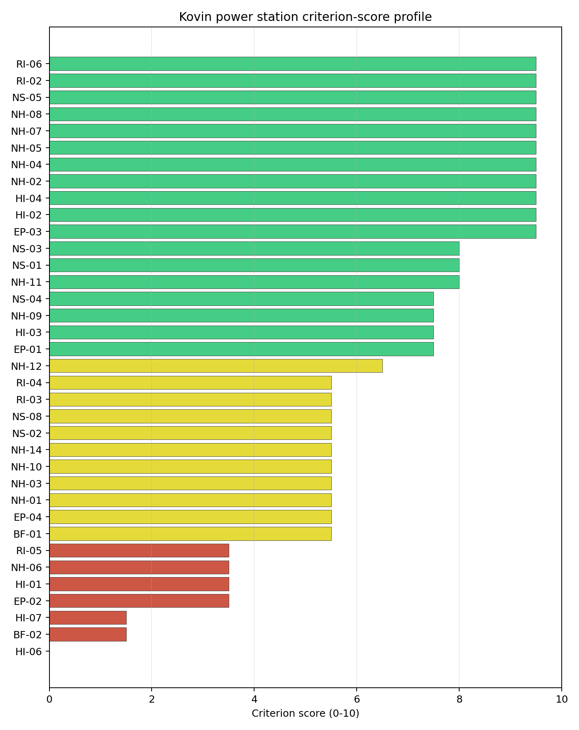
Criterion scores
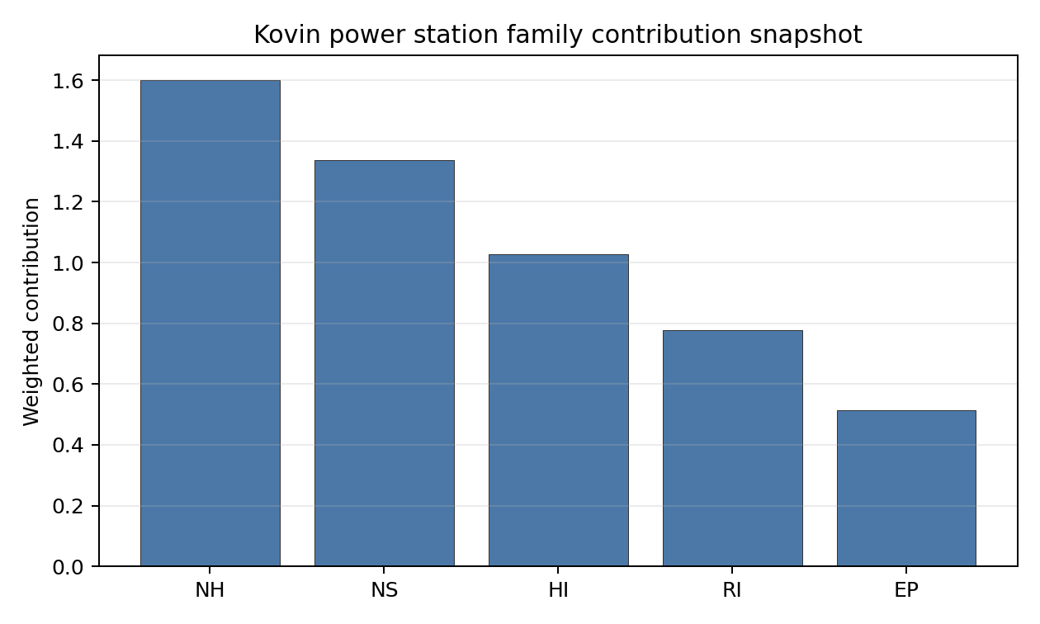
Family contributions
Kovin power station’s baseline composite score is 6.503, with a national Monte Carlo bracket of 5.831-7.094. The site ranks 4 nationally, sits in stability band H, and records a national top-10% hit rate of 0%. That means the site is rank-dependent on the national weight choice and should not be over-read from the point estimate alone. The composite is led by Industrial Explosions (HI-02), Industrial Explosions (HI-02), Industrial Explosions (HI-02), so Stage 3 effort should first narrow the criteria that both depress the score and carry avoidance or low-confidence evidence.

Residual Risk Register
Concern | Evidence | Consequence | Stage 3 action | Owner discipline
Aircraft Crash (HI-01) | nearest airport 2.74 km; nearest flight path 1.37 km | Could change the screening class, site boundary, or characterisation priority. | Confirm Aircraft Crash with site-specific measurements and responsible-agency review. | security
Military Installations (HI-06) | nearest military installation 2.42 km; military installations within radius 6 | Could change the screening class, site boundary, or characterisation priority. | Confirm Military Installations with site-specific measurements and responsible-agency review. | security
Land Area Basic Filter (BF-02) | not measured in the current evidence set | Could change the screening class, site boundary, or characterisation priority. | Confirm Land Area Basic Filter with site-specific measurements and responsible-agency review. | grid
Electromagnetic Interference (HI-07) | nearest high-power transmitter 0.71 km; transmitters within radius 71 | Could change the screening class, site boundary, or characterisation priority. | Confirm Electromagnetic Interference with site-specific measurements and responsible-agency review. | security
Evacuation Routes (EP-02) | road density in EPZ 0.3 km/km2; road length in EPZ 590.0 km | Could change the screening class, site boundary, or characterisation priority. | Confirm Evacuation Routes with site-specific measurements and responsible-agency review. | emergency planning
Geotechnical: Foundation (NH-06) | bearing capacity 68.0 kPa; depth to bedrock 22.2 m | Could change the screening class, site boundary, or characterisation priority. | Confirm Geotechnical: Foundation with site-specific measurements and responsible-agency review. | geotech
Aircraft Crash (HI-01), Military Installations (HI-06), Land Area Basic Filter (BF-02) dominate the residual-risk register. The register is a Stage 3 work plan for screening follow-up, not a finding of site approval or a procurement recommendation.

Stage 3 Follow-Up Checklist
- Resolve Aircraft Crash (HI-01) avoidance flag - measured nearest light-airport distance 2.74 km against the 10 km small-airport screen.
- Resolve Aircraft Crash (HI-01) avoidance flag - measured nearest flight-path proxy 1.37 km against the 4 km airway screen.
- Re-measure Military Installations (HI-06) - native score 0.0/10 with confidence high.
- Re-measure Land Area Basic Filter (BF-02) - native score 1.5/10 with confidence insufficient.
- Re-measure Electromagnetic Interference (HI-07) - native score 1.5/10 with confidence medium.
- Re-measure Evacuation Routes (EP-02) - native score 3.5/10 with confidence medium.
- Re-measure Aircraft Crash (HI-01) - native score 3.5/10 with confidence high.
- Improve data quality for Geotechnical: Subsidence & Collapse (NH-05b) - current flag low.
- Improve data quality for Transport Access (NS-03) - current flag low.

Evidence Limitations
- Geotechnical: Subsidence & Collapse (NH-05b) - quality low.
- Transport Access (NS-03) - quality low.

Štavalj Power Station Site Profile
Štavalj Power Station is a coal/thermal site in Serbia that has been tested against the NuScale VOYGR-6 reference deployment envelope. This profile reads the screening evidence at a level that supports a decision to progress toward Stage 3 characterisation. It is not a site suitability determination, vendor recommendation, or licensing finding.

Site Snapshot
Field | Value
Site name | Štavalj Power Station
Coordinates | 43.2730, 19.9994
Subnational unit | Zlatibor
Installed thermal capacity (source data) | 300 MW
Available surface area | 80.0 ha
Available surface area for development | 1.8 ha
Composite score (baseline weights) | 6.753 (5.928-7.175 MC band)
National stability band | A (top-10% hit rate 92%)
National rank | 1
See the country status map in Serbia Country Profile.

Ownership and Coal-to-Nuclear Context
- Elektroprivreda Srbije Beograd AD (100.00% share), headquartered in Serbia; immediate operator Elektroprivreda Srbije Beograd AD. Path: Elektroprivreda Srbije Beograd AD -> Štavalj Power Station – [100.0%]
- Government of the Republic of Serbia (100.00% share), headquartered in Serbia; immediate operator Elektroprivreda Srbije Beograd AD. Path: Government of the Republic of Serbia -> Elektroprivreda Srbije Beograd AD [100.0%] -> Štavalj Power Station – [100.0%]
Generating units on record: 1 cancelled.

Natural Hazards (NH)
- Seismic: Ground Motion (NH-01) - score 5.5/10 (MC 5.0-6.0) - pass-mark band: At or below the score-5 risk boundary, weight 0.0455, data quality high. Evidence: PGA at 475-year return period 0.129 g; PGA at 2,475-year return period 0.27 g; Vs30 reference (m/s): 760.0.
- Seismic: Surface Rupture (NH-02) - score 7.5/10 (MC 7.0-8.0), weight n/a, data quality screening grade. Evidence: nearest mapped capable fault 21.5 km; fault slip rate 0.122 mm/yr; fault name: RSCF00C.
- Geotechnical: Liquefaction (NH-03) - score 5.5/10 (MC 5.0-6.0) - pass-mark band: Moderate susceptibility, or high/very-high with documented (or pending for high) mitigation, weight n/a, data quality medium. Evidence: liquefaction susceptibility: high; dominant soil type: loam.
- Geotechnical: Slope Stability (NH-04) - score 7.5/10 (MC 7.0-8.0), weight n/a, data quality screening grade. Evidence: site slope 7.03 deg; max slope in 1 km box 88.8 deg; slope stability class: moderate.
- Geotechnical: Subsidence (NH-05) - score 5.5/10 (MC 5.0-6.0) - pass-mark band: At or above the mine-distance score-5 pivot; review possible, weight 0.0354, data quality medium. Evidence: karst present: no; karst severity: moderate; formation type: carbonate (Continuous carbonate rocks).
- Geotechnical: Foundation (NH-06) - score 5.5/10 (MC 5.0-6.0) - pass-mark band: Typical European mixed conditions (bearing 80-150 kPa), weight 0.0253, data quality medium. Evidence: bearing capacity 86.7 kPa; depth to bedrock 38.0 m.
- Volcanism (NH-07) - score 9.5/10 (MC 9.0-10.0) - favourable: Very strong margin above the score-5 boundary (or no in-radius signal is recorded), weight n/a, data quality high. Evidence: volcanic hazard class: negligible.
- Coastal Flooding (NH-08) - score 9.5/10 (MC 9.0-10.0) - favourable: Non-coastal OR elevation >= 50 m AMSL OR landlocked country, with no positive marine-hazard signal, weight 0.0303, data quality medium. Evidence: distance to coast 144.0 km.
- River Flooding (NH-09) - score 7.5/10 (MC 7.0-8.0), weight 0.0404, data quality medium. Evidence: flood zone class: negligible.
- Extreme Winds (NH-10) - score 7.5/10 (MC 7.0-8.0), weight 0.0152, data quality medium. Evidence: screening wind-speed index 8.49 m/s.
- Extreme Precipitation (NH-11) - score 8.0/10 (MC 7.0-8.0) - favourable: aggregated(mean_of_sub_scores), weight 0.0152, data quality medium. Evidence: screening extreme-precipitation index 0.24 mm; screening precipitation index 32.1 mm/yr.
- Extreme Temperatures (NH-12) - score 7.5/10 (MC 7.0-8.0), weight 0.0202, data quality medium. Evidence: extreme high temperature 21.3 deg C; extreme low temperature -6.48 deg C.
- Combined Hazards (NH-14) - score 5.5/10 (MC 5.0-6.0) - pass-mark band: At least 5 resolved, exactly one moderate hazard (3-5) or moderate interaction only, weight 0.0152, data quality n/a. Evidence: values not in measurement tables.

Interpretation - Natural Hazards (NH)
Natural hazards at Štavalj Power Station support a Stage 1-2 screening read, but they do not remove the need for site-specific characterisation. Key measured evidence is Seismic: Ground Motion (NH-01): PGA at 475-year return period 0.129 g; PGA at 2,475-year return period 0.27 g; Geotechnical: Liquefaction (NH-03): liquefaction susceptibility: high; dominant soil type: loam; Geotechnical: Subsidence (NH-05): karst present: no; karst severity: moderate. The main Stage 3 questions are Seismic: Ground Motion (NH-01), Geotechnical: Liquefaction (NH-03), Geotechnical: Subsidence (NH-05); each should be re-measured or confirmed before the site is treated as more than a screening-stage candidate.

Human-Induced and Security-Relevant Hazards (HI)
- Aircraft Crash (HI-01) - score 9.5/10 (MC 9.0-10.0) - favourable: Only small / GA / heliport airport >= 10 km nearby, no flight-path proxy < 4 km, no major airport within 30 km, and no military airbase within 60 km, weight 0.0354, data quality high. Evidence: nearest airport 48.1 km; nearest flight path 24.8 km; airports within search radius 0; airport name: Berane General Hospital Heliport; airport type: heliport.
- Industrial Explosions (HI-02) - score 9.5/10 (MC 7.5-10.0) - favourable: Very strong margin above the score-5 boundary (or no in-radius signal is recorded), weight 0.0354, data quality low. Evidence: values not in measurement tables.
- Toxic/Gas Releases (HI-03) - score 9.5/10 (MC 7.5-10.0) - favourable: Very strong margin above the score-5 boundary (or no in-radius signal is recorded), weight 0.0354, data quality low. Evidence: values not in measurement tables.
- External Fires (HI-04) - score 9.5/10 (MC 7.5-10.0) - favourable: > 15 km, or completed flammable-storage search found nothing in radius, weight 0.0303, data quality low. Evidence: values not in measurement tables.
- Military Installations (HI-06) - score 0.0/10 (MC 0.0-0.0), weight 0.0303, data quality high. Evidence: nearest military installation 0.39 km; military installations within radius 5; installation name: unnamed.
- Electromagnetic Interference (HI-07) - score 1.5/10 (MC 1.0-2.0), weight 0.0101, data quality medium. Evidence: nearest high-power transmitter 1.21 km; transmitters within radius 35; transmitter type: communication.

Interpretation - Human-Induced and Security-Relevant Hazards (HI)
Human-induced and security-relevant hazards at Štavalj Power Station support a Stage 1-2 screening read, but they do not remove the need for site-specific characterisation. Key measured evidence is Military Installations (HI-06): nearest military installation 0.39 km; military installations within radius 5; Electromagnetic Interference (HI-07): nearest high-power transmitter 1.21 km; transmitters within radius 35; Aircraft Crash (HI-01): nearest airport 48.1 km; nearest flight path 24.8 km. The main Stage 3 questions are Military Installations (HI-06), Electromagnetic Interference (HI-07), Aircraft Crash (HI-01); each should be re-measured or confirmed before the site is treated as more than a screening-stage candidate.

Radiological Impact and Emergency Planning (RI / EP)
- Emergency Planning Feasibility (EP-01) - score 5.5/10 (MC 5.0-6.0) - pass-mark band: At or above the composite score-5 boundary, weight n/a, data quality high. Evidence: EP feasibility composite 47.9 /100; road sub-score 15.5 /100; special-population sub-score 90.0 /100; geography sub-score 10.0 /100; population sub-score 80.0 /100; evacuation feasible: yes.
- Evacuation Routes (EP-02) - score 1.5/10 (MC 1.0-2.0), weight 0.0303, data quality medium. Evidence: road density in EPZ 0.155 km/km2; road length in EPZ 304.1 km; motorway access: no.
- Physical Geography Constraints (EP-03) - score 1.5/10 (MC 1.0-2.0), weight 0.0253, data quality medium. Evidence: waterways crossing EPZ 82; major river barrier: yes.
- Special Populations (EP-04) - score 9.5/10 (MC 9.0-10.0) - favourable: 0-2 facilities, weight 0.0303, data quality medium. Evidence: hospitals in EPZ 2; prisons in EPZ 0; care homes in EPZ 0.
- Atmospheric Dispersion (RI-01) - score no native score (unscored - no band matched), weight 0.0303, data quality medium. Evidence: annual mean wind speed 0.59 m/s; atmospheric mixing height 448.4 m; prevailing wind direction: NW.
- Surface Water Dispersion (RI-02) - score 1.5/10 (MC 1.0-2.0), weight 0.0253, data quality n/a. Evidence: values not in measurement tables.
- Groundwater Dispersion (RI-03) - score 5.5/10 (MC 5.0-6.0) - pass-mark band: Moderate-permeability aquifer screening proxy, weight 0.0253, data quality medium. Evidence: aquifer type: sedimentary sands.
- Population Density at EPZ Radii (RI-04) - score 5.5/10 (MC 5.0-6.0) - pass-mark band: aggregated(min_of_sub_scores), weight 0.0404, data quality screening grade. Evidence: population density within 5 km 186.5 /km2; population density within 16 km 26.4 /km2; population density within 25 km 19.4 /km2; population density within 80 km 51.1 /km2; population within 25 km 38,156 people.
- Distance to Population Centres (RI-05) - score 9.5/10 (MC 9.0-10.0) - favourable: No >=50k population-centre proxy within screening envelope, weight 0.0505, data quality screening grade. Evidence: values not in measurement tables.
- Population Projections (RI-06) - score 9.5/10 (MC 9.0-10.0) - favourable: Declining (< -0.5 %/yr), weight 0.0253, data quality screening grade. Evidence: annual population growth rate -1.217 %/yr; projected population at 25 km in 60 yr 21,305 people.

Interpretation - Radiological Impact and Emergency Planning (RI / EP)
Radiological impact and emergency planning at Štavalj Power Station support a Stage 1-2 screening read, but they do not remove the need for site-specific characterisation. Key measured evidence is Evacuation Routes (EP-02): road density in EPZ 0.155 km/km2; road length in EPZ 304.1 km; Physical Geography Constraints (EP-03): waterways crossing EPZ 82; major river barrier: yes; Surface Water Dispersion (RI-02): not measured in the current evidence set. The main Stage 3 questions are Evacuation Routes (EP-02), Physical Geography Constraints (EP-03), Surface Water Dispersion (RI-02); each should be re-measured or confirmed before the site is treated as more than a screening-stage candidate.

Non-Safety and Implementation Considerations (NS)
- Grid Capacity Basic Filter (BF-01) - score 5.5/10 (MC 5.0-6.0) - pass-mark band: Note: substation 15-30 km OR 110-219 kV; reinforcement plausible, weight n/a, data quality n/a. Evidence: values not in measurement tables.
- Land Area Basic Filter (BF-02) - score 1.5/10 (MC 1.0-2.0), weight 0.0253, data quality n/a. Evidence: values not in measurement tables.
- Cooling Water Availability (NS-01) - score 8.0/10 (MC 7.0-8.0) - favourable: aggregated(weighted_mean_of_sub_scores), weight 0.0404, data quality screening grade. Evidence: distance to cooling source 3.8 km; cooling source flow 5.26 m3/s; cooling source type: river; cooling source name: Grabovica; water stress label: Low.
- Grid Connection (NS-02) - score 1.5/10 (MC 1.0-2.0), weight 0.0404, data quality high. Evidence: nearest substation 1.39 km; nearest high-voltage line 0.52 km; grid export capacity 300.0 MW; substations within radius 28; HV lines within radius 92.
- Transport Access (NS-03) - score 10.0/10 (MC 8.0-10.0) - favourable: aggregated(weighted_mean_of_sub_scores), weight 0.0404, data quality low. Evidence: nearest highway 0.28 km; heavy-haul capable: yes.
- Site Topography (NS-04) - score 3.5/10 (MC 3.0-4.0), weight 0.0303, data quality screening grade. Evidence: favourable land cover 26.9 %; moderate land cover 68.5 %; unfavourable land cover 4.6 %; favourable area 80.0 ha; dominant land class: 321.
- Site Footprint Adequacy (NS-05) - score 9.5/10 (MC 7.5-10.0) - favourable: Very strong margin above the score-5 boundary, weight 0.0253, data quality low. Evidence: buildable area 1.84 ha; largest contiguous patch 1.84 ha; buildable patch count 1.
- Existing Infrastructure (NS-06) - score no native score (unscored - no band matched), weight 0.0253, data quality n/a. Evidence: not measured at this site (criterion remains unscored).
- Ecological Sensitivity (NS-08) - score 3.5/10 (MC 1.5-5.5), weight n/a, data quality insufficient. Evidence: natural land cover 4.6 %; distance to nearest protected area 3.907 km; Natura 2000 sensitivity class: unknown; protected-area overlap: no; protected-area sensitivity class: moderate; Natura 2000 sites within 5 km: 0; nearest protected-area designation: Nature Reserve.
- Workforce Availability (NS-10) - score no native score (unscored - no band matched), weight 0.0202, data quality n/a. Evidence: not measured at this site (criterion remains unscored).
- Regulatory/Political Environment (NS-12) - score no native score (unscored - no band matched), weight 0.0303, data quality n/a. Evidence: not measured at this site (criterion remains unscored).
- Construction Logistics (NS-13) - score no native score (unscored - no band matched), weight 0.0202, data quality n/a. Evidence: not measured at this site (criterion remains unscored).

Interpretation - Non-Safety and Implementation Considerations (NS)
Non-safety and implementation considerations at Štavalj Power Station support a Stage 1-2 screening read, but they do not remove the need for site-specific characterisation. Key measured evidence is Grid Connection (NS-02): nearest substation 1.39 km; nearest high-voltage line 0.52 km; Land Area Basic Filter (BF-02): not measured in the current evidence set; Site Topography (NS-04): favourable land cover 26.9 %; moderate land cover 68.5 %. The main Stage 3 questions are Grid Connection (NS-02), Land Area Basic Filter (BF-02), Site Topography (NS-04); each should be re-measured or confirmed before the site is treated as more than a screening-stage candidate.

Composite Score and Stability
Baseline composite score is 6.753, bracketed by Monte Carlo at 5.928-7.175. National stability band is A with a top-10% hit rate of 92% across 12 scored Monte Carlo scenarios.
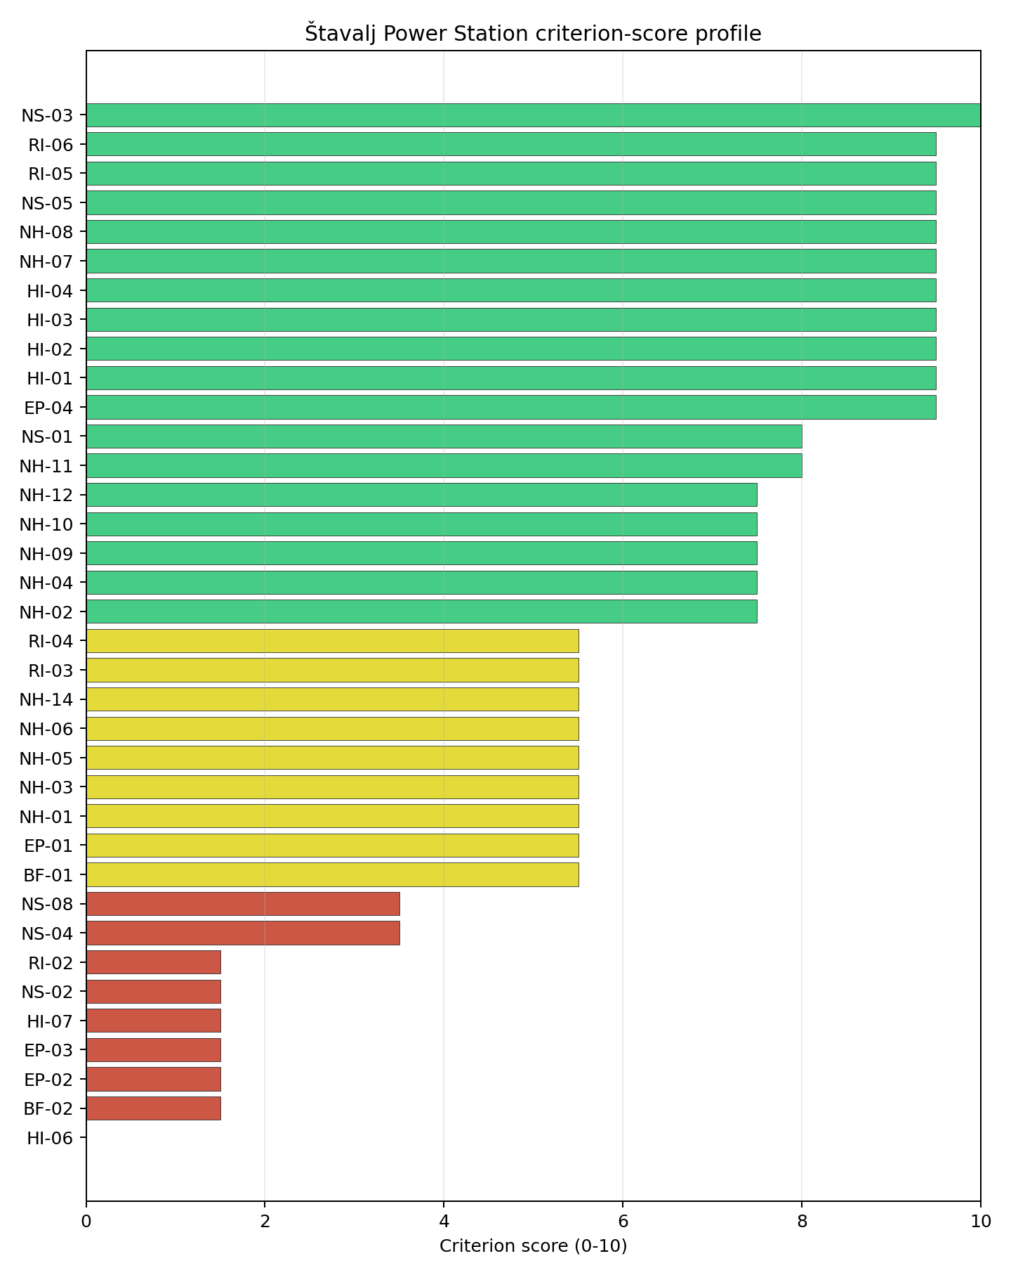
Criterion scores
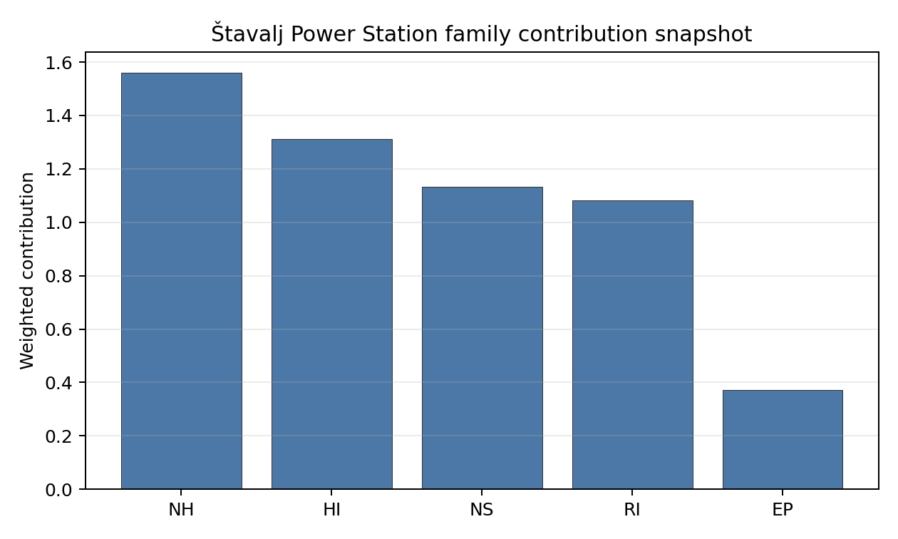
Family contributions
Štavalj Power Station’s baseline composite score is 6.753, with a national Monte Carlo bracket of 5.928-7.175. The site ranks 1 nationally, sits in stability band A, and records a national top-10% hit rate of 92%. That means the site is robust across the national weight perturbations considered. The composite is led by Distance to Population Centres (RI-05), Distance to Population Centres (RI-05), Distance to Population Centres (RI-05), so Stage 3 effort should first narrow the criteria that both depress the score and carry avoidance or low-confidence evidence.

Residual Risk Register
Concern | Evidence | Consequence | Stage 3 action | Owner discipline
Grid Connection (NS-02) | nearest substation 1.39 km; nearest high-voltage line 0.52 km | Could change the screening class, site boundary, or characterisation priority. | Confirm Grid Connection with site-specific measurements and responsible-agency review. | grid
Military Installations (HI-06) | nearest military installation 0.39 km; military installations within radius 5 | Could change the screening class, site boundary, or characterisation priority. | Confirm Military Installations with site-specific measurements and responsible-agency review. | security
Land Area Basic Filter (BF-02) | not measured in the current evidence set | Could change the screening class, site boundary, or characterisation priority. | Confirm Land Area Basic Filter with site-specific measurements and responsible-agency review. | grid
Evacuation Routes (EP-02) | road density in EPZ 0.155 km/km2; road length in EPZ 304.1 km | Could change the screening class, site boundary, or characterisation priority. | Confirm Evacuation Routes with site-specific measurements and responsible-agency review. | emergency planning
Physical Geography Constraints (EP-03) | waterways crossing EPZ 82; major river barrier: yes | Could change the screening class, site boundary, or characterisation priority. | Confirm Physical Geography Constraints with site-specific measurements and responsible-agency review. | emergency planning
Electromagnetic Interference (HI-07) | nearest high-power transmitter 1.21 km; transmitters within radius 35 | Could change the screening class, site boundary, or characterisation priority. | Confirm Electromagnetic Interference with site-specific measurements and responsible-agency review. | security
Grid Connection (NS-02), Military Installations (HI-06), Land Area Basic Filter (BF-02) dominate the residual-risk register. The register is a Stage 3 work plan for screening follow-up, not a finding of site approval or a procurement recommendation.

Stage 3 Follow-Up Checklist
- Resolve Grid Connection (NS-02) avoidance flag - measured grid export capacity 300.0 MW against the reference SMR export-capacity screen.
- Re-measure Military Installations (HI-06) - native score 0.0/10 with confidence high.
- Re-measure Land Area Basic Filter (BF-02) - native score 1.5/10 with confidence insufficient.
- Re-measure Evacuation Routes (EP-02) - native score 1.5/10 with confidence medium.
- Re-measure Physical Geography Constraints (EP-03) - native score 1.5/10 with confidence medium.
- Re-measure Electromagnetic Interference (HI-07) - native score 1.5/10 with confidence medium.
- Improve data quality for Geotechnical: Subsidence & Collapse (NH-05b) - current flag low.
- Improve data quality for Industrial Explosions (HI-02) - current flag low.
- Improve data quality for Toxic/Gas Releases (HI-03) - current flag low.
- Improve data quality for External Fires (HI-04) - current flag low.
- Improve data quality for Transport Access (NS-03) - current flag low.
- Improve data quality for Site Footprint Adequacy (NS-05) - current flag low.

Evidence Limitations
- Geotechnical: Subsidence & Collapse (NH-05b) - quality low.
- Industrial Explosions (HI-02) - quality low.
- Toxic/Gas Releases (HI-03) - quality low.
- External Fires (HI-04) - quality low.
- Transport Access (NS-03) - quality low.
- Site Footprint Adequacy (NS-05) - quality low.

Slovakia Country Profile
Slovakia has six thermal and coal-site records tested against the NuScale VOYGR-6 reference deployment envelope. One site passes both the exclusionary and avoidance screens, four pass the exclusionary screen but retain avoidance flags, and one fails one or more exclusionary checks. Slovakia is an established nuclear-power jurisdiction, so the Stage 3 question is less about first-time institutional readiness and more about whether brownfield thermal assets can be characterised within the national nuclear governance framework.
The leading site is Vojany I power station, with a composite score of 7.022 and a Monte Carlo interval of 6.250-7.481. Its national stability band is A, and it records a 100% national top-10% hit rate. The next four ranked sites remain relevant as comparators and possible later candidates, but their band H sensitivity results mean they require constraint-specific unlock work before they can be treated as equivalent to Vojany I.
Slovakia’s six ranked thermal records produce one full-pass site, four exclusionary-pass sites with avoidance flags, and one hard-fail site. Vojany I is the only site that combines a full pass with band A national stability, so the current brownfield sequence is a one-site leadership case rather than an immediate multi-site programme pool. Trebisov and Novaky sit close on point score, but both carry avoidance flags and band H national stability.
The avoidance unlock pool is concentrated across the exclusionary-pass cohort. Aircraft Crash (HI-01) affects four of the five exclusionary-pass sites, or 80% of that pool, while Grid Connection (NS-02) affects two sites, or 40%. Site Footprint Adequacy (NS-05) and Distance to Population Centres (RI-05) each affect one site. The practical unlock agenda is therefore an aviation and flight-path review across the Slovak candidate set, followed by targeted grid export, site-footprint and population-centre checks for the weaker second-tier sites.
A greenfield option remains available if a future Slovak build-out target exceeds what the brownfield pool can credibly support, but the current evidence does not require it for the first characterisation sequence. A credible Stage 3 sequence begins with Vojany I, keeps Trebisov and Novaky as avoidance-flagged comparators, and treats Martinska and U.S. Steel Kosice Works as later-wave candidates only if aircraft, grid, emergency-planning and land constraints can be retired.

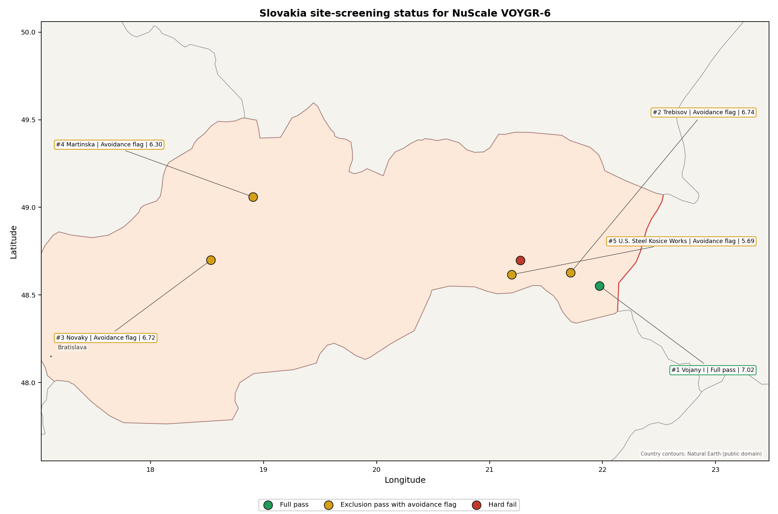
Slovakia status map

Slovakia Site Ledger
Rank | Site | Status | Composite | MC Low | MC High | Band | Top-10 Hit | Coverage
1 | Vojany I power station | Full pass | 7.022 | 6.250 | 7.481 | A | 100% | 76%
2 | Trebisov power station | Exclusion pass with avoidance flag | 6.741 | 6.023 | 7.281 | H | 0% | 76%
3 | Novaky power station | Exclusion pass with avoidance flag | 6.716 | 6.003 | 7.237 | H | 0% | 76%
4 | Martinska power station | Exclusion pass with avoidance flag | 6.303 | 5.669 | 6.775 | H | 0% | 76%
5 | U.S. Steel Kosice Works power station | Exclusion pass with avoidance flag | 5.691 | 5.174 | 6.181 | H | 0% | 76%
- | Kosice power station | Hard fail | - | - | - | - | - | 0%

Avoidance Flag Pareto
Of the 5 sites that pass the exclusionary screen, the avoidance-phase flags concentrate on a small set of criteria. Resolving them is what would move the country from a small leading group to a broader candidate pool.
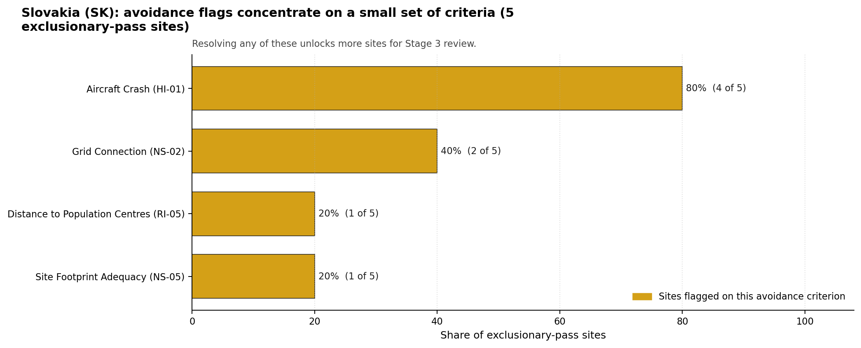
Avoidance flag Pareto
- Aircraft Crash (HI-01) - 4 of 5 exclusionary-pass sites (80%).
- Grid Connection (NS-02) - 2 of 5 exclusionary-pass sites (40%).
- Site Footprint Adequacy (NS-05) - 1 of 5 exclusionary-pass sites (20%).
- Distance to Population Centres (RI-05) - 1 of 5 exclusionary-pass sites (20%).

Exclusionary Failure Pareto
The exclusionary failures across the country trace back to a small number of criteria. They identify which screening checks are responsible for removing sites from further consideration.
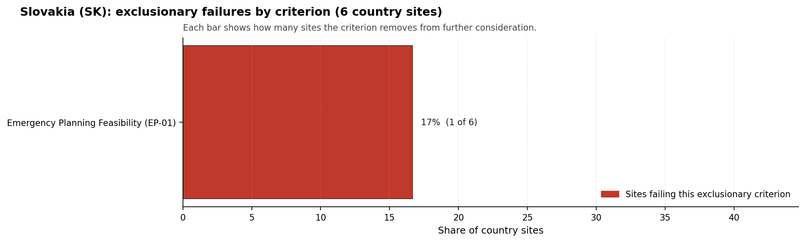
Exclusionary failure Pareto
- Emergency Planning Feasibility (EP-01) - 1 of 6 country sites (17%).

Family Strength and Weakness
Across the country the strongest criterion family is Non-Safety / Implementation at a mean normalised score of 7.04/10. The weakest family is Emergency Planning at 5.22/10. The bottom three individual criteria across the country are:
- Military Installations (HI-06) - mean 0.25/10 across 6 scored sites (min 0.0, max 1.5).
- Electromagnetic Interference (HI-07) - mean 1.50/10 across 6 scored sites (min 1.5, max 1.5).
- Ecological Sensitivity (NS-08) - mean 2.17/10 across 6 scored sites (min 1.5, max 3.5).

Interpretation for Site Selection
The Slovakia result separates a single defensible characterisation candidate from a wider avoidance-flagged comparison pool. The full-pass group contains only Vojany I. Avoidance-flag sites remain useful because they show which national constraints could unlock a broader brownfield programme, but they should not be sequenced ahead of the full-pass leader without resolving the specific aviation, grid, land or population-centre flags shown in the ledger.

Avoidance flag Pareto - what unlocks more sites
The chart shows the unlock agenda for the five exclusionary-pass sites. Aviation dominates the avoidance pool, while grid connection is the main implementation constraint that appears across more than one site.
An IAEA-style reading of the table focuses less on exact rank number and more on screening class, score stability, and the nature of remaining uncertainty. Vojany I power station leads nationally, sits inside the strongest stability band, and retains a full-pass status. That supports a decision to progress the site toward Stage 3 characterisation before lower-ranked or avoidance-flagged locations.
The Monte Carlo interval is a caution against false precision: several sites have overlapping score bands, so small score differences should not be overinterpreted. The decisive distinction is whether a site combines acceptable exclusionary performance with a stable ranking position and no unresolved avoidance flag.
The main Stage 3 questions are therefore targeted rather than generic: confirm local natural-hazard inputs, verify emergency-planning assumptions, test land and ownership constraints, assess cooling and grid interface conditions, and reconcile environmental constraints with national permitting requirements.

Status Counts
- Full pass: 1
- Exclusion pass with avoidance flag: 4
- Hard fail: 1

Martinska power station Site Profile
Martinska power station is a coal/thermal site in Slovakia that has been tested against the NuScale VOYGR-6 reference deployment envelope. This profile reads the screening evidence at a level that supports a decision to progress toward Stage 3 characterisation. It is not a site-suitability determination, vendor recommendation, or licensing finding.

Site Snapshot
Field | Value
Site name | Martinska power station
Coordinates | 49.0592, 18.9070
Subnational unit | Zilina
Installed thermal capacity (source data) | 32 MW
Available surface area | 252.9 ha
Available surface area for development | 252.9 ha
Composite score (baseline weights) | 6.303 (5.669-6.775 MC band)
National stability band | H (top-10% hit rate 0%)
National rank | 4
See the country status map in Slovakia Country Profile.

Ownership and Coal-to-Nuclear Context
The local ownership record identifies MH Manazment AS as a 100.00% parent entry, with MH Teplarensky holding AS as the immediate operator. The ownership chain is domestically anchored in the bundle, but legal control, land parcels and operating rights still require confirmation before any Stage 3 engagement.
Generating units on record: 1 retired. Earliest unit commissioning: 1962; most recent: 1962. The recorded retirement year is 2020, leaving a small brownfield thermal context rather than a large fleet-reuse platform.

Natural Hazards (NH)
- Seismic: Ground Motion (NH-01) - score 5.5/10 (MC 5.0-6.0) - pass-mark band: At or below the score-5 risk boundary., weight 0.0455, data quality high. Evidence: PGA at 475-year return period 0.125 g; PGA at 2,475-year return period 0.304 g; Vs30 reference (m/s): 760.0.
- Seismic: Surface Rupture (NH-02) - score 9.5/10 (MC 9.0-10.0) - favourable: Very strong separation from mapped capable faults; surface-rupture concern effectively screened at desk-study level., weight n/a, data quality screening grade. Evidence: nearest mapped capable fault 50.0 km; fault slip rate 0 mm/yr; fault name: none_in_search_radius.
- Geotechnical: Liquefaction (NH-03) - score 5.5/10 (MC 5.0-6.0) - pass-mark band: Moderate susceptibility, or high/very-high with documented (or pending for high) mitigation., weight n/a, data quality medium. Evidence: liquefaction susceptibility: high; dominant soil type: silty_clay_loam.
- Geotechnical: Slope Stability (NH-04) - score 7.5/10 (MC 7.0-8.0), weight n/a, data quality screening grade. Evidence: site slope 9.34 deg; max slope in 1 km box 87.4 deg; slope stability class: moderate.
- Geotechnical: Subsidence (NH-05) - score 3.5/10 (MC 3.0-4.0), weight 0.0354, data quality medium. Evidence: karst present: no; karst severity: none.
- Geotechnical: Foundation (NH-06) - score 3.5/10 (MC 3.0-4.0), weight 0.0253, data quality medium. Evidence: bearing capacity 76.7 kPa; depth to bedrock 27.7 m.
- Volcanism (NH-07) - score 9.5/10 (MC 9.0-10.0) - favourable: Very strong margin above the score-5 boundary (or connector confirmed no in-radius signal)., weight n/a, data quality high. Evidence: volcanic hazard class: negligible.
- Coastal Flooding (NH-08) - score 9.5/10 (MC 9.0-10.0) - favourable: Non-coastal OR elevation >= 50 m AMSL OR landlocked country, with no positive marine-hazard signal., weight 0.0303, data quality medium. Evidence: distance to coast 532.7 km.
- River Flooding (NH-09) - score 7.5/10 (MC 7.0-8.0), weight 0.0404, data quality medium. Evidence: flood zone class: negligible.
- Extreme Winds (NH-10) - score 5.5/10 (MC 5.0-6.0) - pass-mark band: Middle relative wind exposure around the observed cohort mean (9.0-10.5 m/s)., weight 0.0152, data quality medium. Evidence: screening wind-speed index 9.48 m/s.
- Extreme Precipitation (NH-11) - score 8.0/10 (MC 7.0-8.0) - favourable: aggregated(mean_of_sub_scores), weight 0.0152, data quality medium. Evidence: screening extreme-precipitation index 0.29 mm; screening precipitation index 32.9 mm/yr.
- Extreme Temperatures (NH-12) - score 6.5/10 (MC 6.0-7.0) - pass-mark band: aggregated(mean_of_sub_scores), weight 0.0202, data quality medium. Evidence: extreme high temperature 20.1 deg C; extreme low temperature -8.88 deg C.
- Combined Hazards (NH-14) - score 5.5/10 (MC 5.0-6.0) - pass-mark band: At least 5 resolved, exactly one moderate hazard (3-5) or moderate interaction only., weight 0.0152, data quality n/a. Evidence: values not in measurement tables.

Interpretation - Natural Hazards (NH)
Natural hazards at Martinska are mixed, with seismic loading still inside the screening envelope but geotechnical scores requiring attention. PGA is 0.125 g at the 475-year return period and 0.304 g at the 2,475-year return period, and the nearest mapped capable fault is 50.0 km away. Liquefaction susceptibility is high, bearing capacity is 76.7 kPa, and depth to bedrock is 27.7 m. Subsidence scores 3.5/10 even though karst is not recorded, which signals a screening uncertainty rather than a resolved design input. Stage 3 should prioritize geotechnical investigation, liquefaction testing and confirmation of local river-flood and drainage conditions.

Human-Induced and Security-Relevant Hazards (HI)
- Aircraft Crash (HI-01) - score 3.5/10 (MC 3.0-4.0), weight 0.0354, data quality high. Evidence: nearest airport 3.26 km; nearest flight path 1.63 km; airports within search radius 6; airport name: Martin Airfield; airport type: small airfield.
- Industrial Explosions (HI-02) - score 9.5/10 (MC 9.0-10.0) - favourable: Very strong margin above the score-5 boundary (or completed search confirmed no in-radius signal)., weight 0.0354, data quality medium. Evidence: values not in measurement tables.
- Toxic/Gas Releases (HI-03) - score 9.5/10 (MC 9.0-10.0) - favourable: Very strong margin above the score-5 boundary (or completed search confirmed no in-radius signal)., weight 0.0354, data quality medium. Evidence: values not in measurement tables.
- External Fires (HI-04) - score 9.5/10 (MC 9.0-10.0) - favourable: > 15 km, or completed flammable-storage search found nothing in radius., weight 0.0303, data quality medium. Evidence: values not in measurement tables.
- Military Installations (HI-06) - score 0.0/10 (MC 0.0-0.0), weight 0.0303, data quality high. Evidence: nearest military installation 1.48 km; military installations within radius 21; installation name: Základňa výcviku a mobilizačného doplňovania.
- Electromagnetic Interference (HI-07) - score 1.5/10 (MC 1.0-2.0), weight 0.0101, data quality medium. Evidence: nearest high-power transmitter 2.64 km; transmitters within radius 149; transmitter type: communication.

Interpretation - Human-Induced and Security-Relevant Hazards (HI)
Human-induced hazards at Martinska are severe enough to make the site a later-wave candidate. Martin Airfield is 3.26 km away, and the nearest flight-path proxy is 1.63 km away, producing an Aircraft Crash (HI-01) avoidance flag. Military Installations (HI-06) scores 0.0/10, with Základňa výcviku a mobilizačného doplňovania 1.48 km away and 21 military features within the search radius. Electromagnetic Interference (HI-07) is also weak, with the nearest transmitter 2.64 km away and 149 transmitters recorded. Stage 3 would need defence engagement, airfield hazard modelling and RF survey work before the site can move beyond comparator status.

Radiological Impact and Emergency Planning (RI / EP)
- Emergency Planning Feasibility (EP-01) - score 5.5/10 (MC 5.0-6.0) - pass-mark band: At or above the composite score-5 boundary., weight n/a, data quality high. Evidence: EP feasibility composite 48.0 /100; road sub-score 44.9 /100; special-population sub-score 90.0 /100; geography sub-score 95.0 /100; population sub-score 35.0 /100; evacuation feasible: yes.
- Evacuation Routes (EP-02) - score 3.5/10 (MC 3.0-4.0), weight 0.0303, data quality medium. Evidence: road density in EPZ 0.382 km/km2; road length in EPZ 749.6 km; motorway access: yes.
- Physical Geography Constraints (EP-03) - score 9.5/10 (MC 9.0-10.0) - favourable: No measured relief; open river/waterway context (interim screening)., weight 0.0253, data quality medium. Evidence: waterways crossing EPZ 0; major river barrier: no.
- Special Populations (EP-04) - score 5.5/10 (MC 5.0-6.0) - pass-mark band: 9-25., weight 0.0303, data quality medium. Evidence: hospitals in EPZ 20; prisons in EPZ 2; care homes in EPZ 0.
- Atmospheric Dispersion (RI-01) - score no native score (unscored - no band matched), weight 0.0303, data quality medium. Evidence: annual mean wind speed 0.64 m/s; atmospheric mixing height 446.6 m; prevailing wind direction: NNE.
- Surface Water Dispersion (RI-02) - score 1.5/10 (MC 1.0-2.0), weight 0.0253, data quality n/a. Evidence: values not in measurement tables.
- Groundwater Dispersion (RI-03) - score 5.5/10 (MC 5.0-6.0) - pass-mark band: Moderate-permeability aquifer screening proxy., weight 0.0253, data quality medium. Evidence: aquifer type: alluvial.
- Population Density at EPZ Radii (RI-04) - score 1.5/10 (MC 1.0-2.0), weight 0.0404, data quality screening grade. Evidence: population density within 5 km 656.9 /km2; population density within 16 km 135.1 /km2; population density within 25 km 132.0 /km2; population density within 80 km 111.8 /km2; population within 25 km 259,113 people.
- Distance to Population Centres (RI-05) - score 9.5/10 (MC 9.0-10.0) - favourable: Nearest >=50k population-centre proxy exceeds required distance by >= 50 %., weight 0.0505, data quality screening grade. Evidence: nearest city above 50k people 21.3 km; nearest city population 81,940 people; city name: Žilina.
- Population Projections (RI-06) - score 5.5/10 (MC 5.0-6.0) - pass-mark band: 0 % to +0.3 %., weight 0.0253, data quality screening grade. Evidence: annual population growth rate 0.167 %/yr; projected population at 25 km in 60 yr 214,791 people.

Interpretation - Radiological Impact and Emergency Planning (RI / EP)
Radiological impact and emergency planning are constrained by local population density. Emergency Planning Feasibility (EP-01) scores 48.0/100 and is marked feasible, but the population sub-score is only 35.0/100. Population density reaches 656.9 people/km2 within 5 km, and the 25 km population is 259,113 people. EPZ road density is 0.382 km/km2, with 749.6 km of road and motorway access. Special-population evidence records 20 hospitals and two prisons in the EPZ. Stage 3 should therefore model evacuation clearance, special-population logistics and atmospheric dispersion in the Martin/Zilina corridor before any progression decision.

Non-Safety and Implementation Considerations (NS)
- Grid Capacity Basic Filter (BF-01) - score 5.5/10 (MC 5.0-6.0) - pass-mark band: Note: substation 15-30 km OR 110-219 kV; reinforcement plausible., weight n/a, data quality n/a. Evidence: values not in measurement tables.
- Land Area Basic Filter (BF-02) - score 9.5/10 (MC 9.0-10.0) - favourable: Contiguous and buildable >= ideal area (70 ha/module)., weight 0.0253, data quality n/a. Evidence: values not in measurement tables.
- Cooling Water Availability (NS-01) - score 8.0/10 (MC 7.0-8.0) - favourable: aggregated(weighted_mean_of_sub_scores), weight 0.0404, data quality screening grade. Evidence: distance to cooling source 0.15 km; cooling source flow 7.32 m3/s; cooling source type: small_river; cooling source name: Turiec; water stress label: Low.
- Grid Connection (NS-02) - score 1.5/10 (MC 1.0-2.0), weight 0.0404, data quality high. Evidence: nearest substation 0.73 km; nearest high-voltage line 0.15 km; highest nearby line voltage 110.0 kV; grid export capacity 32.0 MW; substations within radius 415; HV lines within radius 388.
- Transport Access (NS-03) - score 9.0/10 (MC 9.0-10.0) - favourable: aggregated(weighted_mean_of_sub_scores), weight 0.0404, data quality high. Evidence: nearest highway 0.2 km; nearest rail line 0.11 km; heavy-haul capable: yes.
- Site Topography (NS-04) - score 9.5/10 (MC 9.0-10.0) - favourable: > 80 %., weight 0.0303, data quality screening grade. Evidence: favourable land cover 94.1 %; moderate land cover 4.6 %; unfavourable land cover 1.2 %; favourable area 228.5 ha; dominant land class: 121.
- Site Footprint Adequacy (NS-05) - score 9.5/10 (MC 9.0-10.0) - favourable: Very strong margin above the score-5 boundary., weight 0.0253, data quality high. Evidence: buildable area 252.9 ha; largest contiguous patch 252.9 ha; buildable patch count 4.
- Existing Infrastructure (NS-06) - score no native score (unscored - no band matched), weight 0.0253, data quality n/a. Evidence: not measured at this site (criterion remains unscored).
- Ecological Sensitivity (NS-08) - score 1.5/10 (MC 1.0-2.0), weight n/a, data quality high. Evidence: natural land cover 1.2 %; distance to nearest Natura 2000 site 1.705 km; distance to nearest protected area 1.696 km; Natura 2000 overlap: no; Natura 2000 sensitivity class: moderate; protected-area overlap: no; protected-area sensitivity class: high; nearest Natura 2000 site: Turiec a Blatnický potok; Natura 2000 sites within 5 km: 2; nearest protected-area designation: Buffer Zone of a National Nature Reserve, Nature Reserve, National Nature Monument, Nature Monument;.
- Workforce Availability (NS-10) - score no native score (unscored - no band matched), weight 0.0202, data quality n/a. Evidence: not measured at this site (criterion remains unscored).
- Regulatory/Political Environment (NS-12) - score no native score (unscored - no band matched), weight 0.0303, data quality n/a. Evidence: not measured at this site (criterion remains unscored).
- Construction Logistics (NS-13) - score no native score (unscored - no band matched), weight 0.0202, data quality n/a. Evidence: not measured at this site (criterion remains unscored).

Interpretation - Non-Safety and Implementation Considerations (NS)
Martinska has a large land envelope but weak grid scale for the reference deployment. The canonical and development surface-area rows both show 252.9 ha, and Site Footprint Adequacy (NS-05) scores 9.5/10. Cooling water is close, with the Turiec 0.15 km away, 7.32 m3/s flow and a Low water-stress label. Transport access is strong, with highway at 0.20 km, rail at 0.11 km and heavy-haul capability. The binding implementation issue is Grid Connection (NS-02): export capacity is 32 MW, the highest nearby voltage is 110.0 kV, and the criterion scores 1.5/10. Ecological sensitivity is also material, with Turiec a Blatnický potok 1.705 km away and high protected-area sensitivity 1.696 km from the site. Stage 3 should only proceed if grid reinforcement, protected-area constraints and military/airfield questions can be addressed together.

Composite Score and Stability
Baseline composite score is 6.303, bracketed by Monte Carlo at 5.669-6.775. National stability band is H with a top-10% hit rate of 0% in the project’s 50,000-iteration national sensitivity analysis.
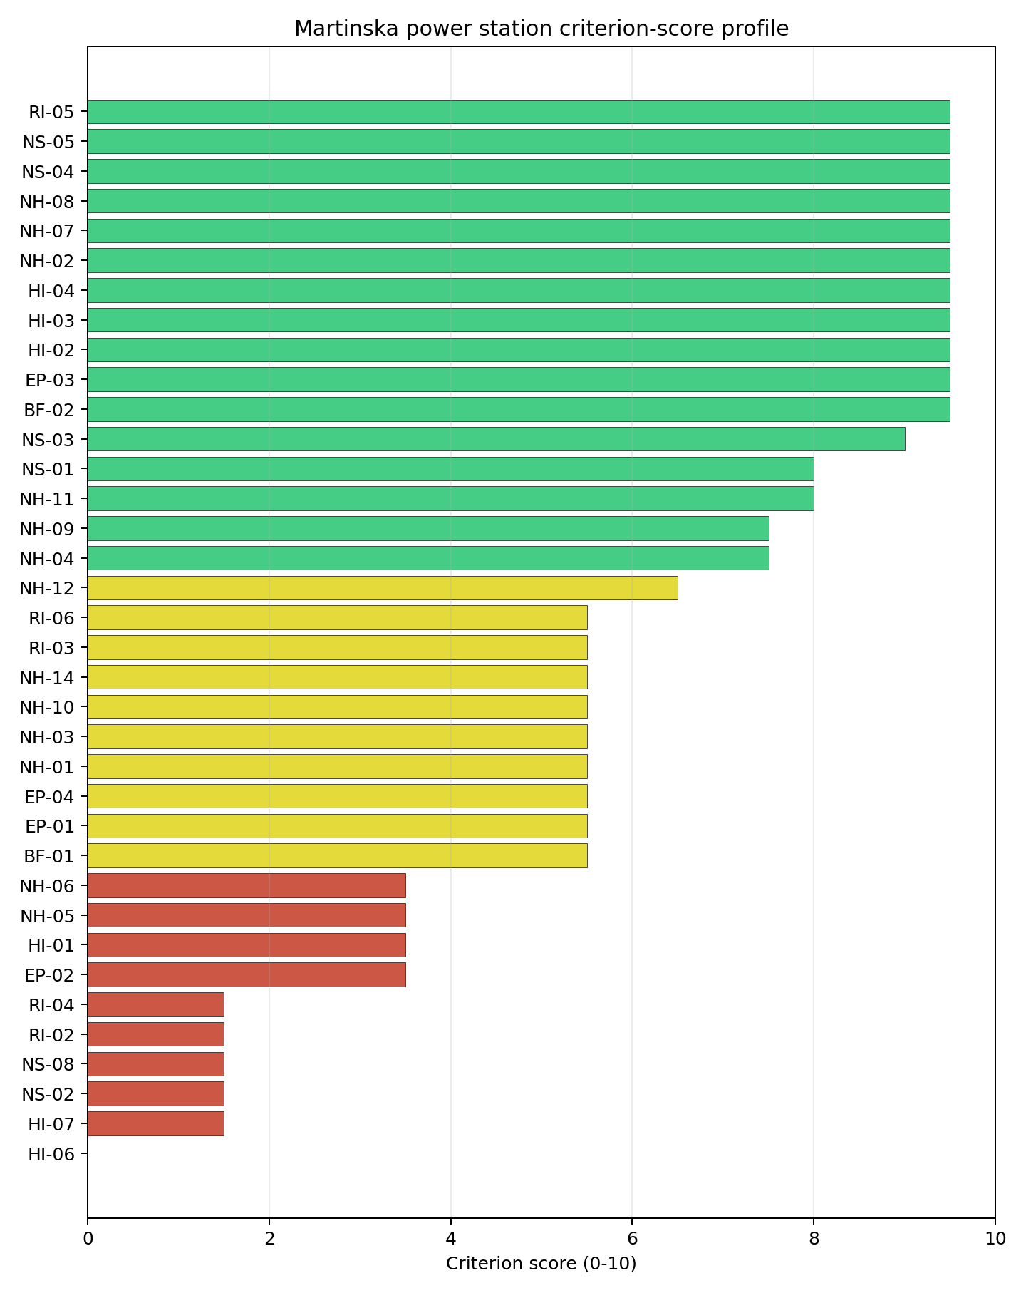
Criterion scores
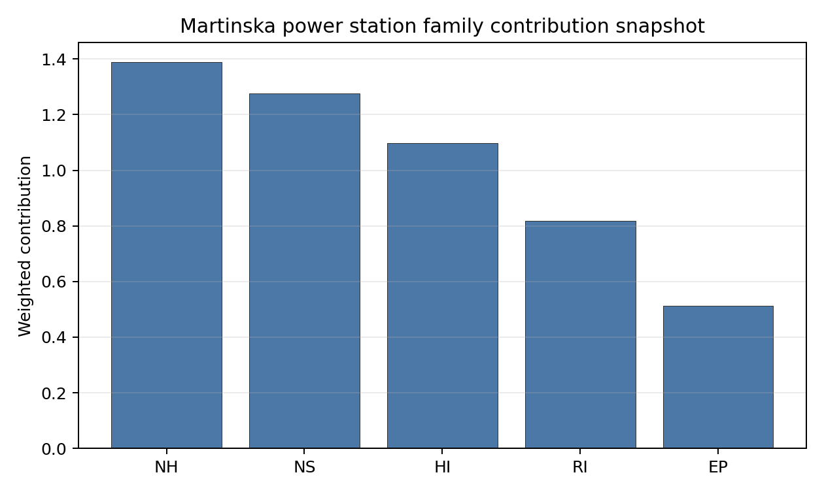
Family contributions
Martinska has a baseline composite score of 6.303, with a Monte Carlo bracket of 5.669-6.775. The national stability band is H, and the national top-10% hit rate is 0%, so the site is not a robust national shortlist candidate in the frozen sensitivity run. Its land, topography, transport and cooling proximity are attractive, but the score is undermined by a small 32 MW inherited export envelope, aircraft proximity, nearby military installations, EMI, high 5 km population density, and ecological constraints. Stage 3 would be most useful as a targeted feasibility test for grid and security constraints rather than as an immediate characterisation sequence.

Residual Risk Register
Concern | Evidence | Consequence | Stage 3 action | Owner discipline
Grid Connection (NS-02) | Export capacity 32 MW; highest nearby voltage 110.0 kV | Transmission reinforcement could dominate feasibility | Confirm grid upgrade pathway and cost envelope | grid
Military Installations (HI-06) | Nearest named feature 1.48 km; 21 features within radius | Security standoff may remain structurally adverse | Engage defence authorities and classify each feature | security
Aircraft Crash (HI-01) | Martin Airfield 3.26 km; flight path 1.63 km | Airfield geometry may prevent removal of the avoidance flag | Model aircraft-crash hazard and flight-path geometry | security
Population Density at EPZ Radii (RI-04) | 656.9 people/km2 within 5 km; 259,113 people within 25 km | EPZ planning could be difficult in the immediate population zone | Model population micro-distribution and evacuation clearance | emergency planning
Ecological Sensitivity (NS-08) | Protected-area sensitivity high at 1.696 km; two Natura 2000 sites within 5 km | Permitting envelope may narrow available site options | Confirm protected-area boundaries and receptor pathways | EIA
Martinska’s residual risks are broad. The site has land and logistics strengths, but grid scale, security, aviation, population and ecology all need favourable Stage 3 outcomes before it can be treated as more than a later-wave comparator.

Stage 3 Follow-Up Checklist
- Resolve Aircraft Crash (HI-01) avoidance flag - measured light-airport distance 3.26 km against the 10 km small-airfield screen.
- Resolve Aircraft Crash (HI-01) avoidance flag - measured flight-path proxy 1.63 km against the 4 km airway screen.
- Resolve Grid Connection (NS-02) avoidance flag - measured grid export capacity 32.0 MW against the 462 MWe reference export-capacity screen.
- Re-measure Military Installations (HI-06) - native score 0.0/10 with confidence high.
- Re-measure Electromagnetic Interference (HI-07) - native score 1.5/10 with confidence medium.
- Re-measure Grid Connection (NS-02) - native score 1.5/10 with confidence high.
- Re-measure Ecological Sensitivity (NS-08) - native score 1.5/10 with confidence high.
- Re-measure Surface Water Dispersion (RI-02) - native score 1.5/10 with confidence insufficient.

Evidence Limitations
- No criterion-family quality fields are flagged as low or missing in this bundle.

Novaky power station Site Profile
Novaky power station is a coal/thermal site in Slovakia that has been tested against the NuScale VOYGR-6 reference deployment envelope. This profile reads the screening evidence at a level that supports a decision to progress toward Stage 3 characterisation. It is not a site-suitability determination, vendor recommendation, or licensing finding.

Site Snapshot
Field | Value
Site name | Novaky power station
Coordinates | 48.6988, 18.5335
Subnational unit | Trenčín
Installed thermal capacity (source data) | 472 MW
Available surface area | 20.0 ha
Available surface area for development | 198.9 ha
Composite score (baseline weights) | 6.716 (6.003-7.237 MC band)
National stability band | H (top-10% hit rate 0%)
National rank | 3
See the country status map in Slovakia Country Profile.

Ownership and Coal-to-Nuclear Context
The local ownership record identifies Slovenské Elektrárne AŞ as the immediate operator. The recorded parent interests include the Government of Slovakia and Ministry of Economy (Slovakia) at 34.00%, Enel SpA at 33.00%, and EP Slovakia BV at 33.00%, with smaller upstream public-market holders also present in the chain. Ownership and control should be confirmed legally before any site-specific engagement.
Generating units on record: 5 retired. Earliest unit commissioning: 1957; most recent: 1976. Retirements span 2013 to 2023, leaving brownfield grid, water, transport and workforce assets that support Stage 3 review.

Natural Hazards (NH)
- Seismic: Ground Motion (NH-01) - score 7.5/10 (MC 7.0-8.0), weight 0.0455, data quality high. Evidence: PGA at 475-year return period 0.074 g; PGA at 2,475-year return period 0.168 g; Vs30 reference (m/s): 760.0.
- Seismic: Surface Rupture (NH-02) - score 9.5/10 (MC 9.0-10.0) - favourable: Very strong separation from mapped capable faults; surface-rupture concern effectively screened at desk-study level., weight n/a, data quality screening grade. Evidence: nearest mapped capable fault 50.0 km; fault slip rate 0 mm/yr; fault name: none_in_search_radius.
- Geotechnical: Liquefaction (NH-03) - score 5.5/10 (MC 5.0-6.0) - pass-mark band: Moderate susceptibility, or high/very-high with documented (or pending for high) mitigation., weight n/a, data quality medium. Evidence: liquefaction susceptibility: moderate; dominant soil type: silty_clay_loam.
- Geotechnical: Slope Stability (NH-04) - score 7.5/10 (MC 7.0-8.0), weight n/a, data quality screening grade. Evidence: site slope 9.32 deg; max slope in 1 km box 86.1 deg; slope stability class: moderate.
- Geotechnical: Subsidence (NH-05) - score 7.5/10 (MC 7.0-8.0), weight 0.0354, data quality medium. Evidence: karst present: no; karst severity: none.
- Geotechnical: Foundation (NH-06) - score 5.5/10 (MC 5.0-6.0) - pass-mark band: Typical European mixed conditions (bearing 80-150 kPa)., weight 0.0253, data quality medium. Evidence: bearing capacity 86.0 kPa; depth to bedrock 25.2 m.
- Volcanism (NH-07) - score 9.5/10 (MC 9.0-10.0) - favourable: Very strong margin above the score-5 boundary (or connector confirmed no in-radius signal)., weight n/a, data quality high. Evidence: volcanic hazard class: negligible.
- Coastal Flooding (NH-08) - score 9.5/10 (MC 9.0-10.0) - favourable: Non-coastal OR elevation >= 50 m AMSL OR landlocked country, with no positive marine-hazard signal., weight 0.0303, data quality medium. Evidence: distance to coast 484.4 km.
- River Flooding (NH-09) - score 7.5/10 (MC 7.0-8.0), weight 0.0404, data quality medium. Evidence: flood zone class: negligible.
- Extreme Winds (NH-10) - score 7.5/10 (MC 7.0-8.0), weight 0.0152, data quality medium. Evidence: screening wind-speed index 8.64 m/s.
- Extreme Precipitation (NH-11) - score 8.0/10 (MC 7.0-8.0) - favourable: aggregated(mean_of_sub_scores), weight 0.0152, data quality medium. Evidence: screening extreme-precipitation index 0.25 mm; screening precipitation index 27.7 mm/yr.
- Extreme Temperatures (NH-12) - score 6.5/10 (MC 6.0-7.0) - pass-mark band: aggregated(mean_of_sub_scores), weight 0.0202, data quality medium. Evidence: extreme high temperature 21.4 deg C; extreme low temperature -8.56 deg C.
- Combined Hazards (NH-14) - score 7.5/10 (MC 7.0-8.0), weight 0.0152, data quality n/a. Evidence: values not in measurement tables.

Interpretation - Natural Hazards (NH)
Natural hazards at Novaky are favourable by Slovak standards, with the main field questions in geotechnical confirmation and local hydrology. Ground motion is the strongest among the selected Slovak sites, with PGA of 0.074 g at the 475-year return period and 0.168 g at the 2,475-year return period. The nearest mapped capable fault is 50.0 km away, liquefaction susceptibility is moderate, bearing capacity is 86.0 kPa, and depth to bedrock is 25.2 m. River flooding is recorded as negligible, and coastal flooding is screened out at 484.4 km from the coast. Stage 3 should confirm the alluvial profile, local drainage and precipitation inputs before using the natural-hazard result for design-basis scoping.

Human-Induced and Security-Relevant Hazards (HI)
- Aircraft Crash (HI-01) - score 3.5/10 (MC 3.0-4.0), weight 0.0354, data quality high. Evidence: nearest airport 8.44 km; nearest flight path 4.22 km; airports within search radius 10; airport name: Prievidza Airfield; airport type: small airfield.
- Industrial Explosions (HI-02) - score 9.5/10 (MC 9.0-10.0) - favourable: Very strong margin above the score-5 boundary (or completed search confirmed no in-radius signal)., weight 0.0354, data quality medium. Evidence: values not in measurement tables.
- Toxic/Gas Releases (HI-03) - score 9.5/10 (MC 9.0-10.0) - favourable: Very strong margin above the score-5 boundary (or completed search confirmed no in-radius signal)., weight 0.0354, data quality medium. Evidence: values not in measurement tables.
- External Fires (HI-04) - score 9.5/10 (MC 9.0-10.0) - favourable: > 15 km, or completed flammable-storage search found nothing in radius., weight 0.0303, data quality medium. Evidence: values not in measurement tables.
- Military Installations (HI-06) - score 0.0/10 (MC 0.0-0.0), weight 0.0303, data quality high. Evidence: nearest military installation 3.12 km; military installations within radius 14; installation name: unnamed.
- Electromagnetic Interference (HI-07) - score 1.5/10 (MC 1.0-2.0), weight 0.0101, data quality medium. Evidence: nearest high-power transmitter 1.95 km; transmitters within radius 109; transmitter type: communication.

Interpretation - Human-Induced and Security-Relevant Hazards (HI)
Human-induced hazards are the main reason Novaky remains avoidance-flagged. Aircraft Crash (HI-01) scores 3.5/10 because Prievidza Airfield is 8.44 km away and the nearest flight-path proxy is 4.22 km away. Military Installations (HI-06) is a binding security issue, with the nearest feature 3.12 km away and 14 military features within the search radius. Electromagnetic Interference (HI-07) also needs review: the nearest high-power transmitter is 1.95 km away and 109 transmitters are recorded within the search radius. Stage 3 should prioritize airfield geometry, military-feature classification and RF/EMI measurement before wider implementation work.

Radiological Impact and Emergency Planning (RI / EP)
- Emergency Planning Feasibility (EP-01) - score 5.5/10 (MC 5.0-6.0) - pass-mark band: At or above the composite score-5 boundary., weight n/a, data quality high. Evidence: EP feasibility composite 54.8 /100; road sub-score 43.3 /100; special-population sub-score 90.0 /100; geography sub-score 10.0 /100; population sub-score 80.0 /100; evacuation feasible: yes.
- Evacuation Routes (EP-02) - score 3.5/10 (MC 3.0-4.0), weight 0.0303, data quality medium. Evidence: road density in EPZ 0.355 km/km2; road length in EPZ 697.5 km; motorway access: yes.
- Physical Geography Constraints (EP-03) - score 1.5/10 (MC 1.0-2.0), weight 0.0253, data quality medium. Evidence: waterways crossing EPZ 78; major river barrier: yes.
- Special Populations (EP-04) - score 5.5/10 (MC 5.0-6.0) - pass-mark band: 9-25., weight 0.0303, data quality medium. Evidence: hospitals in EPZ 12; prisons in EPZ 0; care homes in EPZ 0.
- Atmospheric Dispersion (RI-01) - score no native score (unscored - no band matched), weight 0.0303, data quality medium. Evidence: annual mean wind speed 0.72 m/s; atmospheric mixing height 472.5 m; prevailing wind direction: NNW.
- Surface Water Dispersion (RI-02) - score 1.5/10 (MC 1.0-2.0), weight 0.0253, data quality n/a. Evidence: values not in measurement tables.
- Groundwater Dispersion (RI-03) - score 7.5/10 (MC 7.0-8.0), weight 0.0253, data quality medium. Evidence: aquifer type: low permeability.
- Population Density at EPZ Radii (RI-04) - score 5.5/10 (MC 5.0-6.0) - pass-mark band: aggregated(min_of_sub_scores), weight 0.0404, data quality screening grade. Evidence: population density within 5 km 139.4 /km2; population density within 16 km 166.5 /km2; population density within 25 km 114.7 /km2; population density within 80 km 110.4 /km2; population within 25 km 225,204 people.
- Distance to Population Centres (RI-05) - score 9.5/10 (MC 9.0-10.0) - favourable: Nearest >=50k population-centre proxy exceeds required distance by >= 50 %., weight 0.0505, data quality screening grade. Evidence: nearest city above 50k people 41.8 km; nearest city population 54,458 people; city name: Trenčín.
- Population Projections (RI-06) - score 7.5/10 (MC 7.0-8.0), weight 0.0253, data quality screening grade. Evidence: annual population growth rate -0.05 %/yr; projected population at 25 km in 60 yr 186,685 people.

Interpretation - Radiological Impact and Emergency Planning (RI / EP)
Radiological impact and emergency planning at Novaky are constrained by geography and water pathways. Emergency Planning Feasibility (EP-01) scores 54.8/100 and is marked feasible, but the geography sub-score is only 10.0/100, with 78 waterways crossing the EPZ and a major-river-barrier flag. EPZ road density is 0.355 km/km2, the lowest among the selected Slovak sites, and road length is 697.5 km. Population density is moderate, at 139.4 people/km2 within 5 km and 114.7 people/km2 within 25 km, with 225,204 people inside 25 km. Surface Water Dispersion (RI-02) scores 1.5/10. Stage 3 should model evacuation clearance, river-barrier effects and liquid-pathway dispersion for the Nitra context.

Non-Safety and Implementation Considerations (NS)
- Grid Capacity Basic Filter (BF-01) - score 5.5/10 (MC 5.0-6.0) - pass-mark band: Note: substation 15-30 km OR 110-219 kV; reinforcement plausible., weight n/a, data quality n/a. Evidence: values not in measurement tables.
- Land Area Basic Filter (BF-02) - score 9.5/10 (MC 9.0-10.0) - favourable: Contiguous and buildable >= ideal area (70 ha/module)., weight 0.0253, data quality n/a. Evidence: values not in measurement tables.
- Cooling Water Availability (NS-01) - score 7.0/10 (MC 7.0-8.0), weight 0.0404, data quality screening grade. Evidence: distance to cooling source 0.73 km; cooling source flow 3.77 m3/s; cooling source type: small_river; cooling source name: Nitra; water stress label: Low.
- Grid Connection (NS-02) - score 5.5/10 (MC 5.0-6.0) - pass-mark band: aggregated(min_of_sub_scores), weight 0.0404, data quality high. Evidence: nearest substation 0.19 km; nearest high-voltage line 0.4 km; highest nearby line voltage 110.0 kV; grid export capacity 472.0 MW; substations within radius 279; HV lines within radius 264.
- Transport Access (NS-03) - score 9.0/10 (MC 9.0-10.0) - favourable: aggregated(weighted_mean_of_sub_scores), weight 0.0404, data quality high. Evidence: nearest highway 0.34 km; nearest rail line 0.02 km; heavy-haul capable: yes.
- Site Topography (NS-04) - score 7.5/10 (MC 7.0-8.0), weight 0.0303, data quality screening grade. Evidence: favourable land cover 73.0 %; moderate land cover 8.8 %; unfavourable land cover 18.2 %; favourable area 217.3 ha; dominant land class: 211.
- Site Footprint Adequacy (NS-05) - score 5.5/10 (MC 5.0-6.0) - pass-mark band: At or above the score-5 boundary., weight 0.0253, data quality medium. Evidence: buildable area 198.9 ha; largest contiguous patch 198.9 ha; buildable patch count 13.
- Existing Infrastructure (NS-06) - score no native score (unscored - no band matched), weight 0.0253, data quality n/a. Evidence: not measured at this site (criterion remains unscored).
- Ecological Sensitivity (NS-08) - score 3.5/10 (MC 3.0-4.0), weight n/a, data quality high. Evidence: natural land cover 18.2 %; distance to nearest Natura 2000 site 2.223 km; distance to nearest protected area 4.937 km; Natura 2000 overlap: no; Natura 2000 sensitivity class: low; protected-area overlap: no; protected-area sensitivity class: low; nearest Natura 2000 site: Nitrické vrchy; Natura 2000 sites within 5 km: 1; nearest protected-area designation: Protected Landscape Area; second level of protection.
- Workforce Availability (NS-10) - score no native score (unscored - no band matched), weight 0.0202, data quality n/a. Evidence: not measured at this site (criterion remains unscored).
- Regulatory/Political Environment (NS-12) - score no native score (unscored - no band matched), weight 0.0303, data quality n/a. Evidence: not measured at this site (criterion remains unscored).
- Construction Logistics (NS-13) - score no native score (unscored - no band matched), weight 0.0202, data quality n/a. Evidence: not measured at this site (criterion remains unscored).

Interpretation - Non-Safety and Implementation Considerations (NS)
Novaky has a useful brownfield implementation base, but cooling water and security constraints keep it behind Vojany I. The canonical surface area is 20.0 ha, while the development-area estimate is 198.9 ha; the latter should be treated as a wider expansion envelope, not proof of available controlled land. Cooling Water Availability (NS-01) relies on the Nitra small river 0.73 km away, with 3.77 m3/s flow and a Low water-stress label. Grid Connection (NS-02) is close but moderate, with a substation at 0.19 km, a high-voltage line at 0.40 km, a highest nearby voltage of 110.0 kV and 472 MW of export capacity. Transport access is strong, with rail at 0.02 km, highway at 0.34 km and heavy-haul capability. Stage 3 should test low-flow cooling margins, the voltage upgrade path and land control.

Composite Score and Stability
Baseline composite score is 6.716, bracketed by Monte Carlo at 6.003-7.237. National stability band is H with a top-10% hit rate of 0% in the project’s 50,000-iteration national sensitivity analysis.
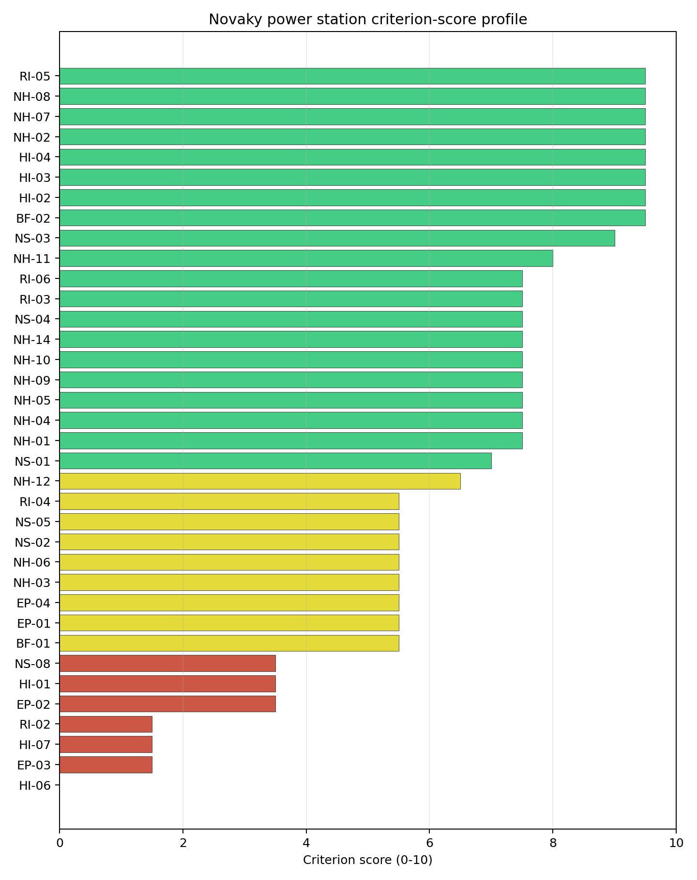
Criterion scores
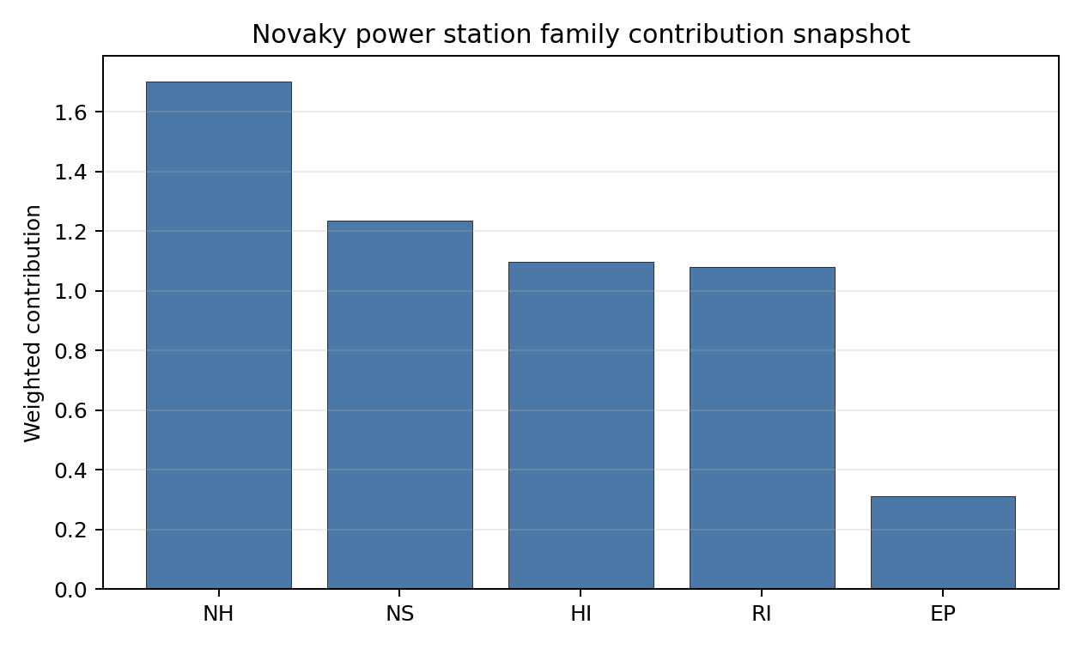
Family contributions
Novaky has a baseline composite score of 6.716, with a Monte Carlo bracket of 6.003-7.237. The national stability band is H, and the national top-10% hit rate is 0%, so the site is a strong point-estimate comparator but not a robust national leader. Its natural-hazard and transport record is attractive, and the brownfield retirement history strengthens the coal-to-nuclear case. The ranking is held back by aircraft proximity, military installations, EMI, geography-constrained emergency planning and weak surface-water dispersion. Stage 3 characterisation would be most valuable if it can retire those specific avoidance and low-score findings rather than re-scoring the entire site.

Residual Risk Register
Concern | Evidence | Consequence | Stage 3 action | Owner discipline
Military Installations (HI-06) | Nearest feature 3.12 km; 14 military features within radius | Security standoff may remain an avoidance constraint | Engage defence authorities and classify the features | security
Aircraft Crash (HI-01) | Prievidza Airfield 8.44 km; flight path 4.22 km | Flight-path geometry may constrain siting envelope | Model aircraft-crash hazard and airfield operations | security
Physical Geography Constraints (EP-03) | 78 waterways crossing EPZ; major river barrier flagged | Evacuation routes may be disrupted by river barriers | Model EPZ clearance and river-crossing resilience | emergency planning
Surface Water Dispersion (RI-02) | Native score 1.5/10; Nitra flow 3.77 m3/s | Liquid-pathway margin may be weak under low-flow conditions | Quantify Nitra low-flow dispersion and discharge pathways | hydrology
Grid Connection (NS-02) | 472 MW export capacity; highest nearby voltage 110.0 kV | Export pathway may need reinforcement for the reference envelope | Confirm substation upgrade and transmission pathway | grid
Novaky is a credible second-tier comparator because its natural-hazard and logistics profile is strong. The residual-risk register shows why it remains behind Vojany I in the national sequence: aviation, security, emergency planning and water-pathway issues all need early evidence.

Stage 3 Follow-Up Checklist
- Resolve Aircraft Crash (HI-01) avoidance flag - measured light-airport distance 8.44 km against the 10 km small-airfield screen.
- Re-measure Military Installations (HI-06) - native score 0.0/10 with confidence high.
- Re-measure Physical Geography Constraints (EP-03) - native score 1.5/10 with confidence medium.
- Re-measure Electromagnetic Interference (HI-07) - native score 1.5/10 with confidence medium.
- Re-measure Surface Water Dispersion (RI-02) - native score 1.5/10 with confidence insufficient.
- Re-measure Evacuation Routes (EP-02) - native score 3.5/10 with confidence medium.

Evidence Limitations
- No criterion-family quality fields are flagged as low or missing in this bundle.

Trebisov power station Site Profile
Trebisov power station is a coal/thermal site in Slovakia that has been tested against the NuScale VOYGR-6 reference deployment envelope. This profile reads the screening evidence at a level that supports a decision to progress toward Stage 3 characterisation. It is not a site-suitability determination, vendor recommendation, or licensing finding.

Site Snapshot
Field | Value
Site name | Trebisov power station
Coordinates | 48.6278, 21.7172
Subnational unit | Košice
Installed thermal capacity (source data) | 885 MW
Available surface area | 33.6 ha
Available surface area for development | 8.9 ha
Composite score (baseline weights) | 6.741 (6.023-7.281 MC band)
National stability band | H (top-10% hit rate 0%)
National rank | 2
See the country status map in Slovakia Country Profile.

Ownership and Coal-to-Nuclear Context
The local bundle carries no ownership rows for Trebisov. The generation record shows one cancelled unit, so the site should be treated as a planned-but-unbuilt thermal record rather than a retired brownfield complex until ownership, land control and inherited infrastructure are verified.
Generating units on record: 1 cancelled.

Natural Hazards (NH)
- Seismic: Ground Motion (NH-01) - score 5.5/10 (MC 5.0-6.0) - pass-mark band: At or below the score-5 risk boundary., weight 0.0455, data quality high. Evidence: PGA at 475-year return period 0.095 g; PGA at 2,475-year return period 0.236 g; Vs30 reference (m/s): 760.0.
- Seismic: Surface Rupture (NH-02) - score 9.5/10 (MC 9.0-10.0) - favourable: Very strong separation from mapped capable faults; surface-rupture concern effectively screened at desk-study level., weight n/a, data quality screening grade. Evidence: nearest mapped capable fault 50.0 km; fault slip rate 0 mm/yr; fault name: none_in_search_radius.
- Geotechnical: Liquefaction (NH-03) - score 5.5/10 (MC 5.0-6.0) - pass-mark band: Moderate susceptibility, or high/very-high with documented (or pending for high) mitigation., weight n/a, data quality medium. Evidence: liquefaction susceptibility: high.
- Geotechnical: Slope Stability (NH-04) - score 9.5/10 (MC 9.0-10.0) - favourable: Well below the risk boundary., weight n/a, data quality screening grade. Evidence: site slope 4.21 deg; max slope in 1 km box 79.9 deg; slope stability class: gentle.
- Geotechnical: Subsidence (NH-05) - score 9.5/10 (MC 9.0-10.0) - favourable: No karst; mine-feature distance well above the score-5 pivot (or unknown)., weight 0.0354, data quality medium. Evidence: karst present: no; karst severity: none.
- Geotechnical: Foundation (NH-06) - score 3.5/10 (MC 3.0-4.0), weight 0.0253, data quality medium. Evidence: depth to bedrock 23.6 m.
- Volcanism (NH-07) - score 9.5/10 (MC 9.0-10.0) - favourable: Very strong margin above the score-5 boundary (or connector confirmed no in-radius signal)., weight n/a, data quality high. Evidence: volcanic hazard class: negligible.
- Coastal Flooding (NH-08) - score 9.5/10 (MC 9.0-10.0) - favourable: Non-coastal OR elevation >= 50 m AMSL OR landlocked country, with no positive marine-hazard signal., weight 0.0303, data quality medium. Evidence: distance to coast 654.8 km.
- River Flooding (NH-09) - score 7.5/10 (MC 7.0-8.0), weight 0.0404, data quality medium. Evidence: flood zone class: negligible.
- Extreme Winds (NH-10) - score 7.5/10 (MC 7.0-8.0), weight 0.0152, data quality medium. Evidence: screening wind-speed index 8.34 m/s.
- Extreme Precipitation (NH-11) - score 8.0/10 (MC 8.0-9.0) - favourable: aggregated(mean_of_sub_scores), weight 0.0152, data quality medium. Evidence: screening extreme-precipitation index 0.23 mm; screening precipitation index 25.6 mm/yr.
- Extreme Temperatures (NH-12) - score 6.5/10 (MC 6.0-7.0) - pass-mark band: aggregated(mean_of_sub_scores), weight 0.0202, data quality medium. Evidence: extreme high temperature 23.6 deg C; extreme low temperature -6.88 deg C.
- Combined Hazards (NH-14) - score 5.5/10 (MC 5.0-6.0) - pass-mark band: At least 5 resolved, exactly one moderate hazard (3-5) or moderate interaction only., weight 0.0152, data quality n/a. Evidence: values not in measurement tables.

Interpretation - Natural Hazards (NH)
Natural hazards at Trebisov are acceptable at screening level except for geotechnical foundation uncertainty. PGA is 0.095 g at the 475-year return period and 0.236 g at the 2,475-year return period, and the nearest mapped capable fault is 50.0 km away. The site is flat, with 4.21 degrees mean slope and a gentle slope-stability class, and river flooding is recorded as negligible. The weak point is Geotechnical: Foundation (NH-06), which scores 3.5/10 with 23.6 m depth to bedrock but no bearing-capacity value in the visible evidence. Liquefaction susceptibility is high. Stage 3 should therefore run bearing-capacity testing, CPT/SPT investigation and liquefaction modelling before treating the East Slovak lowland foundation envelope as resolved.

Human-Induced and Security-Relevant Hazards (HI)
- Aircraft Crash (HI-01) - score 3.5/10 (MC 3.0-4.0), weight 0.0354, data quality high. Evidence: nearest airport 3.26 km; nearest flight path 1.63 km; airports within search radius 11; airport name: Trebišov Airstrip; airport type: small airfield.
- Industrial Explosions (HI-02) - score 9.5/10 (MC 9.0-10.0) - favourable: Very strong margin above the score-5 boundary (or completed search confirmed no in-radius signal)., weight 0.0354, data quality medium. Evidence: values not in measurement tables.
- Toxic/Gas Releases (HI-03) - score 9.5/10 (MC 9.0-10.0) - favourable: Very strong margin above the score-5 boundary (or completed search confirmed no in-radius signal)., weight 0.0354, data quality medium. Evidence: values not in measurement tables.
- External Fires (HI-04) - score 9.5/10 (MC 9.0-10.0) - favourable: > 15 km, or completed flammable-storage search found nothing in radius., weight 0.0303, data quality medium. Evidence: values not in measurement tables.
- Military Installations (HI-06) - score 0.0/10 (MC 0.0-0.0), weight 0.0303, data quality high. Evidence: nearest military installation 1.1 km; military installations within radius 258; installation name: unnamed.
- Electromagnetic Interference (HI-07) - score 1.5/10 (MC 1.0-2.0), weight 0.0101, data quality medium. Evidence: nearest high-power transmitter 5.83 km; transmitters within radius 133; transmitter type: communication.

Interpretation - Human-Induced and Security-Relevant Hazards (HI)
Human-induced hazards are the dominant adverse feature at Trebisov. Aircraft Crash (HI-01) scores 3.5/10 because Trebišov Airstrip is 3.26 km away and the nearest flight-path proxy is 1.63 km away. Military Installations (HI-06) is more severe, with the nearest military feature 1.10 km away and 258 features recorded within the search radius, producing a 0.0/10 score. Electromagnetic Interference (HI-07) also remains weak, with the nearest transmitter 5.83 km away and 133 transmitters within the search radius. Stage 3 should not treat these as routine desk-study refinements; it should begin with military-feature classification, airfield and flight-path hazard assessment, and RF survey work.

Radiological Impact and Emergency Planning (RI / EP)
- Emergency Planning Feasibility (EP-01) - score 5.5/10 (MC 5.0-6.0) - pass-mark band: At or above the composite score-5 boundary., weight n/a, data quality high. Evidence: EP feasibility composite 57.4 /100; road sub-score 47.7 /100; special-population sub-score 90.0 /100; geography sub-score 95.0 /100; population sub-score 60.0 /100; evacuation feasible: yes.
- Evacuation Routes (EP-02) - score 3.5/10 (MC 3.0-4.0), weight 0.0303, data quality medium. Evidence: road density in EPZ 0.429 km/km2; road length in EPZ 841.7 km; motorway access: yes.
- Physical Geography Constraints (EP-03) - score 9.5/10 (MC 9.0-10.0) - favourable: No measured relief; open river/waterway context (interim screening)., weight 0.0253, data quality medium. Evidence: waterways crossing EPZ 0; major river barrier: no.
- Special Populations (EP-04) - score 5.5/10 (MC 5.0-6.0) - pass-mark band: 9-25., weight 0.0303, data quality medium. Evidence: hospitals in EPZ 9; prisons in EPZ 0; care homes in EPZ 0.
- Atmospheric Dispersion (RI-01) - score no native score (unscored - no band matched), weight 0.0303, data quality medium. Evidence: annual mean wind speed 0.82 m/s; atmospheric mixing height 480.2 m; prevailing wind direction: N.
- Surface Water Dispersion (RI-02) - score 3.5/10 (MC 3.0-4.0), weight 0.0253, data quality n/a. Evidence: values not in measurement tables.
- Groundwater Dispersion (RI-03) - score 5.5/10 (MC 5.0-6.0) - pass-mark band: Moderate-permeability aquifer screening proxy., weight 0.0253, data quality medium. Evidence: aquifer type: alluvial.
- Population Density at EPZ Radii (RI-04) - score 3.5/10 (MC 3.0-4.0), weight 0.0404, data quality screening grade. Evidence: population density within 5 km 344.8 /km2; population density within 16 km 109.5 /km2; population density within 25 km 98.1 /km2; population density within 80 km 105.9 /km2; population within 25 km 192,594 people.
- Distance to Population Centres (RI-05) - score 9.5/10 (MC 9.0-10.0) - favourable: Nearest >=50k population-centre proxy exceeds required distance by >= 50 %., weight 0.0505, data quality screening grade. Evidence: nearest city above 50k people 36.9 km; nearest city population 227,458 people; city name: Košice.
- Population Projections (RI-06) - score 5.5/10 (MC 5.0-6.0) - pass-mark band: 0 % to +0.3 %., weight 0.0253, data quality screening grade. Evidence: annual population growth rate 0.283 %/yr; projected population at 25 km in 60 yr 159,653 people.

Interpretation - Radiological Impact and Emergency Planning (RI / EP)
Radiological impact and emergency planning at Trebisov are constrained by the town-edge population pattern and evacuation capacity. Emergency Planning Feasibility (EP-01) scores 57.4/100 and is marked feasible, but the road sub-score is 47.7/100 and EPZ road density is 0.429 km/km2. Population Density at EPZ Radii (RI-04) is weak at 3.5/10 because the 5 km density is 344.8 people/km2, while the 25 km population is 192,594 people. The nearest city above 50,000 people is Košice at 36.9 km, but the local inner-EPZ density remains the practical planning issue. Stage 3 should model evacuation clearance, confirm population micro-distribution, and quantify surface-water dispersion for the Ondava context before Trebisov is promoted beyond comparator status.

Non-Safety and Implementation Considerations (NS)
- Grid Capacity Basic Filter (BF-01) - score 5.5/10 (MC 5.0-6.0) - pass-mark band: Note: substation 15-30 km OR 110-219 kV; reinforcement plausible., weight n/a, data quality n/a. Evidence: values not in measurement tables.
- Land Area Basic Filter (BF-02) - score 1.5/10 (MC 1.0-2.0), weight 0.0253, data quality n/a. Evidence: values not in measurement tables.
- Cooling Water Availability (NS-01) - score 6.0/10 (MC 6.0-7.0) - pass-mark band: aggregated(weighted_mean_of_sub_scores), weight 0.0404, data quality screening grade. Evidence: distance to cooling source 6.19 km; cooling source flow 18.6 m3/s; cooling source type: river; cooling source name: Ondava; water stress label: Low-Medium.
- Grid Connection (NS-02) - score 5.5/10 (MC 5.0-6.0) - pass-mark band: aggregated(min_of_sub_scores), weight 0.0404, data quality high. Evidence: nearest substation 1.11 km; nearest high-voltage line 1.87 km; highest nearby line voltage 110.0 kV; grid export capacity 885.0 MW; substations within radius 490; HV lines within radius 442.
- Transport Access (NS-03) - score 9.0/10 (MC 9.0-10.0) - favourable: aggregated(weighted_mean_of_sub_scores), weight 0.0404, data quality high. Evidence: nearest highway 0.99 km; nearest rail line 0.69 km; heavy-haul capable: yes.
- Site Topography (NS-04) - score 9.5/10 (MC 9.0-10.0) - favourable: > 80 %., weight 0.0303, data quality screening grade. Evidence: favourable land cover 95.2 %; moderate land cover 3.2 %; unfavourable land cover 1.6 %; favourable area 33.6 ha; dominant land class: 211.
- Site Footprint Adequacy (NS-05) - score 7.5/10 (MC 7.0-8.0), weight 0.0253, data quality medium. Evidence: buildable area 8.91 ha; largest contiguous patch 6.68 ha; buildable patch count 5.
- Existing Infrastructure (NS-06) - score no native score (unscored - no band matched), weight 0.0253, data quality n/a. Evidence: not measured at this site (criterion remains unscored).
- Ecological Sensitivity (NS-08) - score 1.5/10 (MC 1.0-2.0), weight n/a, data quality high. Evidence: natural land cover 1.6 %; distance to nearest Natura 2000 site 0.874 km; distance to nearest protected area 6.478 km; Natura 2000 overlap: no; Natura 2000 sensitivity class: high; protected-area overlap: no; protected-area sensitivity class: low; nearest Natura 2000 site: Ondavská rovina; Natura 2000 sites within 5 km: 1; nearest protected-area designation: Nature Reserve / Private Nature Reserve.
- Workforce Availability (NS-10) - score no native score (unscored - no band matched), weight 0.0202, data quality n/a. Evidence: not measured at this site (criterion remains unscored).
- Regulatory/Political Environment (NS-12) - score no native score (unscored - no band matched), weight 0.0303, data quality n/a. Evidence: not measured at this site (criterion remains unscored).
- Construction Logistics (NS-13) - score no native score (unscored - no band matched), weight 0.0202, data quality n/a. Evidence: not measured at this site (criterion remains unscored).

Interpretation - Non-Safety and Implementation Considerations (NS)
Implementation conditions at Trebisov are mixed and do not yet show a strong brownfield-reuse case. The site has 33.6 ha of canonical surface area, but only 8.9 ha of development area and a largest contiguous patch of 6.68 ha. Cooling water is 6.19 km away at the Ondava, with 18.6 m3/s flow and a Low-Medium water-stress label. Grid assets are nearby, with a substation at 1.11 km, a high-voltage line at 1.87 km and an 885 MW export-capacity estimate, but the highest nearby voltage is 110.0 kV. Ecological sensitivity is material because Ondavská rovina is 0.874 km away and classified as high sensitivity. Stage 3 should first test land assembly, grid deliverability, water abstraction distance and protected-area constraints.

Composite Score and Stability
Baseline composite score is 6.741, bracketed by Monte Carlo at 6.023-7.281. National stability band is H with a top-10% hit rate of 0% in the project’s 50,000-iteration national sensitivity analysis.
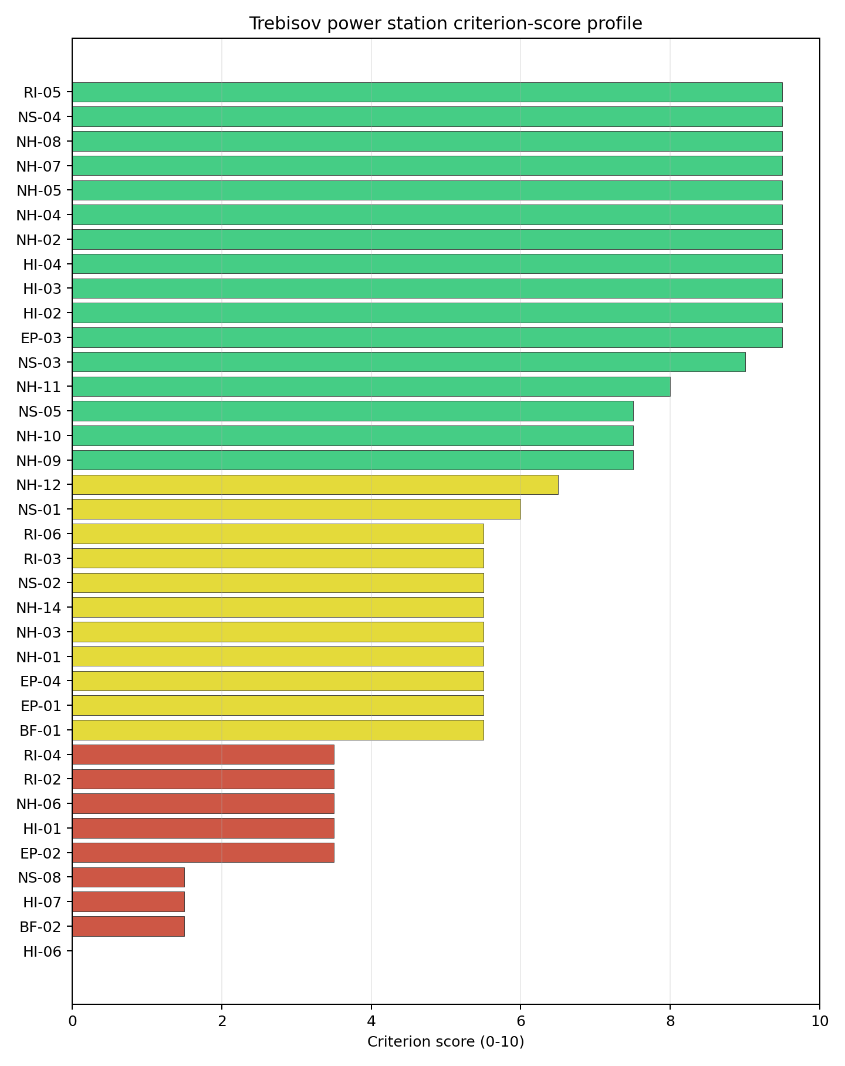
Criterion scores
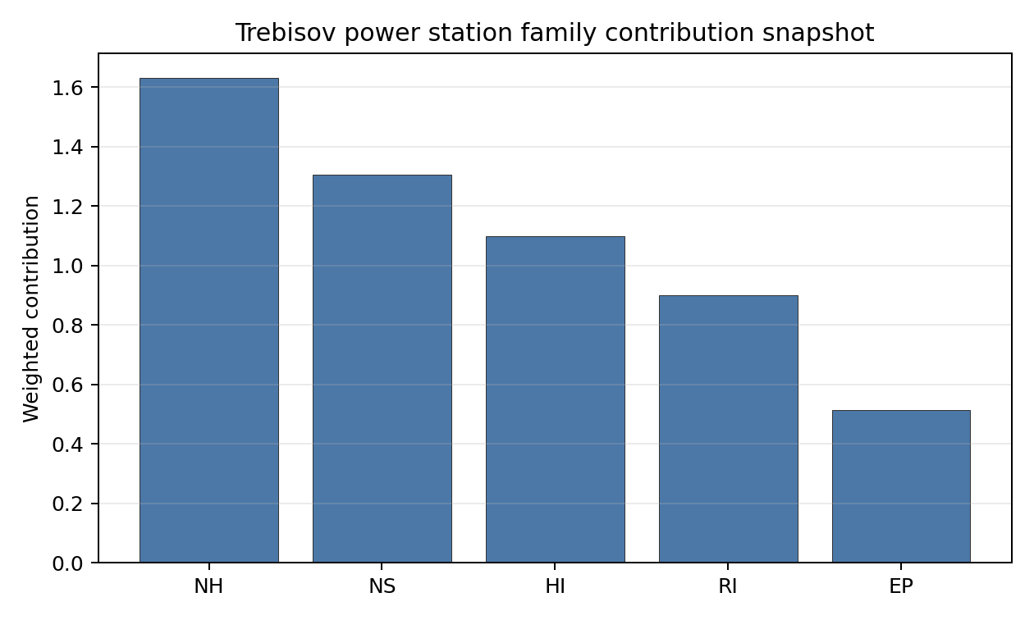
Family contributions
Trebisov has a baseline composite score of 6.741, with a Monte Carlo bracket of 6.023-7.281. The score is close to Novaky on point estimate, but the national stability band is H and the national top-10% hit rate is 0%. That means Trebisov is rank-sensitive and should not be sequenced as a robust leader despite its second-place baseline rank. Its score benefits from transport access, slope/topography, distance to Košice and the planned 885 MW grid envelope, but it is dragged down by aircraft proximity, dense military-feature evidence, EMI, inner-EPZ population density, land fragmentation and ecological proximity. Stage 3 should only proceed if the programme wants to test whether those avoidance flags are resolvable.

Residual Risk Register
Concern | Evidence | Consequence | Stage 3 action | Owner discipline
Military Installations (HI-06) | Nearest feature 1.10 km; 258 features within radius | Security standoff could remain structurally adverse | Engage defence authorities and classify each feature | security
Aircraft Crash (HI-01) | Trebišov Airstrip 3.26 km; flight path 1.63 km | Airfield and approach geometry may prevent removal of the avoidance flag | Model aircraft-crash hazard and flight-path geometry | security
Site Footprint Adequacy (NS-05) | Development area 8.9 ha; largest patch 6.68 ha | Land assembly may be insufficient for the reference envelope | Confirm parcel control and contiguous buildable area | ownership/legal
Population Density at EPZ Radii (RI-04) | 344.8 people/km2 within 5 km; 192,594 people within 25 km | Emergency planning could be constrained by the inner-EPZ population | Model EPZ population and clearance scenarios | emergency planning
Ecological Sensitivity (NS-08) | Ondavská rovina 0.874 km away; high sensitivity | Permitting review may narrow the usable siting envelope | Confirm protected-area pathways and assessment requirements | EIA
Trebisov’s risks are more structural than Vojany I’s. The site remains useful as a ranked comparator, but the Stage 3 burden is heavy because aviation, defence, land and population constraints all require early resolution.

Stage 3 Follow-Up Checklist
- Resolve Aircraft Crash (HI-01) avoidance flag - measured light-airport distance 3.26 km against the 10 km small-airfield screen.
- Resolve Aircraft Crash (HI-01) avoidance flag - measured flight-path proxy 1.63 km against the 4 km airway screen.
- Re-measure Military Installations (HI-06) - native score 0.0/10 with confidence high.
- Re-measure Land Area Basic Filter (BF-02) - native score 1.5/10 with confidence insufficient.
- Re-measure Electromagnetic Interference (HI-07) - native score 1.5/10 with confidence medium.
- Re-measure Ecological Sensitivity (NS-08) - native score 1.5/10 with confidence high.
- Re-measure Evacuation Routes (EP-02) - native score 3.5/10 with confidence medium.

Evidence Limitations
- No criterion-family quality fields are flagged as low or missing in this bundle.

U.S. Steel Kosice Works power station Site Profile
U.S. Steel Kosice Works power station is a coal/thermal site in Slovakia that has been tested against the NuScale VOYGR-6 reference deployment envelope. This profile reads the screening evidence at a level that supports a decision to progress toward Stage 3 characterisation. It is not a site-suitability determination, vendor recommendation, or licensing finding.

Site Snapshot
Field | Value
Site name | U.S. Steel Kosice Works power station
Coordinates | 48.6159, 21.1946
Subnational unit | Košice
Installed thermal capacity (source data) | 208 MW
Available surface area | 11.9 ha
Available surface area for development | 11.9 ha
Composite score (baseline weights) | 5.691 (5.174-6.181 MC band)
National stability band | H (top-10% hit rate 0%)
National rank | 5
See the country status map in Slovakia Country Profile.

Ownership and Coal-to-Nuclear Context
The local ownership record identifies US Steel Košice sro as the immediate operator. Upstream rows trace through United States Steel Corp and Nippon Steel Corp related ownership paths, but several share values are not populated in the bundle. The ownership chain therefore needs legal confirmation before the site can be treated as a controllable brownfield nuclear candidate.
Generating units on record: 1 operating. Earliest unit commissioning: 2008; most recent: 2008. The site is an active industrial power asset, so Stage 3 would need to test operational coexistence, industrial-interface risk and land-control constraints before any reuse decision.

Natural Hazards (NH)
- Seismic: Ground Motion (NH-01) - score 5.5/10 (MC 5.0-6.0) - pass-mark band: At or below the score-5 risk boundary., weight 0.0455, data quality high. Evidence: PGA at 475-year return period 0.083 g; PGA at 2,475-year return period 0.221 g; Vs30 reference (m/s): 760.0.
- Seismic: Surface Rupture (NH-02) - score 9.5/10 (MC 9.0-10.0) - favourable: Very strong separation from mapped capable faults; surface-rupture concern effectively screened at desk-study level., weight n/a, data quality screening grade. Evidence: nearest mapped capable fault 50.0 km; fault slip rate 0 mm/yr; fault name: none_in_search_radius.
- Geotechnical: Liquefaction (NH-03) - score 5.5/10 (MC 5.0-6.0) - pass-mark band: Moderate susceptibility, or high/very-high with documented (or pending for high) mitigation., weight n/a, data quality medium. Evidence: liquefaction susceptibility: moderate.
- Geotechnical: Slope Stability (NH-04) - score 9.5/10 (MC 9.0-10.0) - favourable: Well below the risk boundary., weight n/a, data quality screening grade. Evidence: site slope 4 deg; max slope in 1 km box 29.7 deg; slope stability class: gentle.
- Geotechnical: Subsidence (NH-05) - score 7.5/10 (MC 7.0-8.0), weight 0.0354, data quality medium. Evidence: karst present: no; karst severity: none.
- Geotechnical: Foundation (NH-06) - score 3.5/10 (MC 3.0-4.0), weight 0.0253, data quality medium. Evidence: depth to bedrock 26.9 m.
- Volcanism (NH-07) - score 9.5/10 (MC 9.0-10.0) - favourable: Very strong margin above the score-5 boundary (or connector confirmed no in-radius signal)., weight n/a, data quality high. Evidence: volcanic hazard class: negligible.
- Coastal Flooding (NH-08) - score 9.5/10 (MC 9.0-10.0) - favourable: Non-coastal OR elevation >= 50 m AMSL OR landlocked country, with no positive marine-hazard signal., weight 0.0303, data quality medium. Evidence: distance to coast 622.7 km.
- River Flooding (NH-09) - score 7.5/10 (MC 7.0-8.0), weight 0.0404, data quality medium. Evidence: flood zone class: negligible.
- Extreme Winds (NH-10) - score 7.5/10 (MC 7.0-8.0), weight 0.0152, data quality medium. Evidence: screening wind-speed index 8.51 m/s.
- Extreme Precipitation (NH-11) - score 8.0/10 (MC 8.0-9.0) - favourable: aggregated(mean_of_sub_scores), weight 0.0152, data quality medium. Evidence: screening extreme-precipitation index 0.21 mm; screening precipitation index 22.3 mm/yr.
- Extreme Temperatures (NH-12) - score 6.5/10 (MC 6.0-7.0) - pass-mark band: aggregated(mean_of_sub_scores), weight 0.0202, data quality medium. Evidence: extreme high temperature 24.1 deg C; extreme low temperature -6.48 deg C.
- Combined Hazards (NH-14) - score 5.5/10 (MC 5.0-6.0) - pass-mark band: At least 5 resolved, exactly one moderate hazard (3-5) or moderate interaction only., weight 0.0152, data quality n/a. Evidence: values not in measurement tables.

Interpretation - Natural Hazards (NH)
Natural hazards at U.S. Steel Kosice Works are generally moderate, with the main uncertainty in foundation evidence. PGA is 0.083 g at the 475-year return period and 0.221 g at the 2,475-year return period, and the nearest mapped capable fault is 50.0 km away. Liquefaction susceptibility is moderate, mean site slope is 4.0 degrees, and the maximum slope in the 1 km box is 29.7 degrees. Geotechnical: Foundation (NH-06) scores 3.5/10 because the visible evidence includes 26.9 m depth to bedrock but no bearing-capacity value. Stage 3 should therefore prioritize bearing-capacity testing, dynamic soil characterisation and confirmation of drainage/flood assumptions before the natural-hazard profile is treated as resolved.

Human-Induced and Security-Relevant Hazards (HI)
- Aircraft Crash (HI-01) - score 3.5/10 (MC 3.0-4.0), weight 0.0354, data quality high. Evidence: nearest airport 3.16 km; nearest flight path 1.58 km; airports within search radius 13; airport name: Letisko Veľká Ida; airport type: small airfield.
- Industrial Explosions (HI-02) - score 9.5/10 (MC 9.0-10.0) - favourable: Very strong margin above the score-5 boundary (or completed search confirmed no in-radius signal)., weight 0.0354, data quality medium. Evidence: values not in measurement tables.
- Toxic/Gas Releases (HI-03) - score 9.5/10 (MC 9.0-10.0) - favourable: Very strong margin above the score-5 boundary (or completed search confirmed no in-radius signal)., weight 0.0354, data quality medium. Evidence: values not in measurement tables.
- External Fires (HI-04) - score 9.5/10 (MC 9.0-10.0) - favourable: > 15 km, or completed flammable-storage search found nothing in radius., weight 0.0303, data quality medium. Evidence: values not in measurement tables.
- Military Installations (HI-06) - score 0.0/10 (MC 0.0-0.0), weight 0.0303, data quality high. Evidence: nearest military installation 4.02 km; military installations within radius 72; installation name: unnamed.
- Electromagnetic Interference (HI-07) - score 1.5/10 (MC 1.0-2.0), weight 0.0101, data quality medium. Evidence: nearest high-power transmitter 0.87 km; transmitters within radius 433; transmitter type: communication.

Interpretation - Human-Induced and Security-Relevant Hazards (HI)
Human-induced hazards are a major constraint at U.S. Steel Kosice Works. Aircraft Crash (HI-01) scores 3.5/10 because Letisko Veľká Ida is 3.16 km away and the nearest flight-path proxy is 1.58 km away. Military Installations (HI-06) scores 0.0/10, with the nearest military feature 4.02 km away and 72 features within the search radius. Electromagnetic Interference (HI-07) is also severe: the nearest high-power transmitter is 0.87 km away and 433 transmitters are recorded within the search radius. Stage 3 should begin with airfield hazard modelling, military-feature classification and an RF/EMI survey tied to the operating industrial context.

Radiological Impact and Emergency Planning (RI / EP)
- Emergency Planning Feasibility (EP-01) - score 7.5/10 (MC 7.0-8.0), weight n/a, data quality high. Evidence: EP feasibility composite 68.9 /100; road sub-score 53.6 /100; special-population sub-score 90.0 /100; geography sub-score 95.0 /100; population sub-score 80.0 /100; evacuation feasible: yes.
- Evacuation Routes (EP-02) - score 5.5/10 (MC 5.0-6.0) - pass-mark band: Adequate primary routes (0.5-1.0)., weight 0.0303, data quality medium. Evidence: road density in EPZ 0.527 km/km2; road length in EPZ 1,036 km; motorway access: yes.
- Physical Geography Constraints (EP-03) - score 9.5/10 (MC 9.0-10.0) - favourable: No measured relief; open river/waterway context (interim screening)., weight 0.0253, data quality medium. Evidence: waterways crossing EPZ 0; major river barrier: no.
- Special Populations (EP-04) - score 1.5/10 (MC 1.0-2.0), weight 0.0303, data quality medium. Evidence: hospitals in EPZ 59; prisons in EPZ 2; care homes in EPZ 0.
- Atmospheric Dispersion (RI-01) - score no native score (unscored - no band matched), weight 0.0303, data quality medium. Evidence: annual mean wind speed 0.94 m/s; atmospheric mixing height 488.7 m; prevailing wind direction: N.
- Surface Water Dispersion (RI-02) - score 1.5/10 (MC 1.0-2.0), weight 0.0253, data quality n/a. Evidence: values not in measurement tables.
- Groundwater Dispersion (RI-03) - score 5.5/10 (MC 5.0-6.0) - pass-mark band: Moderate-permeability aquifer screening proxy., weight 0.0253, data quality medium. Evidence: aquifer type: alluvial.
- Population Density at EPZ Radii (RI-04) - score 3.5/10 (MC 3.0-4.0), weight 0.0404, data quality screening grade. Evidence: population density within 5 km 169.0 /km2; population density within 16 km 350.3 /km2; population density within 25 km 188.1 /km2; population density within 80 km 109.1 /km2; population within 25 km 369,221 people.
- Distance to Population Centres (RI-05) - score 1.5/10 (MC 1.0-2.0), weight 0.0505, data quality screening grade. Evidence: nearest city above 50k people 10.3 km; nearest city population 227,458 people; city name: Košice.
- Population Projections (RI-06) - score 3.5/10 (MC 3.0-4.0), weight 0.0253, data quality screening grade. Evidence: annual population growth rate 0.51 %/yr; projected population at 25 km in 60 yr 306,059 people.

Interpretation - Radiological Impact and Emergency Planning (RI / EP)
Radiological impact and emergency planning are the principal reason U.S. Steel Kosice Works remains a weak candidate. Emergency Planning Feasibility (EP-01) scores 68.9/100 and is marked feasible, but Special Populations (EP-04) scores 1.5/10 with 59 hospitals and two prisons in the EPZ. Population Density at EPZ Radii (RI-04) is weak, with 169.0 people/km2 within 5 km, 350.3 people/km2 within 16 km, and 369,221 people within 25 km. Distance to Population Centres (RI-05) scores 1.5/10 because Košice is 10.3 km away. Stage 3 should model EPZ clearance, special-population evacuation and population-centre separation before any reuse scenario is advanced.

Non-Safety and Implementation Considerations (NS)
- Grid Capacity Basic Filter (BF-01) - score 5.5/10 (MC 5.0-6.0) - pass-mark band: Note: substation 15-30 km OR 110-219 kV; reinforcement plausible., weight n/a, data quality n/a. Evidence: values not in measurement tables.
- Land Area Basic Filter (BF-02) - score 1.5/10 (MC 1.0-2.0), weight 0.0253, data quality n/a. Evidence: values not in measurement tables.
- Cooling Water Availability (NS-01) - score 6.0/10 (MC 5.0-6.0) - pass-mark band: aggregated(weighted_mean_of_sub_scores), weight 0.0404, data quality screening grade. Evidence: distance to cooling source 9.97 km; cooling source flow 1.15 m3/s; cooling source type: small_river; cooling source name: Šacký kanál; water stress label: Low-Medium.
- Grid Connection (NS-02) - score 1.5/10 (MC 1.0-2.0), weight 0.0404, data quality high. Evidence: nearest substation 1.72 km; nearest high-voltage line 0.97 km; highest nearby line voltage 110.0 kV; grid export capacity 208.0 MW; substations within radius 419; HV lines within radius 288.
- Transport Access (NS-03) - score 9.0/10 (MC 9.0-10.0) - favourable: aggregated(weighted_mean_of_sub_scores), weight 0.0404, data quality high. Evidence: nearest highway 1.55 km; nearest rail line 0.15 km; heavy-haul capable: yes.
- Site Topography (NS-04) - score 9.5/10 (MC 9.0-10.0) - favourable: > 80 %., weight 0.0303, data quality screening grade. Evidence: favourable land cover 96.5 %; moderate land cover 3.5 %; unfavourable land cover 0.1 %; favourable area 301.1 ha; dominant land class: 121.
- Site Footprint Adequacy (NS-05) - score 3.5/10 (MC 3.0-4.0), weight 0.0253, data quality high. Evidence: buildable area 11.9 ha; largest contiguous patch 11.9 ha; buildable patch count 6.
- Existing Infrastructure (NS-06) - score no native score (unscored - no band matched), weight 0.0253, data quality n/a. Evidence: not measured at this site (criterion remains unscored).
- Ecological Sensitivity (NS-08) - score 3.5/10 (MC 3.0-4.0), weight n/a, data quality high. Evidence: natural land cover 0.1 %; distance to nearest Natura 2000 site 2.316 km; distance to nearest protected area 8.391 km; Natura 2000 overlap: no; Natura 2000 sensitivity class: moderate; protected-area overlap: no; protected-area sensitivity class: low; nearest Natura 2000 site: Košická kotlina; Natura 2000 sites within 5 km: 2; nearest protected-area designation: Protected Site / Private Protected Site.
- Workforce Availability (NS-10) - score no native score (unscored - no band matched), weight 0.0202, data quality n/a. Evidence: not measured at this site (criterion remains unscored).
- Regulatory/Political Environment (NS-12) - score no native score (unscored - no band matched), weight 0.0303, data quality n/a. Evidence: not measured at this site (criterion remains unscored).
- Construction Logistics (NS-13) - score no native score (unscored - no band matched), weight 0.0202, data quality n/a. Evidence: not measured at this site (criterion remains unscored).

Interpretation - Non-Safety and Implementation Considerations (NS)
Implementation conditions reflect an active industrial site rather than a retired coal-to-nuclear brownfield. The canonical and development surface-area rows both show 11.9 ha, below the 14 ha site-area avoidance threshold in the Stage 3 checklist. Cooling Water Availability (NS-01) is constrained: Šacký kanál is 9.97 km away, flow is 1.15 m3/s, and the water-stress label is Low-Medium. Grid Connection (NS-02) scores 1.5/10, with 208 MW export capacity and a highest nearby voltage of 110.0 kV. Transport access is strong, with highway at 1.55 km, rail at 0.15 km and heavy-haul capability, but land, water, grid and population-centre constraints dominate the implementation read. Stage 3 should treat this as an industrial-interface feasibility case, not a straightforward retired-thermal reuse candidate.

Composite Score and Stability
Baseline composite score is 5.691, bracketed by Monte Carlo at 5.174-6.181. National stability band is H with a top-10% hit rate of 0% in the project’s 50,000-iteration national sensitivity analysis.
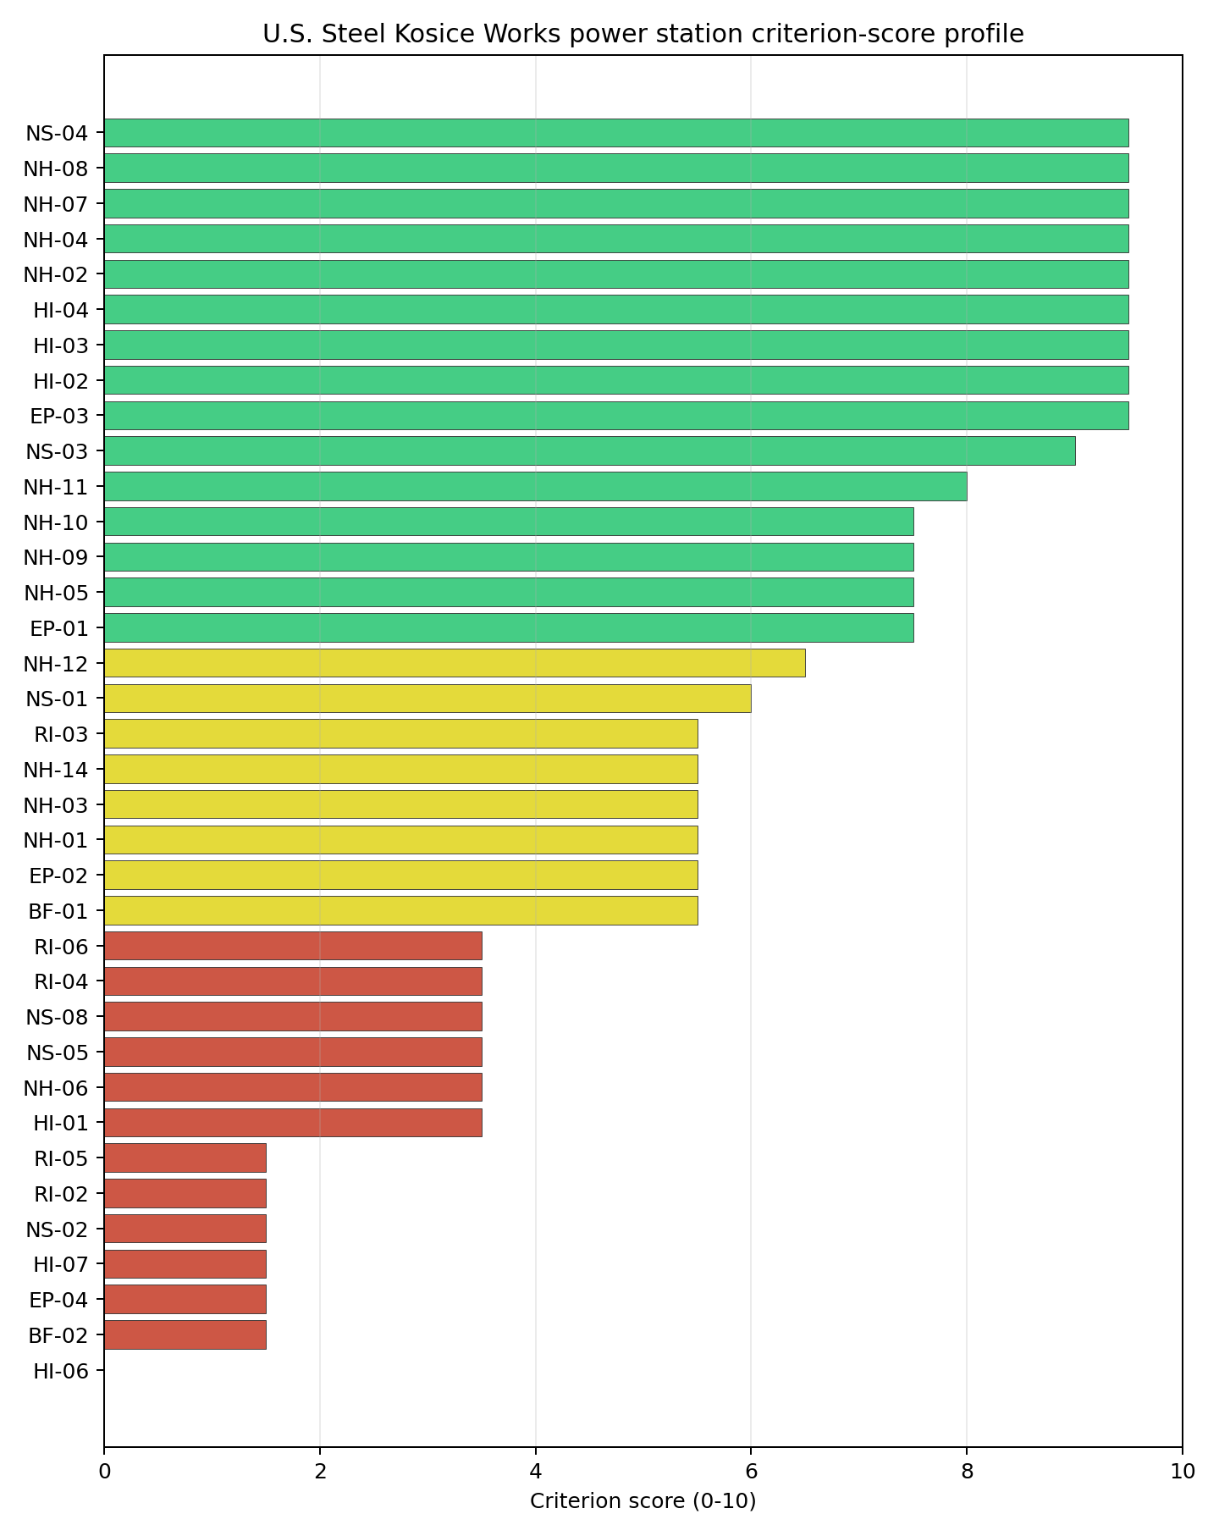
Criterion scores
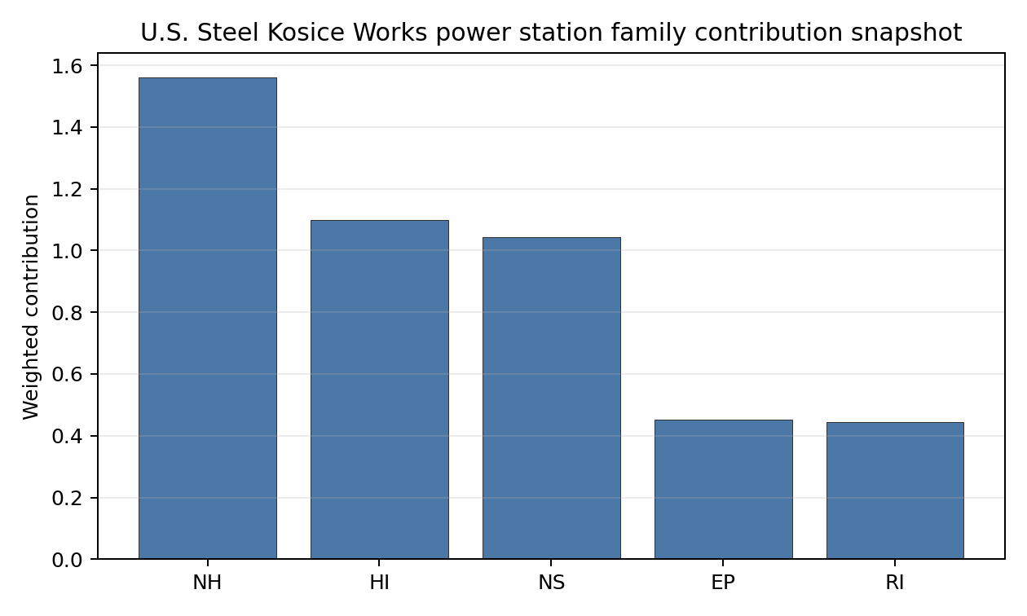
Family contributions
U.S. Steel Kosice Works has a baseline composite score of 5.691, with a Monte Carlo bracket of 5.174-6.181. Its national stability band is H, and the national top-10% hit rate is 0%, placing it at the bottom of the selected Slovakia top-five set. The score benefits from strong transport access and flat topography, but those strengths are overwhelmed by aviation proximity, military features, EMI, high special-population counts, Košice proximity, small site area, low cooling flow and a 208 MW grid export envelope. Stage 3 should only be considered if the programme specifically wants to test active-industrial-site reuse; it is not a priority characterisation candidate under the national sensitivity analysis.

Residual Risk Register
Concern | Evidence | Consequence | Stage 3 action | Owner discipline
Distance to Population Centres (RI-05) | Košice 10.3 km away; nearest city population 227,458 | Population-centre separation may remain an avoidance constraint | Model EPZ and population-centre separation at site scale | emergency planning
Special Populations (EP-04) | 59 hospitals and two prisons in the EPZ | Emergency planning could be complex and resource-intensive | Model special-population evacuation logistics | emergency planning
Aircraft Crash (HI-01) | Letisko Veľká Ida 3.16 km; flight path 1.58 km | Airfield and flight-path geometry may remain adverse | Model aircraft-crash hazard and airspace controls | security
Site Footprint Adequacy (NS-05) | Site area 11.9 ha; largest patch 11.9 ha | The reference envelope may not fit without additional controlled land | Confirm controllable contiguous land and constraints | ownership/legal
Cooling Water Availability (NS-01) | Šacký kanál 9.97 km away; flow 1.15 m3/s | Cooling-water supply may require major redesign or alternative strategy | Quantify cooling-water availability and alternatives | hydrology
Grid Connection (NS-02) | Export capacity 208 MW; highest nearby voltage 110.0 kV | Grid export pathway is undersized for the reference envelope | Confirm reinforcement pathway and substation options | grid
The U.S. Steel Kosice Works register is a set of programme-level constraints, not a normal characterisation punch list. The site remains in the top five by national rank, but the frozen sensitivity result and constraint stack place it behind the retired brownfield candidates.

Stage 3 Follow-Up Checklist
- Resolve Aircraft Crash (HI-01) avoidance flag - measured light-airport distance 3.16 km against the 10 km small-airfield screen.
- Resolve Aircraft Crash (HI-01) avoidance flag - measured major-airport distance 6.3 km against the commercial-airport separation screen.
- Resolve Aircraft Crash (HI-01) avoidance flag - measured flight-path proxy 1.58 km against the 4 km airway screen.
- Resolve Grid Connection (NS-02) avoidance flag - measured grid export capacity 208.0 MW against the 462 MWe reference export-capacity screen.
- Resolve Site Footprint Adequacy (NS-05) avoidance flag - measured canonical site area 11.95 ha against the 14 ha nuclear-island footprint screen.
- Resolve Distance to Population Centres (RI-05) avoidance flag - measured 10.33 km separation from the nearest city above 50,000 people against the 16 km population-centre screen.
- Re-measure Military Installations (HI-06) - native score 0.0/10 with confidence high.
- Re-measure Land Area Basic Filter (BF-02) - native score 1.5/10 with confidence insufficient.
- Re-measure Special Populations (EP-04) - native score 1.5/10 with confidence medium.
- Re-measure Electromagnetic Interference (HI-07) - native score 1.5/10 with confidence medium.
- Re-measure Grid Connection (NS-02) - native score 1.5/10 with confidence high.

Evidence Limitations
- No criterion-family quality fields are flagged as low or missing in this bundle.

Vojany I power station Site Profile
Vojany I power station is a coal/thermal site in Slovakia that has been tested against the NuScale VOYGR-6 reference deployment envelope. This profile reads the screening evidence at a level that supports a decision to progress toward Stage 3 characterisation. It is not a site-suitability determination, vendor recommendation, or licensing finding.

Site Snapshot
Field | Value
Site name | Vojany I power station
Coordinates | 48.5525, 21.9726
Subnational unit | Košice
Installed thermal capacity (source data) | 660 MW
Available surface area | 53.0 ha
Available surface area for development | 89.5 ha
Composite score (baseline weights) | 7.022 (6.250-7.481 MC band)
National stability band | A (top-10% hit rate 100%)
National rank | 1
See the country status map in Slovakia Country Profile.

Ownership and Coal-to-Nuclear Context
The local ownership record identifies Slovenské Elektrárne AŞ as the immediate operator. The recorded parent interests include the Government of Slovakia and Ministry of Economy (Slovakia) at 34.00%, Enel SpA at 33.00%, and EP Slovakia BV at 33.00%, with smaller upstream public-market holders also present in the chain. Ownership and control should be confirmed legally before any site-specific engagement.
Generating units on record: 6 retired. Earliest unit commissioning: 1965; most recent: 1966. Retirements span 2008 to 2024, leaving a brownfield grid, water, transport and workforce context for Stage 3 review.

Natural Hazards (NH)
- Seismic: Ground Motion (NH-01) - score 5.5/10 (MC 5.0-6.0) - pass-mark band: At or below the score-5 risk boundary., weight 0.0455, data quality high. Evidence: PGA at 475-year return period 0.095 g; PGA at 2,475-year return period 0.237 g; Vs30 reference (m/s): 760.0.
- Seismic: Surface Rupture (NH-02) - score 9.5/10 (MC 9.0-10.0) - favourable: Very strong separation from mapped capable faults; surface-rupture concern effectively screened at desk-study level., weight n/a, data quality screening grade. Evidence: nearest mapped capable fault 50.0 km; fault slip rate 0 mm/yr; fault name: none_in_search_radius.
- Geotechnical: Liquefaction (NH-03) - score 5.5/10 (MC 5.0-6.0) - pass-mark band: Moderate susceptibility, or high/very-high with documented (or pending for high) mitigation., weight n/a, data quality medium. Evidence: liquefaction susceptibility: high; dominant soil type: silty_clay_loam.
- Geotechnical: Slope Stability (NH-04) - score 7.5/10 (MC 7.0-8.0), weight n/a, data quality screening grade. Evidence: site slope 5.45 deg; max slope in 1 km box 79.4 deg; slope stability class: moderate.
- Geotechnical: Subsidence (NH-05) - score 5.5/10 (MC 5.0-6.0) - pass-mark band: At or above the mine-distance score-5 pivot; review possible., weight 0.0354, data quality medium. Evidence: karst present: no; karst severity: none.
- Geotechnical: Foundation (NH-06) - score 5.5/10 (MC 5.0-6.0) - pass-mark band: Typical European mixed conditions (bearing 80-150 kPa)., weight 0.0253, data quality medium. Evidence: bearing capacity 88.0 kPa; depth to bedrock 22.9 m.
- Volcanism (NH-07) - score 9.5/10 (MC 9.0-10.0) - favourable: Very strong margin above the score-5 boundary (or connector confirmed no in-radius signal)., weight n/a, data quality high. Evidence: volcanic hazard class: negligible.
- Coastal Flooding (NH-08) - score 9.5/10 (MC 9.0-10.0) - favourable: Non-coastal OR elevation >= 50 m AMSL OR landlocked country, with no positive marine-hazard signal., weight 0.0303, data quality medium. Evidence: distance to coast 660.1 km.
- River Flooding (NH-09) - score 7.5/10 (MC 7.0-8.0), weight 0.0404, data quality medium. Evidence: flood zone class: negligible.
- Extreme Winds (NH-10) - score 7.5/10 (MC 7.0-8.0), weight 0.0152, data quality medium. Evidence: screening wind-speed index 7.63 m/s.
- Extreme Precipitation (NH-11) - score 8.0/10 (MC 8.0-9.0) - favourable: aggregated(mean_of_sub_scores), weight 0.0152, data quality medium. Evidence: screening extreme-precipitation index 0.21 mm; screening precipitation index 25.2 mm/yr.
- Extreme Temperatures (NH-12) - score 6.5/10 (MC 6.0-7.0) - pass-mark band: aggregated(mean_of_sub_scores), weight 0.0202, data quality medium. Evidence: extreme high temperature 25.3 deg C; extreme low temperature -5.87 deg C.
- Combined Hazards (NH-14) - score 5.5/10 (MC 5.0-6.0) - pass-mark band: At least 5 resolved, exactly one moderate hazard (3-5) or moderate interaction only., weight 0.0152, data quality n/a. Evidence: values not in measurement tables.

Interpretation - Natural Hazards (NH)
Natural hazards at Vojany I support Stage 3 consideration, with geotechnical and floodplain confirmation as the main field tasks. Ground motion is moderate, with PGA of 0.095 g at the 475-year return period and 0.237 g at the 2,475-year return period, and the nearest mapped capable fault is 50.0 km away. The site has high liquefaction susceptibility on a silty-clay-loam profile, bearing capacity of 88.0 kPa, and 22.9 m depth to bedrock, so the favourable seismic read still needs a site-specific soil campaign. River flooding is currently recorded as negligible, while coastal flooding is screened out at 660.1 km from the coast. Stage 3 should start with CPT/SPT ground investigation, liquefaction modelling and a Laborec/Bodrog flood review before design-basis natural-hazard claims are hardened.

Human-Induced and Security-Relevant Hazards (HI)
- Aircraft Crash (HI-01) - score 7.5/10 (MC 7.0-8.0), weight 0.0354, data quality high. Evidence: nearest airport 12.3 km; nearest flight path 6.14 km; airports within search radius 8; airport name: Kačanov Airstrip; airport type: small airfield.
- Industrial Explosions (HI-02) - score 9.5/10 (MC 9.0-10.0) - favourable: Very strong margin above the score-5 boundary (or completed search confirmed no in-radius signal)., weight 0.0354, data quality medium. Evidence: values not in measurement tables.
- Toxic/Gas Releases (HI-03) - score 9.5/10 (MC 9.0-10.0) - favourable: Very strong margin above the score-5 boundary (or completed search confirmed no in-radius signal)., weight 0.0354, data quality medium. Evidence: values not in measurement tables.
- External Fires (HI-04) - score 9.5/10 (MC 9.0-10.0) - favourable: > 15 km, or completed flammable-storage search found nothing in radius., weight 0.0303, data quality medium. Evidence: values not in measurement tables.
- Military Installations (HI-06) - score 1.5/10 (MC 1.0-2.0), weight 0.0303, data quality medium. Evidence: nearest military installation 14.9 km; military installations within radius 20; installation name: Už.
- Electromagnetic Interference (HI-07) - score 1.5/10 (MC 1.0-2.0), weight 0.0101, data quality medium. Evidence: nearest high-power transmitter 0.46 km; transmitters within radius 183; transmitter type: mast.

Interpretation - Human-Induced and Security-Relevant Hazards (HI)
Human-induced hazards at Vojany I are manageable but require security and electromagnetic-interference confirmation. The nearest airport is Kačanov Airstrip at 12.3 km, while the nearest flight-path proxy is 6.14 km, so aircraft-crash review remains a Stage 3 task even though the airport distance is outside the 10 km small-airfield screen. Military Installations (HI-06) is weak at 1.5/10, with the nearest feature named Už at 14.9 km and 20 military features within the search radius. Electromagnetic Interference (HI-07) is also weak: the nearest high-power transmitter is 0.46 km away and 183 transmitters are recorded within the search radius. Stage 3 should classify the military features, survey RF field strengths and refresh the local hazardous-neighbour inventory.

Radiological Impact and Emergency Planning (RI / EP)
- Emergency Planning Feasibility (EP-01) - score 7.5/10 (MC 7.0-8.0), weight n/a, data quality high. Evidence: EP feasibility composite 70.7 /100; road sub-score 51.8 /100; special-population sub-score 90.0 /100; geography sub-score 95.0 /100; population sub-score 95.0 /100; evacuation feasible: yes.
- Evacuation Routes (EP-02) - score 3.5/10 (MC 3.0-4.0), weight 0.0303, data quality medium. Evidence: road density in EPZ 0.496 km/km2; road length in EPZ 974.4 km; motorway access: yes.
- Physical Geography Constraints (EP-03) - score 9.5/10 (MC 9.0-10.0) - favourable: No measured relief; open river/waterway context (interim screening)., weight 0.0253, data quality medium. Evidence: waterways crossing EPZ 0; major river barrier: no.
- Special Populations (EP-04) - score 3.5/10 (MC 3.0-4.0), weight 0.0303, data quality medium. Evidence: hospitals in EPZ 36; prisons in EPZ 1; care homes in EPZ 0.
- Atmospheric Dispersion (RI-01) - score no native score (unscored - no band matched), weight 0.0303, data quality medium. Evidence: annual mean wind speed 0.9 m/s; atmospheric mixing height 487.6 m; prevailing wind direction: N.
- Surface Water Dispersion (RI-02) - score 5.5/10 (MC 5.0-6.0) - pass-mark band: 30-100 m3/s., weight 0.0253, data quality n/a. Evidence: values not in measurement tables.
- Groundwater Dispersion (RI-03) - score 5.5/10 (MC 5.0-6.0) - pass-mark band: Moderate-permeability aquifer screening proxy., weight 0.0253, data quality medium. Evidence: aquifer type: alluvial.
- Population Density at EPZ Radii (RI-04) - score 5.5/10 (MC 5.0-6.0) - pass-mark band: aggregated(min_of_sub_scores), weight 0.0404, data quality screening grade. Evidence: population density within 5 km 50.2 /km2; population density within 16 km 78.1 /km2; population density within 25 km 139.0 /km2; population density within 80 km 107.5 /km2; population within 25 km 272,837 people.
- Distance to Population Centres (RI-05) - score 9.5/10 (MC 9.0-10.0) - favourable: Nearest >=50k population-centre proxy exceeds required distance by >= 50 %., weight 0.0505, data quality screening grade. Evidence: nearest city above 50k people 57.3 km; nearest city population 227,458 people; city name: Košice.
- Population Projections (RI-06) - score 7.5/10 (MC 7.0-8.0), weight 0.0253, data quality screening grade. Evidence: annual population growth rate -0.172 %/yr; projected population at 25 km in 60 yr 226,167 people.

Interpretation - Radiological Impact and Emergency Planning (RI / EP)
Radiological impact and emergency planning are the main non-geotechnical workstream for Vojany I. Emergency Planning Feasibility (EP-01) scores 70.7/100 and is marked feasible, but Evacuation Routes (EP-02) remain weak with 0.496 km/km2 road density and 974.4 km of road in the EPZ. Special Populations (EP-04) is material: 36 hospitals and one prison are recorded in the EPZ. Population density is moderate at 50.2 people/km2 within 5 km and 139.0 people/km2 within 25 km, and Košice is 57.3 km away as the nearest city above 50,000 people. Stage 3 should model EPZ clearance times, special-population transport and meteorological dispersion using the 0.9 m/s annual mean wind speed and 487.6 m mixing-height inputs.

Non-Safety and Implementation Considerations (NS)
- Grid Capacity Basic Filter (BF-01) - score 5.5/10 (MC 5.0-6.0) - pass-mark band: Note: substation 15-30 km OR 110-219 kV; reinforcement plausible., weight n/a, data quality n/a. Evidence: values not in measurement tables.
- Land Area Basic Filter (BF-02) - score 9.5/10 (MC 9.0-10.0) - favourable: Contiguous and buildable >= ideal area (70 ha/module)., weight 0.0253, data quality n/a. Evidence: values not in measurement tables.
- Cooling Water Availability (NS-01) - score 8.0/10 (MC 7.0-8.0) - favourable: aggregated(weighted_mean_of_sub_scores), weight 0.0404, data quality screening grade. Evidence: distance to cooling source 1.37 km; cooling source flow 34.7 m3/s; cooling source type: river; cooling source name: Laborec; water stress label: Low-Medium.
- Grid Connection (NS-02) - score 5.5/10 (MC 5.0-6.0) - pass-mark band: aggregated(min_of_sub_scores), weight 0.0404, data quality high. Evidence: nearest substation 0.46 km; nearest high-voltage line 0.21 km; highest nearby line voltage 110.0 kV; grid export capacity 660.0 MW; substations within radius 194; HV lines within radius 384.
- Transport Access (NS-03) - score 10.0/10 (MC 9.0-10.0) - favourable: aggregated(weighted_mean_of_sub_scores), weight 0.0404, data quality medium. Evidence: nearest rail line 0.06 km; heavy-haul capable: yes.
- Site Topography (NS-04) - score 7.5/10 (MC 7.0-8.0), weight 0.0303, data quality screening grade. Evidence: favourable land cover 69.5 %; moderate land cover 12.9 %; unfavourable land cover 17.6 %; favourable area 195.6 ha; dominant land class: 211.
- Site Footprint Adequacy (NS-05) - score 7.5/10 (MC 7.0-8.0), weight 0.0253, data quality high. Evidence: buildable area 89.5 ha; largest contiguous patch 89.5 ha; buildable patch count 10.
- Existing Infrastructure (NS-06) - score no native score (unscored - no band matched), weight 0.0253, data quality n/a. Evidence: not measured at this site (criterion remains unscored).
- Ecological Sensitivity (NS-08) - score 1.5/10 (MC 1.0-2.0), weight n/a, data quality high. Evidence: natural land cover 17.6 %; distance to nearest Natura 2000 site 0.213 km; distance to nearest protected area 2.427 km; Natura 2000 overlap: no; Natura 2000 sensitivity class: high; protected-area overlap: no; protected-area sensitivity class: moderate; nearest Natura 2000 site: Medzibodrožie; Natura 2000 sites within 5 km: 7; nearest protected-area designation: Protected Landscape Area; second level of protection.
- Workforce Availability (NS-10) - score no native score (unscored - no band matched), weight 0.0202, data quality n/a. Evidence: not measured at this site (criterion remains unscored).
- Regulatory/Political Environment (NS-12) - score no native score (unscored - no band matched), weight 0.0303, data quality n/a. Evidence: not measured at this site (criterion remains unscored).
- Construction Logistics (NS-13) - score no native score (unscored - no band matched), weight 0.0202, data quality n/a. Evidence: not measured at this site (criterion remains unscored).

Interpretation - Non-Safety and Implementation Considerations (NS)
Non-safety implementation conditions are the strongest part of Vojany I, but ecological sensitivity and voltage pathway are material. The canonical site footprint is 53.0 ha, and the development-area estimate is 89.5 ha, so land is not the first constraint. Cooling Water Availability (NS-01) is favourable at 8.0/10: the Laborec is 1.37 km away with 34.7 m3/s flow and a Low-Medium water-stress label. Grid Connection (NS-02) has close assets, with a substation at 0.46 km, a high-voltage line at 0.21 km and 660 MW of export capacity, but the highest nearby voltage is 110.0 kV. Ecological Sensitivity (NS-08) is the main implementation risk: Medzibodrožie is 0.213 km away, seven Natura 2000 sites lie within 5 km, and the nearest protected area is 2.427 km away. Stage 3 should therefore confirm grid upgrade options, protected-area constraints and cooling-water low-flow margins.

Composite Score and Stability
Baseline composite score is 7.022, bracketed by Monte Carlo at 6.250-7.481. National stability band is A with a top-10% hit rate of 100% in the project’s 50,000-iteration national sensitivity analysis.
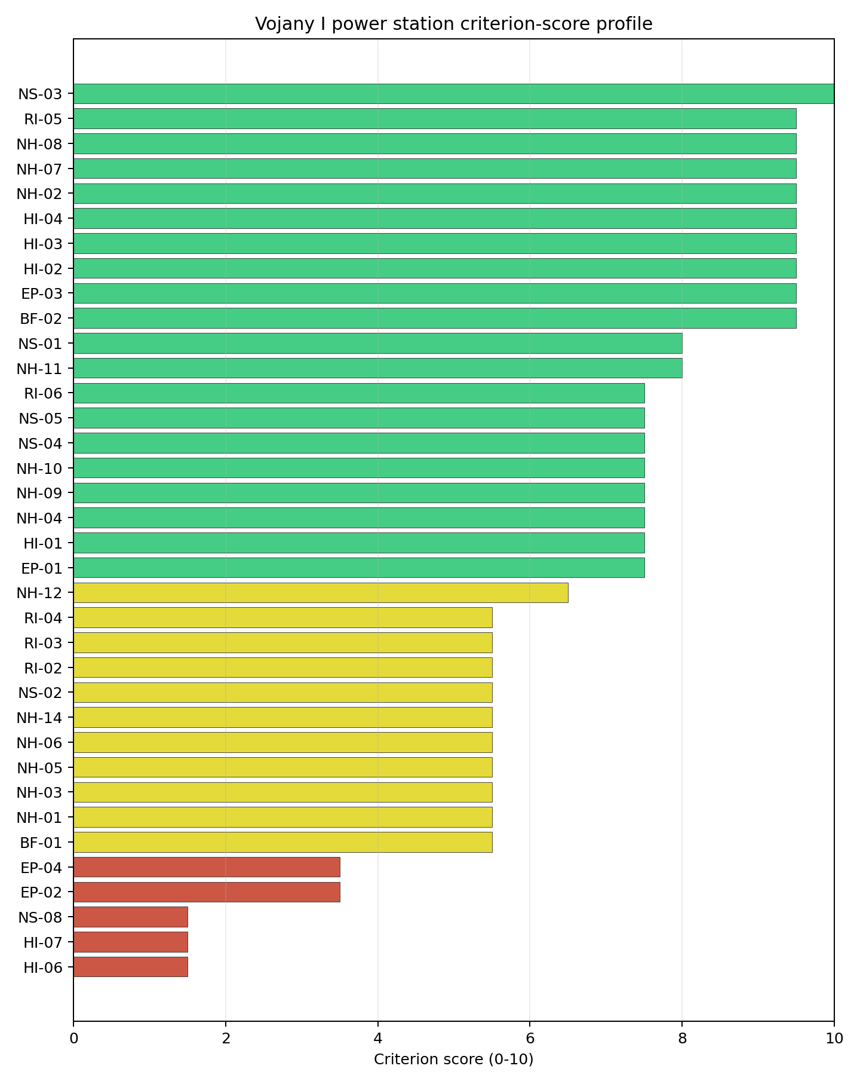
Criterion scores
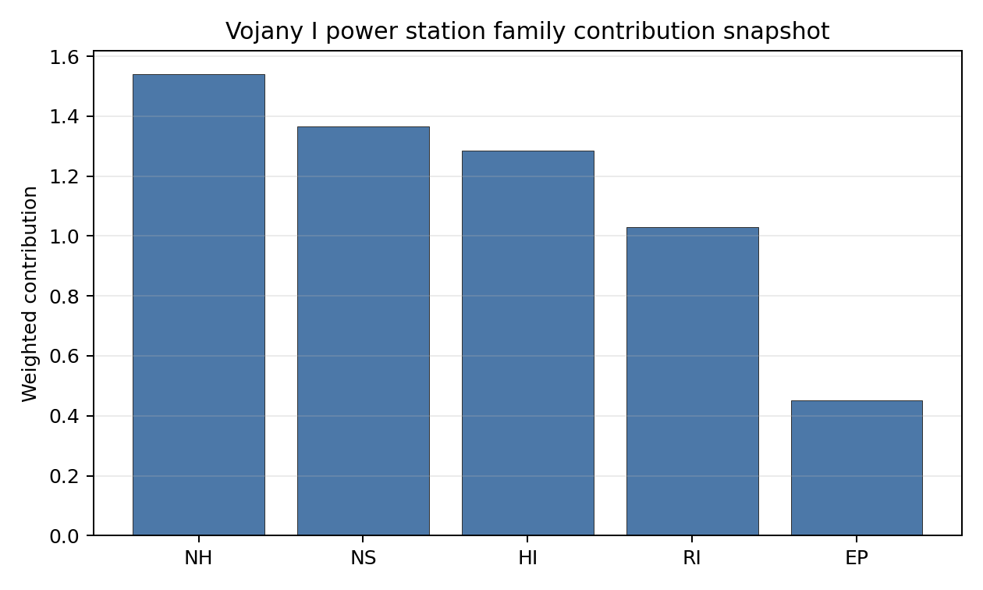
Family contributions
Vojany I has a baseline composite score of 7.022, with a Monte Carlo bracket of 6.250-7.481. The national stability band is A, and the site records a 100% top-10% hit rate across the national sensitivity analysis. That is the only robust Slovak leadership signal in this run: Vojany I remains the national leader under the weight perturbations considered, while the other scored sites fall into band H. The score is supported by full-pass status, strong transport access, a credible land envelope, cooling-water proximity and good population-centre separation. Stage 3 effort should focus on the issues that can most narrow the uncertainty band: ecological sensitivity, EMI, special-population emergency planning, voltage-pathway confirmation and liquefaction characterisation.

Residual Risk Register
Concern | Evidence | Consequence | Stage 3 action | Owner discipline
Electromagnetic Interference (HI-07) | Nearest high-power transmitter 0.46 km; 183 transmitters within radius | RF constraints could affect instrumentation siting and operating protocols | Survey transmitter inventory and field strengths | security
Ecological Sensitivity (NS-08) | Medzibodrožie 0.213 km away; seven Natura 2000 sites within 5 km | Permitting envelope may narrow around protected receptors | Confirm receptor pathways and appropriate-assessment trigger status | EIA
Special Populations (EP-04) | 36 hospitals and one prison in the EPZ | Evacuation planning may require dedicated transport and sheltering arrangements | Model special-population evacuation logistics | emergency planning
Grid Connection (NS-02) | 660 MW export capacity; highest nearby voltage 110.0 kV | Connection may require reinforcement before a multi-module export case | Confirm 220/400 kV pathway and substation upgrade scope | grid
Geotechnical: Liquefaction (NH-03) | High susceptibility on silty-clay-loam profile | Foundation design uncertainty may persist without field testing | Re-measure liquefaction and dynamic soil parameters | geotech
These risks form a Stage 3 work plan for the leading Slovak screening candidate. The register does not remove Vojany I from consideration; it identifies the evidence needed before a characterisation programme can rely on the screening result.

Stage 3 Follow-Up Checklist
- Re-measure Military Installations (HI-06) - native score 1.5/10 with confidence medium.
- Re-measure Electromagnetic Interference (HI-07) - native score 1.5/10 with confidence medium.
- Re-measure Ecological Sensitivity (NS-08) - native score 1.5/10 with confidence high.
- Re-measure Evacuation Routes (EP-02) - native score 3.5/10 with confidence medium.
- Re-measure Special Populations (EP-04) - native score 3.5/10 with confidence medium.

Evidence Limitations
- No criterion-family quality fields are flagged as low or missing in this bundle.

Türkiye Country Profile
Türkiye has 146 thermal and coal-site records that have been tested against the NuScale VOYGR-6 reference deployment envelope. 8 sites pass both the exclusionary and avoidance screens, 102 pass the exclusionary screen but retain avoidance flags, and 36 fail one or more exclusionary checks. The country is therefore not a single-site case, but only a small subset of the national site population currently clears the full screening pathway without a remediation step.
The leading site is Konya Karapınar power station, with a composite score of 7.784 and a Monte Carlo interval of 6.528-8.301. Its national stability band is A with a national top-10% hit rate of 100%. The leader is therefore not only the current point-estimate front-runner; it is also a stable national candidate under the sensitivity treatment used for the report.
Turkey contributes 146 screened thermal and coal-site records under the NuScale VOYGR-6 reference envelope. The accepted national analysis leaves 8 full-pass sites, 102 exclusionary-pass sites with avoidance flags, and 36 hard-fail sites. The five selected profiles follow the national ranking: Konya Karapınar power station (rank 1, 7.784), Eren-1 power station (rank 2, 7.459), Tufanbeyli power station (rank 3, 7.380), Karapinar Konya Şeker power station (rank 4, 7.354), Çayırhan power station (rank 5, 7.347).
The immediate leadership group combines full-pass candidates (Konya Karapınar power station, Eren-1 power station, Çayırhan power station) with avoidance-flagged candidates (Tufanbeyli power station, Karapinar Konya Şeker power station) that remain inside the top five because the selected set follows national rank rather than a full-pass-only filter. The avoidance-flagged entries should move into Stage 3 only with their flagged constraints explicitly scoped at the start of characterisation.
A credible Turkey sequence therefore starts with the full-pass leaders while opening targeted unlock work on the top avoidance-flagged sites. The programme logic is national and sensitivity-aware: it uses the 50,000-iteration national Monte Carlo result to prioritise characterisation effort, while preserving IAEA Stage 1-2 language and avoiding any implication of site approval.
Detailed site profiles are prepared for the five highest nationally ranked Turkey entries under the accepted national analysis: Konya Karapınar power station (rank 1), Eren-1 power station (rank 2), Tufanbeyli power station (rank 3), Karapinar Konya Şeker power station (rank 4), Çayırhan power station (rank 5).

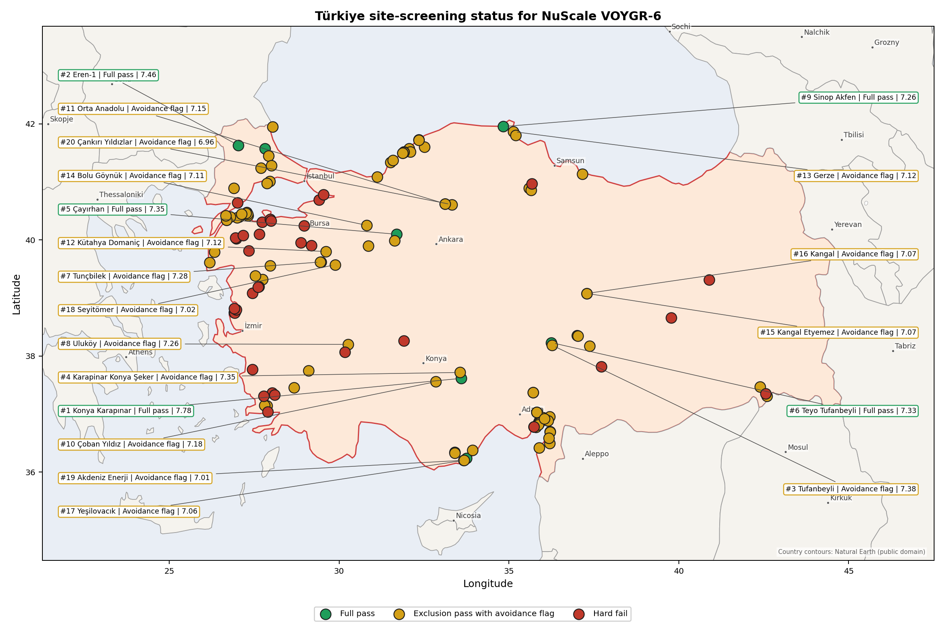
Türkiye status map

Türkiye Site Ledger
Rank | Site | Status | Composite | MC Low | MC High | Band | Top-10 Hit | Coverage
1 | Konya Karapınar power station | Full pass | 7.784 | 6.528 | 8.301 | A | 100% | 71%
2 | Eren-1 power station | Full pass | 7.459 | 6.604 | 7.900 | A | 100% | 76%
3 | Tufanbeyli power station | Exclusion pass with avoidance flag | 7.380 | 6.407 | 7.890 | A | 100% | 74%
4 | Karapinar Konya Şeker power station | Exclusion pass with avoidance flag | 7.354 | 6.386 | 7.864 | A | 100% | 74%
5 | Çayırhan power station | Full pass | 7.347 | 6.513 | 7.806 | B | 100% | 76%
6 | Teyo Tufanbeyli power station | Full pass | 7.328 | 6.366 | 7.838 | B | 92% | 74%
7 | Tunçbilek power station | Exclusion pass with avoidance flag | 7.276 | 6.326 | 7.818 | B | 100% | 74%
8 | Uluköy power station | Exclusion pass with avoidance flag | 7.263 | 6.316 | 7.701 | B | 100% | 74%
9 | Sinop Akfen power station | Full pass | 7.260 | 6.270 | 7.724 | B | 100% | 74%
10 | Çoban Yıldız power station | Exclusion pass with avoidance flag | 7.185 | 6.255 | 7.675 | B | 92% | 74%
11 | Orta Anadolu power station | Exclusion pass with avoidance flag | 7.154 | 6.063 | 7.692 | C | 67% | 71%
12 | Kütahya Domaniç power station | Exclusion pass with avoidance flag | 7.121 | 6.101 | 7.557 | D | 0% | 71%
13 | Gerze power station | Exclusion pass with avoidance flag | 7.116 | 6.326 | 7.587 | D | 17% | 76%
14 | Bolu Göynük power station | Exclusion pass with avoidance flag | 7.107 | 6.194 | 7.565 | D | 8% | 74%
15 | Kangal Etyemez power station | Exclusion pass with avoidance flag | 7.072 | 6.290 | 7.550 | D | 0% | 76%
16 | Kangal power station | Exclusion pass with avoidance flag | 7.072 | 6.290 | 7.550 | D | 8% | 76%
17 | Yeşilovacık power station | Exclusion pass with avoidance flag | 7.059 | 6.280 | 7.569 | D | 8% | 76%
18 | Seyitömer power station | Exclusion pass with avoidance flag | 7.022 | 6.250 | 7.562 | D | 0% | 76%
19 | Akdeniz Enerji power station | Exclusion pass with avoidance flag | 7.009 | 6.240 | 7.519 | D | 0% | 76%
20 | Çankırı Yıldızlar power station | Exclusion pass with avoidance flag | 6.957 | 6.038 | 7.441 | D | 0% | 74%
21 | Alpu power station | Exclusion pass with avoidance flag | 6.947 | 6.189 | 7.437 | D | 8% | 76%
22 | Sarp Golvasi power station | Exclusion pass with avoidance flag | 6.938 | 6.063 | 7.448 | D | 0% | 74%
23 | Yüksek Gölovası power station | Exclusion pass with avoidance flag | 6.938 | 6.063 | 7.448 | D | 0% | 74%
24 | Diler (Akbayir) Elbistan power station | Exclusion pass with avoidance flag | 6.908 | 5.881 | 7.370 | D | 0% | 71%
25 | Babadere power station | Exclusion pass with avoidance flag | 6.891 | 5.987 | 7.355 | D | 0% | 74%
26 | Çankırı Orta power station | Exclusion pass with avoidance flag | 6.880 | 5.861 | 7.418 | D | 0% | 71%
27 | Kahramanmaraş Anadolu power station | Exclusion pass with avoidance flag | 6.872 | 5.972 | 7.368 | D | 0% | 74%
28 | Zorlu Akçakoca power station | Exclusion pass with avoidance flag | 6.815 | 5.967 | 7.253 | D | 0% | 74%
29 | METES power station | Full pass | 6.809 | 6.078 | 7.319 | D | 0% | 76%
30 | Soma Kolin power station | Exclusion pass with avoidance flag | 6.809 | 6.078 | 7.269 | D | 0% | 76%
31 | Afşin-Elbistan power stations | Exclusion pass with avoidance flag | 6.740 | 5.871 | 7.237 | D | 0% | 74%
32 | Umut power station | Exclusion pass with avoidance flag | 6.734 | 5.987 | 7.175 | F | 0% | 76%
33 | Ada Yumurtalık power station | Exclusion pass with avoidance flag | 6.722 | 5.994 | 7.181 | E | 0% | 76%
34 | Misis Adana power station | Exclusion pass with avoidance flag | 6.722 | 5.994 | 7.181 | F | 0% | 76%
35 | Sedef II TES power station | Exclusion pass with avoidance flag | 6.722 | 5.994 | 7.181 | G | 0% | 76%
36 | Yunus Emre power station | Exclusion pass with avoidance flag | 6.720 | 5.856 | 7.257 | E | 0% | 74%
37 | Barbaros-1 power station | Exclusion pass with avoidance flag | 6.719 | 6.005 | 7.125 | G | 0% | 76%
38 | Karaburun power station | Exclusion pass with avoidance flag | 6.681 | 5.826 | 7.217 | H | 0% | 74%
39 | Bandırma III power station | Exclusion pass with avoidance flag | 6.672 | 5.967 | 7.181 | H | 0% | 76%
40 | Cenal power station | Exclusion pass with avoidance flag | 6.668 | 5.816 | 7.151 | H | 0% | 74%
41 | Vize power station | Full pass | 6.653 | 5.952 | 7.144 | H | 0% | 76%
42 | İÇDAŞ Bekirli power station | Exclusion pass with avoidance flag | 6.641 | 5.931 | 7.081 | H | 0% | 76%
43 | Filyos power station | Exclusion pass with avoidance flag | 6.628 | 5.900 | 7.050 | H | 0% | 76%
44 | Astoria Ceyhan power station | Exclusion pass with avoidance flag | 6.622 | 5.894 | 7.081 | H | 0% | 76%
45 | Adana Ceyhan power station | Exclusion pass with avoidance flag | 6.584 | 5.856 | 7.044 | H | 0% | 76%
46 | Iztek Ceyhan Komur power station | Exclusion pass with avoidance flag | 6.584 | 5.856 | 7.044 | H | 0% | 76%
47 | EMBA Hunutlu power station | Exclusion pass with avoidance flag | 6.572 | 5.844 | 7.031 | H | 0% | 76%
48 | Polat power station | Exclusion pass with avoidance flag | 6.562 | 5.770 | 7.000 | H | 0% | 74%
49 | Kıvanç power station | Full pass | 6.556 | 5.730 | 7.122 | H | 0% | 74%
50 | Zafer power station | Exclusion pass with avoidance flag | 6.534 | 5.787 | 6.975 | H | 0% | 76%
51 | Yenidere power station | Exclusion pass with avoidance flag | 6.523 | 5.705 | 7.007 | H | 0% | 74%
52 | Şırnak Galata power station | Exclusion pass with avoidance flag | 6.503 | 5.794 | 6.944 | H | 0% | 76%
53 | Mersin Gülnar power station | Exclusion pass with avoidance flag | 6.451 | 5.649 | 7.016 | H | 0% | 74%
54 | Kirazlıdere power complex | Exclusion pass with avoidance flag | 6.431 | 5.737 | 6.856 | H | 0% | 76%
55 | Trakya Emba power station | Exclusion pass with avoidance flag | 6.391 | 5.662 | 6.812 | H | 0% | 76%
56 | Yeniköy power station | Exclusion pass with avoidance flag | 6.355 | 5.576 | 6.842 | H | 0% | 74%
57 | Irmak power station | Exclusion pass with avoidance flag | 6.344 | 5.681 | 6.862 | H | 0% | 76%
58 | Ece power station | Exclusion pass with avoidance flag | 6.328 | 5.619 | 6.769 | H | 0% | 76%
59 | Gölovası power station | Exclusion pass with avoidance flag | 6.328 | 5.619 | 6.769 | H | 0% | 76%
60 | Hande power station | Exclusion pass with avoidance flag | 6.328 | 5.619 | 6.769 | H | 0% | 76%
61 | Çalışkan Ceyhan power station | Exclusion pass with avoidance flag | 6.322 | 5.594 | 6.781 | H | 0% | 76%
62 | Biga power station | Exclusion pass with avoidance flag | 6.306 | 5.538 | 6.770 | H | 0% | 74%
63 | Muğla power station | Exclusion pass with avoidance flag | 6.299 | 5.533 | 6.763 | H | 0% | 74%
64 | Saltukova power station | Exclusion pass with avoidance flag | 6.299 | 5.533 | 6.816 | H | 0% | 74%
65 | Ergene power station | Exclusion pass with avoidance flag | 6.291 | 5.631 | 6.731 | H | 0% | 76%
66 | Çebi Enerji power station | Exclusion pass with avoidance flag | 6.278 | 5.619 | 6.769 | H | 0% | 76%
67 | İsken Sugözü power station | Exclusion pass with avoidance flag | 6.278 | 5.569 | 6.719 | H | 0% | 76%
68 | Ada Yesildag Enerji power station | Exclusion pass with avoidance flag | 6.266 | 5.606 | 6.756 | H | 0% | 76%
69 | Ağan power station | Exclusion pass with avoidance flag | 6.253 | 5.497 | 6.770 | H | 0% | 74%
70 | Mert power station | Exclusion pass with avoidance flag | 6.253 | 5.525 | 6.675 | H | 0% | 76%
71 | Gürmin Enerji Amasya power station | Exclusion pass with avoidance flag | 6.247 | 5.550 | 6.687 | H | 0% | 76%
72 | Sanko Yumurtalık power station | Exclusion pass with avoidance flag | 6.234 | 5.506 | 6.694 | H | 0% | 76%
73 | Suluova power station | Exclusion pass with avoidance flag | 6.234 | 5.537 | 6.675 | H | 0% | 76%
74 | Amasra Bartın power station | Exclusion pass with avoidance flag | 6.216 | 5.537 | 6.687 | H | 0% | 76%
75 | Ayas power station | Exclusion pass with avoidance flag | 6.216 | 5.506 | 6.656 | H | 0% | 76%
76 | HEMA Amasra power station | Exclusion pass with avoidance flag | 6.216 | 5.537 | 6.687 | H | 0% | 76%
77 | Kilikya power station | Exclusion pass with avoidance flag | 6.216 | 5.506 | 6.656 | H | 0% | 76%
78 | Kandilli power station | Exclusion pass with avoidance flag | 6.209 | 5.512 | 6.700 | H | 0% | 76%
79 | Naren Karabiga power station | Exclusion pass with avoidance flag | 6.201 | 5.457 | 6.717 | H | 0% | 74%
80 | Saray Tekirdağ power station | Exclusion pass with avoidance flag | 6.166 | 5.506 | 6.656 | H | 0% | 76%
81 | Kireçlik power station | Exclusion pass with avoidance flag | 6.153 | 5.425 | 6.575 | H | 0% | 76%
82 | Çelikler Yumurtalık power station | Exclusion pass with avoidance flag | 6.148 | 5.417 | 6.612 | H | 0% | 74%
83 | Hakan Kömür power station | Exclusion pass with avoidance flag | 6.134 | 5.406 | 6.594 | H | 0% | 76%
84 | İÇDAŞ Biga power station | Exclusion pass with avoidance flag | 6.122 | 5.396 | 6.586 | H | 0% | 74%
85 | Albayrak Varaka Paper power station | Exclusion pass with avoidance flag | 6.084 | 5.437 | 6.575 | H | 0% | 76%
86 | Hakan Enerji power station | Exclusion pass with avoidance flag | 6.053 | 5.344 | 6.494 | H | 0% | 76%
87 | Yumurtalık IC İçtaş power station | Exclusion pass with avoidance flag | 6.028 | 5.319 | 6.469 | H | 0% | 76%
88 | Güreci power station | Exclusion pass with avoidance flag | 6.016 | 5.287 | 6.437 | H | 0% | 76%
89 | Lüminer Enerji power station | Exclusion pass with avoidance flag | 6.016 | 5.259 | 6.503 | H | 0% | 76%
90 | Meda power station | Exclusion pass with avoidance flag | 6.016 | 5.356 | 6.506 | H | 0% | 76%
91 | ZETES power stations | Exclusion pass with avoidance flag | 5.971 | 5.286 | 6.442 | H | 0% | 74%
92 | Adana Akdeniz power station | Exclusion pass with avoidance flag | 5.966 | 5.256 | 6.406 | H | 0% | 76%
93 | Şırnak Silopi (CİNER) power station | Exclusion pass with avoidance flag | 5.859 | 5.194 | 6.355 | H | 0% | 74%
94 | Şevketiye Lapseki power station | Exclusion pass with avoidance flag | 5.845 | 5.132 | 6.289 | H | 0% | 74%
95 | Çatalağzı power station | Exclusion pass with avoidance flag | 5.841 | 5.156 | 6.312 | H | 0% | 74%
96 | Yeniyurt power station | Exclusion pass with avoidance flag | 5.834 | 5.087 | 6.275 | H | 0% | 76%
97 | Güney Akdeniz power station | Exclusion pass with avoidance flag | 5.812 | 5.169 | 6.312 | H | 0% | 76%
98 | Namal power station | Exclusion pass with avoidance flag | 5.806 | 5.092 | 6.250 | H | 0% | 74%
99 | Atakaş power station | Exclusion pass with avoidance flag | 5.791 | 5.131 | 6.281 | H | 0% | 76%
100 | Selena power station | Exclusion pass with avoidance flag | 5.756 | 5.062 | 6.181 | H | 0% | 76%
101 | Çerkezköy power station | Exclusion pass with avoidance flag | 5.753 | 5.144 | 6.294 | H | 0% | 76%
102 | Burnaz power station | Exclusion pass with avoidance flag | 5.747 | 5.119 | 6.256 | H | 0% | 76%
103 | Tosyalı İskenderun power station | Exclusion pass with avoidance flag | 5.741 | 5.131 | 6.281 | H | 0% | 76%
104 | Avdan power station | Exclusion pass with avoidance flag | 5.706 | 5.012 | 6.131 | H | 0% | 76%
105 | Kardemir Karabük Demir Çelik power station | Exclusion pass with avoidance flag | 5.594 | 4.909 | 6.065 | H | 0% | 74%
106 | Zonguldak Modern power station | Exclusion pass with avoidance flag | 5.594 | 4.909 | 6.065 | H | 0% | 74%
107 | DETES 1 power station | Exclusion pass with avoidance flag | 5.464 | 4.831 | 5.987 | H | 0% | 74%
108 | Atlas Enerji İskenderun power station | Exclusion pass with avoidance flag | 5.394 | 4.800 | 5.919 | H | 0% | 76%
109 | İskenderun power station | Exclusion pass with avoidance flag | 5.369 | 4.775 | 5.894 | H | 0% | 76%
110 | Evrese power station | Exclusion pass with avoidance flag | 5.237 | 4.556 | 5.612 | H | 0% | 76%
- | Aksa Akrilik power station | Hard fail | - | - | - | - | - | 0%
- | Aliağa Enka power station | Hard fail | - | - | - | - | - | 0%
- | Ant Enerji power station | Hard fail | - | - | - | - | - | 0%
- | Bandırma Elektrik power station | Hard fail | - | - | - | - | - | 0%
- | Bandırma Karat power station | Hard fail | - | - | - | - | - | 0%
- | Bingöl power station | Hard fail | - | - | - | - | - | 0%
- | Bursa power station | Hard fail | - | - | - | - | - | 0%
- | Çan (18 Mart) power station | Hard fail | - | - | - | - | - | 0%
- | Çan-2 power station | Hard fail | - | - | - | - | - | 0%
- | Çırpılar power station | Hard fail | - | - | - | - | - | 0%
- | Demirtaş power station | Hard fail | - | - | - | - | - | 0%
- | Deniz power station | Hard fail | - | - | - | - | - | 0%
- | Dinar power station | Hard fail | - | - | - | - | - | 0%
- | DOSAB cogeneration plant | Hard fail | - | - | - | - | - | 0%
- | Enyat Samsun power station | Hard fail | - | - | - | - | - | 0%
- | Eti Maden Bandirma power station | Hard fail | - | - | - | - | - | 0%
- | Gebze Çolakoğlu power station | Hard fail | - | - | - | - | - | 0%
- | Gönen power station | Hard fail | - | - | - | - | - | 0%
- | Güneybatı Anadolu power station | Hard fail | - | - | - | - | - | 0%
- | Habaş power station | Hard fail | - | - | - | - | - | 0%
- | Helvacı power station | Hard fail | - | - | - | - | - | 0%
- | Ilgın power station | Hard fail | - | - | - | - | - | 0%
- | İzdemir Enerji power station | Hard fail | - | - | - | - | - | 0%
- | Kemerköy power station | Hard fail | - | - | - | - | - | 0%
- | Kipas MMP power station | Hard fail | - | - | - | - | - | 0%
- | Kınık power station | Hard fail | - | - | - | - | - | 0%
- | Orhaneli power station | Hard fail | - | - | - | - | - | 0%
- | Petkim power station | Hard fail | - | - | - | - | - | 0%
- | Sanko Gölbaşı power station | Hard fail | - | - | - | - | - | 0%
- | Silopi (Şırnak) power station | Hard fail | - | - | - | - | - | 0%
- | Soma power station | Hard fail | - | - | - | - | - | 0%
- | Star Refinery Socar power station | Hard fail | - | - | - | - | - | 0%
- | Tekirdağ Malkara power station | Hard fail | - | - | - | - | - | 0%
- | Yatağan power station | Hard fail | - | - | - | - | - | 0%
- | Yıldırım Elazığ power station | Hard fail | - | - | - | - | - | 0%
- | Zorlu Soma power station | Hard fail | - | - | - | - | - | 0%

Avoidance Flag Pareto
Of the 110 sites that pass the exclusionary screen, the avoidance-phase flags concentrate on a small set of criteria. Resolving them is what would move the country from a small leading group to a broader candidate pool.
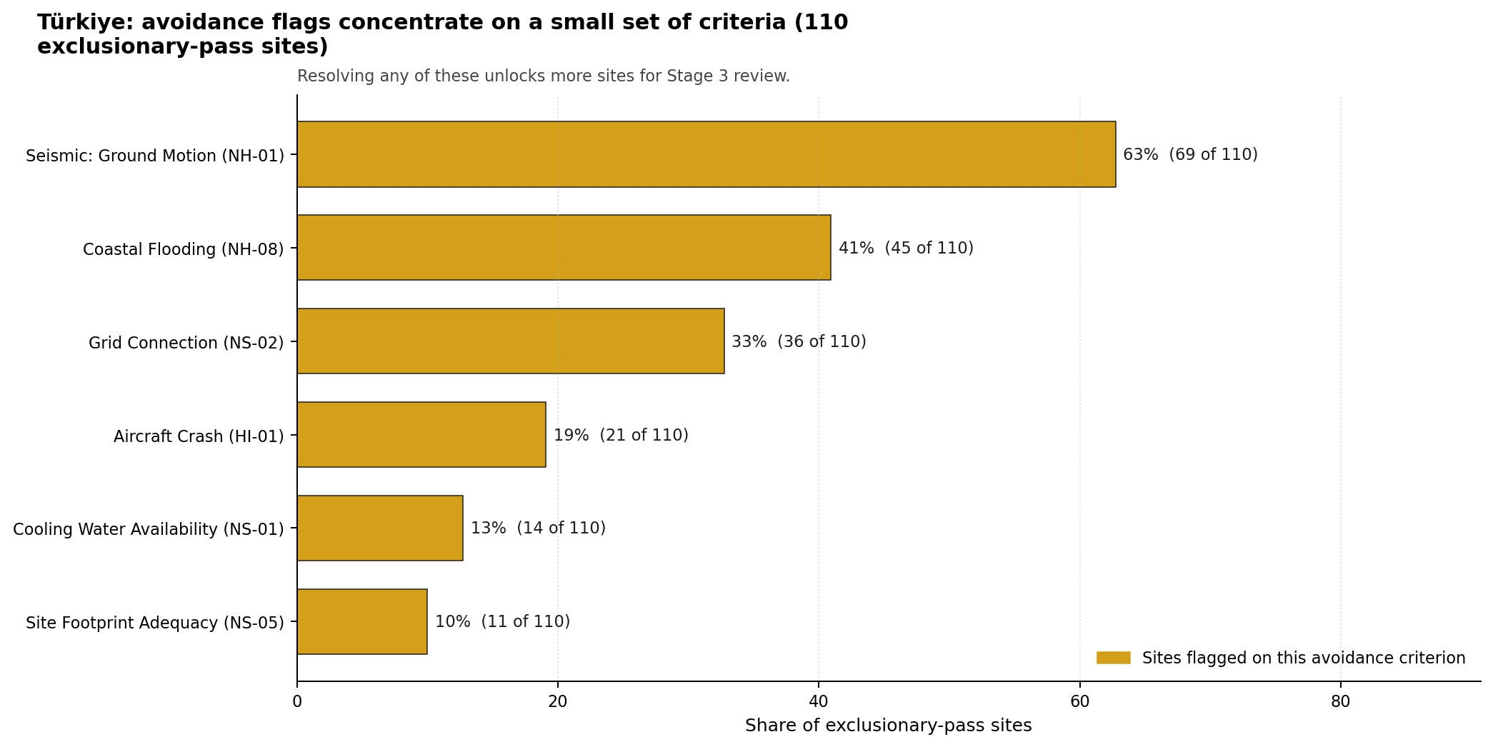
Avoidance flag Pareto
- Seismic: Ground Motion (NH-01) - 69 of 110 exclusionary-pass sites (63%).
- Coastal Flooding (NH-08) - 45 of 110 exclusionary-pass sites (41%).
- Grid Connection (NS-02) - 36 of 110 exclusionary-pass sites (33%).
- Aircraft Crash (HI-01) - 21 of 110 exclusionary-pass sites (19%).
- Cooling Water Availability (NS-01) - 14 of 110 exclusionary-pass sites (13%).
- Site Footprint Adequacy (NS-05) - 11 of 110 exclusionary-pass sites (10%).

Exclusionary Failure Pareto
The exclusionary failures across the country trace back to a small number of criteria. They identify which screening checks are responsible for removing sites from further consideration.
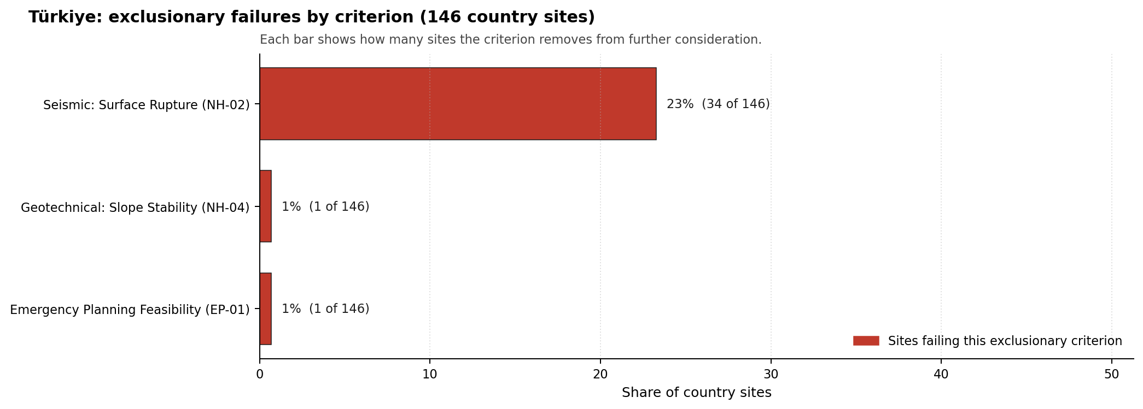
Exclusionary failure Pareto
- Seismic: Surface Rupture (NH-02) - 34 of 146 country sites (23%).
- Emergency Planning Feasibility (EP-01) - 1 of 146 country sites (1%).
- Geotechnical: Slope Stability (NH-04) - 1 of 146 country sites (1%).

Family Strength and Weakness
Across the country the strongest criterion family is Human-Induced Hazards at a mean normalised score of 7.79/10. The weakest family is Radiological Impact at 5.46/10. The bottom three individual criteria across the country are:
- Military Installations (HI-06) - mean 2.44/10 across 146 scored sites (min 0.0, max 5.0).
- Surface Water Dispersion (RI-02) - mean 2.62/10 across 146 scored sites (min 1.5, max 7.5).
- Electromagnetic Interference (HI-07) - mean 3.29/10 across 146 scored sites (min 1.5, max 9.5).

Interpretation for Site Selection
The Türkiye result shows a clear separation between sites that can support further Stage 3 consideration and sites that should remain in the evidence base only as comparators. The full-pass group is the relevant pool for progression. Avoidance-flag sites are not discarded, but they identify locations where a specific constraint must be resolved before the site can be treated as equivalent to the leading group.

Avoidance flag Pareto - what unlocks more sites
The chart shows where focused remediation effort would broaden the candidate pool. The criteria at the top of the Pareto are the policy and engineering levers that, if resolved, move avoidance-flag sites into the leading group.
An IAEA-style reading of the table focuses less on the exact rank number and more on screening class, score stability, and the nature of remaining uncertainty. Konya Karapınar power station is important because it leads nationally, sits inside the strongest stability band, and retains a full-pass status. That does not establish final site suitability. It is a defensible reason to spend Stage 3 effort on field confirmation, national data review, and stakeholder engagement before lower-ranked or avoidance-flag locations.
The Monte Carlo interval is a caution against false precision: several sites have overlapping score bands, so small score differences should not be overinterpreted. The decisive distinction is whether a site combines acceptable exclusionary performance with a stable ranking position and no unresolved avoidance flag.
The main Stage 3 questions are therefore targeted rather than generic: confirm local natural-hazard inputs, verify emergency-planning assumptions, test land and ownership constraints, assess cooling and grid interface conditions, and reconcile environmental constraints with national permitting requirements.

Status Counts
- Full pass: 8
- Exclusion pass with avoidance flag: 102
- Hard fail: 36

Çayırhan power station Site Profile
Çayırhan power station is a coal/thermal site in Türkiye that has been tested against the NuScale VOYGR-6 reference deployment envelope. This profile reads the screening evidence at a level that supports a decision to progress toward Stage 3 characterisation. It is not a site-suitability determination, vendor recommendation, or licensing finding.

Site Snapshot
Field | Value
Site name | Çayırhan power station
Coordinates | 40.0970, 31.6950
Subnational unit | Ankara
Installed thermal capacity (source data) | 1,420 MW
Available surface area | 28.7 ha
Available surface area for development | 28.7 ha
Composite score (baseline weights) | 7.347 (6.513-7.806 MC band)
National stability band | B (top-10% hit rate 100%)
National rank | 5
See the country status map in Türkiye Country Profile.

Ownership and Coal-to-Nuclear Context
- Çelikler Yatırım Holding AŞ (nan% share), headquartered in Türkiye; immediate operator Kolin-Kalyon-Celikler Consortium. Path: Çelikler Yatırım Holding AŞ -> Kolin-Kalyon-Celikler Consortium [unknown %] -> Çayırhan power station Phase B [100.0%]
- Kolin Group (nan% share), headquartered in Türkiye; immediate operator Kolin-Kalyon-Celikler Consortium. Path: Kolin Group -> Kolin-Kalyon-Celikler Consortium [unknown %] -> Çayırhan power station Phase B [100.0%]
Generating units on record: 1 cancelled, 4 operating. Earliest unit commissioning: 1987; most recent: 2000.

Natural Hazards (NH)
- Seismic: Ground Motion (NH-01) - score 5.5/10 (MC 5.0-6.0) - pass-mark band: At or below the score-5 risk boundary., weight 0.0455, data quality high. Evidence: PGA at 475-year return period 0.225 g; PGA at 2,475-year return period 0.461 g; Vs30 reference (m/s): 760.0.
- Seismic: Surface Rupture (NH-02) - score 9.5/10 (MC 9.0-10.0) - favourable: Very strong separation from mapped capable faults; surface-rupture concern effectively screened at desk-study level., weight n/a, data quality screening grade. Evidence: nearest mapped capable fault 50.0 km; fault slip rate 0 mm/yr; fault name: none_in_search_radius.
- Geotechnical: Liquefaction (NH-03) - score 9.5/10 (MC 9.0-10.0) - favourable: Negligible susceptibility (Stage-1 favourable default)., weight n/a, data quality medium. Evidence: liquefaction susceptibility: very_low; dominant soil type: clay_loam.
- Geotechnical: Slope Stability (NH-04) - score 5.5/10 (MC 5.0-6.0) - pass-mark band: At or below the score-5 risk boundary., weight n/a, data quality screening grade. Evidence: site slope 13.4 deg; max slope in 1 km box 88.1 deg; slope stability class: steep.
- Geotechnical: Subsidence (NH-05) - score 5.5/10 (MC 5.0-6.0) - pass-mark band: At or above the mine-distance score-5 pivot; review possible., weight 0.0354, data quality medium. Evidence: karst present: no; karst severity: moderate; formation type: carbonate (Discontinuous carbonate rocks).
- Geotechnical: Foundation (NH-06) - score 5.5/10 (MC 5.0-6.0) - pass-mark band: Typical European mixed conditions (bearing 80-150 kPa)., weight 0.0253, data quality medium. Evidence: bearing capacity 87.3 kPa; depth to bedrock 9.74 m.
- Volcanism (NH-07) - score 9.5/10 (MC 9.0-10.0) - favourable: Very strong margin above the score-5 boundary (or completed screening found no in-radius signal)., weight n/a, data quality high. Evidence: volcanic hazard class: negligible.
- Coastal Flooding (NH-08) - score 9.5/10 (MC 9.0-10.0) - favourable: Non-coastal OR elevation >= 50 m AMSL OR landlocked country, with no positive marine-hazard signal., weight 0.0303, data quality medium. Evidence: distance to coast 118.2 km.
- River Flooding (NH-09) - score 7.5/10 (MC 7.0-8.0), weight 0.0404, data quality medium. Evidence: flood zone class: negligible.
- Extreme Winds (NH-10) - score 9.5/10 (MC 9.0-10.0) - favourable: Lowest relative wind exposure in the current reanalysis-grade monthly-mean gust cohort (< 7.5 m/s)., weight 0.0152, data quality medium. Evidence: screening wind-speed index 5.91 m/s.
- Extreme Precipitation (NH-11) - score 8.0/10 (MC 8.0-9.0) - favourable: aggregated(mean_of_sub_scores), weight 0.0152, data quality medium. Evidence: screening extreme-precipitation index 0.17 mm; screening precipitation index 12.1 mm/yr.
- Extreme Temperatures (NH-12) - score 6.5/10 (MC 6.0-7.0) - pass-mark band: aggregated(mean_of_sub_scores), weight 0.0202, data quality medium. Evidence: extreme high temperature 28.6 deg C; extreme low temperature -2.13 deg C.
- Combined Hazards (NH-14) - score 5.5/10 (MC 5.0-6.0) - pass-mark band: At least 5 resolved, exactly one moderate hazard (3-5) or moderate interaction only., weight 0.0152, data quality n/a. Evidence: values not in measurement tables.

Interpretation - Natural Hazards (NH)
The natural-hazards evidence for Çayırhan power station supports Stage 3 characterisation, with the strongest screening signals in Extreme Winds (NH-10) at 9.5/10, Coastal Flooding (NH-08) at 9.5/10. The main constraints are Land Area Basic Filter (BF-02) at 3.5/10, Grid Capacity Basic Filter (BF-01) at 5.5/10, Seismic: Ground Motion (NH-01) at 5.5/10. These scores should be read as Stage 1-2 screening evidence: the criterion bullets above carry the measured values, while the Stage 3 programme should confirm the low-scoring and low-confidence inputs through field, authority and engineering review before any siting claim is hardened.

Human-Induced and Security-Relevant Hazards (HI)
- Aircraft Crash (HI-01) - score 9.5/10 (MC 9.0-10.0) - favourable: Only small / GA / heliport airport >= 10 km nearby, no flight-path proxy < 4 km, no major airport within 30 km, and no military airbase within 60 km., weight 0.0354, data quality high. Evidence: nearest airport 64.2 km; nearest flight path 32.1 km; airports within search radius 0; airport name: Orhan Ünsal Air Park; airport type: small airfield.
- Industrial Explosions (HI-02) - score 9.5/10 (MC 7.5-10.0) - favourable: Very strong margin above the score-5 boundary (or completed search confirmed no in-radius signal)., weight 0.0354, data quality low. Evidence: values not in measurement tables.
- Toxic/Gas Releases (HI-03) - score 9.5/10 (MC 7.5-10.0) - favourable: Very strong margin above the score-5 boundary (or completed search confirmed no in-radius signal)., weight 0.0354, data quality low. Evidence: values not in measurement tables.
- External Fires (HI-04) - score 9.5/10 (MC 7.5-10.0) - favourable: > 15 km, or completed flammable-storage search found nothing in radius., weight 0.0303, data quality low. Evidence: values not in measurement tables.
- Military Installations (HI-06) - score 3.5/10 (MC 3.0-4.0), weight 0.0303, data quality medium. Evidence: nearest military installation 20.4 km; military installations within radius 3; installation name: Jandarma Komutanlığı.
- Electromagnetic Interference (HI-07) - score 3.5/10 (MC 3.0-4.0), weight 0.0101, data quality medium. Evidence: nearest high-power transmitter 3.58 km; transmitters within radius 24; transmitter type: communication.

Interpretation - Human-Induced and Security-Relevant Hazards (HI)
The human-induced and security-relevant evidence for Çayırhan power station supports Stage 3 characterisation, with the strongest screening signals in External Fires (HI-04) at 9.5/10, Toxic/Gas Releases (HI-03) at 9.5/10. The main constraints are Military Installations (HI-06) at 3.5/10, Electromagnetic Interference (HI-07) at 3.5/10, Aircraft Crash (HI-01) at 9.5/10. These scores should be read as Stage 1-2 screening evidence: the criterion bullets above carry the measured values, while the Stage 3 programme should confirm the low-scoring and low-confidence inputs through field, authority and engineering review before any siting claim is hardened.

Radiological Impact and Emergency Planning (RI / EP)
- Emergency Planning Feasibility (EP-01) - score 5.5/10 (MC 5.0-6.0) - pass-mark band: At or above the composite score-5 boundary., weight n/a, data quality high. Evidence: EP feasibility composite 63.6 /100; road sub-score 44.4 /100; special-population sub-score 90.0 /100; geography sub-score 95.0 /100; population sub-score 80.0 /100; evacuation feasible: yes.
- Evacuation Routes (EP-02) - score 3.5/10 (MC 3.0-4.0), weight 0.0303, data quality medium. Evidence: road density in EPZ 0.374 km/km2; road length in EPZ 733.9 km; motorway access: yes.
- Physical Geography Constraints (EP-03) - score 9.5/10 (MC 9.0-10.0) - favourable: No measured relief; open river/waterway context (interim screening)., weight 0.0253, data quality medium. Evidence: waterways crossing EPZ 0; major river barrier: no.
- Special Populations (EP-04) - score 9.5/10 (MC 9.0-10.0) - favourable: 0-2 facilities., weight 0.0303, data quality medium. Evidence: hospitals in EPZ 1; prisons in EPZ 0; care homes in EPZ 0.
- Atmospheric Dispersion (RI-01) - score no native score (unscored - no band matched), weight 0.0303, data quality medium. Evidence: annual mean wind speed 0.81 m/s; atmospheric mixing height 600.3 m; prevailing wind direction: NW.
- Surface Water Dispersion (RI-02) - score 3.5/10 (MC 3.0-4.0), weight 0.0253, data quality n/a. Evidence: values not in measurement tables.
- Groundwater Dispersion (RI-03) - score 7.5/10 (MC 7.0-8.0), weight 0.0253, data quality medium. Evidence: aquifer type: low permeability.
- Population Density at EPZ Radii (RI-04) - score 5.5/10 (MC 5.0-6.0) - pass-mark band: aggregated(min_of_sub_scores), weight 0.0404, data quality screening grade. Evidence: population density within 5 km 147.2 /km2; population density within 16 km 23.2 /km2; population density within 25 km 35.4 /km2; population density within 80 km 70.5 /km2; population within 25 km 69,457 people.
- Distance to Population Centres (RI-05) - score 9.5/10 (MC 9.0-10.0) - favourable: No >=50k population-centre proxy within screening envelope., weight 0.0505, data quality screening grade. Evidence: values not in measurement tables.
- Population Projections (RI-06) - score 1.5/10 (MC 1.0-2.0), weight 0.0253, data quality screening grade. Evidence: annual population growth rate 1.786 %/yr; projected population at 25 km in 60 yr 76,151 people.

Interpretation - Radiological Impact and Emergency Planning (RI / EP)
The radiological-impact and emergency-planning evidence for Çayırhan power station supports Stage 3 characterisation, with the strongest screening signals in Distance to Population Centres (RI-05) at 9.5/10, Special Populations (EP-04) at 9.5/10. The main constraints are Population Projections (RI-06) at 1.5/10, Evacuation Routes (EP-02) at 3.5/10, Surface Water Dispersion (RI-02) at 3.5/10. These scores should be read as Stage 1-2 screening evidence: the criterion bullets above carry the measured values, while the Stage 3 programme should confirm the low-scoring and low-confidence inputs through field, authority and engineering review before any siting claim is hardened.

Non-Safety and Implementation Considerations (NS)
- Grid Capacity Basic Filter (BF-01) - score 5.5/10 (MC 5.0-6.0) - pass-mark band: Note: substation 15-30 km OR 110-219 kV; reinforcement plausible., weight n/a, data quality n/a. Evidence: values not in measurement tables.
- Land Area Basic Filter (BF-02) - score 3.5/10 (MC 3.0-4.0), weight 0.0253, data quality n/a. Evidence: values not in measurement tables.
- Cooling Water Availability (NS-01) - score 8.0/10 (MC 7.0-8.0) - favourable: aggregated(weighted_mean_of_sub_scores), weight 0.0404, data quality screening grade. Evidence: distance to cooling source 3.68 km; cooling source flow 13.0 m3/s; cooling source type: river; cooling source name: Aladağ Çayı; water stress label: Low.
- Grid Connection (NS-02) - score 5.5/10 (MC 5.0-6.0) - pass-mark band: aggregated(min_of_sub_scores), weight 0.0404, data quality high. Evidence: nearest substation 0.24 km; nearest high-voltage line 0.41 km; highest nearby line voltage 154.0 kV; grid export capacity 1,420 MW; substations within radius 8; HV lines within radius 24.
- Transport Access (NS-03) - score 10.0/10 (MC 9.0-10.0) - favourable: aggregated(weighted_mean_of_sub_scores), weight 0.0404, data quality medium. Evidence: nearest highway 0.47 km; heavy-haul capable: yes.
- Site Topography (NS-04) - score 7.5/10 (MC 7.0-8.0), weight 0.0303, data quality screening grade. Evidence: favourable land cover 60.3 %; moderate land cover 37.6 %; unfavourable land cover 2.1 %; favourable area 178.9 ha; dominant land class: 321.
- Site Footprint Adequacy (NS-05) - score 7.5/10 (MC 7.0-8.0), weight 0.0253, data quality high. Evidence: buildable area 28.7 ha; largest contiguous patch 28.7 ha; buildable patch count 1.
- Existing Infrastructure (NS-06) - score no native score (unscored - no band matched), weight 0.0253, data quality n/a. Evidence: not measured at this site (criterion remains unscored).
- Ecological Sensitivity (NS-08) - score 9.5/10 (MC 7.5-10.0) - favourable: Both networks NULL or > 25 km AND eco_pct NULL or < 15 %., weight n/a, data quality insufficient. Evidence: natural land cover 2.1 %; Natura 2000 sensitivity class: unknown; protected-area overlap: no; protected-area sensitivity class: none; Natura 2000 sites within 5 km: 0.
- Workforce Availability (NS-10) - score no native score (unscored - no band matched), weight 0.0202, data quality n/a. Evidence: not measured at this site (criterion remains unscored).
- Regulatory/Political Environment (NS-12) - score no native score (unscored - no band matched), weight 0.0303, data quality n/a. Evidence: not measured at this site (criterion remains unscored).
- Construction Logistics (NS-13) - score no native score (unscored - no band matched), weight 0.0202, data quality n/a. Evidence: not measured at this site (criterion remains unscored).

Interpretation - Non-Safety and Implementation Considerations (NS)
The non-safety and implementation evidence for Çayırhan power station supports Stage 3 characterisation, with the strongest screening signals in Transport Access (NS-03) at 10.0/10, Ecological Sensitivity (NS-08) at 9.5/10. The main constraints are Land Area Basic Filter (BF-02) at 3.5/10, Existing Infrastructure (NS-06) at 5.0/10, Workforce Availability (NS-10) at 5.0/10. These scores should be read as Stage 1-2 screening evidence: the criterion bullets above carry the measured values, while the Stage 3 programme should confirm the low-scoring and low-confidence inputs through field, authority and engineering review before any siting claim is hardened.

Composite Score and Stability
Baseline composite score is 7.347, bracketed by Monte Carlo at 6.513-7.806. National stability band is B with a top-10% hit rate of 100% across 12 scored Monte Carlo scenarios.
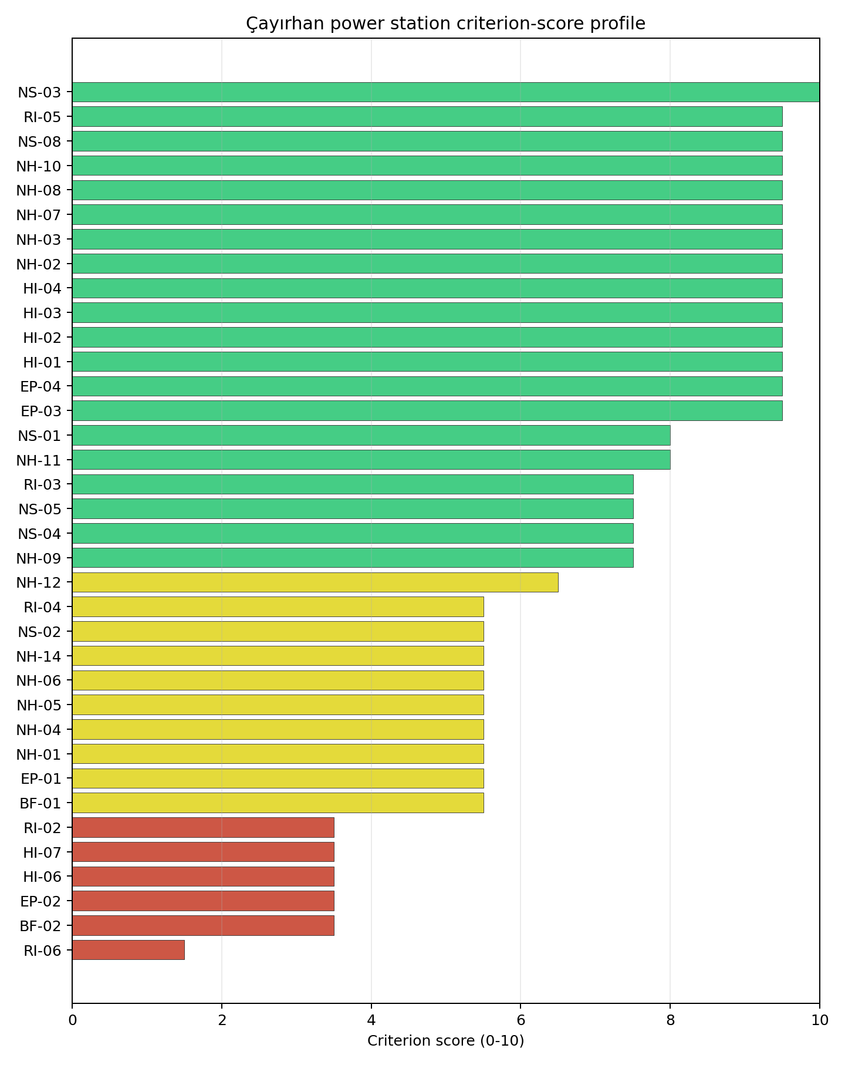
Criterion scores
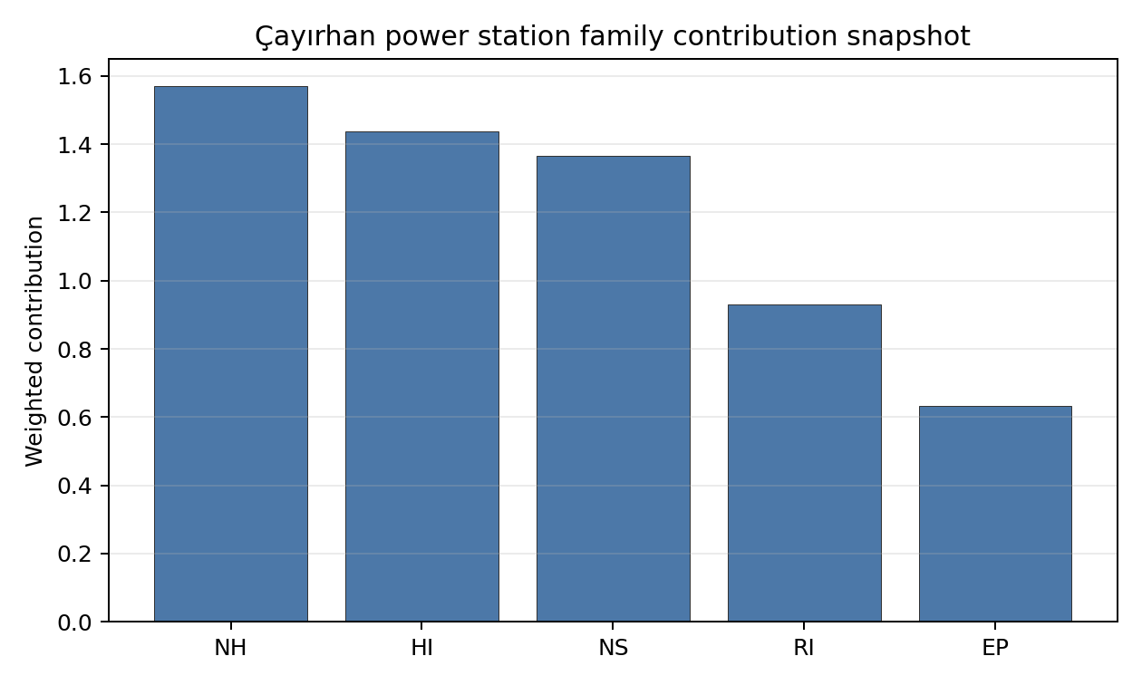
Family contributions
Çayırhan power station’s baseline composite score is 7.347, with a Monte Carlo bracket of 6.513-7.806. The national stability band is B, with a national top-10% hit rate of 100% in the project’s 50,000-iteration national Monte Carlo sensitivity analysis. That places the site in the national shortlist on the accepted Turkey basis. The result supports prioritised Stage 3 characterisation, not site approval or licensing readiness.

Residual Risk Register
Concern | Evidence | Consequence | Stage 3 action | Owner discipline
Population Projections (RI-06) | Screening score 1.5/10, MC 1.0-2.0, confidence medium | Could narrow the viable siting envelope or require mitigation before characterisation progresses | Confirm measured inputs, authority constraints and engineering response for RI-06 | RI specialist
Land Area Basic Filter (BF-02) | Screening score 3.5/10, MC 3.0-4.0, confidence insufficient | Could narrow the viable siting envelope or require mitigation before characterisation progresses | Confirm measured inputs, authority constraints and engineering response for BF-02 | BF specialist
Evacuation Routes (EP-02) | Screening score 3.5/10, MC 3.0-4.0, confidence medium | Could narrow the viable siting envelope or require mitigation before characterisation progresses | Confirm measured inputs, authority constraints and engineering response for EP-02 | EP specialist
Military Installations (HI-06) | Screening score 3.5/10, MC 3.0-4.0, confidence medium | Could narrow the viable siting envelope or require mitigation before characterisation progresses | Confirm measured inputs, authority constraints and engineering response for HI-06 | HI specialist
Electromagnetic Interference (HI-07) | Screening score 3.5/10, MC 3.0-4.0, confidence medium | Could narrow the viable siting envelope or require mitigation before characterisation progresses | Confirm measured inputs, authority constraints and engineering response for HI-07 | HI specialist
These residual risks define the first Stage 3 work package. They do not overturn the national ranking, but they identify the evidence needed before Turkey treats the site as more than a screening-stage candidate.

Stage 3 Follow-Up Checklist
- Re-measure Population Projections (RI-06) - native score 1.5/10 with confidence medium.
- Re-measure Land Area Basic Filter (BF-02) - native score 3.5/10 with confidence insufficient.
- Re-measure Evacuation Routes (EP-02) - native score 3.5/10 with confidence medium.
- Re-measure Military Installations (HI-06) - native score 3.5/10 with confidence medium.
- Re-measure Electromagnetic Interference (HI-07) - native score 3.5/10 with confidence medium.
- Improve data quality for Geotechnical: Subsidence & Collapse (NH-05b) - current flag low.
- Improve data quality for Industrial Explosions (HI-02) - current flag low.
- Improve data quality for Toxic/Gas Releases (HI-03) - current flag low.
- Improve data quality for External Fires (HI-04) - current flag low.

Evidence Limitations
- Geotechnical: Subsidence & Collapse (NH-05b) - quality low.
- Industrial Explosions (HI-02) - quality low.
- Toxic/Gas Releases (HI-03) - quality low.
- External Fires (HI-04) - quality low.

Eren-1 power station Site Profile
Eren-1 power station is a coal/thermal site in Türkiye that has been tested against the NuScale VOYGR-6 reference deployment envelope. This profile reads the screening evidence at a level that supports a decision to progress toward Stage 3 characterisation. It is not a site-suitability determination, vendor recommendation, or licensing finding.

Site Snapshot
Field | Value
Site name | Eren-1 power station
Coordinates | 41.6320, 27.0300
Subnational unit | Kırklareli
Installed thermal capacity (source data) | 490 MW
Available surface area | 311.8 ha
Available surface area for development | 311.8 ha
Composite score (baseline weights) | 7.459 (6.604-7.900 MC band)
National stability band | A (top-10% hit rate 100%)
National rank | 2
See the country status map in Türkiye Country Profile.

Ownership and Coal-to-Nuclear Context
Generating units on record: 2 cancelled.

Natural Hazards (NH)
- Seismic: Ground Motion (NH-01) - score 5.5/10 (MC 5.0-6.0) - pass-mark band: At or below the score-5 risk boundary., weight 0.0455, data quality high. Evidence: PGA at 475-year return period 0.132 g; PGA at 2,475-year return period 0.274 g; Vs30 reference (m/s): 760.0.
- Seismic: Surface Rupture (NH-02) - score 7.5/10 (MC 7.0-8.0), weight n/a, data quality screening grade. Evidence: nearest mapped capable fault 37.9 km; fault slip rate 0.259 mm/yr; fault name: GRCF00Z.
- Geotechnical: Liquefaction (NH-03) - score 5.5/10 (MC 5.0-6.0) - pass-mark band: Moderate susceptibility, or high/very-high with documented (with mitigation to be confirmed for high) mitigation., weight n/a, data quality medium. Evidence: liquefaction susceptibility: moderate; dominant soil type: loam.
- Geotechnical: Slope Stability (NH-04) - score 9.5/10 (MC 9.0-10.0) - favourable: Well below the risk boundary., weight n/a, data quality screening grade. Evidence: site slope 1.91 deg; max slope in 1 km box 24.5 deg; slope stability class: flat.
- Geotechnical: Subsidence (NH-05) - score 9.5/10 (MC 9.0-10.0) - favourable: No karst; mine-feature distance well above the score-5 pivot (or unknown)., weight 0.0354, data quality medium. Evidence: karst present: no; karst severity: none.
- Geotechnical: Foundation (NH-06) - score 5.5/10 (MC 5.0-6.0) - pass-mark band: Typical European mixed conditions (bearing 80-150 kPa)., weight 0.0253, data quality medium. Evidence: bearing capacity 85.3 kPa; depth to bedrock 22.3 m.
- Volcanism (NH-07) - score 9.5/10 (MC 9.0-10.0) - favourable: Very strong margin above the score-5 boundary (or completed screening found no in-radius signal)., weight n/a, data quality high. Evidence: volcanic hazard class: negligible.
- Coastal Flooding (NH-08) - score 9.5/10 (MC 9.0-10.0) - favourable: Non-coastal OR elevation >= 50 m AMSL OR landlocked country, with no positive marine-hazard signal., weight 0.0303, data quality medium. Evidence: distance to coast 83.1 km.
- River Flooding (NH-09) - score 7.5/10 (MC 7.0-8.0), weight 0.0404, data quality medium. Evidence: flood zone class: negligible.
- Extreme Winds (NH-10) - score 5.5/10 (MC 5.0-6.0) - pass-mark band: Middle relative wind exposure around the observed cohort mean (9.0-10.5 m/s)., weight 0.0152, data quality medium. Evidence: screening wind-speed index 9.2 m/s.
- Extreme Precipitation (NH-11) - score 10.0/10 (MC 9.0-10.0) - favourable: aggregated(mean_of_sub_scores), weight 0.0152, data quality medium. Evidence: screening extreme-precipitation index 0.19 mm; screening precipitation index 19.2 mm/yr.
- Extreme Temperatures (NH-12) - score 6.5/10 (MC 6.0-7.0) - pass-mark band: aggregated(mean_of_sub_scores), weight 0.0202, data quality medium. Evidence: extreme high temperature 27.6 deg C; extreme low temperature -1.13 deg C.
- Combined Hazards (NH-14) - score 5.5/10 (MC 5.0-6.0) - pass-mark band: At least 5 resolved, exactly one moderate hazard (3-5) or moderate interaction only., weight 0.0152, data quality n/a. Evidence: values not in measurement tables.

Interpretation - Natural Hazards (NH)
The natural-hazards evidence for Eren-1 power station supports Stage 3 characterisation, with the strongest screening signals in Extreme Precipitation (NH-11) at 10.0/10, Coastal Flooding (NH-08) at 9.5/10. The main constraints are Grid Capacity Basic Filter (BF-01) at 5.5/10, Seismic: Ground Motion (NH-01) at 5.5/10, Geotechnical: Liquefaction (NH-03) at 5.5/10. These scores should be read as Stage 1-2 screening evidence: the criterion bullets above carry the measured values, while the Stage 3 programme should confirm the low-scoring and low-confidence inputs through field, authority and engineering review before any siting claim is hardened.

Human-Induced and Security-Relevant Hazards (HI)
- Aircraft Crash (HI-01) - score 9.5/10 (MC 9.0-10.0) - favourable: Only small / GA / heliport airport >= 10 km nearby, no flight-path proxy < 4 km, no major airport within 30 km, and no military airbase within 60 km., weight 0.0354, data quality high. Evidence: nearest airport 39.7 km; nearest flight path 31.8 km; airports within search radius 0; airport name: Pınarhisar Gendarmerie Heliport; airport type: heliport.
- Industrial Explosions (HI-02) - score 9.5/10 (MC 7.5-10.0) - favourable: Very strong margin above the score-5 boundary (or completed search confirmed no in-radius signal)., weight 0.0354, data quality low. Evidence: values not in measurement tables.
- Toxic/Gas Releases (HI-03) - score 9.5/10 (MC 7.5-10.0) - favourable: Very strong margin above the score-5 boundary (or completed search confirmed no in-radius signal)., weight 0.0354, data quality low. Evidence: values not in measurement tables.
- External Fires (HI-04) - score 9.5/10 (MC 7.5-10.0) - favourable: > 15 km, or completed flammable-storage search found nothing in radius., weight 0.0303, data quality low. Evidence: values not in measurement tables.
- Military Installations (HI-06) - score 1.5/10 (MC 1.0-2.0), weight 0.0303, data quality medium. Evidence: nearest military installation 14.5 km; military installations within radius 38; installation name: Korugan.
- Electromagnetic Interference (HI-07) - score 1.5/10 (MC 1.0-2.0), weight 0.0101, data quality medium. Evidence: nearest high-power transmitter 5.33 km; transmitters within radius 116; transmitter type: communication.

Interpretation - Human-Induced and Security-Relevant Hazards (HI)
The human-induced and security-relevant evidence for Eren-1 power station supports Stage 3 characterisation, with the strongest screening signals in External Fires (HI-04) at 9.5/10, Toxic/Gas Releases (HI-03) at 9.5/10. The main constraints are Military Installations (HI-06) at 1.5/10, Electromagnetic Interference (HI-07) at 1.5/10, Aircraft Crash (HI-01) at 9.5/10. These scores should be read as Stage 1-2 screening evidence: the criterion bullets above carry the measured values, while the Stage 3 programme should confirm the low-scoring and low-confidence inputs through field, authority and engineering review before any siting claim is hardened.

Radiological Impact and Emergency Planning (RI / EP)
- Emergency Planning Feasibility (EP-01) - score 7.5/10 (MC 7.0-8.0), weight n/a, data quality high. Evidence: EP feasibility composite 76.0 /100; road sub-score 61.2 /100; special-population sub-score 90.0 /100; geography sub-score 95.0 /100; population sub-score 95.0 /100; evacuation feasible: yes.
- Evacuation Routes (EP-02) - score 5.5/10 (MC 5.0-6.0) - pass-mark band: Adequate primary routes (0.5-1.0)., weight 0.0303, data quality medium. Evidence: road density in EPZ 0.653 km/km2; road length in EPZ 1,282 km; motorway access: yes.
- Physical Geography Constraints (EP-03) - score 9.5/10 (MC 9.0-10.0) - favourable: No measured relief; open river/waterway context (interim screening)., weight 0.0253, data quality medium. Evidence: waterways crossing EPZ 0; major river barrier: no.
- Special Populations (EP-04) - score 5.5/10 (MC 5.0-6.0) - pass-mark band: 9-25., weight 0.0303, data quality medium. Evidence: hospitals in EPZ 14; prisons in EPZ 3; care homes in EPZ 0.
- Atmospheric Dispersion (RI-01) - score no native score (unscored - no band matched), weight 0.0303, data quality medium. Evidence: annual mean wind speed 1.5 m/s; atmospheric mixing height 583.8 m; prevailing wind direction: NNE.
- Surface Water Dispersion (RI-02) - score 1.5/10 (MC 1.0-2.0), weight 0.0253, data quality n/a. Evidence: values not in measurement tables.
- Groundwater Dispersion (RI-03) - score 7.5/10 (MC 7.0-8.0), weight 0.0253, data quality medium. Evidence: aquifer type: low permeability.
- Population Density at EPZ Radii (RI-04) - score 7.5/10 (MC 7.0-8.0), weight 0.0404, data quality screening grade. Evidence: population density within 5 km 41.9 /km2; population density within 16 km 36.1 /km2; population density within 25 km 77.4 /km2; population density within 80 km 53.6 /km2; population within 25 km 151,941 people.
- Distance to Population Centres (RI-05) - score 9.5/10 (MC 9.0-10.0) - favourable: No >=50k population-centre proxy within screening envelope., weight 0.0505, data quality screening grade. Evidence: values not in measurement tables.
- Population Projections (RI-06) - score 3.5/10 (MC 3.0-4.0), weight 0.0253, data quality screening grade. Evidence: annual population growth rate 0.485 %/yr; projected population at 25 km in 60 yr 166,573 people.

Interpretation - Radiological Impact and Emergency Planning (RI / EP)
The radiological-impact and emergency-planning evidence for Eren-1 power station supports Stage 3 characterisation, with the strongest screening signals in Distance to Population Centres (RI-05) at 9.5/10, Physical Geography Constraints (EP-03) at 9.5/10. The main constraints are Surface Water Dispersion (RI-02) at 1.5/10, Population Projections (RI-06) at 3.5/10, Atmospheric Dispersion (RI-01) at 5.0/10. These scores should be read as Stage 1-2 screening evidence: the criterion bullets above carry the measured values, while the Stage 3 programme should confirm the low-scoring and low-confidence inputs through field, authority and engineering review before any siting claim is hardened.

Non-Safety and Implementation Considerations (NS)
- Grid Capacity Basic Filter (BF-01) - score 5.5/10 (MC 5.0-6.0) - pass-mark band: Note: substation 15-30 km OR 110-219 kV; reinforcement plausible., weight n/a, data quality n/a. Evidence: values not in measurement tables.
- Land Area Basic Filter (BF-02) - score 9.5/10 (MC 9.0-10.0) - favourable: Contiguous and buildable >= ideal area (70 ha/module)., weight 0.0253, data quality n/a. Evidence: values not in measurement tables.
- Cooling Water Availability (NS-01) - score 7.0/10 (MC 6.0-7.0), weight 0.0404, data quality screening grade. Evidence: distance to cooling source 1.59 km; cooling source flow 3.18 m3/s; cooling source type: small_river; cooling source name: Teke Çayı; water stress label: Low-Medium.
- Grid Connection (NS-02) - score 5.5/10 (MC 5.0-6.0) - pass-mark band: aggregated(min_of_sub_scores), weight 0.0404, data quality medium. Evidence: nearest substation 7.63 km; nearest high-voltage line 12.7 km; highest nearby line voltage 154.0 kV; grid export capacity 490.0 MW; substations within radius 249; HV lines within radius 67.
- Transport Access (NS-03) - score 8.0/10 (MC 7.0-8.0) - favourable: aggregated(weighted_mean_of_sub_scores), weight 0.0404, data quality medium. Evidence: nearest highway 4.84 km; heavy-haul capable: yes.
- Site Topography (NS-04) - score 9.5/10 (MC 9.0-10.0) - favourable: > 80 %., weight 0.0303, data quality screening grade. Evidence: favourable land cover 80.2 %; moderate land cover 13.0 %; unfavourable land cover 6.8 %; favourable area 249.4 ha; dominant land class: 211.
- Site Footprint Adequacy (NS-05) - score 9.5/10 (MC 9.0-10.0) - favourable: Very strong margin above the score-5 boundary., weight 0.0253, data quality screening grade. Evidence: buildable area 311.8 ha; largest contiguous patch 1,081 ha; buildable patch count 4.
- Existing Infrastructure (NS-06) - score no native score (unscored - no band matched), weight 0.0253, data quality n/a. Evidence: not measured at this site (criterion remains unscored).
- Ecological Sensitivity (NS-08) - score 9.5/10 (MC 7.5-10.0) - favourable: Both networks NULL or > 25 km AND eco_pct NULL or < 15 %., weight n/a, data quality insufficient. Evidence: natural land cover 6.8 %; Natura 2000 sensitivity class: unknown; protected-area overlap: no; protected-area sensitivity class: none; Natura 2000 sites within 5 km: 0.
- Workforce Availability (NS-10) - score no native score (unscored - no band matched), weight 0.0202, data quality n/a. Evidence: not measured at this site (criterion remains unscored).
- Regulatory/Political Environment (NS-12) - score no native score (unscored - no band matched), weight 0.0303, data quality n/a. Evidence: not measured at this site (criterion remains unscored).
- Construction Logistics (NS-13) - score no native score (unscored - no band matched), weight 0.0202, data quality n/a. Evidence: not measured at this site (criterion remains unscored).

Interpretation - Non-Safety and Implementation Considerations (NS)
The non-safety and implementation evidence for Eren-1 power station supports Stage 3 characterisation, with the strongest screening signals in Ecological Sensitivity (NS-08) at 9.5/10, Site Footprint Adequacy (NS-05) at 9.5/10. The main constraints are Existing Infrastructure (NS-06) at 5.0/10, Workforce Availability (NS-10) at 5.0/10, Regulatory/Political Environment (NS-12) at 5.0/10. These scores should be read as Stage 1-2 screening evidence: the criterion bullets above carry the measured values, while the Stage 3 programme should confirm the low-scoring and low-confidence inputs through field, authority and engineering review before any siting claim is hardened.

Composite Score and Stability
Baseline composite score is 7.459, bracketed by Monte Carlo at 6.604-7.900. National stability band is A with a top-10% hit rate of 100% across 12 scored Monte Carlo scenarios.
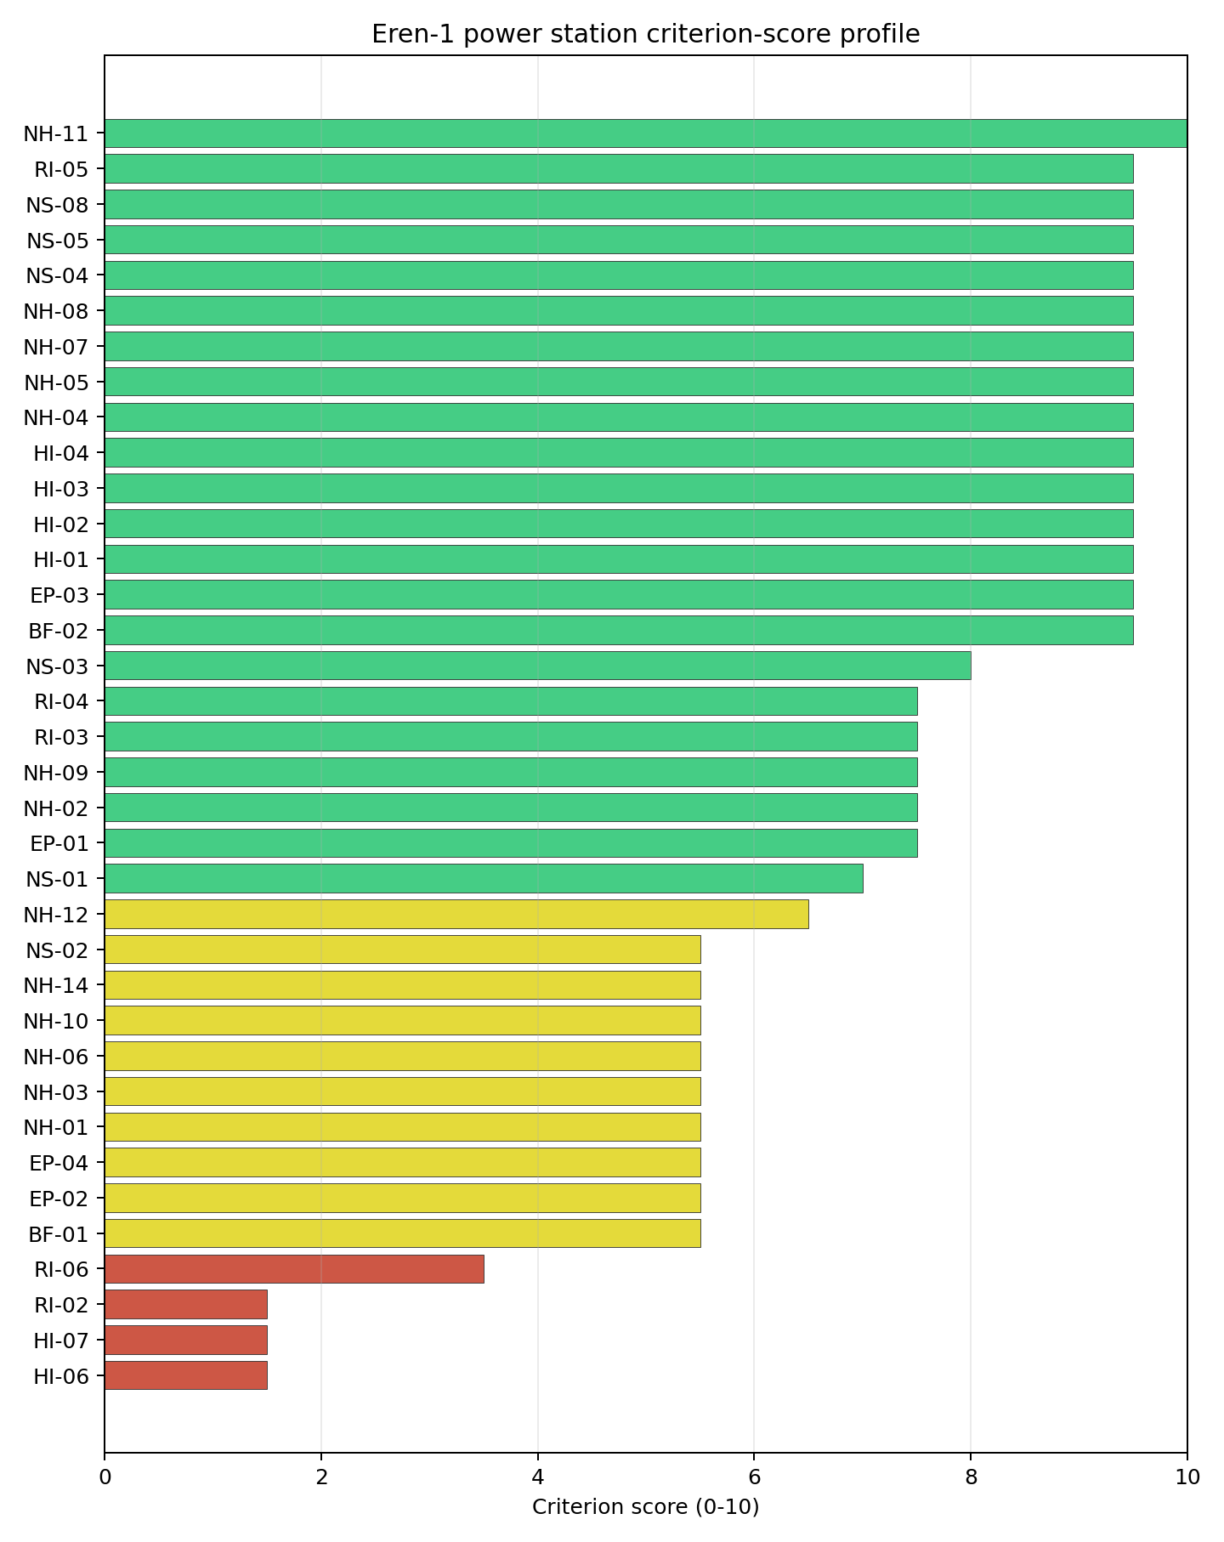
Criterion scores
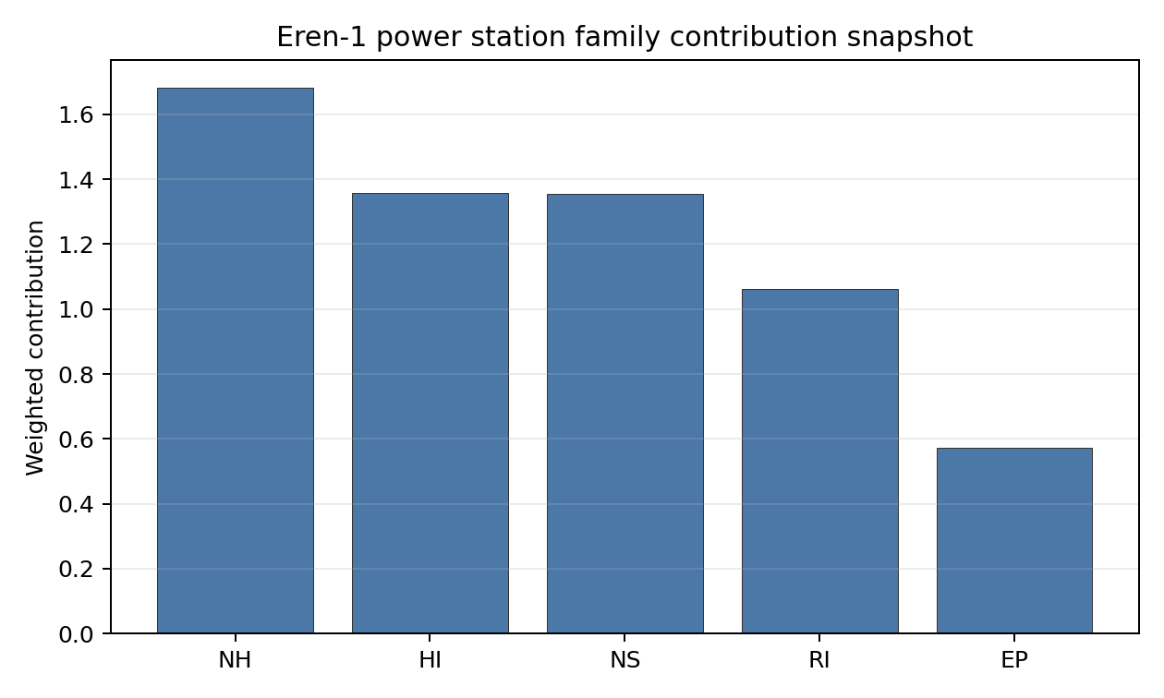
Family contributions
Eren-1 power station’s baseline composite score is 7.459, with a Monte Carlo bracket of 6.604-7.900. The national stability band is A, with a national top-10% hit rate of 100% in the project’s 50,000-iteration national Monte Carlo sensitivity analysis. That places the site in the national shortlist on the accepted Turkey basis. The result supports prioritised Stage 3 characterisation, not site approval or licensing readiness.

Residual Risk Register
Concern | Evidence | Consequence | Stage 3 action | Owner discipline
Military Installations (HI-06) | Screening score 1.5/10, MC 1.0-2.0, confidence medium | Could narrow the viable siting envelope or require mitigation before characterisation progresses | Confirm measured inputs, authority constraints and engineering response for HI-06 | HI specialist
Electromagnetic Interference (HI-07) | Screening score 1.5/10, MC 1.0-2.0, confidence medium | Could narrow the viable siting envelope or require mitigation before characterisation progresses | Confirm measured inputs, authority constraints and engineering response for HI-07 | HI specialist
Surface Water Dispersion (RI-02) | Screening score 1.5/10, MC 1.0-2.0, confidence insufficient | Could narrow the viable siting envelope or require mitigation before characterisation progresses | Confirm measured inputs, authority constraints and engineering response for RI-02 | RI specialist
Population Projections (RI-06) | Screening score 3.5/10, MC 3.0-4.0, confidence medium | Could narrow the viable siting envelope or require mitigation before characterisation progresses | Confirm measured inputs, authority constraints and engineering response for RI-06 | RI specialist
Existing Infrastructure (NS-06) | Screening score 5.0/10, MC 5.0-5.0, confidence insufficient | Could narrow the viable siting envelope or require mitigation before characterisation progresses | Confirm measured inputs, authority constraints and engineering response for NS-06 | NS specialist
These residual risks define the first Stage 3 work package. They do not overturn the national ranking, but they identify the evidence needed before Turkey treats the site as more than a screening-stage candidate.

Stage 3 Follow-Up Checklist
- Re-measure Military Installations (HI-06) - native score 1.5/10 with confidence medium.
- Re-measure Electromagnetic Interference (HI-07) - native score 1.5/10 with confidence medium.
- Re-measure Surface Water Dispersion (RI-02) - native score 1.5/10 with confidence insufficient.
- Re-measure Population Projections (RI-06) - native score 3.5/10 with confidence medium.
- Re-measure Existing Infrastructure (NS-06) - native score 5.0/10 with confidence insufficient.
- Improve data quality for Geotechnical: Subsidence & Collapse (NH-05b) - current flag low.
- Improve data quality for Industrial Explosions (HI-02) - current flag low.
- Improve data quality for Toxic/Gas Releases (HI-03) - current flag low.
- Improve data quality for External Fires (HI-04) - current flag low.

Evidence Limitations
- Geotechnical: Subsidence & Collapse (NH-05b) - quality low.
- Industrial Explosions (HI-02) - quality low.
- Toxic/Gas Releases (HI-03) - quality low.
- External Fires (HI-04) - quality low.

Karapinar Konya Şeker power station Site Profile
Karapinar Konya Şeker power station is a coal/thermal site in Türkiye that has been tested against the NuScale VOYGR-6 reference deployment envelope. This profile reads the screening evidence at a level that supports a decision to progress toward Stage 3 characterisation. It is not a site-suitability determination, vendor recommendation, or licensing finding.

Site Snapshot
Field | Value
Site name | Karapinar Konya Şeker power station
Coordinates | 37.7160, 33.5540
Subnational unit | Konya
Installed thermal capacity (source data) | 2,000 MW
Available surface area | 312.2 ha
Available surface area for development | 312.2 ha
Composite score (baseline weights) | 7.354 (6.386-7.864 MC band)
National stability band | A (top-10% hit rate 100%)
National rank | 4
See the country status map in Türkiye Country Profile.

Ownership and Coal-to-Nuclear Context
- Anadolu Birlik Holding AŞ (54.37% share), headquartered in Türkiye; immediate operator Konya Şeker Sanayi ve Ticaret AŞ. Path: Anadolu Birlik Holding AŞ -> Konya Şeker Sanayi ve Ticaret AŞ [54.37%] -> Karapinar Konya Şeker power station – [100.0%]
Generating units on record: 1 cancelled.

Natural Hazards (NH)
- Seismic: Ground Motion (NH-01) - score 5.5/10 (MC 5.0-6.0) - pass-mark band: At or below the score-5 risk boundary., weight 0.0455, data quality high. Evidence: PGA at 475-year return period 0.132 g; PGA at 2,475-year return period 0.308 g; Vs30 reference (m/s): 760.0.
- Seismic: Surface Rupture (NH-02) - score 9.5/10 (MC 9.0-10.0) - favourable: Very strong separation from mapped capable faults; surface-rupture concern effectively screened at desk-study level., weight n/a, data quality screening grade. Evidence: nearest mapped capable fault 50.0 km; fault slip rate 0 mm/yr; fault name: none_in_search_radius.
- Geotechnical: Liquefaction (NH-03) - score 5.5/10 (MC 5.0-6.0) - pass-mark band: Moderate susceptibility, or high/very-high with documented (with mitigation to be confirmed for high) mitigation., weight n/a, data quality medium. Evidence: liquefaction susceptibility: moderate.
- Geotechnical: Slope Stability (NH-04) - score 9.5/10 (MC 9.0-10.0) - favourable: Well below the risk boundary., weight n/a, data quality screening grade. Evidence: site slope 1.64 deg; max slope in 1 km box 23.0 deg; slope stability class: flat.
- Geotechnical: Subsidence (NH-05) - score 9.5/10 (MC 9.0-10.0) - favourable: No karst; mine-feature distance well above the score-5 pivot (or unknown)., weight 0.0354, data quality medium. Evidence: karst present: no; karst severity: none.
- Geotechnical: Foundation (NH-06) - score 3.5/10 (MC 3.0-4.0), weight 0.0253, data quality medium. Evidence: depth to bedrock 29.9 m.
- Volcanism (NH-07) - score 5.5/10 (MC 5.0-6.0) - pass-mark band: At or above the score-5 boundary., weight n/a, data quality medium. Evidence: nearest Holocene volcano 71.0 km; volcano name: Hasandag-Keciboyduran Volcanic Complex; volcanic hazard class: low.
- Coastal Flooding (NH-08) - score 9.5/10 (MC 9.0-10.0) - favourable: Non-coastal OR elevation >= 50 m AMSL OR landlocked country, with no positive marine-hazard signal., weight 0.0303, data quality medium. Evidence: distance to coast 138.4 km.
- River Flooding (NH-09) - score 7.5/10 (MC 7.0-8.0), weight 0.0404, data quality medium. Evidence: flood zone class: negligible.
- Extreme Winds (NH-10) - score 7.5/10 (MC 7.0-8.0), weight 0.0152, data quality medium. Evidence: screening wind-speed index 7.76 m/s.
- Extreme Precipitation (NH-11) - score 8.0/10 (MC 8.0-9.0) - favourable: aggregated(mean_of_sub_scores), weight 0.0152, data quality medium. Evidence: screening extreme-precipitation index 0.11 mm; screening precipitation index 10.4 mm/yr.
- Extreme Temperatures (NH-12) - score 5.5/10 (MC 5.0-6.0) - pass-mark band: aggregated(mean_of_sub_scores), weight 0.0202, data quality medium. Evidence: extreme high temperature 27.8 deg C; extreme low temperature -7.18 deg C.
- Combined Hazards (NH-14) - score 5.5/10 (MC 5.0-6.0) - pass-mark band: At least 5 resolved, exactly one moderate hazard (3-5) or moderate interaction only., weight 0.0152, data quality n/a. Evidence: values not in measurement tables.

Interpretation - Natural Hazards (NH)
The natural-hazards evidence for Karapinar Konya Şeker power station supports Stage 3 characterisation, with the strongest screening signals in Coastal Flooding (NH-08) at 9.5/10, Geotechnical: Subsidence (NH-05) at 9.5/10. The main constraints are Geotechnical: Foundation (NH-06) at 3.5/10, Grid Capacity Basic Filter (BF-01) at 5.5/10, Seismic: Ground Motion (NH-01) at 5.5/10. These scores should be read as Stage 1-2 screening evidence: the criterion bullets above carry the measured values, while the Stage 3 programme should confirm the low-scoring and low-confidence inputs through field, authority and engineering review before any siting claim is hardened.

Human-Induced and Security-Relevant Hazards (HI)
- Aircraft Crash (HI-01) - score 9.5/10 (MC 9.0-10.0) - favourable: Only small / GA / heliport airport >= 10 km nearby, no flight-path proxy < 4 km, no major airport within 30 km, and no military airbase within 60 km., weight 0.0354, data quality high. Evidence: nearest airport 70.1 km; nearest flight path 35.1 km; airports within search radius 0; airport name: Aksaray Airport; airport type: small airfield.
- Industrial Explosions (HI-02) - score 9.5/10 (MC 7.5-10.0) - favourable: Very strong margin above the score-5 boundary (or completed search confirmed no in-radius signal)., weight 0.0354, data quality low. Evidence: values not in measurement tables.
- Toxic/Gas Releases (HI-03) - score 9.5/10 (MC 7.5-10.0) - favourable: Very strong margin above the score-5 boundary (or completed search confirmed no in-radius signal)., weight 0.0354, data quality low. Evidence: values not in measurement tables.
- External Fires (HI-04) - score 9.5/10 (MC 7.5-10.0) - favourable: > 15 km, or completed flammable-storage search found nothing in radius., weight 0.0303, data quality low. Evidence: values not in measurement tables.
- Military Installations (HI-06) - score no native score (unscored - no band matched), weight 0.0303, data quality screening grade. Evidence: military installations within radius 0.
- Electromagnetic Interference (HI-07) - score 1.5/10 (MC 1.0-2.0), weight 0.0101, data quality medium. Evidence: nearest high-power transmitter 0.38 km; transmitters within radius 15; transmitter type: minaret.

Interpretation - Human-Induced and Security-Relevant Hazards (HI)
The human-induced and security-relevant evidence for Karapinar Konya Şeker power station supports Stage 3 characterisation, with the strongest screening signals in External Fires (HI-04) at 9.5/10, Toxic/Gas Releases (HI-03) at 9.5/10. The main constraints are Electromagnetic Interference (HI-07) at 1.5/10, Military Installations (HI-06) at 5.0/10, Aircraft Crash (HI-01) at 9.5/10. These scores should be read as Stage 1-2 screening evidence: the criterion bullets above carry the measured values, while the Stage 3 programme should confirm the low-scoring and low-confidence inputs through field, authority and engineering review before any siting claim is hardened.

Radiological Impact and Emergency Planning (RI / EP)
- Emergency Planning Feasibility (EP-01) - score 5.5/10 (MC 5.0-6.0) - pass-mark band: At or above the composite score-5 boundary., weight n/a, data quality high. Evidence: EP feasibility composite 59.0 /100; road sub-score 42.2 /100; special-population sub-score 90.0 /100; geography sub-score 95.0 /100; population sub-score 60.0 /100; evacuation feasible: yes.
- Evacuation Routes (EP-02) - score 3.5/10 (MC 3.0-4.0), weight 0.0303, data quality medium. Evidence: road density in EPZ 0.337 km/km2; road length in EPZ 662.4 km; motorway access: yes.
- Physical Geography Constraints (EP-03) - score 9.5/10 (MC 9.0-10.0) - favourable: No measured relief; open river/waterway context (interim screening)., weight 0.0253, data quality medium. Evidence: waterways crossing EPZ 0; major river barrier: no.
- Special Populations (EP-04) - score 9.5/10 (MC 9.0-10.0) - favourable: 0-2 facilities., weight 0.0303, data quality medium. Evidence: hospitals in EPZ 1; prisons in EPZ 0; care homes in EPZ 0.
- Atmospheric Dispersion (RI-01) - score no native score (unscored - no band matched), weight 0.0303, data quality medium. Evidence: annual mean wind speed 1.11 m/s; atmospheric mixing height 646.0 m; prevailing wind direction: NNW.
- Surface Water Dispersion (RI-02) - score 1.5/10 (MC 1.0-2.0), weight 0.0253, data quality n/a. Evidence: values not in measurement tables.
- Groundwater Dispersion (RI-03) - score 5.5/10 (MC 5.0-6.0) - pass-mark band: Moderate-permeability aquifer screening proxy., weight 0.0253, data quality medium. Evidence: aquifer type: volcanic rocks.
- Population Density at EPZ Radii (RI-04) - score 3.5/10 (MC 3.0-4.0), weight 0.0404, data quality screening grade. Evidence: population density within 5 km 414.4 /km2; population density within 16 km 44.5 /km2; population density within 25 km 22.6 /km2; population density within 80 km 39.5 /km2; population within 25 km 44,355 people.
- Distance to Population Centres (RI-05) - score 9.5/10 (MC 9.0-10.0) - favourable: No >=50k population-centre proxy within screening envelope., weight 0.0505, data quality screening grade. Evidence: values not in measurement tables.
- Population Projections (RI-06) - score 7.5/10 (MC 7.0-8.0), weight 0.0253, data quality screening grade. Evidence: annual population growth rate -0.25 %/yr; projected population at 25 km in 60 yr 48,622 people.

Interpretation - Radiological Impact and Emergency Planning (RI / EP)
The radiological-impact and emergency-planning evidence for Karapinar Konya Şeker power station supports Stage 3 characterisation, with the strongest screening signals in Distance to Population Centres (RI-05) at 9.5/10, Special Populations (EP-04) at 9.5/10. The main constraints are Surface Water Dispersion (RI-02) at 1.5/10, Evacuation Routes (EP-02) at 3.5/10, Population Density at EPZ Radii (RI-04) at 3.5/10. These scores should be read as Stage 1-2 screening evidence: the criterion bullets above carry the measured values, while the Stage 3 programme should confirm the low-scoring and low-confidence inputs through field, authority and engineering review before any siting claim is hardened.

Non-Safety and Implementation Considerations (NS)
- Grid Capacity Basic Filter (BF-01) - score 5.5/10 (MC 5.0-6.0) - pass-mark band: Note: substation 15-30 km OR 110-219 kV; reinforcement plausible., weight n/a, data quality n/a. Evidence: values not in measurement tables.
- Land Area Basic Filter (BF-02) - score 9.5/10 (MC 9.0-10.0) - favourable: Contiguous and buildable >= ideal area (70 ha/module)., weight 0.0253, data quality n/a. Evidence: values not in measurement tables.
- Cooling Water Availability (NS-01) - score 3.0/10 (MC 3.0-4.0), weight 0.0404, data quality screening grade. Evidence: distance to cooling source 11.4 km; cooling source flow 0.14 m3/s; cooling source type: small_river; cooling source name: HYRIV-20660735; water stress label: Extremely High.
- Grid Connection (NS-02) - score 5.5/10 (MC 5.0-6.0) - pass-mark band: aggregated(min_of_sub_scores), weight 0.0404, data quality high. Evidence: nearest substation 1.72 km; nearest high-voltage line 3.01 km; highest nearby line voltage 154.0 kV; grid export capacity 2,000 MW; substations within radius 6; HV lines within radius 21.
- Transport Access (NS-03) - score 10.0/10 (MC 9.0-10.0) - favourable: aggregated(weighted_mean_of_sub_scores), weight 0.0404, data quality medium. Evidence: nearest highway 0.88 km; heavy-haul capable: yes.
- Site Topography (NS-04) - score 7.5/10 (MC 7.0-8.0), weight 0.0303, data quality screening grade. Evidence: favourable land cover 77.5 %; moderate land cover 21.7 %; unfavourable land cover 0.7 %; favourable area 243.5 ha; dominant land class: 112.
- Site Footprint Adequacy (NS-05) - score 9.5/10 (MC 9.0-10.0) - favourable: Very strong margin above the score-5 boundary., weight 0.0253, data quality screening grade. Evidence: buildable area 312.2 ha; largest contiguous patch 1,247 ha; buildable patch count 1.
- Existing Infrastructure (NS-06) - score no native score (unscored - no band matched), weight 0.0253, data quality n/a. Evidence: not measured at this site (criterion remains unscored).
- Ecological Sensitivity (NS-08) - score 5.5/10 (MC 3.5-7.5) - pass-mark band: Both networks NULL or >= 5 km., weight n/a, data quality insufficient. Evidence: natural land cover 0.7 %; distance to nearest protected area 7.231 km; Natura 2000 sensitivity class: unknown; protected-area overlap: no; protected-area sensitivity class: low; Natura 2000 sites within 5 km: 0; nearest protected-area designation: Wetland of International Importance (Ramsar Site).
- Workforce Availability (NS-10) - score no native score (unscored - no band matched), weight 0.0202, data quality n/a. Evidence: not measured at this site (criterion remains unscored).
- Regulatory/Political Environment (NS-12) - score no native score (unscored - no band matched), weight 0.0303, data quality n/a. Evidence: not measured at this site (criterion remains unscored).
- Construction Logistics (NS-13) - score no native score (unscored - no band matched), weight 0.0202, data quality n/a. Evidence: not measured at this site (criterion remains unscored).

Interpretation - Non-Safety and Implementation Considerations (NS)
The non-safety and implementation evidence for Karapinar Konya Şeker power station supports Stage 3 characterisation, with the strongest screening signals in Transport Access (NS-03) at 10.0/10, Site Footprint Adequacy (NS-05) at 9.5/10. The main constraints are Cooling Water Availability (NS-01) at 3.0/10, Existing Infrastructure (NS-06) at 5.0/10, Workforce Availability (NS-10) at 5.0/10. These scores should be read as Stage 1-2 screening evidence: the criterion bullets above carry the measured values, while the Stage 3 programme should confirm the low-scoring and low-confidence inputs through field, authority and engineering review before any siting claim is hardened.

Composite Score and Stability
Baseline composite score is 7.354, bracketed by Monte Carlo at 6.386-7.864. National stability band is A with a top-10% hit rate of 100% across 12 scored Monte Carlo scenarios.
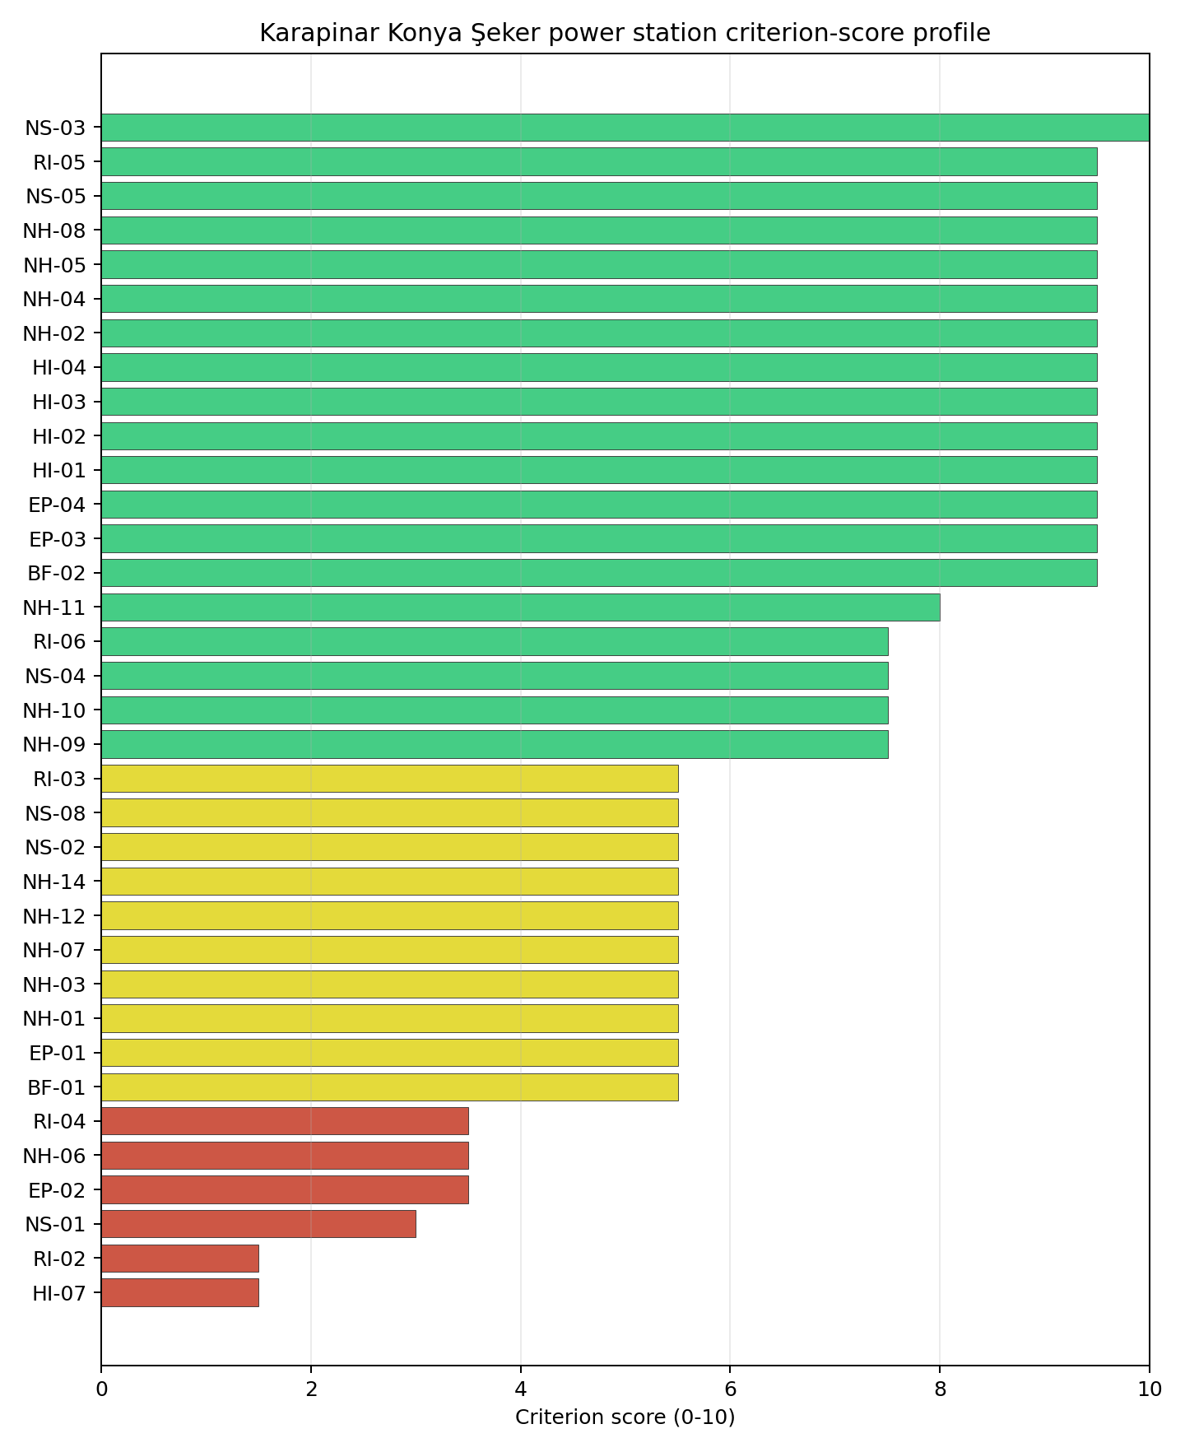
Criterion scores
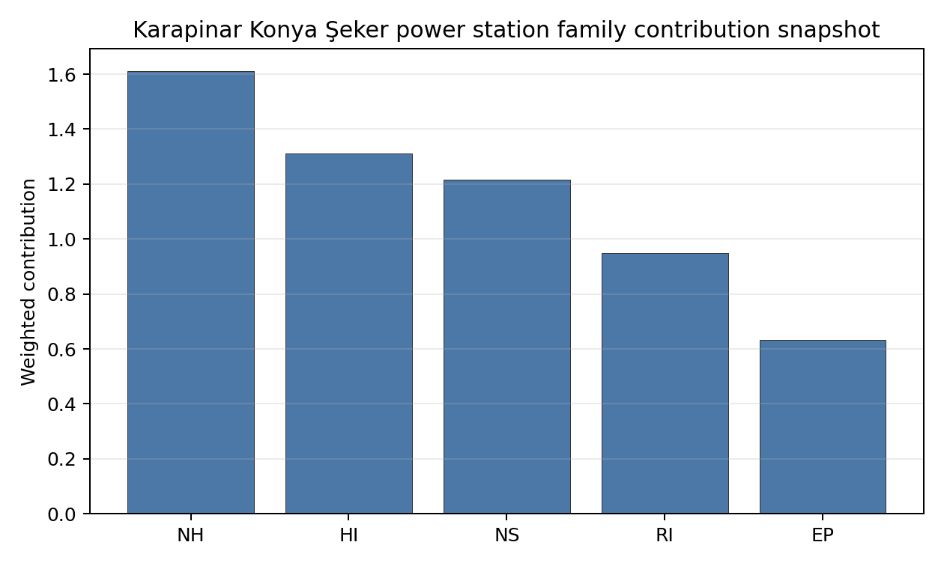
Family contributions
Karapinar Konya Şeker power station’s baseline composite score is 7.354, with a Monte Carlo bracket of 6.386-7.864. The national stability band is A, with a national top-10% hit rate of 100% in the project’s 50,000-iteration national Monte Carlo sensitivity analysis. That places the site in the national shortlist on the accepted Turkey basis. The result supports prioritised Stage 3 characterisation, not site approval or licensing readiness.

Residual Risk Register
Concern | Evidence | Consequence | Stage 3 action | Owner discipline
Electromagnetic Interference (HI-07) | Screening score 1.5/10, MC 1.0-2.0, confidence medium | Could narrow the viable siting envelope or require mitigation before characterisation progresses | Confirm measured inputs, authority constraints and engineering response for HI-07 | HI specialist
Surface Water Dispersion (RI-02) | Screening score 1.5/10, MC 1.0-2.0, confidence insufficient | Could narrow the viable siting envelope or require mitigation before characterisation progresses | Confirm measured inputs, authority constraints and engineering response for RI-02 | RI specialist
Cooling Water Availability (NS-01) | Screening score 3.0/10, MC 3.0-4.0, confidence medium | Could narrow the viable siting envelope or require mitigation before characterisation progresses | Confirm measured inputs, authority constraints and engineering response for NS-01 | NS specialist
Evacuation Routes (EP-02) | Screening score 3.5/10, MC 3.0-4.0, confidence medium | Could narrow the viable siting envelope or require mitigation before characterisation progresses | Confirm measured inputs, authority constraints and engineering response for EP-02 | EP specialist
Geotechnical: Foundation (NH-06) | Screening score 3.5/10, MC 3.0-4.0, confidence medium | Could narrow the viable siting envelope or require mitigation before characterisation progresses | Confirm measured inputs, authority constraints and engineering response for NH-06 | NH specialist
These residual risks define the first Stage 3 work package. They do not overturn the national ranking, but they identify the evidence needed before Turkey treats the site as more than a screening-stage candidate.

Stage 3 Follow-Up Checklist
- Resolve Cooling Water Availability (NS-01) avoidance flag - measured cooling-source distance 11.36 km and extremely high water-stress context against the cooling-water avoidance screen; assess cooling-tower or dry/hybrid cooling options under SSG-35 ultimate-heat-sink characterisation.
- Re-measure Electromagnetic Interference (HI-07) - native score 1.5/10 with confidence medium.
- Re-measure Surface Water Dispersion (RI-02) - native score 1.5/10 with confidence insufficient.
- Re-measure Cooling Water Availability (NS-01) - native score 3.0/10 with confidence medium.
- Re-measure Evacuation Routes (EP-02) - native score 3.5/10 with confidence medium.
- Re-measure Geotechnical: Foundation (NH-06) - native score 3.5/10 with confidence medium.
- Improve data quality for Geotechnical: Subsidence & Collapse (NH-05b) - current flag low.
- Improve data quality for Industrial Explosions (HI-02) - current flag low.
- Improve data quality for Toxic/Gas Releases (HI-03) - current flag low.
- Improve data quality for External Fires (HI-04) - current flag low.

Evidence Limitations
- Geotechnical: Subsidence & Collapse (NH-05b) - quality low.
- Industrial Explosions (HI-02) - quality low.
- Toxic/Gas Releases (HI-03) - quality low.
- External Fires (HI-04) - quality low.

Konya Karapınar power station Site Profile
Konya Karapınar power station is a coal/thermal site in Türkiye that has been tested against the NuScale VOYGR-6 reference deployment envelope. This profile reads the screening evidence at a level that supports a decision to progress toward Stage 3 characterisation. It is not a site-suitability determination, vendor recommendation, or licensing finding.

Site Snapshot
Field | Value
Site name | Konya Karapınar power station
Coordinates | 37.6142, 33.5912
Subnational unit | Konya
Installed thermal capacity (source data) | 1,000 MW
Available surface area | 314.1 ha
Available surface area for development | 314.1 ha
Composite score (baseline weights) | 7.784 (6.528-8.301 MC band)
National stability band | A (top-10% hit rate 100%)
National rank | 1
See the country status map in Türkiye Country Profile.

Ownership and Coal-to-Nuclear Context
- Elektrik Uretim AŞ (100.00% share), headquartered in Türkiye; immediate operator Elektrik Uretim AŞ. Path: Elektrik Uretim AŞ -> Konya Karapınar power station – [100.0%]
- Government of Türkiye (100.00% share), headquartered in Türkiye; immediate operator Elektrik Uretim AŞ. Path: Government of Türkiye -> Elektrik Uretim AŞ [100.0%] -> Konya Karapınar power station – [100.0%]
Generating units on record: 1 cancelled.

Natural Hazards (NH)
- Seismic: Ground Motion (NH-01) - score 5.5/10 (MC 5.0-6.0) - pass-mark band: At or below the score-5 risk boundary., weight 0.0455, data quality high. Evidence: PGA at 475-year return period 0.134 g; PGA at 2,475-year return period 0.314 g; Vs30 reference (m/s): 760.0.
- Seismic: Surface Rupture (NH-02) - score 9.5/10 (MC 9.0-10.0) - favourable: Very strong separation from mapped capable faults; surface-rupture concern effectively screened at desk-study level., weight n/a, data quality screening grade. Evidence: nearest mapped capable fault 50.0 km; fault slip rate 0 mm/yr; fault name: none_in_search_radius.
- Geotechnical: Liquefaction (NH-03) - score 5.5/10 (MC 5.0-6.0) - pass-mark band: Moderate susceptibility, or high/very-high with documented (with mitigation to be confirmed for high) mitigation., weight n/a, data quality medium. Evidence: liquefaction susceptibility: high; dominant soil type: silty_clay_loam.
- Geotechnical: Slope Stability (NH-04) - score 9.5/10 (MC 9.0-10.0) - favourable: Well below the risk boundary., weight n/a, data quality screening grade. Evidence: site slope 0.71 deg; max slope in 1 km box 88.7 deg; slope stability class: flat.
- Geotechnical: Subsidence (NH-05) - score 9.5/10 (MC 9.0-10.0) - favourable: No karst; mine-feature distance well above the score-5 pivot (or unknown)., weight 0.0354, data quality medium. Evidence: karst present: no; karst severity: none.
- Geotechnical: Foundation (NH-06) - score 5.5/10 (MC 5.0-6.0) - pass-mark band: Typical European mixed conditions (bearing 80-150 kPa)., weight 0.0253, data quality medium. Evidence: bearing capacity 88.7 kPa; depth to bedrock 27.9 m.
- Volcanism (NH-07) - score 5.5/10 (MC 5.0-6.0) - pass-mark band: At or above the score-5 boundary., weight n/a, data quality medium. Evidence: nearest Holocene volcano 76.6 km; volcano name: Hasandag-Keciboyduran Volcanic Complex; volcanic hazard class: low.
- Coastal Flooding (NH-08) - score 9.5/10 (MC 9.0-10.0) - favourable: Non-coastal OR elevation >= 50 m AMSL OR landlocked country, with no positive marine-hazard signal., weight 0.0303, data quality medium. Evidence: distance to coast 127.5 km.
- River Flooding (NH-09) - score 7.5/10 (MC 7.0-8.0), weight 0.0404, data quality medium. Evidence: flood zone class: negligible.
- Extreme Winds (NH-10) - score 9.5/10 (MC 9.0-10.0) - favourable: Lowest relative wind exposure in the current reanalysis-grade monthly-mean gust cohort (< 7.5 m/s)., weight 0.0152, data quality medium. Evidence: screening wind-speed index 6.45 m/s.
- Extreme Precipitation (NH-11) - score 8.0/10 (MC 7.0-8.0) - favourable: aggregated(mean_of_sub_scores), weight 0.0152, data quality medium. Evidence: screening extreme-precipitation index 0.12 mm; screening precipitation index 8.64 mm/yr.
- Extreme Temperatures (NH-12) - score 5.5/10 (MC 5.0-6.0) - pass-mark band: aggregated(mean_of_sub_scores), weight 0.0202, data quality medium. Evidence: extreme high temperature 28.4 deg C; extreme low temperature -6.31 deg C.
- Combined Hazards (NH-14) - score 5.5/10 (MC 5.0-6.0) - pass-mark band: At least 5 resolved, exactly one moderate hazard (3-5) or moderate interaction only., weight 0.0152, data quality n/a. Evidence: values not in measurement tables.

Interpretation - Natural Hazards (NH)
The natural-hazards evidence for Konya Karapınar power station supports Stage 3 characterisation, with the strongest screening signals in Extreme Winds (NH-10) at 9.5/10, Coastal Flooding (NH-08) at 9.5/10. The main constraints are Grid Capacity Basic Filter (BF-01) at 5.5/10, Seismic: Ground Motion (NH-01) at 5.5/10, Geotechnical: Liquefaction (NH-03) at 5.5/10. These scores should be read as Stage 1-2 screening evidence: the criterion bullets above carry the measured values, while the Stage 3 programme should confirm the low-scoring and low-confidence inputs through field, authority and engineering review before any siting claim is hardened.

Human-Induced and Security-Relevant Hazards (HI)
- Aircraft Crash (HI-01) - score 9.5/10 (MC 9.0-10.0) - favourable: Only small / GA / heliport airport >= 10 km nearby, no flight-path proxy < 4 km, no major airport within 30 km, and no military airbase within 60 km., weight 0.0354, data quality high. Evidence: nearest airport 80.1 km; nearest flight path 40.1 km; airports within search radius 0; airport name: Aksaray Airport; airport type: small airfield.
- Industrial Explosions (HI-02) - score 9.5/10 (MC 7.5-10.0) - favourable: Very strong margin above the score-5 boundary (or completed search confirmed no in-radius signal)., weight 0.0354, data quality low. Evidence: values not in measurement tables.
- Toxic/Gas Releases (HI-03) - score 9.5/10 (MC 7.5-10.0) - favourable: Very strong margin above the score-5 boundary (or completed search confirmed no in-radius signal)., weight 0.0354, data quality low. Evidence: values not in measurement tables.
- External Fires (HI-04) - score 9.5/10 (MC 7.5-10.0) - favourable: > 15 km, or completed flammable-storage search found nothing in radius., weight 0.0303, data quality low. Evidence: values not in measurement tables.
- Military Installations (HI-06) - score no native score (unscored - no band matched), weight 0.0303, data quality screening grade. Evidence: military installations within radius 0.
- Electromagnetic Interference (HI-07) - score 5.5/10 (MC 5.0-6.0) - pass-mark band: Scoreable ordinary RF environment from count/proximity evidence; power-class-specific severity deferred., weight 0.0101, data quality medium. Evidence: nearest high-power transmitter 10.8 km; transmitters within radius 16; transmitter type: minaret.

Interpretation - Human-Induced and Security-Relevant Hazards (HI)
The human-induced and security-relevant evidence for Konya Karapınar power station supports Stage 3 characterisation, with the strongest screening signals in External Fires (HI-04) at 9.5/10, Toxic/Gas Releases (HI-03) at 9.5/10. The main constraints are Military Installations (HI-06) at 5.0/10, Electromagnetic Interference (HI-07) at 5.5/10, Aircraft Crash (HI-01) at 9.5/10. These scores should be read as Stage 1-2 screening evidence: the criterion bullets above carry the measured values, while the Stage 3 programme should confirm the low-scoring and low-confidence inputs through field, authority and engineering review before any siting claim is hardened.

Radiological Impact and Emergency Planning (RI / EP)
- Emergency Planning Feasibility (EP-01) - score 7.5/10 (MC 7.0-8.0), weight n/a, data quality high. Evidence: EP feasibility composite 68.4 /100; road sub-score 42.6 /100; special-population sub-score 90.0 /100; geography sub-score 95.0 /100; population sub-score 95.0 /100; evacuation feasible: yes.
- Evacuation Routes (EP-02) - score 3.5/10 (MC 3.0-4.0), weight 0.0303, data quality medium. Evidence: road density in EPZ 0.344 km/km2; road length in EPZ 674.9 km; motorway access: yes.
- Physical Geography Constraints (EP-03) - score 9.5/10 (MC 9.0-10.0) - favourable: No measured relief; open river/waterway context (interim screening)., weight 0.0253, data quality medium. Evidence: waterways crossing EPZ 0; major river barrier: no.
- Special Populations (EP-04) - score 9.5/10 (MC 9.0-10.0) - favourable: 0-2 facilities., weight 0.0303, data quality medium. Evidence: hospitals in EPZ 1; prisons in EPZ 0; care homes in EPZ 0.
- Atmospheric Dispersion (RI-01) - score no native score (unscored - no band matched), weight 0.0303, data quality medium. Evidence: annual mean wind speed 0.79 m/s; atmospheric mixing height 637.0 m; prevailing wind direction: NW.
- Surface Water Dispersion (RI-02) - score 3.5/10 (MC 3.0-4.0), weight 0.0253, data quality n/a. Evidence: values not in measurement tables.
- Groundwater Dispersion (RI-03) - score 5.5/10 (MC 5.0-6.0) - pass-mark band: Moderate-permeability aquifer screening proxy., weight 0.0253, data quality medium. Evidence: aquifer type: volcanic rocks.
- Population Density at EPZ Radii (RI-04) - score 7.5/10 (MC 7.0-8.0), weight 0.0404, data quality screening grade. Evidence: population density within 5 km 0.28 /km2; population density within 16 km 47.2 /km2; population density within 25 km 24.4 /km2; population density within 80 km 36.0 /km2; population within 25 km 47,860 people.
- Distance to Population Centres (RI-05) - score 9.5/10 (MC 9.0-10.0) - favourable: No >=50k population-centre proxy within screening envelope., weight 0.0505, data quality screening grade. Evidence: values not in measurement tables.
- Population Projections (RI-06) - score 7.5/10 (MC 7.0-8.0), weight 0.0253, data quality screening grade. Evidence: annual population growth rate -0.262 %/yr; projected population at 25 km in 60 yr 52,475 people.

Interpretation - Radiological Impact and Emergency Planning (RI / EP)
The radiological-impact and emergency-planning evidence for Konya Karapınar power station supports Stage 3 characterisation, with the strongest screening signals in Distance to Population Centres (RI-05) at 9.5/10, Special Populations (EP-04) at 9.5/10. The main constraints are Evacuation Routes (EP-02) at 3.5/10, Surface Water Dispersion (RI-02) at 3.5/10, Atmospheric Dispersion (RI-01) at 5.0/10. These scores should be read as Stage 1-2 screening evidence: the criterion bullets above carry the measured values, while the Stage 3 programme should confirm the low-scoring and low-confidence inputs through field, authority and engineering review before any siting claim is hardened.

Non-Safety and Implementation Considerations (NS)
- Grid Capacity Basic Filter (BF-01) - score 5.5/10 (MC 5.0-6.0) - pass-mark band: Note: substation 15-30 km OR 110-219 kV; reinforcement plausible., weight n/a, data quality n/a. Evidence: values not in measurement tables.
- Land Area Basic Filter (BF-02) - score 9.5/10 (MC 9.0-10.0) - favourable: Contiguous and buildable >= ideal area (70 ha/module)., weight 0.0253, data quality n/a. Evidence: values not in measurement tables.
- Cooling Water Availability (NS-01) - score 5.0/10 (MC 5.0-6.0) - pass-mark band: aggregated(weighted_mean_of_sub_scores), weight 0.0404, data quality screening grade. Evidence: distance to cooling source 4.61 km; cooling source flow 23.9 m3/s; cooling source type: river; cooling source name: HYRIV-20665450; water stress label: Extremely High.
- Grid Connection (NS-02) - score 5.5/10 (MC 5.0-6.0) - pass-mark band: aggregated(min_of_sub_scores), weight 0.0404, data quality medium. Evidence: nearest substation 13.5 km; nearest high-voltage line 14.7 km; highest nearby line voltage 154.0 kV; grid export capacity 1,000 MW; substations within radius 8; HV lines within radius 25.
- Transport Access (NS-03) - score no native score (unscored - no band matched), weight 0.0404, data quality low. Evidence: not measured at this site (criterion remains unscored).
- Site Topography (NS-04) - score 9.5/10 (MC 9.0-10.0) - favourable: > 80 %., weight 0.0303, data quality screening grade. Evidence: favourable land cover 85.7 %; moderate land cover 12.6 %; unfavourable land cover 1.7 %; favourable area 270.1 ha; dominant land class: 333.
- Site Footprint Adequacy (NS-05) - score 9.5/10 (MC 9.0-10.0) - favourable: Very strong margin above the score-5 boundary., weight 0.0253, data quality screening grade. Evidence: buildable area 314.1 ha; largest contiguous patch 1,235 ha; buildable patch count 1.
- Existing Infrastructure (NS-06) - score no native score (unscored - no band matched), weight 0.0253, data quality n/a. Evidence: not measured at this site (criterion remains unscored).
- Ecological Sensitivity (NS-08) - score 5.5/10 (MC 3.5-7.5) - pass-mark band: Both networks NULL or >= 5 km., weight n/a, data quality insufficient. Evidence: natural land cover 1.7 %; distance to nearest protected area 7.94 km; Natura 2000 sensitivity class: unknown; protected-area overlap: no; protected-area sensitivity class: low; Natura 2000 sites within 5 km: 0; nearest protected-area designation: Wetland of International Importance (Ramsar Site).
- Workforce Availability (NS-10) - score no native score (unscored - no band matched), weight 0.0202, data quality n/a. Evidence: not measured at this site (criterion remains unscored).
- Regulatory/Political Environment (NS-12) - score no native score (unscored - no band matched), weight 0.0303, data quality n/a. Evidence: not measured at this site (criterion remains unscored).
- Construction Logistics (NS-13) - score no native score (unscored - no band matched), weight 0.0202, data quality n/a. Evidence: not measured at this site (criterion remains unscored).

Interpretation - Non-Safety and Implementation Considerations (NS)
The non-safety and implementation evidence for Konya Karapınar power station supports Stage 3 characterisation, with the strongest screening signals in Site Footprint Adequacy (NS-05) at 9.5/10, Site Topography (NS-04) at 9.5/10. The main constraints are Cooling Water Availability (NS-01) at 5.0/10, Transport Access (NS-03) at 5.0/10, Existing Infrastructure (NS-06) at 5.0/10. These scores should be read as Stage 1-2 screening evidence: the criterion bullets above carry the measured values, while the Stage 3 programme should confirm the low-scoring and low-confidence inputs through field, authority and engineering review before any siting claim is hardened.

Composite Score and Stability
Baseline composite score is 7.784, bracketed by Monte Carlo at 6.528-8.301. National stability band is A with a top-10% hit rate of 100% across 12 scored Monte Carlo scenarios.
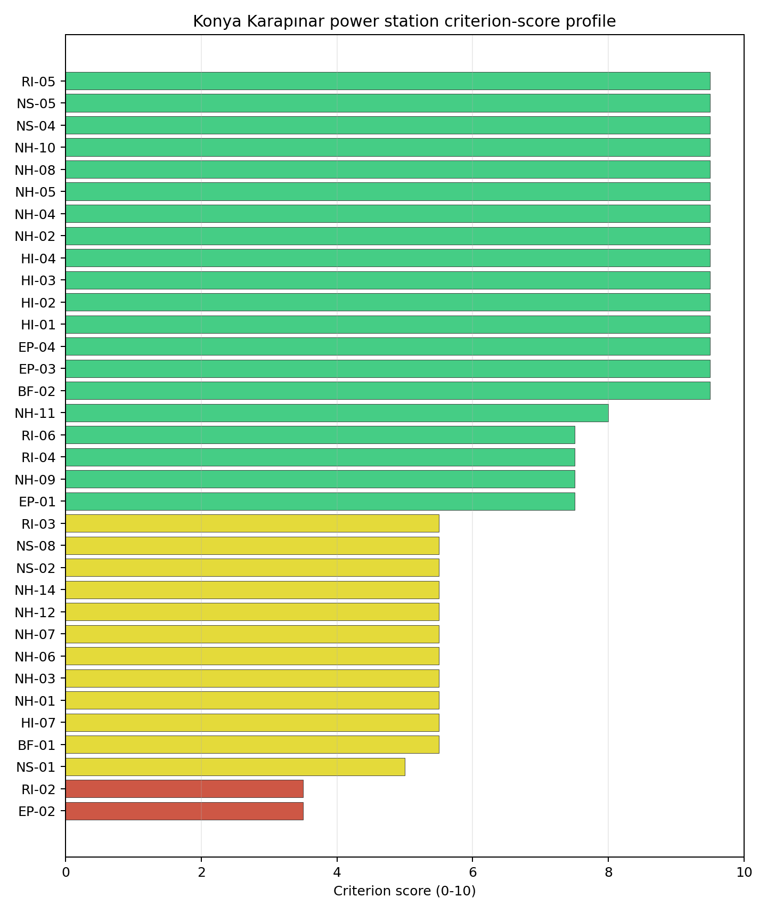
Criterion scores
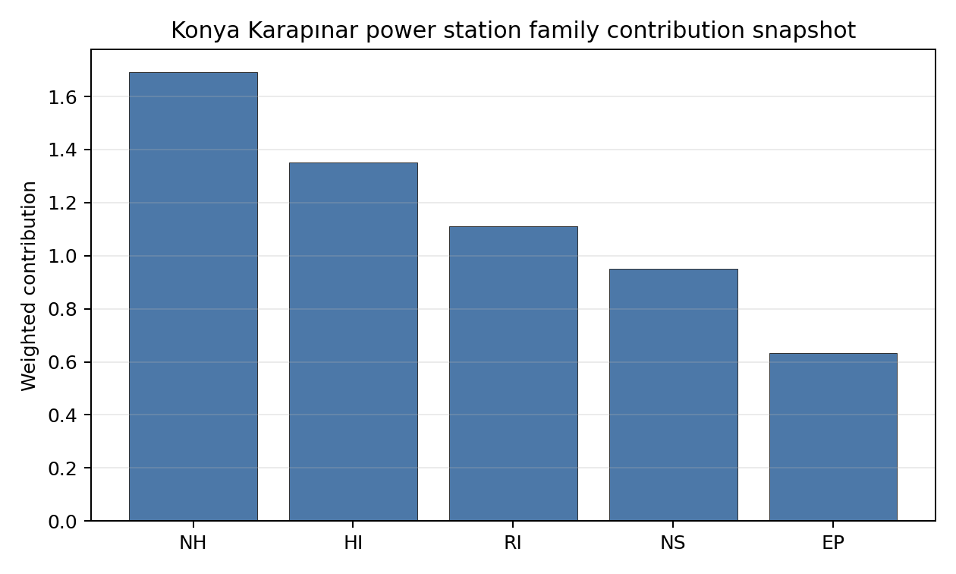
Family contributions
Konya Karapınar power station’s baseline composite score is 7.784, with a Monte Carlo bracket of 6.528-8.301. The national stability band is A, with a national top-10% hit rate of 100% in the project’s 50,000-iteration national Monte Carlo sensitivity analysis. That places the site in the national shortlist on the accepted Turkey basis. The result supports prioritised Stage 3 characterisation, not site approval or licensing readiness.

Residual Risk Register
Concern | Evidence | Consequence | Stage 3 action | Owner discipline
Evacuation Routes (EP-02) | Screening score 3.5/10, MC 3.0-4.0, confidence medium | Could narrow the viable siting envelope or require mitigation before characterisation progresses | Confirm measured inputs, authority constraints and engineering response for EP-02 | EP specialist
Surface Water Dispersion (RI-02) | Screening score 3.5/10, MC 3.0-4.0, confidence insufficient | Could narrow the viable siting envelope or require mitigation before characterisation progresses | Confirm measured inputs, authority constraints and engineering response for RI-02 | RI specialist
Military Installations (HI-06) | Screening score 5.0/10, MC 5.0-5.0, confidence medium | Could narrow the viable siting envelope or require mitigation before characterisation progresses | Confirm measured inputs, authority constraints and engineering response for HI-06 | HI specialist
Cooling Water Availability (NS-01) | Screening score 5.0/10, MC 5.0-6.0, confidence medium | Could narrow the viable siting envelope or require mitigation before characterisation progresses | Confirm measured inputs, authority constraints and engineering response for NS-01 | NS specialist
Transport Access (NS-03) | Screening score 5.0/10, MC 5.0-5.0, confidence medium | Could narrow the viable siting envelope or require mitigation before characterisation progresses | Confirm measured inputs, authority constraints and engineering response for NS-03 | NS specialist
These residual risks define the first Stage 3 work package. They do not overturn the national ranking, but they identify the evidence needed before Turkey treats the site as more than a screening-stage candidate.

Stage 3 Follow-Up Checklist
- Re-measure Evacuation Routes (EP-02) - native score 3.5/10 with confidence medium.
- Re-measure Surface Water Dispersion (RI-02) - native score 3.5/10 with confidence insufficient.
- Re-measure Military Installations (HI-06) - native score 5.0/10 with confidence medium.
- Re-measure Cooling Water Availability (NS-01) - native score 5.0/10 with confidence medium.
- Re-measure Transport Access (NS-03) - native score 5.0/10 with confidence medium.
- Improve data quality for Geotechnical: Subsidence & Collapse (NH-05b) - current flag low.
- Improve data quality for Industrial Explosions (HI-02) - current flag low.
- Improve data quality for Toxic/Gas Releases (HI-03) - current flag low.
- Improve data quality for External Fires (HI-04) - current flag low.
- Improve data quality for Transport Access (NS-03) - current flag low.

Evidence Limitations
- Geotechnical: Subsidence & Collapse (NH-05b) - quality low.
- Industrial Explosions (HI-02) - quality low.
- Toxic/Gas Releases (HI-03) - quality low.
- External Fires (HI-04) - quality low.
- Transport Access (NS-03) - quality low.

Tufanbeyli power station Site Profile
Tufanbeyli power station is a coal/thermal site in Türkiye that has been tested against the NuScale VOYGR-6 reference deployment envelope. This profile reads the screening evidence at a level that supports a decision to progress toward Stage 3 characterisation. It is not a site-suitability determination, vendor recommendation, or licensing finding.

Site Snapshot
Field | Value
Site name | Tufanbeyli power station
Coordinates | 38.1856, 36.2699
Subnational unit | Adana
Installed thermal capacity (source data) | 450 MW
Available surface area | 312.0 ha
Available surface area for development | 312.0 ha
Composite score (baseline weights) | 7.380 (6.407-7.890 MC band)
National stability band | A (top-10% hit rate 100%)
National rank | 3
See the country status map in Türkiye Country Profile.

Ownership and Coal-to-Nuclear Context
- Qatar Investment Authority (0.68% share), headquartered in Qatar; immediate operator Enerjisa Enerji Uretim AS. Path: Qatar Investment Authority -> Qatar Holding LLC [100.0%] -> RWE AG [9.1%] -> E.ON SE [15.0%] -> Enerjisa Enerji Uretim AS [50.0%] -> Tufanbeyli power station Unit 1 [100.0%]
- RWE AG (7.50% share), headquartered in Germany; immediate operator Enerjisa Enerji Uretim AS. Path: RWE AG -> E.ON SE [15.0%] -> Enerjisa Enerji Uretim AS [50.0%] -> Tufanbeyli power station Unit 1 [100.0%]
- Blackrock Advisors LLC (0.14% share), headquartered in United States; immediate operator Enerjisa Enerji Uretim AS. Path: Blackrock Advisors LLC -> BlackRock Inc [5.07%] -> E.ON SE [5.4%] -> Enerjisa Enerji Uretim AS [50.0%] -> Tufanbeyli power station Unit 1 [100.0%]
- Hacı Ömer Sabancı Holding AŞ (50.00% share), headquartered in Türkiye; immediate operator Enerjisa Enerji Uretim AS. Path: Hacı Ömer Sabancı Holding AŞ -> Enerjisa Enerji Uretim AS [50.0%] -> Tufanbeyli power station Unit 2 [100.0%]
- Qatar Holding LLC (0.68% share), headquartered in Qatar; immediate operator Enerjisa Enerji Uretim AS. Path: Qatar Holding LLC -> RWE AG [9.1%] -> E.ON SE [15.0%] -> Enerjisa Enerji Uretim AS [50.0%] -> Tufanbeyli power station Unit 1 [100.0%]
- Sakip Sabanci Holding AŞ (7.03% share), headquartered in Türkiye; immediate operator Enerjisa Enerji Uretim AS. Path: Sakip Sabanci Holding AŞ -> Hacı Ömer Sabancı Holding AŞ [14.07%] -> Enerjisa Enerji Uretim AS [50.0%] -> Tufanbeyli power station Unit 2 [100.0%]
- natural person(s) (10.55% share); immediate operator Enerjisa Enerji Uretim AS. Path: natural person(s) -> Hacı Ömer Sabancı Holding AŞ [21.1%] -> Enerjisa Enerji Uretim AS [50.0%] -> Tufanbeyli power station Unit 3 [100.0%]
- Government of Qatar (0.68% share), headquartered in Qatar; immediate operator Enerjisa Enerji Uretim AS. Path: Government of Qatar -> Qatar Investment Authority [100.0%] -> Qatar Holding LLC [100.0%] -> RWE AG [9.1%] -> E.ON SE [15.0%] -> Enerjisa Enerji Uretim AS [50.0%] -> Tufanbeyli power station Unit 1 [100.0%]
- E.ON SE (50.00% share), headquartered in Germany; immediate operator Enerjisa Enerji Uretim AS. Path: E.ON SE -> Enerjisa Enerji Uretim AS [50.0%] -> Tufanbeyli power station Unit 1 [100.0%]
- BlackRock Inc (2.70% share), headquartered in United States; immediate operator Enerjisa Enerji Uretim AS. Path: BlackRock Inc -> E.ON SE [5.4%] -> Enerjisa Enerji Uretim AS [50.0%] -> Tufanbeyli power station Unit 1 [100.0%]
- small shareholder(s) (32.42% share); immediate operator Enerjisa Enerji Uretim AS. Path: small shareholder(s) -> Hacı Ömer Sabancı Holding AŞ [64.83%] -> Enerjisa Enerji Uretim AS [50.0%] -> Tufanbeyli power station Unit 3 [100.0%]
- The Vanguard Group Inc (0.23% share), headquartered in United States; immediate operator Enerjisa Enerji Uretim AS. Path: The Vanguard Group Inc -> BlackRock Inc [8.66%] -> E.ON SE [5.4%] -> Enerjisa Enerji Uretim AS [50.0%] -> Tufanbeyli power station Unit 1 [100.0%]
Generating units on record: 3 operating. Earliest unit commissioning: 2016; most recent: 2016.

Natural Hazards (NH)
- Seismic: Ground Motion (NH-01) - score 5.5/10 (MC 5.0-6.0) - pass-mark band: At or below the score-5 risk boundary., weight 0.0455, data quality high. Evidence: PGA at 475-year return period 0.199 g; PGA at 2,475-year return period 0.444 g; Vs30 reference (m/s): 760.0.
- Seismic: Surface Rupture (NH-02) - score 7.5/10 (MC 7.0-8.0), weight n/a, data quality screening grade. Evidence: nearest mapped capable fault 31.4 km; fault slip rate 2.449 mm/yr; fault name: TRCF03H.
- Geotechnical: Liquefaction (NH-03) - score 9.5/10 (MC 9.0-10.0) - favourable: Negligible susceptibility (Stage-1 favourable default)., weight n/a, data quality medium. Evidence: liquefaction susceptibility: very_low; dominant soil type: clay_loam.
- Geotechnical: Slope Stability (NH-04) - score 5.5/10 (MC 5.0-6.0) - pass-mark band: At or below the score-5 risk boundary., weight n/a, data quality screening grade. Evidence: site slope 16.0 deg; max slope in 1 km box 89.2 deg; slope stability class: very_steep.
- Geotechnical: Subsidence (NH-05) - score 9.5/10 (MC 9.0-10.0) - favourable: No karst; mine-feature distance well above the score-5 pivot (or unknown)., weight 0.0354, data quality medium. Evidence: karst present: no; karst severity: none.
- Geotechnical: Foundation (NH-06) - score 5.5/10 (MC 5.0-6.0) - pass-mark band: Typical European mixed conditions (bearing 80-150 kPa)., weight 0.0253, data quality medium. Evidence: bearing capacity 82.7 kPa; depth to bedrock 12.7 m.
- Volcanism (NH-07) - score 5.5/10 (MC 5.0-6.0) - pass-mark band: At or above the score-5 boundary., weight n/a, data quality medium. Evidence: nearest Holocene volcano 81.4 km; volcano name: Erciyes Volcanic Complex; volcanic hazard class: avoidance.
- Coastal Flooding (NH-08) - score 9.5/10 (MC 9.0-10.0) - favourable: Non-coastal OR elevation >= 50 m AMSL OR landlocked country, with no positive marine-hazard signal., weight 0.0303, data quality medium. Evidence: distance to coast 142.8 km.
- River Flooding (NH-09) - score 7.5/10 (MC 7.0-8.0), weight 0.0404, data quality medium. Evidence: flood zone class: negligible.
- Extreme Winds (NH-10) - score 5.5/10 (MC 5.0-6.0) - pass-mark band: Middle relative wind exposure around the observed cohort mean (9.0-10.5 m/s)., weight 0.0152, data quality medium. Evidence: screening wind-speed index 9.99 m/s.
- Extreme Precipitation (NH-11) - score 8.0/10 (MC 8.0-9.0) - favourable: aggregated(mean_of_sub_scores), weight 0.0152, data quality medium. Evidence: screening extreme-precipitation index 0.2 mm; screening precipitation index 19.6 mm/yr.
- Extreme Temperatures (NH-12) - score 6.5/10 (MC 6.0-7.0) - pass-mark band: aggregated(mean_of_sub_scores), weight 0.0202, data quality medium. Evidence: extreme high temperature 22.8 deg C; extreme low temperature -11.3 deg C.
- Combined Hazards (NH-14) - score 5.5/10 (MC 5.0-6.0) - pass-mark band: At least 5 resolved, exactly one moderate hazard (3-5) or moderate interaction only., weight 0.0152, data quality n/a. Evidence: values not in measurement tables.

Interpretation - Natural Hazards (NH)
The natural-hazards evidence for Tufanbeyli power station supports Stage 3 characterisation, with the strongest screening signals in Coastal Flooding (NH-08) at 9.5/10, Geotechnical: Subsidence (NH-05) at 9.5/10. The main constraints are Grid Capacity Basic Filter (BF-01) at 5.5/10, Seismic: Ground Motion (NH-01) at 5.5/10, Geotechnical: Slope Stability (NH-04) at 5.5/10. These scores should be read as Stage 1-2 screening evidence: the criterion bullets above carry the measured values, while the Stage 3 programme should confirm the low-scoring and low-confidence inputs through field, authority and engineering review before any siting claim is hardened.

Human-Induced and Security-Relevant Hazards (HI)
- Aircraft Crash (HI-01) - score 9.5/10 (MC 9.0-10.0) - favourable: Only small / GA / heliport airport >= 10 km nearby, no flight-path proxy < 4 km, no major airport within 30 km, and no military airbase within 60 km., weight 0.0354, data quality high. Evidence: nearest airport 85.6 km; nearest flight path 44.0 km; airports within search radius 0; airport name: Kayseri Provincial Health Directorate Helipad; airport type: heliport.
- Industrial Explosions (HI-02) - score 9.5/10 (MC 7.5-10.0) - favourable: Very strong margin above the score-5 boundary (or completed search confirmed no in-radius signal)., weight 0.0354, data quality low. Evidence: values not in measurement tables.
- Toxic/Gas Releases (HI-03) - score 9.5/10 (MC 7.5-10.0) - favourable: Very strong margin above the score-5 boundary (or completed search confirmed no in-radius signal)., weight 0.0354, data quality low. Evidence: values not in measurement tables.
- External Fires (HI-04) - score 9.5/10 (MC 7.5-10.0) - favourable: > 15 km, or completed flammable-storage search found nothing in radius., weight 0.0303, data quality low. Evidence: values not in measurement tables.
- Military Installations (HI-06) - score no native score (unscored - no band matched), weight 0.0303, data quality screening grade. Evidence: military installations within radius 0.
- Electromagnetic Interference (HI-07) - score 5.5/10 (MC 5.0-6.0) - pass-mark band: Scoreable ordinary RF environment from count/proximity evidence; power-class-specific severity deferred., weight 0.0101, data quality medium. Evidence: nearest high-power transmitter 5.62 km; transmitters within radius 18; transmitter type: communication.

Interpretation - Human-Induced and Security-Relevant Hazards (HI)
The human-induced and security-relevant evidence for Tufanbeyli power station supports Stage 3 characterisation, with the strongest screening signals in External Fires (HI-04) at 9.5/10, Toxic/Gas Releases (HI-03) at 9.5/10. The main constraints are Military Installations (HI-06) at 5.0/10, Electromagnetic Interference (HI-07) at 5.5/10, Aircraft Crash (HI-01) at 9.5/10. These scores should be read as Stage 1-2 screening evidence: the criterion bullets above carry the measured values, while the Stage 3 programme should confirm the low-scoring and low-confidence inputs through field, authority and engineering review before any siting claim is hardened.

Radiological Impact and Emergency Planning (RI / EP)
- Emergency Planning Feasibility (EP-01) - score 7.5/10 (MC 7.0-8.0), weight n/a, data quality high. Evidence: EP feasibility composite 67.1 /100; road sub-score 37.3 /100; special-population sub-score 90.0 /100; geography sub-score 95.0 /100; population sub-score 95.0 /100; evacuation feasible: yes.
- Evacuation Routes (EP-02) - score 1.5/10 (MC 1.0-2.0), weight 0.0303, data quality medium. Evidence: road density in EPZ 0.273 km/km2; road length in EPZ 535.2 km; motorway access: yes.
- Physical Geography Constraints (EP-03) - score 9.5/10 (MC 9.0-10.0) - favourable: No measured relief; open river/waterway context (interim screening)., weight 0.0253, data quality medium. Evidence: waterways crossing EPZ 0; major river barrier: no.
- Special Populations (EP-04) - score 7.5/10 (MC 7.0-8.0), weight 0.0303, data quality medium. Evidence: hospitals in EPZ 3; prisons in EPZ 1; care homes in EPZ 0.
- Atmospheric Dispersion (RI-01) - score no native score (unscored - no band matched), weight 0.0303, data quality medium. Evidence: annual mean wind speed 0.92 m/s; atmospheric mixing height 529.4 m; prevailing wind direction: NNW.
- Surface Water Dispersion (RI-02) - score 3.5/10 (MC 3.0-4.0), weight 0.0253, data quality n/a. Evidence: values not in measurement tables.
- Groundwater Dispersion (RI-03) - score 7.5/10 (MC 7.0-8.0), weight 0.0253, data quality medium. Evidence: aquifer type: low permeability.
- Population Density at EPZ Radii (RI-04) - score 7.5/10 (MC 7.0-8.0), weight 0.0404, data quality screening grade. Evidence: population density within 5 km 22.3 /km2; population density within 16 km 22.6 /km2; population density within 25 km 15.2 /km2; population density within 80 km 25.4 /km2; population within 25 km 29,824 people.
- Distance to Population Centres (RI-05) - score 9.5/10 (MC 9.0-10.0) - favourable: No >=50k population-centre proxy within screening envelope., weight 0.0505, data quality screening grade. Evidence: values not in measurement tables.
- Population Projections (RI-06) - score 5.5/10 (MC 5.0-6.0) - pass-mark band: 0 % to +0.3 %., weight 0.0253, data quality screening grade. Evidence: annual population growth rate 0.074 %/yr; projected population at 25 km in 60 yr 32,695 people.

Interpretation - Radiological Impact and Emergency Planning (RI / EP)
The radiological-impact and emergency-planning evidence for Tufanbeyli power station supports Stage 3 characterisation, with the strongest screening signals in Distance to Population Centres (RI-05) at 9.5/10, Physical Geography Constraints (EP-03) at 9.5/10. The main constraints are Evacuation Routes (EP-02) at 1.5/10, Surface Water Dispersion (RI-02) at 3.5/10, Atmospheric Dispersion (RI-01) at 5.0/10. These scores should be read as Stage 1-2 screening evidence: the criterion bullets above carry the measured values, while the Stage 3 programme should confirm the low-scoring and low-confidence inputs through field, authority and engineering review before any siting claim is hardened.

Non-Safety and Implementation Considerations (NS)
- Grid Capacity Basic Filter (BF-01) - score 5.5/10 (MC 5.0-6.0) - pass-mark band: Note: substation 15-30 km OR 110-219 kV; reinforcement plausible., weight n/a, data quality n/a. Evidence: values not in measurement tables.
- Land Area Basic Filter (BF-02) - score 9.5/10 (MC 9.0-10.0) - favourable: Contiguous and buildable >= ideal area (70 ha/module)., weight 0.0253, data quality n/a. Evidence: values not in measurement tables.
- Cooling Water Availability (NS-01) - score 6.0/10 (MC 6.0-7.0) - pass-mark band: aggregated(weighted_mean_of_sub_scores), weight 0.0404, data quality screening grade. Evidence: distance to cooling source 1.92 km; cooling source flow 10.7 m3/s; cooling source type: river; cooling source name: Sarız Çayı; water stress label: High.
- Grid Connection (NS-02) - score 3.5/10 (MC 3.0-4.0), weight 0.0404, data quality medium. Evidence: nearest substation 0.33 km; nearest high-voltage line 26.8 km; highest nearby line voltage 380.0 kV; grid export capacity 450.0 MW; substations within radius 6; HV lines within radius 16.
- Transport Access (NS-03) - score 8.0/10 (MC 7.0-8.0) - favourable: aggregated(weighted_mean_of_sub_scores), weight 0.0404, data quality medium. Evidence: nearest highway 5.5 km; heavy-haul capable: yes.
- Site Topography (NS-04) - score 5.5/10 (MC 5.0-6.0) - pass-mark band: 40-60 %., weight 0.0303, data quality screening grade. Evidence: favourable land cover 46.4 %; moderate land cover 52.4 %; unfavourable land cover 1.2 %; favourable area 143.5 ha; dominant land class: 321.
- Site Footprint Adequacy (NS-05) - score 9.5/10 (MC 9.0-10.0) - favourable: Very strong margin above the score-5 boundary., weight 0.0253, data quality screening grade. Evidence: buildable area 312.0 ha; largest contiguous patch 1,242 ha; buildable patch count 1.
- Existing Infrastructure (NS-06) - score no native score (unscored - no band matched), weight 0.0253, data quality n/a. Evidence: not measured at this site (criterion remains unscored).
- Ecological Sensitivity (NS-08) - score 9.5/10 (MC 7.5-10.0) - favourable: Both networks NULL or > 25 km AND eco_pct NULL or < 15 %., weight n/a, data quality insufficient. Evidence: natural land cover 1.2 %; Natura 2000 sensitivity class: unknown; protected-area overlap: no; protected-area sensitivity class: none; Natura 2000 sites within 5 km: 0.
- Workforce Availability (NS-10) - score no native score (unscored - no band matched), weight 0.0202, data quality n/a. Evidence: not measured at this site (criterion remains unscored).
- Regulatory/Political Environment (NS-12) - score no native score (unscored - no band matched), weight 0.0303, data quality n/a. Evidence: not measured at this site (criterion remains unscored).
- Construction Logistics (NS-13) - score no native score (unscored - no band matched), weight 0.0202, data quality n/a. Evidence: not measured at this site (criterion remains unscored).

Interpretation - Non-Safety and Implementation Considerations (NS)
The non-safety and implementation evidence for Tufanbeyli power station supports Stage 3 characterisation, with the strongest screening signals in Ecological Sensitivity (NS-08) at 9.5/10, Site Footprint Adequacy (NS-05) at 9.5/10. The main constraints are Grid Connection (NS-02) at 3.5/10, Existing Infrastructure (NS-06) at 5.0/10, Workforce Availability (NS-10) at 5.0/10. These scores should be read as Stage 1-2 screening evidence: the criterion bullets above carry the measured values, while the Stage 3 programme should confirm the low-scoring and low-confidence inputs through field, authority and engineering review before any siting claim is hardened.

Composite Score and Stability
Baseline composite score is 7.380, bracketed by Monte Carlo at 6.407-7.890. National stability band is A with a top-10% hit rate of 100% across 12 scored Monte Carlo scenarios.
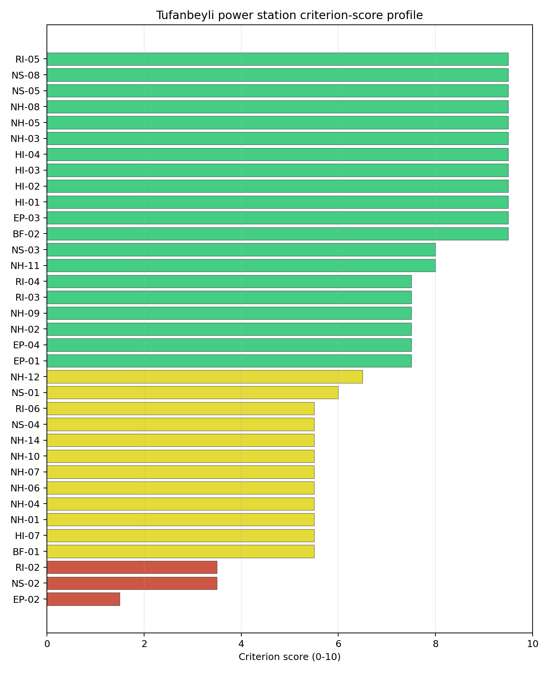
Criterion scores
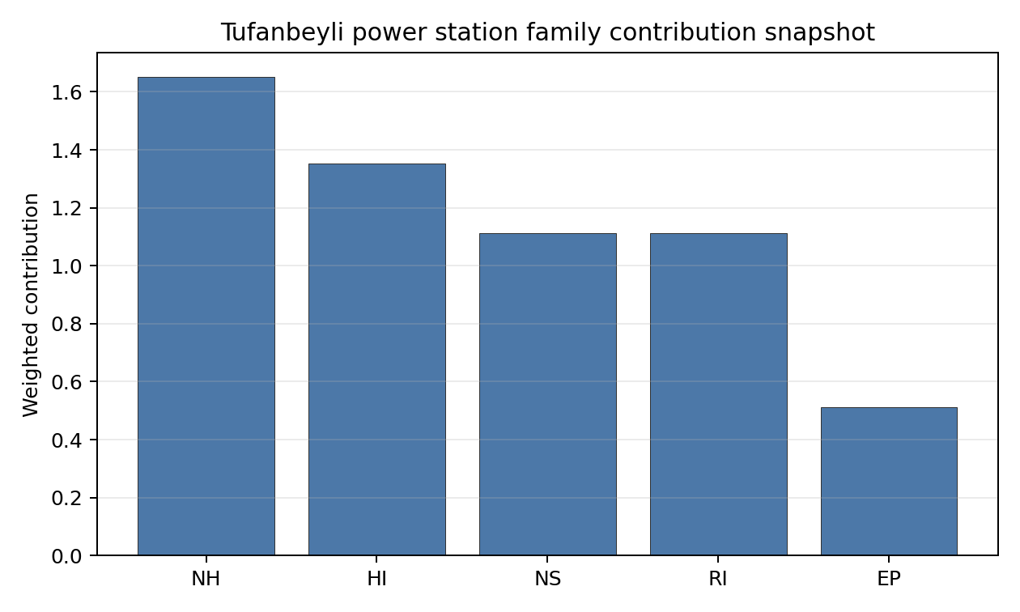
Family contributions
Tufanbeyli power station’s baseline composite score is 7.380, with a Monte Carlo bracket of 6.407-7.890. The national stability band is A, with a national top-10% hit rate of 100% in the project’s 50,000-iteration national Monte Carlo sensitivity analysis. That places the site in the national shortlist on the accepted Turkey basis. The result supports prioritised Stage 3 characterisation, not site approval or licensing readiness.

Residual Risk Register
Concern | Evidence | Consequence | Stage 3 action | Owner discipline
Evacuation Routes (EP-02) | Screening score 1.5/10, MC 1.0-2.0, confidence medium | Could narrow the viable siting envelope or require mitigation before characterisation progresses | Confirm measured inputs, authority constraints and engineering response for EP-02 | EP specialist
Grid Connection (NS-02) | Screening score 3.5/10, MC 3.0-4.0, confidence medium | Could narrow the viable siting envelope or require mitigation before characterisation progresses | Confirm measured inputs, authority constraints and engineering response for NS-02 | NS specialist
Surface Water Dispersion (RI-02) | Screening score 3.5/10, MC 3.0-4.0, confidence insufficient | Could narrow the viable siting envelope or require mitigation before characterisation progresses | Confirm measured inputs, authority constraints and engineering response for RI-02 | RI specialist
Military Installations (HI-06) | Screening score 5.0/10, MC 5.0-5.0, confidence medium | Could narrow the viable siting envelope or require mitigation before characterisation progresses | Confirm measured inputs, authority constraints and engineering response for HI-06 | HI specialist
Existing Infrastructure (NS-06) | Screening score 5.0/10, MC 5.0-5.0, confidence insufficient | Could narrow the viable siting envelope or require mitigation before characterisation progresses | Confirm measured inputs, authority constraints and engineering response for NS-06 | NS specialist
These residual risks define the first Stage 3 work package. They do not overturn the national ranking, but they identify the evidence needed before Turkey treats the site as more than a screening-stage candidate.

Stage 3 Follow-Up Checklist
- Resolve Grid Connection (NS-02) avoidance flag - measured grid export capacity 450.0 MW against the 462 MWe reference export-capacity screen.
- Re-measure Evacuation Routes (EP-02) - native score 1.5/10 with confidence medium.
- Re-measure Grid Connection (NS-02) - native score 3.5/10 with confidence medium.
- Re-measure Surface Water Dispersion (RI-02) - native score 3.5/10 with confidence insufficient.
- Re-measure Military Installations (HI-06) - native score 5.0/10 with confidence medium.
- Re-measure Existing Infrastructure (NS-06) - native score 5.0/10 with confidence insufficient.
- Improve data quality for Geotechnical: Subsidence & Collapse (NH-05b) - current flag low.
- Improve data quality for Industrial Explosions (HI-02) - current flag low.
- Improve data quality for Toxic/Gas Releases (HI-03) - current flag low.
- Improve data quality for External Fires (HI-04) - current flag low.

Evidence Limitations
- Geotechnical: Subsidence & Collapse (NH-05b) - quality low.
- Industrial Explosions (HI-02) - quality low.
- Toxic/Gas Releases (HI-03) - quality low.
- External Fires (HI-04) - quality low.

Ukraine Country Profile
Ukraine has 20 thermal and coal-site records tested against the NuScale VOYGR-6 reference deployment envelope. 12 sites pass both the exclusionary and avoidance screens, 8 pass the exclusionary screen with avoidance flags, and 0 fail one or more exclusionary checks. Ukraine is therefore analytically important: the desk-study pool is broad, and every record remains inside the comparison set.
Ukraine is an established nuclear-power jurisdiction, but the current war context changes how the screening result can be used. This profile applies a conflict and territorial-access caveat: current security conditions, practical site access, infrastructure condition, regulator engagement, emergency-planning continuity and data currency prevent the desk-study records from being treated as practical near-term progression candidates. The report does not make a legal or conflict-status determination for any site.
The leading site is Zmiivska power station, with a composite score of 7.455 and a Monte Carlo interval of 6.263-7.945. Its national stability band is A with a national top-10% hit rate of 92%. That makes it the clearest Ukrainian desk-study leader, but only as an analytical priority for post-war verification.
The selected Ukraine site profiles follow the national ranking rule and cover the top five records: Zmiivska power station, Dobrotvir power station, Ladyzhyn power station, Kryvorizka power station, Burshtyn power station. These are detailed desk-study profiles under caveat, not recommendations for immediate Stage 3 mobilisation.

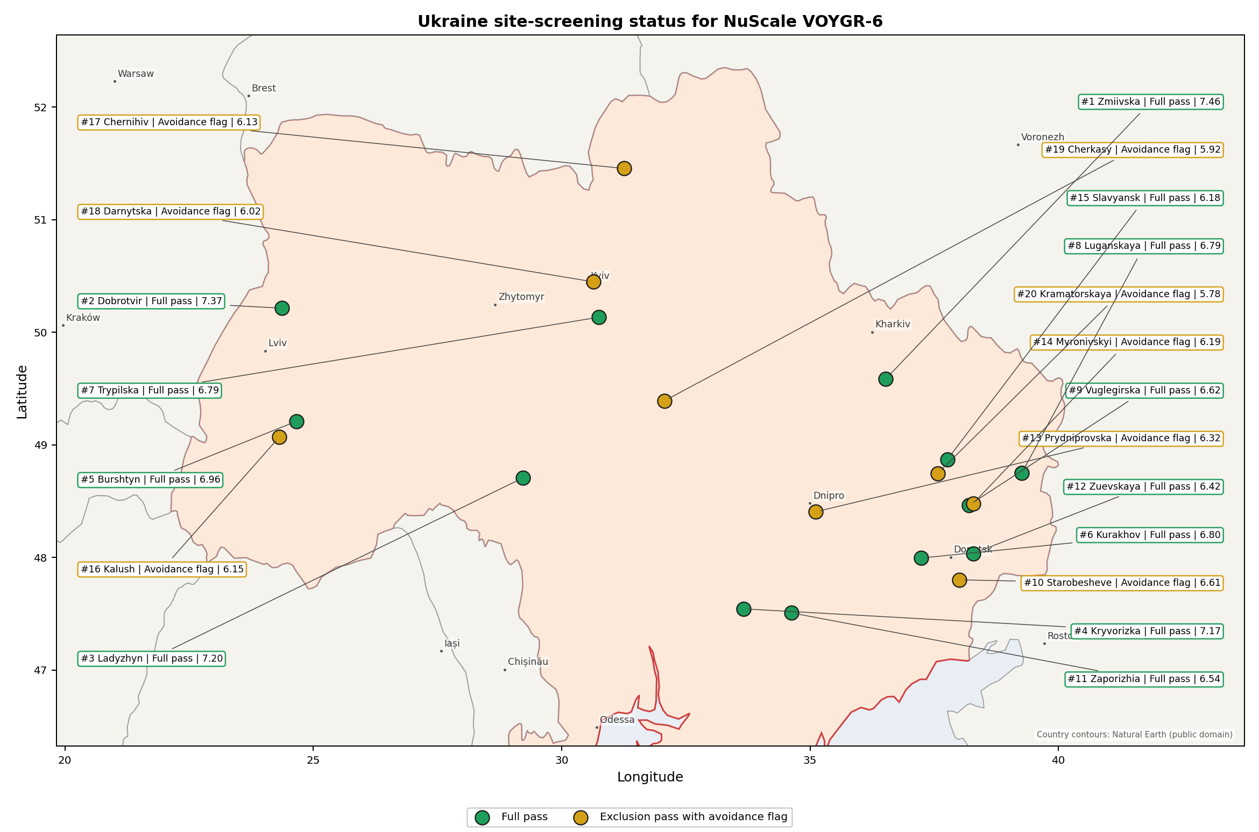
Ukraine status map

Ukraine Site Ledger
Rank | Site | Status | Composite | MC Low | MC High | Band | Top-10 Hit | Coverage
1 | Zmiivska power station | Full pass | 7.455 | 6.263 | 7.945 | A | 92% | 71%
2 | Dobrotvir power station | Full pass | 7.372 | 6.533 | 8.006 | B | 100% | 76%
3 | Ladyzhyn power station | Full pass | 7.197 | 6.391 | 7.706 | D | 8% | 76%
4 | Kryvorizka power station | Full pass | 7.166 | 6.051 | 7.655 | D | 0% | 71%
5 | Burshtyn power station | Full pass | 6.959 | 6.199 | 7.450 | D | 0% | 76%
6 | Kurakhov power station | Full pass | 6.797 | 5.742 | 7.315 | G | 0% | 71%
7 | Trypilska power station | Full pass | 6.795 | 5.894 | 7.364 | G | 0% | 74%
8 | Luganskaya power station | Full pass | 6.788 | 5.889 | 7.258 | G | 0% | 74%
9 | Vuglegirska power station | Full pass | 6.616 | 5.758 | 7.139 | H | 0% | 74%
10 | Starobesheve power station | Exclusion pass with avoidance flag | 6.609 | 5.753 | 7.099 | H | 0% | 74%
11 | Zaporizhia power station | Full pass | 6.543 | 5.702 | 7.033 | H | 0% | 74%
12 | Zuevskaya power station | Full pass | 6.417 | 5.606 | 6.887 | H | 0% | 74%
13 | Prydniprovska power station | Exclusion pass with avoidance flag | 6.318 | 5.530 | 6.808 | H | 0% | 74%
14 | Myronivskyi power station | Exclusion pass with avoidance flag | 6.192 | 5.434 | 6.609 | H | 0% | 74%
15 | Slavyansk power station | Full pass | 6.185 | 5.429 | 6.728 | H | 0% | 74%
16 | Kalush power station | Exclusion pass with avoidance flag | 6.153 | 5.548 | 6.694 | H | 0% | 76%
17 | Chernihiv power station | Exclusion pass with avoidance flag | 6.126 | 5.384 | 6.748 | H | 0% | 74%
18 | Darnytska power station | Exclusion pass with avoidance flag | 6.020 | 5.303 | 6.623 | H | 0% | 74%
19 | Cherkasy power station | Exclusion pass with avoidance flag | 5.921 | 5.227 | 6.358 | H | 0% | 74%
20 | Kramatorskaya power station | Exclusion pass with avoidance flag | 5.781 | 5.121 | 6.252 | H | 0% | 74%

Avoidance Flag Pareto
Of the 20 sites that pass the exclusionary screen, the avoidance-phase flags are concentrated in two criteria. Resolving them would improve the desk-study comparability of the lower-ranked pool; it would not remove the Ukraine conflict and territorial-access caveat.
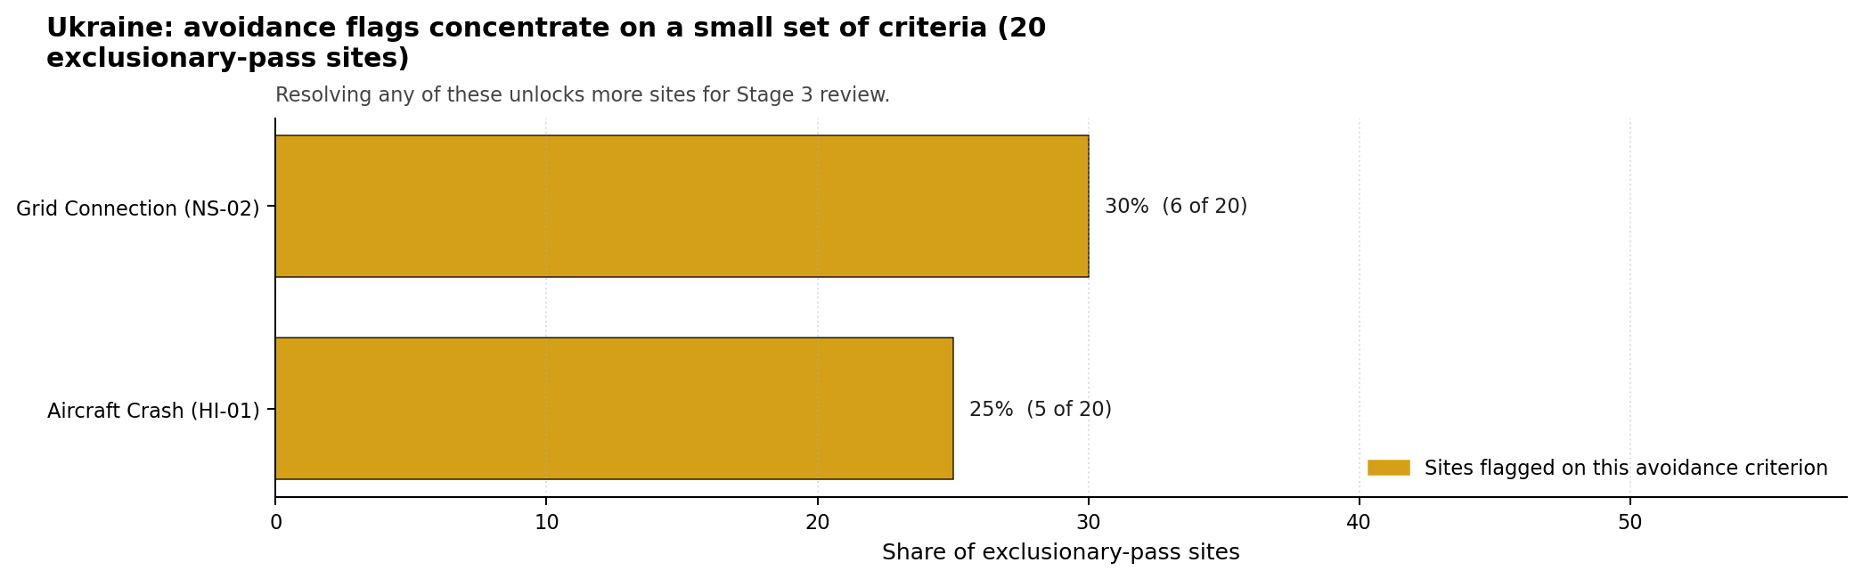
Avoidance flag Pareto
- Grid Connection (NS-02) - 6 of 20 exclusionary-pass sites (30%).
- Aircraft Crash (HI-01) - 5 of 20 exclusionary-pass sites (25%).

Family Strength and Weakness
Across Ukraine the strongest criterion family is Human-Induced Hazards at a mean normalised score of 7.28/10. The weakest family is Emergency Planning at 4.78/10. The bottom three individual criteria across the country are:
- Military Installations (HI-06) - mean 1.55/10 across 20 scored sites (min 0.0, max 5.0).
- Electromagnetic Interference (HI-07) - mean 1.80/10 across 20 scored sites (min 1.5, max 3.5).
- Ecological Sensitivity (NS-08) - mean 2.60/10 across 20 scored sites (min 1.5, max 5.5).

Interpretation for Site Selection
The Ukrainian result is strong as a desk-study comparison and weak as a near-term implementation signal. The full-pass count shows that the scoring framework can identify several brownfield records with favourable grid, transport, land and natural-hazard attributes. The conflict and territorial-access caveat is controlling, so these records should be read as a post-war verification queue rather than a current investment sequence.

Avoidance flag Pareto - what unlocks more sites
Zmiivska and Dobrotvir are the most robust analytical leaders under the national sensitivity treatment. Ladyzhyn, Kryvorizka and Burshtyn complete the top-five profile set but sit in stability band D, so their rank order is less resilient to weight perturbation even though each remains a full-pass site in the baseline screen.
A credible post-war work programme would start with national prerequisites before site-specific progression: updated territorial-control and access review, physical asset-condition surveys, refreshed population and emergency-planning data, security and airspace cadastre checks, grid-restoration evidence, and environmental screening for nearby protected areas. Only after those prerequisites are satisfied should the top-five site packets be used to define Stage 3 scopes.

Status Counts
- Full pass: 12
- Exclusion pass with avoidance flag: 8
- Hard fail: 0

Burshtyn power station Site Profile
Burshtyn power station is a Ukrainian coal/thermal site tested against the NuScale VOYGR-6 reference deployment envelope. This profile summarises Stage 1-2 desk-study evidence for post-war review. It is not a site-suitability determination, vendor recommendation, licensing finding, or near-term progression recommendation.
Ukraine conflict and territorial-access caveat. Current war conditions, security constraints, infrastructure-condition uncertainty, regulator access, emergency-planning continuity and data currency prevent this site from being treated as a practical near-term Stage 3 candidate. The profile does not make a legal or conflict-status determination for the site; it identifies what would need to be verified after stable access is available.

Site Snapshot
Field | Value
Site name | Burshtyn power station
Coordinates | 49.2104, 24.6665
Subnational unit | Halych Raion
Installed thermal capacity (source data) | 3,166 MW
Available surface area | 250.0 ha
Available surface area for development | 114.2 ha
Composite score (baseline weights) | 6.959 (6.199-7.450 MC band)
National stability band | D (top-10% hit rate 0%)
National rank | 5
See the country status map in Ukraine Country Profile.

Ownership and Coal-to-Nuclear Context
Ownership records identify DTEK Westenergy JSC [100%] as the immediate owner or operator recorded for Burshtyn power station. The parentage evidence includes DTEK Group BV, DTEK Energy Holdings BV, DTEK Energy BV, natural person(s). Several upstream share fields remain incomplete, so this profile reports the ownership chain as screening evidence only and does not infer land control, project rights, public acceptance, or procurement feasibility.
Generating units on record: 1 cancelled, 12 mothballed. Earliest unit commissioning: 1965; most recent: 2013. The brownfield value is the inherited grid, cooling, transport and industrial-land context; under the Ukraine caveat, every asset-condition claim requires post-war physical verification before Stage 3 work can be scoped.

Natural Hazards (NH)
- Seismic: Ground Motion (NH-01) - score 7.5/10 (MC 7.0-8.0), weight 0.0455, data quality high. Evidence: PGA at 475-year return period 0.034 g; PGA at 2,475-year return period 0.124 g; Vs30 reference (m/s): 760.0.
- Seismic: Surface Rupture (NH-02) - score 9.5/10 (MC 9.0-10.0) - favourable: Very strong separation from mapped capable faults; surface-rupture concern effectively screened at desk-study level., weight n/a, data quality screening grade. Evidence: nearest mapped capable fault 50.0 km; fault slip rate 0 mm/yr; fault name: none_in_search_radius.
- Geotechnical: Liquefaction (NH-03) - score 5.5/10 (MC 5.0-6.0) - pass-mark band: Moderate susceptibility, or high/very-high with documented (or pending for high) mitigation., weight n/a, data quality medium. Evidence: liquefaction susceptibility: moderate; dominant soil type: silty_clay_loam.
- Geotechnical: Slope Stability (NH-04) - score 7.5/10 (MC 7.0-8.0), weight n/a, data quality screening grade. Evidence: site slope 7.33 deg; max slope in 1 km box 85.1 deg; slope stability class: moderate.
- Geotechnical: Subsidence (NH-05) - score 1.5/10 (MC 1.0-2.0), weight 0.0354, data quality medium. Evidence: karst present: no; karst severity: high; formation type: mixed (Mixed carbonate and evaporite rocks).
- Geotechnical: Foundation (NH-06) - score 5.5/10 (MC 5.0-6.0) - pass-mark band: Typical European mixed conditions (bearing 80-150 kPa)., weight 0.0253, data quality medium. Evidence: bearing capacity 84.0 kPa; depth to bedrock 26.2 m.
- Volcanism (NH-07) - score 9.5/10 (MC 9.0-10.0) - favourable: Very strong margin above the score-5 boundary (or no in-radius signal is recorded)., weight n/a, data quality high. Evidence: volcanic hazard class: negligible.
- Coastal Flooding (NH-08) - score 9.5/10 (MC 9.0-10.0) - favourable: Non-coastal OR elevation >= 50 m AMSL OR landlocked country, with no positive marine-hazard signal., weight 0.0303, data quality medium. Evidence: distance to coast 538.6 km.
- River Flooding (NH-09) - score 7.5/10 (MC 7.0-8.0), weight 0.0404, data quality medium. Evidence: flood zone class: negligible.
- Extreme Winds (NH-10) - score 5.5/10 (MC 5.0-6.0) - pass-mark band: Middle relative wind exposure around the observed cohort mean (9.0-10.5 m/s)., weight 0.0152, data quality medium. Evidence: screening wind-speed index 9.15 m/s.
- Extreme Precipitation (NH-11) - score 8.0/10 (MC 7.0-8.0) - favourable: aggregated(mean_of_sub_scores), weight 0.0152, data quality medium. Evidence: screening extreme-precipitation index 0.26 mm; screening precipitation index 26.5 mm/yr.
- Extreme Temperatures (NH-12) - score 6.5/10 (MC 6.0-7.0) - pass-mark band: aggregated(mean_of_sub_scores), weight 0.0202, data quality medium. Evidence: extreme high temperature 22.1 deg C; extreme low temperature -9.01 deg C.
- Combined Hazards (NH-14) - score 5.5/10 (MC 5.0-6.0) - pass-mark band: At least 5 resolved, exactly one moderate hazard (3-5) or moderate interaction only., weight 0.0152, data quality n/a. Evidence: values not in measurement tables.

Interpretation - Natural Hazards (NH)
Natural hazards at Burshtyn power station are acceptable for desk-study screening, but they are not a substitute for field characterisation. Foundation screening remains material because the bundle records bearing capacity at 84.0 kPa. The main natural-hazard follow-up items are Geotechnical: Subsidence (NH-05) at 1.5/10, Geotechnical: Liquefaction (NH-03) at 5.5/10, Geotechnical: Foundation (NH-06) at 5.5/10. Post-war Stage 3 review should confirm seismic inputs, site geotechnics, flood and drainage assumptions, and design meteorology from measured Ukrainian records and site access surveys.

Human-Induced and Security-Relevant Hazards (HI)
- Aircraft Crash (HI-01) - score 9.5/10 (MC 9.0-10.0) - favourable: Only small / GA / heliport airport >= 10 km nearby, no flight-path proxy < 4 km, no major airport within 30 km, and no military airbase within 60 km., weight 0.0354, data quality high. Evidence: nearest airport 17.1 km; nearest flight path 8.53 km; airports within search radius 1; airport name: Luchyntsi Airstrip; airport type: small airfield.
- Industrial Explosions (HI-02) - score 9.5/10 (MC 9.0-10.0) - favourable: Very strong margin above the score-5 boundary (or completed search confirmed no in-radius signal)., weight 0.0354, data quality screening grade. Evidence: values not in measurement tables.
- Toxic/Gas Releases (HI-03) - score 9.5/10 (MC 9.0-10.0) - favourable: Very strong margin above the score-5 boundary (or completed search confirmed no in-radius signal)., weight 0.0354, data quality screening grade. Evidence: values not in measurement tables.
- External Fires (HI-04) - score 9.5/10 (MC 9.0-10.0) - favourable: > 15 km, or completed flammable-storage search found nothing in radius., weight 0.0303, data quality screening grade. Evidence: values not in measurement tables.
- Military Installations (HI-06) - score 3.5/10 (MC 3.0-4.0), weight 0.0303, data quality medium. Evidence: nearest military installation 18.8 km; military installations within radius 2; installation name: unnamed.
- Electromagnetic Interference (HI-07) - score 3.5/10 (MC 3.0-4.0), weight 0.0101, data quality medium. Evidence: nearest high-power transmitter 3.02 km; transmitters within radius 60; transmitter type: communication.

Interpretation - Human-Induced and Security-Relevant Hazards (HI)
Human-induced and security-relevant hazards at Burshtyn power station require conservative treatment because the source evidence is a desk-study snapshot. The nearest airport proxy is 17.1 km away. The nearest recorded military-installation proxy is 18.8 km away, but the current security context means the cadastre must be refreshed before any siting decision relies on it. The limiting screening items are Military Installations (HI-06) at 3.5/10, Electromagnetic Interference (HI-07) at 3.5/10, Aircraft Crash (HI-01) at 9.5/10. The post-war work package should refresh airspace, military, hazardous-neighbour, transport-hazard and electromagnetic-interference evidence with competent Ukrainian authorities.

Radiological Impact and Emergency Planning (RI / EP)
- Emergency Planning Feasibility (EP-01) - score 5.5/10 (MC 5.0-6.0) - pass-mark band: At or above the composite score-5 boundary., weight n/a, data quality high. Evidence: EP feasibility composite 63.1 /100; road sub-score 42.6 /100; special-population sub-score 90.0 /100; geography sub-score 95.0 /100; population sub-score 80.0 /100; evacuation feasible: yes.
- Evacuation Routes (EP-02) - score 3.5/10 (MC 3.0-4.0), weight 0.0303, data quality medium. Evidence: road density in EPZ 0.344 km/km2; road length in EPZ 675.3 km; motorway access: yes.
- Physical Geography Constraints (EP-03) - score 9.5/10 (MC 9.0-10.0) - favourable: No measured relief; open river/waterway context (interim screening)., weight 0.0253, data quality medium. Evidence: waterways crossing EPZ 0; major river barrier: no.
- Special Populations (EP-04) - score 5.5/10 (MC 5.0-6.0) - pass-mark band: 9-25., weight 0.0303, data quality medium. Evidence: hospitals in EPZ 10; prisons in EPZ 1; care homes in EPZ 0.
- Atmospheric Dispersion (RI-01) - score no native score (unscored - no band matched), weight 0.0303, data quality medium. Evidence: annual mean wind speed 1.19 m/s; atmospheric mixing height 505.2 m; prevailing wind direction: W.
- Surface Water Dispersion (RI-02) - score 1.5/10 (MC 1.0-2.0), weight 0.0253, data quality n/a. Evidence: values not in measurement tables.
- Groundwater Dispersion (RI-03) - score 5.5/10 (MC 5.0-6.0) - pass-mark band: Moderate-permeability aquifer screening proxy., weight 0.0253, data quality medium. Evidence: aquifer type: inland water.
- Population Density at EPZ Radii (RI-04) - score 5.5/10 (MC 5.0-6.0) - pass-mark band: aggregated(min_of_sub_scores), weight 0.0404, data quality screening grade. Evidence: population density within 5 km 111.7 /km2; population density within 16 km 80.2 /km2; population density within 25 km 59.9 /km2; population density within 80 km 105.4 /km2; population within 25 km 117,599 people.
- Distance to Population Centres (RI-05) - score 5.5/10 (MC 5.0-6.0) - pass-mark band: GHSL 16 km population proxy indicates >=50k people in the wider screening ring, but no city-distance margin is available., weight 0.0505, data quality screening grade. Evidence: values not in measurement tables.
- Population Projections (RI-06) - score 9.5/10 (MC 9.0-10.0) - favourable: Declining (< -0.5 %/yr)., weight 0.0253, data quality screening grade. Evidence: annual population growth rate -1.127 %/yr; projected population at 25 km in 60 yr 70,404 people.

Interpretation - Radiological Impact and Emergency Planning (RI / EP)
Radiological impact and emergency-planning evidence at Burshtyn power station supports comparison within Ukraine, not near-term implementation. Evacuation-route density is 0.344 km/km2 inside the emergency-planning zone, making road-network confirmation an early post-war task. The main RI/EP constraints are Surface Water Dispersion (RI-02) at 1.5/10, Evacuation Routes (EP-02) at 3.5/10, Atmospheric Dispersion (RI-01) at 5.0/10, Emergency Planning Feasibility (EP-01) at 5.5/10. Stage 3 should therefore begin with updated population, special-population, evacuation, hydrology and meteorological dispersion studies, all under stable access and regulator engagement.

Non-Safety and Implementation Considerations (NS)
- Grid Capacity Basic Filter (BF-01) - score 7.5/10 (MC 7.0-8.0), weight n/a, data quality n/a. Evidence: values not in measurement tables.
- Land Area Basic Filter (BF-02) - score 9.5/10 (MC 9.0-10.0) - favourable: Contiguous and buildable >= ideal area (70 ha/module)., weight 0.0253, data quality n/a. Evidence: values not in measurement tables.
- Cooling Water Availability (NS-01) - score 7.0/10 (MC 7.0-8.0), weight 0.0404, data quality screening grade. Evidence: distance to cooling source 1.26 km; cooling source flow 4.71 m3/s; cooling source type: small_river; cooling source name: Млинівка; water stress label: Low.
- Grid Connection (NS-02) - score 7.5/10 (MC 7.0-8.0), weight 0.0404, data quality high. Evidence: nearest substation 1.21 km; nearest high-voltage line 0.25 km; highest nearby line voltage 330.0 kV; grid export capacity 3,166 MW; substations within radius 265; HV lines within radius 481.
- Transport Access (NS-03) - score 10.0/10 (MC 9.0-10.0) - favourable: aggregated(weighted_mean_of_sub_scores), weight 0.0404, data quality medium. Evidence: nearest highway 0.72 km; heavy-haul capable: yes.
- Site Topography (NS-04) - score 3.5/10 (MC 3.0-4.0), weight 0.0303, data quality screening grade. Evidence: favourable land cover 34.2 %; moderate land cover 10.5 %; unfavourable land cover 55.3 %; favourable area 38.8 ha; dominant land class: 512.
- Site Footprint Adequacy (NS-05) - score 9.5/10 (MC 9.0-10.0) - favourable: Very strong margin above the score-5 boundary., weight 0.0253, data quality screening grade. Evidence: buildable area 114.2 ha; largest contiguous patch 524.5 ha; buildable patch count 3.
- Existing Infrastructure (NS-06) - score no native score (unscored - no band matched), weight 0.0253, data quality n/a. Evidence: not measured at this site (criterion remains unscored).
- Ecological Sensitivity (NS-08) - score 1.5/10 (MC 0.0-3.5), weight n/a, data quality insufficient. Evidence: natural land cover 55.3 %; distance to nearest protected area 0.093 km; Natura 2000 sensitivity class: unknown; protected-area overlap: no; protected-area sensitivity class: high; Natura 2000 sites within 5 km: 0; nearest protected-area designation: Wetland of International Importance (Ramsar Site).
- Workforce Availability (NS-10) - score no native score (unscored - no band matched), weight 0.0202, data quality n/a. Evidence: not measured at this site (criterion remains unscored).
- Regulatory/Political Environment (NS-12) - score no native score (unscored - no band matched), weight 0.0303, data quality n/a. Evidence: not measured at this site (criterion remains unscored).
- Construction Logistics (NS-13) - score no native score (unscored - no band matched), weight 0.0202, data quality n/a. Evidence: not measured at this site (criterion remains unscored).

Interpretation - Non-Safety and Implementation Considerations (NS)
Non-safety and implementation factors are the main reason Burshtyn power station remains in the Ukraine top-five desk-study set. The canonical site surface area is 250.0 ha, and the current area for development is 114.2 ha; these figures do not prove land availability, contiguity, permitting or control. Grid screening is favourable on proximity: nearest substation 1.21 km, nearest high-voltage line 0.25 km, grid export-capacity proxy 3166 MW. The limiting non-safety items are Ecological Sensitivity (NS-08) at 1.5/10, Site Topography (NS-04) at 3.5/10, Existing Infrastructure (NS-06) at 5.0/10, Workforce Availability (NS-10) at 5.0/10. Post-war review should verify switchyard condition, transmission voltage path, cooling-water availability, ecological constraints, land title, construction logistics and workforce evidence before any progression decision.

Composite Score and Stability
Baseline composite score is 6.959, bracketed by Monte Carlo at 6.199-7.450. National stability band is D with a top-10% hit rate of 0% across 12 scored Monte Carlo scenarios.
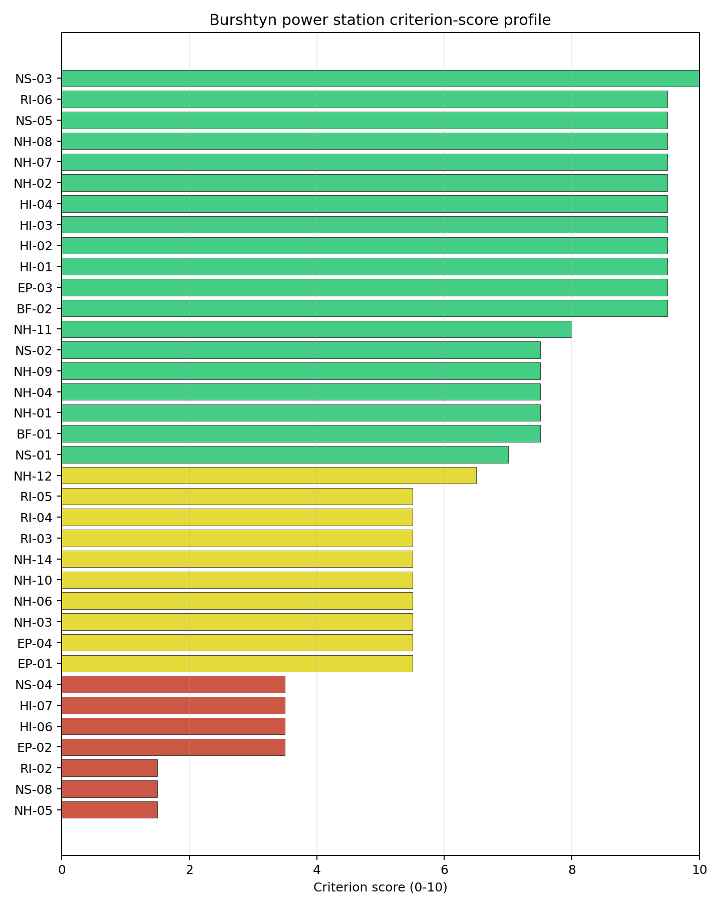
Criterion scores
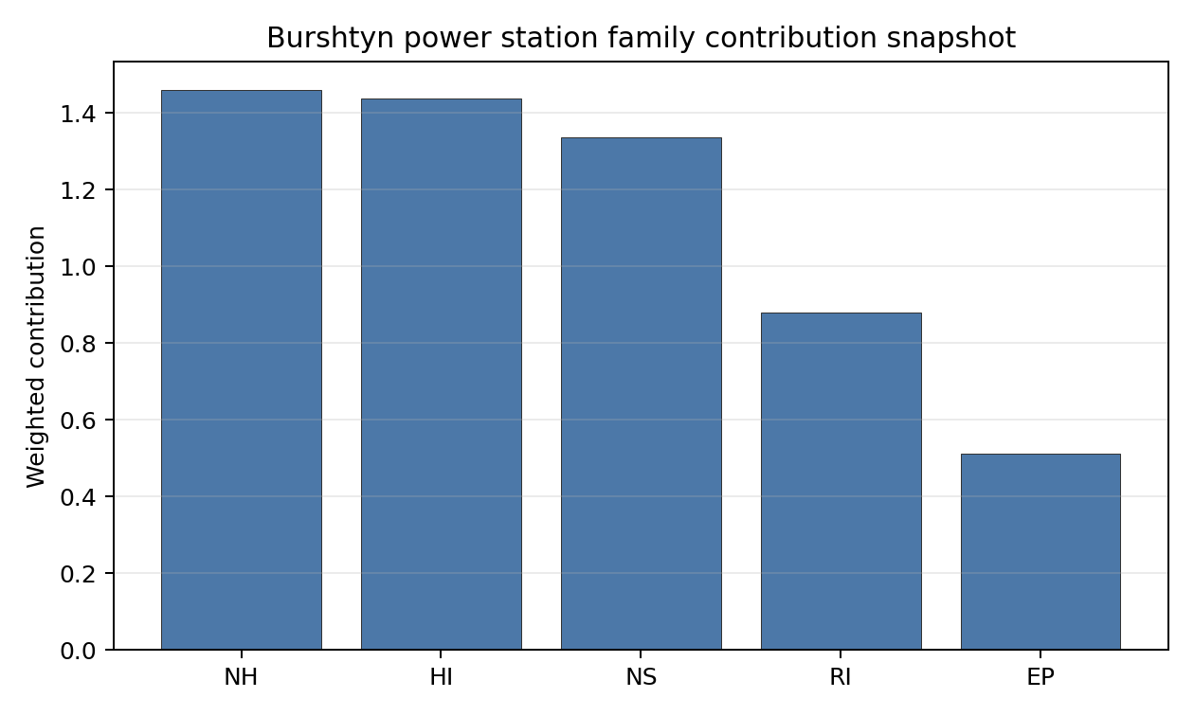
Family contributions
Burshtyn power station ranks 5 nationally with a baseline composite score of 6.959 and a Monte Carlo bracket of 6.199-7.450. Its national stability band is D, with a national top-10% hit rate of 0%. This is a useful but weight-sensitive national screening position within the Ukrainian desk-study pool. The result should sequence evidence collection, not construction readiness: the Ukraine conflict and territorial-access caveat prevents treatment of any Ukrainian site as a practical near-term Stage 3 candidate in this report pass.

Residual Risk Register
Concern | Evidence | Consequence | Stage 3 action | Owner discipline
Conflict and territorial access | Current war conditions affect access, security, infrastructure-condition evidence and emergency-planning currency. | Near-term progression cannot be supported from desk-study data alone. | Defer progression decision until stable access, regulator engagement and updated territorial-control evidence are available. | programme
Geotechnical: Subsidence (NH-05) | Native score 1.5/10; confidence medium. | Could alter the screening class, design basis or mitigation burden if confirmed in field evidence. | Re-measure Geotechnical: Subsidence with site-specific post-war data before Stage 3 scoping. | geotechnical / hazards
Ecological Sensitivity (NS-08) | Native score 1.5/10; confidence insufficient. | Could alter the screening class, design basis or mitigation burden if confirmed in field evidence. | Re-measure Ecological Sensitivity with site-specific post-war data before Stage 3 scoping. | site engineering / environment
Surface Water Dispersion (RI-02) | Native score 1.5/10; confidence low. | Could alter the screening class, design basis or mitigation burden if confirmed in field evidence. | Re-measure Surface Water Dispersion with site-specific post-war data before Stage 3 scoping. | radiological / hydrology
Evacuation Routes (EP-02) | Native score 3.5/10; confidence medium. | Could alter the screening class, design basis or mitigation burden if confirmed in field evidence. | Re-measure Evacuation Routes with site-specific post-war data before Stage 3 scoping. | emergency planning
Military Installations (HI-06) | Native score 3.5/10; confidence medium. | Could alter the screening class, design basis or mitigation burden if confirmed in field evidence. | Re-measure Military Installations with site-specific post-war data before Stage 3 scoping. | security
This register is a post-war evidence plan for Burshtyn power station. It is not a finding of site approval or a recommendation to start Stage 3 work under current conditions.

Stage 3 Follow-Up Checklist
- Re-measure Geotechnical: Subsidence (NH-05) - native score 1.5/10 with confidence medium.
- Re-measure Ecological Sensitivity (NS-08) - native score 1.5/10 with confidence low.
- Re-measure Surface Water Dispersion (RI-02) - native score 1.5/10 with confidence insufficient.
- Re-measure Evacuation Routes (EP-02) - native score 3.5/10 with confidence medium.
- Re-measure Military Installations (HI-06) - native score 3.5/10 with confidence medium.

Evidence Limitations
- No criterion-family quality fields are flagged as low or missing in this bundle.

Dobrotvir power station Site Profile
Dobrotvir power station is a Ukrainian coal/thermal site tested against the NuScale VOYGR-6 reference deployment envelope. This profile summarises Stage 1-2 desk-study evidence for post-war review. It is not a site-suitability determination, vendor recommendation, licensing finding, or near-term progression recommendation.
Ukraine conflict and territorial-access caveat. Current war conditions, security constraints, infrastructure-condition uncertainty, regulator access, emergency-planning continuity and data currency prevent this site from being treated as a practical near-term Stage 3 candidate. The profile does not make a legal or conflict-status determination for the site; it identifies what would need to be verified after stable access is available.

Site Snapshot
Field | Value
Site name | Dobrotvir power station
Coordinates | 50.2143, 24.3747
Subnational unit | Lviv
Installed thermal capacity (source data) | 1,110 MW
Available surface area | 215.1 ha
Available surface area for development | 215.1 ha
Composite score (baseline weights) | 7.372 (6.533-8.006 MC band)
National stability band | B (top-10% hit rate 100%)
National rank | 2
See the country status map in Ukraine Country Profile.

Ownership and Coal-to-Nuclear Context
Ownership records identify DTEK Westenergy JSC [100%] as the immediate owner or operator recorded for Dobrotvir power station. The parentage evidence includes DTEK Group BV, DTEK Energy Holdings BV, DTEK Energy BV, natural person(s). Several upstream share fields remain incomplete, so this profile reports the ownership chain as screening evidence only and does not infer land control, project rights, public acceptance, or procurement feasibility.
Generating units on record: 1 cancelled, 4 mothballed. Earliest unit commissioning: 1960; most recent: 1964. The brownfield value is the inherited grid, cooling, transport and industrial-land context; under the Ukraine caveat, every asset-condition claim requires post-war physical verification before Stage 3 work can be scoped.

Natural Hazards (NH)
- Seismic: Ground Motion (NH-01) - score 9.5/10 (MC 9.0-10.0) - favourable: Well below the risk boundary., weight 0.0455, data quality high. Evidence: PGA at 475-year return period 0.018 g; PGA at 2,475-year return period 0.065 g; Vs30 reference (m/s): 760.0.
- Seismic: Surface Rupture (NH-02) - score 9.5/10 (MC 9.0-10.0) - favourable: Very strong separation from mapped capable faults; surface-rupture concern effectively screened at desk-study level., weight n/a, data quality screening grade. Evidence: nearest mapped capable fault 50.0 km; fault slip rate 0 mm/yr; fault name: none_in_search_radius.
- Geotechnical: Liquefaction (NH-03) - score 5.5/10 (MC 5.0-6.0) - pass-mark band: Moderate susceptibility, or high/very-high with documented (or pending for high) mitigation., weight n/a, data quality medium. Evidence: liquefaction susceptibility: high; dominant soil type: loam.
- Geotechnical: Slope Stability (NH-04) - score 7.5/10 (MC 7.0-8.0), weight n/a, data quality screening grade. Evidence: site slope 8.32 deg; max slope in 1 km box 82.4 deg; slope stability class: moderate.
- Geotechnical: Subsidence (NH-05) - score 5.5/10 (MC 5.0-6.0) - pass-mark band: At or above the mine-distance score-5 pivot; review possible., weight 0.0354, data quality medium. Evidence: karst present: no; karst severity: moderate; formation type: carbonate (Continuous carbonate rocks).
- Geotechnical: Foundation (NH-06) - score 5.5/10 (MC 5.0-6.0) - pass-mark band: Typical European mixed conditions (bearing 80-150 kPa)., weight 0.0253, data quality medium. Evidence: bearing capacity 80.7 kPa; depth to bedrock 16.0 m.
- Volcanism (NH-07) - score 9.5/10 (MC 9.0-10.0) - favourable: Very strong margin above the score-5 boundary (or no in-radius signal is recorded)., weight n/a, data quality high. Evidence: volcanic hazard class: negligible.
- Coastal Flooding (NH-08) - score 9.5/10 (MC 9.0-10.0) - favourable: Non-coastal OR elevation >= 50 m AMSL OR landlocked country, with no positive marine-hazard signal., weight 0.0303, data quality medium. Evidence: distance to coast 567.9 km.
- River Flooding (NH-09) - score 7.5/10 (MC 5.5-9.5), weight 0.0404, data quality insufficient. Evidence: flood zone class: negligible.
- Extreme Winds (NH-10) - score 5.5/10 (MC 5.0-6.0) - pass-mark band: Middle relative wind exposure around the observed cohort mean (9.0-10.5 m/s)., weight 0.0152, data quality medium. Evidence: screening wind-speed index 10.1 m/s.
- Extreme Precipitation (NH-11) - score 8.0/10 (MC 8.0-9.0) - favourable: aggregated(mean_of_sub_scores), weight 0.0152, data quality medium. Evidence: screening extreme-precipitation index 0.23 mm; screening precipitation index 24.9 mm/yr.
- Extreme Temperatures (NH-12) - score 6.5/10 (MC 6.0-7.0) - pass-mark band: aggregated(mean_of_sub_scores), weight 0.0202, data quality medium. Evidence: extreme high temperature 22.5 deg C; extreme low temperature -8.67 deg C.
- Combined Hazards (NH-14) - score 5.5/10 (MC 5.0-6.0) - pass-mark band: At least 5 resolved, exactly one moderate hazard (3-5) or moderate interaction only., weight 0.0152, data quality n/a. Evidence: values not in measurement tables.

Interpretation - Natural Hazards (NH)
Natural hazards at Dobrotvir power station are acceptable for desk-study screening, but they are not a substitute for field characterisation. Foundation screening remains material because the bundle records bearing capacity at 80.7 kPa. The main natural-hazard follow-up items are Geotechnical: Liquefaction (NH-03) at 5.5/10, Geotechnical: Subsidence (NH-05) at 5.5/10, Geotechnical: Foundation (NH-06) at 5.5/10. Post-war Stage 3 review should confirm seismic inputs, site geotechnics, flood and drainage assumptions, and design meteorology from measured Ukrainian records and site access surveys.

Human-Induced and Security-Relevant Hazards (HI)
- Aircraft Crash (HI-01) - score 9.5/10 (MC 9.0-10.0) - favourable: Only small / GA / heliport airport >= 10 km nearby, no flight-path proxy < 4 km, no major airport within 30 km, and no military airbase within 60 km., weight 0.0354, data quality high. Evidence: nearest airport 29.7 km; nearest flight path 14.8 km; airports within search radius 1; airport name: Zhalizhnia; airport type: small airfield.
- Industrial Explosions (HI-02) - score 9.5/10 (MC 9.0-10.0) - favourable: Very strong margin above the score-5 boundary (or completed search confirmed no in-radius signal)., weight 0.0354, data quality screening grade. Evidence: values not in measurement tables.
- Toxic/Gas Releases (HI-03) - score 9.5/10 (MC 9.0-10.0) - favourable: Very strong margin above the score-5 boundary (or completed search confirmed no in-radius signal)., weight 0.0354, data quality screening grade. Evidence: values not in measurement tables.
- External Fires (HI-04) - score 9.5/10 (MC 9.0-10.0) - favourable: > 15 km, or completed flammable-storage search found nothing in radius., weight 0.0303, data quality screening grade. Evidence: values not in measurement tables.
- Military Installations (HI-06) - score 1.5/10 (MC 1.0-2.0), weight 0.0303, data quality medium. Evidence: nearest military installation 12.7 km; military installations within radius 4; installation name: unnamed.
- Electromagnetic Interference (HI-07) - score 1.5/10 (MC 1.0-2.0), weight 0.0101, data quality medium. Evidence: nearest high-power transmitter 0.24 km; transmitters within radius 89; transmitter type: communication.

Interpretation - Human-Induced and Security-Relevant Hazards (HI)
Human-induced and security-relevant hazards at Dobrotvir power station require conservative treatment because the source evidence is a desk-study snapshot. The nearest airport proxy is 29.7 km away. The nearest recorded military-installation proxy is 12.7 km away, but the current security context means the cadastre must be refreshed before any siting decision relies on it. The limiting screening items are Military Installations (HI-06) at 1.5/10, Electromagnetic Interference (HI-07) at 1.5/10, Aircraft Crash (HI-01) at 9.5/10. The post-war work package should refresh airspace, military, hazardous-neighbour, transport-hazard and electromagnetic-interference evidence with competent Ukrainian authorities.

Radiological Impact and Emergency Planning (RI / EP)
- Emergency Planning Feasibility (EP-01) - score 5.5/10 (MC 5.0-6.0) - pass-mark band: At or above the composite score-5 boundary., weight n/a, data quality high. Evidence: EP feasibility composite 60.9 /100; road sub-score 33.4 /100; special-population sub-score 90.0 /100; geography sub-score 95.0 /100; population sub-score 80.0 /100; evacuation feasible: yes.
- Evacuation Routes (EP-02) - score 3.5/10 (MC 3.0-4.0), weight 0.0303, data quality medium. Evidence: road density in EPZ 0.357 km/km2; road length in EPZ 701.7 km; motorway access: no.
- Physical Geography Constraints (EP-03) - score 9.5/10 (MC 9.0-10.0) - favourable: No measured relief; open river/waterway context (interim screening)., weight 0.0253, data quality medium. Evidence: waterways crossing EPZ 0; major river barrier: no.
- Special Populations (EP-04) - score 3.5/10 (MC 3.0-4.0), weight 0.0303, data quality medium. Evidence: hospitals in EPZ 29; prisons in EPZ 0; care homes in EPZ 0.
- Atmospheric Dispersion (RI-01) - score no native score (unscored - no band matched), weight 0.0303, data quality medium. Evidence: annual mean wind speed 1.44 m/s; atmospheric mixing height 543.7 m; prevailing wind direction: WSW.
- Surface Water Dispersion (RI-02) - score 3.5/10 (MC 3.0-4.0), weight 0.0253, data quality n/a. Evidence: values not in measurement tables.
- Groundwater Dispersion (RI-03) - score 5.5/10 (MC 5.0-6.0) - pass-mark band: Moderate-permeability aquifer screening proxy., weight 0.0253, data quality medium. Evidence: aquifer type: alluvial.
- Population Density at EPZ Radii (RI-04) - score 5.5/10 (MC 5.0-6.0) - pass-mark band: aggregated(min_of_sub_scores), weight 0.0404, data quality screening grade. Evidence: population density within 5 km 109.3 /km2; population density within 16 km 61.5 /km2; population density within 25 km 93.4 /km2; population density within 80 km 102.8 /km2; population within 25 km 183,350 people.
- Distance to Population Centres (RI-05) - score 9.5/10 (MC 9.0-10.0) - favourable: Nearest >=50k population-centre proxy exceeds required distance by >= 50 %., weight 0.0505, data quality screening grade. Evidence: nearest city above 50k people 97.0 km; nearest city population 58,231 people; city name: Zamość.
- Population Projections (RI-06) - score 9.5/10 (MC 9.0-10.0) - favourable: Declining (< -0.5 %/yr)., weight 0.0253, data quality screening grade. Evidence: annual population growth rate -1.218 %/yr; projected population at 25 km in 60 yr 109,767 people.

Interpretation - Radiological Impact and Emergency Planning (RI / EP)
Radiological impact and emergency-planning evidence at Dobrotvir power station supports comparison within Ukraine, not near-term implementation. Evacuation-route density is 0.357 km/km2 inside the emergency-planning zone, making road-network confirmation an early post-war task. The main RI/EP constraints are Evacuation Routes (EP-02) at 3.5/10, Special Populations (EP-04) at 3.5/10, Surface Water Dispersion (RI-02) at 3.5/10, Atmospheric Dispersion (RI-01) at 5.0/10. Stage 3 should therefore begin with updated population, special-population, evacuation, hydrology and meteorological dispersion studies, all under stable access and regulator engagement.

Non-Safety and Implementation Considerations (NS)
- Grid Capacity Basic Filter (BF-01) - score 5.5/10 (MC 5.0-6.0) - pass-mark band: Note: substation 15-30 km OR 110-219 kV; reinforcement plausible., weight n/a, data quality n/a. Evidence: values not in measurement tables.
- Land Area Basic Filter (BF-02) - score 9.5/10 (MC 9.0-10.0) - favourable: Contiguous and buildable >= ideal area (70 ha/module)., weight 0.0253, data quality n/a. Evidence: values not in measurement tables.
- Cooling Water Availability (NS-01) - score 8.0/10 (MC 8.0-9.0) - favourable: aggregated(weighted_mean_of_sub_scores), weight 0.0404, data quality screening grade. Evidence: distance to cooling source 1.06 km; cooling source flow 14.4 m3/s; cooling source type: river; cooling source name: Zakhidnyi Buh; water stress label: Low.
- Grid Connection (NS-02) - score 9.5/10 (MC 9.0-10.0) - favourable: aggregated(min_of_sub_scores), weight 0.0404, data quality high. Evidence: nearest substation 0.24 km; nearest high-voltage line 0.27 km; grid export capacity 1,110 MW; substations within radius 428; HV lines within radius 536.
- Transport Access (NS-03) - score 8.0/10 (MC 8.0-9.0) - favourable: aggregated(weighted_mean_of_sub_scores), weight 0.0404, data quality high. Evidence: nearest highway 7.04 km; nearest rail line 0.05 km; heavy-haul capable: yes.
- Site Topography (NS-04) - score 3.5/10 (MC 3.0-4.0), weight 0.0303, data quality screening grade. Evidence: favourable land cover 35.7 %; moderate land cover 32.3 %; unfavourable land cover 32.0 %; favourable area 77.4 ha; dominant land class: 321.
- Site Footprint Adequacy (NS-05) - score 9.5/10 (MC 9.0-10.0) - favourable: Very strong margin above the score-5 boundary., weight 0.0253, data quality screening grade. Evidence: buildable area 215.1 ha; largest contiguous patch 829.1 ha; buildable patch count 7.
- Existing Infrastructure (NS-06) - score no native score (unscored - no band matched), weight 0.0253, data quality n/a. Evidence: not measured at this site (criterion remains unscored).
- Ecological Sensitivity (NS-08) - score 1.5/10 (MC 0.0-3.5), weight n/a, data quality insufficient. Evidence: natural land cover 32.0 %; distance to nearest protected area 0.634 km; Natura 2000 sensitivity class: unknown; protected-area overlap: no; protected-area sensitivity class: high; Natura 2000 sites within 5 km: 0; nearest protected-area designation: Emerald Network.
- Workforce Availability (NS-10) - score no native score (unscored - no band matched), weight 0.0202, data quality n/a. Evidence: not measured at this site (criterion remains unscored).
- Regulatory/Political Environment (NS-12) - score no native score (unscored - no band matched), weight 0.0303, data quality n/a. Evidence: not measured at this site (criterion remains unscored).
- Construction Logistics (NS-13) - score no native score (unscored - no band matched), weight 0.0202, data quality n/a. Evidence: not measured at this site (criterion remains unscored).

Interpretation - Non-Safety and Implementation Considerations (NS)
Non-safety and implementation factors are the main reason Dobrotvir power station remains in the Ukraine top-five desk-study set. The canonical site surface area is 215.1 ha, and the current area for development is 215.1 ha; these figures do not prove land availability, contiguity, permitting or control. Grid screening is favourable on proximity: nearest substation 0.24 km, nearest high-voltage line 0.27 km, grid export-capacity proxy 1110 MW. The limiting non-safety items are Ecological Sensitivity (NS-08) at 1.5/10, Site Topography (NS-04) at 3.5/10, Existing Infrastructure (NS-06) at 5.0/10, Workforce Availability (NS-10) at 5.0/10. Post-war review should verify switchyard condition, transmission voltage path, cooling-water availability, ecological constraints, land title, construction logistics and workforce evidence before any progression decision.

Composite Score and Stability
Baseline composite score is 7.372, bracketed by Monte Carlo at 6.533-8.006. National stability band is B with a top-10% hit rate of 100% across 12 scored Monte Carlo scenarios.
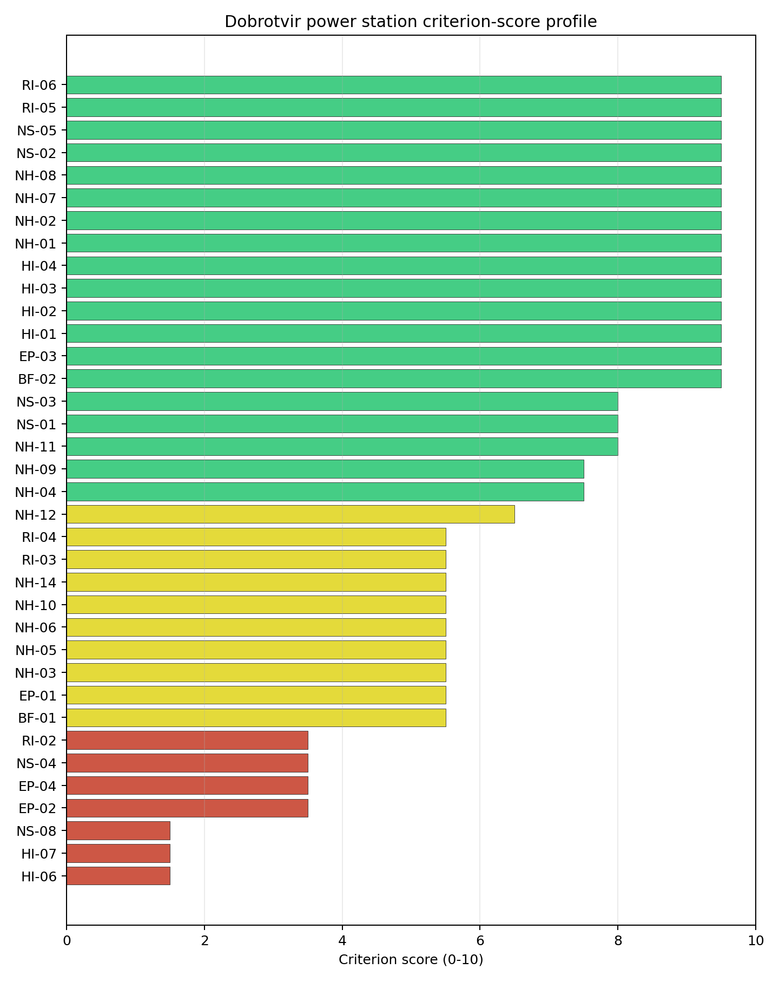
Criterion scores
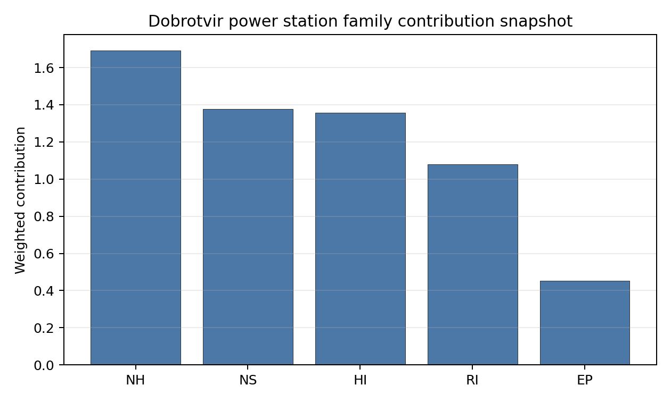
Family contributions
Dobrotvir power station ranks 2 nationally with a baseline composite score of 7.372 and a Monte Carlo bracket of 6.533-8.006. Its national stability band is B, with a national top-10% hit rate of 100%. This is a robust national screening position within the Ukrainian desk-study pool. The result should sequence evidence collection, not construction readiness: the Ukraine conflict and territorial-access caveat prevents treatment of any Ukrainian site as a practical near-term Stage 3 candidate in this report pass.

Residual Risk Register
Concern | Evidence | Consequence | Stage 3 action | Owner discipline
Conflict and territorial access | Current war conditions affect access, security, infrastructure-condition evidence and emergency-planning currency. | Near-term progression cannot be supported from desk-study data alone. | Defer progression decision until stable access, regulator engagement and updated territorial-control evidence are available. | programme
Military Installations (HI-06) | Native score 1.5/10; confidence medium. | Could alter the screening class, design basis or mitigation burden if confirmed in field evidence. | Re-measure Military Installations with site-specific post-war data before Stage 3 scoping. | security
Electromagnetic Interference (HI-07) | Native score 1.5/10; confidence medium. | Could alter the screening class, design basis or mitigation burden if confirmed in field evidence. | Re-measure Electromagnetic Interference with site-specific post-war data before Stage 3 scoping. | security
Ecological Sensitivity (NS-08) | Native score 1.5/10; confidence insufficient. | Could alter the screening class, design basis or mitigation burden if confirmed in field evidence. | Re-measure Ecological Sensitivity with site-specific post-war data before Stage 3 scoping. | site engineering / environment
Evacuation Routes (EP-02) | Native score 3.5/10; confidence medium. | Could alter the screening class, design basis or mitigation burden if confirmed in field evidence. | Re-measure Evacuation Routes with site-specific post-war data before Stage 3 scoping. | emergency planning
Special Populations (EP-04) | Native score 3.5/10; confidence medium. | Could alter the screening class, design basis or mitigation burden if confirmed in field evidence. | Re-measure Special Populations with site-specific post-war data before Stage 3 scoping. | emergency planning
This register is a post-war evidence plan for Dobrotvir power station. It is not a finding of site approval or a recommendation to start Stage 3 work under current conditions.

Stage 3 Follow-Up Checklist
- Re-measure Military Installations (HI-06) - native score 1.5/10 with confidence medium.
- Re-measure Electromagnetic Interference (HI-07) - native score 1.5/10 with confidence medium.
- Re-measure Ecological Sensitivity (NS-08) - native score 1.5/10 with confidence low.
- Re-measure Evacuation Routes (EP-02) - native score 3.5/10 with confidence medium.
- Re-measure Special Populations (EP-04) - native score 3.5/10 with confidence medium.

Evidence Limitations
- No criterion-family quality fields are flagged as low or missing in this bundle.

Kryvorizka power station Site Profile
Kryvorizka power station is a Ukrainian coal/thermal site tested against the NuScale VOYGR-6 reference deployment envelope. This profile summarises Stage 1-2 desk-study evidence for post-war review. It is not a site-suitability determination, vendor recommendation, licensing finding, or near-term progression recommendation.
Ukraine conflict and territorial-access caveat. Current war conditions, security constraints, infrastructure-condition uncertainty, regulator access, emergency-planning continuity and data currency prevent this site from being treated as a practical near-term Stage 3 candidate. The profile does not make a legal or conflict-status determination for the site; it identifies what would need to be verified after stable access is available.

Site Snapshot
Field | Value
Site name | Kryvorizka power station
Coordinates | 47.5432, 33.6595
Subnational unit | Dnipropetrovsk
Installed thermal capacity (source data) | 2,925 MW
Available surface area | 456.0 ha
Available surface area for development | 133.9 ha
Composite score (baseline weights) | 7.166 (6.051-7.655 MC band)
National stability band | D (top-10% hit rate 0%)
National rank | 4
See the country status map in Ukraine Country Profile.

Ownership and Coal-to-Nuclear Context
Ownership records identify DTEK Dniproenergo JSC [100%] as the immediate owner or operator recorded for Kryvorizka power station. The parentage evidence includes DTEK Group BV, DTEK Energy Holdings BV, DTEK Energy BV, GPL Power Ltd. Several upstream share fields remain incomplete, so this profile reports the ownership chain as screening evidence only and does not infer land control, project rights, public acceptance, or procurement feasibility.
Generating units on record: 7 mothballed, 3 retired. Earliest unit commissioning: 1963; most recent: 1972. The brownfield value is the inherited grid, cooling, transport and industrial-land context; under the Ukraine caveat, every asset-condition claim requires post-war physical verification before Stage 3 work can be scoped.

Natural Hazards (NH)
- Seismic: Ground Motion (NH-01) - score no native score (unscored - no band matched), weight 0.0455, data quality medium. Evidence: PGA at 475-year return period 0.01 g; Vs30 reference (m/s): 760.0.
- Seismic: Surface Rupture (NH-02) - score 9.5/10 (MC 9.0-10.0) - favourable: Very strong separation from mapped capable faults; surface-rupture concern effectively screened at desk-study level., weight n/a, data quality screening grade. Evidence: nearest mapped capable fault 50.0 km; fault slip rate 0 mm/yr; fault name: none_in_search_radius.
- Geotechnical: Liquefaction (NH-03) - score 5.5/10 (MC 5.0-6.0) - pass-mark band: Moderate susceptibility, or high/very-high with documented (or pending for high) mitigation., weight n/a, data quality medium. Evidence: liquefaction susceptibility: moderate.
- Geotechnical: Slope Stability (NH-04) - score 9.5/10 (MC 9.0-10.0) - favourable: Well below the risk boundary., weight n/a, data quality screening grade. Evidence: site slope 3.36 deg; max slope in 1 km box 77.5 deg; slope stability class: gentle.
- Geotechnical: Subsidence (NH-05) - score 5.5/10 (MC 5.0-6.0) - pass-mark band: At or above the mine-distance score-5 pivot; review possible., weight 0.0354, data quality medium. Evidence: karst present: no; karst severity: moderate; formation type: carbonate (Discontinuous carbonate rocks).
- Geotechnical: Foundation (NH-06) - score 3.5/10 (MC 3.0-4.0), weight 0.0253, data quality medium. Evidence: depth to bedrock 27.4 m.
- Volcanism (NH-07) - score 9.5/10 (MC 9.0-10.0) - favourable: Very strong margin above the score-5 boundary (or no in-radius signal is recorded)., weight n/a, data quality high. Evidence: volcanic hazard class: negligible.
- Coastal Flooding (NH-08) - score 9.5/10 (MC 9.0-10.0) - favourable: Non-coastal OR elevation >= 50 m AMSL OR landlocked country, with no positive marine-hazard signal., weight 0.0303, data quality medium. Evidence: distance to coast 131.8 km.
- River Flooding (NH-09) - score 7.5/10 (MC 7.0-8.0), weight 0.0404, data quality medium. Evidence: flood zone class: negligible.
- Extreme Winds (NH-10) - score 7.5/10 (MC 7.0-8.0), weight 0.0152, data quality medium. Evidence: screening wind-speed index 8.31 m/s.
- Extreme Precipitation (NH-11) - score 10.0/10 (MC 9.0-10.0) - favourable: aggregated(mean_of_sub_scores), weight 0.0152, data quality medium. Evidence: screening extreme-precipitation index 0.13 mm; screening precipitation index 16.6 mm/yr.
- Extreme Temperatures (NH-12) - score 4.5/10 (MC 4.0-5.0) - pass-mark band: aggregated(mean_of_sub_scores), weight 0.0202, data quality medium. Evidence: extreme high temperature 26.6 deg C; extreme low temperature -8.51 deg C.
- Combined Hazards (NH-14) - score 7.5/10 (MC 7.0-8.0), weight 0.0152, data quality n/a. Evidence: values not in measurement tables.

Interpretation - Natural Hazards (NH)
Natural hazards at Kryvorizka power station are acceptable for desk-study screening, but they are not a substitute for field characterisation. The main natural-hazard follow-up items are Geotechnical: Foundation (NH-06) at 3.5/10, Extreme Temperatures (NH-12) at 4.5/10, Seismic: Ground Motion (NH-01) at 5.0/10. Post-war Stage 3 review should confirm seismic inputs, site geotechnics, flood and drainage assumptions, and design meteorology from measured Ukrainian records and site access surveys.

Human-Induced and Security-Relevant Hazards (HI)
- Aircraft Crash (HI-01) - score 9.5/10 (MC 9.0-10.0) - favourable: Only small / GA / heliport airport >= 10 km nearby, no flight-path proxy < 4 km, no major airport within 30 km, and no military airbase within 60 km., weight 0.0354, data quality high. Evidence: nearest airport 14.6 km; nearest flight path 7.28 km; airports within search radius 1; airport name: Apostolove Airfield; airport type: small airfield.
- Industrial Explosions (HI-02) - score 9.5/10 (MC 9.0-10.0) - favourable: Very strong margin above the score-5 boundary (or completed search confirmed no in-radius signal)., weight 0.0354, data quality screening grade. Evidence: values not in measurement tables.
- Toxic/Gas Releases (HI-03) - score 9.5/10 (MC 9.0-10.0) - favourable: Very strong margin above the score-5 boundary (or completed search confirmed no in-radius signal)., weight 0.0354, data quality screening grade. Evidence: values not in measurement tables.
- External Fires (HI-04) - score 9.5/10 (MC 9.0-10.0) - favourable: > 15 km, or completed flammable-storage search found nothing in radius., weight 0.0303, data quality screening grade. Evidence: values not in measurement tables.
- Military Installations (HI-06) - score no native score (unscored - no band matched), weight 0.0303, data quality screening grade. Evidence: military installations within radius 0.
- Electromagnetic Interference (HI-07) - score 1.5/10 (MC 1.0-2.0), weight 0.0101, data quality medium. Evidence: nearest high-power transmitter 0.55 km; transmitters within radius 35; transmitter type: tower.

Interpretation - Human-Induced and Security-Relevant Hazards (HI)
Human-induced and security-relevant hazards at Kryvorizka power station require conservative treatment because the source evidence is a desk-study snapshot. The nearest airport proxy is 14.6 km away. The limiting screening items are Electromagnetic Interference (HI-07) at 1.5/10, Military Installations (HI-06) at 5.0/10, Aircraft Crash (HI-01) at 9.5/10. The post-war work package should refresh airspace, military, hazardous-neighbour, transport-hazard and electromagnetic-interference evidence with competent Ukrainian authorities.

Radiological Impact and Emergency Planning (RI / EP)
- Emergency Planning Feasibility (EP-01) - score 5.5/10 (MC 5.0-6.0) - pass-mark band: At or above the composite score-5 boundary., weight n/a, data quality high. Evidence: EP feasibility composite 59.1 /100; road sub-score 26.5 /100; special-population sub-score 90.0 /100; geography sub-score 95.0 /100; population sub-score 80.0 /100; evacuation feasible: yes.
- Evacuation Routes (EP-02) - score 1.5/10 (MC 1.0-2.0), weight 0.0303, data quality medium. Evidence: road density in EPZ 0.265 km/km2; road length in EPZ 520.8 km; motorway access: no.
- Physical Geography Constraints (EP-03) - score 9.5/10 (MC 9.0-10.0) - favourable: No measured relief; open river/waterway context (interim screening)., weight 0.0253, data quality medium. Evidence: waterways crossing EPZ 0; major river barrier: no.
- Special Populations (EP-04) - score 5.5/10 (MC 5.0-6.0) - pass-mark band: 9-25., weight 0.0303, data quality medium. Evidence: hospitals in EPZ 23; prisons in EPZ 0; care homes in EPZ 0.
- Atmospheric Dispersion (RI-01) - score no native score (unscored - no band matched), weight 0.0303, data quality medium. Evidence: annual mean wind speed 1.25 m/s; atmospheric mixing height 587.2 m; prevailing wind direction: NE.
- Surface Water Dispersion (RI-02) - score 1.5/10 (MC 1.0-2.0), weight 0.0253, data quality n/a. Evidence: values not in measurement tables.
- Groundwater Dispersion (RI-03) - score 5.5/10 (MC 5.0-6.0) - pass-mark band: Moderate-permeability aquifer screening proxy., weight 0.0253, data quality medium. Evidence: aquifer type: inland water.
- Population Density at EPZ Radii (RI-04) - score 5.5/10 (MC 5.0-6.0) - pass-mark band: aggregated(min_of_sub_scores), weight 0.0404, data quality screening grade. Evidence: population density within 5 km 111.9 /km2; population density within 16 km 49.6 /km2; population density within 25 km 35.7 /km2; population density within 80 km 61.8 /km2; population within 25 km 70,083 people.
- Distance to Population Centres (RI-05) - score 9.5/10 (MC 9.0-10.0) - favourable: No >=50k population-centre proxy within screening envelope., weight 0.0505, data quality screening grade. Evidence: values not in measurement tables.
- Population Projections (RI-06) - score 9.5/10 (MC 9.0-10.0) - favourable: Declining (< -0.5 %/yr)., weight 0.0253, data quality screening grade. Evidence: annual population growth rate -1.562 %/yr; projected population at 25 km in 60 yr 41,960 people.

Interpretation - Radiological Impact and Emergency Planning (RI / EP)
Radiological impact and emergency-planning evidence at Kryvorizka power station supports comparison within Ukraine, not near-term implementation. Evacuation-route density is 0.265 km/km2 inside the emergency-planning zone, making road-network confirmation an early post-war task. The main RI/EP constraints are Evacuation Routes (EP-02) at 1.5/10, Surface Water Dispersion (RI-02) at 1.5/10, Atmospheric Dispersion (RI-01) at 5.0/10, Emergency Planning Feasibility (EP-01) at 5.5/10. Stage 3 should therefore begin with updated population, special-population, evacuation, hydrology and meteorological dispersion studies, all under stable access and regulator engagement.

Non-Safety and Implementation Considerations (NS)
- Grid Capacity Basic Filter (BF-01) - score 5.5/10 (MC 5.0-6.0) - pass-mark band: Note: substation 15-30 km OR 110-219 kV; reinforcement plausible., weight n/a, data quality n/a. Evidence: values not in measurement tables.
- Land Area Basic Filter (BF-02) - score 9.5/10 (MC 9.0-10.0) - favourable: Contiguous and buildable >= ideal area (70 ha/module)., weight 0.0253, data quality n/a. Evidence: values not in measurement tables.
- Cooling Water Availability (NS-01) - score 7.0/10 (MC 6.0-7.0), weight 0.0404, data quality screening grade. Evidence: distance to cooling source 2.78 km; cooling source flow 0.54 m3/s; cooling source type: small_river; cooling source name: HYRIV-20439786; water stress label: Low.
- Grid Connection (NS-02) - score 5.5/10 (MC 5.0-6.0) - pass-mark band: aggregated(min_of_sub_scores), weight 0.0404, data quality high. Evidence: nearest substation 0.44 km; nearest high-voltage line 0.3 km; highest nearby line voltage 150.0 kV; grid export capacity 2,925 MW; substations within radius 293; HV lines within radius 728.
- Transport Access (NS-03) - score 8.0/10 (MC 8.0-9.0) - favourable: aggregated(weighted_mean_of_sub_scores), weight 0.0404, data quality high. Evidence: nearest highway 9.17 km; nearest rail line 0.33 km; heavy-haul capable: yes.
- Site Topography (NS-04) - score 3.5/10 (MC 3.0-4.0), weight 0.0303, data quality screening grade. Evidence: favourable land cover 35.7 %; moderate land cover 6 %; unfavourable land cover 58.3 %; favourable area 48.2 ha; dominant land class: 512.
- Site Footprint Adequacy (NS-05) - score 9.5/10 (MC 9.0-10.0) - favourable: Very strong margin above the score-5 boundary., weight 0.0253, data quality screening grade. Evidence: buildable area 133.9 ha; largest contiguous patch 500.7 ha; buildable patch count 6.
- Existing Infrastructure (NS-06) - score no native score (unscored - no band matched), weight 0.0253, data quality n/a. Evidence: not measured at this site (criterion remains unscored).
- Ecological Sensitivity (NS-08) - score 5.5/10 (MC 3.5-7.5) - pass-mark band: Both networks NULL or >= 5 km., weight n/a, data quality insufficient. Evidence: natural land cover 58.3 %; distance to nearest protected area 9.973 km; Natura 2000 sensitivity class: unknown; protected-area overlap: no; protected-area sensitivity class: low; Natura 2000 sites within 5 km: 0; nearest protected-area designation: Emerald Network.
- Workforce Availability (NS-10) - score no native score (unscored - no band matched), weight 0.0202, data quality n/a. Evidence: not measured at this site (criterion remains unscored).
- Regulatory/Political Environment (NS-12) - score no native score (unscored - no band matched), weight 0.0303, data quality n/a. Evidence: not measured at this site (criterion remains unscored).
- Construction Logistics (NS-13) - score no native score (unscored - no band matched), weight 0.0202, data quality n/a. Evidence: not measured at this site (criterion remains unscored).

Interpretation - Non-Safety and Implementation Considerations (NS)
Non-safety and implementation factors are the main reason Kryvorizka power station remains in the Ukraine top-five desk-study set. The canonical site surface area is 456.0 ha, and the current area for development is 133.9 ha; these figures do not prove land availability, contiguity, permitting or control. Grid screening is favourable on proximity: nearest substation 0.44 km, nearest high-voltage line 0.30 km, grid export-capacity proxy 2925 MW. The limiting non-safety items are Site Topography (NS-04) at 3.5/10, Existing Infrastructure (NS-06) at 5.0/10, Workforce Availability (NS-10) at 5.0/10, Regulatory/Political Environment (NS-12) at 5.0/10. Post-war review should verify switchyard condition, transmission voltage path, cooling-water availability, ecological constraints, land title, construction logistics and workforce evidence before any progression decision.

Composite Score and Stability
Baseline composite score is 7.166, bracketed by Monte Carlo at 6.051-7.655. National stability band is D with a top-10% hit rate of 0% across 12 scored Monte Carlo scenarios.
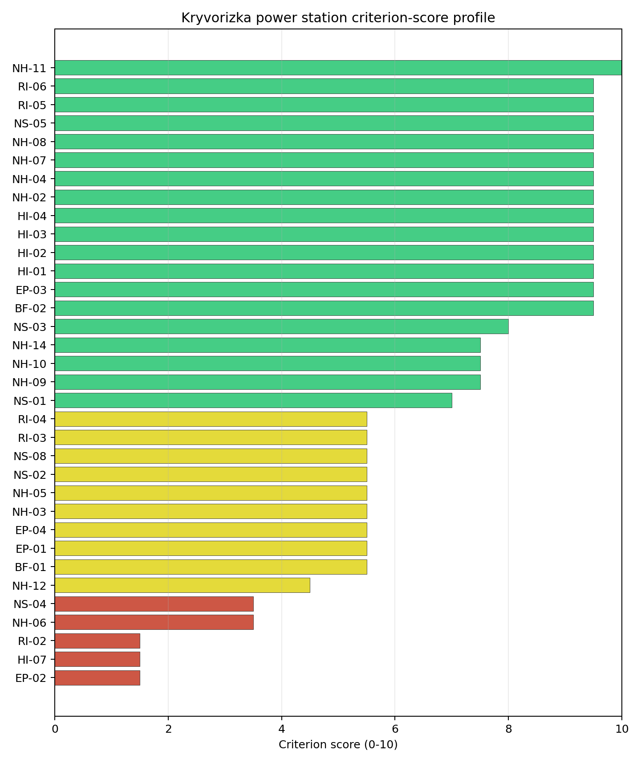
Criterion scores
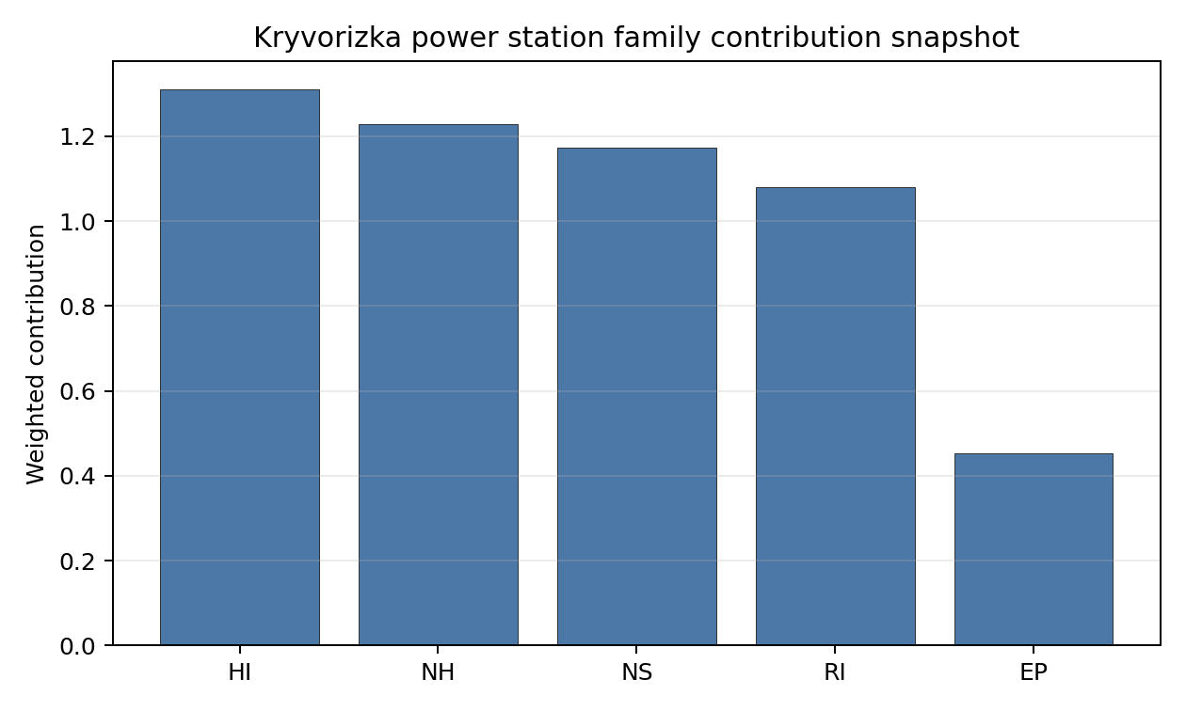
Family contributions
Kryvorizka power station ranks 4 nationally with a baseline composite score of 7.166 and a Monte Carlo bracket of 6.051-7.655. Its national stability band is D, with a national top-10% hit rate of 0%. This is a useful but weight-sensitive national screening position within the Ukrainian desk-study pool. The result should sequence evidence collection, not construction readiness: the Ukraine conflict and territorial-access caveat prevents treatment of any Ukrainian site as a practical near-term Stage 3 candidate in this report pass.

Residual Risk Register
Concern | Evidence | Consequence | Stage 3 action | Owner discipline
Conflict and territorial access | Current war conditions affect access, security, infrastructure-condition evidence and emergency-planning currency. | Near-term progression cannot be supported from desk-study data alone. | Defer progression decision until stable access, regulator engagement and updated territorial-control evidence are available. | programme
Evacuation Routes (EP-02) | Native score 1.5/10; confidence medium. | Could alter the screening class, design basis or mitigation burden if confirmed in field evidence. | Re-measure Evacuation Routes with site-specific post-war data before Stage 3 scoping. | emergency planning
Electromagnetic Interference (HI-07) | Native score 1.5/10; confidence medium. | Could alter the screening class, design basis or mitigation burden if confirmed in field evidence. | Re-measure Electromagnetic Interference with site-specific post-war data before Stage 3 scoping. | security
Surface Water Dispersion (RI-02) | Native score 1.5/10; confidence low. | Could alter the screening class, design basis or mitigation burden if confirmed in field evidence. | Re-measure Surface Water Dispersion with site-specific post-war data before Stage 3 scoping. | radiological / hydrology
Geotechnical: Foundation (NH-06) | Native score 3.5/10; confidence medium. | Could alter the screening class, design basis or mitigation burden if confirmed in field evidence. | Re-measure Geotechnical: Foundation with site-specific post-war data before Stage 3 scoping. | geotechnical / hazards
Site Topography (NS-04) | Native score 3.5/10; confidence low. | Could alter the screening class, design basis or mitigation burden if confirmed in field evidence. | Re-measure Site Topography with site-specific post-war data before Stage 3 scoping. | site engineering / environment
This register is a post-war evidence plan for Kryvorizka power station. It is not a finding of site approval or a recommendation to start Stage 3 work under current conditions.

Stage 3 Follow-Up Checklist
- Re-measure Evacuation Routes (EP-02) - native score 1.5/10 with confidence medium.
- Re-measure Electromagnetic Interference (HI-07) - native score 1.5/10 with confidence medium.
- Re-measure Surface Water Dispersion (RI-02) - native score 1.5/10 with confidence insufficient.
- Re-measure Geotechnical: Foundation (NH-06) - native score 3.5/10 with confidence medium.
- Re-measure Site Topography (NS-04) - native score 3.5/10 with confidence medium.

Evidence Limitations
- No criterion-family quality fields are flagged as low or missing in this bundle.

Ladyzhyn power station Site Profile
Ladyzhyn power station is a Ukrainian coal/thermal site tested against the NuScale VOYGR-6 reference deployment envelope. This profile summarises Stage 1-2 desk-study evidence for post-war review. It is not a site-suitability determination, vendor recommendation, licensing finding, or near-term progression recommendation.
Ukraine conflict and territorial-access caveat. Current war conditions, security constraints, infrastructure-condition uncertainty, regulator access, emergency-planning continuity and data currency prevent this site from being treated as a practical near-term Stage 3 candidate. The profile does not make a legal or conflict-status determination for the site; it identifies what would need to be verified after stable access is available.

Site Snapshot
Field | Value
Site name | Ladyzhyn power station
Coordinates | 48.7058, 29.2187
Subnational unit | Vinnytsia
Installed thermal capacity (source data) | 1,800 MW
Available surface area | 162.0 ha
Available surface area for development | 95.5 ha
Composite score (baseline weights) | 7.197 (6.391-7.706 MC band)
National stability band | D (top-10% hit rate 8%)
National rank | 3
See the country status map in Ukraine Country Profile.

Ownership and Coal-to-Nuclear Context
Ownership records identify DTEK Westenergy JSC [100%] as the immediate owner or operator recorded for Ladyzhyn power station. The parentage evidence includes DTEK Group BV, DTEK Energy Holdings BV, DTEK Energy BV, natural person(s). Several upstream share fields remain incomplete, so this profile reports the ownership chain as screening evidence only and does not infer land control, project rights, public acceptance, or procurement feasibility.
Generating units on record: 6 mothballed. Earliest unit commissioning: 1970; most recent: 1971. The brownfield value is the inherited grid, cooling, transport and industrial-land context; under the Ukraine caveat, every asset-condition claim requires post-war physical verification before Stage 3 work can be scoped.

Natural Hazards (NH)
- Seismic: Ground Motion (NH-01) - score 9.5/10 (MC 9.0-10.0) - favourable: Well below the risk boundary., weight 0.0455, data quality high. Evidence: PGA at 475-year return period 0.019 g; PGA at 2,475-year return period 0.065 g; Vs30 reference (m/s): 760.0.
- Seismic: Surface Rupture (NH-02) - score 9.5/10 (MC 9.0-10.0) - favourable: Very strong separation from mapped capable faults; surface-rupture concern effectively screened at desk-study level., weight n/a, data quality screening grade. Evidence: nearest mapped capable fault 50.0 km; fault slip rate 0 mm/yr; fault name: none_in_search_radius.
- Geotechnical: Liquefaction (NH-03) - score 9.5/10 (MC 9.0-10.0) - favourable: Negligible susceptibility (Stage-1 favourable default)., weight n/a, data quality medium. Evidence: liquefaction susceptibility: very_low; dominant soil type: silty_clay_loam.
- Geotechnical: Slope Stability (NH-04) - score 7.5/10 (MC 7.0-8.0), weight n/a, data quality screening grade. Evidence: site slope 8.59 deg; max slope in 1 km box 84.2 deg; slope stability class: moderate.
- Geotechnical: Subsidence (NH-05) - score 5.5/10 (MC 5.0-6.0) - pass-mark band: At or above the mine-distance score-5 pivot; review possible., weight 0.0354, data quality medium. Evidence: karst present: no; karst severity: none.
- Geotechnical: Foundation (NH-06) - score 5.5/10 (MC 5.0-6.0) - pass-mark band: Typical European mixed conditions (bearing 80-150 kPa)., weight 0.0253, data quality medium. Evidence: bearing capacity 84.0 kPa; depth to bedrock 28.3 m.
- Volcanism (NH-07) - score 9.5/10 (MC 9.0-10.0) - favourable: Very strong margin above the score-5 boundary (or no in-radius signal is recorded)., weight n/a, data quality high. Evidence: volcanic hazard class: negligible.
- Coastal Flooding (NH-08) - score 9.5/10 (MC 9.0-10.0) - favourable: Non-coastal OR elevation >= 50 m AMSL OR landlocked country, with no positive marine-hazard signal., weight 0.0303, data quality medium. Evidence: distance to coast 252.1 km.
- River Flooding (NH-09) - score 7.5/10 (MC 7.0-8.0), weight 0.0404, data quality medium. Evidence: flood zone class: negligible.
- Extreme Winds (NH-10) - score 7.5/10 (MC 7.0-8.0), weight 0.0152, data quality medium. Evidence: screening wind-speed index 8.44 m/s.
- Extreme Precipitation (NH-11) - score 8.0/10 (MC 8.0-9.0) - favourable: aggregated(mean_of_sub_scores), weight 0.0152, data quality medium. Evidence: screening extreme-precipitation index 0.21 mm; screening precipitation index 20.5 mm/yr.
- Extreme Temperatures (NH-12) - score 5.5/10 (MC 5.0-6.0) - pass-mark band: aggregated(mean_of_sub_scores), weight 0.0202, data quality medium. Evidence: extreme high temperature 23.7 deg C; extreme low temperature -9.66 deg C.
- Combined Hazards (NH-14) - score 9.5/10 (MC 9.0-10.0) - favourable: At least 5 underlying NH criteria resolved, all >= 7; no interaction pair below 7., weight 0.0152, data quality n/a. Evidence: values not in measurement tables.

Interpretation - Natural Hazards (NH)
Natural hazards at Ladyzhyn power station are acceptable for desk-study screening, but they are not a substitute for field characterisation. Foundation screening remains material because the bundle records bearing capacity at 84.0 kPa. The main natural-hazard follow-up items are Geotechnical: Subsidence (NH-05) at 5.5/10, Geotechnical: Foundation (NH-06) at 5.5/10, Extreme Temperatures (NH-12) at 5.5/10. Post-war Stage 3 review should confirm seismic inputs, site geotechnics, flood and drainage assumptions, and design meteorology from measured Ukrainian records and site access surveys.

Human-Induced and Security-Relevant Hazards (HI)
- Aircraft Crash (HI-01) - score 9.5/10 (MC 9.0-10.0) - favourable: Only small / GA / heliport airport >= 10 km nearby, no flight-path proxy < 4 km, no major airport within 30 km, and no military airbase within 60 km., weight 0.0354, data quality high. Evidence: nearest airport 15.8 km; nearest flight path 7.91 km; airports within search radius 1; airport name: Haisyn Airfield; airport type: small airfield.
- Industrial Explosions (HI-02) - score 9.5/10 (MC 9.0-10.0) - favourable: Very strong margin above the score-5 boundary (or completed search confirmed no in-radius signal)., weight 0.0354, data quality screening grade. Evidence: values not in measurement tables.
- Toxic/Gas Releases (HI-03) - score 9.5/10 (MC 9.0-10.0) - favourable: Very strong margin above the score-5 boundary (or completed search confirmed no in-radius signal)., weight 0.0354, data quality screening grade. Evidence: values not in measurement tables.
- External Fires (HI-04) - score 9.5/10 (MC 9.0-10.0) - favourable: > 15 km, or completed flammable-storage search found nothing in radius., weight 0.0303, data quality screening grade. Evidence: values not in measurement tables.
- Military Installations (HI-06) - score 1.5/10 (MC 1.0-2.0), weight 0.0303, data quality medium. Evidence: nearest military installation 10.6 km; military installations within radius 2; installation name: unnamed.
- Electromagnetic Interference (HI-07) - score 1.5/10 (MC 1.0-2.0), weight 0.0101, data quality medium. Evidence: nearest high-power transmitter 0.67 km; transmitters within radius 140; transmitter type: mast.

Interpretation - Human-Induced and Security-Relevant Hazards (HI)
Human-induced and security-relevant hazards at Ladyzhyn power station require conservative treatment because the source evidence is a desk-study snapshot. The nearest airport proxy is 15.8 km away. The nearest recorded military-installation proxy is 10.6 km away, but the current security context means the cadastre must be refreshed before any siting decision relies on it. The limiting screening items are Military Installations (HI-06) at 1.5/10, Electromagnetic Interference (HI-07) at 1.5/10, Aircraft Crash (HI-01) at 9.5/10. The post-war work package should refresh airspace, military, hazardous-neighbour, transport-hazard and electromagnetic-interference evidence with competent Ukrainian authorities.

Radiological Impact and Emergency Planning (RI / EP)
- Emergency Planning Feasibility (EP-01) - score 5.5/10 (MC 5.0-6.0) - pass-mark band: At or above the composite score-5 boundary., weight n/a, data quality high. Evidence: EP feasibility composite 63.4 /100; road sub-score 43.5 /100; special-population sub-score 90.0 /100; geography sub-score 95.0 /100; population sub-score 80.0 /100; evacuation feasible: yes.
- Evacuation Routes (EP-02) - score 3.5/10 (MC 3.0-4.0), weight 0.0303, data quality medium. Evidence: road density in EPZ 0.359 km/km2; road length in EPZ 704.7 km; motorway access: yes.
- Physical Geography Constraints (EP-03) - score 9.5/10 (MC 9.0-10.0) - favourable: No measured relief; open river/waterway context (interim screening)., weight 0.0253, data quality medium. Evidence: waterways crossing EPZ 0; major river barrier: no.
- Special Populations (EP-04) - score 5.5/10 (MC 5.0-6.0) - pass-mark band: 9-25., weight 0.0303, data quality medium. Evidence: hospitals in EPZ 18; prisons in EPZ 1; care homes in EPZ 0.
- Atmospheric Dispersion (RI-01) - score no native score (unscored - no band matched), weight 0.0303, data quality medium. Evidence: annual mean wind speed 1.06 m/s; atmospheric mixing height 597.8 m; prevailing wind direction: WNW.
- Surface Water Dispersion (RI-02) - score 5.5/10 (MC 5.0-6.0) - pass-mark band: 30-100 m3/s., weight 0.0253, data quality n/a. Evidence: values not in measurement tables.
- Groundwater Dispersion (RI-03) - score 7.5/10 (MC 7.0-8.0), weight 0.0253, data quality medium. Evidence: aquifer type: low permeability.
- Population Density at EPZ Radii (RI-04) - score 5.5/10 (MC 5.0-6.0) - pass-mark band: aggregated(min_of_sub_scores), weight 0.0404, data quality screening grade. Evidence: population density within 5 km 175.8 /km2; population density within 16 km 50.9 /km2; population density within 25 km 65.4 /km2; population density within 80 km 54.0 /km2; population within 25 km 128,347 people.
- Distance to Population Centres (RI-05) - score 9.5/10 (MC 9.0-10.0) - favourable: No >=50k population-centre proxy within screening envelope., weight 0.0505, data quality screening grade. Evidence: values not in measurement tables.
- Population Projections (RI-06) - score 9.5/10 (MC 9.0-10.0) - favourable: Declining (< -0.5 %/yr)., weight 0.0253, data quality screening grade. Evidence: annual population growth rate -1.605 %/yr; projected population at 25 km in 60 yr 76,833 people.

Interpretation - Radiological Impact and Emergency Planning (RI / EP)
Radiological impact and emergency-planning evidence at Ladyzhyn power station supports comparison within Ukraine, not near-term implementation. Evacuation-route density is 0.359 km/km2 inside the emergency-planning zone, making road-network confirmation an early post-war task. The main RI/EP constraints are Evacuation Routes (EP-02) at 3.5/10, Atmospheric Dispersion (RI-01) at 5.0/10, Emergency Planning Feasibility (EP-01) at 5.5/10, Special Populations (EP-04) at 5.5/10. Stage 3 should therefore begin with updated population, special-population, evacuation, hydrology and meteorological dispersion studies, all under stable access and regulator engagement.

Non-Safety and Implementation Considerations (NS)
- Grid Capacity Basic Filter (BF-01) - score 5.5/10 (MC 5.0-6.0) - pass-mark band: Note: substation 15-30 km OR 110-219 kV; reinforcement plausible., weight n/a, data quality n/a. Evidence: values not in measurement tables.
- Land Area Basic Filter (BF-02) - score 9.5/10 (MC 9.0-10.0) - favourable: Contiguous and buildable >= ideal area (70 ha/module)., weight 0.0253, data quality n/a. Evidence: values not in measurement tables.
- Cooling Water Availability (NS-01) - score 7.0/10 (MC 6.0-7.0), weight 0.0404, data quality screening grade. Evidence: distance to cooling source 0.87 km; cooling source flow 44.5 m3/s; cooling source type: river; cooling source name: Southern Bug; water stress label: Medium-High.
- Grid Connection (NS-02) - score 5.5/10 (MC 5.0-6.0) - pass-mark band: aggregated(min_of_sub_scores), weight 0.0404, data quality high. Evidence: nearest substation 0.74 km; nearest high-voltage line 0.32 km; highest nearby line voltage 110.0 kV; grid export capacity 1,800 MW; substations within radius 85; HV lines within radius 212.
- Transport Access (NS-03) - score 8.0/10 (MC 8.0-9.0) - favourable: aggregated(weighted_mean_of_sub_scores), weight 0.0404, data quality high. Evidence: nearest highway 4.28 km; nearest rail line 0.28 km; nearest waterway 1.27 km; heavy-haul capable: yes.
- Site Topography (NS-04) - score 1.5/10 (MC 1.0-2.0), weight 0.0303, data quality screening grade. Evidence: favourable land cover 19.7 %; moderate land cover 5.5 %; unfavourable land cover 74.8 %; favourable area 19.1 ha; dominant land class: 311.
- Site Footprint Adequacy (NS-05) - score 9.5/10 (MC 9.0-10.0) - favourable: Very strong margin above the score-5 boundary., weight 0.0253, data quality screening grade. Evidence: buildable area 95.5 ha; largest contiguous patch 130.0 ha; buildable patch count 23.
- Existing Infrastructure (NS-06) - score no native score (unscored - no band matched), weight 0.0253, data quality n/a. Evidence: not measured at this site (criterion remains unscored).
- Ecological Sensitivity (NS-08) - score 1.5/10 (MC 0.0-3.5), weight n/a, data quality insufficient. Evidence: natural land cover 74.8 %; distance to nearest protected area 0.36 km; Natura 2000 sensitivity class: unknown; protected-area overlap: no; protected-area sensitivity class: high; Natura 2000 sites within 5 km: 0; nearest protected-area designation: Emerald Network.
- Workforce Availability (NS-10) - score no native score (unscored - no band matched), weight 0.0202, data quality n/a. Evidence: not measured at this site (criterion remains unscored).
- Regulatory/Political Environment (NS-12) - score no native score (unscored - no band matched), weight 0.0303, data quality n/a. Evidence: not measured at this site (criterion remains unscored).
- Construction Logistics (NS-13) - score no native score (unscored - no band matched), weight 0.0202, data quality n/a. Evidence: not measured at this site (criterion remains unscored).

Interpretation - Non-Safety and Implementation Considerations (NS)
Non-safety and implementation factors are the main reason Ladyzhyn power station remains in the Ukraine top-five desk-study set. The canonical site surface area is 162.0 ha, and the current area for development is 95.5 ha; these figures do not prove land availability, contiguity, permitting or control. Grid screening is favourable on proximity: nearest substation 0.74 km, nearest high-voltage line 0.32 km, grid export-capacity proxy 1800 MW. The limiting non-safety items are Site Topography (NS-04) at 1.5/10, Ecological Sensitivity (NS-08) at 1.5/10, Existing Infrastructure (NS-06) at 5.0/10, Workforce Availability (NS-10) at 5.0/10. Post-war review should verify switchyard condition, transmission voltage path, cooling-water availability, ecological constraints, land title, construction logistics and workforce evidence before any progression decision.

Composite Score and Stability
Baseline composite score is 7.197, bracketed by Monte Carlo at 6.391-7.706. National stability band is D with a top-10% hit rate of 8% across 12 scored Monte Carlo scenarios.
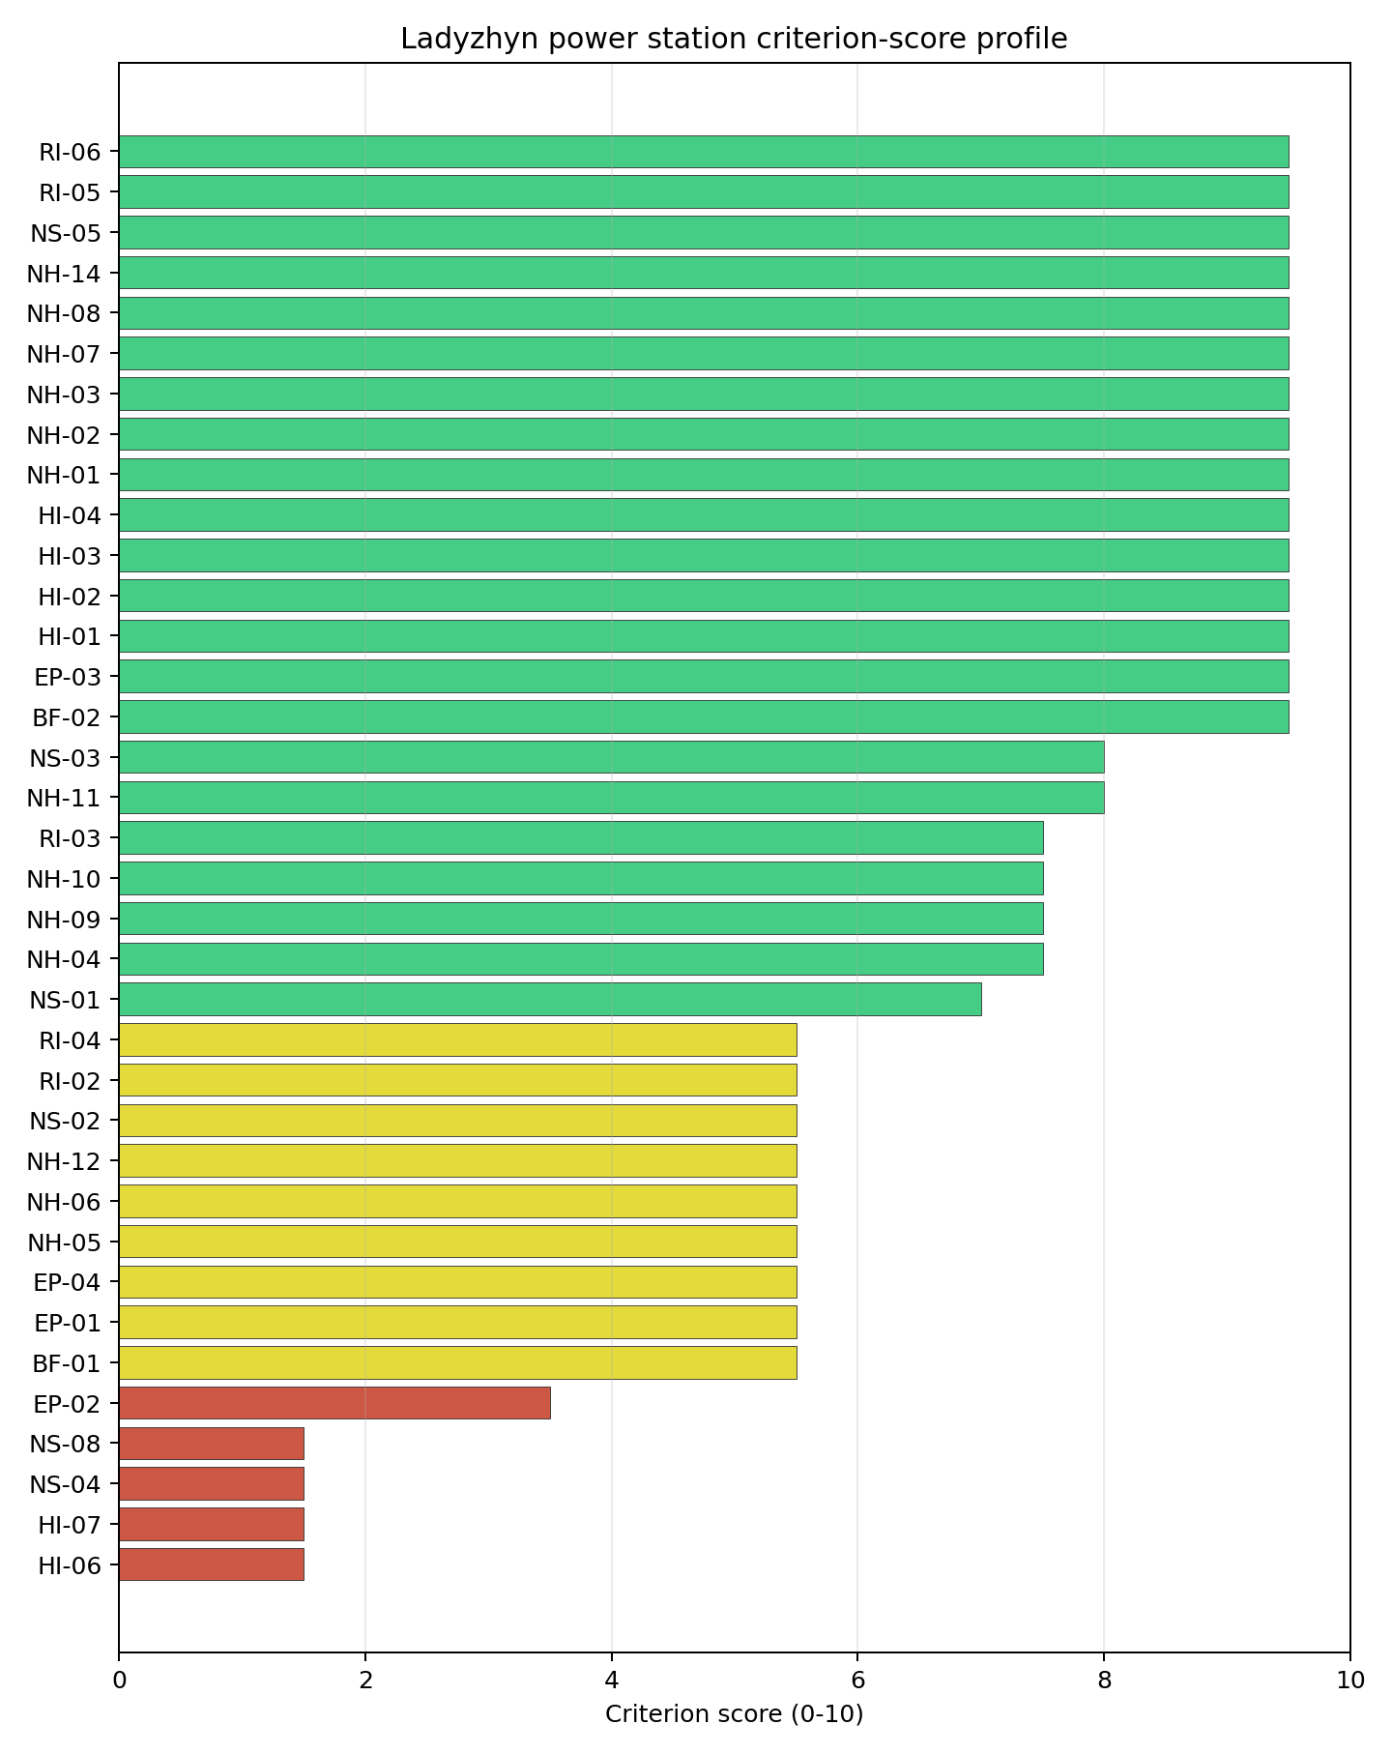
Criterion scores
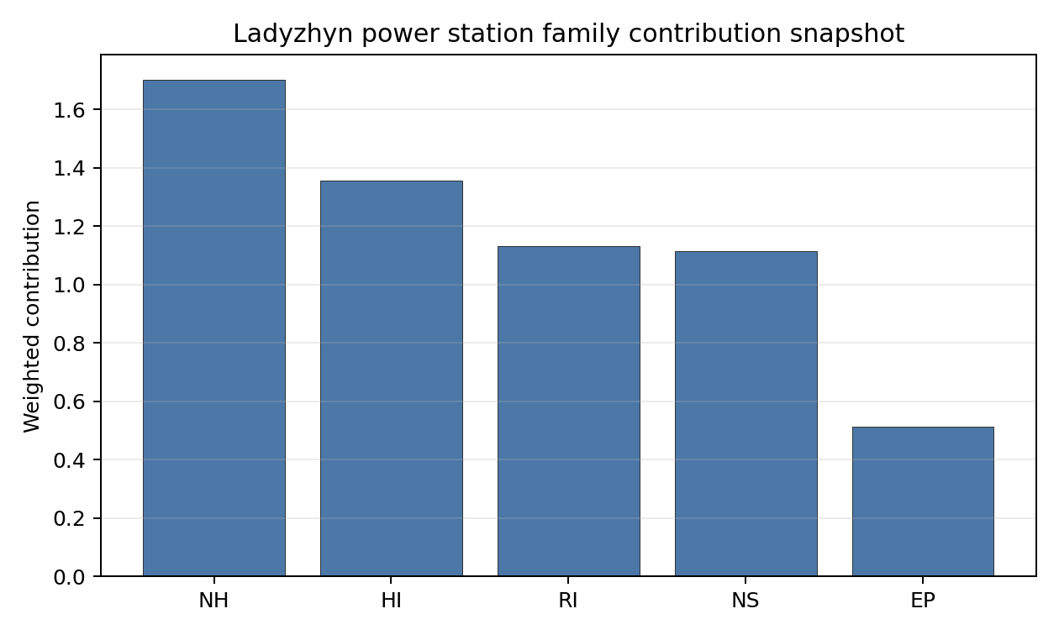
Family contributions
Ladyzhyn power station ranks 3 nationally with a baseline composite score of 7.197 and a Monte Carlo bracket of 6.391-7.706. Its national stability band is D, with a national top-10% hit rate of 8%. This is a useful but weight-sensitive national screening position within the Ukrainian desk-study pool. The result should sequence evidence collection, not construction readiness: the Ukraine conflict and territorial-access caveat prevents treatment of any Ukrainian site as a practical near-term Stage 3 candidate in this report pass.

Residual Risk Register
Concern | Evidence | Consequence | Stage 3 action | Owner discipline
Conflict and territorial access | Current war conditions affect access, security, infrastructure-condition evidence and emergency-planning currency. | Near-term progression cannot be supported from desk-study data alone. | Defer progression decision until stable access, regulator engagement and updated territorial-control evidence are available. | programme
Military Installations (HI-06) | Native score 1.5/10; confidence medium. | Could alter the screening class, design basis or mitigation burden if confirmed in field evidence. | Re-measure Military Installations with site-specific post-war data before Stage 3 scoping. | security
Electromagnetic Interference (HI-07) | Native score 1.5/10; confidence medium. | Could alter the screening class, design basis or mitigation burden if confirmed in field evidence. | Re-measure Electromagnetic Interference with site-specific post-war data before Stage 3 scoping. | security
Site Topography (NS-04) | Native score 1.5/10; confidence low. | Could alter the screening class, design basis or mitigation burden if confirmed in field evidence. | Re-measure Site Topography with site-specific post-war data before Stage 3 scoping. | site engineering / environment
Ecological Sensitivity (NS-08) | Native score 1.5/10; confidence insufficient. | Could alter the screening class, design basis or mitigation burden if confirmed in field evidence. | Re-measure Ecological Sensitivity with site-specific post-war data before Stage 3 scoping. | site engineering / environment
Evacuation Routes (EP-02) | Native score 3.5/10; confidence medium. | Could alter the screening class, design basis or mitigation burden if confirmed in field evidence. | Re-measure Evacuation Routes with site-specific post-war data before Stage 3 scoping. | emergency planning
This register is a post-war evidence plan for Ladyzhyn power station. It is not a finding of site approval or a recommendation to start Stage 3 work under current conditions.

Stage 3 Follow-Up Checklist
- Re-measure Military Installations (HI-06) - native score 1.5/10 with confidence medium.
- Re-measure Electromagnetic Interference (HI-07) - native score 1.5/10 with confidence medium.
- Re-measure Site Topography (NS-04) - native score 1.5/10 with confidence medium.
- Re-measure Ecological Sensitivity (NS-08) - native score 1.5/10 with confidence low.
- Re-measure Evacuation Routes (EP-02) - native score 3.5/10 with confidence medium.

Evidence Limitations
- No criterion-family quality fields are flagged as low or missing in this bundle.

Zmiivska power station Site Profile
Zmiivska power station is a Ukrainian coal/thermal site tested against the NuScale VOYGR-6 reference deployment envelope. This profile summarises Stage 1-2 desk-study evidence for post-war review. It is not a site-suitability determination, vendor recommendation, licensing finding, or near-term progression recommendation.
Ukraine conflict and territorial-access caveat. Current war conditions, security constraints, infrastructure-condition uncertainty, regulator access, emergency-planning continuity and data currency prevent this site from being treated as a practical near-term Stage 3 candidate. The profile does not make a legal or conflict-status determination for the site; it identifies what would need to be verified after stable access is available.

Site Snapshot
Field | Value
Site name | Zmiivska power station
Coordinates | 49.5860, 36.5239
Subnational unit | Kharkiv
Installed thermal capacity (source data) | 2,270 MW
Available surface area | 227.0 ha
Available surface area for development | 172.4 ha
Composite score (baseline weights) | 7.455 (6.263-7.945 MC band)
National stability band | A (top-10% hit rate 92%)
National rank | 1
See the country status map in Ukraine Country Profile.

Ownership and Coal-to-Nuclear Context
Ownership records identify Centrenergo PJSC as the immediate owner or operator recorded for Zmiivska power station. The parentage evidence includes Centrenergo PJSC and the State Property Fund of Ukraine, with a minority share not fully resolved. Several upstream share fields remain incomplete, so this profile reports the ownership chain as screening evidence only and does not infer land control, project rights, public acceptance, or procurement feasibility.
Generating units on record: 10 mothballed. Earliest unit commissioning: 1960; most recent: 1969. The brownfield value is the inherited grid, cooling, transport and industrial-land context; under the Ukraine caveat, every asset-condition claim requires post-war physical verification before Stage 3 work can be scoped.

Natural Hazards (NH)
- Seismic: Ground Motion (NH-01) - score no native score (unscored - no band matched), weight 0.0455, data quality medium. Evidence: PGA at 475-year return period 0 g; Vs30 reference (m/s): 760.0.
- Seismic: Surface Rupture (NH-02) - score 9.5/10 (MC 9.0-10.0) - favourable: Very strong separation from mapped capable faults; surface-rupture concern effectively screened at desk-study level., weight n/a, data quality screening grade. Evidence: nearest mapped capable fault 50.0 km; fault slip rate 0 mm/yr; fault name: none_in_search_radius.
- Geotechnical: Liquefaction (NH-03) - score 5.5/10 (MC 5.0-6.0) - pass-mark band: Moderate susceptibility, or high/very-high with documented (or pending for high) mitigation., weight n/a, data quality medium. Evidence: liquefaction susceptibility: moderate; dominant soil type: silt_loam.
- Geotechnical: Slope Stability (NH-04) - score 7.5/10 (MC 7.0-8.0), weight n/a, data quality screening grade. Evidence: site slope 6.9 deg; max slope in 1 km box 79.2 deg; slope stability class: moderate.
- Geotechnical: Subsidence (NH-05) - score 7.5/10 (MC 7.0-8.0), weight 0.0354, data quality medium. Evidence: karst present: no; karst severity: none.
- Geotechnical: Foundation (NH-06) - score 3.5/10 (MC 3.0-4.0), weight 0.0253, data quality medium. Evidence: bearing capacity 60.5 kPa; depth to bedrock 32.9 m.
- Volcanism (NH-07) - score 9.5/10 (MC 9.0-10.0) - favourable: Very strong margin above the score-5 boundary (or no in-radius signal is recorded)., weight n/a, data quality high. Evidence: volcanic hazard class: negligible.
- Coastal Flooding (NH-08) - score 9.5/10 (MC 9.0-10.0) - favourable: Non-coastal OR elevation >= 50 m AMSL OR landlocked country, with no positive marine-hazard signal., weight 0.0303, data quality medium. Evidence: distance to coast 289.3 km.
- River Flooding (NH-09) - score 7.5/10 (MC 7.0-8.0), weight 0.0404, data quality medium. Evidence: flood zone class: negligible.
- Extreme Winds (NH-10) - score 7.5/10 (MC 7.0-8.0), weight 0.0152, data quality medium. Evidence: screening wind-speed index 8.77 m/s.
- Extreme Precipitation (NH-11) - score 10.0/10 (MC 9.0-10.0) - favourable: aggregated(mean_of_sub_scores), weight 0.0152, data quality medium. Evidence: screening extreme-precipitation index 0.15 mm; screening precipitation index 19.6 mm/yr.
- Extreme Temperatures (NH-12) - score 5.5/10 (MC 5.0-6.0) - pass-mark band: aggregated(mean_of_sub_scores), weight 0.0202, data quality medium. Evidence: extreme high temperature 25.8 deg C; extreme low temperature -10.8 deg C.
- Combined Hazards (NH-14) - score 7.5/10 (MC 7.0-8.0), weight 0.0152, data quality n/a. Evidence: values not in measurement tables.

Interpretation - Natural Hazards (NH)
Natural hazards at Zmiivska power station are acceptable for desk-study screening, but they are not a substitute for field characterisation. Foundation screening remains material because the bundle records bearing capacity at 60.5 kPa. The main natural-hazard follow-up items are Geotechnical: Foundation (NH-06) at 3.5/10, Seismic: Ground Motion (NH-01) at 5.0/10, Geotechnical: Liquefaction (NH-03) at 5.5/10. Post-war Stage 3 review should confirm seismic inputs, site geotechnics, flood and drainage assumptions, and design meteorology from measured Ukrainian records and site access surveys.

Human-Induced and Security-Relevant Hazards (HI)
- Aircraft Crash (HI-01) - score 9.5/10 (MC 9.0-10.0) - favourable: Only small / GA / heliport airport >= 10 km nearby, no flight-path proxy < 4 km, no major airport within 30 km, and no military airbase within 60 km., weight 0.0354, data quality high. Evidence: nearest airport 29.3 km; nearest flight path 14.6 km; airports within search radius 1; airport name: Chuhuiv Air Base; airport type: small airfield.
- Industrial Explosions (HI-02) - score 9.5/10 (MC 9.0-10.0) - favourable: Very strong margin above the score-5 boundary (or completed search confirmed no in-radius signal)., weight 0.0354, data quality screening grade. Evidence: values not in measurement tables.
- Toxic/Gas Releases (HI-03) - score 9.5/10 (MC 9.0-10.0) - favourable: Very strong margin above the score-5 boundary (or completed search confirmed no in-radius signal)., weight 0.0354, data quality screening grade. Evidence: values not in measurement tables.
- External Fires (HI-04) - score 9.5/10 (MC 9.0-10.0) - favourable: > 15 km, or completed flammable-storage search found nothing in radius., weight 0.0303, data quality screening grade. Evidence: values not in measurement tables.
- Military Installations (HI-06) - score no native score (unscored - no band matched), weight 0.0303, data quality screening grade. Evidence: military installations within radius 0.
- Electromagnetic Interference (HI-07) - score 1.5/10 (MC 1.0-2.0), weight 0.0101, data quality medium. Evidence: nearest high-power transmitter 0.99 km; transmitters within radius 37; transmitter type: communication.

Interpretation - Human-Induced and Security-Relevant Hazards (HI)
Human-induced and security-relevant hazards at Zmiivska power station require conservative treatment because the source evidence is a desk-study snapshot. The nearest airport proxy is 29.3 km away. The limiting screening items are Electromagnetic Interference (HI-07) at 1.5/10, Military Installations (HI-06) at 5.0/10, Aircraft Crash (HI-01) at 9.5/10. The post-war work package should refresh airspace, military, hazardous-neighbour, transport-hazard and electromagnetic-interference evidence with competent Ukrainian authorities.

Radiological Impact and Emergency Planning (RI / EP)
- Emergency Planning Feasibility (EP-01) - score 5.5/10 (MC 5.0-6.0) - pass-mark band: At or above the composite score-5 boundary., weight n/a, data quality high. Evidence: EP feasibility composite 45.2 /100; road sub-score 18.8 /100; special-population sub-score 10.0 /100; geography sub-score 95.0 /100; population sub-score 80.0 /100; evacuation feasible: yes.
- Evacuation Routes (EP-02) - score 1.5/10 (MC 1.0-2.0), weight 0.0303, data quality medium. Evidence: road density in EPZ 0.188 km/km2; road length in EPZ 369.8 km; motorway access: no.
- Physical Geography Constraints (EP-03) - score 9.5/10 (MC 9.0-10.0) - favourable: No measured relief; open river/waterway context (interim screening)., weight 0.0253, data quality medium. Evidence: waterways crossing EPZ 0; major river barrier: no.
- Special Populations (EP-04) - score 5.5/10 (MC 5.0-6.0) - pass-mark band: 9-25., weight 0.0303, data quality medium. Evidence: hospitals in EPZ 17; prisons in EPZ 1; care homes in EPZ 0.
- Atmospheric Dispersion (RI-01) - score no native score (unscored - no band matched), weight 0.0303, data quality medium. Evidence: annual mean wind speed 1.3 m/s; atmospheric mixing height 586.0 m; prevailing wind direction: ENE.
- Surface Water Dispersion (RI-02) - score 5.5/10 (MC 5.0-6.0) - pass-mark band: 30-100 m3/s., weight 0.0253, data quality n/a. Evidence: values not in measurement tables.
- Groundwater Dispersion (RI-03) - score 5.5/10 (MC 5.0-6.0) - pass-mark band: Moderate-permeability aquifer screening proxy., weight 0.0253, data quality medium. Evidence: aquifer type: inland water.
- Population Density at EPZ Radii (RI-04) - score 5.5/10 (MC 5.0-6.0) - pass-mark band: aggregated(min_of_sub_scores), weight 0.0404, data quality screening grade. Evidence: population density within 5 km 154.7 /km2; population density within 16 km 52.8 /km2; population density within 25 km 44.4 /km2; population density within 80 km 115.2 /km2; population within 25 km 87,257 people.
- Distance to Population Centres (RI-05) - score 9.5/10 (MC 9.0-10.0) - favourable: No >=50k population-centre proxy within screening envelope., weight 0.0505, data quality screening grade. Evidence: values not in measurement tables.
- Population Projections (RI-06) - score 9.5/10 (MC 9.0-10.0) - favourable: Declining (< -0.5 %/yr)., weight 0.0253, data quality screening grade. Evidence: annual population growth rate -1.429 %/yr; projected population at 25 km in 60 yr 52,233 people.

Interpretation - Radiological Impact and Emergency Planning (RI / EP)
Radiological impact and emergency-planning evidence at Zmiivska power station supports comparison within Ukraine, not near-term implementation. Evacuation-route density is 0.188 km/km2 inside the emergency-planning zone, making road-network confirmation an early post-war task. The main RI/EP constraints are Evacuation Routes (EP-02) at 1.5/10, Atmospheric Dispersion (RI-01) at 5.0/10, Emergency Planning Feasibility (EP-01) at 5.5/10, Special Populations (EP-04) at 5.5/10. Stage 3 should therefore begin with updated population, special-population, evacuation, hydrology and meteorological dispersion studies, all under stable access and regulator engagement.

Non-Safety and Implementation Considerations (NS)
- Grid Capacity Basic Filter (BF-01) - score 7.5/10 (MC 7.0-8.0), weight n/a, data quality n/a. Evidence: values not in measurement tables.
- Land Area Basic Filter (BF-02) - score 9.5/10 (MC 9.0-10.0) - favourable: Contiguous and buildable >= ideal area (70 ha/module)., weight 0.0253, data quality n/a. Evidence: values not in measurement tables.
- Cooling Water Availability (NS-01) - score 7.0/10 (MC 6.0-7.0), weight 0.0404, data quality screening grade. Evidence: distance to cooling source 6.41 km; cooling source flow 55.1 m3/s; cooling source type: major_river; cooling source name: Канал водозабора ТЕС; water stress label: Medium-High.
- Grid Connection (NS-02) - score 7.5/10 (MC 7.0-8.0), weight 0.0404, data quality high. Evidence: nearest substation 0.28 km; nearest high-voltage line 0.49 km; highest nearby line voltage 330.0 kV; grid export capacity 2,270 MW; substations within radius 342; HV lines within radius 443.
- Transport Access (NS-03) - score 9.0/10 (MC 9.0-10.0) - favourable: aggregated(weighted_mean_of_sub_scores), weight 0.0404, data quality high. Evidence: nearest highway 0.69 km; nearest rail line 0.32 km; heavy-haul capable: yes.
- Site Topography (NS-04) - score 3.5/10 (MC 3.0-4.0), weight 0.0303, data quality screening grade. Evidence: favourable land cover 36.4 %; moderate land cover 16.0 %; unfavourable land cover 47.6 %; favourable area 62.1 ha; dominant land class: 512.
- Site Footprint Adequacy (NS-05) - score 9.5/10 (MC 9.0-10.0) - favourable: Very strong margin above the score-5 boundary., weight 0.0253, data quality screening grade. Evidence: buildable area 172.4 ha; largest contiguous patch 625.3 ha; buildable patch count 7.
- Existing Infrastructure (NS-06) - score no native score (unscored - no band matched), weight 0.0253, data quality n/a. Evidence: not measured at this site (criterion remains unscored).
- Ecological Sensitivity (NS-08) - score 1.5/10 (MC 0.0-3.5), weight n/a, data quality insufficient. Evidence: natural land cover 47.6 %; distance to nearest protected area 0.442 km; Natura 2000 sensitivity class: unknown; protected-area overlap: no; protected-area sensitivity class: high; Natura 2000 sites within 5 km: 0; nearest protected-area designation: Emerald Network.
- Workforce Availability (NS-10) - score no native score (unscored - no band matched), weight 0.0202, data quality n/a. Evidence: not measured at this site (criterion remains unscored).
- Regulatory/Political Environment (NS-12) - score no native score (unscored - no band matched), weight 0.0303, data quality n/a. Evidence: not measured at this site (criterion remains unscored).
- Construction Logistics (NS-13) - score no native score (unscored - no band matched), weight 0.0202, data quality n/a. Evidence: not measured at this site (criterion remains unscored).

Interpretation - Non-Safety and Implementation Considerations (NS)
Non-safety and implementation factors are the main reason Zmiivska power station remains in the Ukraine top-five desk-study set. The canonical site surface area is 227.0 ha, and the current area for development is 172.4 ha; these figures do not prove land availability, contiguity, permitting or control. Grid screening is favourable on proximity: nearest substation 0.28 km, nearest high-voltage line 0.49 km, grid export-capacity proxy 2270 MW. The limiting non-safety items are Ecological Sensitivity (NS-08) at 1.5/10, Site Topography (NS-04) at 3.5/10, Existing Infrastructure (NS-06) at 5.0/10, Workforce Availability (NS-10) at 5.0/10. Post-war review should verify switchyard condition, transmission voltage path, cooling-water availability, ecological constraints, land title, construction logistics and workforce evidence before any progression decision.

Composite Score and Stability
Baseline composite score is 7.455, bracketed by Monte Carlo at 6.263-7.945. National stability band is A with a top-10% hit rate of 92% across 12 scored Monte Carlo scenarios.
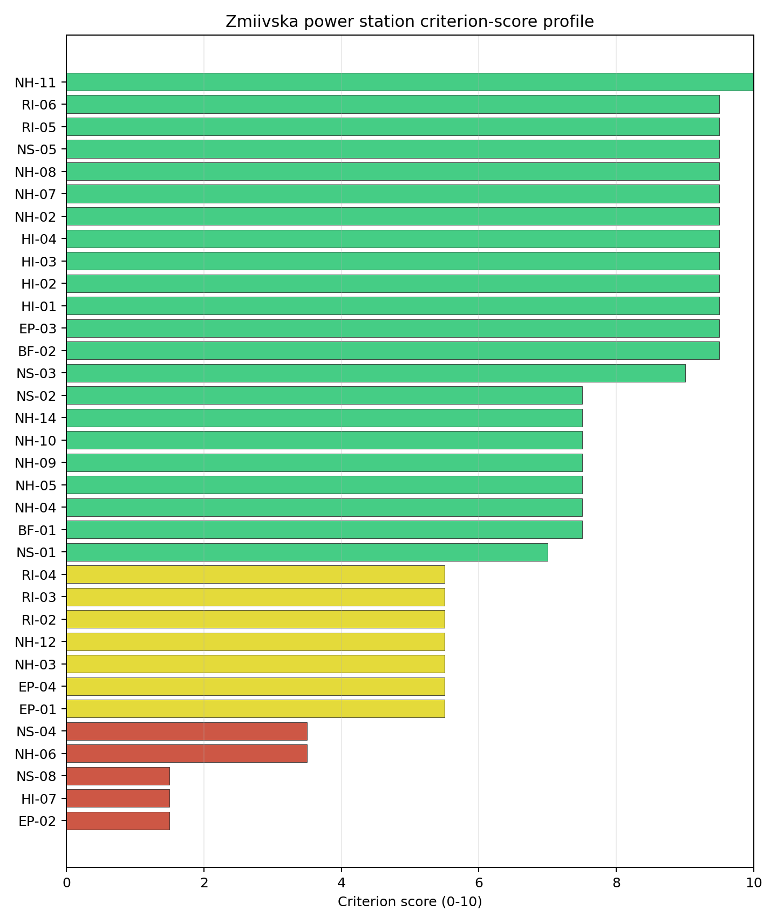
Criterion scores
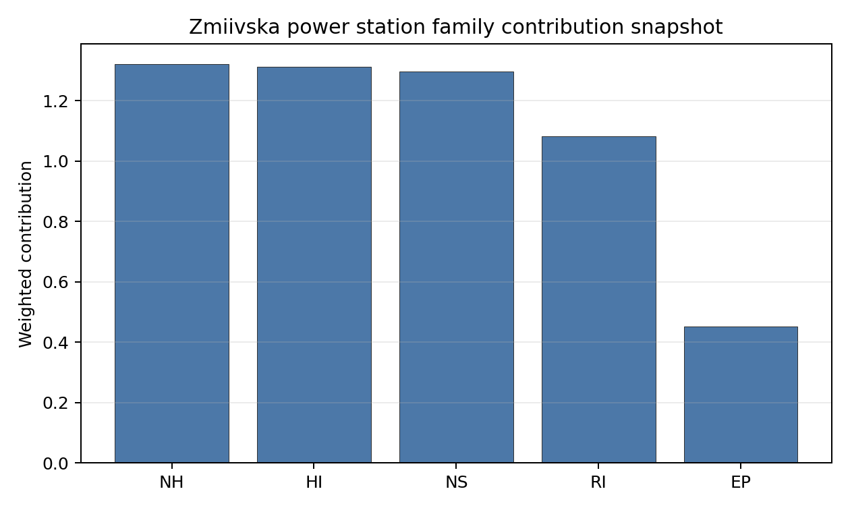
Family contributions
Zmiivska power station ranks 1 nationally with a baseline composite score of 7.455 and a Monte Carlo bracket of 6.263-7.945. Its national stability band is A, with a national top-10% hit rate of 92%. This is a robust national screening position within the Ukrainian desk-study pool. The result should sequence evidence collection, not construction readiness: the Ukraine conflict and territorial-access caveat prevents treatment of any Ukrainian site as a practical near-term Stage 3 candidate in this report pass.

Residual Risk Register
Concern | Evidence | Consequence | Stage 3 action | Owner discipline
Conflict and territorial access | Current war conditions affect access, security, infrastructure-condition evidence and emergency-planning currency. | Near-term progression cannot be supported from desk-study data alone. | Defer progression decision until stable access, regulator engagement and updated territorial-control evidence are available. | programme
Evacuation Routes (EP-02) | Native score 1.5/10; confidence medium. | Could alter the screening class, design basis or mitigation burden if confirmed in field evidence. | Re-measure Evacuation Routes with site-specific post-war data before Stage 3 scoping. | emergency planning
Electromagnetic Interference (HI-07) | Native score 1.5/10; confidence medium. | Could alter the screening class, design basis or mitigation burden if confirmed in field evidence. | Re-measure Electromagnetic Interference with site-specific post-war data before Stage 3 scoping. | security
Ecological Sensitivity (NS-08) | Native score 1.5/10; confidence insufficient. | Could alter the screening class, design basis or mitigation burden if confirmed in field evidence. | Re-measure Ecological Sensitivity with site-specific post-war data before Stage 3 scoping. | site engineering / environment
Geotechnical: Foundation (NH-06) | Native score 3.5/10; confidence medium. | Could alter the screening class, design basis or mitigation burden if confirmed in field evidence. | Re-measure Geotechnical: Foundation with site-specific post-war data before Stage 3 scoping. | geotechnical / hazards
Site Topography (NS-04) | Native score 3.5/10; confidence low. | Could alter the screening class, design basis or mitigation burden if confirmed in field evidence. | Re-measure Site Topography with site-specific post-war data before Stage 3 scoping. | site engineering / environment
This register is a post-war evidence plan for Zmiivska power station. It is not a finding of site approval or a recommendation to start Stage 3 work under current conditions.

Stage 3 Follow-Up Checklist
- Re-measure Evacuation Routes (EP-02) - native score 1.5/10 with confidence medium.
- Re-measure Electromagnetic Interference (HI-07) - native score 1.5/10 with confidence medium.
- Re-measure Ecological Sensitivity (NS-08) - native score 1.5/10 with confidence low.
- Re-measure Geotechnical: Foundation (NH-06) - native score 3.5/10 with confidence medium.
- Re-measure Site Topography (NS-04) - native score 3.5/10 with confidence medium.

Evidence Limitations
- No criterion-family quality fields are flagged as low or missing in this bundle.

Per-Country Top-Site Candidates
Reference SMR: NuScale VOYGR-6. Analytical basis: the project’s 50,000-iteration national Monte Carlo sensitivity analysis over the current frozen scoring rubric.

Interpretation
This section lists the leading exclusionary-pass candidates in each published country. The ranking follows the current national site ledgers: country rank first, then screening class, national composite score, national Monte Carlo interval, stability band, and top-tier hit rate. Countries with fewer than five exclusionary-pass records list the available ranked records only. Hard-failed records remain in the country ledgers and consolidated failure material, but they are not presented as top-site candidates.
Full-pass sites are candidates for detailed Stage 3 characterisation if national authorities wish to continue. Avoidance-flagged sites are candidates for an unlock review before they are treated as equivalent to full-pass sites. Ukraine’s entries remain desk-study priorities under the country caveat in the Ukraine profile.

Per-Country Candidate Tables

Austria (AT)
Country pool: 0 full pass, 6 avoidance flag, 2 hard fail.
National rank | Site | Status | Composite | MC interval | Band | Top-tier hit rate | Capacity (MW)
1 | Riedersbach power station | Avoidance flag | 7.159 | 6.361-7.650 | A | 100% | 220
2 | Timelkam power station | Avoidance flag | 7.016 | 6.245-7.487 | H | 0% | 66
3 | Enns Power Station | Avoidance flag | 6.616 | 5.922-7.156 | H | 0% | 800
4 | Voitsberg power station | Avoidance flag | 6.559 | 5.876-7.050 | H | 0% | 330
5 | Duernrohr power station | Avoidance flag | 6.544 | 5.864-7.081 | H | 0% | 802

Bosnia and Herzegovina (BA)
Country pool: 0 full pass, 5 avoidance flag, 6 hard fail.
National rank | Site | Status | Composite | MC interval | Band | Top-tier hit rate | Capacity (MW)
1 | Stanari Thermal Power Plant | Avoidance flag | 6.747 | 6.028-7.237 | A | 92% | 300
2 | Miljevina power station | Avoidance flag | 6.622 | 5.927-7.131 | H | 8% | 220
3 | Kamengrad Thermal Power Plant | Avoidance flag | 6.572 | 5.886-7.131 | H | 0% | 430
4 | Ugljevik power station | Avoidance flag | 6.458 | 5.707-6.929 | H | 0% | 1,000
5 | Banovici power station | Avoidance flag | 5.934 | 5.325-6.425 | H | 0% | 350

Bulgaria (BG)
Country pool: 0 full pass, 7 avoidance flag, 8 hard fail.
National rank | Site | Status | Composite | MC interval | Band | Top-tier hit rate | Capacity (MW)
1 | Lom Power Station | Avoidance flag | 7.428 | 6.578-7.850 | A | 100% | 400
2 | Maritsa 3 power station | Avoidance flag | 7.009 | 6.240-7.569 | D | 0% | 120
3 | Bobov Dol power station | Avoidance flag | 6.984 | 6.220-7.525 | G | 0% | 1,030
4 | Vidin Works power station | Avoidance flag | 6.828 | 6.093-7.369 | H | 0% | 120
5 | Svilosa power station | Avoidance flag | 6.578 | 5.891-7.119 | H | 0% | 120

Czechia (CZ)
Country pool: 0 full pass, 29 avoidance flag, 0 hard fail.
National rank | Site | Status | Composite | MC interval | Band | Top-tier hit rate | Capacity (MW)
1 | Tusimice power station | Avoidance flag | 7.095 | 6.144-7.691 | A | 92% | 800
2 | Prunerov power station | Avoidance flag | 7.016 | 6.083-7.559 | C | 67% | 2,240
3 | Chvaletice power station | Avoidance flag | 7.009 | 6.240-7.594 | D | 33% | 820
4 | Pocerady power station | Avoidance flag | 6.931 | 6.018-7.526 | D | 0% | 1,000
5 | Ledvice power station | Avoidance flag | 6.916 | 6.164-7.512 | D | 0% | 990

Croatia (HR)
Country pool: 0 full pass, 1 avoidance flag, 1 hard fail.
National rank | Site | Status | Composite | MC interval | Band | Top-tier hit rate | Capacity (MW)
1 | Plomin power station | Avoidance flag | 6.214 | 5.467-6.730 | A | 100% | 842

Hungary (HU)
Country pool: 1 full pass, 10 avoidance flag, 0 hard fail.
National rank | Site | Status | Composite | MC interval | Band | Top-tier hit rate | Capacity (MW)
1 | Mohacs power station | Full pass | 7.584 | 6.705-8.075 | A | 100% | 1,200
2 | Borsod power station | Avoidance flag | 6.941 | 6.184-7.381 | D | 0% | 420
3 | Tiszapalkonya power station | Avoidance flag | 6.778 | 6.053-7.319 | D | 0% | 265
4 | Matraterenye power station | Avoidance flag | 6.641 | 5.795-7.158 | H | 0% | 50
5 | Torony power station | Avoidance flag | 6.595 | 5.760-7.059 | H | 0% | 600

Latvia (LV)
Country pool: 0 full pass, 1 avoidance flag, 0 hard fail.
National rank | Site | Status | Composite | MC interval | Band | Top-tier hit rate | Capacity (MW)
1 | Kurzeme power station | Avoidance flag | 6.603 | 5.912-7.200 | A | 100% | 435

Moldova (MD)
Country pool: 0 full pass, 1 avoidance flag, 0 hard fail.
National rank | Site | Status | Composite | MC interval | Band | Top-tier hit rate | Capacity (MW)
1 | Kuchurgan power station | Avoidance flag | 6.959 | 6.199-7.500 | A | 100% | 1,400

Montenegro (ME)
Country pool: 0 full pass, 1 avoidance flag, 3 hard fail.
National rank | Site | Status | Composite | MC interval | Band | Top-tier hit rate | Capacity (MW)
1 | Bar power station | Avoidance flag | 6.023 | 5.321-6.467 | A | 100% | 800

North Macedonia (MK)
Country pool: 0 full pass, 3 avoidance flag, 1 hard fail.
National rank | Site | Status | Composite | MC interval | Band | Top-tier hit rate | Capacity (MW)
1 | Bitola power station | Avoidance flag | 6.812 | 5.927-7.329 | A | 100% | 699
2 | Negotino power station | Avoidance flag | 6.707 | 5.846-7.171 | H | 0% | 300
3 | Oslomej power station | Avoidance flag | 5.905 | 5.230-6.421 | H | 0% | 255

Poland (PL)
Country pool: 3 full pass, 58 avoidance flag, 2 hard fail.
National rank | Site | Status | Composite | MC interval | Band | Top-tier hit rate | Capacity (MW)
1 | Polaniec power station | Avoidance flag | 7.422 | 6.573-7.956 | A | 100% | 1,882
2 | Pólnoc power station | Full pass | 7.284 | 6.462-7.869 | A | 100% | 1,600
3 | Adamow power station | Full pass | 7.227 | 6.245-7.822 | B | 92% | 600
4 | Gubin Power Project | Avoidance flag | 7.222 | 6.412-7.803 | B | 92% | 3,000
5 | Kedzierzyn CCS Project | Avoidance flag | 7.191 | 6.386-7.737 | C | 75% | 910

Romania (RO)
Country pool: 3 full pass, 19 avoidance flag, 1 hard fail.
National rank | Site | Status | Composite | MC interval | Band | Top-tier hit rate | Capacity (MW)
1 | Turceni power station | Full pass | 7.816 | 6.891-8.256 | A | 100% | 2,640
2 | Rovinari power station | Full pass | 7.159 | 6.361-7.700 | B | 100% | 1,920
3 | Iernut power station | Full pass | 7.114 | 5.285-7.555 | D | 0% | 800
4 | Mintia-Deva power station | Avoidance flag | 7.016 | 6.245-7.487 | D | 0% | 1,285
5 | Braila power station | Avoidance flag | 6.784 | 6.058-7.275 | D | 0% | 850

Serbia (RS)
Country pool: 0 full pass, 6 avoidance flag, 2 hard fail.
National rank | Site | Status | Composite | MC interval | Band | Top-tier hit rate | Capacity (MW)
1 | Štavalj Power Station | Avoidance flag | 6.753 | 5.928-7.175 | A | 92% | 300
2 | Kostolac power station | Avoidance flag | 6.634 | 5.906-7.244 | H | 8% | 1,360
3 | Kolubara A power station | Avoidance flag | 6.559 | 5.831-7.069 | H | 0% | 271
4 | Kovin power station | Avoidance flag | 6.503 | 5.831-7.094 | H | 0% | 700
5 | Kolubara B power station | Avoidance flag | 6.472 | 5.744-6.981 | H | 0% | 725

Slovakia (SK)
Country pool: 1 full pass, 4 avoidance flag, 1 hard fail.
National rank | Site | Status | Composite | MC interval | Band | Top-tier hit rate | Capacity (MW)
1 | Vojany I power station | Full pass | 7.022 | 6.250-7.481 | A | 100% | 660
2 | Trebisov power station | Avoidance flag | 6.741 | 6.023-7.281 | H | 0% | 885
3 | Novaky power station | Avoidance flag | 6.716 | 6.003-7.237 | H | 0% | 472
4 | Martinska power station | Avoidance flag | 6.303 | 5.669-6.775 | H | 0% | 32
5 | U.S. Steel Kosice Works power station | Avoidance flag | 5.691 | 5.174-6.181 | H | 0% | 208

Türkiye (TR)
Country pool: 8 full pass, 102 avoidance flag, 36 hard fail.
National rank | Site | Status | Composite | MC interval | Band | Top-tier hit rate | Capacity (MW)
1 | Konya Karapınar power station | Full pass | 7.784 | 6.528-8.301 | A | 100% | 1,000
2 | Eren-1 power station | Full pass | 7.459 | 6.604-7.900 | A | 100% | 490
3 | Tufanbeyli power station | Avoidance flag | 7.380 | 6.407-7.890 | A | 100% | 450
4 | Karapinar Konya Şeker power station | Avoidance flag | 7.354 | 6.386-7.864 | A | 100% | 2,000
5 | Çayırhan power station | Full pass | 7.347 | 6.513-7.806 | B | 100% | 1,420

Ukraine (UA)
Country pool: 12 full pass, 8 avoidance flag, 0 hard fail.
National rank | Site | Status | Composite | MC interval | Band | Top-tier hit rate | Capacity (MW)
1 | Zmiivska power station | Full pass | 7.455 | 6.263-7.945 | A | 92% | 2,270
2 | Dobrotvir power station | Full pass | 7.372 | 6.533-8.006 | B | 100% | 1,110
3 | Ladyzhyn power station | Full pass | 7.197 | 6.391-7.706 | D | 8% | 1,800
4 | Kryvorizka power station | Full pass | 7.166 | 6.051-7.655 | D | 0% | 2,925
5 | Burshtyn power station | Full pass | 6.959 | 6.199-7.450 | D | 0% | 3,166

Status Legend
- Full pass: the site clears the exclusionary and avoidance screens against the NuScale VOYGR-6 reference envelope.
- Avoidance flag: the site clears the exclusionary screen but carries at least one avoidance criterion that should be resolved before detailed characterisation.
- Hard fail: the site is removed at the exclusionary screen and is not a top-site candidate under the current reference envelope.

Stability Band Reference
Bands A through H are computed from the national sensitivity analysis:
- A: robust national shortlist candidate.
- B / C / D: national top-tier or broader-tier candidate with increasing sensitivity to weights and score bands.
- E / F: volatile candidate that requires stronger evidence before sequencing.
- G / H: rank-fragile candidate whose position depends materially on scoring and evidence assumptions.

Consolidated Failure Section - Countries with No Exclusionary-Pass Site
This section consolidates the countries whose entire thermal-station portfolio is removed at the exclusionary screen against the NuScale VOYGR-6 reference envelope. None of these countries currently support a brownfield coal-to-nuclear conversion path from the screened candidate pool; any future programme would require a greenfield prospecting effort that applies the same exclusionary rules at the screening stage.
The criterion codes referenced below resolve as follows:
- NH-02 Seismic: Surface Rupture
- NH-03 Volcanic Hazard
- NH-04 Geotechnical: Slope Stability
- EP-01 Emergency Planning Feasibility

Country roll
- Albania (AL) - 1 of 1 site removed at the exclusionary screen. Porto Romano Power Station fails NH-02 and NH-03, reflecting the regional Adriatic capable-fault context and proximity to volcanic hazard sources. The country has no further brownfield candidate to fall back to.
- Slovenia (SI) - 3 of 3 sites removed at the exclusionary screen. Sostanj power station and Trbovlje power station fail NH-02 (the latter also fails NH-04 on slope stability); Te-Tol power station fails NH-02 and EP-01. The result is structural: the Slovenian thermal-station footprint sits on or adjacent to capable-fault traces in the Sava and Savinja valleys.
- Kosovo (XK) - 4 of 4 sites removed at the exclusionary screen. All four sites fail NH-02 (Istok, Kosovo A, Kosovo B, Kosovo C); Kosovo C also fails EP-01. The Kosovan thermal cluster is concentrated in the Drenica and Obilic basin, which sits within the Vardar Zone seismic context.
The sites in this section are not deal-breakers for nuclear ambition in the host country; they are deal-breakers for the brownfield coal-to-nuclear path on the existing thermal portfolio. The distinction matters when host governments consider whether to launch a greenfield site-survey programme alongside the regional fleet plan.

6. Recommendations for Detailed Site Evaluation
This chapter converts the Stage 1 and Stage 2 screening findings into a Stage 3 work programme. It identifies the investigations, confirmations, authority engagements, and sequencing that a government or project sponsor should commission before treating any shortlisted site as a candidate for licence-quality evaluation. The recommendations apply to the NuScale VOYGR-6 reference envelope only.
The chapter is written as a work-planning bridge. Chapter 3 defines the screening and ranking method, Chapter 4 fixes the cross-country results, and Chapter 5 carries the country and selected-site residual-risk registers. Where those inputs remain incomplete, this chapter records the dependency and avoids assigning named-site priorities that the accepted evidence has not yet supported.

6.1 Recommended Stage 3 Investigations
Stage 3 characterisation is a different evidentiary standard from Stage 1 and Stage 2 screening. Screening is designed to identify where further effort is justified. Stage 3 collects site-specific measurements, regulator-facing analyses, and authority confirmations that can support the next formal project decisions (IAEA, 2019).

Geotechnical and seismic characterisation
Each selected site should receive a site-specific probabilistic seismic hazard assessment, a deterministic safe-shutdown-earthquake evaluation for the reference envelope, and a capable-fault investigation focused on features that could affect the nuclear island and associated safety systems. The field programme should include boreholes, cone penetration or standard penetration testing, downhole or crosshole shear-wave velocity measurements, groundwater observations, liquefaction triggering assessment, bearing-capacity tests, and slope-stability analysis. Screening-grade seismic and geotechnical scores should remain decision-support evidence until those site measurements are available.

Flooding, cooling water, and hydrology
Selected sites require a design-basis flood analysis covering riverine, pluvial, coastal where relevant, dam-break, drainage, and combined-event pathways. Cooling-water assessment should confirm abstraction reliability, low-flow recurrence, thermal-discharge limits, ultimate heat sink availability, and drought-management obligations. Where the screening evidence lacks measured discharge, intake reach geometry, or dilution information, Stage 3 should treat those values as early field priorities before any cooling or liquid-pathway conclusion is hardened.

Meteorology and combined natural hazards
Stage 3 should replace screening meteorology with site-specific measurements and national station records. The work programme should include at least one year of on-site meteorological observation, severe-weather climatology, design wind pressure, design rainfall, snow and ice loading, wildfire screening where land-cover and fuel-distance conditions require it, and a combined-hazards review. Sites with implausible screening precipitation or wind values need early national-record reconciliation because those values can affect drainage, dispersion, emergency planning, and design-basis assumptions.

Human-induced hazards and nuclear security
Human-induced hazard work should cover aircraft activity, industrial hazards, hazardous material corridors, pipelines, rail and road transport, nearby high-energy infrastructure, military areas, and electromagnetic sources. The Stage 3 file should use national authority registers, operator declarations, field reconnaissance, and ministry engagement rather than treating open public evidence as conclusive. Nuclear security is a separate regulator-facing workstream covering design basis threat, physical protection, cyber security, insider-threat controls, and protected-area interfaces.

Radiological impact and atmospheric dispersion
Radiological assessment should move from screening proxies to site-specific atmospheric, surface-water, groundwater, and population modelling. The Stage 3 deliverables should include an atmospheric dispersion model calibrated to site meteorology, normal-operation and accident dose envelopes, liquid effluent dilution analysis, groundwater pathway assessment, receptor identification, and population projections based on national census and planning evidence. These deliverables are necessary before any screened site can be described as suitable for a licence-quality radiological case.

Emergency planning
Emergency-planning scores in this report are feasibility signals. Stage 3 should produce an evacuation time estimate, sheltering and potassium-iodide distribution concept, special-population plan, communications concept, and exercise framework aligned with the national nuclear emergency plan. Road density, healthcare access, terrain, river barriers, seasonal population, and special facilities should be tested under realistic peak and adverse-weather conditions.

Grid, transport, and construction logistics
The grid workstream should begin with the transmission system operator and should test load-flow, short-circuit, n-1 contingency, reactive power, frequency support, black-start participation, grid reinforcement, and interconnection cost for a 462 MWe reference plant. Transport and logistics should include abnormal-load route surveys, bridge and tunnel checks, port or rail-siding feasibility where relevant, construction laydown planning, and workforce mobilisation. These issues affect schedule and cost rather than nuclear safety, but they can still determine whether a brownfield candidate is practicable.

Land, ownership, environment, and planning
Stage 3 should verify exact plot boundaries, title, encumbrances, zoning, municipal plans, site control, and any state-to-utility or private-owner transaction path. Environmental work should include scoping for environmental impact assessment, Habitats Directive Article 6(3) review where a protected ecological receptor may be affected, contaminated-land investigation for coal-combustion legacy areas, ash and fuel-storage areas, cultural heritage screening, and land-use compatibility. Ownership and site control must be confirmed as legal facts, not inferred from operating-company or parent-entity records.

6.2 Data Gaps Requiring Field Confirmation
Data gaps should be prioritised by the decision they can change. A missing or weak value matters most when it can alter exclusionary status, safety-floor status, national rank stability, or the Stage 3 work scope. Annex E should carry the line-item assumption and data-limitation register once all selected-site profiles have been accepted.
Gap class | Possible decision effect | Stage 3 confirmation route
Exclusionary trigger | Could remove a site from further consideration. | Field measurement, authority confirmation, and regulator-facing technical judgement.
Safety-floor criterion | Could move a site into or out of the ranked candidate set. | Site-specific modelling, national data review, and independent technical review.
Ranking driver | Could reorder candidates within the same country. | Better measured values, ownership confirmation, grid study, or environmental scoping.
Confidence and coverage | Could widen or narrow the national sensitivity band. | Evidence-quality upgrade and assumption-register closure.
Programme constraint | Could delay or redirect Stage 3 even if safety screening remains favourable. | Grid, land, stakeholder, permitting, and operator due diligence.
The most immediate field-confirmation categories are consistent across selected sites. Natural-hazard gaps usually concern capable faults, local geotechnical conditions, precipitation, flood level, cooling-water availability, and combined hazards. Human-induced hazard gaps usually concern military features, hazardous facilities, flight activity, transport corridors, and electromagnetic sources. Radiological and emergency-planning gaps usually concern dispersion inputs, population forecasts, special-population interfaces, evacuation timing, and water-pathway receptors. Non-safety gaps usually concern grid reinforcement, site control, buildable footprint, ecological receptors, construction logistics, workforce availability, and infrastructure reuse.
The site-by-site gap pattern is now carried in the Chapter 5 residual-risk registers. The recurring Stage 3 tasks are consistent across the profiles: confirm national-source evidence, replace screening proxies with field values, resolve avoidance flags before characterisation funding, and preserve country-specific caveats where security, access or institutional conditions control the practical sequence.

6.3 Recommended Regulatory and Stakeholder Follow-Up
Regulatory and stakeholder follow-up should begin before expensive field campaigns are fully committed. Early engagement gives the client government a chance to confirm the evidence standard expected by the national nuclear regulator, the grid operator, environmental authorities, civil-protection bodies, local authorities, land owners, and affected communities.

National nuclear regulator
The first regulatory deliverable should be a pre-application engagement memo. It should describe the reference deployment envelope, the Stage 1 and Stage 2 screening outcome, the proposed Stage 3 scope, the safety-case structure, and the intended sequence of site investigations. The regulator should be asked to confirm expectations for seismic, flood, meteorological, radiological, emergency-planning, external-event, and environmental evidence before the sponsor commits to the full site-characterisation programme.

Transmission system operator
The transmission system operator should receive a formal connection-enquiry package for each selected site. That package should test whether the existing thermal-site connection can support the 462 MWe reference envelope, whether voltage upgrades are required, what reinforcement is needed under n-1 contingency, and how grid-connection timing affects the Stage 3 programme. Screening distance to substations and lines is a useful first signal; the operator’s system study is the decision evidence.

Water, environmental, and planning authorities
Water authorities should confirm abstraction rights, low-flow constraints, thermal-discharge conditions, drought obligations, and river-basin management requirements. Environmental and planning authorities should confirm environmental impact assessment scoping, Habitats Directive Article 6(3) obligations where relevant, zoning compatibility, contaminated-land requirements, cultural heritage screening, and municipal planning interfaces. These engagements should be tied to the exact plot and cooling concept rather than to a generic plant description.

Emergency-planning and civil-protection authorities
Civil-protection authorities should review the emergency planning zone concept, evacuation time estimate, sheltering strategy, special-population interfaces, communications plan, and exercise schedule. The Stage 3 question is whether the emergency plan can be made practical under national law, local road conditions, seasonal loadings, and adverse weather. Screening scores identify where the issue may arise; civil-protection engagement tests the plan against operating reality.

Land owner, operator, and local community
Land-owner and operator engagement should confirm title, encumbrances, operating constraints, demolition or remediation obligations, ash and fuel-storage legacy issues, and any route to site control. Local engagement should start with factual information on plant size, siting on or near the existing power site, infrastructure reuse, workforce transition, and the timing gap between thermal retirement and any future nuclear project (U.S. DOE, 2024). Public engagement should be coordinated with the national client and local authority, and should avoid presenting the screening outcome as a decision to build.

6.4 Prioritisation of Next-Step Work
Prioritisation should follow the same logic for every selected site: validate the screening record, retire exclusionary and safety-floor uncertainty, engage authorities early, and commit to full site characterisation only after the first evidence gates are passed. This keeps Stage 3 cost proportional to the strength and stability of the Stage 1 and Stage 2 result.
Work package | Indicative timing | Decision purpose | Minimum output
A. National evidence validation | Weeks 1-12 | Confirm that no known national source changes exclusionary or safety-floor status. | Validated screening file, evidence-quality upgrade list, and unresolved data-gap register.
B. High-impact field and archival work | Months 3-18 | Replace the highest-risk proxies with site measurements and legal facts. | Geotechnical, meteorological, hydrological, title, zoning, environmental, and human-induced hazard evidence.
C. Authority engagement and due diligence | Months 6-24 | Confirm that regulator, grid, water, planning, emergency, and land-control pathways are practical. | Regulator scope response, grid pathway, water and planning position, emergency-planning framework, and land-control route.
D. Decision to commission full Stage 3 characterisation | Month 18 onward | Decide whether the site merits the full licence-quality site-evaluation programme. | Agreed Stage 3 scope, budget, schedule, risk register, and authority engagement record.
The first work programme should separate full-pass characterisation from avoidance-flag unlock work. Full-pass sites can move directly into Stage 3 scoping once national authorities accept the screening basis. Avoidance-flagged sites should receive a narrower issue-resolution package before expensive field characterisation is commissioned.
Priority group | Sites | Immediate next step | Decision gate
Full-pass national leaders | Turceni, Mohacs, Zmiivska, Vojany I, Konya Karapınar | Commission national evidence validation and Stage 3 scope definition. | Confirm that no national-source evidence changes the full-pass status.
Full-pass fast followers | Rovinari, Dobrotvir, Pólnoc, Adamow, Eren-1, Çayırhan | Run targeted evidence upgrades in parallel with the national leaders. | Decide whether the fast follower remains a reserve or joins the first characterisation tranche.
Avoidance-led national leaders | Riedersbach, Stanari, Lom, Tusimice, Plomin, Kurzeme, Kuchurgan, Bar, Bitola, Polaniec, Štavalj | Resolve the controlling avoidance flag before full Stage 3 mobilisation. | Treat the site as a characterisation candidate only if the avoidance issue is retired or bounded.
Ukraine caveat set | Zmiivska, Dobrotvir, Ladyzhyn, Kryvorizka, Burshtyn | Update security, access, infrastructure-condition, emergency-planning, and authority evidence before any mobilisation. | Use the site profiles as a post-war verification queue, not as immediate implementation instructions.
The method can also be expanded beyond coal and thermal sites. Other large industrial sites may have grid, cooling, transport, land, and workforce characteristics relevant to SMR accommodation. They should enter the framework through the same Stage 1 and Stage 2 gates, with no relaxation of safety, emergency-planning, environmental, or security expectations.

7. Final Remarks
The report gives governments a structured way to move from a broad brownfield site universe to a defensible set of sites for detailed evaluation. It combines IAEA Stage 1 site survey logic, Stage 2 site selection logic, exclusionary and avoidance screening, comparative scoring, and the project’s 50,000-iteration national sensitivity analysis. The result is a prioritisation basis for Stage 3 characterisation, not a licence finding or construction decision.
The main value lies in traceability. A reader can see why a site remains in consideration, which criteria support its position, which criteria hold it back, how stable its national rank is under sensitivity testing, and which evidence gaps require field confirmation. That chain matters more than small differences between adjacent composite scores. It turns the shortlist into a managed work programme rather than a static ranking.
The scope remains Stage 1 and Stage 2. Site-specific ground investigation, design-basis hazard studies, emergency plan approval, grid connection offers, environmental permitting, land control, public engagement, and licensing decisions belong to Stage 3 and later national processes. A recommendation to progress a site means that the screening evidence justifies spending effort on those processes. It does not mean that the site is suitable for construction.
Uncertainty is an input to the decision. Screening evidence is expected to contain proxies, unscored criteria, quality labels, and values that need national confirmation. The report preserves that uncertainty through evidence coverage, score bands, national stability bands, residual-risk registers, and Stage 3 follow-up actions. The right response is targeted investigation, not over-reading the point estimate.
Coal and thermal sites are a rational starting point because many already carry grid, cooling, transport, land, industrial, and workforce attributes that can improve the economics and schedule of later evaluation. Those attributes are useful only when they sit alongside acceptable safety, security, radiological, emergency-planning, environmental, and stakeholder conditions. The framework therefore keeps brownfield reuse advantages inside the same disciplined screening structure as every safety-related concern.
The same framework can be expanded to other large industrial sites that may be suitable for SMR accommodation. Such expansion should preserve the same gates: clear site universe, documented evidence, exclusionary screening, national sensitivity analysis, residual-risk interpretation, and Stage 3 confirmation. The method is portable because it is auditable, but its conclusions remain site-specific.
The final decision belongs to national institutions. Governments, regulators, operators, local authorities, land owners, and the public will determine whether any candidate proceeds from screening to characterisation and from characterisation toward a licence-quality case. This report provides the starting set and the next-step sequence for that decision.

8. References
This chapter is the consolidated external reference list for the reader-facing report. Project-generated methodology artefacts, scoring artefacts, and reproducibility indexes are carried in the annexes rather than cited as external publications.

External Standards and Regulatory Documents
- EPRI (2022) Advanced Nuclear Technology: Site Selection and Evaluation Criteria for New Nuclear Energy Generation Facilities (Siting Guide) - 2022 Revision. Report No. 3002023910. Palo Alto: Electric Power Research Institute.
- European Commission (1992) Council Directive 92/43/EEC on the conservation of natural habitats and of wild fauna and flora. Brussels: European Commission.
- European Parliament and Council (2000) Directive 2000/60/EC establishing a framework for Community action in the field of water policy. Brussels: European Parliament and Council.
- IAEA (2002a) External Human Induced Events in Site Evaluation for Nuclear Power Plants. Safety Standards Series No. NS-G-3.1. Vienna: International Atomic Energy Agency.
- IAEA (2002b) Dispersion of Radioactive Material in Air and Water and Consideration of Population Distribution in Site Evaluation for Nuclear Power Plants. Safety Standards Series No. NS-G-3.2. Vienna: International Atomic Energy Agency.
- IAEA (2011) Meteorological and Hydrological Hazards in Site Evaluation for Nuclear Installations. Safety Standards Series No. SSG-18. Vienna: International Atomic Energy Agency.
- IAEA (2012) Volcanic Hazards in Site Evaluation for Nuclear Installations. Safety Standards Series No. SSG-21. Vienna: International Atomic Energy Agency.
- IAEA (2015) Site Survey and Site Selection for Nuclear Installations. Safety Standards Series No. SSG-35. Vienna: International Atomic Energy Agency.
- IAEA (2019) Site Evaluation for Nuclear Installations. Safety Standards Series No. SSR-1 (Rev. 1). Vienna: International Atomic Energy Agency.
- IAEA (2022) Seismic Hazards in Site Evaluation for Nuclear Installations. Safety Standards Series No. SSG-9 (Rev. 1). Vienna: International Atomic Energy Agency.
- IAEA (2023) Hazards Associated with Human Induced External Events in Site Evaluation for Nuclear Installations. Safety Standards Series No. SSG-79. Vienna: International Atomic Energy Agency.

Coal-to-Nuclear and Energy Transition Sources
- INL (2022) Investigating Benefits and Challenges of Converting Retiring Coal Plants into Nuclear Plants. INL/RPT-22-67964. Idaho Falls: Idaho National Laboratory.
- U.S. DOE (2024) Coal-to-Nuclear Transitions: An Information Guide. Washington DC: U.S. Department of Energy, Office of Nuclear Energy.

Regulatory and Institutional Sources Cited in Country Profiles
Country-profile text in the current report pass uses the project evidence base and the external standards listed above for interpretation. Where a later country packet introduces a public legal, regulatory, transmission-system, environmental-authority, civil-protection, or ownership citation, the reference should be added here in Harvard style before publication.

Annex A: IAEA and EPRI Traceability
What this annex adds. Annex A carries the per-requirement SSR-1 coverage matrix that the main report summarises but does not reproduce. Chapter 1 §1.4 and Chapter 3 §3.3 explain how IAEA and EPRI frameworks are used in this study; they do not list individual Requirements. Annex A does.

Reading the matrix
Each Requirement of IAEA SSR-1 (2019) is mapped to one or more project scoring criteria. The coverage column uses four values:
- full - the criterion or criteria cover the substantive Requirement obligations at screening resolution.
- partial - screening proxies a portion of the Requirement; detailed siting is needed to close it out.
- screening_only - the basic-filter family captures the upstream eligibility gate, not the Requirement itself.
- out_of_scope - the Requirement is operational, programmatic, or quality-assurance-related and is not addressed by a scoring criterion. These are handled in the Stage 3 and operational phases.
The Stage 3 action column states the investigation that would carry the Requirement beyond screening. Project-only criteria (see the second table) are scored for ranking but sit outside the SSR-1 safety remit; they are listed here for completeness so that reviewers see the full rubric.

SSR-1 Requirement × project criterion coverage
SSR-1 Req. | Title | Coverage | Mapped project criteria | Stage 3 action
Req-1 | Responsibilities in site evaluation | out_of_scope | - | Defined during licensing programme setup; addressed in operational governance.
Req-2 | Process of site evaluation | screening_only | BF-01 (grid export), BF-02 (nuclear-island footprint) | Full SSR-1 process applies once Stage 3 begins.
Req-3 | Considerations for site evaluation (information quality) | out_of_scope | - | Managed through the project data-provenance layer and the assumption register.
Req-4 | Earthquakes (vibratory ground motion) | full | NH-01, NH-03, NH-06 | Site-specific PSHA, dynamic soil properties, foundation characterisation.
Req-5 | Surface faulting (capable faults) | full | NH-02 | Capable-fault ground-truth survey within the screening radius.
Req-6 | Meteorological hazards (winds, temperatures, precipitation) | full | NH-10, NH-11, NH-12 | On-site meteorological tower and national-station climatology.
Req-7 | Flooding (river, coastal, surge, tsunami) | full | NH-08, NH-09 | Design-basis flood analysis with combined-event treatment.
Req-8 | Geotechnical hazards (slope, subsidence, karst) | full | NH-04, NH-05, NH-06 | Boreholes, laboratory testing, slope-stability and karst investigation.
Req-9 | Volcanism | full | NH-07 | Probabilistic volcanic hazard assessment where the screening return-period regime indicates it.
Req-10 | Other natural events (wildfire, biological) | partial | NH-13 | Biological hazards to cooling-water intakes require a dedicated Stage 3 study.
Req-11 | External events caused by human activities | full | HI-01, HI-02, HI-03, HI-04, HI-05, HI-06, HI-07, HI-08 | National industrial-register survey, aviation study, defence-ministry engagement.
Req-12 | Population characteristics (current and projected) | full | RI-04, RI-05, RI-06 | Census and municipal-planning-based projection; site-specific population mapping.
Req-13 | Emergency planning zones (EPZ feasibility) | full | EP-01, EP-02, EP-03, EP-04, EP-05 | Evacuation time estimate, concept of operations, civil-protection coordination.
Req-14 | Atmospheric dispersion characteristics | full | RI-01 | Site-specific dispersion model calibrated against on-site meteorology.
Req-15 | Surface- and groundwater dispersion characteristics | full | RI-02, RI-03 | Aquifer conceptual model, river-segment dilution measurement, receptor analysis.
Req-16 | Radioactive material accumulation in water bodies | partial | RI-02, RI-03 | Long-term accumulation modelling deferred to detailed siting.
Req-17 | Combinations of hazards | full | NH-14 | Combined-hazard screening with plausible concurrent events.
Req-18 | Site protection against external hazards | partial | NS-04 | Engineered protection is a design-stage item; topography is only a screening proxy.
Req-19 | Monitoring of site-related parameters | out_of_scope | - | Operational obligation; set out in the pre-operational programme.
Req-20 | Quality assurance for site evaluation | out_of_scope | - | Managed through the project assumption register and provenance layer.

Project-only criteria (not mapped to SSR-1)
The criteria below are ranking axes for implementation and coal-to-nuclear practicality. They are not SSR-1 safety requirements and are excluded from the coverage matrix above.
Criterion | Rationale for inclusion in project ranking
NS-01 - Cooling water / ultimate heat sink | Viability axis; related to SSR-1 Req-15 indirectly but treated as non-safety here.
NS-02 - Grid connection (detailed) | Project-economic axis; outside SSR-1 scope.
NS-03 - Transport access (heavy haul) | Constructability axis; outside SSR-1 scope.
NS-05 - Land availability, ownership, zoning | Project-legal axis; outside SSR-1 scope.
NS-06 - Existing infrastructure reuse | Project-economic axis; outside SSR-1 scope.
NS-07 - Environmental impact (non-radiological) | Covered by EIA legislation, not SSR-1.
NS-08 - Ecological sensitivity | Covered by EIA legislation, not SSR-1.
NS-09 - Socioeconomic impact | Project-acceptability axis; outside SSR-1 scope.
NS-10 - Workforce availability | Project-economic axis; outside SSR-1 scope.
NS-11 - Coal-to-nuclear synergies | Project-strategy axis; outside SSR-1 scope.
NS-12 - Regulatory and political environment | Project-political axis; outside SSR-1 scope.
NS-13 - Construction logistics | Project-economic axis; outside SSR-1 scope.
All rubric criteria are accounted for (no orphans).

EPRI alignment
The EPRI Advanced Nuclear Siting Guide distinguishes four screening actions: exclusionary screening, avoidance screening, suitability evaluation, and alternative-site ranking. The project workflow uses this sequence directly. Exclusionary screening in the project is the hard-exclusion gate; avoidance screening is the avoidance-flag treatment; suitability evaluation is the composite ranking after both gates; alternative-site ranking is the Monte Carlo sensitivity analysis described in Annex C. The EPRI criterion families (footprint, cooling, grid, transport, implementation) map into the project NS family and the BF basic filters. No EPRI concept is left unmapped in the project rubric.

Evidence basis
The matrix is drawn from the generated SSR-1 traceability artefact and the project methodology requirements listed in Annex F. The external standards are cited in Chapter 8 as IAEA SSR-1, IAEA SSG-35, and the EPRI Advanced Nuclear Siting Guide.

Annex B: Scoring Methodology and Exclusionary Floors
What this annex adds. Annex B carries the exclusionary rules, safety-floor pass marks, and minimum metric conditions that Chapter 3 summarises but does not reproduce. It is the threshold catalogue behind the dual gate described in Chapter 3 Sections 3.3 and 3.7.

The dual gate
Each exclusionary criterion can fail a site by two independent paths. A hard E-code fails the site when a measured feature satisfies a rubric condition that the project treats as incompatible with Stage 1 and Stage 2 progression. A safety floor fails the site when its 0-10 ranking score on the same criterion is strictly below the criterion pass mark. Both paths remove the site from composite ranking; the underlying evidence scores remain visible so reviewers can see why the site failed.
The distinction matters for interpretation. A hard E-code generally points to a physical or emergency-planning incompatibility at screening resolution. A safety-floor failure can also be decisive, but it tells reviewers that the site missed the minimum acceptable scoring band rather than crossing the strongest hard expression.

Exclusionary threshold catalogue
The current local exclusionary-floors artefact lists five active exclusionary checks. All carry a pass mark of 5.0 on the 0-10 scale.
E-code | Criterion | Hard-fail condition | Pass mark | Minimum metric to clear the floor
E1 | NH-02 Seismic surface rupture (capable faults) | nearest_fault_km < 5 | 5.0 | nearest_fault_km >= 5.0
E2 | NH-03 Geotechnical, settlement and liquefaction | liquefaction_suscept in ['high', 'very_high'] and has_remedy == false | 5.0 | liquefaction_suscept == 'moderate', or high/very-high susceptibility with a documented remedy under the rubric rule
E3 | NH-04 Geotechnical, slope stability | slope_angle_deg > 25 | 5.0 | slope_angle_deg <= 25.0
E4 | NH-07 Volcanism | nearest_volcano_km < 50 | 5.0 | nearest_volcano_km >= 50.0
E8 | EP-01 Emergency-plan feasibility | ep01_composite_score < 30 | 5.0 | ep01_composite_score >= 30

Per-criterion banding
The bands below show how each active exclusionary criterion is interpreted. Bands below the 5-6 range remain visible in the audit evidence and feed the failure-mode analysis in Annex D.

E1: NH-02 Seismic surface rupture
Band | Condition | Descriptor
9-10 | nearest_fault_km >= 25.0 | Very strong separation from mapped capable faults.
7-8 | nearest_fault_km >= 10.0 | Clear separation from mapped capable faults.
5-6 | nearest_fault_km >= 5.0 | Borderline acceptable separation at screening resolution.
3-4 | nearest_fault_km >= 2.5 | Below the pass band; detailed paleoseismic review would be required.
1-2 | nearest_fault_km >= 1.0 | Very close to a mapped fault; severe surface-rupture concern.
0 | nearest_fault_km < 1.0 | Within or adjacent to a mapped fault trace.

E2: NH-03 Geotechnical, settlement and liquefaction
Band | Condition | Descriptor
9-10 | liquefaction_suscept in ['very_low', 'none'] | Negligible susceptibility at screening resolution.
7-8 | liquefaction_suscept == 'low' | Low susceptibility.
5-6 | Moderate susceptibility, or high/very-high susceptibility with a remedy allowed by the rubric | Minimum acceptable band for screening progression.
3-4 | liquefaction_suscept == 'very_high' and has_remedy is null | Very-high susceptibility with unresolved remedy status.
1-2 | liquefaction_suscept in ['high', 'very_high'] and has_remedy == false | High or very-high susceptibility with no documented remedy.

E3: NH-04 Geotechnical, slope stability
Band | Condition | Descriptor
9-10 | slope_angle_deg <= 5.0 | Flat to very gentle terrain.
7-8 | slope_angle_deg <= 10.0 | Gentle to moderate terrain.
5-6 | slope_angle_deg <= 25.0 | At or below the screening envelope for mitigable slope conditions.
3-4 | slope_angle_deg < 37.5 | Above the screening envelope; geotechnical study would be mandatory.
1-2 | slope_angle_deg < 50.0 | Severe instability risk.
0 | slope_angle_deg >= 50.0 | Catastrophic screening condition.

E4: NH-07 Volcanism
Band | Condition | Descriptor
9-10 | nearest_volcano_km is null or nearest_volcano_km >= 250.0 | No plausible direct pathway at screening resolution.
7-8 | nearest_volcano_km >= 100.0 | Distant from direct volcanic hazard.
5-6 | nearest_volcano_km >= 50.0 | Meets the minimum screening separation.
3-4 | nearest_volcano_km >= 25.0 | Within a range requiring specialist review.
1-2 | nearest_volcano_km >= 10.0 | Near volcanic features; severe direct-hazard exposure.
0 | nearest_volcano_km < 10.0 | Within the closest direct-hazard zone.

E8: EP-01 Emergency-plan feasibility
Band | Condition | Descriptor
9-10 | ep01_composite_score >= 82.5 | High margin above the emergency-planning floor.
7-8 | ep01_composite_score >= 65 | Clear margin above the floor.
5-6 | ep01_composite_score >= 30 | Minimum acceptable emergency-planning feasibility at screening resolution.
3-4 | ep01_composite_score >= 22.5 | Below the pass mark but close enough to warrant targeted explanation.
1-2 | ep01_composite_score >= 15 | Severe shortfall below the floor.
0 | ep01_composite_score < 15 | Outside the acceptance envelope.

Avoidance flags
Avoidance flags are not exclusionary gates. They apply to ranking criteria where proximity to a feature or an implementation constraint lowers a site’s comparative position and identifies a Stage 3 investigation priority. A site with avoidance flags can remain in the national ranking, but the report treats the flag as a condition to resolve before the site can be sequenced confidently.

Composite score construction
Composite scores are formed only for sites that clear the exclusionary gate. Ranking weights are normalised across the criteria used in the score, and family-level scores remain visible alongside the composite so that a high or low result can be attributed to the underlying evidence. Unscored criteria are handled through the methodology described in Annex E and the national sensitivity method in Annex C.

Evidence basis
This annex is drawn from the generated exclusionary-floors artefact listed in Annex F and from the scoring framework described in Chapter 3.

Annex C: National Sensitivity Methodology
What this annex adds. Annex C defines the parameters and interpretation rules for the project’s 50,000-iteration national Monte Carlo sensitivity analysis. Chapter 3 Section 3.8 explains why national rank robustness matters for site selection; this annex states how the national analysis is configured and how the A-H stability bands are read.

Scope of the analysis
The national sensitivity analysis operates only on sites that clear the exclusionary and safety-floor gates for the NuScale VOYGR-6 reference case. Failed sites remain in the evidence base and in the failure-mode analysis, but they do not enter national ranking, national shortlist probabilities, or stability bands.
The estimand is national rank. Each candidate is compared with other candidates in the same country for the same reference deployment envelope. A stable candidate is therefore stable inside its national decision pool, not simply high-scoring in a larger cross-country comparison.

Sensitivity components and parameter settings

One-at-a-time criterion importance
Parameter | Value
Scope | Every ranking-phase criterion in the project rubric.
Perturbation | Set the target criterion weight to zero and renormalise the remaining weights to sum to one.
Metric | Mean absolute national-rank change versus the baseline within each country.
Interpretation | Identifies which criteria most influence the ordering of candidates in a national shortlist.

Category weight perturbation
Parameter | Value
Families perturbed | NH, HI, RI, EP, and NS.
Perturbation magnitude | Plus or minus 20 per cent scaling on the target family.
Profiles | Ten per-family profiles, plus and minus for each of the five families.
Renormalisation | After scaling the target family, all ranking weights renormalise to sum to one.
Interpretation | Tests whether the national shortlist remains similar when a criterion family is weighted more or less strongly.

Swing-weight adjustment
Parameter | Value
Rescale rule | Each criterion’s declared weight is multiplied by the observed 0-10 score range across the survivor pool, then the whole weight vector renormalises to one.
Purpose | Identifies criteria whose declared weight carries limited ranking power because the observed scores vary little across candidates.

National Monte Carlo rank simulation
Parameter | Value
Iteration count | 50,000 per national site pool.
Reference case | NuScale VOYGR-6 only.
Seed | 42, applied deterministically to the site and reference-case pair.
Sampling | Uniform draw inside each criterion’s declared score band.
Reported metrics | Probability of ranking first, probability of ranking in the national top three, probability of ranking in the national top five, median rank, and rank uncertainty bounds.
Interpretation | Separates point-estimate leadership from robust national shortlist membership.

Threshold perturbation
Parameter | Value
Perturbation scope | Numeric measured context such as distances, densities, land areas, slopes, and flows.
Perturbation magnitude | Multiplicative factors of 0.75 and 1.25 on measured numeric inputs.
Interpretation | Tests whether national ordering depends on candidates sitting close to rubric band edges.

Small-pool rule
Parameter | Value
Applicability | National pools with too few surviving candidates for a stable rank distribution.
Treatment | Results are labelled indicative and used as decision support, not as proof of a stable shortlist.
Interpretation | Small national pools can still identify the best available candidate, but probability statements carry wider uncertainty.

Stability band definitions
Each scored site is assigned a stability band using hit rates across non-baseline sensitivity scenarios. Hit rate means the fraction of scenarios in which a site lies inside the relevant national percentile slice.
Band | Rule | Interpretation
A | Top-5 per cent hit rate at least 0.80 | Robust national shortlist candidate.
B | Top-10 per cent hit rate at least 0.80 and not Band A | Defensible national top-tier candidate.
C | Top-10 per cent hit rate from 0.50 to 0.79 and not Band A or B | Candidate often remains in the national top tier.
D | Top-30 per cent hit rate at least 0.64 and not Band A, B, or C | Candidate frequently appears in the broader national tier.
E | Top-30 per cent hit rate at least 0.50 | Candidate appears in the broader tier in roughly half or more of scenarios.
F | Top-30 per cent hit rate at least 0.36 | Candidate appears in roughly one third of scenarios.
G | Top-30 per cent hit rate at least 0.21 | Candidate appears occasionally in the broader tier.
H | Below all rules above | Candidate rarely enters the broader national tier.

Reading the national outputs
The national sensitivity tables should be read together with the exclusionary verdict, avoidance flags, and the Chapter 5 site profile. A Band A or Band B result supports progression toward Stage 3 investigation when the site also has a credible residual-risk register. It does not establish licensing readiness, public acceptance, land control, grid availability, or procurement feasibility.
Point-estimate rank is less important than the joint pattern. A site that ranks first but has low top-three probability is a fragile leader. A site with a slightly lower baseline rank but high top-three or top-five probability may be a stronger practical shortlist candidate.

Known limitations
- One-at-a-time analysis captures first-order effects only. It does not estimate every interaction between criteria.
- Threshold perturbation acts on numeric measured inputs. Qualitative bands are not shifted by the numeric operator.
- Stability bands are population-relative. Small national pools have wider implicit uncertainty than large national pools.
- The Monte Carlo distribution is conservative for low-quality evidence rows and does not replace Stage 3 field confirmation.

Evidence basis
This annex is drawn from the generated sensitivity method artefact, the swing-weight audit, the criterion-correlation check, and the national sensitivity export pack listed in Annex F. The reader-facing interpretation follows Chapter 3 Section 3.8 and Chapter 4 Sections 4.5-4.6.

Annex D: Failure-Mode Analysis
What this annex adds. Annex D carries the failure-mode breakdown for the NuScale VOYGR-6 reference case. Chapter 4 Section 4.4 summarises the dominant exclusion drivers, while Chapter 5 interprets country and site consequences. This annex gives the supporting counts, mechanism split, and compound-failure distribution.

Population and survivorship
The analysis covers the full local candidate universe for the NuScale VOYGR-6 reference case. Each row corresponds to one site evaluation. Of 363 site evaluations, 26 survive every exclusionary gate and every safety floor. The remaining 337 are excluded before any composite ranking or national sensitivity conclusion is stated.
Outcome | Site evaluations | Share of universe
Survived every gate | 26 | 7.2 %
Failed any gate | 337 | 92.8 %
Universe | 363 | 100.0 %
Safety-floor activity dominates the exclusion picture. About 91 per cent of failed evaluations are caught by the safety floor, either alone or together with a hard-expression trigger on the same criterion.

Per-criterion failure breakdown
The counts below are unique site-evaluation counts. A site that fails the same criterion by both the hard expression and the safety floor is counted once in the Hard and floor column, not twice. The Share of failures column expresses each criterion’s contribution against the 337 failed evaluations; percentages sum to more than 100 per cent because some sites fail on several criteria.
Criterion | Name | Hard fails | Floor fails | Hard and floor | Total failed | Share of failures
EP-01 | Emergency-plan feasibility | 57 | 210 | 0 | 267 | 79.2 %
NH-04 | Geotechnical, slope stability | 3 | 161 | 0 | 164 | 48.7 %
NH-05 | Subsidence, karst, mining, oil and gas | 100 | 103 | 99 | 104 | 30.9 %
NH-02 | Seismic surface rupture | 50 | 38 | 0 | 88 | 26.1 %
NS-08 | Ecological sensitivity | 0 | 4 | 0 | 4 | 1.2 %
NH-03 | Geotechnical, settlement and liquefaction | 0 | 1 | 0 | 1 | 0.3 %
Emergency-planning feasibility is the most frequent failure driver. Slope stability is the second driver and is almost entirely a safety-floor issue. Subsidence and karst carry the highest share of compound hard-and-floor failures because the geological indicators tend to co-activate. Surface-rupture screening remains a material filter. Ecological sensitivity and settlement-liquefaction together account for less than 2 per cent of the failed evaluations.

Per-country failure breakdown
The table below gives survival rate, hard-only, floor-only, and compound counts by country. ISO codes follow ISO 3166-1 alpha-2. Survival rate is the share of sites within the country that cleared every exclusionary gate.
ISO | Country | Sites | Survived | Survival rate | Hard only | Hard and floor | Floor only | Sites with at least one survivor
TR | Turkey | 146 | 15 | 10.3 % | 14 | 26 | 91 | 15
PL | Poland | 63 | 4 | 6.3 % | 8 | 20 | 31 | 4
CZ | Czechia | 29 | 0 | 0.0 % | 0 | 29 | 0 | 0
RO | Romania | 24 | 4 | 16.7 % | 3 | 3 | 14 | 4
UA | Ukraine | 20 | 0 | 0.0 % | 0 | 18 | 2 | 0
BG | Bulgaria | 15 | 0 | 0.0 % | 1 | 7 | 7 | 0
BA | Bosnia and Herzegovina | 11 | 0 | 0.0 % | 0 | 11 | 0 | 0
HU | Hungary | 11 | 0 | 0.0 % | 0 | 11 | 0 | 0
AT | Austria | 8 | 0 | 0.0 % | 0 | 2 | 6 | 0
RS | Serbia | 8 | 2 | 25.0 % | 1 | 2 | 3 | 2
SK | Slovakia | 6 | 0 | 0.0 % | 0 | 6 | 0 | 0
ME | Montenegro | 4 | 0 | 0.0 % | 0 | 3 | 1 | 0
MK | North Macedonia | 4 | 0 | 0.0 % | 0 | 0 | 4 | 0
XK | Kosovo | 4 | 0 | 0.0 % | 2 | 2 | 0 | 0
SI | Slovenia | 3 | 0 | 0.0 % | 0 | 3 | 0 | 0
Outside roster | Country outside current published roster | 2 | 1 | 50.0 % | 0 | 0 | 1 | 1
HR | Croatia | 2 | 0 | 0.0 % | 0 | 2 | 0 | 0
AL | Albania | 1 | 0 | 0.0 % | 0 | 1 | 0 | 0
LV | Latvia | 1 | 0 | 0.0 % | 0 | 0 | 1 | 0
MD | Moldova | 1 | 0 | 0.0 % | 0 | 1 | 0 | 0
The country view shows that surviving sites concentrate in Turkey, Poland, Romania, Serbia, and one country outside the current published roster within the local failure artefact. Published country-profile treatment remains controlled by Chapter 5 scope decisions and the current report roster; this annex is a methodology audit surface rather than a country-selection instruction.

Compound versus single-criterion failures
A failed site can be caught by several exclusionary criteria at the same time. The distribution below counts the number of distinct criteria that fail for each excluded evaluation.
Distinct criteria failed | Site evaluations | Share of failed
1 | 141 | 41.8 %
2 | 115 | 34.1 %
3 | 68 | 20.2 %
4 | 12 | 3.6 %
5 | 1 | 0.3 %
About 42 per cent of exclusions are single-criterion and about 58 per cent are compound. Compound exclusions matter because a single-criterion fail can sometimes be re-examined with targeted Stage 3 evidence, whereas multi-criterion fails more often signal a systemic site-suitability problem.

Hard-expression versus safety-floor split
The project rubric treats a criterion as hard when the exclusionary expression triggers and as a floor when the 0-10 ranking score sits below the criterion pass mark of 5.0. For the NuScale VOYGR-6 reference case, the split across failed evaluations is:
Mechanism | Site evaluations
Hard expression only | 29
Safety floor only | 161
Both hard and floor on the same criterion | 147
The dominance of the safety-floor path confirms that most exclusions are caused by screening scores below the minimum acceptable band on critical criteria. This is the behaviour the dual gate is designed to produce: critical weaknesses remove a site from ranking even when a single value does not cross the strongest hard-expression threshold.

Reading the annex with the main body
Chapter 4 Section 4.4 names the top exclusion drivers and interprets their screening significance. Chapter 5 carries the country and site narrative for candidates that remain in scope. Annex D adds the count basis, mechanism split, and compound-failure distribution. A reviewer can trace a disputed failure through the mechanism in this annex, the threshold rule in Annex B, and the evidence limitations in Annex E.

Evidence basis
This annex is drawn from the generated NuScale VOYGR-6 failure-mode artefact and the exclusionary-floors artefact listed in Annex F.

Annex E: Assumption Register and Data Limitations
What this annex adds. Annex E carries the report-facing assumption register and evidence limitation catalogue. Chapter 2 Section 2.3 describes the evidence base at family level; Chapter 4 Section 4.5 summarises uncertainty in the results; Chapter 5 site profiles carry site-specific residual-risk entries. Annex E gives the stable assumption IDs that tie those discussions together.

Reading the register
Every numerical answer in the study rests on a subset of the assumptions below. Each entry carries:
- ID: a stable handle for audit and review.
- Domain: the pipeline stage or criterion family the assumption constrains.
- Statement: the load-bearing claim.
- Impact if wrong: how the headline interpretation would change if the assumption fails.
- Mitigation: how the project guards against the risk.
The register is versioned with the rubric. Any rubric change should update or add an assumption.

Scope assumptions

A-SCOPE-01: Pre-screening only, not detailed siting
- Domain: entire assessment.
- Statement: every result is fit for Stage 1 and Stage 2 pre-screening, long-listing, short-listing, and comparative ranking. Detailed siting requires site walks, geophysical campaigns, PSHA and PFDHA, and regulator-led environmental assessment.
- Impact if wrong: users could mistake a robust screening candidate for an approved site.
- Mitigation: every relevant report surface states the Stage 1 and Stage 2 scope; Annex A marks each SSR-1 Requirement with an explicit coverage label.

A-SCOPE-02: Climate-change horizon out of scope
- Domain: climatological criteria, including river flooding, extreme winds, extreme precipitation, extreme temperatures, and atmospheric dispersion.
- Statement: hazards use historical climatology for the latest available reference period. Long-term climate scenarios are not applied at this stage.
- Impact if wrong: sites near flood, heat, precipitation, or dispersion band boundaries could move by one scoring band under a late-century horizon.
- Mitigation: threshold perturbation in Annex C acts as a first-order proxy, and site-specific climate studies remain a Stage 3 follow-up.

A-SCOPE-03: Current country roster
- Domain: site universe.
- Statement: the candidate-site population is restricted to the countries defined in the version 1.2 report roster and supporting methodology artefacts.
- Impact if wrong: results would not claim completeness for countries outside the roster.
- Mitigation: country scope is stated in the main report and country-profile chapter.

Evidence-architecture assumptions

A-DATA-01: Structured public evidence hierarchy
- Domain: every field used in scoring.
- Statement: structured public evidence and first-party national or institutional records are preferred when available; curated public-evidence collection is used only to fill gaps where structured evidence is absent or incomplete.
- Impact if wrong: a score could depend too strongly on weak public evidence.
- Mitigation: scored rows carry evidence-quality fields, and low-confidence rows receive wider uncertainty treatment in the national Monte Carlo analysis.

A-DATA-02: Single scoring evidence base
- Domain: scoring engine.
- Statement: scoring reads from one reconciled evidence base rather than mixing unreconciled source layers at scoring time.
- Impact if wrong: silent divergence between evidence layers could change scores.
- Mitigation: scoring outputs retain provenance and quality flags for review.

A-DATA-03: Site geometry is a single representative point
- Domain: distance-based criteria.
- Statement: each site is represented by one latitude-longitude point at Stage 1 and Stage 2 resolution.
- Impact if wrong: very large host sites could have emergency-planning or hazard buffers that differ from the point-based screen.
- Mitigation: Stage 3 recomputes against the actual containment, laydown, cooling, and access geometry.

Rubric and scoring assumptions

A-RUBRIC-01: 0-10 ranking scale with uncertainty for low-quality rows
- Statement: every criterion produces a continuous 0-10 score. Rows marked as lower quality receive a wider Monte Carlo uncertainty band than high-quality rows.
- Impact if wrong: stability could be overstated for candidates with weak evidence.
- Mitigation: declared evidence quality is stored and carried into the national sensitivity analysis.

A-RUBRIC-02: Hard safety floor at 5.0 for exclusionary criteria
- Domain: NH-02, NH-03, NH-04, NH-05, NH-07, NH-10, EP-01, NS-01, and NS-08.
- Statement: any site whose ranking score falls strictly below 5.0 on an exclusionary criterion is removed from composite ranking.
- Impact if wrong: the ranking could admit sites with critical weaknesses.
- Mitigation: Annex B documents the floor rules, and Annex D shows the resulting failure modes.

A-RUBRIC-03: Failed sites keep their 0-10 scores for transparency
- Statement: sites that fail a hard E-code or safety floor still carry per-criterion scores in the audit evidence, but their composite ranking score is not used for shortlisting.
- Impact if wrong: ranking would not change, but review transparency would be weaker.
- Mitigation: failure-mode outputs keep the mechanism and criterion evidence visible.

A-RUBRIC-04: Per-criterion weights are interpreted as decision importance
- Statement: published weights represent relative decision importance after normalisation.
- Impact if wrong: a criterion with little observed score variation could appear more influential than it is.
- Mitigation: the swing-weight audit checks whether declared importance matches discriminating power.

Sensitivity assumptions

A-SENS-01: Plus-or-minus-20 per cent category-weight envelope
- Statement: each criterion family can be perturbed by plus or minus 20 per cent for robustness testing.
- Impact if wrong: wider envelopes would expose more borderline candidates as unstable.
- Mitigation: the sensitivity suite is parameterised so the envelope can be widened in a later review cycle.

A-SENS-02: 50,000 national Monte Carlo iterations
- Statement: the version 1.2 national sensitivity analysis uses 50,000 Monte Carlo iterations for national rank-probability outputs.
- Impact if wrong: top-rank and top-five probabilities could carry unnecessary sampling noise.
- Mitigation: the fixed seed and deterministic sampling scheme make the analysis reproducible.

A-SENS-03: Pair-specific seed equals 42
- Statement: each Monte Carlo draw is seeded deterministically from the site and reference-case pair with seed 42.
- Impact if wrong: reproduction failures would be detected by rerun comparison.
- Mitigation: the seed is fixed and documented in Annex C.

A-SENS-04: Criterion-pair correlation flag at absolute correlation of 0.70
- Statement: any pair of criteria with Pearson or Spearman correlation of 0.70 or above is flagged for review.
- Impact if wrong: the scoring framework could double-count an evidence axis.
- Mitigation: the criterion-correlation artefact documents flagged pairs and reviewer decisions.

Reporting and scope-management assumptions

A-REPORT-01: Country shortlist sizing
- Statement: each country ranks at least the top 10 sites where enough sites exist; smaller countries rank all available candidates.
- Impact if wrong: small countries may not support statistically meaningful long-list slices.
- Mitigation: Chapter 5 country profiles explain small-pool limits where relevant.

A-REPORT-02: Aligned methodology artefacts
- Statement: methodology, sensitivity, failure-mode, and report outputs should be aligned to the same frozen scoring and national sensitivity basis.
- Impact if wrong: reviewers could read outputs that do not share the same analytical basis.
- Mitigation: Annex F lists the generated methodology artefacts and maintenance notes.

A-REPORT-03: Out-of-scope items are recorded, not hidden
- Statement: any SSR-1 Requirement the project does not cover is listed in Annex A with an explicit out-of-scope label and rationale.
- Impact if wrong: the report could imply broader coverage than the Stage 1 and Stage 2 method supports.
- Mitigation: Annex A preserves the full Requirement-level traceability matrix.

Evidence-source limitation catalogue
The evidence categories below are the sources that shape scoring confidence. The report describes them by data family rather than by source-platform name.
Evidence category | Domain | Resolution or scope | Screening caveat
Seismic and capable-fault hazard layers | PGA, fault proximity, and geotechnical proxies | Continental or national grid and vector products | Stage 3 requires site-specific PSHA, PFDHA, and geotechnical ground-truthing.
Meteorological and climatological records | Wind, temperature, precipitation, and dispersion proxies | Gridded and national-station reference periods | Screening wind and precipitation values are relative indices for ranking. Implausibly low precipitation or wind values must be reconciled with national meteorological records before design-basis use.
Flood-hazard and hydrological records | River, coastal, surge, and cooling-water context | National and continental hazard layers | Dam-break, combined-event, and design-basis flood studies are Stage 3 tasks.
Land-cover and land-use inventories | Land availability, zoning, industrial context, and buildable-area proxies | Parcel, raster, or national land-use products where available | Industrial classification does not prove permitted, contiguous, or controlled land.
Protected-area and ecological inventories | Non-radiological environmental constraints | National and international protected-area records | Legal significance depends on national practice and project-specific assessment.
Population and settlement grids | EPZ population density, large-centre proximity, and projection proxies | Gridded population surfaces and national statistics where available | Stage 3 requires census, municipal planning, and evacuation-time evidence.
Open infrastructure and transport inventories | Roads, rail, ports, airports, military facilities, and industrial hazards | Public mapping and institutional records | Absence of a mapped feature does not prove absence in reality.
Thermal-plant and grid inventories | Candidate-site identification, plant status, grid context, and reuse potential | Public plant records and TSO disclosures | Retirement status, grid capacity, and ownership require national confirmation.
Conflict and territorial-status records | War-context and control-of-terrain caveats | Dated public evidence | Any site progression depends on updated legal, security, and infrastructure conditions at the time of review.

Country-specific data limitations
Country | Caveat
Ukraine (UA) | War-context caveat. Any site progression depends on territorial stabilisation, updated infrastructure-condition evidence, and national authority review.
Moldova (MD) | Single-site evidence makes the national narrative sensitive to cross-border cooling-water, grid, and emergency-planning assumptions.
Kosovo (XK) | Political-status and data-availability caveats apply; the local failure artefact shows no surviving NuScale VOYGR-6 candidate.
Turkey (TR) | The site universe is large and geographically varied; national authority engagement is central to validating grid, emergency-planning, and infrastructure proxies.

Evidence basis
This annex is drawn from the project-wide assumption register and the evidence-base summaries used by Chapters 2, 4, and 5. The generated source artefact is listed in Annex F.

Annex F: Generated Methodology Artefacts
What this annex adds. Annex F identifies the controlled methodology artefacts that support Chapters 2, 3, 4, 6 and Annexes A-E. It gives a publication-safe reproducibility map without exposing internal repository paths, command names, or working identifiers. Exact file locations and regeneration commands are retained in the internal audit copy.

Controlled Artefact Index
Controlled artefact | Report use | Publication control
IAEA SSR-1 to project criterion traceability | Supports Annex A and the Chapter 1 methodology summary. | Must be regenerated when the criterion set or SSR-1 mapping changes.
Exclusionary thresholds and safety-floor rules | Supports Annex B and the Chapter 2-3 dual-gate description. | Must share the same rubric basis as the main scoring run.
National sensitivity method | Supports Chapter 3 Section 3.8, Chapter 4 Section 4.6, country profiles and Annex C. | Must use the 50,000-iteration national sensitivity basis for version 1.2.
Failure-mode analysis | Supports Chapter 4 driver interpretation, Chapter 5 failure sections and Annex D. | Must be aligned to the NuScale VOYGR-6 reference case.
Swing-weight audit | Supports explanation of criteria that move national ranks most strongly. | Must be reviewed when criterion weights or observed score ranges change.
Criterion-correlation flag list | Supports checks for possible double-counting of related evidence axes. | Must be refreshed when scoring inputs or criteria are revised.
Project-wide assumption register | Supports Annex E and the treatment of uncertainty in Chapters 2, 4, 5 and 6. | Must be updated whenever the rubric or evidence hierarchy changes.
National sensitivity export pack | Supports score intervals, stability bands, and top-tier probabilities. | Must remain aligned with the published country and site profiles.
Scoring specifications and rubrics | Define criterion names, weights, thresholds, bands and evidence treatment. | Must remain frozen for the report version unless a controlled revision is opened.
Report layout specification | Defines the DOCX publication template, table treatment, heading levels and page rules. | Must be changed only through the report-format control process.
Publication assembly package | Combines chapters, Chapter 5 profiles, recommendation tables, failure sections and annexes. | Must strip internal comments and local file links from the assembled publication copy.

Reproducibility Notes
Each controlled artefact is derived from the same reconciled evidence base, scoring rubric and national sensitivity basis used in the report. Rerunning a generator without changing the rubric or evidence base should reproduce the same methodology output. Any change to a controlled artefact should be made together with the affected chapter, annex or profile so that the report does not mix analytical bases.
The publication assembly package is a consumer of the report source files. It assembles the front matter, Chapters 1-8, the Chapter 5 country and site profile sequence, the recommendation and failure sections, and Annexes A-F into a single publication manuscript. The assembly step also removes internal comments and local source links so that the reader-facing copy contains report language rather than file-system references.

Human Review
Before camera-ready publication, the report owner should confirm four points:
- The controlled artefacts all reflect the current frozen scoring rubric.
- National sensitivity outputs use the 50,000-iteration national basis and are interpreted within country pools.
- Annexes A-E cite the same controlled artefacts described here.
- The internal audit copy retains exact paths, commands, and identifiers for reproducibility, while the published copy remains free of internal implementation details.

